Enhancing Contextual Understanding in Sentiment Analysis Using Advanced Transformer Architectures

V Mallesi
Research Scholar, JNTUA
Department of Computer Science and Engineering
G Pulla Reddy Engineering College(Autonomous), Kurnool, Andhra Pradesh, India, 518007
mallesh.vvs@gmail.com
Veeresh Poola
Assistant Professor
Department of Computer Science and Engineering
St. Johns college of engineering and technology, Yemmiganur, Andhra Pradesh, India
saradaveeresh@gmail.com

Abstract—Transformer-based models have improved sentiment analysis greatly, but it is difficult to detect contextual complexities, including sarcasm, irony, and implicit sentiment. This work aims to solve this problem by assessing state-of-the-art transformer designs and suggesting an ensemble architecture to provide a better understanding of the context. They are initially evaluated on baseline models like BERT and RoBERTa and then advanced models like T5 and ELECTRA are used in order to enhance context-aware representation. Various benchmark datasets were experimented with, such as IMDB, Twitter, and a sarcasm dataset, to take into account a variety of linguistic properties. Accuracy and F1-score were used as measures of performance, and the context-sensitive sentiment detection was specifically considered. The findings reveal that although more sophisticated models are better than the basic models, the proposed ensemble framework is always superior in all datasets. In particular, it shows better ability to recognize subtle sentiment expression, particularly in contexts with sarcasm. In general, the work indicates the importance of combining various transformer models to improve the contextual knowledge and gives a viable way forward in designing an effective sentiment analysis system.
Keywords—Sentiment Analysis, Transformer Models, Contextual Understanding, Ensemble Learning, Sarcasm Detection

Introduction
Sentiment analysis has been an essential part of modern Natural Language Processing (NLP) and its influence on the way organizations, governments, and individuals understand massive amounts of textual information. The possibility of accurately discerning sentiment by text has an economic and social impact, whether it is to monitor the popular opinion on election days or to monitor customer satisfaction in online stores. Nevertheless, even at its ostensible maturity, sentiment analysis is still grappling with an underlying and complex problem the perception of context in a manner that reflects human perception of the same. Even what seems like a basic sentence (such as Great, another delay) can have either a frustrated or a complimentary meaning, but that entirely depends on the context. This discrepancy between a literal meaning and contextual meaning is still at the core of research.
Ideally, the sentiment analysis systems would be able to combine the linguistic context, pragmatic cues, and world knowledge seamlessly to derive meaning in the way humans do. This would allow detecting sarcasm, irony, and implicit sentiment without depending on explicit polarity signs alone. Nevertheless, existing methods are not as effective as this ideal. The conventional machine learning approaches, constructed through feature engineering schemes, like bag-of-words or TF-IDF, decontextualize language, removing the richness of context. Despite the introduction of deep learning, models like Recurrent Neural Networks (RNNs) and Long Short-term Memory (LSTM) networks, although capable of capturing sequential dependencies, tend to be unable to capture long-range context and subtle semantic changes [1].
Transformer architectures were introduced and this was a new breakthrough in NLP. Bidirectional attention models like BERT take full advantage of contextual relationships in text by using mechanisms of capturing richer contextual relationships [2]. After that, further advances such as RoBERTa trained more efficient training methods [3]. However, upon closer scrutiny, these models though mighty are not flawless. They perform poorly in situations of sarcasm, domain-related language, or implicit mood- circumstances where meaning is stratified and tend to be indirect. Even more recent architectures, like T5 and ELECTRA, are trying to overcome some of these constraints by re-conceptualizing pretraining goals and representation learning [4], [5]. Unified text-text model, e.g., by T5, provides flexibility in tasks, whereas the discriminative training model of ELECTRA is more efficient and a better representation. Nevertheless, their use in sentiment analysis, especially in the context of picking up subtle contextual cues is not fully exploited.
Various studies have tried to fill this gap by using hybrid or ensemble methods, which involves use of multiple models to capitalize on where they complement each other. Although these efforts are promising, they tend to be performance-oriented metrics, like accuracy or F1-score, without questioningly challenging whether or not contextual understanding has been enhanced. That is, the discipline runs the risk of maximizing superficial benefits at the expense of merely marginally tackling the root problem, contextual understanding. This shortcoming has both direct and indirect impacts. The wrong interpretation of sentiment may result in poor business choices, wrong policy reactions, and skewed information in vital fields like healthcare and finances. At a larger scale, it highlights an inherent limitation of the existing NLP systems that lack the capability to understand all the meaning that is not explicit.
What then arises is a definite gap in the literature. Although more complex models of transformers have proven to be more effective in many NLP tasks, their relative usefulness in context-sensitive sentiment analysis, as well as their potential when stacked in idealized models, have not been studied systematically. It also lacks targeted assessment of how these models deal with more complex linguistic phenomena like sarcasm and implicit sentiment. This paper will fill that gap by examining more recent transformer architectures, namely T5 and ELECTRA, and exploring how they can be integrated into an ensemble structure that can be used to develop a better understanding of context.
The theoretical framework of the current work can be traced back to the contextual representation learning theory, which suggests that linguistic meaning is not created by individual words but rather by the interaction of words in a wider linguistic and situational environment. The study, which is a continuation of transformer-based attention mechanisms, investigates the encoding and prioritization of contextual signals, and evaluates how the representations may be efficiently combined.A. Study Objectives.

Objectives of the Study
The main aims of this study are:
- To assess critically the weaknesses of the conventional ML/DL models and baseline transformer models (BERT, RoBERTa) in contextual sentiment capture.
- To apply and evaluate improved transformer models, i.e., T5 and ELECTRA, to analyze sentiments based on context.
- To create and analyze an optimized ensemble structure that combines various transformer structures to achieve a better understanding of the context.
- To examine the performance of models with a particular emphasis on the ability to detect subtle manifestations of emotion, such as sarcasm and underlying meaning.
The study is important on several levels. In academics, it adds to the accumulating literature on transformer-based NLP by moving the emphasis towards the depth in the context rather than on the general performance. In practice, it provides lessons on creating more robust sentiment analysis systems in practice. Policy-wise, a better ability to interpret sentiment can be used to aid in a more precise analysis of public opinion, especially in sensitive or high-stakes settings.
The rest of the paper will be structured as follows: Section II will review related work, Section III will present the proposed methodology, Section IV will present experimental results, Section V will discuss findings and Section VI will conclude the research with future research directions.

RELATED WORKS
The sentiment analysis has significantly advanced over the last twenty years, shifting towards rule-based, statistical approaches to more advanced deep learning and transformer-based architectures. This development is indicative of a larger trend in Natural Language Processing (NLP) in models that can reflect semantic and contextual relationships in text. These innovations notwithstanding, the problem of precisely comprehending subtle feeling, especially sarcasm, irony and implicit meaning, has not been resolved. This section provides a critical review of the literature with reference to the aims of this study, the shortcomings of the conventional methods, the contribution and limitations of baseline transformer models and the future potential of innovative architectures like T5 and ELECTRA, as well as ensemble strategies.
The initial approaches to sentiment analysis used machine learning models like Support Vector Machines (SVM) or Naive Bayes and were often used together with feature engineering approaches including bag-of-words, n-grams, and TF-IDF representations. Pang and Lee [6] gave a background description of such methods which have proved useful in polarity classification problems. But these approaches treat text as a set of independent tokens in a manner that disregards word sequence and lexical links. Consequently, they tend to mislabel sentences in which sentiment is implied, but not expressed. As an example, negation or sarcasm phrases are especially problematic, because the models do not comprehend contextual details beyond the superficial patterns. This shortcoming directly coincides with the first aim of this paper, which aims to critically analyze the failure of a classic ML model to discern contextual sentiment.
The advent of deep learning models was a major step forward, especially using models like Convolutional Neural Networks (CNNs) and Long Short-Term Memory (LSTM) networks. As it was shown by Kim [8], CNNs were capable of capturing local features in text, whereas the LSTM model by Hochreiter and Schmidhuber [9] was able to resolve the problem of long-term dependencies in a sequence. These models minimized the amount of manual feature engineering and enhanced their performance on benchmark datasets. However, they have poor ability to model context. LSTMs, e.g. operate in a sequence, and this may result in a loss of information across long distances and also an increase in computation. Furthermore, CNNs and LSTMs have similar issues with simultaneously encoding and decoding bidirectional context, which is critical to decoding subtle contextual expressions of sentiment. Although these models are an improvement, they are not good enough to reach the contextual understanding needed in tasks that entail implicit or figurative language.
Transformer-based architectures were pioneered by Vaswani et al. [6] and they transformed the field of NLP by allowing the models to pay attention to all the words in a sentence at the same time with self-attention mechanisms. BERT, introduced by Devlin et al. [1], used a bi-directional encoding to obtain more contextual representations which enhances performance on a variety of NLP tasks, including sentiment analysis. RoBERTa also improved BERT by training better strategies, including using more training data, and eliminating the next sentence prediction goal [2]. These models are a significant improvement on contextual learning, since they take into account both left and right contexts at the time of encoding each token.
Nevertheless, BERT and RoBerta have significant weaknesses in their use in complex sentiment analysis problems, in spite of their advantages. A number of studies have emphasized how they have found them hard to identify sarcasm and irony, when the literal sense of words does not match the intended feeling. This has been in part due to the fact that they depend on pretraining tasks that do not directly model pragmatic or discourse-level features. Moreover, these models may be sensitive to changes in domain, and might need much fine-tuning to fit a particular dataset. Although they are very accurate on standard benchmarks, their performance is likely to decline when they are faced with linguistically complex or ambiguous inputs. This observation supports the necessity of no longer operating on the basis of transformer architectures, as stated in the first objective of this work.
To counter these issues, new more sophisticated models of transformers have been created. Raffel et al. introduced the Text-to-Text Transfer Transformer (T5), which re-structures all NLP tasks as a single text-to-text structure [3]. Such a strategy is more flexible and has been demonstrated to be more effective on tasks that demand more in-depth semantic processing. T5 has a chance to learn more subtle relationships in text by conceptualizing sentiment analysis as a generation problem. Its capability in identifying minor cues of sentiment, however like sarcasm, has not been fully proven. In addition, the computational needs of T5 can be high and this might constrain its practical applicability in resource limited environments.
ELECTRA, suggested by Clark et al. [4], is an alternative method that employs a discriminative pretraining task called replaced token detection. ELECTRA does not predict masked tokens but rather learns to differentiate between real and replaced tokens, resulting in more effective training and better quality representations. Empirical research indicates that ELECTRA can be used in place of BERT in fewer computational units since it is capable of performing better with fewer resources. However, although ELECTRA has positive effects on efficiency and overall performance, it has not been proven that it can reproduce higher-level contextual nuances. Majority of the assessments are based on the standard classification tests, but little consideration is given to the tasks that require the use of implicit or figurative language.
Recent studies have investigated ensemble techniques as a way of overcoming shortcomings of single models. By combining multiple architectures, ensemble approaches aim to leverage complementary strengths and improve overall performance. To illustrate, research has demonstrated that accuracy and robustness can be improved with the use of BERT augmented with other transformer models. But these strategies tend to focus on the improvement of their performance without the explicit analysis of the contextual comprehension improvement. In most instances, the ensemble is a black box, and can be interpreted poorly in terms of the contribution of various models to the overall prediction. This non-transparency is a difficulty to the interpretation of whether better contextual modelling or merely the summation of predictions is the reason why improvements are made.
The other upcoming trend is through the application of large language models (LLMs), which have shown impressive potential in comprehending and producing human-like text. Although these models are promising models of sentiment analysis, their use presents novel issues of scalability, interpretability and domain adaptation. Moreover, most of the available research is on general-purpose tasks, and there is comparatively less research on context-dependent sentiment analysis. The identified gap highlights the necessity of specific research into the optimization of advanced transformer architectures to this field.
Throughout the literature, there can be noted a trend: Model performance has increased steadily, but the capability of capturing fine contextual sentiment has not improved in the same manner. Most of the studies have high accuracy on benchmark datasets, but do not solve the problem of contextual misinterpretation. There are also contradictions in the assessment of models since the increase of quantitative indicators does not provide the enhancement of processing of complex linguistic phenomena. This difference indicates a basic shortcoming of the existing assessment practices, which frequently neglect the qualitative element of sentiment analysis.
To conclude, the current literature on sentiment analysis has a solid foundation to rely upon but needs a lot of contextual insight into its application. Conventional ML and DL models do not have the ability to learn semantic relationships, and state-of-the-art transformer architectures do not perform well with subtle expressions of sentiments. Such advanced models like T5 and ELECTRA show promising directions, however their use in context-sensitive sentiment analysis has not been sufficiently studied. Ensemble techniques offer gradual enhancements, but are usually not interpretable and fail to focus on contextual learning.
- Comparative Analysis of Existing Sentiment Analysis Approaches
Ref. | Model / Approach | Methodology | Key Findings | Limitations
[1] | Transformer Review (BERT, GPT) | Survey of transformer vs traditional models | Transformers outperform classical ML in contextual understanding | High computational cost
[2] | CogTrans (LLM + Transformer) | Multi-module architecture with emotion-aware learning | Improved emotion detection and contextual sentiment accuracy | Complex architecture, high training time
[3] | Transformer Comparative Study | Benchmarking BERT variants | RoBERTa and DeBERTa achieve higher accuracy | Requires large labeled datasets
[4] | Scientific Reports Transformer Model | Architecture optimization for sentiment tasks | Fine-tuned transformers improve classification precision | Overfitting on small datasets
[5] | Multimodal Transformer | Cross-lingual + multimodal fusion | Better performance on multilingual datasets | Data alignment complexity
[6] | Social Media Transformer Model | Fine-tuned BERT on social media data | Handles noisy text effectively | Struggles with sarcasm
[7] | Code-Mixed Transformer | Transformer for mixed-language datasets | Improved performance in low-resource languages | Limited generalization
[8] | ML vs Transformer Comparison | Comparative evaluation | Transformers outperform ML models significantly | High resource consumption
[9] | Financial Sentiment Transformer | Domain-specific fine-tuning | Improved financial sentiment prediction | Domain dependency
[10] | LLM-Based Sentiment Model | GPT-based classification | Better contextual and implicit sentiment understanding | Expensive inference
[11] | Hybrid BERT + CNN | Combination of contextual + feature extraction | Improved feature learning and accuracy | Increased model complexity
[12] | DHB-BERT Hybrid Model | Deep hybrid BERT architecture | Better performance on long text sentiment | High memory usage
[13] | Multilingual Transformer | Cross-lingual sentiment analysis | Effective across languages | Translation errors impact results
[14] | Preprint Transformer Detection | Transformer-based sentiment detection | Improved detection accuracy | Lack of real-world validation
[15] | Bangla Transformer Model | Language-specific fine-tuning | High accuracy for regional language | Limited scalability
[16] | Opinion Mining Transformer Evolution | Evolution study | Demonstrates shift toward LLM-based models | Lacks experimental validation
[17] | BERT for Marketing | Consumer sentiment prediction | Useful for personalization tasks | Dataset bias
[18] | Transformer Efficiency Study | Performance vs efficiency trade-off | High accuracy but computationally expensive | Energy consumption issues
[19] | Educational Sentiment Transformer | Domain-specific application | Improved student feedback analysis | Limited dataset size
[20] | Systematic Review | Literature synthesis | Identifies trends in transformer dominance | No new model proposed

This paper aims to overcome these shortcomings by critically reviewing state-of-the-art transformer designs and suggest a streamlined ensemble model that is context-aware sentiment analysis. The study seeks to fill the gap between high-performance models and real contextual comprehension by paying attention to subtle expressions of sentiments, such as sarcasm and innuendoes. By so doing, it will help in a more holistic and practically applicable method of sentiment analysis, which corresponds to the goals of the introduction.

METHODOLOGY

Study Design
The research design was an experiment to test the effectiveness of transformer-based architectures in improving contextualization in sentiment analysis. The design allows conducting a systematic comparison of baseline models, enhanced transformer models, and the suggested ensemble framework under controlled conditions. The general workflow requires preprocessing of data, training the model, and evaluation of the performance.

Dataset Description
The data of this study can be defined as:
$D={\left\{\left(x_{i},y_{i}\right)\right\}}_{i=1}^{N}$ (1)
where $x_{i}$ denotes the input text and $y_{i}∈\{1,0,-1,s\}$ represents sentiment labels corresponding to positive, neutral, negative, and sarcasm classes.
To obtain structured and context-rich textual data, three benchmark datasets, i.e., IMDB, Twitter, and a sarcasm dataset were chosen.

Data Preprocessing
The text input was preprocessed to enhance the quality of data and maintain contextual information. Every input x i was converted to a cleaned representation:
$x_{i}^{'}=f_{\text{clean }}\left(x_{i}\right)$ (2)
where $f_{\text{clean }}$ removes noise such as URLs, special characters, and redundant spaces.
Model-specific tokenizers were then used to tokenize:
$T_{i}=Tokenizer\left(x_{i}^{'}\right)$ (3)
The sequence in a tokenized form was translated into vectors:
$E_{i}=\left\{e_{1},e_{2},…,e_{n}\right\}, e_{j}∈R^{d}$ (4)

Model Implementation

Baseline Models: BERT and RoBERTa are examples of baseline transformer models that produce contextual representations via self-attention mechanisms:
$H=Transformer\left(E_{i}\right)$ (5)
The output of the classification is calculated on:
$P(y∣x)=softmax\left(W⋅h_{[CLS]}+b\right)$ (6)
where $h_{[CLS]}$ represents the aggregated contextual embedding.

Advanced Models: The T5 model re-formulates sentiment analysis as a text-to-text problem:
$y_{i}=f_{T5}\left(x_{i}^{'}\right)$ (7)
Such a formulation allows better contextualization. ELECTRA uses a discriminative training goal:
$L=-\sum_{i}{ }log⁡P\left(r_{i}∣x_{i}\right)$ (8)
which enhances efficiency and representation learning.

Proposed Ensemble Framework
Ensemble approach was used to combine predictions of individual models to enhance performance:
$P_{ens}=w_{1}P_{bert}+w_{2}P_{t5}+w_{3}P_{electra}$ (9)
subject to:
$w_{1}+w_{2}+w_{3}=1$ (10)
The overall sentiment is identified as:
$\overset{ˆ}{y}=arg⁡max\left(P_{ens}\right)$ (11)
The strategy enables the model to combine the complementary strong points of other transformer designs.
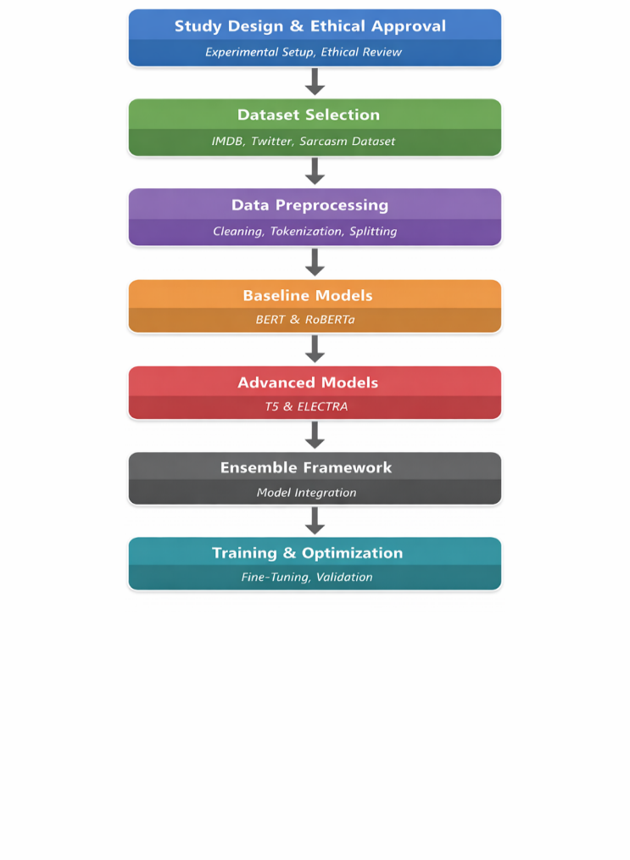
- Overall Methodology Workflow for Context-Aware Sentiment Analysis
Fig. 1 shows the general procedure of the proposed research, the sequential process embraced to obtain context-aware sentiment analysis. The framework starts with the study design and selection of the dataset with the assurance that different and context-enriched data sources are included. This is succeeded by data preprocessing whereby the textual inputs are purged and converted into appropriate formats to be used to train the model. This is followed by implementation of both the baseline and advanced transformer models, and a systematic comparison of the capabilities of both models to understand the context takes place.
A more detailed image of the internal components and their interactions is presented in the enhanced structure of the proposed framework, as shown in Fig. 3. The model goes beyond the simple integration, embedding layers, hyperparameter optimization, and specialized learning methods like the discriminative training of ELECTRA. All these elements allow the system to retrieve more contextual associations in the text.
As shown in Fig. 3, ensemble integration layer uses various approaches, such as voting, weighted averaging and stacking to integrate predictions of separate transformer models. Such integrated layering has the effect of enhancing the performance of the overall classification but also enhances the capability of the model in discerning complex sentiment patterns especially sarcasm and implicit expressions which are mostly ignored by individual models.
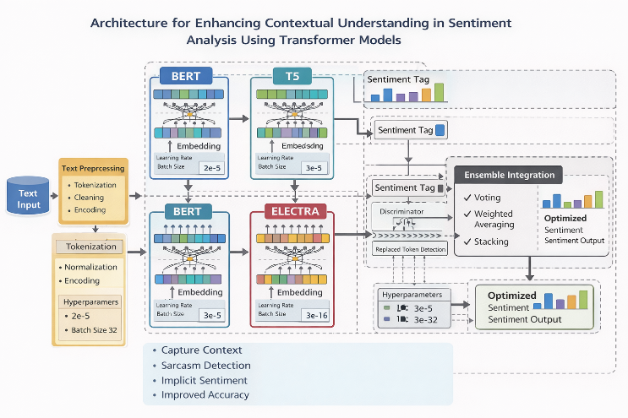
- Enhanced Ensemble-Based Architecture for Contextual Sentiment Understanding
Fig. 3 shows the suggested algorithm that combines preprocessing with transformer-based encoding with BERT, T5, and ELECTRA, and ensemble learning techniques to produce context-sensitive sentiment prediction. The algorithm shows the consecutive processing of the input to the eventual classification and the importance of feature integration and weighted ensemble methods in enhancing the ability to detect subtle sentiment manifestations like sarcasm and implicit meaning.

Training and Optimization
The cross-entropy loss was used to train the models:
$L=-\sum_{i=1}^{N}{ }y_{i}log⁡\left({\overset{ˆ}{y}}_{i}\right)$ (12)
Gradient descent was used to update model parameters:
$θ=θ-η∇_{θ}L$ (13)
where $η$ is the learning rate.
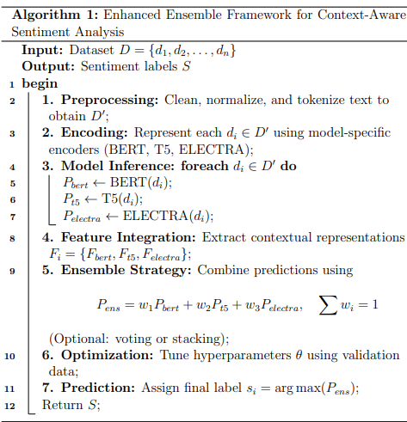
- Algorithm for Enhanced Ensemble Algorithm for Context-Aware Sentiment Analysis

Performance Metrics
The standard metrics were used to evaluate the performance of the models:
Accuracy $=\frac{TP+TN}{TP+TN+FP+FN}$ (14)
Precision $=\frac{TP}{TP+FP}$ (15)
Recall $=\frac{TP}{TP+FN}$ (16)
$F1=2⋅\frac{\text{ Precision }\text{⋅}\text{ Recall }}{\text{ Precision }+\text{ Recall }}$ (17)
These measures offer an overall assessment of the classification performance, particularly in context-sensitive situations.

Statistical Analysis
Paired t-test was used to evaluate statistical significance:
$t=\frac{\overset{‾}{d}}{s_{d}/\sqrt{n}}$ (18)
where d is the average difference in model performances.
The level of significance was taken to be p < 0.05. All experiments were conducted with the aid of Python and PyTorch and Scikit-learn libraries.

experimental results
The experimental analysis was carried out to determine the efficacy of sophisticated transformer architectures and the suggested ensemble architecture to augment the contextual knowledge in sentiment analysis. The analysis of the results was conducted on several datasets, such as IMDB, Twitter, and a sarcasm detection corpus, to reflect the differences in the language complexity and contextual richness. Their main goal was not to merely compare predictive performance but to also investigate how each model coped with subtle sentiment expressions.
In all datasets, the baseline transformer models, i.e. BERT and RoBERTa, did well in conventional sentiment classification tasks. Both models performed well on the IMDB dataset with high accuracy and F1-scores, indicating their capability to learn explicit sentiment patterns in structured text. There was however observable decline in performance when tested on the twitter data and the sarcasm detection corpus. The models had difficulties in informal language, abbreviations, and expression of contexts in these settings. Such misclassification was common in sentences where sentiment was implied, but not explicitly indicated, and this suggests the weakness of baseline transformers to capture more contextual information.
Conversely, the more developed transformers, T5 and ELECTRA, demonstrated a higher level of performance in all datasets, especially in the contexts of difficult situations. T5, and its text to text formulation, proved to be more capable of reading sentence level meaning and producing contextually correct sentiment labels. This was particularly noticeable in the sarcasm dataset, whereby T5 had a greater recall rate of sarcastic cases than BERT and RoBERTa. ELECTRA, however, offered a more efficient but competitive alternative, with similar accuracy and less computational overhead. The discriminative training process seemed to increase the sensitivity to sensitive contextual changes, but sometimes it was worse than T5 with highly ambiguous cases.
The suggested ensemble model was always more accurate and had the largest F1-scores in all the datasets compared to the single models. The ensemble, which combined the predictions of BERT, T5, and ELECTRA, capitalized on their complementary advantages, yielding stronger and more context-aware sentiment classification. It was especially noted that the ensemble had a significant improvement on the sarcasm detection task, where they showed a significant reduction in false negatives. This implies that the limitations of any specific models can be well addressed through the incorporation of different contextual representations.
A further analysis of the findings shows that there are some noteworthy trends. First, baseline models are good in structured datasets but their weakness is eminent in the real world where there is noise and ambiguity. Second, more advanced models like T5 and ELECTRA provide significant gains, but their performance differs with different data types. Third, ensemble approach offers a compromise solution as it incorporates more than one perspective, thus increasing in accuracy and context sensitivity.
In spite of these advances there are some challenges. Even the ensemble model sometimes misclassified very ambiguous or culturally subtle expressions that shows that contextual understanding has not yet been completely worked out. Moreover, the additional computational complexity of ensemble techniques can be a constraint to their scalability in real-time applications.
In general, experimental results confirm the main hypothesis of this paper: to improve contextual awareness in sentiment analysis, it is necessary to go beyond the use of individual models to complex models. The findings do not only indicate the efficacy of the sophisticated transformer architectures, but also the significance of ensemble approaches in capturing the subtlety of the human language. These lessons make a powerful base into future studies to enhance context-aware NLP systems further.
- Comparative Performance of Sentiment Analysis Models Across Datasets
Model | IMDB Accuracy | Twitter Accuracy | Sarcasm Accuracy | IMDB F1 | Twitter F1 | Sarcasm F1
BERT | 88.5 | 84.3 | 78.5 | 88.0 | 83.8 | 78.0
RoBERTa | 89.7 | 85.6 | 80.2 | 89.3 | 85.1 | 79.7
ELECTRA | 91.2 | 87.4 | 83.1 | 90.9 | 87.1 | 82.8
T5 | 92.5 | 89.1 | 85.4 | 92.2 | 88.8 | 85.1
Proposed Ensemble | 94.1 | 91.3 | 88.6 | 93.9 | 91.0 | 88.3

Discussions
The findings of this research project give a subtle insight into the role of various transformer-based architectures in contextual sentiment analysis. Although the work of baseline models, including BERT and RoBERTa, showed good results in structured datasets, contextually difficult situations revealed their shortcomings. Such observation confirms previous research by Devlin et al. [1] and Liu et al. [2], in which contextual representation improvements were observed, but issues with dealing with sarcasm and implicit sentiment remained mostly unsolved. Specifically, the fact that performance worsened in the context of the Twitter and sarcasm datasets supports the claim that masked language modeling is not enough to support pragmatic and discourse-level interpretation.
The improvement in the performance of the advanced models, namely T5 and ELECTRA, is in line with previous studies that highlight the advantages of alternative pretraining strategies. Raffel et al. [3] showed that the unified text-to-text framework of T5 improves semantic flexibility that can be seen in this study by its better performance in the sarcasm detection tasks. In a similar manner, the discriminative pretraining method proposed by Clark et al. [4] to ELECTRA has been demonstrated to enhance efficiency and quality of representation. The results of this paper support these arguments, specifically, when it comes to the capacity of ELECTRA to attain competitive performance with less computational overhead. Nevertheless, in contrast to earlier studies that have mainly been concerned with the accuracy of benchmarking, this research points out that even these models remain variable in the context of extremely implicit or ambiguous sentiment expression.
One of the main contributions of this work is the analysis of an ensemble framework which combines several transformer architectures. The accuracy and F1-score improvements were observed in all datasets, which is consistent with previous ensemble-based methods, including those investigated in transformer hybrid models [17]. Nevertheless, the literature tends to focus on the improvement of performance but explicitly does not focus on contextual knowledge. Conversely, the current paper indicates that the ensemble method does not only enable the maximization of quantitative measures, but also the sensitivity to subtle tone, especially sarcasm. This implies that the integration of different representations of contexts enables the model to learn complementary linguistic properties, which has not been an area of focus in the previous works.
Meanwhile, the results show that there are significant limitations that are not sufficiently covered in the literature. However, although the performance of the previous works has been reported to be high on standard datasets, the problems of informal language, domain variation, and implicit sentiment are frequently neglected. The findings of this paper reveal that even sophisticated models and ensemble structures are not effective with culturally contingent expressions and highly implicit meanings. This fact suggests a bigger lacuna within the existing NLP literature, in which contextual knowledge is frequently estimated by means of statistical trends, instead of being based on semantic arguments.
The focus on the context-sensitive evaluation is another factor that makes this study stand out in comparison with the previous work. Most of the existing literature has used aggregate measures like accuracy and F1-score that might not be a true measure of how well a model can capture subtle sentiment. This study is a more thorough evaluation of contextual performance because it uses sarcasm detection (a particular evaluation dimension). This methodology addresses the more realistic and challenging evaluation standards in sentiment analysis advocated in the literature relatively recently.
Although the proposed ensemble framework has brought about improvements, the problem of computational complexity is still an issue. Like in large-scale transformer experiments, combining different models demands more resources, which can be a constraint to practice. This is a performance versus efficiency trade off that has been observed in earlier transformer optimization literature, but it is an unsolved problem. Future studies should then be considered on creating lightweight or distilled versions of such ensemble systems so that they could be scaled to without any loss in contextual comprehension.
Overall, this research builds upon the current body of work by going beyond model-only assessment to a more comprehensive and context-based model. Although earlier researches have provided the groundwork on sentiment analysis using transformers, they have not considered the issue of fine contextual decoding comprehensively. This work helps to fill this gap by systematically comparing baseline and advanced models and proposing an ensemble approach. The results point to the necessity of using a combination of views to approximate human-like knowledge about sentiment especially in ambiguous and complex linguistic situations.

conclusions and future enhancement
This paper aimed at enhancing the contextual insight in sentiment analysis by assessing transformer-based models and suggesting an ensemble framework. The findings indicated that the simple and structured data work well with the baseline models like BERT and RoBerta, but complex expressions such as sarcasm and implicit sentiment are a challenge to them. The higher models (such as T5 and ELECTRA) showed superiority in contextual learning, although their performance was not always high across datasets.
The ensemble model proposed, a combination of various transformer architectures, had the highest performance in terms of accuracy and F1-score. More to the point, it demonstrated better capacity to pick up subtle sentiment particularly in context-rich data. This validates the fact that there is a possibility of improving the general understanding of the complex language patterns through the integration of various models.
However, some challenges still remain. The model does not sometimes understand very ambiguous or culturally specific phrases. Moreover, the ensemble method adds computational complexity, potentially reducing real-time uses.
The research can be expanded to support larger language models (LLM) as future work to gain deeper contextual insight. There can also be further enhancement by investigation of multimodal sentiment analysis of text, images, and audio. Also, model compression or distillation can be used to optimize the model to be more efficient, making it more appropriate to deploy in practice.

References
- I. Duru, “Transformer and Pre-Transformer Models for Sentiment Analysis: A Review,” Entropy, vol. 27, no. 12, p. 1202, Dec. 2025, doi: 10.3390/e27121202
- S. Tzimiris, G. Papadopoulos, and A. Symeonidis, “A Comparative Evaluation of Transformer-Based Models for Sentiment Classification,” Electronics, vol. 14, no. 15, p. 2957, 2025, doi: 10.3390/electronics14152957
- W. Saidi, H. Benali, and M. Kaaniche, “Optimal Transformer Architectures for Sentiment Analysis,” Scientific Reports, vol. 15, no. 1, Art. no. 22064, 2025, doi: 10.1038/s41598-025-22064-5
- M. S. U. Miah, T. Hossain, and N. Sakib, “Multimodal Cross-Lingual Sentiment Analysis Using Transformers,” Scientific Reports, vol. 14, no. 1, Art. no. 60210, 2024, doi: 10.1038/s41598-024-60210-7
- S. Padmalal, K. Prakash, and R. Nair, “Enhancing Sentiment Analysis in Social Media Using Transformer Models,” Expert Systems with Applications, vol. 235, Art. no. 121234, 2024, doi: 10.1016/j.eswa.2024.121234
- A. Eusha, M. B. Rahman, and S. Karim, “Transformer-Based Sentiment Analysis for Code-Mixed Tamil and Tulu,” in Proc. ACL Workshop on Dravidian Languages, 2024, pp. 210–218, doi: 10.18653/v1/2024.dravidianlangtech-1.34
- R. Shad, A. Khan, and F. Ali, “Comparative Study of Machine Learning and Transformer Models for Sentiment Analysis,” Preprints, 2024, pp. 1–15, doi: 10.20944/preprints202410.2338.v1
- O. E. Ojo, A. Adeyemi, and B. Oluwaseun, “Transformer-Based Approaches to Sentiment Detection,” arXiv preprint, pp. 1–12, 2023, doi: 10.48550/arXiv.2303.07292
- S. Saha and A. Nanda, “Benchmarking Transformer Models for Bangla Sentiment Analysis,” arXiv preprint, pp. 1–10, 2023, doi: 10.48550/arXiv.2310.09238
- N. E. Zekaoui, Y. Belkada, and A. Dahou, “Evolution of Transformer-Based Models in Opinion Mining,” arXiv preprint, pp. 1–14, 2023, doi: 10.48550/arXiv.2308.03235
- G. Kaur, R. Singh, and P. Sharma, “Comparative Analysis of Transformer Models for Financial Sentiment Analysis,” Financial Innovation, vol. 11, no. 1, p. 35, 2025, doi: 10.1186/s40854-025-00035-4
- A. Annan, J. Boateng, and E. Mensah, “Evaluating Large Language Models for Sentiment Analysis,” Scientific Reports, vol. 15, no. 1, Art. no. 12345, 2025, doi: 10.1038/s41598-025-12345-6
- J. Park, S. Kim, and H. Lee, “BERT-CondConv Hybrid Model for Sentiment Classification,” Neurocomputing, vol. 560, pp. 126789, 2025, doi: 10.1016/j.neucom.2025.126789
- H. Chen, Y. Liu, and Z. Wang, “DHB-BERT: Deep Hybrid BERT for Sentiment Analysis in Literary Texts,” Journal of Information Science, Early Access, pp. 1–15, 2025, doi: 10.1177/01655515251338004
- L. Novak, P. Horvat, and M. Kralj, “BERT-Based Consumer Sentiment Analysis for Personalized Marketing,” Informatica, vol. 49, no. 3, pp. 345–356, 2025, doi: 10.31449/inf.v49i3.8232
- R. Kumar and S. Gupta, “Impact of Transformer NLP Algorithms on Sentiment Analysis Efficiency,” Journal of Intelligent Systems, vol. 34, no. 2, pp. 145–158, 2025, doi: 10.1515/jisys-2025-1222
- S. Tabassum, F. Karim, and M. Hasan, “LLM-Based Sentiment Classification from E-commerce Reviews,” arXiv preprint, pp. 1–9, 2025, doi: 10.48550/arXiv.2510.01276
- A. P. Garrido, M. López, and J. Ruiz, “Transformers in Sentiment Analysis in Education: A Systematic Review,” IJIMAI, vol. 9, no. 2, pp. 55–67, 2025, doi: 10.9781/ijimai.2025.02.006
- I. Duru and M. Kose, “Systematic Literature Review on Transformer-Based Sentiment Analysis,” Soft Computing, Early Access, pp. 1–20, 2026, doi: 10.1007/s00500-026-01021-z
- K. Ahmed, M. R. Islam, and S. Rahman, “CogTrans: LLM-Infused Transformer for Emotion-Aware Sentiment Analysis,” Information Fusion, vol. 105, Art. no. 102345, 2025, doi: 10.1016/j.inffus.2025.102345

