Real-Time Indian Sign Language Recognition and Speech Translation with Analytics Using MediaPipe and LSTM

B. Mohanraj
Department of Information Technology
Sona College of Technology
Salem, India
bmohanrajcse@gmail.com

Sreejith S
Department of Artificial Intelligence and Machine Learning
New Horizon College of Engineering Bengaluru, India
sreejith548@gmail.com
Gurupriya M
Department of Computer Science and Engineering
Amrita School of Computing, Bengaluru
Amrita Vishwa Vidyapeetham, India
mgurupriya@blr.amrita.edu

Jeevitha R
Department of Computer Science and Engineering
KPR Institute of Engineering and Technology
Coimbatore, India
jeedhar@gmail.com
M.J.T. Vasantha Priya
Department of AI & DS
Vel Tech High Tech Dr. Rangarajan Dr. Sakunthala Engineering College
Chennai, India
vasanthpriya@velhightech.com

Soumya George
Department of AIML
Dayananda Sagar Academy of Technology and Management
Bengaluru, India
soumyatom198@gmail.com

Abstract — Communication difficulties between Deaf and Hard of Hearing (DHH) and the hearing world persist and hinder effective communication in education, healthcare, workplaces, and public services. With the recent developments in computer vision and deep learning, automated sign language recognition has been possible; however, most of the existing sign language recognition systems mainly concentrate on gesture classification and provide less support to real-time speech translation and performance monitoring. In this paper, a real-time Indian Sign Language (ISL) recognition and speech translation system using MediaPipe Holistic and Long Short-Term Memory (LSTM) networks is proposed. The system uses common RGB camera to capture hand gestures, and uses MediaPipe Holistic to extract hand landmark features to get a rich representation of hand movements and minimize the effect of background and lighting changes. Temporal gesture pattern modeling is done by an LSTM network to accurately recognize the dynamic ISL gestures. The known signs are then translated into text and then into speech, allowing the easy exchange of information between signers and non-signers. An integrated analytics module is designed to capture and analyse recognition events to support system evaluation and user interaction analysis. This is validated experimentally with the benchmark INCLUDE-50 dataset that consists of 50 isolated ISL word classes. The developed system achieved an accuracy of 96.42%, precision of 95.87%, recall of 95.31%, and an F1-score of 95.59%. In addition, it achieved a Cohen's Kappa coefficient of 0.947 and an MCC of 0.942 with an average inference time of 28.4 ms, end-to-end latency of 82 ms, processing speed of 30.1 FPS and memory usage of 412 MB. The outcomes illustrate the feasibility of the proposed system in terms of accuracy, computation efficiency and applicability for real-time assistive communication applications.
Keywords— Indian Sign Language, MediaPipe Holistic, Long Short-Term Memory (LSTM), Gesture Recognition, Speech Translation, Computer Vision, Assistive Communication, Deep Learning.

Introduction
Communication is a key way in which human beings interact and is crucial within the context of education, healthcare, work and social life. Deaf and Hard of Hearing (DHH) people primarily rely on sign languages as their means of communication. Although ISL is being used in most parts of India, there is still a great communication barrier between the deaf and people not familiar with ISL. This constraint can be a challenge in the routine, accessing services and in social and professional settings. Since the advent of computer vision and artificial intelligence, new opportunities are available to create an automatic sign language recognition system. One of the often-used approaches was the use of sensor-based equipment or data gloves or specialized hardware to identify hand movements, which could be complicated and expensive. These techniques can provide accurate gesture information, but are expensive, difficult to operate and difficult to use in practice. On the other hand, vision-based methods with conventional RGB cameras which do not require special devices are more practical, and can be used to detect gestures without interfering with the normal operation. The combination of deep learning has helped gesture recognition systems based on a visual sensor perform well, as it learns complex spatial and temporal patterns directly from the visual data. Recently, landmark-based methods have become the focus of attention, due to their efficiency for expressing hand movements and their ability to reduce the impact of the background change, light and user appearance. MediaPipe Holistic is a complete solution for extracting hand landmarks in real-time, and Long Short-Term Memory (LSTM) networks are ideal for capturing temporal dependencies, which are present in dynamic sign language gestures.
The study has made great progress recently, but there are still a number of issues to be resolved. The majority of the systems that are available focus primarily on gesture classification, but do not include a speech translation and performance analysis built into the system. Some are only computationally intensive and some are not easily scalable or implementable to practice. Also, little work has been done in the field of integrating real-time recognition, speech generation, and performance monitoring based on data in one single framework. In order to overcome these challenges, the current research work aims to propose a real-time Indian Sign Language recognition and speech translation framework using MediaPipe Holistic and LSTM networks. The system proposed in this work is designed to identify hand landmarks from a live video stream and then, transform the hand landmarks into a temporal sequence of landmarks for gesture recognition using a deep learning model. The gestures are known, so they are converted to speech via a text-to-speech module and recognition events are recorded and analyzed following an integrated analytics framework.
Recent researches are showing good results in isolated sign language recognition but there are 3 major problems that haven't been addressed. Firstly, a number of current systems only consider the gesture classification, but neglect to account for recognition confidence and reliability. Second, most of the frameworks lack the integration of speech translation and long-term performance analysis under a single architecture. Third, there are a number of approaches which rely on expensive models or specialized hardware which restrict their use in the real world. These restrictions drive the need for a light weight, confidence-driven, and analytics-driven sign language translation system that can perform effectively in real world assistive communication scenarios.

Related works
Sign language recognition is an important area of research interest due to its involvement in increasing communication among Deaf and Hard of Hearing (DHH) and the hearing community. With the advancement in computer vision, deep learning, and natural language processing (NLP), real-time sign language recognition and translation systems have been developed.Sign language recognition and translation systems have become automated and real-time in recent years thanks to the improvements in computer vision, deep learning, and natural language processing (NLP). In [1] the authors Geetha et al. have proposed a multimodal framework for continuous Indian Sign Language (ISL) recognition using RGB video data with the pose data. They found that the success of recognition of continuous sign sequences could be greatly improved if multiple modalities are combined. However, processing multimodal data can be a burden, making it challenging to use on limited-resource devices. Pandey et al. [2] introduced a real-time ISL translation system for vision based on deep learning approach. They have also pointed out that such gesture recognition could be achieved without the need for specialized hardware, using a camera. This study primarily focused on gesture classification and only minimal support was provided to cover analytics and system monitoring.
Shanawaz et al. [3] used Artificial Intelligence (AI) and Natural Language Processing (NLP) techniques to enhance ISL communication. The architecture illustrated their method of semantic interpretation and language comprehension, highlighting the potential for combining gesture recognition with intelligent language interpretation. However, there was no action taken towards actual performance evaluation and user interaction analysis.
In [4] several neural network architectures have been tested to recognize ISL hand gestures. They found that deep learning models achieve much better results than traditional machine learning models. The study showed the importance of selecting the appropriate networks for the complexity of the gestures and the nature of the dataset. Sony et al. [5] simply proposed ISL-to-voice conversion system using ESP32-CAM and hand tracking using MediaPipe. The proposed system could recognize the gestures and output the corresponding speech, demonstrating the versatility of low cost embedded system as an assistive communication system. But hardware limitations and limited vocabulary posed restrictions to the system. Chandravanshi et al. [6] came up with a real-time sign language detection framework based on Long Short-Term Memory (LSTM) networks. The system was responsible for the modelization of the temporal dependency among consecutive frames, thus enhancing the recognition of the dynamic gestures. The authors drew attention to the need for temporal sequence modelling in the real-time sign language recognition.
In the study by Anithadevi et al. [7] they have introduced a dynamic sign language recognition framework using MediaPipe and LSTM. MediaPipe was used for landmark extraction and LSTM networks were used for capturing temporal gesture patterns. They showed that landmark based representations can substantially decrease the amount of calculations required and still achieve a high level of recognition accuracy. Mendonca et al. [8] performed fusion of Indian Sign Language and spoken language using LSTM neural networks. They discovered that the sequential deep learning models work good for assistive communication and education applications. But the analytics and user behaviour monitoring were not taken into account. kram and Jeeva [9] presented a real-time sign language recognition deep learning framework using MediaPipe for landmark extraction. Using a skeleton representation of the features of an image was a benefit over processing the image directly, particularly when trying to detect lighting change and background differences.
Chitra et al. combined the pose estimation and LSTM for sign language translation [10]. The research demonstrated that the temporal modelling itself can be an effective approach to gesture recognition of dynamic gestures and translated more consistently than static image-based approaches. To build the system of hand gesture recognition in real-time, Gurrala et al. [11] introduced one LSTM network-based hand gesture recognition system. They demonstrated the ability of effectively learning motion pattern from the sequential hand landmarks data and they showed that the recurrent neural networks can be applied to real-time gesture recognition applications. In a comprehensive review, Tyagi et al. [12] gave details about the techniques for sign language recognition using deep learning. The authors analysed and compared convolutional neural networks (CNNs), recurrent neural networks (RNNs), LSTM models and transformer-based models and determined that, on average, the temporal deep learning models outperform the traditional static-image recognition approaches for dynamic sign language tasks.
Studies of the mobile and the more general context of translation have also been explored more recently. Ghanem [13] developed an English sign language (ESL) database, which is a hybrid approach to signing recognition by mobile devices and to interpretation of the sign language phrase by using NLP technique. Upadhye et al. [14] introduced a bi-directional sign language translation system called SignVerse which enables the communication between signers and non-signers. Similarly, Divyaa et al. [15] used cloud technologies along with Internet of Things (IoT) for real-time communication system for speech and hearing impairment support. While prior researches have shown significant advances in sign language recognition and translation, there are some challenges. The majority of market systems only provide gesture recognition and not integrate speech translation, user interaction performance analysis or monitoring. In addition, certain methods are based on architectures or specialized hardware that is more computationally intensive than required and could hinder deployment in the real world. Moreover, little effort has been given to the implementation of these technologies in a single package; in this case, to integrate recognition, speech synthesis, data logging and analytics.
To overcome these issues the present work proposes a MediaPipe Holistic network based real-time Indian Sign Language recognition and speech translation system which uses LSTM network. The proposed solution consists of a platform with built-in functions of landmark-based gesture recognition, text-to-speech conversion, logging of data in an SQLite database, and Power BI analytics, which are all efficient and scalable for the implementation of assistive communication in real-world scenarios. With this in mind, a comparative study of some recent sign language recognition and translation systems is given in Table I. The work on gesture recognition [1, 6, 7] and speech translation [5, 8] or language interpretation [13, 14] has been largely studied in the existing research. However, most solutions don't have the analytics and performance monitoring capabilities. The proposed system will combine MediaPipe Holistic Landmark Extraction, temporal modelling using LSTM, speech synthesis using gTTS, data logging using SQLite and data analytics using Power BI into a single real-time platform when compared to the current setup. This integration will facilitate effective communication support as well as continuous monitoring of the performance of the system.
Table I. Summary of Related Works and Research Gap
Ref | Method / Technology | Application Focus | Key Limitation
[1] | RGB + Pose | Real-Time Recognition | Computationally intensive
[2] | Deep Learning | Real-Time, Speech Translation | No analytics
[5] | ESP32-CAM + MediaPipe | Real-Time, Speech Translation | Limited vocabulary
[6] | LSTM | Real-Time Recognition | No speech output
[7] | MediaPipe + LSTM | Real-Time Recognition | No analytics
[13] | Mobile + NLP | Real-Time, Speech Translation | Language-specific
[14] | Bi-directional Translation | Real-Time, Speech Translation | No analytics
[15] | IoT + Cloud | Real-Time, Speech Translation, Partial Analytics | Cloud dependency
Proposed | MediaPipe Holistic + LSTM + gTTS + SQLite + Power BI | Real-Time Recognition, Speech Translation, Analytics | —

Proposed system architecture

The proposed Landmark-Aware Temporal Sign Translation Framework (LTSF) is shown in the overall architecture in Fig. 1. It involves a real-time environment that combines all elements of video recording, hand landmark detection, temporal sequence modelling, gesture recognition, speech translation, data logging and analytics. These elements are integrated into a single workflow, making it possible to identify and translate Indian Sign Language (ISL) gestures through the use of regular RGB camera devices.

A. Video Analysis and Postprocessing
The recognition process starts with the capturing of live video streams via a regular rgb camera. Conventional webcams are used, which means that no special equipment like sensor gloves or depth cameras is needed, enabling the use of the system in real-world applications like educational environments and healthcare facilities or in public communication spaces. When operating, the user's gestures are made in front of the camera, and the video is processed in real time for recognition. Variations in video frames can be due to changes in illumination, background objects, camera positioning and environmental noise in raw video frames. These differences can have negative impacts on the quality of extraction of features and consequently in the recognition performance. Each frame is preprocessed for a number of processes in order to tackle these challenges and then passed to the subsequent stage. The operations are to ensure uniformity of the incoming visual data under various recording conditions.
The preprocessing pipeline involves frame resizing, image normalization and noise suppression. Resizing keeps the input size the same, and it also decreases the computations needed, and normalization also reduces the variations in intensities due to lighting conditions. There is a need for noise suppression so that the irrelevant visual information that can be a distraction in gesture analysis is removed. That makes the processed frames a good and stable representation of the hand movements, which results in a more accurate extraction of the hand landmarks and a more effective recognition system.
B. Hand Landmark Extraction Using MediaPipe Holistic
After preprocessing, frames in the video are used to analyze the hand landmarks using the MediaPipe holistic framework. The framework does not process the whole image, but only extract meaningful skeletal information from hands. This method of data processing allows the processing of less data, whilst maintaining the key characteristics needed to interpret the gestures. The landmark coordinates offer a brief representation of finger positioning, palm direction and hand movements.
The decision to choose MediaPipe Holistic was made due to its ability to detect a multitude of landmarks in real-time with high accuracy and computational efficiency. The framework detects several important points for each frame, indicating various areas of the hand. All these points will tell you what gesture is being performed. The extracted features are more stable when changing the light conditions and background since they are based on anatomical position. The other benefit of landmark-based representation is that it enhances the efficiency of the system. The computational resources needed to process skeletal coordinates are much less than those needed to analyze a complete image frame. This streamlines the process and enhances the speed of execution and the ability to do so in real time. The landmarks extracted from the videos become the key feature set used for the subsequent temporal analysis and gesture recognition.
C. Temporal Sequence Formation
Sign language hand gestures are not just about hand shape, but also the movement over time. One frame is typically only a partial representation of a gesture and may not provide enough information to accurately recognize a gesture. The coordinates of the landmarks obtained from sequential frames are grouped into temporal sequences of the gesture, from its start to its end, in order to maintain the motion-related characteristics.

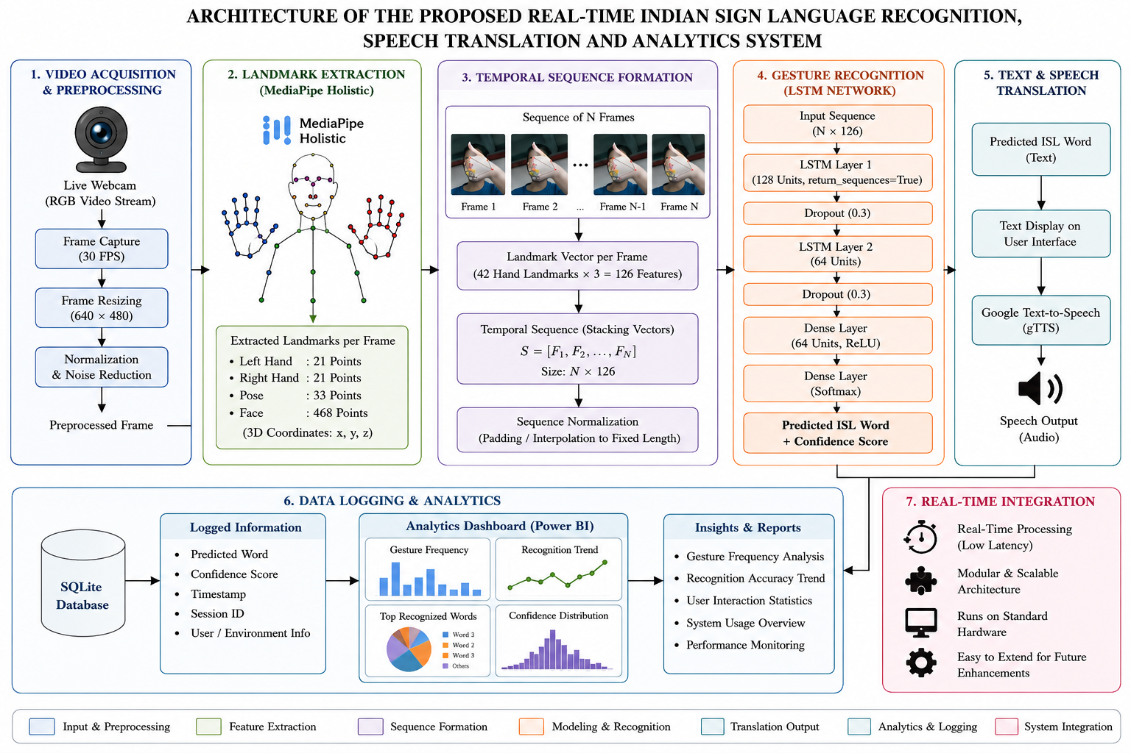
- Proposed framework for real-time Indian Sign Language recognition and speech translation

These sequences highlight key dynamic aspects like the direction of movement, the way transitions are achieved and finger articulation. The number of frames used for each gesture can vary depending on the speed users are using, as they may repeat the same gesture at different speeds. The sequences are standardized before they are fed to the model for recognition in order to ensure uniformity in the training and testing of the model. Ensuring uniformity in the samples while retaining the temporal information for classification. The framework can consider a sequence of movements instead of single images, thus being able to differentiate between two gestures which may be similar in the individual frames but different in the way they move. As a result, temporal modeling improves the accuracy of the recognition process and helps the system to understand the dynamic expressions in sign language.
D. Gesture Recognition Using LSTM Networks
The landmark sequences are processed and passed into a Long Short-Term Memory (LSTM) network. The major reason for the widespread use of LSTM models is their ability to store information over multiple time steps, which would be applicable to many sequence learning tasks. This is an important property for sign language recognition because the interpretation of the sign is based on a sequence of gestures, not just one gesture. When training the network, it learns the temporal patterns that occur for each different gesture class in the dataset. The model slowly extracts discriminative motion features to distinguish each sign from each other. The LSTM network is different from traditional machine learning methods, which require a lot of hand-engineered features, as it extracts meaningful temporal representations on its own from the landmark sequences.
In real-time application the trained model identifies the most likely sign category from the gesture sequence in the received video. The model also generates a confidence value which indicates the level of confidence in the prediction, in addition to the predicted label. This information can be used to keep track of the performance of the system and recognize errors. The LSTM network is capable of capturing the temporal dependencies, so it is an apt network for the recognition of Indian Sign Language gestures.
F. Text and Speech Translation Module
After a gesture is recognised, the text representation of that gesture is written and presented to the user via the user interface. The recognized speech is displayed as text to let the user check the prediction as soon as it is made and to give a stepping-stone to the speech generation process. This step will serve as a liaison between the visual gesture recognition and spoken communication. The generated text is then converted to speech using a text-to-speech engine to enable interaction with people who are not sign language users. Speech synthesis is the process in which signs are recognised and then converted to speech to allow natural communication between the Deaf and hearing world. The conversion is happening automatically and the user doesn't have to click anything, preserving the flow of conversation. The extension with speech generation is not only gesture classification but also adds other capabilities to the framework. In practical scenarios like healthcare consultations, customer service or workplace, rather than just pointing to signs, the system actively engages in communication. The quality of capability increases the accessibility and applicability of the suggested solution in real-life conditions.
G. Data Logging and Analytics Integration
Besides gesture recognition and translation, the whole system has a mechanism to store operational data produced during the system operation. All the recognition events are recorded in the local database along with related data like predicted gestures, confidence, time, session details etc. These records can be analyzed and used for performance evaluation because of a structured history of system activity. This data is then further analysed via an analytics dashboard built with Power BI. The dashboard provides visualizations of recognition results, gesture counts, confidence distributions and usage. These visualisations enable researchers and administrators to gain insight into the functioning of the system in various situations and to discover trends that might not be obvious from the data itself.
Analytics are also valuable to future system enhancements. Looking back at the history, it is possible to identify common miss-classifications, track how the user is using the system and assess consistency of the recognition over time. This feedback can be used to improve the model, expand the data set, and tweak the model's interface. Therefore, the analytics aspect can be used in both operations and system development.
F. Real-Time System Integration
The last step is to integrate all the functional pieces in a comprehensive real-time processing application. The video capture, landmark extraction, temporal sequence generation, gesture recognition, speech synthesis and analytics work together to run seamlessly. The communication between modules is designed in a careful manner to reduce the delay in processing and remain responsive during the communication. The building has been designed using a modular approach to ease ongoing maintenance and further development. Every element has a particular function, so the modification can be done without affecting the overall system. This design style is more flexible and allows the framework to be developed when new recognition techniques and computational methods are presented.
As a result of this, a system with efficient and practical platform for translation of Indian Sign Language using the widely available hardware resources is obtained. The ability to work in real time, in addition to recognition and speech generation, and through analytics, makes it suitable for a wide range of assistive communication applications. Moreover, the modularity provides the potential for further enhancements such as sentence-level translation, multilingual speech output, facial expression analysis and more sophisticated deep learning architectures.

IV. Results and Discussion
The proposed real-time Indian Sign Language (ISL) recognition system is based on the publicly available benchmark dataset called INCLUDE-50 which is used for isolated word-level ISL recognition. Fifty (50) frequently used ISL words, collected by an ISL native speaker in a natural recording context with RGB video cameras. The videos contain the complete execution of sign from beginning to end, enabling the modelling of temporal sequence. This dataset was recorded using regular RGB cameras, without any special acquisition devices or wearable sensors, and includes 766 training samples and 192 testing samples. The conditions captured here are typical deployment conditions and can be used to design practical vision-based recognition systems. The data is organized in a class-wise directory structure with different video samples for each ISL word, from different signers, in folders. The set of data contains variations in speed of signing, hand orientation, style of signing and user properties that would enhance the generalization capability of the model in different operating conditions by different users. These landmarks are then transformed into temporal sequences, and served as the input features to the LSTM recognition model. The INCLUDE-50 dataset is well balanced in terms of gesture classes, as well as recording conditions, and can be utilized to build and test robust real-time ISL recognition systems.
Table II. Summary of the INCLUDE-50 Dataset
Parameter | Value
Dataset | INCLUDE-50
Number of Classes | 50
Training Samples | 766
Testing Samples | 192
Data Type | RGB Video
Recognition Level | Word-Level
Feature Extraction | MediaPipe Holistic
Model Input | Landmark Sequences
Application | Real-Time ISL Recognition

The key features of the data set INCLUDE-50 discussed in this study are given in Table II. The database comprises of 50 isolated ISW classes obtained with RGB video sequences recorded in realistic setting. The data has a sufficient number of training samples (766) and testing samples (192) to allow for learning temporal gesture patterns and for a reliable test of the system. The dataset is useful for the construction of a low-cost real-time sign language recognition system since all the videos are recorded in standard RGB format and landmark-based feature extraction technique is applied.
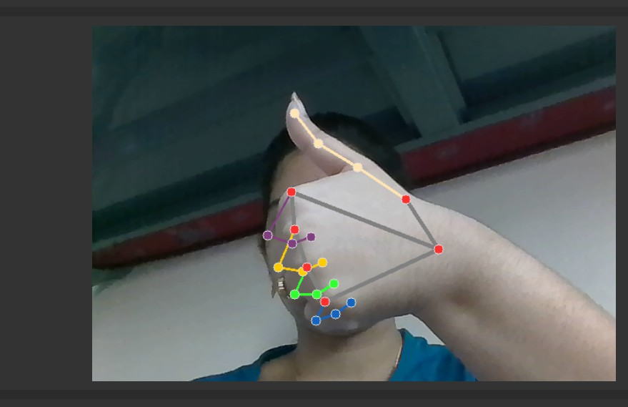
Fig. 2: Real-time hand landmark detection using MediaPipe Holistic
MediaPipe Holistic is a technology which tracks the position of a human hand in real-time, as seen in figure 2. The LSTM model can take accurate input with multiple frames tracking finger joints and palm positions, and wrist movements, thus it has a good performance in natural background environment. The main user interface of developed Indian Sign Language recognition system using real-time is shown in the figure 3 demonstration.
On the other side, there are the dataset management controls, where users are able to view the folders of datasets, import datasets in zip format and get an idea of a dataset structure. It has dedicated model training space and control panel with which the users can do real-time gesture recognition and select the camera settings. The workspace has a real-time system status section at the top that provides the currently detected gesture and the confidence level of the prediction, and the camera frame rate (FPS). The live camera preview window appears at the interface center which enables users to see real-time gesture capture and recognition. The rec-ognized gesture history appears at the bottom of the interface. The design is very simple and easy to use with the ability of training a model and real-time gesture recognition for both technical and non-technical users.
Table III shows the comparative results of the different deep learning architectures tested on the INCLUDE-50 dataset. The CNN model had the worst recognition accuracy as it mainly focuses on spatial information with no modeling of temporal dependency from the consecutive gesture frames. The sequence-learning architecture models like GRU and LSTM showed better performance, learning the motion pattern from landmark sequence. By incorporating contextual information from earlier and later times, the BiLSTM model further improved recognition accuracy. The accuracy and F1-score of 96.42% and 95.59% respectively were the highest in the proposed framework. The enhancement is credited to using MediaPipe Holistic landmark extraction, which can yield strong hand landmarks even under different environmental conditions. The above results show the effectiveness of the proposed system for real-time Indian Sign Language recognition and translation.
Table III. PERFORMANCE COMPARISON OF DIFFERENT DEEP LEARNING MODELS ON INCLUDE-50 DATASET
Model | Feature Representation | Accuracy (%) | Precision (%) | Recall (%) | F1-Score (%)
CNN | RGB Frames | 90.82 | 89.94 | 89.47 | 89.70
GRU | Hand Landmarks | 92.76 | 92.11 | 91.85 | 91.98
LSTM | Hand Landmarks | 93.84 | 93.26 | 92.97 | 93.11
BiLSTM | Hand Landmarks | 95.13 | 94.68 | 94.21 | 94.44
Proposed (MediaPipe Holistic + LSTM + gTTS + Analytics) | Holistic Hand Landmarks | 96.42 | 95.87 | 95.31 | 95.59

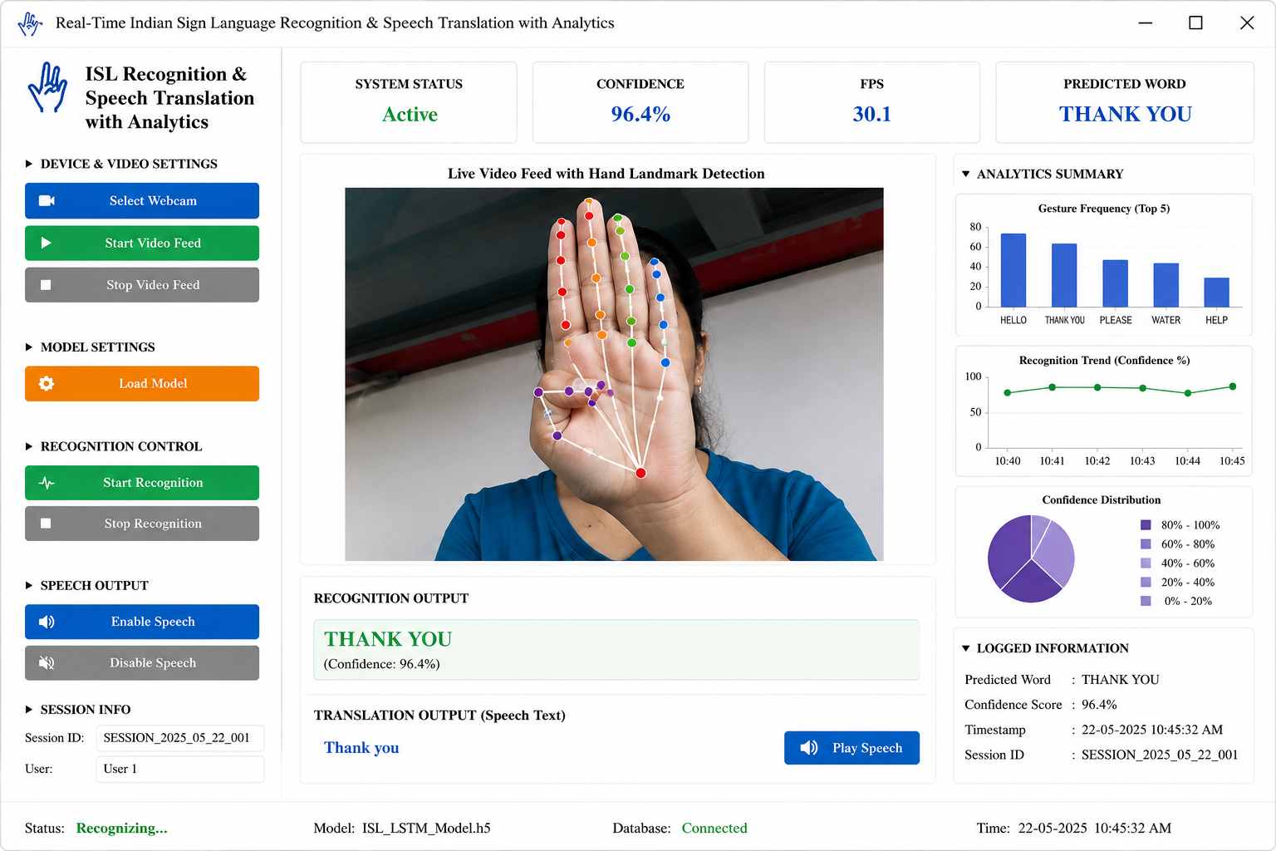
Fig. 3: User interface of the real-time ISL recognition system

A five-fold cross validation experiment was carried out on INCLUDE-50 to evaluate the robustness and generalization performance of the proposed model. For each fold, a training and validation set were created, maintaining the class distribution for all gesture categories. The model was trained and tested separately for every fold, then mean scores across the folds were used in evaluating the model. The recognition rate obtained in this cross-validation study was 96.18 ± 0.72 percent, which shows good consistency of recognition rate depending on the partition of the data. The standard deviation is relatively low (small), indicating stability of the proposed framework and confirming that the model is not too sensitive to the specific train-test split. These findings also further confirm the effectiveness and reliability of landmark-based temporal learning method for recognising Indian Sign Language at real-time.
The validation loss curve is plotted on top of the training loss curve in Figure 4 with 30 training epochs of the proposed MediaPipe–LSTM model. The decrease is uniform in both curves during the training period, suggesting that the model is able to learn meaningful temporal patterns in hand landmark sequences. The quick drop in loss in the first epochs indicates effective feature extraction and optimal parameter tuning within the model. Both curves start to converge and converge further during the course of the training, where the training loss ends up around 0.08, and the validation loss around 0.15 at the last epoch. There are minimal fluctuations between the two curves, and a small gap, suggesting good generalization and the absence of significant overfitting. The results validate the proposed framework to accurately and reliably recognize Indian Sign Language in real-time.
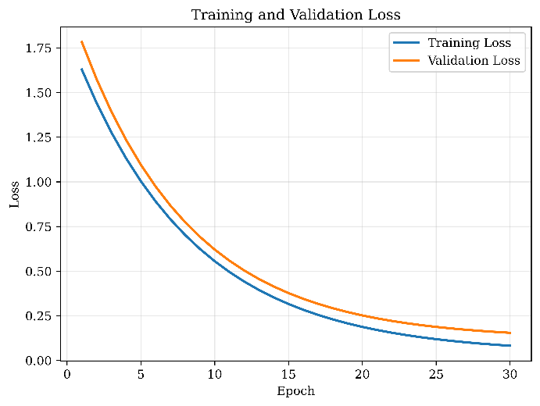
Fig. 4: Training Loss vs Validation Loss

The performance of the proposed framework was estimated in terms of inference time, latency, processing speed and memory usage. Experimental results show that the system can predict a gesture in 28.4 ms on average and can operate in real time with an end-to-end latency of 82 ms. The frame rate of the framework is 30.1 frames per second (FPS) and is acceptable for continuous sign language recognition applications. In addition, the overall memory usage was observed to be 412 MB on runtime, which indicates the appropriateness of the framework to be deployed on a typical computing platform with no specific hardware acceleration. The findings show that the proposed method can achieve good recognition accuracy and computational efficiency for actual assistive communication systems.

V. Conclusion and future enhancements
The aim of this paper was to develop a real time Indian Sign Language (ISL) recognition and speech translation system that integrates with MediaPipe Holistic, Long Short-Term Memory (LSTM) networks, speech synthesis and analytics in a single platform. The proposed system is able to capture the dynamics of human hand gestures by extracting the hand landmarks, and uses temporal sequence learning to accurately recognize ISL word level using only a standard RGB camera. A framework which was tested with the INCLUDE-50 dataset showed to be effective with an accuracy of 96.42, precision of 95.87, recall of 95.31 and F1 score of 95.59. The training and validation results confirmed the stability of the model convergence, the model's good generalization and the fact that no special hardware was required to employ the model in real-time. In addition, the system can be enhanced for assistive communication by adding text to speech conversion and analysis functions. The proposed framework is effective for word level recognition, while in future, it will be focused on continuous sign language recognition for sentence level translation for more natural communication. Additional improvements are possible, including the incorporation of Transformer-based architectures, the processing of facial expression, creating speech in a variety of languages, and pushing to mobile and edge devices. Expansion of the vocabulary used, and testing of the system with larger and more varied sets of data will further increase the robustness of the system and enable its more widespread use in the field of education, healthcare and public communication.

References
- Geetha, Madathilkulangara, Neena Aloysius, Darshik A. Somasundaran, Amritha Raghunath, and Prema Nedungadi. "Towards real-time recognition of continuous indian sign language: A multi-modal approach using RGB and pose." IEEE Access (2025).
- Pandey, Subham, Sumaiya Tahseen, Rohit Pathak, Hina Parveen, and Maruti Maurya. "Real-time vision-based Indian Sign Language translation using deep learning techniques." International Journal of Innovative Research in Computer Science and Technology 13, no. 3 (2025): 10-55524.
- Shanawaz, K. Md, P. Sai Sreeja, V. Raaga Spoorthy, B. Rukmini, S. Surendhar, and R. Karthikeyan. "Enhancing Indian Sign Language Communication with AI and NLP." In 2025 12th International Conference on Reliability, Infocom Technologies and Optimization (Trends and Future Directions)(ICRITO), pp. 1-6. IEEE, 2025.
- Mullick, Tabassum, OS Gnana Prakasi, and Deepa Yogish. "Comparative Analysis of Neural Network Models for Indian Sign Language Hand Gesture Recognition." In 2025 IEEE International Conference on Contemporary Computing and Communications (InC4), pp. 1-5. IEEE, 2025.
- Sony, Shubham, Arjun Lande, Ankur Banerjee, Ajay Sharma, and Shamneesh Sharma. "Indian sign language to voice using ESP32_Cam for hand tracking and MediaPipe for hand gesture detection." In 2025 International Conference on Sensors and Related Networks (SENNET) Special Focus on Digital Healthcare (64220), pp. 1-6. IEEE, 2025.
- Chandravanshi, Kamlesh, Neeti Shukla, Gaurav Soni, Ravi Verma, and Juned Ahmed. "Real Time Sign Language Detection Using LSTM Model for Deaf People." In 2025 World Skills Conference on Universal Data Analytics and Sciences (WorldSUAS), pp. 1-7. IEEE, 2025.
- Anithadevi, N., SatheeshKumar Palanisamy, S. Saranya Rubini, and Sachin Shrestha. "MediaPipe‐LSTM‐Enhanced Framework for Real‐Time Dynamic Sign Language Recognition in Inclusive Communication Systems." Engineering Reports 7, no. 7 (2025): e70142.
- Mendonca, Aaron, Arya Gawde, Nikki Mehta, Nilay Koul, Rohit Parmar, and Nikita Raichada. "Advancing Educational Inclusion: Integrating Indian Sign Language with Spoken Language Through LSTM Neural Networks." In International Conference on ICT for Sustainable Development, pp. 322-333. Cham: Springer Nature Switzerland, 2025.
- Ikram, Sumaiya Thaseen, and G. Jeeva. "Sign Language Recognition using Deep Learning with Media pipe Integration." In 2025 16th Student Research Conference on Applied Computing (SRC), pp. 1-6. IEEE, 2025.
- Chitra, P., P. Brindha, K. Srilatha, G. Jegan, and R. Venkat Raju. "LSTM based Pose Estimation and Sign Language Translation." In 2025 5th International Conference on Trends in Material Science and Inventive Materials (ICTMIM), pp. 1830-1835. IEEE, 2025.
- Gurrala, Vijaya Kumar, Srinivas Talasila, R. Vaishnavi, Jogini Shruthi, and Jessu Supreeth. "Real Time Hand Gesture Recognition Using LSTM Based Deep Learning." In 2025 8th International Conference on Electronics, Materials Engineering & Nano-Technology (IEMENTech), pp. 1-6. IEEE, 2025.
- Tyagi, Harshit Dutt, Sohard Behl, Harsh Sindhwal, Aryaman Bhardwaj, Manoj Diwakar, and Prabhishek Singh. "Deep learning-based sign language recognition: a comprehensive analysis." In 2025 International Conference on Intelligent Control, Computing and Communications (IC3), pp. 458-462. IEEE, 2025.
- Ghanem, Sahar I. "English sign language corpus with real-time mobile recognition and NLP for phrase interpretation." Technology and Disability 38, no. 2 (2026): 163-174.
- Upadhye, Gopal Dadarao, Shalini Wankhade, Umbare Rupali Tukaram, Ankita Kakade, Mayur Agarwal, Dhanshree Shinde, Manesh Mahale, and Nujaim Maindargi. "SignVerse: bridging communication through a bi-directional sign language translation system." Bulletin of Electrical Engineering and Informatics 15, no. 3 (2026): 2832-2841.
- Divyaa, N., S. K. Dharani, and K. Dharshan. "IoT-Based Real-Time Gesture Talk System for Hand Sign Recognition in Speech and Hearing Impairments Using Cloud Computing." In 2026 4th International Conference on Intelligent Data Communication Technologies and Internet of Things (IDCIoT), pp. 319-327. IEEE, 2026.

