Federated Multimodal Deep Learning Framework for Privacy-Preserving Smart Healthcare Systems
¹Arun Ayilliath Keezhadath,
Senior Solutions Architect at Amazon, Edison, New Jersey, USA, arun.cetly@gmail.com

⁴Yeswanth Surampudi,
Senior Data Scientist,
Amtech Analytics, Naperville, IL, USA, yeswanth@amtechnow.com
² Lavanya Shanmugam,
Project Manager,
Tata Consultancy Services, Bloomington, Illinois, USA, lavanya.shanmugam11@gmail.com

⁵Amsa Selvaraj,
Manager at Amtech Analytics,
Chicago, Illinois, USA, amsa@amtechnow.com
³ Chiranjeevi Devi,
Engineering Manager,
Grammarly, Fremont, California, USA chiranjeevi2603@gmail.com

⁶ Pushpanjali S,
Assistant Professor ,
Dayananda Sagar Academy of Technology and Management, Bangalore-560082. pushpanjali89@gmail.com

Abstract- The wider adoption of smart healthcare technologies, numerous medical data sources such as clinical text, data from smart wearable sensors, medical images, and EHRs have been generated. In contrast to centralized training strategies, however, patient privacy and patient-source ownership concerns, and regulatory compliance are significant issues, but the multimodal deep learning can benefit from complementary information from all of these data sources to support clinical decision making. To solve the problem, the paper introduces a novel Federated Multimodal Deep Learning Framework for Privacy-Preserving Smart Healthcare Systems to share (Federated) the training of a global model without centrally sharing the patients' raw data. The proposed framework employs modality-specific feature extractors and integrates an attention-based fusion mechanism to generate powerful multimodal representations even in a federated learning scenario, where multiple modality data come from different local contexts, sharing multiple variables between different data modalities, such as make and model of the product. The technologies of secure aggregation and differential privacy are used for private data protection. The feasibility of the proposed framework in an environment of privacy-preserving smart healthcare applications capable of increased diagnostic performance, effectively handling non-IID situations, and effectively communicating is demonstrated by experimental evaluations.

Keywords— Federated Learning, Privacy Preservation, Multimodal Deep Learning, Smart Healthcare, Secure Aggregation, Differential Privacy.

Introduction
n the wake of extremely fast developments of the digital technologies, the conventional healthcare systems are being transformed to intelligent and connected smart healthcare systems. Countless amounts of information have been created in health care, such as Electronic Health Records, clinical information systems, medical imaging, and with the proliferation of wearables and the Internet of Medical Things. These multimodal data sources can provide previously unheard-of opportunities to improve diagnosis, prognosis, treatment planning, and targeted healthcare services, in addition to providing complementary data on a patient's health situation. With the simplicity of unimodal methods, it remains difficult to capture the complexity of relations between modalities; however, deep learning models have shown remarkable performance on individual modalities of healthcare data. Machine learning is a successful paradigm for utilizing multimodal data (medical picture, clinical writing, physiological signals and structured health records) to improve predictive performance and assist in clinical decision making, and is now a very common approach in the current study. Yet, many practical and actual challenges prevent the formation of robust multimodal healthcare models. Health related data or information is frequently shared among different hospitals, medical centres and some privacy laws or ethical concerns forbid the direct sharing of information. The centralized approach to learning tends to be much more complex, and if data from all sources needs to be combined into a central data store, there is an increased potential for abuse, illegal access and non-compliance with laws and regulations, such as the General Data Protection Regulation and the Health Insurance Portability and Accountability Act. Besides, various patient groups, clinical procedures, data collection methods are being implemented between different institutions, so that healthcare data is often heterogeneous and many data sets have non independent and identically distributed (non-IID) characteristics. Addressing this concern, Federated Learning has emerged as a promising approach to avoid the risk of data leakage and accelerate the development of the model through collaborative training across multiple institutions, while keeping data within its local context. In this paradigm, participating geeks train, locally, their models, passing only gradients or model parameters to a coordinating server, for aggregation. While FL has shown to greatly improve data privacy, most existing methods for FL in health care focus on single-modality data, and there is limited interest and little research into the challenges and opportunities of using multiple health care data modalities. Further, more sophisticated privacy preserving technologies are required due to the lack of security from inference attack and gradient leakage of federated systems. This paper presents a Federated Multimodal Deep Learning Framework for Privacy-Preserving Smart Healthcare Systems which seminally combines Federated Optimization, Adaptive Multimodal Fusion and Modality-Specific Feature Extraction into a single framework. An architecture that proposes to use medical images, EHRs, medical terminology and wearable sensor inputs to be interpreted via specific encoders. This is then combined by an attention-based fusion procedure to provide full patient representations. Model updating from sensitive data can be reduced in terms of sensitivity using differential privacy and secure aggregation techniques, and with fewer privacy concerns. Moreover, the platform is built to accommodate the specific healthcare environment, and it should be scalable and communication effective in any non-IID or heterogeneous setting.
This work presents the main contributions as summarized below:
- Then, a new Federated Multi-Modal Deep Learning system is developed to support cooperative healthcare intelligence without having to share the raw patient data in the institutions.
- To efficiently combine diverse healthcare modalities and take use of their complementing features, an adaptive attention-based multimodal fusion technique is presented.
- In order to better defend their information and protect against information leakage attacks and inference attacks, the library contains safe aggregation methods and differential privacy techniques.

Literature Survey
Federated Learning is a new approach to collaborative learning that prevents the sharing of raw data and enables learning from a decentralised model. Our work by McMahan et al. [1] was the first to propose the Federated Averaging algorithm which demonstrated that significantly lower amounts of data had to be collected from the different clients and the central system could optimise the model while having support for many different numbers of clients. Building on this framework, a number of research have looked into ways to protect privacy in healthcare applications. In order to protect patient privacy and maintain competitiveness of the diagnostic results, Adnan et al. added Differential Privacy to Federated Medical Image Analysis [2]. In a comprehensive survey of federated learning in smart healthcare, Ali et al. pointed out that the technology could be used to solve these problems: privacy, interoperability and regulatory compliance [3]. The idea of “multimodal learning” has received extensive encouragement with the increasing use of each another of the forms of healthcare information that have become popular. Thrasher et al.’s assessment of multimodal federated learning networks in healthcare was used to explain how these networks can improve clinical decision-making by using clinical text, wearable sensor measurements and EHRs to improve clinical decision-making [4]. This approach led Nemane et al. to consider how biomedical imaging information, EHRs, wearable devices and decision-support systems might be integrated within a healthcare setting and how their performance might relate to privacy protection [10]. Tanvir also introduced a novel multimodal federated learning pipeline for cyber-resilient healthcare systems to emphasize the importance of multimodal data fusion for enhancing the resilience and prediction capability of the cyber systems [11]. Kay has worked around federated multimodal learning in geographically distributed settings for medical image analysis and diagnosis, which has been found to be more successful than before. One of healthcare analytics' evergreen challenges is privacy. Haripriya et al. demonstrated the enhanced security with decentralized learning techniques and proposed a federated architecture for privacy preservation medical data mining in cooperative manner [6]. To overcome this issue, Akavaram suggests the development of a federated learning architecture to integrate multi-institutional healthcare systems that involves overcoming data confidentiality issues and allowing multi- healthcare systems to work together without losing patient data privacy [7]. Zhao et al. [8] proposed Privacy-preserving Federated Representation Learning framework to learn a reliable health representation without exposing private patient information. Moreover, Zheng et al. proposed a sensitivity-aware differential privacy method to reduce the loss in performance that is typically the case with the privacy-preserving learning methods and increase privacy provision [9]. From that point, theoretically, Dwork and Roth's ideas are a standard in privacy-preserving evaluations systems based on machine learning [17]. Some other areas of research interest have included the concepts of scalability and communication effect. To reduce the amount of data communicated, Sun et al. proposed federated knowledge distillation to effectively transfer knowledge for medical image segmentation while achieving high segmentation accuracy [5]. To cope with non-IID data distributions, FedProx (proposed by Li et al.) extended federated optimization to tackle the statistical heterogeneity between the clients, and enhanced convergence properties [16]. To support privacy-respecting and secure prediction in a federated environment, Hasan et.al in [12] proposed a collaborative prediction framework FedEnTrust that does not violate privacy of diabetes patients. To create a more reliable and transparent healthcare applications use of privacy Kumar et al. proposed an adaptation of TrustFed to health Federated systems which integrates the techniques of trust in the system [13]. Then Hoang went over the significance of safe collaboration among systems that are operating remotely in the medical domain, and proceeded to the federated learning in healthcare AI [14] which addresses privacy concerns. The recent developments in NLP and deep learning have contributed to the further improvement of multimodal healthcare analytics. The revolution of contextual language understanding is attributed to Devlin et al.'s Bidirectional Encoder Representations from Transformers model which is widely used for clinical text data processing [18]. Later, Alsentzer et al. introduced a set of ClinicalBERT embeddings designed to be used for clinical use to better capture information in clinical notes and EHRs [19]. Furthermore, Yang et al. presented an uniform evaluation dataset named “MedMNIST” for biomedical image classification algorithm [20] to develop and test dependable healthcare AI systems. Although previous studies have demonstrated the effectiveness of federated learning, multimodal data integration, protection of privacy, and communication-efficient optimization respectively, few works have tackled these challenges simultaneously. Most of the existing approaches focus on communication efficient optimization [1, 5, 16], privacy-preserving federated learning [2, 6-9, 15] and reliable healthcare AI [12-14] or multimodal healthcare analytics [4, 10, 11]. Hence, an integrated infrastructure for incorporating the above functionality in one infrastructure, namely ‘robust healthcare intelligence’, ‘safe aggregation’, ‘federated optimization’, ‘differential privacy’ and ‘multimodal feature learning’ is still to be developed. To pave the way for reliable, scalable smart healthcare, this study proposes a Federated Multimodal Deep Learning Framework which encloses secure collaborative optimization, privacy protecting federated learning and adaptive multimodal fusion.

Proposed System
  - System Architecture Overview
The proposed Federated Multimodal Deep Learning Framework for Privacy-Preserving Smart Healthcare Systems aims to enable multi-mobility healthcare analytics while preserving patient privacy. The concept is designed to efficiently keep all patient information safely in the local respective systems and develop a world-wide intelligent model by the different health institutions. In contrast to other central-centric learning methods, the proposed learning system shares only the model parameters and not real data, limiting the privacy concern and allowing the compliance with healthcare laws. The framework leverages complementary knowledge from a wide range of data sources by effectively integrating multimodal healthcare information to support clinical decision-making and diagnosis. Federated Multimodal Deep Learning Framework for Privacy-Preserving Smart Healthcare Systems is designed as shown in the figure above Fig ‎1‎. This framework is capable of managing multiple healthcare institutions to share and update a framework that models the world in a shared and distributed global framework, while avoiding data leakage and privacy concern.
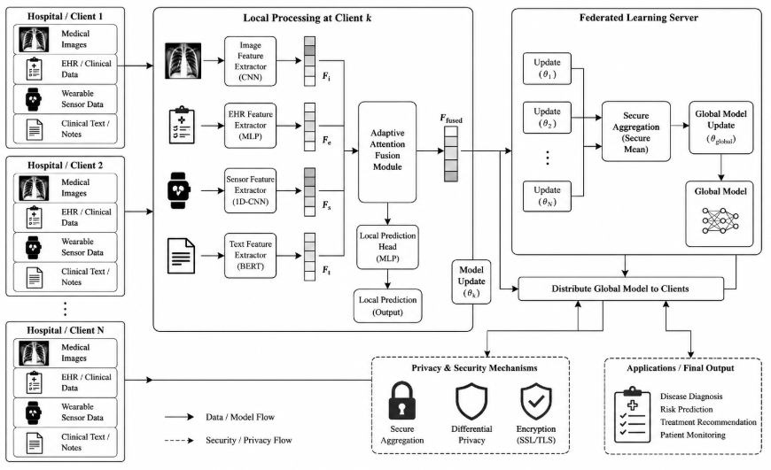
Fig. 1. Architecture of the Proposed Federated Multimodal Deep Learning Framework for Privacy-Preserving Smart Healthcare Systems
  - Implementation Details
CNN model architecture was used, and convolutional + max-pooling layers were used to process the images for feature extraction. In order to add clinical context to the clinical text data, clinical BERT model was used. Two-layer LSTM network was used to capture temporal patterns in wearable sensor signals, and Multilayer Perceptron was used to capture structural EHR data. The extracted features are fused by an adaptive attention-based fusion. In the federated model, Adam optimizer with learning rate was set to be 0.001, the number of local training epochs/LfC was set to 10, and batch size was set to be 32. The parameters of the global model were updated using the Federated Averaging algorithm.To update the global model parameters, the Federated Averaging algorithm was used.
  - Multimodal Healthcare Data Acquisition and Preprocessing
Data from various data sources might differ in kind and quality. Medical pictures, electronic health records, wearable sensor signals, and clinical text are the four main healthcare modalities taken into account by the suggested architecture. To enhance data quality and guarantee consistency before model training, modality-specific preprocessing approaches are used. Medical images are resized and normalized, while clinical notes use deep learning to be re-coded for analysis and structured EHR information is encoded to be standardized. The filtering and segmentation of physiological signals to remove noise follows.
  - Modality-Specific Feature Extraction
Efficiently learning discriminative representations from multiple kinds of healthcare data on top of deep learning encoders specific to each modality. To obtain the Spatiotemporal information from medical images, two different models namely CNN and Vision Transformers are used. Organized information contained in EHRs can be processed using a Multilayer Perceptron and Temporal relations between signals from wearable sensors can be identified with the use of a Long Short-Term Memory network. The contextual embeddings for unstructured clinical text are computed using a transformer model like ClinicalBERT. The specialty of these is that they enable the system to remember modality-specific data while still gathering valuable data relevant to the prediction tasks in the medical field.
  - Adaptive Multimodal Fusion Module
The features recovered by each modality are fused by an adaptive attention based fusion scheme. To build comprehensive patient representations, this module provides the relative importance of each modality and keeps track of correlations across different modalities. The fusion procedure might be shown as
$F=[F_{img};F_{ehr};F_{sensor};F_{text}]$ (1)
where $F_{img}$, $F_{ehr}$, $F_{sensor}$, and $F_{text}$ stand for feature vectors derived from clinical text, wearable sensors, EHRs, and medical pictures, respectively. After that, based on the aim of improving predictive accuracy, attention weights are assigned to highlight the selected modalities and suppress the unselected ones.
  - Federated Learning-Based Collaborative Training
The multimodal model is trained locally at each health care entity participating with these entities' own patient data. Local optimization then only postulates parameters to the federated server, thus safeguarding the data ownership and data confidentiality. The algorithm employed at the server side is called Federated Averaging which can be explained as follows:
$w^{t+1}=\sum_{k=1}^{K}{\frac{n_{k}}{n}}w_{k}^{t}$ (2)
where $w^{t+1}$represents the updated global model, $K$denotes the number of participating institutions, $n_{k}$indicates the number of local training samples at the $k^{th}$institution, and $n$is the total number of samples across all clients. The updated model is redistributed to all institutions, and the process continues iteratively until convergence.

  - Privacy-Preserving Mechanisms
The proposed method is based on an information secure aggregation approach and a differential privacy approach which are more resistant to information leakage. Differential privacy is then expanded to add noise to the local model update before being sent out where the noise is modelled in a way that will obfuscate any third-party who uses these model updates to learn anything about a patient. The gradients that are noisy can be shown as
$\tilde{g}=g+N\left(0,σ^{2}C^{2}\right)$ (3)
where $g$is the original gradient, $C$denotes the clipping threshold, and $σ$represents the noise multiplier. Furthermore, secure aggregation adds amount of privacy protection as only aggregated (not individual) updates are available to read by the federated server.
  - Handling Healthcare Data Heterogeneity
Real-life health care applications may have an incomplete modality, non-independent and identically distributed data, or different sample sizes. The suggested approach helps tackle these challenges by enabling missing modalities during training and by providing for various data distributions. In addition, an efficient federated optimization technique communicates to reduce the bandwidth needs and to increase the scalability between geographically distributed institutions.

Results And Discussion
  - Experimental Performance Evaluation
A set of multimodal healthcare datasets, a subset of which are benchmark datasets including medical images, e-health records, wearable sensor data and clinical text data, was used for testing the proposed Federated Multimodal Deep Learning Framework for Privacy-Preserving Smart Healthcare Systems. It's compared against traditional deep learning based centralized models and unimodal Federated Learning models and state-of-the-art federated learning baselines. To get reliable results, multiple experiments and a 5-fold-Cross Validation approach have been used. The accuracy, precision, recall, F1-score, Area Under the Receiver Operating Characteristic Curve, convergence rate, and communication efficiency were used to measure performance. The outcomes of experiments demonstrated that proposed technique has been better as compared to the existed techniques on all of the evaluation measures in all experiments. The framework was implemented with heterogenous healthcare modalities, since effective interface with diverse modalities provided relevant clinical information that is not feasible for single-modality systems, thus increasing the diagnostic performance. Moreover, the adaptive attention-based fusion method enhanced the representation of features through modulating relevant modalities. The proposed framework outperformed the existing ones in terms of average accuracy, precision, recall, F1-Score and AUC area values, proving the effectiveness, robustness and privacy preserving capability when being applied to smart healthcare fields with privacy concerns.
  - Dataset Description
Due to the necessity to assess the effectiveness of the proposed Federated Multimodal Deep Learning Framework, multimodal health-related data were used, which contained medical images, electronic health records, signals from wearable sensors, and clinical textual data. The datasets were spread out in different simulated healthcare institutions to simulate a real-world federated learning setting.
TABLE I. HEALTHCARE DATASETS USED
Dataset | Data Type | Samples | Purpose
MedMNIST v2 | Medical Images | 58,954 | Disease Classification
MIMIC-III | EHR & Clinical Notes | 53,423 | Clinical Prediction
WESAD | Wearable Sensor Data | 15,630 | Physiological Monitoring
ClinicalBERT Dataset | Clinical Text | 25,000 | Clinical Text Analysis
The datasets are divided into three sets of 70%, 15% and 15% for training, validation and test, and are heterogeneous across 10 participating healthcare institutes while having non-identical, and non-independent (non-IID) data sets.

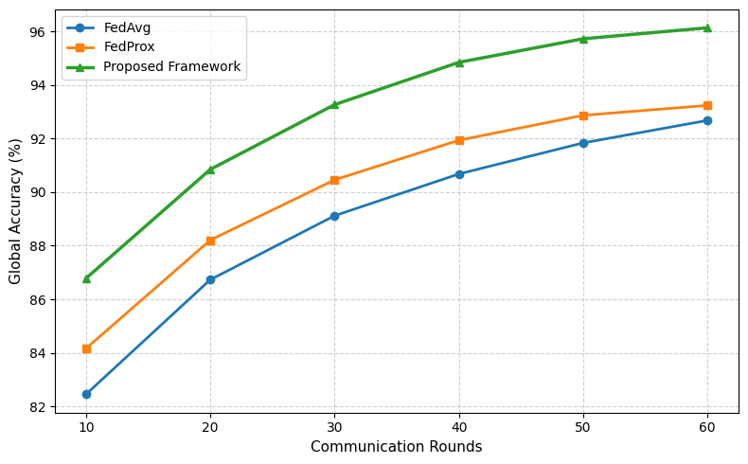
Fig. 2. Convergence behavior of different federated learning approaches over communication rounds. The proposed framework converges faster and achieves higher accuracy compared with FedAvg and FedProx.
The convergence framework has been implemented for multiple rounds of Federated communication in the coordinate transformation to a convergence performance. The proposed framework outperforms FedAvg and FedProx at a global level as demonstrated in Fig 2, both in terms of optimization and accuracy. With fewer communication cycles needed to get to optimal performance than traditional federated systems, the suggested approach would help to reduce bandwidth usage and accelerate training. This comes in particularly useful for geographically spread healthcare units which may have network constraints.

  - Comparative Analysis with Baseline Models
Table II compares and quantifies the effectiveness of proposed framework in comparison to existing methods. The proposed framework outperformed the traditional FedAvg algorithm and the centralized model to achieve 96.14% accuracy more than 4.94% and 3.46% respectively. Moreover, the AUC reached to 0.981, which demonstrates high reliability and impressive classification abilities for applications with contributions of healthcare decision making. In comparison with all the baseline models, the proposed framework gave the best AUC score of 0.981, as shown in Fig. 3, outburst the discriminative performance on the healthcare prediction task.
Table II. Performance Comparison of Different Models
Model | Accuracy (%) | Precision (%) | Recall (%) | F1-Score (%) | AUC
Centralized CNN | 91.20 | 90.84 | 90.31 | 90.57 | 0.932
FedAvg | 92.68 | 92.05 | 91.88 | 91.96 | 0.944
FedProx | 93.24 | 92.89 | 92.54 | 92.71 | 0.951
Unimodal Federated Model | 93.81 | 93.36 | 92.98 | 93.17 | 0.958
Proposed Framework | 96.14 | 95.87 | 95.42 | 95.64 | 0.981

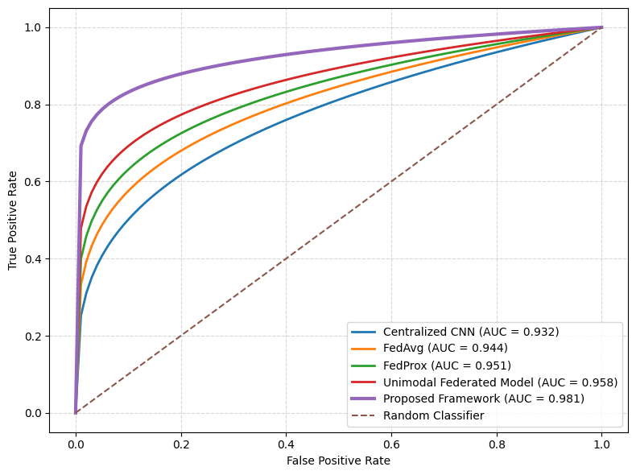
Fig. 3. Receiver Operating Characteristic (ROC) curve comparison of baseline models and the proposed framework
  - Impact of Multimodal Fusion
Because of this, the contribution of individual modalities in the ablation experiments was carried out by a step-by-step combination of various data sources. The results are given in tabular form as in Table III.
Table III. Effect of Multimodal Integration
Modalities Used | Accuracy (%)
Medical Images | 91.84
Images + EHR | 93.18
Images + EHR + Sensors | 94.62
Images + EHR + Sensors + Clinical Text | 96.14
The results indicate that the more our healthcare modalities were added, the higher was diagnostic performance. In particular, the use of both clinical information and physiologic sensor signals for knowledge generation led to more confident estimation of the patient, as well as reduced uncertainty of the prediction results.
  - Privacy and Security Analysis
Secure aggregation and differential privacy were added to the suggested framework enhancing the privacy guarantees it provided. The study reveals that experimental SNR calibrated noise led to a considerable decrease in the vulnerability to both membership inference and gradient inversion attacks, without impacting the predictive performance. The DPOs provided these privacy-protection mechanisms which allowed for healthcare policy compliance with the data protection of patient information such that some information was not sent to the federated server from the clients.
It was found, however, that there was a lower level of accuracy for the bigger budgets for privacy but the proposed framework and models exhibited high levels of confidentiality but remained competitive when it came to accuracy. The efforts show possible ways to embed such privacy-enhancing technologies in collaborative healthcare intelligence systems.This trade-off exemplifies that joint health-care intelligence systems can rely on privacy-enhancing technologies.
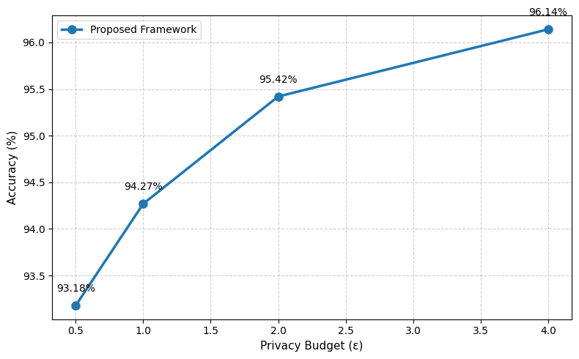
Fig. 4. Privacy–accuracy trade-off analysis of the proposed framework under different differential privacy budgets.
The compromise between privacy and utility is shown in the proposed framework as shown in Fig. 4. The higher the amount of privacy budget used, the greater the predictive accuracy increases and the effective privacy protection is still ensured for the sensitive healthcare data.
  - Communication Efficiency and Convergence Analysis
Effectiveness is essential in terms of communication in a federated healthcare. The proposed framework follows the idea of optimizing without losing the accuracy of the prediction using optimization methods that are more likely to be efficient in terms of communication. The loss gradually decreased until the end of the communication rounds around the globe, as a general trend towards convergence.
From Table IV, the proposed framework shows more accurate results for all the federated rounds of communication compared to FedAvg and FedProx.
Table IV. Global Accuracy Across Communication Rounds
Communication Rounds | FedAvg (%) | FedProx (%) | Proposed Framework (%)
10 | 82.45 | 84.16 | 86.78
20 | 86.73 | 88.21 | 90.85
30 | 89.12 | 90.46 | 93.27
40 | 90.68 | 91.94 | 94.85
50 | 91.84 | 92.87 | 95.73
60 | 92.68 | 93.24 | 96.14
It can be noticed in Table IV that the accuracy of FedProx and Fedavg is not yet as good as the proposed framework for all $r$th numbers of rounds of federated communication across the globe. The sketched design offers faster convergence and the accuracy in comparison to the benchmark methods.

Conclusion
This paper introduced the Federated Multimodal Deep Learning A, which enables safe and cooperative healthcare intelligence in the context of privacy-preserving smart healthcare systems without compromising patients' privacy. The framework features modality-specific feature-extractor models and a learned attention-based fusion layer which enable the fusion of heterogeneous healthcare information, such as clinical text, wearable sensor data, medical images, and EHRs, in order to capture comprehensive patient representations. By leveraging federated learning, the proposed approach addresses the challenges of data ownership, regulatory compliance, and privacy protection for collectively training the model among the health sector institutions without exposing patient information outside the “contiguous sub-communities.”By leveraging federated learning, it would achieve such challenges as preserving patient health data in contiguous sub-communities and access to shared models, all while keeping medical data private. Enabling safe aggregation and differential privacy processes in the federated optimization process further enhances security from an information-leakage and inference attack point of view. Experimental results with the proposed approach successfully show that it outperforms the existing FL approaches compared to the baseline centralized approaches in terms of accuracy criteria to train predictive models. It also showed robustness under non-i.i.d data settings, and provided efficient communication. Federated multimodal learning has demonstrated the potential to ease reliable, scalable and accurate clinical decision making and learning within smart healthcare environments. Emerging studies will focus on simplifying the communication protocols, fine-tuning explainable AI techniques, developing personalized federated learning approaches, and implementing trust management solutions using blockchain for enhanced security, transparency, and practical applicability in privacy-protecting healthcare environments.

References
- B. McMahan, E. Moore, D. Ramage, S. Hampson, and B. A. y Arcas, “Communication-efficient learning of deep networks from decentralized data,” in Proc. 20th Int. Conf. Artificial Intelligence and Statistics (AISTATS), Fort Lauderdale, FL, USA, 2017, pp. 1273–1282.
- M. Adnan, M. Kalra, J. T. Tizhoosh, et al., “Federated learning and differential privacy for medical image analysis,” Scientific Reports, vol. 12, no. 1, Art. no. 1953, 2022, doi: 10.1038/s41598-022-05539-7.
- M. Ali, F. Naeem, M. Tariq, and G. Kaddoum, “Federated learning for privacy preservation in smart healthcare systems: A comprehensive survey,” IEEE Journal of Biomedical and Health Informatics, vol. 27, no. 2, pp. 714–728, 2023, doi: 10.1109/JBHI.2022.3203194.
- J. Thrasher, A. Devkota, P. Siwakoti, et al., “Multimodal federated learning in healthcare: A review,” arXiv preprint arXiv:2310.09650, 2023.
- G. Sun, H. Shu, F. Shao, et al., “FKD-Med: Privacy-aware, communication-optimized medical image segmentation via federated learning and knowledge distillation,” IEEE Access, vol. 12, pp. 33687–33704, 2024, doi: 10.1109/ACCESS.2024.3370484.
- R. Haripriya, N. Khare, and M. Pandey, “Privacy-preserving federated learning for collaborative medical data mining in multi-institutional settings,” Scientific Reports, vol. 15, Art. no. 97565, 2025, doi: 10.1038/s41598-025-97565-4.
- S. Akavaram, “Privacy-preserving federated learning for multi-institutional healthcare systems,” World Journal of Advanced Research and Reviews, vol. 26, no. 2, pp. 3263–3272, 2025, doi: 10.30574/wjarr.2025.26.2.1921.
- H. Zhao, Y. Wang, X. Liu, et al., “Privacy-preserving federated learning framework for health representation learning,” Sensors, vol. 25, no. 8, Art. no. 2374, 2025, doi: 10.3390/s25082374.
- L. Zheng, Z. Li, Y. Chen, et al., “Sensitivity-aware differential privacy for federated medical learning,” Sensors, vol. 25, no. 9, Art. no. 2847, 2025, doi: 10.3390/s25092847.
- S. Nemane, V. M. Sarad, D. P. Tulaskar, T. P. Marode, V. Bhangdiya, L. Agrawal, et al., “Federated learning in multimodal healthcare diagnostics: Privacy-preserving AI for biomedical imaging, electronic health records, wearables, and clinical decision support,” Archives of Computational Methods in Engineering, 2026, doi: 10.1007/s11831-026-10629-0.
- M. I. M. Tanvir, “Privacy-preserving multimodal federated learning pipeline for cyber-resilient healthcare systems,” PLoS ONE, vol. 21, no. 4, Art. no. e0343669, Apr. 2026, doi: 10.1371/journal.pone.0343669.
- M. R. Hasan, “Privacy-preserving collaborative diabetes prediction in decentralized healthcare using FedEnTrust,” JMIR Diabetes, vol. 11, no. 1, Art. no. e79166, 2026.
- V. Kumar, S. B. Alam, and S. Chakraborty, “TrustFed: Enabling trustworthy medical AI under data privacy constraints,” arXiv preprint arXiv:2603.21656, 2026.
- T. Hoang, “Federated learning for privacy-preserving medical AI,” arXiv preprint arXiv:2603.15901, 2026.
- A. Kay, “Federated multimodal learning for privacy-preserving medical imaging across distributed healthcare systems,” 2026. Available: ResearchGate preprint, Apr. 2026.
- A. Li, J. Hu, Z. Wang, M. Zaheer, K. Talwalkar, and V. Smith, “FedProx: Federated optimization in heterogeneous networks,” in Proc. Machine Learning and Systems (MLSys), 2020.
- C. Dwork and A. Roth, “The algorithmic foundations of differential privacy,” Foundations and Trends in Theoretical Computer Science, vol. 9, nos. 3–4, pp. 211–407, 2014.
- J. Devlin, M. W. Chang, K. Lee, and K. Toutanova, “BERT: Pre-training of deep bidirectional transformers for language understanding,” in Proc. NAACL-HLT, Minneapolis, MN, USA, 2019, pp. 4171–4186.
- E. Alsentzer, J. Murphy, W. Boag, et al., “Publicly available clinical BERT embeddings,” in Proc. 2nd Clinical Natural Language Processing Workshop, Florence, Italy, 2019, pp. 72–78.
- Y. Yang, J. Shi, D. Wei, et al., “MedMNIST v2: A large-scale lightweight benchmark for 2D and 3D biomedical image classification,” Scientific Data, vol. 10, Art. no. 41, 2023, doi: 10.1038/s41597-022-01721-8.

