A Method for Enhancing Analog FPV Video Streams for Real-Time Object Detection Using YOLOv9

Amer Abu-Jassar
Department of Computer Science, College of Information Technology, Amman Arab University, Amman, Jordan
A.abujassar@aau.edu.jo

Maria Shishani
Department of Computer Science, College of Information Technology, Amman Arab University, Amman, Jordan
202521008@aau.edu.jo

Hani Attar
Faculty of Engineering, Zarqa University, Zarqa, Jordan / Faculty of Engineering University of Business and Technology, Jeddah, SA
hattar@zu.edu.jo

Mohamed Hafez
Faculty of Engineering FEQS, INTI-IU-University, Pathum Nilai, Malaysia / Faculty of Management, Shinawatra University, Thani, Thailand
mohdahmed.hafez@newinti.edu.my

Vladyslav Yevsieiev
Department CITARSE, Kharkiv National University of Radio Electronics, Kharkiv, Ukraine
vladyslav.yevsieiev@nure.ua

Vyacheslav Lyashenko
Department of Media Systems and Technology, Kharkiv National University of Radio Electronics, Kharkiv, Ukraine
viacheslav.liashenko@nure.ua

Abstract—The paper proposes and considers a method for improving the analog FPV video stream, which is generated and transmitted via a 5.8 GHz communication channel, for further real-time object recognition using the YOLOv9 neural network. The proposed approach is based on a multi-stage preprocessing pipeline. It includes noise reduction, interference compensation, brightness and contrast correction, deinterlacing, frame stabilization, motion blur compensation, resolution enhancement, and color normalization to improve the quality and informativeness of digitized FPV frames. Experiments were conducted using the BetaFPV Meteor 75 Pro FPV drone and the C03 FPV camera. The results obtained demonstrated an improvement in image quality, an increase in the level of detection confidence, and an increase in the number of successfully detected objects. In particular, the average contrast value increases by 45–50%, the detail and clarity of object boundaries increase, and YOLOv9's confidence in the correctness of detection increases by 23%. This confirms the effectiveness of the proposed method for the development of modern technologies in robotic systems based on computer vision in conditions of analog video signal transmission.
Index Terms—computer vision, FPV drone, modern technologies, object detection, preprocessing pipeline, robotic systems, video enhancement, YOLOv9

Introduction
The modern development of FPV drones leads to a growing need for the implementation of intelligent control systems capable of performing automatic detection, recognition and tracking of objects in real time [1, 2], where various methods and approaches can be used [3-7]. This contributes to the expanded application of modern technologies in robotic systems. However, despite the widespread use of analog FPV cameras and 5.8 GHz video channels due to their low data transmission latency, the quality of the received video stream still significantly deteriorates under the influence of noise, interference, artifacts and limited resolution [8, 9]. This leads to a decrease in the efficiency of data analysis based on computer vision algorithms, in particular, neural networks of the YOLO family. It requires high-quality and informative input data to ensure high accuracy of object detection [10, 11]. In this regard, it is necessary to develop specialized methods for processing analog video signals aimed at increasing the in formativeness of digital images before their submission to identification systems [12]. This provides the creation of prerequisites for increasing the reliability, accuracy and autonomy of the corresponding intelligent control systems in the conditions of their real operation, the development of modern technologies, and the formation of the latest robotic systems.
At the same time, the analysis of scientific publications devoted to the issues of object detection, digital video processing, navigation of unmanned systems and the application of neural network algorithms allows us to consider existing scientific approaches, identify their advantages and limitations. This also makes it possible to substantiate the feasibility of developing a method for improving analog FPV video streams for identification systems based on neural networks as one of the leading and promising tools, in particular, based on YOLOv9.
For example, in the study [13], an intelligent drone patrol system using real-time object detection and GPS route adaptation was proposed. However, this solution is not focused on processing analog 5.8 GHz FPV video signals, so it is difficult to directly use it to improve the quality of the input image in conditions of noise, banding, interlacing, and digitization artifacts.
O. Malyi, S. Harachuk and O. Shchukin generalize methods of wireless detection and digital processing of analog video signals using a microcontroller with a built-in ADC [14]. This makes it possible to implement the primary conversion of an analog signal into a digital form. However, this does not completely solve the problem of forming a high-quality video stream for neural network detection, since it does not contain a complex preprocessing pipeline model for noise removal, deinterlacing, frame stabilization, etc.
L. Wu, Z. McKendrick, and J. Zhao investigate virtual cameras for live streaming in virtual reality environments, which improves the presentation of visual information and user interaction with video content [15]. However, this cannot be directly applied to FPV drones with an analog transmission channel.
Jr. R. Stephenson, D. Truong, and B. D. Pan analyze the impact of First-Person View integration on operator workload and situational awareness in small unmanned aircraft systems [16]. This contributes to the assessment of the role of the FPV interface in improving control efficiency. However, this approach does not consider methods for digitally enhancing the analog video stream for automatic object identification. It limits the possibility of further signal processing by a neural network, in particular YOLOv9.
F. M. P. Vieira and J. P. S. Cunha define modern methods of synchronization of multimodal physiological data streams. It makes it possible to increase the coherence of heterogeneous signals in time [17]. However, such a study does not take into account the specifics of the analog video channel of an FPV drone, so the results obtained can be used only partially for the idea of temporal stabilization, but not for the full restoration of the quality of video frames.
In [18], a computer vision system for a small-sized mobile humanoid robot in a smart environment is defined. It makes it possible to increase the efficiency of visual perception of the robotic platform. However, the proposed solution is focused on a ground robotic system and does not take into account the features of FPV drones.
The study [19] provides an overview of the development, problems and prospects of vision-and-language navigation for UAVs. This makes it possible to systematize modern approaches to drone navigation based on visual information and voice commands. However, such an analysis is of an overview nature and does not offer a specialized method for processing analog FPV video before neural network detection.
The authors of the work [20] propose an SDR system for detecting and characterizing drone RF signatures in real time. This makes it possible to carry out radio frequency monitoring and classify UAVs by their radiation. However, this solution works with RF signatures and spectrograms, and not with the video stream of the FPV camera. It is critical for video object identification systems.
M. Șorecău, E. Șorecău and P. Bechet propose a broadband drone radiation monitoring system based on SDR and RFNoC architecture [21]. However, this solution is focused on spectral monitoring and radiation source detection, not on improving analog video imaging.
In [22], a benchmark for event-based SLAM in high-speed maneuver scenarios was investigated. This makes it possible to evaluate the performance of visual odometry and SLAM systems under conditions of fast motion, complex lighting, and aggressive dynamics. This approach is based on event-based cameras and specialized sensors, while the study of analog FPV video involves working with a conventional analog video signal, so the method cannot be directly transferred to the task of restoring frames from a Video Receiver before YOLOv9.
Thus, modern research is actively developing the areas of autonomous drone navigation, FPV interfaces, computer vision, SDR monitoring, data stream synchronization, and event-based perception. However, the considered works did not sufficiently investigate the problem of complex processing of analog FPV video signal 5.8 GHz, as the simplest and most common signal source, for further object recognition by neural networks, in particular YOLOv9. This confirms the feasibility of developing a method for improving the digitization of FPV images. It should combine noise reduction, contrast correction, deinterlacing, frame stabilization, blur compensation, increasing the effective resolution, and adapting the neural network to the real conditions of the analog video channel.

Mathematical Description Of The Proposed Approach
To implement the proposed approach, we will consider a mathematical description of such an approach in the form of a certain sequence of steps, namely: frame capture, quality assessment, signal restoration, stabilization, increasing information content, and adapting the model to real FPV video for further object recognition in YOLOv9. YOLOv9 [23] was chosen as the basic model for object detection, since it represents one of the most modern and most researched architectures of the YOLO family, which provides high accuracy of object detection through the use of the Programmable Gradient Information (PGI) and Generalized Efficient Layer Aggregation Network (GELAN) mechanisms.
Step 1. Analog FPV signal capture model. This is necessary to take into account that the frame from the Video Receiver is not a “pure” digital image [24], but the result of transmitting an analog 5.8 GHz signal:
$I_{0}\left(x,y,t\right)=D\{A[S\left(x,y,t\right)+n_{a}\left(x,y,t\right)+m(x,y,t)]\}$, | (1)
where: $I_{0}\left(x,y,t\right)$ – digital frame after capture from Video Receiver; $S\left(x,y,t\right)$ – useful video signal from FPV camera; $n_{a}\left(x,y,t\right)$ – analog noise; $m(x,y,t)$ – distortion of 5.8 GHz radio channel; $A[∙]$ – transmission via analog channel; $D\{∙\}$ – digitization process via USB/Type-C capture module; $x,y$ – pixel coordinates; t– frame number in time.
Step 2. Assessing the quality of the input frame. This is necessary to assess how noisy, dark, blurry, or damaged the frame is before processing, and to adaptively change the filtering strength:
$Q_{t}=w_{1}C_{t}+w_{2}S_{t}+w_{3}B_{t}+w_{4}R_{t}$, | (2)
where: $Q_{t}$ – frame quality at time $t$; $C_{t}$ – contrast ratio ($C_{t}=σ\left(I_{o}\right)$, where $σ\left(I_{o}\right)$ – standard deviation of frame brightness); $S_{t}$ – sharpness score ($S_{t}$=$Var(∇^{2}I_{0})$, where: $Var(∇^{2}I_{0})$ – frame Laplacian variance) [25]; $B_{t}$ – brightness stability; $R_{t}$ – frame regularity level without gaps and stripes; $w_{1},…,w_{4}$ – parameter significance weighting factors.
Step 3. Filtering random noise and “snow”. This is necessary to solve the problem of removing random noise that occurs due to an analog channel, radio interference, a weak signal or its poor reception:
$I_{1}\left(x,y,t\right)=\frac{1}{W}\sum_{\left(i,j\right)∈Ω}{G_{σ_{s}}(i,j)∙G_{σ_{r}}(I_{0}\left(x,y,t\right) -{-I}_{0}(i,j,t)){∙I}_{o}(i,j,t}$), | (3)
where: $I_{1}\left(x,y,t\right)$ – the value of the pixel of the original image after noise reduction at the point $(x,y)$ at time $t$; $I_{o}(i,j,t)$ – the value of the neighboring pixel in the analysis area $Ω$; $(x,y)$ – the coordinates of the central pixel to be processed; $(i,j)$ – the coordinates of neighboring pixels within the local processing window; $Ω$ – the local area around the central pixel; $G_{σ_{s}}(i,j)$ – the spatial Gaussian weighting function, which determines the influence of the neighboring pixel depending on its distance from the central pixel; $σ_{s}$ – the spatial smoothing parameter; $G_{σ_{r}}(I_{0}\left(x,y,t\right)-I_{0}(i,j,t))$ – the photometric Gaussian weighting function, which estimates the similarity of brightness or colors between the central and neighboring pixels; $σ_{r}$ – the intensity smoothing parameter; $W$ is a normalization coefficient that ensures correct scaling of the result and is calculated as the sum of all weight coefficients.
Step 4. Removing streaks, flicker, and periodic noise. This is necessary to enable YOLOv9’s ability to perceive artifacts as part of the object [26]:
$I_{2}\left(x,y,t\right)=I_{1}\left(x,y,t\right)-L\left(x,y,t\right)+μ_{t}$, | (4)
where: $I_{2}$ – frame after banding compensation; $L\left(x,y,t\right)$ – slow component of illumination or background unevenness; $μ_{t}$ – average brightness of the frame.
Step 5. Contrast and brightness correction, which makes it possible to increase the visibility of objects in the frame, especially with signal attenuation, illumination, dark areas or low contrast:
$$I_{3}\left(x,y,t\right)=255{\left(\frac{I_{2}(x,y,t)}{255}\right)}^{γ},$$ | (5)
where: $I_{3}$ – frame after brightness correction; γ – gamma correction coefficient, if $γ<1$, the image is brightened, $γ>1$ is darkened accordingly.
Step 6. Deinterlacing of analog video [27], allows us to eliminate interlacing, which creates “combs” on moving objects and distorts contours. It consists of a model of dividing the frame into fields:
$F_{even}\left(x,y,t\right)=I_{3}(x,2y,t)$, | (6)
$F_{odd}\left(x,y,t\right)=I_{3}(x,2y+1,t)$, | (6)
where: $F_{even}$ – even field of the frame; $F_{odd}$ – odd field of the frame,
and the progressive frame recovery model required to obtain a complete frame without motion artifacts:
$I_{4}\left(x,y,t\right)=α{\hat{F}}_{even}\left(x,y,t\right)+(1-α){\hat{F}}_{odd}(x,y,t)$, | (7)
where: $I_{4}$ – frame after deinterlacing; ${\hat{F}}_{even},{\hat{F}}_{odd}$ – interpolated fields; $α$ – field mixing coefficient.
Step 7. Stabilization of the frame in time, required to reduce video jitter and increase the stability of YOLOv9 detection. Consists of an interframe transformation model:
$p_{t}=H_{t}p_{t-1}$, | (8)
where: $p_{t}={[x,y,1]}^{T}$ – coordinates of a point in the current frame; $p_{t-1}$ – coordinates of this point in the previous frame; $H_{t}$ – matrix of homography or affine transformation,
and frame stabilization model:
$I_{5}\left(x,y,t\right)=Warp(I_{4}\left(x,y,t\right),H_{t}^{-1})$, | (9)
where: $I_{5}$ – stabilized frame; $Warp(∙)$ – geometric transformation of the frame.
Step 8. Motion blur compensation [28], which is needed to account for the fact that objects can be blurred during FPV drone flight due to rapid movement, vibrations, or insufficient camera exposure. Consists of a blur model:
$I_{5}\left(x,y,t\right)=K\left(x,y\right)*I_{sharp}\left(x,y,t\right)+n(x,y,t)$, | (10)
where: $I_{5}$ – blurred frame; $K\left(x,y\right)$ – blur kernel; $I_{sharp}$ – ideal sharp frame; $n(x,y,t)$ – noise; $*$ – convolution operation,
and recovery models:
$I_{6}=arg\min_{I}{{\left\|K*I-I_{5}\right\|}^{2}+λR(I)}$, | (11)
where: $I_{6}$ – restored frame; $λ$ – regularization coefficient; $R(I)$ – smoothing or/and contour preservation function.
Step 9. Super-resolution model, which is needed to take into account that the analog FPV camera has low real detail, so small objects occupy few pixels [29]:
$I_{7}=SR(I_{6},θ_{SR})$, | (12)
where: $I_{7}$ – high-resolution frame; $SR(∙)$ – super-resolution model; $θ_{SR}$ – parameters of the reconstruction model.
Step 10. Color normalization and conversion to YOLOv9 format, which is necessary for stabilizing the RGB image. In this case, analog FPV video usually has color shift, incorrect brightness and unstable white balance. Consists of the following components:
– color normalization models:
$$I_{8}^{c}\left(x,y,t\right)=\frac{I_{7}^{c}\left(x,y,t\right)-μ_{c}}{σ_{c}},$$ | (13)
where: $I_{8}^{c}$ – normalized color channel; $c∈\{R,G,B\}$; $μ_{c}$ – average value of the channel; $σ_{c}$ – standard deviation of the channel,
– reduction to YOLO format:
$I_{YOLO}=Resize(Pad\left(I_{8}\right),W_{in},H_{in})$, | (14)
where: $I_{YOLO}$ – input frame for YOLOv9; $W_{in},H_{in}$ – model input size, for example 640×640; $Pad(∙)$ – frame padding without aspect ratio distortion; $I_{8}$ – pre-processed frame after passing all stages of video signal quality improvement, including noise reduction, contrast correction, deinterlacing, frame stabilization, blur compensation and color normalization; $Resize(∙)$ – frame scaling operation to fixed dimensions supported by the YOLOv9 model.
Step 11. Adaptive control model of preprocessing pipeline, which allows to take into account that the quality of analog FPV signal changes over time, therefore the same filtering parameters are not always effective. It is necessary to automatically change the processing power depending on the state of the frame:
$Θ_{t}=f(Q_{t},σ_{n},C_{t},S_{t})$, | (15)
where: $Θ_{t}$ – set of processing parameters for frame $t$; $Q_{t}$ – integral quality of the frame; $σ_{n}$ – noise estimate; $C_{t}$ – contrast; $S_{t}$ – sharpness.
Step 12. Temporal stabilization of YOLOv9 results. This takes into account the instability of the analog signal: YOLOv9 can detect an object in one frame and lose it in the next. Therefore, it is necessary to smooth the detection results in time. The model for stabilizing YOLOv9 results consists of
– confidence smoothing model:
${\overline{p}}_{i}\left(t\right)=βp_{i}\left(t\right)+(1+β){\overline{p}}_{i}(t-1)$, | (16)
where: ${\overline{p}}_{i}\left(t\right)$ – smoothed confidence of the model; $p_{i}\left(t\right)$ – current confidence; $β$ – update coefficient,
– bounding box stabilization model:
${\overline{b}}_{i}(t)=βb_{i}\left(t\right)+(1-β){\overline{b}}_{i}(t-1)$, | (17)
where: ${\overline{b}}_{i}(t)$ – stabilized frame of the object; $b_{i}\left(t\right)$ – current frame.
Step 13. Adaptation of YOLOv9 to real FPV video, which takes into account that after preprocessing the model may work unstable if it was trained on pure digital images. Therefore, it is necessary to train the model on frames from BetaFPV Meteor 75 Pro + C03 FPV Camera + Video Receiver. Consists of the following components:
– domain adaptation models:
$D_{s}≠D_{t}$, | (18)
where: $D_{s}$ – training dataset with pure digital images; $D_{t}$ – real dataset from analog FPV video,
– adaptation goal conditions:
$$\min_{θ_{y}}\left[L_{det}\left(D_{t},θ_{y}\right)+λL_{aug}\left(D_{s},D_{t}\right)\right],$$ | (19)
where: $L_{det}$ – YOLOv9 detection loss function; $L_{aug}$ – losses associated with augmentation and approximation of clean data to the analog FPV domain; $λ$ – domain adaptation influence coefficient.
Thus, the generalized model assumes the transmission and digitization of the primary analog signal, its subsequent filtering, contrast correction, deinterlacing with frame stabilization, blur compensation, super-resolution with subsequent data normalization in the format and preparation for further processing using YOLOv9.
At the same time, the proposed method allows us to build a software pipeline in which the frame from the Video Receiver is first captured via cv2.VideoCapture, then undergoes sequential processing using OpenCV, and then is transferred to the YOLOv9 model via the Ultralytics library. The main idea of this approach is not only to launch the neural network, but also to pre-restore the informativeness of the analog FPV frame. This allows us to reduce the impact of noise, stripes, interlacing, blur, unstable brightness and low detail, which directly increases the accuracy and stability of object identification.

Experimental Research And Analysis Of The Obtained Results
The purpose of the experiment is to study the effectiveness of the developed method for improving the digitization of an analog FPV video signal by comparing the characteristics of the original and processed video streams with subsequent identification of objects using the YOLOv9 neural network.
Hardware: FPV drone BataFPV Meteor 75pro with a C03 FPV camera; Video Reciver module connected to a PC via Type-C; Microsoft Surface Pro 9 PC with the following characteristics: CPU Intel Core i7-1255U, RAM 32 GB LPDDR5, GPU Intel Iris Xe.
Software: OS Windows 11, Python programming language, and PyCharm 2025.3.1.1 development environment with the ability to transfer to EDGE devices.
An example of a raw video stream Raw Video Stream (RAW) and a processed video stream (Processed+YOLOv9) by the proposed method from C03 FPV cameras on an FPV drone is presented in Fig. 1.
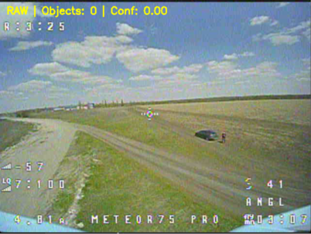
а) frame from RAW stream

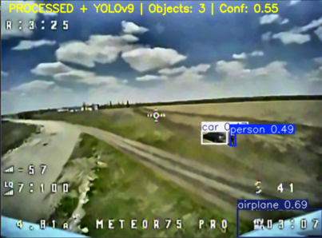
b) frame from Processed+YOLOv9 stream

Fig. 1 Example of comparison of processed and unprocessed frame from video stream from C03 FPV camera

The obtained experimental results in the form of graphs comparing individual video stream parameters of the digitized analog FPV video signal (Processed+YOLOv9) with the raw (RAW) are presented in Fig. 2–7.
Data analysis Fig. 2 shows that the average brightness of the output video stream is within 138–146 units with sharp outliers to 188 and 216 units in the range of 28–33 frames. This indicates the instability of the analog signal and the presence of transmission artifacts. After applying the preprocessing from the proposed approach, the average brightness stabilizes at 115–118 units, and the amplitude of oscillations decreases by more than 4 times. In general, this creates more stable conditions for further data processing based on YOLOv9.
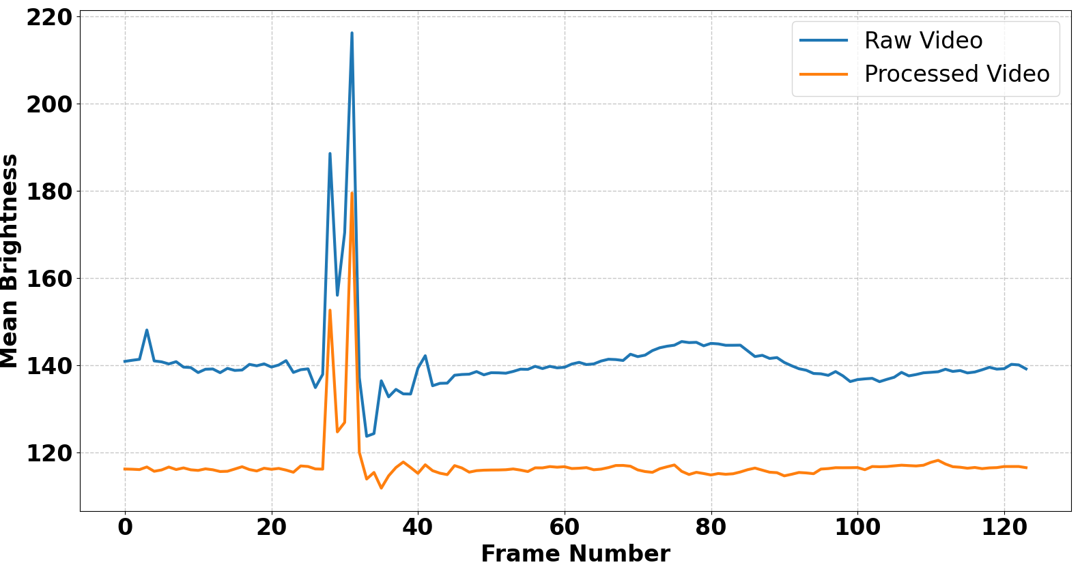
Fig. 2. Brightness Comparison Before and After FPV Preprocessing
The data in Fig. 3 shows that after processing the average contrast value increases from approximately 31–33 to 44–47 units, i.e. by almost 45–50%. This indicates a significant increase in local detail and improved visual separation of objects and background.
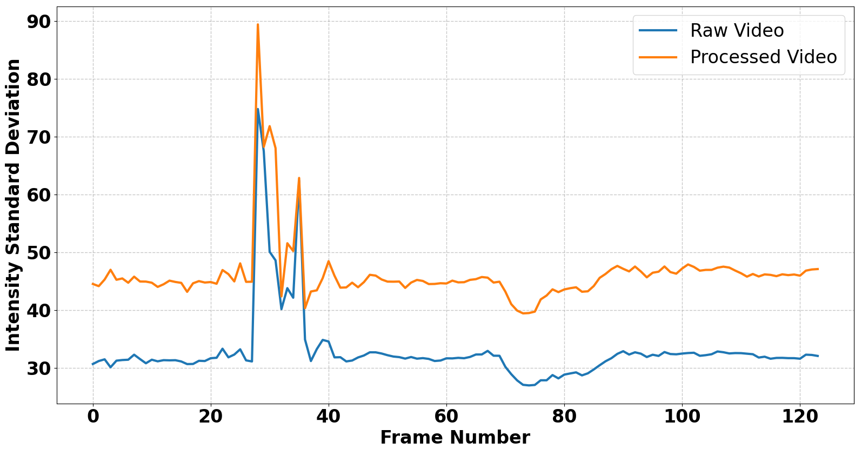
Fig. 3. Contrast Comparison Before and After FPV Preprocessing
Analysis of the change in the level of high-frequency noise shows (Fig. 4) that for most frames the value of the noise component after processing remains within 6–8 units and is comparable to the original video stream. At the same time, an increase in the amplitude of individual peaks to 25–26 units is observed in the zone of intensive improvement of contours and detail. Thus, the proposed method not only performs noise reduction, but also enhances the high-frequency components of the image, necessary for increasing the sharpness and contrast of objects.

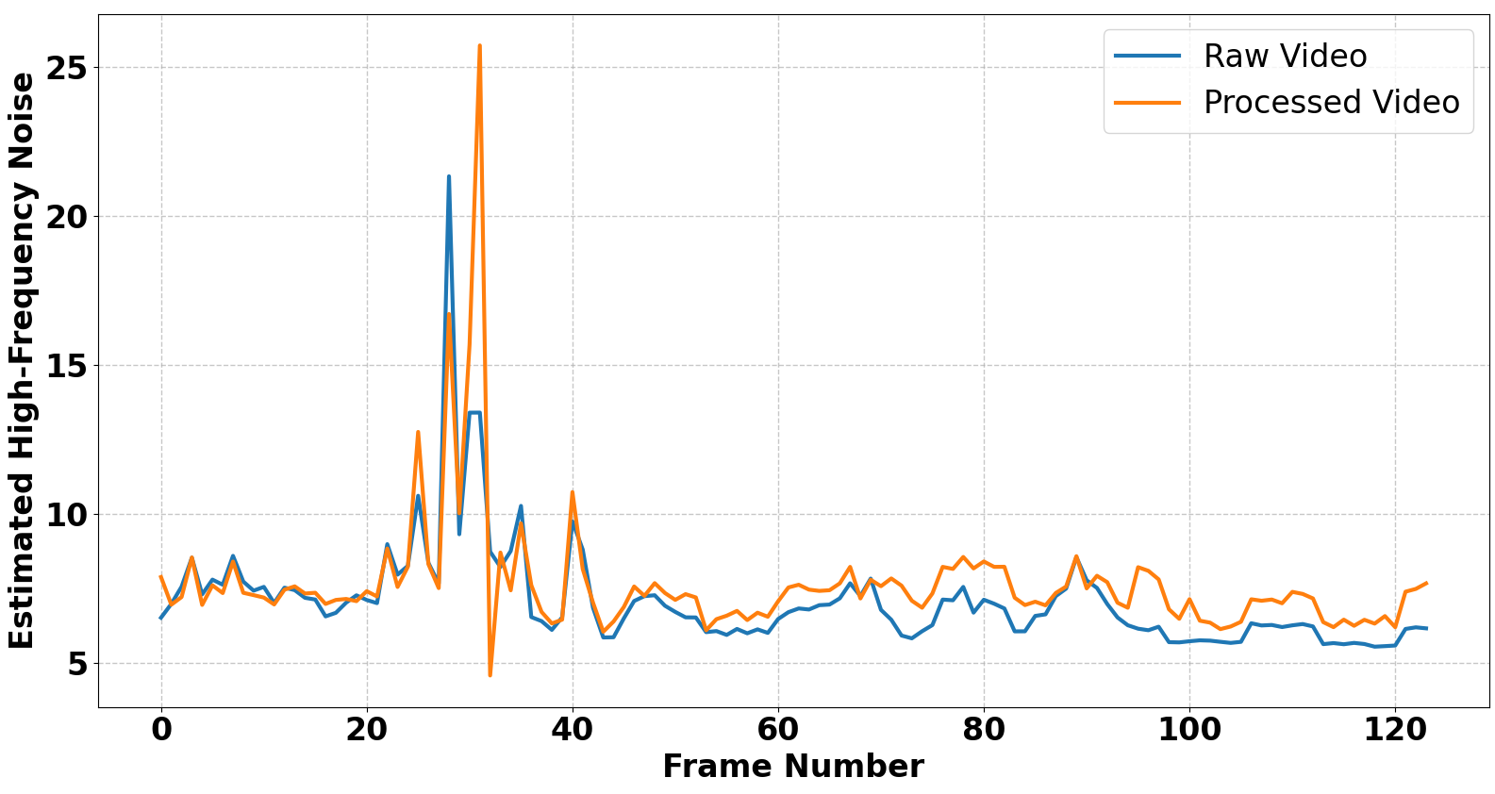
Fig. 4. Noise Level Comparison Before and After FPV Preprocessing
According to the data in Fig. 5, it is seen that after applying the proposed method for preprocessing video data, the number of successfully detected objects increases throughout the entire video stream. That is, the obtained results indicate an increase in the sensitivity of the YOLOv9-based identification system to the informative features of objects after digital processing of the analog FPV video signal. This confirms the effectiveness of the proposed method for improving the quality of detection and recognition.
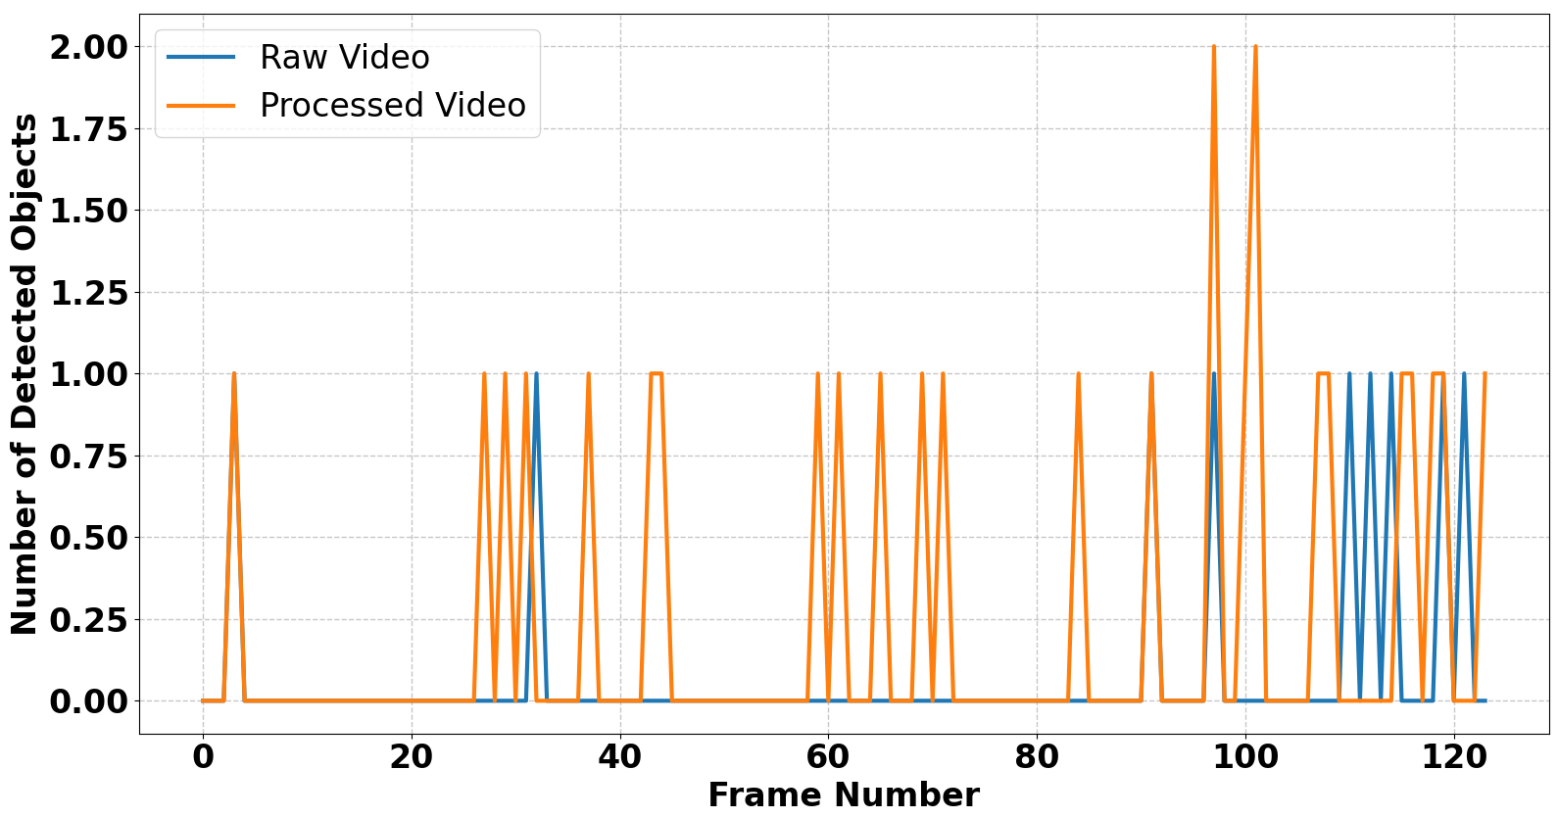
Fig. 5. YOLOv9 Detection Count Comparison
At the same time, the analysis of the average confidence score (Fig. 6) shows that after applying the developed method, the maximum confidence of YOLOv9 in the correctness of detection increases from approximately 0.52 to 0.64. This corresponds to an increase of almost 23%, and the number of frames with non-zero confidence values increases significantly throughout the video sequence. The obtained results indicate that the preliminary digital processing of the analog FPV video signal provides the formation of more informative features of objects, as a result of which the YOLOv9 neural network performs more confident and stable recognition.
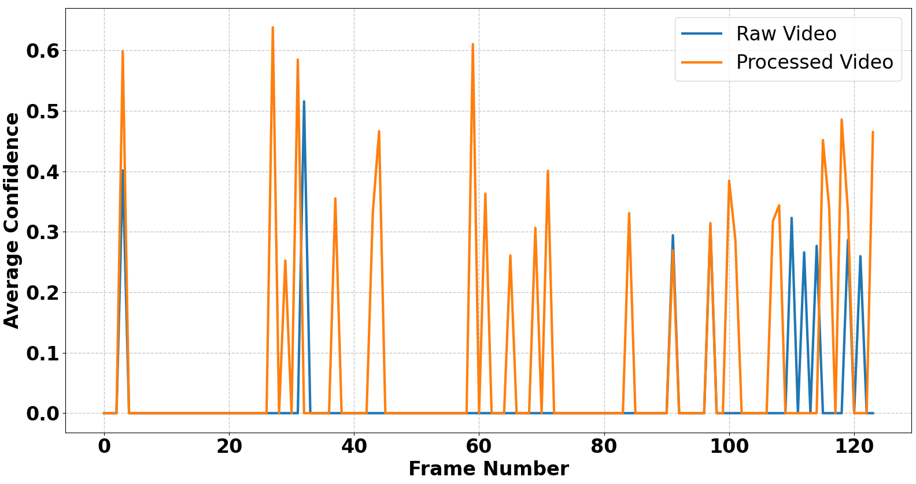
Fig. 6. YOLOv9 Confidence Comparison

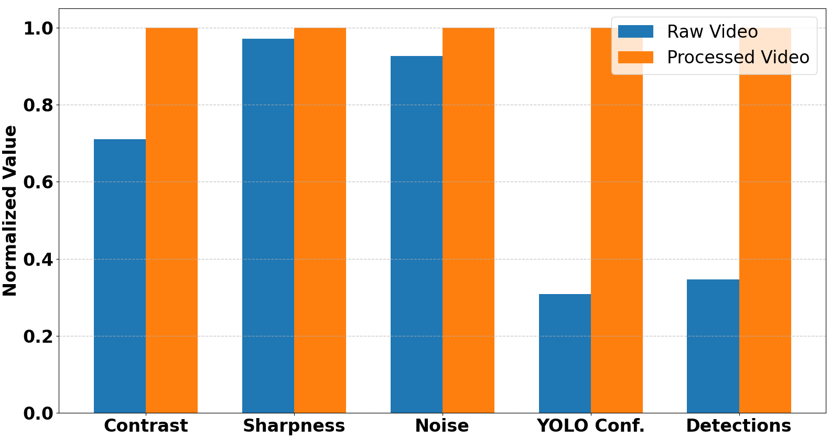
Fig. 7. Normalized Summary of FPV Video Enhancement Results
At the same time, the analysis of the integral normalized estimate (Fig. 7) shows that after applying the proposed method, all the studied indicators reach the maximum normalized level, while for the original video stream the contrast value is about 0.71, sharpness 0.97, noise component 0.93, average YOLOv9 confidence only 0.30 and the number of detections is about 0.32.

Conclusion
The paper develops a method for improving the analog FPV video stream transmitted over a 5.8 GHz communication channel for further real-time object identification using the YOLOv9 neural network. The results obtained show that the greatest positive effect is achieved precisely for object identification indicators, where the confidence score value increases more than threefold, and the number of successful detections increases by approximately 3.1 times. This confirms the effectiveness of the proposed method for digital processing of analog FPV video signals for recognition systems based on YOLOv9. Promising areas of further research include the development of adaptive preprocessing algorithms based on artificial intelligence, the integration of modern super-resolution models, and the implementation of the method on EDGE platforms in real time.

References
M. Donelli, S. Menon, V. Mulloni, G. Marchi, and I. Dal Chiele, “A Light and Compact Circular Polarized Antenna for First-Person-View (FPV) Drones,” Electronics, vol. 15, no. 6, ID Article 1150, 2026. doi: 10.3390/electronics15061150.
- M. T. Yoldar, B. Ünver, S. Özkan, and M. Köklü, “A telemetry-augmented kalman filter for real-time FPV-to-FPV drone interception,” Aerospace Science and Technology, vol. 177, Part A, ID Article 112202, 2026. doi: 10.1016/j.ast.2026.112202.
- Y. M. Al-Sharo, A. T. Abu-Jassar, S. Sotnik, and V. Lyashenko, “Neural networks as a tool for pattern recognition of fasteners,” International Journal of Engineering Trends and Technology, vol. 69, no. 10, pp. 151-160, 2021. doi: 10.14445/22315381/IJETT-V69I10P219.
- M. A. Ahmad, J. H. Baker, I. Tvoroshenko, and V. Lyashenko, “Computational complexity of the accessory function setting mechanism in fuzzy intellectual systems,” International Journal of Advanced Trends in Computer Science and Engineering, vol. 8, no. 5, pp. 2370-2377, 2019. doi: 10.30534/ijatcse/2019/77852019.
- X. Zhou, J. Kan, N. F. L. M. Rosely, X. Duan, J Cai, and Z. Zhou, “ILN-YOLOv8: A Lightweight Image Recognition Model for Crimped Wire Connectors,” IEEE Access, vol. 13, pp. 5193-5202, 2025. doi: 10.1109/ACCESS.2025.3525564.
R. Matarneh, S. Maksymova, Z. Deineko, and V. Lyashenko, “Building robot voice control training methodology using artificial neural net,” International Journal of Civil Engineering and Technology, vol. 8, no. 10, pp. 523-532, 2017.
- H. Attar, A. T. Abu-Jassar, A. Amer, V. Lyashenko, V. Yevsieiev, and M. R. Khosravi, “Control system development and implementation of a CNC laser engraver for environmental use with remote imaging,” Computational intelligence and neuroscience, vol. 2022, no. 1, ID 9140156, 2022. doi: 10.1155/2022/9140156.
- A. K. Sharma, R. K., Panigrahi, and P. K. Sharma, P. K. “Computational Analysis and Material Optimization of Protective Cage Structures Against FPV Kamikaze Drone Delivered Explosive Payloads,” In Journal of Physics: Conference Series, vol. 3196,no. 1, pp. 012061, 2026. doi: 10.1088/1742-6596/3196/1/012061.
- S. Baidachnyi, and et al., “Automated Terminal Guidance for Low-Cost Drone-to-Drone Interception,” In 2026 IEEE International Systems Conference (SysCon), pp. 1-7, 2026. doi: 10.1109/SysCon66367.2026.11503605.
- C. Lv, W. Zhou, Y. Li, Y. Song, and X. Zhang, “Research on a Lightweight YOLOv9 Object Detection Algorithm Fused with Adaptive Gated Coordinate Attention,” Mathematics, vol. 14, no. 10, ID 1738, 2026. https://doi.org/10.3390/math14101738.
- A. Lahmdani, A. Elboushaki, and S. Saoud, “Targeted detection of plant disease infection levels using YOLOv8 and YOLOv9 for agricultural monitoring and public healthcare support,” Discover Artificial Intelligence, vol. 6, ID 258, 2026. doi: 10.1007/s44163-026-00841-z.
- S. F. A. Shah, M. Q. Khan, A. A. Alsuwaylimi, and L. A. Alenezi, “A Two-Stage Spatiotemporal CNN-YOLOv9 Framework for High-Precision Real-Time Abandoned Object Detection in Public Surveillance Videos,” IEEE Access, vol. 14, pp. 35983–35997, 2026. doi: 10.1109/ACCESS.2026.3669588.
- G. V. Narayana, S. P. Swain, D. Pattnayak, M. R. Pradhan, and P. A. Krishna, “Intelligent Drone Patrolling with Real-Time Object Detection and GPS-Based Path Adaptation,” Engineering Proceedings, vol. 124, no. 1, ID 82, 2026. doi: 10.3390/engproc2026124082.
- O. Malyi, S. Harachuk, and O. Shchukin, “Methods for Over-the-Air Detection and Digital Processing of Wireless Analog Video Signals Using a Microcontroller with Built-in ADC,” In 2026 IEEE 18th International Conference on Advanced Trends in Radioelectronics, Telecommunications and Computer Engineering (TCSET), pp. 1-6, 2026. doi: 10.1109/TCSET65181.2026.11461112.
- L. Wu, Z. McKendrick, and J. Zhao, “Stories for I, They and You: Exploring In-situ Virtual Camera Setups for Live Streaming in Virtual Reality,” In Proceedings of the 2026 CHI Conference on Human Factors in Computing Systems, pp. 1-17, 2026. doi: 10.1145/3772318.3790858.
- Jr. R. Stephenson, D. Truong, and B. D. Pan, “A Systems Perspective on Enhancing Operator Workload and Situational Awareness in Small Unmanned Aircraft Systems Through First-Person View Integration,” Systems, vol. 14, no. 2, ID 167, 2026. doi:10.3390/systems14020167.
- F. M. P. Vieira, and J. P. S. Cunha, “Synchronization of Multimodal Physiological Data Streams: State-of-the-Art, Trends, and Future Challenges,” IEEE Access, vol. 12, pp. 70200–70223, 2026. doi: 10.1109/ACCESS.2026.3691002.
- A. T. Abu-Jassar, H. Attar, A. Amer, V. Lyashenko, V. Yevsieiev, and A. Solyman, “Development and investigation of vision system for a small-sized mobile humanoid robot in a smart environment,” International Journal of Crowd Science, vol. 9, no. (1), pp. 29-43, 2025. doi: 10.26599/IJCS.2023.9100018.
- H. Chen, and et al., “Vision-and-Language Navigation for UAVs: Progress, Challenges, and a Research Roadmap,” arXiv preprint, arXiv:2604.13654, 2026. doi: 10.48550/arXiv.2604.13654.
- M. Saber, and et al., “Design and development of an SDR-based system for real-time detection and characterization of drone RF signatures,” Scientific Reports, 2026. doi: 10.1038/s41598-026-48925-1.
- M. Șorecău, E. Șorecău, and P. Bechet, “Wideband Monitoring System of Drone Emissions Based on SDR Technology with RFNoC Architecture,” Drones, vol. 10, no. 2, ID 117, 2026. doi: 10.3390/drones10020117.
- S. Zhong, and et al., “Event-based SLAM Benchmark for High-Speed Maneuvers,” arXiv preprint, arXiv:2604.24033, 2026. doi: 10.48550/arXiv.2604.24033.
- M. Yaseen, “What is YOLOv9: An in-depth exploration of the internal features of the next-generation object detector,” arXiv preprint, arXiv:2409.07813, 2024. doi: 10.48550/arXiv.2409.07813.
- K. Chaiyawong, and S. Akatimagool, “Development of 5.8 GHz SWR Meter for Testing Telecommunication Systems,” In 2019 6th International Conference on Technical Education (ICTechEd6), pp. 1-4, 2019. doi: 10.1109/ICTechEd6.2019.8790892.
- S. Gurappa, T. Satharasi, Y. Hariprasad, and S. S. Iyengar, “MedSR-Vision: Deep Learning Framework for Multi-Domain Medical Image Super-Resolution,” arXiv preprint, arXiv:2605.03343, 2026. doi: 10.48550/arXiv.2605.03343.
- Z. Fei, R. Zhao, K. Xin, G. Chen, and X. Xiang, “Defect detection of ceramic substrates based on improved YOLOv9 algorithm,” International Journal of Machine Learning and Cybernetics, vol. 17, no. 1, Id 29, 2026. doi: 10.1007/s13042-025-02835-2.
- D. O. D. Handayani, T. Mantoro, F. Arifman, B. Rahman, M. A. Ayu, and R. T. Handayanto, “A Canonical Computational Intelligence Framework for Adaptive Traffic Volume and Density Estimation From Legacy Analog Surveillance Systems. IEEE Access, vol. 14, pp. 55707-55721, 2026. doi: 10.1109/ACCESS.2026.3682231.
- H. Zhang, Y. Wang, F. Li, and H. Wang, “Motion Blur Robust Wheat Pest Damage Detection with Dynamic Fuzzy Feature Fusion,” arXiv preprint, arXiv:2601.03046, 2026. doi: 10.48550/arXiv.2601.03046.
- H. Liu, and et al., “Video super resolution based on deep learning: A comprehensive survey,” arXiv preprint, arXiv:2007.12928, 2020. doi: 10.48550/arXiv.2007.12928.

