AgroVision: A Hybrid CNN–Vision Transformer Framework With Environmental Intelligence for Multi-Crop Disease Detection in Smart Agriculture

Dr. S. Santhi  Professor  KIT–Kalaignarkarunanidhi Institute of technology Coimbatore, India  ssanthi.kit@gmail.com | R.Pradeep Raja  Department of Computer Science and Engineering KIT – Kalaignarkarunanidhi Institute of technology Coimbatore, India  Kit.24.20bcs041@gmail.com

Abstract—Agricultural production and food security is greatly affected by plant diseases. Early detection of a disease is a key part of reducing yield losses and sustainable farming with appropriate action. Current deep learning approaches less primarily concentrate on two methods: localized feature extraction with CNN and global context prediction depending on Vision Transformers; and most of the frameworks do not consider the factors affecting the disease evolution. This article suggests a CNN-Vision Transformer network with ambient intelligence, named as ‘AgroVision' network, for multiple disease detection of crop diseases. The proposed approach comprises of a combination of CNN to perform spatial analysis and Transformer-Network to learn from contexts, and also considers the environment conditions like temperature, humidity, soil moisture, soil pH, and the concentration of gases to enhance the reliability of the prediction process. The framework was tested to 13k photos of plant leaves from PlantVillage and other sources of public agricultural data such as rice, wheat, maize and tomato crops. The result of the experiment indicates that the accuracy obtained is 98.2%, precision is 94.1%, and recall 92.6% with the F1 measure value of 93.3% which shows its better disease classification ability and applicability in the smart agriculture sector.

Keywords—Plant Disease Detection, CNN, Vision Transformer, Smart Agriculture, Deep Learning, Environmental Intelligence, Precision Farming, Multi-Crop Disease Classification

Introduction
Agriculture is a critical sector to ensure food security at global level, to boost economic growth and sustainable development. The escalating population has made higher yield and quality of crops a requirement in today's world. Nonetheless, plant diseases are still important for sustainable agriculture and can cause economic losses in agricultural production, affect food quality and negatively impact yields. Under favorable environmental conditions, the diseases like leaf blight, rust, mildew, bacterial and fungal infection can quickly spread among the agricultural fields. According to the studies losses from plant diseases that incur major losses in the food supply and agricultural income are amongst the most important sources of losses amongst all crops annually on an international scale [8, 12]. Traditional methods have mainly been adopted on visual observation and the experience of agricultural people and/or a farmer in detecting the diseases of plants. The manual diagnosis method could achieve diagnosis for small farms, but it was not efficient and time consuming in big farms. In addition, visual diagnosis is often influenced by the skill of the observer, variations in the environment and the similarity of the symptoms of the disease, leading to incorrect diagnoses. This has led to the automated detection technology adopted to precision agriculture. Hyperspectral image analysis has taken a significant leap forward on this topic during the last few years thanks to the introduction of Artificial Intelligence, Deep Learning and computer vision technologies, which have allowed the development of agricultural surveillance systems based on artificial intelligence capable of detecting plant diseases from images taken of leaves. CNNs have been quite effective for low-level spatial features such as texture patterning, limits of lesions or colour abnormalities of diseased leaves etc. More recently, advancement in the vision transformers with self attention for learning long-range contextual relations has been achieved [1, 3]. These technologies have played a significant role in improving automatic diagnosis systems in a smart agriculture environment from the point of effectiveness and reliability. Although CNN based method of plant diseases detection is proven to be efficient, it has several drawbacks that hinders its application in agriculture. CNN features tend to learn place-specific features through the convolutions. The texture or lesion features are easy to recognize without errors, and the CNNs are generally not well suited to understanding the relationship between the local (spatio-temporal) and the global (spatial) understanding of the lesion. The effectiveness of such a classification could be affected in case of incursion of other diseases in the field with similar symptoms but different environment conditions. To tackle some of these limitations, the Vision Transformer model was proposed which uses self-attention mechanism to process the entire image in order to recognise long range feature relationships in images [1, 5]. The ViTs are far better at understanding contexts and features as compared to standard CNN models. The Classification of plant disease [1]–[15] is considered as a case study and is explored on different type of CNN-based architectures, hybrid deep learning architecture and models based on the transfer learning strategies. Those techniques have proven to be successful in categorization, however there are a few problems with the researches at hand. The conventional CNN-based methods mainly aim at local spatial features extraction, while the transformer-based methods mainly emphasize on global context learning. Based on the basic ideas above, Hybrid type of framework is appropriate in improving the effectiveness of the representativeness of features.
The general contributions of the proposed AgroVision framework is described below:
- A CNN–Vision Transformer has been developed with the aim of being resilient to detect plant disease in a multi-crop environment. Environmental factors such as temperature, soil moisture, soil pH, soil gaseous status and relative humidity are also considered for the disease prediction model.
- Spatial feature extraction using current local image processing techniques, followed by global learning from context provide effective disease classification.
- The aim is to develop the intelligent agriculture monitoring solution for presentation and availability of farmers using the internet.

RELATED WORKS
The advent of smart agriculture has witnessed the advancement of novel technologies in the field of Artificial intelligence and deep learning and automated plant disease recognition system has further reached a higher level of development. Different deep learning architectures, such as Convolutional Neural Networks and Recurrent Neural Networks along with their combinations are being studied to further boost the efficacy of the real-time system, its robustness and disease classification accuracy. The explainable hybrid deep-learning model, called PlantXViT based on Convolutional Neural Networks and Visual Transformers, has been recently introduced [1] for detection of plant diseases. The CNN captured low-level spatial information such as lesion texture, discoloration and infection borders while the Vision Transformer relied on self-attention techniques for capturing long-range spatial interactions.While Vision Transformer was interested in the interaction of spatial features in the long range, CNN focused its attention on the small scale features such as boundaries between infections, discoloration and lesion texture. For more knowledge-able purposes, a Grad-CAM visualization module was installed in the system to discard considerable leaf image sites, which are relevant to disease, using Grad-CAM method. The results of the experiment showed that the hybrid CNN–ViT model is superior in terms of classification accuracy and robustness to the CNN-based model. However, the model was too compute intensive and failed to consider influences of environmental factors that could affect a disease spread. For maize leaves, Phan et al. [2] devised a deep learning system that can detect foliar diseases using SLIC superpixel segmentation and convolutional feature extraction. This segmentation method also classifies automatically infected areas from complex backgrounds to get more accurate localization of infection under the laboratory and field condition. However, the framework is mostly exploring doing as little as possible about a global contextual learning, through the transformation architectures. Hemalatha et al. [3] has suggested the multitask Vision Transformer network that can be used to simultaneously localize and categorize the disease. Its architecture included self-attention modules for capturing the interactions between the patches of disease on the leaf surface and can be applied to the leaf images. The multitask learning led to an improvement in the effectiveness of feature representation and decreased feature redundancy. The model worked well in the classification tasks but made it more difficult to design the transformer, and needed a lot of training data for it to generalize well.
In order to diagnose the leaf diseases of tomato, Barman et al. [4] recommended the concept of the Vision Transformer framework using a smartphone. It could be used in real time with images obtained via mobile platform, a very welcome feature for use on farms. However, the framework was only applicable for the planting of tomatoes and was not able to address the data collection of environmental data from several modalities such as humidity, soil pH, soil temperature. Singh et al. [5] introduced a Vision Transformer based disease detection system, suggesting neural augmentation techniques to augment the dataset to further boost generalization capabilities of the model. Utilize the techniques of data augmentation for deriving good robustness to environmental factors other than light changes, and to light changes. But, it was observed that during training the framework required a lot of GPU memory and power. Zhang et al. [6] introduced a hybrid CNN to classify the plant disease into multi-class. These attributes of the local illness including texture changes, images colors and the distribution of lesions, were extracted by the application of convolutional procedures to the image, which was done successfully. But CNN has been shown to have weakness for learning long-range relations between geographically distant disease areas. In order to detect plant diseases in real-time, a hybrid CNN-LSTM model was proposed by Li et al. [7]. The CNN layers were used to capture spatial-specific features to increase the classification performance with LSTM layers to capture sequential feature relationships. Things were different with recurrent structures, however, as it was found that these would render training time and computational complexity prohibitive. Wang et al. [8] performed a comprehensive survey of approaches towards disease diagnosis in multi-crop scenarios with deep learning. It used CNN, Transfer learning method, Transformer Model, and hybrid networks in various Agricultural datasets. While a variety of issues emerged from this survey, it indicated that lack of diversity in information sources, limited capacity to scale up from a particular point, and limited resources to engage in computation were identified issues, along with limited field capacity of practitioners to be flexible with the solutions as they encounter varying conditions on farms. The classification of plant disease Kumar et al. [9] delved into the transfer learning procedure with the pre-trained models including ResNet and VGG networks. In order to do so, the pre-trained models were fine-tuned using datasets pertaining to small-scale farms which resulted in lowering the number of training samples and an increase in model performance. Although the classification efficiency has been enhanced by transfer learning, it still needs to be system-optimized for a specific dataset and didn't include adaptive contextual feature learning. Singh et al. [10] proposed an Hybrid CNN-RNN network for real-time plant disease detection. CNN modules learned the spatial features from the leaf images and the recurrent modules learned the interdependencies among the features to enhance the prediction. This was, however, based on big training sets and higher processing needs. In order to detect disease in real time, Patel et al. [11] also suggested a model of real time plant disease detection by implementing YOLO which can be used for localization and categorisation of plant illness. In the agricultural region, the single-stage object identification with the method significantly reduced the amount of time before inference and improved execution times. Often the problem in the system predominated was the location of objects but there was no complete analysis of the sickness in the context. Sharma et al. [12] introduced the major work on Deep Learning for automated plant-disease diagnosis to alleviate the overfitting, data imbalance, field-environmental uncertainty and lack of robustness. Increasing the accuracy of disease classfication, Gupta et al. [13] introduced a multi-class deep learning system which is a fusion of multiple feature extraction approaches. Lots of deep learning modules were used that had increased the computation and model size. A CNN based model that doesn't involve any transformer-based attention mechanism for modelling the global contextual interactions, that was the given framework by the Verma et al., [14] but due to the unrealistic idea of applying it to agriculture, it wasn't feasible for fast implementation. Deep learning is a new classification method addressing this challenge that includes hybrid approach of feature fusion and convolution of features in classification of plant diseases, proposed by Chauhan et al. [15]. Yet, a classification of environmental intelligence and metrics from agriculture with sensors wasn't included in it.

Proposed System
  - System Architecture
The proposed agroVision is a hybrid deep learning architecture that is supposed to be adopted to diagnose sophisticated and accurate for a disease in smart agriculture environment and to manage multi-crops. The overall picture of flow of the proposed system is presented in the following figure1. Combining Convolutional Neural Networks, Vision Transformers, and environmental intelligence, the system takes a holistic approach to create a predictive architecture that improves disease categorization accuracy in real-world agricultural contexts. The first step is entry into the system of a database of plant leaves images taken from agricultural fields, as well as the agri-sensor obtained environmental information.
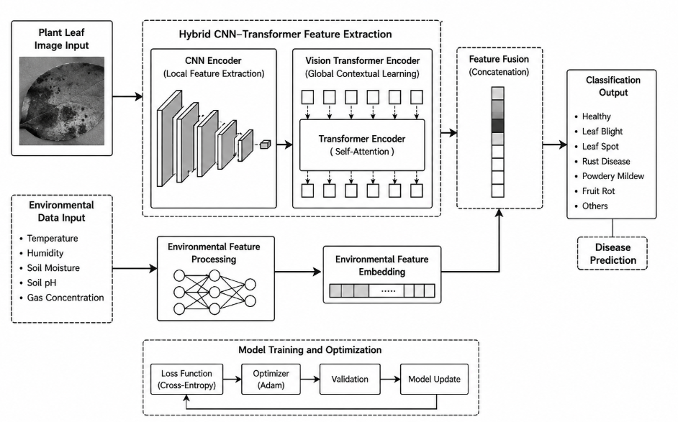
Fig. 1. Proposed AgroVision Hybrid CNN–Transformer Framework
The input pipeline is used for initial pre-processing before extracting the features. The processed picture is then forwarded to the CNN branch in order to get the local spatial features. Then, the general information in various local areas of the disease will be extracted from the feature maps extracted by the CNN using the self-attention mechanism in the Vision Transformer branch. At the same time, an environmental intelligence module containing parameters which are specific to the environment such as temperature, humidity, soil moisture, soil pH and gas concentration are analyzed. Environmental representations retrieved are fused with the visual representation from the CNN and the transformer branch. The feature vector is then fed into the classification head for prediction of diseases. The architecture we propose (as shown in Fig. 1) combines local features extraction, contextual learning, and environment analysis that helps increase the reliability of the prediction system and the resilience in the real agricultural system.
  - Image Preprocessing
The agricultural photos are taken from the environment with noise, through image pre-processing, the feature images are enhanced and the interference pictures are reduced. Due to the illumination changes and motion blur caused by movements of subjects in photos of the leaves, and due to background interference and irregular dimensions of the leaves in photographs taken while doing practical farming, several preprocessing methods are applied prior to the training of the models. Firstly, the photo is cropped to fit a 224 × 224 sized image so as to maintain the uniformity of the photos during the learning phase. The calculations are not changed; only the amount of data they are given. Following resizing, data augmentation can be introduced to add diversity to the data, enhance generalization capability. The augmentation procedure consists of horizontal flipping, vertical flipping, rotation, brightness intensity modification and zoom alteration. These processes mimic real-world processes and keep chances of overfitting in the model low. Noise reduction is applied in this gaussian filtering to remove unwanted noises on the image and obtain a part of image that is sensitive to the disease. Finally, images are normalized based on the values of the amplitude (0% - 100%). The normalization is used to speed up the convergence in the algorithm and to regularize the optimization of the gradients.
  - CNN Feature Extraction
In CNN, the information is localized in space: Each branch recognises special information in the picture of the leaves of the diseased plants. The image is enhanced by a convolutional layer, leading to the identification of boundaries for the diseased tissue, the texture change and colour distortions, as well as estimating the spatial distribution of the diseased spots, which are all features associated with the disease. Pools give dimensionalization of the spatial domain but preserve other essential disease data.
The CNN of the convolution operation is denoted by:
$F_{cnn}=σ(W*X+b)$ (1)
where $X$represents the input image, $W$denotes the convolution kernel, $b$indicates the bias term, and $σ$corresponds to the nonlinear activation function. The generated feature map $F_{cnn}$contains local disease-related representations extracted from the input image.
CNN design is the convolutional layers of kernel size 3x3 followed by max-pooling layers. To ensure the stability of training and help with learning of non-linear features, Batch-normalization and Rectified Linear Units are used. The machine is able to identify more complicated disease patterns in the leaf image, by the hierarchical convolution processes.
  - Vision Transformer
CNNs are able to effectively represent local spatial information, but they have a limited ability to capture long-range spatial interactions between localized areas of diseases, located far apart. The vision transformer module is proposed to maintain the global context learning: The multi-head self-attention creates links within the correspondence between remote sections of the leaf image to construct the Vision Transformer. The mathematical representation of self-attention mechanism is:
$Attention(Q,K,V)=softmax\left(\frac{QK^{T}}{\sqrt{d_{k}}}\right)V$ (2)
where $Q$, $K$, and $V$represent the query, key, and value matrices respectively, while $d_{k}$denotes the dimensionality of the key vector. The self-attention mechanism computes weighted feature relationships among image patches and enables the model to capture global disease dependencies.
The transformer's branch consists of a piece of memory with 16 × 16 patch size, multiple attention heads, and a feature dimension (embedding dimension) of 768 to extract context-specific features. However, the model encompasses multi-head attention hence it can process the information from various heads and thus can simultaneously extract multiple facets of the disease in several regions of the image.
  - Environmental Intelligence Module
One of the main components of the proposed AgroVision architecture is the Environmental Intelligence Module. This suggested module not only involves image analysis, but includes environmental factors that are important in disease occurrence and spread within agricultural systems. The framework collects the data of the sensors connected with the internet of things devices and agricultural technologies like information regarding the temperature and humidity, concentration of volatiles gases, soil moisture and pH. The readings of the different sensors are different so min-max normalization is used for them and then normalized it within the interval 0-1. Fully connected layers in post-normalization are used to embed the environmental parameters, setting up the correlation between the environmental parameters and the behaviors of the plant disease. The fused combined information of the embedded environment characteristics and CNN+transformer-based visual representations is the input to training the controller. The proposed system would consider an environmental intelligence, so it would be able to evaluate eye symptoms and environmental influences jointly and in variable agriculture and would be able to improve the predictability in such.
  - Feature Fusion Strategy
Combining the different local spatial with the global contextual information is the need of the hour to get a unified feature representation and this can only be achieved by the process of feature fusion; and similarly, the process of combining the local with the global information is the need of the hour to achieve environmental intelligence.

The fusion process is mathematically expressed as:
$F_{final}=Concat(F_{cnn},F_{vit},E)$ (3)
where $F_{cnn}$represents local CNN feature maps, $F_{vit}$denotes transformer-based contextual representations, and $E$corresponds to environmental feature embeddings. The concatenated feature vector $F_{final}$contains comprehensive disease-related information obtained from both visual and environmental domains.
In terms of uncertainty of prediction and resistance to misclassification of the diseases in various farm environments the multimodal fusion detection approach developed is more efficient and accurate than the traditional image-based system for disease detection.

  - Classification Layer
The classification phase comprises completely connected thick layers tasked with recognizing types of plant diseases. The dense layer comprised 512 dimension elements and 256 dimension elements in ReLU activation algorithms are then added in with them to perform further feature extraction and to provide a combined feature vector. To prevent overfitting, and promote the generalization of the model, the dense layers are connected and have a dropout regularization rate of 0.3. With softmax as the activation in the final prediction layer, a probability distribution is output for each disease class. The highest score will be used as the score.
The classification process is represented as:
$y=softmax(Wx+b)$ (4)
where $x$denotes the fused input feature vector, $W$and $b$represent trainable weights and bias parameters, and $y$corresponds to the output probability distribution. The proposed classification architecture enables accurate and reliable multi-crop disease prediction while maintaining robustness under practical agricultural conditions.

Results And Discussion
  - Dataset Description
In this study, the set of data comprises of healthy and damaged plant leaves used from public open repositories of agriculture and PlantVillage datasets. Four important crops (Rice, Wheat, Maize and Tomato) were selected for experimental evaluation. For each of the data all of them are categorized by the different types of disease such as Leaf Blight, Rust Disease, Powdery Mildew, Leaf Spot and Fruit Rot. To enhance the practical application, photos were acquired under laboratory and field conditions with various lighting and environmental conditions. All photos were carefully examined to guarantee consistency and accuracy of the labelling of the various classes. The data set was randomly divided into three parts 70%/15%/15% for training, validation and test sets. Overall data distribution is given in table I.
TABLE I. DATASET DISTRIBUTION
Crop | Disease Categories | Images
Rice | Leaf Blight, Leaf Spot | 3,000
Wheat | Rust Disease, Powdery Mildew | 3,000
Maize | Leaf Spot, Blight | 3,000
Tomato | Fruit Rot, Mildew | 4,000
Total | Multiple Diseases | 13,000
  - Quantitative Results
Observation indicated that the AgroVision structure proposed proved very effective in the classification of diseases in orchid crops. The incorporation of CNN-based local feature extraction and transformer-based contextual analysis and environmental intelligence in farming has significantly enhanced the prediction accuracy in different scenarios. Thus the quantitative performance data taken from the testing gave the data which is shown in table II.
TABLE II. PERFORMANCE EVALUATION OF AGROVISION FRAMEWORK
Metric | Value
Accuracy | 98.2%
Precision | 94.1%
Recall | 92.6%
F1-Score | 93.3%
AUC Score | 0.987
With the proposed methodology, good classification accuracy, equality of precision and recall were obtained for the several classes of diseases. The imbalance amount between the precision and recall was found to be primarily caused by the class imbalance of some crop diseases. When excluding the " GPU acceleration", the time it took for the tests was approximately 0.5 seconds/photo, appropriate for the field of agriculture.
  - Dataset Description
All data used in this study is available from PlantVillage and the existing agriculture archives from the public domain, consisting of healthy and damaged plant leaves images. Four main crops; rice, wheat, maize and tomato were chosen to be tested. The diseases are classified as: Leaf Blight, Rust Disease, Powdery Mildew, Leaf Spot and Fruit Rot. Virtual imagery for enhancing the model resistance in diverse situations were captured and obtained from laboratory and field test. The data was divided into 70% training set, 15% validation set and 15% testing set. The distribution of the data set is given in table III.
TABLE III. DATASET DISTRIBUTION
Crop | Disease Categories | Images
Rice | Leaf Blight, Leaf Spot | 3,000
Wheat | Rust Disease, Powdery Mildew | 3,000
Maize | Leaf Spot, Blight | 3,000
Tomato | Fruit Rot, Mildew | 4,000
Total | Multiple Diseases | 13,000
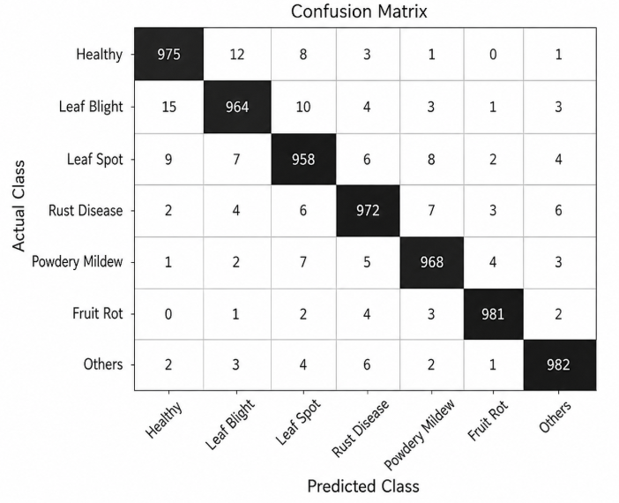
Fig. 2. Confusion Matrix of Proposed AgroVision Framework
  - Confusion Matrix Analysis
For the AgroVision framework normalized classification accuracy a confusion matrix as shown in figure 2 is used. The good evidence of diagonal concentration was observed in most of the illness categories indicating good prediction capabilities for true-positive and low inter-class misclassification. The categories of Powdery Mildew and Leaf Spot were mixed up slightly, with a possibility of lesions of leaf spot appearing like powdery mildew in low light conditions. However, the proposed CNN–Transformer-based system proved quite effective in reducing the ambiguity of categorization by learning the features from the context as well as by adding environmental information.

  - ROC Curve Analysis
Different categorisation thresholds are tested in the proposed framework and then evaluated with the ROC analysis to gauge its discriminative capacity.
The ROC curves shown in Fig. 3 have a high degree of false negative rates, and a low degree of false positive rates, for all types of illness.
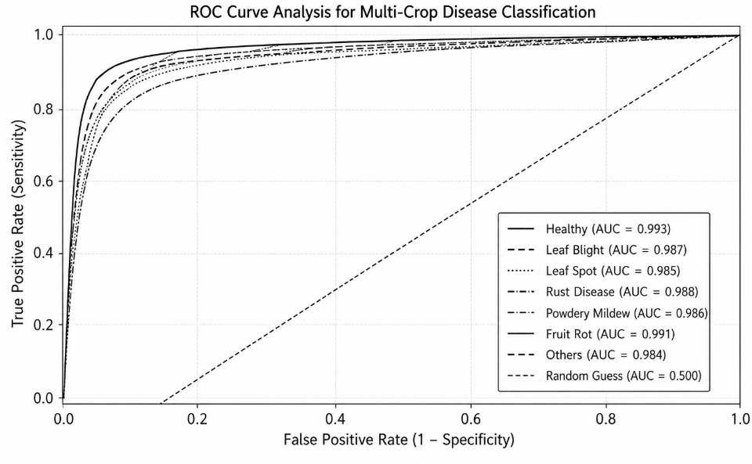
Fig. 3. ROC Curve Analysis for Multi-Crop Disease Classification
The average AUC value was 0.987 which is considered an excellent separation between normal and diseased crop samples. Contextual learning combined with the transformer provided an increase in accuracy to distinguish the various diseases, especially for similar disease sets that were very similar.
  - Ablation Study
An ablation study was conducted to gain insight into the role that each of the architectural components of the proposed AgroVision is playing. The effectiveness of the use of the multimodal feature integration can be demonstrated, as it appears in Table V. In the results, the classification is enhanced with the help of AI by about 1.1% when compared to the vision-only hybrid architecture. A reminder of the need to take into account environmental conditions in agricultural disease forecasts.
TABLE IV. COMPARATIVE PERFORMANCE ANALYSIS
Model | Accuracy | Precision | Recall | F1-Score
CNN | 94.6% | 89.8% | 88.9% | 89.3%
ViT | 95.2% | 90.7% | 89.6% | 90.1%
EfficientNet | 96.1% | 91.9% | 90.8% | 91.3%
ResNet50 | 96.4% | 92.3% | 91.1% | 91.7%
Swin Transformer | 97.0% | 93.2% | 92.0% | 92.6%
Proposed AgroVision | 98.2% | 94.1% | 92.6% | 93.3%
  - Comparative Analysis
The proposed AgroVision framework was compared with some of the current deep learning architectures such as CNN, Vision Transformer, EfficientNet, Swin Transformer and ResNet50 models. Table IV shows the results of the comparison. Created method was better than existing baseline models, regarding the elimination of the disease patterns of a region and the context between them from the global information and in "environmental intelligence" as well. Based on the result with respect to Fig. 4, as can be seen that higher classification accuracy is achieved by using the proposed AgroVision model which is a new multimodal feature fusion scheme than CNN, Vision Transformer, EfficientNet, ResNet50, and Swin Transformer model.

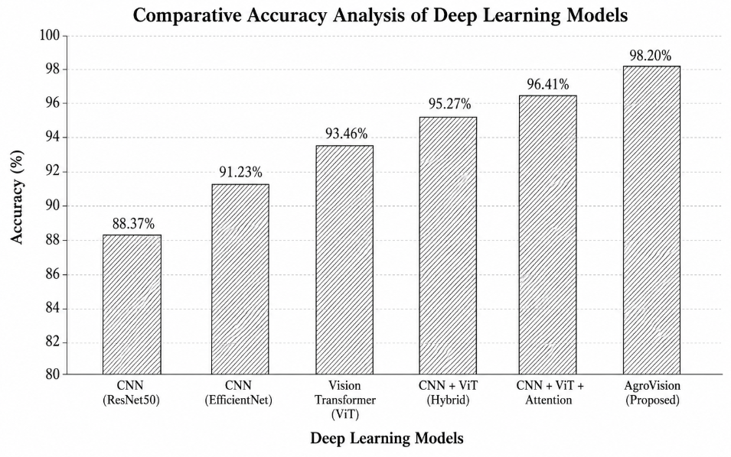
Fig. 4. Comparative Accuracy Analysis of Deep Learning Models
  - Discussion
Experimental findings indicate that the AgroVision framework proficiently integrates CNN-based local feature extraction with transformer-based contextual learning for precise plant disease categorization. The CNN module identifies critical disease attributes, including lesion texture, color variation, and edge patterns, whilst the Vision Transformer enhances recognition by understanding long-range spatial linkages among affected areas. The use of environmental factors such as temperature, humidity, soil moisture, and soil pH significantly improves prediction accuracy in actual agricultural settings. This multimodal fusion method enhances classification robustness and diminishes prediction uncertainty, particularly for visually analogous disorders. The transformer design enhances contextual comprehension beyond traditional CNN frameworks. The proposed architecture was applied in a web-based real-time agricultural monitoring system, facilitating rapid and precise disease diagnosis for farmers and agricultural specialists.

Conclusion
Timely identification of plant diseases is crucial for minimizing crop loss and enhancing agricultural productivity. Manual disease inspection is labor-intensive and inefficient for extensive agriculture. This paper introduces AgroVision, a hybrid deep learning system that integrates Convolutional Neural Networks, Vision Transformers, and environmental intelligence for precise multi-crop disease diagnosis. The approach assimilates both localized visual attributes and overarching contextual data to enhance disease identification across diverse agricultural environments. Environmental factors including temperature, humidity, soil moisture, and soil pH are incorporated into the predictive procedure to improve robustness and practical applicability. Experimental findings indicate that AgroVision attains an overall accuracy of 98.2%, surpassing traditional CNN and transformer-based models in both precision and recall. A user-centric web-based tool was designed to assist farmers and agricultural stakeholders. Future endeavors encompass the deployment of lightweight edge-AI, IoT-based monitoring, integration of Explainable AI, and the implementation of drone-assisted smart farming systems for scalable and intelligent agricultural management.

References
- P. S. Thakur, P. Khanna, T. Sheorey, and A. Ojha, “Explainable Vision Transformer Enabled Convolutional Neural Network for Plant Disease Identification: PlantXViT,” arXiv preprint arXiv:2207.07919, 2022.
- H. Phan, A. Ahmad, and D. Saraswat, “Identification of Foliar Disease Regions on Corn Leaves Using SLIC Segmentation and Deep Learning Under Uniform Background and Field Conditions,” IEEE Access, vol. 10, pp. 111985–111995, 2022, doi: 10.1109/ACCESS.2022.3215497.
- S. K. Hemalatha, P. Karthikeyan, and M. R. Kumar, “A Multitask Learning-Based Vision Transformer for Plant Disease Localization and Classification,” Artificial Intelligence in Agriculture, vol. 8, pp. 100–114, 2024, doi: 10.1007/s44196-024-00597-3.
- U. Barman, R. Choudhury, and S. Sahu, “Vision Transformer and Smartphone-Based Plant Disease Detection System for Tomato Leaves,” Agronomy, vol. 14, no. 2, p. 327, 2024, doi: 10.3390/agronomy14020327.
- A. K. Singh, R. Sharma, and P. Verma, “Effective Plant Disease Diagnosis Using Vision Transformer and Neural Augmentation Techniques,” Expert Systems with Applications, vol. 252, Art. no. 124567, 2024, doi: 10.1016/j.eswa.2024.124567.
- Y. Zhang et al., “Multiclass plant disease classification using hybrid convolutional neural networks,” IEEE Access, vol. 10, 2022.
- X. Li et al., “A hybrid CNN-LSTM model for real-time plant disease detection,” IEEE Transactions on Industrial Informatics, vol. 18, no. 3, 2023.
- H. Wang et al., “Multi-crop disease detection using deep learning: A survey,” IEEE Transactions on Agricultural Engineering, vol. 35, no. 2, 2023.
- A. Kumar et al., “Transfer learning for plant disease classification: A comparative study,” IEEE Transactions on Neural Networks and Learning Systems, vol. 34, no. 5, 2023.
- R. Singh et al., “Hybrid CNN-RNN model for real-time plant disease detection,” IEEE Transactions on Automation Science and Engineering, vol. 20, no. 1, 2023.
- S. Patel et al., "YOLO-based real-time plant disease detection system," IEEE Transactions on Instrumentation and Measurement, vol. 72, 2023.
- P. Sharma et al., "Deep learning for plant disease detection: A review," IEEE Access, vol. 11, 2023.
- M. Gupta et al., "Multi-class plant disease classification using hybrid deep learning models," IEEE Transactions on Systems, Man, and Cybernetics: Systems, vol. 53, no. 4,2023.
- S. Verma et al., "Real-time plant disease detection using hybrid CNN models," IEEE Robotics and Automation Letters, vol. 8, no. 2, 2023.
- A. Chauhan et al., "Hybrid deep learning approach for plant disease classification," IEEE Transactions on Cybernetics, vol. 53, no. 6.

