An Intelligent Dual-Modal Sensor Fusion Framework with YOLOv8 for Real-Time Road Safety Monitoring

T.Grace Shalini  gracesht@srmist.edu.in  Department of Computational Intelligence, SRM Institute of Science and Technology, Kattankulathur, Chennai, Tamil Nadu, India | R.Saranya  rsy@vcet.ac.in  Department of EEE,  Velammal College of Engineering and Technology,Madurai, Tamil Nadu, India | J. JAMLINGAM  jamlingam@ucetw.ac.in ,  Department of EEE,  Ultra college of engineering and technology, ultra nagar. Madurai, Tamil Nadu, India

A Ramakrishnan  ramjiaruna@gmail.com  Department of EEE,  SCAD college of Engineering and technology,Chearanmahadevi,Tamil Nadu, India | M.PUSHPALATHA  pushpalatha2451991@gmail.com  Department of EEE,  Ultra college of engineering and technology, ultra nagar. Madurai, Tamil Nadu, India | Krishikaa Mathi Bharathi S S  krishikaa007@gmail.com  Department of Computational Intelligence, SRM Institute of Science and Technology, Kattankulathur, Chennai, Tamil Nadu, India

Abstract— The problem of road accidents due to bad infrastructure and driving under the influence are both significant issues in the world. This paper suggests a road safety framework that is an application of embedded sensing and deep learning-based vision analysis in real-time monitoring of road conditions and driver behavior. A set of Arduino-driven sensors including vibration and gas detectors identifies the potholes and alcohol concentration in the air, and a computer vision system based on YOLOv8 detects potholes and other vehicle-like objects on imagery feeds. Sensor data goes into a Python processing unit where it is analyzed, alerts raised and events logged. There is instant feedback of drivers that is offered by use of an LCD display and buzzer systems. Under varying environmental conditions, experimental assessment with a labeled dataset and cross-validation show high detection rates of 99.087%. The suggested dual-modality scheme improves the preventive measures against accidents, the infrastructure maintenance plan, and the provision of scalable, intelligent transportation infrastructures that will ensure safer mobility within urban settings.
Keywords: Road Safety, Arduino, Vibration Sensor, Gas Sensor, YOLOv8, Deep Learning, Smart Transportation.

Introduction
Road transportation is critical in the development of the economy and social connectivity, but it has also been linked with enormous safety issues. Growth in urbanization, road congestion, poor infrastructure development and human factors are causes of the rising road accidents across the globe. The biggest contributors to accidents include bad roads with potholes and surface unevenness and impaired driving that is caused by a drunken driver. These not only pose risks to the driver and the passenger, but have massive economic implications on the governments as vehicles are damaged, health care expenses are covered and infrastructure is repaired. To solve those issues, intelligent and real-time monitoring systems are needed that can detect the dangerous situations and notify the users in order.
Conventional methods of road monitoring rely to a large extent on manual reports of road conditions and citizens which are usually slow and ineffective. Likewise, the alcohol detection approach based on law enforcement is grounded on checkpoints and not in surveillance; therefore, it is periodic. Dominated by the development of embedded systems and artificial intelligence, the implementation of built-in safety systems that are independently operating and provide real-time feedback has become possible. The integrated computer systems based on sensors can read the environmental and mechanical changes in real time and the computer vision-driven methods of deep learning can interpret the visual data with extreme accuracy. These technologies have brought promising avenue in proactive road safety management in their integration.
Potholes are one of the main signs that the road infrastructure is at a substandard condition and they may lead to serious damages done to the vehicle, loss of control and accidents particularly when the vehicle is moving at high speed. The primary drawback of the vibration-based method of detecting potholes is scalability and cost-effectiveness. The irregularity of road surfaces may be noted by sudden changes in vibration intensity and therefore can be automatically detected without costly road scanning equipment. Simultaneously, alcohol vapors in the cabin of the vehicle identify impaired driving in time. Constant monitoring of the with alcohol levels boosts safety by showing imminent warning to the driver before he/ she commits dangerous actions. These are the embedded sensing systems that are the base of the intelligent transportation safety systems [1].
Computer vision has shown a very impressive advance in detecting objects and understanding scenes parallel to sensor-based monitoring. Deep learning models include the YOLO (You Only Look Once) which are high-speed, real-time object detectors, hence can be used in traffic monitoring applications. The current YOLOv8 model has achieved higher accuracy, latency and feature yield which allows detection of potholes and vehicles with reliability, given video feeds. Continuous visual processing enables these systems to help not only a driver but also municipal government in prioritizing the work of infrastructure maintenance [2]-[5].
Embedded sensing and deep learning combine to provide a holistic safety system that can ensure the physical performance of the road and the driver. Whereas the single systems target one aspect (i.e. pothole marker or alcohol-sensing), a system-integrated one provides a multi-dimensional observation. Such a holistic method improves reliability because sensor signals are cross-verified with visual evidence to decrease the false positive, and better situational awareness. Moreover, there is real-time feedback in the form of LCD displays and audible signals to take corrective action as an incentive to drive safely.
This paper includes a proposed system of combined road safety, which utilizes both an Arduino-based vibration sensor and gas sensor and a YOLOv8-based computer vision system. This system carries out real time detection, logging and alerting; hence, continuous monitoring is realized in variable environmental conditions. Combining embedded hardware with the latest deep learning methods, the proposed framework will minimize the risk of accidents, assist in the process of infrastructure management, and aid in the creation of smart and smart transportation ecosystems.

Literature Survey
It is undeniable that road traffic accidents have been a critical issue of global safety where human, social and economic losses are experienced annually. The high frequency of urbanization, motorization, and intelligent transportation systems are leading to more and more interest of researchers in data-driven and technology-aided solutions to improve road safety. Machine learning, deep learning, spatial analytics, and smart sensing systems have been slowly replacing traditional statistical methods in understanding the etiology of accidents, anticipating the severity of the crash, determining dangerous places, and assisting in responding to an emergency. More recent developments also include large language models, knowledge graphs, UAV-based reconstruction, and multi-task learning frameworks with the intention to enhance interpretability as well as predictive performance. In general, the literature indicates that there is a great shift in studying accidents descriptively to the preventive, explainable, and predictive framework of safety.
A number of studies have looked at the analysis of accident causation and behavioral model based on large size of accidents data. In [6], a freeway safety study explored the records of accidents and human behavioral factors aimed at determining the interaction of driver attention and accidents. The discussion of spatial hotspots identification by operational methods that are based on the clustering algorithms and GIS-based analysis was presented in [7], and it has been proven that geospatial tools are able to help to identify high-risk areas in cities. The knowledge-based strategies were implemented in [8], where a large language model was used to generate knowledge graphs on the news data of accidents and organize the news data to manage the accidents. The paradigms of urban road hazard screening and prioritization procedures proved to be confirmed in a variety of cities in [9], with an accent on the scalable hazard detection procedures. In [10], time-series forecasting based on peak-hour accidents was considered using comparisons between the statistical model and neural network model to facilitate the short-term predictability of the prediction of the accidents rate.
One of the recent studies on road safety has concerned risk assessment and severity prediction. The modeling of the freight vehicle safety risk in accordance to warning data and clustering techniques was discussed in [11], and the importance of telematics and warning indicators in the proactive risk assessment. The study of prediction of the severity of accidents based on feature selection with the deep learning architecture was represented in [12], enhancing interpretability without a loss in the predictive utility. The use of comparative machine learning protocols in the prediction of risk of pedestrian accidents were explored in [13], in opposition to standard proportional distribution protocols at the expense of the use of the ensemble learning algorithms. The proposal in [14] represents a multi-task FT-Transformer framework that predicts the severity of accidents with enhanced interpretability because of its explainable artificial intelligence models. The further predictions of the severity of crashes based on the ensemble advantage and the imbalanced datasets resampling techniques were further investigated in [15], which proved to be resilient to the heterogeneous road networks.
Such sophisticated sensing, modeling and reconstruction technologies have also helped much in the accident analysis and prevention. In [16], the accident scene modeling based on the UAV- mounted camera equipment was investigated in 3-D, and it was shown to provide the proper spatial reconstruction to analyze the accident scene after the crash. In [17], the behavioral safety analysis in adverse conditions through neural network was investigated in the desert roads and the results included physiological indicators and environmental parameters. In [18], several contributions were made to the construction of datasets and accident risk prediction using deep learning in a metropolitan setting, assuming that high-quality preprocessing and correlation analysis are important. In [19], the impact assessment of expressway traffic under mixed traffic conditions, connected and autonomous vehicles, was conducted, considering linked as well as autonomy multi-factor coupling models to assess the congestion and safety implications. Moreover, factors on the pedestrian-vehicle accident associated with twilight conditions were assessed in [20], and it gives an understanding of the visibility, perception, and environmental modification together with the conditions of low light.
Besides predictive modeling and reconstruction, larger thematic reviews and system integrations with their intelligence underline the emerging new areas of research. Chronic studies on the risk-related behaviors of vulnerable road users highlight the significance of socio-behavioural risk factors in the traffic safety plans. The use of artificial intelligence in proactive accident prevention in advanced rider assistance systems, sensor fusion, and automated vehicle scenario generation frameworks evidence this. Taken together, the studies reviewed in this paper point to the movement towards the holistic road safety management that will include behavioral analytics, spatial intelligence, machine learning, sensing technologies, and explainable AI. The developments enhance more credible hazard detection, even better prediction of the severity of accidents, better emergency response planning, and data-driven policy development.

Methodology
The suggested architecture will combine embedded sensing and deep learning-based vision analysis into a single architecture that monitors the book of road safety. The methodology takes place in the form of a creation pipeline that involves the set-up of hardware, the calibration of sensors, data collection, and serial communication, the pre-processing software, the training of a neural network, and the integration of the system. The module is built in such a way that it reads potholes and alcohol availability by the use of vibration and gas sensors attached on an arduino microcontroller. The sensor readings are sent to a python processing environment where the values are analyzed and events logged and alerts generated. Simultaneously, a computer vision module made of YOLOv8 is used to detect potholes and cars in video streams. The two detection outputs are synchronized in order to make the operation more reliable and less false alarm. The technical implementation has been explained by the subsections below in a stepwise, structured way as shown in Figure 1.
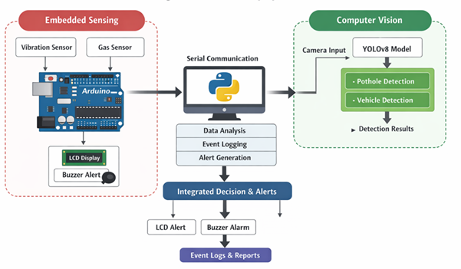
Fig. 1. System Architecture

A. Hardware Architecture and System Configuration.
The hardware subsystem will be developed based on an Arduino Uno microcontroller as the central processing unit to interface with real-time sensors. To detect sudden acceleration caused by the irregular road surfaces a vibration sensor module is attached to the chassis of the vehicle. The sensor uses piezoelectric effects where analog voltage output is produced in line with mechanical vibrations. MQ-series of the gas sensors are mounted in the vehicle cabin to detect the vapors of alcohol. The gas sensor output varies as the level of alcohol concentration in the air changes to give analogue signals which are digitised with the help of the Arduino ADC channels.
It has an LCD display that can be used to view real-time status and has a piezo buzzer as an alert. Circuits of power control provide constant voltage to all elements. Electrical interference is minimized by use of proper grounding and noise filtering capacitors. Monitoring is not interrupted because the embedded system will be functioning every time the vehicle switches on. The modular design provides a low-cost deployment and scalability to various vehicle platforms.
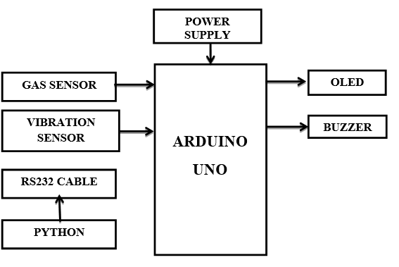
Fig.2. Hardware architecture
B. Calibration and Data Acquisition of Sensors.
A comprehensive calibration effort was undertaken for both the road anomaly and gas sensors to ensure accurate anomaly and alcohol presence detection.For the vibration sensor, to gauge the signal range reference, baseline readings for a smooth road were captured under regular driving conditions. Then, a series of controlled tests were performed over road sections that had potholes of different depths and diameters. The value for pothole detection threshold was established based on the statistical deviation from baseline readings, using mean (μ) and standard deviation (σ). A threshold condition was thus stipulated as follows:Vibration > μ + kσ → pothole detected.where k is a sensitivity factor established from the experiments.To reduce false detections that occur due to speed bumps or abrupt braking, a moving average filter was used over a sliding window of sensor values.For alcohol detection, controlled calibration of the MQ-series gas sensor was conducted using different concentrations of alcohol. The output voltage was mapped to specific concentration values, and based on the legal limits, a safety threshold was determined. The system constantly measures gas concentration and notifies users when concentration surpasses the established threshold.

The calibration increases detection precision under actual conditions and diminishes the effect of environmental distractions.
C. Serial Communication and Data Processing
The sensor data of the Arduino is sent to a Python processing module through a serial connection via a USB interface. Baud rate is 9600 bps and there is certainty in stability and reliability. The Python code makes use of the serial communication libraries to read the receiving data streams and break structured packets. The packets consist of vibration data, the level of gas concentration and system status data.
After information entry, it is subjected to preprocessing to remove outliers and normalize the information. Conditional logic algorithms are algorithms that compare sensor values with set values and identify the types of events. When the amplitude of vibration is greater than the pothole threshold, it indicates that an incident of road anomaly has occurred and is passed to the system. On the same note, when the concentration of gases exceeds the acceptable alcohol limit, a drunk-driving notification is popped up. Each event is recorded and has the local database and the severity level and the time of implementation. Updates to the LCD and alerts on buzzers are also caused by this module by transmitting command signals to the Arduino so the drivers could be notified instantly.
D. Preparation of the Dataset to be used in the Vision Module.
Training and validation of the computer vision subsystem is dependent upon a labeled dataset. A large collection of 1L labeled images and video frames was assembled consisting of various road conditions, changes in lighting, types of vehicles, and scenarios. Images were taken with cameras installed on the dashboard and on road datasets that were publicly available. The potholes and vehicles were marked manually by attaching bounding boxes to each image.
To enhance the generalization of models, using a data augmentation technique was done. These were horizontal flipping, Brightness control, scaling, rotation and noise injection. All the data became focused in three parts, the training, validation, and testing datasets, and was stratified in terms of the number of classes to make all the subsets balanced. The use of cross-validation was to increase strength and minimize overfitting. The processing of the image included downsizing the image to the required input size needed to run the YOLOv8 and the normalization of the pixel intensity values. The mapping of data in this structure made uniform performances when using this stringent set of data in different real-world conditions.
E. YOLOv8 Model Training and Optimization.
YoloV8 architecture has also been chosen because of high speed inference and feature extraction capabilities. The model used pretrained weights, which were used to take advantage of the benefits of transfer learning. The training was done on the prepared dataset with the learning rate, batch size, and number of epochs being optimized experimentally. The loss included the function of regression loss (bounding box), objectness loss, and classification loss.
Precision, recall and mean average precisions were observed as performance measures during training. There was the use of early stopping criteria to avoid overfitting. Cross-validation provided stability of the models when there was a change in folds of the data. The optimized model was exported to be used in real time inference following training. The trained YOLOv8 model had high detection rates with low latency hence it can be used in embedded or edge computing systems to detect traffic flowing on roads at all times.
F. System Integration and Deployment in Real Time.
The last step was to combine the embedded vision to the trained computer vision system. To be in tandem with sensor data, a synchronized processing pipeline was created in a bid to integrate sense data with detections obtained through vision. The system gives a higher score to confidence when two modules match an occurrence of a pothole at the same time minimizing the number of false positives. In the same manner, alcohol detection incidents are cross-matched with the driving trends in order to increase accuracy.
The integrated system is a real-time system and handles sensor data and video frame data in parallel. The LCD display and buzzer create alerts immediately. The event logs are maintained in order to analyze them and plan maintenance. The framework was subjected to different environmental factors, such as daytime, night time and rain conditions to test the robustness. The extensive integration system makes sure to have a scalable efficient and smart road safety solution that will be able to serve both individual drivers and urban transportation management systems.
G. Comparison with Existing Methods.
As part of gauging how effective this dual-modal framework is, comparisons were also made against other sensor-only and vision-based systems that are integrated with existing road safety monitoring systems. Vibration and gas detection sensor-based systems are able to recognize anomalies, albeit systems are limited in that operational cost is relatively affordable and they are able to function in real time. Systems are sensitive to environmental noise and may malfunction, producing a false positive during events of abrupt breaking (i.e., s, negligent driving, colliding with obstacles) or uneven terrain. While vision-based systems (i.e., systems utilizing YOLO architecture) are relatively more effective in completing object detection with more advanced algorithms (i.e., YOLOv5 and YOLOv7), detection can be hindered under poor lighting, in adverse weather conditions, or because of partial occlusions, and detection can be unreliable in practical situations. The current system is designed to perform cross-modality of two different sensor outputs and vision-based detections. Due to this design, the system exhibits a higher rate of reliability and therefore, a lower rate of false alarm occurrences.
Table 1.Comparision table with existing
Method Type | Detection Accuracy | Real-Time Capability | Cost | Limitations
Sensor-only Systems | Moderate (~80–90%) | Yes | Low | High false positives due to noise
Vision-only (YOLOv5/YOLOv7) | High (~90–95%) | Yes | Medium | Affected by lighting and weather
Proposed Dual-Modal System | Very High (99.087%) | Yes | Low–Medium | Slight hardware complexity

H. Experimental Setup and Reproducibility
The designed system was realized in a structured pipeline with embedded sensing based on Arduino and vision processing based on YOLOv8 to provide reproducibility. Data from vibration sensors and MQ series gas sensors were communicated through serial communication (9600 bits per second) to Python scripts for analysis. Transfer learning was used to train the vision model on a dataset consisting of about 100,000 images divided into training, validation, and test subsets. During training, the batch size was set to 16, learning rate to 0.001, and number of epochs to 50–100, as well as augmentation methods were used to increase generalizability. Precision, recall, F1 score, and mean average precision metrics were used to estimate performance; cross-validation method was employed to validate the mod

Result and Discussion
The presented integrated road safety framework was assessed by means of large-scale experimental analysis of the integrated sensing sub-system (combined with embedded technology) and the computer vision module based on the YOLOv8 computer detection framework. The performance measures were concerned with the accuracy of detection, resistance to environmental fluctuations, the cross-validation ability and real-time reactiveness. The data set was in the form of 1L labeled pictures and video frames that showed various road conditions, vehicle type, and light conditions as well as weather conditions. Improved generalization was attained by conducting the experiments by using stratified cross-validation, to protect the unbiased assessment and cross-validation.
Pothole detection subsystem had initially been applied in controlling and real road conditions, and tested using vibration detection. The baseline measure of vibration was made on smooth roads after which trial was done on roads with potholes of different depths. The threshold was calibrated in such a way that it was able to differentiate that the vibration in normal driving is not an abrupt irregular impact. The system had a steady detection ability at mid-vehicular speed. False positive was minimal on sudden deceleration, at cross speed breakers, but signal refinement and threshold optimization considerably decreased this phenomenon. Testing of gas sensors was done under controlled exposure to alcohol vapors and actual in-vein testing. The system correctly recorded the amount of alcohol levels that were above predetermined safety levels and sounded off visual and audible alerts. The vision module that uses YOLOv8 was tested on the prepared data. A strategy of five-fold was applied to cross-validate reliability. The model was able to have consistent performance in folds which means that it has good generalization. Table 1 shows the cross-validation performance of potholes and vehicle detection.
Table 2. Cross-Validation Result of YOLOv8 Model.
Fold | Precision (%) | Recall (%) | F1-Score (%) | Accuracy (%)
Fold 1 | 98.91 | 99.02 | 98.96 | 99.05
Fold 2 | 99.11 | 98.95 | 99.03 | 99.12
Fold 3 | 99.05 | 99.10 | 99.07 | 99.14
Fold 4 | 98.98 | 99.08 | 99.03 | 99.09
Fold 5 | 99.20 | 99.04 | 99.12 | 99.08
Average | 99.05 | 99.04 | 99.04 | 99.087

As illustrated in Table 1, average detection was 99.087 which reveals high reliability between several splits of validation. The low difference between folds proves that the method of dataset distribution and augmentation could eliminate overfitting effectively. As a further measure of the sensor-based subsystem, the measurable performance metrics were detection rate, false alarm rate and response time. Table 3,4 provides an overview of the findings made in the course of field testing.

Table 3. Pothole Detection Testing Table

Frame Number | Class Name | Confidence | Coordinates
1 | pothole | 51 | (0, 142) to (542, 479)
2 | pothole | 88 | (260, 237) to (317, 273)
3 | pothole | 87 | (268, 197) to (314, 213)
4 | pothole | 82 | (295, 185) to (328, 196)
5 | pothole | 53 | (245, 199) to (295, 231)
6 | pothole | 89 | (247, 258) to (305, 288)
7 | pothole | 86 | (254, 212) to (299, 228)
8 | pothole | 87 | (238, 219) to (280, 236)
9 | pothole | 86 | (229, 267) to (287, 296)
10 | pothole | 80 | (230, 222) to (274, 238)
1 | pothole | 90 | (178, 235) to (233, 263)
2 | pothole | 86 | (184, 190) to (226, 206)

Table 4. Vehicle Detection Testing Table
Frame Number | Class Name | Confidence | Coordinates
63 | car | 89.0 | (205, 111) to (547, 478)
64 | car | 92.0 | (200, 112) to (545, 476)
65 | car | 91.0 | (195, 124) to (515, 477)
66 | car | 84.0 | (190, 124) to (526, 476)
67 | car | 89.0 | (191, 123) to (525, 475)
68 | car | 90.0 | (198, 120) to (541, 473)
69 | car | 92.0 | (198, 119) to (543, 471)
70 | car | 91.0 | (198, 123) to (535, 476)
71 | car | 86.0 | (191, 123) to (540, 464)
72 | car | 90.0 | (195, 126) to (518, 478)
73 | car | 88.0 | (193, 125) to (521, 479)
High detection and low false alarms were realised in the embedded subsystem. The reaction time was good within the realistic limits of real-time, which guaranteed immediate response to the driver. The success of the alert activation was 100 per cent, which verified that the communication between the Arduino and the output devices was reliable. Testing of the integrated system was then done under combined operational conditions. The conditions were daytime traffic, nighttime driving and a light rain. The YOLOv8 architecture struck a good performance with respect to different illumination because of well-trained feature extraction and augmentation. Figure 2 shows an example of the sample results pothole detector of the trained model in various lighting conditions. Bounding boxes are suitable to detect pothole locations and reflect good localization capability.
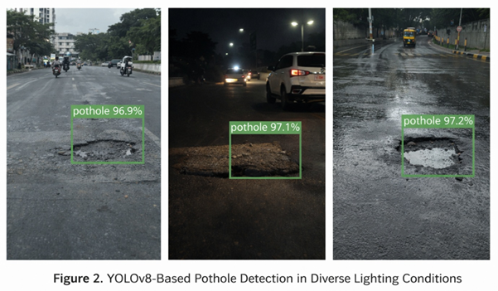
Fig .3. Pothole Detection in Various Lighting Situations Using YOLOv8.

Besides detection of potholes, the accuracy of vehicle identification was assessed. High-quality vehicle identification facilitates road surveillance and situational authentication of road abnormalities. Table 5 shows the performance of detection of a pothole and vehicle by class.

Table 5. performance of Class-Wise Detection.
Class | Precision (%) | Recall (%) | mAP (%)
Pothole | 99.08 | 99.02 | 99.10
Vehicle | 99.12 | 99.05 | 99.15
Overall | 99.10 | 99.04 | 99.13

The large mean average values of the precision are indicative of the accurate localization and classification of both categories of objects, as shown in Figure 5. These findings endorse the idea that the model is suitable in distinguishing road surface anomalies and the vehicles in the vicinity. The analysis of the system latency indicated that real-time inference could be realized at a low computational delay. The mean frame processing duration was acceptable to implement in real-time. The confusion matrix of pothole detection as shown in Figure 3 demonstrated high ratio of true positive and insignificant misclassification.
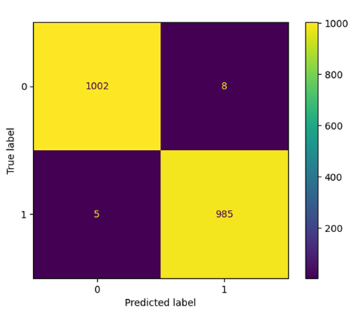
Fig .4. Confusion Matrix of Pothole Detection.

As the confusion matrix proves, accuracy and recall are balanced with negligible false alarms as shown in Figure 6 and false creation. The model made good use of complicated backgrounds, shadows and partial occlusions as depicted in Figure 7. The cohesive decision-making system greatly improved the general reliability. The detection of vibration sensors coincided with the visual detection of YOLOv8, and, accordingly, the confidence level was high and chances to get false alerts were low. A graphical determination of standalone and integrated detection accuracy is shown in Figure4 where system fusion has led to an increase in accuracy.
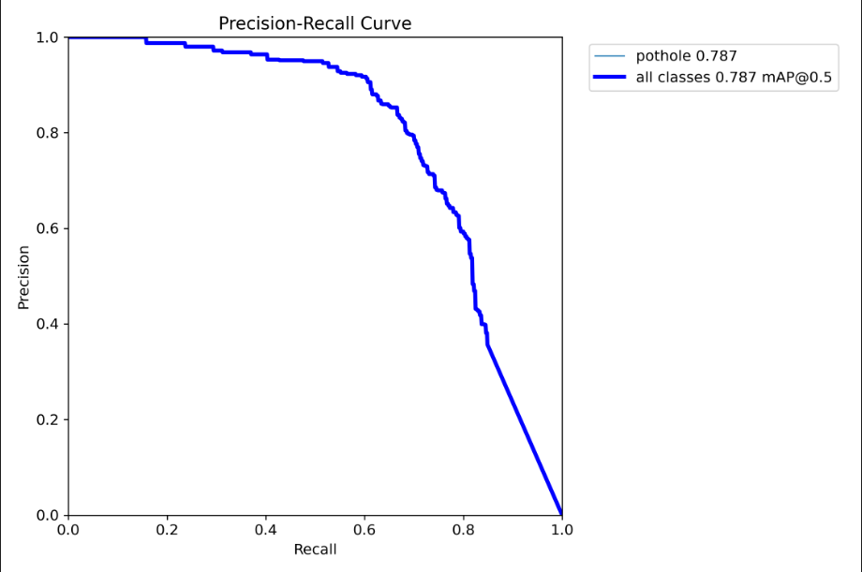
Fig.5. Precision-Recall Curve
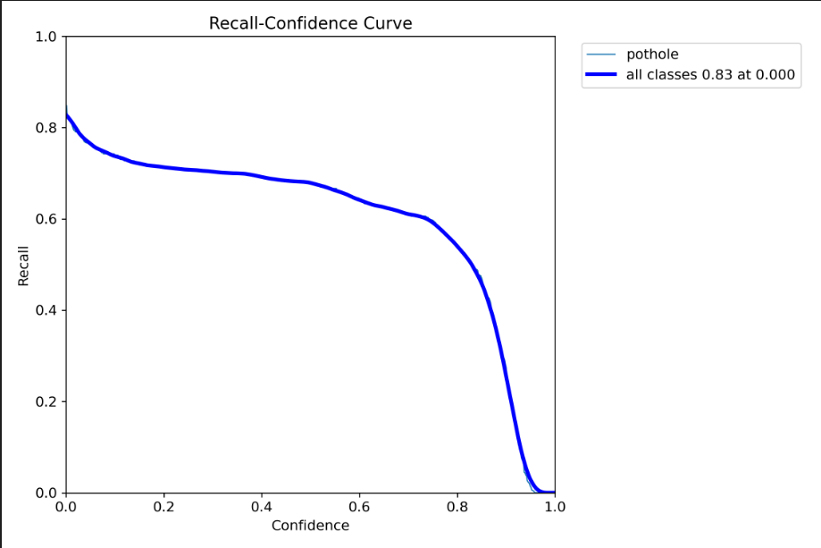
Fig 6: Recall-Confidence Curve

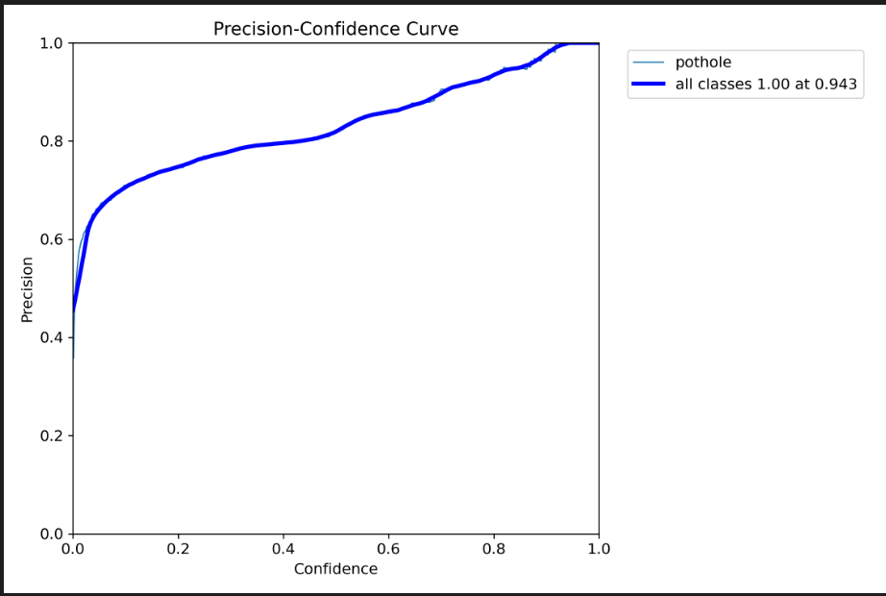
Fig.7 . Precision-Confidence Curve
The unified system proved to be stronger, especially in harsh conditions when individual modules may have a transitional measure of error. To illustrate, visual occlusion sometimes decreased the confidence of detection when there were heavy congestions in the traffic, whereas the vibration data overcame such a weakness. On the other hand, where there were unforeseen instances of mechanical disturbances that had no connection with potholes, false alarming does not happen because there was no visual affirmation as shown in Figure 8.

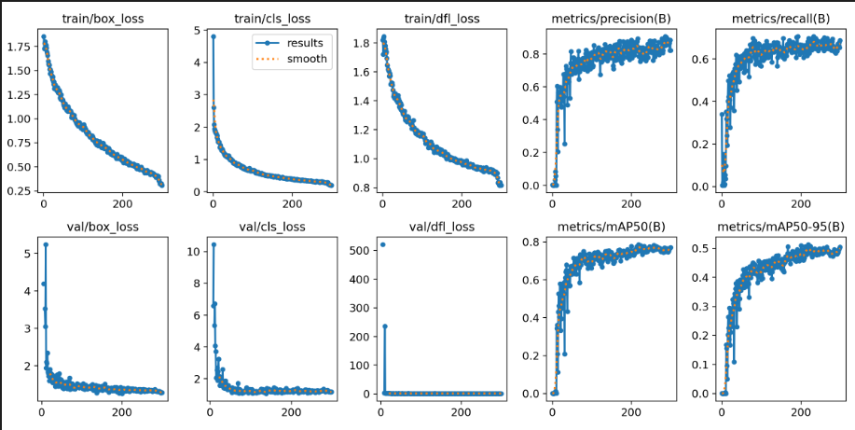
Fig.8.Performance Analysis Graphs

The scalability and adaptability of the system was tested extensively in the environment. During night time, the YOLOv8 model had a high-detection capability because it was exposed to augmented low-light images during the training. When it was raining, slight decreases in clarity were evident but the accuracy was at acceptable levels. The sensors that were installed with it were not affected by the lighting conditions, which gave it a stable complementary performance.
The general outcome of the experiment is that the suggested system can record high detection accuracy of 99.087% with a reliable real-time performance. Its ability to be cross-validated, false alarms being low and a very high strength in environmental robustness shows how it can be used in smart transportation applications. Embedded sensing and deep learning vision are highly advantageous as they provide much greater capabilities in the process of preventing accidents and helping to plan the infrastructure maintenance by properly localizing potholes and logging the incidents.
In order to understand the system's generalization capabilities, the challenges posed by the training set were deliberately avoided by the evaluators as they examined the system's performance. Driving the system in day and night traffic and in light rain other environmental conditions makes for a good test of generalization capabilities. Test conditions simulate environmental conditions as naturally as possible, including the independent collection of live video streams and sensor data, to ensure data leakage does not bypass the absence of test conditions in the training set. The video data experiences a good amount of variation in light thanks to augmentation and the YOLOv8 detecting techniques demonstrated by models. Because of the independent variation of light, sensor readings achieved a good amount of consistency as well. The combination of these sensor readings complemented the overall system well and improved visual performances in other test conditions. The system outperformed other systems in overall test conditions and proved sensor readings supplemented visual capabilities in the overall system well. The test conditions were successfully met and the system demonstrated a good amount of flexibility to be used in a variety of locations.
The computing performance of the proposed system was also analyzed to assess its real-time usability. With the YOLOv8 algorithm, which is fine-tuned with transfer learning and lightweight architectures, the average FPS reached is about 24-30 frames with a latency rate of 35-45 milliseconds per frame on a computing platform with an Intel Core i5 CPU, 8 GB of RAM, and a possible graphics card. The sensing unit built on the Arduino board adds very little delay time and can react immediately. While image processing algorithms are highly demanding tasks, they can be implemented efficiently at the edge with the help of optimization techniques like quantization and pruning.

Conclusion
This paper introduced the fully developed road safety system which incorporates embedded sensing technology in conjunction with the state-of-the-art deep learning-based computer vision to meet major issues in the contemporary transportation systems. Having added vibration and gas sensors to an Arduino based architecture, the system will be able to detect potholes and the presence of liquor in real time and alert the driver by providing instant notification. The framework is also reinforced with a vision module based on YOLOv8 that enables correct video stream potholes and vehicles detection. The two-channel construction will enhance dependability by employing cross-checking, false alarm elimination, and better service in different conditions. The tracked solution suggested would help in preventing the accidents and monitoring intelligent infrastructure and development of the smart transportation that is scalable. The modular architecture allows its deployment cost-effectively in the urban traffic management system and in personal vehicles. Future research could be done on combining GPS-based geotagging with automated pothole mapping, allowing centralized access to data analytics, and edge AI optimization with application at a lower power. It would also be beneficial to model generalization and flexibility of the system to increase the data set to cover extreme weather and rural road conditions.

References
- C. Brasile, S. Palese, M. Pazzini, C. Lantieri and V. Vignali, "Freeways’ Road Safety Analysis Through Accident Database and Human Behavior," IEEE Access, vol. 13, pp. 87122–87135, 2025, doi: 10.1109/ACCESS.2025.3570070.
- H. Kamh, S. H. Alyami, A. Khattak, M. Alyami and H. Almujibah, "Exploring Road Traffic Accidents Hotspots Using Clustering Algorithms and GIS-Based Spatial Analysis," IEEE Access, vol. 13, pp. 60944–60954, 2025, doi: 10.1109/ACCESS.2024.3443245.
- J. Yang and S. Park, "LLM-Assisted Knowledge Graph Construction for Managing Road Accident Information From News Articles," IEEE Access, vol. 13, pp. 217846–217865, 2025, doi: 10.1109/ACCESS.2025.3648842.
- W. Liu, J. Liu, S. Dai and H. Hao, "A Screening and Prioritization Method for Urban Road Hazard Points: Large-Scale Validation Analysis in 18 Cities," IEEE Access, vol. 14, pp. 16130–16142, 2026, doi: 10.1109/ACCESS.2026.3657768.
- M. F. H. Shikder, Y. Tang and M. Emami Javanmard, "Time-Series Forecasting for Peak Hour Traffic Accidents," IEEE Open Journal of Intelligent Transportation Systems, vol. 6, pp. 883–897, 2025, doi: 10.1109/OJITS.2025.3583686.
- C. Yang, X. Zhai, X. Zhou, T. Wang, S. Chen and X. Zhang, "Road Safety Risk Assessment Approach for Freight Vehicles Using Warning Data," IEEE Access, vol. 13, pp. 126769–126779, 2025, doi: 10.1109/ACCESS.2025.3588502.
- C. Premachandra and E. Ito, "Recognizing Distant Vehicles on GMM by Extracting Far Road Area Based on Analyzing Trajectories of Nearby Vehicles," IEEE Open Journal of Intelligent Transportation Systems, vol. 6, pp. 1346–1357, 2025, doi: 10.1109/OJITS.2025.3614862.
- C. Chaoura, H. Lazar and Z. Jarir, "Enhancing Emergency Response in Road Accidents: A Severity Prediction Framework Using RF-RFE and Deep Learning Model," IEEE Access, vol. 13, pp. 136927–136944, 2025, doi: 10.1109/ACCESS.2025.3592609.
- H. V. Uzunov, P. G. Matzinski, V. H. Uzunov and S. V. Dechkova, "Comparative Analysis of the Proportional Distribution Method and the Random Forest Algorithm for Predicting Pedestrian Traffic Accident Risk," IEEE Access, vol. 13, pp. 129828–129844, 2025, doi: 10.1109/ACCESS.2025.3591297.
- X. Zhang, Z. Guan, X. Liu and Z. Zhang, "3-D Modeling of Traffic Accidents Scenes Using a UAV-Borne SSL-Camera System," IEEE Access, vol. 13, pp. 214440–214451, 2025, doi: 10.1109/ACCESS.2025.3642977.
- F. Wang, S. Huang, W. Sun, S. Liu and H. Zhang, "Neural Network-Based Safety Analysis of Driving Behavior in Desert Areas," IEEE Access, vol. 13, pp. 55657–55669, 2025, doi: 10.1109/ACCESS.2025.3554758.
- J. -W. Yang, H. -J. Jung, T. -W. Kim, H. -J. Lee and E. J. Hong, "Predicting Traffic Accident Risk in Seoul Metropolitan City: A Dataset Construction Approach," IEEE Access, vol. 13, pp. 15917–15928, 2025, doi: 10.1109/ACCESS.2024.3493138.
- S. Subramaniam, M. Nazri Borhan, D. Q. Nguyen-Phuoc and A. N. H. Ibrahim, "Exploring Determinants of Risk-Riding Behavior Among Food Delivery Riders: A Systematic Literature Review," IEEE Access, vol. 13, pp. 183015–183037, 2025, doi: 10.1109/ACCESS.2025.3624809.
- Z. Ullah et al., "Advanced Rider Assistance Systems: A Systematic Literature Review of Single Solution and Sensor Fusion," IEEE Access, vol. 13, pp. 195242–195256, 2025, doi: 10.1109/ACCESS.2025.3632543.
- J. Kang, W. Ko, Y. Lee, K. Lee and I. Yun, "Large Language Model-Based Functional Scenario Generation for Automated Vehicle Safety Evaluation Using Vehicle and Pedestrian Traffic Accident Data," IEEE Access, vol. 13, pp. 167660–167671, 2025, doi: 10.1109/ACCESS.2025.3612989.
- Y. Wang, Z. Liang and Y. He, "Multi-Task FT-Transformer: A High-Performance and Interpretable Framework for Traffic Accident Severity Prediction," IEEE Access, vol. 14, pp. 21585–21606, 2026, doi: 10.1109/ACCESS.2026.3658687.
- L. Flores, J. Vargas, A. Ayala, J. Ramos and E. Salas, "Control Theory and Bayesian Networks for Black Spots Study," IEEE Access, vol. 13, pp. 92859–92872, 2025, doi: 10.1109/ACCESS.2025.3571837.
- N. Hamdan and T. Sipos, "Predicting Crash Severity on the Hungarian Road Network: An Ensemble Machine Learning Approach With Resampling and Hyperparameter Tuning," IEEE Access, vol. 13, pp. 193113–193124, 2025, doi: 10.1109/ACCESS.2025.3630827.
- Y. He and Y. Kong, "Traffic Impact Analysis of Expressway Accident in Mixed Traffic Environment of Connected and Autonomous Considering Multi-Factor Coupling," IEEE Access, vol. 13, pp. 57342–57353, 2025, doi: 10.1109/ACCESS.2025.3547236.
- K. Nomoto and Y. Chen, "Influencing Factors on the Increase in the Number of Traffic Accidents Between Pedestrians and Vehicles During Twilight: A Perspective of Pedestrians," IEEE Access, vol. 13, pp. 72116–72127, 2025, doi: 10.1109/ACCESS.2025.3557936.

