^{[1]}Anjanmani Baro, ^{[2]}Kaushik Chandra Deva Sarma*
^{[1]},^{[2]} IE, CIT Kokrajhar
^{[1]}anganju1992@gmail.com,^{[2]}* kcd.sarma@cit.ac.in

A Minimum Potential Based Fully Analytical Threshold Voltage Model of DGJLFETTSS
Abstract— An analytical approach for the threshold voltage modelling based on minimum central potential for double-gate Junctionless field-effect transistor having triangle-shaped spacers reported. To determine the threshold voltage the approach started with the potential model of the device. By definition it is the value of gate potential which results the midpoint potential value is minimum. The threshold voltage expression is compared TCAD simulation results.

Index Terms—FET, Junctionless, Triangle-shaped spacer, Threshold voltage

Introduction
High value of work function difference between the gate material and channel material induces an internal electric field at the oxide semiconductor interface, which leads to the formation of a depletion layer throughout the complete substrate. As a consequence, under this condition, the device is devoid of free electrons and it cannot carry any current or the device is said to be in its off state [1-18]. However, when a gate voltage is applied, the resulting electric field counteracts the internally induced electric field (resulting from the work-function gradient). As a result, the net electric field present in the oxide semiconductor interface starts decreasing with increase in the applied gate to source voltage. As a result width of the depletion layer starts decreasing. At this stage the device is no longer in the fully depleted state, i.e., the farthest portion of the device from the insulator semiconductor interface loses its depletion layer [1-18]. The gate to source voltage above which this phenomenon occurs is known to be the threshold voltage of the device. At this stage, current conduction starts in that non-depleted portion induced at midsection. With the gate voltage increases above threshold condition, the effective electric field in the semiconductor oxide interface further reduces, leading to further reduction of depletion layer. Thus depletion width plays an important role in the conduction mechanism of JLT. In this entire process of operation gate induced variation in the space charge region in the substrate can be linked to the variation in the potential inside the substrate.

Mathematical Model

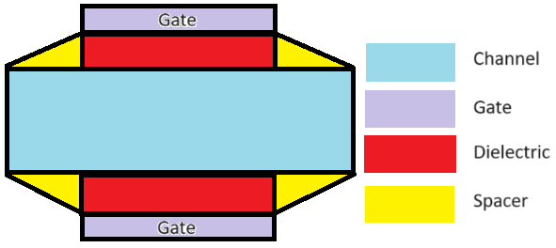

Figure 2. Device structure of the (DGJLFETTSS) [5]

The 1-D potential profile for the DGJLFETTSS is
$ϕ_{0}(x)=\frac{\{V_{ds}+(\frac{qN_{d}}{∈_{si}}-\frac{1}{λ^{2}}ϕ_{gs})λ^{2}\}e^{\frac{L}{λ}}-(\frac{qN_{d}}{∈_{si}}-\frac{1}{λ^{2}}ϕ_{gs})λ^{2}}{(e^{2\frac{L}{λ}}-1)}e^{\frac{x}{λ}}$$$-\frac{\{V_{ds}+(\frac{qN_{d}}{∈_{si}}-\frac{1}{λ^{2}}ϕ_{gs})λ^{2}\}e^{\frac{L}{λ}}-(\frac{qN_{d}}{∈_{si}}-\frac{1}{λ^{2}}ϕ_{gs})λ^{2}e^{2\frac{L}{λ}}}{(e^{2\frac{L}{λ}}-1)}e^{-\frac{x}{λ}}$$ $-(\frac{qN_{d}}{∈_{si}}-\frac{1}{λ^{2}}ϕ_{gs})λ^{2}$ $ϕ_{0ch}(x)=\frac{(V_{ds}+Cλ^{2})e^{\frac{L+L_{d}}{λ}}-\frac{Cλ^{2}}{e^{\frac{L_{s}}{λ}}}}{(e^{2\frac{L+L_{d}}{λ}}-e^{-2\frac{L_{s}}{λ}})}e^{\frac{x}{λ}}-\frac{\{(V_{ds}+Cλ^{2})e^{\frac{L+L_{d}}{λ}}-\frac{Cλ^{2}}{e^{\frac{L_{s}}{λ}}}\}e^{-2\frac{L_{s}}{λ}}-Cλ^{2}(e^{2\frac{L+L_{d}}{λ}}-e^{-2\frac{L_{s}}{λ}})e^{\frac{L_{s}}{λ}}}{(e^{2\frac{L+L_{d}}{λ}}-e^{-2\frac{L_{s}}{λ}})}e^{-\frac{x}{λ}}-Cλ^{2}$(1)
Minimum potential from (1) is,
$ϕ_{0min}(x)=2(ab)^{\frac{1}{2}}+c$ (2)
Where,
$$a=\frac{(V_{ds}+Cλ^{2})e^{\frac{L+L_{d}}{λ}}-\frac{Cλ^{2}}{e^{\frac{L_{s}}{λ}}}}{(e^{2\frac{L+L_{d}}{λ}}-e^{-2\frac{L_{s}}{λ}})}$$
$$b=-\frac{\{(V_{ds}+Cλ^{2})e^{\frac{L+L_{d}}{λ}}-\frac{Cλ^{2}}{e^{\frac{L_{s}}{λ}}}\}e^{-2\frac{L_{s}}{λ}}-Cλ^{2}(e^{2\frac{L+L_{d}}{λ}}-e^{-2\frac{L_{s}}{λ}})e^{\frac{L_{s}}{λ}}}{(e^{2\frac{L+L_{d}}{λ}}-e^{-2\frac{L_{s}}{λ}})}$$
$$c=-Cλ^{2}$$

Equating (2) to zero,
$ϕ_{0min}(x)=2(ab)^{\frac{1}{2}}+c=0$ (3)
Eq. (4.16) can also be written as,
$pC^{2}+qC+r=0$ (4)
Where,
$$P=λ^{4}\left[\begin{aligned}-2e^{\frac{L+L_{d}-3L_{s}}{λ}}-e^{\frac{3L+3L_{d}+L_{s}}{λ}}+e^{\frac{L+L_{d}-L_{s}}{λ}} \\ +e^{-4\frac{L_{s}}{λ}}+e^{2\frac{L+L_{d}}{λ}}-e^{-2\frac{L_{s}}{λ}}+\frac{1}{4}\end{aligned}\right] \\ q=λ^{2}[e^{2\frac{L+L_{d}-L_{s}}{λ}}-2{V_{ds}}^{\frac{L+L_{d}-3L_{s}}{λ}}$$
$$-V_{ds}e^{\frac{3L+3L_{d}+L_{s}}{λ}}+V_{ds}e^{\frac{L+L_{d}-L_{s}}{λ}}] \\ r=V_{ds}e^{2\frac{L+L_{d}-L_{s}}{λ}}$$Solving (4),
Again,
$C=-\frac{qN_{d}}{∈_{Si}}-\frac{1}{λ^{2}}ϕ_{gs}=-\frac{qN_{d}}{∈_{Si}}-\frac{1}{λ^{2}}\left(V_{th}-V_{fb}\right)$ (5)
Where,
is threshold voltage,
$V_{th}=V_{fb}+[\frac{q-\sqrt{q^{2}-4pr}}{2p}-\frac{qN_{d}}{∈_{Si}}]λ^{2}$ (6)
Where,
$$λ=\sqrt{\frac{t_{Si}(4t_{oxeff}∈_{Si}+t_{Si}∈_{ox})}{4∈_{ox}}}$$
i) On the left region
$t_{oxeff}=\frac{t_{ox}}{\cos{θ}(x)}$ (7)
Where,
$θ(x)=\tan^{-1}{(}\frac{x}{t_{ox}})$
where,
$x=0$ to $-L_{S}$
i) On the right region,
$t_{oxeff}=\frac{t_{ox}}{\cos{θ}(x)}$ (8)
Where,
$θ(x)=\tan^{-1}{(}\frac{x-L}{t_{ox}})$
where,
to
i) In the channel,
(9)
to

Results
Dependency of threshold value on dielectric constant, drain voltage, temperature and gate oxide thickness. The mathematical expressions which are framed needs to be validated either through physical experimentation or virtual numerical simulation. Here, virtual validation was performed with the help of Cogenda Visual TCAD and the validation was performed through graphical comparison depicted in Fig2- Fig.5. Higher gate dielectric constant results in higher gate capacitance and electric field which in turn causes the threshold voltage to increase which is indicated in Fig.2. Higher drain voltage results in higher DIBL and lower threshold voltage as shown in Fig. 3. With higher temperature resistivity of semiconductor reduces and as a result threshold voltage also reduces as shown in Fig. 4. With higher gate oxide thickness gate capacitance and electric field are lower which in turn causes the threshold voltage to decrease as shown in Fig.5. In all the comparison the mathematical model and TCAD numerical simulation shows the closeness of mathematical and virtual experimentation with each other with an average deviation of 3% which is the virtual validation of the work.

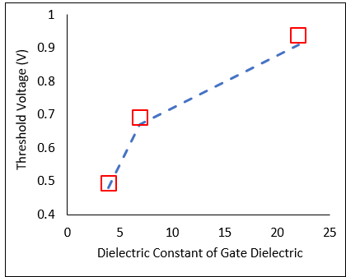
Fig. 2: Dielectric Constant Dependency of Threshold Voltage

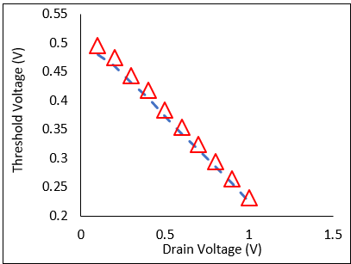
Fig. 3: Dependency of Threshold Voltage

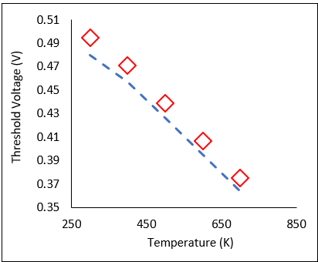
Fig. 4: Temperature Dependency of Threshold Voltage
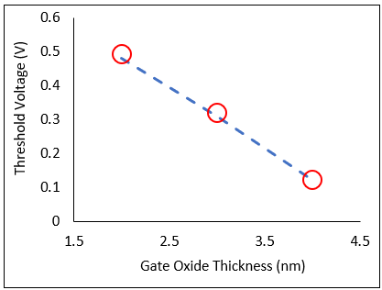
Fig. 5: Gate Dielectric Dependency of Threshold Voltage

A threshold voltage model DGJLFET with triangle-shaped spacer has been developed and presented in this paper. Virtual validation of the analytical expression framed has been performed by comparing the variation of threshold voltage with dielectric constant, drain voltage, temperature and gate oxide thickness. In all the comparison the mathematical model and TCAD numerical simulation shows the closeness of mathematical and virtual experimentation with each other with an average deviation of 3% which is the virtual validation of the work. This implies the model is suitable for compact modelling.

REFERENCES

[1] Lee, C. W., Afzalian, A., Akhavan, N.D., Yan, R., Ferain, I., and Colinge. J.P. Junctionless multigate field effect transistor. Applied Physics Letters, 94(5), pages 053511, 2009
[2] Colinge J.P., Lee, C.W., Afzalian, A., Dehdashti, N., Yan, R., Ferain, I., Razavi, P., O’Neill, B., Blake, A., White, M., Kelleher, A.M., McCarthy B., and Murphy R. SOI Gated Resistor: CMOS without Junctions. In IEEE International SOI Conference, pages 1-2, Foster City, California, USA , 2009
[3] Nazarov, A., Balestra, F., Raskin, J.P., Gamiz, F., and Lysenko, V.S. Semiconductor-On-Insulator Materials for Nanoelectronics Applications, Springer, 2011
[4] Gnani, E., Gnudi, A., Reggiani, S., and Baccarani, G. Theory of the Junctionless Nanowire FET. IEEE Transactions on Electron Devices, 58(9), pages 2903 - 2910, 2011
[5] Colinge, J. P., Lee, H.W., Afzalian, A., Akhavan, N.D., Yan, R., Ferain, I., Razavi, P., O'Neill, B., Blake, A., White, M., Kelleher, A.M., McCarthy, B., and Murphy, R. Nanowire transistors without junctions. Nature Nanotechnology, 5, pages 225–229, 2010
[6] Colinge, J. P. Junctionless Transistors. In IEEE International Meeting for Future of Electron Devices, pages 1-2, Kansai (IMFEDK), 2012
[7] Colinge, J. P., Kranti, A., Yan, R., Lee, C.W., Ferain, I., Yu, R., Akhavan, N.D., and Razavi P. Junctionless Nanowire Transistor (JNT): Properties and design guidelines. Solid- State Electronics, 65–66, pages 33-37, 2011
[8] Park, C. H., Ko, M.D., Kim, K.H., Baek, R.H., Sohn, C.W., Baek, C.K., Park, S., Deen, M.J., Jeong, Y.H., and Lee, J.S. Electrical characteristics of 20-nm junctionless Si nanowire transistors. Solid-State Electronics, 73, pages 7–10, 2012
[9] Gnudi, A., Reggiani, S., Gnani, E. and Baccarani, G. Analysis of threshold voltage variability due to random dopant fluctuations in junctionless FETs. IEEE Electron Device Letters, 33( 3), pages. 336–338, 2012.
[10] Lou, H., Zhang, L., Zhu, Y., Lin, X., Yang, S., He, J., and Chan M. A junctionless nanowire transistor with a dual-material gate. IEEE Transactions on Electron Devices, 59(7), pages 1829–1836, 2012.
[11] Duarte J. P., Kim M.-S., Choi S.-J. and Choi Y.K. A compact model of quantum electron density at the subthreshold region for double-gate junctionless transistors,” IEEE Transactions on Electron Devices, 59(4), pages 1008–1012, 2012.
[12] Gnudi, A., Reggiani, S., Gnani, E. and Baccarani, G. Semi analytical Model of the Subthreshold Current in Short-Channel Junctionless Symmetric Double-Gate Field-Effect Transistors, IEEE Transactions on Electron Devices, 60(4), 2013
[13] Li, C., Zhuang, Y., Di, S., and Han, R. Subthreshold Behaviour Models for Nanoscale, Short-Channel Junctionless Cylindrical Surrounding-Gate MOSFETs. IEEE Transactions on Electron Devices, 60(11), pages 3655-3662, 2013
[14] Holtij, T., Schwarz, T., Kloes, A., and Iñiguez, B. 2D Analytical Potential Modelling of Junctionless DG MOSFETs in Subthreshold Region Including Proposal for Calculating the Threshold Voltage. In 13th International Conference on ULIS, pages 81-84, MINATEC Grenoble, France, 2012
[15] Chiang, T.-K., “A quasi-two-dimensional threshold voltage model for short-channel junctionless double-gate MOSFETs,” IEEE Trans. Electron Dev., vol. 59, no. 9, pp. 2284–2289, Sep. 2012.
[16] Chiang, T. K., A quasi-two-dimensional threshold voltage model for short-channel junctionless double-gate MOSFETs. IEEE Transactions on Electron Devices, 59 (9), pages 2284–2289, 2012
[17] Chiang, T. K., A new quasi-2-D threshold voltage model for short channel junctionless cylindrical surrounding gate (JLCSG) MOSFETs. IEEE Transactions on Electron Devices, 59(11), pages 3127–3129, 2012
[18] Trevisoli, R.D., Doria, R.T., de Souza, M., Das, S., Ferain, I., and Pavanello, M.A. Surface potential based drain current analytical model for triple gate junctionless nanowire transistors. IEEE Transactions on Electron Devices, 59(11), pages 3510–3518, 2012

