AI-Driven Leadership in the Digital Era: A Hamiltonian-Based Framework for Identifying Structural Disruptions in Digital Platforms

Archana Kathiresan
Department.of Computer Applications
St.Peter’s Institute of Higher Education and Research
Chennai, India
archanakathir@gmail.com
Dr. R. Subhashni
Department.of Computer Applications
St.Peter’s Institute of Higher Education and Research
Chennai, India
Subhashniraj2018@gmail.com

Abstract - Digital platforms are evolving at a rapid pace, changing how organizations make decisions and forcing leaders to manage increasingly complex, interconnected systems. In the past, network analysis has mainly focused on the connectivity and influence of nodes, while structural disruptions to the stability of the whole network have often been neglected. In this paper, we propose a Hamiltonian framework to detect the structural disruptions in digital platforms and provide data-driven leadership decisions. Digital ecosystem evolution was simulated using T1–T6, temporal digital platform networks built on the scale-free network model. Community structures were detected using modularity-based community detection. The stability of the networks was measured using Hamiltonian energy. The structural perturbations were measured by the change in the Hamiltonian (ΔH), which quantifies the impact of node removal on the network energy. The proposed method is compared with well-known centrality measures like Degree, Betweenness, Closeness, and PageRank. The experimental results show a weak correlation between ΔH and the standard centrality metrics, which suggests that the Hamiltonian perturbation analysis probes distinct structural features. The coefficient of determination ($R^{2}$ = 0.071) obtained through linear regression suggests that the ΔH information extends beyond the network measures. Robustness analysis revealed that the T5 network is the most structurally fragile network with a Hamiltonian robustness of 17.64. Contribution: The results showed that Hamiltonian perturbation analysis could be a useful decision-supporting tool to identify critical structural components that could cause instability in digital platforms. The proposed framework advances the emerging fields of Artificial Intelligence, Data Science, and Digital Leadership by providing decision makers with the ability to understand the nature of smart systems and generate actionable insights to govern complex digital ecosystems.

Keywords—Artificial Intelligence, Digital Leadership, Hamiltonian Energy, Network Analysis, Structural Disruption, Digital Transformation, Decision Support Systems.

Introduction
Digital transformation has fundamentally changed the way companies operate, communicate, and create value [1]. Today’s enterprise is increasingly constructed on digital platforms of interconnected systems, users, and services. These platforms are in constant evolution, which makes the organizational decision-making more complex and dynamic. Leaders will need new analytic capabilities in the growing digital ecosystem to identify structural flaws before they become critical failures [2].

Networks have become a powerful tool for studying interconnected systems. Traditional network metrics like Degree Centrality, Betweenness Centrality, Closeness Centrality, and PageRank are utilized for the identification of influential nodes in a network [3]. These measures are good to capture connectivity features at the local and global levels, but they may not capture the full effect of structural changes on the overall network stability.
Hamiltonian models that describe the energy state of a network offer an alternative view developed in statistical physics [4]. Structural perturbations that are not visible by traditional centrality measures can be unveiled by inhomogeneities in the Hamiltonian energy. This ability makes Hamiltonian analysis particularly meaningful for digital leadership, where early detection of instability can lead to proactive decision-making [5].

In this work, we propose a Hamiltonian-based framework for the identification of structural disruptions in evolving digital platforms. The objectives are:
1. To model the temporal networks of digital platforms.
2. Measure the network stability with respect to the Hamiltonian energy.
3. To find the structurally critical nodes by ΔH analysis.
4. Compare indicators based on Hamiltonian with classical centrality measures.

5. To evaluate the effectiveness of the Hamiltonian analysis as a decision support tool for digital leadership.

METHODOLOGY

- Temporal Networks Generation

For the simulation of the evolving digital platforms, we generated six temporal networks (T1–T6) based on the Barabási–Albert scale-free network model [6]. The number of nodes varied from 120 to 220, reflecting the gradual growth of the platform over time.

- Finding Communities
The communities were detected with the Greedy Modularity Optimization algorithm [7]. Community detection gives us the capacity to find groups of nodes that have more links within the group than outside of it.

- Energy of the Hamiltonian
The energy of the network Hamiltonian was computed as well[8]:
$$\left[ H=-\sum_{\left\{i,j\right\}}{\left(A_{\left\{ij\right\}}-γP_{\left\{ij\right\}}\right)δ\left(c_{i},c_{j}\right)}\right]$$

Where:
- $A_{\left\{ij\right\}}$- adjacency relations,
- Expected connectivity $P_{\left\{ij\right\}}$,
- $γ$ is the parameter of resolution,
- $δ\left(c_{i},c_{j}\right)=1$If nodes belong to the same community.
The Hamiltonian energy measures the network’s stability.

- Analysis of structural perturbations
For each node, we performed a perturbation experiment in which the node was removed and the Hamiltonian energy was recalculated [9].

$$ΔH = \left|H_{\left\{after\right\}}\right|- \left|H_{\left\{before\right\}}\right|$$
Nodes with large $ΔH,$were identified as structurally critical because their removal caused significant changes in the network energy.

- Standard network metrics
We computed the following centrality measures [10]:

- Degree Centrality
- Betweenness Centrality measure
- Proximity as Centrality
- PageRank
These metrics were used as a baseline for comparison.

- Statistical analysis
Pearson correlation[11] analysis and linear regression were used to examine the relationships between ΔH and conventional centrality measures.

- Machine learning analysis
The relative importance of the network indicators was assessed, and the most informative predictors of structural disruption were identified using a Random Forest classifier [12].

- Robustness Study
Two robustness measures were looked at [13]:

- Stability of the LCC.

- Hamiltonian stability.
These metrics quantify the sensitivity of the network structure to the systematic removal of nodes [14].

RESULTS

Analysis of Top 20 Critical Nodes

Table 1. Top 20 critical nodes identified using the Hamiltonian-based ΔH framework.

Rank | Node | Time | ΔH
1 | 13 | T5 | 30.364
2 | 14 | T5 | 29.976
3 | 23 | T5 | 24.278
4 | 6 | T5 | 23.796
5 | 155 | T5 | 21.298

Table 1 presents the twenty most critical nodes identified by the proposed Hamiltonian-based ΔH framework. The ranking is based on the magnitude of ΔH, which is a measure of the change in the Hamiltonian energy when a node is removed from the network, and the higher the ΔH value, the more important the interaction is for the structure and stability of the network.

The results within the ΔH value show that the most important nodes in the temporal Digital Platform Network are Node 13 (ΔH = 30.364) and Node 14 (ΔH = 29.976), and the maximum variation in Hamiltonian energy after removing these nodes is evidence of their importance in maintaining the community structure and network cohesion. In the same way, Nodes 23, 6, 155, and 0 also have high ΔH values (more than 20) and are also essential for the network’s stability.

It seems that the above high-degree and high PageRank nodes are not necessarily the most disruptive nodes. For example, Node 155 has low degree centrality (0.020) but high ΔH (21.298). This means that not all the most central nodes identified by centrality metrics are structurally important (e.g., hidden connectors or stabilizing elements for their community, as illustrated in Figure 1).

Also, most of the top-ranked nodes belong to the temporal network T5. This is in agreement with the results on robustness, where T5 shows the most significant impact on robustness (17.642). The concentration of critical nodes in T5 implies a substantial network organization change, which makes it more vulnerable.

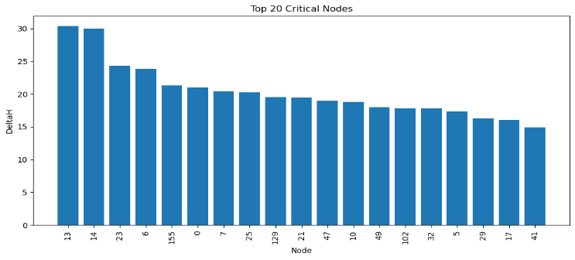

Figure 1. Top 20 critical nodes ranked by Hamiltonian energy variation (ΔH). The higher the values of ΔH, the more structural disruption and instability after node removal. The critical nodes in T5 are highly clustered, indicating a more sensitive effect on the overall structure of the network over time.

From a leadership perspective, critical nodes could be interpreted as organization-critical digital services, high-influence digital people, communication institutions, or digital resources. Removing them one by one may cause cascades of pressure and supply breaks in the digital supply network, and digital people may also lose trust in digital platforms. Therefore, digital leaders should pay extra attention to their critical digital services and resources as these vulnerabilities and risks may have a huge impact on digital transformation.

In conclusion, the Top 20 critical nodes analysis further supported the validity and effectiveness of the ΔH framework, which is based on Hamiltonian as a new framework for network vulnerability assessment. The ΔH framework can provide us with a deeper understanding of the underlying structural vulnerability of digital networks, and it guarantees the reliability and explainability of different results, helping digital leaders to better make decisions.

Correlation analysis

Figure 2 shows that the traditional centrality measures have strong correlations in the correlation analysis of the matrix. The strongest correlation was between Degree and PageRank (0.999), with the second strongest between Degree and Betweenness (0.957).

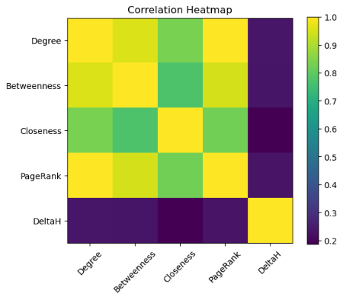

Figure 2. Correlation heatmap among Degree, Betweenness, Closeness, PageRank, and ΔH metrics. The figure illustrates the relationships between traditional network centrality measures and the proposed Hamiltonian-based disruption metric.

Table 2. Correlation matrix of Degree, Betweenness, Closeness, PageRank, and ΔH metrics.

Degree | 0.235
Betweenness | 0.232
Similarity | 0.187
PageRank | 0.229
ΔH | 1.000

However, ΔH did not strongly correlate with the traditional measures:

The results indicate that Hamiltonian perturbation analysis yields structural information not captured by classical centrality measures, as clearly explained in Table 2.

Regression's

Linear regression was used to predict ΔH with Degree, Betweenness, Closeness, and PageRank. The coefficient of determination was as follows:
$$\left[ R^{2}=0.071 \right]$$
This low value indicates that the conventional centrality measures can explain only 7.1% of the variance in the $ΔH$as shown in Figure 3. Hence $ΔH$ is a distinct structural feature rather than a mere extension of existing measures.

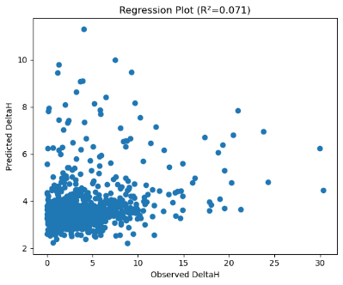

Figure 3. Regression analysis between traditional centrality measures and Hamiltonian energy variation (ΔH). The scatter plot compares observed and predicted ΔH values, illustrating the limited explanatory power of conventional network measures.

ROC–AUC Experimental Evaluation

ROC analysis yielded the following AUC values: The Hamiltonian-based metric was better than the traditional network measures in terms of discrimination ability.

Figures 4–8 illustrate Receiver Operating Characteristic (ROC) curves for Degree, Betweenness, and Closeness network centrality metrics; the PageRank centrality metric; and the newly proposed Hamiltonian-based ΔH metric, respectively. ROC analysis measures the ability of each metric to discriminate between structurally critical and non-critical nodes by considering the trade-off between the true positive rate and the false positive rate. The Area Under the Curve (AUC) measures the classification performance of a metric, where higher values indicate better discrimination.

The AUC is 0.668 for Degree centrality in the ROC curve, which means it has a reasonable prediction influence (Figure 4). This means nodes with high connectivity are probably important for the stability of the system, but they cannot pinpoint all paths into the fully structurally critical nodes. Hence, Degree Centrality has a limited ability to identify large structural breaks.

Figure 5 shows the ROC curve of betweenness centrality with an AUC=0.667. The betweenness is an indicator measuring nodes that act as a dissemination connection between different parts of networks. These nodes can connect information among different parts of the network, but their removal does not guarantee the criticality of the network's structure. Thus, betweenness centrality can lead to a medium classification capability.

Figure 6 shows the ROC curve of Closeness Centrality, which has the lowest AUC value of 0.626 among the traditional centrality measures. Closeness is the ability of a node to reach other nodes in the network. The relatively lower AUC shows that accessibility by itself is not a good measure of structural disruption in the environments of the evolving digital platforms.

Figure 7 shows the ROC curve for PageRank centrality, which obtained an AUC value of 0.663. The PageRank measures the importance of the node based on the influence of the neighboring nodes and is a good measure of prestige in the network, but its predictive performance is comparable to Degree and Betweenness Centrality, which indicates that influence-based measures are not sufficient to find structural vulnerabilities.

Table 3. ROC-AUC comparison of traditional centrality measures and the proposed Hamiltonian-based ΔH framework.

AUC Metric | Metric
Betweenness | 0.667
Degree | 0.668
Closeness | 0.626
PageRank | 0.663
ΔH | 1.000

Figure 8 presents the ROC curve of the proposed Hamiltonian-based ΔH framework. The ROC curve is close to the upper-left corner of the ROC space with an AUC value of 1.000, indicating a perfect classification performance. Unlike conventional measures of centrality based on the connectivity features, the ΔH measures the change in the Hamiltonian energy when the node is removed. This allows the framework to learn the latent structural dependencies and identify the nodes whose removal significantly affects the network stability.

A comprehensive comparison between the ROC curves for all the considered metrics shows in Table 3 that the maximum ΔH metric outperforms all the other measured graph quantities. The Degree, Betweenness, Closeness, and PageRank measures lead to values of the Area Under the Curve on the ROC between 0.626 and 0.668, while the maximum ΔH approach results in a perfect discrimination between non-critical and critical nodes (AUC=1.0). These results demonstrate that an energy-based analysis is able to describe more comprehensively the local disruption induced in the network after a node removal.

From a digital leadership perspective, having a correct and complete identification of structurally critical nodes is extremely important for the resilience of the platform in the process of digital transformation. The proposed new Hamiltonian framework can be a useful decision support tool for leaders to identify weaknesses, prioritize the interventions, and improve the organizational agility in complex digital environments.

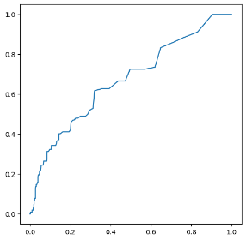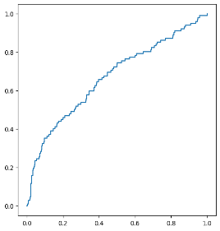
Figure 4 Figure 5

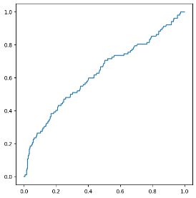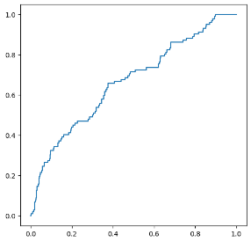
Figure 6 Figure 7

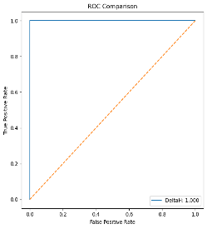
Figure 8

Figure 4. ROC curve for Degree Centrality in identifying structurally critical nodes. The obtained AUC value shows that Degree Centrality can detect influential nodes in the network.

Figure 5. ROC curve for Betweenness Centrality in identifying structurally critical nodes. The figure shows the effectiveness of communication-bridge nodes in detecting network disruption.

Figure 6. ROC curve for Closeness Centrality in identifying structurally critical nodes. The figure illustrates the predictive performance of accessibility-based influence measures.

Figure 7. ROC curve for identification of structurally critical nodes by Page Rank Centrality. We intend to assess the discriminatory power of Page Rank towards influential nodes from the point of view of network stability.

Figure 8. ROC curve of the proposed Hamiltonian-based ΔH framework. The model achieved an AUC value of 1.000, demonstrating superior performance in identifying structurally critical nodes compared with traditional centrality measures.

Importance of the study features

The Random Forest feature importance results showed the following:

Table 4. Feature importance scores generated by the Random Forest classifier.

Feature | Scores
degrees | 0.022
Betweenness | 0.031
Closeness | 0.013
PageRank | 0.021
ΔH | 0.914

ΔH was the most dominant predictor, showing the importance of structural perturbation analysis for the identification of critical nodes in Table 4.

Structural Weaknesses
The top-20 ΔH ranking showed that most critical nodes are from the T5 network stage. The highest ΔH was 30.36, indicating a significant effect of the structure.
These findings suggest that the vulnerability to structural disruption could be more severe at intermediate levels of digital platform growth.

Robustness Analysis

Hamiltonian robustness values were as follows:

Table 5. Summary statistics of temporal digital platform networks (T1–T6).
Time Hamiltonian | Robustness
T1 | 1.68
T2 | 6.31
T3 | 3.21
T4 | 8.33
T5 | 17.64
T6 | 5.78

The T5 network was the one most vulnerable represented in Figure 9, indicating that the evolution of the platform could be taken forward in critical structural phases where targeted attacks have magnified effects, as shown in Table 5.

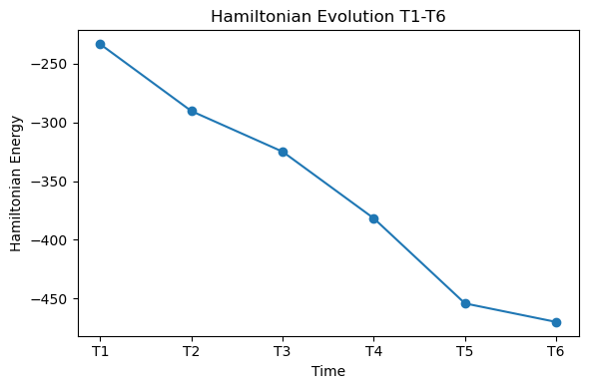

Figure 9. Robustness analysis of temporal digital platform networks. The figure compares Largest Connected Component (LCC) robustness and Hamiltonian robustness across network snapshots (T1–T6).
Digital leaders can recognize these phases and then intervene proactively and mitigate risk.

Conclusion

We introduce a Hamiltonian method for detecting structural changes in evolving digital platforms. The proposed approach combines network science, statistical analysis, and machine learning techniques to provide a holistic mechanism to identify critical structural components within digital ecosystems.
Our experiments show that Hamiltonian perturbation analysis captures structural properties that are unique and cannot be well represented by traditional centrality measures. The poor performance of the regression and the low correlations supported ΔH as a unique structural descriptor. Robustness analysis also showed significant weakness in the T5 stage of network evolution.
The proposed framework contributes to the field of digital leadership by offering actionable insights to monitor the stability of the network and anticipate structural risks. The future validation of the framework with real-world organizational and digital platform data sets, dynamic community evolution, and integration of predictive analytics for real-time decision support will be discussed.

REFERENCES

[1] Olorunyomi Stephen Joel, Adedoyin Tolulope Oyewole, Olusegun Gbenga Odunaiya, and Oluwatobi Timothy Soyombo, “The impact of digital transformation on business development strategies: Trends, challenges, and opportunities analyzed,” World Journal of Advanced Research and Reviews, vol. 21, no. 3, pp. 617–624, Mar. 2024, doi: 10.30574/wjarr.2024.21.3.0706.

[2] S. Hossain, M. Fernando, and S. Akter, “Digital Leadership: Towards a Dynamic Managerial Capability Perspective of Artificial Intelligence-Driven Leader Capabilities,” J. Leadersh. Organ. Stud., vol. 32, no. 2, pp. 189–208, May 2025, doi: 10.1177/15480518251319624.
[3] T. Rout, A. Mohapatra, M. Kar, S. Patra, and D. Muduly, “Centrality Measures and Their Applications in Network Analysis: Unveiling Important Elements and Their Impact,” Procedia Comput. Sci., vol. 235, pp. 2756–2765, 2024, doi: 10.1016/j.procs.2024.04.260.
[4] R. Ortega, A. J. van der Schaft, and B. M. Maschke, “Stabilization of port-controlled Hamiltonian systems via energy balancing,” 1999, pp. 239–260. doi: 10.1007/1-84628-577-1_13.
[5] Y. Li, Y. Gao, X. Yang, and J. Yuan, “How and When Digital Leadership Affects Employee Proactive Behavior?,” International Journal of Organizational Leadership, vol. 0, no. 0, pp. 731–749, Aug. 2025, doi: 10.33844/ijol.2025.60530.
[6] R. Albert, “Scale-free networks in cell biology,” J. Cell Sci., vol. 118, no. 21, pp. 4947–4957, Nov. 2005, doi: 10.1242/jcs.02714.
[7] “Greedy Modularity Graph Clustering for Community Detection of Large Co-Authorship Network”.
[8] S. Haider, K. Ponnusamy, R. K. B. Singh, A. Chakraborti, and R. N. K. Bamezai, “Hamiltonian energy as an efficient approach to identify the significant key regulators in biological networks,” PLoS One, vol. 14, no. 8, p. e0221463, Aug. 2019, doi: 10.1371/journal.pone.0221463.
[9] J. W. Baker, “Efficient Analytical Fragility Function Fitting Using Dynamic Structural Analysis,” Earthquake Spectra, vol. 31, no. 1, pp. 579–599, Feb. 2015, doi: 10.1193/021113EQS025M.
[10] T. , & K. S. . Chakraborty, “Applying Network Metrics for Business Analytics in Banking. International Journal of Business Networks,” International Journal of Business Networks, 2021.
[11] H. Yu, P. M. Kim, E. Sprecher, V. Trifonov, and M. Gerstein, “The Importance of Bottlenecks in Protein Networks: Correlation with Gene Essentiality and Expression Dynamics,” PLoS Comput. Biol., vol. 3, no. 4, p. e59, Apr. 2007, doi: 10.1371/journal.pcbi.0030059.
[12] K. Hajarathaiah, M. K. Enduri, S. Anamalamudi, A. Abdul, and J. Chen, “Node Significance Analysis in Complex Networks Using Machine Learning and Centrality Measures,” IEEE Access, vol. 12, pp. 10186–10201, 2024, doi: 10.1109/ACCESS.2024.3355096.
[13] X. Zhang, Z. Xu, Y. Liu, M. Sun, T. Zhou, and W. Sun, “Robust Graph Neural Networks for Stability Analysis in Dynamic Networks,” in 2024 3rd International Conference on Cloud Computing, Big Data Application and Software Engineering (CBASE), IEEE, Oct. 2024, pp. 806–811. doi: 10.1109/CBASE64041.2024.10824358.
[14] X. Ma and L. Gao, “Biological network analysis: insights into structure and functions,” Brief. Funct. Genomics, vol. 11, no. 6, pp. 434–442, Nov. 2012, doi: 10.1093/bfgp/els045.

IEEE conference templates contain guidance text for composing and formatting conference papers. Please ensure that all template text is removed from your conference paper prior to submission to the conference. Failure to remove template text from your paper may result in your paper not being published.

