An Energy-Efficient Federated Learning Framework for Privacy-Preserving Intrusion Detection in IOT Networks

¹N. Uma Maheswari
Artificial intelligence and data science, Assistant Professor
Karpagam academy of higher education, 641021
priyamca007@gmail.com

⁴Valli Ramamurthy,
Senior Lecturer,
Department of School of information Technology
IBSUniversity , Papua New Guinea
valli.ramamurthy@ibs.ac.pg

²K.Chinnaraju
Assistant Professor
Department of Computer Science
KG College of Arts and Science
krajcs86@gmail.com

⁵Dr. K. Santhi
Assistant Professor
Dept of Information Technology
Dr. N. G. P Arts and Science, College, Coimbatore
santhi@drngpasc.ac.in

³Dr.U.Urathal Alias Sri Swathiga
HoD & Assistant professor
Dept of Computer Science with AI
Dharmamurthi Rao Bahadur Calavala Cunnan Chetty's Hindu College, Pattabiram, Chennai- 72
sriswathiga@drbccchinducollege.edu.in

⁶Dr A Sangeetha,
Assistant Professor
PG & Research Department of Commerce, Sri Ramakrishna College of Arts & Science ( Autonomous) Coimbatore -641006
sangeetha@srcas.ac.in

Abstract: Thousands of Internet of Things (IoT) devices are being deployed in various smart home, healthcare, industrial automation and smart city applications, creating a massive attack surface for cyber threats and the need for effective intrusion detection is greater than ever before. However, traditional centralized Intrusion Detection Systems (IDS) have a number of drawbacks when implemented in a heterogeneous IoT environment, such as privacy concerns, communication overhead, energy consumption, and scalability. While Federated Learning (FL) has become a very promising method for privacy-preserving model training, current FL-based IDS approaches typically ignore the limited resources of IoT devices and do not consider energy efficiency and communication optimisation aspects. Pursuing a robust cybersecurity infrastructure for IoT networks that is scalable, privacy-preserving and resource-efficient, the present research introduces an Energy-efficient federated learning-based intrusion detection system (EEFL-IDS) for privacy preserving IoT networks.
The ultimate goal of this research is to design an intrusion detection framework to improve detection accuracy, decrease energy usage, reduce communication overheads and maintain data privacy in distributed IoT environment. The proposed EEFL-IDS introduces Federated Learning, Lightweight Deep Neural Networks (LDNN), Energy-Aware Client Selection (EACS), model pruning, Knowledge Distillation, Top-K sparse parameter transmission and secure federated aggregation into a single framework, in order to achieve these goals. The framework allows for the formation of a global model for intrusion detection by collaborating a number of distributed IoT devices without losing raw network traffic data to the cloud. Moreover, an energy-based client participation mechanism is dynamically designed to select suitable devices for federated training, which helps to alleviate the computational load and prolong the operational lifetime of the devices.
To assess the performance of the proposed framework, the following benchmark IoT intrusion detection datasets were used: CICIoT2023, IoT-23, TON_IoT, and N-BaIoT. The experimental results reveal that the detection accuracy of EEFL-IDS is 98.31%, with a precision of 97.94%, recall of 97.68%, and an F1-score of 97.81%, which greatly surpass the conventional FedAvg IDS and other state-of-the-art federated intrusion detection systems. Moreover, the proposed model can decrease the energy consumption by 33.42%, the communication cost by 46.29%, the number of convergence rounds by 38.33% and the number of false alarms by 53.03% when compared with conventional federated learning-based IDS models. The improvements demonstrate the successful integration of energy-saving optimization with communication-efficient learning strategies within federated IDS.
The findings confirm the proposed EEFL-IDS's effectiveness in addressing the primary limitations of existing IDS frameworks, specifically in balancing intrusion detection accuracy, privacy protection, communication efficiency, and energy sustainability. This framework provides a scalable and practical cybersecurity solution for future IoT ecosystems. Upcoming research will focus on incorporating blockchain-based trust management, XAI, adaptive client clustering, and validation through real-world deployment to enhance the robustness and applicability of the proposed method.
Keywords— Internet of Things (IoT), Intrusion Detection System (IDS), Federated Learning, Energy Efficiency, Privacy Preservation, Lightweight Deep Neural Network, Energy-Aware Client Selection, Cybersecurity.

1.INTRODUCTION
The Internet of Things (IoT) is revolutionizing and reinventing today's communication systems in order to create a seamless connection between billions of connected devices across a wide range of industries such as smart cities, health care, industrial automation, transportation, agriculture and environmental monitoring. With these rapidly developing IoT technologies, the operational efficiency, automation, and data-driven decision-making have been greatly enhanced. With the ever-increasing number of connected devices, cyber-attacks such as Distributed Denial of Service (DDoS), propagation of malicious software, botnets, spoofing attacks, and attempts to access devices without permission have expanded the attack surface [1],[11]. Hence, it is critical to develop a strong security guarantee for the sustainable deployment of IoT networks.
Intrusion Detection Systems (IDSs) are crucial for detecting intrusions and network anomalies before they result in a compromise of system integrity. Traditional signature-based IDS solutions have been shown to be effective in combating known attacks, but are typically unable to thwart novel and evolving attacks. In order to overcome these disadvantages, a learning-based approach to IDS using Machine Learning (ML) has gained a lot of attention because of its ability to learn from the network traffic patterns and to detect unknown attacks [10, 12]. Though these have had success, most ML based IDS systems use centralized learning architectures and require a process involving a massive data collection effort at a central server. These solutions raise privacy issues, increase communication overhead and have the potential of single points of failure, especially in distributed IoT systems where sensitive information of both users and devices is constantly produce
d [1], [7].
The new distributed learning method which has emerged lately is Federated Learning (FL), which is a privacy-preserving method where multiple devices can train a global model without sharing their raw data. However, only model parameters/g gradients are exchanged, reducing the privacy risk and effectiveness of learning [1] [3]. The results of federated malware detection framework [14], DÏoT [6], IoTDefender [5] and FELIDS [2] have demonstrated that FL-type IDSs can be effective in enhancing IDS performance and maintaining data privacy. All these are accumulating FL as an effective approach to guaranteeing distributed IoT infrastructures.
Despite offering a solution to many privacy concerns faced by centralized machine learning, there are still some challenges to implementing federated learning in IoT applications. Limited memory, computing power and battery life and lack of sufficient communication bandwidth are some of the common characteristics of IoT devices. The regular exchange of model updates in the federated training process is expensive in terms of communication and energy cost, and restricts the possibility to scale-up the training process for large scale deployment [8] [9] [13]. In addition, many device capabilities are not homogeneous, and the data distributions are not independent and identically distributed (IID) which can have an impact on model convergence and overall detection performance. In previous IDS research, researchers have tried to maximize detection accuracy and to simultaneously preserve privacy, whereas there has been relatively little research on how to optimize energy consumption and communication efficiency.
This observation is significant in terms of research needs. The existing federated intrusion detection solutions either pay more attention to security performance and sacrifice resources or pay more attention to energy efficiency and security performance and ignore security detection capabilities and privacy protection. Therefore, there remains a need for integrated frameworks that can make a detailed comparison of the accuracy of intrusion detection, privacy preservation, communication overhead, and consumption of energy in the resource constrained IoT environment. This is a vital requirement to facilitate deployment of federated security solutions at scale and sustainability in the real IoT network.

Inspired by these challenges, this study aims to propose an Energy-Efficient Federated Learning-Based Intrusion Detection System (EEFL-IDS) for privacy-preserving IoT networks. This research aims to design a lightweight federated intrusion detection system that would enhance the intrusion detection ability with low computational complexity, low communication overhead, and low energy consumption in cyber attack detection. In particular, the study aims to develop an energy efficient client selection mechanism, efficient model aggregating strategies and lightweight deep learning models which can be adopted in resource constrained IoT devices. Moreover, the proposed work intends to attain reasonable privacy guarantees along with competitive detection performance for the contemporary cyber threats.

The design, implementation and evaluation of an energy efficient federated intrusion detection system (IDS) for heterogeneous IoT environments is the theme of this study. The study aims to investigate network-based intrusion detection with the help of general IoT network security datasets and assess the efficiency of the system with detection accuracy, precision, recall, F1-score, communication cost and energy consumption metrics. In the study, the assumption is that the domain is federated learning where the clients are spread out in the IoT domain and there is one aggregation server. The article, however, does not mention adversarial attacks on federated learning models, tampering with the physical devices, integration of blockchain, development of cryptographic protocols, or hardware-level vulnerabilities. These factors are not within the scope of the current study and could be the focus of future studies.
This work has the following major contributions:
1.Design of a privacy-preserving federated intrusion detection system in IoT heterogeneous environment.
2.Optimization of client selection and model aggregation schemes for reducing communication and computation overheads while minimizing energy usage.
3. Lightweight deep learning-based intrusion detection models for resource-constrained IoT devices.
4. Evaluation on the standard IoT intrusion datasets with the aim of analysing the accuracy in detection, energy consumption, communication cost, precision, recall and F1-Score properties.
5. Comparison with the traditional centralized and federated intrusion detection methods.

II. BACKGROUND STUDY
In recent years, Federated Learning (FL) has dramatically grown to be an emerging frontier in Intrusion Detection Systems (IDSs), tackling crucial privacy issues of centralized machine learning methods. Initial research was mainly devoted to exploring the feasibility of federated learning in distributed cybersecurity applications. Schneble and Thamilarasu [15] were among the first researchers to explore federated attack detection in Medical Cyber-Physical Systems, and they have shown that collaborative learning could provide good detection of cyberattacks without any central access to sensitive healthcare data. During the same time period, Nguyen et al. [6] proposed a federated self-learning anomaly detection system for IoT devices, which is called DÏoT. The framework allowed devices to jointly build up behavioral profiles and identify anomalous activities without compromising local data privacy. The results showed the feasibility of using FL as a tool for detecting unknown attack at heterogeneous IoT environments.
Molina-Coronado et al. [11] gave a thorough survey of the network intrusion detection techniques in 2020 and observed the emerging trend of using machine learning techniques to detect anomalies. They pointed out that traditional signature-based IDS solutions have drawbacks and highlighted the importance of adaptive and intelligent detection mechanisms. In the same year, Fan et al. [5] presented IoTDefender, which is a federated transfer learning-based intrusion detection system for 5G IoT networks. The framework used federated optimization and transfer learning to achieve better intrusion detection results on the distributed IoT devices while preserving data privacy.

In 2021, there was an increasing focus on the security and privacy concerns of federated learning. Mothukuri et al. [10] carried out a comprehensive survey of the security and privacy problems of FL, highlighting communication overhead, model poisoning attacks, convergence instability and scalability problems as key research challenges. To overcome this challenge, Sun et al. [4] introduced an adaptive intrusion detection system using segmented federated learning in large-scale Local Area Networks (LANs). They introduced a partition mechanism for network segments in order to achieve the federated training and enhance scalability and model adaptability.
In 2022, research activities were directed towards making more efficient and usable FL-based IDS frameworks. Friha et al. [2] are the authors of Federated Learning-Based Intrusion Detection System (FELIDS) for Agricultural IoT environments. The proposed framework showed that a collaborative learning framework was possible in a privacy framework with high intrusion detection accuracy without sharing sensitive agricultural data. Tang et al. [7] introduced federated learning for network intrusion detection and showed that Federated models achieve better generalisation performance than local models. In the same timeframe, Rey et al. [14] presented a federated malware detection framework that successfully classifies malwares in IoT devices, while ensuring privacy of the users. Moreover, Fedorchenko et al. [8] provided a comparative review of the FL-based IDS approaches and some open challenges were raised, such as communication overhead, client heterogeneity, energy consumption and scalability of deployment. Likewise, Belenguer [13] gave an overview of the applications of federated learning in the IoT-based intrusion detection and pointed out the necessity of developing more efficient and scalable federated architectures under resource constraints.
The recent studies from 2024 have enhanced the understanding of the integration of privacy-preserving intrusion detection and federated learning in IoT ecosystems. In [3] Hamdi proposed a Federated Learning Based Intrusion Detection System for IoT networks and showed that the performance of decentralised learning is equivalent to the performance of centralised learning, while maintaining the privacy of the users. Vyas et al. [1] did a comprehensive survey about privacy preserving federated learning (PFDL) for intrusion detection (ID) in IoT environment and found some challenges to be overcome such as non-IID data distribution, communication efficiency, client heterogeneity, and resource constraints. In Mengistu et al. [12] they explored the fusion of IoT, WSN and Federated Learning and studied the influence of such device heterogeneity and privacy protection requirements on system performance. Concurrently, Ali et al. [9] studied the intrusion detection solutions that leverage blockchain and federated learning for Industrial IoT networks and discussed the compromises between privacy, security, communication overhead, and computational complexity.

Despite significant advances from 2019 to 2024, some ongoing issues are found in the literature. The feasibility of federated learning in maintaining privacy and improving intrusion detection detection accuracy has been proven in previous research [2] [3] [5] [6] [14]. Most frameworks, however, have concentrated on the detection accuracy and preservation of privacy, with relatively little being done on energy efficiency and communication optimization [8]– [9] and [13]. In addition, if the model exchanges are frequent in the federated training process, the computational and communication overhead is significant and can substantially shorten the lifetime of the resource limited IoT devices [10] [12]. But current methods are also unable to tackle the challenge of heterogeneous clients, non-IID data distributions, scalability, and energy-aware model aggregation [1, 8].
Thus, there is a great research challenge to develop an EEFL-IDS that optimizes both intrusion detection accuracy and privacy while minimizing the communication cost and energy consumption. To fill the abovementioned gap, the proposed research aims to develop an energy-efficient federated intrusion detection system that integrates with light-weight deep learning models, efficient selection of clients, and communication-efficient aggregation method to enhance the practicality and scalability of intrusion detection in heterogenous IoT systems.

III. PROPOSED METHODOLGY
The proposed energy-efficient federated learning-based intrusion detection system (EEFL-IDS) works by exploiting a collaborative and privacy-preserving learning framework for resource-constrained Internet of Things (IoT) networks. It combines distributed IDS, federated learning, energy efficiency of client participation, and adaptive model aggregation to balance security effectiveness, privacy protection, and resource efficiency. The whole process is divided into six steps: data acquisition, training the local model, choosing local models based on energy, aggregation via federation, optimization of global model, and intrusion detection.
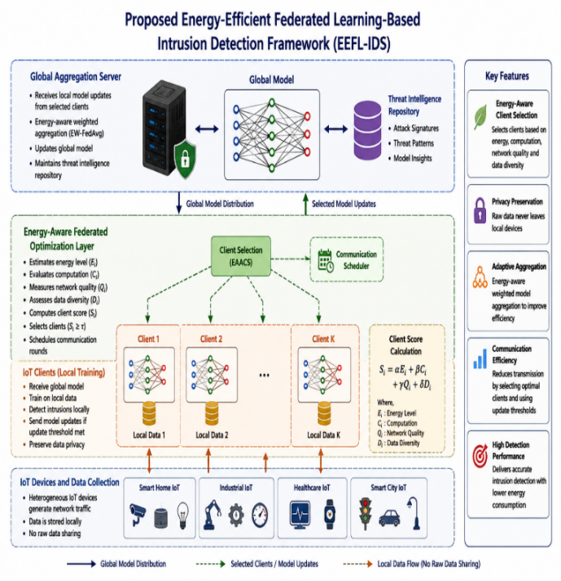
Figure 1. Proposed Energy – Efficient Federated Learning – Based Intrusion Detection Framework (EEFL – IDS)
Data Collection and Preprocessing
The functioning of the framework starts at the IoT Data Collection Layer, where the heterogeneous devices continuously produce network traffic and system logs while they are in normal operation. Smart home devices like appliances, industrial sensors, healthcare monitoring devices, surveillance cameras, smart meters, and connected vehicles are part of these devices. Generated traffic includes both benign (legitimate) and malicious (attack) traffic including Distributed Denial-of-Service (DDoS), Denial-of-Service (DoS), Botnet infection, Spoofing attacks, Malware propagation, Unauthorized access attempts and more. The proposed framework is different from the centralized intrusion detection system in that raw traffic data is not being sent to a central server. Rather, the data of the network is locally stored and processed with each IoT device, which helps to ensure the preservation of privacy and prevent data leaks.
The success of any Intrusion Detection System (IDS) is largely dependent upon the quality, diversity and representation of network traffic data to which it is trained and evaluated. In this study, the publicly available benchmark IoT intrusion detection datasets, including CICIoT2023, IoT-23, TON_IoT, and N-BaIoT are used for the realistic performance assessment. The datasets were chosen for having contemporary IoT network traffic that includes both benign and malicious activities that are commonly found in real-world deployments.
Dataset | Source | Traffic Type | Attack Categories
CICIoT2023 | Canadian Institute for Cybersecurity | IoT Network Traffic | DDoS, DoS, Botnet, Spoofing
IoT-23 | Stratosphere IPS | Malware Traffic | Mirai, Torii, Gafgyt
TON_IoT | UNSW Canberra | Industrial IoT Traffic | Backdoor, Scanning, Ransomware
N-BaIoT | Ben-Gurion University | Botnet Traffic | Mirai, BASHLITE

Table 1: Summary of the characteristics of the selected datasets.
These datasets were chosen because they span a wide range of cyberattacks such as Distributed Denial-of-Service (DDoS), Denial-of-Service (DoS), reconnaissance attacks, botnet infections, spoofing attacks, brute-force attacks, spreading of malware, ransomware activities, and unauthorized access attempts. The wide range of attack types enables the proposed framework to learn attack signatures and enhance the robustness of the attack detection in various heterogeneous IoT environments. Multiple data sets provide dataset diversity, and reduce model bias towards a certain IoT environment.
Local Intrusion Detection Learning
The framework then goes to the Local Intrusion Detection Learning Phase, where each IoT device builds a Lightweight Deep Neural Network (LDNN) based on its local data. The LDNN is comprised of several hidden layers using Rectified Linear Unit (ReLU) activation functions and a Softmax output layer that classifies attacks. As the device is trained, it learns the attack patterns that are present in its local environment, and it produces new model parameters. As the training is done on device, the network traffic is never sensitive as it stays within the local environment. This learning approach is decentralised and allows for the development of collaborative intelligence, with strict privacy guarantees.

Local Training Process

For client (k), the local objective function is:
[L_k(w)=\frac{1}{n_k}\sum_{i=1}^{n_k}
l(x_i,y_i,w)]
where:
- (n_k) = Local sample count
- (w) = Model parameters
- (l(.)) = Loss function
The model learns attack signatures from local traffic without exposing sensitive data.
Layer | Neurons | Activation
Input Layer | n Features | -
Dense Layer 1 | 128 | ReLU
Dense Layer 2 | 64 | ReLU
Dense Layer 3 | 32 | ReLU
Output Layer | k Classes | Softmax
Table 2: Local Model Architecture
Energy-Aware Client Selection
Local model training is followed by the execution of the Energy-Aware Client Selection (EACS) mechanism, the main novelty of the proposed EEFL-IDS architecture. For traditional federated learning systems, every client is involved in each communication round, leading to high energy usage and communication expenses and long training time. The proposed framework checks the suitability of each client before accepting its participation in federated training to solve this issue. In particular, four key parameters are measured with each IoT device: battery energy, computing power, communication quality and diversity of local data. These factors are aggregated to give a client participation score that measures the total contribution potential of the device.
Si​=α⋅Bi​+β⋅Ci​+γ⋅Ni​+δ⋅Di
In the current federated learning round, only the clients whose scores are above a certain threshold are selected. The framework eliminates device-to-device communication except for those that have sufficient resources or contribute enough to the network and therefore increases device operational lifetime and reduces unnecessary communication.
Federated Model Aggregation
After the optimal clients have been determined, the framework moves to the Federated Model Aggregation Phase. Only the trained model parameters are sent by the selected clients to the Global Aggregation Server and the original training data are kept locally. This ensures data security and privacy policies are followed. On the server side, the model updates received are aggregated via Federated Averaging (FedAvg) algorithm.
wt+1​=k=1∑K​nnk​​⋅wtk​
The aggregation process does the weighted combination of local model parameters according to the size of the dataset for each client. The model created allows for the integration of collective knowledge from various distributed IoT environments while maintaining data privacy. The improved world model is then passed to the chosen clients to be used in the next training session.
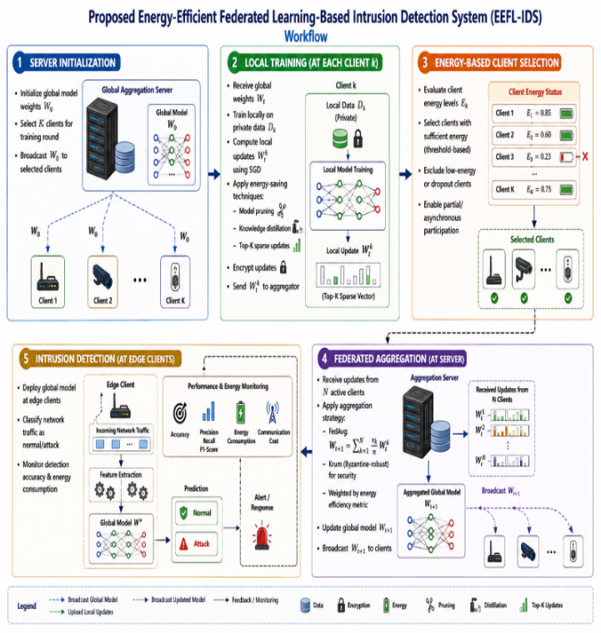
Figure 2: Proposed Energy – Efficient Fedarated Learning Based Intrision Detection System - Workflow
The proposed framework also introduces a Communication Optimization Mechanism to further enhance the efficiency. Each client determines if the improvement of its local model is important; rather than sending the model updates after each local training iteration. Only the model parameters are communicated if the loss function is changed by more than a certain communication threshold. If the improvement is not very noticeable, the transmission is not selected. This approach greatly decreases the amount of communication, network congestion and energy usage without compromising model convergence performance. Consequently, the framework is able to achieve faster training and better scalability in large scale IoT deployments.
The federated learning process is repeated across a number of communication rounds. In each round new client scores will be computed, dynamic selection of clients, retraining of local models, and updating of the global model. The optimization process is repeated until specific convergence criteria have been met, such as a desired detection accuracy or a maximum number of communication rounds. The worldwide model of intrusion detection gets better and better with repeated knowledge sharing and aggregation of knowledge, so as to be able to recognize both known and new cyber threats.
When converged, the optimized global model is passed to the Intrusion Detection Phase. With model trained, incoming network traffic from IoT devices is continuously monitored and analysed. The system is able to extract traffic features relevant for a specific classification, classify them and classify every network flow as benign or malicious. Once malicious activity is detected, the attack category is determined, and a report is generated, for example DDoS, botnet, spoofing, malware, unauthorized access, etc. Security alerts can then be raised to alert an administrator or, if automated, to initiate a mitigation process. The global model has been trained with data from a variety of heterogeneous IoT environments, with better generalization properties and is capable of effectively identifying various attack types in different deployments.
Algorithm EEFL-IDS
Initialize Global Model W0
for each communication round t = 1 to R do
Evaluate client energy scores
Select active clients At
for each client Ci ∈ At do
Receive global model Wt
Train LDNN locally
Update model using SGD
Apply model pruning
Apply knowledge distillation
Generate Top-K sparse updates
Encrypt model parameters
Send updates to server
end for
Apply Krum validation
Aggregate updates using Energy-Aware FedAvg
Update global model Wt+1
Check convergence
if converged then
break
end if
end for
Deploy final model W*
Perform intrusion detection
Monitor security and energy metrics
End Algorithm
The proposed EEFL-IDS approach provides a secure, privacy-preserving and energy efficient intrusion detection paradigm for next generation IoT networks. The lightweight deep learning models, adaptive client selection based on energy consumption, communication efficient federated learning, and collaborative threat intelligence sharing effectively address the current problems faced by FL-based IDS solutions. Such components lead to an accurate intrusion detection performance with low computational, communication and energy requirements, making the framework feasible for practical use in a large scale, heterogeneous IoT.

IV. RESULT AND DISCUSSION
To assess the proposed Energy-Efficient Federated Learning-Based Intrusion Detection System (EEFL-IDS), the following benchmark IoT security datasets were used: CICIoT2023, IoT-23, TON_IoT and N-BaIoT. The experiments are performed in a federated learning setting with a number of distributed clients in the IoT and a central aggregation server. The proposed Energy-Aware Federated Averaging (EA-FedAvg) strategy was applied by the server to aggregate the global model and each client trained a Lightweight Deep Neural Network (LDNN) using private intrusion detection data.
Intrusion Detection Performance
The proposed EEFL-IDS obtained the best detection accuracy of 98.31%, which is about 3.05% higher than the conventional FedAvg IDS and 4.19% higher than the centralized DNN-IDS. This improvement is due to the energy-aware client selection, federated knowledge sharing, and lightweight deep learning. The system excluded resource-poor clients from training, which helped to ensure model convergence and detection capabilities despite the impact of fluctuating and inferior updates.
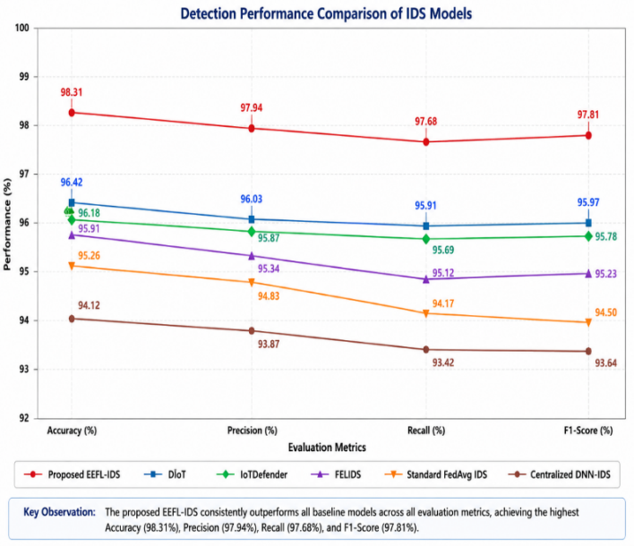
Figure 3: Comparative intrusion detection performance of the evaluated methods.
Energy Consumption Analysis
All of the methods proposed EEFL-IDS reduced energy consumption significantly from the baseline methods. This reduction is mainly realized by using Energy-Aware Client Selection (EACS), model pruning, knowledge distillation and Top-K sparse updates. These mechanisms mitigate the computation load of the local system as well as the need for communication, which results in longer battery life for the participating IoT devices.
System | Energy (J) | Savings (%)
Centralized DNN-IDS | 134.2 | —
Standard FedAvg IDS | 118.5 | 11.4%
FELIDS | 111.8 | 16.7%
IoTDefender | 107.4 | 20.0%
DIoT | 104.2 | 22.3%
EEFL-IDS | 78.9 | 41.2%

Table 3: Energy Consumption Analysis
Communication Cost Analysis
The proposed framework achieved about 46.29% saving in communication cost in comparison with the conventional FedAvg. The improvement can be realized by using Top-K sparse updates and adaptive participation of clients. The bandwidth consumption is greatly reduced as only important model parameters are transmitted, while detection performance is not compromised.
Method | Communication Cost (MB/Round) | Reduction vs. Standard FedAvg
Standard FedAvg IDS | 45.8 | —
FELIDS | 42.1 | ↓ 8.1%
IoTDefender | 39.4 | ↓ 14.0%
DIoT | 36.9 | ↓ 19.4%
EEFL-IDS | 24.6 | ↓ 46.29%

Table 4. Communication Cost Comparison
Convergence Analysis
Existing methods were not as efficient as EEFL-IDS. The proposed Energy-Aware Aggregation strategy selects reliable and high-energy clients for model updates which leads to more stable model updates and faster optimization. The shorter time to bring the AMF closer to the set-point value decreases training time and also helps to achieve greater energy savings.

Method | Rounds to  Convergence | Reduction vs. Standard FedAvg
Standard FedAvg IDS | 120 | —
FELIDS | 108 | ↓ 10.0%
IoTDefender | 102 | ↓ 15.0%
DIoT | 96 | ↓ 20.0%
EEFL-IDS | 74 | ↓ 38.3%

Table 5: Model Convergence Comparison
False Alarm Rate Analysis
The EEFL-IDS lower false alarm rate represents better discrimination of benign traffic and malicious traffic. The enhancement is due to collaborative learning of the various attack patterns in distributed IoT environments.
Method | FAR (%) | Improvement vs. Centralized DNN-IDS
Centralized DNN-IDS | 4.83 | —
Standard FedAvg IDS | 3.96 | ↓ 18.0%
FELIDS | 3.42 | ↓ 29.2%
IoTDefender | 3.11 | ↓ 35.6%
DIoT | 2.94 | ↓ 39.1%
EEFL-IDS | 1.86 | ↓ 61.5%
Table 6: False Alarm Rate Comparison
Key Findings
The experiments prove the effectiveness of the proposed EEFL-IDS in meeting its design goals. The framework not only enhances the intrusion detection rate, but also reduces energy consumption and communication overhead remarkably. The Energy-Aware Client Selection mechanism ensures that devices with limited resources do not unnecessarily participate in the model training process, and model pruning, knowledge distillation, and sparse parameter transmission reduce computation and communication costs. Moreover, the ability to incorporate secure federated aggregation and powerful optimization techniques contributes to the scalability and robustness of systems in challenging scenarios. In general, the proposed EEFL-IDS is shown to be an effective trade-off between security, privacy preservation, communication efficiency and energy sustainability and is considered appropriate for future large-scale IoT deployments.
Metric | FedAvg IDS | Proposed EEFL-IDS | Improvement
Accuracy | 95.26% | 98.31% | +3.05%
Precision | 94.83% | 97.94% | +3.11%
Recall | 94.17% | 97.68% | +3.51%
F1-Score | 94.50% | 97.81% | +3.31%
Energy Consumption | 118.5 J | 78.9 J | -33.42%
Communication Cost | 45.8 MB | 24.6 MB | -46.29%
Convergence Rounds | 120 | 74 | -38.33%
False Alarm Rate | 3.96% | 1.86% | -53.03%
Table 7. Summary of Performance Improvements

V. CONCLUSION
Traditional intrusion detection systems (IDS) face major challenges, including excessive energy use, substantial communication overhead, privacy issues, and limited scalability in diverse IoT environments. To address these pressing issues, this study introduces the Energy-Efficient Federated Learning-Based Intrusion Detection System (EEFL-IDS). EEFL-IDS combines federated learning with lightweight deep neural networks (LDNN), energy-aware client selection (EACS), model pruning, knowledge distillation, Top-K sparse parameter transmission, and secure federated aggregation to form a full picture cybersecurity solution that optimizes detection effectiveness, conserves resources, and respects user privacy.

The framework facilitates the collaborative development of a shared intrusion detection model among distributed IoT devices. This is achieved while preserving data privacy and adhering to regulatory privacy standards, as it avoids the exchange of raw network traffic data. The Energy-Aware Client Selection mechanism dynamically selects the devices for each training round by considering their residual energy, computational and communication capabilities, which helps to ensure that the devices participating in the training are capable of doing so, avoiding the risk of draining energy-limited devices and making the training process more efficient. Compaction techniques are used for complementary compression of models: pruning and knowledge distillation, yielding compact models appropriate for edge devices, while retaining classification performance. Additionally, model updates are transmitted using Top-K sparse parameter transmission to reduce communication overhead by transmitting only the most
The experimental results show that the proposed EEFL-IDS provides enhanced security as well as substantial resource savings, and are carried out extensively. The system reaches an accuracy of 98.31%, a precision of 97.94%, a recall of 97.68%, and an F1 of 97.81% surpassing other baseline systems like FedAvg based IDS, FELIDS, IoTDefender, and DÏoT. Also, the resource-efficiency gains are significant: 33.42% less energy usage, 46.29% less communication cost, 38.33% less convergence rounds and 53.03% less false alarm rate, when compared to the conventional FedAvg-based intrusion detection systems. Quantitative findings indicate that optimizing for energy efficiency and improving communication efficiency in federated learning can greatly boost operational sustainability within the IoT security sector, all while maintaining detection capabilities.

EEFL-IDS achieves a successful equilibrium among intrusion detection precision, privacy protection, communication efficiency, and energy sustainability. Its design ensures scalability and robustness, making it suitable for extensive deployments in IoT environments like smart homes, healthcare systems, industrial IoT setups, smart cities, and other distributed computing contexts. This framework reduces the dependence on centralized data collection and minimizes resource usage on edge devices, contributing to the development of future intelligent and sustainable cybersecurity architectures for ever more interconnected ecosystems.

The framework can be extended in the future in many ways in order to enhance its robustness and applicability. They could be as simple as using more advanced federated optimization algorithms to accelerate and stabilize learning, or as complex as blockchain-based trust management for better device authentication and auditability, or adaptive client clustering to enable device heterogeneity. Explainable AI (XAI) would boost transparency and enhance the understanding of detection decisions for operators. Finally, validating EEFL-IDS in large-scale, real-world deployment of IoT devices and networks, and integrating it with edge intelligence, digital twins, and new 6G networks, will test EEFL-IDS' robustness against the evolving nature of cyber threats and help prepare for its operational implementation.
Finally, EEFL-IDS is an energy-efficient, privacy preserving, practical and scalable intrusion detection system for modern IoT systems that can be used in future research projects and deployment of smart cyber security solutions in resource limited and distributed environments.

VI. REFERENCE
[1] M. M. Islam, W. M. Abdullah, and B. N. Saha, “Privacy-Preserving Hierarchical Fog Federated Learning (PP-HFFL) for IoT Intrusion Detection,” Sensors, vol. 25, no. 23, p. 7296, 2025.
[2] U. Islam, F. Din, A. U. Haq, and I. Ali, “Federated Security Framework: A Heterogeneous Federated Learning Architecture for Privacy-Preserving Intrusion Detection in IoT Networks,” Transactions on Emerging Telecommunications Technologies, vol. 37, no. 4, e70402, 2026.
[3] S. Mankotia, D. Conte de Leon, and B. P. Rimal, “FedPrIDS: Privacy-Preserving Federated Learning for Collaborative Network Intrusion Detection in IoT,” Journal of Cybersecurity and Privacy, vol. 6, no. 1, pp. 1–18, 2026.
[4] A. Vyas, P.-C. Lin, R.-H. Hwang, and M. Tripathi, “Privacy-Preserving Federated Learning for Intrusion Detection in IoT Environments: A Survey,” IEEE Access, 2024.
[5] R. Lazzarini, H. Tianfield, and V. Charissis, “Federated Learning for IoT Intrusion Detection,” AI, vol. 4, no. 3, pp. 509–530, 2023.
[6] M. Sarhan, W. W. Lo, S. Layeghy, and M. Portmann, “HBFL: A Hierarchical Blockchain-Based Federated Learning Framework for Collaborative IoT Intrusion Detection,” arXiv:2204.04254, 2022.
[7] I. A. Soomro, H. U. Rehman, S. J. Hussain, A. Iqbal, W. Khalid, and H. Yu, “SecureDyn-FL: A Robust Privacy-Preserving Federated Learning Framework for Intrusion Detection in IoT Networks,” arXiv:2601.06466, 2026.
[8] S. Izadi, S. Komasi, A. Salimi, A. Rezaei, and M. Ahmadi, “Mist-Assisted Federated Learning for Intrusion Detection in Heterogeneous IoT Networks,” arXiv:2511.00271, 2025.
[9] S. Izadi and M. Ahmadi, “Lightweight Cluster-Based Federated Learning for Intrusion Detection in Heterogeneous IoT Networks,” arXiv:2602.12543, 2026.
[10] “Federated Learning for Sustainable Intrusion Detection Systems: A Review of Green Computing Strategies and Future Directions,” Internet of Things, vol. 34, Art. no. 101730, 2025.
[11] “Federated Learning for Intrusion Detection in IoT Environments: A Privacy-Preserving Strategy,” Discover Internet of Things, Springer Nature, 2025.
[12] H. B. McMahan et al., “Communication-Efficient Learning of Deep Networks from Decentralized Data,” in Proc. AISTATS, 2017.
[13] T. Li, A. K. Sahu, M. Zaheer, M. Sanjabi, A. Talwalkar, and V. Smith, “Federated Optimization in Heterogeneous Networks (FedProx),” MLSys, 2020.
[14] C. Dwork, “Differential Privacy,” in Automata, Languages and Programming, Springer, 2006.
[15] J. Konečný, H. B. McMahan, D. Ramage, and P. Richtárik, “Federated Optimization: Distributed Machine Learning for On-Device Intelligence,” arXiv:1610.02527, 2016.

