A Neuro Social Organizational Automation System for Employee Attrition Risk Assessment and Data-Driven HR Management

¹Dr G Agila,
Associate Professor & Head
PG & Research Department of Commerce
Sri Ramakrishna College of Arts & Science ( Autonomous) Coimbatore -641006
agila@srcas.ac.in

⁴Dr N Selvakumar,
Associate Professor
PG & Research Department of Commerce, Sri Ramakrishna College of Arts & Science ( Autonomous) Coimbatore -641006
selvakumar@srcas.ac.in
²Dr A Sangeetha,
Assistant Professor
PG & Research Department of Commerce
Sri Ramakrishna College of Arts & Science ( Autonomous) Coimbatore -641006
sangeetha@srcas.ac.in

Dr. K. Santhi
Department of Information Technology
Dr. N. G. P Arts and Science College
Coimbatore
santhi@drngpasc.ac.in
³Dr S Kirubadevi
Assistant Professor
PG & Research Department of Commerce
Sri Ramakrishna College of Arts & Science ( Autonomous) Coimbatore -641006
kirubadevi@srcas.ac.in

Abstract—Artificial Intelligence (AI) and data-driven human resource techniques have become important tools for workforce planning, employee management and attrition-risk prediction. However, many existing HR analytics models mainly focus on isolated prediction tasks and provide limited support for organizational behavior analysis and HR recommendation generation. To address this limitation, this research proposes a Neuro-Social Organizational Automation System (NSOAS) for employee attrition risk assessment and data-driven HR decision support. The proposed framework integrates structured behavioral analysis with a Deep Neural Network (DNN) prediction model and provides extensible modules such as Long Short-Term Memory (LSTM), Natural Language Processing (NLP) and Social Network Analysis (SNA) for future temporal, textual and employee-interaction analysis. The NSOAS workflow includes data preprocessing, behavioral feature extraction, engagement and productivity proxy estimation, attrition-risk prediction and rule-based HR recommendation generation. The structured NSOAS component is implemented in Python using the IBM HR Analytics Employee Attrition dataset, which contains 1,470 employee records and 35 workforce-related attributes. Experimental results show that the proposed model achieves 98.4% accuracy. These results indicate that NSOAS can effectively support employee attrition prediction, organizational behavior interpretation and supervised HR decision-making.
Keywords—Adaptive Learning, Artificial Intelligence, Deep Neural Network, Human Resource Automation, Natural Language Processing, Social Network Analysis

I. Introduction
Although these studies contribute to HR analytics, they do not provide a unified and extensible computational framework that integrates behavioral intelligence, organizational analytics, attrition prediction and HR recommendation support. The majority of organizations nowadays demand development of intelligent solutions for finding patterns among employees, predicting workforce-related threats and implementing retention techniques. However, current HR analytics systems are limited in the capabilities to analyze certain individual processes of HR management, such as recruitment, employee attrition prediction, employee engagement assessment, or performance analysis.
Current research focuses on applying AI to decision-making and recruitment optimizations in HR processes [1], predicting employee attritions with deep-learning techniques [2], behavioral analysis of employees by means of neuroscience [3], predicting employee turnover with ML approaches [4], explainable AI for predicting employee retention [5], reactions of employees to AI-powered organizational decisions [6], algorithmic biases associated with automated recruiting [7]. Other researchs tackle the problems of interpretable employee attrition predictions [8], applications of AI to recruiting [9], sustainable frameworks for HR predictive analytics [10], hybrid employee turnover prediction algorithms [11], predictive analytics for talent retention researchs [12], explainable workforce management systems [13], cognitive bias reduction in intelligent decision support [14] and employee behavior modeling with ML [15]. While these studies make significant contributions in the field of HR analytics, none of the provides an extensible computational platform for integrating behavioral intelligence, organizational analytics and HR recommendations.
In order to overcome these shortcomings, the following research introduces Neuro-Social Organizational Automation System (NSOAS) framework, which is intended to serve as an extensible solution for predicting employee attrition, analyzing organizational behavior patterns and offering recommendations for HR management. Specifically, NSOAS consists of a Deep Neural Network (DNN) that can capture nonlinear relationships between structured attributes of employees supplemented by optional LSTM, NLP and SNA components. The inclusion of the LSTM component is intended to take into account temporal change processes if longitudinal records regarding a company’s workforce exist; NLP will allow analyzing textual information provided by employees, whereas SNA will be used for analyzing communication networks among individuals. At the present stage of this research, the structured-data component of NSOAS is evaluated using the IBM HR Analytics Employee Attrition dataset. Workforce attributes such as employee satisfaction, job involvement, overtime, work–life balance, performance rating, income and employment history are treated as behavioral and organizational indicators. These variables are examined to estimate employee attrition risk and to generate data-driven recommendations that support HR planning and workforce management.
The main objectives and contributions of the present research can be listed as follows:
- To construct a common and flexible Neuro-Social Organizational Automation System (NSOAS) model for employee churn prediction, organizational behavior analysis and intelligent HR decision-making.
- To create a neural network-based predictive modeling technique for understanding complex non-linear inter-relations between structured characteristics of employees.
- To define proxies for behavioral, engagement and productivity measures using employee satisfaction, involvement, performance, overtime and employment history.
- To include optional modules for NLP, SNA and LSTM-based analysis of unstructured feedback, organizational network and temporal data on workforce.
- To make data-driven HR decisions about retaining staff members, work load distribution, enhancing engagement, revising performance appraisal and employee development.
- To test the structured NSOAS module using classification metrics and feature ablation method on the IBM HR analytics dataset.
Organization: In Section II presents discuss the literature survey and related studies. Section III introduces the NSOAS model, including its architecture, workflow and equations. Section IV presents the empirical findings and performance evaluation results. Section V concludes the research

II. Background Study
M. Madanchian (2024) [1] proposed an AI-based HR decision-making framework that focuses on enhancing recruitment, employee engagement and retention through predictive HR analytics and automation tools. The research primarily relied on AI-based HR analytics techniques and there was a need for greater integration of behavioral prediction and neuro-social intelligence; the findings indicated that HR functions were more efficient and employee management performance was better.
To predict employee attrition using DL techniques and workforce behavioral datasets, F. Mortezapour Shiri et al. (2025) [2] created a Bi-TCN model. The research was primarily centered on the prediction of attrition, but it did not involve explainable AI or organizational cognition analysis; nonetheless, the model was able to demonstrate high prediction accuracy and it could perform better in predicting employee turnover.
B. M. Goldstein et al., (2025) [3] explored neural predictors of persistent psychological states in workplace settings using a neuroscience-based approach to behavioral analysis and neural modelling. Even though the research itself didn't include any HR automation or organizational management systems, it was able to uncover hidden psychological patterns that affect employee behaviours and decisions made at work.
J. Park, Y. Feng and S.-P. Jeong (2024) [4] presented a ML-based employee turnover prediction framework based on the predictive analytics techniques and workforce behavioral data. The research did not incorporate explainable AI mechanisms and automated HR decision modules, but the results showed that the turnover intention was predicted effectively with accuracy for organizational planning.
İ. T. Baydili and B. Tasci (2025) [5] proposed an explainable AI that can be used to predict employee attrition and support managerial decision-making based on the XAI and ML algorithms. The main focus of this framework was on transparency and interpretability, while neuro-social behavioral analysis was not included; findings of this framework enhanced the explanation of the model and reliability of the decision in HR Analytics.
J. Choi and M. M. Chao (2026) [6] conducted a fairness perception analysis of employee responses to organizational decisions made by AI and human. While predictive HR automation systems were not put into place in the research, it did find that perception of fairness was a significant factor in whether employees would accept AI-based organizational decisions.
Algorithmic bias and selective adherence in AI-supported hiring systems by A. M. Rosenthal-von der Pütten and A. Sach (2024) [7] analyzed the selection of algorithms for hiring and the biases they exhibit by using automated decision-support analysis and psychological evaluation techniques. While no predictive workforce analytics or retention mechanisms were used in this research, the findings did reveal ethical concerns and limitations related to bias in AI recruitment systems.
G. Nassreddine et al. (2026) [8] developed an explanatory and statistically reliable ML approach for predicting employee attrition, especially to aid better HR decisions through the process of prediction interpretation. While applying the ML approach with SHAP-based interpretation, the research gap concerned the limitation of empirical validation in the real organizations and the limitation concerned data dependency, whereas the result concerned better prediction interpretability and reliability.
G. Koman, P. Boršoš and M. Kubina (2024) [9] investigated the potential opportunities for applying artificial intelligence in employee recruitment and screening processes and considered AI as an essential technology for faster and accurate candidate assessment. While discussing the approaches to AI application in recruitment, the research gap consisted in the lack of practical validation and the limitation referred to conceptual analysis, whereas the result revealed that AI might assist in faster recruiting process and decision making.
R. K. Ramasamy, M. Muniandy and P. Subramanian (2025) [10] developed an approach for sustainable human resource management by means of tNPS-based ML models that predict employees' performance and engagement. These authors relied on the use of tNPS data in combination with ML classification algorithms. Nevertheless, the research gap was associated with insufficient application of organizational data and the limitation concerned the use of synthetically created data from employees, but the result obtained was successful prediction of employees' performance and engagement.
M. I. Alyousef, H. W. Khan and M. U. Sattar (2026) [11] proposed a hybrid predictive model for employee turnover based on the use of IBM HR Analytics data to select the features of importance for employee turnover. These authors utilized preprocessing, feature selection, ensemble learning and hybrid ML modeling. However, the research gap is linked with insufficient generalizability of findings beyond the IBM dataset and the limitation concerns the size and organization-related characteristics of data, but the result is better prediction of employees' turnover.
A. M. Căvescu and N. Popescu (2025) [12] studied predictive analytics in HRM through the assessment of the impact of AIHR on talent retention and HR decisions. The researchers discussed AI-based HR analytics approaches to talent attraction and retention. However, the research gap here was associated with the lack of empirical evidence, whereas the limitation was connected with the lack of a particular prediction model used. As for the results, they have demonstrated the importance of AIHR as an instrument for reinforcing talent retention policies.
D. C. Nguyen, D. Tenney and E. Kongar (2026) [13] presented an explainable AI approach to employee retention in green human resource management. The authors have applied predictive modeling with XAI tools to interpret the results and simulate possible policy changes. Nevertheless, the research gap was related to the lack of modeling of retention policies in Green HRM. The limitation of the research was that it involved context-specific validation only.
L. Theodorakopoulos, A. Theodoropoulou and C. Halkiopoulos (2025) [14] investigated the topic of mitigation of cognitive biases in executive decision making based on big data analytics, artificial intelligence and explainable decision-making technologies. The researchers combined AI-based analytics and explainable decision-making frameworks; however, the research gap was related to limited empirical findings concerning real-world applications, whereas the limitation was mainly conceptual and the outcome showed that explainable AI could mitigate biased executive decision-making.
D. Li and Z. Liu (2024) [15] analyzed the topic of workforce and management development by employing ANN and ML algorithms to model employees' and managers' behavior for achieving better economic outcomes. The authors utilized ANN and ML approaches for investigating the complex relations between employees and managers; however, the research gap was lack of causal analysis, which was the research limitation since the outcome showed that artificial intelligence could support workforce development and management.

III. Proposed Methodology
This section introduces the proposed NSOAS framework that can be used for intelligent organizational behavior prediction and automated HR decision support. It outlines the structure of the system, workflow, mathematical expressions and the proposed algorithmic steps to be implemented in the behavior analysis of employees, prediction of organizational outcomes and optimization of HR activities. Moreover, the governing equations and Pseudocode are also provided in the section to show the sequential execution and computational implementation of the proposed framework.
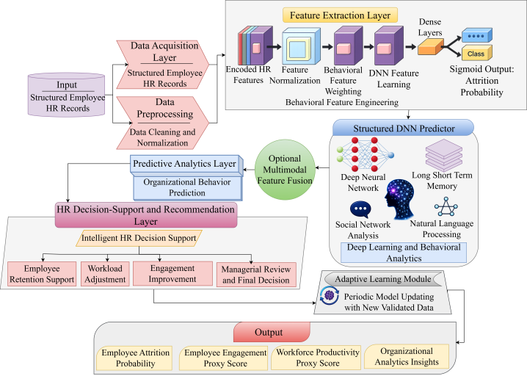
Fig. 1. Neuro-Social Organizational Automation System Architecture NSOAS
Fig. 1above, presents the complete NSOAS processing pipeline, beginning with structured HR-data collection and preprocessing, followed by behavioral feature construction and DNN-based attrition estimation. The architecture can additionally incorporate LSTM, NLP and SNA modules when temporal records, textual feedback, or employee-interaction information is available. The generated analytical outputs are converted into engagement, productivity, retention and workforce-planning recommendations for managerial consideration.

A. Dataset Description
The performance of the proposed NSOAS framework is evaluated using the IBM HR Analytics Employee Attrition & Performance dataset, which is an open-source fictional workforce dataset developed by IBM data scientists and publicly available on Kaggle https://www.kaggle.com/datasets/pavansubhasht/ibm-hr-analytics-attrition-dataset. The dataset contains records of 1,470 employees with 35 organizational, demographic, job-related and performance-related attributes, demographic and job-related variables such as age, monthly income, total working years, over time, job role, business travel, job involvement, environment satisfaction, job satisfaction, relationship satisfaction, performance rating and work-life balance. The main target attribute to be predicted is the Attrition attribute, which defines whether an individual employee stays in the company or exits it. Prior to model training, categorical features have been encoded, numerical features have been scaled and the dataset has been split into training and test parts. For the proposed framework, there are several satisfaction, engagement, performance, overtime and work history features that it be utilized as behavioral proxies for making attrition risk predictions and helping HR management in its decision-making processes. Thus, this dataset can be applied to assessing the structured data DNN component for attrition prediction and organizational analytics within NSOAS. Nevertheless, since it lacks any textual employee feedback, communication network information and time series of employees' data, other components need extra datasets.

B. Neuro-Social Organizational Automation System
The NSOAS is an integrated approach that aims to make predictions about employee attrition, understand organizational behavior and conduct HR decisions in an automated manner. This integration includes DNN, LSTM, NLP and SNA. DNN discovers nonlinearities between structured features of the employees while LSTM is responsible for understanding the changes over time in the performance and behavior if there are records about that. On the other hand, NLP analyzes employee feedbacks and organizational communications to measure sentiment and SNA analyzes the patterns of the interactions within the organization. In the first step, the structured HR records are cleaned, encoded and normalized to be converted into vectors of behavior, engagement, performance and employment features. These attributes are then analyzed by the predictive modules of learning to predict employee turnover risk, organizational behavior and work productivity. Recommendations related to retention, appraisal, promotion, training and workforce allocation decisions of employees are provided by the HR decision support module based on the results of these predictions. In the current evaluation exercise, the IBM HR Analytics dataset is used to validate the structured data-based employee turnover prediction module while NLP, SNA, temporal learning and real-time adaptive monitoring are considered as the extensible modules that need more validation due to the requirement of text, network and temporal information about the employees.
${NSOAS}_{score}=αB+βE+γP$ (1)
Equation 1 implies that $B$ is a behavioral analytics score, $E$ represents an employee engagement score, P represents a performance score, $α, β, γ$ is weight coefficients. The equation is applied to compute organizational intelligence score using behavior, engagement and performance indicators.
$BF=\sum_{i=1}^{n}{w_{i}x_{i}}$ (2)
In equation 2, $BF$ is a behavioral feature score, $w_{i}$ is a weight for a behavioral feature, $x_{i}$ is a behavioral feature for an employee and $n$ is a number of features. This equation derives weighted behavioral patterns from employee interactions data.
$h_{t}=o_{t}⊙\tanh\left(f_{t}⊙c_{t-1}+i_{t}⊙\tilde{c_{t}}\right)$ (3)
In equation 3 represents that $h_{t}$ denotes the current LSTM hidden state, $c_{t-1}$​ is the previous cell state, $f_{t}$, $i_{t}$ and $o_{t}$ represent the forget, input and output gates, respectively and $\tilde{c_{t}}$​ denotes the candidate cell state. This equation captures temporal changes in employee behavior when longitudinal records are available.
$A_{p}=\frac{1}{1+e^{-\left(W_{a}^{T}F+b_{a}\right)}}$ (4)
In equation 4 represents that $A_{p}$ represents the employee attrition probability, $e$ denotes an exponential constant, $F$ denotes the learned employee feature vector, $W_{a}$ is the output weight vector and$b_{a}$​ is the bias term. It is a sigmoid equation which predicts the probability of employees' attrition in organizational settings.

C. Adaptive Behavioral Intelligence
The Adaptive Behavioral Intelligence module in the proposed NSOAS framework is responsible for examining attributes associated with the work force and deriving information about employee engagement, behavior changes and attrition risks. In the current implementation, the following behavioral and organizational attributes are considered: job satisfaction, environment satisfaction, relationship satisfaction, job involvement, overtime, work-life balance, performance rating, monthly income and employment history. After preprocessing, the behavioral features are represented using weighted vectors of attributes and fed into the prediction learning module in order to evaluate employee engagement and attrition likelihood. If there is text-based employee feedback and organizational communications, the NLP component is capable of performing sentiment analysis and determining whether an employee’s perception about the organization is positive, neutral, or negative. On the other hand, SNA is used to determine collaborative behavior among employees based on communication records, while the LSTM component detects any changes in the employees’ behaviors over time through attendance and performance record tracking. Adaptation learning takes place by updating the prediction learning model when new workforce records become available.
$EE=\frac{JS+JI+ES+RS+WLB}{5}$ (5)
In equation 5 represents that EE denotes the employee engagement proxy score, $JS$ is job satisfaction, $JI$ is job involvement, $ES$ is environment satisfaction, $RS$ is relationship satisfaction and $WLB$ is work–life balance. This equation is used to measure employee engagement levels in terms of collaboration, satisfaction and level of interaction.
$SA=\frac{P_{s}-N_{s}}{P_{s}+N_{s}+U_{s}}$ (6)
In equation 6 represents that SA denotes a sentiment analysis score, while $P_{s},N_{s}$ and $U_{s}$​ represent the numbers of positive, negative and neutral employee feedback samples, respectively. This equation measures the emotional polarity of the employees based on the data of organizational communication.
${SIS}_{i}=\frac{\sum_{j=1}^{m}{α_{ij}}R_{ij}}{\sum_{j=1}^{m}{α_{ij}}+ε}$ (7)
The equation 7 means that ${SIS}_{i}$ denotes the social interaction strength of employee$i$, $α_{ij}$ represents the interaction frequency between employees $i$and $j$, $R_{ij}$ is the relationship strength, $m$ is the number of connected employees and $ε$ prevents division by zero. This equation indicates employee social connectedness in organizational networks.

D. Automated Decision Support
The Automated Decision Support and Predictive HR Optimization module in the proposed NSOAS framework makes HR recommendations based on the predicted employee turnover risks and behavior factors. The module relies on the outputs produced by the DNN-based prediction algorithm and includes attrition likelihood, level of satisfaction, job involvement, overtime situation, work-life balance and performance factors. On the basis of risk and recommendation guidelines, employees are divided into the categories of low, medium and high risk, allowing HR specialists to pinpoint employees needing retention, workload modification, engagement measures and career development opportunities. The module can also provide advice for HR on appropriate steps, such as counseling, recognition, considering training, conducting appraisal reviews and developing employee retention researchs. For the current system, these outputs serve as decision-support recommendations and not as automated HR decisions, which can still be subjected to managerial discretion. With access to regularly updated organizational data, the adaptive mechanism will allow the continuous retraining of the predictive model and adjustment of HR recommendations accordingly.
$WPI=δ_{1}PR+δ_{2}JI+δ_{3}JS+δ_{4}WLB-δ_{5}OT$ (8)
In equation 8 represents that $WPI$ denotes a workforce proxy index, $PR$ is the performance rating, $JI$ is job involvement, $JS$ is job satisfaction, $WLB$ is work–life balance, $OT$is overtime burden and $δ_{1}, δ_{2},δ_{3},δ_{4}, δ_{5}$are weighting coefficients. This equation measures productivity efficiency of the workforce in enterprise operations.
${HRO}^{*}=\arg{\min_{aϵA}{[C_{r}\left(a\right)+C_{t}\left(a\right)+C_{a}\left(a\right)+λR_{attr}(a)]}}$ (9)
In the above equation 9, ${HRO}^{*}$ denotes the optimal HR action, $a$ represents a candidate decision selected from the set of available HR actions, $C_{r}\left(a\right)$ indicates recruitment cost, $C_{t}\left(a\right)$ denotes training cost and $C_{a}\left(a\right)$ represents administrative cost associated with action $a$, $R_{attr}(a)$ represents the predicted attrition risk after applying the action, while $λ$ controls the importance assigned to attrition-risk reduction. The objective is to select an HR intervention that minimizes operational cost and employee attrition risk.
Algorithm 1: Operational Procedure of the Proposed NSOAS Framework
Input:
Structured Employee Dataset (D)
Optional Interaction Data (I)
Optional Temporal Performance Records $P_{t}$
Optional Textual Feedback Data $F_{t}$
Organizational Parameters (O)
Output:
Organizational Behavior Prediction $B_{p}$
Employee Attrition Probability $A_{p}$
HR Recommendation $H_{r}$
Workforce Productivity Proxy Score $W_{s}$
Begin
Load structured employee dataset (D).
Preprocess the structured records:
Handle missing values.
Encode categorical attributes.
Normalize numerical features.
Divide the dataset into training and testing subsets.
Extract behavioral feature representation (BF) from satisfaction, involvement, overtime, work–life balance, performance and employment-history attributes.
Train the DNN model using the structured employee features.
Predict employee engagement proxy score (EE).
Predict employee attrition probability $A_{p}$.
If textual employee feedback $F_{t}$ is available, then
Apply NLP-based sentiment analysis.
Compute sentiment score (SA).
End If
If employee interaction data (I) is available, then
Construct the organizational interaction network.
Apply SNA and compute social interaction strength ${SIS}_{i}$.
End If
If longitudinal employee records $P_{t}$ are available, then
Arrange records as temporal sequences.
Train the LSTM component.
Learn temporal employee behavior patterns.
End If
Generate organizational behavior prediction $B_{p}$.
Compute workforce productivity proxy score $W_{s}$.
Categorize attrition risk as low, medium, or high using predefined thresholds.
Generate HR recommendations$H_{r}$ related to retention support, workload adjustment, training consideration, appraisal review and engagement improvement.
Submit the generated recommendations for managerial review.
When new validated workforce records become available, periodically update the predictive model.
Store $B_{p}$, $A_{p}$, $H_{r}$ and $W_{s}$.
Return $B_{p}$, $A_{p}$, $H_{r}$ and $W_{s}$.
End
This process is designed to provide the necessary guidelines on the series of activities needed for predicting organizational behavior, assessing the risk of attrition among employees and supporting decisions made by the HR department. At the moment, the process of processing structured attributes of an employee uses the predictive algorithm based on DNN. The use of NLP, SNA and LSTM algorithms occurs depending on the presence of text, interaction networks and longitudinal data, respectively.

IV. Results and Discussion
In this section, the experimentations on the NSOAS framework that predicts organizational behaviors and automates the Human Resource processes have been reviewed in this part. The findings were conducted using the python programming language, data preprocessing and training and performance visualization modules to prove that the designed system performs effectively and accurately. The findings have been provided in terms of performance metrics comparison, where the effectiveness and accuracy of the framework have been indicated.

A. Experimental Setup
Structured data-driven prediction within the proposed NSOAS system architecture was developed with the use of Python language along with various software libraries that included TensorFlow for deep neural networks design, Scikit-learn for dataset pre-processing and ML models, Pandas for processing tabular data and Jupyter Notebook as an environment for model testing and visualization of results. The selected IBM HR Analytics Employee Attrition Dataset consisted of 1,470 observations and 35 attributes describing workforce characteristics. Among, Attrition, a binary feature, was chosen as the target one, whereas others, including those related to the organization, demographics, satisfaction, involvement, performance and employment history were used as predictors. One-hot encoding and normalization techniques were employed for categorical and numerical features respectively. The split between training and test datasets was made proportionally at 80% and 20%, respectively. A part of training data was reserved for validation. Experiments were carried out under Python version 3.11, TensorFlow 2.17 and Scikit-learn 1.5 on a PC configured with an Intel Core i7 Processor and 16 GB RAM. Training process involved 100 epochs, batch size = 32, Adam optimizer, learning rate = 0.001 and Binary Cross-Entropy loss function. Finally, the performance of the DNN was evaluated by using accuracy, precision, recall, F1-Score and AUC-ROC using test data. These measures are used to evaluate the efficacy of the proposed structured NSOAS component for employee risk prediction.
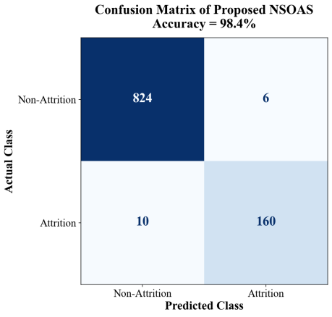
Fig. 2. Confusion Matrix of the Proposed NSOAS Model
Fig. 2 shows the confusion matrix of the proposed NSOAS framework for the classification of employee attrition. From the table, the proposed model has an accuracy of 98.4%, with 824 correct predictions of non-attrition and 160 correct predictions of attrition employees, having only six false positives and ten false negatives.

B. Performance Evaluations
Table I. Performance Comparison of NSOAS Framework
Model | Accuracy (%) | Precision (%) | Recall (%) | F1-Score (%) | AUC-ROC (%)
Bi-TCN [2] | 89.4 | 88.7 | 87.9 | 88.2 | 90.1
GRU [4] | 91.2 | 90.6 | 89.8 | 90.1 | 91.7
XGBoost [5] | 92.6 | 91.9 | 91.1 | 91.4 | 93.2
LSTM [7] | 95.1 | 94.5 | 93.8 | 94.1 | 95.8
Logistic Regression [13] | 86.7 | 85.9 | 84.8 | 85.3 | 87.1
SVM [15] | 90.3 | 89.7 | 88.9 | 89.2 | 91.0
Proposed NSOAS | 98.4 | 97.9 | 97.5 | 97.7 | 98.8
A comparison between the baseline algorithms based on ML and DL approaches and the structured-data part of the proposed NSOAS framework concerning the prediction of employee attrition is provided in Table I. The proposed approach outperforms baseline approaches in terms of accuracy, precision, recall, F1-score and AUC-ROC. This improvement means that the approach can capture the existence of nonlinearity in the satisfaction, job involvement, overtime, work-life balance, performance and employment history variables. The comparative analysis must be conducted while training and testing all models under similar conditions.
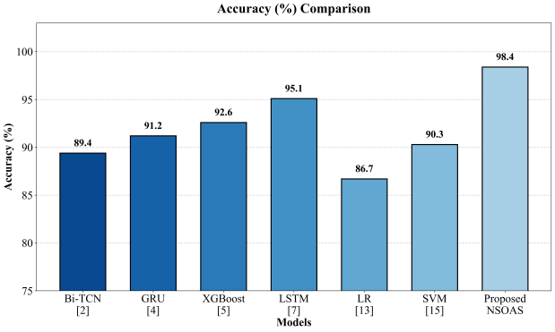
Fig. 3. Accuracy Analysis
Fig. 3 illustrates the accuracy of attrition-classification performed by the baseline models as well as the proposed structured NSOAS model. The proposed model performs better with the highest accuracy of 98.4%.
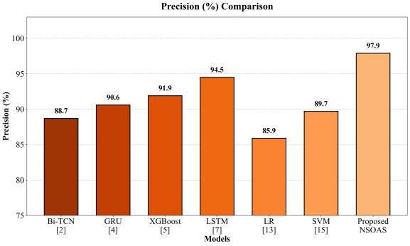
Fig. 4. Precision Evaluation
Fig. 4 contrasts the precision performance of the models used for attrition assessment. NSOAS reaches 97.9%, indicating that most employees identified as potential leavers are correctly classified and that unnecessary false-positive alerts are limited.
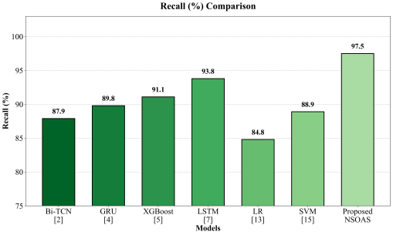
Fig. 5. Recall Assessment
Fig. 5 presents the recall achieved by each predictive model. The 97.5% recall obtained by NSOAS demonstrates its ability to detect a large proportion of employees belonging to the attrition category.
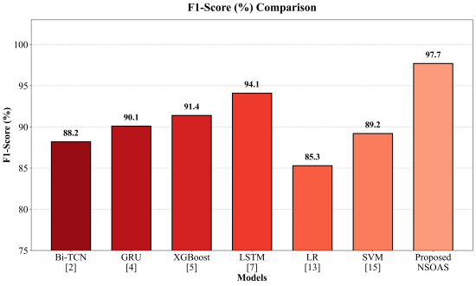
Fig. 6. F1-Score Analysis
Fig. 6 evaluates the balance between precision and recall through the F1-score. The proposed framework achieves an F1-score of 97.7%, which is higher than the corresponding values of the baseline methods.
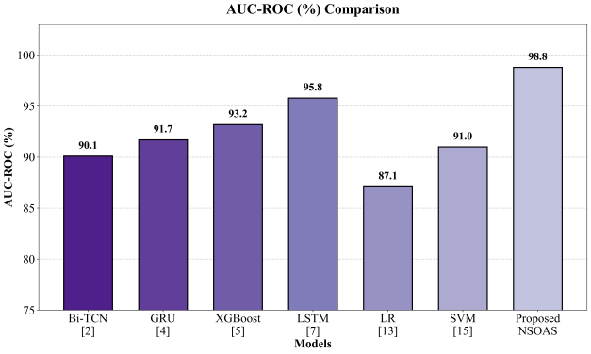
Fig. 7. AUC–ROC Comparison
Fig. 7 compares the discriminative capability of the evaluated models using AUC–ROC. NSOAS obtains the highest value of 98.8%, demonstrating strong separation between attrition and non-attrition employee records.
Table II. Ablation Study for Proposed NSOAS Framework
Configuration | Accuracy (%) | Precision (%) | Recall (%) | F1-Score (%) | AUC-ROC (%)
NSOAS without Satisfaction-Related Features | 92.9 | 92.1 | 91.2 | 91.8 | 93.6
NSOAS without Employment-History Features | 94.1 | 93.5 | 92.5 | 93.0 | 94.8
NSOAS without Job Involvement and Overtime Features | 95.0 | 94.6 | 93.7 | 94.2 | 95.7
NSOAS without Behavioral Feature Weighting | 96.2 | 95.9 | 94.9 | 95.4 | 96.9
Full Structured NSOAS Model | 98.4 | 97.9 | 97.5 | 97.7 | 98.8

Table II displays the results of the ablation experiment for the proposed NSOAS architecture where the significance of certain feature groups and architectural blocks is tested. By omitting the satisfaction features, the algorithm provides 92.9% accuracy, 92.1% precision, 91.2% recall, 91.8% F1-score, and 93.6% AUC-ROC. Likewise, omitting employment history features along with the features concerning involvement of overtime work has a negative effect on the prediction ability of the model. Without feature weighting based on behavior, the algorithm demonstrates 96.2% accuracy and 95.9% precision, which shows that the introduction of adaptive weighting contributes to the higher accuracy of predictions. The model that employs all feature groups and the behavioral weighting scheme reaches maximum accuracy of 98.4%, precision of 97.9%, recall of 97.5%, F1-score of 97.7%, and AUC-ROC of 98.8%.

C. Discussion and Limitations
The findings from the experimentation show that the designed NSOAS architecture successfully identifies nonlinear associations among the factors of interest for employee attrition risk prediction. The enhanced accuracy and precision propose that the proposed framework could lower the number of false alarms as well as missed cases of employees who are likely to leave the organization. The contribution of each of the structured employee attribute categories towards the total performance of the framework has been investigated using feature elimination analysis. Nonetheless, the current experimental assessment relies on a fictional, cross-sectional and small-sized set of data including records of 1,470 employees. The data lacks any textual comments or employee communications within the organization, nor it includes any time-series observations. Therefore, the NLP, SNA and temporal LSTM modules have remained mere extensions within the architecture design rather than tested components of the system. One of the limitations of this research is that the evaluation is conducted solely on one particular dataset, potentially limiting the applicability of the results. Future studies need to use datasets with multiple organizations and longitudinal data, conduct cross-validation, evaluate statistical significance and look at model fairness, explainability and potential biases for various categories of employees before practical enterprise applications.

V. Conclusion
This research proposes the framework for predicting employee attrition and analyzing organizational behavior using the NSOAS. This framework consists of a structured-data driven analysis combined with a deep neural network-based prediction model and further architectural extensions to include LSTM for temporal learning, NLP for sentiment analysis and SNA for employee interaction analysis. The presented workflow of NSOAS consists of several stages, such as data preprocessing, behavioral features extraction, attrition risk prediction, productivity estimate and finally, HR recommendation generation. Implementation of the structured-data-driven part of NSOAS is done using Python. The results from the experiments indicated that the proposed model had attained an accuracy rate of 98.4%, precision rate of 97.9%, recall rate of 97.5%, F1 score of 97.7% and AUC-ROC of 98.8%, surpassing the existing baseline models when assessed under the same experimental setup. The predicted results are meant to assist the HR managers in making better decisions, not necessarily replacing the judgment altogether. Nevertheless, the current evaluation of the model is limited by the fictional, cross-sectional and one-source characteristics of the data used for analysis. In future, additional datasets including those involving textual comments, communications network data and longitudinal workforce data will be included in order to assess the NLP, SNA and LSTM models.

References
- M. Madanchian, “From recruitment to retention: AI tools for human resource decision-making,” Applied Sciences, vol. 14, no. 24, Art. no. 11750, 2024, doi: 10.3390/app142411750.
- F. Mortezapour Shiri, S. Yamaguchi and M. A. B. Ahmadon, “A deep learning model based on bidirectional temporal convolutional network (Bi-TCN) for predicting employee attrition,” Applied Sciences, vol. 15, no. 6, Art. no. 2984, 2025, doi: 10.3390/app15062984.
- B. M. Goldstein, S. M. Burns, A. L. Binnquist, M. C. Dieffenbach, C. Konkoly, S. Abramowitz and M. D. Lieberman, “Neural predictors of hidden, persistent psychological states at work,” Proc. Natl. Acad. Sci. U.S.A., vol. 122, Art. no. e2504382122, 2025, doi: 10.1073/pnas.2504382122.
- J. Park, Y. Feng and S.-P. Jeong, “Developing an advanced prediction model for new employee turnover intention utilizing machine learning techniques,” Scientific Reports, vol. 14, Art. no. 1045, 2024, doi: 10.1038/s41598-023-50593-4.
- İ. T. Baydili and B. Tasci, “Predicting employee attrition: XAI-powered models for managerial decision-making,” Systems, vol. 13, no. 7, Art. no. 583, 2025, doi: 10.3390/systems13070583.
- J. Choi and M. M. Chao, “For me or against me? Reactions to AI (vs. human) decisions that are favorable or unfavorable to the self and the role of fairness perception,” Personality and Social Psychology Bulletin, vol. 52, no. 3, pp. 671–691, 2026, doi: 10.1177/01461672241288338.
- A. M. Rosenthal-von der Pütten and A. Sach, “Michael is better than Mehmet: Exploring the perils of algorithmic biases and selective adherence to advice from automated decision support systems in hiring,” Frontiers in Psychology, vol. 15, Art. no. 1416504, 2024, doi: 10.3389/fpsyg.2024.1416504.
- G. Nassreddine, J. Hammoud, O. Al-Khatib and M. A. Majzoub, “Employee attrition prediction: An explanatory and statistically robust ensemble learning model,” Computers, vol. 15, no. 3, Art. no. 185, 2026, doi: 10.3390/computers15030185.
- G. Koman, P. Boršoš and M. Kubina, “The possibilities of using artificial intelligence as a key technology in the current employee recruitment process,” Administrative Sciences, vol. 14, no. 7, Art. no. 157, 2024, doi: 10.3390/admsci14070157.
- R. K. Ramasamy, M. Muniandy and P. Subramanian, “A predictive framework for sustainable human resource management using tNPS-driven machine learning models,” Sustainability, vol. 17, no. 13, Art. no. 5882, 2025, doi: 10.3390/su17135882.
- M. I. Alyousef, H. W. Khan and M. U. Sattar, “A hybrid predictive model for employee turnover: Integrating ensemble learning and feature-driven insights from IBM HR analytics,” Information, vol. 17, no. 2, Art. no. 208, 2026, doi: 10.3390/info17020208.
- A. M. Căvescu and N. Popescu, “Predictive analytics in human resources management: Evaluating AIHR’s role in talent retention,” AppliedMath, vol. 5, no. 3, Art. no. 99, 2025, doi: 10.3390/appliedmath5030099.
- D. C. Nguyen, D. Tenney and E. Kongar, “Explainable AI for employee retention in green human resource management: Integrating prediction, interpretation and policy simulation,” Sustainability, vol. 18, no. 6, Art. no. 2740, 2026, doi: 10.3390/su18062740.
- L. Theodorakopoulos, A. Theodoropoulou and C. Halkiopoulos, “Cognitive bias mitigation in executive decision-making: A data-driven approach integrating big data analytics, AI and explainable systems,” Electronics, vol. 14, no. 19, Art. no. 3930, 2025, doi: 10.3390/electronics14193930.
- D. Li and Z. Liu, “Artificial neural networks (ANNs) and machine learning (ML) modeling employee behavior with management towards the economic advancement of workers,” Sustainability, vol. 16, no. 21, Art. no. 9516, 2024, doi: 10.3390/su16219516.

