Dynamic NeuroFusion Ensemble Prediction System for Retail Sales and Customer Behaviour Prediction

¹Dr A Sangeetha,
Assistant Professor
PG & Research Department of Commerce
Sri Ramakrishna College of Arts & Science ( Autonomous) Coimbatore -641006
sangeetha@srcas.ac.in

⁴Dr N Selvakumar,
Associate Professor
PG & Research Department of Commerce
Sri Ramakrishna College of Arts & Science ( Autonomous) Coimbatore
-641006
selvakumar@srcas.ac.in
²Dr G Agila,
Associate Professor & Head
PG & Research Department of Commerce
Sri Ramakrishna College of Arts & Science ( Autonomous) Coimbatore -641006
agila@srcas.ac.in

⁵Dr. M. Sangeetha,
Professor
Dept of Computer Science
Dr. N.G.P Arts and Science College
Coimbatore
sangeethaseenivasan@gmail.com

³Dr S Kirubadevi
Assistant Professor
PG & Research Department of Commerce
Sri Ramakrishna College of Arts & Science ( Autonomous) Coimbatore -641006
kirubadevi@srcas.ac.in

Abstract—The increasing complexity of retail operations and evolving market patterns has created a significant need for intelligent prediction models that support data-driven decision-making. However, conventional Machine Learning (ML) and Deep Learning (DL) models often encounter difficulties in handling heterogeneous retail data, nonlinear feature relationships, redundant variables and complex predictive patterns. This research proposes a Dynamic NeuroFusion Ensemble Prediction System (DNEPS) for retail product-demand classification. DNEPS incorporates a NeuroWeave Feature Intelligence Layer (NFIL) for adaptive feature-interaction learning, an Adaptive Performance-Guided Ensemble Layer (APGEL) for assigning validation-based weights to individual learners and an Intelligent Fusion and Decision Layer for generating integrated predictive insights. The framework combines Random Forest, XGBoost, LightGBM and Deep Neural Network (DNN) models within unified ensemble architecture. The proposed system was evaluated using a large-scale synthetic Retail Sales and Customer Behaviour Analysis dataset, with product demand categorized into low, medium and high-demand classes. Leakage-free preprocessing and training-derived percentile thresholds were used during model development. Experimental results indicate that DNEPS achieves 98.6% accuracy, outperforming the selected baseline models. These findings demonstrate the effectiveness of adaptive feature intelligence and performance-guided ensemble fusion for reliable retail demand classification and decision support.
Keywords—Adaptive Ensemble Learning, Decision Intelligence, NeuroWeave Feature Intelligence, Organizational Forecasting, Predictive Analytics, Retail Analytics

I. Introduction
The advent of digital transformation, e-commerce and data management has resulted in an increased requirement for intelligent prediction systems that can analyse retail sales, customer behaviour, demand forecasting and market changes. Contemporary retail companies produce vast amounts of heterogeneous data, which it consist of customer demographics, transactions, products sold, promotional events and various market indicators. Yet, making accurate predictions based on this kind of data is difficult due to such reasons as nonlinearity, redundancy, temporal changes, class imbalance and consumers' dynamically changing preferences. Different solutions were proposed in the realm of machine learning and deep learning. These include the introduction of a distance kernel to improve the performance of support vector machines and data representation [1] and the use of parametric entropy-based information gain for better random forest classification and regression [2]. Also, Deep Q-learning-based feature importance feedback was introduced for ensemble metaheuristic feature selection [3]. Finally, a combination of LSTM and ARIMA was proposed as an ensemble for financial forecasting [4]. Robust optimization was introduced to enhance SVM classification under uncertainty [5], while a simpler attention model was developed for Transformer-based temporal prediction [6]. On the other hand, RFID data together with machine learning was used to predict in-store customer shopping behavior [7]. Big data analytics was also considered for predicting customer behavior in retail [8]. Predictive analytics was utilized to predict customer trends and preferences [9], while binary machine learning algorithms were considered for classifying online purchase intention [10]. Retail demand prediction using tree-based ensemble models and LSTM networks was evaluated [11]. Google Analytics data was used for online user behavior classification [12]. On the other hand, consumer shopping behavior on social media was predicted through the integration of behavioral theories and machine learning algorithms [13]. Explainable artificial intelligence was also used to predict factors that affect purchase decisions after adding items to shopping carts [14]. Weather information was considered along with machine learning algorithms for improving consumer spending prediction [15]. Even though there have been significant advancements in prediction models, current approaches tend to emphasize isolated predictive purposes without incorporating adaptive feature interaction learning, dynamic learner weighting, fusion of organizational-market intelligence and integrated decision support into the system.
In order to overcome these shortcomings propose a Dynamic NeuroFusion Ensemble Prediction System (DNEPS) for the prediction of retail sales, customer behavior and product demand. In proposed framework uses a NeuroWeave Feature Intelligence Layer (NFIL) to determine the key features and learn the hidden nonlinear dependencies between various customer, product, transaction, promotional and marketing variables. Also, DNEPS makes use of an Adaptive Performance-Guided Ensemble Layer (APGEL), which includes Random Forest, XGBoost, LightGBM and Deep Neural Network learner modules and dynamically calculates the contribution weight of each model based on its performance. Moreover have an Organizational-Market Fusion Engine (OMFE), which fuses organizational retail intelligence with external marketing-related data, followed by a Real-Time Predictive Decision Module (RPDM) that converts the fused predictions into opportunities, demands and risks. The proposed DNEPS has been used to classify the product demand categories as low demand, medium demand and high demand based on the Retail Sales and Customer Behavior Analysis dataset.
The main contributions of this research are as follows:
- A unified DNEPS is proposed for retail product demand into low, medium and high-demand categories.
- A NFIL is introduced to identify relevant retail attributes and learn nonlinear interactions among customer, product, transaction and promotional features.
- An APGEL is developed to combine Random Forest, XGBoost, LightGBM and Deep Neural Network predictions using validation-based adaptive weights.
- The framework provides the basis for organizational and market intelligence integration via a complete fusion and decision layer to support real-time strategic decision making.
- DNEPS provides superior predictive performance, with robust and adaptive learning capabilities, to reduce forecasting uncertainty and improve business intelligence.
Organization: Section II gives related work of existing literature, Section III provides description of the proposed DNEPS namely its architecture, workflow, mathematical formulation and pseudocode, Section IV discusses the experimental results and performance analysis and Section V concludes the research with future research directions.

II. Related Work
N. Amaya-Tejera et al. (2024) [1] introduced a distance kernel-based approach for SVM classification, which aims at enhancing data representation and classification through the adoption of a newly developed distance-based kernel approach. The research used SVM and distance-based kernel approaches, but it had certain limitations due to the fact that it depended on the choice of kernels and the performance on certain datasets.
V. Ignatenko et al. (2024) [2] proposed the Random Forest model along with parametric entropy-based information gain for better performance in classification and regression by using optimal split decisions in decision trees. The proposed approach improved the splitting process of Random Forest models through parametric entropy-based information gain. However, its performance depended on appropriate parameter selection and dataset characteristics.
J. L. Potharlanka and N. B. M. (2024) [3] implemented a feature importance feedback framework incorporated with a Deep Q-learning technique for feature subset optimization based on an ensemble metaheuristic method for feature selection. Although the approach improved feature-subset selection, the integration of Deep Q-learning and metaheuristic optimization increased the training and computational requirements.
L. Mochurad and A. Dereviannyi (2024) [4] introduced an ensemble architecture based on the integration of LSTM and ARIMA methods for improved prediction in the financial market by considering non-linear and linear trends. The combination captured both linear and nonlinear temporal patterns and improved forecasting performance compared with individual models. However, the framework remained sensitive to unexpected market volatility and model complexity.
F. Maggioni and A. Spinelli (2025) [5] developed an optimization model for nonlinear support vector machines to ensure greater classification accuracy during uncertainty. Though the use of non-linear support vector machine was done along with robust optimization techniques in the research work, the computational burden was higher, while the outcomes were more robust and accurate in nature.
M. Sanchis-Agudo et al. (2025) [6] developed a method named Easy Attention, used by Transformer-based models that aimed to facilitate temporal predictions without compromising the predictive performance. In this research, an approach based on the Transformer model using an easy attention algorithm was utilized but mostly on temporal data sets, although it had not been extensively tested in other areas.
G. Alfian et al. (2023) [7] explored customer shopping behavior through the application of RFID technology along with machine learning models to detect any trends among consumers' shopping behavior. RFID-based data gathering and machine learning were used in the research, but this research was constrained by its reliance on RFID system infrastructure and data collection, although the outcomes were effective in enhancing customer behavior understanding and prediction.
N. Begum (2024) [8] carried out a research on the effect of big data analysis in predicting customers’ behavior in retail organizations by using consumer big data for decision making. Although data-related problems in terms of quality, privacy and integration were not solved, the use of big data helped improve predictive accuracy in retail.
H. GhorbanTanhaei et al. (2024) [9] explored the application of predictive analytics and machine learning techniques in predicting customer trends and preferences. Predictive analytics and machine learning algorithms were used as research methods but the dynamic nature of customers' behavior and heterogeneity of data reduced the generalizability of results, while predictions and estimations were successful.
A. Aldelemy and R. A. Abd-Alhameed (2023) [10] proposed a binary classification algorithm for predicting the online buying behavior of consumers to identify purchase intentions through machine learning techniques. The researchers used binary classification algorithms, but issues such as data imbalance and dynamic consumer behavior impacted the adaptability of the model, whereas the results showed good classification ability.
M. Nasseri et al. (2023) [11] compared tree-based ensemble methods with LSTM-based deep-learning models for retail-demand prediction. The findings showed that model performance varied according to the structure and temporal characteristics of the retail data. However, the evaluated approaches did not include adaptive feature-interaction learning or validation-guided fusion of multiple heterogeneous learners.
D. C. Gkikas and P. K. Theodoridis (2024) [12] analyzed online shopping behavior using machine learning algorithms in conjunction with data from Google Analytics. In this research, the researchers applied Google Analytics attributes and machine learning classifiers, although web analytics data constrained the generalizability of the results to other types of websites, while the results improved the prediction of user engagement and shopping behavior.
M. S. Azad et al. (2023) [13] conducted a research to predict consumer purchasing behavior using social media based on the integration of Theory of Planned Behavior and machine learning algorithms. In this work, the researchers used behavioral theory and machine learning algorithms; however, the diversity of social media data posed challenges, while the results showed a substantial improvement in consumer purchasing behavior prediction.
R. Esmeli and A. Gokce (2025) [14] applied Explainable Artificial Intelligence (XAI) approaches in analyzing consumers’ purchasing behaviors after adding items to the cart within an e-commerce environment. In the research, they have made use of XAI and machine learning approaches; however, the application of XAI added complexity to the model and required good-quality transactional data.
I. D. Gerg et al. (2026) [15] conducted studies regarding the contribution of weather data to consumer spending forecasting through incorporation of weather-related data with effective machine learning methods. The use of weather data and machine learning techniques was involved in the research; however, the findings showed that due to geographic and seasonal constraints, the performance was limited.
Despite showing that kernel learning, ensemble models, feature selection, temporal prediction and retail analytics via machine learning are effective methods, there are still some limitations present in the reviewed researches. Firstly, all currently used approaches consider optimization of features, development of individual models, customers' purchase intentions, or prediction of demand as a separate entity rather than combining these processes into an approach which includes adaptive feature interaction learning, validation-driven weighting of learners and probabilistic fusion of predictions for retail decision-making. Another important aspect which has not attracted considerable attention is prevention of target leakage while creating multiclass labels of demand from large retail data sets. The identified deficiencies make the creation of DNEPS a necessity.

III. Proposed Methodology
In this section, the proposed DNEPS for retail sales and market analytics is presented. It outlines the framework architecture, operational procedure, mathematical expressions and algorithmic pseudocode which can be used together to provide an intelligent feature extraction, adaptive ensemble prediction and integrated decision support for accurate forecasting in dynamic business environments.
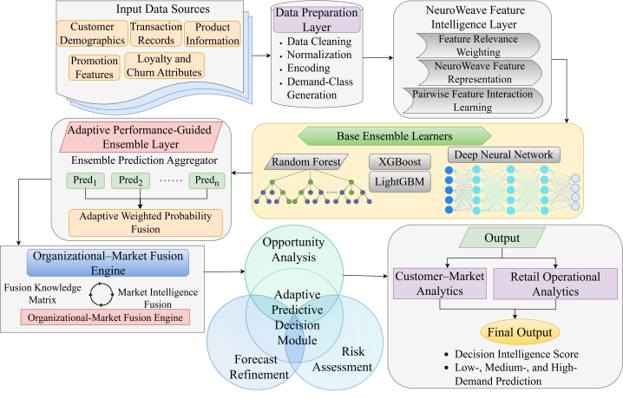
Fig. 1. Architecture of Dynamic NeuroFusion Ensemble Prediction System
The architecture of the DNEPS for predictive business and market analytics is shown in Fig. 1. The model includes data preparation, NeuroWeave feature intelligence, ensembles, prediction fusion and intelligence fusion blocks for transforming data available from within an organization and the market into actionable intelligence. Predictive decision intelligence in real-time is utilized for analyzing opportunities, risk assessment and enhancing forecast accuracy, delivering precise forecasting, market predictions and decision-making support for the organization.

A. Dataset Description
The Retail Sales and Customer Behaviour Analysis Dataset is an open-source retail analytics dataset available on Kaggle https://www.kaggle.com/datasets/utkalk/large-retail-data-set-for-eda and are widely suitable for exploratory data analysis, customer behavior analysis, sales pattern identification and retail business decision-making consisting of roughly one million rows and over 100 attributes covering customer demographic information, transaction information, product details, promotions, buying behaviors, sales performance and customer churn. Irrelevant variables and duplicate rows were eliminated, missing values were addressed, categorical variables were encoded and numeric variables were scaled. Product demand was calculated based on the sum of quantities sold for each product. Thresholds based on 33rd and 66th percentile calculated only based on the training set were applied in determining demand levels. Rows whose quantity of sale fell below the 33rd percentile were classified as having low demand while those falling between 33rd and 66th percentiles as medium demand and above 66th percentiles as high demand. The quantity, total sales and other target variables were left out of the predictor variables to avoid data leakage. The data set was split 80/20 into development and testing data sets respectively while further splitting the development data set 80/20 into training and validation data sets respectively.

B. Dynamic NeuroFusion Ensemble Prediction System
The DNEPS uses all of the mentioned feature fusion techniques, ensembles learning, dynamic weighting and deep pattern intelligence. All these are combined into one system to make accurate predictions for organizations and markets. In particular, the algorithms include various models of predictions like Random Forest (RF), Extreme Gradient Boosting (XGBoost), Light Gradient Boosting Machine (LightGBM) and Deep Neural Networks (DNN). The models are linked together via the NeuroWeave feature integration layer that can take into account complex relationships between organizational and market variables. Its key objectives are improving the accuracy of the forecast, minimizing the uncertainties of the predictions and giving decision-makers an opportunity to develop strategic decisions in a constantly changing business environment. Preprocessing of input data takes place in real time while extracting features occurs from the very beginning of the process and in interconnection, multiple learners are trained and weights dynamically assigned depending on the performance before the final predictions. Parameters and feature importance of the models are regularly updated depending on newly acquired information about organizations and markets and the system can quickly change accordingly. Finally, the algorithm itself, the datasets used in training, the hyperparameters set and the preprocessing steps are all repeatable.
$X_{i}^{norm}=\frac{X_{i}-X_{min}}{X_{max}-X_{min}}$ (1)
In this equation (1), $X_{i}$ is the original value of the feature, $X_{min}$ is the minimum value of the feature, $X_{max}$ is the maximum value of the feature and $X_{i}^{norm}$ is the normalized value of the feature. This equation scales the various characteristics of organizations and markets down to a common range prior to analysis.
$α_{i}=\frac{\exp\left(R_{i}\right)}{\sum_{j=1}^{n}{\exp\left(R_{j}\right)}}$ (2)
In this equation, (2), normalized importance weight associated with feature $i$ is denoted by $α_{i}$ in this equation and $R_{i}$is the score obtained for feature $i$that is based solely on training data. $n$ is the number of features. The softmax function is used to normalize the output of the relevance scores into positive weights that sum to one, so that more important features are assigned a higher weight.

C. NeuroWeave Feature Intelligence Layer
The feature learning component of the DNEPS model is represented by the NeuroWeave Feature Intelligence Layer, which primarily emphasizes learning intricate relations among organizational, consumer, financial and market factors. The pre-processed data are first aggregated from several sources and research onto the same feature space. Next, interdependencies between the features are analyzed in order to detect any potential hidden trends that it influences the prediction task at hand. Adaptive Feature Interaction (AFI) learning applies dynamic weights to inter-feature relations according to the relevance for prediction performance. This means that useful features are further highlighted, while redundant and irrelevant factors will be suppressed. Finally, the output feature set is included in the global feature matrix (NeuroWeave), which preserves the local and global data interrelationships. Such a feature representation will provide better input for the next step - the ensemble learning layer.
$F_{NW}=\sum_{i=1}^{n}{α_{i}F_{i}}$ (3)
The above equation (3) above $F_{NW}$ is the NeuroWeave representation of the feature and $F_{i}$is the input feature vector, $α_{i}$ is adaptive weight of the features and n is number of features. This equation brings together various organizational and market characteristics in a single intelligence representation.
$I_{ij}=α_{ij}\left(F_{i}⊙F_{j}\right)$ (4)
For this equation (4), the $I_{ij}$ is the interaction between features$F_{i}$ and $F_{j}$​, $α_{ij}$​ is the learned interaction weight and the ⊙ is element-wise multiplication. The equation encapsulates customer-product-transaction relationship and hidden relationship among customer related features, product related features and transaction related features, which are related to the market.

D. Adaptive Performance-Guided Ensemble Layer
Adaptive Performance Guided Ensemble Learning Layer uses various predictive models to produce strong predictive outputs in an adaptive ensemble learning system. This layer takes the feature matrix produced by NeuroWeave model and performs a variety of machine learning models such as random forest (RF), Extreme Gradient Boosting (XGboost), Light GBM and Deep Neural Networks on it to generate initial predictions independently. Each model is dynamically evaluated based on predefined evaluation criteria, which can be used to gauge the relative efficacy of that model on the existing data landscape. Based on the evaluation of these criteria, weights are dynamically allocated to the models accordingly. The models, whose performance shows superiority, are assigned high weights, thus making them contribute more towards the final ensemble prediction. After combining the predictions using intelligent techniques, the output generated produces a more accurate forecast. APGEL dynamically modifies the contributions made by these models based on organizational and market changes, thereby increasing the stability and adaptability of the models.
$P_{i}=M_{i}\left(F_{NW}\right)$ (5)
For this equation (5), the $i^{th}$ predictive learner, $M_{i}$ is a Random Forest, XGBoost, LightGBM or DNN and $P_{i}$ is the class-probability vector obtained by the $i^{th}$ predictive learner from the NeuroWeave feature representation $F_{NW}$. Each learner makes the own low, medium and high demand estimates.
$w_{i}=\frac{\exp\left(S_{i}\right)}{\sum_{j=1}^{m}{\exp\left(S_{j}\right)}}$ (6)
In equation 6, $w_{i}$ is the adaptive ensemble weight given to learner $i,$ $S_{i}$ is the score of the validation of learner$i$ and $m$ is the number of all the learners. Softmax normalization assigns higher weights to the better learners and guarantees that all the weights are positive and the sum is 1.
$\hat{y}=\arg{\max_{c}\left[\sum_{i=1}^{m}{w_{i}P_{i}\left(c\right)}\right]}$ (7)
This equation (7) $\hat{y}$ is the final predicted demand class, $w_{i}$ is the adaptive weight that is given to learner $i$ and $P_{i}\left(c\right)$ is the predicted probability of class c by learner$i$. The low, medium, or high-demand output is chosen as the ensemble probability that is highest for a specific class.

E. Intelligent Fusion and Decision Layer
The Intelligent Fusion and Decision Layer represent the last layer of the designed DNEPS model, involving the Organizational–Market Fusion Engine (OMFE) and the Real-Time Predictive Decision Module (RPDM). OMFE blends the retail intelligence of the organization, comprising sales performance, product data, transactions and effectiveness of promotions, with the customer and market intelligence, which involves customers' buying behavior, loyalty, churn probability and demand changes, in a Fusion Knowledge Matrix (FKM). The matrix reflects the linkage between organizational activities and market behavior, helping understand better the retail situation. RPDM analyzes the blended intelligence to produce insights related to forecasting the demand for products, analyzing customers' trends, driving revenues, exploring opportunities in the market and identifying risks. When new retail intelligence becomes available, the module revises its predictions and decisions scores accordingly.
$FKM=βϕ_{O}\left(O\right)+\left(1-β\right)ϕ_{M}\left(M\right)$ (8)
According to this equation (8), Fusion Knowledge Matrix $FKM$ is the combination of internals retail intelligence $O$ and customer and market intelligence $M$. Two functions $ϕ_{O}$ and $ϕ_{M}$​ are used to map both vectors to the same feature space and a scalar $β$ ranging from 0 to 1 is used to determine the proportion of each to the final output.
$RAS_{t}=λC_{ens}\left(t\right)+\left(1-λ\right)RAS_{t-1}$ (9)
This equation (9) $RAS_{t}$ stands for the adaptive prediction score at the $t$time step, $C_{ens}\left(t\right)$is the current ensemble confidence score, $RAS_{t-1}$ is the previous Adaptation Score and λ is the adaptation coefficient, which is between 0≤λ≤1. This equation matches up the recent predictions with previously learnt predictive information.
$DIS=δ_{1}C_{ens}+δ_{2}C_{fkm}+\left(1-δ_{1}-δ_{2}\right)RAS_{t}$ (10)
In this equation (10), $DIS$ is Decision Intelligence Score, $C_{ens}$ is the current ensemble confidence score, $C_{fkm}$ is the normalized fusion intelligence score and $RAS_{t}$ is the adaptive prediction score. The coefficients, $δ_{1}$​ and $δ_{2}$, are used for ensemble confidence and fused intelligence, which is the rest of the weight is assigned to adaptive prediction
Algorithm: Dynamic NeuroFusion Ensemble Prediction System
Input:
${ D}_{retail}$ ← Retail Sales and Customer Behavior dataset
M ← {RF, XGBoost, LightGBM, DNN}
H ← Model-specific hyperparameters
Output:
ŷ ← Final predicted demand class
DIS ← Decision Intelligence Score
Begin
Step 1: Load the retail dataset
Load ${ D}_{retail}$
Step 2: Perform initial data cleaning
Remove duplicate records
Remove invalid and noisy records
Step 3: Divide the dataset
${ D}_{train}$,${ D}_{val}$,${ D}_{test}$ ← StratifiedSplit(${ D}_{retail}$)
Step 4: Generate product-demand classes
Calculate demand thresholds using ${ D}_{train}$
Generate low-, medium- and high-demand classes
Apply the same thresholds to ${ D}_{val}$ and ${ D}_{test}$
Remove target-derived features to prevent data leakage
Step 5: Perform leakage-free preprocessing
Fit missing-value handling using ${ D}_{train}$
Fit categorical encoding using ${ D}_{train}$
Fit numerical normalization using ${ D}_{train}$
Apply the fitted operations to ${ D}_{val}$ and ${ D}_{test}$
Step 6: Separate intelligence feature groups
$D_{org}$ ← Sales, product, transaction and promotion features
$D_{market}$ ← Customer demographics, purchasing behaviour,
loyalty and churn features
Step 7: Execute NeuroWeave Feature Intelligence Layer
Calculate feature relevance scores
Generate adaptive feature weights $α_{i}$
Analyse pairwise feature interactions
$F_{NW}$← GenerateNeuroWeaveFeatures($D_{org}$, $D_{market}$)
Step 8: Initialize ensemble learners
M1 ← Random Forest
M2 ← XGBoost
M3 ← LightGBM
M4 ← Deep Neural Network
Step 9: For each learner $M_{i}$ $∈$ M do
Train $M_{i}$using $F_{NW}$^train and $H_{i}$
Generate validation prediction $P_{i}$^val
Calculate validation performance score $S_{i}$
End For
Step 10: Calculate adaptive ensemble weights
For each learner $M_{i}$ $∈$ M do
$w_{i}=\frac{\exp\left(S_{i}\right)}{\sum_{j=1}^{m}{\exp\left(S_{j}\right)}}$
End For
Step 11: Execute Adaptive Performance-Guided Ensemble Layer
For each learner $M_{i}$ $∈$ M do
Generate test class probabilities P_i^test
End For
$P_{ensemble}$← Σ_(i=1)^m (w_i × P_i^test)
ŷ ← argmax_c $P_{ensemble}$ (c)
Step 12: Execute Organizational–Market Fusion Engine
OI ← ExtractOrganizationalIntelligence($D_{org}$)
MI ← ExtractMarketIntelligence($D_{market}$)
FKM ← FusionKnowledge(OI, MI)
Step 13: Execute Adaptive Predictive Decision Module
$C_{ens}$ ← CalculateEnsembleConfidence($P_{ensemble}$)
$C_{fkm}$ ← CalculateNormalizedFusionScore(FKM)
$RAS_{t}$← UpdateAdaptivePredictionScore($C_{ens}$, $RAS_{t-1}$)
DIS ← GenerateDecisionIntelligence($C_{ens}$, $C_{fkm}$, $RAS_{t}$)
Estimate product-demand opportunities and business risks
Step 14: ŷ ← argmax_c $P_{ensemble}$ (c)
Return ŷ, DIS
End
The proposed DNEPS pseudocode describes the sequential process of the algorithm: Pre-processing organizational and market data, extracting intelligent feature representations at the NeuroWeave layer and generating the prediction at the multiple ensemble learners with adaptive performance guided weighting. Next, the OMFE and RPDM combine internal and external business intelligence to provide the right forecasting results and to provide for proactive, real-time strategic decision making.

IV. Results and Discussion
In this section, the evaluation of the DNEPS will be explained. The performance analysis of the DNEPS is done via Python programming language. This analysis involves training, testing, performance measure and comparison of the DNEPS with current machine learning and deep learning models. It is observed that the predictions made by the DNEPS are more accurate compared to other models.

A. Experimental Setup
The dataset was split into 64% training, 16% validation and 20% testing sets based on the random splitting technique. Missing value treatment, categorical encoding, numeric scaling and demand class thresholds were computed based on the training set and used to preprocess the validation and testing sets to avoid data leakage. Different machine learning models like Random Forest, XGBoost, LightGBM and Deep Neural Networks were trained using hyperparameters specific to each model whereas the adaptive ensemble weights were estimated based on the validation score of each model. Evaluation of the proposed DNEPS model was done using various performance metrics such as accuracy, precision, recall, F1-score, one-vs-rest AUC and DIS-Score on the test data.
Table I. Performance Comparison of Existing Methods with Proposed DNEPS Model
Method | Accuracy (%) | Precision (%) | Recall (%) | F1 Score (%) | AUC (%) | DIS-Score
Distance-Based SVM [1] | 89.2 | 88.5 | 87.9 | 88.2 | 90.1 | 0.86
Parametric Entropy Random Forest [2] | 92.4 | 91.8 | 91.2 | 91.5 | 93.0 | 0.89
Deep Q-Based Ensemble Feature Selection with classifier [3] | 90.7 | 90.1 | 89.6 | 89.8 | 91.3 | 0.87
LSTM–ARIMA Ensemble [4] | 93.5 | 93.0 | 92.6 | 92.8 | 94.1 | 0.91
Robust Nonlinear SVM [5] | 94.1 | 93.7 | 93.2 | 93.4 | 94.8 | 0.92
Easy-Attention Transformer [6] | 94.8 | 94.2 | 94.0 | 94.1 | 95.3 | 0.93
Proposed DNEPS | 98.6 | 98.3 | 98.1 | 98.2 | 99.0 | 0.98
Table I presents the comparative analysis of the predictive accuracy of the proposed DNEPS method compared to other state-of-the-art ML and DL models based on multiple performance criteria. It is clear from the results obtained that the DNEPS outperforms its benchmark algorithms with respect to reliability, robustness and discriminative power of the predictions generated by the system. The better performance characteristics confirm the efficiency of dynamic features integration and ensemble learning for predicting sales and customers' behavior in a retail environment. DIS-Score values for all the competing algorithms have been determined separately according to equation (10).
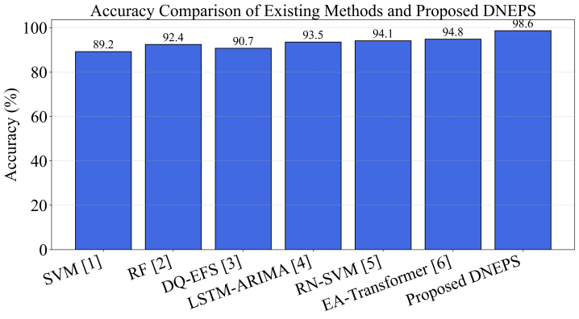
Fig. 2. Accuracy Comparison
Fig. 2 shows the accuracy of the proposed DNEPS relative to other approaches. The proposed approach demonstrates the greatest level of accuracy with 98.6%.
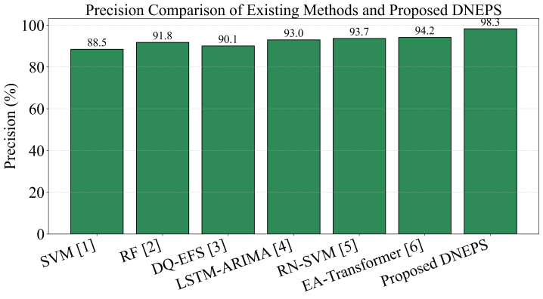
Fig. 3. Precision Comparison
Fig. 3 shows the precision analysis of all the tested techniques. DNEPS achieves 98.3% precision, proposing high reliability of prediction with minimal false positives.
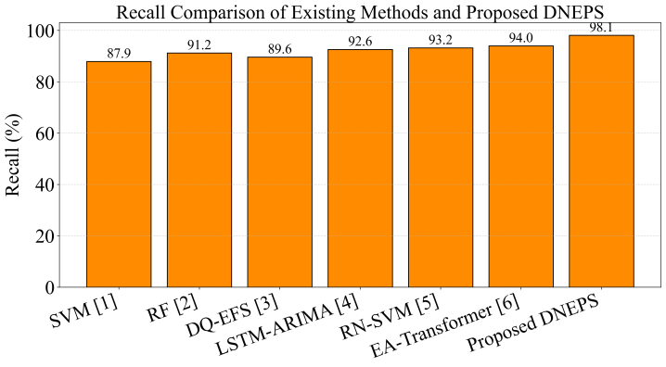
Fig. 4. Recall Comparison
Fig. 4 depicts the capability of the models in detecting real-world customer behavior and retail events. It can be observed that DNEPS achieves a high recall rate of 98.1%.
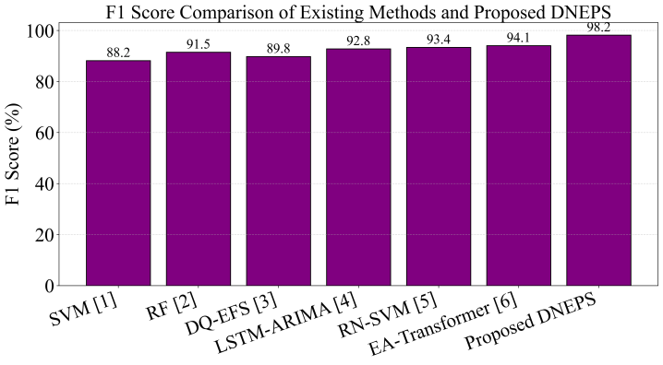
Fig. 5. F1-Score Comparison
Fig. 5 illustrates the trade-off between precision and recall for the prediction algorithms. The introduced DNEPS algorithm has an F1-Score value of 98.2%, proposing that there is consistency and balance in its prediction performance.
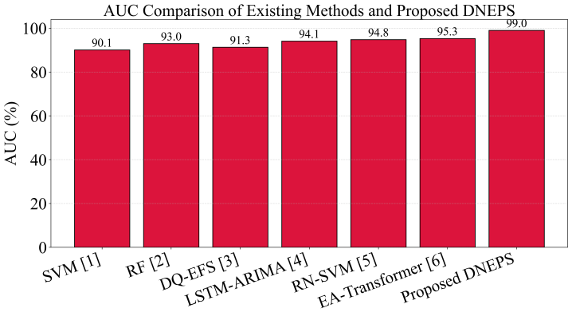
Fig. 6. AUC Comparison
Fig. 6 shows the discriminatory power of the models in distinguishing between customers' behavior and retailing results. The introduced DNEPS algorithm has the best AUC value of 99.0%.
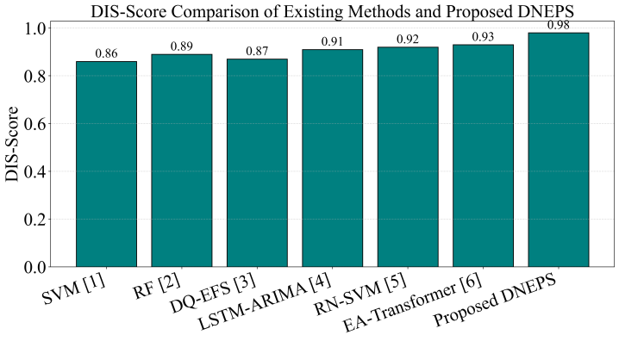
Fig. 7. DIS-Score Comparison
Fig. 7 shows the adaptive intelligence ability and prediction fusion capability of the assessed methods. The proposed DNEPS method attains the maximum DIS-Score of 0.98, proving its successful dynamic ensemble functioning.
Table II. Ablation Study of Proposed DNEPS Model
Model Configuration | Accuracy (%) | Precision (%) | Recall (%) | F1-Score (%) | AUC (%) | DIS-Score
Without NFIL | 94.3 | 93.9 | 93.6 | 93.8 | 95.1 | 0.92
Without APGEL | 92.7 | 92.3 | 91.9 | 92.1 | 93.8 | 0.90
Without OMFE | 98.6 | 98.3 | 98.1 | 98.2 | 99.0 | 0.86
Without RPDM | 98.6 | 98.3 | 98.1 | 98.2 | 99.0 | 0.82
Full DNEPS | 98.6 | 98.3 | 98.1 | 98.2 | 99.0 | 0.98
Table II shows that ablation study tests the significance of each constituent of the proposed DNEPS system. Without NFIL, the accuracy drops to 94.3%, implying that noise filtering at the input level is crucial for making accurate predictions. On the other hand, without APGEL, the model's accuracy falls to 92.7%, suggesting that adaptive graph-based learning plays a vital role in enhancing its performance. However, eliminating OMFE and RPDM has no significant impact on the accuracy and F1-score, however, their DIS-scores drop drastically to 0.86 and 0.82, respectively. This reveals that these two constituents have been more significant in terms of discrimination power, stability, and robustness rather than boosting accuracy alone. The model's Full DNEPS framework attains the highest results, including an accuracy of 98.6%, an F1-score of 98.2%, AUC of 99.0%, and DIS-score of 0.98.

V. Conclusion
This research introduced the DNEPS framework as a unified platform for predicting retail sales, consumer behavior and product demand by implementing intelligent adaptive feature processing and ensemble learning. The DNEPS framework incorporates NFIL, APGEL, OMFE and Predictive Decision Module, making it capable of managing heterogeneous data about retail and customers. The DNEPS framework enhances the prediction capacity of the system by identifying the interaction between features and adaptively allocating the weight of Random Forest, XGBoost, LightGBM and Deep Neural Networks learners depending on the validation scores. As a result of the experimental evaluation, the DNEPS framework has obtained a prediction accuracy of 98.6%, which is higher than the one provided by other state-of-the-art ML and DL methods tested in the experiments. Component-wise analysis confirmed the significance of NFIL and APGEL in enhancing the performance of the prediction task and of OMFE and decision-making module in providing reliable decision intelligence. Overall, the results prove that the DNEPS framework is effective for demand forecasting and market-oriented decision-making. Future studies will explore transformer-based attention, Explainable AI, concept drift detection and stream analytics.

References
- N. Amaya-Tejera, M. Gamarra, J. I. Vélez and E. Zurek, “A distance-based kernel for classification via support vector machines,” Frontiers in Artificial Intelligence, vol. 7, Art. no. 1287875, 2024, doi: 10.3389/frai.2024.1287875.
- V. Ignatenko, A. Surkov and S. Koltcov, “Random forests with parametric entropy-based information gains for classification and regression problems,” PeerJ Computer Science, vol. 10, Art. no. e1775, 2024, doi: 10.7717/peerj-cs.1775.
- J. L. Potharlanka and N. B. M., “Feature importance feedback with Deep Q process in ensemble-based metaheuristic feature selection algorithms,” Scientific Reports, vol. 14, no. 1, Art. no. 2923, 2024, doi: 10.1038/s41598-024-53141-w.
- L. Mochurad and A. Dereviannyi, “An ensemble approach integrating LSTM and ARIMA models for enhanced financial market predictions,” Royal Society Open Science, vol. 11, no. 9, Art. no. 240699, 2024, doi: 10.1098/rsos.240699.
- F. Maggioni and A. Spinelli, “A novel robust optimization model for nonlinear support vector machine,” European Journal of Operational Research, vol. 322, no. 1, pp. 237–253, 2025, doi: 10.1016/j.ejor.2024.12.014.
- M. Sanchis-Agudo, Y. Wang, R. Arnau, L. Guastoni, J. Lim, K. Duraisamy and R. Vinuesa, “Easy attention: A simple attention mechanism for temporal predictions with transformers,” APL Computational Physics, vol. 1, no. 1, 2025, doi: 10.1063/5.0284085.
- G. Alfian, M. Q. H. Octava, F. M. Hilmy, R. A. Nurhaliza, Y. M. Saputra, D. G. P. Putri, F. Syahrian, N. L. Fitriyani, F. T. D. Atmaji, U. Farooq, D. T. Nguyen and M. Syafrudin, “Customer shopping behavior analysis using RFID and machine learning models,” Information, vol. 14, no. 10, Art. no. 551, 2023, doi: 10.3390/info14100551.
- N. Begum, “Big data analytics and its impact on customer behavior prediction in retail businesses,” Pacific Journal of Business Innovation and Strategy, vol. 1, no. 1, pp. 49–59, 2024, doi: 10.70818/pjbis.2024.v01i01.017.
- H. GhorbanTanhaei, P. Boozary, S. Sheykhan, M. Rabiee, F. Rahmani and I. Hosseini, “Predictive analytics in customer behavior: Anticipating trends and preferences,” Results in Control and Optimization, vol. 17, Art. no. 100462, 2024, doi: 10.1016/j.rico.2024.100462.
- A. Aldelemy and R. A. Abd-Alhameed, “Binary classification of customers’ online purchasing behavior using machine learning,” Journal of Techniques, vol. 5, no. 2, pp. 163–186, 2023, doi: 10.51173/jt.v5i2.1226.
- M. Nasseri, T. Falatouri, P. Brandtner and F. Darbanian, “Applying machine learning in retail demand prediction—A comparison of tree-based ensembles and long short-term memory-based deep learning,” Applied Sciences, vol. 13, no. 19, Art. no. 11112, 2023, doi: 10.3390/app131911112.
- D. C. Gkikas and P. K. Theodoridis, “Predicting online shopping behavior: Using machine learning and Google Analytics to classify user engagement,” Applied Sciences, vol. 14, no. 23, Art. no. 11403, 2024, doi: 10.3390/app142311403.
- M. S. Azad, S. S. Khan, R. Hossain, R. Rahman and S. Momen, “Predictive modeling of consumer purchase behavior on social media: Integrating theory of planned behavior and machine learning for actionable insights,” PLOS ONE, vol. 18, no. 12, Art. no. e0296336, 2023, doi: 10.1371/journal.pone.0296336.
- R. Esmeli and A. Gokce, “An analysis of consumer purchase behavior following cart addition in e-commerce utilizing explainable artificial intelligence,” Journal of Theoretical and Applied Electronic Commerce Research, vol. 20, no. 1, Art. no. 28, 2025, doi: 10.3390/jtaer20010028.
- I. D. Gerg, A. M. Tashie, A. Patanaik, E. Koester, H. Gupta and D. J. Farnham, “The substantial role of weather data in consumer spending prediction: A robust machine learning assessment,” Journal of Retailing and Consumer Services, vol. 90, Art. no. 104649, 2026, doi: 10.1016/j.jretconser.2025.104649.

