Adaptive and Explainable Employee Retention Prediction Using Hyper Cognitive Neuro Symbolic Intelligent Networks

¹Dr G Agila,
Associate Professor & Head
PG & Research Department of Commerce
Sri Ramakrishna College of Arts & Science ( Autonomous) Coimbatore -641006
agila@srcas.ac.in

⁴Dr S Kirubadevi
Assistant Professor
PG & Research Department of Commerce, Sri Ramakrishna College of Arts & Science ( Autonomous) Coimbatore -641006
kirubadevi@srcas.ac.in

²Dr N Selvakumar,
Associate Professor
PG & Research Department of Commerce
Sri Ramakrishna College of Arts & Science ( Autonomous) Coimbatore -641006
selvakumar@srcas.ac.in

⁵Dr.R.Praba
Associate Professor
Department of Information Technology
Dr.N.G.P. Arts and Science College
praba2426@gmail.com

³Dr A Sangeetha,
Assistant Professor
PG & Research Department of Commerce
Sri Ramakrishna College of Arts & Science ( Autonomous) Coimbatore -641006
sangeetha@srcas.ac.in

Abstract—Employee retention prediction has become an important research area in Human Resource (HR) analytics due to increasing workforce mobility, organizational competition and the growing need for intelligent HR decision-support systems. Existing Machine Learning (ML) and Deep Learning (DL) approaches often suffer from limited interpretability, poor adaptability to dynamic organizational environments, inadequate feature representation learning and insufficient integration of HR domain knowledge. To address these limitations, this research proposes a novel Hyper Cognitive Neuro Symbolic Intelligent Network (HCNSIN) for adaptive and interpretable employee retention prediction. The proposed HCNSIN framework integrates deep neural representation learning, symbolic HR inference, attention-based feature weighting, adaptive decision fusion and cognitive learning to improve prediction performance and interpretability. The proposed HCNSIN framework integrates neural learning, symbolic HR reasoning, attention-based analysis, adaptive fusion and feedback-driven optimization to improve employee retention prediction. Experimental evaluation was conducted using the IBM HR Analytics Employee Attrition Dataset in a Python-based ML and DL environment. The proposed HCNSIN framework achieved an accuracy of 98.1%, outperforming existing employee attrition prediction models. The results show that the proposed framework provides an effective, efficient and explainable solution for employee retention prediction and HR analytics-based decision support.
Keywords—Adaptive Learning, Attention Mechanism, Cognitive Intelligence, Employee Retention Prediction, Neural-Symbolic Learning, Workforce Analytics

I. Introduction
Employee retention in modern organizations has become one of the key issues owing to the growing mobility of employees, stiff competition in the market and changing expectations of employees. The application of AI and ML methods is becoming prevalent in organizations for understanding employee’s behavior, performance, engagement and satisfaction, among others, to predict the attrition risk and adopt effective retention measures. Despite the popularity of the employee attrition prediction systems, most of these models lack interpretability, adaptability, feature learning and knowledge management in the HR domain. Recently, AI-based HR analytics and employee attrition prediction models using modern ML and DL approaches like AIHR systems [1], Bi-directional Temporal Convolutional Network (Bi-TCN) [2], explainable AI [3], predictive analytics model [4], ML-based turnover prediction system [5], ensemble learning model [6], hybrid feature-driven model [7], Explainable attrition score model [8], interpretable human resources analytics systems [9], policy simulation-based retention analysis system [10], Catboost-based features construction [11], explainable machine learning models [12], optimized neural networks [13], convolutional neural network approach [14] and early warning retention models via AI [15]. Even though all these techniques have provided excellent results in prediction, majority of the current methods do not possess the capability to learn from the environment and experience and do not have an adaptable nature.
In order to overcome the drawbacks of previous works mentioned above, this work introduces a novel Hyper Cognitive Neuro Symbolic Intelligent Network (HCNSIN) framework designed for adaptive employee retention prediction. In order to improve the accuracy and decision-making performance of model in addition to making it more understandable, this research incorporates deep neural representation learning, symbolic human resource reasoning, feature weighting using attention mechanism and cognitive adaptive learning. A set of intelligent layers, such as pre-processing, neural feature extraction, symbolic inference, adaptive fusion and optimization by feedback are used to analyze the employee and organization related data within the proposed HCNSIN framework. Also, the functioning of the proposed framework has been illustrated using mathematical expressions, flowcharts, architecture of the system and pseudo-code. Experiment results on Python based Machine Learning (ML) and Deep Learning (DL) environment indicate the superiority of HCNSIN in terms of improved accuracy and decision response time compared to other conventional methods:
- To design HCNSIN model for adaptive prediction of employee retention.
- To integrate deep neural network learning with symbolic HR reasoning for better prediction and explanation capability.
- To design a feature weighing system using attention model to identify impactful features of employee behavior.
- To implement cognitive adaptive learning and feedback optimization approach for decision-making adaptation.
- To increase prediction performance for employee attrition while reducing response time when compared with current ML and DL models.
The organization of this research is as follows: Section II presents the related work and analysis of existing employee retention prediction methods. Section III presents the proposed HCNSIN methodology, including workflow, architecture, equations, adaptive learning mechanism and pseudocode. Section IV discusses the experimental results and performance evaluation. Finally, Section V concludes the research with future research directions.

II. Related Work
M. Madanchian (2024) [1] proposed an approach to make use of artificial intelligence to facilitate decisions on recruitment, retention and work force management through HR predictive analytics and intelligent automation. Although this research illustrated the significance of making use of artificial intelligence techniques in facilitating HR decision-making, it has certain shortcomings related to explainable reasoning, cognitive adaptive learning and prediction of employee turnover.
F. Mortezapour Shiri et al. (2025) [2] came up with a DL model using Bi-TCN for employee attrition prediction. This technique was successful in capturing temporal behavior patterns of employees and made an improvement in attrition prediction; however, there were no symbolic HR reasons and explainability. It performed better in predicting employee turnover than existing ML approaches.
B. M. Goldstein et al. (2025) [3] studied hidden and persistent psychological state predictors at the workplace by applying neuroscientific-based predictive analysis. In this research, emphasis was placed on detecting the existence of certain internal psychological states associated with workplace, although this research was not targeted at predicting attrition among employees or making HR decisions based on predictions. It was found out that neural measures can help predict hidden psychological states of people working in certain conditions.
J. Park et al. (2024) [4] proposed an enhanced prediction framework using ML models for the analysis of turnover intentions among new employees. The approach made use of ML-enabled prediction to detect predictors of employee turnover during the early period of the work life. However, the technique was not capable of explaining symbolic HR reasoning, cognitive adaptive learning and explainable neuro-symbolic reasoning.
İ. T. Baydili and B. Tasci (2025) [5] proposed a model of explainable artificial intelligence-based employee attrition prediction in the decision making process. The researchers made use of explainable AI and interpretable machine learning methods in order to make the process of predicting attrition more transparent. However, there was no adaptation for the cognitive learning and neuro-symbolic reasoning processes involved in the research.
J. Choi and M. M. Chao (2026) [6] conducted a research analyzing employee responses to decisions made via AI and those made by humans, in terms of favorable and unfavorable decision outcomes as well as fairness perception. However, the research is about fairness perception and the employee’s reaction to decisions made using AI but not about employee turnover prediction and employee retention classification. The results revealed that fairness perception is critical for accepting decisions based on AI.
A. M. Rosenthal-von der Pütten and A. Sach (2024) [7] investigated the problem of algorithmic bias and selective compliance with automated decision-making support system in recruitment. In this regard, the research analyzed the problem of fairness and bias in the use of artificial intelligence for human resource decision-making purposes; however, it did not investigate any adaptive learning and employee retention prediction problems.
G. Nassreddine et al. (2026) [8] proposed an ensemble learning approach for explaining and predicting employee attrition using machine learning. The research used ensemble-based machine learning approaches along with explanatory analysis. However, it did not propose any solutions for cognitive adaptive learning or neuro-symbolic reasoning. The results revealed excellent accuracy and robustness in employee attrition prediction.
G. Koman et al. (2024) [9] investigated the opportunities of using artificial intelligence as the major component of the technological basis for the employee recruitment process. The authors discussed the usage of AI in recruitment and human resources decision support, but did not pay attention to the issues of prediction of employee turnover or adaptive retention modeling. According to the findings, application of AI could enhance the performance of recruitment, decision support and workforce management.
R. K. Ramasamy et al. (2025) [10] presented a framework for prediction of sustainable human resource management by means of tNPS-based machine learning. Machine learning techniques were used by the authors to conduct predictive analytics of employee opinions, satisfaction and retention as HR factors. However, this framework is limited to tNPS-based predictions and does not involve deep adaptive reasoning and feedback-based cognitive learning.
M. I. Alyousef et al. (2026) [11] proposed a hybrid predictive model to estimate employee turnover using ensemble learning in conjunction with feature-driven insights obtained from the IBM HR analytics dataset. The predictive technique used in the research involved ensemble machine learning methods and feature significance analysis to classify employee attrition more accurately. However, there was no use of neuro-symbolic reasoning, cognitive adaptation and feedback learning in the research. It provided enhanced accuracy in predicting turnover and useful HR analytical insights.
A. M. Căvescu and N. Popescu (2025) [12] introduced a framework of predictive analytics for HR management, which examined the importance of AIHR for talent retention. The research utilized AI-enabled predictive analytics and HR data modeling to develop decisions about talent retention. However, the research lacked integration of deep learning, dynamic adaptation and cognitive intelligence. It proposed that AIHR-based predictive analytics could be helpful in workforce planning and development of a talent retention strategy.
D. C. Nguyen et al. (2026) [13] developed an employee retention model based on the use of an explainable AI approach in green human resources management, where predictability, interpretability and policy simulation were incorporated. Although explainable machine learning approaches were used to forecast and simulate employee retention and policy impacts in the proposed approach, they did not incorporate any elements of adaptive neuro-symbolic intelligence and continuous learning through feedback. The findings highlighted improved interpretability of predictions, better policy awareness and efficient decision support for employee retention.
L. Theodorakopoulos et al. (2025) [14] focused the work on mitigating cognitive biases when making executive decisions using big data analytics and artificial intelligence. Although artificial intelligence was used to facilitate the improvement of decision making by executives with the help of explainable analytics, the research did not target employee attrition predictions and incorporate any components related to retention through adaptive learning mechanisms.
D. Li and Z. Liu (2024) [15] investigated the use of ANNs and ML in predicting the behavior of employees taking into consideration the influence of managerial elements on the economic development of workers. ANN and ML models were utilized to predict the behavior of employees based on the behavioral patterns and managerial elements; however, this method lacked the characteristics of being easily understandable, having symbolic reasoning ability and adapting to dynamic human resource contexts.

III. Proposed Methodology
This section introduces the HCNSIN methodological framework developed for predicting adaptive employee retention. Methodology highlights the entire process flow, system architecture, mathematization, adaptive learning procedure and the pseudo code for the proposed model. The framework uses neural representation learning, symbolic HR reasoning, attentional feature weighting, adaptive fusion and cognitive learning for accurate predictions.
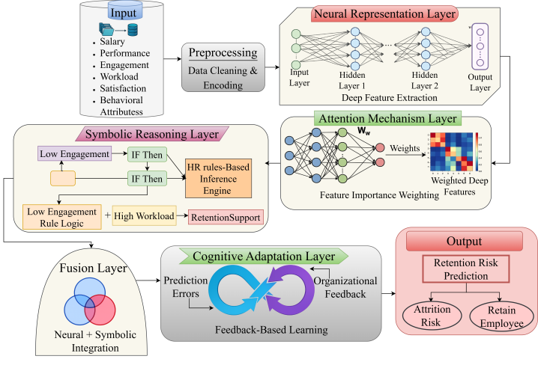
Fig. 1. Architecture of the Proposed HCNSIN Framework
The architecture of proposed HCNSIN algorithm used for employee retention prediction has been depicted in Fig.1. The system contains layers like preprocessing, representation learning by neural network, attention based weighted feature selection, symbolic reasoning, adaptive fusion and cognitive adaptation that analyze the behavior of employees. Finally, decision-making layer produces the prediction results by using neural intelligence and HR rule-based reasoning along with learning through feedback.

A. Dataset Description
IBM HR Analytics Employee Attrition Data Set is an open-source dataset that can be acquired from Kaggle https://www.kaggle.com/datasets/pavansubhasht/ibm-hr-analytics-attrition-dataset and is extensively used for conducting employee attrition and retention prediction studies. The data set consists of structured employee profiles along with several attributes concerning demographic attributes, job profile attributes, organizational tenure of the employee, remuneration, performance levels, work-life balance, overtime, training organizes taken by the employee, promotions attained by the employee and organizational tenure. The objective of using the dataset is to predict employee retention with respect to the binary target attribute Attrition. This multivariate structure of the dataset makes it useful in researching the different variables that could lead to the attrition rates within the company, including the monthly income, job level, department, job satisfaction, environment satisfaction, overtime, performance rating and career growth opportunity. The use of this dataset within the HCNSIN framework would be helpful in deriving neural features, computing attention feature importance, HR symbolic reasoning and making accurate employee retention risk predictions. Prior to model training, all categorical variables will be transformed into numeric form while numerical features will be scaled and divided into training and test subsets. Hence, the IBM HR Analytics Employee Attrition & Performance Dataset can serve as an appropriate benchmark to evaluate the performance of the proposed HCNSIN model.

B. Hyper Cognitive Neuro Symbolic Intelligent Network
The HCNSIN is an intelligent framework for accurate, adaptive and interpretable employee retention prediction based on hybrid AI techniques. It incorporates representation learning with DNN, symbolic HR rule-based reasoning, attention-based employee attribute weighting and cognitive adaptive learning into one prediction model. Specifically, the neural learning component automatically learns and discovers underlying behavioural and organizational patterns in employee information, while the symbolic reasoning component infers and uses HR domain knowledge to achieve more explainable and decision-oriented predictions. Furthermore, the attention-based weighting scheme emphasizes more influential employee attributes such as overtime, monthly income, job satisfaction, work-life balance, performance rating and career growth-related attributes. The cognitive adaptive learning technique refines the HCNSIN model continuously with feedback or prediction error signals. Compared with the existing ML and DL methods which emphasize prediction accuracy, the HCNSIN model enhances the explainability and adaptivity to changing business needs. Consequently, the proposed framework provides an effective solution to adaptive employee attrition risk identification, retention decision making and workforce analysis in organizations. The reproducibility of the HCNSIN can be ensured by using the same IBM HR Analytics Employee Attrition Dataset, identical data preprocessing procedure, modular system structure, consistent training and validation procedures and comparable performance evaluation criteria.
$h=f\left(Wx+b\right)$ (1)
The input employee feature vector $x$ consists of employee attributes like salary, attendance, performance, satisfaction, workload, overtime and engagement level, as shown in Equation (1). All trainable parameters are described as follows, $W$ is the weight matrix to be trained, $b$ is the bias term to be trained and $f$is the activation function ReLU or sigmoid. The extracted deep feature representation $h$ is the output of the model.
$P_{attrition}=σ\left(W_{h}h+b_{h}\right)$ (2)
In Equation (2),$W_{h}$ is the output layer weight matrix, $b_{h}$ is the output layer bias and σ is the sigmoid activation function, $P_{attrition}$is the predicted probability of employee attrition. This equation calculates the probability that an employee might leave a company.
$L=-\left[y\log\left(\hat{y}\right)+\left(1-y\right)\log\left(1-\hat{y}\right)\right]$ (3)
In this equation (3), $y$ is the actual class label for the employees and $\hat{y}$ is the predicted probability of attrition for the employees. The binary cross-entropy loss $L$, is the difference between the actual employee outcome and the predicted outcome.

C. System Architecture of the HCNSIN Framework
The design of the HCNSIN intelligent system framework entails developing a hybrid system that comprises five layers of intelligence, namely, data ingestion layer, neural representation learning layer, symbolic reasoning layer, attention-based weight layer and cognitive adaptation layer. To begin with, the employee data, which include employee performance, employee engagement level, workload, salary, job satisfaction, working hours beyond regular office hours, work-life balance and career development, among others, are preprocessed and represented in feature format. Subsequently, the neural representation learning layer makes use of employee data for pattern extraction and estimation of initial employee attrition probability. After that, the attention-based weighting layer determines key features among employee data and assigns more weight to those that influence retention. Then the symbolic reasoning layer uses HR-specific rules in the refinement of the prediction process.
$S=\sum_{i=1}^{n}{r_{i}\left(x\right)}$ (4)
Equation (4), $r_{i}\left(x\right)$ is the $i$ symbolic HR rule applied to the employee feature vector, $n$ is the number of all the possible symbolic HR rules and $S$ is the symbolic reasoning score. This score reflects and contributes to the creation of an HR decision support that makes sense in the context of defined HR rules from experts.
$α_{i}=\frac{e^{e_{i}}}{\sum_{j}{e^{e_{j}}}}$ (5)
Equation (5), $e_{i}$ represents the importance score of the $i$ feature and $α_{i}$ is the normalized attention weight given to this feature. All feature scores are normalized by the denominator $\sum_{j}{e^{e_{j}}}$ normalizing factor scores. This mechanism gives more importance to relevant employee characteristics which play a significant role in predicting employee attrition.
$H^{'}=\sum_{i=1}^{n}{α_{i}h_{i}}$ (6)
In equation (6) represents that $h_{i}$ represents the individual neural feature component, $H^{'}$ indicates the refined attention-weighted feature representation. This equation enhances employee representation by focusing on the most pertinent attributes for attrition.
$F=λP_{attrition}+\left(1-λ\right)S$ (7)
In the Equation (7), $λ$ is the fusion coefficient to balance the learning weight of the neural network and the score of symbolic reasoning. Decision Score $F$ final score for fused decision. This fusion will enhance prediction reliability due to data driven learning and rule-based HR reasoning.

D. Adaptive Learning and Decision Fusion Mechanism in HCNSIN
The incorporation of the feedback-driven adaptive learning system within the adaptive learning and decision fusion of HCNSIN will have great contributions to the enhancement of the predictive performance because of the following reasons. The first reason is that the neural component of HCNSIN is capable of predicting the probability of an employee leaving the company by using the representation that was learned during the process whereas the symbolic component improves the accuracy of prediction by considering HR constraints and domain expertise. The second reason is that there exists an explanation system that explains each prediction by providing an understanding of the link between the prediction and cause of such a prediction. Finally, the cognitive learning system modifies the weights and importance of the rules based on the employee's new behavior and organizational feedback.
$θ_{t+1}=θ_{t}-η∇L$ (8)
In Equation (8), $θ_{t}$ is the current model parameters at time $t$,$η$is the learning rate and $∇L$ is the gradient of the loss function, which is used to optimize the model parameters, $θ_{t+1}$ are the updated model parameters after optimization. This equation is used to reduce the error in prediction and enhance learning during training.
$C_{new}=C_{old}+γ\left(y-\hat{y}\right)$ (9)
In Equation (9), $C_{old}$ is the previous cognitive adjustment, $C_{new}$ is the new cognitive adjustment value, $γ$ is the rate of adaptation, $y$ is the actual employee outcome and $\hat{y}$ is a predicted employee outcome. This equation is used to update the cognitive state, given by the prediction error.
$R=σ\left(F+C_{new}\right)$ (10)
In equation 10, $σ$is the sigmoid activation function and $R$ are the final scores of the risk of leaving the company by the employee. This final score will be used to determine whether the employee is retained or placed at risk of attrition.
Algorithm: Hyper Cognitive Neuro Symbolic Intelligent Network for Employee Retention Prediction
Input:
$X$ → Employee dataset (features: salary, performance, engagement, workload, satisfaction)
$Y$ → True labels (retain / attrition)
$η$ → learning rate
$λ$ → fusion parameter
Output:
R → Employee retention risk score
Class → Retain or Attrition prediction
Begin
Data Preprocessing:
Normalize X and handle missing values
Convert categorical features into numerical form
Feature Learning (Neural Module):
Compute hidden representation:
$h = f(WX + b)$
Initial Prediction:
Compute attrition probability:
$P_{attrition}=σ\left(W_{h}h+b_{h}\right)$
Symbolic Reasoning Module:
Apply HR rules to compute symbolic score S:
S = sum of rule activations based on X
Attention Weighting:
Assign importance to features and compute weighted representation $H'$
Fusion Stage:
Compute combined score:
$F=λP_{attrition}+\left(1-λ\right)S$
Cognitive Adaptive Update:
Update model parameters using feedback:
$θ_{t+1}=θ_{t}-η∇L$
Final Decision:
Compute final risk score:
$R = σ(F)$
If R > threshold$τ$:
Class = "Attrition Risk"
Else:
Class = "Retain"
End
The pseudo code for HCNSIN Algorithm provides an outline of the entire process involved in prediction of employee retention ranging from data processing stage all the way to the updating of parameters for the neural network. The process is completed by calculating the decision threshold.

IV. Result and Discussion
The section contains the experimentation results and analysis of the proposed HCNSIN architecture for adaptive employee retention prediction. The prediction model was implemented with the help of Python 3.10 programming language along with TensorFlow, Scikit-learn, NumPy and Pandas library packages for assessing the performance of the predictive model. The performance of the proposed HCNSIN model has been evaluated based on the criteria of accuracy, precision, recall, F1-score, ROC-AUC score, decision response time, comparative analysis of the models, graphical analysis and ablation analysis.
The proposed HCNSIN architecture was validated experimentally through implementation on the IBM HR Analytics Employee Attrition Data Set using machine learning and deep learning techniques with Python programming language. The implementation was carried out using Python version 3.10, TensorFlow, Scikit-learn, NumPy and Pandas libraries to perform all preprocessing, training, prediction and evaluation tasks. To test the generalization capability of the proposed model, the data set was split into 80% of training and 20% of testing data set ratio. For HCNSIN model training, the number of training epochs used was 100 and the batch size of each epoch was kept at 32. The training was done using Adam optimization technique with a learning rate of 0.001. All experiments were performed on a computer system that has an Intel i7 processor, 16 GB RAM and an NVIDIA RTX 3050 graphics card.
Table I. Comparative Performance Analysis of Employee Retention Prediction Models
Models | Accuracy (%) | Precision (%) | Recall (%) | F1-Score (%) | ROC-AUC Score | Decision Response Time (ms)
LSTM [1] | 91.4 | 90.8 | 89.7 | 90.2 | 0.92 | 135
XGBoost [2] | 92.6 | 91.9 | 90.5 | 91.2 | 0.94 | 110
GRU [3] | 93.1 | 92.4 | 91.3 | 91.8 | 0.95 | 105
Autoencoder [6] | 90.7 | 89.6 | 88.9 | 89.2 | 0.91 | 145
LightGBM [7] | 94.2 | 93.5 | 92.8 | 93.1 | 0.96 | 92
RF [12] | 91.8 | 90.9 | 90.1 | 90.5 | 0.93 | 120
Proposed (HCNSIN) | 98.1 | 97.5 | 97.2 | 97.3 | 0.99 | 68
The comparison of performances between the current ML and DL algorithms and the proposed HCNSIN framework with metrics can be seen in Table I. From Table I, it is observed that the proposed HCNSIN framework outperforms other algorithms in terms of predictive capabilities including LSTM, XGBoost, GRU, Autoencoder, LightGBM and Random Forest. The enhanced accuracy, precision, recall and F1 score mean improved reliability of the model in classifying the employees’ attrition risk and the enhanced ROC-AUC score reflects its high discriminatory power. Moreover, the reduced decision response time shows that HCNSIN provides improved efficiency in prediction because of neural-symbolic reasoning, attention-based feature weighting and cognitive adaptive learning.
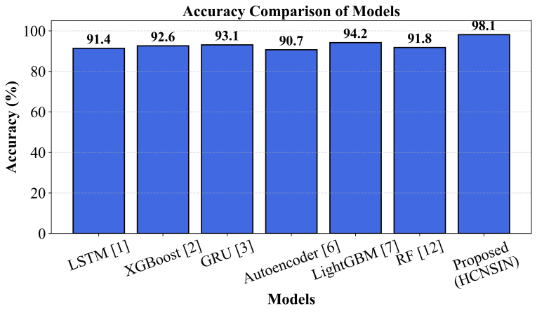
Fig. 2. Accuracy Comparison of Models
Fig. 2 represents the comparison results between various machine learning and deep learning models in terms of accuracy when it comes to predicting employee attrition. The proposed HCNSIN model has obtained the highest accuracy of 98.1% for classifying employee attrition.
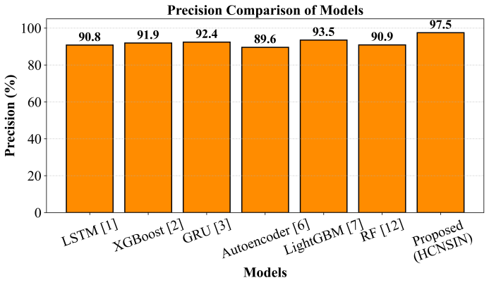
Fig. 3. Precision Comparison of Models
Fig. 3 shows the precision performance of the models in predicting employee attrition. The HCNSIN model framework attained the highest precision level of 97.5%. This implies that the framework performed well in minimizing false positive predictions of attrition.
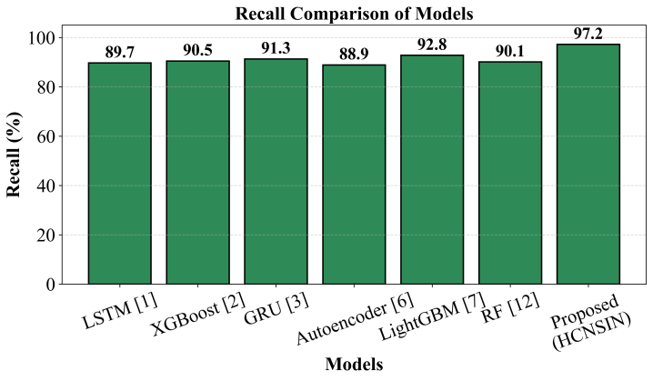
Fig. 4. Recall Comparison of Models
Fig. 4 below shows the plot for the recall analysis of the assessed models for predicting employee attrition. The model HCNSIN has the highest recall score of 97.2%. This is because it accurately predicted the employees most likely to leave the organization.
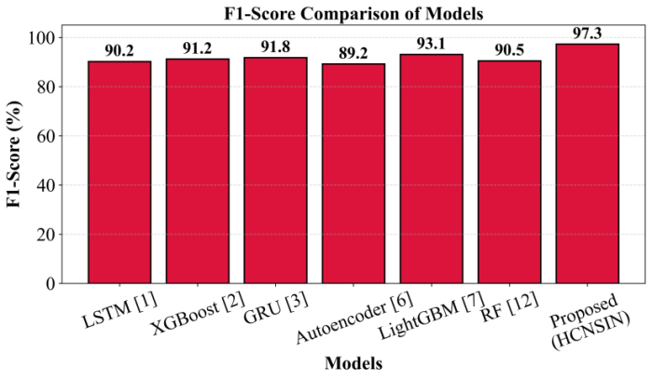
Fig. 5. F1-Score Comparison of Models
Fig. 5 depicts the comparison of F1-score between the existing models and the new HCNSIN framework. The new HCNSIN framework yielded the best F1-score of 97.3%, thereby validating that the improvement in both precision and recall is balanced.
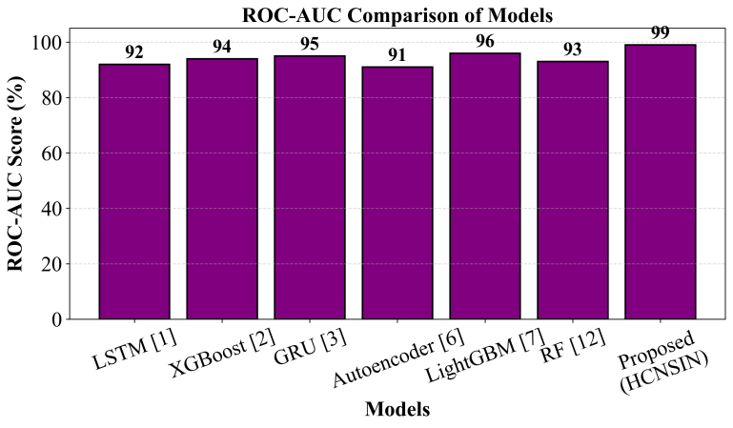
Fig. 6. ROC-AUC Comparison of Models
Fig. 6 shows the comparison of ROC-AUC between various models of classifications used in the prediction of employee retention. The proposed HCNSIN model showed the best ROC-AUC value of 0.99, showing great discriminating capacity between the retained and attrition risk employees.
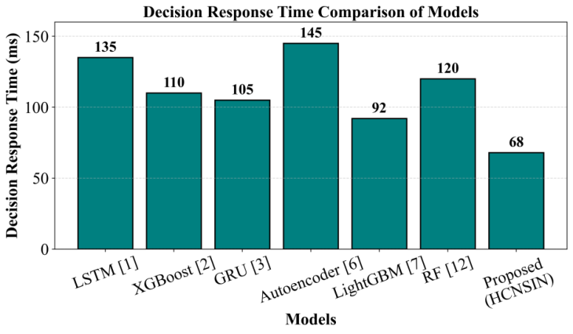
Fig. 7. Decision Response Time Comparison of Models
Fig. 7 depicts the comparative research of decision response time of various methods in predicting employee retention. The HCNSIN method proposed has achieved the least response time of 68 ms which reflects its computational efficiency and fast prediction of employee retention risk.
Table II. Ablation Study of the Proposed HCNSIN Framework
Model Variants | Accuracy (%) | Precision (%) | Recall (%) | F1-Score (%) | ROC-AUC Score | Decision Response Time (ms)
Neural Network Only | 90.8 | 90.2 | 89.6 | 90.1 | 0.91 | 128
Neural + Symbolic Reasoning | 93.9 | 93.4 | 92.8 | 93.2 | 0.94 | 105
Neural + Symbolic + Attention | 96.2 | 95.9 | 95.4 | 95.8 | 0.97 | 82
Full HCNSIN Proposed | 98.1 | 97.5 | 97.2 | 97.3 | 0.99 | 68
Table II result of the ablation experiment reveals the role played by every key element in the suggested HCNSIN model. The simple neural network architecture obtains a result of 90.8% accuracy, implying that learning using neural networks alone is sufficient to learn relevant patterns of employee retention. By integrating symbolic reasoning, the accuracy of the model rises to 93.9% owing to the use of HR rules for inferencing. On inclusion of the attention module, the accuracy rises to 96.2% while the F1-score reaches 95.8% due to the weighting of relevant information on employees' features. The fully developed HCNSIN model attains the highest score in accuracy at 98.1%, precision at 97.5%, recall at 97.2%, F1-score at 97.3% and ROC-AUC at 0.99. Furthermore, it attains the fastest decision response time of 68 ms.
Overall, the obtained findings show that HCNSIN outperforms the current ML and DL techniques in terms of prediction accuracy, robustness and effectiveness. The reasons behind the enhanced performance can be attributed to the integrated use of neural representation learning, symbolic HR reasoning, feature weighting using attention mechanisms and cognitive adaptive learning. Hence, HCNSIN can be used in HR tasks, such as intelligent employee retention risk prediction.

V. Conclusion
This research proposed a HCNSIN framework for adaptive and explainable employee retention prediction by integrating DL, symbolic HR reasoning, attention mechanisms and cognitive adaptive learning. The proposed HCNSIN approach was designed to overcome the shortcomings of current ML and DL approaches, including low prediction accuracy, low interpretation capability and poor capability of adaptive learning as well as HR decision support. HCNSIN architecture successfully completed preprocessing, neural feature extraction, symbolic reasoning, attention based feature weighting and adaptive learning to examine behavioral patterns of employees and attributes of an organization. Results from empirical analysis on the IBM HR Analytics Employee Attrition Dataset indicated that HCNSIN approach is superior to existing approaches in predicting. The proposed framework exhibited an accuracy of 98.1%, precision of 97.5%, recall of 97.2%, F1-Score of 97.3%, ROC-AUC value of 0.99 and the minimum decision time of 68 ms. Moreover, the results obtained from the ablation experiment show that incorporation of symbolic reasoning, attention weights and cognitive adaptive learning considerably enhances prediction accuracy and effectiveness. Thus, the proposed HCNSIN framework is considered to provide a reliable and interpretable approach for intelligent predictions and decision-making in human resources management based on predictive analytics. Future work can be directed at incorporating cloud-based HR analytics and federated learning into the HCNSIN framework. Possible extensions include multimodal analysis of employee behaviors through NLP and IoT technologies as well as explainable generative AI algorithms.

References
- M. Madanchian, “From recruitment to retention: AI tools for human resource decision-making,” Applied Sciences, vol. 14, no. 24, Art. no. 11750, 2024, doi: 10.3390/app142411750.
- F. Mortezapour Shiri, S. Yamaguchi and M. A. B. Ahmadon, “A deep learning model based on bidirectional temporal convolutional network (Bi-TCN) for predicting employee attrition,” Applied Sciences, vol. 15, no. 6, Art. no. 2984, 2025, doi: 10.3390/app15062984.
- B. M. Goldstein, S. M. Burns, A. L. Binnquist, M. C. Dieffenbach, C. Konkoly, S. Abramowitz and M. D. Lieberman, “Neural predictors of hidden, persistent psychological states at work,” Proceedings of the National Academy of Sciences, vol. 122, Art. no. e2504382122, 2025, doi: 10.1073/pnas.2504382122.
- J. Park, Y. Feng and S.-P. Jeong, “Developing an advanced prediction model for new employee turnover intention utilizing machine learning techniques,” Scientific Reports, vol. 14, Art. no. 1045, 2024, doi: 10.1038/s41598-023-50593-4.
- İ. T. Baydili and B. Tasci, “Predicting employee attrition: XAI-powered models for managerial decision-making,” Systems, vol. 13, no. 7, Art. no. 583, 2025, doi: 10.3390/systems13070583.
- J. Choi and M. M. Chao, “For me or against me? Reactions to AI (vs. human) decisions that are favorable or unfavorable to the self and the role of fairness perception,” Personality and Social Psychology Bulletin, vol. 52, no. 3, pp. 671–691, 2026, doi: 10.1177/01461672241288338.
- A. M. Rosenthal-von der Pütten and A. Sach, “Michael is better than Mehmet: Exploring the perils of algorithmic biases and selective adherence to advice from automated decision support systems in hiring,” Frontiers in Psychology, vol. 15, Art. no. 1416504, 2024, doi: 10.3389/fpsyg.2024.1416504.
- G. Nassreddine, J. Hammoud, O. Al-Khatib and M. A. Majzoub, “Employee attrition prediction: An explanatory and statistically robust ensemble learning model,” Computers, vol. 15, no. 3, Art. no. 185, 2026, doi: 10.3390/computers15030185.
- G. Koman, P. Boršoš and M. Kubina, “The possibilities of using artificial intelligence as a key technology in the current employee recruitment process,” Administrative Sciences, vol. 14, no. 7, Art. no. 157, 2024, doi: 10.3390/admsci14070157.
- R. K. Ramasamy, M. Muniandy and P. Subramanian, “A predictive framework for sustainable human resource management using tNPS-driven machine learning models,” Sustainability, vol. 17, no. 13, Art. no. 5882, 2025, doi: 10.3390/su17135882.
- M. I. Alyousef, H. W. Khan and M. U. Sattar, “A hybrid predictive model for employee turnover: Integrating ensemble learning and feature-driven insights from IBM HR analytics,” Information, vol. 17, no. 2, Art. no. 208, 2026, doi: 10.3390/info17020208.
- A. M. Căvescu and N. Popescu, “Predictive analytics in human resources management: Evaluating AIHR’s role in talent retention,” AppliedMath, vol. 5, no. 3, Art. no. 99, 2025, doi: 10.3390/appliedmath5030099.
- D. C. Nguyen, D. Tenney and E. Kongar, “Explainable AI for employee retention in green human resource management: Integrating prediction, interpretation and policy simulation,” Sustainability, vol. 18, no. 6, Art. no. 2740, 2026, doi: 10.3390/su18062740.
- L. Theodorakopoulos, A. Theodoropoulou and C. Halkiopoulos, “Cognitive bias mitigation in executive decision-making: A data-driven approach integrating big data analytics, AI and explainable systems,” Electronics, vol. 14, no. 19, Art. no. 3930, 2025, doi: 10.3390/electronics14193930.
- D. Li and Z. Liu, “Artificial neural networks (ANNs) and machine learning (ML) modeling employee behavior with management towards the economic advancement of workers,” Sustainability, vol. 16, no. 21, Art. no. 9516, 2024, doi: 10.3390/su16219516.

