A Survey on Ultrasound-Based Classification of Embryo–Fetal Brain Abnormalities
^{1,2*}Vanchala Bhagwat Sutar  ¹Research scholar, Department of Computational Intelligence  SRM Institute of Science and Technology  Kattankulathur, Chennai 603203, Tamil Nadu, India  &  ²Assistant Professor, Computer Science and Engineering (Artificial Intelligence and Machine Learning)  D.K.T.E. Society's Textile & Engineering Institute  Ichalkaranji, Maharashtra, 416115 India.  sutarvanchala@gmail.com | ³Dr. Shiny Angel T S  ³Associate Professor, Department of Computational Intelligence, Faculty of Engineering & Technology, Kattankulathur - Chennai  SRM Institute of Science and Technology  Kattankulathur, Chennai 603203, Tamil Nadu, India  shinyant@srmist.edu.in

Abstract—Classification of fetal brain abnormalities is important in prenatal healthcare, as it helps to identify developmental disorders at an early stage using ultrasound images. Its main objective is to distinguish between normal and abnormal brain development for medical intervention at the right time and to improve pregnancy survival rates. Still, this classification work is difficult because of poor-quality ultrasound images, fetal movement, overlapping anatomical structures, and limited annotated datasets. In medical settings, baseline techniques mostly depend on handcrafted features or require large labeled datasets that are difficult to obtain. The most common issues faced by them are complex spatial patterns, a lack of interpretability, poor generalization, and Overfitting. This study helps to examine the challenges in fetal abnormality detection by reviewing and categorizing existing approaches. This study analyzes the methods and categorizes them into Deep Learning (DL), Machine Learning (ML), and Artificial Intelligence (AI) techniques. The evaluation is conducted regarding datasets, tools, performance metrics, and publication years. The study also highlights current limitations and identifies future research directions. The analysis shows that DL-based methods are the most effective for fetal abnormality detection. Python is the most widely used implementation tool, accuracy is the primary evaluation metric, and most of the studies were published in 2021, 2023, and 2024. Thus, this analysis helps to identify key trends and limitations in existing approaches and supports the development of an efficient fetal abnormality detection model.
Keywords—Fetal brain abnormalities, Fetal segmentation, Fetal abnormality, Deep Learning, Machine Learning.
- Introduction
In human life, the fetal period is a critical stage of development during which organs mature and essential body parts take shape. This is the basis for the long-term health and well-being of an individual. Among these, the development of the head and brain is especially important because it directly affects lifelong neurological function. Any disturbance in brain growth during this stage can result in serious health complications that risk the life of the child [1]. Fetal brain abnormalities are common in many cases, with studies indicating that intracranial irregularities occur in about 1 in 100 births. In terms of analyzing brain structure, clinicians depend on standard axial neurosonographic planes, particularly the transventricular and transcerebellar view [2]. However, these abnormalities can vary widely, ranging from developmental issues to vascular conditions, which made the diagnosis a challenging one. The fetal brain can appear differently depending on the imaging plane, fetal position, and technical factors [3]. Sonographers must carefully adjust the probe while interpreting real-time images, where even slight movements can significantly change the view. This variability leads to measurement errors and inconsistent examination times; thus, assessment is both complex and demanding [4].
Machine learning (ML) techniques help the models to learn patterns from medical images using statistical models [5]. These methods support diagnostic processes by identifying diseases precisely, and, in some cases, these models are better than human experts. Nevertheless, effective ML models need large and well-balanced datasets that contain both normal and abnormal cases. In fetal analysis, these models are necessary to identify congenital heart defects. Deep learning (DL) helps to learn meaningful features automatically from data, even when datasets are smaller. This capability is increased through data augmentation techniques, which artificially expand the training data. DL has improved performance in medical imaging tasks, as it can both identify and categorize anatomical structures in a way similar to object detection systems. Recent research has explored various DL approaches, including fully convolutional networks for fetal anatomy localization, Transfer Learning (TL) for ultrasound image recognition, and hybrid ConvNet-RNN models for capturing spatial and temporal patterns. Due to limited availability of fetal cardiac datasets, some studies use 3D ultrasound videos from online sources, though these are often unstructured and inconsistent [6].
This survey analyzes 25 research articles focused on embryo-fetal abnormality classification. The reviewed methods are categorized into Deep Learning (DL), Machine Learning (ML), and Federated Learning (FL) approaches. The study not only compares these techniques but also identifies their key limitations and challenges that aids to highlight possible directions for future research. In addition, the survey examines important aspects such as types of datasets used, publication years, tools, and the performance metrics used in each study.
The layout of subsequent sections is structured as follows. Section II presents a categorization of recent models for fetal abnormality classification. Section III describes the general workflow involved in fetal abnormality prediction systems. Section IV provides a detailed review of conventional models, while Section V discusses the research gaps associated with these baseline approaches. Section VI offers a comprehensive assessment of the models, including the tools used, datasets, publication year, and evaluation metrics. Section VII summarizes the survey.
- Categorization of work
Embryo-fetal brain abnormality classification approaches are categorized into groups based on their strategies, comparison, evaluation, and method selection. Here, fetal brain abnormality detection techniques are categorized into DL-based, ML-based, and AI-based. Fig. 1 shows categorization of fetal abnormality classification approaches.
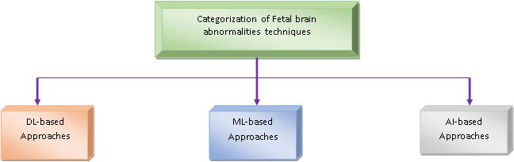
Fig. 1. Categorization of fetal abnormality detection approaches
- General Structure of Fetal Brain Abnormality Detection
The general framework of fetal brain abnormality classification includes image acquisition from ultrasound, followed by preprocessing, segmentation, feature extraction, and classification. The following sections explain these steps.
- Pre-processing
Pre-processing is the enhancement of the quality of fetal ultrasound images. It includes steps like noise reduction, contrast enhancement, and normalization that help to make important anatomical structures more visible [7].
- Segmentation
Segmentation includes extracting brain regions from ultrasound images. This phase is required for analyzing anatomical structures and detecting abnormalities by separating relevant areas from the background [8].
- Feature Extraction
Feature extraction is to capture important characteristics of the brain from the segmented image. It aids in identifying patterns, such as ventricle size, brain symmetry, and tissue texture that indicate abnormalities [8].
- Classification of fetal brain abnormality
Classification of fetal brain abnormality is the categorization of fetal brain images based on extracted features into normal or abnormal categories. It is performed using ML, DL, or AI models that are trained using labeled medical data. Fig. 2 shows the general structure of fetal brain abnormality classification [8].
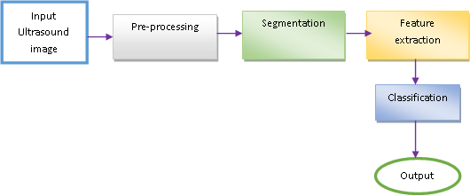
Fig. 2. General structure of fetal brain abnormality classification
- Literature Survey
This section reviews various fetal brain abnormality classification methods and classifies them into DL-based, ML-based, and FL-based. It also discusses the limitations of each method and highlights existing research gaps, as well as providing ideas for improving the accuracy and reliability of detection systems that are to be developed in the future.
  - DL-based Methods
Some of the DL-based approaches for identifying fetal abnormalities are mentioned as follows.
L. S. Hesse, et al.[9] developed Convolutional Neural Network (CNN) for subcortical segmentation of the fetal brain. This method correctly segmented ultrasound images, even with an inadequate number of annotated samples. It reduced the burden of manual labeling, especially when merged with weak annotations. It also created growth trajectories and provided the relevant information on fetal brain development over several populations. However, it required proper image alignment for exact results, and it exhibited poor performance on low-quality scans.
W. A. Bastiaansena, et al. [10] introduced DL approach for identifying normal brain development. This model generated a 4D atlas of early human brain development that helped to attain age-specific changes during the first trimester. It provided a comprehensive and dynamic reference that supported early detection of abnormalities. Thus, it helped clinicians and researchers to study environmental and parental influences. Still, it needed high-quality and diverse imaging data, which was difficult to obtain. This restricted its applicability in clinical environments.
R. Qu, et al. [11] devised CNN-based domain Transfer Learning (TL) for recognition of fetal brain standard scan planes. This model minimized overfitting issues and utilized the limited datasets in an effective manner. Nevertheless, it was not generalized well to different clinical settings. In addition to this, building and training these models was computationally intensive and also required further validation before routine clinical use.
V. Nagabotu and A. Namburu, et al. [12] designed U-Net for precise segmentation of fetal head in ultrasound images. This technique combined attention mechanisms and feature layer selection that helped to enhance the extraction of important spatial information and improved skull boundary detection. Moreover, segmentation accuracy is increased by fusing global and local features. However, it required high-quality annotated datasets, and did not perform well in complex scenarios like twin fetuses, as it required further validation from experts.
M. . N. Rachmatullah, [6] utilized CNN method using the U-Net architecture for the semantic segmentation of fetal echocardiography. This model exhibited accurate segmentation by combining the U-Net with post-processing techniques and supported expert sonographers through providing visibility of small and complex fetal cardiac structures, which were difficult to analyze due to limited data and low image quality. Nevertheless, it was trained on a small dataset, which constrained its generalization to large clinical settings. It was also sensitive to data quality and preprocessing steps, and local thresholding performed poorly in comparison to global methods. Even though this model had several disadvantages, it possessed the capability to automate CHD screening.
M. Priya and M. Nandhini [7] introduced Detection of Fetal Brain Abnormalities (DFBA) for the detection of fetal brain abnormalities. Even though this model possessed better classification performance on limited medical datasets, it lacked an increased number of layers and neurons, and it struggled with overfitting problems. Additionally, its applicability in a practical environment was constrained by its dependence on a particular type of dataset.
J. Gao, et al. [13] developed RepairNet method to screen ultrasound fetal biometry. In real clinical environments, domain shift was a major concern, but this model overcame those challenges through combining a segmentation network and also exhibited high segmentation quality even in noisy or degraded images. Moreover, it also improved cross-domain correction of faulty masks, while the selective screener filters out unreliable results. However, this multi-stage architecture increased computational complexity, and its accuracy depended on anatomical guidance and imaging conditions.
E. Saraswathi, et al. [14] designed CNN classifier algorithm for recognition and classification of fetal brain abnormalities. While comparing with traditional approaches, the model performs better and faster by achieving a high accuracy, and it could detect and categorize several abnormalities in the brain of the fetus in different stages of pregnancy. Moreover, it minimized computation cost and maximized image processing efficiency. Nevertheless, its performance was dependent on the quality and quantity of the data used, which limited the diversity of the data. Therefore, further testing should be done before its implementation in the clinical setting.
D. Vetriselvi and R. Thenmozhi et al.[15] introduced MSAG_ENET for the classification of 2D-US Fetal Brain Anomalies. Here, the integration of the Multiscale Self Attention Generator facilitated the process of data augmentation, which helped in overcoming small datasets and enhanced the reliability of the algorithm. Then, preprocessing techniques, including anisotropic diffusion filtering, played a critical role in reducing speckle noise. Nonetheless, it was highly dependent on the quality of preprocessing techniques and parameter tuning, which made it difficult to implement for other conditions.
S. Nurmaini, et al. [16] designed Mask-RCNN (MRCNN) for the detection of septal defects with fetal ultrasonography images. This model performed multiclass segmentation of critical structures of the heart. Moreover, Multi-scale feature learning was achieved in the model through region proposals and RoI alignment techniques. Yet, training data was relatively small, limiting the ability to generalize to different practical situations.
M. Komatsu, et al. [17] developed Supervised Object detection with Normal data Only (SONO) for detection of cardiac structural abnormalities in fetal ultrasound. The system showed clear advantages in fetal cardiac ultrasound analysis by accurately detecting cardiac substructures and identifying potential structural abnormalities. Its ability to process ultrasound videos made it valuable for real-time assessment, while the barcode-like timeline provided a simple and intuitive way to visualize the entire examination process. This helped clinicians to better understand the sequence and quality of captured views. However, it required extensive clinical validation before it could be reliably adopted in practical settings. Variability in ultrasound quality, fetal position, and error made by technicians affected its performance.
M. K. Sarker, et al.[18] developed COMFormer for the classification of Maternal-Fetal and Brain Anatomy. This method was superior in dealing with ultrasound images that are complex, as conventional CNN models failed to do so. It contributed significantly to improved feature extraction and classification capabilities of this algorithm, thus helping to identify the brain of the fetus and maternal anatomy. Nevertheless, this model needed large datasets that have been labeled and massive computational power, and it also relies greatly on good-quality data.
V. A. Chenarlogh, et al.[19] developed U-Net for Fetal Segmentation. This model presented numerous benefits in the realm of prenatal imaging. Thus, it helped in automate and accurate identification of fetal elements within an image obtained through ultrasound. This technique made prenatal diagnosis more efficient and less laborious. However, it required a high-quality annotated dataset for the training process, and it was difficult to obtain such a dataset in the medical field.
  - AI-based Methods
AL-based approaches that are utilized for identifying fetal abnormalities are mentioned as follows.
M. Alzubaidi, et al. [20] devised FetSAM, a segmentation technique for fetal head biometrics. This model was effective in enhancing the process of fetal brain segmentation since it was accurate and adaptive to various conditions. This demonstrated the strength and the ability of the model to perform better than other existing models made it an ideal candidate for use in clinical environments, and it also helped to minimize variations caused by the expertise of the sonographer handling the process. However, it showed poor segmentation accuracy for a certain class due to dataset imbalance and anatomical variability across trimesters.
L. Sun, et al.[21] presented AI based model for measuring fetal intracranial markers. This approach developed an AI-based method that could be used for the evaluation of fetal intracranial parameters, with high agreement being achieved between the automatic evaluation and the manual one, while it also offered a faster and standardized way. Another strength lied in the creation of the normal reference range during the first trimester. Nevertheless, the model cannot be validated using other imaging devices. Moreover, there were no data on cases that did not have normal parameters, which limited its performance.
D. Bhargavi, et al.[22] presented U‑Net‑based model for fetal segmentation. In this model, through incorporating elements from residual learning and attention models, the presented network allowed the identification of both local and abstract features with good accuracy. The approach worked well regardless of whether fetal ultrasound images, colonoscopy photos, or even MRIs needed to be analyzed. Nevertheless, the complex structure of the model made the process rather costly and time-consuming, and its efficacy was affected by variations in ultrasound image quality, fetal position, and noise artifacts.
R. Singh, et al.[23] developed U-Net++ with ResNet for fetal ultrasound image segmentation. The most significant advantage of this model was its high precision and accuracy in segmenting even the most complicated and challenging images. In addition, including some techniques that contribute to better visualization and transparency of the model's decision-making process, which allows doctors to gain insights into the model's predictions and build trust. However, this model encountered problems when applied to the practical settings because of the high demands for computational power and quality training data, and it could not be applicable on resource-constrained settings.
A. Doranalli, et al.[24] introduced Hybrid CNN-XGBoost for Fetal Health Screening. This system exhibited impressive performance in identifying aneuploidies from ultrasound and other medical imaging data. The key strength of this model lies in the combination of high performance and cost-effectiveness in implementing the algorithm in real time. Nonetheless, this method suffered from potential weaknesses due to its dependence on curated and synthesized data and required further evaluation before being implemented in actual healthcare practices.
  - ML-based Methods
ML-based approaches for identifying fetal abnormalities are listed below.
R. Mei, et al.[25] presented K-means clustering with decision-tree regression for fetal abnormality identification. This model was applied to construct a probability-based recommendation system with high reliability. Such a framework exhibited notable strengths such as robustness to non-normally distributed variables, enhanced model interpretability, and increased efficiency and early detection capacity, minimizing repeated blood sampling and facilitating more accurate clinical decisions. Nevertheless, it lacked prospective validation from multiple clinical centers, which restricted generalization capacity. Moreover, maternal physiological or biological factors were not included in the predictive framework, and the multi-stage modeling pipeline led to higher system complexity and decreased clinical usability.
E. Yalçın, et al.[26] introduced CatBoost for early diagnosis of fetal genetic disorders. This model had high predictive performance because of its capacity to capture complex interactions in structured data. In addition, this approach had clinical significance as it lowered the rate of false positives, which contributed to avoiding unnecessary invasive tests and psychological distress. Nevertheless, the use of artificial data and a single-center study were limiting factors for applicability.
S. J. Sree and C. Vasanthanayaki [27] presented fuzzy connectedness segmentation for fetal ultrasound image segmentation. The main advantage of this approach was its higher segmentation accuracy that made it more reliable for delineating fetal structures in ultrasound images. However, this improved performance was because of higher computational complexity compared to simpler methods, and it required high processing time, and while segmenting abdomen region, this model showed less accuracy because of changing appearance of these structures in ultrasound images.
D. Dash and M. Kumar [28] designed a Support Vector Machine (SVM) for classifying fetal abnormalities. This approach was better for obtaining an ideal hyperplane for segregating between healthy patients and those with the disease using clinical observations. It demonstrated its effectiveness in dealing with high-dimensional data; it achieved good precision and also operated well with smaller datasets due to kernel methods. However, it was computationally expensive, difficult to fine-tune, and lacked interpretation ability, which made clinical decision-making difficult.
M. U. Nasir, et al.[29] developed Federated machine learning (FML) for Fetal Health Prediction. In this method, blockchain was incorporated for security and distributed learning. Because of its higher accuracy rate, it could be applied in the diagnosis of fetal health problems. Nevertheless, the outcomes could be confined to the number of samples used and the experiment settings employed, which made generalization difficult. Moreover, the model's dependency on simulations and its comparison with a simple algorithm reduced its validity.
B. Xie, et al. [30] introduced U-net and VGG-net for Fetal brain abnormalities diagnosis. This system not only showed good results in diagnosing diseases but also offered the localization of lesions. It was used as a decision-making support tool, especially for helping junior doctors to detect the diseases of fetal brain. However, the accuracy and efficiency of the system depended on the quality of ultrasound images; therefore, it was influenced by some factors, such as noise.
B. Wu, et al. [31] designed Support Vector Machine (SVM) for Fetal Heart Defect Detection. This model increased the efficiency of classification along with a relatively light computational process compared with other models, which facilitated its deployment in resource-constrained clinical settings. Moreover, it decreased the burden of labor and assisted with the training of young sonographers. However, it had poor classification accuracy in comparison with state-of-the-art algorithms.
- Research Gaps
Some of the research gaps and issues overcome by existing DL, AL, and ML-based approaches are discussed in this part.
The MSAG_ENET framework in [15] was developed for improving the detection of anomalies in the fetal brain with attention-based augmentation and preprocessing. However, it depended on well-tuned hyperparameters and image qualities, which made it difficult to scale across many clinical sites. The SONO framework in [17] presented an excellent methodology to detect structural problems of the fetal heart as well as visualized video sequences from the ultrasound imaging process; however, the methodology needed rigorous validation due to sensitivity to various imaging conditions, the positioning of the fetus, and the skills of the operators performing the ultrasound procedures. The method developed based on an AI model in [21] showed high accuracy in agreement with manual measurements, while improving the speed. However, its limited validation across various ultrasound imaging devices, as well as the low number of examples of pathological cases, limited its usability in practice. U-Net++ with ResNet in [23] struggled to handle variability in data, complexity during computation, and generalization at different clinical imaging conditions. Even though CatBoost in [26] had demonstrated better predictive capability for early diagnosis of fetal genetic disorders, its effectiveness on large-scale and diverse clinical datasets was insufficiently explored. Although FML in [29] showed better outcomes in fetal health prediction, limited research had addressed data heterogeneity, privacy preservation, and model performance across multi-institutional clinical datasets. U-Net and VGGNet-based fetal brain diagnosis systems in [30] struggled with noise and varying ultrasound image quality, which restricted their consistent accuracy in practical clinical settings.
- Assessment and Discussion
The evaluation was conducted by reviewing traditional approaches, the tools and datasets utilized, the publication timeline, and the performance metrics used for analysis.
  - Assessment based on methodologies
Fig. 3 depicts the classification of baseline techniques based on the approaches utilized. According to the findings from 25 chosen papers, the approaches are categorized as DL, ML, and AI techniques. Of all these types, DL is the most common technique, applied in 52% of all the chosen papers. ML has 28%, while AI has 20%. This shows that DL has the capacity to learn complicated image features independently.
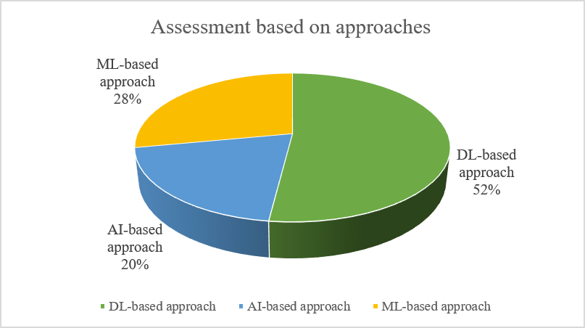
Fig. 3. Evaluation based on methodologies
  - Assessment in terms of tools
Fig. 4 presents the implementation tools analysis in terms of tool, like Python and MATLAB. Among the reviewed papers, 6 articles have used Python implementation, whereas only 3 papers used MATLAB. Therefore, MATLAB can be considered for applications such as simulation, prototyping, and model-based design, while Python is extensively applied for designing DL and ML techniques, including AI. In summary, Python is the most common tool used for predicting fetal abnormalities.
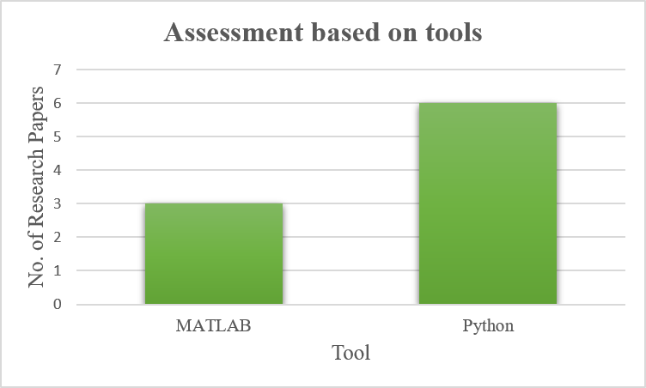
Fig. 4. Assessment in terms of tools
  - Assessment based on datasets
Fig. 5 demonstrates the distributions of the data sets employed in the reviewed literature, such as CHD data set, FETAL_PLANES_DB data set, fetal brain atlas, BCNatal data set, Real data set, clinical signal data set, Kaggle, and HC18data set. Among all these data sets, the most frequently applied data set is Real data set, which is used in eight articles. The reasons behind their popular usage include their large scale and high-quality annotations that make them fit for benchmarking and comparative evaluations in fetal abnormality classification.
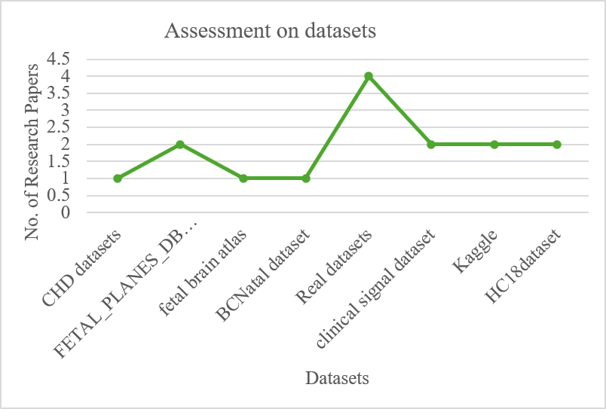
Fig. 5. Assessment with respect to datasets
  - Assessment based on publication year
A summary of the publication years of the studies included in this review is provided in Table I. Here, 2021, 2023, and 2024 were found to be the years with a large number of papers published regarding fetal abnormality classification with a count of 4. This shows that there has been an exponential increase in the development and advancement of this field in those particular years.
Table I. Assessment with respect to publication years
Publication years | Number of papers
2019 | 1
2020 | 3
2021 | 4
2022 | 3
2023 | 4
2024 | 4
2025 | 3
2026 | 3
  - Assessment based on metrics
Table II shows the analysis of the traditional methods' evaluation measures, such as accuracy, precision, recall, Dice Score, and F1 measure. Accuracy is one of the measures that appear most frequently among the reviewed papers and appears in twelve of them.
Table II. Assessment based on metrics
Evaluation Metrics | Papers
Accuracy | [6][7][14][18][15][11][24] [29][27] [28][31][26]
Precision | [15][11] [24][28]
Recall | [15][11] [24]
Dice Score | [15][11] [24] [30]
F1-score | [19] [12][22][23][30]
  - Assessment based on analytical measures
Table III depicts the number of research papers grouped according to their accuracy levels. The highest level of accuracy 95%-100% are attained by research papers [6], [15], [18], [24], [29], [28], and [26] denoting high levels of accuracy. Accuracy levels between 90%-95% are observed for research paper [7], [11], and [14]. Research papers [27] and [31] attain accuracy levels of 85%-90%, which denotes an average level of accuracy.
Table III: Analysis of analytical measures
Accuracy Range | Papers
85%-90% | [27][31]
90%-95% | [7][11][14]
95%-100% | [6][15][18][24][29][28][26]
- Conclusion
With the development of intelligent healthcare systems, there is a growing need for adaptive and intelligent approaches to detect fetal abnormalities. The early detection of any disease or abnormality during pregnancy plays an important role in providing improved care during pregnancy, and in turn improves the outcome of the mother and fetus. However, detection of such problems is quite difficult due to different reasons like position of fetus, quality of ultrasound images, and other complicated anatomical structure. This survey covers 25 academic articles related to fetal abnormality detection approaches. Firstly, it provides a basic framework for fetal brain abnormality classification approach. The chosen papers are classified as DL, ML, and AI. Major challenges considered in the selected paper are also highlighted. As the result of the analysis, the most prevalent approach to fetal abnormality classification is based on DL; the most common programming language for implementations is Python; most popular type of data sets for fetal abnormality detection is Real datasets; accuracy is still the most common measurement criteria for fetal abnormality detection; and many studies on the problem were conducted in 2021, 2023, and 2024. The future scope lies in the development of a hybrid optimization and DL model for effective fetal brain abnormality classification by considering the key findings of this analysis.
References
- H. R. Torres, P. Morais, B. Oliveira, C. Birdir, M. Rüdiger, J. C. Fonseca and J. L. Vilaça, "A review of image processing methods for fetal head and brain analysis in ultrasound images," Computer methods and programs in biomedicine, vol. 215, pp. 106629, 2022.
- B. Xie, H. Cai, J. Xian, T. Lei, L. Zhang and H. Xie, "Computer-aided diagnosis for fetal brain ultrasound images using deep convolutional neural networks," International journal of computer assisted radiology and surgery, vol. 15, pp. 1303-1312, 2020.
- T. L. Angtuaco, "Ultrasound imaging of fetal brain abnormalities: three essential anatomical levels," Ultrasound Quarterly, vol. 21, no. 4, pp. 287-294, 2005.
- K. Rasheed, F. Junejo, A. Malik and M. Saqib, "Automated fetal head classification and segmentation using ultrasound video," IEEE Access, vol. 9, 2021.
- S. Saria, A. Butte and A. Sheikh, "Better medicine through machine learning: what’s real, and what’s artificial," PLoS medicine, vol. 15, no. 12, pp. e1002721, 2018.
- M. . N. Rachmatullah, S. Nurmaini, A. . I. Sapitri, . A. Darmawahyuni, B. Tutuko and Firdaus, "Convolutional neural network for semantic segmentation of fetal echocardiography based on four-chamber view," Bulletin of Electrical Engineering and Informatics, vol. 10, no. 4, pp. 1987-1996, 2021.
- M. Priya and M. Nandhini, "Detection of fetal brain abnormalities using data augmentation and convolutional neural network in internet of things," Measurement: Sensors, vol. 28, pp. 100808, 2023.
- O. Attallah, M. A. Sharkas and H. Gadelkarim, "Fetal brain abnormality classification from MRI images of different gestational age," Brain sciences, vol. 9, no. 9, pp. 231, 2019.
- L. S. Hesse, F. Moser, M. C. Haak and A. . I. L. Namburete, "Subcortical segmentation of the fetal brain in 3D ultrasound using deep learning," NeuroImage, vol. 254, pp. 119117, 2022.
- W. A. Bastiaansena, M. Rousian, A. H. Koning, W. J. Niessen, S. Klein, R. . P. Steegers-Theunissen and B. S. d. Bakker, "The 4D Human Embryonic Brain Atlas: Spatiotemporal atlas generation for rapid anatomical changes," Computerized Medical Imaging and Graphics, pp. 102702, 2026.
- R. Qu, G. Xu, C. Ding, W. Jia and M. Sun, "Deep learning-based methodology for recognition of fetal brain standard scan planes in 2D ultrasound images," Ieee Access, vol. 8, pp. 44443-44451, 2019.
- V. Nagabotu and A. Namburu, "Precise segmentation of fetal head in ultrasound images using improved U‐Net model," ETRI Journal, vol. 46, no. 3, pp. 526-537, 2024.
- J. Gao, Q. Lao, P. Liu, Q. Kang, Z. Jiang, Y. Chen and L. Zhang, "Anatomically guided cross-domain repair and screening for ultrasound fetal biometry," IEEE Journal of Biomedical and Health Informatics, vol. 27, no. 10, pp. 4914-4925, 2023.
- E. Saraswathi, S. Kalaiarasi and A. S. Agnal, "Recognition and Classification of Fetal Brain Abnormalities," Turkish Journal of Computer and Mathematics Education, vol. 12, no. 9, pp. 534-2540, 2021.
- D. Vetriselvi and R. Thenmozhi, "MSAG_ENET Based Medical Image Augmentation and Classification of 2D-US Fetal Brain Anomalies," International Journal of Intelligent Engineering & Systems, vol. 17, no. 4, 2024.
- S. Nurmaini, N. Rachmatullah, A. I. Saptiri, F. Firdaus and A. Jovandy, "Accurate detection of septal defects with fetal ultrasonography images using deep learning-based multiclass instance segmentation," IEEE access, vol. 8, pp. 196160-196174, 2020.
- M. Komatsu, A. Sakai, R. Komatsu, R. Matsuoka, S. Yasutomi, K. Shozu, A. Dozen, H. Machino, H. Hidaka, T. Arakaki, K. Asada, S. Kaneko, A. Sekizawa and R. Hamamoto, "Detection of cardiac structural abnormalities in fetal ultrasound videos using deep learning," Applied Sciences, vol. 11, no. 1, pp. 371, 2021.
- M. K. Sarker, M. Alsharid, V. K. Singh, N. Hernandez-Cruz, A. T. Papageorghiou and . J. A. Noble, "COMFormer: Classification of maternal–fetal and brain anatomy using a residual cross-covariance attention guided transformer in ultrasound," IEEE Transactions on Ultrasonics, Ferroelectrics, and Frequency Control, vol. 70, no. 11, pp. 1417-1427, 2023.
- V. A. Chenarlogh, A. Shabanzadeh, M. G. Oghli, N. Sirjani, S. F. Moghadam, A. Akhavan, H. Arabi and M. K. Tarzamni, "Clinical target segmentation using a novel deep neural network: double attention Res-U-Net," Scientific Reports, vol. 12, no. 1, pp. 6717, 2022.
- M. Alzubaidi, U. Shah and M. Househ, "FetSAM: advanced segmentation techniques for fetal head biometrics in ultrasound imagery," IEEE Open Journal of Engineering in Medicine and Biology, vol. 5, no. 281-295, 2024.
- L. Sun, J. Yao, J. Yu, N. Sun, K. Chen, C. Ji, Y. Lin, J. Zhang, Z. Yang, Q. Pan, L. Yin and X. Deng, "A novel artificial intelligence model for measuring fetal intracranial markers during the first trimester based on two‐dimensional ultrasound image," nternational Journal of Gynecology & Obstetrics, vol. 167, no. 3, pp. 1090-1100, 2024.
- D. Bhargavi, K. Manikanta, K. Garg and M. Arora, "Prognosis of Anomaly Detection in Tiny Life using AI based Fetal Segmentation Approach," Procedia Computer Science, vol. 258, pp. 2107-2118, 2025.
- R. Singh, S. Gupta, H. G. Mohamed, S. Bharany, A. U. Rehman, Y. Y. Ghadi and S. Hussen, "Advancing prenatal healthcare by explainable AI enhanced fetal ultrasound image segmentation using U-Net++ with attention mechanisms," Scientific Reports, vol. 15, no. 1, pp. 19612, 2025.
- A. Doranalli, C. B, A. R. SR and M. HN, "AI-Driven Fetal Health Screening Using a Hybrid CNN–XGBoost Cascaded," 2026.
- R. Mei, Z. Yao and Q. Cai, "BMI-Stratification-Driven Optimization of NIPT Timing and Fetal Abnormality Determination," Highlights in Science, Engineering and Technology, vol. 162, pp. 485-495, 2026.
- E. Yalçın, T. K. Koç, S. Aslan, S. C. Demir, S. Aykut and M. Sucu, "Hyperparameter optimization based machine learning approach for early diagnosis of fetal genetic disorders," Discover Computing, vol. 28, no. 1, pp. 274, 2025.
- S. J. Sree and C. Vasanthanayaki, "Fetal ultrasound image segmentation using fuzzy connectedness algorithm," Advances in Mathematics: Scientific Journal, vol. 9, no. 10, pp. 8293-8301, 2020.
- D. Dash and M. Kumar, "n ensemble-based stage-prediction machine learning approach for classifying fetal disease," Healthcare analytics, vol. 5, pp. 100322, 2024.
- M. U. Nasir, K. O. Khalil, K. Ateeq, B. S. Almogadwy, M. A. Khan, M. H. Azam and K. M. Adnan, "Federated Machine Learning Based Fetal Health Prediction Empowered," Computers, Materials, & Continua, vol. 78, no. 3, pp. 3303, 2024.
- B. Xie, T. Lei, H. Cai, J. Xian, N. Wang, M. He, L. Zhang and H. Xie, "Computer-aided diagnosis for fetal brain ultrasound images using deep convolutional neural networks," International journal of computer assisted radiology and surgery, vol. 15, no. 8, pp. 1303-1312, 2020.
- B. Wu, P. Liu, H. Wu, S. Liu, S. He and G. Lv, "An effective machine-learning based feature extraction/recognition model for fetal heart defect detection from 2D ultrasonic imageries," Computer Modeling in Engineering & Sciences, vol. 134, no. 2, pp. 1069, 2023.

