Adaptive Trajectory Planning of an Omnidirectional Mobile Robot in a Dynamic Environment
Hani Attar
Faculty of Engineering, Zarqa University, Zarqa, Jordan / Faculty of Engineering University of Business and Technology, Jeddah, SA
hattar@zu.edu.jo

Amer Abu-Jassar
Department of Computer Science, College of Information Technology, Amman Arab University, Amman, Jordan
A.abujassar@aau.edu.jo
Mohammad Amin Bany Essa
Gigafactory Nevada, Sparks, Nevada, USA
mbanyessa@tesla.com

Mohamed Hafez
Faculty of Engineering FEQS, INTI-IU-University, Pathum Nilai, Malaysia / Faculty of Management, Shinawatra University, Thani, Thailand
mohdahmed.hafez@newinti.edu.my

Vladyslav Yevsieiev
Department CITARSE, Kharkiv National University of Radio Electronics, Kharkiv, Ukraine
vladyslav.yevsieiev@nure.ua

Vyacheslav Lyashenko
Department of Media Systems and Technology, Kharkiv National University of Radio Electronics, Kharkiv, Ukraine
viacheslav.liashenko@nure.ua

Abstract—The paper considers the problem of adaptive trajectory planning of an omnidirectional mobile robot in a dynamic environment. The proposed approach combines discrete global planning on a grid map with an obstacle inflation model, trajectory smoothing using the elastic band method, and kinematic tracking. The experiments confirmed the ability of the algorithm to effectively replan the path when obstacles appear and disappear without a complete recalculation of the route. The results obtained demonstrate high computational efficiency, smoothness of movement, and a significant safety margin. In particular, the minimum clearance along the final discrete path of 2.0 m demonstrates a significant safety margin with respect to obstacles. This meets the requirements of autonomous navigation within the framework of the Industry 5.0 concept, the development of modern technologies for the development of mobile robots.
Index Terms—adaptive planning, dynamic environment, Industry 5.0., modern technologies, mobile robot

Introduction
Adaptive planning of robot movement in a dynamic environment is one of the key tasks in the development of modern robotic complexes and systems [1, 2]. However, classical global planning algorithms require a complete recalculation of the route when the map changes. This reduces the speed and stability of real-time navigation. In this context, D-star Lite (D*Lite) is a promising approach [3-7], since it provides an update of the optimal path based on local changes, minimizing the amount of repeated calculations. Here it is also advisable to apply various methods and approaches of modern robotics and technologies [-]. At the same time, it is the combination of D*Lite with various robot movement models that allows us to form optimal trajectories. Such trajectories are not only geometrically correct on a discrete map, but also suitable for execution taking into account speed and control constraints.
Therefore, the development and research of adaptive trajectory planning for an omnidirectional mobile robot based on D*Lite is a relevant direction. It is also being identified by other researchers.
For example, L. Liu, M. Sun, E. Zhao, and K. Zhu consider three-dimensional dynamic trajectory planning based on the combination of Proximal Policy Optimization (PPO) learning with the Improved Interfered Fluid Dynamic System (IIFDS) field-like model [8]. This approach makes it possible to obtain 3D trajectories taking into account dynamic factors of the underwater environment and increase adaptability due to the Reinforcement Learning (RL) component. However, this approach is difficult to use directly, since it is focused on 3D movement in water and requires a separate learning policy (PPO) with other dynamics models and constraints.
In the study [9], the route construction for a mobile robot using Bidirectional Rapidly-exploring Random Tree (BRRT) and hybridization with A-star (A*) (H-BRRT) was analyzed. However, in a dynamic environment, this method is less suitable as a baseline, because BRRT/A* usually requires more significant recalculation when updating route maps. Along with this, D*Lite incrementally recalculates only “locally affected” areas, which is critical when obstacles change frequently.
In the paper by Y. Hu, M. Sang and H. Duan, torque and jerk constrained trajectory planning based on polynomial profiles and adaptive iteration [10] is proposed. However, this approach cannot be used for mobile platform navigation in a grid map because it focuses on temporal parameterization and dynamic constraints.
In the paper by H. Li, H. Pang, H. Xia, Y. Huang and X. Zeng, trajectory planning in dynamic scenarios based on Bézier curves with formalization through control points [11] is investigated. However, the D*Lite formulation provides guaranteed connectivity and replanning on a discrete map when obstacles change. But the Bézier approach without an additional discrete search/collision checking mechanism may lose its traversability guarantees in dense environments.
In the study of O. Zhang, Z. Liu, X. Shao, W. Yao, L. Wu, and J. Liu, a learning-based trajectory planning framework with pre-planning and post-processing stages for working under uncertainty conditions is proposed [12]. However, for a mobile platform on a plane (omnidirectional or tracked), this approach is practically not directly transferable, since the physics of the system, the state space and control objectives (base drift, free-floating dynamics) are different.
In the work [13], a trajectory planning algorithm for UAVs based on an adaptive potential field with reinforcement through multi-agent reinforcement learning is considered. However, for the D*Lite task on a lattice, this approach is not a direct replacement, because potential fields, even with “adaptation”, often require special tuning and do not guarantee optimality.
In the study [14], a hybrid algorithm for orchard robots based on improved D*Lite for narrow passages and dense obstacles is considered. This solution is the closest in ideology, but it cannot be transferred “one-to-one” to a tracked platform without adaptation.
In the work of T. Chen, Y. Lan, Y. Li, , J. Zhang and Y. Yin, Y a hybrid D*Lite with Transformer-enhanced Soft Actor-Critic is defined for International Regulations for Preventing Collisions at Sea (COLREGs)-compliant autonomous navigation in a dynamic marine environment [15]. However, this approach is difficult to use as a baseline, in particular for an omnidirectional mobile robot, due to the need to train the RL agent and the specific rules and interaction models.
In the study [16], an efficient online controller tuning for an omnidirectional mobile robot was developed based on a surrogate multi-output polynomial predictor and evolutionary optimization. However, it does not replace D*Lite, because it does not solve the other part of the problem - control auto-tuning and controller tuning.
In the article by E. Villalba-Aguilera, J. Blesa and P. Ponsa, the capabilities of Model Predictive Control (MPC) for controlling position and orientation tracking in a multilayer architecture for a three-wheeled omnidirectional robot are analyzed [17]. However, this solution is not a direct planner, since MPC plays the role of low-level or mid-level trajectory execution control.
Thus, modern publications are intensively developing trajectory planning of mobile robots. Therefore, against this background, the study of adaptive planning, in particular, for an omnidirectional robot based on D*Lite is quite appropriate. That is, such research closes the practical niche of fast, reproducible and incremental replanning on discrete maps with formal accounting for inflation and the possibility of integration with smoothing and tracking. This also creates a clear foundation for further adaptation to other platforms, including on omnidirectional wheels. Therefore, it is more appropriate to consider the appropriate mathematical formalization of the proposed mobile robot planning.

Mathematical Description Of The Proposed Approach
First of all, we note that a feature of omnidirectional wheels is the presence of auxiliary rollers or a special geometry of contact with the surface [18, 19]. Therefore, the use of omnidirectional wheels significantly increases the maneuverability of mobile robots, simplifies the implementation of precise positioning and ensures a smoother and more efficient execution of complex trajectories.
However, to describe the proposed approach, it is necessary to formalize the discretization of the mobile robot environment. That is, it is necessary to transform the continuous space into a state grid, on which D*Lite will work in the form of a trajectory search in the graph:
$G=\left(V,E\right)$ , $V=\{(i,j)\}$ , $E=\{\left(s,\acute{s}\right):\acute{s}∈Nrb(s)$}, | (1)
$x=x_{min}+(i+\frac{1}{2})∆$ , $y=y_{min}+(j+\frac{1}{2})∆$, | (1)
where: $G$ – the graph of the discretized environment of the mobile robot in the form of vertices and edges; $V$ – the set of vertices of the graph corresponding to the cells of the grid map; $i,j$ – integer indices of the cells along the axes of the grid; $s=(i,j)$ – the discrete state of the robot, which specifies its position within the grid map; $E$ – the set of edges of the graph, which determines the permissible transitions between neighboring cells; $Nrb(s)$ – the set of neighboring states of the cell $s$, available for direct transition according to the selected connectivity (4- or 8-connected); $x$ – the coordinate of the cell center in physical space along the $X$ axis; $y$ – the coordinate of the cell center in physical space along the $Y$ axis; $x_{min}$ – the minimum value of the $x$ coordinate, which determines the origin of the map in the global coordinate system; $y_{min}$ – the minimum value of the $Y$ coordinate; $∆$ – the spatial discretization step or the size of one cell of the grid map, which determines the resolution of the environment model.
At the same time, the following model of obstacles on the robot’s path and “inflation” is proposed. Obstacle inflation is a procedure for artificially expanding the geometric boundaries of obstacles on the environment map in order to take into account the dimensions of the mobile robot, its kinematic limitations, and localization errors during trajectory planning [20, 21]. In the inflation process, each obstacle is increased by an amount corresponding to the effective radius of the robot and an additional safety margin. As a result, the robot in the model is considered as a point, but with a guaranteed safe distance from objects:
$O_{infl}=\{s:∃o∈O and d(s,o)≤r_{infl}\}$, | (2)
$r_{infl}=r_{robot}+r_{margin}$, | (2)
where: $O_{infl}$ – set of inflated obstacles; $s$ – grid map cell for which membership in the inflated obstacle is checked; $o∈O$ – element of the obstacle set corresponding to an occupied cell or object in the environment; $O$ – set of initial (non-inflated) obstacles obtained from the environment map or sensor data; $d(s,o)$ – distance metric between cell $s$ and obstacle $o$, which is used to determine the safe zone around obstacles; $r_{infl}$ – obstacle inflation radius, which determines the minimum allowable distance between the robot and the obstacle; $r_{robot}$ – effective radius of the mobile robot, which approximates its dimensions in the plane of motion; $r_{margin}$ – additional safety margin, which takes into account localization errors, sensor inaccuracies, and motion dynamics.
The cost of transition between cells, that is, “how much does it cost” to move between neighboring states, is defined as:
$$c\left(s,\acute{s}\right)=\left\{\begin{matrix}∞, \acute{s}∈O_{infl} \\ w∙{\left|\left|p\left(\acute{s}\right)-p\left(s\right)\right|\right|}_{2}, other\end{matrix}\right.$$ | (3)
where: $c\left(s,\acute{s}\right)$ – the cost of the mobile robot’s transition from state $s$ to the neighboring state $\acute{s}$; $s$ – the current discrete state (cell) of the grid map from which the transition is made; $\acute{s}$ – the target discrete state (neighboring cell) to which the transition is made; $∞$ – the infinitely large transition cost, which is used to prohibit movement through inflated obstacles; $O_{infl}$ – the set of inflated obstacles, hitting which makes the transition inadmissible; $w$ – the weight coefficient that scales the real geometric distance between cells and allows taking into account movement priorities; $p\left(s\right)$ – the vector of coordinates of the center of cell $s$ in physical space; $p\left(\acute{s}\right)$ – the vector of coordinates of the center of cell $\acute{s}$ in physical space; ${||∙||}_{2}$ – the Euclidean distance between the centers of two neighboring cells, which determines the basic geometric “cost” of movement.
To speed up the process of finding the optimal trajectory, it is suggested to use the Heuristic function in D*Lite:
$$h\left(s,s_{start}\right)={||p\left(s\right)-p(s_{start})||}_{2},$$ | (4)
where: $h\left(s,s_{start}\right)$ – heuristic function that estimates the approximate cost of movement; $s_{start}$ – current starting state, corresponding to the current position of the mobile robot on the map; $p(s_{start})$ – vector of coordinates of the center of the cell of the starting state in physical space.
The model of the main variables $g$ and $rhs$ in the D*Lite algorithm has the following form:
$$rhs\left(s\right)=\left\{\begin{matrix}0, s=s_{goal} \\ \min_{\acute{s∈Succ(s)}}\left(g\left(\acute{s}\right)+c\left(s,\acute{s}\right)\right),other\end{matrix}\right.$$ | (5)
$$g\left(s\right)≈current best estimate of value to s_{goal}$$ | (5)
where: $rhs\left(s\right)$ – one-step agreed estimate of the cost of the path from state $s$ to the goal state; $s$ – a discrete state of the lattice map for which the values of $rhs$ and $g$ are calculated; $s_{goal}$ – the goal state corresponding to the endpoint of the mobile robot’s movement; $Succ(s)$ – the set of subsequent (neighboring) states to which a direct transition from state $s$ is possible; $\acute{s}$– one of the neighboring states from the set $Succ(s)$, which is considered during cost minimization; $g\left(\acute{s}\right)$ – the current best known estimate of the cost of the path from state $\acute{s}$ to the goal state $s_{goal}$; $g\left(s\right)$ – the current estimate of the optimal cost of the path from state $s$ to the goal state $s_{goal}$; $rhs\left(s\right)=0$ at $s=s_{goal}$ – boundary condition that sets the zero cost of achieving the goal.
To efficiently calculate and quickly adapt the trajectory of a mobile robot to changes in the dynamic environment, a priority key of the Open type is introduced in the D*Lite algorithm. Open is a priority queue that stores inconsistent states with the corresponding keys that require updating the values of $rhs$ and $g$:
$k\left(s\right)=[\min\left(g\left(s\right),rhs\left(s\right))+h\left(s,s_{start}\right)+{+k}_{m},\min\left(g\left(s\right),rhs\left(s\right)\right)\right],$ | (6)
where: $k\left(s\right)$ – priority key of state $s$; $g\left(s\right)$ – current estimate of the best known cost of the path from state $s$ to the target state; $rhs\left(s\right)$ – one-step agreed cost estimate of the path from state $s$ to the target; $min⁡(g\left(s\right),rhs\left(s\right))$ – basic cost estimate of the state; $h\left(s,s_{start}\right)$ – heuristic estimate of the distance between state $s$ and the current starting state of the robot; $k_{m}$ – key shift parameter, which accumulates changes in the position of the starting state and ensures the correctness of priorities during robot movement; $[∙,∙]$ – two-component key vector: the first component of which corresponds to the global priority taking into account the heuristics, and the second – to specify the processing order with equal values of the first component.
Then the vertex update operation has the following form:
$$if s≠s_{goal}:rhs\left(s\right)=\min_{\acute{s∈Succ\left(s\right)}}{(g\left(\acute{s}\right)+c(s,\acute{s})},$$ | (7)
and is determined by the following options:
$if g(s)≠rhs(s)→s$ must be in OPEN with key $k\left(s\right),$
$if g(s)=rhs(s)→s$ is removed from OPEN (if any).
To ensure correct and effective replanning of the omnidirectional mobile robot's path when obstacles change, we introduce the concept of the main agreement cycle – this is the reduction of the values of $g$ and $rhs$ of all relevant states to the agreed state. Here the found trajectory is optimal relative to the current environment map:
$$while\left(topKey\left(OPEN\right)<k\left(s_{start}\right)\right)$$  $$or \left(rhs\left(s_{start}\right)≠g\left(s_{start}\right)\right),$$ | (8)
where: $topKey\left(OPEN\right)$ – the minimum lexicographically ordered priority key among all states in the OPEN queue; $k\left(s_{start}\right)$ – the priority key of the current starting state of the robot; $g(s_{start})$ – the current estimate of the best known cost of the path from the starting state to the target state.
In order to take into account new obstacles or cell release without recalculating “from scratch”, the following event model is used:
$c_{new}\left(s,\acute{s}\right)←c_{old}\left(s,\acute{s}\right)+∆c(s,\acute{s})$, | (9)
where for each edge, the change in cost is calculated as follows:
$UpdateVertex(s)$ and/or $UpdateVertex(\acute{s})$,
where: $c_{new}\left(s,\acute{s}\right)$ – updated transition cost; $c_{old}\left(s,\acute{s}\right)$ – previous transition cost value; $∆c(s,\acute{s})$ – increase or decrease transition cost; $UpdateVertex(s)$ – local update operation of state $s$; $UpdateVertex(\acute{s})$ – similar update procedure for neighboring state $\acute{s}$.
The discrete path extraction model from $g$ – field is necessary for converting the results of the D*Lite algorithm and has the following form:
$$s_{k+1}=arg\min_{\acute{s∈Succ(s_{k})}}{(g\left(\acute{s}\right)+c(s_{k},\acute{s}))},$$ | (10)
where: $s_{k+1}$ is the next discrete state of the trajectory, which is chosen as the optimal movement step; $c(s_{k},\acute{s})$ is the cost of the transition between the current and neighboring states. It takes into account the geometric distance and the presence of obstacles.
To smooth the trajectory of the robot route, it is proposed to use the “elastic band” method [22]. According to which the path is modeled as a set of connected points between which imaginary elastic forces act. In such a model, the first component of the cost function seeks to reduce the length of the trajectory, and the second component seeks to reduce sharp bends and oscillations, ensuring smooth movement:
$J=\sum_{k=1}^{N-1}{{||p_{k+1}-p_{k}||}^{2}+λ\sum_{k=2}^{N-1}{{||p_{k+1}-2p_{k}+{+p}_{k-1}||}^{2},}}$ | (11)
where: $J$ is the objective function of trajectory smoothing; $k$ is the index of a discrete point of the trajectory, which determines its position in the sequence of points; $N$ is the total number of discrete points of the trajectory; $p_{k}$ is the vector of coordinates of the $k$-th point of the trajectory in the physical space $(x_{k},y_{k})$; ${||p_{k+1}-p_{k}||}^{2}$ is the square of the Euclidean distance between neighboring points of the trajectory; ${||p_{k+1}-2p_{k}+p_{k-1}||}^{2}$ is the square of the second difference of coordinates, which approximates the local curvature of the trajectory and penalizes sharp bends; $λ$ is the smoothing coefficient, which determines the relative weight of the smoothness of the trajectory compared to its length.
Along with this, the kinematic model of the omnidirectional robot is described as follows:
– state model:
$$x={[x,y,θ]}^{T},$$ | (12)
– discrete motion model:
$$x_{k+1}=\left[\begin{matrix}x_{k} \\ y_{k} \\ θ_{k}\end{matrix}\right]+∆t\left[\begin{matrix}v_{x}cosθ_{k}-v_{y}sinθ_{k} \\ v_{x}sinθ_{k}+v_{y}cosθ_{k} \\ w\end{matrix}\right],$$ | (13)
where: $x$ – state vector of the mobile robot; $x$ – coordinate of the robot position along the $x$ axis; $y$ – coordinate of the robot position along the $y$ axis; $θ$ – orientation angle of the mobile robot; $x_{k+1}$ – state vector of the mobile robot at the next discrete step; $x_{k}={[x_{k},y_{k},θ_{k}]}^{T}$ – state vector of the robot at the current discrete step $k$; $k$ – index of the discrete time step; $∆t$ – time discretization step; $v_{x}$ – linear speed of the robot along the $x$ axis; $v_{y}$ – linear speed of the robot along the $y$ axis; $w$ – angular velocity of rotation of the robot around the vertical axis; $cosθ_{k}$, $sinθ_{k}$ – trigonometric functions that provide the conversion of linear speeds from the robot coordinate system to the global coordinate system.
The model of constraints on robot control has the following form:
$|v_{x}|≤v_{x,max}$, $\left|v_{y}\right|≤v_{y,max}$, $|w|≤w_{max}$, | (14)
which transforms into a series of acceleration constraints:
$|v_{x}^{k}-v_{x}^{k-1}|≤a_{x,max}∆t$, | (15)
$|v_{y}^{k}-v_{y}^{k-1}|≤a_{y,max}∆t$, | (15)
$|w^{k}-w^{k-1}|≤α_{max}∆t$, | (15)
where: $v_{x,max}$, $v_{y,max}$ – maximum linear speeds; $w_{max}$ – maximum angular velocity; $a_{x,max}$, $a_{y,max}$ – maximum linear accelerations; $α_{max}$ – maximum angular acceleration.
At the same time, the model of the transformation of “trajectory point” → velocity command in the system $(v_{x},v_{y},w)$ is defined as follows:
– positional error model:
$e_{x}=x^{*}-x$, $e_{y}=y^{*}-y,$ | (16)
where: $e_{x}$ – position error along the $x$ axis; $e_{y}$ – position error along the $y$ axis; $x^{*}$, $y^{*}$ – coordinates of the target point of the trajectory,
– model of error conversion into linear speeds and rotation matrix $R\left(Θ\right)$:
$\left[\begin{matrix}v_{x} \\ v_{y}\end{matrix}\right]={R(Θ)}^{T}\left[\begin{matrix}k_{p}e_{x} \\ k_{p}e_{y}\end{matrix}\right]$ , $R\left(Θ\right)=\left[\begin{matrix}cosθ & -sinθ \\ sinθ & cosθ\end{matrix}\right],$ | (17)
where: $\left[\begin{matrix}v_{x} \\ v_{y}\end{matrix}\right]$ – vector of linear speeds of the robot; $k_{p}$ – gain coefficient of the proportional position controller; ${R(Θ)}^{T}$ – transposed rotation matrix,
– angular control model $w$, which is designed to stabilize the orientation of the robot relative to the desired direction of movement:
$$w=k_{θ}∙wrap\left(θ^{*}-θ\right),$$ | (18)
where: $w$ – angular speed of rotation of the robot; $k_{θ}$ – gain coefficient of the orientation controller; $θ^{*}$ – desired value of the robot orientation; $wrap(θ^{*}-θ)$ – function of reducing the angular error to the interval $[-π,π]$, which ensures correct and continuous operation of the angular controller.
Taken together, the above models (16-18) provide simple, stable and effective tracking of a smoothed trajectory.
Thus, the developed numerical modeling method based on the D*Lite algorithm provides effective and incremental replanning of mobile robot trajectories in a dynamic environment without the need for a complete route recalculation. This significantly reduces computational costs. At the same time, the combination of D*Lite with omnidirectional motion models allows the formation of maneuvering and smooth trajectories.

Experimental Research and Analysis of the Obtained Results
The purpose of the experiment is to verify the performance and adaptability of the D*Lite algorithm for planning the trajectory of an omnidirectional mobile robot in a dynamic lattice environment. The input data is a configuration of a lattice map with a size of $80×50$ cells with a sampling step of $δ=0.2$m and the origin of the coordinates $x_{min}=0.0$, $y_{min}=0.0$. In this case, 8-connectivity of neighbors is used. The environment is formed as a “slalom corridor” with internal and external obstacles. The robot parameters are given by the radius $r_{robot}=0.25$m and the safety margin $r_{margin}=0.10$ m The inflation radius is $r_{infl}=0.35$m. This defines the forbidden area for planning and controlling the robot’s position. For kinematic tracking, the speed limits $v_{max}=0.85$m\s and $w_{max}=2.2$ rad\s and the controller coefficients $k_{p}=1.15$ and $k_{θ}=2.2$ are used. The discrete integration time is $dt=0.05$ s. with a maximum simulation time of 80 s. In the D*Lite planner, the cost weight factor $w_{cost}=1.0$ is used and dynamic obstacle change events occur at times $t=\{18.0,34.0,52.0\}$. To smooth the discrete path, an “elastic band” with parameters $iters=140$, $λ=0.28$ and $step=0.14$ is used. To follow the smoothed trajectory, $lookahead=0.7$m is used. This allows us to obtain a smooth continuous trajectory and display it on the map together with the inflation zone.
Hardware and software for the experiment: Microsoft Surface Pro 9 with CPU Intel Core i7-1255U, RAM 32 GB LPDDR5, GPU Intel Iris Xe, OS Windows 11, programming language Python. Development environment PyCharm 2025.3.1.1.
The results of the numerical simulation are presented in Fig. 1-4.
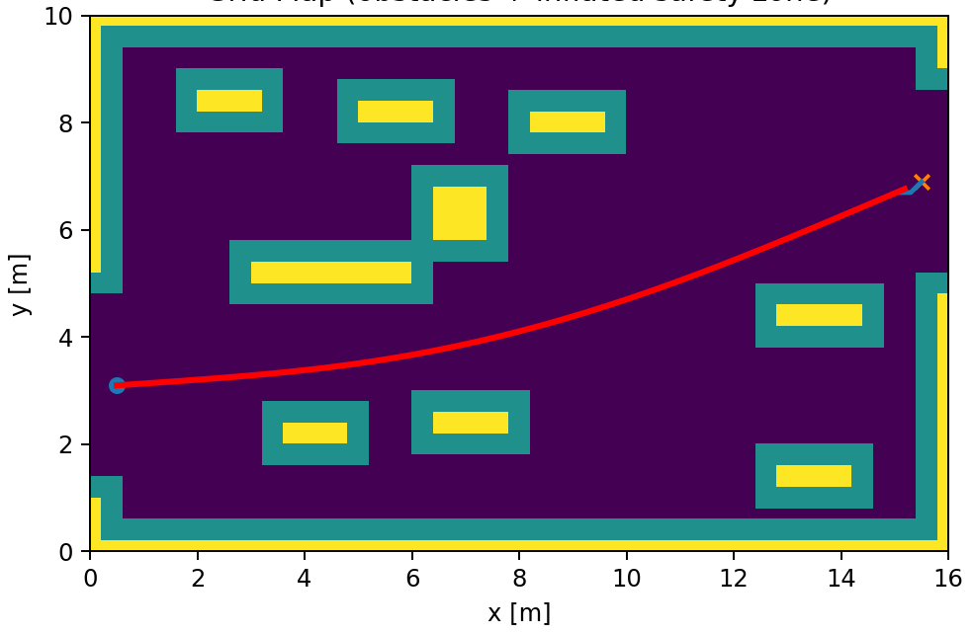
Fig. 1. Grid Map (obstacles + inflated safety zone)

The Grid Map (obstacles + inflated safety zone) graph (Fig. 1) shows that the robot successfully follows a continuous trajectory (red curve) from the start at approximately the point $x≈0.5$, $y≈3.1$ to the target $x≈15.6$, $y≈6.9$. The trajectory is smoothed and monotonically increases in y. This indicates a correct combination of D*Lite global planning and subsequent tracking without “stepped” transitions between cells. During the movement, the curve passes through the central free corridor and does not demonstrate dangerous approaches to inflated zones. It is also clear that the trajectory does not touch the inflated map boundaries along the perimeter. So, the environmental restrictions are taken into account correctly and the path remains permissible.
The Robot Trajectory (continuous, meters) graph (Fig. 2) shows that the continuous trajectory begins approximately at the point $x≈0.6$, $y≈3.1$ and ends in the region $x≈15.5$, $y≈6.9$. This corresponds to reaching the target position. The curve is smooth, without kinks and sharp changes in direction. The monotonic increase in the y coordinate and the gradual increase in curvature in the final section indicate adaptive correction of the movement when bypassing obstacles without stops or oscillations. In general, the trajectory is kinematically correct and suitable for real execution, taking into account speed restrictions.
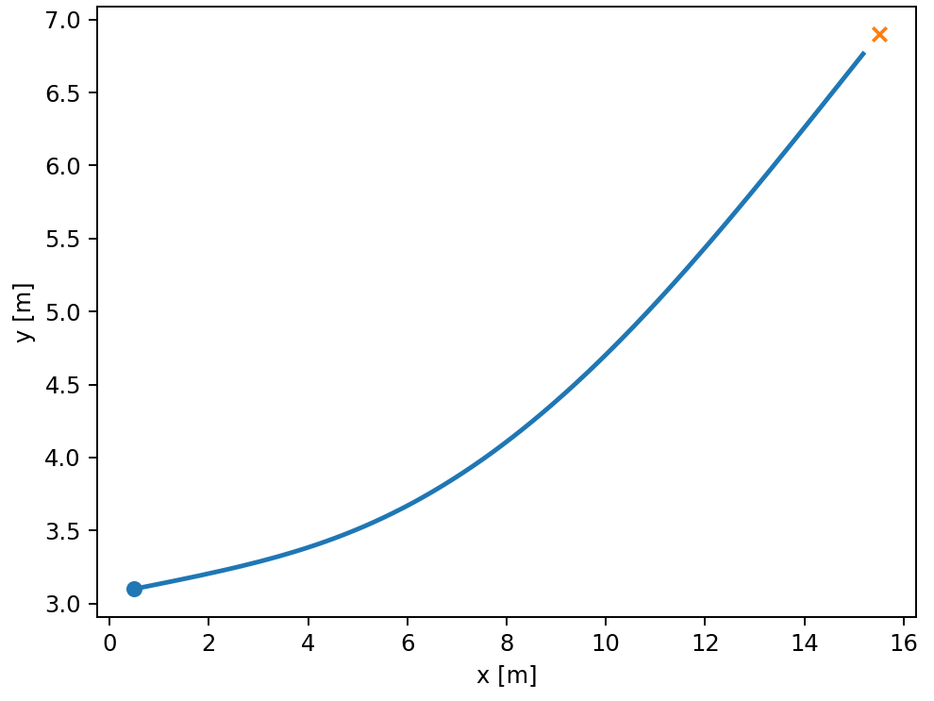
Fig. 2. Robot Trajectory (continuous, meters)

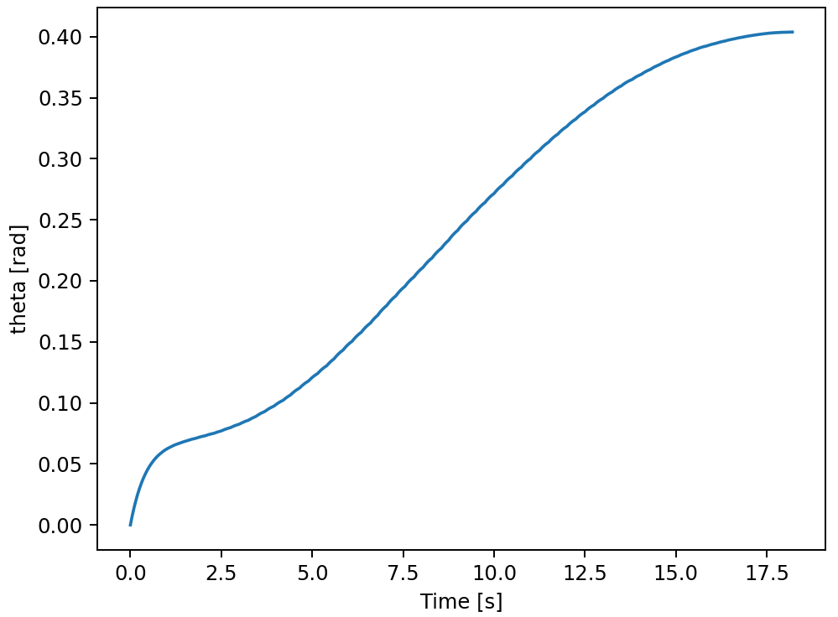
Fig. 3. Heading Angle Over Time
The Heading Angle Over Time graph (Fig. 3) shows that the orientation angle $θ$ smoothly changes from a value close to 0 rad to approximately 0.40 rad over a time of about 18 s, without jumps or sharp fluctuations. The initial rapid adaptation of the angle in the first seconds indicates a correction of the direction of movement after the start. The subsequent almost monotonic growth of the curve reflects a consistent following of the curvilinear trajectory. The absence of oscillations confirms the stability of the angle controller and the correct choice of the coefficient $k_{θ}$. In general, the dynamics of $θ(t)$ is kinematically smooth and corresponds to the safe and energy-efficient movement of an omnidirectional mobile robot.
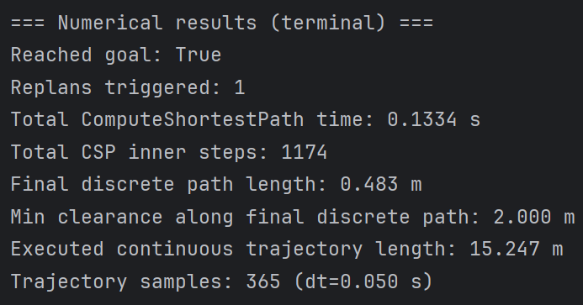
Fig. 4. Results of the calculation of the numerical simulation
The results presented in Fig. 4 indicate the successful achievement of the target point. This confirms the correctness of the trajectory construction and the operation of the D*Lite algorithm in a dynamic environment. The ComputeShortestPath calculation time of 0.1334 s. at 1174 internal CSP steps indicates high computational efficiency of incremental replanning. The minimum clearance along the final discrete path of 2.0 m demonstrates a significant safety margin with respect to obstacles. The length of the executed continuous trajectory of 15.247 m reflects realistic, smoothed movement in space. The number of trajectory samples of 365 at a step $dt=0.05$ s confirms sufficient time resolution of the simulation for analyzing the dynamics of the robot's movement.

Conclusion
The paper develops and investigates an adaptive method for planning trajectories of an omnidirectional mobile robot. This approach combines the incremental D*Lite algorithm with models of obstacle inflation, trajectory smoothing, and kinematic tracking. The simulation results showed that the proposed approach provides guaranteed goal achievement with a high safety margin. At the same time, computational costs remain low due to local replanning without complete path recalculation. The use of omnidirectional wheels and a holonomic motion model made it possible to form smooth, maneuvering trajectories. The application of the “elastic band” method significantly improved the quality of the trajectory, eliminating the kinks of the discrete path and ensuring stable operation of the speed and orientation controllers. The results obtained indicate that the proposed approach can be effectively used in autonomous navigation tasks and meets the safety and adaptability requirements characteristic of the Industry 5.0 concept.

References
- E. Stracca, G. Grioli, L. Pallottino, and P. Salaris, “Risk-Aware Routing for a Robot in a Shared Dynamic Environment,” IEEE Transactions on Robotics, vol. 42, pp. 1048-1067, 2026. doi: 10.1109/TRO.2026.3658295.
- Y. M. Al-Sharo, A. T. Abu-Jassar, S. Sotnik, and V. Lyashenko, “Generalized procedure for determining the collision-free trajectory for a robotic arm,” Tikrit Journal of Engineering Sciences, vol. 30, no. 2, pp. 142-151, 2023. doi: 10.25130/tjes.30.2.15.
- H. Sukri, and et al., “Enhanced Precision Control of a 4-DOF Robotic Arm Using Numerical Code Recognition for Automated Object Handling,” Journal of Robotics and Control (JRC), vol. 6, no. 1, pp. 315-335, 2025. doi: 10.18196/jrc.v6i1.24349.
- A. T. Abu-Jassar, Y. M. Al-Sharo, V. Lyashenko, and S. Sotnik, “Some Features of Classifiers Implementation for Object Recognition in Specialized Computer systems,” TEM Journal: Technology, Education, Management, Informatics, vol. 10, no. 4, pp. 1645-1654, 2021. doi: 10.18421/TEM104-21.
- A. T. Abu-Jassar, H. Attar, A. Amer, V. Lyashenko, V. Yevsieiev, and A. Solyman, “Development and investigation of vision system for a small-sized mobile humanoid robot in a smart environment,” International Journal of Crowd Science, vol. 9, no. (1), pp. 29-43, 2025. doi: 10.26599/IJCS.2023.9100018.
- J. H. Baker, F. Laariedh, M. A. Ahmad, V. Lyashenko, S. Sotnik, and S. K. Mustafa, “Some interesting features of semantic model in Robotic Science,” SSRG International Journal of Engineering Trends and Technology, vol. 69, no. 7, pp. 38-44, 2021. doi: 10.14445/22315381/IJETT-V69I7P205.
- A. T. Abu-Jassar, H. Attar, A. Amer, V. Lyashenko, V. Yevsieiev, and A. Solyman, “Remote monitoring system of patient status in social IoT environments using amazon web services technologies and smart health care,” International Journal of Crowd Science, vol. 9, no. 2, pp. 110-125, 2025. doi: 10.26599/IJCS.2023.9100019.
L. Liu, M. Sun, E. Zhao, and K. Zhu, “Three-Dimensional Dynamic Trajectory Planning for Autonomous Underwater Robots Under the PPO-IIFDS Framework,” Journal of Marine Science and Engineering, vol. 13, no. 3, ID 445, 2025. doi: 10.3390/jmse13030445.
- A. Abu-Jassar, H. Al-Sukhni, Y. Al-Sharo, S. Maksymova, V. Yevsieiev, and V. Lyashenko, “Building a Route for a Mobile Robot Based on the BRRT and A*(H-BRRT) Algorithms for the Effective Development of Technological Innovations,” International Journal of Engineering Trends and Technology (IJETT), vol. 72, no. 11, pp. 294-306, 2024. doi: 10.14445/22315381/IJETT-V72I11P129.
Y. Hu, M. Sang, and H. Duan, “A novel trajectory planning approach with torque and jerk constraints based on polynomial interpolation profile and adaptive iteration,” CIRP Journal of Manufacturing Science and Technology, vol. 60, pp. 277-295, 2025. doi: 10.1016/j.cirpj.2025.05.009.
H. Li, H. Pang, H. Xia, Y. Huang, and X. Zeng, “Research on Trajectory Planning Method Based on Bézier Curves for Dynamic Scenarios,” Electronics, vol. 14, no. (3), ID 494, 2025. doi: 10.3390/electronics14030494.
O. Zhang, Z. Liu, X. Shao, W. Yao, L. Wu, and J. Liu, “Learning-based task space trajectory planning frame-work with pre-planning and post-processing for uncertain free-floating space robots,” IEEE Transactions on Aerospace and Electronic Systems, vol. 61, no. 3, pp. 6325-6338, 2025. doi: 10.1109/TAES.2025.3527428.
M. Shao, X. Liu, C. Xiao, T. Zhang, and H. Yuan, “Research on UAV Trajectory Planning Algorithm Based on Adaptive Potential Field,” Drones, vol. 9, no. 2, ID 79, 2025. doi: 10.3390/drones9020079.
Q. Jiang, Y. Shen, H. Liu, Z. Khan, H. Sun, and Y. Huang, “A Hybrid Path Planning Algorithm for Orchard Robots Based on an Improved D*Lite Algorithm,” Agriculture, vol. 15, no. 15, ID 1698, 2025. doi: 10.3390/agriculture15151698.
T. Chen, Y. Lan, Y. Li, J. Zhang, and Y. Yin, Y. (2025). “D*Lite and Transformer-Enhanced SAC: A Hybrid Reinforcement Learning Framework for COLREGs-Compliant Autonomous Navigation in Dynamic Maritime Environments,” Journal of Marine Science and Engineering, vol. 13, no. 8, ID 1498. doi: 10.3390/jmse13081498.
A. G. Rojas-López, M. G. Villarreal-Cervantes, A. Rodríguez-Molina, and J. A. Paredes-Ballesteros, “Efficient Online Controller Tuning for Omnidirectional Mobile Robots Using a Multivariate-Multitarget Polynomial Prediction Model and Evolutionary Optimization,” Biomimetics, vol. 10, no. 2, ID 114, 2025. doi: 10.3390/biomimetics10020114.
E. Villalba-Aguilera, J. Blesa, and P. Ponsa, “Model-based predictive control for position and orientation tracking in a multilayer architecture for a three-wheeled omnidirectional mobile robot,” Robotics, vol. 14, no. 6, ID 72, 2025. doi: 10.3390/robotics14060072.
- P. Pinkham, and M. Parnichkun, “Development and Balancing Control of a Unicycle Robot Using Omnidirectional Wheel,” International Journal of Mechanical Engineering and Robotics Research, vol. 15, no. 3, pp. 260-269, 2026. doi: 10.18178/ijmerr.15.3.260-269.
- M. Jalalnezhad, and S. Spanogianopoulos, Deep multilayer neural framework for dynamic slip mitigation in omnidirectional mobile robots. Journal of Vibration Engineering & Technologies, vol. 14, ID 124, 2026. doi: 10.1007/s42417-025-02269-8.
- Z. Liang, L. Wang, H. Wang, B. Zhang, and C. Liu, “Autonomous obstacle avoidance and path planning for mobile robots in orchard environments combining with map construction and positioning methods,” Computers and Electronics in Agriculture, vol. 244, ID 111514, 2026. doi: 10.1016/j.compag.2026.111514.
- Z. Chen, H. Dou, C Zhai, Z. Wang, Y. Gao, and X. Wang, “Autonomous centerline and point-to-point navigation control method based on multi-sensor fusion in degraded orchards environments,” Computers and Electronics in Agriculture, vol. 244, ID 111466, 2026. doi: 10.1016/j.compag.2026.111466.
- Z. Wan, X. Wang, J. Han, and C. Yang, “Path planning for Ackermann-steered robots based on bidirectional A* and timed elastic band algorithms,” Robotica, pp. 1-26, 2026. doi: 10.1017/S0263574726103440.

