Shared Use of CPU/GPU/NPU/FPGA Resources of the EDGE Platform for SLAM, Detection and Control of a Mobile Robot
Mohammad Hamdan
Department of Computer Science, College of Information Technology, Amman Arab University, Amman, Jordan
m.hamdan@aau.edu.jo

Vyacheslav Lyashenko
Department of Media Systems and Technology, Kharkiv National University of Radio Electronics, Kharkiv, Ukraine
viacheslav.liashenko@nure.ua

Amer Abu-Jassar
Department of Computer Science, College of Information Technology, Amman Arab University, Amman, Jordan
A.abujassar@aau.edu.jo

Hani Attar
Faculty of Engineering, Zarqa University, Zarqa, Jordan / Faculty of Engineering University of Business and Technology, Jeddah, SA
hattar@zu.edu.jo

Vladyslav Yevsieiev
Department CITARSE, Kharkiv National University of Radio Electronics, Kharkiv, Ukraine
vladyslav.yevsieiev@nure.ua

Mohamed Hafez
Faculty of Engineering FEQS, INTI-IU-University, Pathum Nilai, Malaysia / Faculty of Management, Shinawatra University, Thani, Thailand
mohdahmed.hafez@newinti.edu.my

Abstract—The paper proposes a new approach to the joint use of CPU, GPU, NPU, and FPGA resources of the EDGE platform to perform SLAM tasks, object detection, and control of a mobile robot in real time. This approach is based on formalized models for estimating computational load, energy consumption, delays, and hardware resource loading. This allows for adaptive distribution of tasks between available computing modules. In particular, it is established that there is no long-term increase in delays in task execution in the presence of a variable intensity of the incoming task flow. At the same time, the absence of a stable, uncontrolled increase in the number of deadline violations determines the ability of the proposed approach to adaptively redistribute tasks between the CPU, GPU, NPU, and FPGA. The nature of the energy consumption curve indicates adaptive distribution of tasks between the CPU, GPU, NPU, and FPGA. This ensures stable operation of the system without sharp energy overloads.
Index Terms—computational load distribution, EDGE platform, mobile robot, modern technologies, object detection, robotic systems

Introduction
The development of modern technologies based on autonomous mobile robots requires the simultaneous execution of resource-intensive tasks such as Simultaneous Localization and Mapping (SLAM) [1-3], computer vision [4], object detection and motion control in real time without the use of external computing services [5-7]. Various methods and approaches can be applied here [8-12]. However, the traditional use of only the central processor does not provide the required level of productivity and energy efficiency, which limits the capabilities of robotic systems when operating in complex dynamic environments [13, 14]. A promising direction for solving this problem is the joint use of the Central Processing Unit (CPU), Graphics Processing Unit (GPU), Neural Processing Unit (NPU) and Field-Programmable Gate Array (FPGA) resources of Edge Computing (EDGE) [15-20]. This allows distributing the computational load between specialized hardware modules according to the nature of the tasks being performed. At the same time, such an approach creates the prerequisites for increasing performance, reducing delays in decision-making, and ensuring the effective functioning of intelligent mobile robots. Therefore, the development of this approach is reflected in various studies.
Thus, in [21], FPGA-oriented computing in robotics is considered, in particular, hardware accelerators for different stages of the robotic conveyor. This makes it possible to increase productivity and energy efficiency in tasks with tight time constraints. However, this approach cannot be directly used for the proposed study, since the main emphasis is on FPGA acceleration, and not on adaptive multi-resource task distribution between all types of computing modules.
In the study by S. Seok, D. J. Hyun, S. Park, D. Otten and S. Kim, emphasis is placed on the highly parallel architecture of the control system based on multicore CPU and FPGA for multi-stage robots [22]. This makes it possible to provide high-frequency synchronization of data processing from a large number of sensors and actuators. However, such a solution is mainly focused only on the control loop of multi-stage robots. At the same time, the possibility of simultaneous use of SLAM, neural network object detection, and dynamic task distribution between GPU and NPU is not sufficiently taken into account.
A. Podlubne and D. Göhringer investigate adaptive computing in robotics, including models, methods, and applications of heterogeneous computing elements [23]. However, such a review cannot be directly used as a ready-made method for the problem of joint use of CPU/GPU/NPU/FPGA resources of the EDGE platform. This is due to the fact that it is only generalizable and does not form a specific model of optimal distribution of SLAM, detection, and control taking into account delays, energy consumption, and current resource load.
S. M. Sali, M. Meribout, and A. A. Majeed investigated FPGA-implementation of CNN for detection, classification, and tracking in autonomous systems [24]. This approach is mostly focused on FPGA-acceleration of CNN tasks. However, the proposed does not cover the complex distribution between CPU, GPU, NPU, and FPGA for simultaneous SLAM operation, object detection, planning, and control of a mobile robot.
In the work of L. Capogrosso, P. Bonazzi and M. Magno, a comparative analysis of EDGE and in-sensor AI processors, including heterogeneous System on Chip (SoC), neural accelerators and low-power architectures [25], was conducted. This allows us to assess the trade-off between latency, energy efficiency and performance for AI workloads on peripheral devices. However, this study focuses only on the comparative analysis of AI processors and in-sensor computing, and not on building an algorithm for dynamically assigning heterogeneous robotic tasks between hardware resources of the EDGE platform.
In the study [26], an adaptive small-sized energy-efficient Neural Learning Unit for EDGE and IoT applications was developed. However, this solution describes a separate specialized neural hardware unit and does not solve the problem of system balancing between SLAM, computer vision, neural network inference and mobile robot control.
Thus, the above publications confirm the relevance of using heterogeneous, FPGA-oriented, neural network and energy-efficient edge computing in robotics. However, such studies do not fully solve the problem of joint use of CPU, GPU, NPU and FPGA resources of the EDGE platform for simultaneous SLAM execution, object detection and control of a mobile robot. This determines the need for a more detailed consideration of such an approach for its implementation, primarily in robotic systems. At the same time, to define and generalize the appropriate approach, it is advisable to provide a formalized and description of the joint combination of CPU, GPU, NPU and FPGA resources of EDGE platforms.

Formalized Description of the Joint Use of Cpu, Gpu, Npu and Fpga Resources of Edge Platforms
The model of the set of computational tasks of a mobile robot formalizes the set of tasks that are performed on the EDGE platform of a mobile robot. First of all, these are: sensor data processing, neural network inference, SLAM, route planning, actuator control, and safety monitoring [27-31].
So, we will represent the set of tasks in the form of:
$$T=\left\{T_{1},T_{2},…,T_{n}\right\},$$ | (1)
$$T_{i}=\left\{C_{i},M_{i},D_{i},L_{i},P_{i},A_{i}\right\},$$ | (1)
where: $T$ – set of computational tasks; $T_{i}$ – $i$ -th task; $n$ – total number of tasks; $C_{i}$ – task computation capacity: Floating Point Operations Per Second (FLOPS) or number of operations per second [32]; $M_{i}$ – memory capacity required to perform the task; $D_{i}$ – allowable execution delay; $L_{i}$ – actual task execution time; $P_{i}$ – task priority; $A_{i}$ – task type: sequential, parallel, neural network or hardware-accelerated.
To represent the available computing resources of the EDGE platform, between which tasks are distributed, the following model is proposed:
$$R=\left\{CPU,GPU,NPU,FPGA\right\},$$ | (2)
$$R_{j}=\left\{F_{j},M_{j},E_{j},L_{j}^{min},Q_{j}\right\},$$ | (2)
where: $R$ – set of available resources; $R_{j}$ – $j$ -th computing resource; $F_{j}$ – resource performance; $M_{j}$ – available memory of the resource; $E_{j}$ – resource energy consumption; $L_{j}^{min}$ – minimum technological delay of the resource; $Q_{j}$ – current resource load.
At the same time, the task-resource compatibility model determines on which resource it is advisable to perform a specific task, taking into account its type:
$S_{ij}=\left\{\begin{matrix}1, it task T_{i} can be executed on resource R_{j} \\ 0,if execution is impossible\end{matrix}\right.$, | (3)
where: $S_{ij}$ – task-resource compatibility coefficient; $T_{i}$ – $i$ -th task; $R_{j}$ – $j$ -th resource of the EDGE platform.
For example, control logic tasks should be performed on a CPU, convolutional neural networks on a GPU or NPU, and low-level signal processing and parallel operations on an FPGA.
To estimate the execution time of each task on each available resource, the following task execution time model is proposed:
$$t_{ij}=\frac{C_{i}}{F_{j}∙η_{ij}}+t_{ij}^{com},$$ | (4)
where: $t_{ij}$ – task execution time $T_{i}$ on resource $R_{j}$; $C_{i}$ – task computation volume; $F_{j}$ – resource performance; $η_{ij}$ – task execution efficiency coefficient on a given resource; $t_{ij}^{com}$ – data transfer time between resources.
The energy consumption model takes into account energy costs when performing tasks on various hardware resources of the EDGE platform:
$$e_{ij}=P_{j}∙t_{ij},$$ | (5)
where: $e_{ij}$ – energy spent on task $T_{i}$ on resource $R_{j}$; $P_{j}$ – power consumption of resource; $t_{ij}$ – task execution time.
To check whether a task can be executed within the allowable time, it is proposed to use the following task execution delay model:
$$L_{i}=t_{ij}+q_{j,}$$ | (6)
$$L_{i}≤D_{i,}$$ | (6)
where: $L_{i}$ – total task execution delay; $t_{ij}$ – task execution time on the resource; $q_{j}$ – waiting time in the resource queue; $D_{i}$ – maximum allowable delay for the task.
The task assignment model introduces a decision variable that determines on which resource each task will be executed:
$x_{ij}=\left\{\begin{matrix}1,it task T_{i} can be executed on resource R_{j} \\ 0,otherwise \end{matrix},\right.$ | (7)
$$\sum_{j=1}^{m}{x_{ij}=1},$$ | (7)
where: $x_{ij}$ – task allocation variable; $m$ – number of resources.
The resource load constraint model does not allow overloading the CPU, GPU, NPU or FPGA [33-35]:
$\sum_{i=1}^{n}{x_{ij}∙\frac{t_{ij}}{D_{i}}≤U_{j}^{max}}$, | (8)
where: $U_{j}^{max}$ – maximum allowable resource load; $x_{ij}$ – fact of task assignment to resource; $t_{ij}$ – task execution time; $D_{i}$ – allowable task delay.
The integral objective function of load distribution allows finding the optimal task distribution between CPU, GPU, NPU and FPGA taking into account time, energy, delay and load balance:
$J=α\sum_{i=1}^{n}{\sum_{j=1}^{m}{x_{ij}t_{ij}+β}}\sum_{i=1}^{n}{\sum_{j=1}^{m}{x_{ij}e_{ij}++γ\sum_{j=1}^{m}{{(U_{j}-\overline{U})}^{2}+δ\sum_{i=1}^{n}{max⁡(0,L_{i}-D_{i})}}}}$, | (9)
$J→min,$ | (9)
where: $J$ – integral optimization criterion; $α$ – execution time weight; $β$ – energy consumption weight; $γ$ – resource balancing weight; $δ$ – penalty weight for real-time violation; $U_{j}$ – current resource load; $\overline{U}$ – average load of all resources; $L_{i}-D_{i}$ – exceeding the permissible delay.
To determine which resource it is necessary to assign a specific task to, the following rule for selecting the optimal resource is proposed:
$R_{i}^{*}=arg\min_{R_{j}∈R}{(αt_{ij}+βe_{ij}+γQ_{i}++δmax⁡(0,L_{i}-D_{i}))}$, | (10)
under the conditions
$$S_{ij}=1, { M}_{i}≤M_{j}, { L}_{i}≤D_{i},$$ | (11)
where: $R_{i}^{*}$ – optimal resource for task $T_{i}$; $Q_{i}$ – current queue or resource load; ${ M}_{i}$ – memory required by the task; $M_{j}$ – available memory of the resource.
The dynamic load redistribution model allows adaptively transferring tasks between CPU, GPU, NPU and FPGA when the load or robot motion conditions change:
$$∆U_{j}\left(k\right)=U_{j}\left(k\right)-U_{j}^{max},$$ | (12)
$$if ∆U_{j}\left(k\right)>0, then T_{i}→R_{l},$$ | (12)
where:
$$R_{i}=arg\min_{R_{i}∈R}{(Q_{l}+t_{il}+e_{il})},$$ | (13)
where: $k$ – current discrete time; $U_{j}\left(k\right)$ – resource load at time $k$; $U_{j}^{max}$ – permissible resource load; $R_{l}$ – alternative resource; $t_{il}$ – task execution time on alternative resource; $e_{il}$ – energy consumption of alternative resource.
Thus, the proposed formalization allows for the rapid distribution of mobile robot tasks between CPU, GPU, NPU, and FPGA depending on the type of task, its priority, allowable delay, amount of computation, power consumption, and current resource load. In this case, it is advisable to use CPU for control logic and process coordination, GPU for parallel image processing, NPU for inference of compact neural networks, and FPGA for fast streaming signal processing and tasks with tight time constraints. This approach provides reduced latency, increased energy efficiency, and stable operation of the EDGE platform of the mobile robot in real time.

Experimental Research and Analysis of the Obtained Results
The purpose of the experiment is to verify the adequacy and effectiveness of the proposed approach to the joint use of CPU, GPU, NPU and FPGA resources of the EDGE platform in terms of adaptive distribution of the computational load between SLAM tasks, object detection and mobile robot control, taking into account real-time requirements, power consumption and hardware load.
The following main input parameters were used for the experiments:
200 simulation steps with a time interval between simulation steps of 200 ms;
the weighting coefficients of the objective function are $α$=0.40 to minimize task execution time, $β=$0.25 to minimize energy consumption, $γ=$ 0.20 to balance the resource load and $δ=$0.15 to penalize for exceeding the permissible delays;
for CPU the parameters used were: $F_{CPU}$=120, $M_{CPU}$=8 Gb, $P_{CPU}$=12 W and $U_{CPU}^{max}$=0.85;
for GPU – $F_{GPU}$=420, $M_{GPU}$=6 Gb, $P_{gPU}$=25 W and $U_{GPU}^{max}$=0.90;
for NPU – $F_{NPU}$=300, $M_{NPU}$=4 Gb, $P_{NPU}$=8 W and $U_{NPU}^{max}$=0.88;
for FPGA – $F_{FPGA}$=260, $M_{FPGA}$=3 Gb, $P_{FPGA}$=6 W and $U_{FPGA}^{max}$=0.82;
parameters of the control task (C=20, D=0.20 s), computer vision (C=150, D=0.45 s), neural network inference (C=130, D=0.35 s), SLAM (C=100, D=0.50 s) and digital signal processing (C=70, D=0.25 s), where C is the number of calculations of the task, and D is the maximum allowable delay of its execution.
Also taken into account was the data transfer time between resources $t_{com}=0.005÷0.030 s$, which simulates data exchange delays within the EDGE platform.
The obtained simulation results are presented in Fig. 1-4.

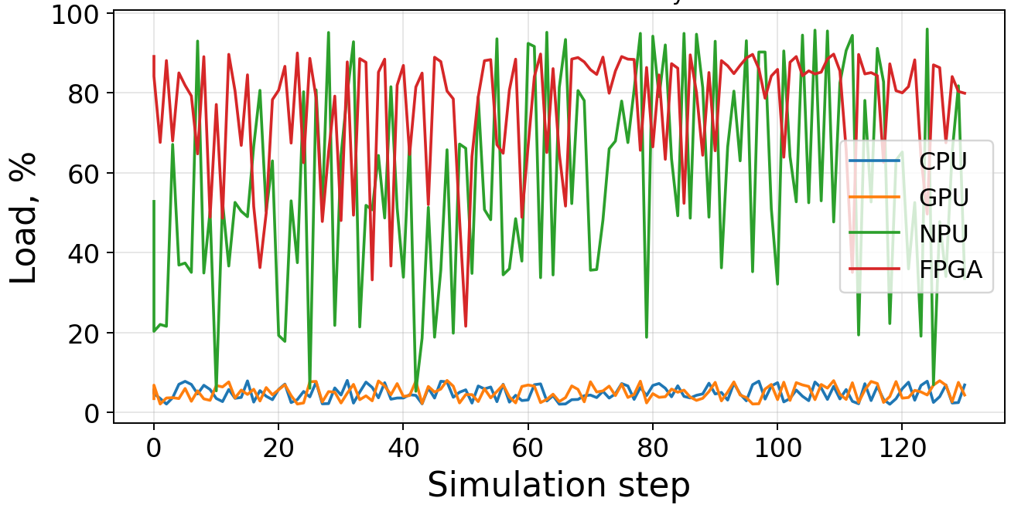
Fig. 1. Resource Load History
The obtained simulation results (Fig. 1) demonstrate that the main computational load during most of the experiment was concentrated on the FPGA and NPU, the load of which varied approximately in the ranges of 65–92% and 15–96%, respectively. At the same time, the CPU and GPU remained loaded mainly at the level of 2–8%. In general, this indicates the effective use of specialized hardware accelerators to perform resource-intensive tasks of the EDGE platform. The nature of the change in the load curves confirms the operability of the proposed approach to resource balancing, since the system adaptively redistributes tasks between the FPGA and NPU. This depends on the current operating conditions and provides high performance without overloading the central and graphics processors.
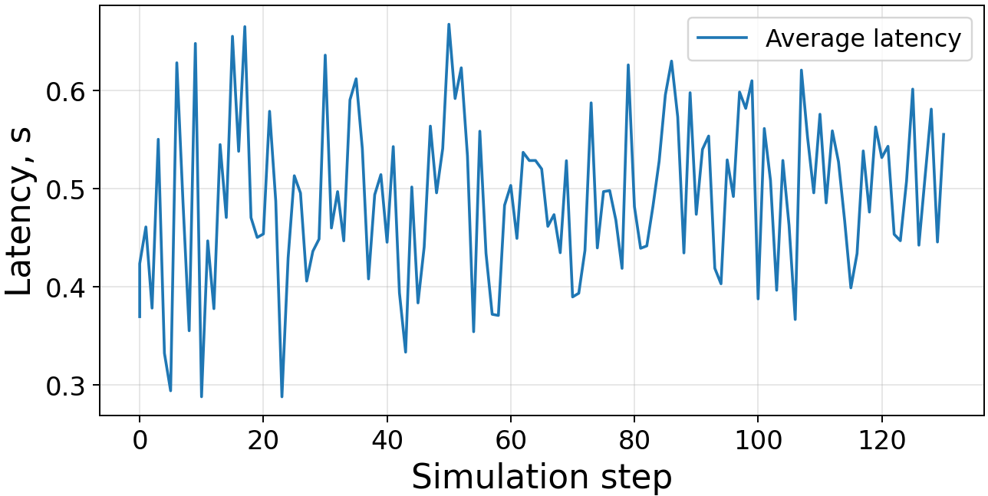
Fig. 2. Average Latency History
The simulation results for the average task execution latency throughout the experiment remained within approximately 0.29–0.66 s with an average value of about 0.50 s (Fig. 2). This indicates the stable operation of the load distribution mechanism between the CPU, GPU, NPU and FPGA even in the presence of variable intensity of the incoming task flow. The absence of long-term increase in latency and its oscillation around an almost constant level confirm the effectiveness of the proposed resource balancing approach. It follows from the above that this approach ensures timely execution of calculations and supports the necessary characteristics of the EDGE platform in real-time mode.
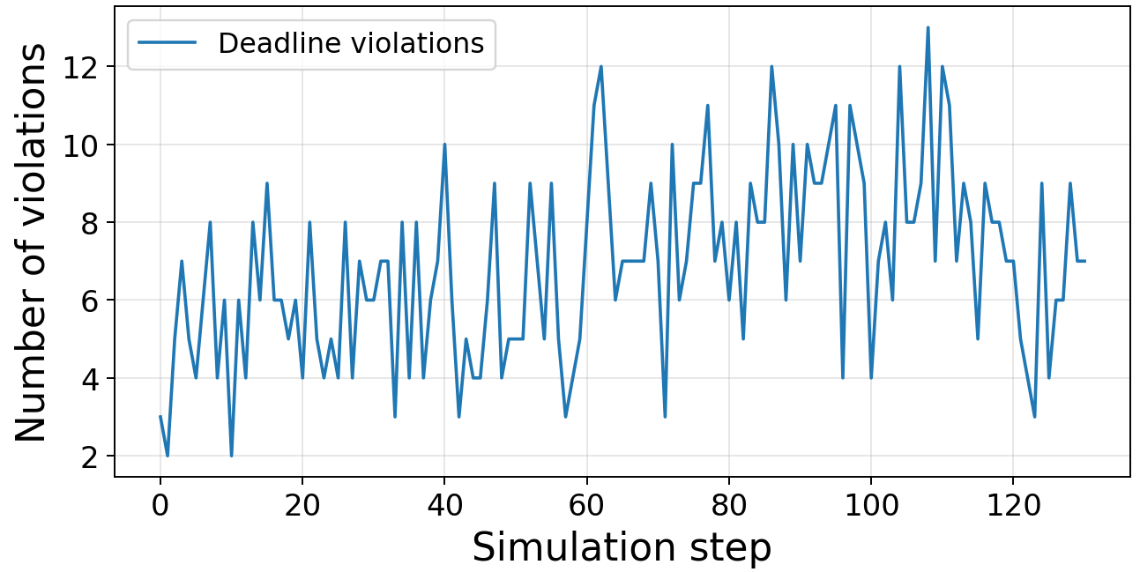
Fig. 3. Deadline Violation History
The simulation results regarding the number of time limit violations during the experiment varied from approximately 2 to 13 cases per simulation step with an average level of about 7–8 violations (Fig. 3). This indicates the presence of periods of increased load on the computing resources of the EDGE platform. Despite local peaks, the absence of a steady uncontrolled increase in the number of deadline violations confirms the ability of the proposed approach to adaptively redistribute tasks between the CPU, GPU, NPU and FPGA and maintain an acceptable level of service in conditions of a dynamic flow of computational requests.
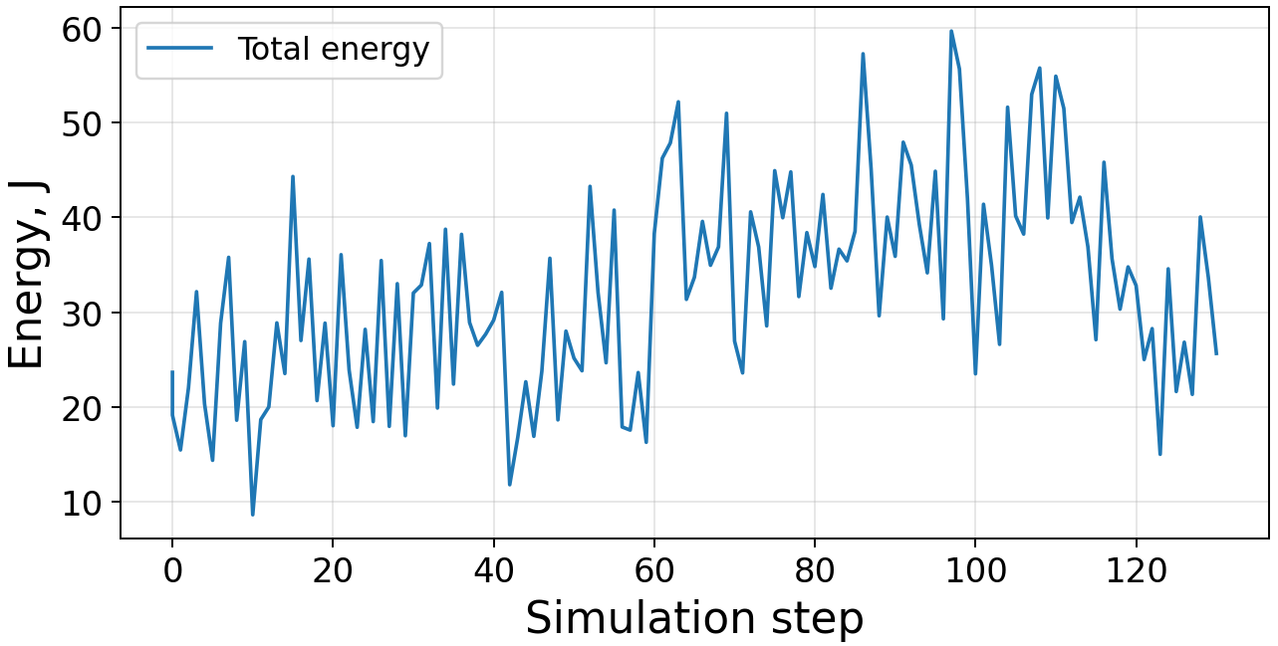
Fig. 4. Total Energy Consumption History
The results of the simulation on the change in the total energy consumption of the EDGE platform (Fig. 4) varied in the range from approximately 9 to 62 J with an average level of about 35–35 J. At the same time, at the end of the experiment, a tendency to increase in energy costs is observed. This is due to an increase in the intensity of the computational load and more active use of computational resources. The nature of the energy consumption curve also indicates the adaptive operation of the proposed task distribution mechanism between the CPU, GPU, NPU and FPGA. Therefore, this ensures stable operation of the system without sharp energy overloads even under conditions of dynamic changes in the number and complexity of computational tasks.

Conclusion
As a result of the research, a new approach to the joint use of CPU, GPU, NPU and FPGA resources of the EDGE platform for performing SLAM tasks, object detection and mobile robot control was generalized. This provides adaptive distribution of the computational load taking into account performance, energy consumption, time constraints and the current state of hardware resources. The results of numerical modeling confirmed the effectiveness of the proposed approach, demonstrating the rational redistribution of resource-intensive tasks to specialized NPU and FPGA accelerators. This made it possible to maintain a stable level of delays, an acceptable number of time constraint violations and an energy-efficient mode of operation of the system. The results obtained confirm the prospects of using the developed method for creating high-performance autonomous mobile robots and real-time cyber-physical systems, in particular for use in intelligent manufacturing Industry 5.0, autonomous logistics and unmanned robotic complexes.

References
Y. Yan, J. Li, Q. Liu, S. Lv, and Q. Wu, “RGB-D SLAM: A Review of Methods and Performance Trade-Offs for Different Requirements,” Sensors, vol. 26, no. 11, ID 3513, 2026. doi: 10.3390/s26113513.
B. Lv, and S. Duan, “Learning-Based Multi-Robot Active SLAM: A Conceptual Framework and Survey,” Applied Sciences, vol. 16, no. 3, ID 1412, 2026. doi: 10.3390/app16031412.
- T. Pereira, C. Viegas, S. Soares, and N. Ferreira, “Visual and Visual–Inertial SLAM for UGV Navigation in Unstructured Natural Environments: A Survey of Challenges and Deep Learning Advances,” Robotics, vol. 15, no. 2, ID 35, 2026. doi: 10.3390/robotics15020035.
A. T. Abu-Jassar, H. Attar, A. Amer, V. Lyashenko, V. Yevsieiev, and A. Solyman, “Development and investigation of vision system for a small-sized mobile humanoid robot in a smart environment,” International Journal of Crowd Science, vol. 9, no. (1), pp. 29-43, 2025. doi: 10.26599/IJCS.2023.9100018.
T. S. Almuzaini, and A. V. Savkin, “Trajectory Planning for Autonomous Underwater Vehicles in Uneven Environments: A Survey of Coverage and Sensor Data Collection Methods,” Future Internet, vol. 18, no. 2, ID 79, 2026. doi: 10.3390/fi18020079.
V. Lyashenko, A. T. Abu-Jassar, V. Yevsieiev, and S. Maksymova, “Automated Monitoring and Visualization System in Production,” International Research Journal of Multidisciplinary Technovation, vol. 5, no. 6, pp. 9-18, 2023. doi: 10.54392/irjmt2362.
- Z. Xu, K. Xue, P. Wang, and D. Kong, “Hierarchical Active Perception and Stability Control for Multi-Robot Collaborative Search in Unknown Environments,” Actuators, vol. 15, no. 4, ID 209, 2026. doi: 10.3390/act15040209.
- H. Sukri, and et al., “Enhanced Precision Control of a 4-DOF Robotic Arm Using Numerical Code Recognition for Automated Object Handling,” Journal of Robotics and Control (JRC), vol. 6, no. 1, pp. 315-335, 2025. doi: 10.18196/jrc.v6i1.24349.
- M. A. Ahmad, J. H. Baker, I. Tvoroshenko, and V. Lyashenko, “Computational complexity of the accessory function setting mechanism in fuzzy intellectual systems,” International Journal of Advanced Trends in Computer Science and Engineering, vol. 8, no. 5, pp. 2370-2377, 2019. doi: 10.30534/ijatcse/2019/77852019.
- X. Zhou, J. Kan, N. F. L. M. Rosely, X. Duan, J Cai, and Z. Zhou, “ILN-YOLOv8: A Lightweight Image Recognition Model for Crimped Wire Connectors,” IEEE Access, vol. 13, pp. 5193-5202, 2025. doi: 10.1109/ACCESS.2025.3525564.
- H. Attar, A. T. Abu-Jassar, A. Amer, V. Lyashenko, V. Yevsieiev, and M. R. Khosravi, “Control system development and implementation of a CNC laser engraver for environmental use with remote imaging,” Computational intelligence and neuroscience, vol. 2022, no. 1, ID 9140156, 2022. doi: 10.1155/2022/9140156.
- S. K. Mustafa, V. Yevsieiev, I. Nevliudov, and V. Lyashenko, “HMI Development Automation with GUI Elements for Object-Oriented Programming Languages Implementation,” SSRG International Journal of Engineering Trends and Technology, vol. 70, no. 1, pp. 139-145, 2022. doi: 10.14445/22315381/IJETT-V70I1P215.
- N. Tahir, and R. Parasuraman, “Edge computing and its application in robotics: A survey,” Journal of Sensor and Actuator Networks, vol. 14, no. 4, ID 65, 2025. doi: 10.3390/jsan14040065.
- M. Lisondra, B. Benhabib, and G. Nejat, “Embodied ai with foundation models for mobile service robots: A systematic review,” Robotics, vol. 15, no. 3, ID 55, 2026. doi: 10.3390/robotics15030055.
V. Maisto, and A. Cilardo, “Compute-Efficient Modelling of Multi-NPU Inference on Edge MPSoCs for Energy-Aware Online Workload Allocation,” ACM Transactions on Architecture and Code Optimization, vol. 23, no. 1, pp. 1-25, 2026. doi: 10.1145/3799238.
S. Ahmad, M. Hafeez, and S. A. R. Zaidi, “Vision-Language Models on the Edge for Real-Time Robotic Perception,” arXiv preprint, arXiv:2601.14921, 2026. doi: 10.48550/arXiv.2601.14921.
S. Khalid, M. U. Rehman, A. B. Usman, and M. Khawar, “Resource-efficient models for edge devices,” Edge Intelligence, pp. 111-153, 2026. doi.org/10.1016/B978-0-44-338297-0.00011-8.
K. Ali, A. Ajan, and M. H. Imtiaz, “FPGA-Based Implementations of Biometric Recognition: A Review,” Electronics, vol. 15, no. 10, ID 2145, 2026. doi:10.3390/electronics15102145.
W. Wang, D. Zhou, W. Xie, and W. Zhang, “An Energy-Efficient FPGA-Based CNN Accelerator with Dual-Multiply Packing and Ping-Pong Buffering for Real-Time Object Detection,” Electronics, vol. 15, no. 11, ID 2442, 2026. doi: 10.3390/electronics15112442.
A. Yu, A. Ahmadi, and L. MacEachern, “A Spiking Neural Network Based Hough Transform Implementation for FPGAs,” IEEE Transactions on Emerging Topics in Computational Intelligence, pp. 1-17, 2026. doi: 10.1109/TETCI.2026.3683795.
Z. Wan, and et al., “A survey of fpga-based robotic computing,” IEEE Circuits and Systems Magazine, vol. 21, no. 2, pp. 48-74, 2021. doi: 10.1109/MCAS.2021.3071609.
S. Seok, D. J. Hyun, S. Park, D. Otten, and S. Kim, “A highly parallelized control system platform architecture using multicore CPU and FPGA for multi-DoF robots,” In 2014 IEEE International Conference on Robotics and Automation (ICRA), pp. 5414-5419, 2014. doi: 10.1109/ICRA.2014.6907655.
A. Podlubne, and D. Göhringer, “A survey on adaptive computing in robotics: Modelling, methods and applications,” IEEE Access, vol. 11, pp. 53830-53849, 2023. doi: 10.1109/ACCESS.2023.3281190.
S. M. Sali, M. Meribout, and A. A. Majeed, “Real Time FPGA Based CNNs for Detection, Classification, and Tracking in Autonomous Systems: State of the Art Designs and Optimizations,” arXiv preprint, arXiv:2509.04153, 2025. doi: 10.48550/arXiv.2509.04153.
L. Capogrosso, P. Bonazzi, and M. Magno, “Performance analysis of edge and in-sensor ai processors: A comparative review,” arXiv preprint, arXiv:2603.08725, 2026. doi: 10.48550/arXiv.2603.08725.
A. Rostami, and et al., “NLU: An Adaptive, Small-Footprint, Low-Power Neural Learning Unit for Edge and IoT Applications,” IEEE Open Journal of Circuits and Systems, vol. 6, pp. 85-99, 2025. doi: 10.1109/OJCAS.2025.3546067.
S. B. Halima, F. B. Abdallah, and J. Haggege, “Deep Reinforcement Learning-Based Obstacle Avoidance for Embedded Mobile Robot Navigation,” In 2026 IEEE International conference on Advanced Systems and Emergent Technologies (IC_ASET), pp. 1-6, 2026. doi: 10.1109/IC_ASET69920.2026.11502382.
E. A. Rodríguez-Martínez, W. Flores-Fuentes, F. Achakir, O. Sergiyenko, and F. N. Murrieta-Rico, “Vision-based navigation and perception for autonomous robots: Sensors, SLAM, control strategies, and cross-domain applications – A review,” Eng., vol. 6, no. 7, ID 153, 2025. doi: 10.3390/eng6070153.
S. Nahavandi, R. Alizadehsani, D. Nahavandi, S. Mohamed, N. Mohajer, M. Rokonuzzaman, and I. Hossain, “A comprehensive review on autonomous navigation,” ACM Computing Surveys, vol. 57, no. 9, pp. 1-67, 2025. doi: 10.1145/3727642.
S. Ibraev, and D. Sultan, “A Review of Control Strategies for Robotic Systems with Embedded Sensors,” Engineering, Technology & Applied Science Research, vol. 15, no. 6, pp. 29536-29544, 2025. doi: 10.48084/etasr.13913.
- A. T. Abu-Jassar, H. Attar, A. Amer, V. Lyashenko, V. Yevsieiev, and A. Solyman, “Remote monitoring system of patient status in social IoT environments using amazon web services technologies and smart health care,” International Journal of Crowd Science, vol. 9, no. 2, pp. 110-125, 2025. doi: 10.26599/IJCS.2023.9100019.
T. C. Chang, S. Park, J. P. Lim, and S. Nagarakatte, “FLoPS: Semantics, Operations, and Properties of P3109 Floating-Point Representations in Lean,” arXiv preprint arXiv:2602.15965, 2026. doi: 10.48550/arXiv.2602.15965.
H. Nehete, G. Verma, A. Monga, A. K. Shukla, S. Yadav, and B. K. Kaushik, “Hardware Architectures and Optimization Techniques for Convolutional Neural Network Accelerators,” Machine Learning in Nanoelectronics: Devices, Circuits and Systems, pp. 113-154, 2026. doi: 10.1002/9781394336203.ch5.
J. Qi, “Combining Edge Computing to Enhance Real-Time Control and Low-Latency Response of Line Robots,” International Journal of Computer Information Systems and Industrial Management Applications, vol. 18, ID 9, 2026. doi: 10.70917/ijcisim-2026-0087.
- Y. Liu, and et al., “FEGW-YOLO: a feature-complexity-guided lightweight framework for real-time multi-crop detection with advanced sensing integration on edge devices,” Sensors, vol. 26, no. 4, ID 1313, 2026. doi: 10.3390/s26041313.

