Neuro-Fuzzy Robot Route Planner D*Lite with Risk-Taking
Amer Abu-Jassar
Department of Computer Science, College of Information Technology, Amman Arab University, Amman, Jordan
A.abujassar@aau.edu.jo

Hani Attar
Faculty of Engineering, Zarqa University, Zarqa, Jordan / Faculty of Engineering University of Business and Technology, Jeddah, SA
hattar@zu.edu.jo

Vyacheslav Lyashenko
Department of Media Systems and Technology, Kharkiv National University of Radio Electronics, Kharkiv, Ukraine
viacheslav.liashenko@nure.ua

Vladyslav Yevsieiev
Department CITARSE, Kharkiv National University of Radio Electronics, Kharkiv, Ukraine
vladyslav.yevsieiev@nure.ua

Mohamed Hafez
Faculty of Engineering FEQS, INTI-IU-University, Pathum Nilai, Malaysia / Faculty of Management, Shinawatra University, Thani, Thailand
mohdahmed.hafez@newinti.edu.my

Svitlana Maksymova
Department CITARSE, Kharkiv National University of Radio Electronics, Kharkiv, Ukraine
svitlana.milyutina@nure.ua

Abstract—The paper presents a new hybrid method, Neuro-Fuzzy Robot Route Planner D*Lite with Risk-Taking, for autonomous route planning of a mobile robot in an uncertain environment. This opens up new opportunities for the development of modern technologies in the operation of robotic systems. The proposed approach combines the D*Lite algorithm, neuro-fuzzy risk assessment, a LiDAR-based occupancy map, and a compact neural network TinyML-MLP for edge devices such as ESP32-Cam. The results of numerical simulations confirmed the ability of the method to form safe trajectories, maintain stable navigation performance, and ensure effective achievement of the target point in a dynamic environment.
Index Terms—autonomous navigation, mobile robot, modern technologies, neuro-fuzzy navigation, risk assessment, robotic systems, route planning

Introduction
Autonomous navigation of mobile robots in dynamic and uncertain environments is one of the key tasks of modern robotics [1-4]. Here various methods and approaches can be applied [5-7]. At the same time, traditional route planning algorithms [8, 9], in particular D*Lite, provide effective trajectory replanning [10, 11]. However, such algorithms do not sufficiently take into account the level of risk and uncertainty associated with incomplete sensory information and the appearance of dynamic obstacles [12, 13]. At the same time, it is the use of neural networks and fuzzy logic that allows integrating mechanisms for risk assessment, uncertainty analysis, and decision-making under conditions of incomplete information [14, 15].
For example, in the work of G. Malczyk, M. Kulkarni and K. Alexis, an approach to active perception of information in autonomous navigation based on reinforcement learning [16] is investigated. This makes it possible to increase the safety of movement in complex unknown environments by combining trajectory planning and information-oriented sensor control. However, this approach cannot be directly used, since it is based on end-to-end RL-policy and active camera. However, in this case, it is more appropriate to combine D*Lite with fuzzy risk assessment, map uncertainty based on the real limitations of a small-sized robotic platform.
In the study [17], an autonomous navigation system for a firefighting robot without its own full perception is proposed based on the use of information from a network of CCTV cameras. This solution makes it possible to ensure the movement of the robot to the center of the fire even in cases where the robot's own sensors are blocked or damaged [17]. However, the proposed approach cannot be directly used because it depends on external video surveillance infrastructure and does not solve the problem of local online route replanning.
In [18], an approach to building a mobile robot route based on the BRRT and A*(H-BRRT) algorithms is generalized. This allows to increase the efficiency of route search in a space with obstacles. The proposed method makes it possible to combine random route construction with A* optimization, which is useful for mobile robot motion planning tasks [18]. At the same time, this approach cannot be fully used in the sense of this study, since it does not provide dynamic replanning of the robot's motion.
In [19], conditions for improving the performance of visual odometry for autonomous navigation during low light and rough terrain are determined. The proposed approach makes it possible to increase the stability of robot motion estimation in complex visual conditions. Here classical methods may lose accuracy [19]. However, this approach cannot be directly used for other tasks, since it focuses on visual odometry, and not on risk-based route planning.
J. Rakun and G. Popič propose an optimized algorithm for autonomous navigation of field robots aimed at increasing the accuracy of movement, reducing crop damage and reducing the time of task completion [20]. This solution makes it possible to improve the practical use of robots by adapting the route to local conditions. However, this approach cannot be directly applied to any localities, since it is focused on agricultural trajectories and does not contain a local risk model. In addition, such risk models should be combined with the uncertainty of the LiDAR map, the fuzzy selection of risk zones and the D*Lite online replanning mechanism.
D. Morilla-Cabello and E. Montijano developed the CHORAL approach for traversal-aware planning of safe and efficient routes in heterogeneous multi-agent robotic systems [21]. This approach allows us to take into account the characteristics of mobile robots, the semantic map of the environment and the distribution of inspection tasks between platforms [21]. At the same time, this approach cannot be fully used for the purposes of this study, since it is focused on team-based semantic planning of heterogeneous robots. Therefore, a compact neuro-fuzzy planner for a single mobile robot with LiDAR, limited resources and risk-based replanning is not considered.
In [22], the problems of using fleets of ground robots in urban search operations are investigated taking into account the needs of professional users. This study allows us to determine the requirements for scalable control of robot groups, situational awareness, route planning and a human-oriented interface [22]. However, such research is predominantly of a systemic-organizational and HCI nature and does not, in particular, offer a mathematical model of neuro-fuzzy risk-based route planning.
Thus, the above analysis of publications shows that modern research is actively developing the areas of autonomous navigation, active perception, visual odometry, and multi-agent planning [23, 24]. At the same time, the considered works have not sufficiently investigated the problem of combining D*Lite with neural risk assessment, a fuzzy risk-taking mechanism, and local map uncertainty for the operation of a mobile robot in a dynamic and partially unknown environment. Therefore, this is what determines the key task and direction of disclosure of the main goal of the study regarding the level of risk and uncertainty associated with incomplete sensory information and the appearance of dynamic obstacles. At the same time, the solution to the problem is presented through the generalization of the neuro-fuzzy method of mobile robot route planning based on the D*Lite algorithm, taking into account the risk and uncertainty of the environment to increase the efficiency of autonomous navigation. This contributes to the combination of traditional but effective robot motion planning algorithms with the possibility of its replanning to take into account emerging risks and uncertainty based on neural networks and fuzzy logic.

Mathematical Description Of The Proposed Approach
Neuro-fuzzy robot route planner D*Lite with risk-taking (NFR-DLP), is a new concept of a hybrid route planning method for a small robot. The technical basis of such development is: EDGE ESP32-Cam and LiDAR sensor [25, 26]. Therefore, the corresponding method is the following holistic hybrid scheme: LiDAR map → uncertainty estimation → neural network EDGE model → global and local real-time planning → route planning.
The general state model of a small robot ($x_{k}$), describes its position and orientation during movement in an uncertain environment:

$$x_{k}={[x_{k},y_{k},θ_{k},v_{k},w_{k}]}^{T},$$ | (1)

where: $x_{k},y_{k}$ – robot coordinates; $θ_{k}$ – orientation angle; $v_{k}$ – linear velocity; $w_{k}$ – angular velocity; $k$ – discrete time.
The kinematic model of motion is used for numerical simulation of robot movement:

$$\left\{\begin{matrix}x_{k+1}=x_{k}+v_{k}\cos\left(θ_{k}\right)∆t, \\ y_{k+1}=y_{k}+v_{k}\sin\left(θ_{k}\right)∆t, \\ θ_{k+1}=θ_{k}+w_{k}∆t,\end{matrix}\right.$$ | (2)

where: $v_{k}$ – speed of movement; $w_{k}$ – speed of rotation; $∆t$ – sampling step.
The hardware limitations model of the ESP32-Cam EDGE device ($C_{edge}$) takes into account limited RAM, processor frequency and neural network execution time:

$$C_{edge}=α_{1}\frac{M_{NN}}{M_{max}}+α_{2}\frac{T_{inf}}{T_{max}}+α_{3}\frac{P_{cpu}}{P_{max}},$$ | (3)

where: $M_{NN}$ – neural network memory; $M_{max}$ – available ESP32-Cam memory (RAM 4Mb); $T_{inf}$ – inference time; $T_{max}$ – allowable processing time; $P_{cpu}$ – processor load; $α_{1},α_{2},α_{3}$ – weighting factors.
The LiDAR distance measurement model describes obtaining the distance to obstacles for building an environment map:

$$z_{i}=d_{i}+n_{i},$$ | (4)

where: $z_{i}$ – measured LiDAR distance; $d_{i}$ – real distance to the object; $n_{i}$ – measurement noise (Gaussian noise) [27]; $i$ – LiDAR beam number.
The probabilistic occupancy map model [28, 29] generates an environment map taking into account the uncertainty of the sensor data:

$$p_{ij}^{occ}\left(k\right)=\frac{1}{1-exp⁡(-l_{ij}(k))},$$ | (5)
$$l_{ij}\left(k\right)=l_{ij}\left(k-1\right)+log\frac{p(z_{k}|m_{ij})}{1-p(z_{k}|m_{ij})},$$ | (5)

where: $p_{ij}^{occ}\left(k\right)$ – probability of cell occupancy; $l_{ij}$ – og-odds value; $m_{ij}$ – map cell; $z_{k}$ – LiDAR measurement.
The environmental uncertainty model determines the risk of moving through areas with poor visibility or unstable sensor data:

$$U_{ij}=β_{1}p_{ij}^{occ}+β_{2}σ_{ij}+β_{3}D_{ij}^{unknow},$$ | (6)

where: $U_{ij}$ – uncertainty level of the cell; $σ_{ij}$ – variance of sensor measurements; $D_{ij}^{unknow}$ – feature of unknown area; $β_{1},β_{2},β_{3}$ – weighting factors.
Neural network model for local risk assessment, describes a compact neural network TinyML Multi-Layer Perceptron (TinyML-MLP) on ESP32-Cam [30-32], which assesses the danger of a local area:

$$R_{k}^{NN}=f_{θ}\left(I_{k},z_{k},p_{ij}^{occ},U_{ij}\right),$$ | (7)

where: $R_{k}^{NN}$ – neural network risk assessment; $f_{θ}(∙)$ – NN TinyML-MLP; $I_{k}$ – frame from ESP32-Cam; $z_{k}$ – LiDAR data; $p_{ij}^{occ}$ – occupancy map; $U_{ij}$ – uncertainty (information entropy).
The network assesses the risk of the robot passing through the local area of the map and generates a risk coefficient:

$$R_{k}^{NN}∈\left[0,1\right],$$ | (8)

where: $R_{k}^{NN}=0$ – safe zone; $R_{k}^{NN}=1$ – critically dangerous zone.
The input vector TinyML-MLP consists of the following features:

$$F_{k}=\left[d_{front},d_{left},d_{right},p_{occ},U,v,θ_{goal}\right],$$ | (9)

where: $d_{front}$ – distance in front; $d_{left}$ – distance to the left; $d_{right}$ – distance to the right; $p_{occ}$ – probability of cell occupancy; $U$ – uncertainty of the environment; $v$ – robot speed; $θ_{goal}$ – direction to the goal.
The following architecture is proposed: input layer (7 neurons), hidden layer 1 (16 neurons), hidden layer 2 (8 neurons) and output layer (1 neuron).
The mathematical model of the layers has the following form:
- first hidden layer:

$$h_{1}=ReLU\left(W_{1}F_{k}+b_{1}\right),$$ | (10)

- second hidden layer:

$$h_{2}=ReLU\left(W_{2}h_{1}+b_{2}\right),$$ | (11)

- entrance:

$$R_{k}^{NN}=σ\left(W_{3}h_{2}+b_{3}\right),$$ | (12)

where: $h_{1},h_{2}$ – vector of output values of neurons of the first hidden layer and the second; $R_{k}^{NN}$ – neural network estimate of local risk of robot movement at time $k$; $ReLU(∙)$ – nonlinear activation function; $σ(∙)$ – sigmoid activation function, limiting the output signal to the range $[0;1]$; $W_{1},W_{2}$ – matrix of weight coefficients of the first and second hidden layers, respectively; $W_{3}$ – matrix of weight coefficients of the output layer; $F_{k}$ – vector of input features of the neural network at time $k$; $h_{1},h_{2}$ – vector of outputs of the first and second hidden layers; $b_{1},b_{2}$ – vector of biases (bias) of the first and second hidden layers; $b_{3}$ - bias of the output neuron.
The hybrid route cost function combines route length, risk, uncertainty and hardware limitations:

$$J\left(π\right)=\sum_{k=1}^{N}{\left(w_{1}L_{k}+w_{2}U_{k}+w_{3}R_{k}^{NN}+w_{4}C_{edge}+w_{5}E_{k}\right),}$$ | (13)

where: $π$ – route; $L_{k}$ – local step length; $U_{k}$ – uncertainty; $R_{k}^{NN}$ – risk; $C_{edge}$ – hardware complexity; $E_{k}$ – energy costs; $w_{1},…,w_{5}$ – criteria weights.
The global route planning model builds a basic route on the map taking into account the cost of cells:

$$π^{*}=arg\min_{π}{J(π)},$$ | (14)
$$π=\left\{q_{0},q_{1},…,q_{N}\right\},$$ | (14)

where: $π^{*}$ – optimal route; $q_{0}$ – starting point; $q_{N}$ – target point; $q_{i}$ – intermediate nodes of the route.
The local reactive route correction model allows the robot to change the trajectory in real time when new obstacles appear:

$$∆u_{k}=-ζ_{1}∇U_{k}-ζ_{2}∇R_{k}^{NN}+ζ_{3}\left(q_{gool}-q_{k}\right),$$ | (15)

where: $∆u_{k}$ – control correction; $∇U_{k}$ – uncertainty gradient; $∇R_{k}^{NN}$ – risk gradient; $q_{k}$ – current position; $ζ_{1},ζ_{2},ζ_{3}$ – influence coefficients.
The real-time model for Python visualization defines the condition for updating the map, route and graphs in matplotlib:

$$T_{cycle}=T_{lidar}+T_{map}+T_{NN}+T_{plan}+T_{vis}≤T_{real},$$ | (16)

where: $T_{lidar}$ – time to obtain LiDAR data; $T_{map}$ – map update time; $T_{NN}$ – neural network operation time; $T_{plan}$ – planning time; $T_{vis}$ – matplotlib visualization update time; $T_{real}$ – allowable time of one real-time cycle.

Experimental Research And Analysis Of The Obtained Results
To evaluate the effectiveness of the proposed NFR-DLP method, a simulation of the mobile robot route construction process was conducted. During the experiment, the robot moves from the initial to the target point with continuous route replanning based on the D*Lite algorithm, taking into account the level of risk and uncertainty of the environment.
Hardware: Microsoft Surface Pro 9 PC with the following characteristics: CPU Intel Core i7-1255U, RAM 32 GB LPDDR5, GPU Intel Iris Xe.
Software: OS Windows 11, programming language Python, and development environment PyCharm 2025.3.1.1.
The expected result is the formation of a safe trajectory without collisions with obstacles, reaching the target point and obtaining time dependencies of risk indicators, uncertainty, route length and planning time. It confirms the operability of the proposed method (Fig. 1-Fig. 6).
The obtained simulation results show (Fig. 1) that the proposed NFR-DLP method provides successful formation of a safe route from the initial to the target point in the presence of static obstacles (large black rectangles and squares) and environmental uncertainty (dynamic obstacles in the form of small black squares). The constructed trajectory of the robot movement is consistent with the global route formed by the D*Lite algorithm. In this case, the robot moves through free areas of the map and maintains a safe distance to obstacles. This confirms the operability of the proposed approach and the feasibility of using neuro-fuzzy risk assessment to increase the reliability of mobile robot navigation in a dynamic environment.

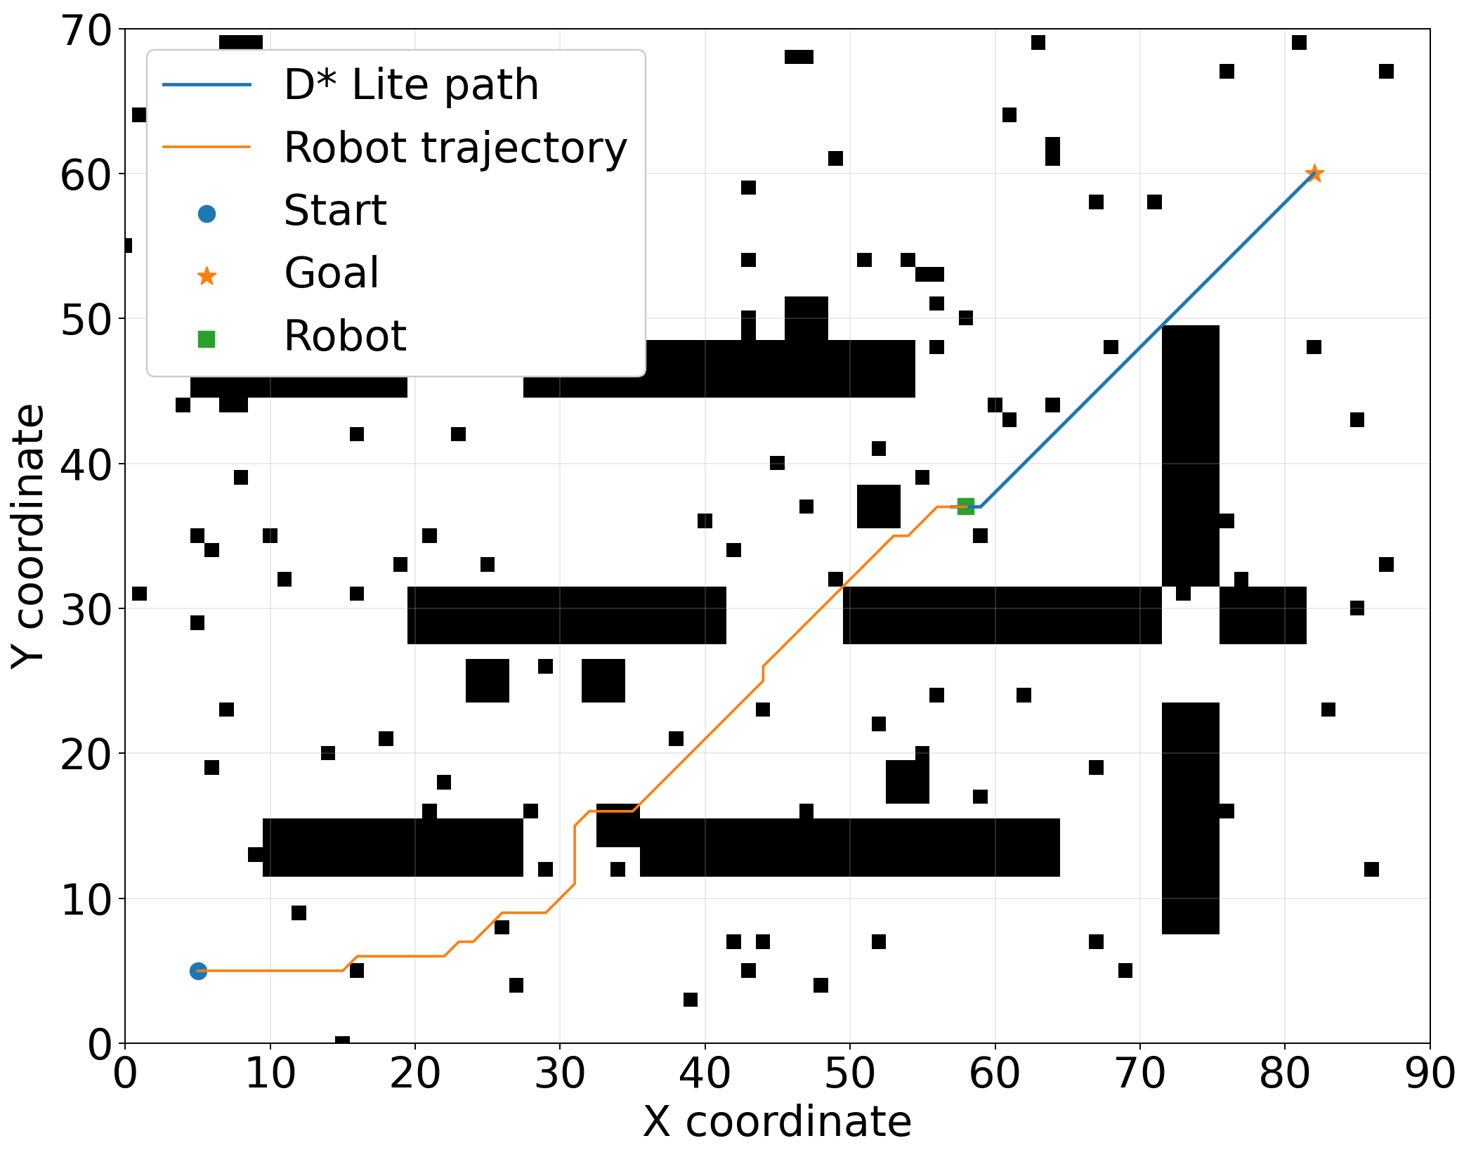
Fig. 1. Neuro-Fuzzy Robot Route Planner D*Lite with Risk-Taking

Neuro-Fuzzy risk map (Fig. 2) indicates that the proposed neuro-fuzzy approach successfully identifies areas of increased danger along the robot's movement route and near obstacles. At the same time, a spatial distribution of the risk level in the working environment is formed. The highest risk values (in Fig. 2, this is a more saturated and dark color of space) are observed in areas with a complex configuration of obstacles and increased uncertainty. This confirms the ability of the method to take into account the features of the environment when making navigation decisions.

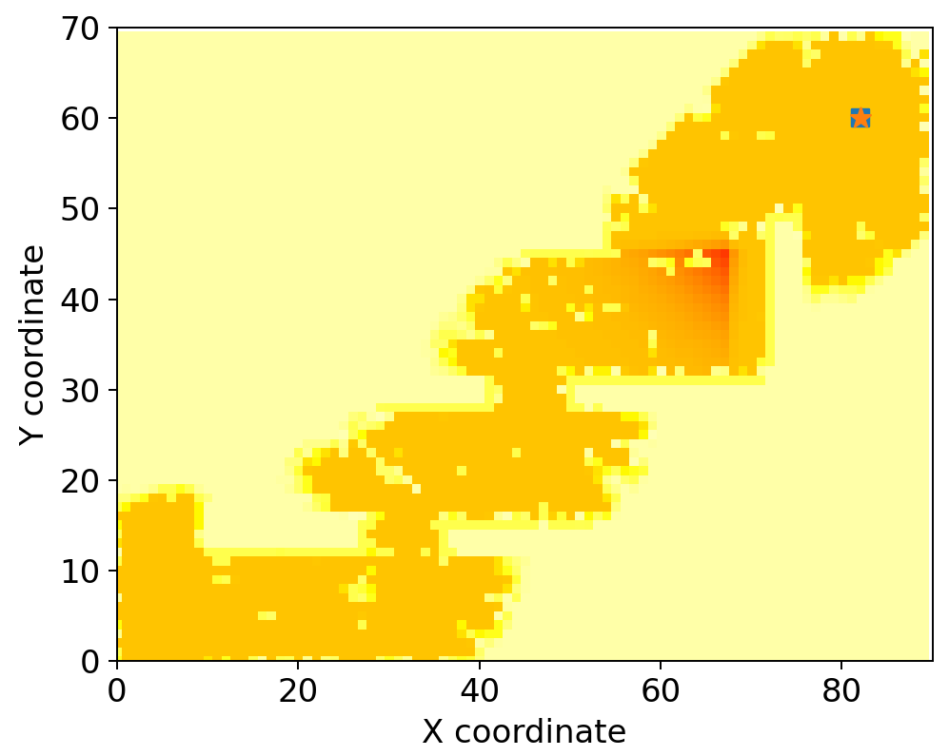
Fig. 2. Neuro-Fuzzy risk map

The map of probable environment occupation (Fig. 3) demonstrates that the system successfully forms a spatial representation of free and occupied areas based on LiDAR sensor data. This provides detection of obstacle contours and available areas for navigation. The results demonstrate the ability of the method to accumulate and refine information about the environment during the robot's movement, creating a basis for effective route replanning and increasing the reliability of autonomous navigation.

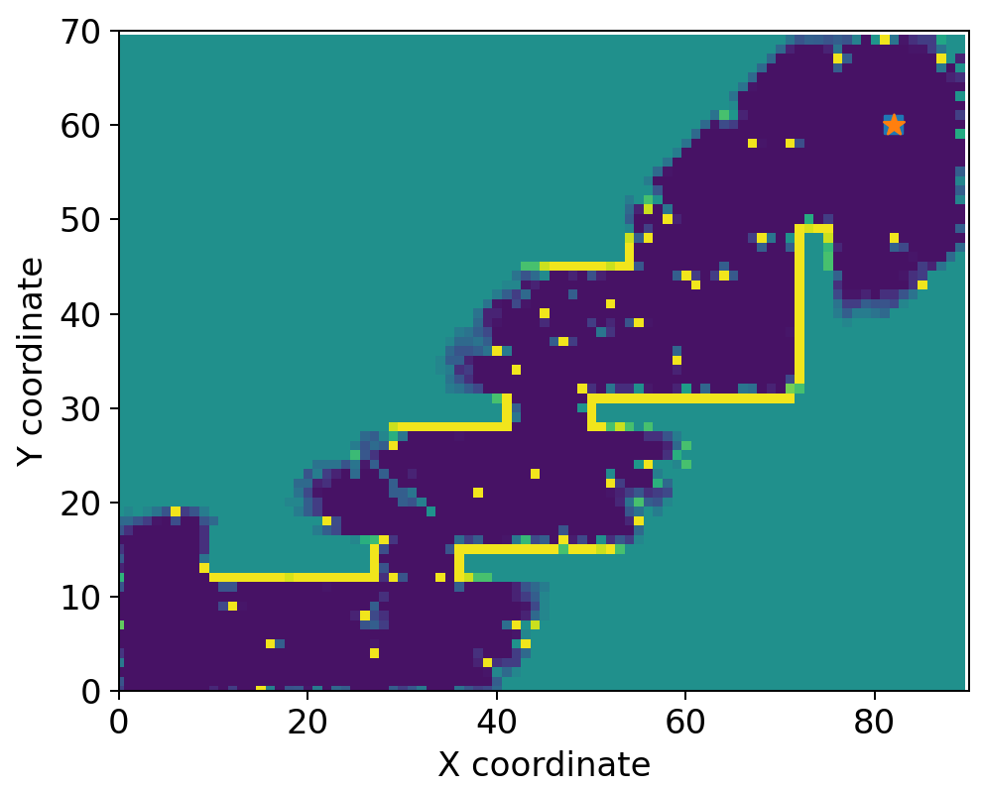
Fig. 3. Occupancy grid probability

The results obtained on the Risk and uncertainly graph (Fig. 4) indicate that during most of the experiment the risk level remains practically constant at a level of about $R≈0.66.$ The uncertainty of the environment is maintained at a lower level of $U≈0.29$. This indicates the stability of the navigation process and sufficient awareness of the robot about the environment. A short-term increase in uncertainty to $U≈0.88$ and risk to $R≈0.86$ (about the 50th step) indicates the detection of a potentially dangerous or insufficiently explored area. Soon the system successfully returns to the normal operating mode. Overall, this confirms the effectiveness of the mechanism of adaptive risk, and uncertainty assessment during route planning.

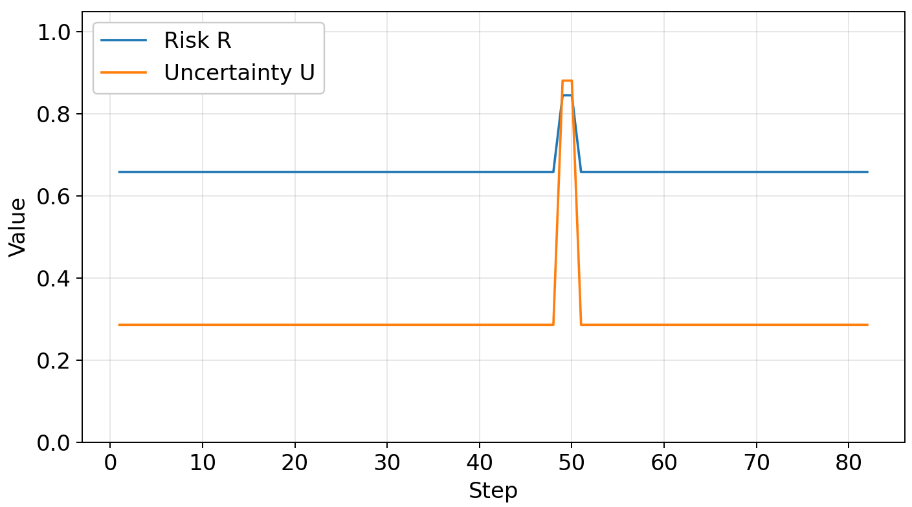
Fig. 4. Risk and uncertainly

The results of the Planning metric simulation (Fig. 5) demonstrate a gradual decrease in the route length from approximately 100 to almost 0 conventional units as the robot approaches the target point. At the same time, the minimum distance to obstacles remains positive and stable throughout the experiment. This indicates the safe nature of navigation. The planning time at the initial stages reaches about 1400 ms due to the need to build a global route and process environmental uncertainties. Later, the planning time decreases to tens of milliseconds, confirming the effectiveness of the D*Lite algorithm with multiple route replanning in real time.

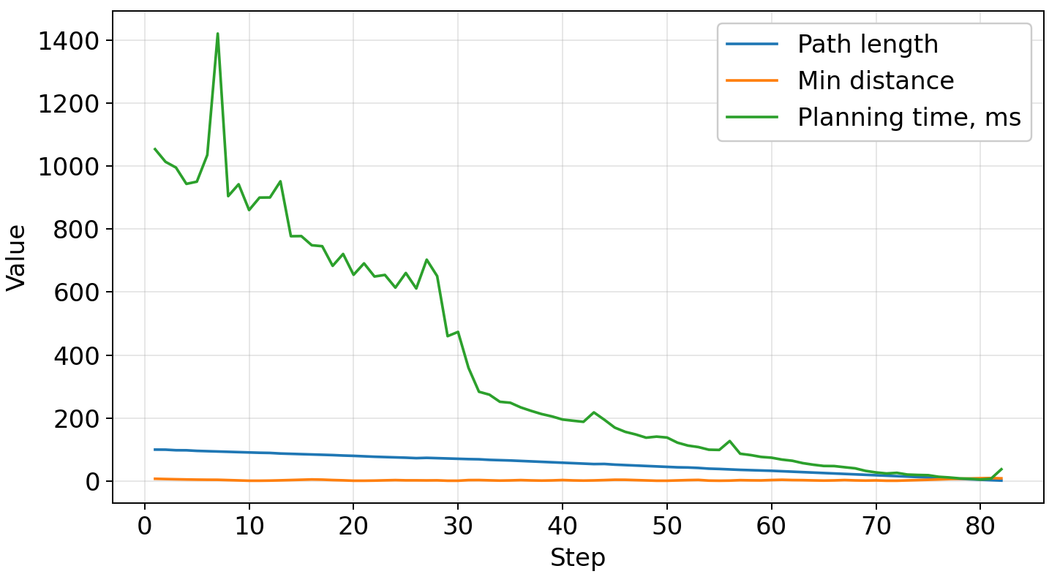
Fig. 5. Planning metric

The Final experiment metric graph (Fig. 6) demonstrates the stable operation of the proposed method throughout the navigation process, as the levels of neuro-fuzzy risk and map uncertainty remain low and practically unchanged. This indicates a confident perception of the environment and the absence of critical threats on the route. At the same time, the length of the current route gradually decreases from the initial value to zero at the moment of reaching the goal, while the minimum distance to obstacles remains at a safe level throughout the experiment, confirming the effectiveness of the algorithm in constructing a safe and optimal trajectory of the mobile robot.

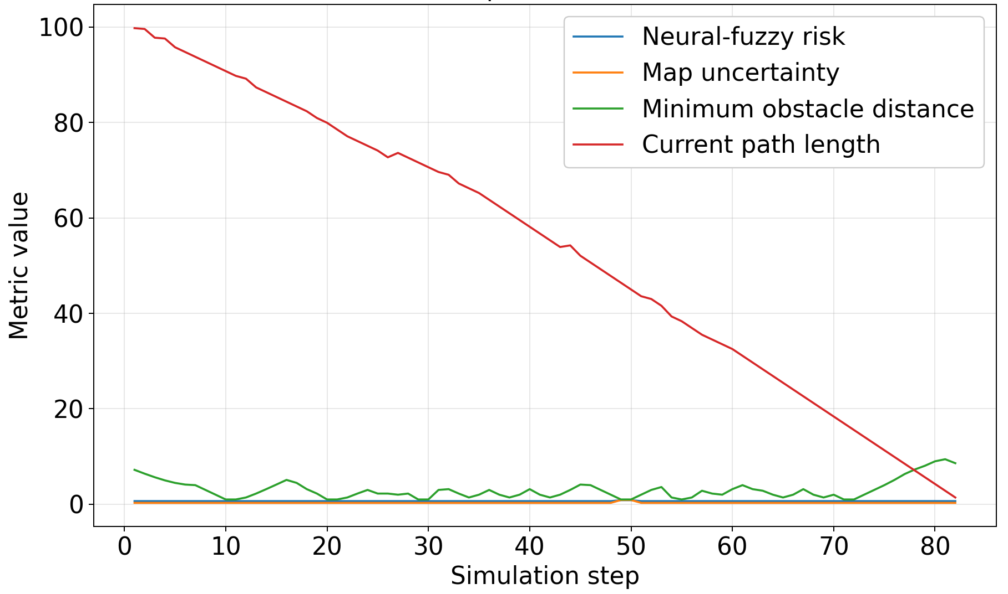
Fig. 6. Final experiment metric

Therefore, the simulation results confirm the operability and effectiveness of the NFR-DLP method for autonomous mobile robot route planning in an uncertain environment.

Conclusion
As a result of the research, a new method Neuro-Fuzzy Robot Route Planner D* Lite with Risk-Taking is presented. This method combines the D* Lite algorithm, neuro-fuzzy risk assessment and environmental uncertainty models to build safe routes for a mobile robot in real time. The proposed mathematical apparatus allows taking into account LiDAR sensor data, environmental features and limitations of EDGE devices such as ESP32-Cam when making navigation decisions. The proposed approach ensures the formation of a safe trajectory of movement taking into account risk, uncertainty and obstacle configuration, demonstrating stable navigation performance.
Thus, the simulation results confirm the efficiency of the method, its ability to adaptively replan the route, avoid obstacles and provide stable navigation performance under conditions of uncertainty. This indicates the prospects for using the developed approach in autonomous mobile robots, multi-robot systems, Industry 5.0 logistics platforms.
A promising direction for further research is the development of robotic systems to perform humanitarian tasks to neutralize dangerous objects, and the creation of intelligent robotic complexes that operate in dynamic environments.

References
- D. Damjanović, P. Biočić, S. Prakljačić, D. Činčurak, and J. Balen, “A comprehensive survey on SLAM and machine learning approaches for indoor autonomous navigation of mobile robots,” Machine vision and applications, vol. 36, no. 3, ID 55, 2025. doi: 10.1007/s00138-025-01673-0.
A. Waga, S. Benhlima, A. Bekri, J. Abdouni, and F. Z. Saber, “A survey on autonomous navigation for mobile robots: From traditional techniques to deep learning and large language models,” Journal of King Saud University Computer and Information Sciences, vol. 37, no. 7, ID 198, 2025. doi: 10.1007/s44443-025-00216-x.
- J. H. Baker, F. Laariedh, M. A. Ahmad, V. Lyashenko, S. Sotnik, and S. K. Mustafa, “Some interesting features of semantic model in Robotic Science,” SSRG International Journal of Engineering Trends and Technology, vol. 69, no. 7, pp. 38-44, 2021. doi: 10.14445/22315381/IJETT-V69I7P205.
- A. T. Abu-Jassar, H. Attar, A. Amer, V. Lyashenko, V. Yevsieiev, and A. Solyman, “Development and investigation of vision system for a small-sized mobile humanoid robot in a smart environment,” International Journal of Crowd Science, vol. 9, no. (1), pp. 29-43, 2025. doi: 10.26599/IJCS.2023.9100018.
- H. Sukri, and et al., “Enhanced Precision Control of a 4-DOF Robotic Arm Using Numerical Code Recognition for Automated Object Handling,” Journal of Robotics and Control (JRC), vol. 6, no. 1, pp. 315-335, 2025. doi: 10.18196/jrc.v6i1.24349.
- R. Matarneh, S. Maksymova, Z. Deineko, and V. Lyashenko, “Building robot voice control training methodology using artificial neural net,” International Journal of Civil Engineering and Technology, vol. 8, no. 10, pp. 523-532, 2017.
- A. T. Abu-Jassar, H. Attar, A. Amer, V. Lyashenko, V. Yevsieiev, and A. Solyman, “Remote monitoring system of patient status in social IoT environments using amazon web services technologies and smart health care,” International Journal of Crowd Science, vol. 9, no. 2, pp. 110-125, 2025. doi: 10.26599/IJCS.2023.9100019.
- W. Zhu and G. Qiu, “Path planning of intelligent mobile robots with an improved rrt algorithm,” Applied Sciences, vol. 15, no. 6, ID 3370, 2025. doi: 10.3390/app15063370.
- X. Fu, Z. Huang, G. Zhang, W. Wang, and J. Wang, “Research on path planning of mobile robots based on improved A* algorithm,” PeerJ Computer Science, vol. 11, ID e2691, 2025. doi: 10.7717/peerj-cs.2691.
- Q. Jiang, Y. Shen, H. Liu, Z. Khan, H. Sun, and Y. Huang, “A Hybrid Path Planning Algorithm for Orchard Robots Based on an Improved D*Lite Algorithm,” Agriculture, vol. 15, no. 15, ID 1698, 2025. doi: 10.3390/agriculture15151698.
- H. Wu, and et al., “Improved A∗+ D∗ Lite hierarchical framework path planning algorithm for heterogeneous sea ice scenarios,” Ocean Engineering, vol. 343, ID 123387, 2026. doi: 10.1016/j.oceaneng.2025.123387.
- Y. Luo, J. Tan, and Y. Han, “Global path planning method based on improved genetic algorithm,” Cluster Computing, vol. 29, no. 2, ID 76, 2026. doi: 10.1007/s10586-025-05870-4.
- V. Lyashenko, A. T. Abu-Jassar, V. Yevsieiev, and S. Maksymova, “Automated Monitoring and Visualization System in Production,” International Research Journal of Multidisciplinary Technovation, vol. 5, no. 6, pp. 9-18, 2023. doi: 10.54392/irjmt2362.
- L. Le, and T. D. Nguyen, “Enhancing the Robustness of Omnidirectional Mobile Robots using an Adaptive Neuro-Fuzzy Inference System-Based Proportional–Integral and Dynamic Surface Control Hybrid Controller,” Journal of Robotics and Control (JRC), vol. 7, no. 2, pp. 3542-3555, 2026. https://doi.org/10.18196/jrc.v7i2.29618
- Q. Li, and N. S. Ahmad, “Neural Network–Based Motion Control of Wheeled Mobile Robots: A Comprehensive Review,” IEEE Access, vol. 14, pp. 74494-74518, 2026. doi: 10.1109/ACCESS.2026.3693268.
- G. Malczyk, M. Kulkarni, and K. Alexis, “Reinforcement Learning for Active Perception in Autonomous Navigation,” arXiv preprint, arXiv:2602.01266, 2026. doi: 10.48550/arXiv.2602.01266.
- R. Deng, S. Ding, Y. Ding, M., Wang, X. Huang, and A. Usmani, “Autonomous navigation of non-perception firefighting robot through CCTV-informed vision sharing,” Expert Systems with Applications, vol. 296, ID 129210, 2026. doi: 10.1016/j.eswa.2025.129210.
- A. Abu-Jassar, H. Al-Sukhni, Y. Al-Sharo, S. Maksymova, V. Yevsieiev, and V. Lyashenko, "Building a Route for a Mobile Robot Based on the BRRT and A*(H-BRRT) Algorithms for the Effective Development of Technological Innovations," International Journal of Engineering Trends and Technology (IJETT), vol. 72, no. 11, pp. 294-306, 2024. doi: 10.14445/22315381/IJETT-V72I11P129.
- P.T.T. Nguyen, and et al., “Improving the Performance of Visual Odometry for Autonomous Navigation in Environments with Low Illumination and Uneven Terrain,” Int. J. Fuzzy Syst., vol. 28, pp. 66-84, 2026. doi: 10.1007/s40815-024-01930-w.
- J. Rakun, and G. Popič, “Optimized autonomous navigation for field robots: extended results and practical deployment,” Precision Agriculture, vol. 27, no. 1, ID 5, 2026. doi: 10.1007/s11119-025-10303-8.
- D. Morilla-Cabello, and E. Montijano, “CHORAL: Traversal-Aware Planning for Safe and Efficient Heterogeneous Multi-Robot Routing,” arXiv preprint, arXiv:2601.10340, 2026. doi: 10.48550/arXiv.2601.10340.
- P. Zhou, and et al., “Applying Ground Robot Fleets in Urban Search: Understanding Professionals' Operational Challenges and Design Opportunities,” arXiv preprint, arXiv:2602.04992, 2026. doi: 10.48550/arXiv.2602.04992.
- R. Stower, A. Gautier, M. Wozniak, P. Jensfelt, J. Tumova, and I. Leite, “Take a chance on me: how robot performance and risk behaviour affects trust and risk-taking,” In 2025 20th ACM/IEEE International Conference on Human-Robot Interaction (HRI), pp. 391-399, 2025. doi: 10.1109/HRI61500.2025.10973966.
- C. Stinkeste, A. W. Kempe, and G. Skantze, “Manners Matter: How Robot Politeness Influences Human Risk-Taking and Social Perception,” In 2025 34th IEEE International Conference on Robot and Human Interactive Communication (RO-MAN), 1025-1032), 2025. doi: 10.1109/RO-MAN63969.2025.11217830.
- S. Maheshwaran, P. S. Pakianathan, S. Munishwaran, P. I. Prabu, R. Gunadeep, and M. Manosurya, “IoT-Enabled Spy Robot with Landmine Detection using Esp32-Cam,” In 2026 International Conference on AI-Driven Smart Systems and Ubiquitous Computing (ICAUC), pp. 314-318, 2026. doi: 10.1109/ICAUC68182.2026.11441044.
- P. Chen, and et al., “A review of research on SLAM technology based on the fusion of LiDAR and vision,” Sensors, vol. 25, no. 5, ID 1447, 2025. doi: 10.3390/s25051447.
- B. Monroy, J. Bacca, and J. Tachella, “Generalized recorrupted-to-recorrupted: Self-supervised learning beyond gaussian noise,” In Proceedings of the IEEE/CVF Conference on Computer Vision and Pattern Recognition, pp. 28155-28164, 2025. doi: 10.1109/CVPR52734.2025.02622.
- C. Ho, and et al., “Mapex: Indoor structure exploration with probabilistic information gain from global map predictions,” In 2025 IEEE International Conference on Robotics and Automation (ICRA), pp. 13074-13080, 2025. doi: 10.1109/ICRA55743.2025.11128862.
- L. Achey, A. Reed, B. Crowe, B. Hayes, and C. Heckman, “Robust robotic exploration and mapping using generative occupancy map synthesis,” Autonomous Robots, vol. 50, no. 1, ID 8, 2026. doi: 10.1007/s10514-025-10229-0.
- A. Fernandes, H. Landaluce, and I. Angulo, “Real-time anomaly detection for industrial conveyors using multi-task deep learning and TinyML,” In AIP Conference Proceedings, vol. 3381, no. 1, pp. 050006, 2026. doi: 10.1063/5.0309148.
- M. Tri Lê, P. Wolinski, and J. Arbel, “Efficient neural networks for tiny machine learning: A comprehensive review,” ACM Transactions on Intelligent Systems and Technology, vol. 17, no. 4, pp. 1-41, 2026. doi: 10.1145/3798276.
- S. Alharthi, M. Rashid, and M. Aljabri, “TinyML in Industrial IoT: A Systematic Review of Applications, System Components, and Methodologies,” Sensors, vol. 26, no. 8, ID 2550, 2026. doi: 10.3390/s26082550.

