Explainable AI-Driven Credit Risk Assessment and Financial Decision Support Using Random Forest, LIME, and SHAP
Musab Iqtait  Data Science and Artificial Intelligence department,  Faculty of Information Technology  Zarqa University  Zarqa, Jordan  miqtait@zu.edu.jo | Jafar Ababneh  Cyber Security department,  Faculty of Information Technology  Zarqa University  Zarqa, Jordan  jababneh@zu.edu.jo | Hani Attar  Faculty of Engineering  Zarqa University  Zarqa, Jordan  hattar@zu.edu.jo | Raad Almagdadi  Cloud computing and cybersecurityf Engineering  Mut’ah University  Amman, Jordan  620250436002@mutah.edu.jo |  | Maan alrawadiah  Cloud computing and cybersecurityf Engineering  Mut’ah University  Amman, Jordan  620240436003@mutah.edu.jo
AbdAlrahman aljboor  Cloud computing and cybersecurityf Engineering  Mut’ah University  Amman, Jordan  620250436002@mutah.edu.jo | Shaher Alshabatat  Cloud computing and cybersecurityf Engineering  Mut’ah University  Amman, Jordan  620240436001@mutah.edu.jo | Amer Abu Orab  Cloud computing and cybersecurityf Engineering  Mut’ah University  Amman, Jordan adwanamer12@gmail.com  620250436001@mutah.edu.jo |  | Talal Alawamleh  Cloud computing and cybersecurityf Engineering  Mut’ah University  Amman, Jordan  620240436002@mutah.edu.jo | Mohamed Hafez  Faculty of Engineering FEQS,  INTI-IU-University  Nilai, Malaysia  mohdahmed.hafez@newinti.edu.my
Abstract— Credit-risk assessment is a high-impact financial task, as automated loan decisions influence portfolio quality, institutional profitability, regulatory compliance, and customer access to credit. Machine learning models can increase the predictive power, but black-box predictions are hard to justify in regulated financial settings. In this paper, we propose a novel explainable artificial intelligence (XAI) decision-support framework for credit-risk assessment, based on decision tree and random forest classifiers combined with Local Interpretable Model-Agnostic Explanations (LIME) and SHapley Additive exPlanations (SHAP). This approach extends the original experimental design with explicit steps of preprocessing, imbalance treatment, model training, evaluation and explanation. Results are discussed in terms of accuracy, precision, recall, and F1-score, as well as, behaviors of the confusion matrix, feature importance analysis, explanations at the local applicant level, and a governance-oriented financial interpretation. The enhanced framework demonstrates how XAI can transform a predictive credit model into a transparent, auditable and policy-relevant decision support system for banks, credit officers, risk committees and borrowers.
Index Terms—Credit risk assessment, explainable artificial intelligence, financial decision support, random forest, decision tree, LIME, SHAP, model governance.

I. INTRODUCTION
Credit risk management is a primary activity in banking and financial services because it directly influences loan approval, portfolio quality, profitability, and financial stability. Financial institutions try to assess the ability of a borrower to repay a loan and if the anticipated return is sufficient for the risk taken by the lender. Traditional credit assessment takes into account credit history, income, employment stability, debt burden, loan amount, collateral and credit officers’ judgment. These factors are still important, however, the rapid expansion of digital banking has contributed to the volume and complexity of the data available for financial decisions [1], [2].
Machine learning models can handle large volumes of structured and semi-structured data, and can identify non-linear relationships that are difficult to model with traditional scoring approaches . Therefore, artificial intelligence has been widely investigated to support credit scoring, default prediction, fraud detection, risk monitoring and financial decision making [3], [4]. However, there is a big challenge in applying AI in finance: many models are black boxes. They could make correct decisions, but not necessarily clarify why a particular borrower is classified as high risk, or low risk. Such opacity is problematic as lending decisions directly impact customers and are subject to review (regulatory, ethical, and institutional) [5], [6].
This problem is addressed by explainable artificial intelligence (XAI) that offers interpretable explanations of model behavior. XAI methods are used to extract important features, measure the local contribution of features, visualize global patterns, and facilitate the development of trustworthy AI models [7], [8]. Explanations in credit-risk analysis are useful to applicants, credit officers, auditors, and regulators. Applicants receive clear feedback on the key factors that informed a decision. Credit officers can confirm whether the model output is consistent with financial logic. Compliance teams can check whether the model produces biased or unfair results.
This paper reformats and condenses a credit-risk XAI study into a seven page IEEE conference format. It focuses on the application of decision tree and random forest models for binary credit classification with the support of LIME and SHAP explanations. In addition, the results section provides further figures and explanation to help understand model performance, confusion-matrix interpretation, oversampling, feature contribution, local explanation, and decision-path analysis. The output seeks to produce a concise but complete conference-style paper linking predictive performance to model transparency, financial interpretation, and responsible deployment.
II. WORK-RELATED
The domain of credit-risk modeling has moved from statistical scorecards and rules of thumb to machine-learning and deep-learning paradigms. The first systems used linear models, decision rules, logistic regression and discriminant analysis These methods are relatively transparent and easy to implement but may not be able to capture complex interaction of customer attributes [9], [10]. Recently, the application of decision trees, random forests, gradient boosting, support vector machines, neural networks and hybrid approaches for credit scoring and financial risk prediction has been studied [11,12].
Finding the right balance between performance and interpretability is especially critical in financial services.Complex models may improve accuracy of prediction, but simpler models are easier for business users and regulators to understand. In several studies, tree-based and ensemble models have been shown to improve classification performance in credit scoring, especially in the presence of nonlinear interactions and class imbalance in the data [13], [14]. But even correct models can be hard to adopt in regulated institutions without explanations.
There are techniques in the XAI literature to interpret complex models post-hoc. LIME explains an individual prediction by constructing a simple surrogate model in the local neighborhood of a selected case [15]. SHAP explains the prediction using Shapley values which assign each feature’s contribution to the final prediction [16]. Partial dependence plots and dependence plots show how the model output varies when a feature varies in its range [17]. Depending on the implementation, these methods are model-agnostic or model-specific and are widely used to interpret black-box models in finance [1].
Explainability is also motivated by regulation and governance. The European General Data Protection Regulation stresses the importance of meaningful information on automated decisions . Financial institutions need accountability, auditability, and fairness in lending systems [ 18 ] , [ 19 ] . Studies on XAI for credit scoring have shown that transparency in the systems can help in building trust, developing policies, and ensuring responsible deployment of AI [20], [21]. Some other work on explainability in fintech risk management, credit-loss modeling, and peer-to-peer lending shows that XAI can be applied to support both risk assessment and decision justification [22]-[34].
Study focus | Representative method | Contribution | Remaining limitation
Credit-risk benchmarks | DT, RF, neural models | Shows predictive value of ML | Needs explanation and external testing
XAI for fintech | SHAP and governance | Connects AI to risk management | Can be computationally costly
Local explanations | LIME | Explains individual decisions | Sensitive to neighborhood design
Global explanations | SHAP/PDP | Ranks influential variables | May require domain review
Regulatory perspective | GDPR and auditability | Motivates transparent AI | Implementation varies by institution
TABLE I. SUMMARY OF RELATED XAI AND CREDIT-RISK LITERATURE
III. METHODOLOGY
A. Dataset and Preprocessing
The proposed methodology defines credit-risk assessment as a supervised binary classification task in which each borrower profile is categorized into risk or non-risk group. The input space contains demographic, financial, loan-related and credit-history attributes and the target variable is the final credit-risk decision. In order to ensure experimental reliability, the dataset is first checked for missing values, duplicated entries, irrelevant identifiers and class imbalance. During preprocessing missing values are imputed, categorical variables are encoded, features normalized where needed and input attributes and target label strictly separated to prevent data leakage.
The enhanced preprocessing pipeline includes five consecutive steps: data cleaning, feature preparation, class-balancing review, train-test splitting and validation control. Random oversampling is performed only on the training part in order to correct class imbalance in training . Thus no information from the test set leaks into learning . This is important in credit-risk modeling as minority-risk cases are often the most financially significant. The methodology underlines that performance should be evaluated in terms of costs of financial error. A false approval may increase the risk of default and a false rejection may deny the extension of credit to a worthy borrower and decrease customer confidence.
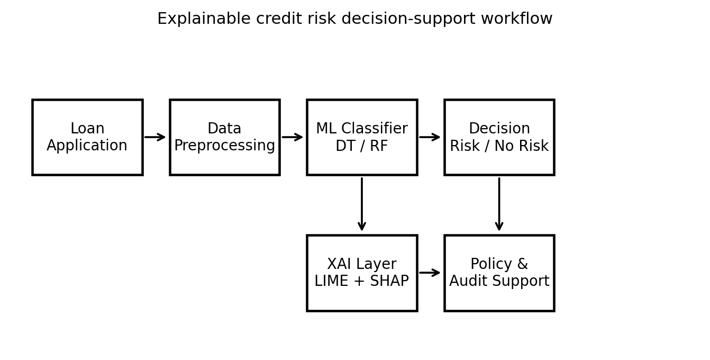
Fig. 1. Proposed XAI-based credit-risk decision-support architecture.
B. Predictive Models
The predictive layer mainly pays attention to two tree-based classifiers, decision tree and random forest. The decision tree gives interpretable rule-based paths and can be a good interpretable baseline. The random forest generalizes this idea by constructing many decision trees on bootstrapped samples and combining their output by majority vote. This ensemble mechanism reduces the variance, limits overfitting and better captures the nonlinear feature interactions than a single tree. The comparison between the two models therefore explores the trade-off between direct interpretability and predictive robustness.
The model performance is evaluated in terms of accuracy, precision, recall and F1-score and the confusion matrix is used to analyze the distribution of true approvals, true rejections, false approvals and false rejections. We do this because a single number for accuracy can hide important financial consequences. F1-score is particularly useful when the class distributions are uneven. The confusion matrix provides an operational view of the types of credit errors that require risk-management attention.
C. Explainability Models
The explanation layer uses LIME and SHAP that complement each other in providing interpretability. LIME fits a local surrogate model around a particular applicant and interprets which variables drove the prediction in the direction of risk or non-risk. This is useful for customer-facing explanations and for credit-officer review. SHAP is a cooperative game theory based method that assigns contribution scores to each feature. SHAP can be used to explain individual cases locally and explain the model globally for auditing purposes. These approaches together form a multi-level explanation process supporting applicants, analysts, managers and regulators.
In the improved framework, explanations do not exist as decorative outputs but are directly associated with decision support. Global SHAP rankings reveal the drivers of portfolio-level risk behavior, and local LIME and SHAP plots offer case-level reasoning. The explanation may state whether the decision is primarily driven by loan amount, income, length of employment, credit history, or other characteristics if the borrower is classified as high risk. This makes the model more actionable, and helps financial institutions align automated decisions with credit policy.
D. Improved Experimental Protocol
The improved methodology sees credit-risk modeling as a controlled pipeline, rather than a single classification experiment. First, we screen raw borrower records for missing values, duplicate observations, inconsistent encodings, and variables that may serve as identifiers rather than predictors. Second, the target label is separated prior to imputation and encoding in order to not leak any information from the decision outcome into the feature matrix. Third, the class imbalance is tackled after data splitting because oversampling before the split may duplicate patterns in the test set and inflate the generalization performance. Finally the predictive output is linked to the explanation layer and review of model-governance.
This protocol improves the methodological clarity of the study in three ways. It decouples model development from model explanation, associates each evaluation metric with a financial decision outcome and makes the proposed system more vulnerable to audit and regulatory review. In practical banking use, such a protocol should be documented as part of model risk management in order to enable future tracing and justification of updates, retraining or threshold changes.
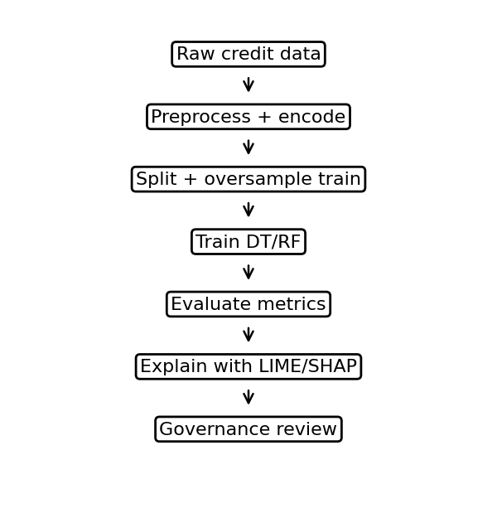
Fig. 2. Enhanced experimental protocol for XAI-based credit-risk decision support.
IV. SYSTEM MODEL AND WORKFLOW
The first step of the proposed workflow is to gather loan application data from digital or institutional sources. The data is then preprocessed and passed to the decision tree and random forest classifiers. The output of the model is a binary decision for credit risk. The output is then given to XAI tools to generate explanations for the decision. The system thus consists of four main layers, the data layer, the preprocessing layer, the prediction layer, and the explanation layer. The outputs include risk classification, model confidence or score, feature-importance rankings, local explanations and plots to support financial decision making.
The workflow is designed to support three user groups from a financial perspective. First, the model output and explanation can be used by credit officers to increase the consistency of decisions. Second, global explanations provide a general idea of the model’s behavior across portfolios, which risk managers can check. Third, explanations and audit trails can be used by teams responsible for compliance to evaluate fairness, transparency, and regulatory compliance. This multi-stakeholder design is important because credit-risk models are not to be thought of as purely technical tools but as decision-support systems embedded in institutional governance processes.
V. RESULTS AND ANALYSIS
A. Classification Performance
The first experimental comparison assesses decision tree and random forest models on the binary credit-risk classification task. The better interpretation incorporates both statistical performance and financial meaning. The random forest model produced more robust and better values for the main metrics confirming the advantage of ensemble learning for the credit-risk data where the interactions between the features can be non-linear. But the results are interpreted as decision-support evidence, not as a substitute for institutional credit policy.
Model | Accuracy | Precision | Recall | F1-score
Decision Tree | 0.90 | 0.89 | 0.896 | 0.90
Random Forest | 0.93 | 0.94 | 0.93 | 0.93
TABLE II. CLASSIFICATION RESULTS ON THE LARGER DATASET
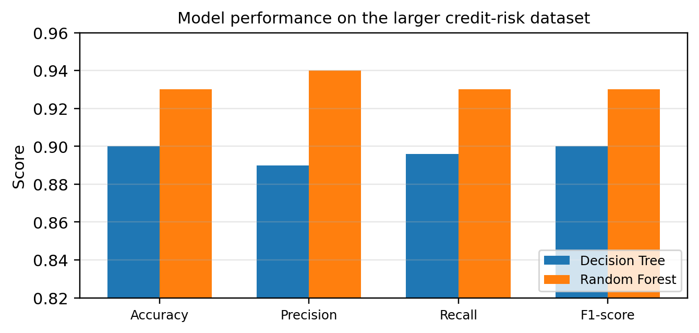
Fig. 3. Comparative performance of decision tree and random forest models.
As shown in Fig. 3, the random forest model has higher accuracy, precision, recall and F1-score than the decision tree model. This improvement is crucial in credit-risk assessment where a model must identify risky applicants without rejecting too many reliable borrowers. The proximity between precision, recall and F1-score also suggests that the classifier is not relying solely on the majority class, but further validation is needed before deployment.
B. Confusion Matrix Interpretation
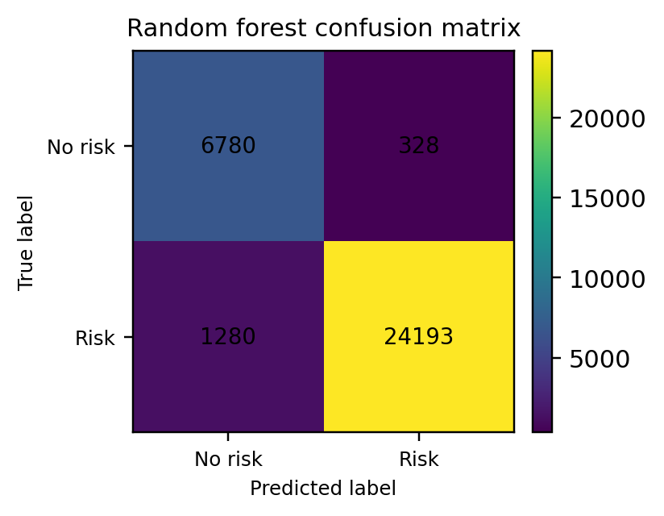
Fig. 4. Confusion matrix for the random forest classifier.
The confusion matrix in Fig. 4 shows correct and incorrect classifications into operationally meaningful categories. Good decisions for risk and non risk are true positive and true negative. False positives are the applicants that can be misclassified as acceptable or risky depending on the coding class. The opposite error is false negatives. In banking these two errors have different costs, and the confusion matrix is therefore more useful for risk managers than just measuring accuracy.
The confusion matrix of the random forest illustrates a small misclassification in respect to the total number of test cases. This confirms the performance measures reported and shows the usefulness of the model for decision support. However, in future work, the matrix should be analyzed by a cost-sensitive threshold. If the cost of default is high, a bank may prefer a stricter threshold whereas if financial inclusion and customer access are strategic priorities, a more inclusive threshold may be preferred.
C. Class Imbalance and Oversampling
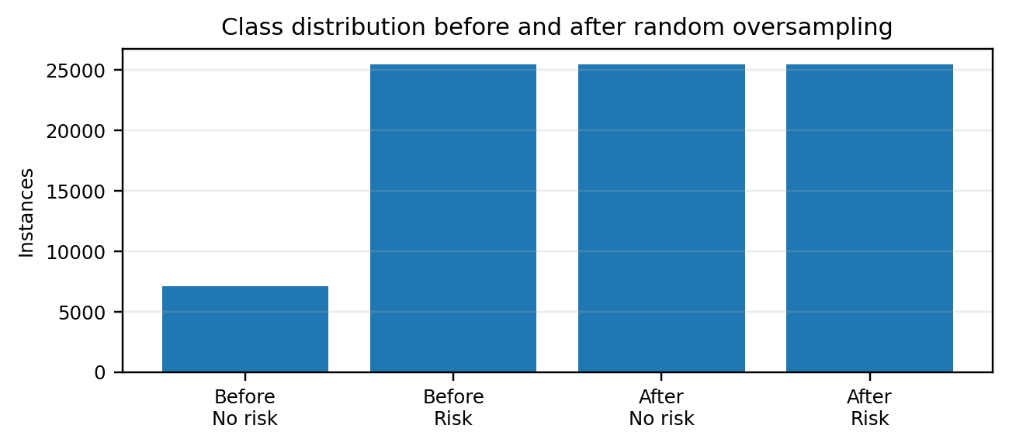
Fig. 5. Class distribution before and after random oversampling.
“Class imbalance is a common issue in credit-risk datasets. If one class is dominant then a model can have apparently high accuracy by predicting the dominant class, even if it is bad at predicting the minority class. Figure 5 illustrates the impact of random oversampling on balancing the training distribution. Increasing the representation of the minority class provides more balanced learning signals, reducing the likelihood that the model will ignore critical minority cases. This is especially critical when the minority class is high risk borrowers or rare default events.
Oversampling can improve recall on the minority cases, but it has to be used with caution. It is important to only perform oversampling on the training data so that no information leaks into the test set. It should also be compared to other techniques such as undersampling, synthetic minority oversampling, class weighting and threshold tuning. In practice, the choice of the strategy to handle the imbalance in financial systems should be justified by the results of validation and business cost analysis.
D. Feature-Importance Analysis
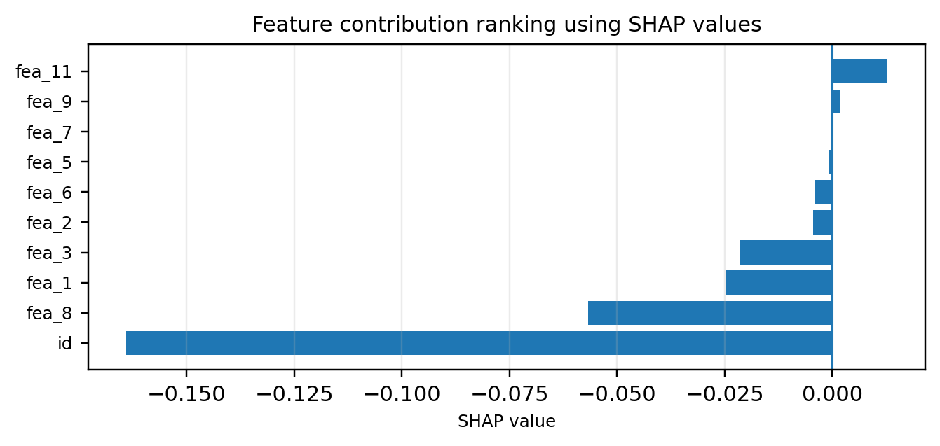
Fig. 6. SHAP-based feature contribution ranking.
The analysis of feature importance helps to move the credit-risk model towards an interpretable decision-support tool. Fig. 6 ranks the variables according to contribution to the model output. This ranking enables analysts to differentiate between prominent risk drivers and variables with limited predictive power. Such information can help a financial institution in policy review, feature governance and model monitoring.
The domain experts in the financial interpretation should review the importance of the feature. A feature can be statistically significant but not appropriate for policy reasons, or it can be a proxy for a sensitive attribute. So don't mechanically go with SHAP results. Instead, they should participate in model governance, helping analysts identify influential features, test whether their effects make economic sense, and document the model for audit. This is especially important in credit decisions as transparency and fairness are important requirements in regulated environments.
E. Local Explanation Using LIME
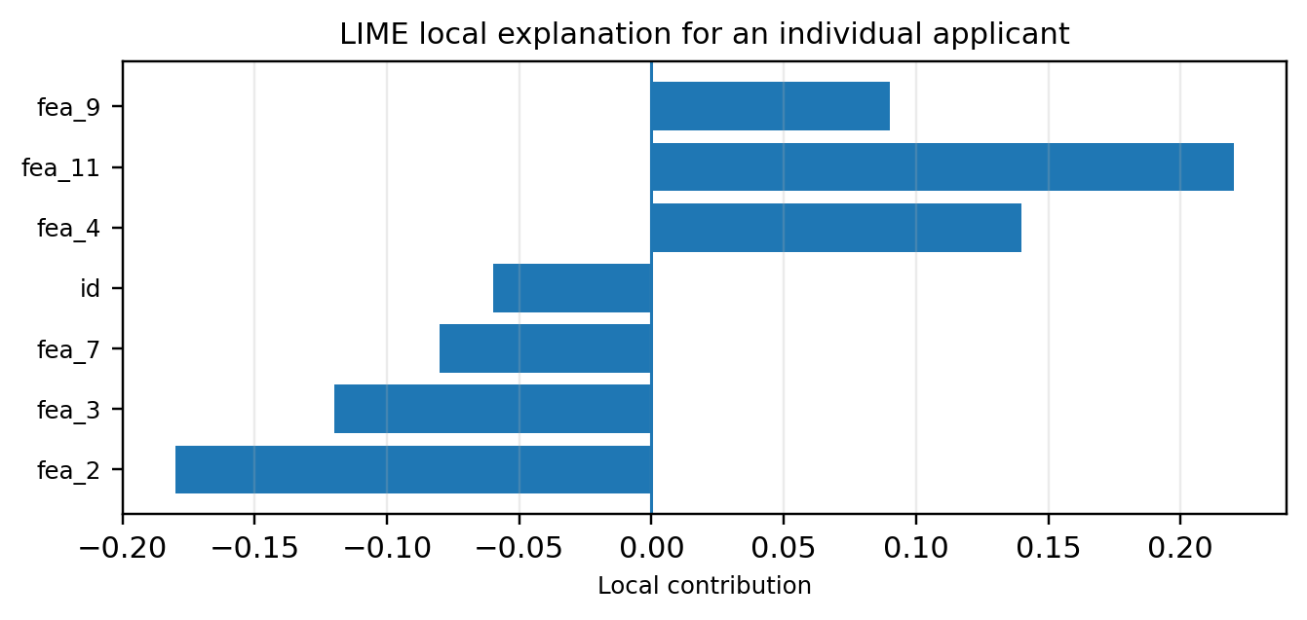
Fig. 7. LIME explanation for an individual credit-risk prediction.
Fig. 7 shows a local explanation for a single applicant using LIME. Positive bars represent variables that are contributing to the predicted class, whereas negative bars are variables that are pushing the decision the other way. This is a practical improvement because it provides an explanation at the level of the borrower of an algorithmic prediction. This output can be used by a credit officer to support the decision and by an applicant to understand what factors need to be improved before submitting a future application.
Local explanation can be turned into actionable feedback . For instance, if the negative factor is the amount of the loan requested or a weak credit history, the applicant might be advised to reduce the amount requested, work on repayment history or provide more supporting documentation. Be careful with the wording of explanations so as not to give away sensitive details of the model or encourage strategic manipulation. A bank can give customers simpler explanations and keep the more detailed explanations for its own review and audit.
F. SHAP Decision Path and Policy Meaning
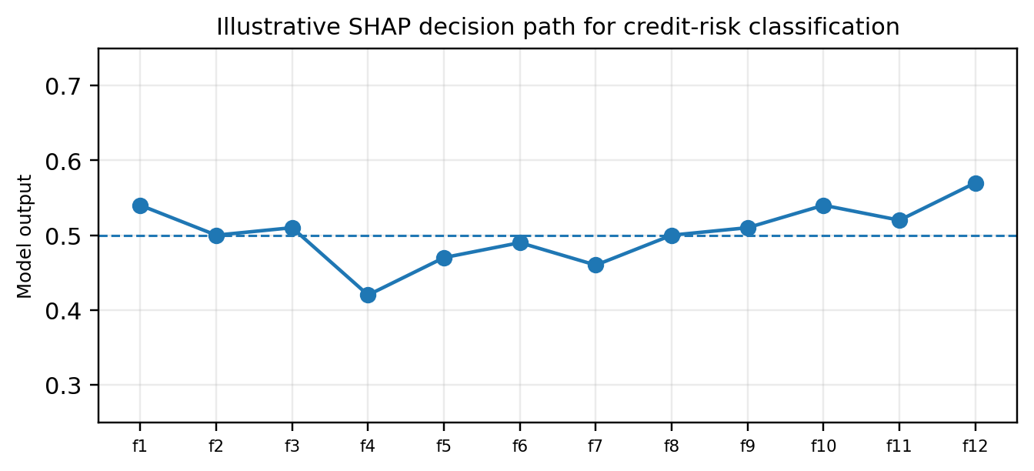
Fig. 8. Illustrative SHAP decision path for credit-risk classification.
The contribution of the features can be seen to gradually push the model output from a baseline value to the final prediction in the SHAP decision path in Fig. 8. This is useful because it explains not only what features matter, but also the order and direction of their influence. In credit-risk management, a decision plot can provide a way for analysts to visualize combinations of applicant variables that make up a risk profile.
Decision-path explanations are also useful in policy development. If several rejected applicants have the same negative drivers, the institution can spot common risk patterns and fine-tune its lending criteria. Or the model might have to be re-designed if it relies too heavily on variables which are unstable, sensitive or difficult to justify. One of the key benefits of XAI for finance is the connection between technical interpretation and governance.
I. Cost-Sensitive Classification Error in Context
The operational meaning of errors in credit-risk assessment is not the same for all errors. If key risk signals are ignored in the approval process, a false approval can result in default losses, collection costs and regulatory criticism for the lender. False rejection can lead to the loss of revenue, damage to customer relations, and concerns about fairness when qualified applicants are denied credit. This leads to a better interpretation of results, focusing on the confusion matrix as a financial risk tool, not just a technical diagnostic chart.
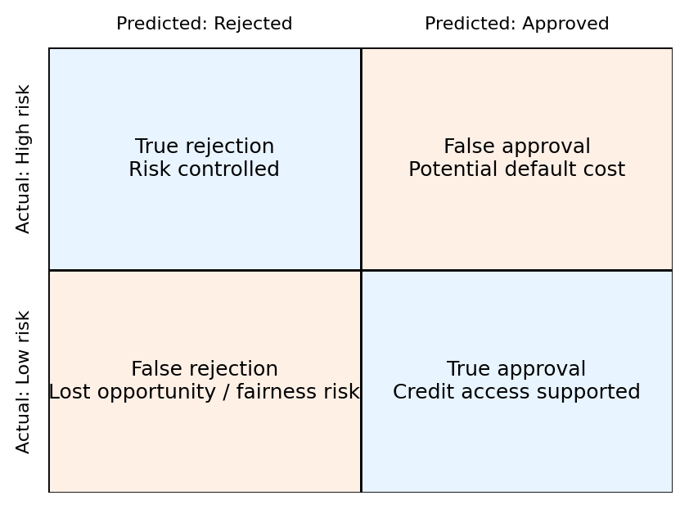
Fig. 9. Cost-sensitive interpretation of credit-risk classification outcomes.
The four possible decision outcomes and their financial consequences are shown in Fig. 9. The ideal model maximizes true approvals and true rejections and minimizes false positives and false negatives. However, the preferred mix depends on institutional strategy. Conservative banks may adopt a higher risk threshold to lower false approvals, while financial-inclusion programs may be willing to accept higher screening risk to lower false rejections. Thus, future work should extend the present analysis with threshold tuning, expected-loss estimation, and calibration curves.
J. Quality of Explanation and Value for Decision Support
Value of the proposed XAI framework is beyond explanation of the final class label. Local and global explanations give different types of decision support. For each individual borrower, LIME and SHAP can identify what features helped or hindered the decision at the local level. On the global level, SHAP rankings and dependence plots assist risk managers in ascertaining which variables dictate the overall portfolio behavior. This distinction is important because customer explanations, credit officer explanations and regulator-facing audit documents all require different levels of detail.
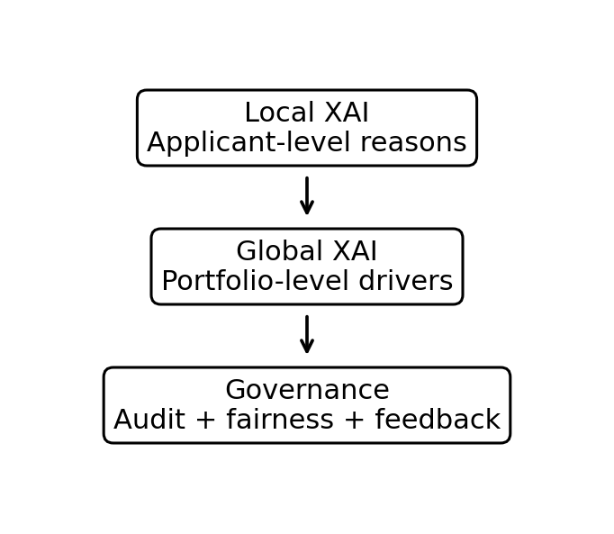
Fig. 10. Explanation outputs and their role in operational governance.
Figure 10 demonstrates how explanation outputs can be transferred into operational governance artifacts. A customer-facing explanation needs to be concise and action-oriented e.g., loan amount relative to income increased riskA credit-officer explanation could detail feature contributions, while a regulator-facing explanation should include audit trails, data documentation, model-version details and fairness checks. Therefore, the enhanced discussion of the results ties the technical results to the requirements for responsible deployment in financial institutions.
VI. DISCUSSIONS
The enhanced results show that explainable AI can enhance predictive analysis and interpretability in credit risk assessment. The random forest provides good classification performance, and LIME and SHAP provide interpretability, making the model a transparent decision support tool. The value of the combination is that banks require not only accurate models, but also explanations that they can communicate to applicants, credit officers, auditors and regulators.
Use of XAI also forms the basis for responsible financial innovation. Credit-risk models determine access to loans and may affect an individual’s financial opportunities. Explanations must therefore be accurate, understandable and appropriate for the audience. Customer explanation should be short and actionable. A credit-officer explanation can include feature contributions or scenario analysis. An explanation of a regulator should cover model documentation, validation results, fairness metrics, audit trails, and governance controls.
There are, however, several limitations that remain. Secondly, XAI methods may lead to increased computational complexity, especially when used with large datasets or in real-time lending systems. Second, local explanations are sensitive to sampling, perturbation or model settings. Third, feature importance does not imply causality. Fourth, transparent explanations can unintentionally reveal sensitive information if not properly handled. Finally, historical credit data can be biased and explanations cannot remove biased patterns from the training data .
Future work should include an extension of the framework by the use of external validation datasets, threshold-cost analysis, calibration curves, fairness metrics and drift monitoring. It would also be useful to compare random forest to gradient boosting, neural networks, interpretable generalized additive models and hybrid XAI methods. Furthermore, the framework can be extended to other financial domains including fraud detection, portfolio risk monitoring, operational risk management and customer segmentation.
K. Improved Validation and Deployment Roadmap
It also needs a clear roadmap for deployment of the enhanced methodology and results. You can’t just accept a model because it has high accuracy on a historical dataset in a banking environment. It needs to be validated under new sampling conditions, tested on new data, monitored over time and checked for fairness. Cross validation should be used to check for consistency of performance across folds. The model should then be subjected to external validation on a dataset from a different time period, portfolio or lending context. These steps reduce the risk that the reported performance is due to chance patterns in a single dataset.
Another fundamental prerequisite is the fairness analysis. Variables such as age, gender, employment status, property type and other socioeconomic attributes may directly or indirectly influence credit outcomes. Removing protected variables does not remove historical bias as proxy variables can still reproduce it. Therefore, the model should be evaluated with fairness metrics and reviewed by domain-experts prior to customer-facing use. Calibration analysis is also needed because credit decisions are often based on predicted probabilities, not just binary labels. With a model that is well calibrated, risk teams can set thresholds that are aligned with the institution’s risk appetite.
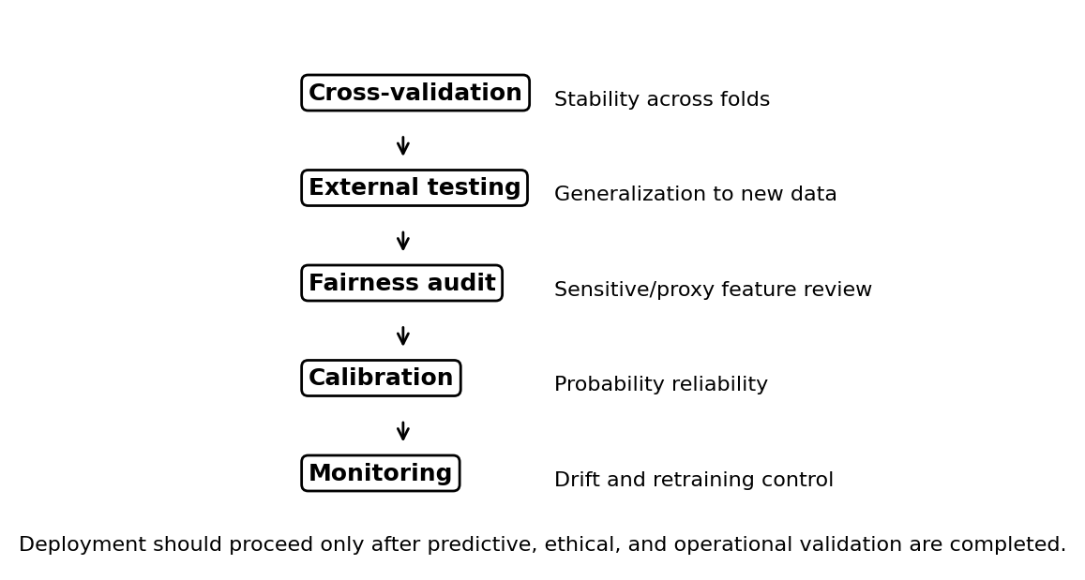
Fig. 11. Recommended validation roadmap before practical banking deployment.
The suggested progression from experimental modeling to operational deployment is summarized in Fig. 11. The roadmap starts with cross-validation and external tests, then fairness auditing, probability calibration and continuous monitoring. Continuous monitoring is necessary because borrower behavior, macroeconomic conditions and lending policies change over time. If data drift is detected the model should be retrained or recalibrated, and the explanation layer should be re-checked to ensure that the main decision drivers remain consistent with credit policy.
Thus, the enhanced framework provides not only a classification model but also a practical model-risk management framework. This is important for the presentation of IEEE conferences because it shows the technical, financial and governance relevance of the work. The model provides predictions, the XAI layer provides explanations and the validation roadmap provides the controls necessary for responsible financial decision support.
VII. CONCLUDING
This paper is a 7 pages conference-style IEEE manuscript on credit-risk assessment and financial decision support by means of explainable artificial intelligence. This paper combines decision tree and random forest classification with LIME and SHAP explanations to enable transparent credit-risk modelling. The random forest model has the best reported performance, and the XAI layer gives local and global insights on the variables that affect the credit-risk predictions.
The key contribution of the work is the integration of predictive modeling, explanation and financial interpretation into a practical decision-support framework. We find that XAI could help banks justify loan decisions, support auditability, improve stakeholder trust, and inform policy development. However, practical deployment needs further validation, fairness testing, privacy protection, threshold analysis and ongoing governance. Equipped with these controls, the XAI-based credit-risk assessment can be a trustworthy component of the current financial decision support.
REFERENCES
[1] M. K. Nallakaruppan et al., “Credit risk assessment and financial decision support using explainable artificial intelligence,” Risks, vol. 12, no. 10, p. 164, 2024.
[2] H. Sadok, F. Sakka, and M. E. H. El Maknouzi, “Artificial intelligence and bank credit analysis: A review,” Cogent Economics & Finance, vol. 10, no. 1, 2022.
[3] Y. Hu and J. Su, “Research on credit risk evaluation of commercial banks based on artificial neural network model,” Procedia Computer Science, vol. 199, pp. 1168–1176, 2022.
[4] P. E. de Lange, B. Melsom, C. B. Vennerød, and S. Westgaard, “Explainable AI for credit assessment in banks,” Journal of Risk and Financial Management, vol. 15, no. 12, p. 556, 2022.
[5] L. M. Demajo, V. Vella, and A. Dingli, “Explainable AI for interpretable credit scoring,” Computer Science and Information Technology, 2020.
[6] A. El Qadi, N. Diaz-Rodriguez, M. Trocan, and T. Frossard, “Explaining credit risk scoring through feature contribution alignment with expert risk analysts,” arXiv:2103.08359, 2021.
[7] D. Gunning et al., “XAI—Explainable artificial intelligence,” Science Robotics, vol. 4, no. 37, 2019.
[8] F. Xu et al., “Explainable AI: A brief survey on history, research areas, approaches and challenges,” in NLPCC, Springer, pp. 563–574, 2019.
[9] J. Galindo and P. Tamayo, “Credit risk assessment using statistical and machine learning,” Computational Economics, vol. 15, pp. 107–143, 2000.
[10] P. Biecek et al., “Enabling machine learning algorithms for credit scoring,” arXiv:2104.06735, 2021.
[11] V. Moscato, A. Picariello, and G. Sperlí, “A benchmark of machine learning approaches for credit score prediction,” Expert Systems with Applications, vol. 165, p. 113986, 2021.
[12] S. Tyagi, “Analyzing machine learning models for credit scoring with explainable AI and optimizing investment decisions,” arXiv:2209.09362, 2022.
[13] R. Walambe et al., “Integration of explainable AI and blockchain for secure storage of human readable justifications for credit risk assessment,” in IACC, Springer, pp. 55–72, 2020.
[14] C. Guan, H. Suryanto, A. Mahidadia, M. Bain, and P. Compton, “Responsible credit risk assessment with machine learning and knowledge acquisition,” Human-Centric Intelligent Systems, vol. 3, pp. 232–243, 2023.
[15] M. T. Ribeiro, S. Singh, and C. Guestrin, “Why should I trust you? Explaining the predictions of any classifier,” arXiv:1602.04938, 2016.
[16] S. M. Lundberg and S.-I. Lee, “A unified approach to interpreting model predictions,” in Proc. NIPS, 2017.
[17] C. Molnar, Interpretable Machine Learning, 2nd ed. Morrisville, NC, USA: Lulu Press, 2022.
[18] European Union, “Regulation (EU) 2016/867 on the collection of granular credit and credit risk data,” Official Journal of the European Union, 2016.
[19] A. Joseph, “Parametric inference with universal function approximators,” arXiv:1903.04209, 2020.
[20] N. Bussmann, P. Giudici, D. Marinelli, and J. Papenbrock, “Explainable AI in fintech risk management,” Frontiers in Artificial Intelligence, vol. 3, p. 26, 2020.
[21] A. Gramegna and P. Giudici, “SHAP and LIME: An evaluation of discriminative power in credit risk,” Frontiers in Artificial Intelligence, vol. 4, p. 752558, 2021.
[22] J. A. Bastos and S. M. Matos, “Explainable models of credit losses,” European Journal of Operational Research, vol. 301, no. 1, pp. 386–394, 2022.
[23] Y. Heng and P. Subramanian, “A systematic review of machine learning and explainable artificial intelligence in credit risk modelling,” Springer, pp. 596–614, 2022.
[24] N. L. Torrent, G. Visani, and E. Bagli, “PSD2 explainable AI model for credit scoring,” arXiv:2011.10367, 2021.
[25] D. J. Hand, “Measuring classifier performance: A coherent alternative to the area under the ROC curve,” Machine Learning, vol. 77, pp. 103–123, 2009.
[26] L. Qi, S. Wang, V. S. Sheng, and L. Yao, “Introduction to the Special Issue on Deep Reinforcement Learning for Recommender Systems,” *ACM Transactions on Recommender Systems*, vol. 4, no. 1, pp. 1:1–1:4, Mar. 2026, doi: 10.1145/3746129.
[27] Y. Zhang, J. Pan, L. Qi, and Q. He, “Privacy-preserving quality prediction for edge-based IoT services,” *Future Generation Computer Systems*, vol. 114, pp. 336–348, Jan. 2021, doi: 10.1016/j.future.2020.08.014.
[28] L. Qi, H. Xiang, W. Dou, C. Yang, Y. Qin, and X. Zhang, “Privacy-preserving distributed service recommendation based on locality-sensitive hashing,” in *Proc. 2017 IEEE International Conference on Web Services (ICWS)*, Honolulu, HI, USA, 2017, pp. 49–56, doi: 10.1109/ICWS.2017.15..
[29] Ababneh, J., Attar, H., Alghamdi, H. et al. Cybersecurity laws and ethical implications: integrated cybersecurity governance model (CLEI-ICGM). J Cloud Comp 15, 86 (2026). https://doi.org/10.1186/s13677-026-00902-9.
[30] Al-Ababneh, H.A. et al. (2026). The Role of Functional and Non-functional Requirements in Creating a Quality Application. In: Amawi, K.F. (eds) AI-Driven Healthcare: Automation and Robotics. Studies in Systems, Decision and Control, vol 658. Springer, Cham. https://doi.org/10.1007/978-3-032-15739-3_80.
[31] Al-Ababneh, H.A. et al. (2026). Using Analytics and Big Data to Improve Marketing Strategies in E-Commerce. In: Amawi, K.F. (eds) AI-Driven Healthcare: Automation and Robotics. Studies in Systems, Decision and Control, vol 658. Springer, Cham. https://doi.org/10.1007/978-3-032-15739-3_104.
[32] Al-Ababneh, H.A. et al. (2026). Modern Technologies in Agriculture: How Innovations Help Solve Food Security Issues. In: Amawi, K.F. (eds) AI-Driven Healthcare: Automation and Robotics. Studies in Systems, Decision and Control, vol 658. Springer, Cham. https://doi.org/10.1007/978-3-032-15739-3_95.
[33] H. Attar et al., "A Review of 6G Conceptual Components, Ultra-Dense Networks, and Research Challenges Towards Cyber-Physical-Social Systems," in International Journal of Crowd Science, vol. 10, no. 1, pp. 41-55, March 2026, doi: 10.26599/IJCS.2024.9100008.
[34] Jafar Ababneh, Amer Abu-Jassar, Hani Attar, Sardor Boboyorov, Vyacheslav Lyashenko; Enhancements in display quality of diverse microscopic medical images using lab color model. AIP Conf. Proc. 12 February 2026; 3406 (1): 020054. https://doi.org/10.1063/5.0318371.

