Coexistence of AI Generations: Lessons from Mobile Network Evolution and Their Security Implications

Dr. Nataraju A B¹, Prasenjit Das², Ranjit Avasarala³, Dr. Hariprasad S A⁴
¹ Department of ECE, Acharya Institute of Technology, Bangalore, INDIA
² Co-Founder, CINQUENETWORK PRIVATE LIMITED , Bangalore, INDIA
³ Senior Product Architect, Nokia, Naperville, IL USA
⁴ Chief Executive Officer, Mysore Education Society, Bangalore, INDIA
{nataraju.ab, prasenjitpdas, harisetjain}@gmail.com, ranjit.avasarala@nokia.com,

Abstract: Telecom taught the world how to run heterogeneous generations in parallel for decades (1G–5G and beyond). This paper formalizes that analogy for artificial intelligence (AI), where rule‑based, statistical/ML, deep learning, foundation models, and agentic systems will coexist for the foreseeable future. We make five contributions: (1) a formalized mapping between coexistence phenomena in mobile networks and AI multi‑version ecosystems; (2) a layered architecture for version‑aware AI orchestration with capability negotiation and sandboxed execution; (3) two analytical risk models quantifying interoperability and security exposure under coexistence; (4) a structured threat analysis with attack paths unique to cross‑model and cross‑agent amplification; and (5) a quantitative evaluation protocol encompassing semantic drift, safety policy violation rates, and change‑failure risk during phased upgrades. We detail engineering and governance controls that mirror proven telecom practices (multi‑RAT, phased migration, telemetry‑driven operations) which can help multi variant AI systems.
Index Terms : Ai Coexistence, Agentic Ai, Multi‑Model Orchestration, Telecom Evolution, Interoperability, Security, Phased Migration

- INTRODUCTION
Mobile networks are one of the killer technologies invented during the 19th century, they have evolved in a big way in a short span of time. The enhancements have their own pros and cons. We will understand the evolution of mobile networks, Intelligent Networks, Artificial Intelligence systems then we will understand the pros and cons of their co-existence and ways to counter the problem posed. Here is the organization of the paper.

  - Evolution of Mobile Networks: From 1G to 5G and Beyond [1][2][3]
Mobile networks enable wireless communication between users, devices, and services using radio signals. Their evolution is marked by generational shifts, each introducing new technologies, higher data rates, enhanced spectrum efficiency, and improved user experiences. This document summarizes the major characteristics and technological advancements across each generation.

Below is the evolution of mobile networks by Generation

Table 1: Mobile network evolution [14]
Gen | Year | Salient features
1G | 1980 | Analog voice calls, basic mobile communication
2G | 1990 | Digital voice, SMS, Early data services
3G | 2000 | Mobile data, Internet access and multimedia
4G | 2010 | High-speed internet, streaming, app ecosystem, packet switched
5G | 2020 | Ultra-fast speeds (eMBB), massive IoT (mMTC), low-latency and network slicing
6G | 2030 | AI-Native, hyper-adaptive, supporting holographic communication, digital twins, ubiquitous sensing, integrating physical and digital worlds [15]

The rest of the paper is organized as follows: Security and interoperability analysis, Evolution of Intelligence Networks (IN), Evolution of Artificial Intelligence (AI) systems, Convergence of IN and AI systems and contributions of this study. Section II talks about the similarity between coexistence of mobile networks and AI systems. Section III talks about consequences of coexistence of multiple generations of mobile networks, Section IV lists out probable issues one can expect when multiple generations of AI systems coexist. Section V lists out key learnings from mobile networks’ deployment which may help AI system deployment considering coexistence is inevitable. Section VI lists out recommendations for policy makers, customers, and Technology organizations to embrace AI coexistence [4] and its evolution.

  - Security and interoperability analysis
STRIDE Threats: Spoofing (model/agent identity), Tampering (prompt‑injection via adapters), Repudiation (missing traces), Information Disclosure (cross‑model leakage), Denial of Service (orchestrator overload), Elevation of Privilege (agentic overreach).
Comparative Risk by Generation: Rule‑based (Low surface, Medium interop risk); Classical ML (Medium/Medium); Deep Learning (Medium–High/Medium); Foundation Models (High/High); Agentic Systems (Very High/Very High).
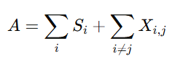

Attack‑Surface Equation:
- A – Total attack surface of the system
- S_{i} ​ – Intrinsic attack surface contributed by component i
Example: APIs, open ports, authentication mechanisms, memory exposure
- X_{i,j}​ – Cross-component interaction vulnerabilities between components i and j
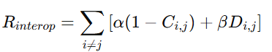
The total attack surface is not only the sum of individual components, but also the interaction complexity between them
Interop Risk:

- C_{i,j}​ – Compatibility score between components i and j
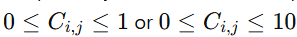
Range::

Semantic or protocol divergence
- α – weight for incompatibility risk
- β – weight for divergence risk

Guardrail–Amplification Trade‑off:
- define g = guardrail strength (filters, policies, safety checks)
- K(g) = action fan-out under adversarial prompts
(how many actions a malicious input can trigger)
- U(g) = usability

Hypothesis K′(g)<0

Increasing guardrails reduces adversarial action amplification.

However, U′(g)<0

Too many guardrails reduce usability.
  - Evolution of Intelligent Networks [5]
Telecommunication networks and Artificial Intelligence (AI) have advanced in parallel over the past four decades. Intelligent Networks have introduced programmability, service flexibility, and centralized control into telecom systems, while AI systems evolved from rule-driven reasoning to data-driven and ultimately autonomous agentic intelligence. The Figure-1 shows the time line over which AI systems have grown from primitive IN systems to Agentic systems.
    - Phase I – Basic Call and Service Control
The first generation of IN architectures, developed during the late 1980s and early 1990s, aimed to separate service logic from switching hardware. The core components—Service Switching Point (SSP), Service Control Point (SCP), and Intelligent Peripherals (IP)—enabled basic intelligent services such as Freephone (1800/800 services), toll-free numbers, call forwarding, and virtual private networks. INAP (Intelligent Network Application Protocol) provided standardized interfaces for communication between SSP and SCP. This phase established the fundamental principle of centralized service control, which later became essential for modern digital services. Figure-1 shows the architecture of IN systems, which form the basis of AI systems.
    - Phase II – Enhanced Service Flexibility
During the mid-1990s, IN Phase II introduced improved programmability and logic execution. Telecom operators gained the ability to deploy more complex services including prepaid billing, customized routing, and advanced service switching functions. The architecture supported service portability across heterogeneous networks, enabling consistency across geographical regions and access technologies. The CAMEL (Customized Applications for Mobile Networks Enhanced Logic) specifications extended IN capability to GSM networks, making intelligent services accessible to mobile users.

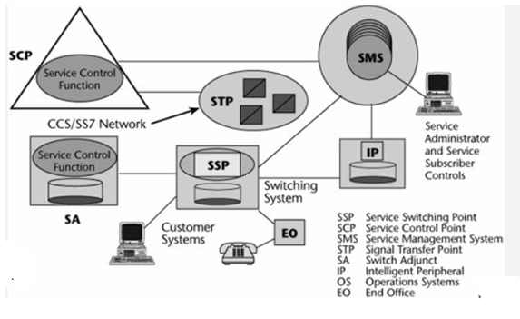
Figure 1: Architecture of Intelligent Systems [6]
    - Phase III – Integrated Multimedia and IP Convergence
With the emergence of packet-switched networks in the early 2000s, IN evolved toward IP integration. Phase III introduced enhanced multimedia capabilities, advanced signalling, and early forms of service orchestration [7]. The architecture began shifting from hardware-based SCPs to software-driven service platforms, anticipating the arrival of IMS (IP Multimedia Subsystem) and NGN (Next Generation Networks).
    - Phase IV – Softwarized, Cloud-Based IN
Modern IN functions migrated toward cloud and virtualization frameworks, leveraging technologies such as NFV (Network Function Virtualization) and SDN (Software Defined Networking). [10] Service logic became fully programmable and deployable as cloud-native microservices. IN, originally hardware-centric, transformed into a software service layer integrated with application servers, orchestration frameworks, and open APIs. This final stage established the foundation for AI-native and intent-driven networks.
  - Evolution of Artificial Intelligence Systems
Artificial Intelligence systems have evolved a lot over time. Here is a brief overview of the evolution of AI systems.
    - Rule-Based AI (1950s–1980s)[8]
Early AI systems were dominated by symbolic logic and expert systems. Knowledge was manually encoded, and decision-making followed deterministic rules. Although useful for diagnostics and simple automation [9], these systems lacked adaptability, scalability, and the ability to learn from data.
    - Machine Learning and Statistical AI (1990s–2010)
The next major shift emerged with statistical learning, pattern recognition, support vector machines, and clustering algorithms. AI became data-driven, improving prediction accuracy and enabling early applications in telecom such as fault detection, traffic forecasting, and anomaly detection. However, models still required engineered features and domain expertise.
    - Deep Learning Era (2010–2020)
Advances in neural networks, GPU acceleration, and large-scale datasets led to breakthroughs in computer vision, speech processing, and natural language understanding. Deep learning models such as CNNs, RNNs, and LSTMs enabled high-performance automation in network optimization, resource allocation, and customer experience management.
    - Foundation Models and Generative AI (2020–2023)
The emergence of large transformer-based models enabled general-purpose intelligence. Foundation models capable of multitask reasoning, code generation, and multimodal processing significantly expanded the scope of AI applications in telecom. These systems formed the cognitive foundation for self-organizing networks, predictive maintenance, and AI-augmented decision support.
    - Agentic AI Systems (2023–Present)
The latest evolution involves AI agents capable of autonomous planning, goal execution, tool usage, and cross-domain decision-making. Unlike traditional models that respond to queries, agentic systems can carry out multi-step workflows, interact with digital systems, and operate with minimal supervision.
These capabilities align closely with telecom goals such as Zero-Touch Networks (ZTN), intent-based orchestration, closed-loop automation, and AI-native RAN control—a key pillar of future 6G architectures.
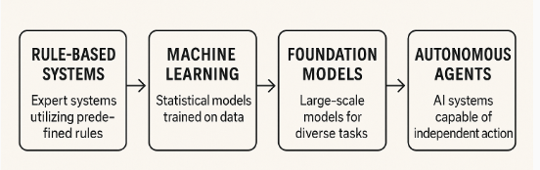 Figure 2: Evolution of AI Systems
  - Convergence of IN and AI Systems

The evolution of IN and AI exhibits a complementary trajectory. IN established programmability, centralized logic, and service abstraction, while AI provides intelligence, adaptability, and autonomy. Their convergence is transforming today’s networks in the following ways:
- AI-enhanced IN: Predictive analytics improves routing, charging, and customer services.
- Intent-based networks: Services are defined by operator intent rather than configuration.
- Closed-loop automation: AI agents monitor, analyse, and optimize networks in real time.
- AI-native 6G: Future networks integrate AI at the RAN, core, edge, and service layers [10].
  - Quantitative analysis protocol
Metrics: Semantic Drift Rate (SDR); Policy Violation Rate (PVR); Coexistence Attack Surface (A); Change-Failure Risk (CFR).
Scenarios:
- Legacy ML + LLM - vary adapter mismatch and measure SDR/PVR;
- LLM + Agent - measure amplification K(g) vs. guardrail strictness;
- Tri-generation - compute E across shadow → canary → full upgrade.

Procedure:
- Phase-1 baseline models;
- Phase-2 enable adapters and estimate C_{i, j};
- Phase-3 orchestrate with shadow/canary and track SDR/PVR/CFR;
- Phase 4 sensitivity analysis over guardrails, adapter noise, and tool scopes
  - Problem description and Formal existence model
Let M = {M₁, …, M_{n}} denote models/agents spanning generations (legacy ML, foundation models, agentic).
Compatibility C_{i,j} ∈ [0,1]: probability that M_{i} and M_{j} interoperate without schema/semantic mismatch under a given task profile.
Semantic Drift D_{i,j}∈[0,1]: normalized divergence in outputs when M_{i} and M_{j} address the same input with equivalent specifications.
Security Exposure S_{i} ≥ 0: expected vulnerability mass of M_{i} (e.g., prompt-injection susceptibility, data leakage potential, tool-use risk).
Cross-Model Interaction Surface X_{i,j}≥0: additional attack surface from handoffs, tool call chains, or shared memory between M_{i} and M_{j}.
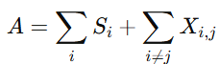
Coexistence Attack Surface:
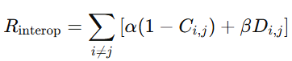
Interoperability Risk:
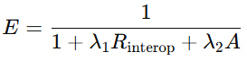
Coexistence Stability Index higher is better):

  - Contributions of this study
This study makes the following explicit research contributions:
- First formalized comparison of intergenerational coexistence in mobile networks (1G–6G) and multiversion AI ecosystems (rule‑based → agentic AI).
- First formalized comparison of intergenerational coexistence in mobile networks
- Novel coexistence risk model mapping telecom coexistence risks (security debt, interoperability gaps, fragmentation) to emerging AI risks.
- Architecture-level framework for multi-model AI ecosystems inspired by telecom multi-RAT, softwareized IN, and phased-migration mechanisms.
- Structured security threat analysis introducing a cross-model attack amplification path unique to agentic AI coexistence.
- Actionable policy, engineering, and governance recommendations for managing AI coexistence over long lifecycles.
- Similarity in mobile networks’ coexistence and AI-variants’ coexistence
Here are a set of parameters upon which similarities between mobile networks and AI systems are compared to establish mechanisms to co-exist variants of AI systems.
- Long lifecycles & slow sunsets : Mobile operators phased out 2G/3G over many years because of legacy devices and economic impact; abrupt shutdowns would strand devices and services. Expect AI models — especially embedded/local models in products — to follow similar long tails [11]. Enterprises will run multiple model generations concurrently for compatibility and cost reasons.
- Regional fragmentation : Different countries / operators shut down legacy networks on different schedules based on regulation, market demand and economics. Likewise, jurisdictions will regulate agentic AI differently (some aggressive, some permissive), so deployments will be fragmented across regions.
- Backward compatibility and interoperability complexity: Coexistence required “dual-stack” solutions (devices/support for multiple radio standards) and gateways that translated protocols. For AI, expect orchestration layers that route decisions to appropriate model versions, and compatibility layers for APIs and data formats.
- Operational scale + device mass: Telecoms had to manage millions of low-bandwidth devices (IoT) that couldn’t be easily upgraded. AI will similarly be embedded in vast fleets (edge devices, bots, workplace automations) with limited update paths. Unmanaged legacy AI components will be a long-term operational burden.
- Security debt & exploit surface across generations: Older mobile tech had weaker security (e.g., weak encryption in 2G), producing persistent vulnerabilities during coexistence. Agentic AI introduces new attack surfaces (prompt injection, hallucinations, agents acting on system resources) that can interact badly with legacy systems. Recent reports show system-level agents can hallucinate and be susceptible to prompt-injection style attacks.
- Consequences of Coexistence of Mobile Network Generations
- Increased Network Complexity - Coexisting generations introduce heterogeneous architectures, protocols, and interfaces (circuit-switched vs. packet-switched, legacy signalling vs. IP-based cores). This significantly increases design, integration, and operational complexity.
- Operational Overhead and Cost Inflation - Operators must maintain parallel infrastructures, skilled manpower, spares, and vendor contracts for legacy and modern networks simultaneously. This raises OPEX and slows down full ROI realization for newer generations.
- Spectrum Fragmentation and Inefficient Utilization [12] - Legacy networks continue to occupy valuable spectrum bands, limiting spectrum reframing opportunities for newer technologies such as LTE and 5G, thereby reducing overall spectral efficiency.
- Interoperability and Backward Compatibility Challenges [13] - Ensuring seamless mobility, roaming, handover, and service continuity across generations requires gateways, protocol translation, and dual-stack devices - often resulting in performance trade-offs and failure points.
- Performance Inequality and User Experience Gaps - Users on older generations experience lower data rates, higher latency, and limited services, while newer-generation users benefit from advanced capabilities. This creates non-uniform Quality of Service (QoS) across the network.
- Security Vulnerabilities and Attack Surface Expansion - Legacy generations (e.g., 2G with weak encryption) introduce persistent security weaknesses. During coexistence, attackers can exploit older protocols to compromise or pivot into newer network segments, increasing systemic risk.
- Delayed Innovation and Slower Technology Adoption - Dependence on legacy compatibility constraints can restrict the deployment of advanced features (e.g., network slicing, URLLC), slowing innovation and full exploitation of next-generation capabilities.
- Regulatory and Compliance Complexity - Different regions mandate continued support for legacy services (e.g., emergency calling, IoT/M2M devices), forcing operators to maintain older networks longer than technically desirable.
- Energy Inefficiency and Sustainability Impact - Running parallel radio access and core infrastructures increases power consumption and carbon footprint, conflicting with green networking and sustainability goals.
- Long-Tail Legacy Persistence - Once deployed, mobile technologies exhibit very long lifecycles. Even after official sunset announcements, residual devices and applications keep older generations alive, complicating network rationalization.
- Vendor Lock-in and Integration Dependencies - Legacy systems often rely on proprietary vendor implementations, limiting flexibility in upgrades and creating dependency chains that affect future network evolution.
- Management and Monitoring Blind Spots - Unified observability across heterogeneous generations is difficult. Legacy systems may not expose fine-grained telemetry, leading to partial visibility and slower fault diagnosis.
Since the coexistence of multiple networks impacts in so many ways, there is no single solution that fits in all the network deployments across the world. It has to be decided based on a specific scenario – type of users, user density, economic status. Very similar inferences can be drawn for coexistence of AI deployments as well.

- Probable Consequences due to Coexistence of AI Deployments (Novelty of this work)
This section lists out the contributions of this work.
In line with observations from Mobile networks’ coexistence we can expect following issues while different versions of AI systems to co-exist for next ‘n’ decades, such as
- Architectural and System Complexity - Coexisting AI systems differ in model architecture, data requirements, execution environments, and control logic. This heterogeneity increases integration complexity and makes end-to-end system behaviour harder to predict.
- Interoperability and Semantic Inconsistency - Different AI models may interpret inputs, contexts, or intents differently. When orchestration hands tasks between models, semantic drift can occur, resulting in inconsistent or conflicting decisions.
- Operational Overhead and Lifecycle Burden - Organizations must maintain, monitor, patch, and govern multiple AI versions concurrently. Model retraining schedules, dependency management, and infrastructure support significantly increase operational cost.
- Security Surface Expansion - Each AI version introduces distinct vulnerabilities [16](e.g., prompt injection, data poisoning, model inversion). Coexistence enlarges the attack surface and enables cross-model exploitation paths.
- Attack Amplification Through Agentic Systems - When autonomous agents coexist with legacy AI components, a single compromised agent can trigger cascading actions across systems—amplifying the impact of breaches beyond traditional model-level failures. Figure-3 depicts the trend of attacks against guardrail.
- Data Governance and Privacy Inconsistencies - Different AI deployments often follow heterogeneous data-access rules, retention policies, and compliance standards. This leads to data leakage risks, regulatory violations, and loss of auditability.
- Monitoring and Observability Blind Spots -Traditional monitoring captures performance metrics but not reasoning paths, hallucinations, or autonomous actions. Coexisting AI systems produce fragmented telemetry, reducing visibility into system behaviour.
- Reliability and Safety Degradation - Conflicting decisions from multiple AI models can undermine system stability, especially in safety-critical or closed-loop environments. Error attribution becomes difficult when failures emerge from multi-model interactions.

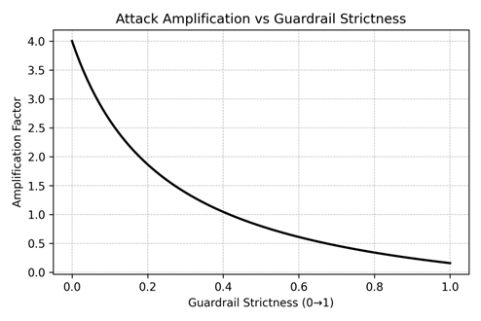
Figure-3: Attack Amplification vs Guardrail Strictness

- Version Drift and Model Inconsistency - Over time, models evolve differently due to retraining, data drift, or configuration changes. Without strict version control, coexistence results in unpredictable behaviour and degraded performance.
- Regulatory and Cross-Jurisdictional Complexity - AI regulations vary across regions and sectors. Coexisting deployments must comply with different governance regimes, forcing feature divergence and region-specific constraints.
- Delayed Decommissioning and “Shadow AI” - Older or experimental AI deployments often persist beyond their intended lifespan, creating ungoverned “shadow AI” systems that escape security and compliance oversight.
- Innovation Drag and Technical Debt Accumulation - Backward compatibility requirements constrain architectural choices, slowing adoption of safer or more efficient AI paradigms and increasing long-term technical debt.
- Trust Erosion and Accountability Challenges - When outcomes are produced by interacting AI systems, assigning responsibility and explaining decisions becomes difficult, reducing stakeholder trust and complicating incident response.

AI Coexistence Layered Architecture (AICLA)
We propose AICLA, a layered architecture that governs multiversion AI deployments (legacy ML, foundation models, agents) with explicit version control, capability negotiation, sandboxed execution, and telemetry‑driven governance. (Figure - 4)
- Layer 1: Data, Policy & Telemetry Substrate.
Unified data contracts; policy stores for privacy and safety; high‑fidelity telemetry (reasoning traces, tool calls, action logs).
- Layer 2 :Model & Agent Registry.
Versioned registry with SBOM‑like manifests: training data lineage, capabilities, permitted tools, and regional policy flags.
- Layer 3 :Interoperability & Compatibility Layer.
Schema adapters and semantic mediation. Provides compatibility contracts (input/output schemas, confidence semantics) akin to protocol interworking in telecom.
- Layer 4: Orchestration & Routing.
Version‑aware router selects a model/agent by task profile, risk level, jurisdiction, and capability manifest. Supports shadow mode, A/B and canary rollout.
- Layer 5: Guardrails & Constraints.
Inline policy engine (content, data, actions). Human‑in‑the‑loop checkpoints for high‑risk intents, with configurable approval workflows.
- Layer 6: Sandboxed Execution Runtime.
Constrained tool access via short‑lived scoped tokens, filesystem/network sandboxes, and reversible side‑effect buffers.
- Layer 7: Observability & Drift Control.
Cross‑model observability: hallucination rate, policy‑violation rate, semantic drift, and rollback safety indicators.

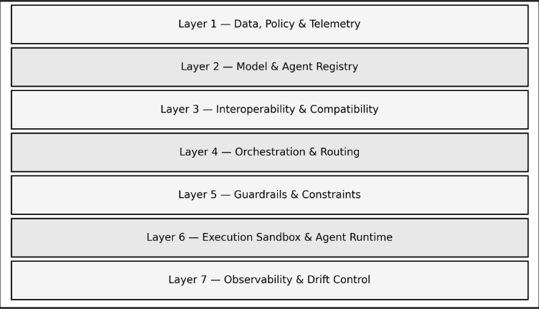

Figure-4: AI Coexistence Layered Architecture (AICLA).

- Key learnings and Recommended practices for AI deployments
Based on the similarities listed in the previous sections following lessons can be learnt and suggestions to mitigate the probable threats in AI based deployments (similar to how it has been handled during evolution of mobile network deployment).

Long Tail Lifecycles Must Be Expected

Mobile operators learned that older generations (e.g., 2G) may survive 20+ years.
AI implication: Legacy ML systems, classical models, and older agents will remain in production even when new models emerge. Organizations must plan for multi-model ecosystems, not single-model dominance.

Backward Compatibility and Interoperability are Critical

Multi-RAT architectures showed the value of compatibility frameworks.
AI implication: API standardization, model-version contracts, and consistent data formats are essential to avoid unpredictable agent/model behaviour.

Migration Must Be Incremental and Phased

Mobile networks shifted spectrum and services gradually.
AI implication: AI upgrades must occur in controlled phases with fallback mechanisms, shadow modes, A/B testing, and rollback plans. Figure-5 depicts the risk budget as a function of deferred handing of security, multi-version interop, this is inevitable but it has to be budgeted as part of multi-version coexistence.
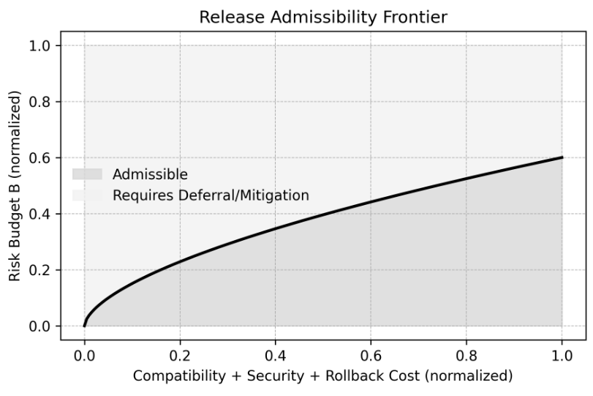
Figure-5: Release Admissibility Frontier

Regional and Domain-Specific Fragmentation Is Normal

Mobile network availability varies globally.
AI implication: AI regulations, compute availability, and risk tolerance will differ across countries and industries. AI systems must support region-specific features, privacy constraints, and guardrails.

Operational Complexity Grows with Co-existence

More generations → more operational overhead in telecom.
AI implication: Multi-version AI ecosystems require orchestration layers to handle model routing, lifecycle management, monitoring, and governance across diverse AI components.

Security Becomes a Multi-Layer Challenge

Legacy mobile networks (e.g., 2G) exposed weak encryption even when newer generations were secure.
AI implication:
- Older AI models may be vulnerable to prompt injection, bias, or data poisoning.
- Newer models may introduce emergent risks or autonomous actions.
- Organizations must secure the entire stack, not just the latest models.

Sunset Planning is as Important as Deployment
Mobile networks required scheduled retirement of older generations.
AI implication: AI systems must include planned retirement of outdated model versions, documentation, and data governance to avoid “shadow AI.”

- Recommendations for Policy Makers, Customers, and Technology Organizations
Based on learnings observed in the previous section, following are the recommendations for the policy makers and enterprises to support for the coexistence of the multiple variants of AI systems

Recommendations for Policy Makers
- Establish Standards for Multi-Version AI Coexistence: Just as mobile networks adopted global standards (GSM, LTE), define interoperability and safety baselines for AI models, agent behaviour, logging, and lifecycle management.
- Mandate Transparency of Model Capabilities and Limitations : Require vendors to publish capability manifests, known risks, version histories, and supported lifetimes, similar to telecom equipment certification.
- Encourage Region-Specific Guardrails Without Fragmenting Innovation : Provide clear guidelines on autonomous actions, cross-border data flows, and high-risk use cases while avoiding unnecessary restrictions that hinder research and competitiveness.
- Create National AI Safety Testbeds : Fund shared infrastructure where start-ups, enterprises, and academia can test agentic systems for robustness—analogous to telecom test labs and spectrum-testing centres.
- Define Rules for Incident Reporting and Auditability : Introduce mandatory disclosure for major AI failures, security breaches, or harmful autonomous actions, with standardized audit formats.
- Support Long-Tail Sunset Frameworks : Provide regulation for retiring outdated AI models responsibly, especially those embedded in critical sectors like healthcare, finance, and telecom.

Recommendations for Customers (Enterprises)

- Build an AI Inventory and Version Map : Maintain a living catalogue of all deployed AI components, their versions, capabilities, and risk levels—similar to network asset registries.
- Implement Least-Privilege, Policy-Based Access for AI Agents: Constrain what agents can read, write, or execute. Short-lived, scoped tokens should be the default.
- Adopt Phased Deployment and Rollback Strategies: Use shadow modes, A/B testing, fallback paths, and graceful migration—exactly as mobile operators handled 2G → 3G → 4G transitions.
- Mandate Sandboxed Execution for Agentic AI: Prevent agents from executing direct actions on production systems without a controlled, reversible interface.
- Integrate Continuous Monitoring and Drift Detection: Track AI behaviour, hallucination rates, policy violations, and anomalous action patterns with telecom-style telemetry systems.
- Prioritize Vendor Governance and Supply-Chain Safety: Ensure third-party models or agent frameworks include signed releases, secure training pipelines, and transparent update policies.

Recommendations for Technology Organizations & AI Developers
- Design for Multi-Model Coexistence from Day One: Use modular orchestration layers that can route tasks to specific models, support backward compatibility, and enforce capability negotiation.
- Expose Clear, Versioned Capability Manifests: Every model should declare its tools, boundaries, safety rules, and limitations—mirroring network function descriptors in telecom.
- Provide Secure SDKs and Migration Tooling: Offer upgrade kits, compatibility layers, monitoring plugins, and documentation to help customers evolve safely.
- Build Guardrail Layers Natively into Agentic Systems: Include inline policy engines, human-approval workflows, and explainability traces directly in the runtime.
- Focus on Robustness and Adversarial Resistance: Regularly test for prompt injection, jailbreaks, data poisoning, and unexpected emergent behaviours using automated red-team cycles.
- Offer Region-Aware Configuration Profiles: Allow features to be enabled, disabled, or restricted depending on jurisdictional rules—similar to telecom spectrum or encryption restrictions.

- Conclusion
The coexistence of multiple mobile generations offers clear guidance for managing the growing heterogeneity in AI ecosystems. Telecom experience shows that fragmented rollouts, uneven regional readiness, legacy dependencies, and complex transition paths are natural features of any large-scale technological shift. Applying these lessons to AI highlights the need for version-aware orchestration, sandboxed execution, continuous validation, and well-defined lifecycle governance. The analysis also underscores the emerging security challenges posed by agentic AI, including amplified attack surfaces, cross-model inconsistencies, and opaque decision chains—issues that mirror past vulnerabilities observed during mobile interoperability and roaming evolution.
To address these challenges, coordinated action across policy makers, enterprises, technology developers, and standardization bodies becomes essential. Establishing global standards for model capability descriptions, interoperability, safety assurance, and sunset management will be critical as AI deployments expand across sectors. Enterprises must adopt telecom-style operational rigor with inventories, phased upgrades, drift monitoring, and least-privilege controls. Technology organizations must prioritize secure-by-design architectures and offer clear migration pathways. Policy makers and standards bodies must ensure consistent, interoperable, and auditable frameworks that maintain innovation without compromising safety.
Overall, the study demonstrates that the long-standing discipline of telecommunications engineering provides valuable, actionable lessons for managing the complexity, risk, and opportunity of next-generation AI. By embracing structured coexistence and adopting proven lifecycle principles, the global ecosystem can guide agentic AI toward a future that is secure, reliable, and aligned with societal needs.

- References
- Andeed Ma; James Ong; Siok Tan, "AI History," in AI for Humanity: Building a Sustainable AI for the Future , Wiley, 2024, pp.53-75,
- A Timeline from 1G to 5G: The Evolution of Mobile Communication , https://www.mpirical.com/knowledge-base/the-evolution-of-mobile-communication
- Nagma Parveen, Khaizuran Abdullah, Khairayu Badro, Yasir Javed , Zafar Iqbal Khan, “Coexistence in Wireless Networks: Challenges and Opportunities”, Telecom 2025, 6(2), 23
- D. Sculley, et.al., “Hidden technical debt in Machine learning systems”. In Proceedings of the 29th International Conference on Neural Information Processing Systems - Volume 2 (NIPS'15), Vol. 2. MIT Press, Cambridge, MA, USA, 2503–2511.
- Biklien Hoang and G. Ganguly, "Intelligent Internet - Convergence of internet and intelligent network," Proceedings 2000 IEEE Intelligent Network Workshop, Cape Town, South Africa, 2000, pp. 1-11, doi: 10.1109/INW.2000.868160
- ITU-T SS7 Q.700 series or Intelligent Network (IN) specs
- P. Rost et al., "Network Slicing to Enable Scalability and Flexibility in 5G Mobile Networks," in IEEE Communications Magazine, vol. 55, no. 5, pp. 72-79, May 2017
- C. -H. Lin, S. -B. Chan, Y. -C. Lai, W. -L. Liang, M. -S. Huang and Y. -Y. Chen, "AI in eHealth: Diagnosis of Parkinson's Disease with Augmented Reality," 2021 IEEE International Conference on Consumer Electronics-Taiwan (ICCE-TW), Penghu, Taiwan, 2021, pp. 1-2,
- X. Foukas et al., “Network Slicing in 5G: Survey and Challenges,” IEEE Communications Magazine, 2017
- N. Feamster, J. Rexford, and E. Zegura, “The Road to SDN: An Intellectual History of Programmable Networks,” ACM SIGCOMM CCR, 2014
- D. Soldani and A. Manzalini, "Horizon 2020 and Beyond: On the 5G Operating System for a True Digital Society," in IEEE Vehicular Technology Magazine, vol. 10, no. 1, pp. 32-42, March 2015.
- Youngsun Kwon, Duk Kyu Park, Hongjai Rhee, “Spectrum fragmentation: Causes, measures and applications”, Telecommunications Policy, Vol.41, Issues 5–6, 2017, Pages 447-459, ISSN 0308-596
- S. Alraih, R. Nordin, A. Abu-Samah, I. Shayea and N. F. Abdullah, "A Survey on Handover Optimization in Beyond 5G Mobile Networks: Challenges and Solutions," in IEEE Access, vol. 11, pp. 59317-59345, 2023
- T. Mshvidobadze, "Evolution mobile wireless communication and LTE networks," 2012 6th International Conference on Application of Information and Communication Technologies (AICT), Tbilisi, Georgia, 2012, pp. 1-7,
- I. Trrad, "5G and Beyond: Evolution of Wireless Communication Technologies," 2025 International Conference on Frontier Technologies and Solutions (ICFTS), Chennai, India, 2025, pp. 1-9
- Dario Amodei, Chris Olah, Jacob Steinhardt, Paul Christiano, John Schulman, Dan Mané, “Concrete Problems in AI Safety”, arXiv:1606.06565v2 [cs.AI] 25 Jul 2016

