HYBRID DEEP LEARNING FRAMEWORK TO PREDICT GOLD PRICE USING STOCK MARKET AND MACROECONOMIC INDICATORS

Mr. M. Mohanasundharam
Assistant Professor,
Dept of Computer Science,
Hindusthan College of Engineering and Technology
mohantvsm@gmail.com

Dr. K. Karuppasamy,
Prof & Head,
Dept of Computer Science,
RVS College of Engineering and Technology.

Abstract: Forecasting of gold prices has great importance in finance literature due to the random and irregular motion of the market, which never follows a predictable behavior; rather, there is a sequence of actions influenced by global events, the economy, and investors, which makes the forecasting process more challenging. Proper prediction of gold price is a necessary action to be taken by the policymakers and the business owners for proper financial decision-making, but predicting gold price is impossible work due to a number of factors influenced by it, like the stock market, financial factors, the economy, etc. A classical statistical or machine learning model fails to understand the complex relationship that exists between the data since these factors do not follow any fixed sequences and dependencies of long-term trends; therefore, to fulfill this need, this proposed work explores an innovative hybrid deep learning approach to predict gold prices with the help of the indicators from the stock market and macroeconomic parameters. A model composed of an autoencoder, 1D convolutional neural network (CNN), bidirectional long short-term memory (BiLSTM), gated recurrent unit (GRU), transformer encoder, and multi-head attention model to enhance feature learning and forecasting. Furthermore, some technical indicators like RSI, EMA, and MACD, together with the macroeconomic factors, form a data set. In the above-stated architecture, an autoencoder would be used for compression and denoising the dataset while a CNN captures local structures. BiLSTM and GRU networks will attempt to model the present state based on prior information, and Transformers with attention will focus on connecting the long-past data and the present forecast and will weight features important for forecasting. Our proposed model provides higher prediction accuracy.

Keywords: Deep Learning, CNN, BiLSTM, GRU, CNN+BiLSTM

INTRODUCTION
Gold is the valuable commodity and actual financial asset in the world economy. It holds significant significance in the economic domain. Accurate prediction of gold prices is becoming an essential part of financial analysis; therefore, the demand for intelligent prediction systems is required. Market participants in the finance sector heavily rely on gold prices to perform financial decision-making. However, predicting gold prices accurately is a difficult task, as the gold market depends on numerous factors, for example, stock market values and macroeconomic conditions. The non-linear and volatile characteristics of time series financial data are a very difficult challenge for traditional forecasting models since prices fluctuate in a complicated manner that traditional models fail to capture complex temporal dependencies, previously unseen patterns, and long-term relationships in gold price dynamics. Currently, machine learning and deep learning models have achieved tremendous improvement in financial forecasting because they can perform predictions automatically without any human involvement. Among various techniques, CNN is well-performed in extracting feature representations from time-series data, while recurrent neural network (RNN) models were trained for learning relations and patterns from data in a series in time in financial data.
Also, Transformer architecture has been introduced to tackle long-range dependency problems and to capture meaningful information from linear data. On the other hand, a single deep learning model has limitations such as lacking sufficient feature extraction capabilities, having overfitting issues, and being unable to cope with short- and long-term dynamics of the market.To overcome the aforementioned limitations, a new prediction model of gold price with stock market value and macroeconomic factors has been designed. This new framework incorporates the concepts of autoencoder, 1D convolutional neural network (1D CNN), batch normalization, bidirectional long short-term memory (BiLSTM), gated recurrent unit (GRU), transformer encoder, and multi-head attention, which show promising prediction results compared to traditional models. Firstly, the autoencoder model is implemented for feature compression and noise reduction of high-dimensional financial data for extracting efficient feature representations.
A 1D CNN layer extracts local market features and short-term sequential relationships, whereas batch normalization is employed for stabilizing the model training. The BiLSTM and GRU layers further help in extracting bidirectional temporal dynamics and long-term sequential features of gold price changes. The transformer encoder integrated with multi-head attention further captures the contextual features and dependencies between the important financial features and identifies the long-range dependence on the data by capturing the long-term dependence among relevant features in the dataset. The global average pooling method is also implemented for dimensionality reduction to overcome the overfitting issue, while dense and dropout layers are incorporated for the generation of stable and well-generalized prediction results. The performance of the developed framework is evaluated using performance indices like RMSE, MAE, and R-squared.This proposed framework is compared against various traditional deep learning models such as LSTM, GRU, CNN-BiLSTM, BiLSTM, and CNN-LSTM. Ultimately, the developed model aims to establish a well-organized and reliable intelligent forecasting system that assists financial analysts, investors, and institutions in executing their financial decisions.

- LITERATURE SURVAY
Gkalp Narer [1] states that deeper deep-learning models are more frequently utilized for exchange rate and gold price forecasting. This is because they can analyze complex market trends, whereas most alternative models (except these mentioned here) are unable to do so. The work notes that improving hyperparameters results in higher accuracy and that hybrid models outperform single-model frameworks. However, much of the existing methodology is based on outdated recurrent architectures and small data sets; these models cannot analyze long-range relationships or a wider market range adequately. Most frameworks of this type will find it difficult to fuse the stock market trends, macroeconomic indicators, and technical indicators into one unified framework. To address this gap, this method presents a hybrid deep learning model for gold price forecasting that takes all technical indicator factors to further the feature learning and prediction accuracy.
Gergana's [2] finding is that recent gold price forecasting research has focused on combining econometrics, machine learning (ML), and deep learning (DL) models in hybrid frameworks to increase the forecasting accuracy of the results. The model developed here includes financial, macroeconomic, and sentiment data to adequately reflect the complexities of the gold price fluctuations. Most current frameworks depend heavily on historical data; they fail to incorporate real-time capabilities and advanced architectures for analyzing both short- and long-range market trends. This research aimed to overcome these limitations by proposing a hybrid deep learning framework to forecast gold prices by including stock market and macroeconomic indicators. This research incorporates all of the new technologies together to allow for more sophisticated feature learning and higher prediction accuracy.
Amirhossein Amini's [3] research observed that many traditional deep learning models have been utilized for gold price forecasting to enhance prediction accuracy of the nonlinear financial data. These traditional deep learning models included CNN-BiLSTM models, which offered good results in the extraction of local patterns and linear relationships. Nevertheless, the current methodology has some shortcomings regarding historical data analysis. To overcome these shortcomings, this research has developed a new model of forecasting gold price by utilizing the necessary indicators.
Yali Zhao's [4] research applied a hybrid model approach and yielded high accuracy in forecasting gold prices, and the proposed model is a combination of sequential learning and long-range dependent variables. However, this methodology is associated with high computational costs.
Ioannis E.'s [5] study applied a CNN-LSTM model and attained results that surpassed those of traditional models. However, numerous methodologies still depend predominantly on historical gold price data and thus do not address long-range dependencies and noise reduction effectively and are unable to integrate a broad range of financial indicators.
Agampreet Saini's [6] research has found that many studies on gold price forecasting have employed deep learning models to obtain accurate predictions and have also incorporated a range of financial indicators, such as the US dollar index, silver prices, and crude oil prices, for effective modeling. In addition, there are limitations in the range of integrated factors within many existing techniques.
David Opeoluwa Oyewol's [7] work has established that traditional models can be augmented with an artificial learning approach such as the PLSTM-AL and LSTM models, which accurately forecast stock movements. However, this methodology experiences challenges in macroeconomic data analysis, fails to integrate real-time sentiment and new image information, and also makes real-time trading difficult due to its high computational cost. This paper proposes an alternative method to all traditional models and successfully tackles all the aforementioned problems.
Xingsi Xue's [8] study determined that the combination of fractal data and traditional models can identify long-term stock market trends. These results, however, have shown that the combination with the CNN models does not lead to the required level of accuracy. Traditional models treat fractal data as simple inputs, and they also fail to include modern attention mechanisms; these factors are critical in producing accurate predictions. The proposed framework combines all of the new tools to avoid the disadvantages of having a single, ineffective model. It has implemented an advanced mechanism to enhance accuracy.
NGBoost and other ML methods used by Fahmi Ghallabi [9] have also shown their performance to predict ESG stock prices, even in a critical market problem like the COVID-19 crisis, but typically these systems can only predict simple stock price movements in the market; there are some deep learning methods used in such a critical situation. Instead, they used shallow learning methods. We suggest a new framework that bridges the gap between those simple prediction systems and deep learning ones, in which noisy data handling, sudden ups and downs, and day-by-day changes have been considered.
- PROPOSED SYSTEM
Forecasting of gold prices has been a challenge. It is highly unlikely to forecast linearly. Interest rates, fluctuation of currency, and any sudden global event affect it significantly. Models are often unable to address such variations due to being unable to analyze such information properly. This proposes a pipeline composed of multiple AI components where dependence on one individual tool is reduced to the minimal level; instead of a single component analyzing all variables, each of them handles some particular aspect of the problem in a specific way:
1. Data gathering: This first step involves acquiring all the relevant data that have an impact on the price of gold. These data include closing price, value of the USD, treasury yields, and the VIX (a measure of market volatility or fear). We need to compute standard technical indicators such as MACD, RSI, moving average, and so on from the above data and also have to store them.
2. Cleaning the data: The data procured from financial markets is normally noisy. This data is then passed through an autoencoder that will act as a garbage compactor, reducing the dimensionality of the data in order to store the most important information by removing irrelevant noise present in the dataset, and then the compact data is stored in memory for the next step.
3. Catching short-term spikes: In this step, the cleaned data obtained from the previous stage are processed through a 1D CNN for the recognition of local and short-term spikes by analyzing the pattern. Batch normalization is utilized for stabilizing the data, which allows the system to train at higher learning rates and reduces the time required.
4. Tracking memory and time: The BiLSTM and GRU networks that capture short- and long-term memory, respectively, are then employed. A BiLSTM captures events both in the forward and backward directions and thus provides accurate results, whereas the long short-term memory (LSTM) can be utilized to capture events in a larger span of time.
5. Making the guess: A pooling and dense layer are then used to combine the extracted information to predict the closing price. Dropout layers are used during the training to prevent the model from memorizing the past so it has to learn more flexible patterns.
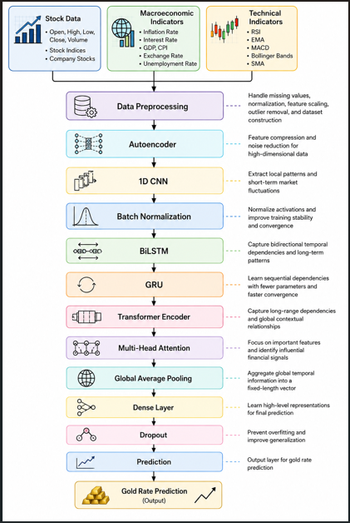

Fig1. Workflow of Proposed System

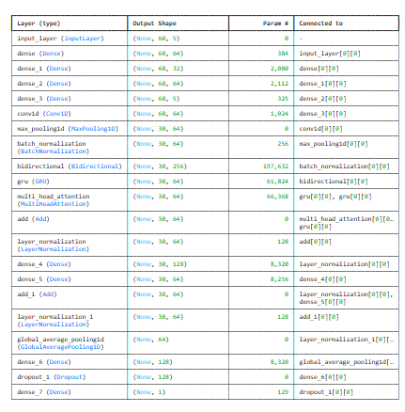
Fig 2. Proposed Model Summery

- COMPARATIVE ANALYSIS OF EXIXTING PLATFORMS AND PROPOSED MODEL

Model | Main Components | Limitation | Difference from Proposed Model
LSTM | LSTM + Dense | Captures only basic temporal dependency | Proposed model additionally uses CNN, Autoencoder, GRU, Transformer, and Attention
GRU | GRU + Dense | Simpler sequence learning | Proposed model captures richer sequential and contextual information
CNN-LSTM | CNN + LSTM | Limited long-range dependency learning | Proposed model includes BiLSTM, GRU, Transformer Encoder, and Attention
BiLSTM | Bidirectional LSTM | No local feature extraction or attention | Proposed model includes CNN, Transformer, and Multi-Head Attention
CNN-BiLSTM | CNN + BiLSTM | Cannot effectively model long-range contextual relationships | Proposed model uses Transformer Encoder and Attention for deeper contextual learning
Proposed Hybrid Model | Autoencoder + CNN + BiLSTM + GRU + Transformer + Attention | Advanced feature extraction and contextual learning | Combines multiple deep learning mechanisms for improved forecasting

Tab1. Existing model limitation with proposed method.

Model | RMSE | MAE | R²
LSTM | 305.0168 | 237.3271 | 0.7977
GRU | 245.7165 | 216.2632 | 0.8687
CNN-LSTM | 154.4419 | 105.2089 | 0.9481
BiLSTM | 329.2254 | 244.9076 | 0.7398
CNN-BiLSTM | 370.5995 | 291.2391 | 0.6703
Proposed Hybrid Model | 164.4267 | 108.8161 | 0.9574

Tab2. Experimental Results of existing and proposed model

The experimental results clearly illustrated the comparison of performances of deep learning architectures on the prediction of gold price. With regard to the baseline models, CNN-LSTM shows better performance, with the following RMSE, MAE, and R values, which are 154.4419, 105.2089, and 0.9481. Which shows that the model is a strong baseline model and is good at capturing all the local and other features. Following the CNN-LSTM, GRU also performs better than LSTM (R=0.8687, RMSE=245.7165). However, comparing BiLSTM and CNN-BiLSTM, it shows weaker performance. Since its error values are higher and R values are lower (respectively 0.7398 and 0.6703). The novel hybrid model provides performance of R=0.9574, RMSE=164.4267, and MAE=108.8161. The new model provides good improvement over the traditional models. Comparing all the results of the hybrid architectures with the attention mechanism achieved good results on prediction.

V. RESULT AND DISCUSSION
For validation purposes, the proposed hybrid deep learning framework was tested with three main macroeconomic variables, such as the US Dollar Index (100), Treasury Yield (4.5%), and VIX (20). These inputs give the predicted gold price as $5,192/ounce (114,850/8 grams of gold in India), which shows a 1.42% decrease when compared to the current market price, indicating a slightly bearish trend of gold in the short term. The R score for the model is 95.74%, with an RMSE of 164.43 and an MAE of 108.82, respectively. Prediction depends greatly on the combined effect of the chosen macroeconomic variables. The USD Dollar Index is negatively correlated with gold price, as it lowers gold demand when it strengthens internationally. A higher treasury yield of 4.5% makes the investors shift their investments from the non-interest-bearing assets, such as gold, to the interest-bearing ones; this lowers the demand for gold. At the same time, a VIX of 20 indicates a medium level of risk in the financial market, thus raising demand for gold as a safe-heaven asset. This impact is outweighed by the negative influences from the dollar and treasury yields.It is evident from the results obtained that the proposed hybrid model is able to effectively capture both short-term and long-term dependencies in financial data. By the integration of autoencoder, CNN, BiLSTM, GRU, transformer encoder, and multi-head attention, the developed framework successfully learns complex relations among the macroeconomic variables and the movements of the gold price. Higher prediction accuracy and good accuracy indicators suggest that the developed system could be a good decision-support tool for investors, analysts, and financial institutions for forecasting and making investment decisions.
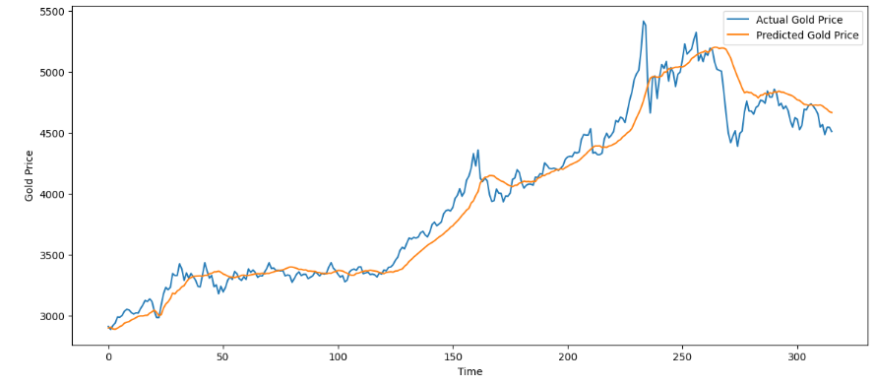
Fig3. Proposed model Accuracy
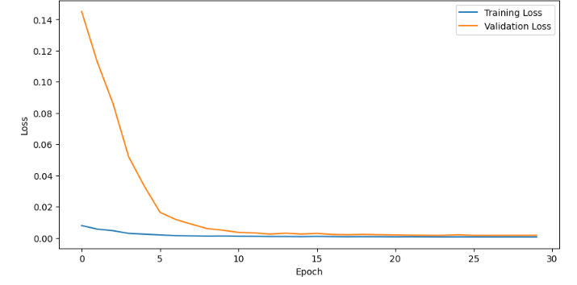
Fig4. Proposed model loss

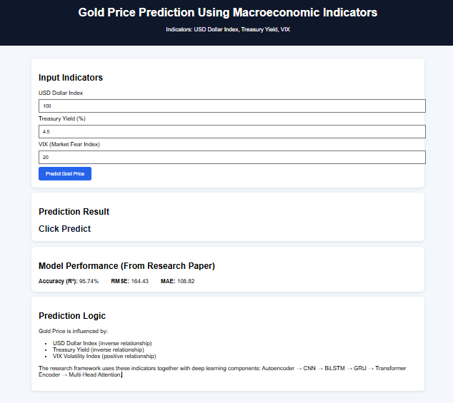
Fig 5. Webpage view with Indicators and result.

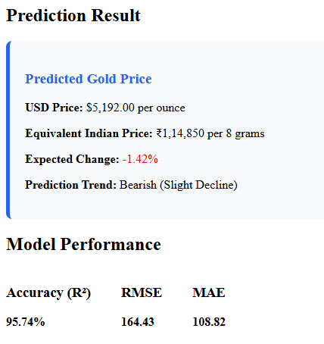
Fig 6. Predicted output of Gold Price
- CONCLUSION
A proposed hybrid deep learning framework for gold price prediction using major macroeconomic indices (USD Dollar Index, Treasury Yield and VIX) has been created, and a user-friendly web page is designed for gold price prediction, model accuracy and indicator-based analysis. The proposed model has been compared with other deep learning models, such as LSTM, GRU, CNN-LSTM, BiLSTM, and CNN-BiLSTM. CNN-LSTM had great baseline performance, but the proposed hybrid model had better prediction accuracy of R=0.9574 with high prediction and generalizability ability compared with others. Therefore, hybrid deep learning models can be applied successfully for capturing complex financial time series information and gold price prediction accuracy. This study developed a website which makes prediction and analysis in financial decision support more useful.

VI. FUTURE ENHANCEMENT
In future work, we will aim to enhance our proposed hybrid model with many kinds of advanced optimization approach. In addition, we will combine more influential macroeconomic indices and higher frequency financial time series data into our model to get higher prediction accuracy. Other advanced deep learning architectures such as graph neural networks or reinforcement learning-based prediction models may also be tried.
- REFERENCE
- Gökalp Çınarer, “Forecasting Current Exchange And Gold Rates With Hybrid Models Using Time Series And Deep Learning Algorithms”,2025.
- Gergana Taneva-Angelova, Stefan Raychev, Galina Ilieva, “A Framework for Gold Price Prediction Combining Classical and Intelligent Methods with Financial, Economic, and Sentiment Data Fusion”,2025.
- AmirhosseinAmini, RobabKalantari,”Gold price prediction by a CNN-Bi-LSTM modelalongwithautomatic parameter tuning”,2024.
- Yali Zhao, Yingying Guo ,and Xuecheng Wang, “Hybrid LSTM–Transformer Architecture with Multi-Scale Feature Fusion for High-Accuracy Gold Futures Price Forecasting”,2025.
- Ioannis E. Livieris,Emmanuel Pintelas,Panagiotis Pintelas,” A CNN–LSTM model for gold price time-series forecasting”,2020.
- Agampreet Saini, Rahul Kumar Singh, Puneet Sinha, “Forecasting gold price using hybrid deep neural network LSTM-autoencoder”,2025.
- David Opeoluwa Oyewola Al-musbahu Abdulrahim, “Stock market prediction with optimized PLSTM-AL in smart urban cities”,2025.
- Xingsi Xuea, , Rashmi Bhardwaj, Surbhi Sharma, “Fractal memory and deep learning: A new paradigm for stock market prediction”,2026.
- Fahmi Ghallabi, Bilel Souissi, Tunisia, Shoaib Ali, “ESG stock markets and clean energy prices prediction: Insights from advanced machine learning”, 2024.

