Development of Low Power GNSS time-based system with fault tolerance and DMA driven data
Aditya Doiphode¹ and Lalit Mohan Saini²
School of VLSI and Embedded System Design¹, Department of Electrical Engineering²
National Institute of Technology, Kurukshetra, Haryana, India
Email – 324108101@nitkkr.ac.in¹, lmsaini@nitkkr.ac.in²
Abstract— Among all possible time keeping schemes in modern timekeeping Embedded systems requiring real-time synchronization, GNSS(Global Navigation Satellite System) is one of the widely used one. GNSS Receivers use signals transmitted by satellites orbiting the Earth. GNSS based system, during integration and testing, the most widespread issue observed in the system is either absence of satellite acquisition or failure to get connection with the satellites. At such situations RTC(Real Time Clock) becomes a crucial component. Traditional polling based method demands a lot of power and CPU cycle, which are not feasible for low power embedded systems. In this paper, a system employing UART(Universal Ashynchronous Receiver and Transmitter) DMA(Direct Memory Access) with circular buffer and FreeRTOS to implement asynchronous reception of GNSS data in an optimized manner with minimal processor usage has been proposed. The system possesses all the attributes of a low power design, such as sleep mode operation, interrupt-driven task switching, and RTC-driven wake-up from sleep mode, and has been proven to be an efficient, expandable, and robust solution for embedded low power time keeping applications such as IOT devices, autonomously working devices, industrial instrumentation, and real time navigation devices.
Keywords—GNSS, RTC, drift, STM32-F401RE, GNSS2A1, Baremetal, FreeRTOS

INTRODUCTION
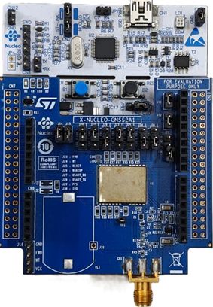
Accurate and reliable time synchronization is a crucial requirement for numerous modern embedded systems like: wireless communication, industrial automation, autonomous systems, navigation and the Internet of Things (IoT). The need for accurate timing reference in real-time embedded applications arises due to event coordination, event logging, synchronization or failure monitoring. The highly accurate UTC time reference is today provided through the GNSS technology, that become a preferred source for data in distributed systems of timing and synchronization. To ensure the timing capabilities needed for correct positioning, the analysis of GNSS clock performances is essential [1]. Even small timing errors cause large positional errors due to the great speed of propagation of electromagnetic signals. As radio waves move at nearly 300,000 km/sec, an error of only a microsecond will cause positioning errors of nearly 300 m [2]. In view of this, timing references must be precise and very stable. In GNSS, each satellite contains a very precise atomic clock, continuously emitting accurate timing data that the receiver can process and position its coordinates on the ground based on trilateration of signal travel time information from at least 4 satellites. Accordingly, the positioning precision, synchronization accuracy and system stability depend heavily on receiver clock accuracy. Issues such as clock drift, jitter, synchronization latency and oscillator instability have an impact on navigation performance, especially for real-time embedded systems which operate under limited hardware constraints.
Figure 1: NUCLEO-F401RE with GNSS2A1
Typical embedded GNSS systems commonly use a polling type software architectures in its serial communication and processing stages. While they are easy to implement, these type of designs always consume the processor time creating more CPU usage and excessive power consumption. The performance of such systems is less reliable at low-power embedded systems that require efficient power consumption and deterministic real-time performance. Such system also do not allow proper scaling and degrade real-time multitasking performance.
Table 1:Comparison of High-Precision Remote Time Transfer Techniques
Method | Typical Uncertainty | Infrastructure requirements | Real Time capability | Cost
GNSS Common View | ~3ns | GNSS Receiver | Limited | Low
Satellite Two way Transfer | <1ns | Dedicated Satellite Resources | Yes | Very High
Optical Fibre transfer | Sub ns level | Fiber Network | Yes | High
Proposed GNSS Real-Time Common View | <2ns | GNSS Receiver + Network | Yes | Low

Among the latest trend on embedded systems is Real-Time Operating Systems (RTOS), used for efficient task management, modularity, responsiveness and deterministic execution. There are several free and commercial RTOS which could be implemented in microcontrollers constrained on resources, such FreeRTOS. FreeRTOS is the most adopted RTOS due to its small memory footprint and light weight task management. Using an RTOS in an embedded application allows tasks to be executed on the event driven manner, not continuously polled thereby increase efficiency and reduce CPU load [2].
Beside efficient task scheduling, Direct Memory Access (DMA) could reduce the burden of CPU interaction with the peripheral module [3]. DMA based UART reception is to enable asynchronous communication of the GNSS data, instead of continuously interrupt CPU for this matter, it can reduce power consumption of the embedded system needed in the low power real-time embedded system. When RTOS is coupled with DMA based communication, the spurious wake up can also be reduced and therefore save more power of the embedded system.
One of the most important aspect of the embedded GNSS based timing system is the continuous of the timing function under loss of the GNSS data. Environmental like urban canyon, antenna disconnect from the main unit, interference or weak visibility of the satellites can cause the loss of GNSS system synchronization. It is crucial for the timing function to work even without GNSS sync. The Real Time Clock (RTC) based hold over mechanism is adopted, which will keep an estimate value of the system time during the GNSS signal loss, and after which re-sync to the received GNSS time.The main contributions of this work are summarized as follows:
- Development of a DMA-driven GNSS data acquisition architecture for reduced CPU overhead.
- Implementation of a FreeRTOS-based real-time embedded timing system.
- Integration of low-power techniques using sleep mode and event-driven task scheduling.
- Design of a fault-tolerant RTC holdover mechanism for GNSS signal loss conditions.
- Runtime performance analysis using Segger SystemView for real-time task monitoring and CPU load evaluation.
- Experimental power profiling and energy characterization for Bare-Metal and FreeRTOS solutions using the STLINK-V3PWR hardware monitor and STM32CubeMonitor-Power tool.
The proposed system provides a scalable and energy-efficient embedded timing solution suitable for applications such as IoT synchronization systems, industrial monitoring platforms, autonomous embedded devices, and real-time navigation systems.

LITERATURE REVIEW
The Global Navigation Satellite System (GNSS) has become one of the most widely adopted technologies for positioning, navigation, and timing applications. In recent years, researchers have explored GNSS-based synchronization, autonomous navigation, low-power embedded implementations, and real-time operating system integration to improve system reliability and efficiency. This section reviews significant contributions relevant to the proposed work.

2.1 GNSS-Based Time Synchronization

Accurate time is also one of the fundamental services provided by GNSS. A synchronization method using GNSS in vehicular networks was proposed and demonstrated by Hasan, whose experiments were performed using off-the-shelf GNSS receivers. It shows that the accuracy of the timing in the vehicular nodes is around 2 s, while that among nodes is less than 10 s during usual conditions and less than 20 s during transient signal lost of GNSS. This proved that the GNSS can provide sufficient timing information for the distributed real-time applications [4]. However, their system was designed for vehicular communication network, and was not analyzed for low-power embedded systems or embedded microcontrollers.

2.2 GNSS Clock Performance Analysis

The reliability of onboard satellite clocks greatly influences GNSS position and timing analysed performance anomalies of on-board atomic Caesium and Rubidium clocks of GPS and GLONASS satellites [5]. The researchers analysed the frequency stability, time deviation, clock anomalies of satellite atomic clocks which could be crucial for the satellite timing performance. It was found that determined oscillations and frequency jumps were typical anomalies for satellite atomic clocks, degrading precision of timing and reliability of positioning. The reliability of atomic clocks on board satellites were proved to be necessary to ensure the operational ability of GNSS services but they didn't evaluate on the receiver and embedded application level.

2.3 Navigation in GNSS-Challenged Environments

Although GNSS signals coverage on the earth, they would suffer poor quality in busy environments, urban canyons, tunnels etc. proposed an adaptive-robust fusion algorithm that integrated GNSS and Strapdown Inertial Navigation Systems (SINS) using an adaptive Kalman filter and demonstrated that navigation reliability and continuity would be improved greatly during GNSS signal loss or degradation [6]. Experimental result showed that it can improve position accuracy and robustness obviously in GNSS signal degraded environments. But the algorithm possessed high computational complexity and more sensors, which is hard to deploy in low-cost embedded microcontrollers in IoT applications.

2.4 Low-Power GNSS Tracking Systems

The power consumption is becoming one of the major concerns for the portable and battery operated GNSS applications. Sundar proposed and implemented a low power real time GPS tracker with RTOS and client-server Architecture based on a cloud architecture. It consists of GPS tracking, Wireless data transmission and connection to the cloud for real time monitoring GPS positions by saving system power consumption, which confirms that use of RTOS scheduling along with a proper system architecture could greatly boost the performance of GPS tracking system in term of power consumption [7]. However, in this work, the authors mainly focused on the tracking feature and the cloud connectivity, little consideration on the synchronization and the RTC hold over, the evaluation of embedded timing accuracy was also not demonstrated.

2.5 RTOS for Embedded Systems
As number of components in an embedded system grows, use of RTOS is common solution. IEEE 2050 is standard defined architecture of RTOS for small embedded system and for IoT edge device. It lists necessary functions to make a RTOS suitable for small embedded systems and for IoT edge device which are: priority based task scheduling, task synchronization, interrupt handling, resource control, and power saving features. It emphasizes the importance of deterministic tasks for low-resource microcontrollers, and formal method to write efficient embedded application. Standard shows a conceptual outline of RTOS but it does not specify any RTOS functions that is designed for GNSS applications and for low power time related solution that runs on STM32 microcontroller.

2.6 Research Gap
As seen from above literature work, there has been quite a lot of work put into the area of GNSS synchronization, clock analysis, navigation augmentation, and RTOS based embedded system. In terms of GNSS timing, current research are mainly based on vehicular networks, railway system or telecommunications infrastructures where dedicated hardware and challenging system setup is required [8]. In terms of navigation augmentation, a lot of work has been based on complex and CPU-intensive sensor fusion algorithms on IMUs, vision sensors with sophisticated filters.
In terms of low-power GPS tracking system, RTOS framework research have been very well documented. But there has not been a lot of research being placed on the aspect of GNSS timing, DMA assisted acquisition of data, RTC holdover mechanism, FreeRTOS task schedule and low power consumption all at the same time in one single embedded system [9]. No experimental validation for such system is available for a low-cost platform such as the STM32F401RE.
Hence, a low power GNSS-based time synchronization and position tracking system for an embedded platform-STM32F401RE is designed and implemented. This system aims to have a real-time and reliable operation. The system makes use of GNSS signal for time synchronization by providing external clock to the on-chip Real-Time Clock and uses a UART-DMA interface to receive data [10]. The system is designed to maintain real-time performance while keeping CPU usage and power consumption low even when there is signal loss.
In railway time synchronization network, the introduced hierarchical timing arrangement is depicted as Table 2. On the highest level, Level-1 Node is directly connected to GNSS and synchronized to either the clock synchronization network or local clock backup source. Level-2 Node's timing signal is derived from Level-1 Node and GNSS receiver and local clock are both used as a backup. The Level-3 Node could trace time from the Level-2 Node and local clock is available if no signal from external reference is received. As for Mobile Train Node, its timing can be obtained from the GNSS directly and the local clock is used to compensate when GNSS signal is unavailable. The fault tolerant characteristic is improved and is capable to continue operation even with problem in GNSS signal and broken synchronization network if there is redundant time source. The proposed multi-level timing approach is adaptable to the proposed STM32-based GNSS timing system where the RTC is employed as the local backup during GNSS disruption.
Table 2:Railway Time Synchronization Network heirarchy
Node Level | Primary Timing Source | Backup Timing Source
Level1-Node | GNSS Satellite Timing | Clock Synchronization Network +Internal Clock
Level2-Node | Level1-Node | GNSS + Internal Clock
Level3-Node | Level2-Node | Internal Clock
Mobile Train-Node | GNSS Satellite Timing | Internal Clock

PROPOSED SYSTEM ARCHITECTURE
The system is designed as an event-driven, modular system that seeks to decouple time critical data acquisition from timekeeping within an application. This architecture has three main layers; the Hardware Abstraction Layer (HAL), the Real Time Kernel Layer, and the Application Logic Layer.

3.1 Hardware Integration

The hardware system has been designed to offer a very accurate means of tracking time.

The Nucleo-F401RE platform uses an ARM Cortex M4 processor operating at 84MHz, providing sufficient overhead in terms of system processing capabilities to both perform complex NMEA String calculations and to context switch efficiently.

The most time-critical aspect of the system architecture and that which has been used to maintain precise timekeeping has been the ability to bypass internal High Speed Internal (HSI) and Low Speed Internal (LSI) oscillators and instead to rely on the use of an external 32.768KHz Low Speed External (LSE) crystal. This has been achieved due to two criteria; Firstly technically the LSE oscillator possesses greater accuracy and less frequency drift than the HSI and LSI oscillators (typically the LSE is specified with accuracy within 20ppm) thus significantly reducing any Clock Skew that will occur should the system lose its GNSS signal, and Secondly in practice it has been found that use of the LSE oscillator prevents "runaway" oscillation of the internal 32.768KHz oscillator in the case of an erroneous NMEA string, an issue that has been observed with some NMEA modules.

The X-NUCLEO-GNSS2A1 is interfaced with the board via a high speed UART, and has Hardware Flow Control via Software on pins PA8 (Reset) and PA5 (Wakeup) which allow for a "cold start" of the Teseo-VIC3DA to overcome internal corruptions upon power up.

3.2 DMA-Driven Data Pipeline

The data pipeline is designed to solve the problem of Interrupt Overload.

Circular Buffer Mechanism: A 512-byte circular buffer is allocated in the MCU's SRAM. The DMA2 controller is programmed to move data from the USART1 Data Register to this buffer using a Peripheral-to-Memory request. This happens entirely in the background, consuming zero CPU cycles.

Event-Driven Triggering: Instead of traditional "Buffer Half-Full" or "Buffer Full" interrupts, which are non-deterministic for variable-length NMEA sentences, the system employs UART Idle Line Detection. The UART hardware monitors the RX line for a duration of one character frame of silence. This silence signifies the end of an NMEA "burst" (which usually contains $GPRMC, $GPGGA, and $GPGSV sentences). The resulting IDLE interrupt acts as a "Data Ready" signal, waking the high-priority parsing task with surgical precision.

3.3 FreeRTOS Task Model
The software architecture utilizes a manually ported FreeRTOS kernel to manage concurrency with preemptive fixed-priority scheduling. The system is decomposed into three specialized tasks to ensure determinism:
- GNSS Parser Task (Priority 3): The highest priority task, synchronized via Task Notifications. It remains in a blocked state until signaled by the UART ISR. Upon wakeup, it performs in-place tokenization of GPRMC sentences using pointer aliasing to minimize memory copying.
- Clock Manager Task (Priority 2): A time-triggered task utilizing vTaskDelayUntil() to maintain a deterministic 1 Hz refresh rate. It implements the failover logic by evaluating the temporal freshness of the GNSS data.
- System Logger Task (Priority 1): A low-priority consumer task that handles asynchronous console I/O via a Message Queue. This prevents slow serial transmission (115200 bps) from blocking time-critical synchronization logic.

PROPOSED WORK AND METHODOLOGY
This work involves the design of an effective synchronization flow and power reduction technique using kernel-level power management. This project designs and implements a low-power, GNSS-based time and position tracking system that continues to operate when signals are not received and attempts to stay in the low-power modes of the processor whenever possible. This system was implemented on an STM32F401RE microcontroller; it uses a kernel for time synchronization and task scheduling (FreeRTOS), DMA to perform the data acquisition from the GNSS receiver and RTC for time holdover and low-power modes. While many embedded GNSS systems rely on a serial receiver with polling from a processor, this system uses DMA to transfer the data through a UART so that the processor can relax in the low-power modes of the controller when no data needs to be processed. Tasks running in the system are a GNSS receiver task, NMEA parser task, RTC synchronization task, fault detection task and the power management task, all scheduled on the RTOS FreeRTOS.

4.1 GNSS-RTC Synchronization and Failover Logic
The essential functional part being the GNSS-Disciplined failover. Global state variables (struct) guarded by a Mutex semaphore to prevent race conditions in concurrent access.
When the GNSS Parser Task finds the "Active" (A) status valid in the GPRMC sentence, the UTC time is converted to IST and the local RTC hardware is disciplined using the HAL_RTC_SetTime() API.
The Failover State Machine operates as follows:
- Synchronized State: GNSS data is valid; the internal RTC is continuously disciplined, and the system displays GNSS time.
- Transition Logic: A software "heartbeat" monitors the last_fix_tick. If the interval between the current system tick and the last valid fix exceeds a 2000 ms threshold, the system flags the GNSS source as "untrusted."
- Holdover State: The system performs a zero-latency switch to the internal RTC. Temporal continuity is maintained by reading the RTC shadow registers in an atomic Time-Date sequence to ensure consistency.

4.2 Energy Optimization via Tickless Idle

A significant portion of this research focuses on MCU Duty Cycle Reduction.

Tickless Idle implementation: In the regular RTOS mode, the processor will be awaken 1000 times per second by the SysTick timer. This is to support config_USE_TICKLESSIDLE, where the tick is disabled when no tasks is ready to run (e.g. Between the 1 second gap between clock refresh)

Power State Transition: The MCU remain in sleep mode (WFI) during those times. Even if all the peripheral clock are on ( DMA, UART, RTC ), core clock is off which lower a lot the current ( average current, very important parameter for battery operated IoT timing nodes).

4.3 Observability and Validation
To validate the deterministic nature of the tasks, Instrumented Trace Analysis is performed.
- Measure Context Switch: We take the value of the context switch using SystemView tool when the DMA interrupt is received. It measures the time from Idle Task to GNSS Parser task for context switch.
- Preemption Validation: It can be observed that from trace when clock manager is creating string,GPS data has arrived and Parser task has rightly preempt it to perform the RTC synchronization within sub millisecond jitter. Thus we obtained the empirical result for research claim of 'Jitter Reduction'.

EXPERIMENTAL RESULTS AND DISCUSSION

5.1 FreeRTOS Runtime Performance Evaluation
Runtime behavior was examined by tracing the operation of the implemented GNSS timing system on Segger SystemView. Here the aim was to examine task behavior, scheduler overhead, interrupt behavior, processor utilization while the system is working as intended. Tracing was done on an STM32F401RE running at 84MHz using a FreeRTOS scheduler. Recorded SystemView events were relevant to GNSS processing, RTC synchronization, application code execution and interrupt handling.
Table 3: SystemView Runtime Statistics
Parameter | Value
Microcontroller | STM32F401RE
CPU Frequency | 84MHz
RTOS | FreeRTOS
Recording Duration | 1.409s
Number of Events | 3227
Event Frequency | 2205 Event/sec
Number of Tasks | 5
Task Switches | 35
Number of ISR’s | 1
Interrupt Count | 69

Table 3 summarizes the overall runtime statistics captured during system execution. A total of 3227 events were recorded within 1.409 seconds, corresponding to an event frequency of 2205 events/s. No trace overflows were observed, indicating reliable trace collection and sufficient bandwidth for runtime analysis. The recorded task switches and interrupt events confirm correct operation of the FreeRTOS scheduler and event-driven processing architecture.

5.2 CPU Utilization Analysis
The processor utilization of individual tasks was evaluated to determine the computational load introduced by GNSS processing, RTC synchronization, and application logic. CPU load percentages were obtained directly from Segger SystemView context statistics.
Table 4: CPU Utilization of FreeRTOS Tasks
Task Name | Function | CPU Load
GNSS_PARSE | GNSS NMEA Parsing | 3.40%
LOGIC_PARSE | Application Logic | 0.32%
CLOCK_PARSE | RTC Synchronization | 0.01%
Scheduler | Task Scheduling | 0.08%
Systick | System Tick Processing | 0.02%
Idle Task | Processor Idle State | 99.49%

Table 4 shows that the GNSS parsing task represents the primary computational workload, consuming 3.40% of processor resources. The RTC synchronization task required only 0.01% CPU utilization, demonstrating that GNSS-based time synchronization introduces negligible processing overhead. Furthermore, scheduler and SysTick activities consumed less than 0.1% of processor resources. The Idle task occupied approximately 99.49% of execution time, indicating that the processor remained inactive for most of the operating period and validating the effectiveness of the event-driven design.

5.3 Task Execution Time Statistics
Interrupt execution behavior was analyzed to evaluate the responsiveness of the DMA-assisted communication architecture. The total interrupt count and cumulative interrupt execution time were extracted from SystemView statistics.
Table 5: Task Execution Time Statistics, Task Activation and Blocking Statistics
Task Name | Activations | Total Run Time (ms) | Average Run Time | Total Blocked Time | Maximum Run Time | Maximum Blocked Time (ms)
GNSS_PARSER | 30 | 48.247 | 1.608 | 0.513 | 3.684 | 516.810
LOGIC_PARSER | 2 | 4.482 | 2.241 | 0.092 | 4.440 | 2059.357
CLOCK_PARSER | 2 | 0.091 | 0.046 | 0.010 | 0.075 | 2125.750
Timer Service | 1 | 0.019 | 0.019 | 0.012 | 0.0191 | 1772.012

Table 5 summarizes the execution-time and blocking characteristics of the implemented FreeRTOS tasks obtained using Segger SystemView. The GNSS_PARSER task was the most active task in the system, executing 30 times with a cumulative run time of 48.247 ms and a maximum execution time of 3.684 ms, indicating that GNSS NMEA parsing constitutes the primary computational workload. In comparison, the LOGIC_PARSER and CLOCK_PARSER tasks exhibited significantly lower execution times, with the CLOCK_PARSER requiring only 0.091 ms of total processor time, demonstrating that RTC synchronization introduces negligible computational overhead. Furthermore, all tasks remained in the blocked state for substantially longer durations than their execution times, confirming the effectiveness of the event-driven architecture implemented using FreeRTOS and DMA-based communication. By allowing tasks to remain suspended until relevant events occur, the system avoids continuous polling and unnecessary CPU activity, resulting in high processor idle time and improved energy efficiency. These results validate the suitability of the proposed architecture for real-time GNSS-based timing applications and provide a strong foundation for future low-power enhancements through sleep and tickless-idle mechanisms.

5.4 Power Consumption
The power consumption of the proposed GNSS timing system was evaluated using the STLINK-V3PWR measurement platform under both Bare-Metal and FreeRTOS-based implementations. Experimental results showed that the Bare-Metal implementation consumed a minimum current of 119.2 mA, a maximum current of 158.0 mA, and an average current of 131.26 mA. In contrast, the FreeRTOS + DMA implementation reduced the minimum current to 79.89 mA, the maximum current to 118.30 mA, and the average current to 89.73 mA. This corresponds to an overall reduction of approximately 31.6% in average current consumption. The improvement can be attributed to the event-driven architecture of FreeRTOS, where tasks remain blocked until triggered by DMA reception events, thereby eliminating continuous polling and reducing unnecessary processor activity. These results demonstrate that the combination of FreeRTOS task scheduling and DMA-assisted communication significantly improves the energy efficiency of the GNSS timing system while maintaining reliable real-time operation.

Table 6: Power Consumption Comparison of Bare-Metal and FreeRTOS Implementations
Parameters | BareMetal GNSS System | FreeRTOS GNSS System
Min Current (mA) | 119.2 | 79.89
Max Current (mA) | 158.0 | 118.30
Average Current (mA) | 131.26 | 89.73
Reduction % | - | 31.6%
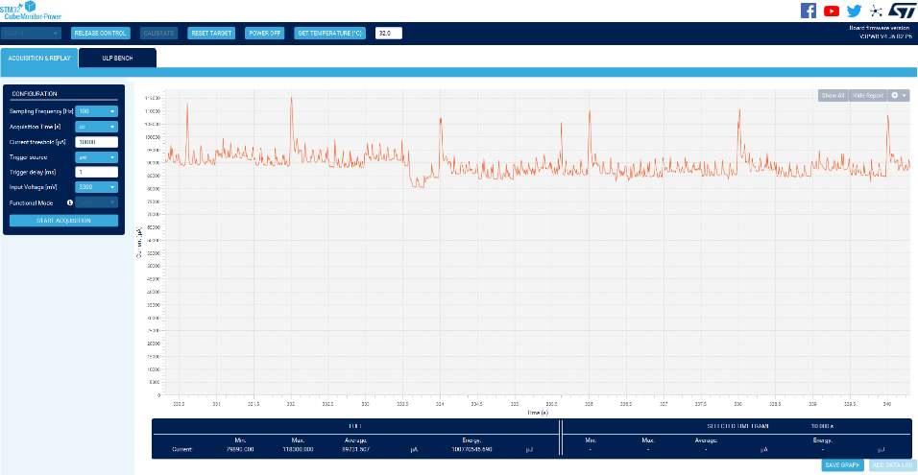
Table 6 compares the power consumption characteristics of the proposed GNSS timing system under Bare-Metal and FreeRTOS implementations. Experimental measurements were obtained using the STLINK-V3PWR power measurement platform while the STM32F401RE continuously received GNSS NMEA data from the X-NUCLEO-GNSS2A1 expansion board. The Bare-Metal implementation exhibited an average current consumption of 131.26 mA, whereas the FreeRTOS-based implementation reduced the average current to 89.73 mA. This corresponds to a power reduction of approximately 31.6%.
Figure 3: Current Consumption Profile Measured Using STLINK-V3PWR
Figure 2: Runtime visualization of FreeRTOS tasks and interrupt activities obtained using SEGGER SystemView on the STM32F401RE platform.
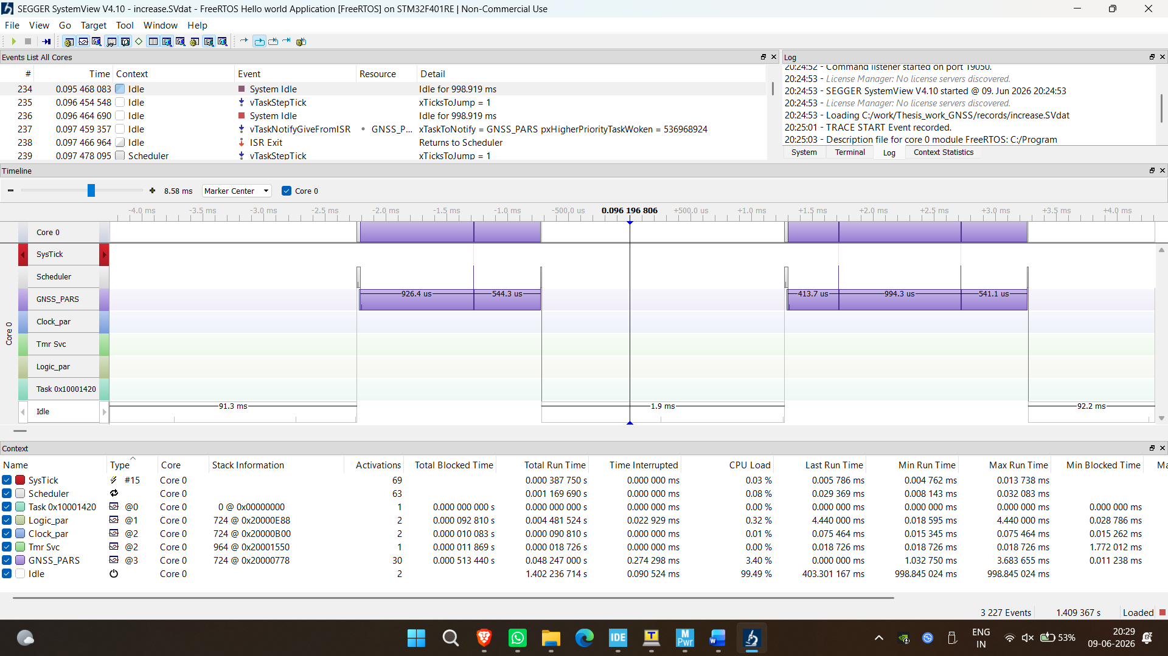
Figure 3 presents the current consumption waveform of the proposed GNSS timing system operating under FreeRTOS and DMA-based data acquisition. The average current consumption was measured at approximately 89.7 mA, with periodic current peaks corresponding to GNSS data reception and processing events. The reduced baseline current indicates improved energy efficiency compared to the bare-metal implementation.

CONCLUSION AND FUTURE SCOPE
This thesis presents the architecture and the implementation of a GNSS based time synchronization platform which uses a STM32F401RE microcontroller, a X-NUCLEO-GNSS2A1 expansion board, a RTC peripheral and a DMA assisted UART communication, along with a FreeRTOS operating system. This proposed architecture uses time synchronized GNSS derived UTC time to set on-chip RTC and perform fast NMEA messages acquisition through a DMA assisted and event triggered tasking system. The experimental performance obtained through SEGGER SystemView was found to have very low CPU usage, the task performing GNSS parsing uses 3.40% of the CPU, the processor is in idle state for approximately 99.49% of the runtime. The power measurement done through the STLINK-V3PWR tool, indicated a mean current consumption of 89.73 mA with FreeRTOS compared to 131.26 mA for bare-metal, thus showing a decrease in the mean current consumption of around 31.6%. Both of the experiments proved that the developed architecture achieves time synchronization accurately with GNSS as well as being very power efficient and computationally effective. It was concluded that DMA assisted communication combined with RTC synchronization and FreeRTOS tasking provide a very efficient, low power and scalable solution for embedded time synchronization systems.
Some enhancements can be implemented in order to enhance the precision and the power consumption of the implemented system:
- RTC drift compensation: by comparing the RTC characteristics and long-term RTC drift will be calibrated through the software calibration algorithm based on the periodic GNSS synchronization.
- PPS synchronization: GNSS device may provide PPS signal that could be used for sub microsecond synchronization. NMEA only synchronization provide few millisecond timing accuracy, this new approach could achieve 10 time accuracy of synchronization.
- FreeRTOS tickless idle: FreeRTOS Tickless idle configuration could be use to allow STM32F401RE to sleep while idle periods. This would improve energy efficiency.
- Multi-constellation support: In future, more GNSS system (Galileo, GLONASS, BeiDou, etc) can be use in addition to GPS to increase precision and robustness, or in case of no GPS signal.
- Advanced Low-Power Modes: The use of STOP or STANDBY operating modes of STM32F401RE could be study to achieve very low-power GNSS time distribution nodes for battery-powered systems.
- Network Time Distribution: The synchronize RTC may be used to achieve network time distribution between systems in a distributed architecture, industrial synchronization network, railway synchronization network, or on IOT time server.
- Comparative RTOS Analysis: Further study could compare FreeRTOS to other Real-Time Operating System (Zephyr, Azure RTOS, RTEMS, etc) to assess their schedule latency, processing power and power consumption for GNSS applications.
- Hardware Timestamping and Precision Time Protocol (PTP): Further work could incorporate hardware timestamping capabilities within the device or implement IEEE 1588 Precision Time Protocol (PTP) to enable accurate time synchronization within distributed embedded systems.

REFERENCES
- X. Longxia, "A Nanosecond-Level Time Distribution System of UTC(NTSC)," 2025 Joint Conference of the European Frequency and Time Forum and IEEE International Frequency Control Symposium (EFTF/IFCS), Querétaro, Mexico, 2025, pp. 1-4.
- K. Shen, Y. Li, T. Liu, J. Zuo and Z. Yang, "Adaptive-Robust Fusion Strategy for Autonomous Navigation in GNSS-Challenged Environments," in IEEE Internet of Things Journal, vol. 11, no. 4, pp. 6817-6832, 15 Feb.15, 2024.
- D. Li, W. Zhang, M. Dong and K. Ota, "DMA-Assisted I/O for Persistent Memory," in IEEE Transactions on Parallel and Distributed Systems, vol. 35, no. 5, pp. 829-843, May 2024.
- Y. Zhong, R. Hu, X. Bai, X. Li, L. -T. Hsu and W. Wen, "Enhancing GNSS Positioning Accuracy for Road Monitoring Systems: A Factor Graph Optimization Approach Aided by Geospatial Information," in IEEE Transactions on Instrumentation and Measurement, vol. 73, pp. 1-12, 2024, Art no. 5501812.
- A. Cernigliaro, S. Valloreia, L. Galleani and P. Tavella, "GNSS space clocks: Performance analysis," 2013 International Conference on Localization and GNSS (ICL-GNSS), Turin, Italy, 2013, pp. 1-5.
- S. Banu and H. Shanavas, "Ground Based Augmentation Systems (GBAS) with Global Navigation Satellite System (GNSS)," 2024 4th International Conference on Mobile Networks and Wireless Communications (ICMNWC), Tumkuru, India, 2024, pp. 1-5.
- S. Anand, A. Johnson, P. Mathikshara and K. R., "Low Power Real Time GPS Tracking Enabled with RTOS and Serverless Architecture," 2019 IEEE 4th International Conference on Computer and Communication Systems (ICCCS), Singapore, 2019, pp. 618-623.
- A. Minetto, "Nanosecond-Level Resilient GNSS-Based Time Synchronization in Telecommunication Networks Through WR-PTP HA," in IEEE Systems Journal, vol. 18, no. 1, pp. 327-338, March 2024.
- J. Zhang, "Performance Evaluation of Railway Time Synchronization Network Based on GNSS Real-time Common View," 2025 Joint Conference of the European Frequency and Time Forum and IEEE International Frequency Control Symposium (EFTF/IFCS), Querétaro, Mexico, 2025, pp. 1-5.
- K. F. Hasan, Y. Feng and Y. -C. Tian, "Precise GNSS Time Synchronization With Experimental Validation in Vehicular Networks," in IEEE Transactions on Network and Service Management, vol. 20, no. 3, pp. 3289-3301, Sept. 2023.
- STMicroelectronics, “Teseo VIC3DA GNSS module datasheet,” DocID- DS13571-Rev6,2024. Available: https://www.st.com/resource/en/datasheet/teseo-vic3da.pdf
- NMEA Sentence information https://aprs.gids.nl/nmea/
- STMicroelectronics, "STM32CubeIDE Integrated Development Environment for STM32," Available: https://www.st.com/en/development-tools/stm32cubeide.html
- SEGGER Microcontroller GmbH, "SEGGER SystemView – Real-Time Recording and Visualization Tool," Available: https://www.segger.com/products/development-tools/systemview/
- STMicroelectronics, "STM32CubeMonitor-Power User Manual and Software Package," Available: https://www.st.com/en/development-tools/stm32cubemonpwr.html

