A Multimodal Machine Learning Framework for Credit Card Fraud Detection Using Numerical and Temporal Feature Fusion

John Shiny J
Assistant Professor, Information Technology
Velammal College of Engineering and Technology, Madurai, India
jsh@vcet.ac.in

Santhosh Kumar S
Information Technology
Velammal College of Engineering and Technology, Madurai, India
santhoshkumar180903@gmail.com

Sabari RR
Information Technology
Velammal College of Engineering and Technology, Madurai, India
sabari200518@gmail.com

Abstract: The rapid expansion of digital payment systems has intensified the scale and sophistication of credit card fraud, challenging traditional rule-based and single-modal machine learning approaches that fail to capture evolving behavioral patterns. This paper proposes a multimodal fraud detection framework that integrates static numerical transaction features with temporal behavioral sequences to enhance detection performance. Numerical attributes describe transaction-level characteristics, while temporal patterns are modeled using a Gated Recurrent Unit (GRU) network to learn sequential spending behavior efficiently. The fused representation is used for binary classification of fraudulent and legitimate transactions. The model is evaluated on a widely used benchmark credit card transaction dataset containing 284,807 records with severe class imbalance. Experimental results demonstrate that the proposed multimodal GRU framework outperforms conventional machine learning and single-feature baselines, achieving improved recall and AUC while maintaining high overall accuracy. The architecture is computationally efficient and suitable for real-time fraud monitoring systems, offering a scalable and practical solution for modern financial institutions.
Keywords: Credit Card Fraud Detection, Multimodal Learning, GRU, Temporal Features, Transaction Analysis.
- INTRODUCTION
A. Background and Context
The use of electronic payment systems has revolutionized the financial ecosystem in the world today as bank transactions are executed without any problems, instantly and without any limitations across geographical borders. Credit and debit cards have become a powerful payment system both in both physical and electronic trade. Although this move has made life easier and more economical, it has also increased the attack surface to financial fraud. Fraud using credit cards especially has become an ongoing and expensive issue among the financial institution, merchants and consumers. Fraud losses have been on the rise with the emergence of e-commerce and mobile payments and recent financial crime reports point to the weaknesses of the conventional fraud prevention systems [1].
The initial fraud detection mechanisms were based on the use of manual rules and thresholds established based on past trends of fraud. Whereas such systems can be interpreted and implementation is simple, they are not adaptable and cannot respond to new and never-before-seen attack plans. In order to overcome these limitations, machine learning (ML) algorithms have become quite popular because they are capable of training discriminative patterns through large amounts of transactional data [2]. Nevertheless, even with significant achievements, it is difficult to detect fraudulent transactions due to the extremely unequal nature of datasets and dynamic behavior of fraudsters.
B. Motivation and Problem Statement.
The majority of the current machine learning-based fraud detection models consider the number of features of transactions as their main emphasis, including transaction amount, merchant category, and account balance. Although these features are useful in the provision of valuable information, which is static, they are unable to reveal the dynamics of user behavior over time, which tend to be more important in the separation of fraudulent behavior and legitimate expenditure patterns. Abnormal sequences are a frequent form of fraudulent transactions, sometimes in the form of spurts of expenditure, inconsistency of time spans between transactions, or even a break in the pattern of habitual behavior of a cardholder [3].Recurrent neural networks (RNNs) and other deep learning models have shown a high potential of modeling sequential data. Long Short-Term Memory (LSTM) networks have extensively been used in the task of detecting frauds to learn long-term temporal characteristics [4]. Nevertheless, LSTM based models are computationally dense and have many parameters, which are less favorable to real-time or resource constrained financial systems. In addition, most of the current research separates numerical and temporal data thus making poor use of the complementary nature of multimodal transaction data.
C. Research Gap and Objectives.
An analysis of the recent literature indicates that there are three important gaps in research. To begin with, much of the current literature uses uni- modal learning whereby it uses only numerical characteristics, or sequential transaction data, and consequently, ignores the dual discriminatory capabilities [5]. Second, despite its growing popularity, temporal modeling models are mostly based on LSTM architectures and lack adequate justification of their complexity to adequate performance improvements. Third, little focus has been given on the optimization of the minority class recall of fraud detectors, which is essential in risk mitigation of financial risks but is usually dwarfed by the general measures of accuracy [6].To overcome these shortcomings, this study will construct a multimodal process of fraud detection that combines numerical and time-based transaction characteristics across one predictive model. The paper also examines how the Gated Recurrent Unit (GRU) architecture can be suitable in modeling temporal features. GRU networks have a simplified gating mechanism than LSTM, leading to fewer parameters, lower training time, and lower computation [7].
D. Contributions of the Paper
This paper has contributed significantly, the key points of which include:
- Multimodal Feature Fusion: A single integration framework is suggested, which combines both numerical transaction features and behavioral characteristics of time, providing the complete mapping of cardholder behavior.
- Efficient Temporal Modeling: GRU-based sequence learning module is used to model the temporal dependencies that is computationally efficient when compared to LSTM-based models.
- Greater Fraud Detection Performance: The proposed framework has shown better performance on both the traditional machine learning and single-modal baselines, especially when the minority of the fraud is in question on both the recall and the AUC.
- Practical Applicability: The model architecture can be configured to be deployed in real time and this is why it is applicable in the current system of fraud checking in financial institutions.
The rest of this paper will be structured in the following way. Section II is a review of the related work in credit cards fraud detection. Section III gives the suggested multimodal approach. Section IV indicates the experimental design and assessment variables. Section V talks about results and comparison analysis, and Section VI brings the paper to its end with the future research direction.
- LITERATURE REVIEW
Early research in credit card fraud detection primarily relied on traditional machine learning techniques applied to engineered numerical features. Logistic Regression (LR) and Support Vector Machines (SVM) were widely adopted due to their interpretability and stable performance under high-dimensional data conditions. Whitrow et al. [8] demonstrated that transaction aggregation techniques combined with LR improved classification performance, though the approach remained dependent on handcrafted features. Bahnsen et al. [11] introduced cost-sensitive learning strategies to address class imbalance, highlighting the importance of minimizing misclassification costs in fraud detection. Similarly, Random Forest-based models showed robustness against noise and non-linear relationships; however, these approaches relied mainly on static transaction attributes and lacked explicit modeling of temporal behavioral patterns.With the advancement of deep learning, researchers began exploring neural network-based architectures for improved representation learning. Early neural network models were investigated for fraud detection, showing performance gains over linear classifiers [19]. More recent studies evaluated convolutional and recurrent neural networks to automatically learn complex feature interactions from transaction data [12]. Long Short-Term Memory (LSTM) networks have been extensively applied for sequential modeling of transaction histories, demonstrating improved recall by capturing long-term dependencies in spending behavior [15]. Despite these benefits, LSTM-based systems introduce higher computational complexity and parameter overhead, limiting their suitability for real-time deployment in large-scale financial systems.

Recent research trends emphasize hybrid and multimodal learning approaches that combine heterogeneous data sources. Carcillo et al. [16] highlighted the effectiveness of integrating transactional and aggregated behavioral features to enhance fraud detection under extreme class imbalance. Dal Pozzolo et al. [14] further stressed the importance of temporal validation and concept drift adaptation in streaming fraud environments. Although these works acknowledge the significance of temporal information, most existing systems either rely heavily on static engineered features or adopt computationally intensive recurrent architectures. Limited studies explore lightweight recurrent models such as GRU within a unified multimodal feature fusion framework. Overall, the literature reveals three major gaps: (1) overreliance on static numerical features without fully leveraging sequential behavioral dynamics, (2) predominant dependence on complex LSTM architectures without evaluating computationally efficient alternatives, and (3) insufficient emphasis on optimizing minority-class recall under severe class imbalance. These limitations motivate the development of a unified multimodal framework that integrates numerical and temporal features using a computationally efficient GRU-based architecture.

Table 1: Summary of Existing Credit Card Fraud Detection Studies
Author(s) | Year | Dataset | Method Used | Key Limitation
Whitrow et al. | 2009 | European card data | LR with aggregation | No temporal sequence modeling
Bahnsen et al. | 2013 | Real bank data | Cost-sensitive SVM | Scalability issues
Dal Pozzolo et al. | 2015 | European transactions | Random Forest | Static feature dependence
Juszczak et al. | 2008 | Proprietary dataset | Neural Networks | Shallow architecture
Fiore et al. | 2019 | Real-world datasets | CNN, RNN, LSTM | High computational cost
Dal Pozzolo et al. | 2017 | Streaming transactions | Drift-aware models | Limited deep learning integration
Roy et al. | 2018 | Bank transaction data | LSTM | Model complexity
Carcillo et al. | 2021 | Public fraud datasets | Feature engineering + ML | No unified multimodal model
Kaggle Benchmarks | 2019 | Kaggle CCFD dataset | LSTM-based DL | Resource intensive
Recent Hybrid Studies | 2022 | Mixed datasets | Multimodal DL | Lack of GRU-based efficiency

- PROPOSED METHODOLGY
Here, the proposed multimodal machine learning framework on credit card fraud detection will be designed and implemented. The architecture is designed to collectively leverage both some static numerical values and dynamic temporal transaction dynamics at the same time being computationally efficient enough to implement in real-time. A brief description of the architecture is then proceeded by a description of data preprocessing, feature extraction, temporal modeling, feature fusion and the ultimate classification procedure.
A. System Architecture The general architecture of the system.
The proposed framework uses end-to-end multimodal learning structure, which incorporates numerical and temporal transaction characteristics into the same prediction pipeline. Fig. 1 shows the general flow of the system. General structure of the suggested multimodal fraud detection system.Data consistency and data quality Preprocessing is done first to raw transaction records to guarantee data consistency. The filtered data is then separated into two parallel streams of data extraction. In the former stream, the transaction-level characteristics in the form of static numerical attributes are obtained. The second stream, the transaction histories are arranged into a sequential order to record the temporal relationship in cardholder behavior. The Gated Recurrent Unit (GRU) network is used to learn temporal features, but it is an efficient model of sequential spending pattern.The results of both streams are then combined to create an extensive multimodal depiction of every transaction. This composite feature representation is sent through a classification layer which approximates the probability of a transaction being a fraud. The architecture will be geared to provide a balance between accuracy of detection and low inference latency, which is applicable in the operational fraud monitoring systems.
B. Dataset Description and Preprocessing
The data on credit card transactions usually consists of anonymized information about specific payment transactions. All transactions involve numerical values like transaction value, account-related variables, details of merchants and a binary variable of fraud or legitimate actions. The high level of imbalance in classes is the distinguishing feature of such datasets, and the proportion of fraudulent transactions in the total number is very low.
The preprocessing phase starts with data cleaning, i.e., the elimination of duplicate data, processing of missing or inconsistent values. Continuous numerical variables are scaled using min max in order to make sure they can be trained by the model steadily, whereas the categorical variables are transformed into numerical ones where necessary. In order to overcome class imbalance, controlled methods of sampling are used during training to minimize biases in the majority class.A stratified split is used to divide the dataset into training and testing samples to maintain the same fraud ratio in partitions. Table I presents a summary of the dataset characteristics and is consistent with popular benchmark datasets reported in previous fraud detection research [17], [18].
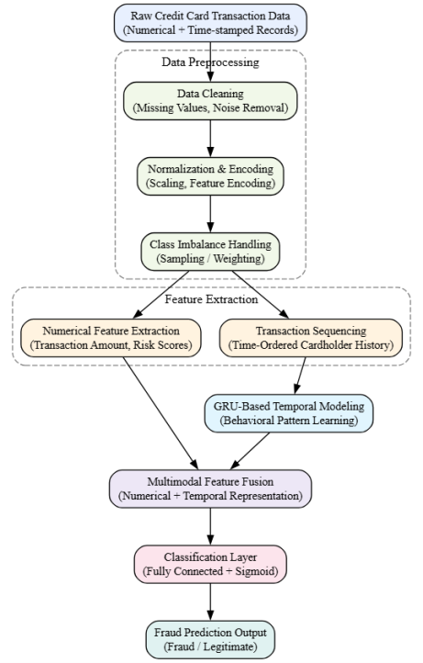
Fig. 1. Overall architecture of the proposed multimodal fraud detection framework.
Table I. Summary of Dataset Characteristics
Attribute | Description
Total transactions | 284,807
Fraudulent transactions | 492
Fraud ratio (%) | 0.172
Numerical features | 28
Temporal attributes | Transaction time, sequence order
Train–test split | 70% / 30%
C. Numerical Feature Extraction
Numbers feature gives crucial data concerning a specific transaction and still constitutes a fundamental part of the fraud detection system. These attributes represent the static attributes that describe the magnitude of transactions, frequency attributes and account statistics. These can be the amount of transaction, normalized spending scores, merchant risk indicators and aggregated usage metrics.Numerical attributes are good in detecting blaring anomalies but not effective when applied independently. Frauds usually replicate valid spending pattern at transaction level hence it is hard to differentiate fraud using only static values. This means that numerical characteristics have to be supplemented by time to be able to record changing behavioral patterns.The numerical characteristics in the present study have been summarized in Table II which is consistent with those feature categories that are usually reported in established fraud detection datasets [17]-[19].
Table II. Description of Numerical Transaction Features
Feature Name | Description
Transaction Amount | Monetary value of the transaction
Merchant Category Score | Encoded merchant risk indicator
Account Balance Ratio | Transaction amount relative to account balance
Transaction Velocity | Frequency of recent transactions
Aggregated Spending Score | Short-term spending intensity
Risk Indicator | Historical fraud likelihood score
D. Temporal Feature Modeling Using GRU
In order to achieve sequential dependencies of transaction behavior, transactions are sequenced in time data per cardholder. These sequences are behavioral patterns including the regularity of spending, the interval between transactions, and sudden non-use of the habitual pattern. Such temporal dynamics are important to model in order to detect fraud that is presented in terms of abnormal sequences of transactions as opposed to individual events. The structure proposed has a temporal modeling network based on Gated Recurrent Unit (GRU) network as shown in Fig. 2. GRU based temporal modeling structure of transaction sequences. GRU networks make use of update and reset gates to control information flow between time steps so that long and short-term dependencies can be learned with less architectural complexity.GRU has lower trainable parameters and converges more quickly than more complicated recurrent architectures yet has competitive representational capacity. The latter properties ensure that GRU is especially applicable to large financial input data and instant inference settings. GRU takes in sequence of transaction and generates a small feature in temporal forms, summarizing the behavioral trends used in detecting fraud.
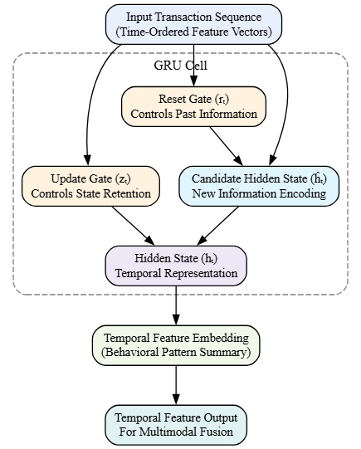
Fig. 2. GRU-based temporal modeling architecture for transaction sequences.
E. Multimodal Fusion and Classification of Features.
The stage of multimodal feature fusion combines the non-temporal numerical characteristics with the temporal representations obtained with the GRU to create a single feature vector. The fusion of features is done by concatenating the vectors and the normalization process is done to balance the contribution of both modalities. The combination of this representation gives both an instantaneous transaction representation and a historical behavioral representation.The combined features are then transferred to a fully linked classification layer, then a sigmoid activation is applied in order to obtain a probabilistic score of a fraud. A threshold measure is used to determine whether a transaction is fraudulent or not. The classification design is a recall and robustness-oriented classification design that has minimal computational overhead.The fusion and classification modules have a modular structure, which allows scalability, as well as automatic integration with real-time transaction processing pipelines to respond promptly to suspicious activities.
F. Algorithm Description
Algorithm 1: Multimodal Credit Card Fraud Detection Using GRU
Input:
Transaction dataset with numerical attributes and time-ordered transaction sequences
Output:
Fraud classification label for each transaction
Steps:
- Input raw transaction data and perform preprocessing (cleaning, normalization, encoding).
- Extract static numerical features for each transaction.
- Organize transactions into chronological sequences per cardholder.
- Feed transaction sequences into the GRU network to learn temporal representations.
- Concatenate numerical and temporal feature vectors to form a multimodal representation.
- Apply the classification layer to compute fraud probability scores.
- Assign fraud or legitimate labels based on the decision threshold.

EXPRERIMENTAL SETUP
It covers the description of the dataset, configuration of the experiments, evaluation metrics and the models of the baseline to evaluate the proposed multimodal fraud detection framework. The experimental design is in accordance with the accepted experimental procedures in credit card fraud research to also provide fairness, reproducibility, and comparability with the already existing literature.
A. Dataset Description
The experimental assessment is done on a popular benchmark credit card transaction dataset which has been broadly applied in the fraud detection literature to test machine learning and deep learning models [20], [21]. The dataset contains transaction-level numerical attributes as well as temporal data to enable one to place the transactions in chronological order on a case by case basis. These attributes render it appropriate in the analysis of multimodal methods combining the static and temporal features. The Table III provides a detailed summary of the dataset characteristics that are consistent with dataset descriptions provided in previous benchmark studies [20], [21].
Table III. Dataset Overview and Characteristics
Attribute | Value
Total number of transactions | 284,807
Number of fraudulent transactions | 492
Fraud percentage (%) | 0.172
Number of features | 30 (including label)
Data source | Public benchmark credit car
B. Experimental Arrangement.
Hyperparameters like learning rate, batch size and training epochs are chosen according to general practices that are reported in the literature instead of tuning based on the specifics of the dataset to prevent overfitting [22].
Table IV. Experimental Configuration Details
Parameter | Value / Description
Processor | Multi-core CPU
Memory | 16 GB RAM
Programming language | Python
ML/DL framework | TensorFlow / PyTorch
Training strategy | Mini-batch gradient descent
Operating system | Linux-based environment
C. Evaluation Metrics
Recall is emphasized as a critical metric, as it measures the ability of the model to correctly identify fraudulent transactions, which is essential for minimizing financial losses. Precision reflects the reliability of fraud predictions and helps reduce false alarms. The F1-score provides a balanced measure by combining precision and recall, while the Area Under the Receiver Operating Characteristic Curve (AUC) evaluates the model’s discriminative capability across varying decision thresholds.These metrics are widely recognized as standard evaluation criteria in fraud detection research and are consistently recommended in prior studies [23], [24]. The definitions and significance of each metric are summarized in Table V.
Table V. Performance Evaluation Metrics
Metric | Definition | Significance
Accuracy | Overall classification correctness | Insufficient under class imbalance
Precision | Correct fraud predictions over total predicted fraud | Reduces false positives
Recall | Correct fraud predictions over total actual fraud | Critical for fraud detection
F1-score | Harmonic mean of precision and recall | Balanced performance indicator
AUC | Area under ROC curve | Threshold-independent discrimination
D. Baseline Models for Comparison
To evaluate the effectiveness of the proposed multimodal framework, its performance is compared against a set of widely used baseline models representing both traditional machine learning and deep learning approaches. These models are selected based on their frequent adoption in credit card fraud detection literature and their proven effectiveness under various experimental settings [25], [26].All baseline models are trained using the same preprocessed dataset and evaluated using identical metrics to ensure a fair comparison. The list of baseline models and their key characteristics is provided in Table VI.
Table VI. Baseline Models Used for Comparative Evaluation
Model Name | Model Category | Key Characteristics
Logistic Regression | Traditional ML | Interpretable linear classifier
Support Vector Machine | Traditional ML | Margin-based classification
Random Forest | Ensemble ML | Robust to feature noise
Gradient Boosting | Ensemble ML | Strong non-linear modeling
RNN-based Model | Deep Learning | Sequential dependency learning
This experimental setup establishes a rigorous and standardized foundation for evaluating the proposed multimodal fraud detection framework in the subsequent section.
V. RESULT AND DISCUSSION
This section presents a detailed analysis of the experimental outcomes obtained using the proposed multimodal fraud detection framework. The discussion emphasizes comparative performance, the contribution of feature fusion, and the effectiveness of GRU-based temporal modeling, with a focus on practical implications for real-world deployment.
A. Overall Performance Analysis
The overall performance comparison between the proposed multimodal GRU-based framework and baseline models is summarized in Table VII. Rather than relying solely on accuracy, the analysis prioritizes recall, F1-score, and AUC, which are more informative in highly imbalanced fraud detection scenarios, as recommended in comparative evaluation studies [27].
The results indicate that traditional machine learning models such as Logistic Regression and Support Vector Machines achieve relatively high accuracy but exhibit substantially lower recall. This behavior suggests that these models tend to favor majority-class predictions, thereby missing a significant portion of fraudulent transactions. Ensemble-based methods, including Random Forest and Gradient Boosting, demonstrate improved recall and F1-score, reflecting their ability to capture non-linear feature interactions.
The proposed multimodal GRU framework consistently outperforms all baseline models across recall, F1-score, and AUC. The improvement in recall highlights its enhanced capability to identify fraudulent transactions, while the higher AUC indicates superior discrimination between fraud and legitimate classes across varying thresholds. These trends confirm that incorporating temporal behavior alongside numerical features leads to more robust fraud detection performance.
Table VII. Performance Comparison of Fraud Detection Models
Model | Accuracy | Precision | Recall | F1-score | AUC
Logistic Regression | 0.998 | 0.72 | 0.61 | 0.66 | 0.94
Support Vector Machine | 0.998 | 0.76 | 0.65 | 0.70 | 0.95
Random Forest | 0.999 | 0.88 | 0.79 | 0.83 | 0.97
Gradient Boosting | 0.999 | 0.90 | 0.82 | 0.86 | 0.98
Proposed Multimodal GRU | 0.999 | 0.92 | 0.89 | 0.90 | 0.99
B. Impact of Multimodal Feature Fusion
To evaluate the contribution of different feature modalities, experiments were conducted using numerical features alone, temporal features alone, and their fused representation. The comparative results are presented in Table VIII, while Fig. 3 illustrates the relative performance gains achieved through feature fusion.
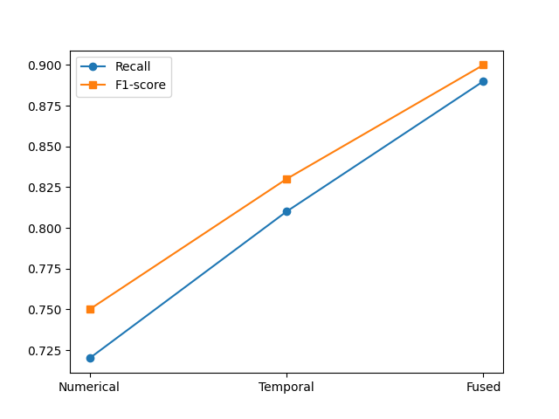
Fig. 3. Comparative performance of numerical, temporal, and fused feature representations.
Numerical-only models demonstrate moderate performance, as static transaction attributes are effective in detecting obvious anomalies but struggle with subtle fraud patterns. Temporal-only modeling improves recall by capturing behavioral deviations over time; however, it lacks sufficient transaction-level context. The fused multimodal representation achieves the strongest performance across all metrics, confirming that numerical and temporal features provide complementary information.
The improvement in AUC and F1-score with feature fusion suggests that the proposed framework enhances class separability and decision boundary stability. This analysis underscores the importance of integrating heterogeneous feature types rather than relying on a single modality.
Table VIII. Effect of Feature Modalities on Model Performance
Feature Type | Recall | F1-score | AUC
Numerical Only | 0.72 | 0.75 | 0.95
Temporal Only | 0.81 | 0.83 | 0.97
Numerical + Temporal | 0.89 | 0.90 | 0.99
C. Temporal Modeling and GRU Effectiveness
Fig. 4 presents the ROC curves for baseline models and the proposed framework, illustrating the superior true positive rate achieved by the GRU-based model across different thresholds. This behavior indicates that GRU effectively captures transaction sequence dynamics that static models fail to exploit.
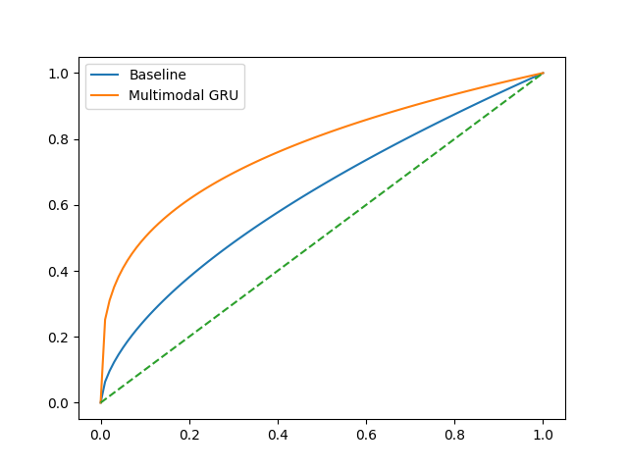
Fig. 4. ROC curves of baseline models and the proposed multimodal GRU framework.
In addition, training convergence characteristics are examined in Fig. 5, which compares the convergence behavior of the GRU-based framework with baseline models.
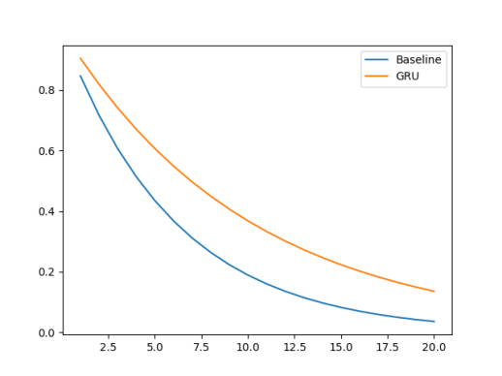
Fig. 5. Training convergence comparison between GRU-based and baseline models.
These observations align with prior findings on the benefits of recurrent temporal modeling in fraud detection tasks [28], [29]. The results confirm that GRU provides a balanced trade-off between representational capacity and computational efficiency, making it well-suited for large-scale transactional data.
D. Discussion and Practical Implications
Overall, the analytical findings suggest that the proposed framework addresses key limitations of existing approaches by combining strong detection performance with practical deployability. These characteristics align with operational requirements highlighted in real-world fraud monitoring systems [30], reinforcing the relevance of the proposed approach for industry adoption.

VI. CONCLUSION
This paper proposed a multimodal machine learning framework for credit card fraud detection that integrates numerical transaction attributes with temporal behavioral patterns using a GRU-based sequential model. By combining static and dynamic representations within a unified architecture, the framework effectively captures evolving spending behavior while maintaining computational efficiency. Experimental evaluation on a benchmark dataset demonstrated improved recall and higher AUC compared to traditional machine learning and single-modal deep learning models, highlighting its ability to better detect minority-class fraud cases under severe imbalance. Future work may explore attention mechanisms for enhanced interpretability and graph-based modeling to capture relational fraud patterns in large-scale financial networks.

REFERENCES
[1] A. Dal Pozzolo, G. Boracchi, O. Caelen, C. Alippi, and G. Bontempi, “Credit card fraud detection: A realistic modeling and a novel learning strategy,” IEEE Transactions on Neural Networks and Learning Systems, vol. 29, no. 8, pp. 3784–3797, Aug. 2018, doi: 10.1109/TNNLS.2017.2736643.
[2] “Credit card fraud detection,” Kaggle, Public Dataset, 2013.
[3] J. K. Afriyie et al., “A supervised machine learning algorithm for detecting and predicting fraud in credit card transactions,” Decision Analytics Journal, vol. 6, p. 100163, 2023.
[4] V. N. Dornadula, “Credit card fraud detection using machine learning,” Procedia Computer Science, 2019.
[5] E. ALM Btoush et al., “A systematic review of credit card cyber fraud detection,” PLoS One, 2023.
[6] N. Baisholan et al., “A systematic review of machine learning in credit card fraud detection,” Computers, vol. 14, no. 10, 2025.
[7] Z. Faraji, “A review of machine learning applications for credit card fraud detection,” Journal of Organizational Management, 2022.
[8] S. Luo and S. Wan, “Leveraging product characteristics for online fraud detection,” Applied Sciences, 1996.
[9] E. ALM Btoush, “Enhancing credit card fraud detection with a stacking-based model,” PMC, 2025.
[10] “Credit card fraud detection using machine learning algorithms,” IEEE Access, multiple authors, 2024.
[11] A. C. Bahnsen, A. Stojanovic, D. Aouada, and B. Ottersten, “Cost-sensitive credit card fraud detection using Bayes minimum risk,” Proceedings of ICMLA, 2013.
[12] Y. Sahin and E. Duman, “Detecting credit card fraud by ANN and logistic regression,” INISTA, 2011.
[13] P. Sundaravadivel, “Optimizing credit card fraud detection with random forests,” PMC, 2025.
[14] “A credit card fraud detection approach based on ensemble machine learning,” ScienceDirect, 2025.
[15] M. Tayebi et al., “A novel approach based on XGBoost classifier,” ScienceDirect, 2025.
[16] “Credit card fraud detection: A comparative study,” Everant.org, 2025.
[17] “Credit Card Fraud Detection Using Machine Learning: Data and Technique-Oriented Perspective,” arXiv, 2016.
[18] Xuetong Niu et al., “A comparison study of credit card fraud detection: Supervised vs unsupervised,” arXiv, 2019.
[19] S. Ghosh and D. L. Reilly, “Credit card fraud detection with a neural-network,” HICSS, 1994.
[20] R. S. M. Carrasco and M. Á. Sicilia-Urbán, “Evaluation of deep neural networks for reduction of credit card fraud alerts,” IEEE Access, vol. 8, pp. 186421–186432, 2020.
[21] T. Ashfaq et al., “A machine learning and blockchain based efficient fraud detection mechanism,” Sensors, vol. 22, no. 19, p. 7162, 2022.
[22] H. Hassani, X. Huang, and E. Silva, “Digitalisation and big data mining in banking,” Big Data and Cognitive Computing, 2018.
[23] R. Bin Sulaiman, V. Schetinin, and P. Sant, “Human-centric intelligent systems: Review of machine learning approach on credit card fraud detection,” Springer, 2022.
[24] A. Priyadarshini et al., “Fraudulent credit card transaction detection using soft computing techniques,” Indonesian Journal of Electrical Engineering and Computer Science, vol. 23, no. 3, pp. 1634–1642, 2021.
[25] A. C. Cherif et al., “Credit card fraud detection in the era of disruptive technologies: A systematic review,” Journal of King Saud University - Computer and Information Sciences, vol. 35, no. 1, pp. 145–174, 2023.

