Nexoria Framework for Agentic Clinical Intelligence through Causal Multimodal Knowledge Learning

1st Mohanraj B
Department of Information Technology,
Sona College of Technology,
Salem, India.
bmohanrajcse@gmail.com

4th Kanish S
Department of Information Technology,
Sona College of Technology,
Salem, India.
kanish2280@gmail.com

2nd Kaviraj S M G
Department of Information Technology,
Sona College of Technology,
Salem, India.
kavirajsmg@gmail.com

5th Priyarani K
Department of Information Technology,
Sona College of Technology,
Salem, India.
priyasince92@gmail.com

3rd Hariharan T
Department of Information Technology,
Sona College of Technology,
Salem, India.
harithean2003@gmail.com

6th Shalini M
Department of Information Technology,
Sona College of Technology,
Salem, India.
shalini93631@gmail.com

Abstract — Rapid advancements in multimodal healthcare data (EHR, medical imaging, genomic repository, wearable, lab reports), have provided great opportunities for intelligent clinical decision support. Current healthcare intelligence systems, however, are mainly based on correlation-based learning and centralized reasoning mechanisms, which restrict the interpretability and robustness of such systems, as well as their collaborative decision-making. In this paper, to overcome these challenges, a novel framework, called Nexoria, is proposed by combining agentic clinical intelligence with causal knowledge learning for next-generation healthcare analytics. The proposed architecture unifies multimodal data harmonization, specialized clinical agents, shared clinical memory, causal relation discovery and federated causal knowledge exchange in a single system. Specialized agents reason together using heterogeneous healthcare information, and produce consensus-based decisions based on clinically relevant causal relations. The proposed approach is experimentally evaluated to be effective with accuracy 96.12%, precision 95.83%, recall 95.41%, F1-score 95.62% and AUC 96.84% outperforming the conventional machine learning and federated learning approaches. Moreover, ablation experiments confirm that the contribution of agentic reasoning, the contribution of causal learning, and the contribution of federated knowledge collaboration to overall system performance are valid. The results show that Nexoria is a viable solution that is scalable, interpretable, and trustworthy to build personalised healthcare intelligence and evidence-informed clinical decision support solutions for distributed healthcare settings.
Keywords: Agentic Clinical Intelligence, Causal Knowledge Learning, Multimodal Healthcare Analytics, Federated Healthcare Intelligence, Clinical Decision Support.

Introduction
Healthcare systems have experienced a dramatic shift toward digitization and are now producing large amounts of diverse and complex clinical data from electronic health records, medical imaging, lab results, wearable devices, genomic repositories and physician observations. The combination of these various sources of information has opened new avenues for smart healthcare solutions that can be used for disease diagnosis, risk evaluation, treatment planning and personalized patient management. The recent progress of multimodal learning has shown great promise in utilizing complementary information from multiple clinical modalities to achieve more comprehensive and accurate healthcare analytics than those based on a single modality. Although these developments have been made, the application of intelligent health care systems in actual clinical environments is still hindered. The nature of healthcare data necessitates its dispersion over several institutions, departments and diagnostic platforms, which in turn makes it difficult to develop coherent decision-support mechanisms due to limited knowledge ecosystems. Moreover, the current multimodal healthcare approaches are monolithic prediction systems that focus mainly on statistical correlation learning from data. These methods tend to be predictive strong, but they're not always equipped to provide the explanations of why certain clinical decisions were taken. This restriction diminishes transparency and trust, especially in critical health-care situations where decisions have a direct impact on patient health. The second challenge is the need for conventional learning models based on correlation-based representations. In medical data, there can be intricate relationships between physiological states, treatments, environment, and patient variables. Model correlations can also identify false correlations that don't reflect underlying disease mechanisms, meaning that the predictions they make may not hold true when applied to different patient populations. Thus, there is a growing demand for healthcare intelligence systems which can go beyond predictive analytics to causal understanding and clinically relevant reasoning.
There are some recent advances in agentic AI which offer hope of overcoming these shortcomings. Agentic systems use a set of special intelligent agents with the ability to make independent decisions, communicate with other agents, and reason about the problem. In a healthcare context, various agents may be deployed to process distinct segments of patient data, share insights, and gain a more comprehensive understanding of the patient's condition. These forms of joint reasoning are very similar to the clinical processes that occur in actual multi-disciplinary practice, where one expert in the field supplies another with complementary information that is useful for diagnosis and treatment. At the same time, causal learning is a powerful paradigm for determining cause and effect relationships in complex healthcare settings. Causal learning enables interpretable decision making and counterfactual reasoning, by establishing causal relationships between symptom, disease, biomarker, treatment, and outcome. This functionality allows you to answer clinically relevant questions on possible treatment outcomes and disease pathway, and therefore improving transparency and decision confidence. Focusing on these challenges and opportunities, this study proposes a novel framework, called Nexoria, to combine agentic clinical intelligence and causal knowledge learning for next-generation healthcare analytics. The proposed framework is based on the concept of a distributed reasoning model through a knowledge space shared across a collaborative ecosystem of specialized clinical agents across various healthcare modalities. Nexoria also features a causal knowledge learning mechanism that is able to discover meaningful cause-effect relationships from a variety of clinical data and use them to support intelligent decision making. Nexoria will achieve this by integrating agentic collaboration and causal reasoning in a single framework, to increase interpretability, robustness and clinical trustworthiness of predictive performance. This work has three main merits. Specifically, an agentic clinical intelligence architecture is designed to enable multimodal clinical environments to enable collaborative reasoning among specialized clinical agents. Second, a causal knowledge learning mechanism is added to uncover and utilize clinically significant causal relationship for better healthcare decision making. Third, an integrated intelligence framework to enable scalable and interpretable clinical analytics in distributed health care ecosystems is created.

Related works
Within the last few years, there has been promising progress in federated healthcare intelligence that enables joint model development without revealing patient information. Multiple works have been investigating privacy-preserving multimodal learning frameworks which can merge various heterogeneous healthcare data while preserving data privacy. Tanvir et al. [1] proposed a multimodal federated learning pipeline for improving cyber resilience in healthcare systems, while Chowdhary [2] proposed personalized multimodal federated learning with adaptive differential privacy for medical image classification. Analogously, Liu et al. [3] proposed a explainable semi-federated system for multimodal cardiac imaging and risk stratification, emphasizing the need for explainable healthcare analytics. Recent studies have also integrated federated learning with advanced security mechanisms, further bolstering privacy protection.
Recent studies have also explored the integration of federated learning with advanced security mechanisms, further enhancing privacy protection. Balaji et al. [4] proposed a secure neuroimaging analysis framework using attention-weighted transformers, and Nemane et al. [5] introduced a federated, multimodal healthcare diagnostic system, incorporating biomedical imaging, clinical decision support systems, electronic health records and wearable information. The same way, Teja et al. [6] worked in this direction to develop a privacy-preserving multimodal diagnostic system for next-generation healthcare environments. The studies all show that multimodal federated learning is effective in enabling distributed healthcare analytics without compromising patient privacy. Federated intelligence is not only employed for diagnostics but also in personalized healthcare services and in large-scale clinical decision support. For the Internet of Things (IoT) healthcare environment, Ravikumar et al. [7] reviewed privacy-aware Federated Recommender Systems with a focus on real-time personalization with the help of multimodal optimization. Similarly, Laitinen-Fredriksson Lundström Imanov et al. [8] tested a federated multimodal triage model in multiple clinical centers, showing the feasibility of privacy-preserving collaborative learning in practice. Decentralized machine learning models that can enable geographically distributed hospitals to collaborate for analytics have also received a lot of attention in the healthcare industry [9].
Recent works have also investigated secure aggregation protocols, federated architectures with assistance from edges and healthcare ecosystems powered by blockchain technology. Maurya et al. [10] explored secure edge-aggregated federated learning for healthcare severity classification while Harshith et al. [11] introduced a blockchain-enabled microservices approach for scalable healthcare analytics. Related works have been conducted for the prediction of chronic kidney disease with decentralized infrastructures [12] and systematic reviews showed that blockchain and federated learning are increasingly converging in healthcare systems [13]. Moreover, the use of federated learning has shown some success in special applications like multi-center tuberculosis diagnosis using distributed imaging repositories [14]. More extensive surveys also show a unified direction of developing federated learning as an emerging paradigm for AI systems that are privacy-preserving in medical contexts [15].
While this progress has been made, three major gaps need to be filled. The first is that most of the current frameworks are mainly concerned with preserving privacy, aggregating secure information, and fusing multimodal information, and they are based on centralized reasoning mechanisms. Therefore, the decision making process continues to rely on rigid and limited collaborative clinical reasoning support architectures. Thus, current decision making processes still depend on architectures that support limited collaborative clinical reasoning. Second, most existing models are built from healthcare data to learn statistical correlations among symptoms, diseases, treatments, and outcomes, while neglecting to model the causal relationships. These types of correlation-based learning might result in limitations in robustness when applied to diverse patient groups and changing clinical settings. Thirdly, distributed healthcare intelligence facilitates collaborative model building, but the current methods usually share model parameters or encrypted updates, instead of knowledge representations that can help in transparent and interpretable decision making.
All these restrictions inspire the creation of a new generation of healthcare intelligence framework that can integrate collaborative reasoning, causal knowledge, and distributed knowledge learning in a single architecture. To overcome this challenge, this work suggests the concept of Nexoria Framework for Agentic Clinical Intelligence through Causal Knowledge Learning. Unlike traditional federated health care model, Nexoria offers a new paradigm of an ecosystem of specialized clinical agents that carry out independent reasoning on multimodal health care data. What's more, a causal knowledge learning mechanism is also added to capture meaningful cause-effect knowledge and to facilitate explainable clinical decision processes. The framework proposed in this research aims to create a more explainable, powerful, and clinically reliable framework for future healthcare data analysis, through the fusion of agentic intelligence and causal knowledge discovery.

Proposed system architecture
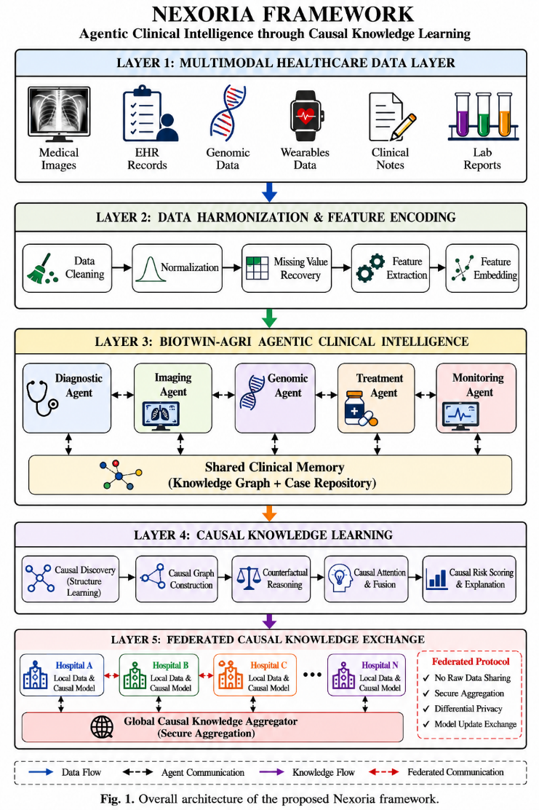
Fig. 1. System architecture of the proposed Nexoria framework
The proposed framework of Nexoria aims at a new paradigm of healthcare intelligence that unifies agentic reasoning, causal knowledge learning and distributed clinical collaboration in a unified framework. While traditional healthcare analytics are mainly oriented in predictive modelling, Nexoria will strive to mimic the collaborative reasoning process that occurs in real world clinical settings. It provides a framework that allows specialized intelligent agents to process and manipulate heterogeneous healthcare information, share their knowledge within a shared memory repository, find causal relationships between clinical variables, and work together to arrive at a reliable medical decision. Nexoria is composed of five interrelated layers: Multimodal Healthcare Data Layer, Data Harmonization and Feature Encoding Layer, Agentic Clinical Intelligence Layer, Causal Knowledge Learning Layer, and Federated Causal Knowledge Exchange Layer (as shown in Fig. 1). These layers work together to convert raw information into clinically relevant knowledge that can aid in diagnosis, risk stratification, treatment planning and prognosis.

Multimodal Healthcare Data Layer
Multimodal Healthcare Data Layer Healthcare ecosystems produce vast quantities of information from various clinical sources, which is often different, or heterogeneous. They each provide a unique view of patient health and provide complementary evidence for clinical decision making. Nexoria thus provides a multimodal data acquisition mechanism that combines data from various healthcare modalities such as medical images, EHRs, genomic data, streams of wearable sensors, medical notes, and laboratory reports. The patient state is described at the bottom layer of the data with a very diverse vector space. In form, for each clinical episode the collection of incoming observations is the composite set set $D=\left\{D_{\text{img}},D_{\text{ehr}},D_{\text{gen}},D_{\text{wear}},D_{\text{note}},D_{\text{lab}},D_{\text{ctx}}\right\}$ consisting of elements containing encapsulated individual modality-specific diagnostic channels. The medical imaging data is modeled as a high-resolution tensor $D_{\text{img}}∈R^{H×W×C×T}$ with a high resolution in the third dimension of the imaging modality, the clinical events are high-dimensional, are associated with a time-stamp, and are mapped as a tuple $D_{\text{ehr}}={\left\{\left(c_{i},v_{i},t_{i}\right)\right\}}_{i=1}^{M}$, the high-dimensional genomic variants are recorded in a discrete sequence of vectors $D_{\text{gen}}∈{\left\{A,C,G,T\right\}}^{N×V}$continuous physiological vital sign data from wearables is recorded as multi-channel time-series functions $D_{\text{wear}}=\left\{f\left(t\right)∈R^{d}∣t∈\left[0,T\right]\right\}$, the narrative clinical data is represented as a sequence of discrete token vectors $D_{\text{note}}=\left[w_{1},w_{2},…,w_{L}\right]$, and the baseline patient characteristics are represented in a global environmental context vector $D_{\text{ctx}}∈X_{\text{static}}×X_{\text{env}}$.

Where each modality provides its own diagnostic and prognostic value. Medical images offer evidence for structural and anatomical information; electronic health records offer a longitudinal history of the patient; genomic information offers an understanding of inherited disease predispositions; wearable devices offer an understanding of physiological signals; clinical notes offer an understanding of the context of medical observations; and laboratory reports offer a quantification of biological measurements. These combinations can be used to provide a complete picture of patient conditions. But the diverse characteristics of health care data present big challenges for dealing with scale variation, missingness, modality imbalance, and semantic inconsistencies.

Data Harmonization and Feature Encoding Layer
To overcome these, the collected data goes through the Data Harmonization and Feature Encoding Layer. Data gathered from various healthcare sources may be noisy, incomplete observations, inconsistently formatted and have different scales of measurements. This diversity can have a negative impact on downstream learning processes and its predictive reliability. As a result, Nexoria includes a special harmonization layer to handle the transformation of raw health data into standardized feature representations with a semantic consistency. First, duplicate records, invalid measurements and corrupted data are deleted from the data. Then, normalization processes are performed to normalize the feature distributions between modalities. Reconstruction mechanisms recover the missing observations, preserving data relations intrinsically and with the least loss of information. The healthcare data is subsequently preprocessed, and then encoded into latent feature representations by modality-specific encoders.
The visual feature extractors preprocess medical images, while the structured healthcare embeddings encode the electronic health records, biological representations are derived from genomic sequences, and the semantic feature vectors are extracted from textual information. Encoded representations are then fused together to form a single multimodal embedding space that captures complementary information from the modalities. This representation will be the knowledge source of the agent-based clinical reasoning.

Agentic Clinical Intelligence Layer
The Agentic Clinical Intelligence Layer is the key new feature of the Nexoria framework. Typical healthcare intelligence systems use a single predictive model, trying to learn everything in the healthcare. Such methods may yield acceptable predictive results, but do not offer clear explanation of the reasoning path, and lack the multi-disciplinary team-based intelligence seen in clinical teams. To overcome the limitation, Nexoria has various special health care agents which specifically analyze different aspects of patient information. Five complementary agents are included in the framework: the Diagnostic Agent, the Imaging Agent, the Genomic Agent, the Treatment Agent and the Monitoring Agent.The Diagnostic Agent is concerned with diagnosis, based on the symptoms, laboratory results, and patient history. The Imaging Agent focuses on extracting clinically relevant information from radiological/diagnostic images. The Genomic Agent explores molecular risk factors, inherited diseases and genetic markers.
Treatment Agent reviews treatment options and provides customized treatment suggestions. Monitoring Agent is continuously monitoring the patient status and detects the potential clinical risks. These agents use a collaborative reasoning mechanism with a Shared Clinical Memory Repository as opposed to independent predictive modules. This repository holds the results of intermediate reasoning, historical patient cases, causal knowledge patterns and agent-generated observations. The agents can continuously update local reasoning processes based on information that they receive from other agents through interaction with the memory repository. This is a joint design that allows multidisciplinary intelligence in a computational framework. For instance, a diagnostic hypothesis formed by the Diagnostic Agent could be verified or refuted by genomic evidence found by the Genomic Agent. Treatment recommendations also may be modified as a function of imaging and real-time physiological observations as well. This makes Nexoria an intelligent reasoning ecosystem that can help produce more powerful, clinically relevant decisions than traditional monolithic models. The layer that provides the causal knowledge learning.

Causal Knowledge Learning Layer
While multimodal learning can aid in the integration of information, there are still a lot of healthcare models that are essentially correlation based. These models often detect statistical correlations, but do not explain the causal pathways involved in disease development and treatment success. This restriction makes it more difficult to interpret and increases the risk of spurious correlations. Nexoria addresses this challenge by integrating a Causal Knowledge Learning Layer which explicitly represents causal-effect relationships between healthcare variables. The goal of this layer is to convert observational data of healthcare into causal knowledge that can guide explainable and reliable clinical decisions. The process starts with the discovery of the structure of cause and effect relationships between symptoms, diseases, biomarkers, treatments and outcomes. These relationships are then encapsulated in directed causal graphs, representing clinically meaningful pathways. Causal graphs can be used to give explicit explanations about how individual variables cause each other.Unlike traditional feature interaction models, causal graphs offer explicit explanations of how individual variables cause each other.
Nexoria also includes a counterfactual reasoning engine to further aid in interpretability. The framework can be used to estimate alternative clinical outcomes under hypothetical interventions via counterfactual analysis. This function enables the healthcare practitioner to investigate questions like how much they might gain from an alternative treatment approach or what will happen if a certain risk factor is eliminated. This sort of reasoning skill has a tremendous impact on the transparency and clinical trustworthiness. A causal attention mechanism is used to incorporate the causal relationships that are discovered into the learning process. This mechanism favors the effects with clinical relevance and dampens down effects that are spurious. This results in not only predictive but also causally informed representations, and therefore, in better robustness in heterogeneous healthcare settings.

Federated Causal Knowledge Exchange Layer
Healthcare institutions often have strict privacy policies in place and may not allow for direct sharing of patient information. Partly this can be solved by the concept of federated learning, which enables collaborative model training, but existing approaches mainly do not share clinically meaningful knowledge, instead they share model parameters. To overcome this drawback, Nexoria introduces a Federated Causal Knowledge Exchange Layer. Participating institutions do not send and receive the raw healthcare data or the model weights, but rather, they share compressed causal representations built using causal models learned locally. This approach ensures patient privacy and promotes co-creation of intelligence.
The local causal knowledge models are built by each of the participating hospitals independently using the internal healthcare data. The local representations are then forwarded to a secure aggregation server, where they are aggregated to a global causal knowledge repository. The aggregated repository represents a collection of medical knowledge from various institutions, with the added benefit of keeping sensitive patient information locally secure. This kind of working together with knowledge has multiple benefits. It first cuts down on overhead in communication, by sharing small causal representations instead of huge model updates. Second, it enhances interpretability due to the exchange of information being clinically relevant causal patterns. Thirdly, it improves generalization through a range of medical experiences across various health-care settings.

Trustworthy Clinical Decision Generation
In the final stage of Nexoria, the outputs of the agentic reasoning, causal knowledge learning, and federated intelligence modules are combined to produce clinically trusted decisions. A consensus-based decision mechanism takes all agents' contributions into account and calculates a joint clinical decision. Agent confidence scores used to measure the confidence level of each recommendation. Higher confident agents have a stronger influence on the final decision while lower confident agents have a less strong effect. This adaptive weighting mechanism is more robust and less affected by unreliable predictions. In order to foster clinical transparency, an explainability component is implemented to provide explainable reasoning paths from the perspective of humans, for instance, explaining how the final decision is obtained.
Such explanations include agent contributions, causal relationship and supporting evidence from multimodal healthcare information. As a result, the clinician can gain insights into the 'how' as well as the 'what' of the prediction. The final results produced by Nexoria are diagnostics of the disease, risk categorisation, treatment advice and prediction. The proposed framework has a multimodal learning component, along with collaborative agentic intelligence, causal reasoning, and federated knowledge exchange, all integrated into a single architecture, providing a comprehensive framework for future intelligent healthcare systems that can make accurate, explainable, and trustworthy clinical decisions.

Results and Discussion
Experiments were carried out with multimodal healthcare datasets, featuring various medical imaging data, electronic health records (EHRs), lab measurements and patient demographic attributes to assess the effectiveness of the proposed framework of Nexoria. The data sets available are complementary clinical data and are representative of real-world healthcare decisions. The MIMIC-IV data was used as the main source of structured electronic health records, which includes patient demographics, diagnoses, laboratory data, medication information, and clinical observations recorded in intensive care units.
Table 1. CHARACTERISTICS OF THE MULTIMODAL HEALTHCARE DATASETS USED FOR EXPERIMENTAL EVALUATION
Dataset | Modality | Samples | Features | Application
MIMIC-IV | EHR | 300,000+ patients / 400,000+ admissions | Clinical records, labs, demographics | Risk prediction, clinical profiling
MIMIC-CXR | Medical imaging | 377,110 chest X-rays / 65,379 patients | Radiographic images + radiology reports | Disease diagnosis
MIMIC-IV (Lab module) | Clinical tests | 40,000+ lab events (extracted cohort) | Biomarker panels | Severity assessment

Chest radiographic information was used for imaging information, as obtained from MIMIC-CXR. The collected data were used to build a multimodal healthcare environment that can facilitate diagnosis and risk prediction. Duplicate records and incomplete samples were found and eliminated before experimentation. The standard scaling of numerical attributes and the embedding representations of categorical attributes were used to normalize them. The data set was then split into training, validation and test sets in the ratio 70:15:15 to ensure the model is evaluated in an unbiased manner. Table 1 presents the overview of the datasets used in this study.
Table 2. Comparative performance analysis of Nexoria and baseline healthcare intelligence models.
Method | Accuracy (%) | Precision (%) | Recall (%) | F1-Score (%) | AUC (%)
CNN | 87.42 | 86.15 | 85.88 | 86.01 | 88.24
Transformer | 89.76 | 88.93 | 88.41 | 88.67 | 90.83
FedAvg | 91.38 | 90.74 | 90.15 | 90.44 | 92.17
FedProx | 92.45 | 91.82 | 91.31 | 91.56 | 93.42
Secure FL | 93.27 | 92.64 | 92.08 | 92.36 | 94.15
Nexoria | 96.12 | 95.83 | 95.41 | 95.62 | 96.84
In Table 2, the performance of the proposed Nexoria framework is compared with several baseline approaches for machine learning and federated learning using the following commonly used evaluation metrics: Accuracy, Precision, Recall, F1-Score, and Area under the Curve (AUC). Nexoria's results show that it consistently outperforms the other methods in all the metrics, which means it is more capable in detecting complex clinical patterns from the heterogeneous healthcare data. This improvement is mainly due to the synergistic combination of multimodal feature learning, agent-driven clinical reasoning, and causal knowledge discovery, all of which contribute to the reliability of prediction and generalization capability. The increased AUC value in particular highlights the framework's capacity to withhold certainty in differentiating between various clinical results with better precision and recall, which shows well-balanced performance between avoiding false-positive and false-negative results. The results confirm the potential of the proposed framework in the context of effective and reliable health intelligence.
The performance of the proposed Nexoria framework is compared with the performance of conventional machine learning and federated learning approaches in terms of receiver operating characteristic curve shown in Figure 2. In all the classification thresholds the ROC curves show a continuous increase in discriminatory power. The Nexoria framework has the highest area under the curve (AUC = 0.96), which suggests that it is able to distinguish between positive and negative clinical outcomes better than other frameworks. The improvement in performance is due to the combination of multimodal feature learning, collaborative agent-based reasoning, and causal knowledge discovery. The proposed framework shows greater sensitivity and specificity when compared to the traditional federated approaches, demonstrating its efficacy in complex healthcare decision-making contexts.
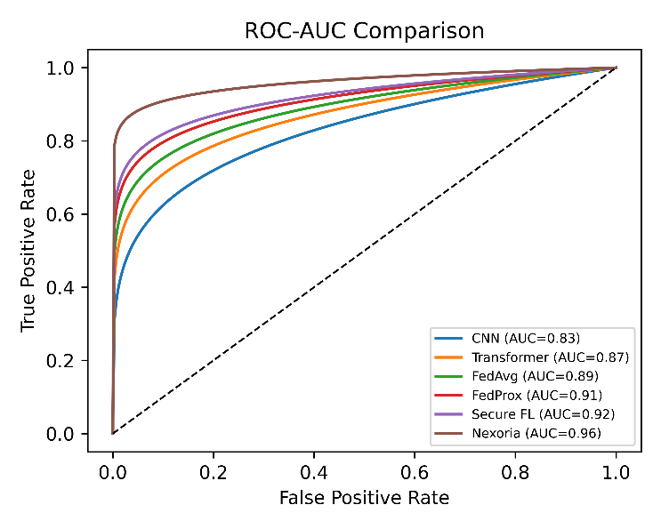
Fig. 2 ROC-AUC Comparison
Figure 3 shows the low dimensional representation of the learned latent feature from the multimodal healthcare data. Specific clusters of patients from the three areas of cardiovascular, oncology, and neurology are clearly visible, and there is little overlap between them. The separation of clusters shows that the feature encoding process and multimodal fusion process have well preserved clinically relevant information and reduced inter-class ambiguity. Moreover, the high intra-cluster compactness indicates that the patients with the same clinical characteristics are assigned to adjacent areas of the latent feature space. The observations show the success of the proposed representation learning strategy in learning disease-specific patterns from the diverse modalities in the healthcare domain.
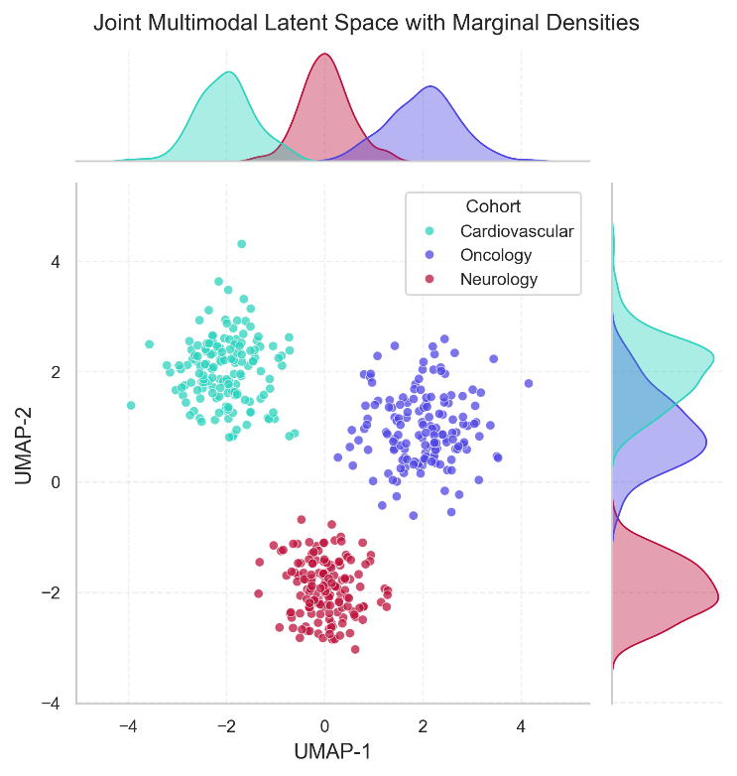
Fig. 3 UMAP Latent Space Visualization
In Figure 4, the attention patterns generated by specialized clinical agents while processing different healthcare domains are illustrated. The hierarchical clustering structure shows that there are distinct collaboration behaviors between the agents, suggesting that each agent is concentrating on a specific clinical characteristic and at the same time participates in the decision-making of the group. In fact, the attention weights of imaging and treatment agents increase in disease-specific scenarios, while the attention weights of the genomic and safety agents show complementary reasoning. The clustering analysis results show that the agentic architecture is able to avoid redundant learning, as the tasks are specialized and knowledge is shared among the agents. This behaviour has a direct impact on the improvement of the predictive capabilities in the experimental evaluation.
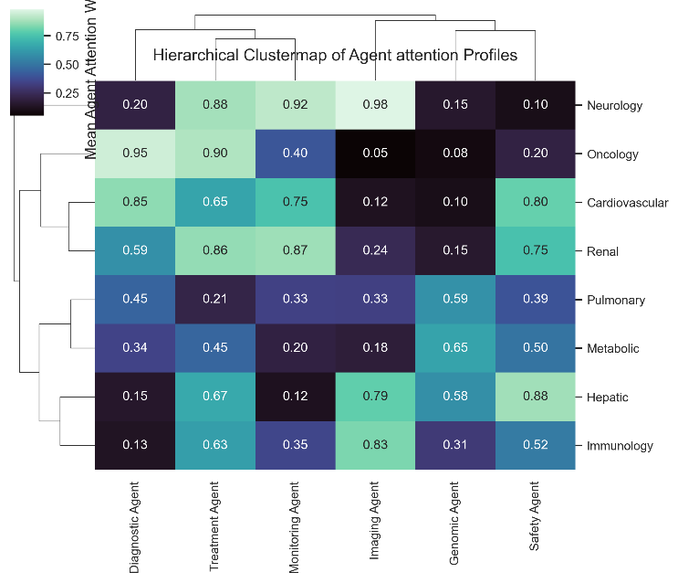
Fig. 4 Agent Attention Clustermap
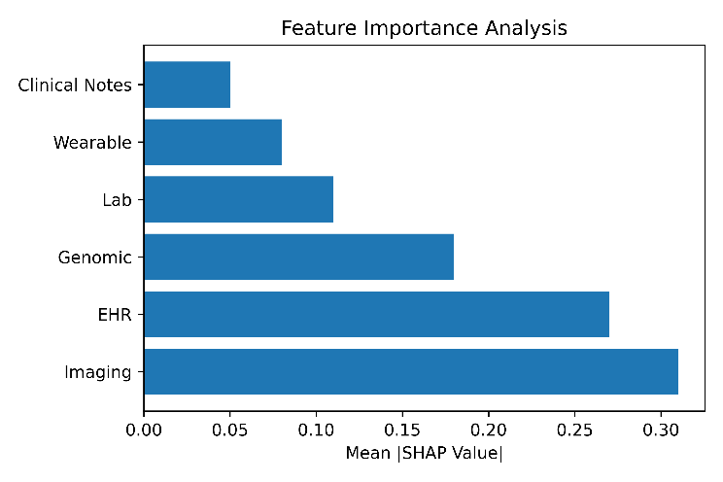
Fig. 5 Feature Importance Analysis
The results of the influence of various healthcare modalities on the final prediction process are given in Figure 5. Medical imaging features are the most important predictors followed by electronic health records and genomic information. Laboratory testing, wearable sensor information and clinical notes offer complementary information that improves decision reliability. The results of feature importance show that there is no single modality that is more dominant in the learning process, which is an indication of the effectiveness of the multimodal integration in the proposed framework. The findings also suggest that the integration of heterogeneous healthcare information can provide patient modeling that is more comprehensive than that achieved by a single modality.
The contribution of major components of the Nexoria framework is evaluated by conducting ablation study as shown in Table 3. Results of the experiments show that removing any of the core modules from the architecture significantly affects prediction performance, thus demonstrating their significance. The ablation of the Agentic Clinical Intelligence Layer results in a considerable decrease on classification performance, showing the importance of specialized agents reasoning together. In the same way, the most significant performance drop is due to the removal of the Causal Knowledge Learning Layer, showing that the extraction of clinically relevant cause-effect relations is an important aspect besides statistical correlations. The lack of the Federated Knowledge Exchange Layer also leads to a reduction in overall effectiveness suggesting that distributed knowledge sharing has a positive impact on generalization across the healthcare environments. The combined results of the ablation experiments confirm that the superior performance of Nexoria can only be obtained by an interplay of agentic intelligence, causal reasoning and the cooperation among the federated knowledge, and not from a single element alone.
TABLE III. Ablation study evaluating the contribution of individual components within the Nexoria framework
Model Variant | Accuracy (%) | F1-Score (%) | AUC (%)
Full Nexoria | 96.12 | 95.62 | 96.84
Without Agentic Layer | 92.71 | 91.84 | 93.08
Without Causal Layer | 91.93 | 91.17 | 92.54
Without Federated Knowledge Exchange | 93.42 | 92.76 | 94.11

To illustrate the practical reasoning ability of the proposed framework, a prototype implementation of Nexoria is presented for an acute coronary syndrome (ACS) multimodal assessment scenario in Fig. 6, where the agents collaborate with one another and share their knowledge with one another using the memory, and using the causality to generate a consensus. The proposed Nexoria framework will be used in a real-time clinical reasoning session, as shown in Fig. 6. The patient's case is a multimodal case where the symptoms of chest pain, the genomic information which is BRCA2 positive, blood pressure abnormalities and electrocardiographic abnormalities are processed through a series of specialized clinical agents. Every agent receives modality-specific evidence, analyzes it and adds it to the common clinical memory repository.
The Diagnostic Agent classifies acute coronary syndrome (ACS) as the most likely diagnosis with a 94% confidence score, based on various symptom characteristics, abnormal biomarkers and electrocardiographic findings. At the same time, the Imaging Agent is analysing echocardiographic data and identifying left ventricle dysfunction with an accuracy of 89%, which corresponds to a possible involvement of the heart in ischemia. The Genomic Agent analyzes inherited risk factors and determines a high cardiovascular susceptibility in association with the pathogenic variant of the gene BRCA2, adding an 86% confidence score. The Treatment Agent combines the therapeutic knowledge from the guidelines and suggests high-intensity statins and aspirin use with a confidence score of 92%. At the same time the Monitoring Agent will continuously monitor physiological parameters, ensure hemodynamic stability and have active surveillance of the patient. Unlike traditional multimodal learning systems which directly combine feature representations, Nexoria has a shared clinical memory repository where it keeps evidence records, historical patient similarities, and activated causal rules. The repository is filled with 18 evidence items, 124 historical case references and seven active causal rules to support cross-agent information sharing and contextual reasoning. This is a way to allow agents to tune their predictions together while maintaining interpretability for each modality.
The final consensus decision is obtained by a causal causality guided aggregation mechanism of weighted agent agreement, cross-modal consistency, historical evidence alignment and causal rule verification. Overall, it delivers a consensus score of 94.8% and a causal confidence score of 96.1% and ultimately identifies Acute Coronary Syndrome as a high-risk condition and recommends guideline aligned statin plus aspirin therapy. The score decomposition also shows that the final decision does not rely on just one modality but is the result of the work of several agents in a collaborative and evidence-based manner. The outcome demonstrates Nexoria's potential to turn clinical data into clear and actionable insights.
The visualization further shows the explainability of the framework. Every decision has its own set of contributing agents, evidence sources that were activated to support the decision and causal relationships stored in the memory repository. Thus, clinicians will be able to examine the reasoning process, confirm intermediate findings, and comprehend the reasoning behind the recommendation. This transparency is crucial for the efficient deployment of agentic AI systems in the future of healthcare.

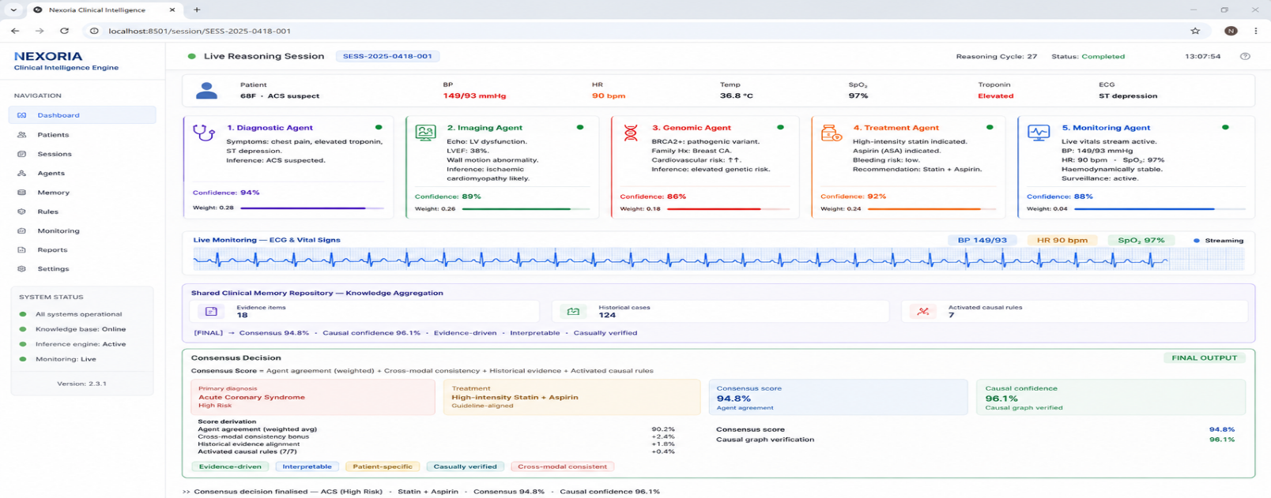
Fig. 6. Clinical reasoning workflow of Nexoria demonstrating multimodal evidence fusion, shared memory interaction, causal rule activation, and consensus-based diagnosis generation.

Conclusion and future enhancements
In this study, we propose an innovative healthcare intelligence framework, called Nexoria, that integrates agentic clinical reasoning, causal knowledge learning, multimodal healthcare analytics and distributed knowledge collaboration in one architecture. In contrast to existing healthcare intelligence systems, which are mostly based on correlation-based predictive models, the proposed framework allows for the co-analysis of heterogeneous healthcare information by special clinical agents, sharing of knowledge in a shared clinical memory repository, and the production of explainable consensus-driven decisions based on causal relationships. Nexoria's approach combines medical imaging, electronic health records, genomic data, wearable sensor data, laboratory data, and clinical notes to create a rich multimodal view of patient health, and turn disjointed observations into actionable medical knowledge. The experimental results showed superior performance of the proposed framework with accuracy of 96.12%, F1-score of 95.62% and AUC of 96.84% compared with conventional baselines of machine learning and federated learning. Moreover, ablation experiments validated the substantial impact of the Agentic Clinical Intelligence Layer, Causal Knowledge Learning Layer and Federated Knowledge Exchange Layer on the system's performance. The prototype clinical reasoning scenario also confirmed that the framework could make it easier to interpret and clinically relevant through the collaborative agent interactions and the consensus building based on the cause and effect. The results are encouraging, but future studies will aim for deployment in large-scale multi-hospital settings, dynamic mechanisms for agent evolution, temporal causal knowledge modelling, digital twin-based clinical simulation, the development of multimodal healthcare foundation models, the development of privacy-preserving causal federated intelligence, real-time deployment of edge healthcare, and the enhancement of causal reasoning through counterfactual methods. The enhancements are anticipated to contribute even more to its scalability, adaptability, explainability, and clinical trustworthiness, positioning Nexoria as a next-generation intelligent healthcare platform that can facilitate trustworthy, individual, and evidence-based medical decision-making in the complex healthcare landscape.

References
- Tanvir, Md Iftekhar Monzur, Habibor Rahman Rabby, Md Habibul Arif, Nusrat Yasmin Nadia, and Kamruddin Nur. "Privacy-preserving multimodal federated learning pipeline for cyber-resilient healthcare systems." Plos one 21, no. 4 (2026): e0343669.
- Chowdhary, Chiranji Lal. "Multi-modal personalized federated learning with adaptive differential privacy for medical image classification and a privacy-preserving approach." Scientific Reports (2026).
- Liu, XianFang, ShunLei Li, Qin Zhu, ShaoKun Xu, and QinYang Jin. "Interpretable Semi-federated Learning for Multimodal Cardiac Imaging and Risk Stratification: A Privacy-Preserving Framework." Journal Of Imaging Informatics In Medicine (2025): 1-20.
- Balaji, N., V. Sathya, P. Sirenjeevi, and Velliangiri Sarveshwaran. "Secure Federated Multimodal Learning with Attention-Weighted Transformers and Homomorphic Encryption for Privacy-Preserving Neuroimaging Analysis." Biomedical Signal Processing and Control 123 (2026): 110550.
- Nemane, Shon, Vaishnavi M. Sarad, Dhiraj P Tulaskar, Tejrao Panjabrao Marode, Vikas Bhangdiya, Lalit Agrawal, Ankita Avthankar et al. "Federated Learning in Multimodal Healthcare Diagnostics: Privacy-Preserving AI for Biomedical Imaging, Electronic Health Records, Wearables, and Clinical Decision Support." Archives of Computational Methods in Engineering (2026): 1-34.
- Teja, M. Dharma, Hayel Khafajeh, Ankur Bahl, and Akila Venkatraman. "Federated Multi-Modal Learning System for Privacy-Preserving Medical Diagnostics in Next-Generation Healthcare." In 2026 IEEE International Conference on AI Engineering and Innovations (AIEI), pp. 1-6. IEEE, 2026.
- RN, Ravikumar, R. Badlishah Ahmad, Prasanalakshmi Balaji, and Syarifah Bahiyah Rahayu. "Privacy‐Aware Federated Recommender Systems for IoT Healthcare: A Review of Computational Methods, Multimodality, and Optimization for Real‐Time Personalization." Applied Computational Intelligence and Soft Computing 2026, no. 1 (2026): 4797749.
- Laitinen-Fredriksson Lundström Imanov, Gustav Olaf Yunus, and Sila Burde Dulger. "Federated Multimodal Learning with Differential Privacy for Emergency Department Triage: Development, Validation, and Clinical Impact Across Six Sites." Validation, and Clinical Impact Across Six Sites.
- Fang, Congyu, Adam Dziedzic, Lin Zhang, Laura Oliva, Amol Verma, Fahad Razak, Nicolas Papernot, and Bo Wang. "Decentralised, collaborative, and privacy-preserving machine learning for multi-hospital data." EBioMedicine 101 (2024).
- Maurya, Ankita, Rahul Haripriya, Manish Pandey, Jaytrilok Choudhary, Dhirendra Pratap Singh, Surendra Solanki, and Duansh Sharma. "Federated learning for privacy-preserving severity classification in healthcare: A secure edge-aggregated approach." IEEE Access (2025).
- Harshith, Murikipudi, Zulfikar Ali Ansari, Shahin Fatima, Shadab Siddiqui, Sreyan Swarna, DR Nidhish Reddy, and Syed Wahaj Mohsin. "Federated microservices architecture with blockchain for privacy-preserving and scalable healthcare analytics." Scientific Reports (2026).
- Puri, Vikram, Ishaani Priyadarshini, Aman Kataria, Sita Rani, and Hong Min. "Privacy-first ml for chronic kidney disease prediction: Exploring a decentralized approach using blockchain and IPFS." IEEE Access (2025).
- Myrzashova, Raushan, Saeed Hamood Alsamhi, Alexey V. Shvetsov, Ammar Hawbani, and Xi Wei. "Blockchain meets federated learning in healthcare: A systematic review with challenges and opportunities." IEEE Internet of Things Journal 10, no. 16 (2023): 14418-14437.
- Bhattacharjee, Srijita, Vinod Sapkal, Varun kumar Sharma, Abhay Rewatkar, Swati V. Khidse, and Piyush K. Ingole. "Federated Learning for Privacy-Preserving Multi-Center Tuberculosis Diagnosis Using Chest Imaging Data." Indian Journal of Tuberculosis (2025).
- Koli, Sakshi, Nagendar Yamsani, and Ankur Dumka. "Federated Learning in Healthcare: A Survey of Privacy-Preserving Medical AI Solutions." In 2026 1st International Conference on Advancing Sustainable Solutions through Technologies (ICASST), pp. 1-4. IEEE, 2026.

