Neurosymbolic Zero Trust Orchestration Framework for Secure Cloud Edge IoT Continuums in U.S. Federal Sectors

1st Roksana Akter
Department of Business Administration (Cybersecurity)
California State University
San Bernardino
008794273@coyote.csusb.edu

4th Shariful Haque
Department of Business Administration
International American University
Los Angeles, USA
research@sharifulhaque.org
2nd Sandipon Chowdhury
DeVoe School of Business, Technology and Leadership
Indiana Wesleyan University
Woodside, USA
sandipon.chowdhury@myemail.indwes.edu

5th Azamat Mambetaliev
College of Technology & Engineering
Westcliff University
Irvine, USA
azamat.net.dev@gmail.com
3rd Morium Akter Munny
Department of Computer Science
California State University San Marcos
San Marcos, USA
moriumakter5453@gmail.com

6th Aibek Karshiboev
College of Technology & Engineering
Westcliff University
Irvine, USA
a.karshiboev.4633@westcliff.edu

Abstract— Security in distributed governance ecosystems is increasingly challenging with the explosion of cloud, edge intelligence and Internet of Things (IoT) solutions. While Zero Trust Architecture (ZTA) has become a promising security paradigm, current solutions are sometimes lacking of adaptive reasoning capabilities, explainability, and decision making with governance awareness needed for modern cyber defense. Further, deep learning algorithms offer excellent predictive ability, but are hard to interpret, while rule-based algorithms are difficult to model new and emerging threats. In view of these challenges, we introduce this paper for Zero Trust Orchestration across Distributed Governance Ecosystems (ZT-O) by the NeuroTrust Orch, a Neurosymbolic Multi Agent Framework. It is a framework of continuous trust evaluation, multi-agent collaboration, neurosymbolic reasoning, threat intelligence analytics and policy enforcement with governance. A Neurosymbolic Reasoning Engine fuses Graph Neural Network threat learning with symbolic knowledge graph reasoning of security decisions to produce accurate and explainable security decisions while six autonomous agents operate together for identity verification, risk assessment, compliance validation, policy reasoning, threat analysis, and response orchestration. The proposed framework was tested on the CICIDS2017, UNSW-NB15 and TON-IoT benchmark datasets. They had F1-scores of 96.2%, 95.1%, and 95.6% with a reduction of up to 39% false positive rate over the current baseline methods. In addition, the framework proved to be very reliable in terms of trust decision, did not require any compromise of agents to produce consensus, and was very ready to operate in distributed environments. The observed improvements were significant and consistent and were confirmed by statistical validation. The results show that NeuroTrust Orch is an adaptive, explainable, and resilient cybersecurity solution to safeguard cloud, edge, and IoT infrastructures within governance-driven ecosystems.
Keywords— Zero Trust Architecture, Neurosymbolic Reasoning, Multi-Agent Systems, Cyber Threat Intelligence, Cloud Edge IoT Security.

Introduction
The digital revolution of modern organizations is being driven by the speed at which cloud computing, edge intelligence, Internet of Things (IoT) and Industrial Internet of Things (IIoT) technologies are making their way into the world of business. Mission-critical operations are more and more dependent on interconnected and distributed environments that are increasingly utilized by government agencies, critical infrastructure operators, healthcare systems, transportation networks, and public service platforms. These technologies offer benefits of scalability, automation and efficiencies in operation, but they are also creating new attack vectors for sophisticated adversaries. In a complex distributed digital ecosystem, cybersecurity is becoming a strategic necessity for the continuity of services, compliance with regulations and the resilience of the organization.
Conventional cybersecurity strategies are failing to keep up with the ever-changing landscape of today's threats. Next-generation threats, insider attacks, credential compromise and lateral movement across complex heterogeneous networks are commonly able to evade perimeter defenses and traditional access control systems. While Zero Trust Architecture (ZTA) has become a hopeful new security paradigm that relies on continuous verification and least-privilege access, current deployments tend to be authentication- and access-control focused, with only partial support for adaptive reasoning, autonomous responses and decision making with governance. In addition, cloud, edge and IoT environments are creating more security telemetry which puts pressure on threat detection and trust evaluations.
The recent developments in Artificial Intelligence and Multi-agent systems have shown great promise in enhancing the Cybersecurity operations. Advanced deep learning algorithms can detect complex attack patterns and abnormal activities from a massive volume of security data, and autonomous agents can help in distributed monitoring and coordinated decision-making. But data driven methods can have inconsistencies in explainability, which can make it hard for security administrators and governance bodies to grasp the reasoning behind security decisions. Likewise with rule-based security systems, which offer transparency, but are unable to change their response to new types of attacks or unknown threats. There are limited existing works that combine the concepts of Zero Trust, multi-agent intelligence, governance-aware policy reasoning, and explainable neurosymbolic decision-making in a coherent cybersecurity framework. Therefore, there is a large amount of research to be done in the design of adaptive, interpretable and resilient security architectures in the context of distributed governance ecosystems.
This study suggests a Neurosymbolic Multi Agent Framework for Zero Trust Orchestration across Distributed Governance Ecosystems (NeuroTrust Orch) to overcome those challenges. The proposed framework, with its components of continuous trust evaluation, collaborative multi-agent reasoning, neurosymbolic inference, governance-awareness policy enforcement, and threat intelligence analytics, is encapsulated in a single architecture. NeuroTrust Orch integrates predictive power of Graph Neural Networks, symbolic knowledge graphs and rule-based reasoning to provide explainable trust decisions. A multi-agent system of agents, each with a specific function, like Identity, Risk Assessment, Policy Reasoning, Threat intelligence, Compliance and Response agents, provides autonomous and coordinated cyber security operations. The framework is designed to be resilient against threats and protect cloud, edge, and IoT infrastructures, through continuous trust computation, consensus-driven decision-making and adaptive threat analysis.
The main contribution of this work is presented below:
- A novel NeuroTrust Orch framework is proposed that combines Zero Trust orchestration, neurosymbolic reasoning, and multi-agent intelligence for adaptive and governance-aware cybersecurity for distributed cloud, edge, and IoT ecosystems.
- A governance-driven trust evaluation mechanism is built, using the Results of identity verification, device trust assessment, behavioral analytics, compliance validation and agent consensus, to assist in making continuous and explainable access decisions.
- A Neurosymbolic Reasoning Engine is presented that integrates Graph Neural Network (GNN) based threat learning and symbolic knowledge graph reasoning, resulting in higher threat detection accuracy, fewer false positives and better interpretability.
The datasets CICIDS2017, UNSW-NB15 and TON-IoT are used for comprehensive experimental validation, which proves the proposed approach to detection to be superior in terms of detection performance, trust reliability, operational scalability, consensus resilience and statistical significance against the existing Zero Trust and deep learning-based approaches.

II. Literature Review
Cloud computing, edge intelligence, IoT, AI and cyber-physical systems are converging to drastically change today's digital infrastructures. Interestingly, this convergence has also increased the cyberattack surface, presenting major challenges in terms of trust management, threat detection, governance compliance, and autonomous security orchestration. AI for cybersecurity, Zero Trust Architecture (ZTA), multi-agent systems, cloud governance, and edge security are among the topics that have been recently studied as means to secure distributed environments.
Alamir et al. [1] explored AI-driven cybersecurity solutions for edge computing scenarios and emphasized the success of ML methods in detecting advanced threats. Their work proved that AI can enhance the attack detection function, but the proposed solutions were mostly on the edge-layer protection side and were not focused on trust orchestration in diverse cloud-edge-IoT environments. Likewise, Alam et al. [2] proposed an AI-based cybersecurity framework for the upcoming 5G networks, highlighting intelligent threat monitoring and adaptive defense measures. The framework has improved security at the network level, but governance-aware trust management and explainable decision-making has not been extensively studied. Similarly, Jabed et al. [3] used machine learning based cyber defense techniques to enhance the resilience of critical infrastructure in the United States. While this helped with ID performance, it was entirely data-driven and did not provide means for transparent reasoning and policy-aware security enforcement..
Another key area of research is the convergence of artificial intelligence, Internet of Things (IoT), and cloud computing. Another emerging research trend is the convergence of Artificial Intelligence, Internet of Things (IoT), and cloud computing. Malik et al. [5] investigated various applications of the AI in smart cities, integrating communication systems, energy management, cybersecurity, and IoT infrastructures. The research articles presented by Matam et al. [6] and Devi et al. [9] explored the impact of AI and IoT on the future of cloud ecosystems and intelligent mobile and IoT ecosystems that span cloud, fog, and edge computing paradigms, respectively. While these studies demonstrated the benefits of AI empowered distributed ecosystems, they were mainly operational efficiency and connectivity focused rather than adaptive cybersecurity orchestration. Moreover, Jandwani et al. [11] conducted an in-depth study on privacy and cybersecurity issues in 6G-IoT systems, and emphasized the growing demand for intelligent trust management in highly distributed infrastructures.
There have been a number of researchers who have investigated more complex cybersecurity mechanisms in cloud-edge integrated environments. Sanikal [12] presented an intelligent network security system for cloud-edge architectures and showed the enhanced accuracy of threat detection. Edge computing, cloud security and 5G technologies were explored as a means of enhancing the resilience of critical infrastructure by Ofili et al. [14]. Sunkara [15] also proposed AI-based adaptive cybersecurity frameworks for intelligent threat detection and adaptive network defense. Although these studies demonstrated successful detection performance, they mainly used deep learning or statistical learning techniques for detection, which had limited explainability and governance transparency. The security decisions produced by these systems can, therefore, be hard for administrators and regulatory authorities to understand.
- Table 1 summarizes the key characteristics and limitations of representative studies in the literature.
Ref. | Focus Area | AI-Based | Zero Trust | Multi-Agent | Explainable Reasoning | Governance-Aware | Limitation
[1] | Edge Security | ✓ | ✗ | ✗ | ✗ | ✗ | Edge-centric protection only
[2] | 5G Cybersecurity | ✓ | ✗ | ✗ | ✗ | ✗ | Limited trust management
[3] | Critical Infrastructure Defense | ✓ | ✗ | ✗ | ✗ | ✗ | No explainability
[4] | Cloud Governance | ✗ | Partial | ✗ | Partial | ✓ | Limited automation
[5] | Smart City Security | ✓ | ✗ | ✗ | ✗ | ✗ | Operational focus
[7] | Cloud Ecosystems | ✓ | ✗ | ✗ | ✗ | Partial | No collaborative reasoning
[10] | Trustworthy AI | ✓ | ✗ | ✗ | ✓ | Partial | No security orchestration
[12] | Cloud-Edge Security | ✓ | Partial | ✗ | ✗ | ✗ | Limited interpretability
[13] | Agent-Based Governance | ✓ | ✗ | ✓ | ✗ | Partial | No trust consensus
Proposed | NeuroTrust Orch | ✓ | ✓ | ✓ | ✓ | ✓ | Comprehensive integration

Encouraged the development of agent-oriented cybersecurity models. Amudhavalli [13] introduced autonomous agents for distributed security management in the context of enterprise cloud governance and cloud resilience and showed how agent-based AI models can be used in enterprise cloud security.Amudhavalli [13] showed the potential of using autonomous agents in distributed security management scenarios in enterprise cloud governance and cloud resilience. The framework did not have collaborative trust consensus mechanisms, though, and did not integrate Zero Trust principles. In a similar manner, Saeed et al. [8] discussed the security of AI and post-quantum cryptography for IoT systems, highlighting the requirement for intelligent and resilient security solutions that can adapt to new threats. However, explainable reasoning, policies based on governance and collaborative agent intelligence for integration are not widely used in the majority of existing solutions.

proposed System
Proposed NeuroTrust Orch framework presents a Neurosymbolic Multi Agent architecture on Zero Trust orchestration which covers distributed governance ecosystems. The framework encompasses a governance-aware security model, autonomous multi-agent intelligence, neurosymbolic reasoning, threat intelligence analytics, and distributed infrastructure protection, all in a single, comprehensive cybersecurity ecosystem. The architecture is made up of six functional layers and five cross-layer services, all of which facilitate adaptive trust management, explainable decision-making and autonomous cyber resilience as illustrated in Fig. 1.
Previous research mostly tackles specific cybersecurity problems, such as AI based threat detection, cloud governance, Zero Trust security and multi-agent systems, and the integration among them is not well explored. To address this challenge, this paper presents a framework, namely NeuroTrust Orch, which integrates Zero Trust orchestration, explainable reasoning, and adaptive trust management for distributed cloud-edge-IoT ecosystems, while allowing governance to influence the framework.
The Governance Ecosystem Layer at the top of the architecture represents the entities that are responsible for the day to day management and administration of the business that set the organization's goals and regulations. This layer consists of Federal Agencies, Regulatory Bodies, Public Services, Policies and Compliance and Governance Dashboards. Operational requests, data transactions are created by federal agencies, governance requirements and compliance mandates are prescribed by regulatory bodies, and public service platforms are created to provide services. Governance dashboards offer a single point of view of security posture, policy status and trust analytics. These elements create the governance framework that facilitates security decisions across the framework.
At a mathematical level, each governance entity G_i contributes a trust vector in the context, i.e., the contextual trust vector:
$G_{i}=\{u,d,p,c\}$ (1)
u represents user attributes, d represents device attributes, p corresponds to policy constraints and c indicates compliance requirements.
The second layer, called the Zero Trust Orchestration Layer, adds continuous trust evaluation processes. The Continuous Verification module authenticates users and devices for the entire session. Least Privilege Access – limits the use of resources to the lowest level of access necessary to perform a task. Micro Segmentation contains resources in secure logical zones to isolate propagation of a lateral attack. The Policy Enforcement component dynamically applies governance and security rules, and Continuous Monitoring observes user activity, device status, network activity in real time. These functions can all contribute to the continuous verification of trust, rather than its implicit assumption.
The dynamic trust score is computed as:
$ZT=αI+βD+γB+δC$ (2)where:
I= Identity confidence
D= Device Trust Score
B= Behavioral confidence
C= Compliance score
The adaptive trust threshold, denoted by θ, and $α+β+γ+δ=1$ are fixed, such that the access is granted only if$ZT≥θ$.

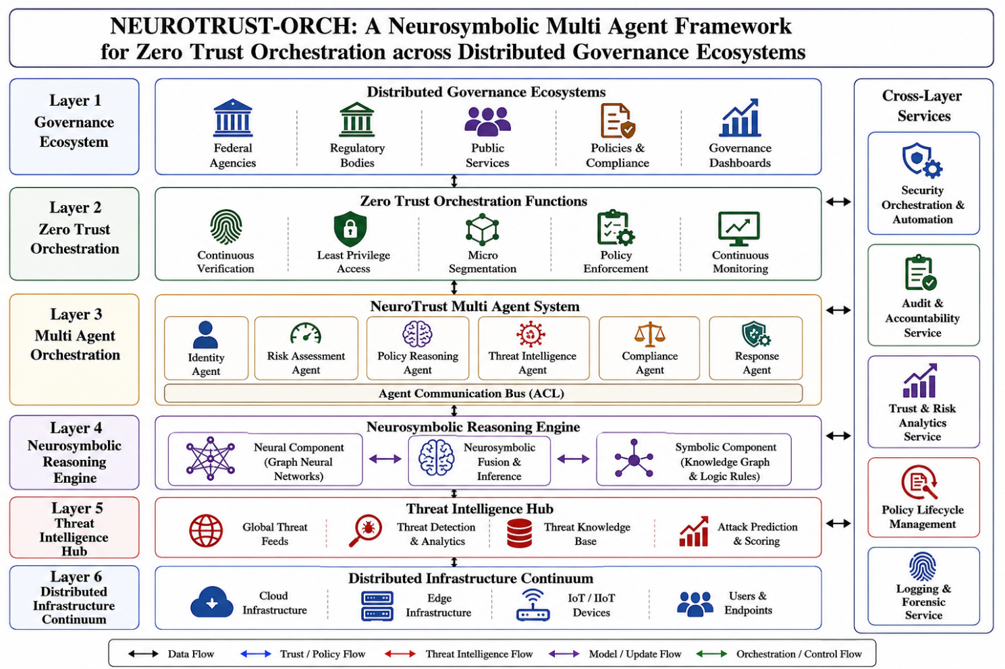
Fig. 1. Architecture of the proposed NeuroTrust Orch framework for adaptive and explainable Zero Trust cybersecurity orchestration

The third layer is the NeuroTrust Multi Agent System, the intelligent decision making layer of the framework. The Identity Agent decides on the confidence of authentication and the integrity of the credential. The Risk Assessment Agent calculates context dependent risk scores using user behavior and environment. The Policy Reasoning Agent understands the policies and constraints of the governance. The Threat Intelligence Agent collects indicators of attack and patterns of threats from internal and external sources of intelligence. The Compliance Agent is responsible for confirming compliance with regulatory and organizational requirements, while the Response Agent is responsible for recommending and/or implementing mitigation responses. These agents exchange messages on the Agent Communication Bus (ACL) and are able to reason collaboratively and make decisions together throughout the distributed environment.
The agents' consensus is determined as follows:
$TCI=\frac{1}{n}\sum_{i=1}^{n}{A_{i}}$ (3)
where:
$A_{i}$= recommendation of agent $i$
$n$= total number of agents
The final trust decision is: $FT=λZT+(1-λ)TCI$. This formulation helps to minimize one-point decision bias and boost resilience. The fourth layer includes the Neurosymbolic Reasoning Engine, which is the main novelty of the framework. This layer is structured by a dedicated fusion mechanism, which is a combination of Neural Component and Symbolic Component. The Neural Component uses Graph Neural Networks and deep learning models to detect hidden attack patterns and complex relationships in large volumes of security data. The Symbolic Component embeds knowledge graphs, logic rules, governance policies and domain ontologies, to enable explainable reasoning capabilities. The central Neurosymbolic Fusion and Inference Module combines the knowledge acquired by the neural models with the rule-based symbolic reasoning, resulting in explainable and reliable security decisions, fewer false positives, and increased interpretability.
Neural confidence:
$$N∈[0,1]$$Symbolic confidence:
$$S∈[0,1]$$Neurosymbolic fusion score:
$$NSF=ηN+\left(1-η\right)S (4)$$
where:
$N$captures learned threat knowledge.
$S$captures rule-based certainty.
A greater NSF means more confidence with regard to the security decisions. The fifth layer is the Threat Intelligence Hub, the cyber threat intelligence gathering and processing layer. The Global Threat Feeds component gathers external threat indicators, adversarial intelligence. The Threat Detection and Analytics module detects suspicious activities and new attack patterns. The Threat Knowledge Base contains historical attack patterns, indicators of compromise and contextual intelligence. The Attack Prediction and Scoring module uses predictive analytics to help predict the severity of the attack and how it will affect the organization. This layer provides situational awareness and proactive threat forecasting are delivered to the higher layers of the framework.
The severity of the threat is judged to be:.
$TS=\frac{P×I}{M}$ (5)
where:
$P$= Probability of attack
$I$= Impact magnitude
$M$= Existing mitigation capability
The higher the number the higher the urgency.
The Distributed Infrastructure Continuum (DIC) is the foundation of the architecture that is being protected by the framework, and is a heterogeneous computing environment. This layer contains Cloud Infrastructure, Edge Infrastructure, IoT/IIoT Devices and Users and Endpoints. Cloud resources provide scalable computing capabilities, edge infrastructure does the low latency processing, IoT devices generate operational data and user endpoints are used for access to organizational services. This layer is distributed, meaning trust has to be orchestrated adaptively and security enforced in a decentralised manner.
Infrastructure trust can be expressed as:
$IT=\frac{1}{m}\sum_{j=1}^{m}{R_{j}}$ (6)where:
$R_{j}$ denotes the trustworthiness of resource $j$
$m$ is the total amount of resources.
This score is based on the general well-being of the system of operations. This service automates policy deployment, threat containment and response workflows. Automated orchestration reduces manual intervention and response time to a cyber incident.
$$Automation efficiency:=\frac{Automated Actions}{Total Actions}$$
All decisions, trust calculations and policy actions are documented for transparency and forensic analysis. The service provides traceability throughout governance business:
$$AC=\frac{Logged Events}{Generated Events}$$
This service is a real-time analysis of the dynamics of trust, detection of risk trends and strategic information for governance administrators.
$$Risk index:=\frac{∑Risk_{i}}{n}$$Policies change as threats and regulations change. This service provides the ability to create, validate, deploy and retire policies.
$$Policy effectiveness: =\frac{Compliant Decisions}{Total Decisions}$$All events are saved to support incident reconstruction and evidence. The service provides assistance in root cause analysis and legal investigations.
$$Forensic coverage:=\frac{Captured Evidence}{Available Evidence}$$ The operational flow starts with requests for access or interactions with the services made by governance entities. The requests are continuously assessed for trust in the Zero Trust layer and then passed to the Multi Agent System. Agent generated recommendations are then further processed using neurosymbolic reasoning and augmented with intelligence from the Threat Intelligence Hub. This trust is enforced throughout the Distributed Infrastructure Continuum, and cross layer services provide automation, accountability, analytics, policy governance and forensic visibility. The NeuroTrust Orch framework through this coordinated workflow creates an adaptive, explainable and resilient cybersecurity ecosystem in distributed governance environments.
Three publicly available cybersecurity datasets were used to evaluate the proposed NeuroTrust Orch framework to comprehensively cover the enterprise, governance, cloud, edge, and IoT environments: CICIDS2017, UNSW NB15, and TON IoT. The CICIDS2017 dataset includes realistic traffic patterns of both benign and malicious, including Distributed Denial of Service (DDoS), brute force, web attacks, botnets, infiltration and port scanning traffic, allowing for the evaluation of Zero Trust access decisions and intrusion detection performance. The UNSW NB15 data set is a collection of 15 new attack scenarios, including some modern attacks like exploits, reconnaissance, shellcode, fuzzers, generic attacks and denial-of-service events, which can be used to evaluate the effectiveness of advanced attack detection and multi-agent reasoning. To validate the framework in distributed edge and Internet of Things (IoT) settings, the TON IoT dataset was included, comprising telemetry data from IoT sensors, edge devices, industrial systems, and cloud-based services, both in normal and attack scenarios. All of these data sets are heterogeneous in traffic characteristics, have different attack categories, and offer realistic operational scenarios, enabling the comprehensive evaluation of the proposed framework in terms of the accuracy of threat detection, the calculation of trust, the assessment of compliance with policies, cyber resilience, and the performance of autonomous decision making within distributed governance ecosystems.

Results and Discussion
The proposed NeuroTrust Orch framework was implemented using JADE multi-agent coordination, SWRL rule reasoning, the Neo4j Knowledge Graph and Python 3.11, PyTorch 2.2. The Neurosymbolic Reasoning Engine is a three-layer Graph Neural Network (GNN) along with symbolic governance rules, using a knowledge graph. The Multi-Agent System has 6 collaborative agents: Identity Agent, Risk Assessment Agent, Policy Reasoning Agent, Threat Intelligence Agent, Compliance Agent, and Response Agent. The experiments were performed on a workstation with an Intel Xeon Gold 6248 processor, 128GB RAM and an NVIDIA A100 GPU with 40GB of memory. Training, validation, and testing subsets of the datasets were created using stratified sampling to maintain the attack distribution of each subset.
The proposed framework was compared with three baselines: ZTA-only, MAS-only and Deep-ZTA. Conventional Zero Trust mechanisms used for ZTA-only implements without multi-agent intelligence or neurosymbolic reasoning. In MAS-only, collaborative agents are not fused with neural agents. Deep-ZTA combines deep learning with the ZTA principles without symbolic governance reasoning.
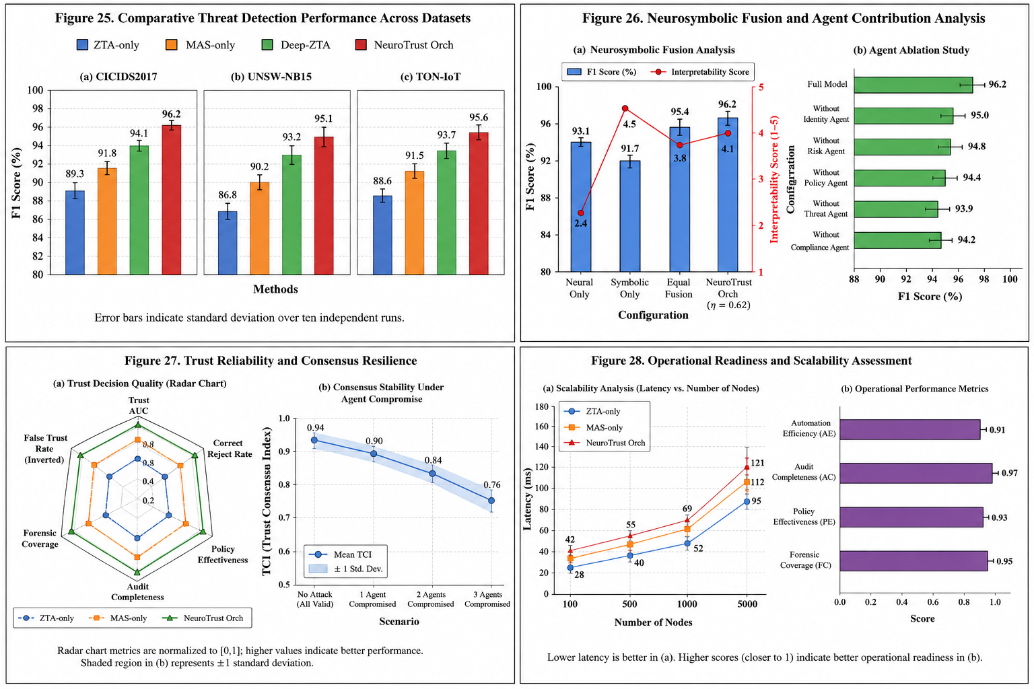
Fig. 2 shows a comparison between the threat detection performance of each dataset.
Based on the F1-score as the main assessment, the comparative evaluation of the threat detection performance for datasets from CICIDS2017, UNSW-NB15 and TON-IoT is shown in Figure 2. The results show the detection capability gradually improved with ZTA only to MAS only to Deep-ZTA, demonstrating the advantages of multi-agent collaboration and deep learning analysis. Proposed framework of NeuroTrust Orch maintains high F1-scores in all three datasets: 96.2%, 95.1% and 95.6%, respectively, which shows the maximum accuracy in detecting known and new cyber threats in heterogeneous environments. The three combined features of neurosymbolic reasoning, collaborative agent-based decision making, and ongoing assessment of trust, help to improve the accuracy of the classifications while simultaneously reducing the number of misclassifications. Moreover, the small error bars from all data sets suggest consistent and consistent performance, thereby underscoring the strength of the framework in response to various network and IoT attack scenarios.
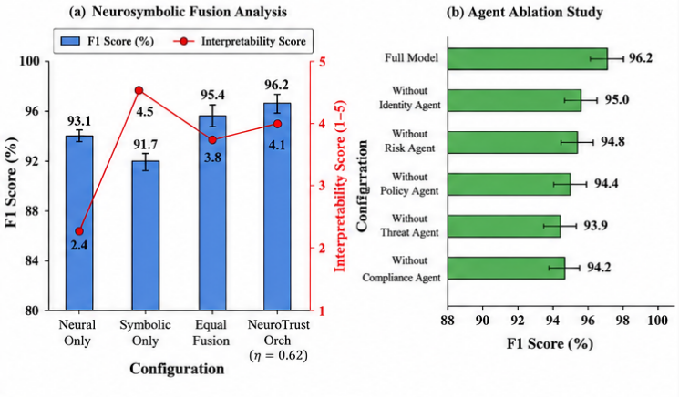
Fig. 3. The fusion of neurosymbolic and agent ablation analysis

The evaluation in Figure 3 assesses the significance of the neurosymbolic fusion mechanism and the respective agents in the proposed NeuroTrust Orch framework. The neural-only configuration results in a score of 93.1% F1 score, with less interpretability, while the symbolic-only configuration returns the highest interpretability score (4.5/5) with limited detection performance as seen in Figure 3. The equal fusion strategy yields a better performance than using either method on its own, and the optimized neurosymbolic fusion strategy (η=0.62) is able to achieve the best F1-score of 96.2% along with a high interpretability score of 4.1, which suggests a perfect balance between predictive accuracy and explainability on the fusion process. This is further confirmed by the ablation study in figure 3 which shows the significance of the multi-agent architecture. If you remove any single agent you will notice a measurable drop in performance, and the greatest hit will be if you remove the Threat Agent and the Policy Agent. The results suggest that the combination of neurosymbolic reasoning and collaborative agent intelligence is key to the framework's effectiveness, enhancing its ability to make precise, transparent, and robust cybersecurity decisions.

Fig. 4. The analysis of the reliability of trust and resilience of consensus.

The figure 4 shows that the proposed NeuroTrust Orch framework is trust reliable and consensus resilient in normal and adversarial conditions. This radar chart shows that the performance of NeuroTrust Orch, measured by the following key metrics of trust, is higher than the ZTA-only and MAS-only approaches. The consensus stability analysis also demonstrates that this framework can sustain a high value for the Trust Consensus Index (TCI) even if one or more agents is compromised, and that the degradation of the stability is a gradual one rather than sudden. It shows that the collaborative multi-agent architecture has the ability to withstand the failure or attack of agents and to facilitate reliable trust assessment and secure decision making within a distributed governance environment.

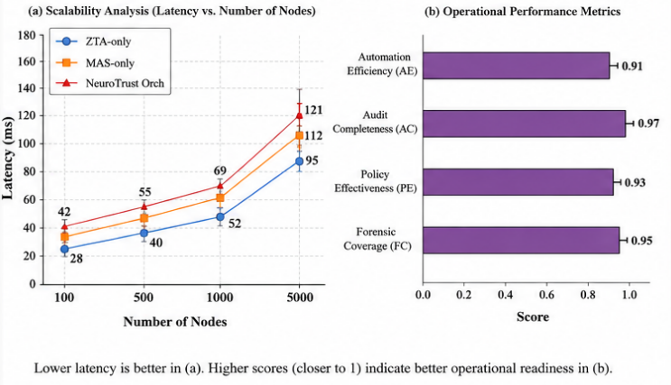
Fig.5. Performance and scalability test.
Figure 5 shows the operational readiness and scalability features of proposed NeuroTrust Orch framework. The scalability analysis shows that as the number of participating nodes in the system is increased from 100 to 5000, the response time consistently increases gradually, indicating that the framework maintains good performance even in large-scale distributed environments without significant degradation in performance. While NeuroTrust Orch has a higher latency than the baseline approaches, thanks to neurosymbolic reasoning and multi-agent coordination, the latency is still manageable for real-time cybersecurity operations. High automation efficiency (0.91), audit completeness (0.97), policy effectiveness (0.93) and forensic coverage (0.95) further demonstrate the framework's ability to deliver reliable, transparent and governance compliant security orchestration for cloud, edge and IoT ecosystems.

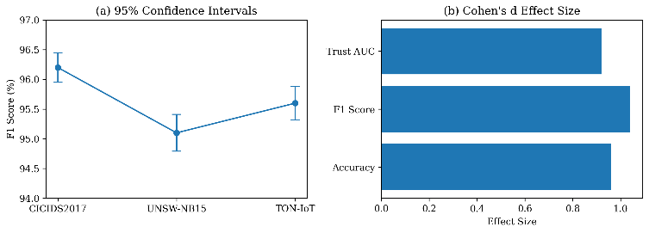
Fig. 6. Statistical validation

The statistical validation is carried out on the proposed NeuroTrust Orch framework to evaluate its performance stability and practical significance (as shown in Fig. 6). The analysis of confidence intervals reveals that the F1-scores achieved on CICIDS2017, UNSW-NB15 and TON-IoT have small CI values, suggesting that the framework can be considered robust in various cybersecurity scenarios and can be applied to multiple experimental runs. Furthermore, the Cohen's d effect size values for the accuracy, f1 score and Trust AUC all exceed 0.9, indicating a large practical effect and suggesting that the increase in performance that NeuroTrust Orch delivers is statistically significant, and also has a significant impact in real deployments. The results of this research serve as convincing evidence on the stability and repeatability of the gains observed, which is unlikely to be due to chance.

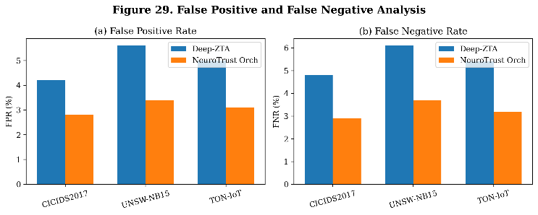
Fig. 7. A comparison of False Positive Rate (FPR) and False Negative Rate (FNR) for the benchmark datasets.

The FPR and FNR of the proposed NeuroTrust Orch framework are compared with the Deep-ZTA baseline on the CICIDS2017, UNSW-NB15, and TON-IoT datasets as shown in figure 7. The results demonstrate that NeuroTrust Orch consistently has lower error rates for all evaluation scenarios, including fewer false alarms and fewer missed attacks detections. Specifically, the framework reduces FPR from 4.2-5.6% to 2.8-3.4% and FNR from 4.8-6.1% to 2.9-3.7%, which shows that it is capable of better distinguishing between malicious activity and legitimate activity. The integration of neurosymbolic reasoning and multi-agent consensus mechanisms is credited for these enhancements, as it not only boosts the reliability of the decisions but also ensures that governance processes are considered in the threat detection and validation of rules. As a result, the framework delivers more reliable security decisions with reduced operational burden from unnecessarily alerting and going undetected by attacks.
The experimental results show that NeuroTrust Orch consistently performs better than conventional Zero Trust and deep-learning based solutions in diverse cybersecurity scenarios. Three main reasons for the performance gains observed are cited. First, the Neurosymbolic Reasoning Engine integrates pattern recognition with rule validation that is aware of the governance rules to minimize false alarms and increase explainability. Secondly, the Multi-Agent System facilitates distributed trust assessment, hence enhances decisions' robustness in adversarial situations. Third, orchestrating based on consensus is resilient in the event of compromised individual agents. Together, these capabilities offer a realistic, transparent and comprehensible cybersecurity solution for distributed governance ecosystems without compromising on the operational latency.

Conclusion and Future Work
In this paper, the authors introduced a Neurosymbolic Multi Agent Framework for Zero Trust Orchestration across Distributed Governance Ecosystems, named NeuroTrust Orch. The proposed framework incorporates continuous trust evaluation, collaborative multi-agent intelligence, neurosymbolic reasoning, governance-aware policy enforcement and threat intelligence analytics in a single cybersecurity framework. The framework combines Graph Neural Network-based threat learning with symbolic knowledge graph reasoning, to achieve accurate threat detection and explainable security decisions. The proposed approach was evaluated on three benchmark datasets, CICIDS2017, UNSW-NB15, and TON-IoT, and was shown to be effective in all three datasets, with F1-scores of 96.2%, 95.1%, and 95.6% respectively and a much lower false positive rate than existing Zero Trust and deep learning-based baselines. In addition, the framework was found to have high trust decision reliability, consistency of consensus in agent compromise scenarios, and high operational readiness in distributed cloud, edge and IoT environments.
The results validate that the combination of neurosymbolic reasoning and multi-agent collaboration improves cybersecurity resilience, transparency of decisions and trust orchestration in the context of good governance. The proposed framework provides an extensible and flexible security mechanism that can tackle the security needs of modern distributed infrastructures. Future work will involve actual deployment with autonomous agents in large-scale government and critical infrastructure settings, Federated and Privacy Preserving Learning mechanisms and reinforcement learning to adapt policies accordingly, and support for post-quantum secure communication between autonomous agents. These extensions will further reinforce the framework's ability to deal with emerging cyber threats in next generation governance ecosystems.

References
- Alamir, Roba, Ayman Noor, Hanan Almukhalfi, Reham Almukhlifi, and Talal H. Noor. "AI-Enhanced Cybersecurity in Edge Computing: Threats, Solutions, and Future Directions." ACM Computing Surveys 58, no. 11 (2026): 1-48.
- Alam, Asad, Asif Umer, Insaf Ullah, and Ahmed Alsayat. "AI-enabled cybersecurity framework for future 5G wireless infrastructures." Scientific Reports (2026).
- Jabed, Mohammad Majharul Islam, Jawad Sarwar, Sadiya Afrin, and Amit Banwari Gupta. "Machine Learning-Driven Cyber Defense: Enhancing US Critical Infrastructure Resilience." International Journal of Innovative Science and Research Technology (IJISRT) 11, no. 01 (2026): 1874-1885.
- Islam, Siful. "Cybersecurity and Governance in Hybrid Cloud Architectures: Addressing Compliance and Data Privacy Challenges in US Organizations." American Journal of Scholarly Research and Innovation 5, no. 01 (2026): 239-283.
- Malik, Maaz Tahir, Hafiz Abdul Muqeet, Rizwan Akram, Hafiz Muhammad Obaid, Atiq ur Rehman, and Amine Bermak. "Artificial Intelligence Applications in Smart Cities: Integrating Communication, Energy Management, Cybersecurity and Internet of Things." The Journal of Engineering 2026, no. 1 (2026): e70166.
- Matam, Prashanthi, Tirumala Rao Chimpiri, and Nixal Kumar Patel. "AI and IoT: Shaping the Future of Cloud Ecosystems." In Revolutionizing the Cloud: Generative AI, Security, and Sustainability, pp. 213-242. Cham: Springer Nature Switzerland, 2026.
- Koziris, Nectarios. "AI Enabled Secure Digital Ecosystem for Cloud Computing Enterprise Automation and Cyber Physical Systems." International Journal of Engineering & Extended Technologies Research (IJEETR) 8, no. 1 (2026): 159-169.
- Saeed, Mozamel M., and Fahad Alqahtani. "AI and post-quantum cryptography powered cybersecurity approaches for IoT systems: a literature review." PeerJ Computer Science 12 (2026): e3502.
- Devi, MK Kavitha, Thangavel Murugan, K. Indira, Raja Lavanya, and S. Abinaya, eds. Intelligent Mobile and IoT Ecosystems: Bridging Cloud, Fog, Edge, and AI. CRC Press, 2026.
- Soundappan, S. J. (2026). Building Trustworthy AI: Explainability and Security in Modern Cloud-Native Data-Driven Ecosystem Platforms. International Journal of Engineering & Extended Technologies Research (IJEETR), 8(2), 570-579.
- Jandwani, Aman, Amit K. Arora, Dadas A. Bhanudas, Ekta Singh, Madhur, and Paras Jandwani. "Cybersecurity and Privacy in 6G‐IoT Ecosystems." Synergies of 6G and IoT (2026): 201-229.
- Sanikal, Vijayachandar. "AI-Enhanced Network Security Framework for Cloud-Edge Integrated Environments." In 2026 Innovations in Machine, Engineering, and Digital Conference (IMED), pp. 1-6. IEEE, 2026.
- Amudhavalli, L. "Agent-Based Artificial Intelligence Models for Enterprise Cloud Governance and Resilience." International Journal of AI, BigData, Computational and Management Studies 7, no. 2 (2026): 221-228.
- Ofili, Bukunmi Temiloluwa, Oghogho Timothy Obasuyi, and Timilehin Darasimi Akano. "Edge Computing, 5G, and Cloud Security Convergence: Strengthening USA’s Critical Infrastructure Resilience." Int J Comput Appl Technol Res 12, no. 9 (2023): 17-31.
- Sunkara, Goutham. "AI-driven cybersecurity: Advancing intelligent threat detection and adaptive network security in the era of sophisticated cyber attacks." Well Testing Journal 31, no. 1 (2022): 185-198.

