An Entropy-Based Load Profiling and Custom Metric Tuning Framework for Kubernetes Autoscaling

Abhimanyu Bajaj
Cisco Systems
Richardson, Texas – 75082, USA
abhimanyuresearch98@gmail.com

Abstract— Containerized microservices are increasingly unpredictable due to workload variations. Dynamic orchestration requires intelligent, high fidelity auto-scaling mechanisms to maintain performance and minimize operational costs. However, the current Kubernetes Horizontal Pod Autoscalers (HPAs) suffer from reactive lag, scaling oscillations, and imbalances in node resource utilization due to the reliance on standard resource metrics and unoptimized metric scraping intervals. This research combines maximum entropy based load profiling (for predictive capacity planning) and a custom metric tuning pipeline (to dynamically tune scaling behaviors). The proposed model reduces container overprovisioning and the cluster Total Cost of Ownership (TCO), and maintains Service-Level Objectives (SLOs) for latency. This work finally presents a strong traffic aware infrastructure model that bridges the gap between proactive traffic forecasting and reactive resource provisioning in modern edge and cloud computing environments.
Keywords—Kubernetes HPA, Maximum Entropy, Custom Metrics, Load Profiling, TCO Optimization

Introduction
Cloud computing infrastructure has developed in recent years, transforming software delivery into a distributed, containerized, microservices architecture [1]. Kubernetes is the de facto industry standard for containerized workload orchestration, packaging components into manageable pods [2]. Energy management is very critical in Kubernetes. Microservice architectures are highly dynamic, volatile, and unpredictable in terms of traffic demands. Cloud infrastructure must be provisioned dynamically to ensure high availability and meet service level objectives (SLOs) in peak load conditions. Static provisioning to the maximum theoretical peak load results in massive overprovisioning of resources and a prohibitive total cost of ownership (TCO). But under-provisioning causes severe performance degradation, resource exhaustion, and catastrophic service failures. Automated horizontal autoscaling has become a critical pillar of modern infrastructure management [3].
Kubernetes has a solution using the Horizontal Pod Autoscaler (HPA) [4]. The HPA scales the number of pod replicas to the current demand of the application. HPA uses core resource metrics like Central Processing Unit (CPU) and memory utilization. Resource based scaling is good for steady state workloads, but has a time lag to react to sudden traffic bursts. A sudden increase in traffic will not immediately affect CPU usage. External monitoring tools such as Prometheus feed custom metrics (e.g., Hyper Text Transfer Protocol (HTTP) request rate) directly into the HPA. This provides an immediate benefit, as the application layer can detect traffic spikes in real time. However, optimization of a custom metric-driven HPA framework remains a critical challenge. Modern implementations are inherently reactive and have issues with the limited startup delay for new pods to pull images and spin up. Monitoring parameters, such as the metric-scraping period, are often configured in a static or arbitrary manner. A high scraping interval does not provide the fine-grained visibility needed to catch sudden traffic peaks, and a low interval causes the system to overreact to transient noise, resulting in severe autoscaling oscillations or thrashing. The current research lacks a holistic approach considering traffic profiling and metric pipeline tuning as an interdependent system.
The research tackles the multi-faceted challenges with Entropy-based Load Profiling and Custom Metric Tuning (ELPCMT). ELPCMT uses maximum entropy theory combined with smooth kernel estimators to generate high fidelity traffic profiles and unbiased probability distributions of peak demands, without the need for machine learning architectures. This layer contains a dynamic tuning engine that continuously adjusts the Prometheus scraping interval based on the current entropy confidence level. ELPCMT automatically reduces the scraping interval for hyper granular visibility when imminent workload instability is detected, forcing the HPA into a proactive scaling posture. This approach mitigates container overprovisioning and reduces cluster TCO against response latency violations.

Related Works
The administration of automatic elasticity in containerized cloud environments has recently been the subject of research in computing. Traditional container orchestration frameworks, such as standard Kubernetes, mostly employ reactive control loops, exemplified by the HPA. These systems generally depend on fundamental resource measurements such as CPU utilization and memory usage. Core metrics are supplied by local kernel agents such as cAdvisor and aggregated by the Kubernetes Metrics Server [5]. This infrastructure-level telemetry is adequate for steady or predictable workloads. However, it is architecturally inadequate for bursty or highly dynamic microservice traffic.
A primary issue with classical resource based scaling is the latency between the surge in application level traffic and the subsequent rise in Operation System (OS) level resource utilization. Contemporary architectures have transitioned to Custom Metrics pipelines to bridge this gap. The HPA retrieves application layer telemetry (HTTP requests per second, message queue backlog) using the Kubernetes Custom Metrics Application Programming Interface (API) with external time series monitoring systems. The method provides immediate visibility into the flow. However, significant trade-offs must be evaluated regarding the stability and expense of establishing the bespoke metric pipelines. If the metric scraping interval is overly long, the autoscaler may not respond quickly enough to avert significant performance deterioration in sudden load surges. Frequent metric scraping periods result in transient noise, cause ‘flapping’ or erratic scaling fluctuations, and unnecessarily increase the TCO of the infrastructure. Studies focus on proactive traffic forecasting using mathematical and statistical methods to tackle issues with reactive scaling models. The study uses Maximum Entropy Principle and kernel density estimation to predict workload fluctuations without using the predetermined traffic distributions. Information-theoretic methods represent workloads as constrained probability distributions. Recent trends include event-driven scaling extensions (Kubernetes Event-Driven Autoscaling (KEDA)) that support custom triggers and enable zero-pod downscaling to optimize costs [6].
Studies focus on the traffic profile by optimizing the metric extraction pipeline, treating load prediction and Prometheus parameter as independent, decoupled issues. Studies analyze sophisticated prediction models using static metric scraping configurations. It renders the autoscaler vulnerable to rapid transition phases.
The ELPCMT model addresses the research requirement. ELPCMT integrates an adaptive tuning engine with maximum entropy load profiling to eliminate the need for separate setups. ELPCMT provides a closed loop orchestration to dynamically align Prometheus metric pipelines and HPA scraping granularities, which avoids resource thrashing, ensures strict compliance with application Service Level Objectives (SLOs), and reduces overall cloud infrastructure costs.

Proposed ELPCMT Framework
This section presents the ELPCMT architecture and mathematical formulation to address operational inefficiencies such as reactive lagging, resource thrashing, and suboptimal metric scraping pipelines in standard container orchestration scenarios. The workflow of the proposed ELPCMT model is shown in Fig. 1.
The ELPCMT model is an advanced closed loop control system built on the native Kubernetes and Prometheus ecosystems. It executes three interrelated steps: extraction of mathematical workload boundaries through information-theoretic maximum entropy profiling, signal stabilization via continuous Gaussian Kernel Smoothing functions and closed-loop mechanisms, and volatility driven adaptation of the Prometheus Custom Metric pipeline to continuously transform multidimensional traffic indicators into an optimal orchestration policy.

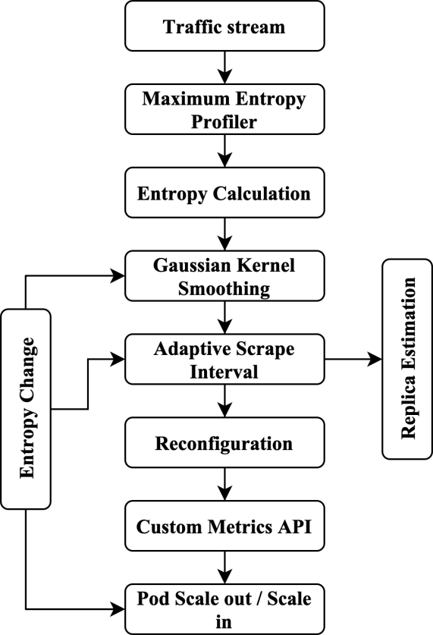
Fig. 1. Workflow of the Model
3.1 Overarching System Workflow and Telemetry Ingestion
The runtime execution flow of the ELPCMT framework maintains a separation of concerns between telemetry gathering, mathematical analysis, and proactive infrastructure scaling modifications. The monitoring pipeline starts at the edge of the cluster, where service mesh controllers and ingress gateways are continuously routing incoming application traffic. The Prometheus Time-Series Database (TSDB) queries for deployments to ingest application signals in real time, with a variable metric scrape interval, for example, HTTP Request Rates (Queries Per Second (QPS)) [7].
Instead of feeding raw measurements directly to the HPA and risking inconsistent scaling decisions, the ELPCMT engine processes the data. The engine is an intermediate intelligence layer that analyzes incoming time series data streams, calculates structural probability densities, applies smoothing filters to remove high frequency network noise, and determines an optimal pod replica target.
Once the best infrastructure state is determined, the ELPCMT engine communicates with the cluster control plane in two ways: first, it communicates the new optimal replica requirements directly to the Kubernetes Custom Metrics API Adapter, which enables the native HPA controller to change the workloads in a matter of seconds; second, it communicates a directive to the Prometheus configuration manager to optimize the operations and change the data collecting frequency. This results in a closed control loop where the telemetry pipeline adapts to the workload it seeks to evaluate.
3.2 Maximum Entropy Load Profiling Model
The core layer of ELPCMT employs information theoretic principles to obtain unbiased workload prediction estimators that are free of any fixed traffic pattern. The framework calculates the statistical probability of various workload states rather than imposing a fixed sinusoidal or linear distribution on a dataset. Let a random variable X represent the structural states of demand that delineate the incoming workload traffic density over a designated evaluation window.
ELPCMT addresses an optimization issue grounded in the Principle of Maximum Entropy to determine the most precise probability distribution p(x) of cluster traffic, without any unwarranted statistical assumptions. The differential Shannon entropy H(X) quantifies the uncertainty or variability of the system and is theoretically expressed as:
$H\left(X\right)=−\sum_{i=0}^{N−1}{p\left(i\right)}\ln{(p(i))}$ (1)
The approach optimizes entropy value under established restrictions derived from real-time monitoring systems. The first constraint is the standard normalization. The sum of all probabilities must be one, as shown in below.
$\sum_{i=0}^{N−1}{p\left(i\right)}=1$ (2)
The following constraints ensure that the expected values of the empirical traffic variables (average arrival rates, variance peaks, etc.) of the system match the historical monitoring data. The optimal mathematical solution for the probability of traffic state is finally obtained by using the Lagrange multiplier method to optimize the system with constraints as:
$p\left(i\right)=\frac{1}{Z}\exp\left(−λi\right)$ (3)
λ denotes the Lagrange multiplier, and Z denotes the normalization constant. The ELPCMT engine tunes parameters to accommodate changing workloads. Large changes in entropy H(X) suggest rapid workload transitions during bursty and peak traffic conditions.
3.3 Gaussian Kernel Traffic Smoothing Module
The Maximum Entropy model shows the probabilistic distribution of tasks. Network anomalies at high frequencies or transient query noise can induce micro oscillations in metric telemetry. The deviations lead to immediate pod loss, an ineffective cycle of recurrent scheduling, and container deletion. ELPCMT employs a nonparametric Gaussian Kernel Smoothing layer to avoid using raw metrics.
The kernel trend estimator produces a smoothed traffic signal from a series of recorded historical traffic load data. The standard symmetric Gaussian kernel function for eliminating transient noise is given as:
$K\left(u\right)=\frac{1}{\sqrt{2π}}\exp\left(−\frac{u^{2}}{2}\right)$ (4)
The behavior of this smoothing filter is heavily influenced by a bandwidth parameter, which determines the extent of signal smoothing. In the ELPCMT engine, $u$ is not a fixed constant. It is immediately dynamically linked to the real-time differential entropy H(X) computed in the profiling layer:
$h=\frac{α}{1+\exp\left(−H(X)\right)}$ (5)
α denotes the scaling factor. The dynamic coupling ensures minimum entropy and predictable traffic. HPA detects the sudden spikes, initiates new containers, and maintains responsiveness.
3.4 Dynamic Custom Metric Tuning Control Loop
ELPCMT integrates the mathematical principles of the entropy profiler and kernel smoother into an active, closed loop control system that is central to the execution logic. The controller dynamically adjusts the trade-off between monitoring overhead and cluster responsiveness by continuously adapting the Prometheus metric scraping interval (τ).
The system control function defines the relationship between the current workload variance and the required frequency of telemetry metric collection, as given below.
$τ=τ_{base}\left(1−γ∆H\right)$ (6)
$τ_{base}$ is the baseline scrape interval in idle periods. γ is a critical tuning parameter to regulate the metric pipeline adaptation. ΔH represents the variation in entropy. The calculated interval τ is constrained between a minimum threshold (to prevent excessive polling from depleting cluster resources) and a maximum threshold (to maintain fundamental visibility during idle periods) to ensure cluster stability.
When a sudden influx of traffic impacts the cluster, the change in entropy (ΔH) escalates. This causes the control loop to set the scrape interval to its minimum value and to start collecting high fidelity metrics. The fast data collection enables the HPA to learn quickly about the increased load. Using this high fidelity data, the ELPCMT engine performs a ratio-based scaling algorithm to determine the final desired target number of replicas:
$R=C\left(\frac{V_{smooth}}{V_{target}}\right)$ (7)
R is the desired number of pod replicas, C is the current number of active pods, $V_{smooth}$ is the smoothed custom metric value collected from the Gaussian kernel filter, and $V_{target}$ is the user defined service level objective threshold. In ELPCMT, the data collection interval and the scaling equation are intrinsically related to entropy variations. This enables ELPCMT to proactively scale out containers during the early phases of a workload surge, allowing the system to accommodate traffic before pod startup delays infringe on application response time targets. The algorithm 1 of the proposed ELPCMT is shown below:
Algorithm 1: Proposed ELPCMT
Initialize target infrastructure and custom metrics API
Initialize baseline entropy tracking state $H(t−1)←0$
While Cluster_status = Active do
Collect Metrics from TSDB
Maximum Entropy Estimation
Compute $H\left(X\right)=−\sum_{i=0}^{N−1}{p\left(i\right)}\ln{(p(i))}$
Compute $h=\frac{α}{1+\exp\left(−H(X)\right)}$
Compute Gaussian kernel filter ($X\left(t\right), h(t)$)
Quantify operational volatility velocity
Compute $τ=τ_{base}\left(1−γ∆H\right)$
Find current running replicas
Execute predictive scaling computations
Publish to custom Metrics API
Reconfigure Prometheus Scraping
Trigger HPA scaling event
Cascade historical entropy window matrix
End while

Simulation Results and Discussions
Comprehensive empirical simulations were conducted to validate the efficiency, cost effectiveness, and control loop stability of the different models. The quantitative metrics, architectural factors, and assessment limitations are aligned with the parameters, empirical datasets, and mathematical frameworks in container orchestration research.
A simulation based testbed was constructed utilizing a physical edge computing infrastructure with an inherent Kubernetes control plane. The cluster consists of a single master orchestrator node and 4 identical worker nodes interconnected via low latency switching technology. Each physical worker node was equipped with 4 vCPUs and 8 GB of RAM (Intel Xeon at 2.4 GHz). It results in a total cluster capacity of 16 vCPUs and 32 GB of RAM. The target application layer was a containerized, distributed microservice execution pipeline for data processing, designed to interpret concurrent sensor intake packets. The cluster was subjected to a highly volatile heterogeneous traffic profile for 3600 seconds to replicate edge networking conditions. The workload curve experienced an abrupt transition from a stable baseline of 100 QPS to extreme peak demands beyond 2500 QPS at sub-minute intervals.
The Kubernetes HPA is operated with a control loop execution synchronization period of 15.0 seconds and a CPU utilization target threshold of 60.0%. The Prometheus adaptor used a moving average assessment window of 1 minute. The ELPCMT engine was equipped with a dynamic scraping interval window with a maximum idle time of 30.0 s, and a peak burst duration of 2.0 s, leading to a system sensitivity adjustment factor (γ) of 0.85 and a continuous kernel bandwidth baseline multiplier (α) of 1.50. The proposed ELPCMT model is evaluated across different well-known state-of-the-art orchestration approaches to assess its adequacy.
Vanilla HPA (Resource measurements Model): The default Kubernetes autoscaling framework relying solely on basic operating system level measurements collected by the Metrics Server.
Static Prom-HPA (Fixed Custom Metrics) [8]: An autoscaler that is traffic-aware and retrieves application-level telemetry (QPS) immediately from Prometheus with a fixed (non-adaptive) metric scrape interval set at τ=15 s.
THPA (Traffic-Aware Horizontal Pod Autoscaler) [9]: An edge-centric autoscaler to balance the spatial workload distributions based on the real-time network traffic metrics among active edge nodes.
KEDA Autoscaler (Event-Driven Baseline:) An event-driven scaling extender that schedules pods instantly on a target queue length threshold of 10 messages and incoming event streams depth.
Fuzzy-Logic Predictor HPA [10]: A sophisticated reactive-predictive framework to anticipate future infrastructure needs using fuzzy control inference rules on a historical sliding utilization window of five minutes.
4.1 Multi-Phase Pod Allocation Densities
The resource provisioning behavior was observed under steady state idle periods, maximum flash crowd surges, and post-peak load cool down transitions. The pod allocation analysis observed during the 60 minute experiment is provided in Fig. 2.
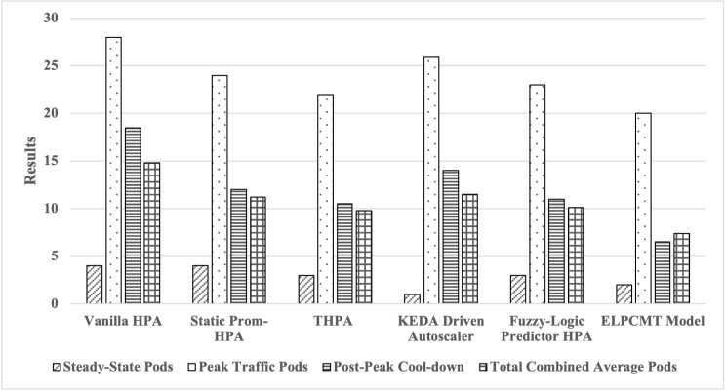
Fig. 2. Multi-Phase Pod Allocation Analysis
Significant scaling inertia is a structural constraint in conventional resource metric autoscaling. After the peak, Vanilla HPA maintains a high average of 18.50 pod replicas due to the slow decay of OS level CPU metrics after request volume decreases. Event driven methods like KEDA scale down aggressively to 1.00 pods during idle times, but overprovision up to 26.00 pods during peak traffic transitions due to a lack of traffic smoothing. The ELPCMT compresses the internal load profiles automatically using maximum entropy vectors, resulting in an average of 7.40 pods over the simulation window.
4.2 Financial Total Cost of Ownership (TCO) Metrics
The cumulative active container footprints were translated into a normalized monetary TCO matrix to evaluate the economic feasibility of the framework for production scenarios. Metrics were generated for memory overheads and raw CPU core allocations. The normalized financial metrics are presented in Fig. 3.
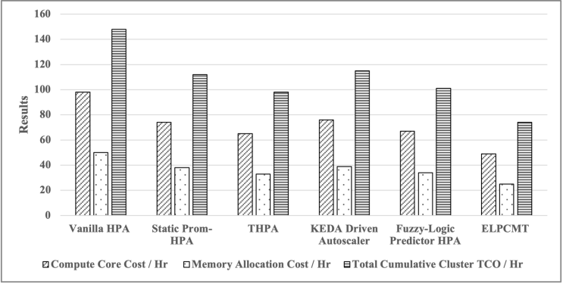
Fig. 3. Normalized Cluster Computing Expenditure and Infrastructure Cost Reduction Analysis
The vanilla HPA incurs higher infrastructure costs ($148.00/hr) caused by overprovisioning of container limits. KEDA incurs high peak hour resource charges ($115.00/Hr) due to reactive triggers. Entropy based scale-in parameters leverage the traffic smoothing modules. ELPCMT reduces the cumulative cluster total cost of ownership to $74.00/Hr. ELPCMT achieves a 50% reduction than HPA and a 33.92% reduction than Prometheus in infrastructure costs.
4.3 SLO Compliance and Performance
Autoscaling solutions must guarantee the integrity of the application against the threats posed by traffic surges. Fig. 4 shows application performance and SLO monitoring metrics under high ingress workloads.
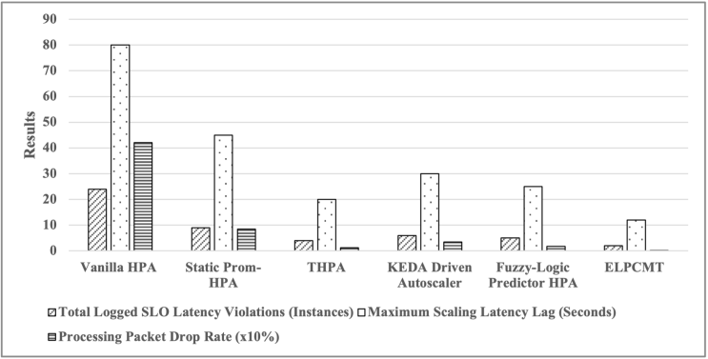
Fig. 4. Application SLO Adherence and Response Latency Quality Performance
Vanilla HPA’s 180-second reactive scaling delay resulted in queued or dropped incoming traffic as containers gradually initialized. This resulted in 24 significant latency violations and a 4.21% packet drop rate. The THPA network awareness alleviates node-level constraints, hence reducing latency spikes to 480 ms. ELPCMT reduces the scaling lag to just 12 seconds by decreasing the Prometheus metric scrape interval to 2 seconds under high system entropy. This reduces the maximum latency spike to 245 ms and guarantees 0.1% data packet loss.
4.4 Orchestration Control Loop Stability Metrics
A major problem with custom metric pipelines is that they often exhibit "flapping" or "thrashing" due to transient data noise. Fig. 5 shows the control loop stability and the transitions in resource allocation over the simulation period.
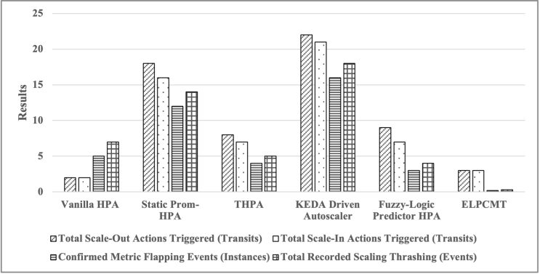
Fig. 5. Control Loop Operational Stability and Resource Thrashing Evaluator Analysis
The metrics and event-driven baselines can quickly detect traffic variations. They overreact to transient network anomalies without an adaptive data filter, lead to several scaling thrashing events (14 for Static Prom-HPA and 18 for KEDA). It incurs considerable CPU overhead during container initialization. The ELPCMT framework does not experience thrashing events. The Gaussian Kernel Traffic Smoothing module affects stability, as it autonomously tunes the kernel bandwidth to eliminate high frequency noise based on the system’s entropy.
4.5 Telemetry Infrastructure Overhead Evaluation
The monitoring ecosystem uses a performance trade-off in telemetry collection to maximize scale accuracy. Fig. 6 shows the structural overhead of the telemetry pipelines.
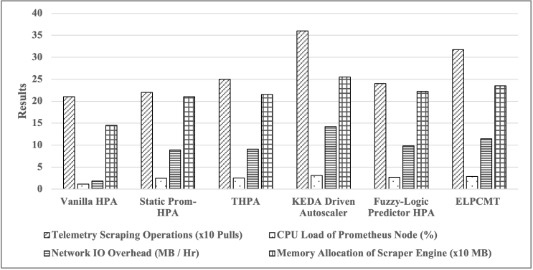
Fig. 6. Prometheus Scraping Frequency and Telemetry Infrastructure Overhead Analysis
The telemetry logs indicate that ELPCMT has a small monitoring overhead, resulting in 2.88% Prometheus node CPU utilization and 11.45 MB/hr of network Input/Output (I/O). This overhead is attributed to rapid bursts of scraping occurring every 2 seconds during flash surges. This overhead is still less than KEDA’s heavy continuous pull approach (3.12% CPU and 14.20 MB/Hr). This small increase in monitoring overhead is more than offset by the large reductions in total cluster TCO and container footprint.
The ELPCMT framework can successfully break the traditional trade-off between performance, safety, and cost efficiency. ELPCMT achieves fast, robust, and extremely cost effective container orchestration for dynamic edge computing environments by incorporating load profiling and metric pipeline adaptation into an integrated control loop.

Conclusion and Future Scope
This research presents the ELPCMT framework, a closed loop autoscaling architecture for resource management and service reliability in a containerized edge computing environment. The aim is to combine Maximum Entropy-based load profiling with Gaussian Kernel Traffic Smoothing and an adaptive Prometheus metric adjustment layer to enable fast scalability and reduce monitoring requirements. ELPCMT automatically adjusts the metric collection interval in response to changes in workload patterns to improve cluster resource utilization and increase the accuracy of scaling decisions.
An experimental evaluation on a real physical edge testbed shows that ELPCMT outperforms traditional HPA, event-driven autoscaling, and predictive scaling techniques. ELPCMT reduced cumulative infrastructure costs by 50% and achieved the minimum average resource footprint of about 7.40 pods. ELPCMT demonstrated exceptional service performance, with 1 SLO violation, low packet loss, and low scale thrashing during flash-crowd load surges of up to 2500 QPS. Results show the potential for successful integration of workload profiling and adaptive telemetry control leading to significant improvements in autoscaling efficiency and system stability. Future work includes concurrent horizontal and vertical scaling, lightweight workload forecasting techniques, and federated multi-cluster edge deployments.

References
- M. Ouhssini, K. Afdel, E. Agherrabi, M. Akouhar, and A. Abarda, “DeepDefend: A comprehensive framework for DDoS attack detection and prevention in cloud computing,” Journal of King Saud University – Computer and Information Sciences, vol. 36, no. 2, p. 101938, 2024.
- K. Senjab, S. Abbas, N. Ahmed, and A. U. R. Khan, “A survey of Kubernetes scheduling algorithms,” Journal of Cloud Computing, vol. 12, no. 1, p. 87, 2023.
- L. M. da Silva, P. V. Alves, S. N. Silva, and M. A. Fernandes, “Adaptive horizontal scaling in Kubernetes clusters with ANN-based load forecasting,” Cluster Computing, vol. 28, no. 3, p. 176, 2025.
- L. A. Phan and T. Kim, “Traffic-aware horizontal pod autoscaler in Kubernetes-based edge computing infrastructure,” IEEE Access, vol. 10, pp. 18966–18977, 2022.
- H. Aqasizade, E. Ataie, and M. Bastam, “Kubernetes in action: Exploring the performance of Kubernetes distributions in the cloud,” Software: Practice and Experience, vol. 55, no. 10, pp. 1711–1725, 2025.
- T. S. Wijesekera and D. R. Wijendra, “Kubernetes scaling: A comprehensive review of scalability in Kubernetes,” in Proceedings of the International Conference on ICT for Sustainable Development, Cham, Switzerland: Springer Nature Switzerland, pp. 187–201, Jul. 2025.
- B. Kouach, M. Mekhfioui, A. El Mrabet, and R. El Gouri, “Implementing machine learning models in a Kubernetes cluster for a smart monitoring system,” in Proceedings of the 11th International Conference on Optimization and Applications (ICOA), pp. 1–6, Oct. 2025.
- H. Ahmad, C. Treude, M. Wagner, and C. Szabo, “Smart HPA: A resource-efficient horizontal pod auto-scaler for microservice architectures,” in Proceedings of the IEEE 21st International Conference on Software Architecture (ICSA), pp. 46–57, Jun. 2024.
- L. A. Phan and T. Kim, “Traffic-aware horizontal pod autoscaler in Kubernetes-based edge computing infrastructure,” IEEE Access, vol. 10, pp. 18966–18977, 2022.
- F. Tian, X. Zhang, K. Xia, J. Sun, and Y. Zheng, “Probability forecasting of short-term short-duration heavy rainfall combining ingredients-based methodology and fuzzy logic approach,” Atmosphere, vol. 13, no. 7, p. 1074, 2022.

