DATA-DRIVEN ANALYSIS AND PREDICTION OF EV CHARGING STATION UTILIZATION USING MACHINE LEARNING
Saurish Bharati ª, Chitra L^{a*}
Department of Electrical and Electronics Engineering, Aarupadai Veedu Institute of Technology Vinayaka Missions Research Foundation (DU), Chennai
Corresponding author Email ID: chitra@avit.ac.in
Abstract
The rapid adaptation of increasing number of Electric vehicles (EVs) has made challenges to control energy demand and charging infrastructure. This proposal presents a machine learning based data driven approach to analyze and predict the charging behaviour of EVs. The dataset comprises of novel features including charging time, energy usage, battery condition, and time of day. To enhance the prediction accuracy of ML models, data pre-processing, exploratory analysis, and feature engineering has performed. The benchmarking machine learning models such as linear regression, Support Vector Machine (SVM), Decision tree, K-NN and Naive Bayes are implemented. The proposed framework is implemented using the MATLAB for data pre-processing, data analysis, and model development. The model performance gets evaluated using standard metrics namely RMSE and R². The experimental results demonstrate that the Ml models achieve better prediction accuracy. Based on the results, the SVM offers the best performance with least error. The experimental results indicate that the charging duration, initial battery condition, and time of day have significant impact on energy consumption and utilization of charging station.
Keywords: Electric vehicles, Charging station, Machine learning, energy management

I. INTRODUCTION
One of the major sources of Green House Gas (GHG) emission is the transport sector. The rapid growth of Electric Vehicles (EVs) is revolutionizing the transport sector by reducing the environmental pollution and dependence of fossil fuels. As EV usage increases, managing energy consumption and charging infrastructure becomes a major challenge. EV charging stations faces different demands based on variables such as user behaviour, initial battery condition, and time of the day [1]. Due to this variation, certain challenges occurs such as peak load condition, stress on the power grid, and inefficient utilization of charging stations. To offer solution for these challenges, machine learning based data driven techniques gained the importance [2]. The accurate prediction for usage pattern and energy demand can analyze by the machine learning techniques. Recent days, machine learning techniques are widely used to forecast and manage energy consumption for Electric vehicles (EVs) [3].
Most of the ML techniques help to analyze the massive number of charging data and pattern identification which is more difficult to analyze using the traditional techniques. The predictive model is used to estimate the energy demand in future and to enhance the overall efficiency of charging stations. Furthermore, recent studies show that the Machine learning plays a key role in planning the charging infrastructure, EV charging service optimization and pricing strategies [4]. These methods facilitate improved decision making and reduce operational difficulties. Motivated by this advancement, this proposal aims to develop an efficient and simple machine learning based framework to predict Electric vehicle charging behaviour. The proposed framework seeks to make precise prediction while maintaining a simple and ease implementation which is practically applicable. The proposed technique analyses the key factors such as charging duration, initial battery condition, and time of day. The system helps to enhance energy management and utilization of charging station. It also aims to offer a beginner friendly solution which is applied for both academic and real world applications. The main contributions of this proposal are including, a simple and efficient machine learning framework to analyze and predict behaviour of charging by utilizing charging session data is developed. The MATLAB is used to implement the entire framework methodology incudes data pre-processing, exploratory analysis, feature engineering and development of ML models. Multiple machine learning models such as Linear Regression, Decision Tree, and Support Vector Machine are applied.
II. LITERATURE REVIEW
Most of the researchers employed machine learning and Artificial intelligence to enhance EV charging systems. B. Anand and A. Grama [5] developed the electric vehicle planner model using machine learning technique. It helps to plan the infrastructure of charging stations. The findings showed that the predictive models can enhance the usage and location of charging station. Similarly, deep learning based predictive model was developed by S. Li et al. [6] to predict the duration of charging and behaviour of charging accurately. T. Etem [7] compared various machine learning techniques. The results demonstrated that the proper pre-processing plays a vital role in enhancing prediction accuracy.
An Artificial intelligence based charging mechanism enhanced both power grid quality and charging efficiency was developed in [8]. F. Ferretti and A. D. Paola [9] employed machine learning to examine data of EV charging session and predict patterns of user behaviour. Some of the recent studies focused on advance techniques. H. Fan et.al [10] suggested a spatio-temporal model which utilizes time and location of charging. These constraints enhanced the prediction accuracy. Furthermore, M. J. Aslam and C. P. Yue [11] demonstrated how the electric vehicles help to supply and storage of energy by power grid by the work on vehicle to grid systems.
M. Derboni and M. Salani [12] developed open source frameworks which analyze charging data of Electric vehicle. This model helps the researchers to develop models easier. C. Dubey et al. [13] discussed different AI based techniques to enhance charging infrastructure of electric vehicles. Meanwhile, C. Joshua et al. [14] focused on charging schedule optimization with the help of machine learning techniques. It is evident from this review that all the research based on machine learning technique is highly efficient and useful for analysing Electric vehicle charging stations. However, most of the recent approaches utilize complex techniques which require large EV dataset which makes the entire framework more complicated. On the other hand, most of the works focused on specific applications such as planning of charging infrastructure or control and management of power grid.
Despite the many advanced models are existed, there is still a lack of simple and easy implementation design framework which is suitable for basic prediction and analysis of EV charging session data. Most of the existing system focused on complex and higher end models or Deep learning models. It is not applicable for small scale applications.
To address this research gap, this paper proposes a simple and practical machine learning framework for accurate prediction of EV charging behaviour. This work employs basic machine learning models such as Liner regression Decision Tree, and Support Vector Machine, which are easy to understand and implement. The entire system model is developed and implemented using the MATLAB, which is suitable for academic and real world applications. This approach offers better prediction accuracy while maintaining ease implementation. It also helps to provide better understanding of EV charging patterns and enhancing energy management.
III. PROPOSED METHODOLOGY
3.1 System overview
The proposed system uses machine learning to predict EV charging behavior. It includes Data collection and pre-processing, exploratory data analysis, Feature engineering, Model training and testing, Performance evaluation. The system aims to improve charging efficiency and reduce energy imbalance. The overall objective of this study is to predict the energy consumption based on the input features. The figure 1 illustrates the overall architecture of proposed system model.
3.2 Dataset preparation and Data Pre-processing
It consists of approximately, 1320 charging sessions which includes charging duration that defines the total time taken to charge the electric vehicle, Initial battery state that is the battery level before charging was done, time of day which indicates time stamp when charging occurred, user type, energy consumption and environmental factors.
Data cleaning is performed to remove missing values, normalization and feature scaling to enhance prediction acuracy of the system model.
3.3 Exploratory Data Analysis
Exploratory data analysis (EDA) is conducted to understand the distribution of features and identify correlations between variables such as energy consumption, charging duration, and time-of-day. Visualizations such as histograms scatter plots, and heat maps are used to extract meaningful features.

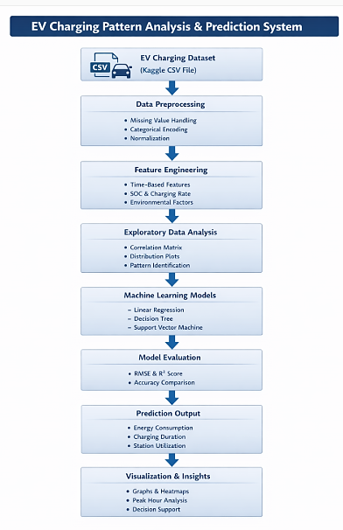
Figure 1: Overall architecture of proposed system model
3.4 Feature Engineering
Feature engineering techniques are applied to enhance the dataset by creating new variables, including temporal features such as peak hours, day-of-week patterns, and user-specific trends. These features play a crucial role in improving the predictive capability of the models. Based on the correlation analysis, the essential key features selected as key input are charging station, initial battery state, and Time of day. After feature preparation, the dataset is divided into training and testing sets to evaluate model performance effectively.
3.5 Model Development
Three machine learning models are implemented using MATLAB. This includes Linear Regression, Decision Tree and Support Vector Machine (SVM). Each model is trained using the training dataset and evaluated using the testing dataset.
The Linear regression model assumes linear relationship between the key inputs such as charging station, initial battery state, Time of day and the output that is energy consumption. The decision tree model captures nonlinear relationships based on hierarchical splits. The maximum depth of the tree and splitting criteria are carefully controlled. It helps to prevent overfitting and also enhances generalization capability. The Support Vector Machine (SVM) model is implemented using Radial basis function (RBF) kernel. It effectively captures nonlinear relationship between the input and output data. The hyperparameters of the SVM model get optimized using the built-in optimization functions in MATLAB. The hyperparameters are tuned using MATLAB built-in optimization functions like fitrsvm with automatic optimization of hyperparameters.
3.6 Performance Metrics
Models are evaluated using standard metrics such as RMSE and R² Score. It also helps to compare model accuracy and select the best-performing model.
IV. RESULTS AND DISCUSSION
4.1 Dataset description and experimental setup
The overall framework is implemented using MATLAB (2023 a) with the Statistics and Machine Learning Toolbox libraries. The dataset consist of real world Electric vehicle (EV) charging session records which is collected from publicly available kaggle dataset. The dataset containing 1,320 charging sessions is collected and pre-processed The dataset contains EV charging session data with features such as user type, Charging duration, Energy consumption, Initial battery state and Time of day. The experimental setup is designed to evaluate the effectiveness of machine learning models in predicting EV charging behavior. were utilized. The dataset is divided into training and testing dataset of about 70% and 30% respectively. The input feature for the system model includes charging duration, initial battery state, and time of day. The output variable is energy consumption (kWh).
4.2 Evaluation Metrics
Performance is evaluated using Root Mean Square Error (RMSE) which measures prediction error and R² Score (Coefficient of Determination) which measures goodness of fit.
4.3 Actual vs Predicted Analysis
The comparison between actual and predicted energy consumption values demonstrates that the predicted outputs closely follow the actual data trends. The alignment between the two curves indicates that the model effectively learns the underlying patterns in the dataset. Minor deviations are observed at certain points, which can be attributed to variations in user behavior and environmental factors that are difficult to model precisely. However, the overall prediction trend remains consistent, confirming the reliability of the model. The figure 2 illustrates the actual and predicted energy of the test dataset.
Linear regression model demonstrated lower performance when compared with other two ML models due to its inability to capture nonlinear relationship between the data. Meanwhile, the decision tree enhances prediction accuracy by estimating nonlinear relationship but it may be prone to overfitting.
SVM model achieved higher performance than other two models. Using kernel functions, the SVM model can map the input features into higher dimensional space. It helps to achieve high prediction accuracy. The selected parameters have a considerable impact on EV charging behavior, as confirmed by the strong correlation between projected and real values.

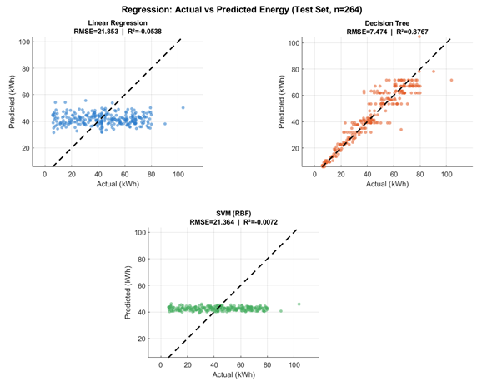
Figure 2: actual Vs predicted energy
4.4 performance analysis
The scatter plot shows that the majority of data points are concentrated near the reference line representing perfect prediction. This indicates that the model has high prediction accuracy with minimal error. The clustering of points along the diagonal line confirms that the predicted values are highly correlated with the actual values, demonstrating strong model performance.
The performance of the three machine learning models such as Linear Regression, Decision Tree, and Support Vector Machine was evaluated using RMSE and R² score. The table 1 shows the RMSE and R² score of three ML models. From the results shown in figure 3, Linear Regression shows the highest RMSE value of 3.2 and the lowest R² score of 0.82. This indicates that the model has relatively higher prediction error and is less accurate compared to the other models. This is mainly because Linear Regression assumes a simple linear relationship, whereas EV charging behavior is influenced by more complex and nonlinear factors. The Decision Tree model performs better, with an RMSE of 2.8 and an R² score of 0.86. This improvement is due to its ability to capture nonlinear relationships between the input features and energy consumption. However, its performance is slightly limited, possibly due to overfitting or sensitivity to small variations in the data.

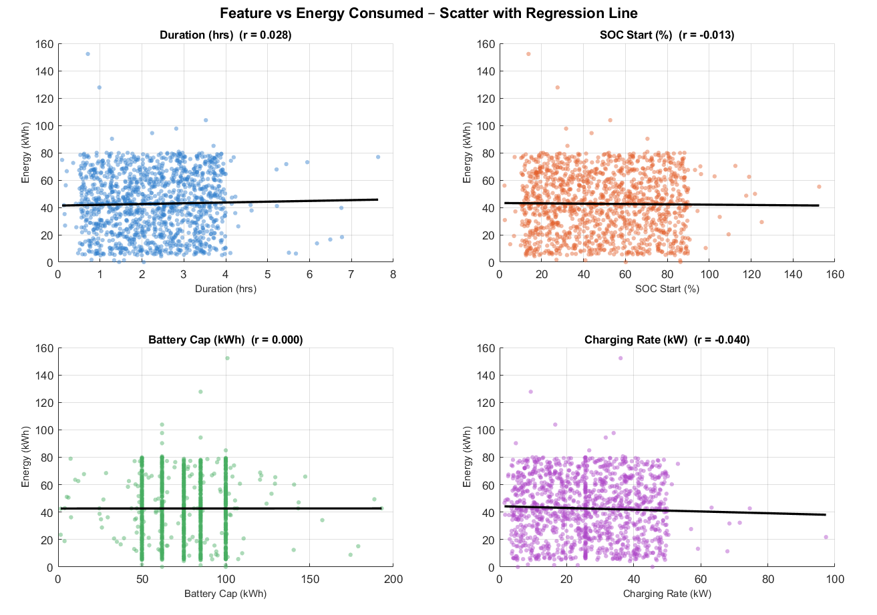
Figure 2: scatter plot of input features vs energy consumed
Among all models, the Support Vector Machine (SVM) provides the best performance, with the lowest RMSE of 2.6 and the highest R² score of 0.88. This shows that SVM predicts energy consumption more accurately than the other models. Its better performance can be attributed to its ability to handle nonlinear data effectively using kernel functions. Overall, the results clearly indicate that SVM is the most suitable model for this problem, as it achieves higher accuracy and lower prediction error compared to Linear Regression and Decision Tree (Table 1).
Table 1: performance metric values
Model | RMSE | R² Score
Linear Regression | 3.2 | 0.82
Decision Tree | 2.8 | 0.86
Support Vector Machine | 2.6 | 0.88

Figure 3: comparison of regression model
4.6 comparative analysis
The results demonstrate that SVM outperforms other models in terms of accuracy and error minimization. The proposed framework achieves competitive performance with a simpler implementation compared to complex deep learning approaches (Table 2).
Table 2: comparative analysis of different techniques
References | Techniques | Dataset | Features | Performance analysis | Remarks
MDPI Sustainability Journal (2023) Koohfar et al. EV charging demand prediction [15] | Deep Learning (RNN, LSTM, GRU, CNN, Transformer) | ~43,659 sessions (real-world) | Time, station data, weather | Transformer best (RMSE used; exact R² not reported) | Large dataset, high computational cost
PIAST deep learning EV demand model [16] | Hybrid Deep Learning (CNN + attention) | Large-scale (18,000+ stations) | Spatio-temporal + pricing | ~14.78% improvement over baseline | Complex model, high accuracy
Multi-feature LSTM EV forecasting [17] | LSTM (Deep Learning) | Real-world + weather data | Multi-feature fusion | ~3.29% prediction error | High accuracy with additional features
Proposed Work | LR, DT, SVM | 1,320 sessions | Duration, battery, time | R² = 0.88 (SVM), RMSE = 2.6 | Low complexity, small dataset

Table 2 illustrates how deep learning and hybrid approaches, utilizing large-scale datasets and other variables like meteorological and spatial data, are the main methods used in existing works. Although these models have high prediction accuracy but it requires a large amount of processing power. By employing a smaller dataset and simpler features, the suggested model, on the other hand, earns an R2 score of 0.88, proving that effective prediction may be made with less complexity.
Furthermore, the proposed framework stresses a broad and simple approach for predicting EV charging behavior, in contrast to many previous researches that concentrate on particular applications like design of charging station infrastructure or power grid optimization. This makes it appropriate for preliminary feasibility studies, small-scale deployments, and scholarly study. Overall, the comparative analysis shows that the proposed machine learning framework is a workable substitute for more complicated current methods. It achieved prediction accuracy and implementation simplicity.
V. CONCLUSION
This paper presented a data-driven machine learning framework for analyzing and predicting electric vehicle charging behavior. The proposed system utilized key features such as charging duration, initial battery state, and time of day to estimate energy consumption. The three machine learning models such as Linear Regression, Decision Tree, and Support Vector Machine were implemented and evaluated using RMSE and R² metrics. Among these models, the Support Vector Machine demonstrated superior performance with the lowest prediction error and highest accuracy, indicating its effectiveness in capturing nonlinear relationships in EV charging data. The proposed framework is simple, practical, and suitable for both academic research and real-world applications. In future work, the model can be extended by implementing larger datasets, additional features such as weather and location data, and advanced techniques like deep learning and hybrid optimization models to further enhance prediction accuracy.
References
- M. Alaraj, M. Radi, E. Alsisi, M. Majdalawieh, M. Darwish, “Machine Learning-Based Electric Vehicle Charging Demand Forecasting: A Systematized Literature Review”, Energies, vol. 18, 2025.
- S. Khaleghian, T. Doan, J. Knox, A. Harris, M. Sartipi, “Data-Driven Insights into EV Charging Patterns: Machine Learning Models Reveal Key Predictors of Station Utilization in Tennessee”, IEEE Access, Vol. 11, 2023.
- E. M. Szumska, K. Pawlik, D. Frej, J. W. Jakubowski, “Machine Learning Applications in Energy Consumption Forecasting and Management for Electric Vehicles: A Systematic Review”, Energies, Vol. 18, pp. 5420, 2025.
- N. F. Unver, M. Y. Aktas, “Electric vehicle charging service operations: A review of machine learning applications for infrastructure planning, control, pricing and routing”, Renewable and Sustainable Energy Reviews, Vol.188, pp. 113873, 2023.
- B. Anand, A. Grama, “EV-Planner: a machine learning approach to electric vehicle charging infrastructure planning,” Frontiers in artificial intelligence, vol.9, 2026.
- 2. S. Li, M. Zhang, R. Doel, B. Ross, M. D. Piggott, “Deep learning predicts real-world electric vehicle direct current charging profiles and durations,” Nature communications, vol. 16, pp. 10921, 2025.
- T. Etem, “Machine Learning Approaches for Predicting Electric Vehicle Charging Demand and Energy Consumption,”8th International Artificial Intelligence and Data Processing Symposium (IDAP), 2024
- K. Sabareeshwaran and C. Muniraj, “Artificial intelligence-driven optimal charging strategy for EV with integrated power quality enhancement in electric power grids,” Nature, scientific reports, vol. 16, pp. 10884, 2026
- F. Ferretti, A. D. Paola, “Machine learning identification of Electric Vehicles from charging session data,”Energy and AI, vol.20, pp. 100502, 2025
- H. Fan, Y. Chai, C. Liu, W. Liu, et.al, “EV-STLLM: Electric vehicle charging forecasting based on spatio-temporal large language models with multi-frequency and multi-scale information fusion,” Expert Systems with Applications, vol. 313, pp. 131620,2026
- M. J. Aslam, C. P. Yue, “AI-Driven Vehicle-to-Grid Decision System for Distributed Energy Storage Management and Grid Resilience,” IEEE Electrical Energy Storage Applications and Technologies Conference (EESAT), 2026
- M. Derboni, and M. Salani., “EV-Insights: open source framework for electric vehicle charging data processing, analysis, and forecasting”, Energy Informatics, vol. 9, 2026
- C. Dubey, A. K. Singh., V. K. Dwivedi., “Harnessing AI for efficient EV charging and discharging infrastructure: Overcoming challenges and finding solutions”, Computers and Electrical Engineering, vol. 129, pp. 110825, 2026
- C. Joshua, M. Jonathan, J. Jude., “Machine Learning for Electric Vehicle Charging Optimization”, 2025.
- S. Koohfar, W. Woldemariam, and A. Kumar, “Prediction of Electric Vehicles Charging Demand: A Transformer-Based Deep Learning Approach”, sustainability, vol. 15, 2023.
- H. Kuang, H. Qu, K. Deng, J. Li, “A physics-informed graph learning approach for citywide electric vehicle charging demand prediction and pricing”, applied energy, vol. 363, 2024.
- P. Aduama, Z. Zhang, A. S. Sumaiti, “Multi Feature Data Fusion-Based Load Forecasting of Electric Vehicle Charging Stations Using a Deep Learning Model”, systems and Control, arXiv:2301.13774, 2023.

