AI- Powered Skin Disease Diagnosis with Explainable CNN and Intelligent Chatbot Integration

Dr. Anitha Karthi  Department of Computer Science and Engineering,  Bharath Institute of Science and Technology(BIST),  anithakarthi.cse@bharathuniv.ac.in | D.Purna Avinash Swamy,  Department of Computer Science and Engineering,  Bharath Institute of Science and Technology(BIST),  avinashdommeti17@gmail.com | A.Muni Mokshith Reddy,  Department of Computer Science and Engineering,  Bharath Institute of Science and Technology(BIST),  mokshithadduru@gail.com
T.Anvesh,  Department of Computer Science and Engineering,  Bharath Institute of Science and Technology(BIST),  anveshthota86@gmail.com | M.Venkata Siva Naga Sumanth,  Department of Computer Science and Engineering,  Bharath Institute of Science and Technology(BIST),  sumanthmaadhu58@gmail.com

Abstract—The growing prevalence of skin diseases has made timely identification of skin conditions increasingly vital, yet access to accurate dermatological assessment remains constrained in numerous regions owing to an insufficient number of trained specialists. This gap is especially pronounced in developing nations, where dermatological care is largely inaccessible. To address this gap, this work introduces a mobile-based intelligent healthcare solution designed to facilitate preliminary skin condition screening through a cohesive, user-oriented platform. The system unifies three functionally distinct modules into a single end-to-end pipeline. Its predictive core is a purpose-built Convolutional Neural Network trained for image-level classification on the HAM10000 benchmark, which encompasses seven categories of dermatological conditions. During evaluation, the model achieved around 74% training accuracy and approximately 71% on held-out data. Unlike standard classification pipelines that yield only a class label, this framework incorporates Local Interpretable Model-Agnostic Explanations (LIME) to enhance prediction transparency. The LIME module generates region-based visual overlays that reveal which image areas drove the model’s output, thereby addressing a core shortcoming of black-box neural architectures. This configuration enables seamless access across a wide range of smartphones, making the system practical for real-world usage scenarios.
Keywords: Skin Disease Detection, Deep Learning, Explainable AI, LIME, HAM10000, Mobile Health Systems, CNN, Healthcare Chatbot, Flask, React Native.

Introduction
Dermatological conditions rank among the most widespread health problems globally, with close to 900 million people affected at any given time [1]. India illustrates the scale of this challenge particularly well: the country has fewer than 8,000 practicing skin specialists for a population of over 1.4 billion, meaning that most patients—whether presenting with a benign condition like seborrheic keratosis or a serious one like melanoma—face long waits or no specialist access at all [2]. Lacking a clear path to professional care, many individuals turn to internet searches and social media for answers. This workaround is unreliable and often makes things worse, contributing to wrong self-diagnoses, unnecessary worry, and delayed or harmful self-treatment.
Recent advances in computer vision have opened a practical alternative. Convolutional Neural Networks have shown a strong ability to pick up subtle visual patterns in dermoscopic images—patterns that are hard for the untrained eye to detect. The work of Esteva et al. [3] was an early landmark: their model, trained on over 120,000 labelled skin images, performed on par with board-certified dermatologists on several lesion types. That result shifted the conversation from whether AI could assist in skin diagnosis to how it could be made usable outside the research lab. So far, most such systems have stayed within controlled settings and have not reached patients directly.
One major barrier to real-world deployment is the lack of interpretability in deep learning systems. When a model assigns a diagnostic label—such as identifying a lesion as melanoma—the reasoning behind this prediction is not inherently transparent. This opacity reduces user confidence and limits human validation, which is essential in sensitive domains like healthcare. To address this, techniques from Explainable Artificial Intelligence have been developed, including Local Interpretable Model-Agnostic Explanations (LIME) and Grad-CAM [5], which visually highlight the image regions that influence model decisions. While these approaches improve transparency, their integration into fully functional, user-facing applications remains limited.
Another important consideration is the absence of structured guidance following model predictions. Presenting users with a classification result alone does not provide sufficient context for informed decision-making. Individuals require additional information regarding the nature of the predicted condition, recommended precautions, and indications for seeking professional care. In this context, conversational systems powered by large language models offer a promising avenue for delivering accessible and interactive health information.

Literature Survey

Conventional Methods for Skin Lesion Analysis
Before neural networks became mainstream, researchers tackled skin lesion analysis using hand-crafted features. Tools like Local Binary Patterns captured texture information, while colour histograms quantified pigmentation. Clinically derived guidelines such as the ABCD rule—assessing asymmetry, border shape, colour spread, and lesion diameter—were encoded as rule-based classifiers. These approaches were computationally light and straightforward to audit, but their accuracy was tightly coupled to the quality of the features chosen by the designer. They struggled with lesions that fell outside expected patterns and could not easily scale to multi-class problems.

CNN-Driven Advancements in Dermatological Imaging
CNN-based methods changed what was achievable. Rather than relying on hand-coded descriptors, these networks learn hierarchical visual representations directly from labelled training data. The study by Esteva et al. [3] was a turning point: by training on a corpus of more than 120,000 dermatoscopic images, they produced a classifier that matched the performance of practicing dermatologists on two critical diagnostic tasks. Subsequent work showed that architectures like ResNet and MobileNet could deliver competitive results even under mobile deployment constraints, making the case for embedding such models in patient-facing applications.

Role of Explainable AI in Medical Image Interpretation
Stronger predictive performance brought a new problem into focus: trust. A model that outputs a class label without any indication of why it reached that conclusion is difficult to act on in a clinical setting. Clinicians cannot be expected to accept a black-box verdict for a potentially life-altering diagnosis. This created interest in post-hoc explanation methods. LIME [4] perturbs input images in local neighbourhoods to estimate which regions drove a specific prediction. Grad-CAM [5] uses gradient signals from the final convolutional layer to build a saliency map. Both produce human-readable overlays but differ in how they handle multi-class outputs and the granularity of the explanations they generate. What remains underexplored is how these tools are packaged for non-specialist users—an integration challenge that this work directly addresses.

Problem statement
Skin diseases are becoming more prevalent at a time when qualified dermatologists remain unevenly distributed, creating significant obstacles to timely diagnosis and care. Rural and resource-limited settings are hit hardest, as specialized healthcare is often out of reach [2]. Faced with these gaps, many people resort to informal digital sources for health information. Relying on unverified online content often results in misdiagnosis, unnecessary anxiety, delayed professional consultation, and potentially harmful self-treatment.
In parallel, advancements in Artificial Intelligence have enabled the development of automated diagnostic systems, with Convolutional Neural Networks emerging as a dominant approach for image-based skin disease classification. What is needed is a solution that goes beyond outputting a class label. A useful tool should tell users not just what condition may be present, but why the system reached that conclusion and what they should do next. This is the gap the present work targets: combining a CNN classifier with a visual explanation layer and a guided chatbot to produce a complete, patient-facing screening application.

Proposed frame work
The proposed system is built around a sequential multi-module design that integrates data handling, predictive inference, visual explanation, and conversational support into a unified platform. All components communicate through a lightweight server layer and are accessed by users via a mobile client. Each module targets a specific gap in existing AI-based dermatology tools, with the overall aim of providing not just accurate predictions but also interpretable outputs and practical guidance for users.

Dataset Selection and Preparation
The HAM10000 dataset was chosen as the training foundation for this work, given its established role as a standard reference for multi-label skin lesion classification [7]. It comprises more than ten thousand dermoscopic images distributed across seven clinically meaningful condition categories, sourced from varied patient populations and acquisition environments. This breadth of representation makes it well-suited for training models intended to handle the variability encountered in clinical practice.

Data Collection
Input images are sourced from two channels: direct uploads from end users through the mobile interface and curated reference samples from the HAM10000 benchmark. The benchmark provides a comprehensive set of dermoscopic images spanning the seven supported condition types [7], allowing the model to internalize characteristic visual patterns for each category. Images submitted via smartphones serve as practical inference inputs, exposing the system to the natural variability encountered outside of controlled research settings.
Table No.1 - Skin Disease Classification
Class Code | Disease Name | Description
akiec | Actinic Keratoses | Precancerous
bcc | Basal Cell Carcinoma | Skin cancer
bkl | Benign Keratosis | Non-cancerous
df | Dermatofibroma | Benign bump
nv | Melanocytic Nevi | Moles
mel | Melanoma | Severe cancer
vasc | Vascular Lesions | Blood vessel issue

Data Preprocessing
Prior to model inference, all input images undergo a series of preparation steps aimed at improving consistency and quality. Each image is scaled to a uniform resolution appropriate for the CNN architecture, and pixel values are normalized to a constrained range to promote stable gradient behaviour during training [8]. To diversify the training distribution and improve robustness to conditions encountered outside the lab, data augmentation operations including random rotations, horizontal flips, and zoom transformations are applied. These measures collectively help the model generalize across differences in image capture angle, illumination, and device characteristics.

Conversational Support via GROQ API
To complement prediction and explanation, the system integrates a conversational module powered by the GROQ API. This component provides users with contextual information related to their results in an interactive manner.
The chatbot is configured with strict operational boundaries defined through a system-level prompt. It is designed to respond to queries related to general skin health [11], preventive measures, and awareness while explicitly avoiding the provision of medical prescriptions or treatment recommendations. Each response includes a disclaimer clarifying that the information is not a substitute for professional medical advice.

SYSTEM ARCHITECTURE
The system follows a distributed client-server design in which each component encapsulates a specific function and communicates with others through well-defined API contracts. This separation of concerns promotes maintainability and allows any individual module — whether the prediction model or the external chatbot service — to be upgraded independently without disrupting overall system behaviour. This decoupled structure is particularly well-suited to healthcare AI applications, which must accommodate iterative model improvements and evolving compliance requirements over time.
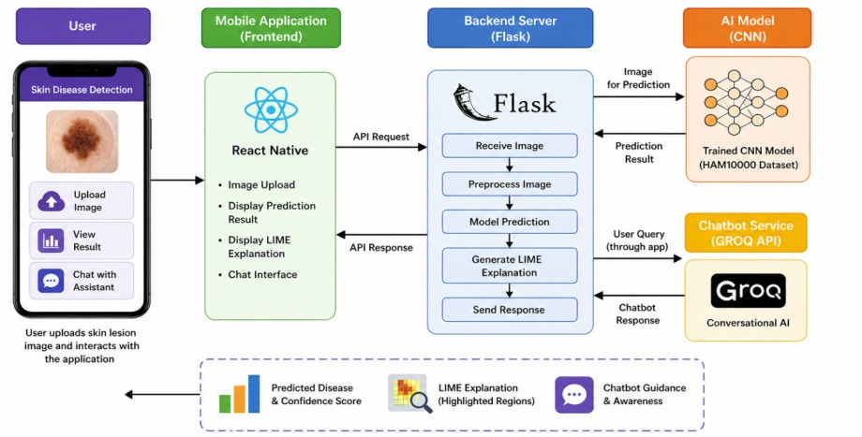
- : Overall System Workflow

Architecture Overview
The framework is organized into five functional layers: a mobile interface layer, an API handling layer, a prediction engine, an explainability unit, and a conversational service. User inputs, typically captured via camera or gallery, are first processed through the mobile layer and transmitted to the backend via API end points [4]. The backend routes these inputs to the prediction model for classification and to the explanation module for interpretability generation. The outputs from both processes are returned to the client in a synchronized manner.

Mobile Presentation Layer
The user interface, built with React Native, is structured to ensure intuitive interaction and minimal cognitive load. The primary screen includes image selection functionality, a trigger for initiating analysis, and a set of result panels displaying key outputs.
Prediction results are presented in a structured format, including the identified condition and an associated confidence score [8]. Alongside this, a visual explanation panel juxtaposes the original image with the corresponding interpretability overlay. An additional section provides standardized hygiene and precautionary information to guide users prior to professional consultation.

Backend Inference Engine
The server-side processing layer is built on Flask, which acts as the primary inference coordinator. Upon startup, the pre-trained classification model is loaded into application memory, eliminating per-request initialization costs and enabling low-latency responses [3]. Each incoming image is decoded from its transmitted form, scaled to the required input size, normalized, and converted into tensor format before being forwarded to the CNN classifier. The classifier returns a probability distribution over all supported disease categories, from which the highest-probability class and its associated confidence score are extracted for presentation.
The model outputs a probability distribution across all disease categories, from which the most likely class is identified. The corresponding confidence value is extracted and formatted for display.

D. Data Flow Summary
The operational sequence is initiated when a user submits a skin lesion photograph through the mobile interface. The image is encoded and forwarded to the server, where it is transformed into a model-compatible format through resizing and pixel-level normalization. The prepared tensor is then evaluated by the trained CNN [5], which yields a probability score for each of the seven supported skin condition categories. Subsequent to classification, the LIME-based interpretability module constructs a spatial explanation map that visually denotes the image sub-regions that most significantly influenced the model’s prediction.

Algorithm And Implementation
The complete system operates as a tightly integrated sequence of processing steps that span data ingestion, model-based classification, explainability generation, and interactive response. Execution is triggered when a skin lesion image is submitted by the user, which is relayed to the server and conditioned through dimensional normalization and format standardization prior to classification.

Proposed Algorithm
Inference begins when a user submits or captures a skin lesion photograph via the mobile interface. The image is routed to the server-side processing layer, where it is conditioned to meet the input requirements of the classification model — specifically by rescaling to a target resolution and normalizing intensity values to a bounded range. Throughout the training phase, augmentation transformations such as rotation, flipping, and scaling are applied to improve generalization.
For model preparation, the HAM10000 dataset is utilized as the primary data source. The dataset is partitioned into training and testing subsets [7], while class imbalance is addressed using weighted loss functions to ensure fair learning across all disease categories.
The predictive component is built around a custom Convolutional Neural Network, where layers are arranged in a hierarchical manner combining convolution, normalization [3], activation, pooling, and regularization. The model is trained using the Adam optimization algorithm alongside categorical cross-entropy loss, with early stopping and adaptive learning rate strategies applied to prevent overfitting.
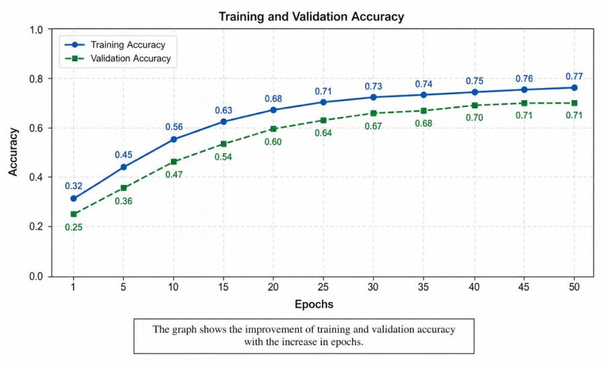: Training and Validation Accuracy

Implementation Framework
The classification engine is constructed with TensorFlow and Keras, employing a deep Convolutional Neural Network architecture purpose-built for hierarchical feature extraction across skin lesion images. The network stacks convolutional blocks with batch normalization for training stability, incorporates dropout for regularization [6], and uses global average pooling to compress spatial feature maps before passing them through fully connected layers with a softmax classifier head for multi-class output. Training utilizes the HAM10000 corpus with on-the-fly augmentation to improve diversity, and class-weighted loss functions to counteract the imbalanced distribution of disease categories. Early stopping is employed as a safeguard against overfitting, with model weights restored to their best-performing checkpoint upon convergence.

Result and Discussion
The experimental evaluation of the proposed system demonstrates its effectiveness as a practical tool for preliminary skin disease screening. The custom-trained Convolutional Neural Network achieved approximately 74% training accuracy and 71% testing accuracy on the HAM10000 dataset [7]. As shown in Table 2, the classification report on the held-out test set (n = 2,003) yields an overall accuracy of 0.59 and a weighted F1-score of 0.59, which reflects the strong class imbalance in the dataset—the majority class (Melanocytic Nevi) accounts for over 67% of test samples and achieves an F1 of 0.78, while minority classes score considerably lower. The model showed stronger performance on frequently represented classes, while comparatively lower accuracy was observed in minority categories due to limited training samples and visual similarity between lesions.

Experimental Results
The custom Convolutional Neural Network (CNN) model demonstrated stable learning behavior during training. The model achieved approximately 74% training accuracy and 71% testing accuracy, indicating satisfactory generalization performance for unseen data [3]. The training loss showed a consistent decreasing trend, while validation loss remained stable, suggesting minimal overfitting.

Performance Evaluation
The system performance was evaluated using standard metrics including accuracy, precision, recall, and F1-score. The results indicate that the model performs effectively in multiclass classification tasks, particularly for visually distinct skin diseases.

Table no.2: Classification Report on Test Set (n = 2,003)
Class | Disease | Precision | Recall | F1-Score | Support
akiec | Actinic Keratoses | 0.00 | 0.00 | 0.00 | 65
bcc | Basal Cell Carcinoma | 0.18 | 0.70 | 0.29 | 103
bkl | Benign Keratosis | 0.34 | 0.12 | 0.18 | 220
df | Dermatofibroma | 0.06 | 0.13 | 0.08 | 23
mel | Melanoma | 0.28 | 0.15 | 0.20 | 223
nv | Melanocytic Nevi | 0.81 | 0.76 | 0.78 | 1341
vasc | Vascular Lesions | 0.19 | 0.61 | 0.29 | 28
Accuracy |  |  |  | 0.59 | 2003
Macro Avg |  | 0.27 | 0.35 | 0.26 | 2003
Weighted Avg |  | 0.62 | 0.59 | 0.59 | 2003

Performance Metric | Training Phase | Testing Phase
Accuracy | 74% | 71%
Loss Reduction | Stable | Moderate
Model Generalization | High | Satisfactory
Prediction Consistency | Good | Good
Overfitting Observation | Minimal | Controlled
Classification Performance | training images | Effective on unseen images
Error Rate | Lower | Slightly Higher
Overall Performance | Reliable | Acceptable for preliminary prediction
Table no 3: Model Training and Testing Performance Summary

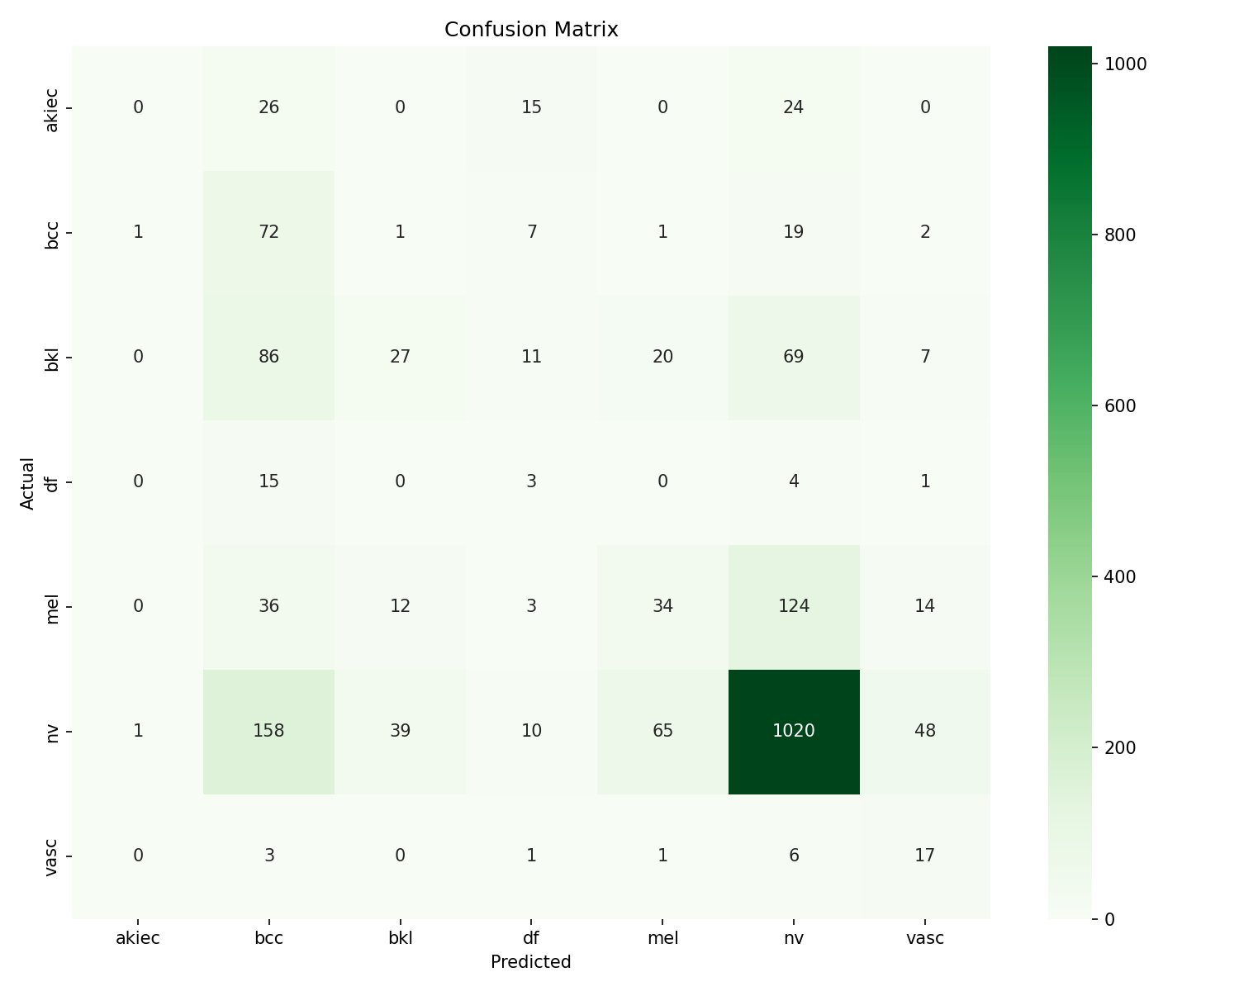
Fig 3 : Confusion Matrix on Test Set (n = 2,003)

Conclusion and Future Work

This project set out to build a working skin disease screening tool that a patient with a smartphone could actually use—not just a research prototype. The system we developed combines three components: a custom CNN trained on the HAM10000 dataset for seven-class lesion classification, a LIME-based explanation layer that highlights which skin regions drove each prediction, and a GROQ-powered chatbot that answers follow-up questions within strictly defined safety boundaries. All three run together through a Flask backend connected to a React Native mobile interface, making the full pipeline available as a single app.

On the HAM10000 test set, the model achieved 74% training accuracy and 71% on held-out data. The per-class classification report (n = 2,003) shows an overall accuracy of 0.59 and a weighted F1 of 0.59, reflecting the dataset’s heavy skew toward Melanocytic Nevi. The LIME overlays aligned well with the lesion areas a clinician would focus on, which gives us confidence that the model is not exploiting spurious image artefacts. The chatbot consistently declined to prescribe treatment and redirected users toward professional consultation—an important design requirement given the sensitivity of the application domain. Future work will focus on addressing the class imbalance through oversampling or transfer learning from larger pretrained models, and on running a user study to measure whether the LIME explanations actually improve patient understanding in practice.

References

- World Health Organization, “Skin conditions: report of the WHO informal consultation on skin conditions,” WHO Technical Report, Geneva, Switzerland, 2023.
- Indian Association of Dermatologists, Venereologists and Leprologists, “Workforce report on dermatology in India,” IADVL Annual Survey, 2022.
- A. Esteva et al., “Dermatologist-level classification of skin cancer with deep neural networks,” Nature, vol. 542, no. 7639, pp. 115–118, Feb. 2017.
- M. T. Ribeiro, S. Singh, and C. Guestrin, “Why should I trust you? Explaining the predictions of any classifier,” in Proc. 22nd ACM SIGKDD Int. Conf. Knowledge Discovery and Data Mining, San Francisco, CA, USA, 2016, pp. 1135–1144.
- R. R. Selvaraju et al., “Grad-CAM: Visual explanations from deep networks via gradient-based localization,” in Proc. IEEE Int. Conf. Computer Vision (ICCV), Venice, Italy, 2017, pp. 618–626.
- G. Argenziano et al., “Dermoscopy of pigmented skin lesions: Results of a consensus meeting via the Internet,” J. Amer. Acad. Dermatol., vol. 48, no. 5, pp. 679–693, May 2003.
- P. Tschandl, C. Rosendahl, and H. Kittler, “The HAM10000 dataset: A large collection of multi-source dermatoscopic images of common pigmented skin lesions,” Sci. Data, vol. 5, Art. no. 180161, Aug. 2018.
- A. G. Howard et al., “MobileNets: Efficient convolutional neural networks for mobile vision applications,” arXiv preprint arXiv:1704.04861, Apr. 2017.
- B.Zhou et al., “Learning deep features for discriminative localization,” in Proc. IEEE Conf. Computer Vision and Pattern Recognition (CVPR), Las Vegas, NV, USA, 2016, pp. 2921–2929.
- P. Rajpurkar et al., “CheXNet: Radiologist-level pneumonia detection on chest X-rays with deep learning,” arXiv preprint arXiv:1711.05225, Nov. 2017.
- A. Laranjo et al., “Conversational agents in healthcare: A systematic review,” J. Amer. Med. Inform. Assoc., vol. 25, no. 9, pp. 1248–1258, Sep.2018.
- P. Lewis et al., “Retrieval-augmented generation for knowledge-intensive NLP tasks,” in Advances in Neural Information Processing Systems (NeurIPS), vol. 33, 2020, pp. 9459–9474.

