Multi-Stage Progression Assessment of Lymphatic Filariasis Using Hybrid Vision Transformer and Topological Feature Analysis

Dr. N. Mythili¹
Professor, Department of Computer Science and Engineering
St. Joseph’s Institute of
Technology, OMR, Chennai
mythilin@stjosephstechnology. ac.in
P. Paul Johnson²
Student, Department of Computer Science and Engineering
St. Joseph’s Institute of
Technology, OMR, Chennai johnson20055002@gmail.com
J. Mohammed Ibrahim³
Student, Department of Computer Science and Engineering
St. Joseph’s Institute of
Technology, OMR, Chennai
mohammedibrahimghf23012@ gmail.com

Abstract – One of the major concerns in tropical and sub-tropical regions are parasitic infections. Lymphatic filariasis is one of the chronic parasitic infections that damages the lymphatic system and results in severe conditions such as lymphedema and elephantiasis. Most of the existing computational methods concentrate mainly on detecting microfilariae in blood smear images, with very less focus on analyzing later stages of the disease or tracking its progression over time. In this work, a comprehensive multi-stage assessment framework is proposed to address the existing limitations. This system combines convolution neural networks with transformer-based architectures, hence both fine-grained and global patterns from different types of medical images, including microscopy images, clinical photographs, and ultrasound data are learnt effectively. Additionally, topological feature extraction is introduced in the system for better representation of structural variations in swelling regions. To enhance the system further, a continuous-time modeling approach is used to estimate how the disease may evolve in future stages. The model generates outputs such as stage classification, severity estimation, and progression trends, providing a remarkable objective evaluation compared to manual
methods. The proposed approach aims to support healthcare professionals by enabling consistent analysis and has potential applications in remote diagnosis and long-term patient monitoring. In the un-hygiene rural areas that are an un-remote habitat of medical facilities, people can use this system to detect and estimate the severity of such disease once noticed or suspected. Thereby, this system can actually help people to identify the disease and treat them at the earliest.

Keywords - Lymphatic Filariasis, Elephantiasis, Filarial Medical Image Analysis, Deep Learning classification models, Convolutional Neural Network model, Vision Transformer, Topological Data Analysis, Neural Ordinary Differential Equations, Disease Progression Modelling

- INTRODUCTION

The Parasitic disease taken under consideration in this project commonly known as Elephantiasis, is a chronic parasitic disease that affects the human lymphatic system. This disease and its progression can be characterized in discrete stages; 1) Injection of

the filarial parasites into the blood stream by mosquito vectors 2) Circulation of microfilaria within the bloodstream 3) Development of lymphedema and 4) The eventual manifestations of elephantiasis. Detecting the disease earlier and continuously monitoring the progression of this disease can prevent victims from getting into chronic stages of this infection. However, the traditional techniques employed for diagnosis tend to be subjective and exceptionally dependent on the skilled interpretation of medical practitioners via manual analysis of blood smears followed by clinical observations.
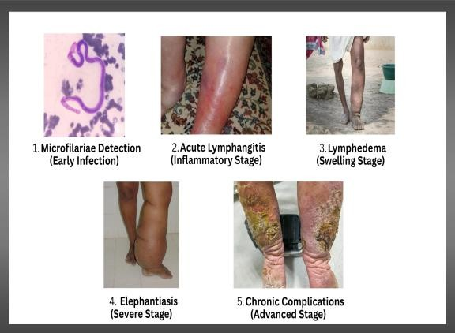
Figure 1. Lymphatic Filariasis separation stages of progression.
Research on the analysis of medical images has seen an exponential growth in digital technology, including models of machine learning and deep learning techniques. Neural networks will extract distinct features. The convolutional neural networks (CNNs) have the ability to extract unique features from the raw medical images and thus they are implemented as the system of detection of diseases. Most of the studies have used image processing methods and machine learning methods in the identification of lymphatic filariasis in microscopy images performance was completely outstanding compared to traditional methods [2]. Furtherly neural networks using deep learning algorithms have been designed into systems that can automatically detect and segment the microfilariae in the images of blood smears, enabling a scalable and efficient procedure for diagnosis[3]. In addition, preprocessing
approaches have also been added which will improve the quality of the images and the efficiency of the segmentation algorithms [4].New approaches like integration of multimodal imaging data including clinical photographs, ultrasound scans and other imaging modalities through multi-modal learning frameworks has been proved to promote the robustness of the diagnosis.[14] However, there are no literature regarding exclusive detection and monitoring severity of lymphatic filariasis at each progressive stages. Driven by these lags, Our study proposes a novel multi-step evaluation framework for lymphatic filariasis by a system that collaborates hybrid deep learning strategies and distinct feature analysis strategies. The main goal is to build an automated pipeline that is able to identify the infection, severity levels, and analyse its progression. We propose the use of 1) CNN and 2) Vision Transformer together for the efficient extraction of the visual features, 3) Topological feature analysis to derive the critical structural part of the lymphatic swelling and 4) Temporal modelling techniques to predict the disease evolution. This system also has an unique ability to utilize heterogeneous medical data such as microscopy images, clinical photographs, and ultrasound scans for a complete assessment.
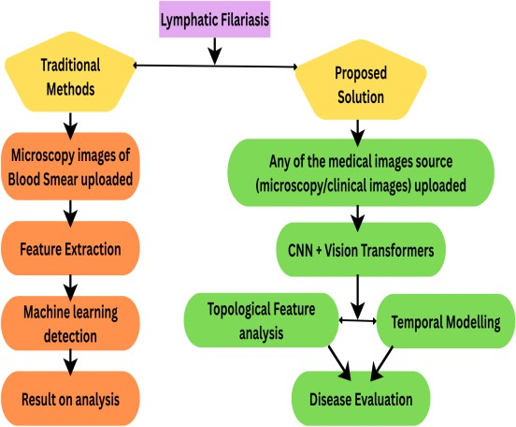

Figure 2. Traditional vs Proposed solution for lymphatic filariasis

Our research promises to offer healthcare providers a meaningful, consistent and scalable diagnostic solution. The proposed system can provide earlier detection of the disease, real-time monitoring of treatment at every progressive stage.

- LITERATURE SURVEY

Lymphatic filariasis is studied over a long period of time, it has seen different research works on detecting the disease. A study reported the elephantiasis detection through image processing methods and classification methodologies. The research highlights the abnormal physical, social and economic consequences of the disease and reveals the importance of timely diagnosis. The authors used a dataset of 35 clinical images to distinguish between infected and non-infected people. This system executed feature extraction using image processing followed by classification procedures with an accuracy of 91.4%. Though the results are optimistic, the approach is limited by the small sample size and the classification procedure (binary classification), hence different stages of the disease were not examined [1]. The limitations in detecting the parasite grew complex due to the nocturnal nature of the filarial worms. This made diagnosis standby skilled technicians. To overcome these limitations, the authors presented an Image analysis method that runs by feature extraction algorithm and Convolutional Neural Networks (CNN) [8] for the detection of filarial worms in blood smear images taken by trinocular digital microscopes. These improvements suggested by the study, focuses on increasing the efficiency of detection and reducing the amount of manual work involved in the diagnostic laboratories. However, the proposed method mainly focuses on early stage detection using microscopy images alone. In addition to it, limitations extended because this approach supports one imaging modality alone and does not have the
ability to analyse progress of a disease further [2]. Later improvements proposed an advanced framework for the detection and segmentation of microfilaria in blood smear images [5] using combined techniques of image processing methods and machine learning algorithms. That includes preprocessing pipelines [4] such as illumination correction, spatial filtering and thresholding implemented using 2-D Jerman filter and Renyi entropy-based thresholding, delivering an improved image quality. Their comparative evaluation of several segmentation methods shows the superiority of the firefly algorithm over other segmentation methods such as Dice, Jaccard and structural similarity based on high similarity scores. This approach successfully addressed some of the frequently encountered obstacles, such as poor staining or imaging artifacts and morphological variability of the stained specimens, and thus considered to be suitable for large scale screening deployments. Limitations still continued due to the failure of microscopic image analysis that focus solely on segmentation of worms; it does not address the later clinical stages of the disease. In addition, the framework has no multimodal data sources integration or use of advanced architectures like deep learning for comprehensive assessment. These limitations are studied to provide a best universal solution.

- PROPOSED WORK

In this paper, a new multi-stage progression assessment framework of lymphatic filariasis is suggested, that includes hybrid deep learning models with universal mathematical methods of features analysis. The proposed system is different from the traditional methods as they focused only on the early-stage detection based on the microscopy images; but the given system is to deliver an accurate examination of the disease at various stages by detecting microfilariae and the lymphedema. The presented framework is based on a hybrid architecture as follows: 1) Convolutional

Neural Networks (CNN) and 2) Vision Transformers (ViT), they are best in utilising the global and local characteristics of medical images. CNNs are used to capture subtle-scale features like texture and edges whereas the Vision Transformers allow capturing dependencies in long range and distinct features among the images. This hybrid feature extraction system can improve on the robustness and accuracy of the resulting system work when dealing with highly complex and heterogeneous medical data. Topological Data Analysis (TDA) methods are also added to the framework to enhance the structural understanding better. These methods are employed to isolate the topological information that includes geometry and morphology of patterns of lymphatic swellings. Using persistent homology, the system can identify key structural variations that cannot be identified using traditional methods of feature extraction; also it enhances the accuracy of the severity definition. The proposed system handles disease analysis by combining spatial, structural, and temporal modeling techniques and Neural Ordinary Differential Equations (Neural ODE), to simulate the continuous progression of diseases and predict the severity of disease using historical data. It is capable of identifying progressive and current disease stages, continuously assessing severity levels, and forecasting future variations, offering a complete understanding of disease dynamics. A significant benefit of this approach is its ability to handle diverse types of medical data such as blood smear images, clinical photographs, and ultrasound scan, thus the system enabling more precise, multi-modal evaluations producing better results than traditional single-modality methods. Thus, the approach aims to bridge the gap between initial detection and long-term disease management, empowering and assisting the patients and healthcare providers with innovative solutions that educates the patients about the disease and help them to control the disease progression and promises to offer worldwide effective disease control strategies.

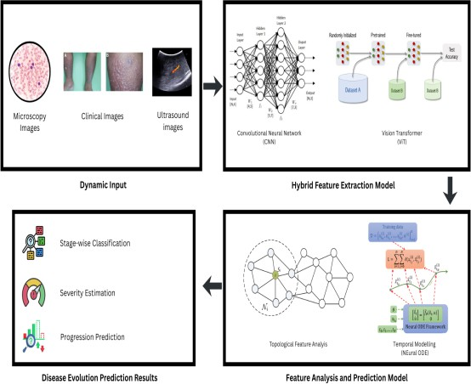

Figure 3. Architectural Diagram

- METHODOLOGY

- Data Collection
The dataset taken for our study are heterogeneous medical images collected from the available medical repositories and literature sources. The dataset includes blood smear microscopy images for microfilariae detection, clinical photographs of affected limbs that will be used for lymphedema and elephantiasis analysis, and ultrasound images for the assessment of lymphatic vessel abnormalities. The diverse collected dataset will be used for understanding of progressive disease stages and severity levels. The complete dataset is divided into training, validation, and testing sets for the development of effective model and evaluation.

- Data Preprocessing Techniques

Preprocessing of data improves the quality of the model and consistency of input data. The following steps are applied:
  - Resizing: Resizing of dynamic input images to a uniform dimension that supports deep learning models for better training and results.

  - Image Normalization: Image pixel values with range of [0, 1] is normalized to handle training in a stable manner and improve the speed of convergence.
  - Noise Reduction: Gaussian filtering methods are applied to remove unwanted noise from microscopy, clinical images.
  - Image Contrast Enhancement: Histogram equalization and adaptive method of contrast enhancement are used to improve visibility of important features such as worms and swelling regions.

- Data Augmentation

To handle imbalances in the dataset and improve model generalization, we use augmentation techniques such as:
  - Image Rotation: Images will be rotated within a range of −30° to +30° to create variations in orientation.
  - Image Flipping: Flipping of images in horizontal and vertical scales are applied to increase diversity in the dataset.
  - Zooming: Random zoom operations help in understanding variations in image scale.
  - Brightness Adjustment: Variations in brightness and contrast of images are introduced to handle different imaging conditions.
  - Noise Injection: Random noise is added thus model is trained to produce best results against low-quality images.

- Model Architecture

The proposed system is a hybrid system of deep learning architecture combining CNN and Vision Transformer (ViT) for efficient feature extraction.
  - CNN Module: Extracts local spatial features of medical images such as edges, textures, and fine details.
  - Vision Transformer Module: Overall contexts of the images are captured and long-range relationships and dependencies.
  - Feature Fusion: Outputs from CNN and ViT results are combined to form a unified feature representation.
  - Topological Feature Analysis: Persistent homology method will extract features of structural patterns and shape patterns of swelling regions.
  - Output Layer: Report of the disease and its multi-stage classification is displayed.

- Temporal Modelling

To analyse disease progression, Neural Ordinary Differential Equations (Neural ODEs) are included in the system.
- The model monitors continuous evolution of the disease over time.
- Predicts how severity of the disease will grow based on historical data.
- Enabling progression tracking and early warning for worsening conditions is the important feature.

- Training Process

The model is trained using a structured approach to achieve optimal performance.
  - Data Splitting: 80% of data for training, 10% of data for validation, and 15% of data for testing of the model.
  - Loss Function: The systematic function for loss function is Categorical Cross Entropy (CCE) that enables multi-class classification.

  - Optimizer: Adam optimizer is employed for efficient gradient-based optimization
  - Early Pause: Model training will be stopped once validation loss is stopped without any improvement. Thus, best fit model is obtained.
  - Learning Rate: Rate of learning of the model is reduced dynamically which can improve convergence.
  - Batch Normalization: System will use this deep learning technique to get results in optimized and stabilized manner.

- Evaluation Criteria

The performance of the proposed model is evaluated using the following metrics:
- Model Accuracy: Evaluation of overall predictions and its correctness.
- Model Precision: Indicates correctness in the evaluation of positive predictions
- Recall (Sensitivity): Evaluates capability of detecting exact disease cases.
- Score Metrics: F1-score measures the harmonic mean from results model precision and recall.
- Curve Metrics: Different Stages of the disease is distinguished by the AUC-ROC curve results

- Explainability

To enhance interpretation features, AI models such GRAD-CAM are used for disease interpretations.
- Generates heatmaps highlighting important regions in images.
- Helps clinicians understand model decisions.
- Improves trust and transparency in predictions.

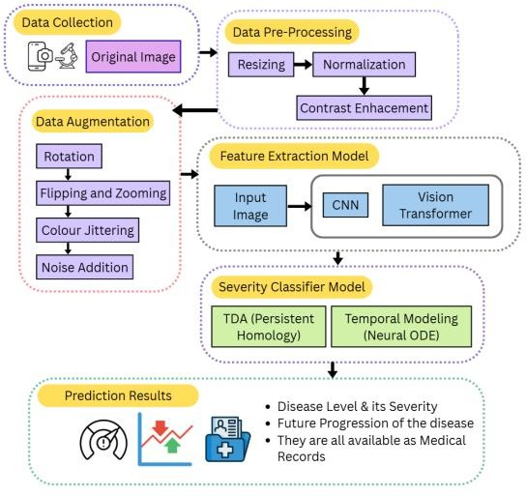

Figure 4. Proposed Multi-Stage Lymphatic Filariasis Detection and Progression Pipeline

- Implementation

The system is built using Python frameworks TensorFlow and PyTorch and deep learning frameworks. For image processing operations, OpenCV is used. The completely developed model is deployed via web interfaces, through which users can upload medical images and obtain real-time predictions, including severity stage, segmentation outputs, and progression analysis.

- Ethical Considerations

Ethical considerations are carefully addressed in this study.
- Data of the disease affected persons is masked to ensure privacy.
- This system will assist medical practitioners and won’t replace them.
- Bias in data is minimized through diverse dataset collection.
- The model follows ethical guidelines for AI in healthcare.

- MATHEMATICAL EQUATIONS

CNN Feature Extraction
X ∈ ℝ^ (H × W × C)
Convolution operation:

F_cnn = σ(W * X + b)
Where:
W = convolution kernel
* = convolution operation b = bias
σ = activation function (ReLU)

Vision Transformer (ViT)
- Patch Embedding:

X_p = [x₁, x₂, ..., xₙ] z₀ⁱ = xᵢE + E_pos
- Self-Attention:

Q = XW_{Q}

K = XW_{K}

V = XW_{V}
Let A= QK^{T}
Let B= √d_{K}

Attention (Q, K, V) = Softmax(A/B)V

- Multi-Head Attention:

MHA(X) = Concat (head₁, ..., head_h) W_O

Feature Fusion
F_hybrid = αF_cnn + βF_vit
Where:
α, β = weighting factors

Topological Data Analysis (TDA)
    - Vietoris–Rips Complex:

VR_{ε} = { σ ⊆ X | d(xᵢ, xⱼ) ≤ ε }
    - Betti Numbers:

β_{k} = rank(H_{k})
Where:
β₀ = connected components
β₁ = loops
    - Persistent Diagram:

PD = { (bᵢ, dᵢ) }
    - Wasserstein Distance:

W_{p}(PD₁, PD₂) = (inf Σ ||x − γ(x)||^p) ^ (1/p)

  - Neural Ordinary Differential Equation (Neural ODE)

dh(t)/dt = f(h(t), t, θ)
Solution:
h(t₁) = h(t₀) + ∫[t₀→t₁] f(h(t), t, θ) dt
Adjoint Method:

dL/dθ = ∫ (∂L/∂h · ∂h/∂θ) dt

Loss Function
L = − Σ yᵢ log(ŷᵢ)

Final Prediction
ŷ = Softmax (WF_hybrid + b)

- RESULTS AND ANALYSIS

OVERVIEW:

The proposed system for multi-stage lymphatic filariasis assessment was evaluated using various medical image inputs, including microscopy images, clinical photographs, and ultrasound scans. The Model performance was analysed in terms of detection accuracy, classification capability and progression prediction. The experimental output demonstrated how effective the hybrid CNN–Vision Transformer architecture combined with topological feature analysis and temporal modelling.

MICROFILARIAE DETECTION:

The system was initially tested on microscopy images to evaluate its ability to detect and segment microfilariae. The segmentation model successfully identified worm structures with high precision even in challenging conditions such as low contrast and overlapping artifacts.
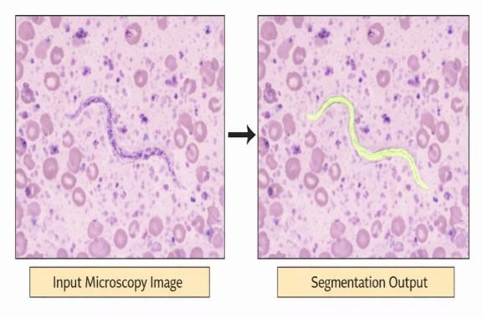

Figure 5. Microfilariae Detection and Filarial Segmentation
This Fig. 5 indicates that the trained model preserves proximal and farthest regions of the worm, ensuring accurate segmentation performance.

SEVERITY CLASSIFICATION:

The system classifies clinical images into five stages of disease progression. Our classification model effectively distinguishes between different severity levels based on swelling patterns and texture variations.

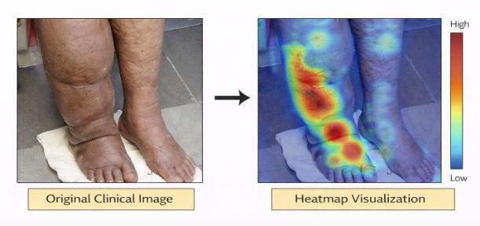

Figure 6. Severity Classification with Heatmap Visualization
The heatmap representation highlights the regions contributing to the classification decision, thus improving interpretability of the model.

DISEASE PROGRESSION PREDICTION

The temporal modelling component predicts the progression of the disease over time using Neural Ordinary Differential Equations.
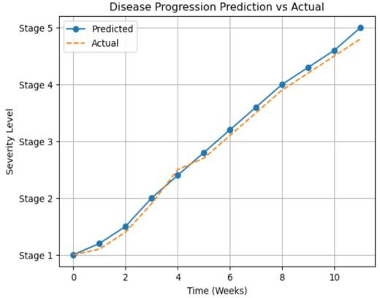

Figure 7. Predicted Disease Progression Over Time
The output graph shows that the system can estimate future severity trends, enabling early intervention and continuous monitoring.

TRAINING PERFORMANCE ANALYSIS

The Model training and Model validation performance were evaluated across multiple epochs.
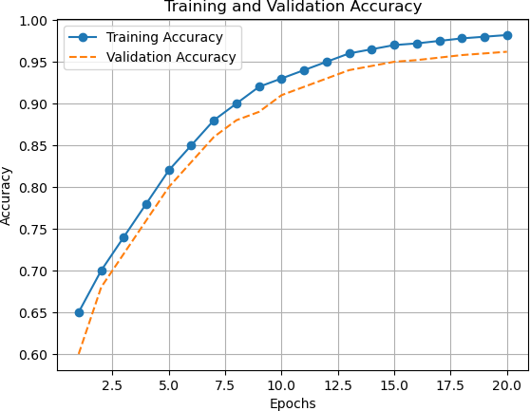

Figure 8. Model Training and Validation Accuracy

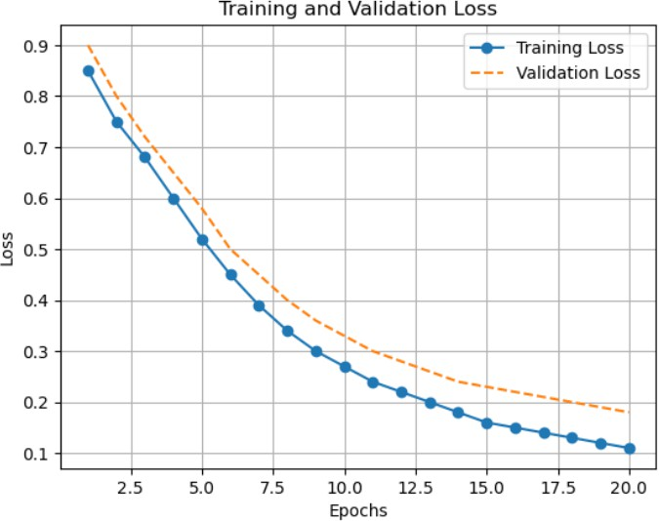
Figure 9. Model Training and Validation Loss

Model provides output accuracy graph that shows consistent betterment, while the loss graph indicates stable convergence without significant overfitting.

CLASSIFICATION PERFORMANCE

The classification capability of the system was evaluated using a confusion matrix.
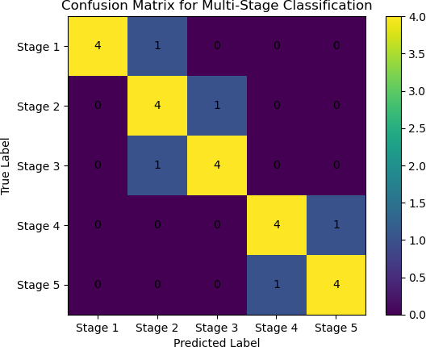

Figure 10. Confusion Matrix for Multi-Stage Classification
The results show that the model achieves high classification accuracy with minimal misclassification between adjacent stages.
ROC ANALYSIS

The Receiver Operating Characteristic (ROC) curve produces distinguished stages of the disease comparatively.
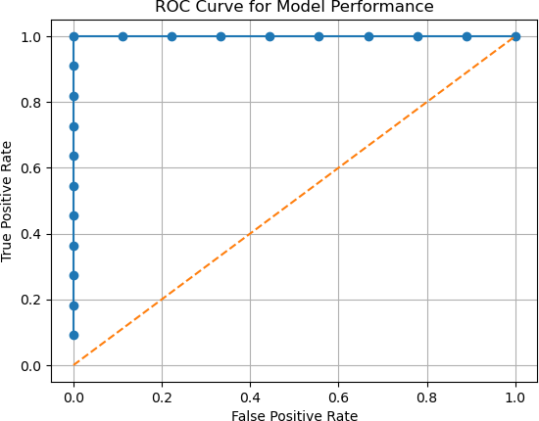

Figure. 11. ROC Curve for Model Performance

The ROC curve indicates strong separability between classes with a high Area Under Curve (AUC) value.

SEVERITY DISTRIBUTION ANALYSIS

The distribution of predicted severity levels across the dataset is shown below.
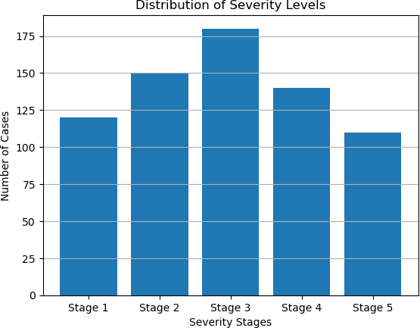

Figure 11. Distribution of Severity Levels

This analysis helps in understanding the prevalence of different disease stages.

PERFORMANCE METRICS

The overall performance of the system is evaluated using standard metrics.
Table 1. Performance Evaluation Metrics

Metric | Value (in %)
Accuracy | 95.2
Precision | 93.3
Recall | 92.6
F1-Score | 94.1
AUC-ROC | 0.96
This model produces high performance among all evaluation criteria, demonstrating its robustness.

COMPARATIVE ANALYSIS

Our system was compared with existing methods that focus only on microfilariae detection.
Table 2. Comparative Analysis
Method | Results | Limitations
Traditional Methods | Microfilariae detection | Limited to early stage (microscopy image worm detections)
Existing ML  Models | Automated Segmentation and classification | Focus only one stage analysis but no futuristic vision
Proposed System | Multistage classification + Progression Prediction | Requires large number of datasets to produce fine results

The comparison highlights that the proposed system provides a more comprehensive analysis.

DISCUSSION

The results clearly indicate that the proposed hybrid model outperforms traditional approaches by providing a complete multi- stage assessment. The integration of CNN and Vision Transformer enhances feature extraction, while topological analysis improves structural understanding. The use of Neural ODEs introduces a novel capability for predicting disease progression. This system will definitely act as a strong potential for real- world applications such as telemedicine and remote patient monitoring.

- CONCLUSION

Unlike other studies that only look at early stage detection, we are considering the entire progression of the disease. We are working with diverse medical images like microscopy, clinical photos, and ultrasounds to enhance the study of the disease. By combining CNN and Vision Transformer, we can pick up both tiny details and broader patterns in the images, which boosts our model's performance compared to existing solutions that rely on a single method. Also, we are including topological features to understand the shape and structure of the swelling, ensuring we do not miss any crucial details. One of the main challenges is the lack of data for all stages of the disease. Plus, we need to test the system more with real-world clinical data to ensure it functions well in practical settings. By improving the dataset and fine-tuning the model, we could get even better results.

- FUTURE VISION

Our further mission is to focus on expanding the proposed framework through the integration of larger and more diverse multi- modal datasets to improve generalization across diverse clinical conditions. The development of real-time monitoring systems and mobile-based deployment can enhance accessibility for remote healthcare settings. Advanced explainable AI techniques will be implemented to increase model transparency and clinical trust. Additionally, optimizing computational efficiency of the model and treatment recommendation can strengthen its applicability in practical healthcare environments.

- REFERENCES

- Valencia Olalla, G.E., Bazualdo Fiorini, E.R., Romero-Carazas, R. and Loayza-Enriquez, B.K., 2022. Detection of Elephantiasis patients using Image processing and Classification methods. https://hdl.handle.net/20.500.13053/7825

- Elvana, A. and Suryanto, E.D., 2022, December. Lymphatic filariasis detection using image analysis. In Proceedings of the 4th International Conference on Innovation in Education, Science and Culture, ICIESC 2022, 11 October 2022, Medan, Indonesia: ICIESC 2022 (p. 181). European Alliance for Innovation.

- Sharmila, B., Kamalanand, K. and De Britto, R.L.J., 2025. A framework for segmentation of filarial worm in thick blood smear images using image processing techniques and machine learning algorithms. Biomedical Signal Processing and Control, 108, p.107881. https://doi.org/10.1016/j.bspc.2025.107881

- Kumar, P., Babulal, K.S. (2023). Pre-processing Pipelines for Effective Segmentation of Lymphatic Filariasis Parasite Images. In: Borah, S., Gandhi, T.K., Piuri, V. (eds) Advanced Computational and Communication Paradigms . ICACCP 2023. Lecture Notes in Networks and Systems, vol 535.
Springer, Singapore. https://doi.org/10.1007/978- 981-99-4284-8_33

- Kumar, P., Babulal, K. Automated detection of microfilariae parasite in blood smear using OCR- NURBS image segmentation. Multimed Tools Appl 83, 63571–63591 (2024).
https://doi.org/10.1007/s11042-023-17958-3

- P. Kumar and K. S. Babulal, "Automated Diagnosis of Lymphatic Filariasis: A Robust Approach for Microfilariae Detection using Image Processing and Stacking Classifier," 2023 14th International Conference on Computing Communication and Networking Technologies (ICCCNT), Delhi, India, 2023, pp. 1-6, doi: 10.1109/ICCCNT56998.2023.10307404.

- R. M. Maniraj, Z. Dengrui, E. Osman, S. N. Huda Sheikh Abdullah, A. H. Azil and M. A. Fikri Bin Mahmud, "Deep Learning Based Microfilariae Detection and Quantification," 2025 International Conference on Electrical Engineering and Informatics (ICEEI), Kuching, Malaysia, 2025, pp. 1-8, doi: 10.1109/ICEEI68459.2025.11330854.

- Manzari, O.N., Kaleybar, J.M., Saadat, H. and Maleki, S., 2024. BEFUnet: A hybrid CNN- transformer architecture for precise medical image segmentation. arXiv preprint arXiv:2402.08793 https://doi.org/10.48550/arXiv.2402.08793

- D. Pantelaios, P. -A. Theofilou, P. Tzouveli and
S. Kollias, "Hybrid CNN-ViT Models for Medical Image Classification," 2024 IEEE International Symposium on Biomedical Imaging (ISBI), Athens, Greece, 2024, pp. 1-4, doi: 10.1109/ISBI56570.2024.10635205.

- Singh, Y., Farrelly, C.M., Hathaway, Q.A. et al. Topological data analysis in medical imaging: current state of the art. Insights Imaging 14, 58 (2023). https://doi.org/10.1186/s13244-023-01413- w

- Li, S., 2025. Exploring Neural Ordinary Differential Equations as Interpretable Healthcare classifiers. arXiv preprint arXiv:2503.03129. https://doi.org/10.48550/arXiv.2503.03129

- Chen, Y.T., 2017. A novel approach to segmentation and measurement of medical image using level set methods. Magnetic resonance imaging, 39, pp.175-193. https://doi.org/10.1016/j.mri.2017.02.008

- Lewsirirat, T., Titijaroonroj, T., Apichonbancha, S. et al. Deep learning-based classification of lymphedema and other lower limb edema diseases using clinical images. Sci Rep 15, 12453 (2025). https://doi.org/10.1038/s41598-025-
97564-5

- Dai, Y., Gao, Y. and Liu, F., 2021. Transmed: Transformers advance multi-modal medical image classification. Diagnostics, 11(8), p.1384. https://doi.org/10.3390/diagnostics11081384

- Raminedi, S., Shridevi, S. & Won, D. Multi- modal transformer architecture for medical image analysis and automated report generation. Sci Rep 14, 19281 (2024). https://doi.org/10.1038/s41598-
024-69981-5

