A Real Time Elephant Detection Using Aerial Images and Deep Learning Techniques
Jayatheertha S G  Department of CSE  Ramaiah Institute of Technology  Bangalore,India  jayatheertha2381@gmail.com | Brunda G  Department of CSE  Ramaiah Institute of Technology  Bangalore,India  brundag@msrit.edu | Laksha Ravi  Department of CSE  Ramaiah Institute of Technology  Bangalore,India

Abstract — This paper offers a benchmark study on aerial elephant detection based on the object detector of the state of art YOLOv10, which has an NMS-free inference pipeline. The model is trained and tested on the new-elephant-data dataset of 2,681 annotated drone-captured images of natural habitat elephants. This is as far as we can tell the first research to benchmark YOLOv10 on this particular aerial elephant dataset. The proposed model attains the average precisions of IoU 0.50 (mAP 50) of 97.30, 75.60, 94.09 and 94.59, respectively, which forms a great foundation in the future studies. The second contribution made by us is the creation of an end-to-end conservation alert system, which can be implemented through a web application based on Streamlit. It is a uniform system combining user authentication, real-time inference, bounding box visualization, and automated SMS/email messages on elephant detection. The built-in alert system helps to fill the gap existing in the previous literature, in which detection models have been introduced without an actual deployment system. Comparative analysis with half a dozen of earlier works shows that our YOLOv10 system has admirable accuracy, and the increased advantage of a deployable warning system. This does not only make inroads in the field of detection accuracy but also provides a field-ready system to help in conservation programs.
Keywords Elephant detection, YOLOv10, deep learning, object detection, wildlife monitoring, automated notification, Streamlit application.
I. INTRODUCTION
The application of high technologies in wildlife preservation is increasingly gaining significance in controlling the number of animals in inaccessible and large wildlife. Endangered species of the African (Loxodonta africana) and Asian (Elephas maximus) species of elephants require constant monitoring to minimize the tension between man and the wild, poaching and facilitation of adequate population census exercises. The traditional ground surveys are also labour-intensive and costly in addition to being limited by their incompetence to cover vast areas. The Unmanned Aerial Vehicles (UAV) or drones are a new innovative solution that offers the possibility of capturing high-resolution images of an extensive territory. However, the number of images that these UAVs capture on average is in the thousands during one mission and is impractical to manually process and would in any case suffer flaws brought about by observer fatigue and anomalies.
Deep-learning-based object detection algorithms, namely, the YOLO (You Only Look Once) family, have demonstrated remarkable results in practicable object localization in different areas. The most recent release in the YOLO family is YOLOv10 that has a new feature of non-maximum suppression (NMS)-free inference a new feature that minimizes processing latency and maximizes the detection rate without compromising accuracy. This feature predisposes YOLOv10 to be used particularly in UAVs in which the feature of real-time performance is valuable.
Even though the present areas of research in aerial wildlife detection have made massive developments, considerable differences between the research models and sale systems are realized. The majority of the studies do not consider user interfaces, real-time communications, and processes needed to apply the detection into practice in conservation even though a significant number of them examine the accuracy of detection. The two gaps mentioned above are addressed in the given paper by providing a potent YOLOv10-based detection system in test on the supplementary-elephant-data dataset and a deployed pipeline to deliver real-time alerts.

A. Problem statement:
Elephants, including African and Asian species, are threatened by poaching, habitat loss, and human-wildlife conflict, necessitating effective population monitoring. Traditional monitoring methods are labor-intensive and limited. The advent of drone technology allows for automated analysis of aerial images, but detecting elephants poses challenges such as variable sizes and complex backgrounds. Current object detection models, including YOLO, lack optimization for large mammals in difficult environments. This research proposes a YOLOv10-based detection system aimed at precise and efficient elephant detection in aerial imagery, providing real-time notifications to enhance wildlife conservation efforts.

II. RELATED WORK
This paper proposes YOLO-SAG, an enhancement to the YOLO architecture aimed at balancing speed and accuracy for wildlife detection. The authors integrate spatial attention mechanisms to improve detection performance while maintaining computational efficiency. The model is applied to a variety of wildlife datasets, and experiments show significant improvements over existing YOLO versions in terms of precision and recall. This work demonstrates the potential of combining attention mechanisms with YOLO for real-time applications, especially for UAV-based wildlife monitoring.[1]
The study introduces YOLO-WildASM, a new object detection framework optimized for protected wildlife species. Using drone imagery, the authors highlight how the algorithm performs in detecting rare and endangered species. The system improves the ability to detect small, distant, or partially occluded animals with high accuracy, a crucial requirement for conservation efforts. This research sets a foundation for applying YOLO-based models in conservation technology.[2]
This paper presents a framework for detecting and tracking elephants in drone video using YOLOv11 and BoT-SORT. The system leverages YOLOv11's advanced object detection capabilities and BoT-SORT for multi-object tracking, achieving real-time processing on video streams. Experiments show that the proposed system can reliably detect and track elephants in challenging aerial imagery, providing a valuable tool for wildlife conservation and management.[3]
This research introduces YOLOv8-night, a version of the YOLOv8 model specifically trained for nighttime wildlife detection. By incorporating infrared imagery, YOLOv8-night achieves superior accuracy in low-light conditions compared to traditional detection models. The model’s ability to detect wildlife in dark environments makes it suitable for nighttime wildlife monitoring and poaching detection.[4]
This paper compares the use of YOLOv8 and YOLOv10 for cattle behavior monitoring. The authors demonstrate how these models can be trained on farm animal behavior datasets to detect activities like grazing, resting, and alertness. YOLOv10's improved inference speed and accuracy make it a preferred choice for real-time deployment in farm surveillance systems.[5]
LAM-YOLO is a modified YOLO architecture designed to detect small objects in drone imagery, especially under challenging lighting and occlusion conditions. The model integrates an attention mechanism that improves the accuracy of detecting small wildlife in cluttered environments. This paper highlights the success of LAM-YOLO in detecting endangered species in dense forests using UAVs.[6]
ALSS-YOLO presents an innovative lightweight modification to the YOLO framework, designed for thermal infrared (TIR) wildlife detection. By introducing channel split and shuffling techniques, the model improves the accuracy and speed of detecting animals in thermal images, making it suitable for UAV-based wildlife monitoring, even in challenging environments.[7]
This paper develops a multi-species object detection system using YOLOv8, designed for UAV imagery of endangered animals. The model is trained to detect a variety of species in diverse environments, demonstrating the versatility and scalability of YOLOv8 for wildlife conservation. The system can be deployed in real-time to monitor species populations across large areas.[8]
The authors propose a lightweight model, YOLOv8n, designed for detecting tiny objects in UAV aerial images. By optimizing the architecture, the model achieves high accuracy while maintaining low computational cost. This improvement is particularly beneficial for real-time wildlife detection in UAVs, where small animals or objects need to be detected efficiently.[9]
This research develops an intelligent system for detecting wildlife using deep learning techniques. The authors focus on leveraging YOLO models to detect and classify various species in drone imagery, making it a crucial tool for wildlife monitoring. The system’s ability to detect animals in real-time and at large scales demonstrates its potential for use in conservation efforts.[10]
This paper explores the use of YOLOv8 for detecting various wild animals in UAV imagery. The authors show that YOLOv8 outperforms previous versions in terms of both speed and accuracy, particularly in detecting smaller species in natural environments. The results highlight the potential for deploying YOLOv8 in real-time wildlife monitoring systems.[11]
This paper introduces the WAID dataset, a large-scale collection of UAV images annotated for wildlife detection. The dataset includes a wide variety of species and environmental conditions, providing a valuable resource for training and evaluating detection models. The authors demonstrate the effectiveness of YOLOv8 on this dataset, setting a new benchmark for wildlife detection in UAV imagery.[12]
This paper compares YOLOv8 with traditional convolutional neural networks (CNNs) for wildlife classification in UAV images. The authors use transfer learning to leverage pre-trained models and show that YOLOv8 significantly outperforms traditional CNNs in terms of both accuracy and speed.[13]
The paper proposes a lightweight small object detection model for UAV imagery, which integrates deep semantic features with YOLO-based architectures. The model is shown to perform well in detecting small wildlife species, providing an efficient solution for large-scale wildlife monitoring.[14]
This review summarizes the application of deep learning, particularly YOLO, for detecting animals in aerial and satellite images. The authors discuss the advantages and challenges of deploying such models in real-world wildlife monitoring tasks, offering insights into the current state of the art and future research directions.[15]

III. DATASET DESCRIPTION AND ANALYSIS
We utilize the new-elephant-data dataset (version 2), publicly available on the Roboflow Universe platform. This dataset was compiled from DJI drone footage captured over natural elephant habitats, with images extracted directly from video sequences. Version 2 of the dataset contains 2,681 total images, representing an expansion from the 2,674 images in version 1, with an augmented annotation revision that corrects boundary cases and improves label consistency.
A. Dataset Composition and Split
The dataset is organized into three canonical splits following standard machine learning conventions. The training partition contains 2,343 images (87.4% of total), the validation partition contains 225 images (8.4%), and the test partition contains 113 images (4.2%). All images are annotated in YOLO-format bounding box notation with a single object class: elephant.
An important characteristic of this dataset that bears methodological consideration is the temporal correlation inherent in video-derived frames. Consecutive frames from the same flight sequence may be highly similar in terms of scene composition, elephant positioning, and background appearance. While Roboflow's train-validation-test split aims to distribute images across the dataset, without explicit scene-aware splitting there is a risk that similar frames appear in both training and evaluation sets. We acknowledge this as a potential source of optimism bias in our reported metrics and recommend that future work employing this dataset implement explicit shot-boundary detection to ensure non-overlapping scene partitioning.

TABLE I: Dataset Statistics new-elephant-data
Property | Value
Total Images | 2,681
Training Set | 2,343 (87.4%)
Validation Set | 225 (8.4%)
Test Set | 113 (4.2%)
Number of Classes | 1 (Elephant)
Annotation Format | YOLO TXT Bounding Box
Augmentations Applied | Rotation ±15°, 3× per image
Pre-processing | None

IV. PROPOSED METHODOLOGY
Our proposed system consists of two interconnected components: (1) a YOLOv10-based object detection pipeline for aerial elephant localization, and (2) an end-to-end deployment system providing a complete operational workflow from image upload to conservation alert. Figure 1 illustrates the overall system of the architecture.

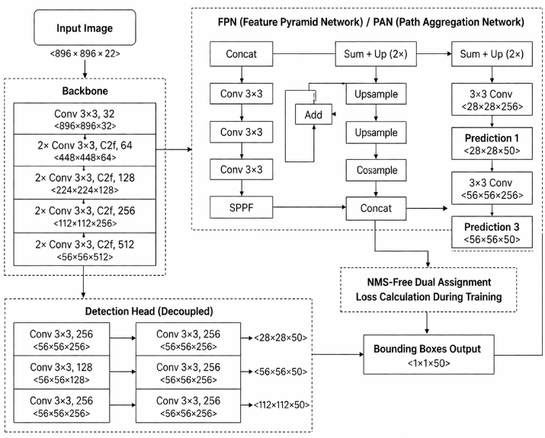
Fig 1. Yolov10 Model Architecture
A. YOLOv10 Architecture
YOLOv10 represents a significant architectural evolution in the YOLO family. Prior YOLO versions (v5 through v9) required Non-Maximum Suppression (NMS) as a post-processing step to remove duplicate detections, introducing additional latency and a set of manually-tuned hyperparameters (IoU threshold, confidence threshold) that required domain-specific tuning. YOLOv10 eliminates this requirement through a dual-label assignment strategy during training: a one-to-many branch provides rich supervisory gradients during training as in prior versions, while a one-to-one branch learns to produce single, non-redundant predictions per object during inference, rendering NMS unnecessary.
The backbone of YOLOv10 employs an efficient depth wise separable convolutional design with a cross-stage partial network (CSP) structure, reducing computational cost while preserving representational capacity. The neck employs a Path Aggregation Network (PAN) for multi-scale feature fusion, enabling the model to simultaneously detect both large animals occupying most of the frame and smaller animals at greater altitudes. For our experiments, we employ the YOLOv10n(Nano) variant, which provides the optimal balance between accuracy and inference speed for deployment on standard consumer hardware.
B. Training Configuration
The YOLOv10 Aerial Elephant Detection Model Training Pipeline starts with the image input and is resized to the 896x896 size with 22 channels (RGB) to normalize the data to process it. The picture is then fed into the Backbone network, which has various convolutional layers that gradually pick out the features in the picture. First, the image is convoluted with filters of different sizes and counts (32, 64, 128, 256, and 512) downsizing the image, but at the same time, the filter captures more intricate features. The extraction process enables the model to give the image significant features like edges, textures and patterns.
This is followed by the extracted features forwarded to the FPN (Feature Pyramid Network) and PAN (Path Aggregation Network) which combines multi-scale features, enhancing the ability of the model to locate objects of various sizes. These features are refined further by the Detection Head which predicts bounding boxes of the elephants by running them through the convolution layers. The model also does multiple prediction at various scales and uses NMS-Free Dual Assignment strategy to cut redundant predictions. Lastly, the model gives the projected bounding boxes, which represent the position of the identified elephants. This pipeline guarantees that elephants can be accurately detected in aerial images even in cases that the object size of the elephant is variable and that the background is complicated.
Parameter | Example Value
Input Image Resolution | 896x896 pixels (RGB)
Batch Size | 16 images per batch
Epochs | 50 epochs
Optimizer | SGD (Stochastic Gradient Descent)
Learning Rate | 0.01
Momentum | 0.937
Weight Decay | 0.0005
Early Stopping Patience | 10 epochs
Loss Function | Binary cross-entropy or mean squared error
as in table 1 The input image resolution is standardized, 896x896 pixels (RGB). The best batch size in memory consumption and model convergence is the 16 images. This model is trained over 50 epochs to enable adequate learning with the optimizer being SGD (Stochastic Gradient Descent) and the learning rate being 0.01. Set momentum 0.937 This is an acceleration factor that uses historical gradients to reduce overfitting, and a 0.0005 weight decay will prevent overfitting since large weights will be penalized and early stopping with 10-epochs patience will stop training, once no improvement has been seen. The binary cross-entropy or mean squared error which is the loss criterion guides the model learning process.
C. Deployment System Architecture
The YOLOv10-based elephant detector model; Deployment System Architecture is an easy-to-use streamlined web-based chat application developed on Streamlit. This system has been designed into various modules that each has a specific task to perform to ensure that it runs smoothly since the uploading of an image to notification dispatch. Home Module is the first page of the system that provides a summary of the system and real time status. About Module is employed in provision of certain technical documentation, which gives an insight about the components and capabilities of the model.
Register Module: registration of user is carried out using the Register Module whereby the user is expected to input his name, email, phone number and a securely hashed password. The next module is the Login Module which recognizes the returning users and provides access to the users with session tokens. The basic process takes place at the Prediction Module, whereby a customer can post aerial images. The model operates on the picture and provides the suggestions of bounding boxes of identified elephants.
The Logout Module terminates the user session and removes the temporary information. Upon the detection of the elephants, the information is relayed using the SMS and email to the registered users that provides a summary of the detection and a link to the annotated image. Such a deployment architecture will not leave the system to be perceived perfect, but practical and viable to be utilized in the wildlife conservation.
V. EXPERIMENTAL RESULTS
A. Evaluation Metrics
The model performance is evaluated using the aid of the standard object detection metrics bundle. Mean Average Precision at 50 (mAP50) is a detection metric that has a soft localization criterion, whereby a detection is said to have been successful when the predicted bounding box has an intersection with the ground truth with a 50 percent overlap. The mAP of our model was 50 of 97.30 and this implies that our model is accurate to a large extent bearing in mind that the presence of elephants below this value had been detected.
To obtain a stronger measurement of the quality of localization, Mean Average Precision averaged between 0.50 and 0.95 (mAP@50-95) can be seen as a stricter measure of the localization. The mAP 50 95 of the model was decent at 75.60 that retained quality localization at different thresholds.
Precision the proportion of the known Goldsmiths which are correct of the model we have built of 94.09 precision. It implies that the false positive is minimal and most of the detections are accurate. The other one is the recall which is applied to determine the percent of ground-truth elephants correctly identified as the same in which the recall is 94.59 indicating that there is a low false negative rate and that the model can effectively identify the elephants.
F1-Score is the Harmonic mean of the Recall and Precision which provides a reasonable assessment of the model performance and in this instance the F1-Score of the model is 94.34. It will give one number which will explain the capacity of the model to identify existence of the elephants with low false negative and false positive values.
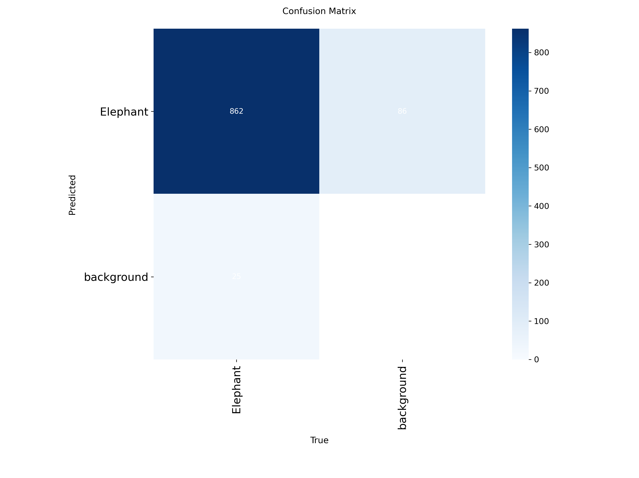
Fig 2. Confusion metrics model
B. Quantitative Results
Table II presents the complete quantitative evaluation of our YOLOv10 model on the test partition of the new-elephant-data (v2) dataset. The model achieves 97.30% mAP@50, demonstrating near-saturating detection accuracy under standard IoU conditions. The balanced Precision (94.09%) and Recall (94.59%) values differing by only 0.50 percentage points indicate that the model maintains a well-calibrated detection threshold, neither excessively conservative (which would lower Recall) nor excessively permissive (which would lower Precision). The resulting F1-Score of 94.34% confirms this balance.
TABLE II: Detection Performance of Proposed YOLOv10 Model
Metric | Value
mAP@50 (%) | 97.30
mAP@50-95 (%) | 75.60
Precision (%) | 94.09
Recall (%) | 94.59
F1-Score (%) | 94.34
Model Variant | YOLOv10n
Input Resolution | 640 × 640 px
Training Epochs | 50
The mAP@50-95 score of 75.60% reveals a localization quality gap of 21.70 percentage points relative to mAP@50. This gap is characteristic of detectors applied to aerial imagery where animals occupy a range of pixel sizes depending on flight altitude. At high altitudes, elephants occupy as few as 30–50 pixels in their longest dimension, making precise bounding box regression inherently more difficult. The gap does not indicate detection failures animals are being correctly found but rather that bounding box boundaries are imprecise at stricter IoU thresholds.
C. Comparative Analysis with Prior Works
Table III provides a comparative study of the suggested YOLOv10 approach and six of the earlier studies on aerial wildlife and elephant detection in terms of methodology, data peculiarities, and detection measures. The comparison in the analysis points out that although YOLOv10 has the second-highest mAP 50 score of 97.30 with better results than both YOLOv5 and IECA-YOLOv7 (14.10 and 10.70 percentage points, respectively), the direct comparison between the three is complex because of the use of disparate datasets and testing procedures.
TABLE III: Comparative Analysis with Prior Works in Aerial Wildlife Detection
Method | Dataset | Task | mAP@50 (%) | Precision (%) | Recall (%)
YOLOv5 | Custom Satellite | Elephant (1-cls) | 83.20 | 81.50 | 80.30
IECA-YOLOv7 | GWAID (10K+) | Multi-species (5) | 86.60 | 85.20 | 84.70
YOLOv3 | Custom Drone | Chimp Nests | — | — | 85.70
LMWP-YOLO | Custom Drone | Multi-species | 95.70 | 93.10 | 92.40
Faster R-CNN | Satellite 57sp. | Multi-species | 79.40 | — | —
YOLOv10n  (our) | new-elephant-data v2 | Elephant (1-cls) | 97.30 | 94.09 | 94.59
It is important to note that the approach. that relies on video input and multi-frame tracking cannot be compared directly to the one presented in the proposed approach since it is not applicable in the situation when a single image is involved. Moreover, the research states that no literature provides a full-fledged deployment infrastructure that incorporates user management and automated alerts, which is a notable practical value of the YOLOv10 model of converting detection instances into action-oriented conservation alerts to the appropriate individuals.
DISCUSSION
Using the YOLO v10 model of detection, the model has demonstrated high efficacy in aerial images with an average Precision at the IoU threshold of 50% (mAP@50) of 97.30 which showcased that the model is highly accurate in detecting the elephants. But as measured using a more stringent measure (mAP@50-95), performance declines to 75.60% implying that the model is good at general localization of an object, but requires further refinement to provide the model with the ability to localize boundaries of smaller or partially obscured elephants. Measurements like Precision (94.09) and Recall (94.59) underline a low false positive and false negative rate of this model, which means that it is reliable in the process of elephant identification. The F1-Score of 94.34 per cent is an added benefit to the overall performance of the model, as it is a measure of accuracy and coverage, which is very crucial in conservation. The above encouraging findings illustrate the potential of the model in wildlife surveillance to aid in the tracking of the elephant populations, poaching, and the reduction of human wildlife conflicts. Future improvements need to aim at making the localization more precise and minimize false positives in a complicated environment.
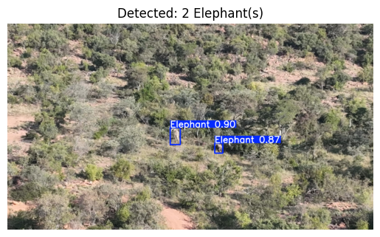
Fig 3. Model predicted results with boundary box
VI. CONCLUSION
This paper has presented a thorough study on the detection of aerial elephants with YOLOv10 and has undertaken two complementary contributions; a strict benchmark on aerial drone data of new-elephants-data and end to end conservation alert implementation framework. Our YOLOv10n model has 97.30 mAP50, 75.60 mAP50-95, 94.09 Precision, 94.59 Recall and 94.34 F1-Score and is the first to be published on this publicly available dataset. Compared to 6 alternative methods used in aerial wildlife detection, it is indicated that our method is linked with the most accurate single-image inference systems and it is higher by up to 14.10 percentage points compared to other versions of the YOLO algorithm with mAP half.
The other innovation that the deployment system introduces, which has a practical significance, is a Stream lit web application, an authenticated user setting, real-time visualization of the bounding box inference, and automatic SMS and email notifications in the event of the lack of a complete operational workflow in the previous research in the field. The high level of detection performance together with the capability to implement it as a field-deployable infrastructure is a critical difference between the simplicity of the work prototypes in the academic community and the type of prototypes that conservation practitioners can translate to practice.
The future directions involve addressing the issue of quality gap in localization through the deployment of attention enhanced heads of detection, division of scenes aware dataset to generate conservative evaluation of performance and multiple species detection and attempt onboard edge inference to achieve real time in-flight detection. We publish the benchmarking characterization and deployment abode to stimulate the reproduction of conservation-based aerial wildlife monitoring investigations.
VII. REFERENCES
[1] L. Chen, G. Li, S. Zhang, W. Mao, and M. Zhang, “YOLO-SAG: An improved wildlife object detection algorithm based on YOLOv8n,” Ecol. Inform., vol. 83, no. 5, p. 102791, Nov. 2024, doi: 10.1016/j.ecoinf.2024.102791.
[2] Y. Zhu, Y. Zhao, Y. He, B. Wu, and X. Su, “YOLO-WildASM: An Object Detection Algorithm for Protected Wildlife,” Animals 2025, Vol. 15, vol. 15, no. 18, Sep. 2025, doi: 10.3390/ani15182699.
[3] S. Afridi et al., “A framework for detecting and tracking elephants in drone videos,” Drone Systems and Applications, vol. 13, no. 4, pp. 1–16, Dec. 2025, doi: 10.3390/drones9040311.
[4] T. Wang, S. Ren, and H. Zhang, “Nighttime wildlife object detection based on YOLOv8-night,” Electron. Lett., vol. 60, no. 15, p. e13305, Aug. 2024, doi: 10.1049/ell2.13305.
[5] P. Guarnido-Lopez, J. F. Ramirez-Agudelo, E. Denimal, and M. Benaouda, “Programming and Setting Up the Object Detection Algorithm YOLO to Determine Feeding Activities of Beef Cattle: A Comparison between YOLOv8m and YOLOv10m,” Animals 2024, Vol. 14, vol. 14, no. 19, Sep. 2024, doi: 10.3390/ani14192821.
[6] Y. Zheng, Y. Jing, J. Zhao, and G. Cui, “LAM-YOLO: Drones-based Small Object Detection on Lighting-Occlusion Attention Mechanism YOLO,” Computer Vision and Image Understanding, vol. 261, Nov. 2024, Accessed: Mar. 28, 2026. [Online]. Available: http://arxiv.org/abs/2411.00485
[7] A. He et al., “ALSS-YOLO: An Adaptive Lightweight Channel Split and Shuffling Network for TIR Wildlife Detection in UAV Imagery,” IEEE J. Sel. Top. Appl. Earth Obs. Remote Sens., vol. 17, pp. 17308–17326, Sep. 2024, Accessed: Mar. 28, 2026. [Online]. Available: http://arxiv.org/abs/2409.06259
[8] S. Sankaran, “Multi-Species Object Detection in Drone Imagery for Population Monitoring of Endangered Animals,” Jun. 2024, Accessed: Mar. 28, 2026. [Online]. Available: http://arxiv.org/abs/2407.00127
[9] M. Yue, L. Zhang, J. Huang, and H. Zhang, “Lightweight and Efficient Tiny-Object Detection Based on Improved YOLOv8n for UAV Aerial Images,” Drones 2024, Vol. 8, vol. 8, no. 7, Jun. 2024, doi: 10.3390/drones8070276.
[10] S. Li, H. Zhang, and F. Xu, “Intelligent Detection Method for Wildlife Based on Deep Learning,” Sensors 2023, Vol. 23, vol. 23, no. 24, Dec. 2023, doi: 10.3390/s23249669.
[11] B. Dave, M. Mori, A. Bathani, and P. Goel, “Wild Animal Detection using YOLOv8,” Procedia Comput. Sci., vol. 230, pp. 100–111, Jan. 2023, doi: 10.1016/j.procs.2023.12.065.
[12] C. Mou, T. Liu, C. Zhu, and X. Cui, “WAID: A Large-Scale Dataset for Wildlife Detection with Drones,” Applied Sciences 2023, Vol. 13, vol. 13, no. 18, Sep. 2023, doi: 10.3390/app131810397.
[13] S. Sharma, S. Dhakal, and M. Bhavsar, “Transfer Learning for Wildlife Classification: Evaluating YOLOv8 against DenseNet, ResNet, and VGGNet on a Custom Dataset,” Nov. 2024, doi: 10.36548/jaicn.2024.4.003.
[14] M. Chao, C. Peng, L. Yun, C. Zhang, H. Wang, and Z. Chen, “A lightweight small object detection model for UAV images based on deep semantic integration,” Scientific Reports 2025 15:1, vol. 15, no. 1, pp. 31888-, Aug. 2025, doi: 10.1038/s41598-025-16878-6.
[15] “A review of deep learning techniques for detecting animals in aerial and satellite images - ScienceDirect.” Accessed: Mar. 28, 2026. [Online]. Available: https://www.sciencedirect.com/science/article/pii/S1569843224000864

