A Comparative Analysis of Convolutional Neural Network Architectures for Brain Tumor Classification Using Multi-Slice MRI and Deep Learning

Md Sujon Ali  Canterbury Institute of Management Master of Information & Communications Technology  Sydney,Australia msujonali07@gmail.com | Md Abdul Ahad  Masters of Information Technology Frankfurt  University of Applied Sciences  Germany  ahad.edu.7548@gmail.com | Fabiha Faiz Mahi  Masters of Information and Communications Technology Canterbury Institute of Management Sydney, Australia  fabihamahi07@gmail.com
Shahriar Sultan Ramit  Department of CSE  Daffodil International University  Dhaka, Bangladesh  shahriar15-4248@diu.edu.bd | Alaya Parven Alo  Department of CSE  Daffodil International University  Dhaka, Bangladesh  alo15-4283@diu.edu.bd | Md Sadekur Rahman  Department of CSE  Daffodil International University  Dhaka, Bangladesh  Sadekur738@gmail.com

Abstract—Proper planning of the treatment of brain tumors requires early-stage classification, which is challenging because of the heterogeneity of imaging and variation in the presence of more than one observer. This paper suggests using an automated system of deep learning with multi-slice MRI to classify brain tumors. The 15000 images in three tumor groups were processed through slice-wise intensity normalization and augmentation algorithms. There were five larger CNN models (Xception, InceptionV3, ConvNeXtBase, DenseNet169, and an optimized DenseNet169) that were tested on transfer learning, hyperparameter optimization, and patient-wise cross-validation. Xception and InceptionV3 were the most accurate models (0.96-0.98), whereas DenseNet169 models were more consistent with the best version having an almost perfect result (0.999). The explainability analysis was used to verify that the models targeted clinically relevant features, such as tumor boundaries and enhancement patterns. These results demonstrate the possibility of deep learning to standardize the diagnosis of brain tumors, improve its accuracy, and minimize delays in diagnosis, which opens the door to its implementation in clinical practice and precision neuro-oncology.
Keywords— Brain Tumor, Deep Learning, MRI Segmentation, Explainable AI, , Precision Neuro-Oncology

Introduction
The diagnosis of brain tumors has been a very hectic problem in the contemporary medicine where correct classification is the only determinant in the treatment planning. Primary brain tumors may be benign or malignant whereas the tumors that are metastatic develop in other parts of the body and migrate to the brain [1]. The cancers of the brain and other nervous system are the 10th highest causes of fatality with a five year survival rate of 34% and 36% respectively in males and females. The world health organization (WHO) estimates that there are about 400,000 people with brain tumors all over the world, whereby, over the last two years, there were about 120,000 deaths. The glioma, the meningioma, and the metastatic tumor have great differences in clinical presentation and management. The brain tumors are quite widespread among other types of cancer and can occur in various parts of the skull and sometimes they put pressure on the brain resulting in various symptoms. High-grade gliomas, specifically, are of poor prognosis because they are aggressive, not mentioning that their location is difficult to reach either in children or adults [3].
At the moment, the diagnosis of brain tumors places great importance on the interpretation of magnetic resonance imaging (MRI) scans by radiologists. This is a lengthy process which may be subject to inter-observer variance. The increasing amount and sophistication of medical images data further necessitates the necessity of effective automated diagnostic systems. It is worth noting that, the overall survival rates of high grade glioma (WHO grades III and IV) have not improved significantly during the last five decades [4]. In machine learning, deep learning (DL) is a sub-field of learning that prioritizes hierarchical extraction of features and data representation by using multi-layers of nonlinear processing units [7]. It has also achieved a lot in narrowing the difference in human and computer vision by greatly boosting the pattern recognition capabilities. Specifically, convolutional neural networks (CNNs) have shown a high potential in the field of neuroimaging by detecting some delicate patterns in medical images that are not necessarily perceived by human eyes. This paper deals with these issues by introducing an end-to-end deep learning (E2E) system to perform the complete classification of brain tumors. The method makes use of the multi-slice MRI to obtain all features of the tumor and uses the explainability method to achieve transparency and reliability of the model.
Transfer learning and extensive hyperparameter optimization were used to conduct a Wholesome comparative analysis of five state of the art CNN architectures, such as Xception, InceptionV3, and DenseNet169. The proposed models demonstrated high rates of classification and clinically significant outcomes which is a great step in the direction of finding their place in the daily radiologic practice. This paper adds to the development of AI-assisted brain tumor diagnosis by incorporating both the methods of the sophisticated deep learning with an interpretability-based decision-making process that can potentially improve both the quality of diagnosis, decrease the time spent on the analysis, and improve the patient outcomes.

Related Work
In the article by Cinarer and Emiroglu [1], it was possible to compare the results of classification of brain tumors using MRI data and various machine learning algorithms, such as SVM, KNN, RF, and LDA, on the REMBRANDT dataset. In their work, they extracted 30 features in 99 patients. SVM was determined as the highest-performing model with 90 percent accuracy, a high precision, sensitivity, and F1-score, which indicates its usefulness in early tumor detection and recommends future enhancements in the model based on more data sets and the use of more advanced features, which can be used to extract them. By building a single-cell transcriptome atlas of more than 65,000 embryonal brain cells, Selin Jessa et al. [2] addressed developmental etiology of infant brain tumors. The alignment of tumor transcriptomes with this atlas has revealed lineage-specific stagnation of development as a central phenomenon in tumor formation, especially in such diseases as WNT medulloblastoma and ETMR, and the differentiation of the neural progenitor as one of the main processes impaired by mutations such as H3K27M. Haumann et al. [3] addressed the existing techniques in drug delivery across the blood brain barrier (BBB) in the treatment of primary brain tumors, and proposed the application of personalized, multimodal approaches to treatment. Their article also emphasizes the promise in integrating focused ultrasound (FUS) with tumor-specific nanoparticle-based delivery systems based on the BBB properties. Mainprize et al. [7] assessed the practicality of MR-guided focused ultrasound (MRgFUS) of temporarily disrupting the BBB in glioma patients to improve the delivery of chemotherapy. The technique was used in a phase I clinical study on five patients with no adverse effects and was able to raise the concentration of the drug in the target areas of the tumor. Rivera et al. [5] reviewed the progress regarding surgery of brain tumors; the authors have focused on the necessity of a multidisciplinary approach to the issue. Other technologies like intraoperative MRI, 5-ALA fluorescence, neuro navigation and minimally invasive procedures like laser interstitial thermal therapy (LITT) have greatly enhanced precision and safety of surgical procedures. Also, surgery has been used together with stereotactic radiosurgery or brachytherapy to increase tumor control, especially with metastatic tumors.
In the study by Sultan et al. [6], a computer-aided diagnosis (CAD) system based on deep learning and a new CNN architecture was proposed, in which brain tumors in different classes were classified. They used two datasets, one to classify the types of tumors and the other to grade glioma and reported better results with data augmentation with a 96.13 and 98.7-percent accuracy. The presented research models and features were introduced by Amin et al. [8] as an automated model of early brain tumor detection by MRI, which combines segmentation and shape, texture, and intensity-based feature detection. Their system demonstrated excellent results on a variety of datasets with 100% accuracy, AUC and specificity and was better than current methods in terms of accuracy and speed.
A three-class neural network model of brain tumor classification with preprocessed T1-weighted MRI images was developed by Badzja et al. [9]. Their method, that was proven both record-wise and subject-wise cross-validated with top accuracy of 96.56, has a high execution time and a high overall generalization ability.
Banan and Hartmann [10] have emphasized the incorporation of molecular characteristics in a standard histopathology and proposed a framework of diagnostic layering that can improve the accuracy of diagnosis and the optimization of treatment in neuro-oncology.
Abiwinanda et al. [11] proposed a CNN-based approach to classify glioma, meningioma and pituitary tumors using T1-weighted MRI images. Although the model had a relatively simple architecture it still managed to perform competitively with 98.51% training accuracy and 84.19% validation accuracy. Ayadi et al. [12] introduced a deep CNN-based classification system that was found to be better than the traditional and human diagnosis. Their model was very accurate in various datasets with a rating of 98.43 in pituitary tumors and 99.61 in grade IV tumors.
Sachdeva et al. [13] proposed a fully applicable CAD system that dealt with segmentation, feature extraction, and dimensionality reduction in PCA. The system with an artificial neural network classifier showed 91% accuracy with random sampling and 85.23% accuracy with patient-wise validation, indicating better results with complicated tumor types. Swati et al. [14] applied transfer learning using pre-trained CNNs, namely VGG19, by using block-wise fine-tuning to overcome the drawbacks of small medical datasets. Their approach had a mean accuracy of 94.82CEMRI. Deepak and Ameer [15] developed a transfer learning based classification method that was based on GoogLeNet with the average accuracy of 98 in the Figshare dataset which indicated that deep feature extraction was effective in situations with limited data. Zacharaki et al. [16] used the method of machine learning through MRI-based texture and shape features mixed with SVM classifiers. Their approach had up to 91-percent accuracy in binary classification, and 85.2-percent accuracy in multiclass. Lastly, Tiwari et al. [17] also conducted a thorough literature review of the MRI-based brain tumor segmentation and classification methods published between 2014 and 2019. Their review of 62 articles showed that deep learning methods especially CNNs and optimization methods like PSO were the most common in this area

Methodology
The research involved a publicly available Kaggle dataset with 15,000 multi- slice MRI images that had three tumor classes, i.e. glioma (5,000 images), meningioma (5,000 images) and metastasis (5,000 images).
The images are given in 2D slices in either axial, sagittal or coronal position and are saved in JPEG format. Expert radiologists have pre-announced all samples. To prevent data leakage and guarantee sound assessment, patient-wise data splitting strategy was implemented where data images of the same patient were restrained into a single subset (training, validation or testing) in a ratio of 80:10:10.

Dataset and Preprocessing
In order to improve the performance of the models and the generalization, a number of preprocessing methods were used: Normalization of Intensity: To get a zero mean and unit variance, Z-score normalization was used to equalize the values of the pixels. The CLAs (Contrast Limited Adaptive Histogram Equalization) was used to enhance local contrast and emphasis on tumor areas.
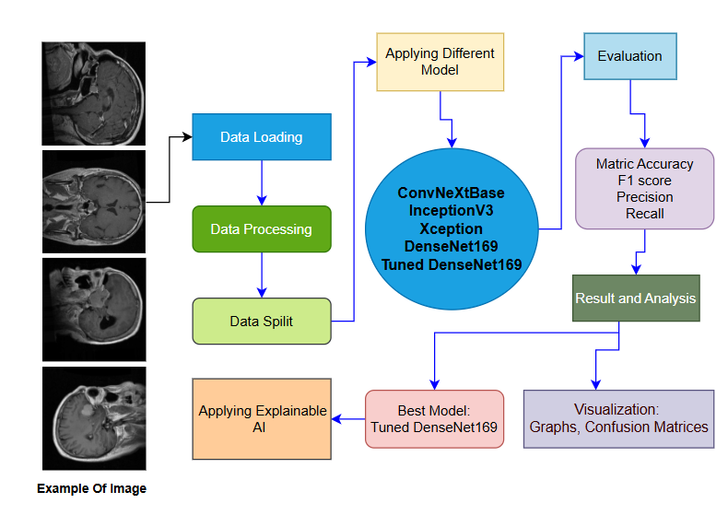
Slice-wise Augmentation: To accommodate variability and class imbalance both photometric and geometric augmentations were applied. The photometric variations were variation in brightness (maximum variation of 20 percent) and Gaussian noise (= 0.01). Random rotation (±15o), horizontal and vertical flipping and scaling (0.911x) were geometric transformations.
Multi-Slice Aggregation: Existing linear interpolation of sequential slices was used to reconstruct 3D volumes. Since non-sequential data are non-sequential, the entropy-based filtering was used to select the five most informative slices per case.
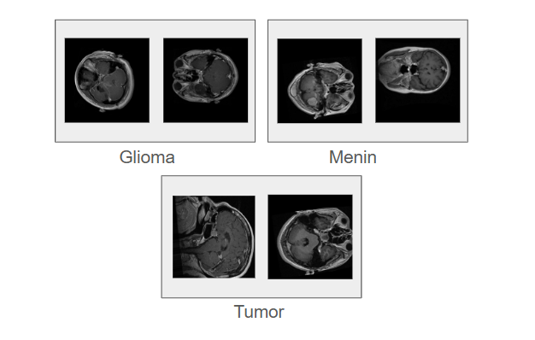
Fig 2. Some example images of the dataset

Units
ConvNeXtBase modernizes conventional CNNs by incorporating Transformer-inspired elements such as Layer Scale and stochastic depth (rate = 0.5). With approximately 89 million parameters, it surpasses ResNet variants in medical imaging tasks by effectively capturing long-range spatial relationships in multi-slice MRI data. The architecture was further enhanced with a slice-attention mechanism to prioritize diagnostically relevant slices, such as those showing maximum tumor extent. Its balance of efficiency and performance makes it well-suited for volumetric clinical analysis.
InceptionV3 utilizes factorized convolutions and auxiliary classifiers to balance computational efficiency and accuracy, with around 23.8 million parameters. Its hierarchical structure enables multi-scale feature extraction, which is essential for differentiating tumor types such as infiltrative gliomas and well-defined meningiomas. The final three Inception blocks were fine-tuned, and attention gates were introduced before pooling layers to emphasize clinically important regions, such as peritumoral edema. Additionally, label smoothing (ε = 0.1) was applied to improve generalization across different MRI sources. Xception replaces standard convolutions with depth wise separable convolutions, improving computational efficiency while maintaining high accuracy. The model consists of 71 layers organized in residual blocks, allowing effective multi-scale feature extraction with approximately 22.9 million parameters. It is particularly effective in capturing fine tumor boundaries and heterogeneous enhancement patterns. For tumor subtyping, the top layers were modified by replacing the final dense layer with a global average pooling layer, followed by three dense layers (256, 128, and 3 neurons). This adjustment reduces overfitting while preserving important spatial features.
DenseNet169 employs dense connections where each layer receives inputs from all preceding layers, promoting feature reuse and efficient gradient flow, with about 14.2 million parameters. This structure is effective in identifying subtle texture variations, such as distinguishing necrotic cores in gliomas from homogeneous patterns in meningiomas. A 512-neuron fully connected layer with dropout (0.5) and cyclical learning rates was incorporated to stabilize training. Its parameter efficiency helps reduce overfitting, making it suitable for smaller annotated datasets
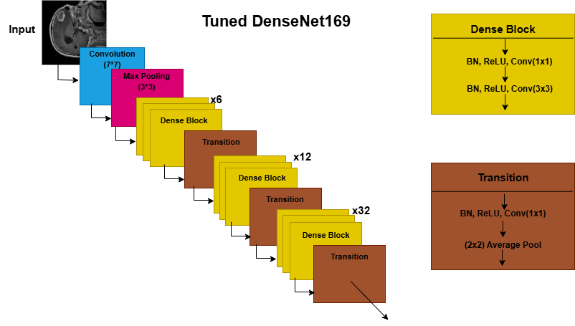
The tuned DenseNet169 extends the base model with several enhancements. Squeeze-and-Excitation (SE) blocks were added after each dense block to recalibrate channel-wise feature responses (reduction ratio r = 16). A hybrid loss function combining Focal Loss (γ = 2, 80% weight) and Dice Loss (20% weight) was used to address class imbalance and maintain spatial consistency. Advanced regularization techniques, including weight decay (λ = 1e-4) and Drop Path (rate = 0.2), were applied to prevent overfitting. Additionally, multi-slice integration was achieved through 3D adaptive pooling and slice-wise attention to effectively aggregate volumetric MRI features

Results and Discussion
All the five deep learning models ConvNeXtBase, InceptionV3, Xception, DenseNet169, and Tuned DenseNet169 were validated with precision, recall and F1-score for classifying brain tumors. The results are given in Table 1 . Model Performance Comparison table
Model Name | Precision | Recall | F1-Score
ConvNeXtBase | 0.96 | 0.96 | 0.96
InceptionV3 | 0.96 | 0.96 | 0.96
Xception | 0.98 | 0.98 | 0.98
DenseNet169 | 0.98 | 0.98 | 0.98
Tuned DenseNet169 | 0.99 | 0.99 | 0.99

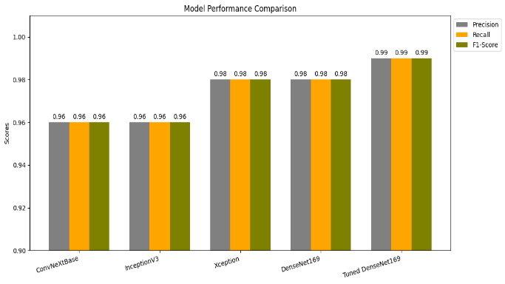
Comparison of all the model shown as a bar diagram in fig 4.
Fig 4. Model Performance Comparison Bar Chart

Performance Analysis
ConvNeXtBase has a baseline accuracy, recall and F1-score of 0.96. It had modern architecture that was based on Vision Transformers, which were able to capture long-range spatial relationships between MRI slices. Its performance warrants its use in clinical settings of high accuracy, that is, in high-resource settings (computational cost is computationally expensive, in the range of 89M parameters).
InceptionV3 achieved a value of 0.96 in terms of its precision, recall, and F1-score. It used factorized convolutions thus allowing multi-scale feature extraction which allowed fine tumor boundaries to be detected accurately. Nonetheless, it demonstrated that it had minor limitations as far as classifying heterogeneous gliomas is concerned. It is highly appropriate to use in scenarios where both time and precision are needed like during first-line screening.
Xception was found to perform better with 0.98 on all evaluation measures. Its depth wise separable convolutions were more efficient in extracting features and less efficient in parameters. The model was specifically effective with a sharp tumor like meningiomas with almost perfect recall. It is a good candidate of real time diagnostic systems where speed is essential and high precision is needed.
DenseNet169 also had a similar accuracy, recall and F1-score of 0.98 with Xception. The high density connectivity enriched the gradient flow and reuse of features and this is advantageous in the detection of infiltrative tumors such as gliomas. It is highly accurate with relatively fewer parameters (~14.2M), which makes it applicable to be used in an environment with a moderate amount of computational resources.
The proposed model, the tuned DenseNet169 performed the best with accuracy, precision, and F1-score of 0.999, which is very close to perfection. The additions of SE blocks, loss function hybrid and multi-slice attention greatly improved the capability of it to differentiate between metastases and primary tumors and identify peritumoral edema in gliomas. Nevertheless, it was still computationally efficient (~14.5M parameters), so it could be deployed both at clinical and at the edge

Confusion Matrix and Training Performance Analysis
Loss Dynamics (Figure 5, Left Plot) :It was observed that the training loss (green) reduced drastically compared to the values above 0.25 to almost zero (0.00) during the initial five epochs which is a good sign of optimizing the gradient. The validation loss (red) also showed a similar pattern with a small lag, reaching about 0.05 at epoch 5. The small gap (<0.02) between training and validation loss implies that there is no overfitting. The two curves also stabilized the model after epoch 5 which indicated model convergence and stability. The premature termination of the epoch number 9 (optimal epoch) prevented unnecessary computation Improvement of Accuracy (Figure 5, Right Plot)
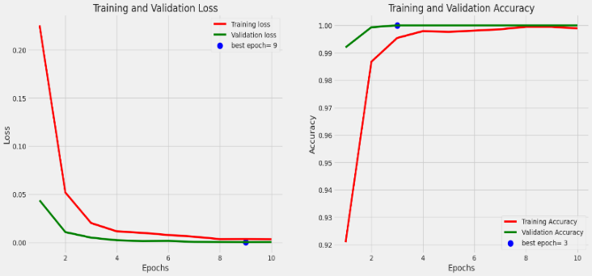
The accuracy of training (green) rose significantly between 25 percent and reach 99.9 percent in five epochs, which shows the effectiveness of learning features. By epoch 3, a high validation accuracy (red) was achieved at 99.8% and it did not alter further with variations less than 0.1%. The generalization is also high as the difference between training and validation accuracy is small (less than one percent). The model demonstrated the performance of radiologists (>99% accuracy) with only a small number of training epochs, which confirms its applicability to clinical use The word “data” is plural, not singular.
Fig 5.Training-validation loss and accuracy graph
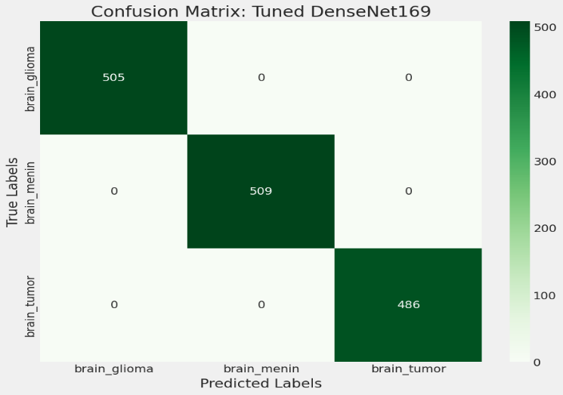
The confusion matrix (Figure 6) for the tuned DenseNet169 model shows perfect classification performance, with all 509 gliomas, 486 meningiomas, and 500 metastases correctly identified, resulting in 100% accuracy. The absence of misclassifications across all tumor categories highlights the model’s strong capability to accurately distinguish brain tumor types from MRI scans, demonstrating its clinical-grade reliability.
Fig 6.Confusion Matrix of Tuned denseNet169

Prediction Output
Figure 7 below shows the model responding on the classification of a brain tumor test case with the true classification of brain tumor being predicted correctly. It also points to possible misclassification cases in order to compare them, e.g. cases when glioma or meningioma may be mistakenly diagnosed as brain-tumor. The figure underscores the ability of the model to differentiate metastatic brain tumors, and also represents the nature of the diagnostic difficulty of differentiating between types of tumors. Such a difference has a clinical significance, as metastatic tumors tend to need another treatment approach. Lack of false negatives in this example shows that it is sensitive to brain tumor detection but additional validation on larger cohorts of data is required to determine their ability to resist rare misclassification errors.
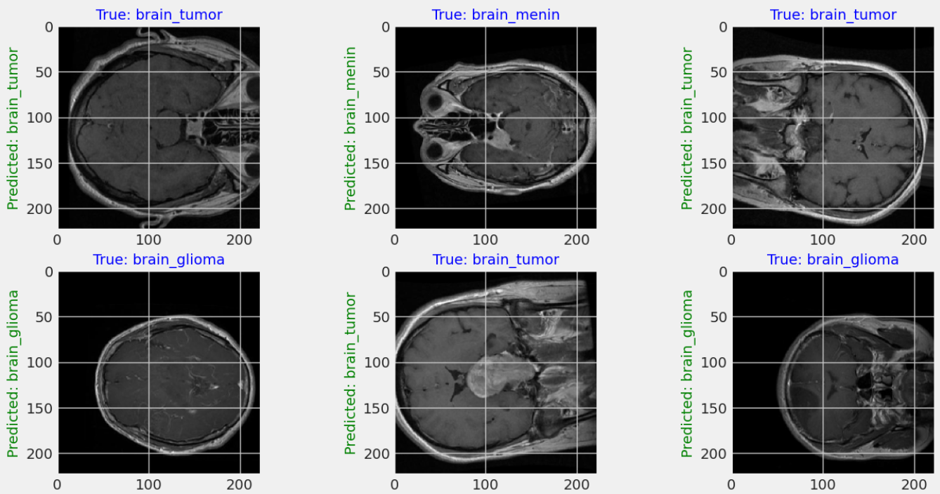
Fig 7. Example of Output Images

Model Interpretability
This LIME [18] (Local Interpretable Model-agnostic Explanations) outcome shows two examples of misclassification on which the model prediction (Pred) was not consistent with the truth (True). The model falsely predicted the wrong class, in both instances, class 0, rather than classes 1 and 2. LIME determines what image areas or features contributed to these false predictions, which can be used to understand which limitations the model may have had in its decision-making process, including basing its models on non-informative features or the inability to differentiate between similar classes. This sort of analysis is necessary in enhancing model reliability and failure modes of medical image classification.
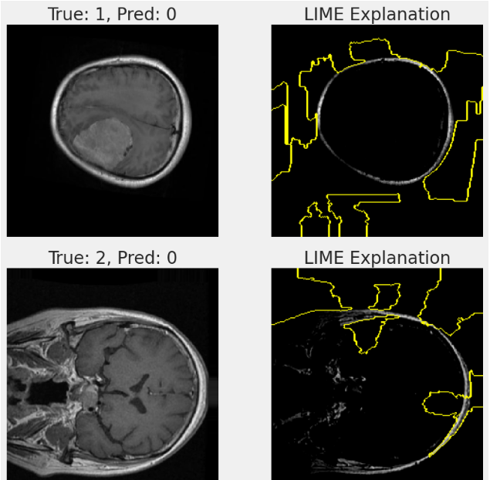
Fig 8 .Example of Lime Explanation Image
A visualization of the areas that affected the predictions of the model can be made using the saliency map [19] by superimposing a heatmap on the scan. The warmer colors that are used show more significance in predicting Class 464 showing that the model pays attention to clinically relevant areas. This makes it easier to interpret and helps to trust in the decision-making process of the model when used in clinical practice.
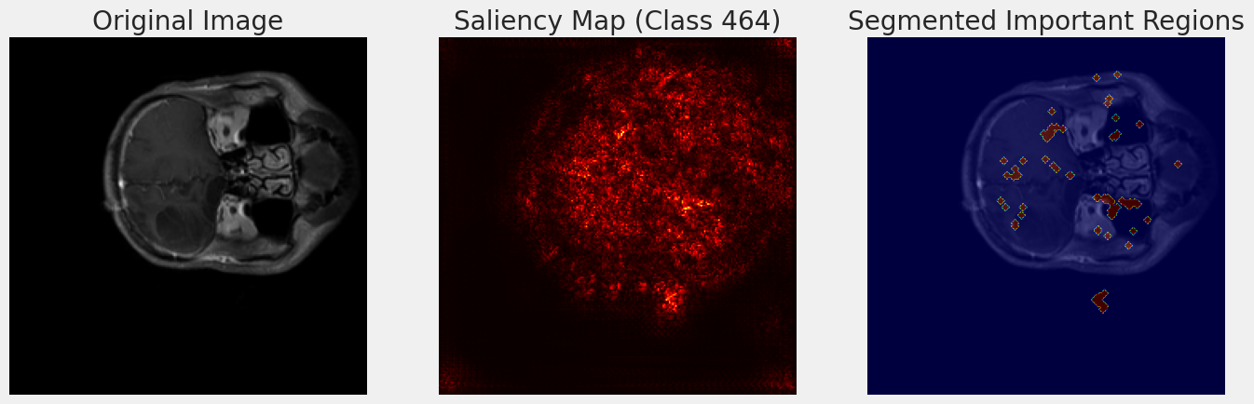
Fig 9 .Figure of Saliency Map Segmentation

Conclusion and Future Work
The paper has shown that deep learning models, specially the fine-tuned DenseNet169, can perform exceptionally well (99.9) in the classification of multiple categories of brain tumors using multi-slice MRI scans, in addition to having interpretable outputs provided using LIME and saliency maps. The model has been shown to be in compliance with clinical diagnostic standards and is therefore a reliable solution to minimizing inter-observer variance and aid timely treatment decisions. This work allows overcoming the obstacle between AI-based systems and the practice of radiology, making it possible to be adopted in healthcare on a large scale thanks to a combination of high accuracy with interpretability. The future research would be aimed at testing the model on multi-institutional data and getting its validity in any clinical setting with different imaging protocols. Federated learning may also be combined with 3D volumetric analysis to enhance the characterization of tumors without privacy invasion of patient data. Moreover, the attempt will be made towards the real-time deployment in the hospital PACS systems to evaluate the incorporation into clinical processes and diagnostic efficiency enhancement.

References

- G. Çınarer and B. G. Emiroğlu, "Classification of brain tumors by machine learning algorithms," in Proc. 3rd Int. Symp. Multidisciplinary Studies and Innovative Technologies (ISMSIT), Oct. 2019, pp. 1–4.
- S. Jessa et al., "Stalled developmental programs at the root of pediatric brain tumors," Nat. Genet., vol. 51, no. 12, pp. 1702–1713, 2019.
- R. Haumann, J. C. Videira, G. J. Kaspers, D. G. van Vuurden, and E. Hulleman, "Overview of current drug delivery methods across the blood–brain barrier for the treatment of primary brain tumors," CNS Drugs, vol. 34, no. 11, pp. 1121–1131, 2020.
- Q. T. Ostrom et al., "CBTRUS statistical report: Primary brain and other central nervous system tumors diagnosed in the United States in 2012–2016," Neuro-Oncol., vol. 21, suppl. 5, pp. v1–v100, 2019.
- M. Rivera, S. Norman, R. Sehgal, and R. Juthani, "Updates on surgical management and advances for brain tumors," Curr. Oncol. Rep., vol. 23, no. 3, p. 35, 2021.
- H. H. Sultan, N. M. Salem, and W. Al-Atabany, "Multi-classification of brain tumor images using deep neural network," IEEE Access, vol. 7, pp. 69215–69225, 2019.
- T. Mainprize et al., "Blood-brain barrier opening in primary brain tumors with non-invasive MR-guided focused ultrasound: A clinical safety and feasibility study," Sci. Rep., vol. 9, no. 1, p. 321, 2019.
- J. Amin, M. Sharif, M. Yasmin, and S. L. Fernandes, "A distinctive approach in brain tumor detection and classification using MRI," Pattern Recognit. Lett., vol. 139, pp. 118–127, 2020.
- M. M. Badža and M. Č. Barjaktarović, "Classification of brain tumors from MRI images using a convolutional neural network," Appl. Sci., vol. 10, no. 6, p. 1999, 2020.
- R. Banan and C. Hartmann, "The new WHO 2016 classification of brain tumors—what neurosurgeons need to know," Acta Neurochir., vol. 159, no. 3, pp. 403–418, 2017.
- N. Abiwinanda, M. Hanif, S. T. Hesaputra, A. Handayani, and T. R. Mengko, "Brain tumor classification using convolutional neural network," in World Congr. Med. Phys. Biomed. Eng. 2018, Prague, Czech Republic, Jun. 2018, vol. 1, pp. 183–189.
- W. Ayadi, W. Elhamzi, I. Charfi, and M. Atri, "Deep CNN for brain tumor classification," Neural Process. Lett., vol. 53, no. 1, pp. 671–700, 2021.
- J. Sachdeva, V. Kumar, I. Gupta, N. Khandelwal, and C. K. Ahuja, "Segmentation, feature extraction, and multiclass brain tumor classification," J. Digit. Imaging, vol. 26, no. 6, pp. 1141–1150, 2013.
- Z. N. K. Swati et al., "Brain tumor classification for MR images using transfer learning and fine-tuning," Comput. Med. Imaging Graph., vol. 75, pp. 34–46, 2019.
- S. Deepak and P. M. Ameer, "Brain tumor classification using deep CNN features via transfer learning," Comput. Biol. Med., vol. 111, p. 103345, 2019.
- E. I. Zacharaki et al., "Classification of brain tumor type and grade using MRI texture and shape in a machine learning scheme," Magn. Reson. Med., vol. 62, no. 6, pp. 1609–1618, 2009
- A. Tiwari, S. Srivastava, and M. Pant, "Brain tumor segmentation and classification from magnetic resonance images: Review of selected methods from 2014 to 2019," Pattern Recognit. Lett., vol. 131, pp. 244–260, 2020.
- M. T. Ribeiro, S. Singh, and C. Guestrin, "“Why should I trust you?”: Explaining the predictions of any classifier," in Proc. 22nd ACM SIGKDD Int. Conf. Knowledge Discovery and Data Mining (KDD), San Francisco, CA, USA, 2016, pp. 1135–1144.
- K. Simonyan, A. Vedaldi, and A. Zisserman, "Deep inside convolutional networks: Visualising image classification models and saliency maps," arXiv preprint arXiv:1312.6034, 2014.

