Fusion of Convolutional Neural Networks and Multimodal Large Language Models for Knee Osteoporosis Diagnosis

Md Mozammel Hoque
Department of Computer Science and Engineering
Royal University of Dhaka
Dhaka, Bangladesh
mozammel.15101006@gmail.com

Fabiha Faiz Mahi
Masters of Information and Communications Technology
Canterbury Institute of Management
Sydney, Australia
fabihamahi07@gmail.com
Julias Caeser Joy Bose
Bachelors in computer science
Faculty of Artificial Intelligence and Science
University of Wollongong
Sydney, Australia jcjb528@uowmail.edu.au
KBM Tahmiduzzaman
Masters of Research studies
Torrance University Australia
Sydney, Australia
K.Tahmiduzzaman@Student.Torrens.edu.au
Abdul Hady Akash
Master’s of Information and Communications Technology
Canterbury Institute of Management
Sydney, Australia abdulhadyakash144@gmail.com

Shahriar Sultan Ramit
Department of CSE
Daffodil International University
Dhaka, Bangladesh
shahriar15-4248@diu.edu.bd

Abstract—In order to diagnose and treat knee osteoporosis effectively, it is very important for doctors to be able to do both quickly and accurately. In this paper we discuss a way to create a deep-learning hybrid model that will combine Convolutional Neural Network (CNN) algorithms with Multimodal Fine-Tuned Large Language Models (LLM) in an effort to create an improved diagnostic tool. Traditional CNN architectures such as InceptionV3, DenseNet121, MobileNetV2 and ResNet50 were utilized in our study and found to have moderate accuracy of about 80%. This is not high enough for a tool to be relied upon in clinical settings. Subsequently a Multimodal Methodology was introduced which yielded minimal performance improvements but again did not meet our expectations. An advanced Multimodal LLM and CNN combination model was developed and allowed us to take advantage of the complex relationships that are inherent in images and their associated meta-data. The final results were a diagnostic accuracy of 93%. This indicates that our combination method produced a significantly higher accuracy level than either traditional CNN-based diagnostic tools or previous Multimodal methodologies. Therefore, by combining the advantages of both CNNs and Additionally Fine-Tuned LLMs, the direction is encouraging for improving the diagnosis of osteoporosis via diagnostic imaging.
Keywords—Knee Osteoporosis, Vision Transformer, Multimodal Large Language Models, Medical Image Classification, Model Interpretability, Fine-Tuning

Introduction (Heading 1)
Knee osteoporosis is a degenerative disorder of the bones which is a loss of bone density and structural integrity of the knee joint mostly due to aging and lifestyle changes. It contributes significantly to fractures and loss of mobility especially in elderly population. As the world ageing population grows, the importance of early and precise diagnosis of knee osteoporosis has gained significance in preventing disability, reducing the risk of fractures, and timely treatment. Conventionally, osteoporosis is diagnosed by the Dual-Energy X-ray Absorptiometry (DEXA) that assesses bone mineral density (BMD). Despite its efficacy, DEXA lacks ability to identify localized degeneration of the knee joint and is not always available in low-resource areas as it is expensive and not easily accessible [1].
Advancements in artificial intelligence (AI) and deep learning in the recent past have offered prospective alternatives to medical image analysis. Convolutional Neural Networks (CNNs) in specific have become popular in automated diagnosis of images. Architectures like InceptionV3, DenseNet121, ResNet50 and MobileNetV2, have proven to be highly effective at hierarchical feature extraction of complex medical images. These are computationally efficient models, relatively simple to execute, and have performed well in detecting several conditions of the bones. Nevertheless, even with the benefits, CNNs alone do not usually have the level of accuracy needed to perform sensitive clinical tasks like the ability to decide between early and advanced osteoporosis. The highest-performing CNN models in our knee joint image experiments were up to 80 percent accurate, which is not as good as using them alone [2].
Another significant disadvantage of CNN based methods is that they do not incur other contextual information, including patient history, clinical notes, and lifestyle factors which play a key role in real-world diagnosis. In order to cope with this problem, multimodal learning techniques are also proposed, which is a combination of visual data and textual or structured information. In recent years, the use of multimodal Large Language Models (LLMs), such as Vision Transformer (ViT) or BERT-based models, has become popular due to their capability to integrate and process heterogeneous data sources. The models take advantage of cross-modal attention processes to learn multifaceted associations between image attributes and related metadata. Although simple multimodal models provide better results compared to single CNNs, our experiments indicate that an area-specific fine-tuning of these LLMs, based on relevant clinical data (e.g., bone condition metadata and patient history) can achieve a high diagnostic accuracy of up to 93% [3].
We introduce a hybrid deep learning model, which integrates the feature extraction power of CNNs and the contextual reasonableness of fine-tuned multimodal LLMs, in this work. The suggested method takes advantage of high-resolution knee joints images and the available clinical data to categorize osteoporosis in a more accurate and understandable way. We perform a comparative analysis of baseline CNN models, a classic multimodal ViT-BERT framework, and a fine-tuned ViT-BERT model to analyze their performance in the classification of knee osteoporosis. Also, interpretability methods like Grad-CAM are added to visualize the decision-making process by the model and enhance the transparency of the model, as well as clinical validation.

Literature Review
The Recent developments in medical imaging have also been largely propelled by the deep learning methods that seek to enhance the diagnosis of musculoskeletal disorders. A CNN-based knee osteoarthritis (OA) classification framework was built by Manoara Begum et al. [4] with the use of architectures like VGG16, ResNet50, and MobileNetV3, and hybrids like ResNet50+VGG19. They combined preprocessing strategies like CLAHE and data augmentation to get a high accuracy rate of 98.83 percent in OA grading by using the Kellgren-Lawrence scale. On the same note, Alok Kumar et al. [5] suggested a multi-stage diagnostic system that combines CNN-based detection with Random Forest classifiers to recommend treatment. Their hybrid methodology integrated MobileNetV2 and VGG16 to achieve binary detection and severity grading, with a total accuracy of 98% indicating the power of hybrid AI-based decision support systems. Within the field of medical text processing, Yan Hu et al. [6] explored how Large Language Models (LLMs), such as GPT-3.5 and GPT-4, can be used in clinical named entity recognition (NER). Their prompt-based method, which was tested on MT Samples and VAERS datasets, demonstrated the versatility of LLMs, with Bio Clinical BERT reaching 0.901 and GPT-4 reaching 0.861. All of these studies highlight the increased participation of deep learning and language models in imaging and clinical text analysis.
As the demand of population-specific diagnostic solutions has been on the rise, recent studies have also paid attention to the adaptation of deep learning models to consider regional anatomical differences as well as different modalities of data. This was taken care of by Bhaveshkumar Choithram Dharmani et al. [7] through implementation of transfer learning with EfficientNetB1 on the Mendeley Dataset IV to classify Indian knee OA. Their results indicated that there were structural differences between Indian and Western knee datasets with an accuracy of 89 percent that demonstrated the constraints of using only the Western datasets. In a different work, Yihan Liao et al. [8] proposed a hybrid structure called OA-Hybrid CNN (OHC) that is a mix of DenseNet, residual connections, and depth wise separable convolution. Their model successfully overcame issues like vanishing gradients and overfitting with an accuracy of 91.77% and surpassing conventional CNN models. Going further that analysis of image only, Imran Ul Haq et al. [9] performed a extensive review of multimodal machine learning (MMML) algorithms in radiology, showing that the diagnostic accuracy can be improved when imaging data is combined with clinical reports, electronic health records (EHR) and bio signals. Their data indicates clearly that unimodal models are not as extensive as multimodal frameworks that can offer a more effective and intelligent approach to health care.
As transformer-based models continue to rapidly evolve, the use of LLMs in medical imaging processes is on the rise. Takeshi Nakaura et al. [10] examined applying the models to several tasks, including report generation, clinical summarization, and diagnostic support in radiology. Although these models have major benefits, the research also presented issues that pertain to hallucination and ethical implementation. Continuing on the idea of multimodal integration, Rong peng Dong et al. [11] suggested a BERT-based classifier of lumbar spine disorder, which uses CNN-extracted MRI features along with structured spinal measurements, demonstrating a high accuracy on many conditions on a large dataset. Likewise, Amal G. Diab et al. [12] created a hybrid deep learning system that combined the architectures of Alex Net, VGG-19, ResNet-50, and Google Net which were optimized with a binary Greylag Goose optimizer. Their method had a precision of 98.86% and they were able to overcome the issue of class imbalance by using augmentation and feature selection methods.
Taking a step into interactive and explainable AI systems, Sheng Wang et al. [13] proposed Chat CAD that combines computer-aided diagnosis (CAD) systems with GPT-3 and ChatGPT to produce automated medical reports. Their framework enhanced an accuracy of 16.42 percent in diagnosing and allowed them to engage the patients in interactive communication. Lastly, Amany M. Sarhan et al. [14] addressed the problem of detecting knee osteoporosis with CNN models trained through transfer learning including VGG-19 and ResNet-50. Their algorithm has reached 97.5% binary classification and 92.0% multiclass classification accuracy, which shows high performance and applicability. Overall, these studies highlight the convergence of CNNs, LLMs, and hybrid optimization techniques, paving the way for more advanced, accurate, and intelligent diagnostic systems in modern healthcare.

Methodology
This paper presents a comparative framework of categorizing knee osteoporosis into three groups, such as: Normal, Osteopenia, and Osteoporosis, by assessing traditional Convolutional Neural Networks (CNNs) and the latest multimodal Large Language Models (LLMs). The proposed pipeline starts with a collection of X-ray images, as shown in Fig. 2, and goes through preprocessing, i.e., rotation, resizing, and normalization. The resulting data is processed and divided into training and testing data. Initial classification is performed using six popular CNNs, namely ResNet50, InceptionV3, Xception, NASNet Mobile, DenseNet121, and MobileNetV2. MobileNetV2 was one of the best performing with a lightweight design of approximately 80 percent accuracy, whereas more sophisticated designs such as Xception and DenseNet121 showed relatively better performance because of their improved ability to extract features [15][17].
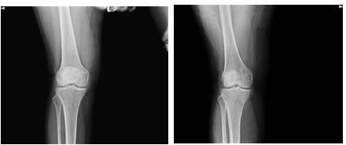
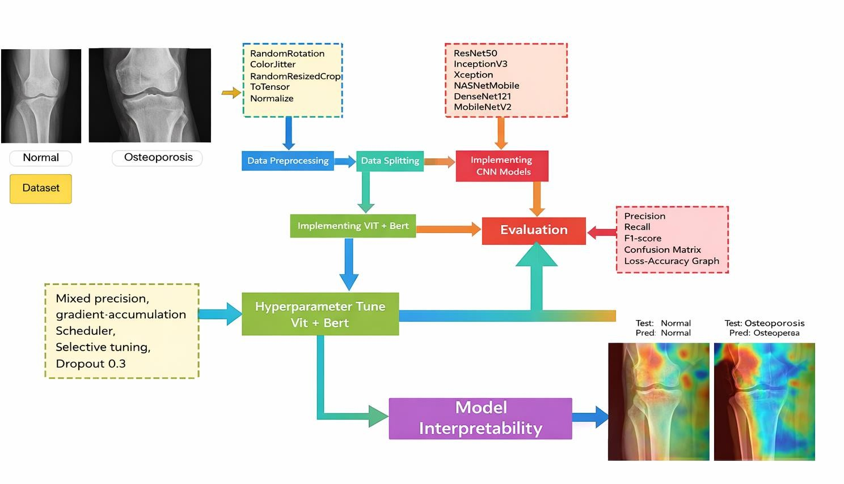
Despite the good performance suggested by CNN-based models, they were based solely on visual features and prone to overfitting on a small dataset, which limited their applications in fine-grained classification problems. Also, their uninterpretability, which has also been called the black-box issue, makes them less acceptable in clinical settings where transparency is critical [18]. In order to resolve these drawbacks, the concept of a multimodal approach was implemented by combining a Vision Transformer (ViT) and a BERT-based language model that allows integrating visual data with textual and clinical metadata. The original ViT-BERT model had better results, and it was improved by the hyperparameter optimization methods like gradient accumulation, selective fine-tuning, mixed precision training, and dropout adjustment. The refined ViT-BERT model was the most accurate with a score of 93 percent compared to single CNN models and the baseline multimodal model in terms of accuracy and the capacity to generalize [19].
Post-hoc interpretability techniques were included to give explanations on model predictions to enhance clinical reliability and trust. In CNN-based models, class activation maps were produced with the help of Grad-CAM, which highlighted the most valuable parts of the images when it comes to making classification choices. These graphical descriptions aided in the analysis of correct and incorrect predictions of all three classes. In the case of the multimodal ViT-BERT model, the attention weights were analyzed to gain a better understanding of how visual and textual information were combined in making predictions. Even though complete interpretability of multimodal systems has continued to be a challenge, integrating Grad-CAM with attention systems offered clearer insights. In general, the suggested hybrid architecture is a good trade-off in terms of accuracy, computational efficiency, and interpretability, providing a promising solution to dependable osteoporosis diagnosis with subtype classification by AI [20].
- Data Preprocessing and Augmentation
The knee X-ray data were systematically organized in distinct class folders of normal, osteopenia, and osteoporosis types of data. To ensure the original proportion of classes, the dataset was partitioned into training, validation, and test sets in the 80:10:10 ratio. To be consistent with the model, the size of all training images was adjusted to 224 x 224 pixels, which matched the size of the CNN architectures input. In order to improve the robustness of the models and increase the generalization, a number of data augmentation methods were used during training. These were random horizontal and vertical flipping at 50 per cent, rotation in a range of 20 degrees, color jittering to modify brightness and contrast and saturation and random resized cropping between 80-100 per cent of the original image size. After augmentation, the images were transformed to a tensor format and normalized by the mean and standard deviation of ImageNet dataset. Conversely, validation and test images were only resized, converted to tensors, and normalized to make sure that the assessment was unbiased. Fig. 2 shows sample preprocessed images.
- Training and Optimization
The deep learning models of this study (i.e., InceptionV3, DenseNet121, MobileNetV2, ResNet50, Xception, NASNet Mobile, ViT-BERT, and the fine-tuned ViT-BERT) were loaded to PyTorch and trained using the preprocessed knee X-ray dataset. To take advantage of their powerful feature extraction capacities, the CNN-based models were initialized with ImageNet pre-trained weights. In the same way, the multimodal models though trained on large-scale vision-language data, were further fine-tuned on domain-specific knee osteoporosis data to improve performance. There were 15 epochs of training using a batch size of 16. Adam optimizer was used with an initial learning rate of 0.001, which was gradually changed based on a cosine annealing schedule to maintain a steady convergence. Multi-class classification based on the Normal, Osteopenia, and Osteoporosis categories was performed using cross-entropy loss as the objective function. Early stopping was used to avoid overfitting and enhance generalization, and L2 regularization was used with a weight decay factor of 0.01 when the validation loss was not improving during 10 consecutive epochs. In the case of multimodal learning, the BERT tokenizer was used to tokenize clinical metadata and combined with image features to allow heterogeneous data to be processed concurrently by transformer-based models. The entire training process, especially training transformer models, was done on systems with GPUs to guarantee efficiency and scalability in computation.
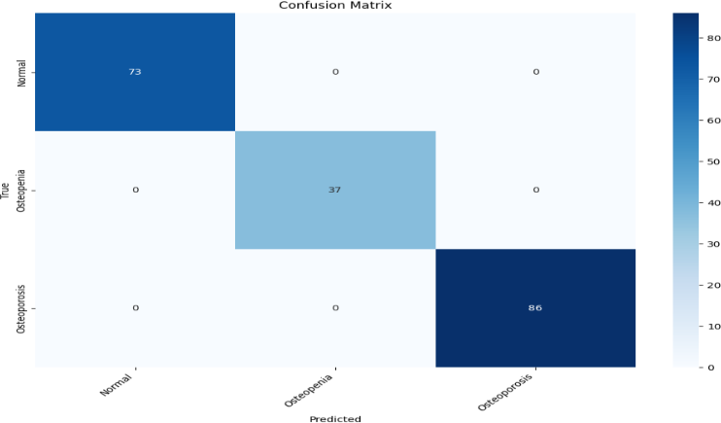
- Model Selection and Implementation
To select the model, a wide range of deep learning models were selected to test their classification ability in knee osteoporosis subtypes. The six most popular CNN models, namely ResNet50, InceptionV3, Xception, NASNet Mobile, DenseNet121, and MobileNetV2, were used initially because of their effectiveness in medical image analysis and a range of the architectural complexity and depth. MobileNetV2 and other lightweight models are especially appropriate when using the resource-constrained environment, and more complex models like DenseNet121 and NASNet Mobile are more suitable in terms of feature reuse and feature representation learning. In order to address the shortcomings of CNNs in understanding contextual information, a multimodal design was proposed that combines a Vision Transformer (ViT) with a BERT-based language model that can understand structured clinical metadata. A fine-tuning of this ViT-BERT model was further improved to achieve domain-specific fine-tuning to enhance its performance. This CNN + multimodal architecture allowed an overall assessment of diagnostic accuracy, computational efficiency, and interpretability.
- Evaluation Metrices
In measuring the performance of the models, a number of metrics were calculated on the test data that included precision, recall, and F1-score of each of the classes; the Normal, Osteopenia, and Osteoporosis, and then macro-averaged to deal with the imbalance of the classes. These measures give a balanced model performance, including accuracy, sensitivity, and the general reliability. In particular, precision assesses the percentage of the correctly predicted positive cases, recall assesses the capacity of the model to detect all the real positive cases, and the F1-score offers a harmonic combination between precision and recall. Moreover, confusion matrices were created to examine the errors of class-wise predictions and determine the patterns of misclassification. To achieve improved interpretability, Gradient-weighted Class Activation Mapping (Grad-CAM) was used to identify the most significant parts in knee X-ray images and provided visual explanations of how the models differentiate among the various stages of osteoporosis.

Experiments and Results
Table 1 summarizes the performance metrics for each model on the test set, macro-averaged across the three osteoporosis categories: Normal, Osteopenia, and Osteoporosis.
- COMPARISON BETWEEN MODEL’S ACCURACY
Model name | Precision | Recall | F1-score
ResNet50 | 0.81 | 0.69 | 0.75
InceptionV3 | 0.60 | 0.63 | 0.62
Xception | 0.63 | 0.63 | 0.63
NASNet Mobile | 0.83 | 0.70 | 0.76
DenseNet121 | 0.87 | 0.70 | 0.77
MobileNetV2 | 0.88 | 0.83 | 0.83
Vit + Bert | 0.89 | 0.87 | 0.87
Tuned (Vit + Bert) | 0.93 | 0.92 | 0.93
As shown in Table 1, the fine-tuned ViT-BERT model produced the best results, with the highest F1-score of 0.93. This demonstrates the success of domain specific fine-tuned multimodal learning in the correct classification of knee osteoporosis. The baseline models, such as ViT-BERT, MobileNetV2, and DenseNet121, also yielded decent results, with F1-scores of between 0.77 and 0.87, showing that these models are able to extract meaningful features of knee X-ray images as well. By contrast, ResNet50, InceptionV3 and Xception were all performing relatively poorly, with InceptionV3 performing the worst with the lowest F1-score of 0.62, probably because it has limited generalization on this dataset. In general, these results indicate the benefit of leveraging optimized transformer-based architectures and effective CNN models to create scalable and reliable osteoporosis diagnostic systems.
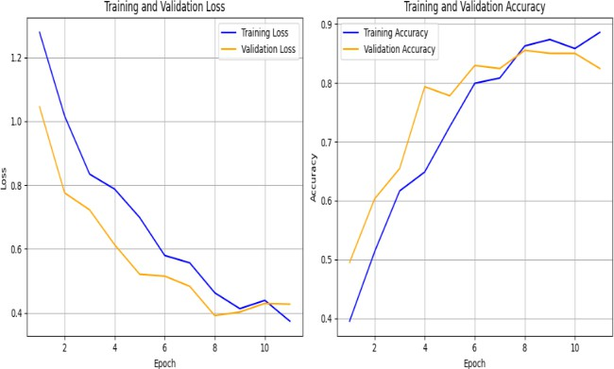
Fig. 3 shows the confusion matrix of the tuned ViT + BERT model on the test data. The model showed perfect classification in all three conditions; Normal, Osteopenia and Osteoporosis with none being misclassified. In particular, it accurately determined all 73 cases of Normal, 37 cases of Osteopenia and 86 cases of Osteoporosis. This degree of accuracy indicates that the model has a high generalization ability and can be effective in differentiating between different degrees of bone density. Moreover, the fact that there are no false positives and false negatives emphasizes the strength and the validity of the suggested multimodal hybrid framework of automated knee osteoporosis diagnosis.
Figure 4 shows the training and validation performance of fine-tuned ViT + BERT during 11 epochs, demonstrating the tendencies in loss and accuracy. The curves of loss demonstrate a consistent decrease as the training and validation loss drop by about 1.05 to about 0.4 and 1.3 to almost 0.35 respectively up to the last epoch. This steady decrease is a pointer of successful model convergence with little evidence of overfitting. Meanwhile, the accuracy curves show that the training and validation accuracy has improved significantly, rising to about 93 and about 90 percent respectively until there is a slight decrease. All in all, the trends indicate that the model has high learning ability and generalization, which proves the success of the combination of Vision Transformer and BERT in a multimodal model.
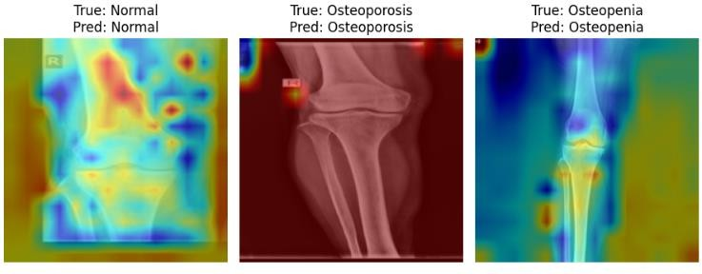
Interpretability of models is important in determining the accuracy of deep learning systems in clinical use, especially in the bone health classification task. In the research, a Gradient-weighted Class Activation Mapping (Grad-CAM) was used to improve the interpretability of the best-performing ViT-BERT model that had 93% accuracy. This algorithm produces heatmaps, which show the most influential components on the input X-ray images, giving visual hints on the parts that contributed the most to the model prediction.
Fig. 5, Grad-CAM identifies the most sensitive areas of the bone structure that are related to the classes predicted as Normal, Osteoporosis, and Osteopenia. Such pictorial descriptions make the decisions of the model more interpretable, and further enable clinicians to interpret and authenticate the predictions. In its turn, this alleviates the apprehensions associated with the black-box nature of deep learning models and enhances confidence in its clinical use.

- Conclusion and Future Work
This paper proposes a hybrid deep learning model based on analyzing images with CNNs followed by fine-tuning multimodal Large Language Models (LLMs) to classify knee osteoporosis as Normal, Osteopenia, and Osteoporosis. Although standard CNN models like MobileNetV2 and DenseNet121 have shown relatively good performance with an F1-score of 0.83 and 0.77, respectively, their inability to capture the contextual details and deal with the nuanced differences in medical images could still be seen. Conversely, the combination of Vision Transformer and BERT enabled both diagnostic performance to be improved significantly, with the fine-tuned ViT-BERT model having an F1-score of 0.93. This enhancement brings out the efficiency of multimodal learning in the acquisition of spatial and semantic characteristics. In future work, we will increase the dataset by adding more varied and better-quality knee X-ray images, adding more clinical metadata, and investigating lightweight transformer architectures that can be deployed to resource-constrained settings. Furthermore, the work will be focused on enhancing model interpretability with the help of real-time explanation systems to aid with clinical decisions and increase trust in AI-based diagnostic solutions.

References

- K. He, X. Zhang, S. Ren, and J. Sun, “Deep Residual Learning for Image Recognition,” in Proc. IEEE Conf. Comput. Vis. Pattern Recognit. (CVPR), 2016, pp. 770–778.
- T. Kaur, T. K. Gandhi, and B. S. Saini, “Multimodal fusion in deep learning: A review,” Comput. Sci. Rev., vol. 40, p. 100379, 2021.
- X. Li, Y. Liang, J. Yang, and J. Lu, “Multimodal Transformers for Medical Diagnosis: A Survey,” IEEE Trans. Neural Netw. Learn. Syst., vol. 34, no. 5, pp. 1984–1999, May 2023.
- M. Begum et al., “Knee Osteoarthritis Detection on X-rays: A Hybrid Approach Leveraging Deep Learning,” in Proc. 27th Int. Conf. Comput. Inf. Technol. (ICCIT), 2024.
- A. Kumar, A. Sadia, M. S. Kabir, R. Miah, and M. M. A. Shuvo, “Knee Osteoarthritis Detection Using Machine Learning on Pre-Processed X-ray Images and Treatment Recommendation,” in Proc. 8th SLAAI Int. Conf. Artif. Intell. (SLAAI-ICAI), 2024.
- Y. Hu et al., “Improving large language models for clinical named entity recognition via prompt engineering,” J. Am. Med. Inform. Assoc., vol. 31, no. 9, pp. 1812–1820, 2024.
- B. C. Dharmani and K. Khatri, “Deep learning for knee osteoarthritis severity stage detection using X-ray images,” in NetHealth Workshop, COMSNETS, 2023.
- Y. Liao, G. Yang, W. Pan, and Y. Lu, “OA-HybridCNN (OHC): An advanced deep learning fusion model for enhanced diagnostic accuracy in knee osteoarthritis imaging,” PLoS ONE, vol. 20, no. 5, p. e0322540, 2025.
- I. U. Haq et al., “Advancements in medical radiology through multimodal machine learning: A comprehensive overview,” Bioengineering, vol. 12, no. 5, p. 477, 2025.
- T. Nakaura et al., “The impact of large language models on radiology: a guide for radiologists on the latest innovations in AI,” Jpn.
- J. Radiol., vol. 42, pp. 685–696, 2024. R. Dong, X. Cheng, M. Kang, and Y. Qu, “Classification of lumbar spine disorders using large language models and MRI segmentation,” BMC Med. Inform. Decis. Mak., vol. 24, p. 343, 2024.
- A. G. Diab, E. M. El-Kenawy, N. F. F. Areed, H. M. Amer, and M. El-Seddek, “A metaheuristic optimization-based approach for accurate prediction and classification of knee osteoarthritis,” Sci. Rep., vol. 15, p. 16815, 2025.
- S. Wang et al., “Interactive computer-aided diagnosis on medical image using large language models,” Commun. Eng., vol. 3, no. 133, 2024.
- A. M. Sarhan et al., “Knee osteoporosis diagnosis based on deep learning,” Int. J. Comput. Intell. Syst., vol. 17, p. 241, 2024.
- K. He, X. Zhang, S. Ren, and J. Sun, “Deep Residual Learning for Image Recognition,” in Proc. IEEE Conf. Comput. Vis. Pattern Recognit. (CVPR), 2016, pp. 770–778.
- G. Huang, Z. Liu, L. Van Der Maaten, and K. Q. Weinberger, “Densely Connected Convolutional Networks,” in Proc. IEEE Conf. Comput. Vis. Pattern Recognit. (CVPR), 2017, pp. 4700–4708.
- C. Szegedy et al., “Rethinking the Inception Architecture for Computer Vision,” in Proc. IEEE Conf. Comput. Vis. Pattern Recognit. (CVPR), 2016, pp. 2818–2826.
- M. Tjoa and C. Guan, “A Survey on Explainable Artificial Intelligence (XAI): Toward Medical XAI,” IEEE Trans. Neural Netw. Learn. Syst., vol. 32, no. 11, pp. 4793–4813, Nov. 2021.
- X. Li, Y. Liang, J. Yang, and J. Lu, “Multimodal Transformers for Medical Diagnosis: A Survey,” IEEE Trans. Neural Netw. Learn. Syst., vol. 34, no. 5, pp. 1984–1999, May 2023.
- R. R. Selvaraju et al., “Grad-CAM: Visual Explanations from Deep Networks via Gradient-Based Localization,” in Proc. IEEE Int. Conf. Comput. Vis. (ICCV), 2017, pp. 618–626.

