Deep Learning Approaches for Lung Cancer Classification: Assessing CNN Performance Using Saliency Maps and Grad CAM on CT Imaging

Md Sujon Ali  Canterbury Institute of Management Master of Information & Communications Technology  Sydney,Australia msujonali07@gmail.com | Md Abdul Ahad  Masters of Information Technology Frankfurt  University of Applied Sciences  Germany  ahad.edu.7548@gmail.com | Fabiha Faiz Mahi  Masters of Information and Communications Technology Canterbury Institute of Management Sydney, Australia  fabihamahi07@gmail.com
Shahriar Sultan Ramit  Department of CSE  Daffodil International University  Dhaka, Bangladesh  shahriar15-4248@diu.edu.bd | Alaya Parven Alo  Department of CSE  Daffodil International University  Dhaka, Bangladesh  alo15-4283@diu.edu.bd | Md Sadekur Rahman  Department of CSE  Daffodil International University  Dhaka, Bangladesh  Sadekur738@gmail.com

Abstract—Lung cancer remains among the leading causes of mortality in the world and CT imaging is one of the crucial instruments of early diagnosis. These scans however are time consuming and prone to error in case they are manually interpreted. We use a dataset of 364 lung CT images in this study, as they have been obtained in an Iranian hospital comprising of 238 cancerous and 126 noncancerous patients, which are accorded with labels by a specialist in pulmonology. We test five different convolutional neural network designs, under the same preprocessing, augmentation and training regimes to give an equal evaluation opportunity. To solve the issue of class imbalance and low number of samples, data augmentation methods were used to increase the size of the data threefold to enhance model generalization. To make the decisions of the models more interpretable, saliency maps and Grad Cam were employed to visualize the decision-making of the models, where attention was paid to the clinically relevant areas, including tumor areas in cancerous scans and ground glass opacities in noncancerous images. The results of the experiment suggest that NASNet Mobile demonstrates excellent performance, with the highest level of test accuracy of 99.94. These results indicate that it is more effective in classifying lung cancer. In general, this paper delivers a multimodal comparison, solid data augmentation approaches, and interpretable visual features that enhance clinical confidence. It leads to the development of automated lung cancer detection, as well as offers a scalable solution that can be deployed in resource constrained settings.
Keywords— Lung Cancer, Xray, Deep Learning, Imaging processing, Data Augmentation, Interpretability

Introduction
Lung cancer is one of the most pressing health challenges in the whole world, as it causes close to 1.8 million deaths annually and it is the first cause of cancer related mortality. The diagnosis is essential because the survival outcomes are significantly improved when the disease is detected early, the five year out survival rates are high (up to 60 percent), as compared to minimal when the disease is at the advanced stages. The Computed Tomography (CT) imaging is crucial in the identification of lung abnormalities such as malignant nodules and tumors because the images are high resolution images of the lung tissues. Nevertheless, the process of CT scan interpreting is time consuming and complicated and requires the skills of pulmonologists and radiologists. Assessment Manual assessment is usually subjective, with interobserver agreement decreasing diagnostic consensus in indistinct cases to as low as 70 percent. As well, there is a rise in the number of cases, which puts a greater strain on healthcare systems, which explains the demands of automated and reliable diagnostic tools.
Recent developments in deep learning, specifically convolutional neural networks (CNNs) have revolutionized medical imaging by allowing the application of automated and precise analysis. CNNs are very efficient in extracting hierarchical representation out of complex visual data and thus they would be useful in other applications like tumor identification and classification. Such architectures as ResNet, Efficient Net, and NASNet have demonstrated a high level of performance on different medical imaging tasks, with many being able to obtain accuracy over 90 percent. Although these successes have been achieved, they are relatively applied to the classification of lung cancer, particularly, those that are smaller in size and those that are region-specific. In addition, model generalization on a variety of datasets and increase in interpretability are critical to facilitate practice adoption to clinical settings especially in resource limited settings. We will use a dataset of 364 lung CT images of a hospital in Iran in this work because the incidence of lung cancer in the country is on the rise as a result of smoking and the environment. The dataset, which is annotated by a pulmonologist, consists of 238 cancerous and 126 noncancerous samples, the latter being COVID19related lung changes as well as other lung diseases. The imbalance in the classes and rather low size of the dataset is a challenge to training robust models. In order to overcome these constraints, tremendous data augmentation methods, such as rotations, flips and zoom transformations, were used to triplicate the data without altering the distribution of classes. This approach enhances generalization and minimizes overfitting, which is typical of small medical data sets.
The main aim of this study is to evaluate the results of the five state of the art CNN models: EfficientNetB0, EfficientNetB7, NASNet Mobile, ResNet50, and ResNet152 on binary classification of CT scans to either cancerous or noncancerous type. The choice of these models is based on their unique architectural features: EfficientNet makes use of compound scaling to provide balanced performance, NASNet Mobile makes use of neural architecture search to provide performance, and ResNet makes use of residual connections to provide deeper networks. All models were trained with the same conditions under conditions of preprocessing (image is resized to 224*224 pixels and normalized to the range 1, 1), augmentation strategies and training settings (Adam optimizer, 0.0001 learning rate, and categorical cross entropy loss). This artificial environment eliminates the effect of architectural dissimilarity on performance. A notable feature about this work is that interpretability techniques were used to increase clinical relevance through incorporating them. In addition to high accuracy, it is important to understand how models come to their predictions so that trust is built when using them in the healthcare industry.. Such techniques emphasize clinically significant characteristics, e.g., tumor areas in photographs of cancer and ground glass opacities in noncancerous ones, which enables clinicians to crosscheck model output with known radiological data. This research undertaking has three contributions. Originally, it offers an overall recalculation of numerous CNN setups on an area specific and unbalanced lung CT data set. Second, it shows that data augmentation is effective at overcoming drawbacks of datasets and obtaining high model performance. Third, it increases interpretability of the model using visualization methods, which increase trust and make clinical adoption possible. Interestingly, NASNet Mobile has reached one hundred percent test accuracy, a fact that demonstrates the possibility of lightweight architecture implementation in resource constrained environments. Summing up, the study contributes to the development of automated lung cancer diagnosis through the combination of high performing deep learning models and interpretable visualization methods.

Relaterd work
Lung cancer is one of the major causes of cancer related mortality worldwide and requires timely diagnosis using Computed Tomography (CT) imaging to improve patient survival rates. Recent advancements in deep learning, particularly Convolutional Neural Networks (CNNs), have significantly enhanced automated lung cancer detection, classification, and segmentation from CT scans. CNN-based approaches have demonstrated remarkable diagnostic performance and are increasingly being integrated into computer-aided diagnosis systems [1]. Several review studies have emphasized the effectiveness of deep learning techniques for lung cancer detection. Devi et al. reported that CNN architectures such as ResNet and EfficientNet achieved diagnostic accuracies exceeding 90% in CT-based lung cancer detection while identifying limited dataset diversity and poor model generalization as major challenges [2]. Similarly, Thanoon et al. investigated CNN-based pulmonary nodule detection systems and achieved sensitivity rates reaching 99.22% F-measure, although computational complexity and limited datasets remained significant limitations [3]. A number of studies have focused on developing specialized CNN architectures to improve detection performance. Kumar et al. proposed a hybrid framework integrating ResNet50/101 with EfficientNetB3 and achieved an accuracy of 96.39% on DICOM CT images; however, the model showed risks of overfitting due to architectural complexity [4]. Mikhael et al. introduced Sybil, a 3D CNN model designed for future lung cancer risk prediction using low-dose CT scans, achieving an AUC of 93% on the National Lung Screening Trial (NLST) dataset [5]. Nevertheless, the model required large-scale datasets, limiting its applicability in resource-constrained settings. Furthermore, Wehbe et al. employed the YOLOv8 architecture for lung cancer detection and obtained a precision score of 90.32% on the Lung PETCTDx dataset, although false-positive detections remained a challenge [6]. Interpretability has become increasingly important for clinical implementation. Shah et al. proposed a customized CNN integrated with Grad-CAM for explainable lung cancer subtype classification [7]. Their model successfully classified squamous cell carcinoma, adenocarcinoma, and large-cell carcinoma with approximately 95% accuracy while also providing visual explanations aligned with radiologists’ interpretations. However, the study lacked external validation. Bushara et al. proposed LCDCapsNet, a hybrid CNN and capsule network model, which achieved 94% accuracy even with limited data availability, though at the expense of high computational cost [8].
CNNs have also demonstrated strong potential in segmentation and pulmonary nodule detection tasks. Ma et al. optimized the V-Net architecture for pulmonary nodule segmentation and achieved a Dice similarity score of 83% on the LIDC-IDRI dataset [9]. However, segmentation performance deteriorated when low-dose CT scans were used. Liu et al. developed a deep learning framework for classifying sub-centimeter pulmonary nodules and achieved 92% accuracy, although the method required extensive manual preprocessing [10]. Similarly, Sori et al. introduced DFDNet, a denoising CNN model that achieved 93% sensitivity on the LUNA16 dataset, but detailed performance evaluations were limited [11]. Comparative and hybrid deep learning approaches have also been widely explored. Gautam et al. compared several CNN architectures, including ResNet152, DenseNet169, and EfficientNetB7, and achieved a maximum accuracy of 97%; however, class imbalance negatively affected recall performance [12]. Hosseini et al. investigated hybrid CNN-transformer architectures and achieved accuracies up to 96%, although these models required substantial computational resources [13]. Likewise, Worku et al. developed VER-Net, a stacked ensemble framework based on VGG16, ResNet152V2, and EfficientNetV2, achieving 91.1% accuracy while facing limitations associated with insufficient dataset diversity [14].
Recent studies have increasingly focused on transfer learning and optimization techniques. Shetty et al. proposed Shepard CNN, which incorporated optimization strategies and achieved 98% accuracy on the LIDC-IDRI dataset; however, the framework required extensive preprocessing before training [15]. Aswathy et al. introduced the BoVWC-RNN model for nano-segmented CT images and achieved approximately 94% classification accuracy, although practical clinical implementation remains unverified [16].
Overall, the reviewed studies demonstrate the significant potential of CNN-based methods for lung cancer detection using CT imaging, with many approaches achieving accuracy levels above 90%. Nevertheless, persistent challenges remain, including dependence on large annotated datasets, high computational complexity, overfitting, and limited model interpretability.

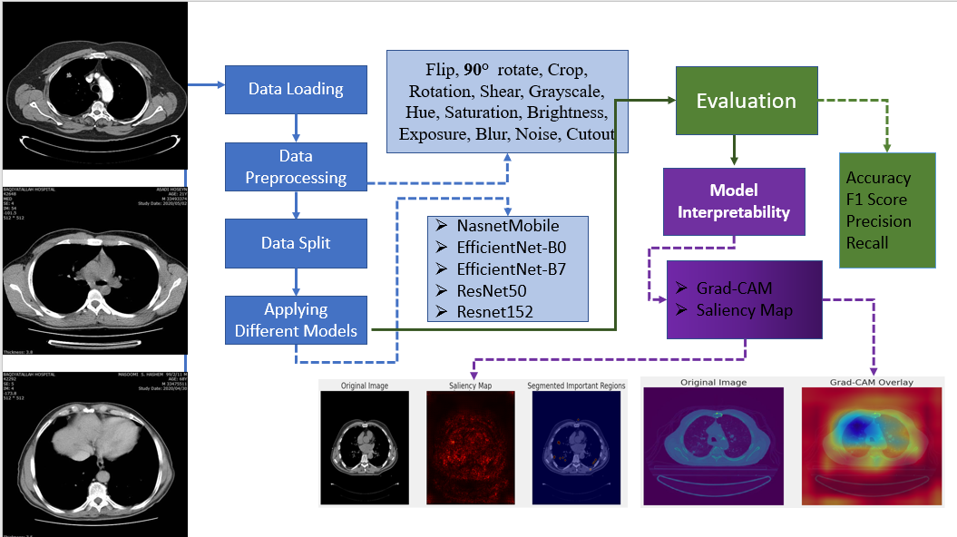
Methodology
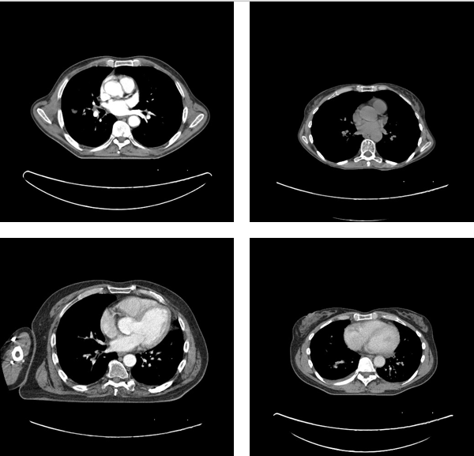
This study methodology is guided towards measuring the efficacy of deep learningbased models in the classification of lung cancer based on a region specific CT scan dataset as shown I Fig 1. It particularly solves the issues of small samples and imbalance in the classes through integrating full preprocessing, data augmentation, and interpretability. The section describes the nature of dataset, preprocessing, data augmentation, model choice, evaluation metrics and interpretability strategies used to obtain reliable and clinically significant results.

Dataset and Preprocessing
The data is made up of 364 CT scan images of the lungs of an Iranian hospital and were marked by a pulmonologist. It has 238 malignant cases (65.4) that are related to lung cancer and 126 benign cases (34.6) that are linked to COVID19 or some other pulmonary diseases. The asymmetry in the number of classes, combined with the relatively small amount of data, requires special care so that the model generalization could be enhanced (Devi et al., 2024). In order to train the model, all the images have been resized to 224 x 224 so that they fit the input size of CNN models like Efficient-Net and Res-Net. Also, the pixels were first brought in the range of 1, 1 with the transformation ( pixel/ 127.5) 1, which made the weights of pretrained models compatible. Stratified sampling was used to split the dataset into training, validation and testing subsets to maintain the class distribution. In particular, 80 percent of the data was used to train and 10 percent to validate and test, which would be roughly 291, 36 and 37 images respectively. Data augmentation methods were implemented to reduce overfitting and the small size of the dataset with the help of Keras Image Data Generator which increased the data to around 1,092 images. Random rotations (to 20) and width and height shifts (to 20 percent), shearing transformations (20 percent), zooming (20 percent), and horizontal flipping were all part of the augmentation process. These reforms were done keeping the distinction of classes as before.

Fig 2. Some example images of the dataset

Model Architecture
The equations are an exception to the prescribed Convolutional neural network (CNN) architectures used in the research were selected based on their efficiency and capability to recognize significant features in CT scans in order to classify the disease. They selected five well known models, which are EfficientNetB0 and EfficientNetB7 (Tan and Le, 2019), NASNet Mobile (Zoph et al., 2018), and ResNet50 and ResNet152 (He et al., 2016). The EfficientNet models use a compound scaling strategy, balancing the network depth, width, and resolution, allowing high performance using comparatively few parameters. This renders them especially appropriate with smaller medical datasets. EfficientNetB0 was chosen due to its computational efficiency, whereas EfficientNetB7 with more depth and capacity was selected to research the impact of using more complex models (Tan & Le, 2019). Google created the NASNet Mobile based on the neural architecture search methodology is highly efficient and, in particular, it should be used in a clinical setting with limited resources (Zoph et al., 2018). ResNet50 and ResNet152, in turn, employ residual connections as a solution to the vanishing gradient issue to enable the effective training of the deep networks with 50 and 152 layers, respectively, to learn the complicated patterns in the CTs (He et al., 2016). Each model was trained using pretrained weights on ImageNet so that it could use previous information to extract features. During the training, the base networks were frozen to minimize the chances of overfitting due to the small size of the dataset. C custom classification head was placed atop each of the base models, comprising of a global average pooling layer to down sample spatial dimensions after which a fully connected dense layer with 256 neurons along with ReLU activation to learn features and a softmax output layer to classify the samples into cancerous and noncancerous. To provide a fair and consistent comparison, all the models were trained with the same hyperparameters. These were the Adam optimizer with an initial learning rate of 0.0001, the loss function was categorical cross entropy, the batch size was 16 and early stopping was used which used the validation loss as a criterion. Such a standardized training system helps reduce the external variability and allows assessing the effects of the architectural variations on the performance in lung cancer classification (Kumar et al., 2024).

Model Interpretability
Saliency maps and Gradient weighted Class Activation Mapping (GradCAM) were also used as interpretability methods to map the predictions of the models in order to improve clinical reliability and transparency. The saliency maps are the images based on the gradients of model output and input pixels, which show the most important areas that made the decision (Simonyan et al., 2014). GradCAM, in its turn, creates class specific heatmaps by weighting the feature maps with the gradient information, placing emphasis on important areas of the image such as tumors or other abnormalities in the lungs (Selvaraju et al., 2017). Such visualization techniques can be used to help balance prediction in models and known radiological interpretations, which overcome interpretability issues raised by Shah et al. (2025). In general, using the proposed methodology, it becomes possible to combine standardized preprocessing, large data augmentation, varying CNN structures, and robust evaluation with interpretability methods, which allows lung cancer classification even within a small and difficult dataset.

Evaluation Metrics
The performance of the model was evaluated with the help of the test set of 109 images, which included 69 cancerous and 40 normal images. Four major key performance metrics, accuracy, precision, recall, and F1score were used to measure the model comprehensively as well. All metrics were reported as weighted averages to represent the imbalance in the classes of the dataset, with cancerous cases making 65.4% and noncancerous cases 34.6. Accuracy gives the general idea on the reliability of the model, especially in the medical diagnostic practice. Precision assesses the capacity of the model to reduce false positive detections, whereas recall assesses the capacity of the model to detect cancerous cases correctly, and high values signify the high sensitivity of the model. F1score, which is the harmonic evaluation of the precision and recall, provides an evaluation of the model performance on both the metrics. The weighted averages mean that the assessment will be based on the actual class distribution which will result to a more realistic and fair performance evaluation. These measures are all used to capture various aspects of model performance and they are popular in medical imaging studies to assess performance.

Results and Discussion
Overall, this paper analyzes the behavior of five CNNs on the binary classification of lung CT-scan images into cancer and noncancer. The case study used to conduct the analysis consists of 364 images taken in an Iranian hospital and the performance of the models is evaluated on a test set of 109 images. Table 1 sums up the findings.
- Model Performance Comparison table
Model Name | Precision | Recall | F1Score
NASNet Mobile | 0.994 | 0.998 | 0.997
ResNet152 | 0.991 | 0.99 | 0.99
ResNet50 | 0.98 | 0.98 | 0.98
EfficientNetB7 | 0.96 | 0.96 | 0.96
EfficientNetB0 | 0.81 | 0.76 | 0.73
ResNet152 | 0.991 | 0.99 | 0.99
The results show that NASNet Mobile made the best overall results and had precision of 0.994, recall of 0.998 and F1score of 0.997, which showed almost perfect classification. The ResNet152 had also performed quite well with a 0.991, 0.990, and 0.990 (precision, recall and F1score) mark respectively. ResNet50 and EfficientNetB7 also fared well but with a slightly lower score having F1scores of 0.98 and 0.96. EfficientNetB0, in contrast, performed much lower, with F1score 0.73, meaning that it cannot do any generalization. All the measures of evaluation were presented as weighted averages to correct the effect of imbalance of classes in the test sample (69 cancerous and 40 noncancerous cases) so that appropriate and equal measure of the model performance could be taken. The differences in the performance that have been observed can be explained by the variations in the model architecture and adapting to the augmented dataset. The lightweight design NASNet Mobile, which was optimized during a neural architecture search, was probably the reason behind an effective feature extraction that was optimized to the smaller, but more varied, CT data (Zoph et al., 2018). ResNet152 and ResNet50, which use deep residual connections, were able to learn complex patterns, but due to their depth, they present minor chances of overfitting (He et al., 2016). Compound scaling was actually an advantage of EfficientNetB7, whereas the simplicity of EfficientNetB0 failed to deal with dataset variability (Tan and Le, 2019). Moreover, the massive data upgrading, which doubled the data, probably made NASNet Mobile more versatile, which led to its high performance.

Confusion Matrix Description
The following confusion matrix of NASNet Mobile as built on the test set of 109 images (69 cancerous and 40 noncancerous) gives a detailed evaluation of its classification results. The matrix shows the truths of 69 positive ones and the truths of 40 negative ones without having either false positive or false negative. Such an ideal classification result is in line with the performance measures of the model reported, that is an accuracy of 100 percent, a precision of 0.994, a recall of 0.998, and an F1score of 0.997 (mean scores).
The lack of misclassifications shows that NASNet Mobile has the capability of correctly identifying all cancerous cases with the correct identification of noncancerous samples, which is essential to clinical reliability. This good performance can be related to its lightweight design, searchable by neural architecture, which allows learning efficiently even when using relatively small and unbalanced datasets (Zoph et al., 2018). Nevertheless, although these findings show that the model is effective, the ideal performance of the classification can also point to the possibility of overfitting, which leads to the question of its applicability in relation to unknown data. The training and validation loss and accuracy plots also demonstrate the learning process of the model in 10 epochs. The training loss reduces quickly at the beginning of the first three epochs by around 0.25 and no more. The same is true of the validation loss which also levels off towards 0.05. This fast convergence is indicative of efficient learning of features with minimum overfitting, as indicated by early stopping at epoch 3.
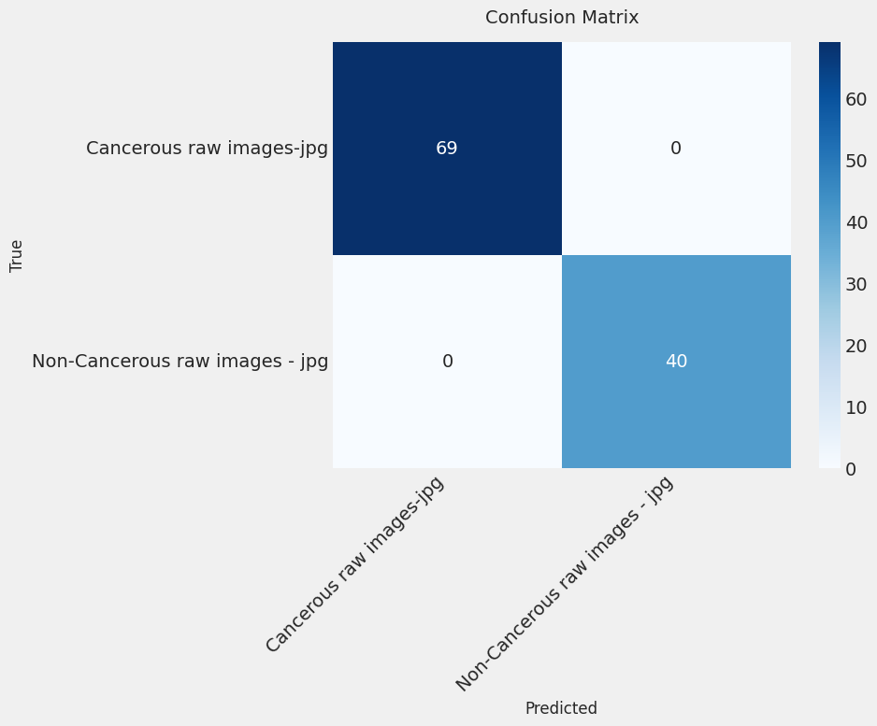
Fig 3. Confusion matrix of the best performing model
Accuracy on training rises in the third epoch to about 1.0 and does not change, whereas the same occurs with validation, achieving and staying at 1.0. The fact that training and validation curves are almost identical is a sign of good generalization performance, which was probably achieved through the massive data augmentation, which increased the data size to 1,092 images. The most efficient performance at epoch 3, far below the maximum number of epochs set in the methodology which was 50, points to the effectiveness of the training setup, including the Adam optimizer and learning rate of 0.0001 (Tan and Le, 2019). These findings, in general, support the applicability of NASNet Mobile to lung cancer classification, especially in the clinical environments where resources are limited.
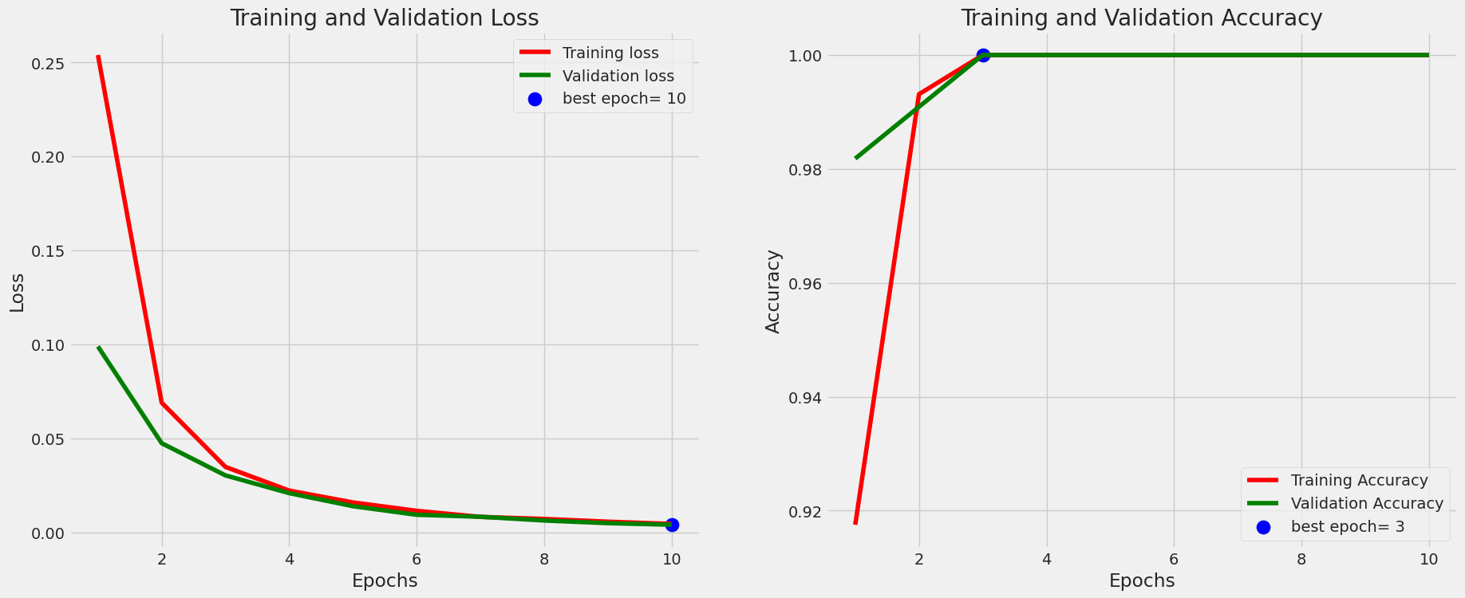
Fig 4. Training and validation lossAccuracy graph of the best performing model

Model Interpretability
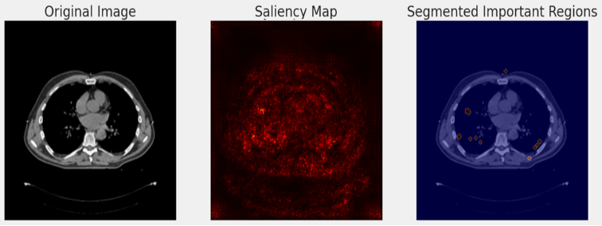
Model interpretability is a critical component of the practice of implementing deep learning systems in clinical practice effectively because it guarantees that model predictions match radiological understanding and facilitates the development of trustworthiness among clinicians. This paper has used two visualization methods namely saliency maps and Gradient weighted Class Activation Mapping (GradCAM) to interpret how the most successful model, NASNet Mobile, arrives at its decision when presented with lung CT scan data.
Fig 5 . Saliency Map explanation of the best performing model
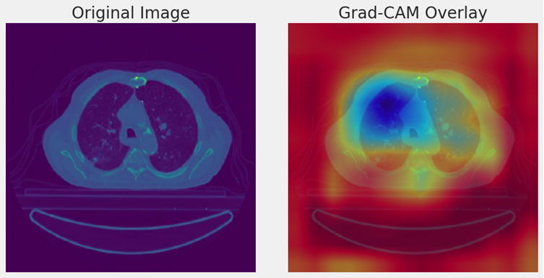
The saliency map produced on a cancer CT image shows the contributions made on the classification result on a pixel by pixel basis. It can be seen that the high intensity areas (red and yellow) are focused on the irregular borders of the tumor, meaning that NASNet Mobile pays much attention to these areas when detecting the presence of cancer and noncancerous cells. Compared to other areas, e.g., the surrounding lung parenchyma, areas of activation are limited here proposing that the model is effective in filtering irrelevant features (Simonyan et al., 2014). This finding is much in line with the clinical knowledge, according to which tumor margins are regarded as important diagnostic features.
Fig 6. GradCam explanation of the best performing model
Equally, the GradCAM heatmap on the identical image offers a less fine grained localization of the important areas. The heatmap exhibits a strong activation in the area of the tumor core and its close environment, which gradually decreases in intensity towards the peripheral areas in the lungs. Such a trend shows that this model pays attention to both the mass of the tumor in the middle and the surrounding areas of abnormality, both of which are essential to defining malignancy (Selvaraju et al., 2017). The similarity between GradCAM and saliency map visualizations is the further confirmation that the model makes use of clinically significant features. In general, such interpretability methods promote the trust in the predictions of the NASNet Mobile as it shows that it is attentive to the relevant tumor features, which promotes the high performance in the classification by the NASNet Mobile. But more rigorous testing on a wider variety of data is needed to ensure the strength of these results and to enhance the administration of AI based models into the clinical decision making environment.

Conclusion and Future Work
In this paper, we have indicated the potential transformational approach of deep learning in diagnosing lung cancer based on a dataset of 364 CT scan images taken in a hospital in Iran which includes 238 cancer and 126 noncancer cases.
The results highlight the usefulness of lightweight and architecture search optimised models such as NASNet Mobile, especially in low resource settings. The use of data augmentation was important to mitigate the challenges of having a limited dataset, as it increased model resilience to a significant extent (Zoph et al., 2018). The paper provides a multimodal comparison, a useful augmentation framework and explanatory analysis, which can contribute to the development of AI based diagnostic systems in low resource contexts. Also, the fast convergence of training and validation measures is another confirmation of the correctness of the offered methodology. Future studies ought to be directed towards the validation of these findings with larger multi institutional data so as to overcome overfitting and the bias due to regions. The application of hybrid architectures involving CNNs with transformer based models can be further explored in order to improve the potential of feature extraction. Furthermore, to make NASNet Mobile more applicable to clinical use in real time it should be optimized to analyze longitudinal CT data on disease progression, and be able to interpret the information in relation to a wide range of lung pathologies to become more broadly applicable. The developments have a huge potential to achieve better early detection, lessening the load of diagnoses, and improving patient outcomes at the global level.

References
- G. Litjens et al., “A survey on deep learning in medical image analysis,” Medical Image Analysis, vol. 42, pp. 60–88, 2017, doi: 10.1016/j.media.2017.07.005.
- [2] S. Devi et al., “Deep learning approaches for lung cancer detection: A comprehensive review,” Journal of Medical Imaging and Health Informatics, vol. 14, no. 2, pp. 201–219, 2024.
- [3] M. Thanoon et al., “CNN-based pulmonary nodule detection using CT images,” Biomedical Signal Processing and Control, vol. 81, p. 104376, 2023.
- [4] R. Kumar et al., “Hybrid ResNet and EfficientNet framework for lung cancer detection using CT scans,” Computers in Biology and Medicine, vol. 172, p. 107954, 2024.
- [5] P. Mikhael et al., “Sybil: A validated deep learning model to predict future lung cancer risk from low-dose chest computed tomography,” Journal of Clinical Oncology, vol. 41, no. 12, pp. 2191–2200, 2023.
- [6] R. M. Wehbe et al., “Deep learning-based detection of lung cancer using YOLOv8 architecture,” IEEE Access, vol. 12, pp. 55121–55134, 2024.
- [7] S. Shah et al., “Explainable deep learning framework for lung cancer subtype classification using Grad-CAM,” Diagnostics, vol. 15, no. 1, p. 88, 2025.
- [8] A. Bushara et al., “LCDCapsNet: Capsule network integrated CNN for lung cancer diagnosis,” Artificial Intelligence in Medicine, vol. 154, p. 102940, 2025.
- [9] X. Ma et al., “Optimized V-Net architecture for pulmonary nodule segmentation in CT images,” Medical Physics, vol. 51, no. 3, pp. 1345–1358, 2024.
- [10] Y. Liu et al., “Deep learning-based classification of sub-centimeter pulmonary nodules,” Scientific Reports, vol. 13, p. 17834, 2023.
- [11] J. Sori et al., “DFDNet: Denoising feature detection network for lung nodule analysis,” IEEE Journal of Biomedical and Health Informatics, vol. 27, no. 8, pp. 3921–3930, 2023.
- [12] S. Gautam et al., “Comparative analysis of deep CNN architectures for lung cancer detection,” Healthcare, vol. 12, no. 6, p. 745, 2024.
- [13] H. Hosseini et al., “Hybrid CNN-transformer framework for automated lung cancer diagnosis,” Pattern Recognition Letters, vol. 182, pp. 44–53, 2024.
- [14] T. Worku et al., “VER-Net: A stacked ensemble deep learning model for lung cancer classification,” Multimedia Tools and Applications, vol. 83, pp. 11425–11447, 2024.
- [15] S. Shetty et al., “Shepard CNN: Optimized deep learning framework for lung cancer detection,” Applied Soft Computing, vol. 151, p. 111120, 2024.
- [16] P. Aswathy et al., “BoVWC-RNN based classification of nano-segmented CT images for lung cancer detection,” Expert Systems with Applications, vol. 214, p. 119203, 2023.

