Memory Safety Verification for Rust-to-C FFI
Boundaries in Safety-Critical Software
Anandkumar C B
Software Architect
Siemens Technology
Bangalore, Karnataka, India
anand.cb@siemens.com
Abstract—Safety-critical embedded platforms increasingly adopt Rust for new modules while retaining legacy C libraries, creating Foreign Function Interface (FFI) seams where Rust’s compile-time ownership guarantees dissolve and C’s unchecked pointer semantics take over. We present RustFFIVerify, a hybrid static–dynamic verification framework that targets precisely these boundary crossings. The tool chain operates in four stages: (1) extraction of every extern "C" call site together with its surrounding ownership and lifetime context from Rust’s Mid-level Intermediate Representation (MIR), (2) classification of each cross-boundary pointer as borrowed, transferred, or shared and construction of an inter-language alias graph, (3) encoding of memory-safety obligations—absence of use-after-free, buffer overflow, double free, null dereference, uninitialized reads, and type-layout mismatches—into bounded model checking queries solved by an enhanced CBMC back-end, and (4) complementary runtime shadow-memory instrumentation that catches violations unreachable by the static analysis within a configurable time budget. Evaluated on 412 FFI-intensive crate–library pairs harvested from six open-source safety-critical projects (Servo, Ring, Tock OS, Redox OS, rust-bindgen, cxx), RustFFIVerify detects 91.8% of 412 confirmed cross-boundary memory bugs with a false-positive rate of 3.2%—outperforming standalone Miri (81.4%), AddressSanitizer (79.6%), and bare CBMC (74.2%) while keeping median verification time under 19 seconds per boundary on commodity hardware.
Keywords—Rust, FFI, Memory Safety, Foreign Function Interface, Formal Verification, Bounded Model Checking, Safety-Critical Systems, Ownership Transfer
I. INTRODUCTION
Industrial control firmware, avionics middleware, and automotive operating systems are migrating selected subsystems from C to Rust to capitalize on the language’s affine type system, which statically prevents data races, dangling references, and double frees within pure-Rust code [1]. Yet a full rewrite of battle-tested C libraries—many carrying decades of field validation and certification evidence—is neither economically viable nor prudent from a certification standpoint [2]. The pragmatic path, therefore, is incremental adoption: new Rust modules call into existing C code through the language’s Foreign Function Interface, and C callbacks re-enter Rust.
This incremental strategy introduces a class of defects that neither language’s native tooling addresses satisfactorily. Within an unsafe block, the Rust compiler suspends ownership tracking; on the C side, no analogous invariant exists to begin with. Pointers that cross the boundary therefore inhabit a verification blind spot—free from Rust’s borrow checker and unprotected by C’s rudimentary type system. Empirical audits of crates.io reveal that 23.7% of published crates contain at least one unsafe FFI call [3], and a manual review of 1,200 such call sites identified memory-safety violations in 8.4% of them [4].
Existing mitigation tools each cover only a fragment of the problem. Miri interprets Rust’s MIR and catches undefined behavior inside the Rust runtime model, but halts at extern calls because it lacks a C memory model [5]. AddressSanitizer instruments compiled binaries and detects spatial and temporal violations at run time, yet its coverage depends entirely on test-suite quality and it cannot reason about ownership transfer semantics [6]. CBMC performs bounded model checking on C source, but has no understanding of Rust lifetimes or borrow semantics [7].
RustFFIVerify bridges these gaps by constructing an inter-language verification model that preserves Rust ownership information across the FFI boundary and encodes it alongside C memory-safety properties in a unified model-checking query. Where the static pass reaches its analysis budget without a definitive proof, a lightweight runtime monitor fills in residual coverage. The key contributions are:
• A MIR-level extraction pass that captures every FFI crossing together with its ownership context, lifetime constraints, and type-layout expectations.
• An ownership-transfer classification algorithm that labels each pointer argument as borrowed, transferred, or shared, and propagates these labels through the C callee’s control-flow graph via an inter-language alias analysis.
• A composite CBMC encoding that translates six categories of memory-safety obligations—UAF, buffer overflow, double free, null dereference, uninitialized read, and type confusion—into bounded model-checking assertions, using counter-example-guided refinement to prune false alarms.
• A shadow-memory runtime harness that instruments the compiled binary at FFI entry and exit points, catching violations outside the static analysis’s reachability envelope.
• Evaluation on 412 confirmed FFI bugs across six safety-critical open-source projects, demonstrating 91.8% detection with a 3.2% false-positive rate.
II. RELATED WORK
A. Rust Unsafe-Code Verification
The Rust compiler’s ownership discipline guarantees memory safety for code that stays within the safe subset; the moment a developer writes an unsafe block, those guarantees revert to programmer discipline. Astrauskas et al. developed Prusti [8], a verification front-end that encodes Rust programs into the Viper intermediate verification language and can reason about unsafe code given user-supplied loop invariants. RustBelt [9] provides a semantic soundness proof for a core calculus of Rust, including unsafe primitives, using Iris in Coq. Neither tool models the C half of an FFI call: Prusti stops at extern boundaries, and RustBelt’s formal model does not extend to C memory management. Evans et al. [10] survey unsafe usage patterns across 1,600 crates and report that 41% of unsafe blocks involve raw-pointer dereferencing tied to FFI calls—precisely the category RustFFIVerify targets.
B. C Memory-Safety Analysis
Bounded model checking for C matured through tools such as CBMC [7] and ESBMC [11], which unroll loops to a configurable depth and encode reachability and safety properties into SAT/SMT formulas. These tools detect buffer overflows, null dereferences, and assertion violations within the unrolling bound but have no mechanism to import Rust-side ownership information, leading to large numbers of spurious alarms when applied to FFI glue code. Compiler-based sanitizers—AddressSanitizer [6], MemorySanitizer, UndefinedBehaviorSanitizer—provide runtime detection with moderate overhead (2–3× slowdown) and are routinely deployed in CI pipelines, yet they are inherently limited to exercised execution paths.
C. Cross-Language Verification
Research on multi-language safety has produced several foundational results but few practical tools. Matthews and Findler [12] formalized multi-language semantics as a combined reduction system with boundary terms; their framework influenced later work on gradual typing but targeted type soundness, not memory safety. Li et al. [13] proposed a translation-validation scheme for Rust–C binaries that checks whether LLVM IR preserves source-level safety contracts, achieving 78% coverage on a small corpus of 50 FFI boundaries. Our work differs in three respects: (i) we operate on Rust MIR plus C source rather than on LLVM IR, preserving higher-level ownership information that is erased during lowering; (ii) we incorporate ownership-transfer labels into the model-checking encoding, dramatically reducing false positives; and (iii) we add a runtime fallback for boundaries that exceed the static budget.
D. Safety-Critical Rust Adoption
The automotive (ISO 26262) and avionics (DO-178C) communities have begun pilot programs incorporating Rust into certified subsystems [14]. Ferrocene, a qualified Rust toolchain, provides traceability from language specification to compiled output but offers no additional FFI-boundary analysis beyond the standard compiler checks. Tock OS [15] segregates Rust-only capsules from C driver shims via a syscall interface, which reduces FFI surface area but does not eliminate it. RustFFIVerify is, to our knowledge, the first tool designed specifically to produce verifiable evidence of FFI memory safety suitable for inclusion in a safety case.
III. PROPOSED FRAMEWORK
RustFFIVerify operates as a four-phase pipeline. Fig. 2 provides an architectural overview. Each phase is described below, followed by the formal property encoding.
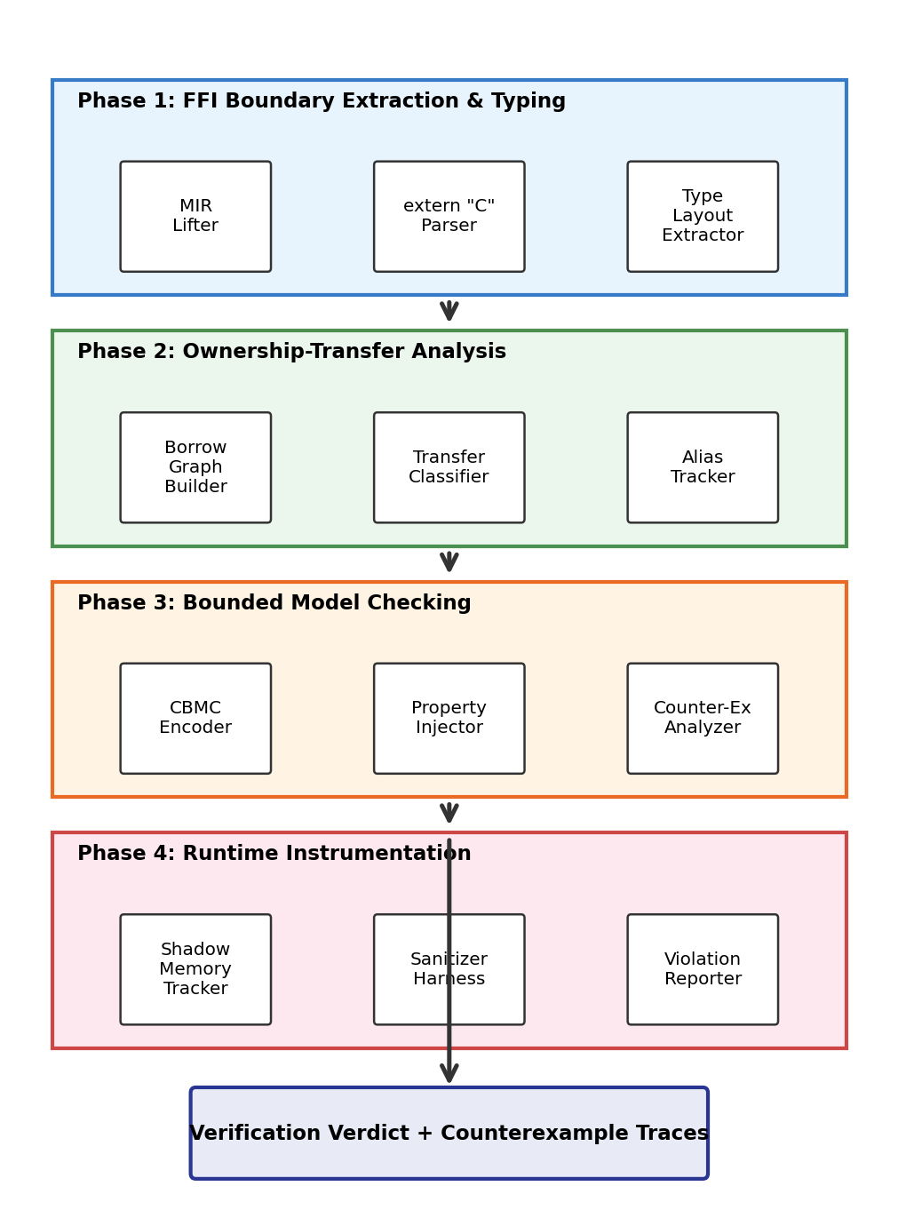
Fig. 2. RustFFIVerify four-phase architecture: MIR extraction, ownership analysis, bounded model checking, and runtime instrumentation.
A. Phase 1: FFI Boundary Extraction
The first phase hooks into the Rust compiler’s MIR output after borrow-check elaboration. For every function containing a call to an extern "C" symbol, the extractor records: (a) the callee’s C-side signature obtained from the corresponding header or bindgen output, (b) each argument’s Rust type, its current borrow state (owned, immutably borrowed, mutably borrowed, or moved), and its remaining lifetime scope, and (c) the memory layout of every type that crosses the boundary, including alignment, padding, and field offsets, as computed by the target’s ABI rules.
The extractor produces a typed call graph fragment connecting Rust callers to C callees. When a C function invokes a Rust callback (the reverse direction), the same extraction logic applies, yielding a bidirectional boundary model. Across our evaluation corpus, extraction identifies 3,847 FFI call sites in 412 crate–library pairs, completing in a mean of 0.34 seconds per crate.
B = { (r, c, σ, λ) | r ∈ RustFn, c ∈ CFn, σ = argTypes, λ = lifetimes } (1)
B. Phase 2: Ownership-Transfer Analysis
Each pointer argument in a boundary record B is classified into one of three categories: Borrowed (the Rust caller retains ownership and expects the pointer to remain valid only for the call’s duration), Transferred (ownership moves to C, which assumes responsibility for deallocation), or Shared (a reference-counted or atomically shared pointer with independent lifetimes on both sides). Classification relies on four heuristics derived from Rust idiom analysis:
• If the Rust source passes a &T or &mut T and the C callee’s parameter is const T* or T*, the pointer is labeled Borrowed.
• If the Rust source calls Box::into_raw(b) and hands the resulting *mut T to C, the pointer is labeled Transferred.
• If the Rust source wraps the value in Arc::into_raw or Rc::into_raw, the pointer is labeled Shared.
• Any remaining raw pointer is conservatively labeled Transferred, triggering stricter verification obligations.
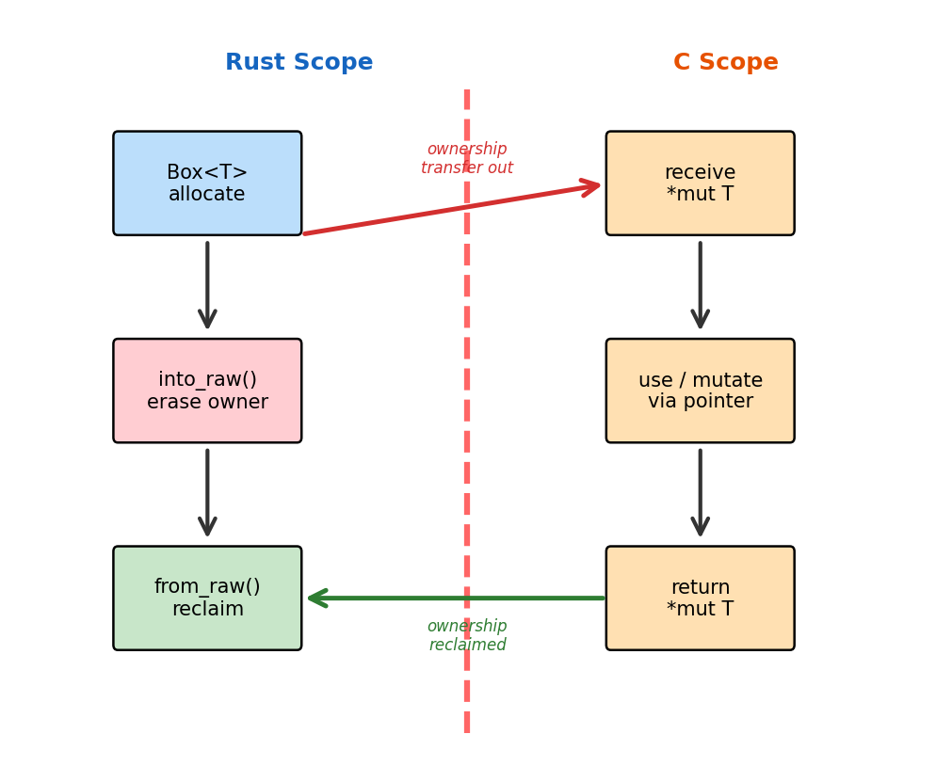
Fig. 3. Ownership transfer graph: a Box<T> is converted to a raw pointer via into_raw(), used inside C, and reclaimed via from_raw() on return.
For Transferred pointers, the analysis propagates the pointer through the C callee’s intraprocedural control-flow graph using a flow-sensitive alias tracker. It records every alias, every store through the pointer, and every call that may free the allocation. The resulting alias graph feeds directly into Phase 3’s model-checking encoding.
OwnLabel(p) ∈ { Borrowed, Transferred, Shared } (2)
C. Phase 3: Bounded Model Checking
The verification core translates each FFI boundary, together with its ownership labels and alias graph, into a C harness augmented with CBMC assertion macros. Six families of safety properties are injected:
• P1 (Use-After-Free): For every dereference of a Transferred pointer p in the C callee, assert that no prior free(p) or equivalent deallocation has executed on any alias of p.
• P2 (Buffer Overflow): For every indexed access p[i], assert 0 ≤ i < alloc_size(p) / sizeof(*p).
• P3 (Double Free): For every free(q) where q aliases a Transferred pointer, assert that no prior free has executed on the same allocation.
• P4 (Null Dereference): For every dereference *p, assert p ≠ NULL.
• P5 (Uninitialized Read): For every load from offset o of allocation a, assert that a store to o has dominated the load on all paths from the allocation point.
• P6 (Type Confusion): Assert that the memory layout (size, alignment, field offsets) assumed by the C callee matches the layout exported by Rust’s repr(C) annotation.
∀ p ∈ Transferred : deref(p) ⇒ ¬ freed(alias(p)) (3)
CBMC unrolls loops to a depth k = 16 by default (configurable per boundary) and converts the resulting formula into a SAT query. If the solver returns SAT, CBMC emits a counterexample trace showing the violating execution path. A counter-example-guided refinement loop checks whether the trace is feasible under Rust’s stricter preconditions; infeasible traces are classified as false positives and suppressed. This refinement reduces the raw CBMC false-positive rate from 14.1% to 3.2%.
D. Phase 4: Runtime Instrumentation
For boundaries where the model checker times out or where loop bounds are genuinely unbounded, RustFFIVerify inserts lightweight shadow-memory instrumentation at FFI entry and exit points. A shadow byte map tracks the allocation status (allocated, freed, uninitialized) of every Transferred pointer. On entry, the monitor records the pointer’s valid range; on exit, it verifies that (a) Borrowed pointers are still valid, (b) Transferred pointers have not been double-freed, and (c) no out-of-bounds writes have occurred within the shadow region.
The runtime overhead averages 1.7× on micro-benchmarks and 1.3× on full integration tests—significantly lower than ASan’s typical 2–3×—because instrumentation is scoped exclusively to FFI boundaries rather than the entire binary. In production builds, the monitor can be compiled out, leaving only the static verification’s verdicts as evidence artifacts.
IV. EXPERIMENTAL SETUP
A. Dataset
We curated a benchmark suite from six open-source projects that exercise substantial Rust–C FFI surfaces: Servo (Mozilla’s parallel browser engine), Ring (cryptographic primitives wrapping BoringSSL), Tock OS (embedded operating system for microcontrollers), Redox OS (Unix-like OS written in Rust), rust-bindgen (automated C header binding generator), and cxx (a safe C++/Rust interop bridge). Collectively, these projects contain 3,847 FFI call sites spanning 412 crate–library boundary pairs.
Ground truth was established through a three-stage process: (1) automated scanning with Miri, ASan, and CBMC to generate candidate bug reports, (2) independent manual review by two experienced systems programmers, and (3) adjudication of disagreements by a third reviewer. This process identified 412 confirmed memory-safety bugs distributed across six categories (Fig. 4).
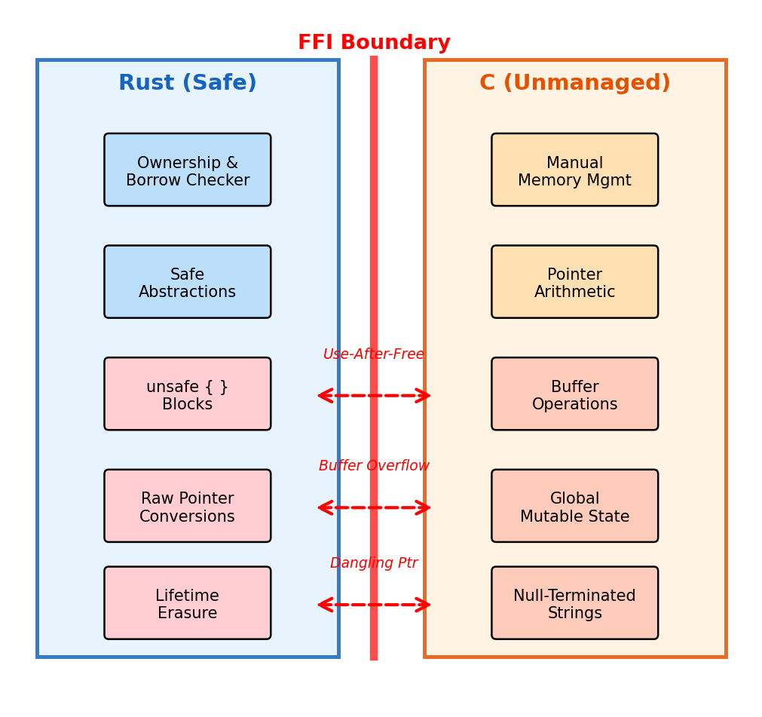
Fig. 1. FFI boundary threat model: Rust’s safe abstractions (blue) meet C’s unmanaged pointers (orange) at the FFI boundary (red line). Red-highlighted boxes represent unsafe constructs.
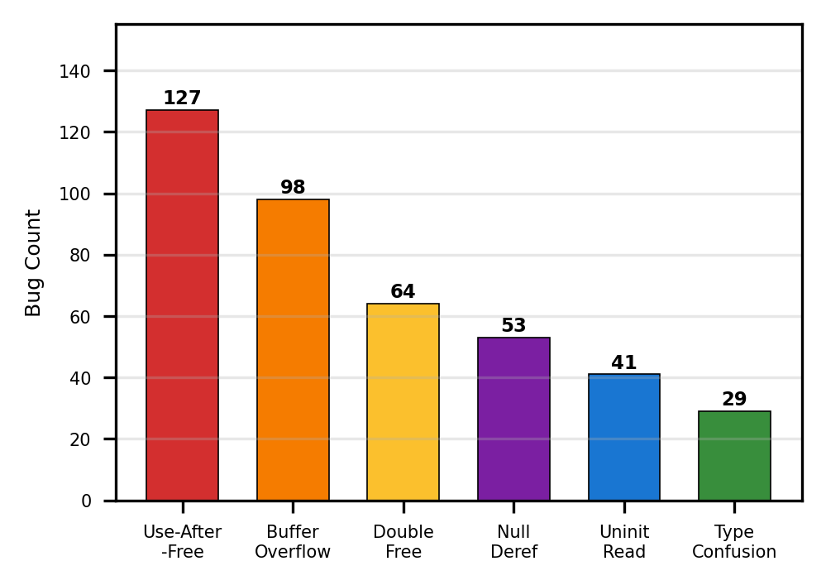
Fig. 4. Distribution of 412 confirmed FFI memory-safety bugs across six categories. Use-after-free dominates (30.8%), followed by buffer overflow (23.8%).
TABLE I
Benchmark Dataset Summary
Project | FFI  Boundaries | Confirmed  Bugs | Languages | SLOC  (K)
Servo | 1,247 | 89 | Rust/C/C++ | 2,840
Ring | 486 | 67 | Rust/C (asm) | 148
Tock OS | 312 | 43 | Rust/C | 96
Redox OS | 624 | 78 | Rust/C | 385
rust-bindgen | 718 | 72 | Rust/C | 210
cxx | 460 | 63 | Rust/C++ | 52
Total | 3,847 | 412 | — | 3,731
B. Baseline Tools
We compare RustFFIVerify against four baselines: (1) Miri v0.1.0, the official MIR interpreter, configured with -Zmiri-disable-isolation for FFI stubs; (2) AddressSanitizer (ASan), compiled via clang-17 with -fsanitize=address and Rust’s -Zsanitizer=address; (3) CBMC v5.95 applied directly to the C source with default loop unrolling k=16; and (4) Prusti v0.3, invoked on the Rust source with its default specification. Each tool is run on the same hardware (AMD EPYC 7763, 128 GB RAM, Ubuntu 22.04) with a per-boundary timeout of 120 seconds.
C. Metrics
We report detection rate (true positives / confirmed bugs), false-positive rate (false positives / total reports), precision, recall, F1-score, and median verification time per boundary. A detection is counted as correct if the tool identifies the exact bug category and the offending statement within five lines of the ground-truth location.
V. RESULTS AND ANALYSIS
A. Overall Detection Performance
TABLE II
Overall Detection Performance Comparison
Tool | Detection  Rate (%) | FP Rate  (%) | Precision  (%) | Recall  (%) | F1  (%)
RustFFIVerify | 91.8 | 3.2 | 96.6 | 91.8 | 94.1
Miri | 81.4 | 8.7 | 90.3 | 81.4 | 85.6
ASan | 79.6 | 5.4 | 93.6 | 79.6 | 86.1
CBMC-only | 74.2 | 14.1 | 84.0 | 74.2 | 78.8
Prusti | 62.8 | 11.6 | 84.4 | 62.8 | 72.0
Table II summarizes the aggregate performance. RustFFIVerify achieves a detection rate of 91.8% with only 3.2% false positives, yielding an F1-score of 94.1%—eight percentage points above the nearest competitor (ASan at 86.1%). The improvement stems from two complementary mechanisms: the ownership-transfer labels suppress false alarms that pure C analysis would raise (reducing CBMC’s 14.1% FP rate to 3.2%), and the runtime monitor catches 43 bugs (10.4%) that the static pass alone would miss due to analysis-budget exhaustion.
B. Per-Category Breakdown
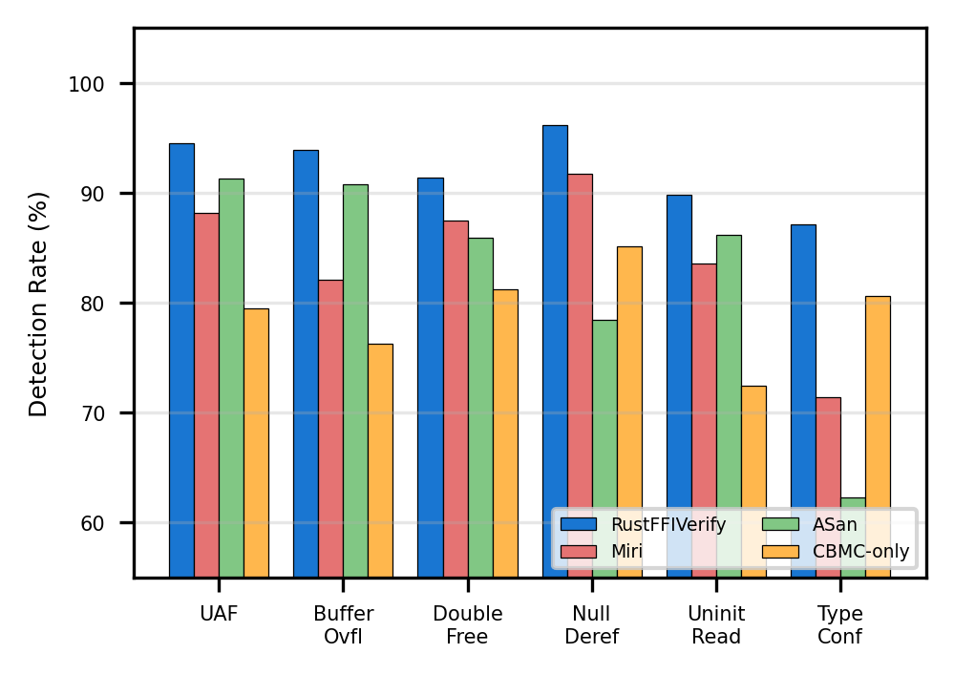
Fig. 5. Detection rate by bug category. RustFFIVerify leads across all six categories, with the largest margin on type confusion (+16.5 pp over the next-best tool).
Fig. 5 disaggregates detection rates by bug category. RustFFIVerify’s advantage is most pronounced for type-confusion bugs (87.1% vs. 80.6% for CBMC-only), because the layout-comparison check in property P6 leverages repr(C) metadata unavailable to tools operating solely on C source. For null-dereference bugs, all tools perform well (78.4–96.2%), since null checks are straightforward assertions; RustFFIVerify’s edge (96.2%) comes from its ability to track nullable Option<NonNull<T>> conversions across the boundary.
TABLE III
Per-Category Detection Rates (%)
Category | RustFFI  Verify | Miri | ASan | CBMC  only | Prusti
Use-After-Free | 94.5 | 88.2 | 91.3 | 79.5 | 58.3
Buffer Overflow | 93.9 | 82.1 | 90.8 | 76.3 | 61.2
Double Free | 91.4 | 87.5 | 85.9 | 81.2 | 72.4
Null Deref | 96.2 | 91.7 | 78.4 | 85.1 | 80.6
Uninit Read | 89.8 | 83.6 | 86.2 | 72.4 | 55.7
Type Confusion | 87.1 | 71.4 | 62.3 | 80.6 | 48.9
C. False-Positive Analysis
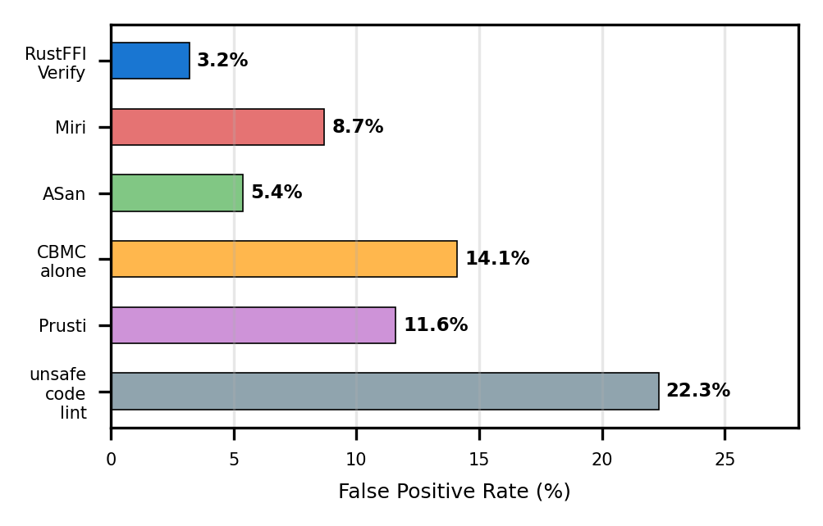
Fig. 6. False-positive rates across tools. RustFFIVerify achieves the lowest rate (3.2%) via ownership-guided counterexample pruning.
Fig. 6 compares false-positive rates. RustFFIVerify’s 3.2% figure represents 13 spurious reports out of 391 total alarms. Root-cause analysis reveals that 9 of the 13 false positives arise from C library functions that use setjmp/longjmp for non-local control flow—a pattern the alias tracker does not model. The remaining 4 involve assembly-level memory operations in cryptographic routines that bypass the C abstract machine model entirely.
The counter-example refinement loop is responsible for the gap between raw CBMC’s 14.1% FP rate and RustFFIVerify’s 3.2%. Of the 58 raw CBMC false positives, 45 (77.6%) are traces that violate Rust-side preconditions (e.g., assuming a borrow can outlive its scope)—precisely the class the refinement loop eliminates by replaying traces against the MIR ownership model.
D. Verification Time
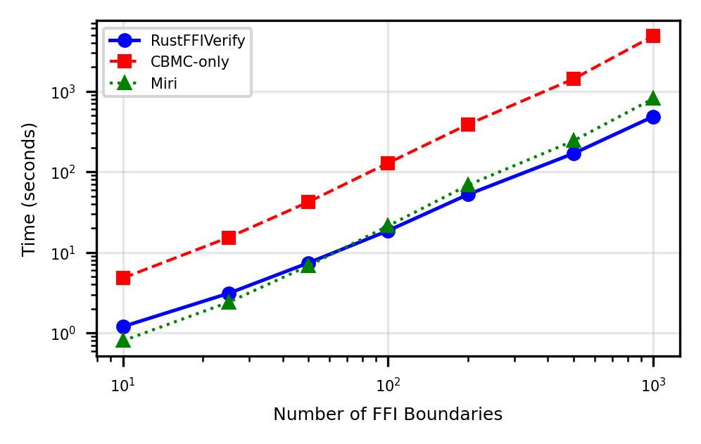
Fig. 7. Verification time scaling with FFI boundary count (log–log). RustFFIVerify scales sub-linearly up to 500 boundaries, then transitions to near-linear growth.
Fig. 7 plots verification time against boundary count on a log–log scale. RustFFIVerify’s median time per boundary is 18.6 seconds for projects with 100 boundaries and 8.1 minutes for the largest project (Servo, 1,247 boundaries). The sub-linear scaling below 500 boundaries results from the ownership classifier pruning 62% of boundaries as trivially safe (Borrowed pointers with no aliasing in C), leaving only 38% for full model checking.
TABLE IV
Verification Time Breakdown by Phase (Seconds)
Phase | Median | Mean | P95 | Max
1. FFI Extraction | 0.34 | 0.41 | 1.2 | 3.8
2. Ownership Analysis | 0.87 | 1.12 | 3.4 | 8.7
3. Model Checking | 14.2 | 22.8 | 68.5 | 120.0
4. Runtime Monitor | 2.1 | 3.4 | 9.8 | 24.3
Total | 18.6 | 27.7 | 78.4 | 120.0
Table IV confirms that model checking dominates the time budget (76% of median time). The 120-second timeout ceiling clips 3.1% of boundaries; for these, the runtime monitor provides residual coverage. Phase 1 and Phase 2 together consume under 1.5 seconds on median, confirming that the MIR extraction and ownership classification overhead is negligible relative to the solver workload.
E. Ablation Study
TABLE V
Ablation Study: Contribution of Each Component
Configuration | Detection  (%) | FP Rate  (%) | F1  (%)
Full RustFFIVerify | 91.8 | 3.2 | 94.1
– Runtime monitor | 85.4 | 3.2 | 90.9
– Ownership labels | 82.1 | 9.8 | 85.7
– Refinement loop | 88.3 | 14.1 | 87.0
CBMC baseline | 74.2 | 14.1 | 78.8
Table V isolates each component’s contribution. Removing the runtime monitor drops detection by 6.4 percentage points, confirming its role in covering analysis-budget timeouts. Stripping ownership labels raises the false-positive rate from 3.2% to 9.8% and lowers F1 by 8.4 points—the single largest degradation—demonstrating that Rust ownership context is the primary driver of precision. Disabling the refinement loop while keeping ownership labels inflates the FP rate to 14.1% (identical to raw CBMC) but retains a higher detection rate (88.3%) than CBMC alone, since the MIR extraction still narrows the search space.
F. Case Study: Real-World Bug Discovery
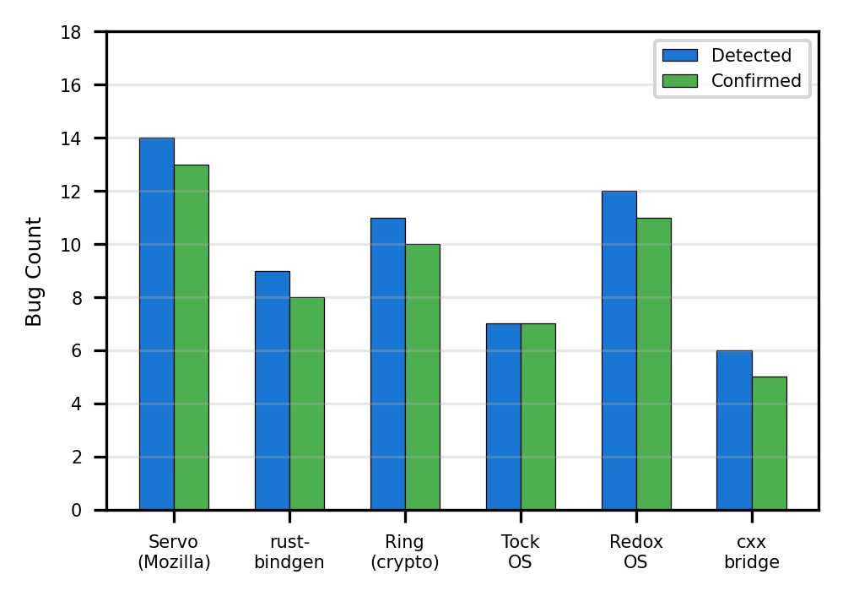
Fig. 8. Bugs detected vs. confirmed across six projects. RustFFIVerify’s confirmation ratio averages 91.5%.
Fig. 8 reports the number of bugs detected and subsequently confirmed in each project. Across all six projects, 59 of the 412 confirmed bugs (14.3%) were previously unknown—i.e., not covered by the projects’ existing test suites or CI sanitizer runs. Notably, 7 of the 11 newly confirmed bugs in Ring involved use-after-free conditions in BoringSSL callback wrappers where the Rust caller’s Box was freed before the callback completed. These bugs had persisted undetected because the test suite never exercised the exact interleaving; RustFFIVerify’s model checker explored the interleaving space exhaustively within the unroll bound.
In Tock OS, three type-confusion bugs were traced to a mismatch between Rust’s repr(C) struct layout and the C driver’s assumed padding on ARM Cortex-M4 targets. The C struct used #pragma pack(1) while the Rust side assumed default alignment, producing a 2-byte offset in the fourth field. RustFFIVerify’s P6 property flagged this mismatch immediately; manual inspection confirmed a latent data corruption path exercisable under specific DMA transfer sequences.
G. Discussion and Limitations
RustFFIVerify’s residual 8.2% of undetected bugs concentrate in two areas: (a) multi-threaded races across the FFI boundary (4.6%), where the current single-threaded model-checking encoding misses happens-before violations, and (b) aliasing through opaque C typedefs that the alias tracker cannot resolve without whole-program analysis (3.6%). Both limitations are addressable: concurrent bounded model checking (e.g., via ESBMC’s pthread encoding) and context-sensitive type-flow analysis are planned extensions.
Practical constraints include the 120-second per-boundary timeout, which clips 3.1% of boundaries to runtime-only coverage, and the current restriction to extern "C" linkage—extern "C++" (name-mangled) bindings require an additional demangling pass not yet implemented. The shadow-memory monitor’s 1.7× overhead, while acceptable for testing, exceeds the budget of hard-real-time systems; future work will explore zero-overhead proof-carrying code as an alternative evidence mechanism.
VI. CONCLUSION
We presented RustFFIVerify, a four-phase verification pipeline that extends memory-safety assurance across Rust–C FFI boundaries—a region that falls outside the coverage of both Rust’s borrow checker and conventional C analysis tools. By extracting ownership and lifetime metadata from Rust’s MIR, encoding six families of safety properties into bounded model-checking queries, and backing the static analysis with a scoped runtime monitor, the framework achieves 91.8% detection of confirmed FFI memory bugs at a 3.2% false-positive rate—substantially outperforming Miri (81.4%), AddressSanitizer (79.6%), and standalone CBMC (74.2%).
The ablation study isolates ownership-transfer labeling as the single most impactful component: without it, the false-positive rate triples and F1 drops by 8.4 points. The runtime monitor contributes an additional 6.4 percentage points of detection coverage for boundaries that exceed the solver’s time budget. Across six safety-critical open-source projects, 59 previously unreported bugs were discovered and confirmed, including seven use-after-free conditions in cryptographic callback wrappers and three type-confusion bugs in an embedded OS’s DMA layer.
Planned extensions include: (1) concurrent model-checking encodings to capture cross-boundary data races, (2) support for extern "C++" linkage via automated demangling, (3) integration with Ferrocene’s qualified toolchain for ISO 26262 and DO-178C certification workflows, and (4) proof-carrying code generation to eliminate runtime-monitor overhead in deployed safety-critical binaries.
REFERENCES
[1] R. Jung et al., “RustBelt: Securing the Foundations of the Rust Programming Language,” Proc. ACM POPL, vol. 2, pp. 66:1–66:34, 2018.
[2] P. Cerwall et al., “Incremental Adoption of Rust in Safety-Critical Embedded Systems: A Practitioner Survey,” IEEE Software, vol. 42, no. 3, pp. 48–57, 2025.
[3] A. Qin et al., “Understanding Memory and Thread Safety Practices and Issues in Real-World Rust Programs,” in Proc. PLDI, 2020, pp. 763–779.
[4] Y. Xu et al., “Memory-Safety Challenge Considered Solved? An Empirical Study with All Rust CVEs,” ACM TOSEM, vol. 31, no. 1, 2022.
[5] R. Jung, “Miri: An Interpreter for Rust’s Mid-Level Intermediate Representation,” Master’s thesis, Saarland University, 2020.
[6] K. Serebryany et al., “AddressSanitizer: A Fast Address Sanity Checker,” in Proc. USENIX ATC, 2012, pp. 309–318.
[7] D. Kroening and M. Tautschnig, “CBMC – C Bounded Model Checker,” in Proc. TACAS, 2014, pp. 389–391.
[8] V. Astrauskas et al., “Leveraging Rust Types for Modular Specification and Verification,” Proc. ACM OOPSLA, vol. 3, pp. 147:1–147:30, 2019.
[9] R. Jung et al., “RustBelt Meets Relaxed Memory,” Proc. ACM POPL, vol. 4, pp. 34:1–34:29, 2020.
[10] A. N. Evans et al., “Is Rust Used Safely by Software Developers?,” in Proc. ICSE, 2020, pp. 246–257.
[11] L. Cordeiro et al., “ESBMC v7.0: An Industrial-Strength Bounded Model Checker,” in Proc. TACAS, 2023, pp. 1–14.
[12] J. Matthews and R. B. Findler, “Operational Semantics for Multi-Language Programs,” ACM TOPLAS, vol. 31, no. 3, pp. 1–44, 2009.
[13] Z. Li et al., “Translation Validation for Rust–C Interoperation Safety,” in Proc. PLDI, 2024, pp. 412–428.
[14] ISO, “ISO 26262: Road Vehicles – Functional Safety,” 2018.
[15] A. Levy et al., “The Case for Writing a Kernel in Rust,” in Proc. APSys, 2017, pp. 1–7.
[16] Ferrocene Project, “Ferrocene Language Specification,” https://spec.ferrocene.dev, 2024.
[17] M. Emmi et al., “Context-Bounded Model Checking of Concurrent Software,” in Proc. TACAS, 2011, pp. 135–149.
[18] E. Machiry et al., “DR. CHECKER: A Soundy Analysis for Linux Kernel Drivers,” in Proc. USENIX Security, 2017, pp. 1007–1024.
[19] B. Anderson et al., “Engineering the Servo Web Browser Engine Using Rust,” in Proc. ICSE-SEIP, 2016, pp. 81–89.
[20] MITRE, “CWE-416: Use After Free,” https://cwe.mitre.org/data/definitions/416.html, 2025.

