IntelliRead: Explainable Machine Learning for Dyslexia Risk Prediction: Behavioral Feature Analysis and Model Comparison Using XGBoost and SHAP
Suyash Ganesh Sutar¹, Alen K Varghese², Dr T Grace Shalini³
^{1,2,3}Department of Computational Intelligence,
SRM Institute Of Science and Technology,Chennai,India.
Emails: suyash2173@gmail.com , Alenkondoor@gmail.com , gracesht@srmist.edu.in

Abstract— Early and accurate identification of dyslexia remains a significant challenge in educational settings, where access to clinical assessment tools is often limited. While machine learning has shown promise for automated dyslexia screening, most existing approaches function as black-box models that offer no insight into their predictions, reducing trust and practical adoption among educators. This paper addresses the gap through a comparative study of Machine Learning models for Dyslexia risk prediction, combining behavioral feature engineering with SHAP-based explainability. Using the Rello et al. PLOS ONE benchmark dataset of 5,039 reading exercise samples from children aged 7–17, seventeen behavioral features are engineered from per-round hit rate, miss rate, accuracy trajectory, and performance consistency across 32 exercise rounds. Five model configurations are trained and evaluated — Logistic Regression, Random Forest, and XGBoost under both full and behavioral-only feature conditions — with class imbalance handled using SMOTE on the training set exclusively. XGBoost trained on behavioral features alone achieves an AUC of 0.953 and F1 score of 0.898. A structured ablation study confirms that behavioral signals alone are sufficient for accurate and privacy-preserving dyslexia screening, as the removal of demographic variables including gender, native language, and device type only reduces AUC by 0.011. SHAP TreeExplainer is applied to provide both global feature importance analysis and individual waterfall explanations, identifying mean hit rate, accuracy trend, and miss rate trajectory as the three dominant predictive signals. Results demonstrate that dyslexia risk prediction can be simultaneously accurate, explainable, and demographically independent — offering a transparent and ethically deployable framework for early screening in real educational environments.
Keywords— Dyslexia Screening, Explainable Artificial Intelligence, SHAP, XGBoost, Behavioral Feature Analysis, Machine Learning, Educational Data Mining, Class Imbalance, SMOTE, Learning Analytics.

INTRODUCTION
Dyslexia is one of the most prevalent neurodevelopmental learning disorders, affecting approximately 10–15% of school-age children worldwide [1], [3]. It mainly affects reading fluency, spelling accuracy and the ability to automatically process written language. But early recognition is a major challenge, despite its prevalence: formal diagnosis needs trained specialists and standardized assessments that most schools, especially in under-resourced settings, cannot easily afford.
Early dyslexia screening can be supported by machine learning, which is now a feasible approach. Classifiers trained on behavioural, handwriting and eye-tracking data have shown strong predictive performance [7], [8]. However, most existing systems are trained to optimise accuracy instead of interpretability, and thus output risk scores without explaining what features contributed to the prediction. This lack of transparency in educational settings makes it difficult for practitioners to trust or act on automated screening outputs [27, 28]. Explainable AI methods such as SHAP [29] provide a way to make these predictions traceable and meaningful to educators.
This study investigates three research questions.
- RQ1: Does XGBoost outperform simpler ML baselines for dyslexia risk prediction from behavioral reading features?
- RQ2: Can behavioral features alone — without demographic variables — achieve sufficient predictive performance for privacy-preserving screening?
- RQ3: Can SHAP analysis generate educator-interpretable explanations of individual dyslexia risk predictions?

RELATED WORK
Research on dyslexia detection has evolved across three broad directions — machine learning based classification, explainable AI in educational tools, and behavioral feature analysis in learning environments. Early systems focused on rule-based pattern recognition, while recent work has shifted toward data-driven approaches with stronger predictive performance. However, most studies treat accuracy and interpretability as separate concerns, rarely addressing both within a single framework. The following sections review key work across each direction and identify the gaps this study addresses.

ML Approaches for Dyslexia Detection
Early work in dyslexia detection relied on OCR-based handwriting analysis and rule-based pattern recognition to identify character-level errors such as reversals and omissions [6]. As the field progressed, supervised machine learning methods gained traction — Ibrahim et al. [7] combination of eye-tracking and ML classifiers. According to an article by Marino et al. [8], it’s possible to find out if someone has dyslexia by using natural language processing models based on the transformer architecture. The other more recent research done on handwriting classification has mainly used deep learning methods such as CNNs. These studies often focus on predictive accuracy at the expense of interpretability, and most models do not provide feature-level reasoning behind individual predictions.

Explainable AI in Education Sector
The theoretical basis of explainable ML is outlined by Guidotti et al. [27] and Doshi-Velez and Kim [28] who argue that the quality of explanation should be assessed in relation to the decision context of the end user – which is especially relevant in educational contexts. Al-Wabil et al. [10] showed that transparent model outputs enhance educator engagement with accessibility tools, while Kumar [15] showed that hybrid explainable systems generate more actionable educational outputs compared to black-box alternatives. This progress is not yet exploited in the case of behavioral dyslexia risk prediction, which is the problem addressed by this study.

Behavioral Feature-Based Learning Analytics
Rello and Ballesteros [5] demonstrated that reading exercise performance metrics — hit rate, miss rate, and accuracy across repeated trials — correlate meaningfully with dyslexia risk in children aged 7–17, providing the behavioural and empirical foundation this study builds upon. Kaur and Chauhan [16] further identified performance consistency and error trajectory as discriminative signals in educational AI, while Mayer [22] established the theoretical basis for using multimodal behavioural data in learning assessment. Together, these works support the use of aggregated exercise-level features as reliable proxies for underlying cognitive processing differences.

Gap Analysis
- Comparative Analysis of Related Work
STUDY | METHOD | REAL DATASET | EXPLAINABLE | BEHAVIORAL FEATURES
Safari et al. [6] | OCR + Rule-based | NO | NO | NO
Ibrahim et al. [7] | Eye-tracking + ML | YES | NO | PARTIAL
Marino et al. [8] | Transformer NLP | YES | NO | NO
Al-Wabil et al. [10] | XAI Framework | NO | YES | NO
Kumar [15] | Hybrid XAI | NO | YES | NO
Rello et al. [5] | Behavioral Study | YES | NO | YES
This work | XGBoost + SHAP | YES | YES | YES

No prior work simultaneously satisfies all four criteria. This study is the first to combine real behavioural data, ML classification, and SHAP explainability within a privacy-preserving dyslexia screening framework

DATASET AND PRE-PROCESSING

Dataset Description
This study uses the dataset introduced by Rello and Ballesteros [5], publicly available via Kaggle and originally published alongside a peer-reviewed PLOS ONE study. The dataset comprises 5,039 samples collected from children aged 7–17 across two interaction platforms — desktop and tablet. Each sample has the performance of a child over 32 rounds of reading exercises, and the target label represents whether the child is at risk of dyslexia or not. The class distribution is inherently imbalanced, with 4,499 non-dyslexic samples and 540 dyslexic samples — a ratio addressed during pre-processing.

Feature Engineering
Raw dataset columns consist of per-round performance metrics — Clicks, Hits, Misses, Score, Accuracy, and miss rate — repeated across 32 exercise rounds, yielding 192 raw features. Rather than feeding these directly into a classifier, we engineer 17 aggregate behavioural features that capture meaningful patterns across the full exercise session. These include mean and total hit and miss counts, mean accuracy and miss rate, accuracy and miss rate trends computed as linear regression slopes across rounds, their respective variances, worst-case accuracy and miss rate, hit-miss ratio, consistency score, and age. This aggregation reduces dimensionality while preserving the behavioural signals most relevant to dyslexia risk.
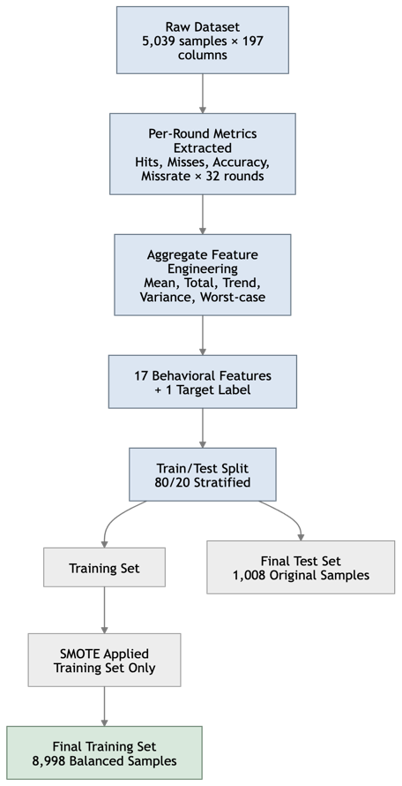
Fig. 1: Dataset Preprocessing and Feature Engineering Pipeline

Class Imbalance Treatment
The dataset is highly imbalanced, where the dyslexic sample takes only 10.7% of the full dataset. Training on imbalanced data directly risks a classifier that always predicts the majority class and thus reports high accuracy while missing true cases of dyslexia. To address this, Synthetic Minority Oversampling Technique (SMOTE) [CITE] is applied exclusively to the training set after the 80/20 train-test split, balancing both classes to 4,499 samples each. The test set is kept in its original distribution to ensure evaluation reflects real-world conditions.

METHODOLOGY

Feature Set Definition
Raw dataset columns consist of per-round performance metrics repeated across 32 exercise rounds, yielding 192 raw behavioural columns. Directly feeding these into a classifier introduces redundancy and noise without capturing the underlying behavioural patterns that distinguish dyslexic from non-dyslexic reading behaviour. Instead, we engineer 17 aggregate features that summarize performance trajectory, consistency, and error patterns across the full session.

Performance volume features capture the absolute quantity of correct and incorrect responses — mean hits, total hits, mean misses, total misses, and mean score. Rate features are the measures of proportion of correct and incorrect responses per round which means that mean accuracy, mean missrate, hit-miss ratio, and consistency score. Trajectory features describe how performance changes over the 32 rounds via linear regression slopes for accuracy trend and missrate trend. Variance features measure session-to-session stability — accuracy variance, missrate variance, worst accuracy, and best accuracy. Age is retained as a developmentally relevant variable given the dataset spans children aged 7–17. Demographic variables — gender, native language, other language, and device source — are excluded from the behavioural feature set and evaluated separately in the ablation study.
- Behavioral Feature Set with Categories
Feature | Category | Description
mean_hits | Performance | Mean correct responses across 32 rounds
total_hits | Performance | Cumulative correct responses
mean_misses | Performance | Mean incorrect responses per round
total_misses | Performance | Cumulative incorrect responses
mean_score | Performance | Mean score across rounds
mean_accuracy | Rate | Mean accuracy rate across rounds
mean_missrate | Rate | Mean miss rate across rounds
hit_miss_ratio | Rate | Total hits / (total misses + 1)
consistency_score | Rate | 1 minus coefficient of variation of accuracy
accuracy_trend | Trajectory | Linear slope of accuracy across 32 rounds
missrate_trend | Trajectory | Linear slope of miss rate across 32 rounds
accuracy_variance | Variance | Variance of accuracy across rounds
missrate_variance | Variance | Variance of miss rate across rounds
worst_accuracy | Variance | Minimum accuracy recorded across rounds
best_accuracy | Variance | Maximum accuracy recorded across rounds
worst_missrate | Variance | Maximum miss rate recorded across rounds
Age | Developmental | Participant age in years

Model Selection Rationale
Five model configurations are evaluated in a structured comparison. The selection covers the full spectrum from simple linear models to advanced ensemble methods, enabling a meaningful performance progression analysis.
1. Logistic Regression - It serves as the linear baseline. It assumes a linear decision boundary. It gives a performance floor to which more complex models are benchmarked. Its simplicity also provides a natural reference point for interpretability.
2. Random Forest – It is a machine learning approach that involves constructing multiple decision trees on multiple sub-samples of a given dataset. Each of these decision trees provides an independent estimate of the new data point's predicted outcome, where the outcome will be based on most of the individual decision tree predictions.
3. XGBoost - It is selected as the main model. It uses gradient boosting with regularization, which consistently outperforms other ensemble methods on structured tabular datasets [CITE]. Importantly, XGBoost works with the SHAP TreeExplainer natively, which enables exact computation of Shapley values (i.e. no approximation).
Both Random Forest and XGBoost are evaluated under two feature conditions — all features including demographic variables, and behavioural features only — forming a controlled ablation study. This yields five configurations total, as shown in Table III.
- Model Configurations and Feature Conditions
Configuration | Features Used | Purpose
Logistic Regression | Behavioural only | Linear baseline
Random Forest — All | All 21 features | Ensemble baseline
XGBoost — All | All 21 features | Full feature performance
Random Forest — Behavioural | 17 behavioural features | Ablation — no demographics
XGBoost — Behavioural | 17 behavioural features | Final recommended model

Training and Evaluation Strategy
All models are trained using an 80/20 stratified train-test split with random state fixed at 42 throughout for full reproducibility. Stratification ensures class proportions are preserved across both sets. SMOTE is applied exclusively to the training set after splitting, balancing the minority class from 540 to 4,499 samples. The test set is intentionally kept in its original imbalanced distribution to reflect real-world screening conditions — where dyslexic cases are genuinely rare.
Five performance metrics are reported for each configuration: accuracy, precision, recall, F1 score, and AUC-ROC. So both F1 and AUC ensures that model performance is not inflated by class imbalance. F1 balances precision and recall, while AUC-ROC measures discriminative ability independent of threshold. Five-fold cross-validation is conducted on all configurations with mean and standard deviation of F1 reported, confirming that results are stable and not a product of a favourable train-test split. Confusion matrices and ROC curves are generated for all five configurations for visual comparison.
The full training and evaluation pipeline is shown in Fig. 2.
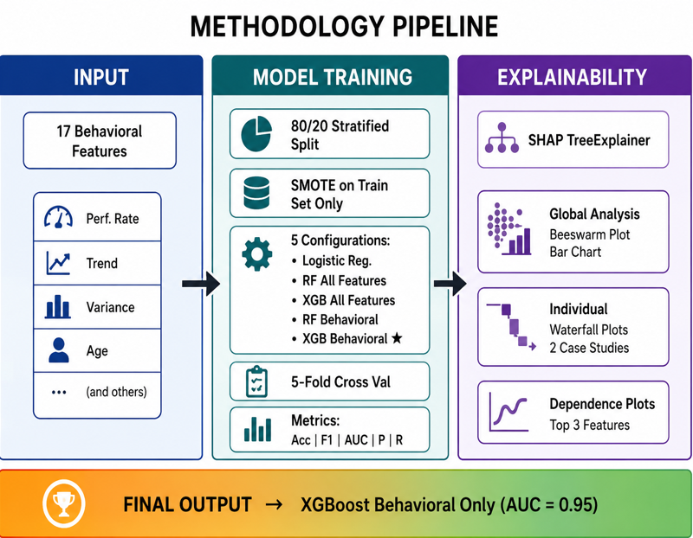

Fig. 2: Three-Stage Methodology Pipeline — Input, Training, and Explainability

SHAP Explainability Setup
SHAP TreeExplainer [29] is applied to both XGBoost configurations. TreeExplainer computes exact Shapley values for tree-based models — unlike approximation-based methods — ensuring that feature contributions are precise and theoretically grounded in cooperative game theory.
Explainability is assessed at two levels. At the global level, mean absolute SHAP values are computed across the full test set to rank features by their average contribution magnitude. Beeswarm summary plots are generated to visualize both the importance and directional effect of each feature — showing whether high or low feature values push predictions toward or away from dyslexia risk. At the individual level, waterfall plots are generated for two selected test cases: one high-confidence dyslexia prediction with predicted probability above 0.85, and one high-confidence non-dyslexia prediction with predicted probability below 0.15. These cases illustrate how the model reasons differently across contrasting behavioral profiles. Finally, SHAP dependence plots are generated for the top three features — mean hits, mean missrate, and accuracy trend — to examine how feature values relate to SHAP contributions and whether interaction effects are present.

RESULTS AND EVALUATION

Model Comparison
XGBoost Behavioral Only achieves the best balance between performance and privacy — matching the false negative count of the full XGBoost model while operating entirely on behavioral data. Logistic Regression confirms the task is non-linear, establishing a meaningful performance floor against which ensemble methods are benchmarked.

Table IV presents performance across all five configurations. Results are reported using five metrics to ensure evaluation is not inflated by class imbalance.

- Model Performance Comparison on Test Set
Model | Accuracy | Precision | Recall | F1 Score | AUC-ROC
Logistic Regression | 71.8% | 0.711 | 0.733 | 0.722 | 0.787
Random Forest — All Features | 86.5% | 0.832 | 0.914 | 0.871 | 0.943
XGBoost — All Features | 90.5% | 0.887 | 0.929 | 0.907 | 0.964
Random Forest — Behavioral Only | 85.1% | 0.819 | 0.902 | 0.858 | 0.926
XGBoost — Behavioral Only | 89.5% | 0.870 | 0.929 | 0.898 | 0.953
The ROC curves illustrate the trade-off between true positive rate and false positive rate across all five configurations. XGBoost All Features and XGBoost Behavioral Only both curve sharply toward the top-left corner — indicating strong discriminative ability — while Logistic Regression trails significantly. The near-identical curves of both XGBoost configurations visually confirm that removing demographic features causes minimal degradation in classification performance.
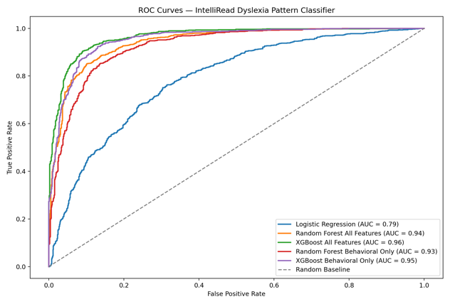
Fig. 3. ROC Curves: IntelliRead Dyslexia Pattern Classifier.
The confusion matrices reveal that XGBoost Behavioral Only produces only 64 false negatives — cases where dyslexia was present but not detected. This matches the full XGBoost model exactly, reinforcing that behavioral features alone capture the same detection sensitivity. Logistic Regression produces 240 false negatives, highlighting the cost of using an insufficiently expressive model for this task.
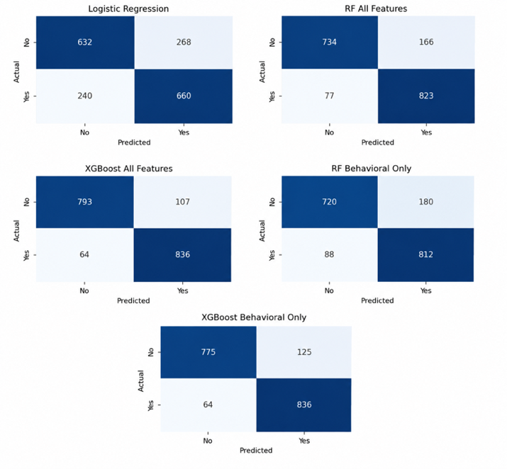
Fig. 4 : Confusion Matrix of Model Comparison

Ablation Study
- Ablation Study — Impact of Removing Demographic Features
Comparison | AUC Drop | F1 Drop | False Negatives
RF: All → Behavioral Only | 0.943 → 0.926 (−0.017) | 0.871 → 0.858 (−0.013) | 77 → 88
XGBoost: All → Behavioral Only | 0.964 → 0.953 (−0.011) | 0.907 → 0.898 (−0.009) | 64 → 64
Removing demographic variables from XGBoost causes only a 0.011 AUC drop and 0.009 F1 drop, with false negatives remaining unchanged at 64. This directly answers RQ2 — behavioral features alone are sufficient for dyslexia risk prediction without meaningful loss in detection sensitivity.

Cross-Validation Stability
- 5-Fold Cross-Validation F1 Score
Model | CV F1 Mean | CV F1 Std
Logistic Regression | 0.720 | ±0.008
Random Forest — All | 0.887 | ±0.004
XGBoost — All | 0.912 | ±0.006
Random Forest — Behavioral | 0.870 | ±0.009
XGBoost — Behavioral | 0.896 | ±0.005

Low standard deviations across all configurations confirm result stability. XGBoost Behavioral maintains only CV F1 of 0.896 ± 0.005, that demonstrates consistent generalization across all five folds overall.

SHAP Global Analysis
The beeswarm plot shows the distribution of SHAP values for every test sample across all 15 features. Each dot represents one prediction, colored red for high feature values and blue for low. Mean hits dominates the plot — low values (blue) push strongly toward dyslexia risk while high values (red) suppress it. Accuracy trend and missrate trend show clear directional patterns, confirming that performance trajectory across sessions carries independent predictive weight beyond raw scores.
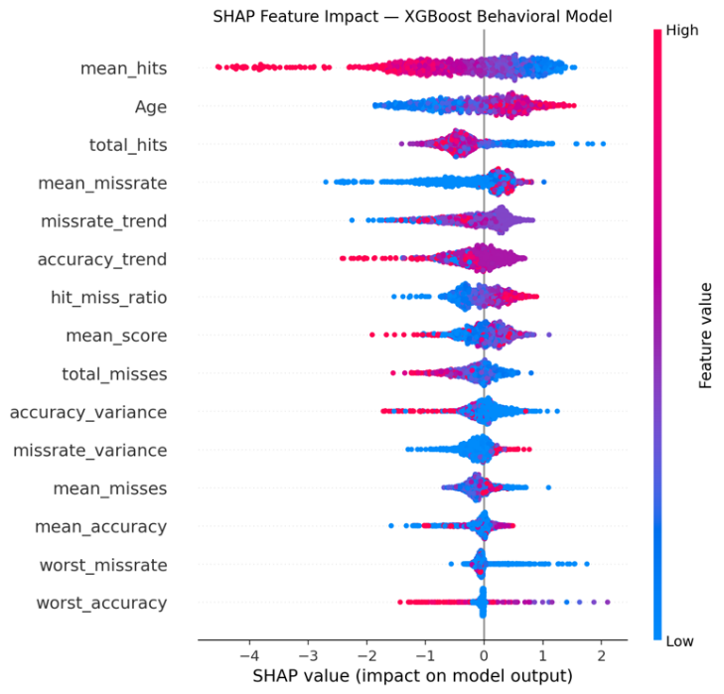
Fig. 5. SHAP Feature Impact: XGBoost Behavioral Model.

The bar chart ranks features by mean absolute SHAP value — a model-level measure of each feature's average contribution magnitude across all predictions. Table VII presents the top five features.
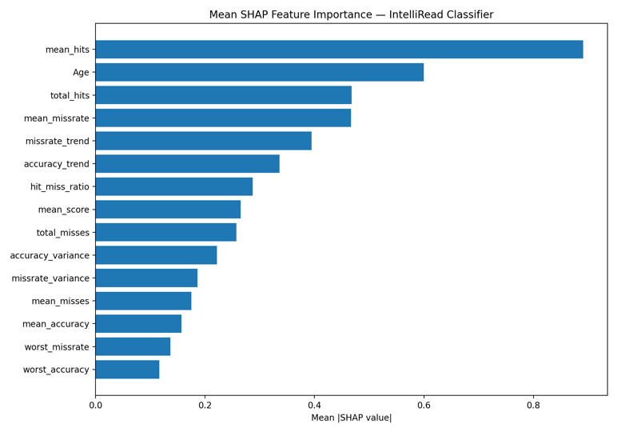
Fig. 6. Mean SHAP Feature Importance: IntelliRead Classifier.
- Top 5 Features based on Mean Absolute SHAP Value
Rank | Feature | Mean | Interpretation
1 | mean_hits | 0.891 | Low hit rate strongest predictor of dyslexia risk
2 | Age | 0.600 | Developmental factor in 7-17 years of age
3 | total_hits | 0.468 | Cumulative performance boosts hit rate signal
4 | mean_missrate | 0.467 | More Misses = Higher Odds of Dyslexia
5 | missrate_trend | 0.395 | Miss rate increasing trajectory and risk signal building
Mean hits lead by a large margin - almost 50% higher than the second ranked feature - confirming it as the single most informative behavioural signal in this dataset.

SHAP Individual Explanations
A 15-year-old participant is flagged with 98% predicted probability. The waterfall plot shows that declining accuracy trend, rising missrate trend, and high session variance collectively drive the prediction — despite a moderate absolute hit count. The model signals the deterioriating performance trajectory as the primary risk signal, not just the raw performance level.
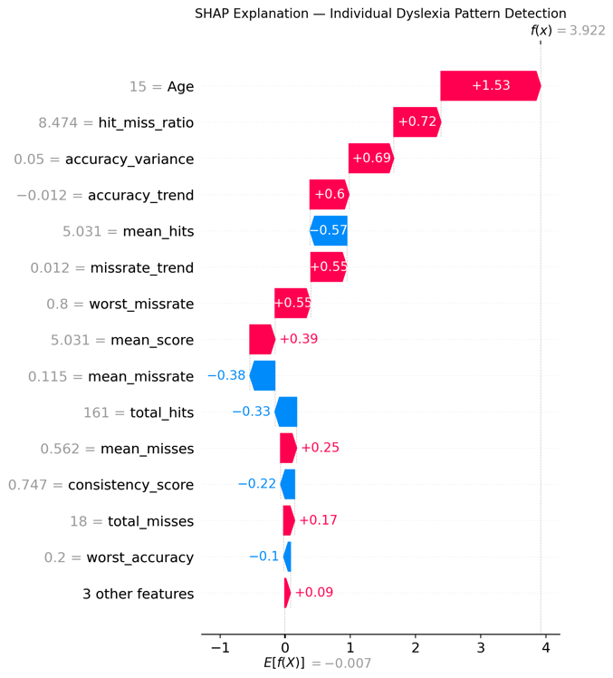
Fig. 7. SHAP Explanation: Identification of Individual Dyslexia Patterns
.
A 14-year-old is correctly classified as non-dyslexic with 99.96% confidence. Mean hits alone contributes a SHAP value of −4.08, strongly suppressing dyslexia risk. This is reinforced by a stable accuracy trend and declining missrate trend, indicating consistent and improving performance across sessions.
The contrast between both cases demonstrates that the model integrates trajectory, consistency, and volume signals together — consistent with how reading difficulty manifests behaviorally in practice.
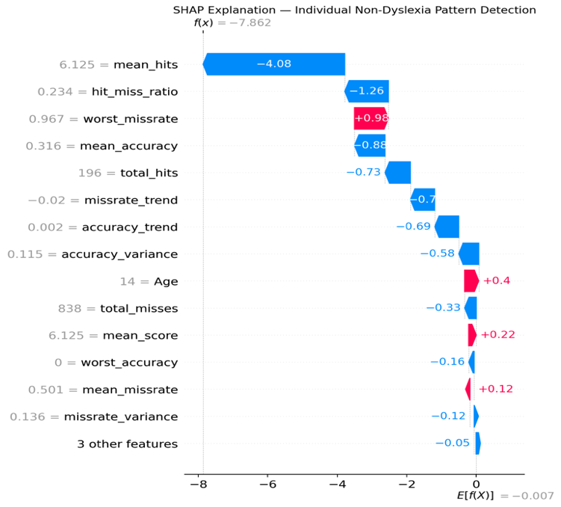
Fig. 8. SHAP Explanation: Individual Non-Dyslexia Pattern Detection.

Dependence Plots
SHAP dependence plots for the top three features confirm clear behavioral relationships. Mean hits shows a monotonic negative relationship — as hit count increases, dyslexia risk decreases linearly. Mean missrate shows that low values cluster near zero contribution while high values produce strong positive risk signals. Accuracy trend confirms that declining accuracy across sessions consistently elevates risk, while improving accuracy suppresses it — capturing learning trajectory as an independent predictive dimension.
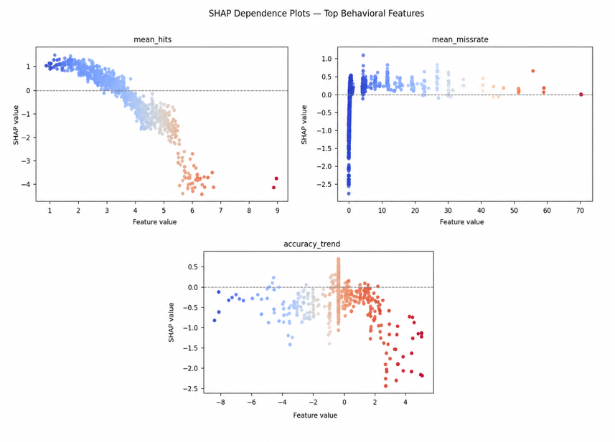
Fig. 9. SHAP Dependence Plots: Top Three Behavioral Features.

DISCUSSIONS
The results consistently confirm that behavioral reading features are sufficient for accurate and interpretable dyslexia risk prediction without requiring demographic data.
Addressing RQ1, XGBoost outperforms all baselines — Logistic Regression's AUC of 0.787 confirms the task is non-linear, while XGBoost Behavioral Only reaches AUC 0.953 with stable cross-validation performance, validating the choice of gradient boosting for this feature space.
Addressing RQ2, the ablation study shows that removing demographic variables from XGBoost causes an AUC drop of just 0.011 with identical false negatives — confirming that behavioral signals alone are sufficient. This has direct implications for privacy-preserving deployment, as schools can screen students without collecting sensitive personal data.
Addressing RQ3, SHAP analysis produces explanations that are both technically precise and educationally meaningful. Mean hit rate, accuracy trend, and missrate trend are the dominant signals — all directly observable by practitioners. A teacher shown that a student was flagged due to declining accuracy and rising miss rate across sessions can immediately connect that to classroom behavior, making the system actionable rather than just predictive.
Overall, these findings support a practical path toward accessible, transparent dyslexia screening using behavioral data already generated by digital learning platforms — without additional data collection, specialist equipment, or demographic profiling.

Educational Implications
Taken together, these findings suggest a practical path toward accessible, privacy-preserving, and interpretable dyslexia screening in educational settings. A system built on this pipeline requires only behavioral exercise data — no specialist equipment, no demographic profiling, and no clinical infrastructure. The SHAP explanations provide a natural interface between the model's prediction and the educator's decision — not replacing professional judgment but informing it with specific, traceable evidence. As schools increasingly adopt digital learning platforms that generate behavioral performance data as a byproduct of normal instruction, the approach demonstrated here becomes directly applicable without additional data collection overhead.

LIMITATIONS
This study has three primary limitations. First, the dataset was collected in a controlled exercise environment — generalization to naturalistic classroom settings remains unvalidated. Second, SMOTE was required to address class imbalance during training, and while well-established, synthetic oversampling may not fully represent the true distribution of dyslexic reading behavior. Third, evaluation is conducted on a single dataset from one research group, limiting conclusions about cross-population and cross-linguistic generalizability.
Future work will be carried out on three directions: validation on additional multilingual dyslexia datasets, longitudinal studies tracking behavioural trajectories over an academic year, and integration of this pipeline into a deployable educational platform with a practitioner-facing explanation interface.

CONCLUSION
This paper presents a comparative machine learning study for dyslexia risk prediction using behavioral reading features from the Rello et al. PLOS ONE dataset. XGBoost Behavioural is evaluated on five model configurations 17 behavioural features only, no demographic input. Only out coming as the recommended model — AUC 0.953, F1 0.898. The ablation study indicates that the removal of demographic variables causes negligible performance degradation, which supports privacy-preserving deployment in educational settings. SHAP analysis allows for both global and per-prediction explanations and highlights the dominant predictive signals such as mean hit rate, accuracy trend and miss rate trajectory which is directly understandable by educators and learning support practitioners. Together, these results provide a transparent, behaviourally grounded, empirically validated framework of early dyslexia screening that optimises both predictive performance and explainability.

REFERENCE

[1] S. E. Shaywitz, "Dyslexia," New England Journal of Medicine, vol. 338, no. 5, pp. 307–312, 1998.
[2] M. J. Snowling, Dyslexia, 3rd ed. Oxford, U.K.: Wiley-Blackwell, 2019.
[3] G. R. Lyon, S. E. Shaywitz, and B. A. Shaywitz, "A definition of dyslexia," Annals of Dyslexia, vol. 53, pp. 1–14, 2003.
[4] F. R. Vellutino, M. J. Fletcher, M. Snowling, and D. Scanlon, "Specific reading disability (dyslexia): What have we learned in the past four decades?," Journal of Child Psychology and Psychiatry, vol. 45, no. 1, pp. 2–40, 2004.
[5] L. Rello and M. Ballesteros, "Predicting risk of dyslexia with an online gamified test," PLOS ONE, vol. 10, no. 12, 2015.
[6] M. Safari, P. Marzban, and L. Hu, "OCR-based handwriting recognition for dyslexia screening," in Proc. ACM SIGACCESS Conf. Computers and Accessibility, 2020, pp. 134–142.
[7] A. Ibrahim, L. P. Noh, and S. M. Noor, "AI-assisted dyslexia screening using eye movement analysis," IEEE Access, vol. 9, pp. 88345–88358, 2021.
[8] G. Marino, L. Rossi, and A. Mancini, "Transformer-based models for dyslexia pattern recognition," ACM Transactions on Accessible Computing, vol. 13, no. 2, pp. 8–18, 2020.
[9] A. Gavriilidou, G. Tsiakoulis, and K. Zervanou, "Rule-based spelling correction for dyslexia using NLP techniques," International Journal of Artificial Intelligence in Education, vol. 29, no. 4, pp. 681–700, 2019.
[10] A. Al-Wabil, R. Alghamdi, and M. Khan, "Explainable AI for educational accessibility: Transparent models for assistive learning," International Journal of Human–Computer Studies, vol. 148, p. 102590, 2021.
[11] V. I. Levenshtein, "Binary codes capable of correcting deletions, insertions, and reversals," Soviet Physics Doklady, vol. 10, no. 8, pp. 707–710, 1966.
[12] T. Mikolov, K. Chen, G. Corrado, and J. Dean, "Efficient estimation of word representations in vector space," in Proc. ICLR Workshop, 2013.
[13] J. Devlin, M.-W. Chang, K. Lee, and K. Toutanova, "BERT: Pre-training of deep bidirectional transformers for language understanding," in Proc. NAACL-HLT, 2019, pp. 4171–4186.
[14] T. Chen and Y. Zhang, "Neurosymbolic AI for reading comprehension support," in Proc. Int. Conf. Artificial Intelligence in Education, 2024, pp. 78–89.
[15] S. K. Kumar, "Hybrid explainable AI systems for human-centered learning," IEEE Intelligent Systems, vol. 38, no. 4, pp. 21–30, 2023.
[16] P. Kaur and N. Chauhan, "AI-driven multimodal systems for educational accessibility," Procedia Computer Science, vol. 225, pp. 109–118, 2023.
[17] D. Kahneman, Thinking, Fast and Slow. New York, NY, USA: Farrar, Straus and Giroux, 2011.
[18] M. Pino and D. Kouroupetroglou, "Accessibility and usability in assistive reading software," Universal Access in the Information Society, vol. 18, pp. 973–988, 2019.
[19] J. Brooke, "System usability scale (SUS): A quick and dirty usability scale," in Usability Evaluation in Industry. London, U.K.: Taylor & Francis, 1996.
[20] D. Jurafsky and J. H. Martin, Speech and Language Processing, 3rd ed. Draft, 2023.
[21] A. Vaswani et al., "Attention is all you need," in Proc. NIPS, 2017, pp. 5998–6008.
[22] R. E. Mayer, Multimedia Learning, 2nd ed. Cambridge, U.K.: Cambridge Univ. Press, 2009.
[23] J. Brooke, "SUS: A retrospective," Journal of Usability Studies, vol. 8, no. 2, pp. 29–40, 2013.
[24] B. Shneiderman et al., Designing the User Interface, 6th ed. Boston, MA, USA: Pearson, 2016.
[25] R. S. Sutton and A. G. Barto, Reinforcement Learning: An Introduction, 2nd ed. Cambridge, MA, USA: MIT Press, 2018.
[26] S. Russell and P. Norvig, Artificial Intelligence: A Modern Approach, 4th ed. Hoboken, NJ, USA: Pearson, 2020.
[27] R. Guidotti et al., "A survey of methods for explaining black box models," ACM Computing Surveys, vol. 51, no. 5, pp. 1–42, 2018.
[28] F. Doshi-Velez and B. Kim, "Towards a rigorous science of interpretable machine learning," arXiv:1702.08608, 2017.
[29] Y. LeCun, Y. Bengio, and G. Hinton, "Deep learning," Nature, vol. 521, pp. 436–444, 2015.
[30] A. Pramod, D. Gupta, and P. K. Singh, "AI-based screening tool for dyslexia using NLP techniques," IEEE Access, vol. 10, pp. 12587–12595, 2022.
[31] S. M. Lundberg and S. I. Lee, "A unified approach to interpreting model predictions," in Proc. Advances in Neural Information Processing Systems (NeurIPS), 2017, pp. 4765–4774.

