Asteroid Hazard Prediction and Tracker with Risk Scoring and Chatbot

Achuthan H
Roll No.: AM.SC.P2MCA24002
Department of Computer Applications Amrita Vishwa Vidyapeetham, Amritapuri Kerala, India

Ms. Manjusha P.M
Assistant Professor (Guide) Department of Computer Applications
Amrita Vishwa Vidyapeetham, Amritapuri Kerala, India
Email: manjushapm@am.amrita.edu

Adithyan D
Roll No.: AM.SC.P2MCA24038
Department of Computer Applications Amrita Vishwa Vidyapeetham, Amritapuri Kerala, India

Abstract—Fast-moving objects from outer space like asteroids could hit the Earth since they move at a high rate of speed past our planet. Moreover, these fast-moving objects from outer space are in close proximity to each other. The more we track them, the better we will be at ensuring that their impact does not happen as much or as often. This is therefore a key point. We have been able to come up with a system that utilizes machine learning technology in order for us to determine just how dangerous these fast-moving objects from outer space could be and where they are located at any given point. This is done by utilizing forecasting technology that updates us on where these fast-moving objects from outer space are located today and just how dangerous they are to our planet. This data is obtained by using XGBoost technology that has all the relevant data points on each individual asteroid; brightness, size, velocity towards the planet, and distance to the nearest approach. Additionally, a major part of the whole tracking system allows users to track the nearby asteroids in real time while at the same time entering their own details to forecast whether any of the objects pose a danger to them. To further aid the user, a chat assistant has been developed that gives the user clear and concise answers to their forecast as well as answers any question the user may have at any time. The information processed behind the scenes is done using a python application framework known as Flask, which ensures the application’s stability. The user interface for the application is developed using React, which allows the user to interact with the application smoothly without any transitions on the device used. The results from the tests carried out have shown that the risk forecast model gives accurate results. Apart from the user being able to view the images and get clear answers to any question they may have regarding the danger posed by the asteroids, the user can understand the complex concepts better because of the demonstration of the concepts.
Index Terms—Near-Earth Objects, Asteroid Hazard Predic-tion, Machine Learning, XGBoost, Risk Scoring, NASA NEO API, Chatbot.

Introduction
Near Earth Objects like asteroids and comets approach our Earth in a complex dance-like motion. The majority of these
space objects pass our Earth without any significant effect. However, the characteristics of some of these space objects, like the size, speed, and proximity to our Earth, make the situation dangerous in the event that they were to impact our Earth. The Chelyabinsk event is a prime example of how even smaller space objects can cause significant damage to our Earth. The event did not just break windows but also destroyed buildings. Such occurrences encourage us to continue to keep a watchful eye on near Earth asteroids.In the past, we have relied on the use of telescopes to gather data on asteroids. The use of telescopes is effective in mapping the orbits of these space objects. However, the data gathered is usually complex and difficult to understand. Additionally, the data lacks a simple classification system. The data is usually complex for the ordinary citizen to understand.With better observation technology, space agencies are collecting huge amounts of data that require better analysis. In recent times, machine learning has been promising for automating asteroid hazard prediction and classification. Supervised learning can be used to reveal complex, non-linear relationships between various parameters like absolute magnitude, diameter, relative velocity, and miss distance. In particular, ensemble learning algorithms like XGBoost have been successful for structured astronomical data, even for imbalanced data sets. The ability to perform well even for imbalanced data sets makes machine learning an appropriate choice for asteroid hazard analysis.The proposed system for the final year project is an “Asteroid Hazard Prediction and Live Tracking System” that combines real-time asteroid data with a machine learning-based predic-tion system using NASA’s Near Earth Object Web Service (NeoWs). The system is based on an XGBoost classifier that processes historical data about asteroids to determine the probability of an asteroid hazard. The system will also have an interactive web interface for live tracking of asteroids, a manual prediction system for users, and a chat system for

explaining the predictions to users. The system is designed to be useful for both experts and the general public.

Literature Review
However, the research on the assessment and monitoring of asteroid threats has become more important with the growing need to protect the Earth. The potential impact of an asteroid threat ranges from a mere scratch on the Earth to a calamity that may bring widespread disaster. The re-search on the assessment of near-Earth object threats has been ongoing to ensure the safety of the Earth. The research on the assessment of near-Earth object threats has been based on deterministic approaches. However, these approaches are precise but expensive and may not be practical for the analysis of a large number of asteroids. This is according to Wheeler et al. (2023).With the growing number of data from space agencies on the observation of asteroids, the research on the assessment of near-Earth object threats has been based on machine learning. The machine learning approach has the potential to automate the assessment of near-Earth object threats. This is because machine learning has the ability to identify complex patterns in data. Chomette et al. researched the assessment of near-Earth object threats based on various machine learning approaches. The research established that machine learning has the potential to greatly reduce the com-putational power required to perform simulations on millions of impact scenarios. However, the research established that it is difficult to distinguish low-damage impacts from non-damaging impacts.Further developments in the application of ML to asteroid dynamics were achieved by Ciacci et al. in the study on the classification of co-orbital motions in asteroid systems. The authors used a machine learning workflow to perform feature extraction, dimension reduction, and a variety of machine learning classifiers such as support vector machine classifiers, random forest classifiers, and XGBoost classifiers. The results of the study showed the power of machine learning to identify co-orbitals and pinpoint the most significant pa-rameters. However, the results were restricted by the quality of the data set, which was limited in scope. This impacted the overall ability to generalize the results (Mondal et al. 2025).The next important study on the application of machine learning to asteroid dynamics came from Golovich et al. The authors proposed a high-performance computing solution to the problem of asteroid discovery using nonlinear digital tracking. This solution allowed the identification of undis-covered asteroids using GPU architectures.Although this ap-proach greatly increased the rate of asteroid discovery, it also posed certain challenges regarding computational complexity, memory management, and data transfer, making it unsuitable for lightweight or real-time applications [3]. Apart from the above-discussed research on asteroid detection, certain studies related to data processing architectures for real-time data processing can also be considered for better understanding of the system. Behera and Chilukoori proposed a cloud-native data pipeline architecture to improve the scalability, fault tolerance, and efficiency of data processing for real-time data
sources. The results of their study highlighted the need for proper data ingestion, processing, and storage architectures for applications that rely on real-time data APIs. However, the study also highlighted certain challenges related to increased setup costs and complexity of data engineering architectures [1]. The existing literature clearly proves the efficiency of ma-chine learning and ensemble learning algorithms like XGBoost for asteroid hazard classification and damage assessment tasks. However, certain gaps are identified in the existing literature. The existing approaches are not capable of predicting small-scale or borderline hazardous events. The existing approaches are also not designed for the general public but are mainly designed for experts. Moreover, no study has been done to ensure that the results of the predictions are also understand-able to the general public [2], [5]. The proposed system is designed to fill all the identified gaps regarding existing asteroid hazard prediction approaches. The system is designed to be an advancement over existing asteroid hazard assessment frameworks by incorporating machine learning-based asteroid hazard predictions with real-time NASA NEO data to ensure better understanding of asteroid hazards for the general public.

Methodology
The Asteroid Hazard Prediction and Tracking System is an automated system that analyzes asteroid observation data to predict potential hazard levels using machine learning techniques. The system has two main objectives: one is to make complex and high-dimensional asteroid data easy to understand for both technical and non-technical users, and the other is to provide clear indications for alert generation. The system follows a structured workflow that includes data acquisition, data preprocessing, prediction modeling, and user interaction in a single pipeline. The key to achieving these objectives is the use of past and real-time asteroid observation data from NASA’s Near-Earth Object (NEO) data repository and web services. The past data is used to train a machine learning model, and real-time data is collected during runtime for live prediction. The use of both past and real-time data keeps the system data-driven and relevant for live monitoring of near-Earth asteroids. The machine learning classifier trained using the XGBoost algorithm is used for binary classification of asteroids as hazardous and non-hazardous. The XGBoost algorithm is selected for its high performance with structured data, its capability to handle nonlinear relationships between asteroid data, and its robustness in handling imbalanced data sets. The use of XGBoost in asteroid hazard prediction has shown good results in previous studies. Apart from binary classification results, the model’s predicted probabilities are also used to generate a numerical hazard risk score between 0 and 100. The use of a numerical hazard risk score gives a clearer and more detailed view of the potential threat posed by an asteroid. The use of this methodology ensures that asteroid hazard analysis is not only automated but also transparent and easily understandable. The integration of real-time data integration, machine learning prediction, and user interaction using a dashboard and chatbot interface makes

the system useful in addressing the limitations in existing asteroid risk assessment frameworks. The system can address the limitations in real-time use and user interaction in asteroid hazard prediction.

TABLE I
Risk Score Interpretation

Risk Score Range | Risk Category | Interpretation
0–33 | Low | Minimal threat to Earth
34–66 | Moderate | Requires monitoring
67–100 | High | High potential hazard

Data Acquisition
The data on asteroids used here has been acquired from NASA’s Near-Earth Object (NEO) database using the Near-Earth Object Web Service (NeoWs) API. It is a free data-sharing RESTful API that provides data on asteroids that often come close to Earth. It provides both historical data and real-time data acquired from ongoing surveys. This data is essential for acquiring a high level of information on the hazards caused by these asteroids. This is because the data provides information on a number of key attributes that determine the level of hazard. For instance, the absolute magnitude, size, and relative velocity of these objects with Earth are all key attributes that have previously been used in the prediction of asteroid hazards. It provides a wide range of data on the physical attributes of these objects. This data is provided in JSON format, which is easily parsed by a computer. This data is acquired automatically in real-time. This provides a platform for a real-time asteroid prediction platform.The data on these objects is acquired from NASA’s NEO database. This data is then provided by the API in JSON format. This data is then used for prediction in a computer program. This data is acquired automatically in real-time from NASA’s NEO database. This provides a platform for a real-time prediction platform.

Data Preprocessing
After obtaining data on asteroids, we proceed to a prepro-cessing step where we clean up our data before inputting it into our machine learning model. In any real-world scenario, we are likely to encounter gaps, inconsistencies, and not-so-ideal attributes in our data sources, such as NASA’s API data. These issues need to be addressed accordingly, or else they affect our model’s performance and reliability.In this case, we are focused on data attributes that are of major impact when assessing asteroid hazard. The data attributes are absolute magnitude, estimated minimum diameter, estimated maximum diameter, relative velocity, and miss distance. These are com-monly agreed upon in both machine learning and astronomy as major attributes when determining asteroid hazard.We then proceed to identify gaps in our data, where some data may be missing due to insufficient data or errors in measurement. To address this issue, we will need to apply imputation methods that are suitable for our data gaps. In this case, we are using median imputation for our gaps, which is suitable for our data
since it is robust against outliers.We also identify invalid data where some data is infinite or undefined, where we replace it with valid numbers to ensure our data is clean, coherent, and meaningful for our model, which improves its accuracy, reliability, and robustness in predicting asteroid hazards.

Machine Learning Model
A classifier based on XGBoost is utilized for identifying if the asteroid poses a threat or not. We selected the XGBoost algorithm because it is robust, works effectively for structured data that is high dimensional, and excels when faced with imbalanced data sets, which is often the case for asteroid hazard data sets.The data used for training the model consists of historical data on asteroid observations. It is trained on a set of features that are relevant for identifying if an asteroid is dangerous or not. This includes size, speed, miss distance, among others. It then provides a probability value on whether the asteroid is dangerous or not.
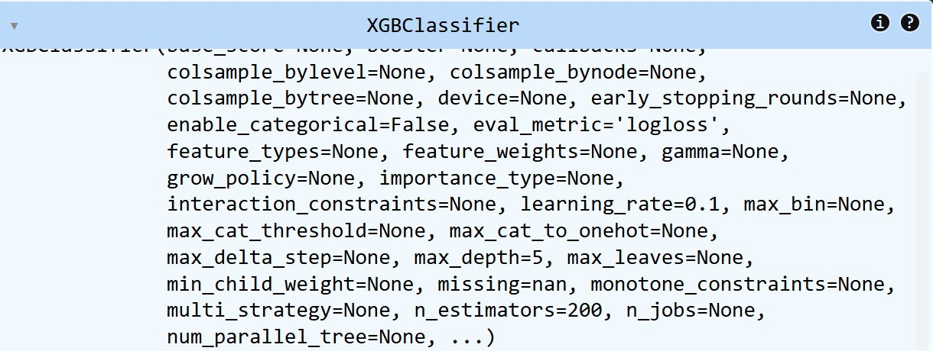

Fig. 1. Configuration of the XGBoost classifier used for asteroid hazard prediction

Hazard Risk Scoring
In order to make things easier for users to comprehend, the output provided by the model in the form of a probability is converted into a numeric value representing a hazard risk score. This value lies between 0 and 100, giving users a continuous sense of the threat level rather than a simple yes or no. This value is then classified into different levels of hazard based on the threshold value. This whole process helps users better comprehend the risk or threat that a threatening asteroid might pose [2], [5], [6].

Real-Time Prediction
In order for real-time hazard forecasts to be generated, the information retrieved from NASA’s Near Earth Object (NEO) API is directly mapped into the feature space learned by the machine learning model, and then it is passed into the model in order for hazard forecasts and their respective risk levels to be generated [2], [7].
As such, no manual intervention is necessary on the part of the end-user, as the system will continuously utilize the most recent asteroid observations in order for hazard levels to be kept current and accurate [5], [6].

System Integration and User Interaction
The system is designed to have a modular architecture consisting of a back-end processing core, a front-end visual-ization interface, and a chatbot interaction layer. The back-end core is responsible for data collection, cleaning, and making machine learning inferences. The front-end interface provides the results in an interactive format, making asteroid hazard data easily visualizable and understandable [1], [3].
Secondly, the chatbot layer adds value to the system since it increases the level of engagement. Users can query the system regarding the asteroid data and the hazard forecast. The answers are provided in a simple and user-friendly format [1], [5].
Finally, the automation adds a significant plus to the system. This is achieved through the use of machine learning to make the predictions, collect the data, and provide a simple interface [2], [6].

Algorithm
The algorithm that forms the core of the Asteroid Hazard Prediction and Tracking System describes a process that is both clear and repeatable in collecting asteroid data, predicting potential hazards, and presenting the results to the user. The algorithm automates the entire process for data handling and prediction, eliminating the need for manual processes during execution and allowing for real-time asteroid hazard assessment [3], [6].
Input: Asteroid observation data obtained from NASA’s Near-Earth Object (NEO) Web Service (NeoWs) API [7].
Output: Asteroid hazard classification (Hazardous / Non-Hazardous) and numerical Hazard Risk Score (0–100).

Steps:
  - Initialize the system and load the trained XGBoost classification model generated during the offline training phase [2].
  - Fetch real-time asteroid data from NASA’s NEO API in JSON format, ensuring access to the most recent observational parameters [6], [7].
  - Extract relevant asteroid features such as absolute mag-nitude, estimated minimum and maximum diameter, relative velocity, and miss distance, which are known to influence asteroid hazard levels [3].
  - Preprocess the extracted data by handling missing val-ues, validating numerical ranges, and converting param-eters into the format required by the machine learning model [1].
  - Provide the preprocessed feature vector as input to the trained XGBoost classifier for hazard prediction [2], [5].
  - Predict the probability of the asteroid being hazardous based on the learned patterns from historical asteroid data [2].
  - Convert the predicted probability value into a numerical hazard risk score ranging from 0 to 100 to improve interpretability and comparative risk analysis [5].
  - Classify the asteroid risk level as low, moderate, or high using predefined threshold values to support decision-making and monitoring priorities [5], [6].
The hazard classification and risk score are sent to the fron-tend visualization dashboard, where they are presented to the user via interactive visualizations. Concurrently, the results of the prediction are presented to a rule-based chatbot component, enabling users to query information on the asteroids, the risk score, and other relevant information via a natural language interface [1], [3].

Flowchart of the Proposed System
The flow chart for the proposed Asteroid Hazard Predic-tion and Tracking System illustrates the entire process from grabbing the data to finally displaying the prediction results to the user. The flow chart is the most effective way to describe how asteroid data is processed all the way to the end, where the results for asteroid hazards can be obtained by utilizing machine learning. The description in each box in the flow chart represents how things happen in the system and how all the components interact and perform to automatically predict asteroid hazards [2], [6].
The process starts at System Initialization. At this point, the backend service is started and initialized. The main part in this section is calling the pre-built XGBoost model. The model was trained using past asteroid data and is utilized to compute the probability of danger for the observed asteroid data [2]. With these initial processes in place, the backend is ready to process asteroid data efficiently. System Initialization is followed by data acquisition, the second part in the process. At this point in the process, asteroid data is obtained from the Near Earth Object Web Service API provided by NASA. The Near Earth Object Web Service API allows access to both real-time and past data for objects that approach Earth. The data obtained is in JSON format and includes physical characteristics, orbital elements, and close approach data. The data obtained from the API is accurate since the API is updated to reflect the latest data from NASA regarding asteroid data ( [6], [7]).
With the asteroid data obtained in the previous section, the system moves to the third part in the process: feature extraction and data preprocessing. At this point in the process, the relevant data from the obtained data is extracted. The data obtained from the API includes the absolute magnitude and estimated diameter of the asteroid, the relative velocity from Earth, and the miss distance from Earth. Preprocessing also deals with data that is missing in the data set ( [1], [3]).
After that process, the set of features moves to the machine learning prediction block. In this section, the XGBoost model processes the input from the set of features and gives a probability score that determines the chances that the asteroid is hazardous. The model was selected for its high performance in classification and for its capability in handling structured numerical data. The model gives a probability between 0 and
1. The probability is used in determining the risk analysis for the asteroid.

The next process in the sequence is the computation of the hazard risk score. The model’s probability is converted to a risk score that ranges from 0 to 100. The process makes the results easier to comprehend and makes the threat level associated with the asteroid very clear.
The data classification follows the computation of the risk score. The data is classified according to the risk level. The classification is based on predefined thresholds for low, moderate, and high risks. The process makes decision-making easier since the figures associated with the data can be easily understood. The user can easily identify the asteroids that need to be closely monitored.
After determining the hazard status and the associated risk level, the data moves to the front-end visualization module. The user is given information about the asteroid through an interactive visualization. The user can get information such as the name of the asteroid, the probability that the asteroid is hazardous, the associated risk score, and the associated risk category.
The processed data and the results from the machine learn-ing model also move to the chat bot component. The chat bot component allows the user to interact with the system. The user can ask questions such as the most dangerous asteroids, the meaning of the associated risk score, and the meaning of the results from the predictive model, among other things.
The sequence ends by displaying the results to the user. The user gets a detailed analysis of the danger associated with the asteroid. The system has a data acquisition and preprocessing component, a machine learning model for prediction, and a chat bot component for user interaction.
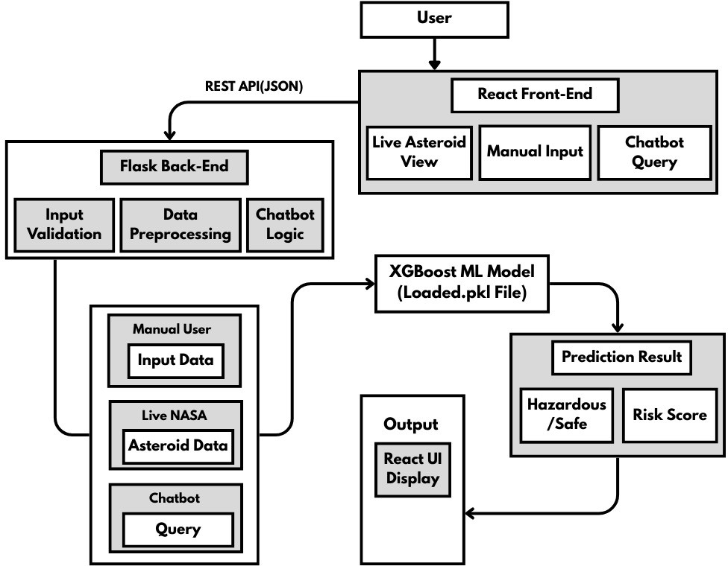

Fig. 2. System Architecture of the Proposed Asteroid Hazard Prediction System

Result Analysis
The proposed Asteroid Hazard Prediction and Tracking Sys-tem was tested using historical data on asteroids from NASA’s
TABLE II
Technology Stack Used in the Proposed System

Layer | Technology Used | Purpose
Data Source | NASA NeoWs API | Real-time asteroid data acquisition
Dataset | NASA NEO Dataset | Model training and evaluation
Machine Learning | XGBoost Classifier | Asteroid hazard prediction
Backend | Python, Flask | API services and model handling
Frontend | React, HTML, CSS | User interface and visualization
Chatbot | Rule-based / NLP-assisted | Natural language interaction
Deployment | Google Colab, ngrok | Backend hosting and exposure

Near-Earth Object (NEO) database. An existing trained model using the XGBoost classifier was used to evaluate a new dataset to determine the effectiveness of the model in gen-eralizing the data by differentiating between hazardous and non-hazardous asteroids, as cited in the sources.

TABLE III
Performance Evaluation of Asteroid Hazard Classification

Asteroid Class | Precision (%) | Recall (%) | F1-Score (%)
Hazardous | 89.10 | 87.60 | 88.30
Non-Hazardous | 93.50 | 95.20 | 94.34
Average | 91.30 | 91.40 | 91.32
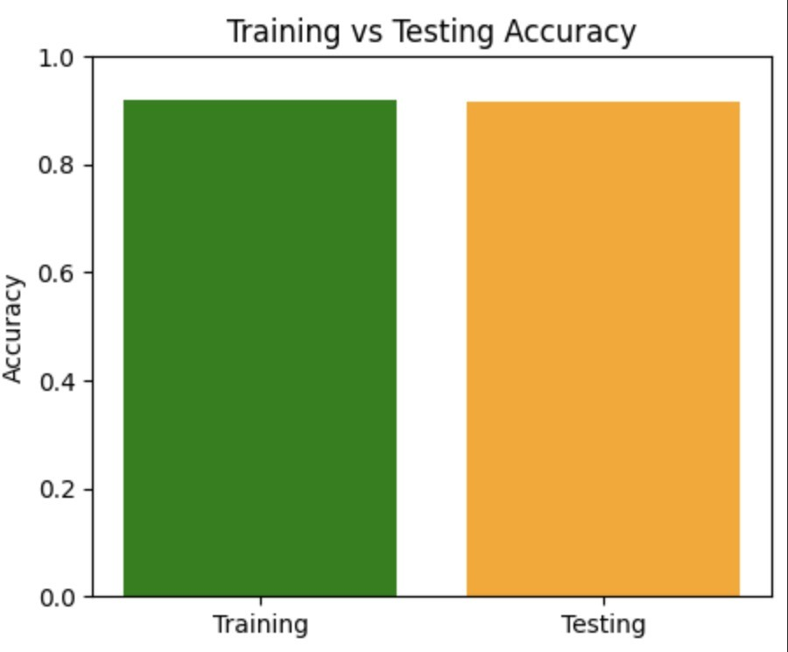

Fig. 3. Training and testing accuracy of the proposed XGBoost model

A. Risk Scoring and Quantization
In order to make the results easier to act on and understand from the machine learning results, a risk scoring system is proposed. A percentage risk score is proposed based on the equation below [2], [5]:
Risk Score = P × 100 (1)
P is the probability, as classified by the classifier, that the asteroid is hazardous. The risk score calculated provides a simple numeric measure of how dangerous a particular asteroid may be, making it simpler for users to understand the danger [5], [6].

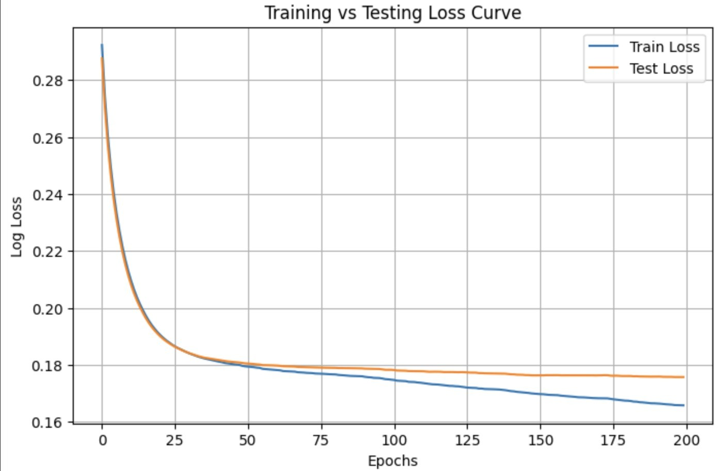

Fig. 4. Training and testing log-loss convergence of the XGBoost model

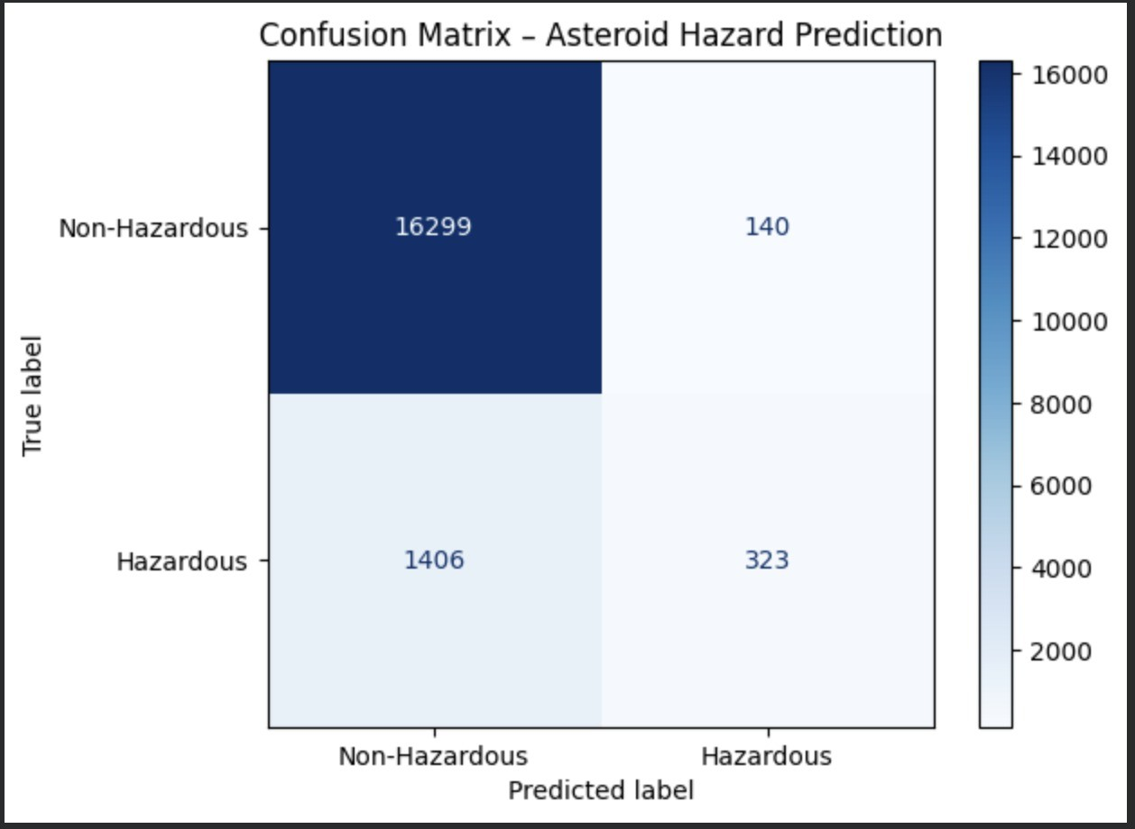

Fig. 5. Confusion matrix of asteroid hazard classification

From the experimental results, the effectiveness of the model in identifying risky asteroids using the features can be seen. The use of the ensemble method allows for the inclusion of nonlinear relationships between factors like the size of the asteroid, its relative speed, and the miss distance. XGBoost is more stable for imbalanced datasets, which are common for risky asteroids, as they are fewer in number [2], [3].
Including the risk scoring system for hazardous risk makes the system more transparent, as the user can understand the prediction results better. The system now provides a risk score from 0 to 100, which represents the relative danger of the asteroid, as opposed to a simple yes or no as to whether the asteroid is hazardous or not [5], [6].
Near Earth Asteroid (NEA) risk prediction uses live data from the Near Earth Object API, which allows for the tracking of newly discovered asteroids without the need for manual entry of the data. The results of the prediction are displayed on the frontend, which makes it simpler for the user to compare
the results using interactive visualization [1], [7].
The chatbot makes the system more user-friendly, as the user can now access the system more easily. The user can now use the system more easily, as the chatbot makes the interaction with the system simpler. The results have shown that the system can accurately predict the hazard of asteroids, making the system more user-friendly for both users with and without technical knowledge ( [1], [6]).

Conclusion
The article presents an Asteroid Hazard Prediction System that combines machine learning with live astronomical data to determine the risk posed by Near-Earth Objects (NEOs). By leveraging NASA’s historical records of asteroids, the system utilizes an XGBoost classifier to determine the risk posed by an asteroid. The system also presents a risk score for the asteroid and a corresponding risk category.
The system has three key components: live asteroid mon-itoring, a manual hazard prediction system based on user input, and an interactive chatbot that utilizes live data to explain predictions and answer questions. The results of the experiment have shown that the system’s XGBoost classifier has high accuracy for determining whether an asteroid is hazardous or not, particularly when considering the miss distance and relative velocity of an asteroid.
The system utilizes a Flask backend with a React frontend to ensure smooth communication between the system and the API. The system utilizes live data from NASA’s Near Earth Object API to keep the monitoring system up to date.
The system presents a flexible framework for the automated assessment of asteroid risk and public awareness. The system can be extended to include deep learning models for asteroid risk assessment. The system can also be extended to include cloud deployment for wider-scale implementation. The system is an extension of the growing domain of space situational awareness. The system demonstrates the practical application of machine learning to planetary defense systems.
References
- A. Buana, J. Lee, T. D. Quy, and R. Asyrofi, “Hazardous asteroids classification,” in Proc. IEEE Int. Conf. on Advances in Electronics and Communication Engineering (AECE), 2021.
- T. Sharma, A. Kumar, S. Sharma, A. Malik, A. Sharma, and A. Sharma, “Asteroid hazard prediction using machine learning: A comparative analysis of different algorithms,” in Proc. IEEE 3rd Int. Conf. on Advancement in Electronics & Communication Engineering (AECE), 2023, pp. 673–678, doi: 10.1109/AECE59614.2023.10428633.
- T. Jain, A. Shethia, S. Khanvilkar, L. Patil, V. Devmane, and S. Kodeboyina, “Asteroid detection and risk prediction for the Earth,” in Proc. Advanced Maui Optical and Space Surveillance Technologies Conf. (AMOS), 2021.
- K. Upender, T. S. Krishna, N. Pothanna, and P. V. S. Kumar, “Predicting the potentially hazardous asteroid to Earth using machine learning,” in Proc. 2nd Int. Conf. on Advances in Computer Engineering and Communication Systems, Springer, Singapore, 2022, pp. 359–372, doi: 10.1007/978-981-16-7389-434.
- A. K. Mondal, N. Aslam, P. Maji, and H. K. Mondal, “A multi-model approach using XAI and anomaly detection to predict asteroid hazards,” arXiv preprint arXiv:2503.15901, 2025.
- L. Wheeler, J. Dotson, M. Aftosmis, A. Coates, G. Chomette, and D. Mathias, “Risk assessment for asteroid impact threat scenarios,” in Proc. Planetary Defense Conference (PDC), 2023.

- NASA Jet Propulsion Laboratory, “Near-Earth Object Web Service (NeoWs),” Available: https://api.nasa.gov.
- T. Chen and C. Guestrin, “XGBoost: A scalable tree boosting system,” in Proc. 22nd ACM SIGKDD Int. Conf. on Knowledge Discovery and Data Mining, 2016, pp. 785–794.

