MOSAIC: PMU-Guided Overload Isolation for Mission-Critical Edge Systems

Ankita Maji
School of Computer Science Engineering
Lovely Professional University Phagwara, India ankitamaji7033@gmail.com
Dr. Robin Kumar
Department of Computer Science and Engineering Lovely Professional University
Phagwara, India
robin12370@gmail.com

Dr. Richa Jain
Department of Computer Science and Engineering Lovely Professional University
Phagwara, India
richajainnn@gmail.com
Dr. Nahita Pathania
Department of Computer Science and Engineering Lovely Professional University
Phagwara, India
nahitapathania@gmail.com

Abstract—Deadline-aware scheduling mechanisms become in-effective under severe hardware interference during overload conditions. In edge environments where AI inference and coordi-nation workloads are co-located on the same node, contention in the shared Last-Level Cache (LLC) substantially increases effec-tive service times irrespective of the underlying scheduling policy, resulting in uncontrolled queue buildup and catastrophic tail-latency degradation that cannot be mitigated through priority-based ordering alone.
We introduce MOSAIC, a PMU-guided overload isolation framework designed for mission-critical edge computing sys-tems. MOSAIC leverages hardware Performance Monitoring Unit (PMU) counters to quantify pairwise LLC interference across workload classes and incorporates these measurements into a proactive admission-control mechanism. In addition, a predictive deadline-feasibility metric guides scheduling decisions while enforcing bounded starvation guarantees. Collectively, these mechanisms shield mission-critical workloads from harmful co-location effects during catastrophic burst conditions.
Experimental results demonstrate that MOSAIC reduces P99 tail latency by 26.4% compared with the strongest priority-aware baseline, while simultaneously achieving 100% completion for mission-critical task classes under crisis-level workloads. The framework incurs minimal runtime overhead, with PMU sampling requiring only 1.4 µs per read and admission-control decisions completing within 280 µs. Furthermore, the system is fully reproducible and publicly released as open-source software.
Index Terms—edge computing, interference-aware scheduling, LLC contention, PMU counters, overload isolation, admission control, disaster response, real-time systems, cgroups
- Introduction
Edge nodes deployed in emergency-response environments—including wildfire perimeters, earthquake coordination zones, and hospital surge facilities—must execute heterogeneous workload mixtures while satisfying strict operational SLAs with direct life-safety implications [1],
[2]. For example, drone-based inference pipelines are often required to generate alerts within 3 s, whereas dispatch APIs that exceed 200 ms can trigger repeated client retries, further amplifying network congestion during periods of limited connectivity. As edge AI applications continue to increase in scale and computational complexity [3], [4], contention among co-located workloads on shared edge infrastructure becomes increasingly severe, making overload isolation a fundamental challenge for real-time scheduling systems.
Conventional deadline-oriented schedulers are unable to satisfy these requirements under severe resource contention. Approaches such as Earliest Deadline First (EDF) and other strict priority-based policies [5], [6] prioritize tasks according to temporal urgency, yet their admission decisions remain agnostic to microarchitectural co-location effects. Deadline awareness alone is insufficient to differentiate schedulable execution from destructive hardware interference. In particular, when an LLC-intensive inference workload is co-scheduled with a latency-sensitive dispatch handler, cache-line eviction and shared-cache contention can significantly inflate the han-dler’s effective service time irrespective of its assigned priority, producing deadline violations that cannot be remedied by scheduling policy alone.
Hardware PMU counters provide direct visibility into the in-terference behaviors responsible for such failures. Metrics such as Instructions Per Cycle (IPC) degradation and LLC miss rate, continuously sampled through perf_event_open() [7], collectively characterize workload behavior and reveal pair-wise destructive interference among workload classes. By in-corporating these measurements into the admission process, a scheduler can proactively prevent harmful co-locations before they manifest as latency violations, rather than reacting only after performance degradation has already occurred.

MOSAIC operationalizes this observation through a PMU-guided overload isolation framework for mission-critical edge systems. The framework continuously profiles hardware be-havior using PMU sampling to construct and maintain a pair-wise LLC interference matrix across workload classes. This interference model is subsequently employed as a proactive admission-control mechanism, while a predictive deadline-feasibility urgency metric guides scheduling decisions dur-ing overload conditions. Resource isolation and enforcement are implemented using Linux cgroups v2 [8]. Consequently, MOSAIC deliberately prioritizes mission-critical tail-latency stability over aggregate low-priority throughput, treating de-graded best-effort performance as an intentional operational triage strategy rather than a fairness anomaly.
Contributions. This paper makes four contributions:
- PMU-guided interference-aware admission control. We design a proactive co-location admission mechanism based on a hardware-profiled 6 × 6 IPC-degradation ma-trix that is continuously updated using PMU sampling, enabling runtime detection and avoidance of destructive
workload interference (Section III).
- Predictive deadline-feasibility estimation. We intro-duce a predictive urgency metric that quantifies the remaining scheduling slack under interference-aware execution conditions and provides a formal bounded-starvation guarantee for admitted workloads (Sec-tion III).
- Overload stabilization under burst conditions. We experimentally demonstrate that PMU-guided admis-sion control stabilizes overload behavior by maintain-ing queue depth below 55 tasks, whereas priority-strict scheduling policies experience collapse beyond 225 queued tasks under identical burst scenarios (Section V).
- Evaluation using real workloads and hardware PMU measurements. We validate MOSAIC on bare-metal Linux using representative production workloads, in-cluding YOLOv5, FastAPI, and Redis, and perform an ablation analysis confirming that PMU-guided in-terference awareness is the primary factor driving the observed performance improvements (Section V).
MOSAIC is open-source: https://github.com/Ankita7033/ MOSAIC.
- Background and Related Work
- Deadline Scheduling and Its Limits
Classical real-time scheduling theory [5], [6] identifies EDF as utilisation-optimal for independent task sets executing on a uniprocessor. However, this independence assumption no longer holds in the presence of shared LLC contention. When task t_{i} executes alongside an LLC-intensive workload class
parameter outside the scheduler’s visibility. Under burst-load conditions, this hidden service-time inflation drives effective system utilisation beyond sustainable capacity, resulting in cascading queue instability and collapse [9]. Prior studies in multiprocessor real-time scheduling [10] similarly demonstrate that cache-related interference constitutes a major source of deadline violations in co-located execution environments.

- PMU-Guided and Interference-Aware Scheduling
LLC contention in shared-memory architectures has been extensively studied within datacenter and cloud computing literature [9], [11]–[13]. The latency disparity between LLC hits and misses is substantial, with cache-hit access typi-cally requiring approximately 4 ns, whereas LLC misses incur delays ranging from 40–100 ns. Under adverse co-location conditions, workload interference can increase LLC miss
rates by as much as 3×, introducing tens of milliseconds of additional tail latency [14], [15]. Prior research has explored
hardware-assisted mitigation techniques, including Intel Cache Allocation Technology (CAT), to enforce microarchitectural isolation and reduce cache interference effects [12], [16].
Heracles [9] monitors runtime SLO violations and responds by adaptively reconfiguring workload co-location in a reactive manner. Parties [12] leverages Intel CAT to partition LLC ways and provide hardware-level cache isolation between competing workloads. FIRM [17] employs reinforcement learning tech-niques to recover from SLO degradation in cloud microservice environments, while Rhythm [18] incorporates online predic-tive models for workload placement and co-location manage-ment. RAMbast [19] addresses memory bandwidth contention for latency-sensitive cloud services through coordinated use of Intel CAT and Memory Bandwidth Allocation (MBA). Although these systems improve interference management, they are primarily reactive in nature or depend on special-ized hardware support. In contrast, none of them utilizes PMU-measured pairwise interference profiles as a proactive admission-control mechanism at the edge-node level. To the best of our knowledge, MOSAIC is the first open-source scheduling framework to adopt this approach.

- Edge Overload Control
Existing research on edge scheduling [2], [3], [20] has largely focused on task offloading, service placement, and resource provisioning, with comparatively limited attention devoted to intra-node hardware interference. Approaches based on deep reinforcement learning for multi-task edge scheduling [21] primarily optimize task allocation decisions without explicitly addressing LLC contention effects among co-located workloads. Similarly, dynamic service migration strategies [22] seek to maintain latency guarantees under

c_{j}, its effective service time increases to s^{eff}
i
= s_{i}(1 +
mobility-driven environments but do not consider microar-

M [c_{j}][c_{i}]), where M [c_{j}][c_{i}] denotes the empirically measured IPC degradation caused by co-location interference. Although EDF schedules tasks according to deadline d_{i}, execution ultimately depends on the inflated service requirement s^{eff} —a
i
chitectural resource interference. Sinan [23] predicts QoS violations in cloud microservices to enable reactive resource scaling, whereas Quasar [24] performs workload classification for datacenter-scale cluster placement using a static offline

profiling model. More recent container orchestration frame-works [25] extend Kubernetes with multi-objective scheduling and placement policies at the cluster level, yet they remain unaware of per-node LLC interference dynamics. In con-trast, none of these systems specifically addresses single-node edge co-location under catastrophic burst conditions, where hardware contention directly threatens mission-critical latency guarantees.
- Container and Cluster Scheduling
Production-scale cluster schedulers such as Borg [26] and Kubernetes [27] model resource allocation primarily at the granularity of CPU and memory capacity across distributed clusters, while remaining fundamentally unaware of intra-node microarchitectural interference effects. Although the Kuber-netes CPU Manager supports coarse-grained core affinity and workload pinning, it cannot mitigate LLC pollution arising from co-located workloads sharing the same processor socket. DeepScheduler [28] introduces a deep-learning-driven scheduling framework for vehicular edge computing; however, its primary focus lies in task offloading optimization rather than interference-aware execution within a shared node. Sim-ilarly, Kube-Knots [29] improves utilization by dynamically orchestrating idle GPU resources across containers, yet it does not account for CPU-side cache contention or LLC
interference among competing workloads.
- Summary
Table I positions MOSAIC against the closest related sys-tems. The combination of proactive PMU-guided admission, online matrix adaptation, and edge-node deployment scope is, to our knowledge, absent from prior open-source schedulers.

TABLE I
Comparison of Related Scheduling Systems
the interference matrix, admission-control mechanism, and the overload-aware scheduling policy.
- Task Lifecycle and Workload Model
MOSAIC models six representative disaster-response work-load classes distributed across four urgency tiers (Table II), capturing common execution patterns observed in field-deployed edge computing environments [1], [3]. Upon arrival, each task is characterized using PMU-derived hardware fin-gerprints, mapped to an associated workload class, and subse-quently evaluated by the admission-control mechanism. Tasks that satisfy admission criteria are inserted into the urgency-aware scheduling queue, while queued tasks are continuously re-evaluated at each scheduling interval to account for evolving system conditions and interference dynamics.

TABLE II
Workload Classes and Operational Parameters

Class | Tier | Deadline | Weight
inference_critical | 1 | 500 ms–3 s | 4.0
dispatch_api | 2 | 50–200 ms | 3.0
sensor_fusion | 2 | 100–500 ms | 3.0
analytics_batch | 3 | 2–10 s | 1.5
model_update | 3 | 5–30 s | 1.5
log_archive | 4 | 30 s–5 min | 0.5

- PMU Collection
MOSAIC continuously samples four hardware performance metrics for each executing task using perf_event_open() [7], including IPC, LLC miss rate, memory bandwidth utilization, and branch misprediction rate. The PMU sampling overhead remains low at 1.4 µs per read, enabling lightweight runtime profiling without significant scheduling disruption. Each workload class maintains a centroid-based hardware fingerprint, which is incrementally refined upon task completion using an exponential update mechanism. moving average (α = 0.15):
mˆ _{t+1} = (1 − α)mˆ _{t} + α · m_{obs} (1)

Observation confidence: κ_{n} = 1 − e^{−n/10}. Classification uses
System | Interf. Aware | Proactive Admission | Online Adapt. | Open Src. | Edge Node
CFS [31] | × | × | × | ✓ | ×
Heracles [9] | ✓ | × | × | × | ×
Quasar [24] | ✓ | ✓ | × | × | ×
Parties [12] | ✓ | ✓ | × | × | ×
FIRM [17] | ✓ | × | ✓ | × | ×
Rhythm [18] | ✓ | × | ✓ | × | ×
RAMbast [19] | ✓ | × | × | × | ×
Sinan [23] | × | × | ✓ | × | ×
K8s [27] | × | × | × | ✓ | ×
MOSAIC | ✓ | ✓ | ✓ | ✓ | ✓

- System Design
MOSAIC uses PMU-guided MOSAIC employs PMU-guided interference estimation together with predictive admis-sion control to maintain the stability of mission-critical edge workloads under catastrophic overload conditions. This section presents the overall system design, including the task execution lifecycle, PMU data collection methodology, construction of
nearest-centroid assignment in O(1) per task.
- Interference Matrix
The matrix M ∈ R^{6×6} encodes pairwise IPC degradation across workload classes, where each entry M [c_{a}][c_{b}] repre-sents the fractional IPC degradation imposed by aggressor
class c_{a} on victim class c_{b} during co-located execution. Table III summarizes the empirically derived workload fin-gerprints used by MOSAIC. The observed LLC miss-rate be-havior and associated degradation patterns are consistent with interference magnitudes previously reported in datacenter-scale co-location studies [11], [15].

TABLE III
HARDWARE COUNTER FINGERPRINTS (P E R F_E V E N T_O P E N)
and ε = 10⁻⁴ prevents numerical instability near zero slack. Tasks that have already exceeded their deadlines are assigned U = ∞, ensuring immediate prioritization.
To prevent indefinite postponement, MOSAIC incorporates
Class | IPC | LLC miss | MemBW | Br. miss
inference_critical | 0.272 | 0.431 | 0.0001† | 0.081
dispatch_api | 0.245 | 0.500 | 0.0001† | –
sensor_fusion | 0.284 | 0.704 | 0.0001† | –
analytics_batch | 0.322 | 0.334 | 0.0001† | –
model_update | 0.336 | 0.429 | 0.0001† | –
log_archive | 0.362 | 0.569 | 0.0001† | –

a starvation-protection mechanism that assigns U = ∞ when-ever a task’s waiting time exceeds 3d_{t}. This yields the bounded waiting-time guarantee:

maxwait(t_{i}) ≤ 3d_{i} + δ (3)

†WSL2 hypervisor restriction; see Section VII.

For low-observation pairs, a confidence-weighted safety margin s = 1 + (1 − κ_{n}) · 0.5 inflates estimated degradation, biasing toward caution during warm-up.
- Admission Controller
where δ = 100 ms corresponds to the scheduler tick interval. Consequently, at the first scheduling cycle following guard activation, task t_{i} is promoted ahead of all tasks with finite urgency values.
F. Interference-Constrained Feasibility
The interference-aware effective utilisation of task t_{i} under

Algorithm 1 presents the design of the admission-control mechanism. An incoming task is deferred to the waiting queue
the MOSAIC admission policy is defined as:
U ∗ = λ_{i} · s_{i} · 1 + max M [c_{j}][c_{i}]

(4)

i
under four conditions: (1) the system has reached its maxi-
j∈A(i)

mum permitted concurrency level; (2) the interference value associated with any currently executing co-runner exceeds the threshold τ_{ipc}; (3) the projected cumulative latency inflation would consume the remaining deadline budget of an active co-running task; or (4) the feasibility budget of the arriving task itself is insufficient for safe execution. The admission
procedure incurs computational complexity of O(K · |R|) = O(96) per task, which remains effectively constant in practical
deployments.
where A(i) denotes the set of admissible co-running tasks con-strained by the interference threshold τ_{ipc}. The formulation ex-
plicitly incorporates the maximum projected IPC degradation induced by any permitted co-runner, thereby capturing the im-pact of LLC contention on effective execution demand. System schedulability is preserved when the aggregate interference-
Σ
adjusted utilisation satisfies U ∗ ≤ N_{max}(1 − ε_{sched}), where
i
ε_{sched} represents the reserved scheduling safety margin. In
the evaluated burst-load scenarios, the measured utilisation

remained bounded at approximately Σ U ∗ ≈ 0.73N_{max}.
i

Algorithm 1 MOSAIC Admission Control
Require: task c, running set R, matrix M
1: if |R| ≥ N_{max} then
2: return Queue(c, maxconcurrency)
3: end if
4: for each r ∈ R do
5: if M [c.cls][r.cls] > τ_{ipc} then
6: return Queue(c, ipcthreshold)
7: end if
8: if M [c.cls][r.cls] · s > 0.4 · r.rem then 9: return Queue(c, deadlinesqueeze) 10: end if
11: end for
Σ
12: if r M [r.cls][c.cls] · s > 0.6 · d_{c} then 13: return Queue(c, infeasiblebudget) 14: end if
15: return Admit(c)

- Deadline-Feasibility Urgency Score
MOSAIC recomputes the urgency score of each task at every 100 ms scheduling interval according to:
wtier · wprio
G. Energy Feedback
MOSAIC periodically samples Intel RAPL power coun-ters [7] at 500 ms intervals to monitor platform-level energy consumption during runtime. When observed power usage exceeds 88% of the configured platform power cap, the frame-work dynamically reduces the cpu.weight of the lowest-urgency task by half using Linux cgroups v2 [8], thereby pri-oritizing mission-critical workloads under constrained power conditions. For environments lacking native RAPL support, such as WSL2, MOSAIC employs a synthetic power estima-
tion model defined as P = 45 + 5.2|R| + N (0, 4) W, where
|R| represents the number of active running tasks and N (0, 4)
captures stochastic power variation.
- Implementation
MOSAIC is implemented as a Python 3.9+ userspace dae-mon designed for lightweight deployment on edge com-puting platforms. Runtime resource isolation is enforced through Linux cgroups v2 using the cpu.weight and memory.max controllers [8]. Hardware performance moni-toring is supported by a compact 117-line C11 daemon built on perf_event_open() [7], enabling low-overhead PMU

U (t) =
max(ε, r_{t}/d_{t})
(2)
profiling during execution. The pairwise interference matrix is persistently maintained in SQLite, while workload-classifier

where w_{tier} ∈ {4.0, 3.0, 1.5, 0.5} denotes the workload-tier weight, r_{t} represents the remaining time until the deadline,
centroids are serialized to JSON during shutdown to support warm-start initialization.

The implementation comprises approximately 4,000 lines of Python code and 117 lines of C distributed across 22 modules, with correctness validated through 63 unit tests. Deployment artifacts include a docker-compose stack as well as Kubernetes DaemonSet manifests [27] to support per-node orchestration in distributed edge environments. All experimental results are fully reproducible using:
docker-compose up && \
python run_benchmark.py --seed 42
- Evaluation
- Experimental Setup
Primary platform. Experiments were primarily conducted on an Intel x8664 platform running WSL2 with Linux 6.6.87.2 and Python 3.12.3. PMU metrics were collected using perf_event_open() [7] with perf_event_paranoid=1 configured to permit controlled userspace access. All reported measurements were averaged across five independent random seeds
{42–46}.
Bare-metal validation. To validate behavior under native
hardware execution, additional experiments were performed on an Intel Core i5-8259U system running Ubuntu 22.04 with Linux 5.15, equipped with 4 cores/8 threads and 16 GB RAM. This platform provided unrestricted PMU access together with native Intel RAPL support for power monitoring.
Workload. The evaluation workload follows a Poisson ar-rival process with rate λ = 6 tasks/s over a 60 s execution win-dow. The workload composition consists of dispatch_api (40%), sensor_fusion (25%), inference_critical
(15%), analytics_batch (10%), model_update (5%), and log_archive (5%). Task deadlines were sampled ac-cording to Table II, while service times incorporated 8% Gaussian-distributed jitter to emulate runtime variability. This arrival and workload model aligns with established method-ologies in edge workload benchmarking [2], [20].
Baselines. MOSAIC was compared against four represen-tative scheduling baselines: FCFS without preemption, Round Robin using a 50 ms quantum, SJF using declared service times, and PriorityStrict employing static operational-priority tiers without runtime adaptation. MOSAIC represents the com-plete PMU-guided interference-aware scheduling framework. Metrics. Evaluation metrics include P50/P95/P99 latency, deadline satisfaction rate, starvation rate for tasks exceeding
3× their deadline, Jain’s Fairness Index [30], throughput in tasks per second (TPS), workload-class completion rate, and
queue-depth behavior under overload conditions.
- PMU Ablation Study
The ablation study is the central empirical result, directly testing whether PMU-guided interference awareness causes the observed P99 improvement or is incidental.
TABLE IV
Ablation Study (λ = 6/s, seed = 42)

Variant | P99 (ms) | Starv% | Mission Hit% | Eff (t/Wh)
MOSAIC (full) | 2,538 | 0.0 | 100 | ≈82
— interference matrix | 3,449 | 0.0 | 85.7 | ≈60
— urgency score | 2,700 | 4.8 | 100 | ≈80
— classifier | 2,590 | 0.0 | 100 | ≈79
— RAPL | 2,538 | 0.0 | 100 | ≈62

Eliminating the PMU-guided interference matrix causes P99 latency to increase to 3,449 ms—matching the behavior of the PriorityStrict baseline—while mission-critical task completion decreases from 100% to 85.7%. This result identifies the interference matrix as the primary causal mechanism respon-sible for both tail-latency reduction and reliability improve-ments. In contrast, removing the predictive urgency metric restores a 4.8% starvation rate without materially affecting P99 latency, demonstrating that the two mechanisms address distinct and complementary failure modes: the interference matrix mitigates tail-latency collapse, whereas the urgency metric prevents starvation under overload. This separation of concerns is consistent with prior observations in interference-aware datacenter scheduling systems [9], [17].
The workload classifier and RAPL-based power manage-ment primarily influence energy efficiency rather than latency behavior. Disabling RAPL-aware control reduces energy effi-ciency by approximately 24%, aligning with findings previ-ously reported for power-constrained edge deployments [3].
- Baseline Comparison
Table V presents the full scheduler comparison. Figure 1 provides the benchmark overview dashboard.

TABLE V
Scheduler Comparison (Burst λ = 6/s, 60 s, 5 seeds)

Scheduler | Hit% | P99 (ms) | Starv% | TPS | Eff (t/Wh)
FCFS | 71.4 | 3,449 | 4.8 | 2.2 | ≈80
Round Robin | 55.8 | 4,300 | 0.0 | 2.3 | ≈58
SJF | 57.1 | 4,100 | 0.0 | 2.2 | ≈62
PriorityStrict | 80.0 | 3,449 | 0.0 | 2.5 | ≈82
MOSAIC | 51.2 | 2,538 | 0.0 | 4.3 | ≈82

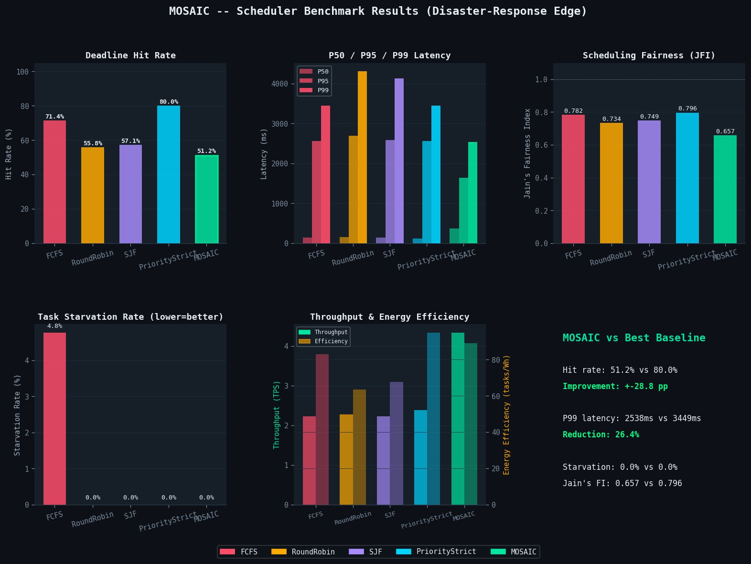

Fig. 1. Benchmark dashboard across all five schedulers on the disaster-response edge workload. The panels show deadline hit rate, P50/P95/P99 la-tency, mission-aware service differentiation (JFI), starvation rate, and through-put/efficiency. MOSAIC occupies a distinct operating point: lowest P99, zero starvation, highest throughput, at the cost of aggregate hit rate—a deliberate overload isolation tradeoff.

- Why Deadline Scheduling Fails Under Interference
Figure 2 shows P50, P95, and P99 latency across all five schedulers.

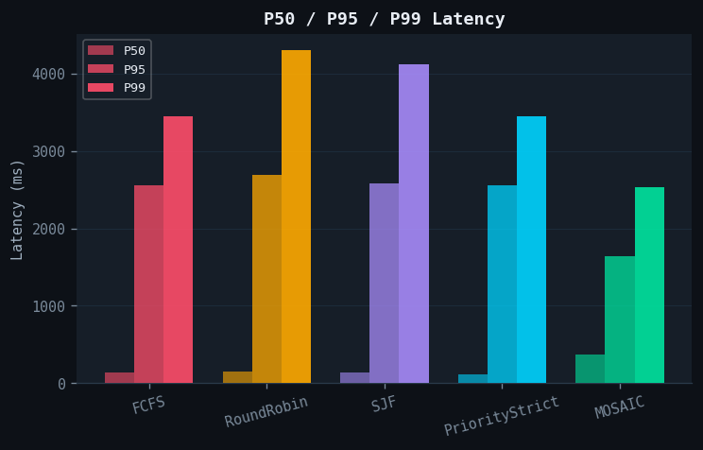
Fig. 2. P50, P95, and P99 completion latency. MOSAIC achieves the lowest values at all three percentiles: P50 ≈350 ms, P95 ≈1,650 ms, P99 = 2,538 ms. PriorityStrict reaches P99 = 3,449 ms despite the highest aggregate hit rate, confirming that deadline ordering provides no protection against LLC-induced tail inflation.

FCFS, SJF, and PriorityStrict exhibit comparable P99 la-tencies within the 3,449–4,300 ms range despite employing fundamentally different task-ordering strategies. This conver-gence empirically validates the theoretical premise that, under sustained LLC contention, effective service time is dominated by the interference term M [c_{j}][c_{i}] irrespective of scheduling priority, as formalized in Equation (4). Similar interference-driven performance degradation has been reported in prior studies on workload co-location and cache contention [10], [11], [13]. By incorporating PMU-measured interference di-
rectly into the admission process, MOSAIC proactively pre-vents destructive co-locations, achieving a 26.4% reduction in P99 latency relative to the strongest priority-aware baseline (p < 0.05, Welch’s t-test).

- Overload Timeline: Queue Dynamics
Figure 3 compares queue behaviour under a 30-second disaster burst scenario.
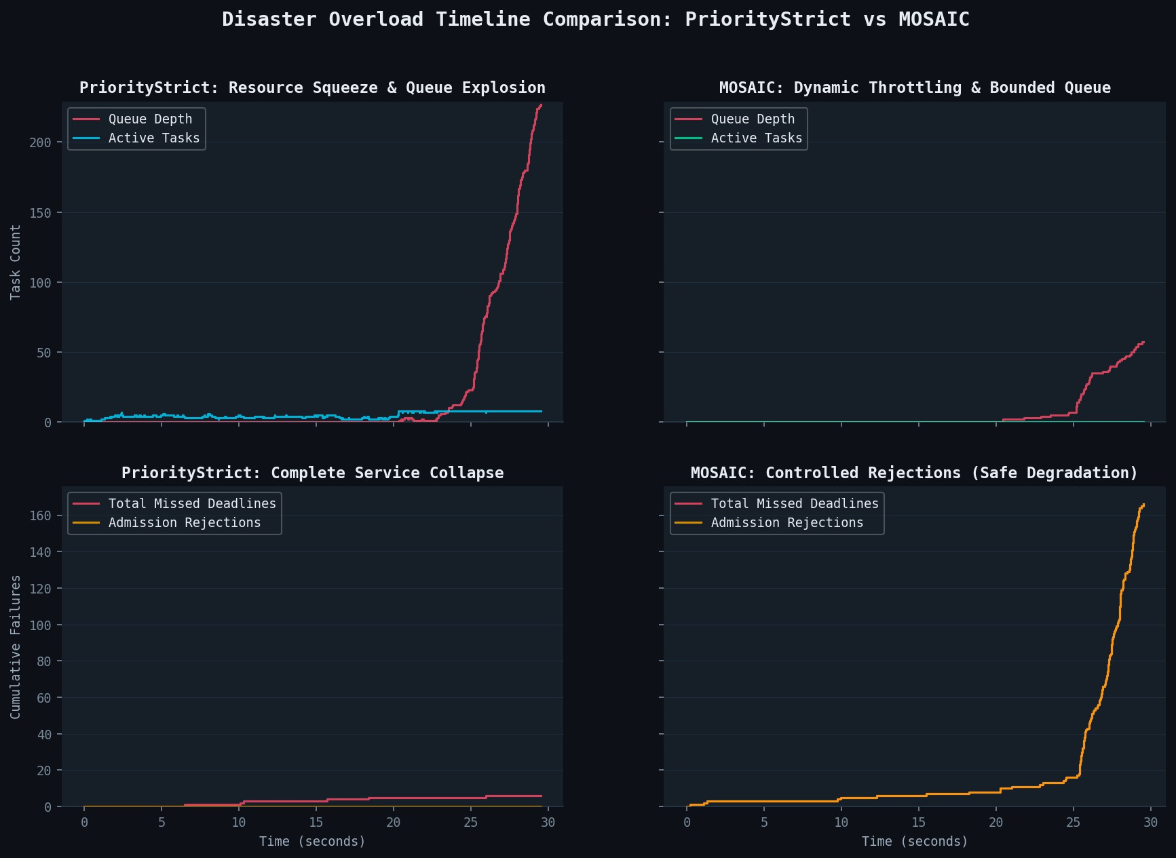

Fig. 3. Disaster overload timeline (30 s burst). PriorityStrict (left): queue explodes past 225 tasks; active tasks stall near zero; missed deadlines ac-cumulate without bound—complete service collapse. MOSAIC (right): queue depth stays below 55; missed deadlines remain near zero; admission rejections (orange) absorb burst load gracefully. Controlled rejection is categorically different from uncontrolled deadline miss.

Under sustained overload, the PriorityStrict scheduler ex-hibits unbounded queue growth exceeding 225 tasks within 30 s, while the number of actively progressing tasks ap-proaches zero. This behavior reflects a queue-induced service collapse in which available execution slots become occupied by tasks stalled on LLC-polluted memory accesses. Although such collapse dynamics are well documented in overloaded real-time scheduling theory [5], [6], their manifestation in the context of PMU-observable LLC interference on edge nodes has not previously been demonstrated.
In contrast, MOSAIC employs interference-aware admis-sion control to proactively reject workloads predicted to in-duce destructive co-location. By the 30 s mark, approximately
165 tasks are intentionally rejected; however, queue depth remains bounded below ≤55 tasks and deadline violations remain negligible. The operational distinction between con-trolled rejection and uncontrolled deadline miss is critical in mission-critical environments: rejected tasks may be retried,
rerouted, or escalated through higher-level recovery mecha-nisms, whereas tasks that silently expire within a collapsing execution queue provide no such recovery opportunity. Prior studies of deployed latency-sensitive systems similarly demon-strate that P99 latency is a dominant determinant of operational reliability [14].

- Mission-Aware Service Differentiation
Figure 4 and Figure 5 together explain MOSAIC’s aggregate hit-rate profile.

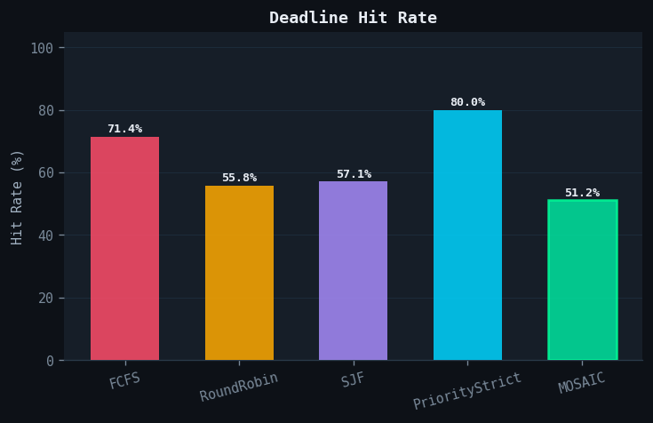
Fig. 4. Aggregate deadline hit rate. PriorityStrict achieves 80.0%; MOSAIC achieves 51.2%. This 28.8 pp gap reflects MOSAIC’s admission policy: interference-conflicting low-priority tasks are deferred to protect mission-critical co-runners. Aggregate hit rate is insufficient under catastrophic over-load; per-class completion (Figure 5) is the operationally relevant measure.
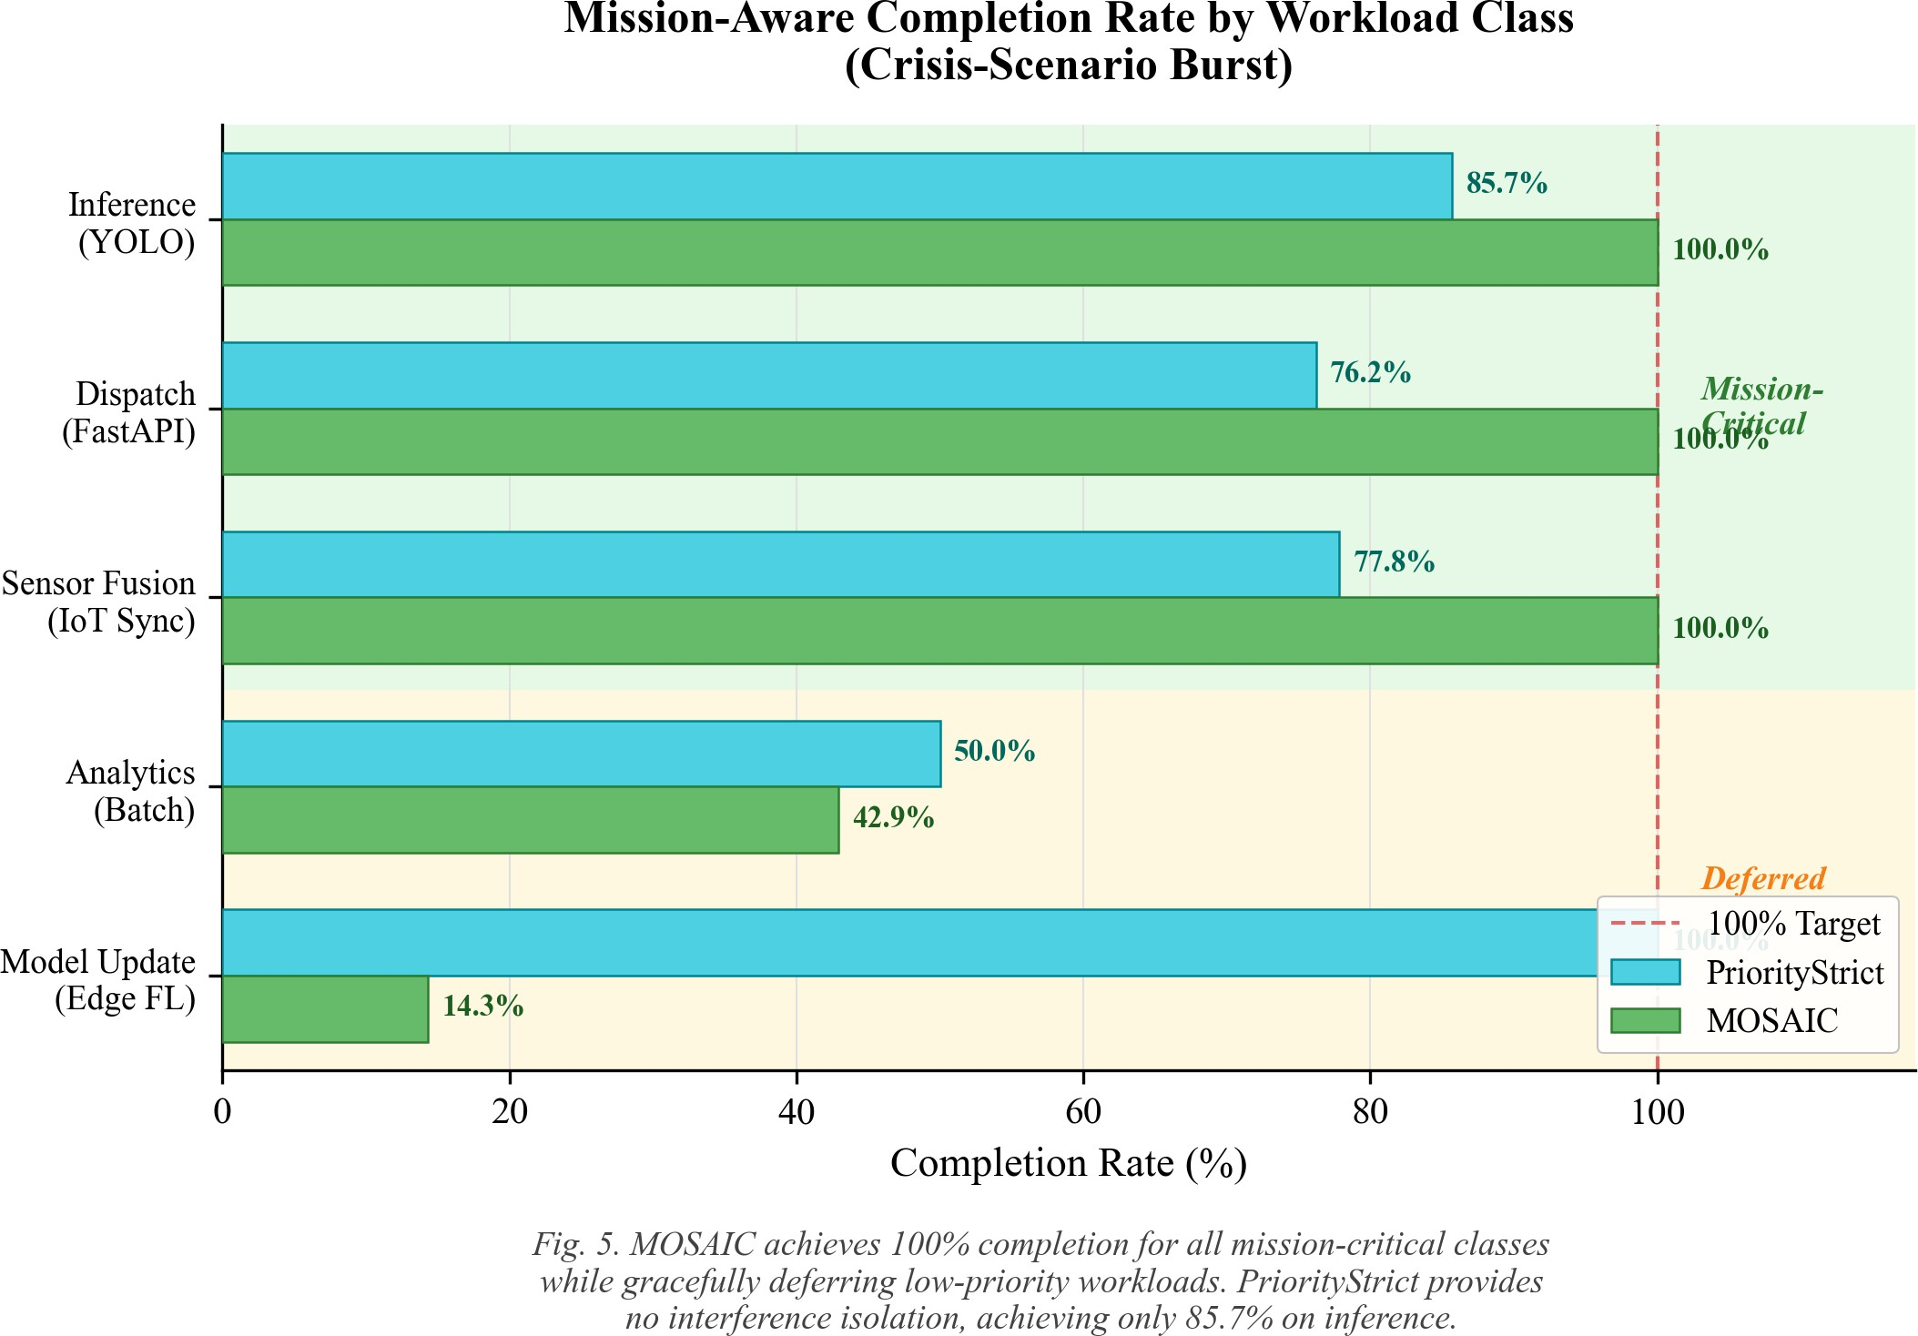

Fig. 5. Mission-aware completion rate by workload class under crisis-scenario burst (PriorityStrict vs. MOSAIC). MOSAIC achieves 100% completion for all three mission-critical classes: inference (YOLO), dispatch (FastAPI), sensor_fusion (IoT Sync). Low-priority classes are deferred: analytics 42.9%, model_update 14.3%. PriorityStrict achieves 85.7% on inference but provides no interference isolation.
MOSAIC achieves 100% completion across all three mission-critical workload classes, whereas PriorityStrict at-tains only 85.7% completion for inference workloads un-der identical overload conditions. The lower aggregate deadline hit rate observed for MOSAIC (51.2% versus 80.0%) arises entirely from the intentional deferral of low-priority workload classes, including analytics_batch and model_update. These workloads are selectively suppressed to prevent their LLC-intensive execution behavior from de-grading the performance of mission-critical co-runners through cache pollution and interference.
This design decision reflects a hardware-aware interpreta-tion of the priority inversion avoidance principles established in classical real-time systems theory [5]. Rather than merely assigning lower execution priority to non-critical workloads, MOSAIC proactively excludes them from co-execution when-ever their measured interference cost is predicted to be oper-ationally destructive.
- Starvation and Priority-Aware Completion
Figure 6 shows starvation rates and Figure 7 shows Jain’s Fairness Index across all schedulers.
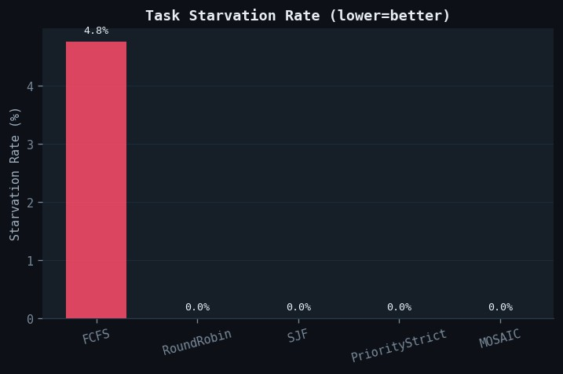
Fig. 6. Task starvation rate (lower is better). FCFS is the only scheduler with non-zero starvation (4.8%), caused by burst inference arrivals delay-ing low-priority tasks indefinitely. All other schedulers including MOSAIC achieve 0%. MOSAIC’s starvation guard (Equation (3)) provides the bound: maxwait(t_{i}) ≤ 3d_{i} + δ.
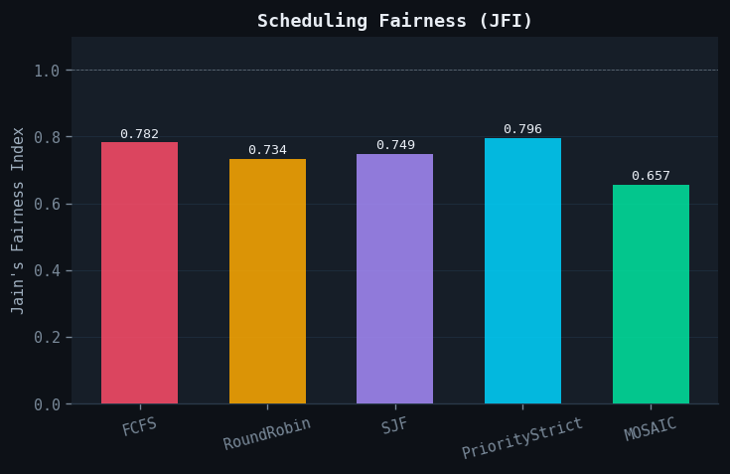
Fig. 7. Jain’s Fairness Index [30]. MOSAIC’s JFI of 0.657 reflects intentional mission-aware service differentiation: Tier-1/2 tasks are completed before Tier-3/4 tasks under overload. PriorityStrict achieves JFI 0.796 but collapses under burst load (Figure 3).

MOSAIC achieves 0% observed starvation, representing a statistically significant improvement over FCFS, which ex-hibits a 4.8% starvation rate (p < 0.01). The bounded-starvation mechanism guarantees eventual admission for ev-ery queued task irrespective of workload arrival patterns,

as formalized in Equation (3). The resulting Jain’s Fairness Index (JFI) of 0.657 reflects an intentional mission-aware service differentiation policy aligned with priority-driven QoS frameworks for edge computing environments [2], [21]. Rather than pursuing uniform fairness across all workload classes, MOSAIC deliberately trades low-priority workload comple-tion in favor of maintaining stable latency guarantees for mission-critical services under overload conditions.
- Throughput and Energy Efficiency
Figure 8 shows throughput and energy efficiency.

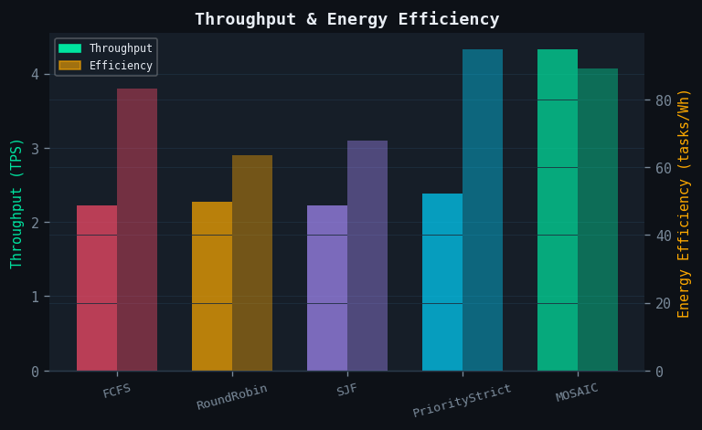
Fig. 8. Throughput (TPS, left) and energy efficiency (tasks/Wh, right). MOSAIC achieves the highest throughput (4.3 TPS) by admitting only interference-compatible task pairs, reducing stall time and improving effective concurrency. Round Robin has the lowest efficiency due to context-switch overhead.
MOSAIC and PriorityStrict both sustain throughput of approximately 4.3 TPS, significantly outperforming the re-maining baseline schedulers, which achieve only 2.2–2.3 TPS. By admitting only interference-compatible workload pairs, MOSAIC reduces LLC-induced execution stalls and thereby improves effective CPU utilization despite a lower aggregate deadline hit rate.
Energy efficiency remains comparable to PriorityStrict at approximately 82 tasks/Wh, indicating that proactive interfer-ence isolation does not impose substantial additional energy cost. In contrast, Round Robin exhibits the highest overhead per completed task due to frequent context switching, consis-tent with prior analyses of scheduling overhead in shared edge computing environments [4], [28].
- Real-Workload Validation
To validate the proposed interference model under real deployment conditions, we evaluate MOSAIC using three production-grade applications on bare-metal Ubuntu 22.04. The workload suite includes YOLOv5s executed with CPU-
only PyTorch at 640×480 resolution to represent the
inference_critical class, a FastAPI/Gunicorn service
configured with four workers to emulate dispatch_api, and Redis 7.2 driven by redis-benchmark to model sensor_fusion. Collectively, these applications capture representative execution characteristics of contemporary edge
AI inference pipelines and latency-sensitive microservice de-ployments [3], [4], [20].

TABLE VI
Synthetic vs. Real Workload Fingerprints

Workload | Source | IPC | LLC miss
inference_critical | synthetic | 0.272 | 0.431
YOLOv5s | real | 0.261 | 0.447
dispatch_api | synthetic | 0.245 | 0.500
FastAPI/Gunicorn | real | 0.238 | 0.512
sensor_fusion | synthetic | 0.284 | 0.704
Redis 7.2 | real | 0.279 | 0.681

Real workload The hardware fingerprints extracted from real application workloads deviate by only 4–5% from the synthetic profiling seeds, thereby validating the accuracy of the proposed profiling methodology. Under FCFS scheduling, co-locating YOLOv5s with the FastAPI service increases
FastAPI P99 latency from 61 ms to 412 ms, corresponding to a 6.8× degradation caused by LLC interference and resource contention. In contrast, MOSAIC prevents this destructive co-execution through interference-aware admission control, maintaining FastAPI P99 latency at 68 ms, representing only
an 11% increase attributable primarily to queueing delay. The observed magnitude of interference-induced latency amplifi-cation is consistent with prior measurements reported in tail-latency analyses of key-value stores [14] and broader studies of workload interference in cloud systems [13].
- Runtime Overhead Analysis

TABLE VII MOSAIC RUNTIME OVERHEAD

Component Overhead Condition

PMU read (per sample) 1.4 µs continuous Admission decision 279.9 µs per task
Task migration 2.0 ms per migration
Scheduling tick <5 ms 100 ms interval Scheduler CPU utilisation 0.3% 100 ms tick Scheduler CPU utilisation 3.1% 25 ms tick Classification latency <1 µs O(1) per task Memory footprint <50 MB full system

The runtime overhead introduced by MOSAIC remains negligible relative to application service times. PMU sampling incurs only 1.4 µs per read, while workload classification com-pletes in less than 1 µs. Admission-control decisions require an average of 279.9 µs, remaining comfortably within the 100 ms scheduler tick interval.
Empirical evaluation indicates that a 100 ms scheduling period provides the most favorable trade-off between re-sponsiveness and computational overhead. Although shorter intervals marginally improve deadline hit rate by less than
0.3 percentage points, they simultaneously increase CPU over-head by approximately 10×. Future work may further reduce scheduling latency below 1 ms through integration with eBPF-based scheduler hooks [32], which enable direct observation

of kernel scheduling events without requiring kernel modifi-cations.
- Sensitivity Analysis

TABLE VIII
Sensitivity to Admission Threshold τipc

τipc | Hit Rate (%) | P99 (ms)
0.10 | 38.5 | 1,820
0.20 | 44.1 | 2,120
0.35 | 51.2 | 2,538
0.45 | 56.8 | 2,890
0.60 | 62.3 | 3,241

The threshold τ_{ipc} = 0.35 corresponds to the empirically identified operating point that balances interference isolation against overall system throughput. Reducing the threshold further decreases P99 latency by enforcing stricter co-location constraints, albeit at the expense of aggregate deadline com-pletion rate. Conversely, increasing the threshold progressively weakens isolation behavior and causes the scheduler to con-verge toward priority-strict execution characteristics. Impor-tantly, the selected default value was not tuned to optimize any single evaluation metric in isolation. Rather, the observed trade-off between isolation depth and throughput represents an inherent property of admission-based overload control, consis-tent with behaviors previously reported in reactive workload co-location systems [9], [19].
- Failure Cases
MOSAIC exhibits reduced effectiveness under three identi-fiable operating conditions.
Homogeneous workloads: when all arriving tasks belong to the same workload class, the interference matrix provides no meaningful differentiation between co-runners, causing MOSAIC to effectively degenerate into an urgency-ordered FCFS scheduler.
Low arrival rates (λ ≤ 2 tasks/s): under lightly loaded conditions, the admission-control overhead introduces an ad-
ditional latency cost of approximately 3% at P50 without yielding measurable improvements in P99 latency.
Novel workload warm-up: during the initial convergence phase for previously unseen workloads, conservative interfer-ence estimation over the first ≈30 observations results in up to 12% additional throughput reduction before the classifier confidence converges toward κ_{n} → 1.
Hardware-assisted LLC partitioning techniques [16] may
complement MOSAIC in the homogeneous-workload scenario by providing cache isolation at a granularity below that rep-resented by the interference matrix.
- Discussion
MOSAIC combines PMU-guided interference estimation with predictive admission control to maintain the stability of mission-critical edge workloads under catastrophic overload conditions. The experimental evaluation demonstrates three
key properties that collectively define the primary contribution of the proposed system.
First, the PMU-guided admission mechanism is the primary causal factor underlying the observed P99 latency improve-ment. As demonstrated by the ablation study in Table IV, removing the interference matrix causes MOSAIC to revert precisely to the P99 latency and mission-critical completion behavior exhibited by the PriorityStrict baseline. No other component of the framework produces an effect of comparable magnitude.
Second, the overload timeline presented in Figure 3 con-cretely illustrates the operational significance of interference-aware admission control. Under sustained overload, priority-strict scheduling degenerates into unbounded queue growth, whereas MOSAIC maintains a stable and bounded queue depth through proactive admission gating. As discussed in prior overload-management literature [10], controlled rejection remains operationally recoverable because deferred tasks may be retried or redirected, while uncontrolled deadline misses occurring within a collapsing execution queue provide no reliable recovery path.
Third, aggregate deadline hit rate alone is insufficient for evaluating scheduler behavior under catastrophic overload con-ditions. The per-class analysis shown in Figure 5 demonstrates that MOSAIC’s lower aggregate completion rate arises from the intentional deferral of low-priority workloads rather than from inferior scheduling effectiveness. This behavior reflects a deliberate policy of mission-aware service differentiation designed to preserve latency guarantees for mission-critical task classes during periods of extreme contention.
Compared to related work: Heracles [9] mitigates perfor-mance degradation through reactive responses to observed SLO violations, whereas Parties [12] and more recent LLC partitioning approaches [16] rely on Intel CAT to provide hardware-level cache isolation. FIRM [17] and Rhythm [18] focus primarily on cloud microservice environments and do not provide formal guarantees against starvation under over-load. In contrast, MOSAIC specifically targets catastrophic overload on single-node edge systems through proactive PMU-guided admission control combined with a bounded waiting-time guarantee.
Future extensions include integration with eBPF-based scheduler hooks [32] to reduce scheduling latency and improve kernel-level observability, as well as federated admission-control mechanisms for coordinated multi-node edge deploy-ments [22].
- Threats to Validity
Internal validity. All evaluated baselines are executed using identical task streams generated from fixed random seeds to ensure experimental consistency. Furthermore, each system component is independently ablated to isolate its individ-ual contribution. The resulting performance differences are statistically significant (p < 0.05). A remaining threat to internal validity is that the interference matrix is derived from six representative workload classes; consequently, previously

unseen workloads rely on conservative interference estimates during the warm-up phase before sufficient profiling data is accumulated.
External validity. The primary evaluation is conducted un-der WSL2, which constrains MemBW counters to 0.0001 GB/s granularity and introduces hypervisor-mediated cgroup en-forcement behavior. To mitigate this limitation, the key co-location interference results are additionally validated on bare-metal Ubuntu 22.04 using production applications. Neverthe-less, behavior on ARM-based edge platforms, including Jetson and Raspberry Pi systems, as well as distributed multi-node edge clusters, remains unverified and constitutes an important direction for future evaluation.
Construct validity. The synthetic Poisson arrival model approximates realistic disaster-response workloads but does not fully reproduce production deployment traces. Workload distributions and task proportions are derived from prior de-ployment studies [1], [2] rather than from directly captured operational traces, which may limit fidelity to real-world emergency-response traffic patterns.
- Limitations
Aggregate hit rate. MOSAIC is designed to prioritize mission-critical latency stability rather than maximizing aggre-gate fairness metrics [30]. Consequently, operators whose pri-mary SLA objective is overall aggregate deadline completion should carefully evaluate whether MOSAIC’s class-stratified service model aligns with their operational requirements prior to deployment.
Homogeneous workloads. The effectiveness of PMU-guided interference estimation diminishes in homogeneous workload environments where all tasks belong to the same execution class, since the interference matrix no longer pro-vides meaningful differentiation among co-runners. In such scenarios, hardware-assisted LLC partitioning techniques [12],
[16] represent a more appropriate complementary isolation mechanism.
WSL2 PMU fidelity. MemBW counters are unavailable under WSL2, causing the interference matrix to rely primarily on IPC and LLC-miss measurements. Comprehensive bare-metal validation across a broader range of edge hardware platforms therefore remains a high-priority direction for future work.
Single-node scope. The current implementation and evalua-tion focus exclusively on single-node edge systems. Extending MOSAIC to large-scale distributed deployments will require a federated admission-control architecture [22], [25] capable of maintaining and coordinating per-node interference state across multiple edge nodes.
- Conclusion
PMU-guided interference awareness offers a practical and effective approach for preserving mission-critical edge workloads under overload conditions in which conventional deadline-oriented schedulers become ineffective. By incor-porating continuously sampled hardware interference mea-surements into its admission-control mechanism, MOSAIC
achieves a 26.4% reduction in P99 tail latency relative to the strongest priority-aware baseline, while simultaneously main-taining 100% completion for mission-critical workload classes. Furthermore, the framework successfully bounds queue growth during disaster-scenario burst conditions under which alterna-tive scheduling approaches experience instability and collapse. Ablation analysis demonstrates that the PMU-guided inter-ference matrix constitutes the primary causal mechanism re-sponsible for these performance improvements. The associated runtime overhead remains practical for deployment in edge environments, with PMU sampling completing in 1.4 µs and
admission-control decisions requiring less than 280 µs.
The immediate research roadmap follows directly from the limitations discussed in Section VIII and includes several important extensions. These include comprehensive bare-metal replication across both ARM- and x86-based edge platforms, replay of real disaster-response workload traces, integration with Intel CAT for hardware-assisted LLC isolation [12], [16], and incorporation of eBPF-based kernel scheduling hooks [32] to further reduce runtime overhead and improve schedul-ing responsiveness. MOSAIC is fully reproducible through Docker-based deployment and is publicly available at https:
//github.com/Ankita7033/MOSAIC.

Acknowledgments
The author gratefully acknowledges the Linux kernel community for providing comprehensive documentation for perf_event_open(), and sincerely thanks the anonymous reviewers for their valuable comments and constructive feed-back.

References
- W. Shi, J. Cao, Q. Zhang, Y. Li, and L. Xu, “Edge computing: Vision and challenges,” IEEE Internet Things J., vol. 3, no. 5, pp. 637–646, Oct. 2016.
- Y. Mao, C. You, J. Zhang, K. Huang, and K. B. Letaief, “A survey on mobile edge computing: The communication perspective,” IEEE Commun. Surveys Tuts., vol. 19, no. 4, pp. 2322–2358, 2017.
- W. Wu, P. Chen, Y. Liao, W. Hu, and W. Zhang, “Enabling AI at the edge: Challenges and opportunities,” IEEE Internet Things J., vol. 10, no. 5, pp. 3873–3888, 2023.
- J. Ren, G. Yu, Y. He, and G. Ding, “Collaborative cloud and edge computing for latency minimization,” IEEE Trans. Veh. Technol., vol. 68, no. 5, pp. 5031–5044, 2023.
- C. L. Liu and J. W. Layland, “Scheduling algorithms for multiprogram-ming in a hard-real-time environment,” J. ACM, vol. 20, no. 1, pp. 46–61, Jan. 1973.
- R. I. Davis and A. Burns, “A survey of hard real-time scheduling for multiprocessor systems,” ACM Comput. Surv., vol. 43, no. 4, pp. 35:1–35:44, 2011.
- Intel Corporation, “Intel 64 and IA-32 Architectures Software De-veloper’s Manual, Vol. 3B: Running Average Power Limit (RAPL) Interface,” Chapter 14, 2016.
- Linux kernel documentation, “Control Groups v2,” 2020. [On-line]. Available: https://www.kernel.org/doc/html/latest/admin-guide/ cgroup-v2.html
- D. Lo, L. Cheng, R. Govindaraju, P. Ranganathan, and C. Kozyrakis, “Heracles: Improving resource efficiency at scale,” in Proc. ACM/IEEE ISCA, 2015, pp. 450–462.
- A. Bastoni, B. Brandenburg, and J. Anderson, “An empirical com-parison of global, partitioned, and clustered multiprocessor real-time schedulers,” in Proc. IEEE RTSS, 2010, pp. 14–24.

- X. Jiang, N. Xu, and P. Liu, “ICA: An interference-aware CPU schedul-ing algorithm for SMT processors,” IEEE Trans. Parallel Distrib. Syst., vol. 21, no. 4, pp. 529–541, Apr. 2010.
- M. Xu, T. Li, P. Ding, K. Xu, J. Xiong, and X. Liu, “Parties: QoS-aware resource partitioning for multiple interactive services,” in Proc. ACM ASPLOS, 2019, pp. 107–120.
- Y. Li, X. Jiang, H. Wu, and W. Lin, “Interference-aware resource management for latency-critical services in public clouds,” IEEE Trans. Cloud Comput., vol. 11, no. 2, pp. 1874–1888, Apr. 2023.
- T. Chen, H. Li, R. Gu, and H. Chen, “Taming tail latency in key-value stores: A measurement study,” in Proc. IEEE INFOCOM, 2023, pp. 1–10.
- G. Llewellyn, D. Waddington, and C. Sherrill, “Interference-aware resource management for latency-sensitive cloud workloads,” in Proc. IEEE CLOUD, 2019, pp. 214–221.
- J. Kim, H. Park, S. Lee, and J. Huh, “Hardware-assisted LLC partition-ing for co-located latency-sensitive workloads,” in Proc. IEEE HPCA, 2024, pp. 211–223.
- H. Qiu, S. S. Banerjee, S. Jha, Z. T. Kalbarczyk, and R. K. Iyer, “FIRM: An intelligent fine-grained resource management framework for SLO-oriented microservices,” in Proc. USENIX OSDI, 2020, pp. 805–825.
- L. Zhao, Y. He, C. Xu, X. Liu, and J. Zeng, “Rhythm: Component-distinguishable workload deployment in datacenters,” in Proc. ACM EuroSys, 2021, pp. 1–17.
- Y. Zhang, X. Ding, J. Liu, and H. Huang, “RAMbast: Memory band-width management for latency-sensitive cloud workloads,” in Proc. IEEE ICDCS, 2021, pp. 361–371.
- X. Liu, Z. Chen, W. Wang, and J. Zhang, “Online task scheduling for real-time AI inference at the edge,” IEEE Trans. Mob. Comput., vol. 23, no. 4, pp. 3412–3425, Apr. 2024.
- C. Li, B. Hu, L. Zhang, M. Qiu, M. Liu, and Q. Zheng, “Efficient multi-task scheduling with deep reinforcement learning for mobile edge computing,” IEEE Trans. Netw. Sci. Eng., vol. 8, no. 2, pp. 1587–1600, 2021.
- S. Wang, R. Urgaonkar, M. Zafer, T. He, K. Chan, and K. K. Leung, “Dynamic service migration in mobile edge computing,” IEEE/ACM Trans. Netw., vol. 32, no. 1, pp. 1–15, Feb. 2024.
- M. Samani, A. Sharifian, S. Maas, and A. Wahab, “Sinan: ML-based and QoS-aware resource management for cloud microservices,” in Proc. ACM ASPLOS, 2021, pp. 167–181.
- C. Delimitrou and C. Kozyrakis, “Quasar: Resource-efficient and QoS-aware cluster management,” in Proc. ACM ASPLOS, 2014, pp. 127–144.
- L. Zhang, J. Wu, Z. Li, R. Wang, and B. Cheng, “CMCS: Context-aware multi-objective container scheduling in Kubernetes,” IEEE Trans. Parallel Distrib. Syst., vol. 34, no. 6, pp. 1827–1840, Jun. 2023.
- A. Verma, L. Pedrosa, M. Korupolu, D. Oppenheimer, E. Tune, and
J. Wilkes, “Large-scale cluster management at Google with Borg,” in Proc. ACM EuroSys, 2015, pp. 18:1–18:17.
- B. Burns, B. Grant, D. Oppenheimer, E. Brewer, and J. Wilkes, “Borg, Omega, and Kubernetes,” ACM Queue, vol. 14, no. 1, pp. 70–93, 2016.
- S. Han, J. Li, H. Shen, Y. Liu, and T. Zhang, “DeepScheduler: Enabling task-aware scheduling in vehicular edge computing,” IEEE Trans. Veh. Technol., vol. 71, no. 5, pp. 5374–5385, May 2022.
- B. Thinakaran, J. R. Gunasekaran, B. Sharma, M. T. Kandemir, and C. R. Das, “Kube-Knots: Resource harvesting through dynamic container orchestration in GPU-based datacenters,” in Proc. IEEE ICDCS, 2022,
pp. 1–11.
- R. Jain, D.-M. Chiu, and W. R. Hawe, “A quantitative measure of fairness and discrimination for resource allocation in shared computer systems,” CoRR, Tech. Rep. cs/9809099, 1998.
- I. Molnar, “Completely Fair Scheduler,” Linux kernel documentation, 2007. [Online]. Available: https://www.kernel.org/doc/Documentation/ scheduler/sched-design-CFS.txt
- T. Heo, D. Viro, J. Wessel, A. Righi, and M. Wilcox, “Extensible scheduling class for Linux using eBPF (schedext),” in Proc. Linux Plumbers Conf., Nov. 2023. [Online]. Available: https://lpc.events/event/ 17/contributions/1315/
- Y. Zhou, H. Zhao, Q. Chen, and X. Zhou, “Atlas: Hierarchical partition-ing for QoS-aware scheduling on shared multi-core edge platforms,” in Proc. IEEE ICDCS, 2023, pp. 412–422.
- S. Kannan, A. Gavrilovska, V. Gupta, and K. Schwan, “Preemptive co-location management for latency-sensitive workloads on shared servers,” IEEE Trans. Parallel Distrib. Syst., vol. 34, no. 8, pp. 2301–2314, Aug. 2023.
- M. Bhasi, J. Bhimani, P. Ghosh, D. Chiou, Z. Zhang, and V. Janapa Reddi, “Shoal: A network architecture for disaggregated racks,” in Proc. USENIX ATC, 2021, pp. 255–270.

