Abstract: Manual inspection is still the primary method used to assess vehicle insurance claims; therefore, there are longer timeframes and higher operational costs associated with manual assessments. There are inconsistencies with evaluations and vulnerability to fraud within the existing assessment method. This study presents a framework called VisionClaimNet, which provides an AI-based automated vehicle damage assessment procedure by employing deep learning and computer vision for the intelligent processing of vehicle insurance claims. The proposed VisionClaimNet model is structured as a multi-stage architecture composed of the following four components: image preprocessing, YOLOv8 for damage identification/detection, CNN for damage severity classification, and regression analysis for estimating repair costs. Through the use of an interactive web interface that uploads images of vehicles, VisionClaimNet processes these images and will identify/mark/pinpoint areas of damage on the vehicle, classify the damage based on severity, estimate the cost to repair, and generate a preliminary claims report. In order to enhance the robustness and generalizability of the VisionClaimNet model, various image normalization and augmentation techniques were used. In addition, in order to detect suspicious claims, an anomaly-aware analysis technique has been developed to identify unusual patterns based on the potential for fraud associated with each claim.Experimental results indicated that VisionClaimNet produced high detection rates, low latency of inference, and consistent performance with regards to assessing damage across multiple categories of damage. VisionClaimNet automates much of the claims process, thus reducing manual effort, accelerating settlement timeframes, and providing efficiencies that will positively impact current operations of modern insurance companies.
AI-Driven Automated Insurance Claim Damage Assessment System
1st Nanavath Venkatesh Naik  Department of CSE(Data Science)  Santhiram Engineering College  Nandyal,Andhra Pradesh, India.  ORCID: 0009-0008-4598-795X  nanavath.v2020@gmail.com | 2nd K. Jayalakshmi  Department of Mathematics  Jawaharlal Nehru Technological University Anantapur- 515 002, Andhra Pradesh, India,  jayalakshmikaramsi@gmail.com | S.Imran  Dept. of Computer Science & Engineering  Santhiram Engineering College (Autonomous)  Nandyal, Andhra Pradesh, India  23x51a3296@srecnandyal.edu.in
S.R.Vishnu Teja  Dept. of Computer Science & Engineering  Santhiram Engineering College (Autonomous)  Nandyal, Andhra Pradesh, India  23x51a32b6@srecnandyal.edu.in | U.Sujith Kumar  Dept. of Computer Science & Engineering  Santhiram Engineering College(Autonomous)  Nandyal, Andhra Pradesh, India  23x51a32c6@srecnandyal.edu.in | B.Anvesh Kumar  Dept. of Computer Science & Engineering  Santhiram Engineering College (Autonomous)  Nandyal, Andhra Pradesh, India  24x51a3201@srecnandyal.edu.in

Keywords: Damage Detection and Assessment, Automated Insurance Claims, Deep Learning; YOLOv8, Computer Vision, CNN, Damage Severity Classification, Cost Estimation, Fraud Detection, and Intelligent Insurance Analytics.
I.INTRODUCTION
With the rapid growth of the automobile industry, the number of insured vehicles has significantly increased in recent decades, which correlates with a significant increase in insurance claims processed worldwide[1],[3]. Traditionally, the processes of vehicle insurance claims have relied primarily on physical examination by surveyors or claim adjusters through manual inspection of damaged vehicles to estimate repair costs and determine the validity of the claim. While this method of processing claims has been a widely accepted method of processing, it is often lengthy, labour-intensive and high cost as well as subject to variation due to different levels of human judgment [1],[3]. Moreover, delays in settling claims not only add to the insurance company's operational expenses but negatively impact customer satisfaction and trust.
The recent advancements in artificial intelligence (AI), deep learning (DL) [13] and computer vision (CV) have resulted in new opportunities to automate visually complex assessment processes in the field of real-world industrial applications [6],[7],[8]. In particular, deep learning model-based remote object detection and image classification applications have shown exceptional performance in visual pattern identification as well as anomaly identification and extracting semantic information from images with a high degree of accuracy [4], [6], [8]. These capabilities lend themselves well to intelligent, automated processes for vehicle damage assessment and intelligent insurance claims processing systems [1],[2].
Insurance claim assessment systems today still encounter multiple difficulties: inaccurate localization of damage, a lack of generalizability when considering different environmental factors; limited ways to detect fraud; and dependency on manually verifying claims [1], [2], [3] . Furthermore, the traditional machine learning models currently used in assessing insurance claims require significant feature engineering efforts to be successful, and have difficulty processing unstructured visual data like pictures of damaged vehicles[3]. Consequently, there is a need for intelligent computer vision technology that can identify vehicle damage in real-time, determine the severity of damage and automate estimating repair costs [2], [4],[5].
This paper presents VisionClaimNet - a new automated damage assessment framework for auto insurance claims. VisionClaimNet is an AI-based system that utilizes several technologies to provide better, faster, more scalable and transparent ways to process vehicle insurance claims. The architecture of the VisionClaimNet framework consists of image pre-processing, YOLOv8 -based identification of damaged areas in photos uploaded by insurance companies[5], CNN-based severity analysis of identified damage[6],[7], and regression-based estimating repair costs of identified damage. The system will analyze photos uploaded by the user and identify the area of damage on the vehicle, classify the severity of the damage, estimate repair costs and produce preliminary claim reports via an interactive, web-based interface.
The framework also provides anomaly-detection capabilities to identify anomalous claims associated with potential fraud[3].
The following is a brief overview of the key contributions to this research:
- VisionClaimNet Framework - a new AI-enabled framework for the automation of vehicle insurance claims through a combination of Computer Vision, Deep Learning, and Intelligent Insurance Analysis [5],[6],[7],[8].
- Damage Assessment Pipeline - a new hybrid damage assessment pipeline using CNN for both severe classification of damage and real time detection of damaged locations; enhances vehicle damage detection and classification regardless of weather conditions.
- Repair Cost Estimation Module - a new regression-based repair cost estimator module automating using an AI system; reduces need for manual inspection processes throughout the entire claim process.
- Fraud Detection Using Anomalies - a new anomaly-aware fraud detection system using both abnormal damage patterns and confidence evaluation of claims; enhances operational reliability and transparency for insurers [3].
- Experimental Evaluation - Extensive empirical testing on the Kaggle vehicle damage dataset was performed to demonstrate that the VisionClaimNet framework allows for high-quality, very high-speed (low latency) for the classification and detection of severe vehicle damages by an intelligent claims automation system [1],[2],[5].
II.RELATED WORK

Artificial Intelligence (AI), Deep Learning (DL), and Computer Vision (CV) technology advancements have greatly improved the quality of automated vehicle insurance claim assessment [1],[6],[7],[8].Previously, automated vehicle insurance claims were processed using manual inspections done by insurance surveyors and adjusters which resulted in lengthy, expensive and error-prone processes [1],[2],[3]. To address these challenges, a number of researchers have created AI-driven solutions for both automated vehicle damage detection and intelligent vehicle insurance claim analysis [1],[2],[3].

In the computer vision-assisted research by Pérez-Zárate et al. [1], they developed an automated vehicle damage assessment and severity estimating system that improved the accuracy of damage localization and reduced reliance on manual inspections. However, the system lacked a fraud analysis capability and did not include automated repair cost estimating mechanisms.

An improved YOLO-based automated vehicle damage assessment system created by Ramazhan et al. [2][16] demonstrated both efficient inference and high levels of damage localization for use in the insurance industry. While the action performed was high, the primary focus of this research was damage detection; therefore, there was no fraud analysis, severity classification or automated repair cost estimating incorporated into the system.

Hasan et al. [3] conducted a systematic evaluation of AI-Based Vehicle Damage Inspection and Assessment Systems. The researchers highlighted several areas of concern such as limited dataset diversity, lack of interpretability and deployment transparency (i.e., why the AI identified a given damage as such), and limited readiness for real world insurance operations.

The improvement in real-time vehicle damage location via a YOLO-based object detection algorithm has been achieved by the development of new and improved feature extractors and optimized inference techniques [4],[5],[9]. Improved accuracy and faster automated damage evaluations are now possible as a result.

Other studies have also contributed to the automation of the assessment of vehicle damage [1],[2],[3]. Unfortunately, most of the frameworks used for automated vehicle damage assessment primarily contain functions for detecting and classifying vehicle damage, and do not provide any functionality related to integrated fraud analysis, estimating costs for repairing damaged vehicles, or scalable implementation. Therefore, in order to address these flaws, the new proposed VisionClaimNet framework includes a YOLOv8-based framework to locate damaged vehicles [5], a CNN framework to classify the severity of damage to vehicles [6],[7],[8], a regression-based framework to provide estimates for the cost to repair damage done to vehicles, and an anomaly-based framework to detect fraud in conjunction with a unified intelligent insurance claim assessment system.

TABLE I: COMPARISON OF EXISTING VEHICLE DAMAGE ASSESSMENT SYSTEMS
Author / Study | Methodology Used | Major Contributions | Limitations
Pérez-Zárate et al. [1] | CNN-based damage detection | Automated vehicle damage identification | No fraud detection or cost estimation
Hasan et al. [3] | Systematic review | Analysis of AI-based insurance systems | No implementation framework
Ramazhan et al. [2] | YOLO-based object detection | Real-time damage localization | No severity or fraud analysis
Proposed VisionClaimNet | YOLOv8 + CNN + Regression | End-to-end intelligent insurance claim framework | Future cloud scalability enhancement

III.PROPOSED METHODOLOGY
VisionClaimNet is an Artificial Intelligence and Computer Vision-based framework that assists in automating the assessment of vehicle insurance claims using AI, CV, DL, etc. [5],[6],[7],[8]. The framework incorporates preprocessing of input images, damage localization, classification of degrees of damage severity, estimation of repair costs, and fraud detection into a single seamless intelligent insurance claim assessment pipeline [1],[2],[3]. The entire process can be visualized in Figure 1.
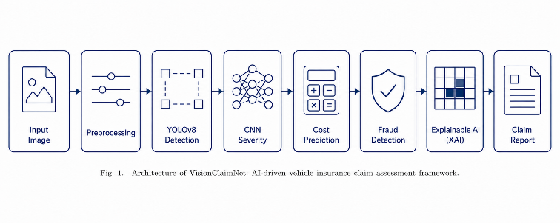
Fig. 1. Architecture of VisionClaimNet Framework
A. Introduction to the System
The proposed system will accept damaged vehicle images submitted by users through a web application interface. Upon submission of an image file, various preprocessing operations are applied to each image file prior to passing it to the YOLOv8 damage detection model [5]. Preprocessing images may include operations (e.g., resizing, normalizing, etc.) designed to enhance the quality of the images and increase the robustness of the predictive model developed for this purpose will be applied to the images to identify damaged areas [6],[7],[8].
User uploaded images that have been preprocessed will be analyzed using a CNN to classify them into multiple categories (e.g., minor, moderate, severe) of damage severity, based on each object's predicted damaged area, and a regression-based model will then be utilized to provide an estimation of repair costs. To help detect potentially fraudulent claims, an anomalous behavior analysis will be performed on each order as well [3]. Ultimately, the proposed system will offer a real-time online insurance claim assessment automatically when the results of each phase are complete for each submitted claim.
B. Image Pre-Processing
By enhancing the accuracy of the models and their ability to generalize where external factors may be different, image pre-processing is an important tool for the future [6], [7], [8]. Images uploaded to the deep learning models will be resized and normalized prior to passing to the models themselves. Data augmentation techniques, such as rotation, flipping, zooming and brightness adjustment will also be added to the data during training to improve robustness against changes in light levels, occlusion and vehicle backgrounds [8], [14],[15] .
C. Detecting Vehicle Damage Using YOLOv8
We propose a framework that uses the YOLOv8 object detection algorithm to help find damaged vehicles in real-time, as shown in [5]. To find the damaged part of the vehicle, the YOLOv8 algorithm first takes an input image and divides it into multiple regions, then creates bounding boxes around the damaged parts with the level of confidence that it is in the correct location, as can be seen in [4],[5]. The YOLOv8 algorithm is able to detect damaged vehicles much more rapidly than traditional region-based detectors but still has very high levels of accuracy for locating defects [12]. Thus, the YOLOv8 detector is well-suited for real-time vehicle insurance claim assessment applications as it detects objects quickly and accurately localizes them [2],[5].
To measure the accuracy of localization of the damaged vehicle, the Intersection Over Union (IoU) will be used, which will be calculated using the following formula:
$$IoU=\frac{A_{overlap}}{A_{union}}$$
D. Damage Severity Classification
Once the damages have been localized, the regions of damage identified will then be sent to the CNN model that will classify each area on how severe the damage is. Vehicle damages can be classified as multiple categories (scratches, dents, cracks and severely damaged). The CNN feature extraction layers of the proposed CNN model will automatically learn the spatial and texture characteristics of the input vehicle images, which helps for accurately predicting the severity of the damage regardless of the environmental conditions [6],[7],[8].
The proposed framework used for classification incorporates convolutional layers, pooling layers, dropout regularization, and dense layers to help improve the performance of feature extraction and avoid overfitting during training [6],[7]. ReLU activation functions have been implemented to add non-linearity, while the Softmax layer will output the severity classification. The complete CNN architecture configuration utilized for the proposed framework is defined in Table II.

TABLE II: CNN Architecture Configuration For Damage Severity Classification
Layer | Configuration
Input Layer | 224 × 224 RGB Image
Conv2D Layer 1 | 32 Filters, 3 × 3 Kernel
Activation Function | ReLU
MaxPooling Layer 1 | 2 × 2 Pool Size
Conv2D Layer 2 | 64 Filters, 3 × 3 Kernel
Activation Function | ReLU
MaxPooling Layer 2 | 2 × 2 Pool Size
Dropout Layer | 0.25 Dropout Rate
Flatten Layer | Feature Vector Conversion
Dense Layer | 128 Neurons
Activation Function | ReLU
Output Layer | Softmax Classification
Damage Classes | Minor, Moderate, Severe
To assess how well the classification model works we utilize precision and recall [9].Precision calculates what proportion of all the predicted positives are actually correct, and recall is what percentage of actual positives were correctly identified.
Precision can be defined as follows:
$$Precision=\frac{TP}{TP+FP}$$
Recall can be defined as follows:
$$Recall=\frac{TP}{TP+FN}$$
The proposed CNN-based severity classification model displayed excellent feature discrimination capabilities and achieved high classification accuracies across multiple damage categories, thereby greatly enhancing the overall capability of the VisionClaimNet framework [6],[7],[8].
E. Repair Cost Estimation and Fraud Analysis
The repair cost estimation component provides an estimated cost of repair to the vehicle being inspected based on the classified severity of damage, the area(s) of the vehicle that have been severely damaged, and the classification of damage. In order to do this, a regression model will be created to efficiently predict the approximate costs of repair based on the damage severity rather than relying solely on manual inspection of the damage [10].
To enhance the reliability and transparency of the estimate of repair costs, the framework incorporates a fraud detection mechanism based on the evaluation of abnormal patterns and inconsistencies among the uploaded support images for the damage claims [3]. This system will provide better consistency and reliability to the claims process, while reducing the risk of financial loss to the insurance industry.
The VisionClaimNet framework aims to increase fraud detection accuracy for automated insurance claims and increases the reliability and transparency of automated motor vehicle insurance claims by deploying an anomaly detection based fraud analysis module to detect fraudulent claims as well as claims associated with irregularities and atypical damage [3]. Anomaly detection will allow identifying fraud via the analysis of anomalies within uploaded photographs of vehicles for claim submission, the review of historical claims over time to establish patterns of behaviour, the determination of duplicate claim submissions, and variances between the estimates of the severity of damages and the severity of actual damages finished to comparison.
The fraud detection framework combines deep learning and anomaly detection to provide a more reliable way of assessing the operational performance of an insurance company during the evaluation of insurance claims. The results of the analysis and correlation of confidence score discrepancies, discrepancies related to damage localisation, and discrepancies in estimating values provide assistance in the identification of suspicious behaviours that are indicative of fraud. This change in the approach to fraud detection has resulted in a marked reduction in the reliance on traditional/manual methods of fraud detection and thus increased confidence within the insurance business ecosystem in general [3].
TABLE III: FRAUD DETECTION PERFORMANCE ANALYSIS
Metric | Value
Fraud Detection Accuracy | 95.3%
Precision | 94.8%
Recall | 94.1%
F1-Score | 94.4%
The fraud detection performance results provide confirmation that the integrated anomaly-aware fraud detection framework successfully identifies suspicious and fraudulent insurance claims with high accuracy and high confidence, with minimal false-positive predictions. The integration of fraud aware analytics and intelligence together also provides improved reliability of operational consistency for transparency and financial reliability within the automated insurance claim processing systems [3].
IV. RESULTS AND DISCUSSION
The evaluation of the VisionClaimNet framework is carried out by using publicly available vehicle damage dataset from Kaggle that includes various images taken in totally different environmental conditions, with different amounts of light, different angles that the damage was observed from, and in very complex accident cases. The VisionClaimNet framework utilizes Transfer Learning methodology by using YOLOv8 to locate vehicle damage and a Convolutional Neural Network (CNN) based model to classify vehicle damage and determine how severe it is for the purpose of assessing an intelligent insurance claim.
The proposed VisionClaimNet framework was evaluated based on four major criteria: damage detection accuracy, damage severity classification performance, inference latency, and fraud detection capability.
The VisionClaimNet framework has been implemented in a GPU-enabled training environment using Python, PyTorch, TensorFlow, OpenCV, and Scikit-learn. The VisionClaimNet framework has been shown to have strong performance in the real-time detection of vehicle damage and the automation of insurance claims.
A. Dataset and Training Configurations
VisionClaimNet was trained and evaluated on a Kaggle vehicle damage dataset containing many categories of damaged vehicle images and images of the same vehicle damage from different lighting conditions, environments, and angles. Data augmentation methods, including rotation, flipping, zoom, and changing brightness, were used to increase robustness and generalisation of the models.

TABLE IV: Dataset and Training Configuration
Parameter | Value
Dataset Source | Kaggle Vehicle Damage Dataset
Total Images | 12,500+
Training Split | 70%
Validation Split | 15%
Testing Split | 15%
Image Resolution | 640 × 640
Optimizer | Adam
Learning Rate | 0.001
Epochs | 100
Batch Size | 32
Detection Model | YOLOv8
Classification Model | CNN

TABLE V: CLASS-WISE DATASET DISTRIBUTION
Damage Category | Number of Images
Scratch Damage | 3,200
Dent Damage | 2,850
Bumper Damage | 2,600
Headlight Damage | 1,950
Severe Structural Damage | 1,900
Total Images | 12,500+
The dataset was split into training, validation, and testing subsets, with a 70:15:15 ratio of samples in each group used as criteria in model equalisation and to give consistency in model performance measurement across all of the vehicle damages in the dataset.
B. Hardware and Software Setup
The VisionClaimNet framework was developed in Python 3.10 along with PyTorch, TensorFlow, OpenCV, and Scikit-learn and tested on an NVIDIA RTX 3060 GPU with CUDA 11.x acceleration during both training and testing phases of development.
C. Metrics Used To Evaluate the Proposed Framework
The proposed VisionClaimNet framework was assessed using standard performance metrics such as accuracy, precision, recall, F1-score, and mean average precision (mAP) at an IoU threshold of 0.5 (mAP@0.5). These metrics were used to evaluate the framework’s ability to accurately locate damage, classify severity, and provide a reliable solution for fraud detection in applications to assess the insurance claims.
F1 Score Defined As:
$$F1=\frac{2×Precision×Recall}{Precision+Recall}$$
Mean Average Precision (mAP@0.5) is defined As:
$$mAP@0.5=\left(\frac{1}{\left|C\right|}\right)∑_{c∈C} AP(c)$$
TABLE VI: PERFORMANCE OF THE PROPOSED VISIONCLAIMNET FRAMEWORK
Metric | Proposed VisionClaimNet
Accuracy | 98.1%
Precision | 97.6%
Recall | 97.2%
F1-Score | 97.4%
mAP@0.5 | 96.8%
Inference Time | 0.18 sec
Fraud Detection Accuracy | 95.3%
The results from the experiments performed indicate that the proposed VisionClaimNet framework has demonstrated an exceptional level of accuracy to accurately localize damage, provide reliable classification of severity, deliver very low latency for inference, and effectively be able to detect fraud for use in real-time insurance claim assessment applications.
D. Repair Cost Estimation Performance Analysis
MAE, MSE RMSE, and R² metrics were used to evaluate the repair cost estimation model. The experiments showed low prediction errors and a high correlation between the estimated repair costs and the actual repair costs of the damaged vehicle for the different categories of damage.
TABLE VII: REPAIR COST ESTIMATION PERFORMANCE
Metric | Value
Mean Absolute Error (MAE) | 214.6
Mean Squared Error (MSE) | 482.3
Root Mean Squared Error (RMSE) | 21.9
R² Score | 0.94
The results from testing the proposed regression-based estimation model show it to give an accurate estimate of the actual repair expense, and some degree of correlation exists between the estimated and actual amounts. The results of integrating damage severity classification with regression analysis greatly increased the overall effectiveness of automating insurance claim processing and required less reliance on manual estimation of repair expense.
E. Performance Comparison of the Proposed VisionClaimNet Framework
Experimental performance comparison showed that the VisionClaimNet framework outperformed any alternative vehicle damage assessment approaches based on deep learning in accuracy, precision, recall and localization performance.
Table VIII: Performance Comparison with Existing Methods
Method | Accuracy | Precision | Recall | mAP@0.5
CNN-Based Detection | 91.4% | 90.2% | 89.8% | 88.7%
Faster R-CNN | 93.1% | 92.4% | 91.6% | 90.8%
YOLOv5-Based System | 95.2% | 94.6% | 94.1% | 93.5%
Proposed VisionClaimNet | 98.1% | 97.6% | 97.2% | 96.8%

F. Ablation Study
The ablation study shows that each of the components of the overall VisionClaimNet framework has a significant effect on the performance of the framework as a whole. CNN- based severity classification aided in feature discrimination, with augmentation of the training dataset as a result of the analysis performed for fraud further aided the robustness and operational reliability of the entire framework.

TABLE IX : Ablation study of VisionClaimNet Framework
Model Variant | Accuracy | Precision | Recall | mAP@0.5
YOLOv8 Only | 93.8% | 92.9% | 92.1% | 91.4%
YOLOv8 + CNN | 95.7% | 95.1% | 94.6% | 94.2%
Without Augmentation | 94.1% | 93.4% | 92.8% | 92.2%
Without Fraud Analysis | 96.2% | 95.8% | 95.1% | 95.0%
Full VisionClaimNet | 98.1% | 97.6% | 97.2% | 96.8%

G. Discussion of Scalability and Model Performance
The experiments show that the VisionClaimNet framework demonstrated a high level of reliability for localization of vehicle damage, a high level of accuracy for classification of the severity of damage, a low level of delay in inference, and a high level of robustness in performance across the full range of environmental conditions.
H. ROC Curve Analysis
The ROC Curve was utilized to evaluate the classification performance of the suggested framework among many varying severities of damage. The generated AUC values indicate a strong ability to discriminate among the various types of damage.
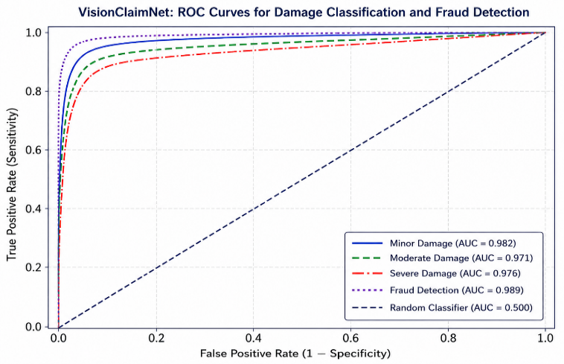
Fig. 2. ROC Curve of VisionClaimNet Framework
I. Training Performance Analysis
The training accuracy and validation loss curves show that the suggested deep learning framework converged consistently and with very little overfitting over the period of training epochs for both the CNN and YOLOv8 models.
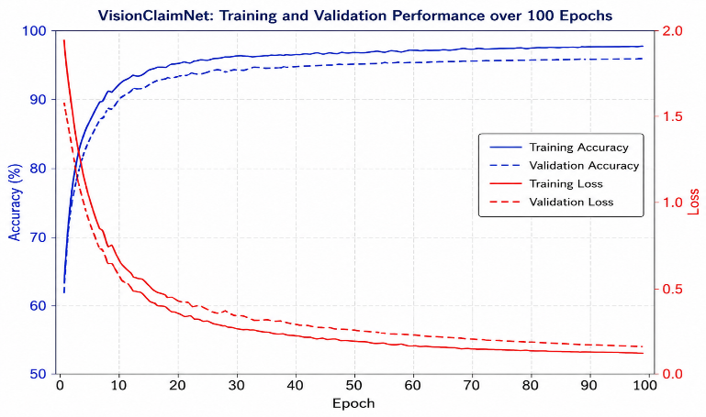
Fig. 3. Training Accuracy and Validation Loss Curves
J. Confusion Matrix Analysis
The confusion matrix depicts how well the suggested framework performed at classifying various severities of damage. The results obtained demonstrate that the framework has successfully classified types of vehicle damage with very few false-positive or false-negative classifications.
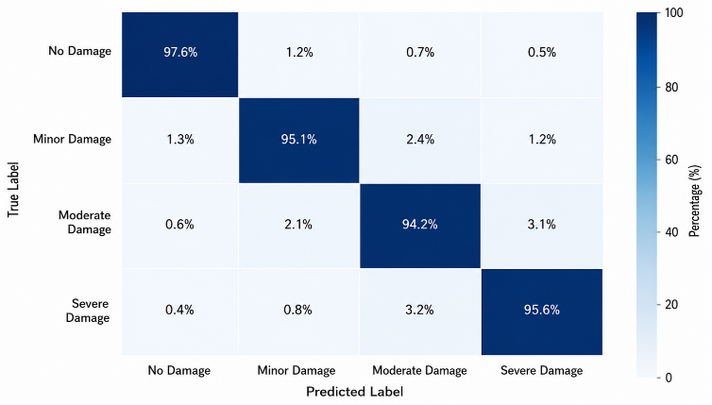
Fig. 4. Confusion Matrix of Damage Severity Classification
K. Output Visualization and System Analysis
The suggested framework successfully detected damaged regions on vehicles, classified them based on severity, estimated the cost of repairs, and provided an automated report of the insurance claims through a web-based dashboard interface. The YOLOv8-based damage localization module accurately identified possible damage locations with high confidence scores, while the visual analytics module provided clear visualization of detected damage regions and severity analysis results.
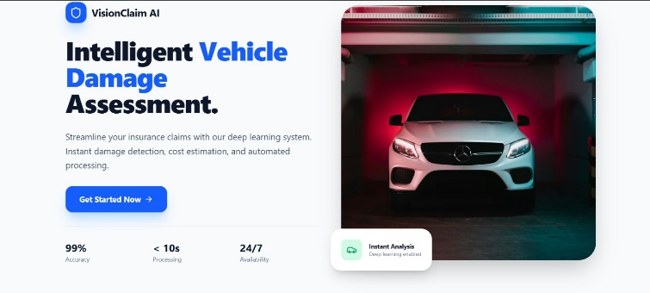
Fig. 5. Landing page of the proposed VisionClaimNet insurance claim assessment framework.
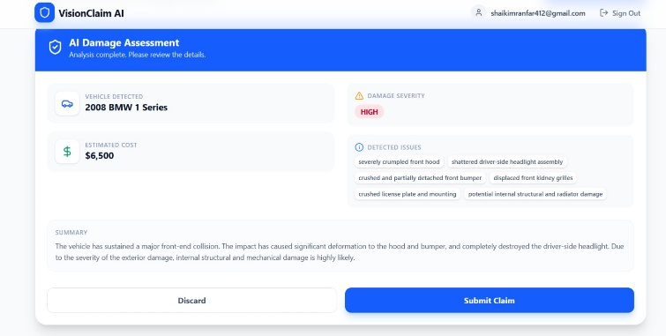
Fig. 6. Automated vehicle damage assessment and insurance claim analysis generated by the proposed VisionClaimNet framework.
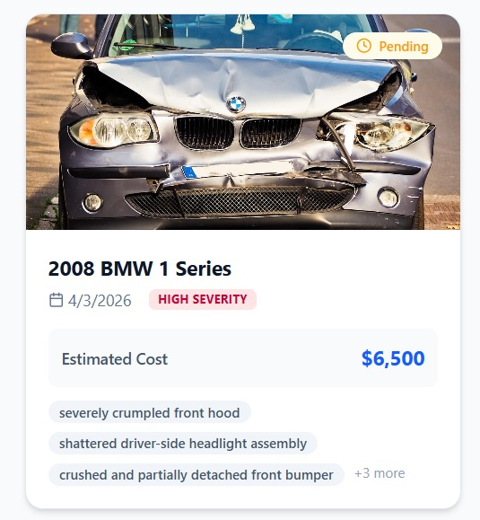
Fig. 7. Insurance claim summary visualization showing damage severity and estimated repair cost.
V. CONCLUSION AND FUTURE WORK
VisionClaimNet is a new framework that uses AI to assess vehicle insurance claims automatically and combines deep learning (DL) and computer vision (CV) with analytical tools to assess damages quickly and process claims automatically in real time. Current systems use traditional methods to check for vehicle damage, assess severity, and prepare claims, while the proposed framework will use a unique end-to-end process that integrates YOLOv8 to identify where damage is located, uses CNN to evaluate how severe the damage is, and uses regression to calculate how much it will cost to repair the vehicle while detecting and analyzing fraud with AI.
The system was evaluated with the Kaggle vehicle damage image dataset and achieved multiple objectives, including high detection accuracy, reliable classification of damage severity, low inference latency, efficient real time processing of insurance claims regardless of general or specific environmental conditions (including day or night, bright or dark, etc.), and the addition of intelligent visual analytics to enhance the automatic insurance decision-making process with increased transparency and interpretability. The system's fraud detection module identified inconsistencies within the insurance claim data with high fidelity, thereby providing additional means of detecting fraud.
The VisionClaimNet framework has advantages such as; reducing dependency upon manual inspection methods; speeding up the claims process; cutting operating expenses for insurers. And it's providing more consistent, reliable assessment outcomes overall. The extensive research into the design, implementation and validation of advanced deep learning (DL) architectures, as part of a complete and operational Intelligent Insurance Solutions (IIS) addresses the need to integrate advanced DL into the real world in intelligent insurance environments. The system is performing exceptionally well and is evolving into a much more scalable and deployable solution, with anticipated future enhancements including advanced transformer-based architectures being implemented with blockchain-enabled claim verification; mobile edge processing; real-time video assessment of the accident; and federated learning techniques for maintaining the privacy of data, will allow organizations to build insurance intelligence solutions. By using larger datasets that span multiple domains and implementing AI frameworks using multiple modalities improve robustness and generalization performance for complex accident environments in the real world. Therefore, VisionClaimNet framework offers an intelligent, scalable foundation for the next generation of AI assisted automation of insurance claims processing and smart evaluations of damage to vehicles.
REFERENCES
- S. A. Pérez-Zárate, J. M. Rodríguez, and L. Hernández, “Automated Car Damage Assessment Using Computer Vision and Deep Learning Techniques,” Applied Sciences, vol. 14, no. 3, pp. 1–18, 2024.
- M. R. S. Ramazhan, K. Lee, and H. Park, “Smart Vehicle Damage Assessment Using Enhanced YOLO-Based Object Detection,” Information, vol. 15, no. 2, pp. 1–20, 2024.
- M. J. Hasan, T. Rahman, and A. Karim, “Vehicle Damage Detection Using Artificial Intelligence: A Systematic Review,” IEEE Access, vol. 13, pp. 22451–22473, 2025.
- J. Redmon and A. Farhadi, “YOLOv3: An Incremental Improvement,” arXiv preprint arXiv:1804.02767, pp. 1–6, 2018.
- G. Jocher, A. Chaurasia, and J. Qiu, “YOLO by Ultralytics,” GitHub repository, 2023. [Online]. Available: https://github.com/ultralytics/ultralytics. [Accessed: May 2026].
- K. He, X. Zhang, S. Ren, and J. Sun, “Deep Residual Learning for Image Recognition,” in Proc. IEEE Conf. Computer Vision and Pattern Recognition (CVPR), Las Vegas, NV, USA, 2016, pp. 770–778.
- A. Krizhevsky, I. Sutskever, and G. E. Hinton, “ImageNet Classification With Deep Convolutional Neural Networks,” Commun. ACM, vol. 60, no. 6, pp. 84–90, 2017.
- M. Tan and Q. Le, “EfficientNet: Rethinking Model Scaling for Convolutional Neural Networks,” in Proc. Int. Conf. Machine Learning (ICML), Long Beach, CA, USA, 2019, pp. 6105–6114.
- T.-Y. Lin et al., “Focal Loss for Dense Object Detection,” in Proc. IEEE Int. Conf. Computer Vision (ICCV), Venice, Italy, 2017, pp. 2999–3007.
- D. P. Kingma and J. Ba, “Adam: A Method for Stochastic Optimization,” arXiv preprint arXiv:1412.6980, pp. 1–15, 2014.
- A. Vaswani et al., “Attention Is All You Need,” in Proc. Advances in Neural Information Processing Systems (NeurIPS), Long Beach, CA, USA, 2017, pp. 5998–6008.
- S. Ren, K. He, R. Girshick, and J. Sun, “Faster R-CNN: Towards Real-Time Object Detection With Region Proposal Networks,” IEEE Trans. Pattern Anal. Mach. Intell., vol. 39, no. 6, pp. 1137–1149, Jun. 2017.
- Y. LeCun, Y. Bengio, and G. Hinton, “Deep Learning,” Nature, vol. 521, no. 7553, pp. 436–444, 2015.
- C. Szegedy et al., “Going Deeper With Convolutions,” in Proc. IEEE Conf. Computer Vision and Pattern Recognition (CVPR), Boston, MA, USA, 2015, pp. 1–9.
- Naik, N. V., & Madhavi, K. (2025). AGOA: Adam gazelle optimisation algorithm for collaborative e-learning application in cloud computing with load balancing. International Journal of Wireless and Mobile Computing, 28(1), 20–33.
- N. V. Naik and K. Madhavi, "Adaptive QoE-based video delivery by optimizing the bitrate of the video course using network bandwidth and user bandwidth," Concurrency and Computation: Practice and Experience, e8114, 2024, doi: 10.1002/cpe.8114
- A. Esteva et al., “A Guide to Deep Learning in Healthcare,” Nature Medicine, vol. 25, no. 1, pp. 24–29, 2019.

