VISION -BASED HANDS-FREE VIRTUAL KEYBOARD USING EYE AND HEAD MOVEMENTS
Mohanapriya K ¹, Jathika M², Mohamed Maideen S³, Murugavel R ⁴
Department of Computer Science and Engineering, Velalar College of Engineering and Technology, Erode- 638012,
Tamil Nadu, India
kmohanapriyacse@gmail.com, mjathika@gmail.com , mohamadmaideen103@gmail.com , murugavelramalingam430@gmail.com

Abstract — One of the biggest challenges for physically challenged people is writing on their own. The project “Hands-Free Virtual Keyboard using Hand and Head Movement” focuses on overcoming the real-world problem of physically challenged people.

They can write letters on the screen using their eye and head movements. The system is developed using Python, OpenCV, and Media Pipe Face Mesh for real-time facial landmark tracking and detection. The virtual keyboard is completely designed and displayed on the screen. It includes alphabets, numbers, and special keys including Enter, Shift, Alt, and Backspace. The user’s head movement is detected using 238 predefined facial landmarks using Media Pipe, and it is used for navigation across the keyboard.

A red dot is used to display the eye position tracking in real time. The keys are selected using the eyeblink using eye aspect ratio, ensuring accurate input. The keys are highlighted for a certain time, and the user uses a blink for key selection. The letter is displayed in the text box.The proposed system provides independent writing for physically challenged people.

It is cost-effective and does not require any external hardware beyond the webcam, making it suitable for all people to solve real-world problems.

Keywords— open CV, Media Pipe, Tkinter, Math, NumPy ,Threading ,Queue,PIL(Pillow)

Introduction
In recent years, human-computer interaction is one of the emerging fields. Human-computer interaction helps to interact with humans in an easy and efficient manner [1,2]. Traditional input devices like mouse, keyboard, and joystick require a physical connection and manual support. Do you imagine how physically challenged people use these resources? Yes, it is quite challenging; they need another person's help, but computer interaction plays a vital role here. It helps to communicate without manual effort [3,4].
Computer vision helps to interact with the computer using facial and eye movements, and human gestures. They use techniques like eye blink detection, facial landmark
detection, and gestures [5,6]. These allow the computer to enable human interaction without input devices operated physically. These new technologies help people with hands-free typing and support technological advancements [7,8].
A vision-based hands-free virtual keyboard helps people to type using their eye and head movements as input in real time [7,8]. The user uses a webcam to capture live video to track facial landmarks like the eye, ear, and nose [9,10]. Head movements are used to navigate the direction of the cursor and also help in pointing towards the key [10]. The blink is only used to select the letter [5,11].
The virtual keyboard has alphabets, numbers, backspace, delete, and some other keys. The system is implemented using Python, and OpenCV is used to capture live video. The facial landmarks are identified using Media Pipe, which has inbuilt positions on the face. The graphical interface is created using Tkinter, and it helps in creating the virtual keyboard interface. It is used to display the text in the output and helps in highlighting the keys, and has some functionalities like space and enter [12,13].
Math is an inbuilt Python library used for simple calculations. It is used to calculate blink detection and calculate the horizontal and vertical distance of the eye [6,14]. OpenCV gives the image, and it is stored in NumPy arrays.
As here, Section II discusses related work. Section III describes the proposed system architecture and methodology. Section IV presents experimental results. Section V concludes the paper.

Literature Survey
The paper uses real-time human-computer interaction for wheelchair motion using eyeblink and eye tracking. The pupils of the eye were captured, and it is mainly used for direction. The convolutional neural network is used to track the opening and closing of the eye states to the input system [1].
The blink scanning keyboard uses human-machine interaction to assist devices, which is designed for physically challenged people and people suffering from motor neuron disease or severe cerebral palsy. By wearing a Bluetooth headset, the electromyography signal is used for eyeblink, where one sensor is in the forehead and the other three are in the left side ear. This is used for scanning the keyboard [2].

The model is designed to evaluate mobile phone usage during online classes. The biometric data, academic performance, and behavioral data are collected from 12 people and divided into three segments. Sixteen synchronization sensors, including ECG, video camera, eye tracking, and keystrokes, are monitored for learner activity for 30 minutes involving quizzes and document reading [3].
Blink detection is mainly used in computer vision. It plays a major role in emotion prediction and fatigue. The application of deep learning techniques has shown rapid growth in recent years. Blink detection based on deep learning has higher detection accuracy compared to traditional methods for eye tracking. This paper uses multiple deep learning models and helps researchers understand clear approaches. It discusses the challenges of deep learning in eye detection [4].
Eye track-based communication helps many people to communicate with serious health diseases. The user needs to focus on the key until it is typed, which may cause eye strain and typing errors. In this method, the input speed is increased using electroencephalography (EEG) data [5].
Understanding and predicting student behavior is crucial in modern online education. The system uses multimodal learning analytics to analyze and predict student behavior using computer vision-based learning sessions. It examines key challenges and highlights the growing role of psychological signals, brain activity, and heart rate. Integrating models makes the system more customized and adaptive for the online learning experience [6].
The system uses an eyeglass-type switch, and eyeglasses are mounted with eye and blink sensors designed to nurse call focus for people suffering from amyotrophic lateral sclerosis. It targets people with low illumination at night and supine posture. The convolutional pipeline estimates eye position, eye closure, and facial landmarks [7]. Eyeblink-based user computer interaction may increase strain on the eyes and may lead to fatigue. Virtual reality technology is used to check whether VR reduces fatigue compared to normal video clips. VR technology has higher brain activity, and flat video has higher neural connectivity.
Both methods reduce eye fatigue [8].
The task is conducted between interrupted and uninterrupted people. Eighteen persons were selected, and they were performing interrupted and uninterrupted tasks. The person performing interrupted tasks is mentally disturbed, increases workload, and may forget the primary task. It does not directly interrupt task time. Eye movement and tracking differ at the start and end when interruption occurs [9].
The study explores technology for individuals affected by autism spectrum disorder using eye tracking and machine learning. The virtual keyboard is controlled using eye movements. The disadvantages are low accuracy, increased eye strain, and inefficient selection, which remains challenging [10].
The research study is about how people use their eye, hand, and head movements while performing a task like playing games. The paper planned a game similar to the game on iPad (Pong). It has a paddle and a red ball. This helps understand how people adjust their movements based on the task given in a game. Eye tracking plays an important role. It
uses pursuit movements for smooth tracking and saccades for critical movements. The game has harder levels when the ball moves very fast [11].
The advanced part of the online education system focuses on student interest in learning classes. It uses eye movements for tracking tiredness, eye closure, and yawning, and face detection is used for emotion recognition like happy or sad. It uses text feedback for student comments using Bidirectional Encoder Representations from Transformers. It uses deep learning models like CNN-LSTM for eye fatigue detection. It has two-way communication with feedback [12]. The paper uses the computerized digit vigilance test to measure attention. It measures only reaction time and omits features like yawns, head movements, and eye blinking rate. It develops an AI model based on computerized digit vigilance for elderly people. It uses Open Face AI for retrieving attentional features and establishes an AI model for
prediction [13].
The major challenges of eye tracking are light conditions and noisy environments. It compares unsupervised learning models for blink detection. It uses image correlation (IC) for tracking eye movements in noisy environments. The video is captured using a mobile phone and tested using AI algorithms [14].
The project focuses on identifying eye blinking and pupil size detection for normal individuals and those with attention deficit hyperactivity disorder (ADHD). People watch a short video, and blinking and pupil detection are measured. For normal people, pupil detection is normal and they have a correct blinking rate, whereas people with ADHD have mismatched or weaker blinking rates, and their pupil response is also reduced at times [15].
Computer vision helps identify anxiety in people using their blink rates. Chronic anxiety affects quality of life. Blink data is collected from multiple parts of the country with the age group of 18–30 years. The major emotions are happy, sad, joy, fear, and anger. Blink rate is used to identify anxiety, and it uses machine learning models like Naive Bayes, Decision Tree, and Logistic Regression. The results have accuracy up to 78%–94% [16].
In modern society, mobile phones and computers play a major role. The project develops a virtual keyboard for physically challenged people. The keyboard has alphabets, numbers, emoji menu, and mathematical calculation parts, and it also has Latin symbols. It includes special characters. The testing has positive feedback from users and a usability score of 93 [17].

Methodology
The design and implementation of a real-time vision based virtual keyboard using eye and head movements system will be discussed in this section.

System Architecture
Figure 1 Shows the general architecture for the proposed vision-based virtual keyboard using eye and head movement mechanisms. The major layers are: capturing the real-time user face, identifying the face using MediaPipe, tracking the eye movements, and displaying a virtual keyboard for selection using the eye blink, so the text will be displayed in the text box.

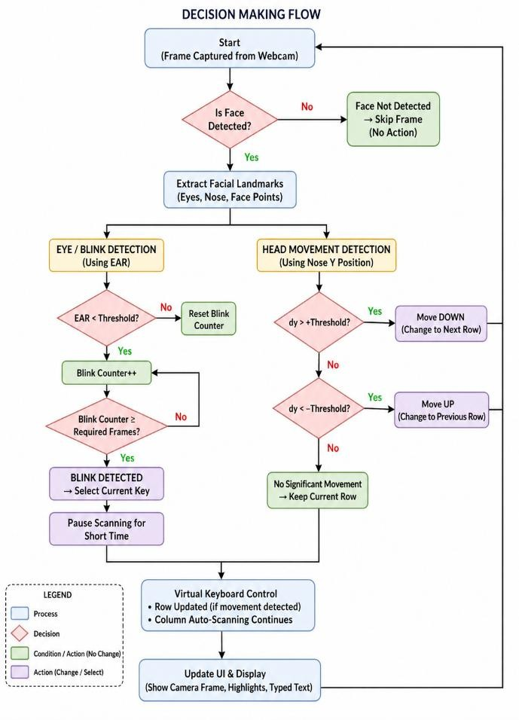
Fig 1. System Architecture of the Proposed Vision Based Virtual Keyboard using eye and head movements
Fig 1 illustrates the complete workflow, including image capture, face detection, identifying the head movements , and selecting the keys .

Webcam Input Capture
This module is responsible for capturing the real-time live video of the user through a web camera. The video is converted into frames, and it is processed continuously to detect the facial landmark positions. The accuracy of the system depends on the input video; poor-quality video would affect the accuracy of the system.

Face Detection

The face detection is used to detect the facial landmarks from the given video frame. This is an essential step because future
steps depend on the position of the face. The computer vision technology is used to scan the face and detect the important
𝐵 = (𝑥, 𝑦, 𝑤, ℎ) (1)

where ,

B-boundary box

x-horizontal position y-vertical position
w-width of the boundary box

h-how tall the face region is captured

Facial Landmark Detection

Facial landmark detection is used to identify the facial key points on the face like eyes, nose, and mouth. These landmarks help in identifying the position of the face and help in head movement tracking. Landmark detection helps in precise tracking. These points help in tracking the eye position and its blink movements. It provides structured data for the next steps.

𝐿 = {(𝑥1, 𝑦1), (𝑥2, 𝑦2) … . . , (𝑥𝑛, 𝑦𝑛)} (2) Where,
L-set of all facial landmarks

(x1,y1)-coordinates of the first landmark (x2,y2)-coordinates of the second landmark (xn,yn)-coordinated of the nth landmark
x-horizontal position of the landmark y-horizontal position of the landmark n-total number of points

E .Eye and Blink Detection

Using this method, the blink and eye are detected. The system mainly focuses on the eye and facial positions. The eye aspect ratio is used to check whether the eye is open or closed. Eye blinks are used to confirm the letter for the text output box. The blink has a certain threshold value, which helps in avoiding unnecessary blinks. It enables hands-free typing without using the keyboard.

||𝑝2−𝑝6||+||𝑝3−𝑝5||

facial landmarks. Once the face is detected, the face will be enclosed in rectangular boxes called boundary box; it is used to prevent unnecessary background. Face detection differs from the lighting condition, facial landmarks, and distance
𝐸𝑎𝑟 =

where
(3)
2.||𝑝1−𝑝4||

between the camera and the user. It acts as a foundation layer for all other processes
x, y=coordinates of each landmarks.

Numerator-vertical eye distance Denominator – horizontal eye distance Ear-eye aspect ratio

Head Movement Detection

Head movements are used to track the direction of the cursor and access the keyboard position. The head movements are mainly tracked using the nose position; by comparing with the previous frame, the head movement is determined. Small movements have small cursor shifts; this helps in navigating in the keyboard. The head movements are top, down, left, and right directions. It has smooth cursor movements in the keyboard. The interaction of the system is done without manual movements.

Exponential Moving Average (EMA)

EMA is a signal processing technique that is used to smooth noisy data, and it gives more importance to recent values and less importance to older values.

It is used because raw input data contains some noise. It may lead to fluctuations and result in unstable behavior.

In vision-based hands-free virtual typing using eye and head movements, it is used to smooth the noise in facial landmark detection.

𝐸𝑀𝐴𝑡 = 𝛼𝑥𝑡 + (1 − 𝛼)𝐸𝑀𝐴𝑡 − 1 (4) Where:
xt= current value
EMAt−1= previous value
α= smoothing factor

It provides stability and reliability in the head detection phase.

State Machine Module

The state machine model is also called the Finite State Machine (FSM) model to ensure controlled interaction for both eye and head movements. The head movement is implemented by FSM which has two states: armed and disarmed states. In armed state, it monitors the vertical nose position. When the nose position greater than the threshold, the head movement (UP and DOWN) is triggered. A valid movement is detected, and the system is transferred to the disarmed state, where it ignores all other head movements until it becomes neutral. It prevents unnecessary movements. After that, the system returns to the armed state when the neutral position is detected. The blink detection also follows the Finite State Machine (FSM). It is used to monitor the Eye Aspect Ratio (EAR). The blink is confirmed using the EAR
value, and the blink is detected using the threshold rate of the opening and closing eye movements in the blink detection.

Auto-Scanning UI Model

The system uses this model for the virtual keyboard for hands-free typing. This is very helpful when the user cannot use the traditional methods for typing, such as a keyboard and mouse. The auto-scanning is done using rows and columns. The keyboard rows are controlled by head movements. When the user moves the head up and down, the row will change based on the head movements. After the row is selected, the keys in the row are automatically highlighted at a fixed interval, and the user can select the key based on blink movements. The model provides user-friendly interaction, which uses head movements for navigation and selection of rows, and blink for selecting the text.

Threshold Control Module

This module plays a major role in vision-based hands-free typing using eye and head movements. It is used for managing the threshold values responsible for the decision-making of the system.

In this project, various thresholds are used. In blink detection, the Eye Aspect Ratio (EAR) threshold is used to determine whether the eye is open or closed. If the threshold value is small, then the blink will be detected, and the EAR ratio will indicate that the eye is closed. When the threshold is greater, then the eye will be considered as open.

In the head movement detection module, the threshold is determined using the nose position. If the displacement is sufficient, then the head movement is detected.

The return threshold is used to determine the end of the movement.

Timing and Control Module

This module is responsible for all time-based operations, which help smooth synchronization when different processes take place. It helps in controlled interaction and smooth processing. This module handles the parameters of eye-based timing. The blink cooldown module ensures multiple blink detection at the given step. By controlling these parameters, it helps the system achieve smooth navigation.

Keyboard Rendering Module

This module is responsible for generating and displaying a virtual keyboard interface. It provides a virtual keyboard with alphabet letters and has special functionalities like space, caps, enter, and shift. The keys are aligned with clear fonts and colors. The user sees the virtual keyboard and can select the letters

.

Results and Discussion
468 (Media Pipe Face Mesh)
Total Landmarks
Eye Landmarks Used Tracking Method
Processing Speed
6 points per eye
Real-time landmark detection
~20–30 FPS

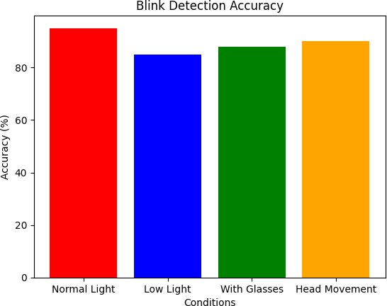
The project, vision-based hands-free virtual keyboard using eye and head movements, was successfully designed and implemented. Using computer vision technologies, OpenCV and MediaPipe are able to detect facial and eye movements to capture inputs such as blink movements and head movements.
The virtual keyboard helps people to visualize the keys and helps to identify them without physical manual
movements. This helps people to choose the alphabets,

numbers, and other special symbols. Using head movements, the person can navigate to the particular keys and select them using eye blinking.
The eye is tracked using a red dot for accurate movements. The system is cost-efficient, which does not require any other hardware except a webcam. There are certain limitations; lighting conditions and the existing point have some difficulties. The other proposed systems are very expensive, and they require many hardware components. It helps people to communicate easily and effectively.
The advantages of the system are: it helps people with hands-free typing, it is controlled using eye and head movements, it requires only the inbuilt hardware along with the system, works in real time, and reduces eye fatigue slightly. The blink is only used for selection.
The disadvantages of the system are: lighting is one of the major problems because it reduces the accuracy of the system performance, it may lead to false blinks, it is slow compared to physical keyboard typing, and the user should stay in the position within the camera view. Small movements of the head and blink may not be detected.
In conclusion, the project helps disabled people to interact efficiently.
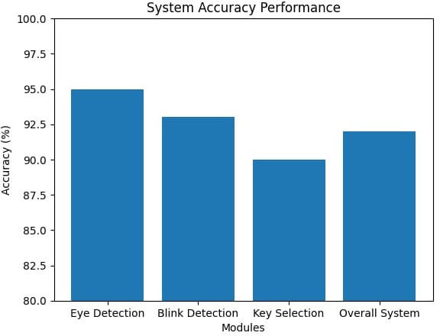
Fig 2. System Accuracy Performance

The above Figure [2] represents the system accuracy performance using eye detection, blink detection, key selection, and the overall system performance.

a) Facial Landmarks Detection Details
Description
Component

Fig.3 Blink Detection Accuracy

The above Fig. [3] describes the various light conditions and their accuracy. The first accuracy is under normal light, around 85%, and using head movements, the accuracy is around 82%, followed by the conditions with glasses and low light.
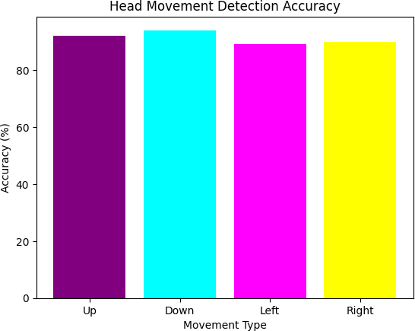

Fig.4 Head Movement Detection

The above Fig. 4 describes the head movement accuracy. The lowest accuracy is for left and right movements because head

movement is more stable in up and down directions. The highest movement accuracy is in the down direction, around 87%, followed by the up direction at around 85%.

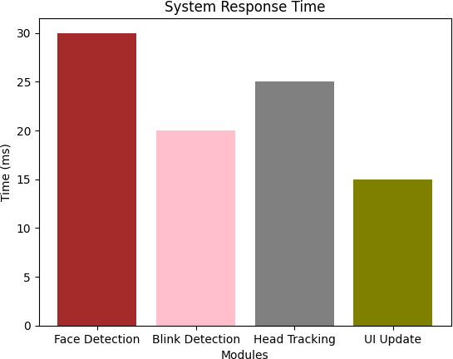

Fig.5 System Response Time

The above Fig. [5] describes the overall system response time, where face detection has the highest response time, followed by head tracking, then blink detection, and finally UI.
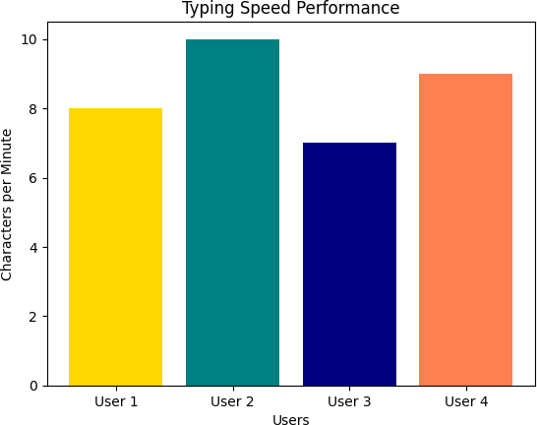

Fig .6 Typing Speed Performance

The above Fig. [6] describes the typing speed based on different types of users, depending on their understanding of the system and overall performance. The typing speed varies from person to person according to their eye and head movements.

V . Results and Disc Conclusion
Vision-based hands-free typing using eye and head movements is expected to demonstrate an efficient way of tracking hands-free interaction with the computer with the
help of eye movements and blink detection. The system uses a webcam to capture live video, which acts as an input for the system and detects facial landmarks and eye movements. The accuracy under normal lighting conditions is approximately 90–92%. The eye aspect ratio provides an accuracy of 85–90%.

The cursor is moved based on head movements in up, down, left, and right directions. The accuracy of the cursor movements is 80–88%. The movements are adjusted based on the head directions.

The virtual keyboard is designed, and it is used to display the output text on the screen. The keyboard includes alphabets, numbers, and special characters. The system generates the text on the screen with proper blink accuracy of 85–88%.

The vision-based hands-free virtual keyboard will achieve an accuracy of 88–90%. It depends on environmental conditions like lighting, camera resolution, and the position of the user.

VI. References
- Luo, W., Cao, J., Ishikawa, K. and Ju, D., 2021. A human-computer control system based on intelligent recognition of eye movements and its application in wheelchair driving. Multimodal Technologies and Interaction, 5(9), p.50.
- S. W. Yang, C. S. Lin, S. K. Lin, and C. H. Lee, “Design of virtual keyboard using blink control method for the severely disabled,” Computer Methods and Programs in Biomedicine, vol. 111, no. 2, pp. 410–418, 2013.
- R. Daza, A. Becerra, R. Cobos, J. Fierrez, and A. Morales, “A multimodal dataset for understanding the impact of mobile phones on remote online virtual education,” Scientific Data, vol. 12, no. 1, p. 1332, 2025.
- J. Xiong, W. Dai, Q. Wang, X. Dong, B. Ye, and J. Yang, “A review of deep learning in blink detection,” PeerJ Computer Science, vol. 11, p. e2594, 2025.

- T. D. Ngo, L. T. Nguyen, and T. H. Le, “Adjusting data input speed in a human-computer interface system controlled by eye gaze and electroencephalography data,” Technology and Disability, vol. 37, no. 1, pp. 104–117, 2025.
- A. Becerra, R. Cobos, and C. Lang, “Enhancing online learning by integrating biosensors and multimodal learning analytics for detecting and predicting student behaviour: A review,” Behaviour & Information Technology, pp. 1–26, 2025.

- R. Tamai, T. Saitoh, K. Itoh, and H. Zhang, “Eyeglass-Type Switch: A wearable eye-movement and blink switch for ALS nurse call,” Electronics, vol. 14, no. 21,
p. 4201, 2025.
- X. Wang, J. Qu, L. Bu, and S. Zhu, “Investigating virtual reality for alleviating human–computer interaction fatigue: A multimodal assessment and comparison with flat video,” IEEE Transactions on Visualization and Computer Graphics, 2025..
- S. Chen and J. Epps, “The eyes show it: Exploring eye behavior and impact on human mental state during task

interruption,” International Journal of Human-Computer Studies, p. 103772, 2026.
- S. Afrin, A. Ahmed, M. Anannya, S. K. Dey, M. M. Rahman, and R. Mazumder, “An intelligent assistive system for autistic learners,” Engineering Reports, vol. 7, no. 11, p. e70455, 2025.

- A. Schroeger, A. Goettker, D. I. Braun, and K. R. Gegenfurtner, “Keeping your eye, head, and hand on the ball: Rapidly orchestrated visuomotor behavior in a continuous action task,” Journal of Vision, vol. 25, no. 12, pp. 20–20, 2025.
- Q. El Maazouzi and A. Retbi, “Multimodal detection of emotional and cognitive states in e-learning through deep fusion of visual and textual data with NLP,” Computers, vol. 14, no. 8, p. 314, 2025.
- G. H. Lin, D. Bai, Y. J. Huang, S. C. Lee, M. T. T. Vu,
and T. H. Chiu, “Artificial intelligence–based computerized digit vigilance test in community-dwelling older adults: development and validation study,” JMIR Medical Informatics, vol. 13, p. e73038, 2025.

- A. Di Nisio, V. I. D’Alessandro, G. Scarcelli, A. M. L. Lanzolla, and F. Attivissimo, “Noise robustness evaluation of image processing algorithms for eye blinking detection,” Measurement, vol. 239, p. 115508, 2025.
- O. Lipschits, S. Sadon, and R. Geva, “Automatic neural mechanisms of social synchrony: pupil and blink responses in adults with ADHD symptoms,” Journal of Neural Transmission, pp. 1–13, 2025..
- N. Das, L. Moharana, S. Nayak, and A. Routray, “Emotional blink patterns: A possible biomarker for anxiety detection in a HCI framework,” SN Computer Science, vol. 6, no. 3, p. 277, 2025..

- A. H. Khaleel, T. Abbas, and A. W. S. Ibrahim, “Multitask virtual keyboard controlled by an eye-gaze-based intelligent entry system,” Journal of Computational and

