AI- Powered Diagnostic Framework for Polycystic Ovary Syndrome Using Medical Image Analysis based on Hybrid VGG16+ Improved UNet

V Devi
Saveetha School of Engineering
Saveetha Institute of Medical and Technical Sciences,
Devisakshitha@gmail.com

K Thinakaran
Saveetha School of Engineering
Saveetha Institute of Medical and Technical Sciences,
thinakarank.sse@saveetha.com

Abstract: Polycystic Ovary Syndrome (PCOS) is an endocrine condition that impacts girls aged 12 to 45 years. It is the condition that causes the cyst to form in the ovary. The oocyte doesn't mature the way it should, and instead forms cysts, which are fluid-filled sacs. Polycystic ovary is the name for an ovary that has several cysts in it. It could have an effect on both ovaries. PCOS is the most common hormonal disorder in women who can have children. It affects hormone secretion over time, causing a lot of ovarian cysts and other major health concerns. This illness can cause a number of problems, including type 2 diabetes, gestational diabetes, weight gain, unsightly body hair, and more. The number of PCOS cases has gone up a lot in the last few years, which is scary. People can have better lives if they find out they have PCOS early and follow their doctor's advice. In this article, we introduced an innovative hybrid model comprising VGG16 and an enhanced UNet for the classification of PCOS in ultrasound images. We utilized CNN for feature extraction and our hybrid model for classification of ultrasound ovary pictures in the context of PCOS classification. The results reveal that our proposed model is more accurate and works better than other models that are already out there.
Keyword: PCOS, Image Classification, Machine Learning (ML), Deep Learning (DL), VGG, ResNet, CNN, U-Net.

- INTRODUCTION

There are three types of ovaries based on their structure: normal, cystic, and polycystic. Cysts with eggs form in normal ovaries every month. Every cyst that forms in the ovaries is filled with water and comes out of the ovary when a woman has her period. Cysts that cannot be excised from the body persist in ovarian tissue, resulting in polycystic ovaries. Polycystic ovaries have a lot of follicles, but they can't mature and ovulation can't happen. This is the key thing that sets polycystic ovaries apart from normal ones. PCOS is a hormonal condition that manifests through a range of symptoms. It occurs in around 20% of women of reproductive age [1].
PCOS is an endocrine illness in women of childbearing age, however it is still not detected enough. This means that the US spends billions of dollars a year on healthcare, but we don't have good estimates of how common it is. Research shows that healthcare experts may miss find up to 75% of women with PCOS. It has a number of symptoms, such as periods that are irregular or missing, high levels of androgens. PCOS can have a big effect on a woman's physical and mental health [2]. It causes hormonal imbalances that lead to symptoms like irregular periods, acne, heart disease, hirsutism, insulin resistance, and obesity. The complex disruption of hormonal equilibrium and ovulatory mechanisms characteristic of PCOS intricately interacts with reproductive dynamics, hindering menstrual regularity and ovulation [3].
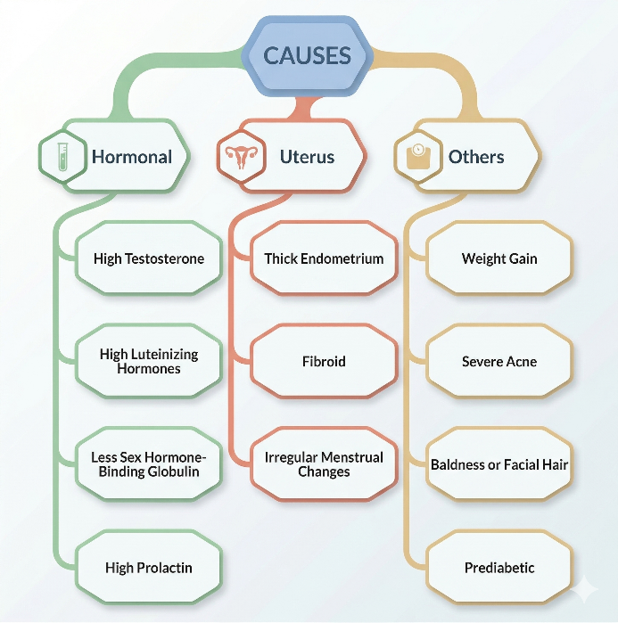
Figure1. Causes of PCOS

Polycystic ovarian syndrome (PCOS) causes the ovaries to grow and form many tiny cysts. So they have periods that are irregular, light, or don't happen at all. PCOS can cause both functional and harmful cysts to form on your ovaries. Functional cysts exist during a woman's menstrual cycle, but they are rarely cancerous or produce symptoms. They usually go away on their own. Pathological cysts are less common and slightly more likely to turn into cancer [4]. Most of the time, these cysts are caused by a number of things. Fig. 1 shows most common causes or signs of PCOS. Even though PCOS is not cancerous, it needs to be find and diagnose because it increases the chance of gynecological problems if it is not treated for a long period, as seen in Fig. 2.

Figure2. Long-term complication of PCOS
PCOS has a lot of different side symptoms that show themselves in different ways. Some women will have mild or modest side effects, while others will have more serious ones. Obesity, darkening of the skin, and changes in skin color are further signs of PCOS. Figure 3 shows what PCOS looks like and how it affects people. Researchers can clearly see the signs and effects of PCOS by looking at this figure [5]. One of the most common ways that doctors figure out what's wrong with a patient is through medical imaging. Ultrasound imaging is a typical way to find out if someone has PCOS. Because having more than normal follicles is the most common symptom of PCOS, ultrasonography imaging has proved very helpful for doctors in diagnosing and monitoring individuals with PCOS. Ultrasound imaging is not only useful, but it is also cheap and easy to move around [6].
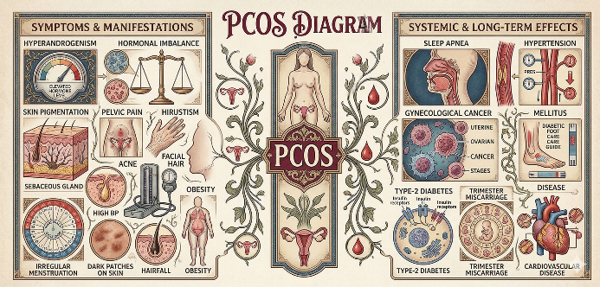

Figure3. Some common symptoms and effects of PCOS in women. The left side of PCOS shows symptoms, and the right side shows effects.

Motivation of the work
- A lot of women around the world have PCOS, yet it's still hard to get an early and appropriate diagnosis, especially in places with few resources.
- If a diagnosis is delayed, it might cause infertility, metabolic issues, and long-term health problems that make women's lives worse.
- The accuracy of manual ultrasound analysis relies significantly on the availability of experts and subjective interpretation.
- This project is chosen to create an automated, dependable, and unbiased diagnostic support system with AI-driven medical picture analysis.
- The suggested paradigm seeks to aid physicians, facilitate early intervention, and enhance women's reproductive health outcomes, ultimately yielding beneficial societal contributions.

Ultrasound (US) has been the most widely used imaging method for examining patients with ovarian problems. Ultrasound has a number of benefits over other types of medical imaging, like CT and MRI. This is because ultrasonography is cheap, easy to get, safer, and gives results right away. This imaging technique is an excellent way to construct a DL model for automatic analysis. It makes the test more objective and accurate for diagnosis. Automatic classification of PCOS in the initial stage using ultrasound pictures and clinical data facilitates illness identification [7].
Thanks to AI, we can now find and treat complicated disorders. Using machine learning methods, it is possible to find PCOS earlier, before it gets worse [8]. By looking at complicated clinical, hormonal, and imaging data, AI algorithms can do PCOS detection more rapidly and precisely than old techniques. These technologies help make treatment more personalized and minimize consequences of the disease by making it possible to train models on huge and diverse data sets. AI can also assist lower the financial strain of the expensive management and treatment costs of this illness by allowing for early diagnosis and tailored therapies [9].
The standard methods for identifying PCOS through computational techniques utilize various image processing methods for feature extraction, followed by conventional ML techniques for image classification. This process is laborious and yields suboptimal results [10]. The emergence of sophisticated computational methods, especially DL algorithms, has recently opened new possibilities for improving the identification and classification of PCOS [19]. These algorithms could make diagnoses more accurate and help doctors come up with individualized treatment plans. Researchers can use artificial intelligence to find new biomarkers, improve diagnostic criteria, and make predictive models that can help doctors make decisions for PCOS [11]. Some researchers also used CNN deep learning methods to find PCOS in US pictures. Deep learning algorithms usually do a great job of sorting photographs into categories. In this article, we introduced an innovative hybrid model comprising VGG16 and an enhanced UNet for the classification of PCOS in US images.

- RELATED WORKS

Sathiyapriya Jagadeesan et al. [12] proposed an innovative method for dimensionality reduction and identification of PCOS utilizing deep learning techniques. The objective of their research project is to formulate a diagnostic criterion for PCOS and a corresponding analytical methodology for CAD systems. One dataset has ultrasound images of the ovaries, and the other has clinical data. It is recommended to utilize several deep learning techniques for the implementation of AI-driven computer-aided design (CAD). The first proposed approach employs ovarian ultrasound pictures to identify PCOS morphology, utilizing a DL model for automated PCOS diagnosis, aiming to reduce the false positive rate and enhance the method's performance. Their research has released a study that looks at the effects of combining imaging and clinical data to find PCOS using a DL technique. The suggested method got a prediction accuracy of 98%.
Sowmiya S et al. [13] created a computerized system that can automatically find follicles in an US image. YOLOv8 object identification can accurately find several follicular regions in a single image, and it does this in a very short amount of time. Then, GLCM features were taken out, and ML techniques were used to sort them.. It was able to tell the difference between PCOS and non-PCOS cases with 90% accuracy for dataset1 and 98% accuracy for dataset2. The proprietary F-Net CNN model, on the other hand, was the best classifier in the study, with an accuracy rate of 95%.
Anushka Agrawal et al. [14] stated that the segmentation and classification of ultrasound images of the ovary demonstrate that AI is the most effective way for identifying PCOS. To beat PCOS, it is best to get diagnosed and treated early. AI can figure out if someone has PCOS by learning about features in self-correcting areas. Different research initiatives use AI methods including neural networks, CNN, SVM, Bayesian Classifier, LR, KNN, and others to find and diagnose PCOS.
Poonam Moral et al. [15] created a cutting-edge automated system that uses AI methods like ML, TL, and DL to find and classify PCOS.
S. Reka et al. [16] illustrated data-driven early detection of PCOS in women to facilitate optimal treatment and management of the condition. QEI-SAM has also found the exact traits that will be the main signs of PCOS, which will help doctors quickly and properly figure out what is wrong with their patients and save money for those who have already had a lot of testing to find out what is wrong with them.
Yuvaraj Natarajan et al. [17] introduced the FCAU-Net model, an improved Attention U-Net that includes a FFCM, to accurately classify ultrasound images of people with PCOS. The technique presents two substantial contributions. Then, FCE imaging was used to improve the images. These phases stress high-intensity pixel attributes, which makes the input better for categorization. The improved pipeline added data augmentation, which made a dataset of 45,600 photos that were split into 80% for training and 20% for validation. They have classification accuracy of 99.89%, which is much better than what has been done before.
S. Kranthi et al. [18] put forward a model called MMFEDL-DPCOS. The MMFEDL-DPCOS model seeks to analyze and diagnose PCOS with US pictures, facilitating an accurate and preliminary diagnostic phase. Lastly, the RSAE method is used to sort things into groups. The result of the proposed approach demonstrated a accuracy rate of 98.68%. One major problem with the strategy is that it relies on a small dataset. The approach is also limited because it doesn't work as well with a wide range of people, which could make the diagnosis less consistent.
M Sumathi et al. [19] mentioned that CNN works as the image classifier and segmentation and FE techniques are used to find the cysts from dataset. The input ultrasound images are used as training data and their method defines the test data in the dataset with reference to the training data to find out whether the ovary is affected and it also determines the properties of the afflicted region like area, solidity, extension, perimeter.
K. Sheikdavood et al. [20] proposed the automatic early identification of PCOS by cyst segment using DL and metaheuristic method. The preprocessing steps include changing the image to grayscale, changing the brightness and contrast, and getting rid of speckle noise. Their new technology finds out the size, area, and perimeter of cysts to help doctors make better diagnoses. Third, a DL model called a CNN is used to get the appropriate features from the segmented images. The ten most important features are looked at out of the 45 pieces.

Summary:
- PCOD is a condition where ovaries release immature or partially mature eggs.
- Leads to enlarged ovaries with multiple small cysts.
- Causes irregular periods, acne, weight gain, and infertility issues.
- Often confused with PCOS but generally less severe.
- Early detection through imaging and clinical analysis helps manage symptoms effectively.

- PROPOSED METHOD

PCOS is an endocrine condition characterized by elevated estrogen levels, leading to various complications associated with PCOS. This has a big effect on girls during their teenage years.
- Early and accurate diagnosis is challenging due to varied symptoms and overlapping clinical presentations.
- Traditional diagnostic is time consuming and Delayed or inaccurate diagnosis leads to poor management and increases the risk of complications like infertility, diabetes, and cardiovascular diseases.
- There is a critical need for intelligent, accurate, and interpretable diagnostic systems to support early detection and effective management.

- Dataset

The dataset used in this study consists of ultrasound images for detecting Polycystic Ovary Syndrome (PCOS). It includes two classes: PCOS (positive) and non-PCOS (negative) cases. A total of 1000 images are considered, with 500 images in each class to maintain balance. These images capture ovarian features such as cysts and follicle patterns. The dataset is used to train and evaluate models like CNN, AlexNet, U-Net, and the proposed model.

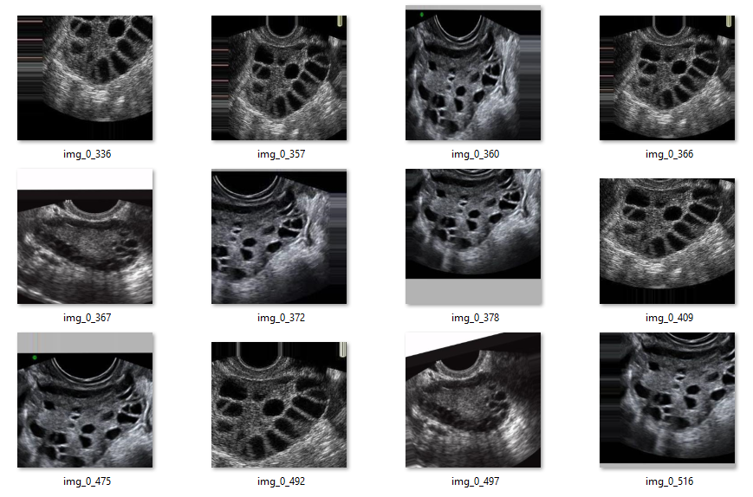
Figure 4. Sample Dataset of PCOS infected Ultrasound images
- Preprocessing
Preprocessing is an important step that improves the input data before it is looked at.
Gray Scale Conversion: The technique of converting color photos to grayscale is called gray scaling.
Image Resizing: This will improve the image by cutting out objects and utilizing quick multioperators to get rid of artifacts and salience distortions. To change the size of the photographs, the height and width of the images are changed separately to a larger size.
Image Normalization: Min-max normalization55 is used to make the pixel values the same. This means changing each pixel value I so that it is between 0 and 1.
The frost filter removes noise by utilizing a kernel that changes according on the space around it. This filter gives you a noise-free image [20].
- Feature Extraction
CNN is a simple type of deep neural network. It is a linear math process that uses two whole numbers. CNN is really good at ML since it is very diverse [57]. This method works quite well for finding cysts in ultrasound pictures. It is easy for CNN-trained models to tell if an ovary is normal or has PCOS [5].
The convolution layer has a 64-filter configuration with 1-astride-size filter per filter, as indicated by the block conv1 -1*3 @ 64. Input data is simplistic and lacks dimension. Pooling, activation function, completely connected, and convolution layers are the essential components. With the help of the constructed data, the CNN learns to represent intricate aspects. More precise classification is achieved with this fundamental CNN architecture for feature extraction. To obtain the features and select the most valuable ones, we employ the model that performs the best on test data. Following convolution in the picture below is the rectified linear unit (ReLU) which prevents the spread of negative and small values. The input data X is made simpler using the pooling layer.
- VGG16+ Improved UNet classification
It divides a picture into smaller parts or areas to make it easier to understand and change how the image is shown. It is very essential for medical imaging since it lets you find and separate key structures with great accuracy. For example, it lets you see cysts in ultrasound pictures to help diagnose PCOS [15].
In this study, we utilize the deep CNN architecture VGG-16 in conjunction with the U-Net Model to identify characteristics of PCOS from medical images. The VGG Net model works better than the Alex Net model because it uses numerous small kernel size filters instead of big kernel size filters [11]. We employed an upgraded version of the U-Net model, the attention-based residual Unet (AResUNet) model from [4], to get better classification results.
Simonyan and Zisserman came up with VGG as one of the CNN architectures in the 2014 ILSVRC competition for computer vision. VGG stands for the Visual Geometry Group Lab at Oxford University. The primary principle behind VGG is that it works better with a tiny convolution filter with a (3 × 3) kernel than with a large one. VGG-16 and VGG-19 were the most prevalent types of VGG. They each had 16 or 19 layers. There are three parts to it: convolutional, pooling, and fully linked layers. There are thirteen convolutional layers and 3 fully linked layers in the VGG-16. It also features five pooling layers that are placed after every two or three convolutional layers [7].

People usually use VGG16 to sort images. Its structure, which is based on a DCNN, is well known for being effective and easy to use [32]. Three of its sixteen layers are fully connected (FC), while the other thirteen are convolutional. Finding patterns within photographs that are composed of other patterns is where this approach really shines. The convolutional layers employ 3x3 filters, which are smaller. After that, the max-pool layers swiftly compress the input while preserving crucial characteristics. The capacity to extract features is enhanced by the VGG16 architecture. The method has produced outstanding results on several benchmark datasets, like as ImageNet, and its architecture has inspired other subsequent methods, becoming it an essential tool for transfer learning and image classification applications. The diagram below shows how the VGG16 Model is built.
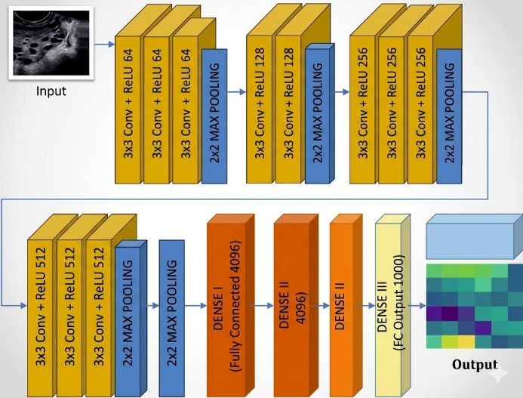
Figure 5. VGG16 Model.

All of the U-Net models give equal weight to both figuring out where things are in space and separating them from each other [21]. The proposed study has revised the U-Net architecture to focus more on segmenting objects from US pictures, as illustrated in the figure below.
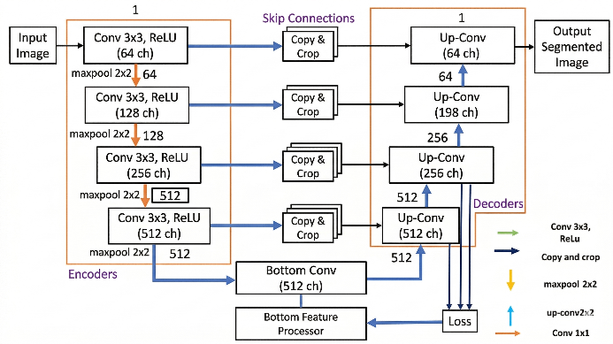
Figure 6. Attention aware residual UNet architecture.
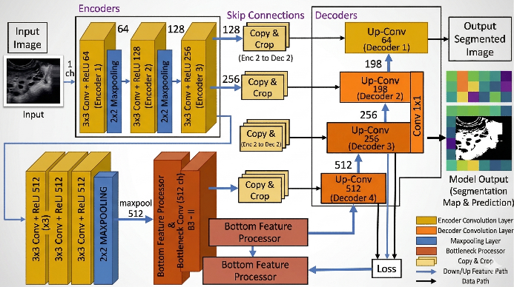
Figure 7. Proposed architecture
As demonstrated in the graphic above, medical imaging anomalies can be distinguished using a convolutional neural network like Residual UNet or ResUNet. This research presents the ARESUNet model. Batch Normalization, a ReLU activation function, two convolution units per block, and a stride of 1 in Maxpooling make up the training route. The amount of feature channels increases by a factor of two for every downsampling operation. The expanding path incorporates upsampling, joining, and double convolution into its expansion of the feature maps from the contracting path. The ADAM optimizer turns the network's biases and weights so they're facing the opposite direction of gradients in order to minimize a loss function. During training, the network is fed ultrasound pictures annotated with ground truth labels. Up there you can see the ResUNet diagram. Dilated convolution layers, max-pooling, and cascading batch normalization are just a few of the Residual Blocks used in the AResUNet layer architecture. The outcomes from the Residual Blocks are incorporated into the final layer [4]. The ADAM optimizer, with its 5×10⁻⁴ learning rate and loss function based on binary cross-entropy, was employed.

- Results
Accuracy: The accuracy statistic usually tells you how successfully the model does classification. It can be anywhere from 0 to 100 percent, with a greater number meaning better classification. This is how you figure it out:
$Accu = (TP+TN)/(TP+FP+FN+TN)$ (1)
Precision: In order to determine the accuracy of the predictions, the precision metric compares the predicted mask with the ground truth. The answer is found by
$Precision (Prec) = TP/TP+FP$ (2)
Recall: To determine the completeness of a positive prediction, the following formula is used:
$Recall (Rec) = TP/TP+FN$ (3)
F1 Score: When recall and precision are harmonically averaged, the result is the F1 Score. Therefore, maximize your F1 score by maximizing both memory and precision. To find the F1 score, one must
$F1-Score = 2*(Prec * Rec) / (Prec + Rec)$ (4)
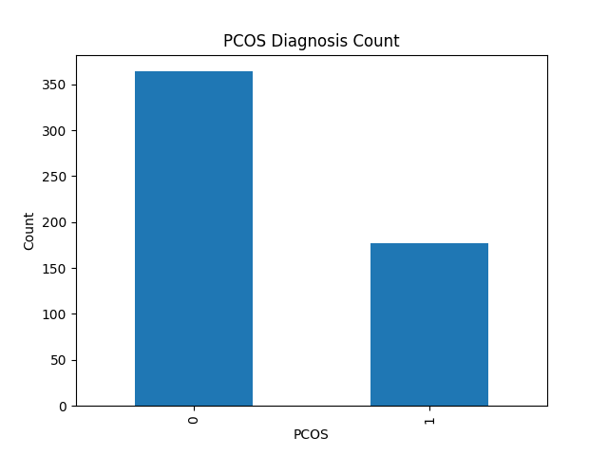
Figure 8. Infected and Non-Infected data with PCOS
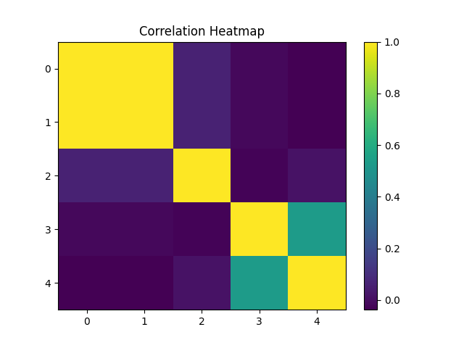
Figure 9. Correlation heatmap
Table 1. Result of Accu, Prec, Rec, F1-Score of the segmented images.
Model | TP | FN | FP | TN)
CNN | 380 | 120 | 115 | 385
AlexNet | 445 | 55 | 57 | 443
U-Net | 410 | 90 | 90 | 410
Proposed Model | 455 | 45 | 19 | 481

Model | Accuracy | Precision | Recall | F1 Score
CNN | 76.8 | 76.9 | 76.0 | 77.0
AlexNet | 88.8 | 88.6 | 89.0 | 88.0
U-Net | 82.3 | 82.0 | 82.0 | 82.0
Proposed VGG16+ Improved U-Net | 96.7 | 95.9 | 91.0 | 93.4

Figure 7. Result of Accu, Prec, Rec, F1-Score of the segmented images.
Table 1 and Figure above shows the Table 1. Result of Accu, Prec, Rec, F1-Score of the segmented images. In this result our proposed VGG16+ Improved U-Net shows better accuracy of 96.7%, Precision is 95.9%, Recall is 91.0% and F1 Score 93.4 %. When compared with other algorithms such as CNN, AlexNet, U-Net our proposed model shows better result.
- CONCLUSION
The research described herein may serve as a pioneering study in the field of PCOS identification, integrating the benefits of both traditional and DL methodologies. In this article, we introduced an innovative hybrid model comprising VGG16 and an enhanced UNet for the classification of PCOS in ultrasound images. For PCOS classification, we employed CNN to get features and our hybrid model to divide the Ultrasound ovary images into parts. Our proposed VGG16+ Improved U-Net has an accuracy of 96.7%, which is better than existing algorithms like CNN, AlexNet, and U-Net. This suggests that our model performs better. We can integrate ImageNet with other transfer learning algorithms to generate better results in the future.

REFERENCES

- Gülhan, P. G., Özmen, G., & Alptekin, H. (2023). CNN based determination of polycystic ovarian syndrome using automatic follicle detection methods. Politeknik Dergisi, 27(4), 1589-1601.
- Poorani, B., & Khilar, R. (2024). An innovative approach for PCO morphology segmentation using a novel MOT-SF technique. Discover Computing, 27(1), 27.
- Diptho, R. A., Jahan, N., & Istiyaq, T. (2023). PCOS Diagnosis with Confluence CNN : A Revolution in Women ’ s Health. 13–15.
- Bedi, P., Goyal, S. B., Singh, A., & Kumar, M. (2024). An integrated adaptive bilateral filter-based framework and attention residual U-net for detecting polycystic ovary syndrome. Decision Analytics Journal, 10(November 2023), 100366. https://doi.org/10.1016/j.dajour.2023.100366
- Ahmed, S., Rahman, S., Jahan, I., Kaiser, M. S., Member, S., & Hosen, A. S. M. S. (2023). A Review on the Detection Techniques of Polycystic Ovary Syndrome Using Machine Learning. IEEE Access, 11(August), 86522–86543. https://doi.org/10.1109/ACCESS.2023.3304536
- Nazarudin, A. A., Zulkarnain, N., Mokri, S. S., Mimi, W., & Wan, D. (2023). Performance Analysis of a Novel Hybrid Segmentation Method for Polycystic Ovarian Syndrome Monitoring.
- Alamoudi, A., Khan, I. U., Aslam, N., Alqahtani, N., Alsaif, H. S., Dandan, O. Al, Gadeeb, M. Al, & Bahrani, R. Al. (2023). A Deep Learning Fusion Approach to Diagnosis the Polycystic Ovary Syndrome ( PCOS ). 2023. https://doi.org/10.1155/2023/9686697
- Rahman, M., Islam, A., Islam, F., & Zaman, M. (2024). Informatics in Medicine Unlocked Empowering early detection : A web-based machine learning approach for PCOS prediction. Informatics in Medicine Unlocked, 47(April), 101500. https://doi.org/10.1016/j.imu.2024.101500
- Ghaderzadeh, M., Garavand, A., & Salehnasab, C. (2025). Artificial intelligence in polycystic ovary syndrome : a systematic review of diagnostic and predictive applications. 6.
- Suha, S. A., & Islam, M. N. (2022). An extended machine learning technique for polycystic ovary syndrome detection using ovary ultrasound image. Scientific Reports, 1–16. https://doi.org/10.1038/s41598-022-21724-0
- Praneesh, M., Nivetha, N., Maidin, S. S., & Ge, W. (2024). Optimized Deep Learning method for Enhanced Medical Diagnostics of Polycystic Ovary Syndrome Detection. 5(3), 1399–1411.
- Jagadeesan, S., & Marannan, P. (2025). Vector Conversion Based PCOS Detection In Data Segmentation Using Multi Task Learning By Dynamic Deep Learning Architecture. 22(March), 209–222.
- Sowmiya, S., Id, S. U., Alhajlah, O., Almutairi, F., Aslam, S., & Id, A. R. K. (2024). F-Net : Follicles Net an efficient tool for the diagnosis of polycystic ovarian syndrome using deep learning techniques. 1–22. https://doi.org/10.1371/journal.pone.0307571
- Agrawal, A., Ambad, R., Lahoti, R., & Muley, P. (2022). Role of Artificial Intelligence in PCOS Detection. 491–494. https://doi.org/10.4103/jdmimsu.jdmimsu
- Moral, P., Mustafi, D., Mustafi, A., & Sahana, S. K. (2024). CystNet : An AI driven model for PCOS detection using multilevel thresholding of ultrasound images. 1–19.
- Reka, S., Praba, T. S., Prasanna, M., Naga, V., & Reddy, N. (2025). Automated high precision PCOS detection through a segment anything model on super resolution ultrasound ovary images. 1–17.
- Natarajan, Y., R, S. P. K., & M, S. D. (2025). Feature fusion context attention gate UNet for detection of polycystic ovary syndrome. 1–35.
- Kranthi, S., Sandeep, Y., Pranathi, K., Laxmi Lydia, E., Joshi, G. P., & Cho, W. (2026). A multimodal feature fusion with deep representation learning approach for polycystic ovary syndrome diagnosis using ultrasound images. Scientific Reports.
- Sumathi, M., Chitra, P., Sakthi Prabha, R., & Srilatha, K. (2021, February). Study and detection of PCOS related diseases using CNN. In IOP conference series: materials science and engineering (Vol. 1070, No. 1, p. 012062). IOP Publishing.
- Sheikdavood, K., & Bala, M. P. (2023). Polycystic Ovary Cyst Segmentation Using Adaptive K-means with Reptile Search Algorithm. https://doi.org/10.5755/j01.itc.52.1.32096
- Sarkar, M., Mandal, A., & Tudu, A. (2024). Franklin Open DC-UNet : Looking for follicles in the ovarian ultrasound images. Franklin Open, 8(September 2023), 100149. https://doi.org/10.1016/j.fraope.2024.100149

