Explainable AI-based student mental health and sleep prediction using social media usage

Divya singh Ms. Niharika Singh Bishwajeet Pandey
Dept of MCA Dept of MCA Dept Of MCA
GLBITM GLBITM GLBITM
Greater Noida , India Greater Noida , India Greater Noida , India
singh.divi0522@gmail.com Niharika.singh1@glbitm.ac.in bishwajeet.pandey@glbitm.ac.in

Abstract- In recent years , social media usage has excessively influenced the mental health of students and also play significant role in their sleep patterns . This study presents an explainable artificial intelligence (XAI) based system for analysing student mental health conditions and their sleep quality while using their social media behaviour. This method include many features such as daily screen time , social media usage , sleep time , sleep quality , anxiety level , academic pressure and many more. SHAP technique is used to enhance transparency in the model . the system implemented is a web based application that allows students to put up their daily habits and received personalized predictions which can be helpful to them .

This proposed model aims to bridge the gap between predictive performance and model interpretability , making it a valuable tool for early detection and preventive intervention in their well-being.

Keywords- Social Media Impact, Student Mental Health, Sleep Deprivation, Digital Wellbeing, Behavioural Data Analysis, Explainable, dual prediction framework , data-driven student wellness.
- INTRODUCTION
It comes as no surprise that social media platforms have become an integral part of our lives on Earth. However, during the last several years, there has been an evident shift in the way we connect with these sites. Rather than logging into computers to check for any changes, our feeds now accompany us everywhere, from waking up until going to bed at night. While they are successfully maintaining contact with us and providing the relevant information, they face quite a lot of disadvantages, which can be hardly ignored anymore.

In particular, one should mention the psychological aspect of it all. Starting from an occasional break, when one quickly glances at the feed of Instagram or Tik Tok, the next thing that is likely to happen is getting sucked in by the never-ending stream for an hour or two. Unconsciously, we continue scrolling through pictures and videos, comparing our lives with those who have seemingly perfect lives. As we learn from the specialists, screen time significantly increases our stress level; however, most students realize that only after suffering from burnout or anxiety.

Apart from the influence on the mood, both the functionality of individuals on a daily basis and academic performance suffer. The apps make it utterly impossible for us to engage in any deep work due to the constant availability factor. The constant notifications distract our study time, while scrolling the feeds at night also makes us lose much-needed sleep time. All this makes up an endless cycle since when we are too tired during the daytime, we get stressed in school and escape into the virtual world at night, thereby making it normal for the sleep deprived condition among students.

It’s not that we utilize social media, but how we utilize it. This research is meant to move past general advice and the cliche of screen time is terrible. By using 1,705 college students, it is hoped that specific behaviors will be recognized as the most detrimental on any given day. Lastly, understanding these unique behaviors will allow us to formulate actionable, personalized interventions for college students to improve their digital wellbeing.

- BACKGROUND
Mental health illnesses and problems with sleeping have become one of the biggest threats to global population and have affected the health state of many individuals. As mentioned by WHO, more and more people suffer from such disorders as anxiety, depression, and insomnia. Moreover, these illnesses and symptoms might influence each other, which is why it is crucial to detect and monitor them timely.
Standard methods of evaluation require spending much time and conducting interviews and self-assessment. However, due to the development of new technologies, it is possible to receive various indicators from smartphones and wearables and monitor them in a timely manner.
AI and machine learning technologies allow creating effective models and analysing big amounts of information in order to detect patterns linked to mental health and sleep behaviour. The system can predict problems based on different factors and provide useful suggestions.

The proposed system will help to prevent health problems associated with stress and depression or sleep disorders and ensure continuous monitoring.
- LITERATURE REVIEW
Recent research has been focused on using AI and ML for prediction of psychological diseases and assessing sleep. The range of data sources that were used includes the information generated by wearable sensors, mobile phone activities and self-reporting questionnaires. Supervised ML algorithms such as decision trees, support vector machines, and random forests have been used to assess stress levels and symptoms of depression.
As for deep learning, recurrent neural networks (RNN) and LSTMs proved effective in analysis of time-series information relevant for sleep patterns and physiological data. It was found that features such as heart rate variability, activity, and sleep time are capable of predicting the efficiency of sleep and the state of mental health of patients. Moreover, NLP was used to extract valuable information from textual data obtained through digital interactions on social media and other web platforms.
While there is considerable evidence that proves the effectiveness of these techniques in predicting psychological problems and assessing sleep patterns, there are still several issues that need to be addressed before wider adoption of AI in this field. First, there are concerns regarding data privacy. Second, the lack of suitable labelled datasets remains a problem.
Moreover, recent research papers provide a further look at how multimodal data can help boost the accuracy of the predictions made by the algorithms. For example, using information provided by wearable devices like heartrate and bodily movements, as well as users' behaviour with smartphones, can greatly enhance the precision of predictions and their reliability in terms of both mental health conditions and sleep prediction. In addition, there is an increasing need to use explainable AI in order to make predictions more understandable and increase the level of users' trust in AI algorithms, especially those used for healthcare purposes.
Another important point made by many researchers is privacy-preserving measures that should be taken into account when developing a prediction algorithm. Federated learning becomes a popular approach that helps train models while protecting user's data. Thus, combining various approaches related to AI can help achieve better results.
- METHODOLOGY
In order to determine the direct correlation between digital habits and student wellbeing, we processed set of student records, 1,705 in total.

A. Data Collection and Demographics.

In this dataset, the sample was a heterogeneous group of high school, undergraduate and graduate students with different academic backgrounds. It is significant to capture various age groups as the use of technology by a 16-year-old high school student and a 24-year-old graduate student will be very different. The information was totally anonymized to ensure that the privacy of the students was not compromised and to motivate them to be honest in reporting their habits.

B. Key Variables Analyzed.

We prioritized the simplest behavioral indicators in our analysis instead of making the model overly complex with dozens of minor data points:

Average hours of use per day: The number of hours that are actively spent in front of social apps.

Most Frequented Platform: The most frequently used apps that include Instagram, Facebook, Snapchat, and LinkedIn based on category.

Sleep Hours Per Night: The average number of hours the student actually sleeps on an average weeknight.

Mental Health Score: A self-report scale that reveals overall stress, frequency of anxiety, and overall wellbeing.

C. Analytical Approach

We initially tidied the data, removing any missing responses and standardizing the numbers to make them accurate. Then, instead of merely viewing the plain averages, we applied statistical analysis in order to discover the latent interactions between variables. This enabled us to classify the overall effect of social media on each student in three different groups namely, Positive, Neutral or Negative.

- RESULTS

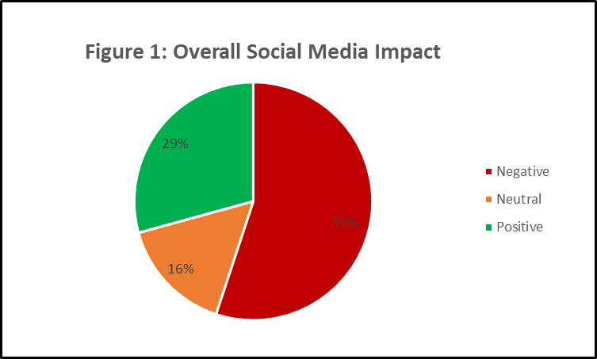

The data analysis revealed several distincts and surprising patterns regarding how students interact with devices.

- THE SLEEP–SCREEN TIME CONNECTION
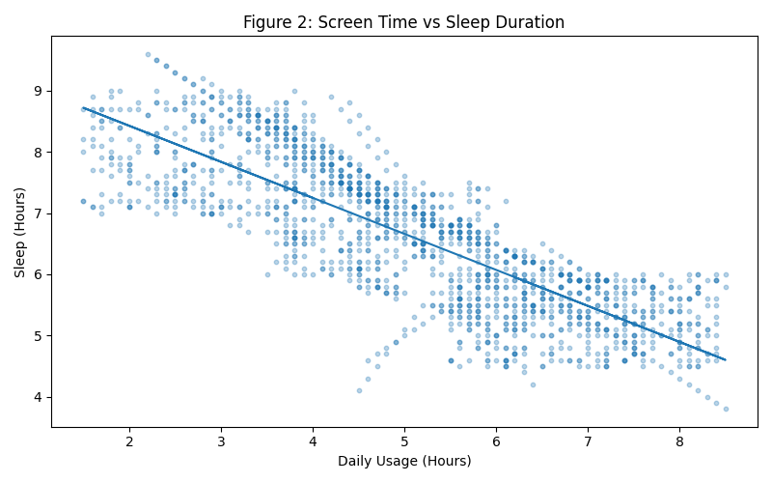

Figure 1. illustrates the relationship between daily social media usage and sleep duration . The plot shows a general downward trend indicating that as screen time increases , sleep hours tend to decrease . This suggests that excessive use od social media negatively impacts sleep patterns .

- PLATFORM DIFFERENCES:

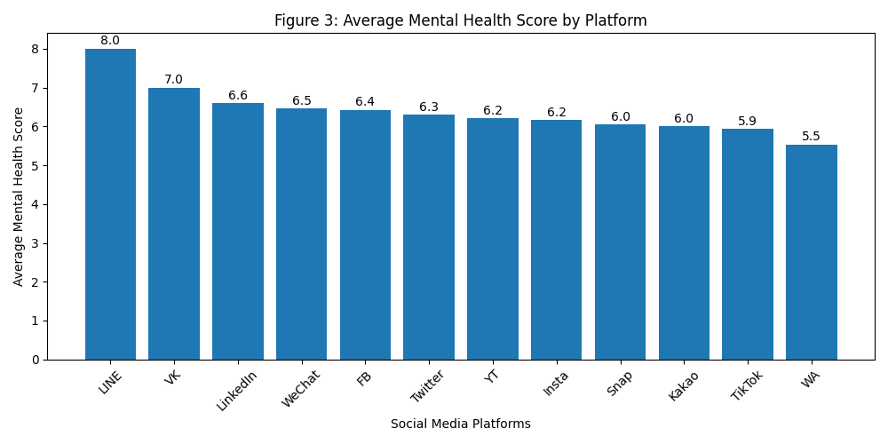

Figure 2. illustrates presents the average mental health score across different social media platforms. The variation in bar heights indicates that certain platforms have a stronger impact on mental health than others. This highlights that the effect of social media is platform-dependent .
- ACADEMIC IMPACT & DISTRIBUTION
Students who fell into “Negative Impact” category were twice as likely to report that their social media habits actively interfered with their academic performance.
This is largely due to the “switching cost “of the human brain. Every time a student stops reading a textbook to check a snapchat notification, it takes the brain several minutes to fully refocus on the academic task. Over a few hours of studying , this constant divided attention leads to severe mental fatigue .
- DISCUSSION
One thing in the results comes very clear, and that is that it is not necessarily that social media is a mental health poison, but bad digital boundaries most definitely are. Late-night passive scrolling combined with a high-level of anxiety visual platforms forms a student burnout nightmare.

Since our data distinctly reflects what makes the negative scores, we are able to provide particular, practical recommendations to students that desire to change their digital wellbeing:

The 10 PM Physical Separation Rule: The key factor behind the low scores on negative mental health is sleep deprivation, so willpower alone is not typically sufficient. We suggest that the students should physically charge their phones in the other side of the room or even in another room altogether after 10 PM. This avoids the temptation of scrolling late at night and prevents the blue-light inhibition of melatonin.

Carrying out a Platform Audit: Students who are under pressure daily (high stress) can temporarily remove apps that are based on comparison (such as Instagram or Tik Tok) during the next two weeks. They must also be devoted to direct messaging applications to inform friends at this period, and after that,
reconsider whether their mental health index has naturally enhanced.

Switching to Active Use: School counsellors are supposed to urge students to switch their use of their phones. Rather than spending hours passively watching content, students are to be taught to be digitally mindful: they are meant to use social media as an active tool to organize study groups, as an organizational tool to plan real-life events or as a video chat tool to meet family members.

- CONCLUSION
To conclude, the utilization of AI and ML in the field of mental health and sleep prediction presents enormous opportunities for revolutionizing current strategies of healthcare management. Based on current scientific studies, it may be stated that the combination of different types of data, obtained with wearable devices, smartphones, or self-reporting, is capable of providing an opportunity for continuous health monitoring and early detection of potential problems. The usage of more advanced approaches like deep learning or hybrid models is also able to improve the efficiency of predictive methods, analysing complex and dynamic information
Nevertheless, various limitations, such as those related to data privacy concerns or a lack of suitable data sets, should be considered. In addition, it is vital to mention ethical concerns associated with such technologies and ensuring users' trust.
In general, AI-based technologies seem to present a promising solution in the provision of personalized and proactive approaches to managing mental well-being. Further investigations in terms of improving the interpretability and reliability of predictive models are needed.
Moreover, advances in deep learning and hybrid model approaches have improved the ability to recognize complicated interactions between sleep and psychologies, thereby improving accuracy and personalization of predictions. Explaining the AI methods employed is another factor that promotes the development of trust, a critical aspect when considering the application of such models in healthcare.
Although there have been numerous advances in AI, its implementation can be faced with challenges such as data heterogeneity, algorithm biases, and difficulties integrating AI in the current healthcare framework. These issues should be dealt with effectively through inter-disciplinary teamwork and ethical consideration.
In summary, the use of artificial intelligence to predict mental health and sleeping conditions offers great prospects in the future of healthcare, and holds many benefits such as improved quality of life and decreased healthcare costs.
- ACKNOWLEDGEMENTS

I take pleasure in thanking everyone who had helped in completing this project on AI-based mental health and sleep prediction successfully.
I wish to convey my deepest thanks to my project guide for the invaluable guidance provided by him/ her during the entire period of the preparation of this project. It was very helpful since they have knowledge regarding Artificial Intelligence and Machine Learning techniques that were used in this project.
I would like to thank my institution along with my other faculty members for offering the essential resources and a favourable environment that helped in the preparation of this project.

I wish to thank my friends and fellow students for their valuable suggestions and cooperation at different times during this project. This cooperation was really fruitful as it made things much better.
Lastly, I wish to thank my dear family members for their continuous support and encouragement. This encouragement gave me the energy to complete this project.
All this help has made it possible to complete this project.
- REFERENCES
World Health Organization. (2022). Mental health and sleep disorders overview. Retrieved from official WHO reports.

• Andrew Ng. (2018). Machine Learning Yearning. DeepLearning.AI.

• Pattern Recognition and Machine Learning – Christopher M. Bishop. (2006). Springer.

• Deep Learning – Ian Goodfellow, Yoshua Bengio, & Aaron Courville. (2016). MIT Press.

• National Sleep Foundation. (2021). Sleep Health Index and Reports.

• IEEE Access. (2020). Research articles on sleep prediction using wearable devices.

• Nature Digital Medicine. (2019). Studies on AI in mental health monitoring.

• Journal of Medical Internet Research. (2021). AI-based mental health prediction using mobile data.

• Kaggle. (Various). Datasets related to sleep and mental health analysis.

• TensorFlow – Google. Used for model development and training.
• Sleep Medicine Reviews. (2018). Research on sleep patterns and their impact on mental health.
• IEEE Transactions on Biomedical Engineering. (2020). Studies on wearable sensor data for health monitoring.
• Artificial Intelligence in Medicine. (2019). Applications of AI in healthcare diagnostics.
• Geoffrey Hinton et al. (2012). Deep Neural Networks for Acoustic Modelling in Speech Recognition. Foundational deep learning research.
• American Academy of Sleep Medicine. (2021). Clinical guidelines for sleep disorder evaluation.
• Computers in Human Behaviour. (2020). Analysis of smartphone usage and mental health patterns.
• Frontiers in Psychiatry. (2021). Machine learning models for depression detection.
• Hands-On Machine Learning with Scikit-Learn, Keras, and TensorFlow – Aurélien Géron. (2019). O’Reilly Media.
• National Institute of Mental Health. (2022). Mental health statistics and research data.
• PLOS ONE. (2019). Studies on predictive analytics in healthcare.

