Integrating Power BI with Machine Learning Models for Predictive Analytics

Lakshita  Department of Computer Science  and Engineering  Chandigarh University  Mohali, India  lakshitakajla28@gmail.com | Meenu Gupta  Department of Computer Science  and Engineering  Chandigarh University  Mohali, India  Meenu.e9406@gmail.com | Rakesh Kumar  Department of Computer Science and Engineering  Chandigarh University  Mohali, India  Rakesh.e8623@gmail.com | Laxmi Madhu Kumar Brahmandam  Independent Researcher  Texas,USA  Dr.blmk@gmail.com

Abstract-- The use of machine learning in business intelligence is growing for the analysis of customer buying patterns. This study provides a comparative evaluation of the context-based machine learning models that are designed to predict high-value purchases, based on an online retail dataset. Two models were developed, Model A that was based on basic transactional characteristics, and Model B that used other contextual elements like timing and location information. Logistic Regression and XGBoost were applied in order to evaluate the performance of the models. The findings reveal that the model that is improved with contextual information is better in predictive performance, where XGBoost Model B achieves an accuracy of 72.88 and a 0.81 ROC-AUC, outperforming the baseline model. To explain the importance of features, SHAP explainability methods have been used, and it has been found that the most influential variables were the unit price, hour of purchase, and product frequency. These results illustrate the significance of the context and explainable AI in improving analytics in business intelligence.
Keywords: Predictive Analytics, Power BI, Data Visualization, Decision-making, Business Intelligence, Data Trends.

INTRODUCTION
The emergence of e-commerce in recent years has resulted in the creation of large transactional datasets. Businesses are now turning to Business Intelligence (BI) systems to make the best of this data for decision-making [1]. While early BI tools mainly support descriptive analysis, which mostly provides a summary of past events [2]. But, through the use of machine learning, companies are able to conduct predictive analytics to detect patterns in customer behaviour and predict what will happen in the future [3]. In the retail field, it is important to know how customers shop because analyzing transactional data can offer insights into customer behavior, price setting, and future demand. The task of predicting valuable transactions is one of the key analytical tasks to improve profitability, enabling companies to identify high-value customers, improve marketing and inventory management [4]. Machine learning algorithms like Extreme Gradient Boosting (XGBoost) and Logistic Regression are commonly applied to large-scale transactional data for classification purposes because of their speed, scalability and accuracy [5]. However, while these models are highly accurate, they can be harder for business users to interpret and understand how the predictions are derived. This opacity can be a barrier to the practical use of machine learning models by businesses. To overcome this, Transparent Machine Learning models are used to enhance model interpretability [6]. Techniques like SHapley Additive Explanations (SHAP) are used to explain feature relevance and the role of each feature in the model. To elaborate more on context-aware machine learning, we used an online retail dataset to develop models to predict big-ticket items. Two models are built: Model A, which uses only transactional features, and Model B, which uses both transactional and contextual features (time and location). This study shows that the inclusion of context information positively affects model performance, while the use of explainable AI methods gives insight that helps in improving the benefits of business intelligence.
We have also tested two models: Model A, which is based solely on transactional data features, and Model B, which is based on additional contextual data features such as time and location information. The findings show the value of using contextual information in model predictions, and that XAI offers insights that can benefit BI systems

RELATED WORK
The last evolutions in Artificial Intelligence (AI), Machine Learning (ML), and Business Intelligence (BI) have enhanced the functionality of the latest analytics systems. The combination of AI-powered models and business intelligence platforms can help organizations to draw valuable insights out of big data and enhance decision making. BI systems like Microsoft Power BI are adding more and more features that use AI to support decision-making using analytics and predictive modelling.
Nallamothu [1] discussed the application of AI assistants like DAX Copilot to business intelligence processes. The research showed that AI-enabled assistants have the potential to automate complex queries, help in creating insights, and enhance the interaction of the user with analytical dashboards. The study concluded that AI-based analytics can greatly improve the productivity and analytical efficiency in BI settings.
Osho et al. [2] suggested a hybrid AI-Power BI model that is expected to be used in real-time supply chain visibility and forecasting. Their model integrated machine-learning-based algorithms and BI visualization dashboards to track the supply chain activities and forecast patterns in the future.
Daruvuri et al. [3] examined the importance of AI and data engineering methods to improve analytics in Power BI systems. Their efforts emphasized the significance of scalable data pipelines, and automated data processing methods to enhance the BI performance. This paper has shown that machine learning models can be used to complement BI platforms to enable organizations to analyze large amounts of data in a more efficient manner.
In another study, Patel [4] has analyzed the effect of AI-enhanced analytics on enhancing business decisions with the help of Power BI Copilot. The study highlighted that AI-supported suggestions, natural language searches, and automated data extracts greatly minimize the work done manually and empower quicker and more precise decision-making.
Mandaliya [5] suggested a context-driven artificial intelligence model of business intelligence applications. The paper has established that incorporating both contextual information and machine learning algorithms in predicting has a higher accuracy and quality of insights produced by the BI systems. The experimental analysis showed that the Random Forest algorithm was the best among the analyzed models.
Talakola [6] examined the use of cloud-based analytics systems with the BI tools to process large amounts of data. The article brought to the fore the use of cloud computing services like Google Cloud Platform to facilitate scale-able analytics and real-time reporting. The findings revealed that cloud integration has a major positive impact on the accessibility of data and the performance of the system.
Mohammed and Ansari [7] conducted an extensive overview of the effect and constraints of the AI integration in Power BI systems. Their research found that it had a number of advantages such as predictive analytics, automated data visualization, and better reporting efficiency. Nevertheless, data privacy issues, problems with the interpretability of algorithms, and complexity of integration were also mentioned by the authors.
Nikitha and Hussain [8] recommended a predictive analytics framework that combines machine learning models like ARIMA, LSTM, and Random Forest with BI dashboards. Its experimental analysis revealed that the LSTM-based forecasting models had a greater prediction accuracy than the conventional statistical methods.
Kundavaram [9] examined how artificial intelligence can be utilized to improve the business intelligence reporting systems. This paper has shown that AI-driven automation has the capability to find patterns in big data and create actionable insights without human intervention, thus enhancing efficiency in reporting and shortening the time to analysis.
Azmi et al. [10] explored the use of context-aware AI chatbots in business intelligence systems. In their study, they revealed that conversational interfaces allow users to make queries to BI systems in natural language, which helps increase accessibility among non-technical users.
Quamar et al. [11] came up with conversational business intelligence architecture which is founded on ontology-driven architecture. Their system helped users access analytical insights in a dialogue-based experience as opposed to the conventional dashboards. The paper has shown conversational BI systems can increase user interaction and ease the process of exploring the complex data. Alghamdi and
Al-Baity [12] wrote about augmented analytics, which is powered by artificial intelligence. In their study, they highlighted that machine learning and natural language processing technologies and automated data preparation were revolutionizing the traditional BI systems into intelligent decision-support platforms.
Chen et al. [13] proposed scalable machine learning that is used in the big data settings. Their study revealed the significance of distributed computing models in managing huge data sets and complementing machine learning efficiency in large scale analytics applications. Jordan and
Mitchell [14] examined how machine learning will affect data-driven applications in the future. Their analysis highlighted that machine learning models combined with big data technologies are going to be significant in predictive analytics, automation, and intelligent decision-making systems.
Sharda et al. [15] discussed the development of business intelligence and analytics technologies. Their study emphasized the move towards traditional descriptive analytics to predictive analytics and prescriptive analytics made possible by machine learning algorithms. Davenport and
Ronanki [16] examined the actual adoption of AI in the enterprise. Their analysis determined three primary types of AI uses in business, i.e., process automation, cognitive insights, and customer engagement.
Zhang et al. [17] suggested predictive analytics frameworks based on deep learning in large-scale data settings. Their study revealed that deep neural networks are able to detect intricate patterns in large datasets and enhance the accuracy of predictions in BI systems.
Knaflic [18] noted that the use of good data visualization in the analytics systems is crucial. The paper has emphasized the importance of developing dashboards and visual storytelling as crucial elements in the process of communicating machine learning models insights.
According to Gartner Research [19], artificial intelligence-driven BI systems and augmented analytics become key components of enterprise analytics. The report emphasized the growing use of automated machine learning and conversational analytics technologies in the contemporary organizations.
Russom [20] examined the predictive analytics in business intelligence systems. The paper highlighted the significance of combining machine learning algorithms with BI tools so that organizations can make more advanced forecasts and make decisions based on the data.
All in all, the studies point out that the integration of AI and ML between BI systems such as Power BI can tremendously improve the data analysis, predictive analytics, and decision-making processes. AI-driven capabilities are automation, natural language querying, and predictive modeling, which improve user interaction, and reduce manual labor. Additionally, real-time analytics and prediction are also supported with the help of cloud computing, scalable data pipelines and advanced algorithms including LSTM and Random Forest. Lastly, AI-based BI systems are transforming the traditional analytics to new, automated and user-friendly decision-support systems.

PROPOSED SYSTEM
The system in question is aimed at combining the methods of Artificial Intelligence (AI) and Machine Learning (ML) with the latest Business Intelligence systems to improve the level of decision-making and predictive analytics. The system will be implemented to integrate data processing, machine learning models, interactive visualization dashboards to deliver real-time business insights. The system architecture would take advantage of the functionality of advanced BI systems, including Microsoft Power BI, to establish a smart analytics environment. The main goal of the offered system is to create an AI-based business intelligence system that will be able to process high amounts of data within the organization, find latent trends, and produce predictive analytics. The proposed system, unlike traditional BI systems, aims to expand the range of features of historical data analysis, descriptive reporting, and introduce predictive and intelligent analytics capabilities.

A. System Architecture
The proposed system architecture comprises of five key layers as shown in figure 1 - Data Collection Layer, Data Processing Layer, Machine Learning Layer, Analytics Layer, and Visualization Layer.
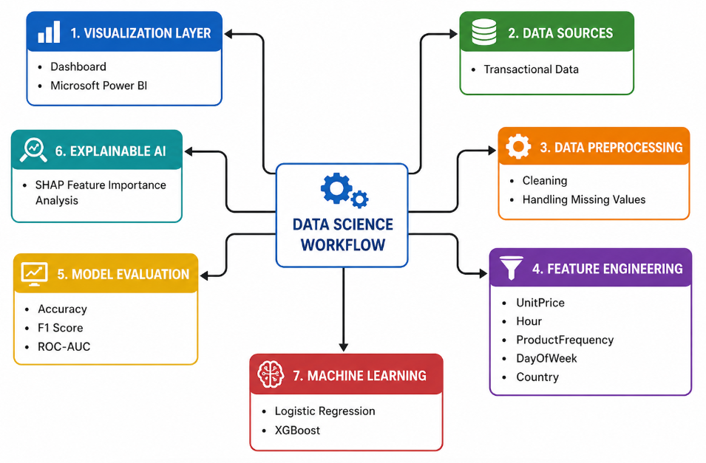
Figure 1: The general design of the proposed AI-based business intelligence system

1. Data Collection Layer
The former part of the system gathers information across various sources including enterprise databases, cloud storage systems, APIs, and transactional systems. The data collected can be sales records, customer records, operational measures, and supply chain data. It is stored in a centralized data repository where this heterogeneous data can be analyzed.
2. Data Processing Layer
The preprocessing and transformation of the data is performed in this layer. Data cleaning methods are used to eliminate inconsistencies, duplicate data and missing data. There are data integration techniques through which data among two or more sources are integrated to a structured format. This processed data is then stored in a data warehouse, or cloud-based storage system.
3. Machine Learning Layer
The machine learning layer will be used to create predictive models that will analyze past data and determine significant patterns. Several machine learning models like the Random Forest, Regression model and Time- Series forecasting methods are used to come up with predictive insights. These models can be used to predict the future business trends, detect anomalies and make decisions.
4. Analytics Layer
The analytics layer takes the outputs of the machine learning models and transforms it into valuable business insights. The results are interpreted with the help of advanced analytics methods, including the trend analysis, predictive analytics, and anomaly detection. The layer also incorporates natural language query capabilities.
5. Visualization Layer
The last tier of the proposed system aims at displaying analytical outcomes with the help of interactive dashboards and visual reports. BI tools such as Microsoft Power BI are used to create visualizations such as charts, graphs, and KPI dashboards. These visual tools enable the decision-makers to see business trends and performance quickly. The visual is shown in Figure 2.
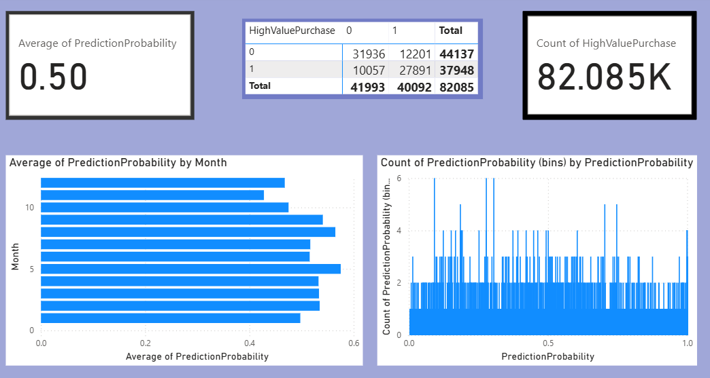
Figure 2: Power BI dashboard visualization
The initial charts in the dashboard are the Average Prediction Probability by Month. This chart shows the average probability value produced by the machine learning model per month. It assists analysts to see how the forecasted purchase probability changes with time, and allows one to see the seasonal patterns or change in customer purchasing behavior.
The second visualization shows the Count of Prediction Probability by Prediction Probability Range. This chart shows the number of transactions that are in the various probability ranges that the model predicts. It gives information on the distribution of predictions and how to decide whether the model is confidently identifying high-probability purchase events or uncertain predictions.
The third visualization represents High Value Purchase Classification (0 and 1). In this visual, the model divides the transactions into two classes in which 0 is normal or low-value purchases whereas 1 is high-value purchases. The classification assists organizations in determining what kind of high-revenue transactions they may have and target marketing or sales efforts towards customers who are more likely to make a purchase.
The proposed system enables business analysts to interpret the results of the prediction fast, track the trends, and make a data-driven decision based on the visual information by combining machine learning predictions with interactive dashboards.

B. Machine Learning Models
The following two machine learning algorithms were used in this research which are Logistic Regression and Extreme Gradient Boosting (XGBoost)
The baseline classification algorithm was the Logistic Regression due to its simplicity and interpretability. Nonlinear relationships within the complex business data are however likely to be missed in the linear models. In order to address this weakness, the proposed system employs XGBoost, an ensemble learning algorithm with gradient boosting that builds a series of decision trees in order to enhance the predictive accuracy.
Two configurations of each model were trained:
- LR Model A
- LR Model B
- XGB Model A
- XGB Model B

C. Working of Proposed System
Our system provides an integrated data-to-knowledge workflow that combines data preprocessing, feature engineering, machine learning, context-aware analytics and business intelligence (BI) visualization to gain insights from transactional data. The workflow starts with the collection of data from various enterprise systems, and for the purpose of this research, online retailer transactions from the Kaggle dataset is used. An entry in the dataset represents a transactional item purchased by a customer, including the Invoice Number, Stock Code, Product Description, Quantity, Invoice Date, Unit Price, Customer ID and Country. As several rows contain the same Invoice Number, this suggests that customers may have bought several items in a single transaction. We start with over half a million records in the dataset, and perform preprocessing to cleanse and prepare the data. This involves filtering out rows with missing Customer ID, removing invalid transactions (negative quantities and unit prices) and duplicates. As a result of the cleaning process, 397,000 records remain, ready for analysis[21].
After the data is preprocessed, feature engineering is performed to enhance the data's usefulness for making predictions. Sales, which indicates the total value of the transaction, is created as a new feature based on the Quantity and Unit Price. Further, a target feature, HighValuePurchase, is introduced to determine whether a given transaction represents a high value purchase or not, using the median of the sales values. Contextual information like Month, Day of Week, Hour of Purchase and Product Frequency are also derived to understand the transaction patterns throughout different times of the year and day. These features allow us to gain insights into customer purchasing patterns and trends in different regions and at different times.
Once the features are engineered, the data is used for training machine learning models for classification. The model identifies patterns between different features of customers, their buying habits, and the value of transactions to determine if a transaction is high-value or not. The data is divided into training and test sets. The performance is evaluated using metrics like accuracy, precision, recall and F1-score. Tuning the hyperparameters is done to enhance the model's effectiveness and prevent overfitting, ensuring it can be applied to new data without issues.
The system features a context-aware AI layer that extends conventional business intelligence, providing dynamic insights based on the user and contextual factors. Rather than rigid reporting, the system generates insights based on various factors such as time (daily, monthly, and seasonal patterns), customer segments, product categories and geographical regions. This enables the system to both extract insights and suggest explanations of patterns in a more informed manner. Lastly, the data and predictive analytics results are presented through business intelligence dashboards. These dashboards provide insights into trends in sales, distribution of high-value customers, product sales, and customer purchase patterns from different countries. The outcomes of the predictive analytics are also visualised to aid decision making. The visualisation component allows business stakeholders to be able to understand the large data and take decisions such as inventory optimisations, marketing improvement and high-value customer management.
In summary, the system functions as a holistic decision support system, using data engineering, machine learning and context sensitive intelligence to analyse big data in the retail sector and produce business insights quickly and effectively.

IV. RESULTS
The results and analysis give complete evaluation of the model performance, prediction and processing efficiency. Accuracy, F1 Score, and ROC-AUC measures of the machine learning models were used to evaluate its performance. The results are shown in Table 1.
TABLE I. PERFORMANCE COMPARISON OF MACHINE LEARNING MODELS

Model | Accuracy | F1 Score | ROC-AUC
LR Model A | 0.643516 | 0.604300 | 0.706352
LR Model B | 0.684096 | 0.644396 | 0.744912
XGB Model A | 0.682122 | 0.693027 | 0.768525
XGB Model B | 0.728842 | 0.714787 | 0.818812

The findings show that XGBoost Model B performed the most, the accuracy, F1 score and ROC-AUC value exceeded the values of all the models. This illustrates the fact that XGBoost algorithm is better at capturing more intricate relationships within the data. Comprehensively, the findings confirm that the incorporation of contextual characteristics undoubtedly make models to perform greatly. Also, the excellent results of XGBoost demonstrate the benefit of integrating advanced ensemble methods of predictive analytics into business intelligence applications.

A. Comparative Analysis
When the Logistic Regression and XGBoost models are compared, some key observations can be made as demonstrated in Figure 3:
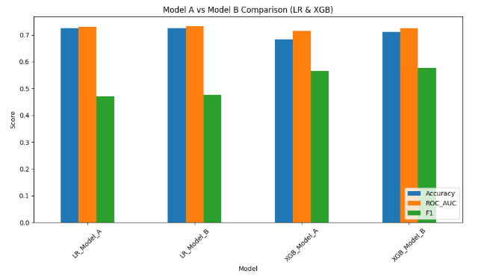

Figure 3: Model A v/s Model B comparison
1. Logistic Regression Models: Easier and simpler to read. Applicable to separable datasets that are linear. However, it has limitations in performance with complex datasets.
2. XGBoost Models: Give better predictive accuracy. Deal with nonlinear patterns. Apply ensemble learning in gradient boosting. The findings indicate that ensemble-based models such as XGBoost are very useful in enhancing the performance of classification in business analytics applications.
B. Explainable Artificial Intelligence
The effect of features are displayed in figure 4 on the basis of prediction result. The findings show that the value of UnitPrice. This implies that pricing and time are very important determinants of the high-value purchasing of the behavior..
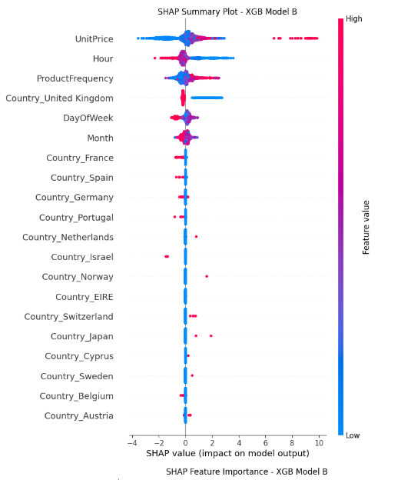
Figure 4: SHAP Summary Plot for XGBoost model B
The proposed system uses SHAP (SHapley Additive exPlanations) to enhance model interpretability. SHAP provides insights into the value added by each feature to the overall forecast of the machine learning model. The findings of Figure 5 shows that the value of UnitPrice is the most influential in the model, then Hour and ProductFrequency. This implies that pricing and time are important determinants of the high-value purchasing behavior.
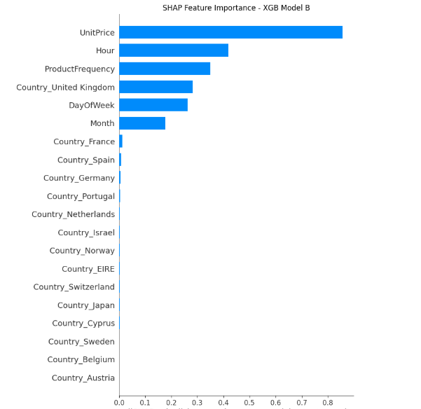
Figure 5: SHAP Feature Importance Plot for XGBoost Model B
C. Visualization and Business Insights
The SHAP summary plot created within the present study shows that the most influential variables that impact the outcome of the prediction are UnitPrice, Hour, and ProductFrequency. When the SHAP values are higher, this indicates that the feature has a larger effect on the model output. This is because explainability enables business analysts to make more sense of model predictions and facilitates transparent decisions.
The results of the machine learning models were presented in interactive dashboards created in Microsoft power BI. These dashboards enable business analysts to track key metrics and analyze customer buying trends in a user-friendly way. Machine learning predictions and visualization tools used together help decision-makers to determine the products with high demand and the buying behavior of customers.

V. CONCLUSION AND FUTURE SCOPE
In conclusion, the business analytics framework based on machine learning developed in the context of this work has offered a coherent integration of predictive modeling, explainable artificial intelligence, and business intelligence visualization to improve decision-making processes based on the available data. The experimental results can demonstrate that ensemble learning models, particularly XGBoost is more efficient compared to older models in handling more complex business data and has a greater accuracy, F1 score and ROC-AUC. SHAP also promotes the understanding of the models used to understand the key factors influencing the behavior of the customers such as Unitprice, purchase hour and frequency of products. Further, through the integration of machine-learning output and interactive dashboard features of Microsoft Power BI, business users are able to easily interpret knowledge, performance, and make strategic choices. Overall, the proposed system can provide a potent way of transforming raw data into viable business intelligence.
In future the system can be improved by adding real-time data streaming technologies to allow conducting continuous analysis and making immediate decisions. Predictive performance on complex datasets can be further enhanced with the help of the sophisticated machine learning and deep learning models, including neural networks and transformer-based models. Moreover, automated feature selection and hyperparameter optimization methods can be adopted to enhance model efficiency and scalability. Increasing explainability (e.g., using LIME) can give more information about model behavior.

REFERENCES

[1] T. K. Nallamothu, “The future of business intelligence: Integrating AI assistants like DAX Copilot into analytical workflows,” International Journal of Information Technology (IJIT), vol. 6, no. 1, pp. 151–164, Jan.–Jun. 2025.
[2] G. O. Osho, J. O. Omisola, and J. O. Shiyanbola, “An integrated AI–Power BI model for real-time supply chain visibility and forecasting: A data-intelligence approach to operational excellence,” International Journal of Advanced Multidisciplinary Research Studies, vol. 4, no. 6, pp. 1463–1480, 2024.
[3] R. Daruvuri, R. Ravikumar, P. Mannem, and S. R. Aeniga, “Augmenting business intelligence: How AI and data engineering elevate Power BI analytics,” International Journal of Innovative Research in Computer and Communication Engineering (IJIRCCE), vol. 12, no. 12, Dec. 2024.
[4] H. B. Patel, “Enhancing business decision-making through AI augmented analytics using Power BI Copilot,” 2025.
[5] S. Mandaliya, “Harnessing context-aware AI for smarter decision making: A new era in business intelligence,” in Proc. First Int. Conf. Women in Computing (InCoWoCo), IEEE, 2024.
[6] S. Talakola, “Analytics and reporting with Google Cloud Platform and Microsoft Power BI,” International Journal of Artificial Intelligence, Data Science, and Machine Learning, vol. 3, no. 2, pp. 43–52, 2022.
[7] A. K. Mohammed and M. A. Ansari, “The impact and limitations of AI in Power BI: A review,” International Journal of Multidisciplinary Research and Publications, 2023.
[8] N. D. Nikitha, I. Hussain, and P. M., “Integrating Power BI with machine learning models for predictive analytics,” in Proc. 7th Int. Conf. Contemporary Computing and Informatics (IC3I), IEEE, 2024.
[9] V. N. K. Kundavaram, “Leveraging artificial intelligence within Power BI to improve business intelligence reporting,” Journal of Science and Technology, vol. 10, no. 8, pp. 1–8, Aug. 2025.
[10] M. Azmi, A. Mansour, and C. Azmi, “A context-aware empowering business with AI: Case of chatbots in business intelligence systems,” Procedia Computer Science, vol. 224, pp. 479–484, 2023.
[11] A. Quamar, F. Özcan, D. Miller, R. J. Moore, R. Niehus, and J. Kreulen, “Conversational BI: An ontology-driven conversation system for business intelligence applications,” IBM Research AI, 2017.
[12] N. A. Alghamdi and H. H. Al-Baity, “Augmented analytics driven by AI: A digital transformation beyond business intelligence,” 2021.
[13] T. Chen et al., “Scalable machine learning for big data analytics,” Communications of the ACM, vol. 55, no. 5, pp. 86–93, 2012.
[14] M. I. Jordan and T. M. Mitchell, “Machine learning: Trends, perspectives, and prospects,” Science, vol. 349, no. 6245, pp. 255–260, Jul. 2015.
[15] R. Sharda, D. Delen, and E. Turban, Business Intelligence, Analytics, and Data Science: A Managerial Perspective, 4th ed. Pearson, 2018.
[16] T. H. Davenport and R. Ronanki, “Artificial intelligence for the real world,” Harvard Business Review, vol. 96, no. 1, pp. 108–116, 2018.
[17] Y. Zhang, Q. Yang, and others, “Deep learning based predictive analytics for big data applications,” IEEE Access, vol. 8, pp. 123–134, 2020.
[18] C. N. Knaflic, Storytelling with Data: A Data Visualization Guide for Business Professionals. Hoboken, NJ, USA: Wiley, 2015.
[19] Gartner Research, “Augmented analytics and AI-driven BI platforms,” Gartner Report, 2023.
[20] P. Russom, “Predictive analytics in business intelligence,” TDWI Research Report, 2011.
[21]https://www.kaggle.com/datasets/luisrenterialezano/retail-sales-dataset

