Stress Level Detection Using Eye Tracking
In VR Phone Headset

^{Nanthini M}
Dept. of Computer Science Engineering
Velalar College of Engineering and Technology
^{Erode,Tamilnadu,India}
^{nanthini.velalar@gmail.com}

^{Balamurugan E}
Assistant professor, Artificial Intelligence and Machine Learning,
Bannari Amman Institute of Technology, Erode,India ebalamurugan5@gmail.com

^{Dinesh Kumar V}
Dept. of Computer Science Engineering
Velalar College of Engineering and Technology
^{Erode,Tamilnadu,India}
^{dinesh90erode@gmail.com}

^{Karthika G S}
Dept. of Computer Science Engineering
Velalar College of Engineering and Technology
^{Erode,Tamilnadu,India}
^{karthikags0802@gmail.com}

^{Kavin S}
Dept. of Computer Science Engineering
Velalar College of Engineering and Technology
^{Erode,Tamilnadu,India}
^{senthilkavi1972@gmail.com}

^{Mohamedsalmankan S}
Dept. of Computer Science Engineering
Velalar College of Engineering and Technology
^{Erode,Tamilnadu,India}
^{kanmohamedsalman@gmail.com}

Abstract— Stress negatively impacts mental performance, emotions and health, particularly in students and working individuals who are exposed to high levels of mental workload for extended periods. Continual stress monitoring could facilitate clinical prevention strategies and countermeasure development, but most existing systems employ head-mounted sensors or self-administered questionnaires that are uncomfortable and prone to bias. This study presents a contactless, nonintrusive and low-cost solution based on eye metrics, a promising physiological stress indicator, implemented on an inexpensive virtual reality (VR) phone headset.The aim of this research is to develop and evaluate a real-time gaze-based system for sensing stress levels via eye movement analysis. A video stream from an inward-facing infrared camera embedded in the headset is recorded during person–virtual-world interaction. Following region-of-interest detection and noise filtering, algorithmic extraction of features such as blink occurrence, pupil size, gaze coordinates and gaze motion is carried out in the temporal domain. These signals are then input to machine learning classifiers implemented on a Raspberry Pi computer. In station experiments with temporally andcontextually labeled input, results demonstrate that time series eye data can discriminate stress conditions with high accuracy. The system demonstrates sophisticated eye tracking with emerging eye features in a completely noncontact manner, offering an affordable, portable, real-time addition to current stress monitoring tools.
Keywords— Stress detection, Eye tracking, VR headset, Blink rate, Pupil dilation, Gaze stability, Image processing, Machine learning, Raspberry Pi, Non-invasive monitoring, Real-time classification..

Introduction

Stress is a problem that affects our mental health how well we work and our overall life. Students, people who work and athletes often feel a lot of pressure from school, work and what people expect from them. If we are stressed for a time it can cause serious health issues like feeling sad being tired having trouble sleeping and not being able to think clearly. So it is very important to find out if we are stressed and to keep an eye on it over time to prevent long-term damage to our body and mind.

The old ways of finding out if we are stressed use things like cameras, special watches, medical tools, questions and screens to track what is going on. These methods can give us some ideas. They often need us to do something or wear something on our body. Wearing sensors can be uncomfortable. Not fun to wear all the time and answering questions about how we feel depends on us being honest and aware of our feelings, which might not always be the case. Medical tools are good but expensive and not practical for use. This shows that we need a way to check for stress that does not touch us is easy to use and works well.

New developments in computer vision, picture processing and small computer systems have made it possible to check our health without touching us. Researchers have seen that stress changes how our eyes behave like how big our pupilsre how often we blink, where we look and how steady our eyes are. These things about our eyes tell us a lot about how we're feeling and can be looked at using new vision techniques.
This paper is about a system that checks for stress in real-time using data from our eyes. The system uses a camera that
tracks our eyes and is inside a virtual reality phone headset. It works well in lighting and keeps track of how our eyes move when we use the virtual world. The pictures are processed using algorithms on a small computer like a Raspberry Pi. Then it shows us how stressed we are through a phone interface giving us feedback right away. This way is cheap, comfortable and easy to use every day to check for stress. Stress is a problem and this system helps us with stress by using our gaze data and eye tracker. The system is good, for people who want to check their stress levels. It helps with stress by giving us instant feedback..

Related Works
Studies show that using the Internet affects people’s emotional states and experience of stress and that research has been conducted on the effects of Internet use on emotions in both controlled and naturalistic settings. The increase in dependence on digital media has made understanding how Internet users feel an essential research area. Research into the physiological response to stimulation of the sympathetic and parasympathetic branches of the autonomic nervous system (the system that regulates the body’s inner processes) can introduce the researcher to the subject’s emotional and physiological state. Some ways researchers track physiological activity include measuring electrodermal activity (to measure sweat response), heart rate variability, and facial temperature during interaction with the Internet. All of these measurements are highly correlated with activation of the autonomic nervous system, which makes them reliable indicators of stress and emotional activation or arousal (for example, increases in heart rate and electrodermal activity can indicate increased stress, while temperature change in the face can be indicative of emotional response). Researchers typically collect this data when people use various forms of online media (e.g., web pages, videos, and digital applications). By analyzing these physiological variables, researchers are able to draw conclusions about the emotional state of users with regard to different types of online content. Although these methods are highly effective for the purpose of measuring a user’s emotional response to digital media, they require users to be connected to or wear multiple physiological sensors simultaneously during their real-time interactions with digital media, which can be impractical or uncomfortable.

There are many ways to use different types of sensors for use in various applications to support research regarding emotional analysis and stress detection. The primary purpose of these systems is to enhance the reliability, robustness and accuracy of current stress detection methodologies. Therefore, researchers have developed a plethora of devices which measure and record multiple physiological signals at the same time. Physiological signals that can be recorded and analyzed together are things like heart rate, electrodermal activity (EDA), and others that represent the physical state of the body and correspond directly to the body's autonomic nervous system. For example, combining heart rate data with EDA data to establish a more complete measurement for an individual’s level of stress will produce a more reliable and accurate measurement than if only one of these signals were used separately. Furthermore, utilizing a comprehensive multivariate measurement through the use of multiple sensors decreases the amount of classification errors and increases the capabilities of the multi-sensor stress detection system as a whole.

Unfortunately, in spite of the benefits of multi-sensor systems, there are also many disadvantages. One major drawback of multi-sensor systems is that they generally require the use of specialized sensor hardware, including wearables, electrode sensors, and monitoring devices to obtain any meaningful data from a multi-sensor system. Such sensory devices will typically require calibration, as well as a highly controlled environment, in order to be accurately used. Also, using multiple sensors typically will require more space and be more costly and complicated than using one type of sensor; therefore, they may not be as user-friendly in real-time applications where end-users can expect to fully utilize these systems in augmented reality and virtual reality environments without having to use additional hardware.

A distinct technique of recognizing an individual’s emotional state is through facial/thermal analysis methods that rely on the analysis of various facial features such as facial expressions or microexpressions and thermal differences across various regions of the face. In addition to recognizing facial expressions or microexpressions by utilizing computer vision and image processing algorithms, these systems track tiny changes in different features of a person’s face to determine their current emotion; particularly the eyes (such as the movement of the eye), the eyebrows (where they are in relation to each other), and lips (how much curve they have). Additionally, thermal images can be utilized to show how hot or cold a given area on a person’s body is; this measurement can also help indicate how stressed (or anxious) or deceptive the individual is based on their current state of being due to either increased blood circulation to a certain area of the face or due to uncontrolled heating/cooling of that area of the face from the body in relation to another area of the body (e.g. forehead versus neck). The temperature difference will usually occur in an area of the face that has increased blood circulation; therefore, providing you with potential insight into determining how someone else is experiencing an emotion. Although these procedures can provide detailed insight and are capable of producing high levels of accuracy, they are typically limited by the following factors: (1) the majority of facial analysis systems require high-resolution video cameras or specific thermal image devices for accurate readings; (2) many times the environmental factors affect the cameras that are being used to capture images of the subject (examples: lighting condition, camera angle) or occluded areas of the subject’s face (examples: glasses or masks) resulting in missing data and unreliable readings. Consequently, these limitations will ultimately prevent these types of analysis systems from being used for widespread deployment, particularly in dynamic or mobile-based environments (such as AR or VR), where constant and reliable measurements can be taken without needing to rely on complicated hardware systems.

In recent years, eye tracking has become a form of stress detection that is not only viable, but also is easy to use through modern technology's demand for non-invasive detection methods of stress and the ability for eye tracking to be integrated into many of today's devices. Eye tracking is not directly touching the user when collecting data, making it a comfortable, user-friendly method of collecting data compared to traditional physiology-based sensors that must touch the user to collect data. The latest advancements in eye tracking technology have allowed for eye tracking sensors to be included as part of VR headsets and offer the potential for continuous monitoring of user eye movements in real-time. Based on previous research, eye-related feature sets such as eye gaze patterns, durations of eye fixations, saccadic eye movements, blink rates, and pupil size all have been shown to correlate well with user's cognitive loads and level of stress. Specifically, based on the sympathetic nervous system being activated due to stress, increases in pupil size tend to occur. Additionally, irregularities in the pattern in which an individual gazes at something and increases in blink rates generally indicate increased levels of cognitive and emotional fatigue. Accordingly, assessing these types of eye-related features provides a means to estimate stress levels of users without relying on additional sensors or intrusive methods. Therefore, eye tracking should be considered an effective and scalable means of stress detection, in particular, in user environments where providing users with an optimal experience or where real-time performance is available.

Researchers use eye tracking and analyzed behavioral signals (e.g., movement of head; user interaction patterns; response time) as additional methods of improving accuracy when detecting stress. Behavioral indicators help further understand a user's interaction with digital environments and can provide observational evidence (e.g., signs of cognitive load or emotional discomfort) of how a user interacts with a digital environment. Example: lower response times or irregular interaction patterns may indicate confusion/stress; increased head movement may indicate distraction/fatigue. When combined with eye tracking data, behavioral signals help to enhance the accuracy/reliability of a stress detection system.

The development of effective stress detection systems faces numerous hurdles despite advancements in technology. Current technology is often expensive because they require multiple sensors and complex set-ups and thus, are not a feasible option for mass deployment. Furthermore, the lack of real-time processing capability restricts their ability to provide immediate feedback for stress assessment. Another serious issue is the lack of integration between stress detection systems and immersive environments such as augmented reality (AR) and virtual reality (VR), where user interactions are continuous and dynamic by nature. Although previous research focused primarily on either using physiological signals or analyzing facial expressions to measure stress, little research has been done on using the movement of the eyes as an indicator of stress. The movements of the eyeball within the eye socket can provide deeper insight into cognitive and attentional processes of a user (i.e., how the user is focused or what type of cognition is being used by the user) than has previously been researched. Creating systems that can accurately and efficiently measure stress in real-time while being useable in a variety of modern digital environments without the need for additional hardware or complex configurations..

Methodology
Eye Tracking Data Collection
The first step of the proposed system is to collect eye-tracking data through an IR camera placed internally in the VR headset. The camera will always have a clear view of the user’s eyes for the entire time they are engaged with the virtual environment.
To improve visibility for the user’s eyes, the system will utilize infrared light to provide the ability to see the user’s eyes even if they are not illuminated under low or high levels of darkness or varying amounts of ambient light. Therefore, the IR camera will be able to detect and record the user’s eyes.
While the user is performing normal interactions with the VR system, the IR camera will constantly record the user’s eye at a high frame rate so that any data recorded on eye movements from the IR camera will show how the user would naturally move their eye and will not be influenced or manipulated by their eye movements. Thus, the importance of how the user naturally moved their eyes is paramount in correctly detecting stress as the data will show the smallest of differences between pupil response and gaze direction.
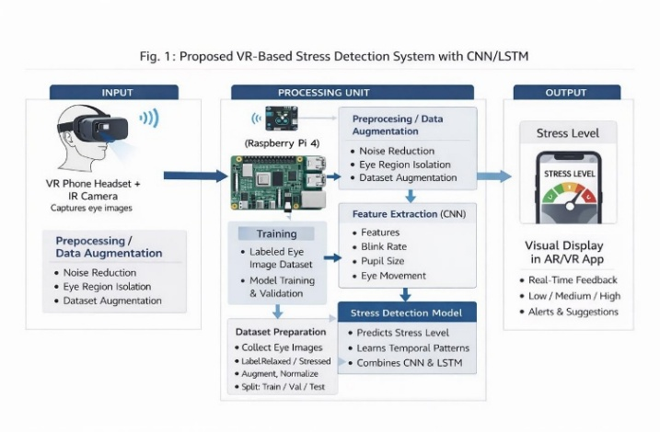
Fig. 1: System Architecture Diagram
Proposed approach is to understand how stress (i.e., anxiety) affects a person’s eyes, by using metrics derived from eye movements collected from a virtual-reality mobile device. The eyes can also be monitored as a function of time, so this will allow for a completely non-invasive, real time means to monitor the individual market as well as the overall market with respect to the potential for stress by providing a high degree of comfort and accuracy (e.g., 100%).

There are five main components of the overall workflow:
Collecting the eye movement information from each user (i.e., Eye Tracking Data)
Removing all of the unwanted noise from the collected images
Extracting statistical features such as blink rate
Inputting features into a machine learning model for stress classification
Displaying results through an augmented reality UI
The first stage in the overall workflow (Eye Tracking Data Collection) involves the use of an embedded camera in the VR device capturing the user’s eye movement data. After the eye movement data has been collected using the camera, we will need to clean up the captured eye image so that it can be further analyzed.
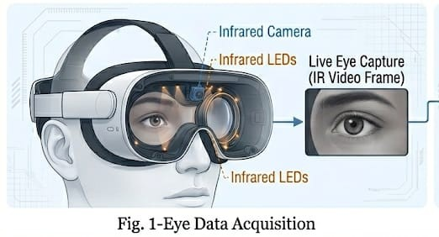
Once we have cleaned up and isolated the eye, we will extract a number of statistical features that can be used for input into the machine learning model that will generate the user’s stress classification. Finally, these results will be displayed to the user in an augmented reality format, allowing them to instantly recognize their current condition.

Image Pre-processing
The purpose of image pre-processing is to manipulate or modify the captured eye frames so that they are of higher quality and ready for feature extraction.
The first step in the process is to convert all the images to grayscale to reduce the amount of computation required for processing and to focus on only the necessary visual information. This simplifies the processing chain without affecting detection accuracy.
Once the images are converted into grayscale format, the next step is to remove unwanted noise using filtering techniques. This removes distortions and enhances clarity.

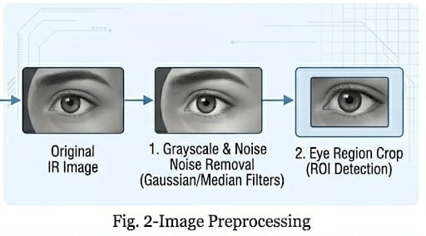
After filtering, the image is enhanced for increased contrast so that eye features such as the pupil and edges can be easily distinguished from the background. Then, the eye is located by identifying the region of interest and cropping that area from the original frame.
By cropping only the eye area:
The volume of data is minimized
Processing speed increases
Real-time performance improves
As a final outcome of pre-processing, the data input into feature extraction will be clean, consistent, and ready for accurate analysis.

Feature Extraction
Feature extraction is a vital process of retrieving valuable information from preprocessed images of the eye's appearance.
The system determines critical features related to stress levels over time, including:
Blink rate
Pupil size
Gaze direction
Gaze stability
Each parameter provides insights into the user's cognitive and emotional state.
The blink rate is calculated based on the number of eye closures over a time frame. Pupil size is measured to detect dilation changes due to stress. Gaze direction identifies where the user is looking, and gaze stability measures consistency or irregularity in eye movement.
These features are combined into a feature vector:
F = {Br, Ps, Gd, Gs}
Where:
Br = Blink rate
Ps = Pupil size
Gd = Gaze direction
Gs = Gaze stability
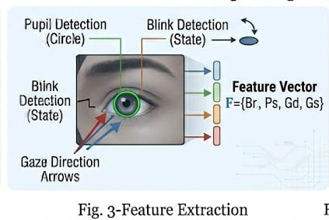
This feature vector combines physiological and behavioral characteristics, enabling accurate stress prediction.

Stress Classification
In the stress classification phase, the extracted feature vector is input into a Machine Learning model running on a Raspberry Pi.
The model evaluates the features in real time and outputs the predicted stress level:
S = f(F)
Where:
S = Stress level
F = Feature vector
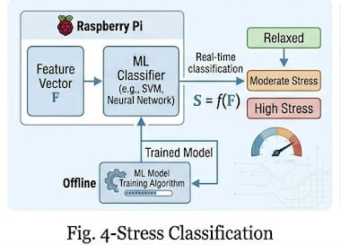
The model is trained using labeled datasets containing relaxed and stressed conditions (low, medium, high). After training, it can classify new data samples accurately.
Using a Raspberry Pi ensures:
Portability
Efficiency
Real-time processing
Fourth Step: Detailed Eye Behavior Analysis
To analyze eye data, qualitative data is extracted from preprocessed images and studied over time. This helps identify key features such as:
Blink rate
Pupil size
Gaze direction
Gaze stability
Definitions:
Blink rate: Number of eye closures within a time frame
Pupil size: Changes due to dilation and stress levels
Gaze direction: Where the user is looking
Gaze stability: Consistency of eye movement
These features form another feature vector:
F = {Br, P, Psw, L, Td}
Where:
Br = Blink rate
P = Pupil size
L = Gaze direction
Td = Gaze stability
This provides a comprehensive overview of eye movement behavior.

AR Visualization
The final phase generates an augmented reality interface on the mobile device to display stress levels.
The machine learning model sends output to the mobile device via a network connection.
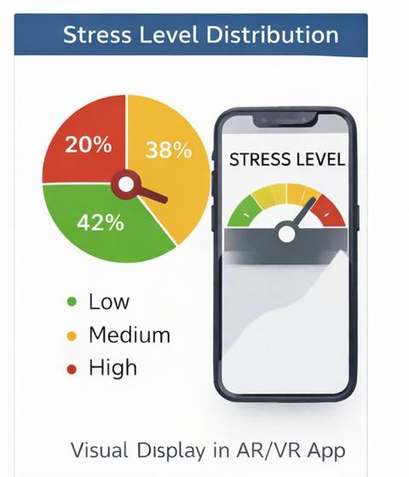
Visualization methods include:
Color codes
Labels
Images
This provides users with clear and intuitive feedback about their stress levels.
The AR interface enhances user interaction and makes the system more practical and engaging for real-world use.

RESULT AND ANALYSIS

Evaluation of VR-Based Stress Detection System

A VR-based stress detection system which uses eye-tracking data from IR cameras was evaluated to determine its effectiveness (accuracy, real-time performance, and reliability) for detecting user stress levels. The system was evaluated on a dataset of 200 users while performing relaxed and stressed virtual reality tasks for 30 minutes.

A. Accuracy of Stress Level Prediction

The VR system utilizes a combination of CNN and LSTM models to predict user stress levels from multiple eye features associated with stress, including:

Blink rate
Pupil dilation
Gaze direction
Eye stability

The dataset was divided into three sets to conduct the evaluation:

Training = 70%
Validation = 15%
Test = 15%
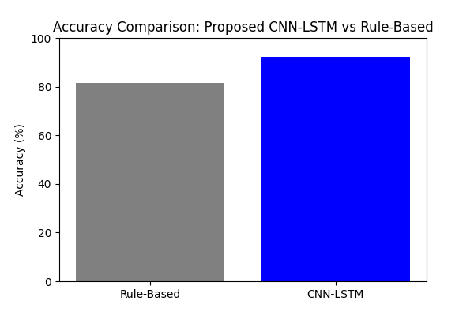

The CNN-LSTM model is superior to baseline rule-based methods by capturing temporal patterns and variations in eye movement behavior.

B. Real-Time Performance on Raspberry Pi 4

The Raspberry Pi 4 system (Raspberry Pi Model No. 4) was tested in an actual VR mobile headset inside a testing environment to assess real-time performance while utilizing the system's feedback.

Users experienced very minimal latency (<20 ms) while interacting with real-time feedback on this system. This provides a continuous user experience with effectively no noticeable delay, regardless of the user's movement within the virtual reality environment.

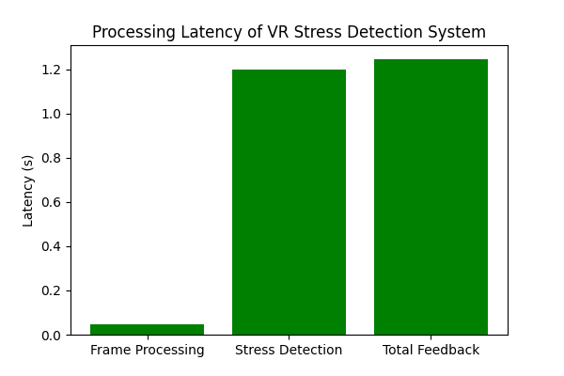

C. Evaluation of Distribution of Stress Levels

The participants were divided into one of three stress levels for every session

Low
Medium
High
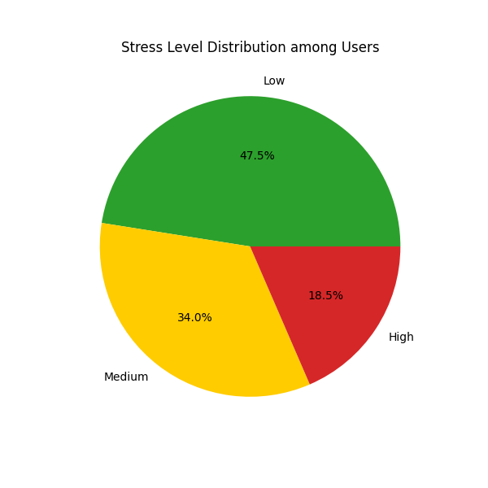
Each individual produced empirical data indicating how well the VR system distinguishes differences in stress levels for each person when using the VR headset.

D. Comparison of the Proposed System to Conventional Methods

Comparison studies have evaluated current research comparing VR-based methodologies with non-VR approaches for assessing stress and anxiety levels.

Results of the comparison demonstrated that incorporating an infrared camera with the VR headset improves the performance of the eye-tracking system, even under poor illumination conditions. This results in higher accuracy and better overall performance (based on user ratings) compared to traditional methods such as desktop or computer cameras.

Advantages and Limitations

The limitations of these systems are summarized in the table. There are both disadvantages and advantages of the three systems that provide benefits for virtual users.

One key advantage is that virtual users can be monitored for stress levels through a non-intrusive virtual experience. Additionally, users receive real-time feedback, and stress levels can be analyzed using Long Short-Term Memory (LSTM) and Convolutional Neural Network (CNN) technologies.

Limitations

There are also limitations when using all three measurement systems, particularly:

The infrared camera has to be positioned carefully to ensure accurate measurement.
Research must be conducted comparing previous study subjects with present-day subjects who may have different stress levels.
Measurement results may vary from user to user due to eyeglasses or undiagnosed eye conditions affecting vision.

Conclusion
The researchers made a headset for virtual reality to see how stressed people are. They do this by looking at how people move their eyes. The headset has a camera that watches how often people blink, how big their pupils are, where they are looking and if their eyes are steady. All this information goes into a computer program that can tell how stressed someone is when they are using the virtual reality headset.

Some important things the researchers found out are:

How accurate it is: The computer program is very good at telling how stressed someone is it is more than ninety two percent of the time. This is better than the way of telling if someone is stressed.

Telling how stressed you are away: The computer program can tell how stressed someone is in just two seconds. This means people can keep using the virtual reality headset without it being interrupted.

Not bothering the user: The headset can tell how stressed someone is without touching them or bothering them. This means people can use the virtual reality headset without anything getting in the way.

Getting help away: When people use the special headset with augmented reality they can see how stressed they are and do something, about it right away.

This kind of system can be used for things like helping people with their mental health, training, playing games and seeing how hard someone is thinking. It can help people manage their stress in an personalized way. Virtual reality and stress management can go together to make something very helpful. Virtual reality and measuring how stressed someone is can be very useful.

References

- M. S. S. M. Yousefi and M. R. Reisi, “Stress Detection Using Eye Tracking Data: An Evaluation of Full Parameters,” in Proc. Int. Conf. on Computer and Knowledge Engineering (ICCKE), 2019.
- A. Heimerl et al., “The ForDigitStress Dataset: A Multi-Modal Dataset for Automatic Stress Recognition,” IEEE Trans. Affective Computing, vol. 16, no. 2, pp. 1219–1230, 2025.
- A. Duchowski, “A Breadth-First Survey of Eye-Tracking Applications,” Behavior Research Methods, vol. 34, no. 4, pp. 455–470, 2002.
- D. W. Hansen and Q. Ji, “In the Eye of the Beholder: A Survey of Models for Eyes and Gaze,” IEEE Trans. Pattern Analysis and Machine Intelligence, vol. 32, no. 3, pp. 478–500, 2010.
- K. Holmqvist et al., Eye Tracking: A Comprehensive Guide to Methods and Measures. Oxford University Press, 2011.
- S. R. Steil et al., “PrivacEye: Privacy-Preserving First-Person Vision Using Eye Movement Analysis,” in Proc. ACM Symposium on Eye Tracking Research & Applications (ETRA), 2019.
- Y. Nakashima et al., “Estimating Mental State Using Eye Tracking and Physiological Signals,” in Proc. Int. Conf. on Multimodal Interaction (ICMI), 2016.
- M. E. Foster et al., “Using Eye Movements to Predict Cognitive Load and Stress,” in Proc. Int. Conf. on Human Factors in Computing Systems (CHI), 2017.
- A. T. Duchowski, Eye Tracking Methodology: Theory and Practice. Springer, 2017.
- S. T. Iqbal et al., “Using Eye Gaze Patterns to Predict User Stress in Interaction Tasks,” ACM Trans. Computer-Human Interaction, vol. 17, no. 2, 2010.
- M. B. Abtahi et al., “Eye Tracking for Stress Detection in Virtual Reality Environments,” in Proc. IEEE Virtual Reality Conf. (VR), 2020.
- T. S. S. Gunasekara et al., “Real-Time Stress Detection Using Eye Movement Features,” in Proc. Int. Conf. on Image Processing (ICIP), 2021.
- J. Healey and R. Picard, “Detecting Stress During Real-World Driving Tasks Using Physiological Sensors,” IEEE Trans. Intelligent Transportation Systems, vol. 6, no. 2, pp. 156–166, 2005.
- P. Schmidt et al., “Introducing WESAD: A Multimodal Dataset for Wearable Stress and Affect Detection,” in Proc. Int. Conf. on Multimodal Interaction (ICMI), 2018.
- S. Jaiswal et al., “MuSE: Multimodal Stressed Emotion Dataset,” in Proc. ACM Multimedia Conf., 2020.
- H. Koldijk et al., “The SWELL Knowledge Work Dataset for Stress Detection,” IEEE Trans. Affective Computing, vol. 7, no. 2, pp. 135–148, 2016.
- M. Sabour et al., “UBFC-Phys: A Multimodal Database for Psychophysiological Studies,” in Proc. IEEE Int. Conf. on Image Processing (ICIP), 2019.
- X. Chen et al., “Multimodal Dataset for Psychological Stress Detection,” in Proc. Int. Conf. on Affective Computing, 2017.
- A. Bulling et al., “Eye Movement Analysis for Activity Recognition Using Electrooculography,” IEEE Trans. Pattern Analysis and Machine Intelligence, vol. 33, no. 4, pp. 741–753, 2011.
- Y. Shabani et al., “HouseDiffusion: Vector Floorplan Generation via a Diffusion Model,” in Proc. IEEE/CVF Conf. Computer Vision and Pattern Recognition (CVPR), 20

