ESP32-Based Universal IR Remote Control System

Koduru Pavan Kumar Reddy
Department of EEE Siddhartha Academy of Higher Education (SAHE) Deemed to be University Vijayawada, India
kodurupavankumarreddy52@gmail.com

P. Venkatesh
Department of EEE Siddhartha Academy of Higher Education (SAHE) Deemed to be University Vijayawada, India venki249@vrsiddhartha.ac.in
Damarla Naga Srinivas Department of EEE Siddhartha Academy of Higher Education (SAHE) Deemed to be University Vijayawada, India
nagasrinivasdamarla@gmail.com

Katikala jayavardhan Department of EEE Siddhartha Academy of Higher Education (SAHE) Deemed to be University Vijayawada, India
katikalajayavardhan@gmail.com
Abdul Ashraf Department of EEE Siddhartha Academy of Higher Education (SAHE) Deemed to be University Vijayawada, India ashrafvyr@gmail.com
Amruth Kumar Ronanki Department of EEE Siddhartha Academy of Higher Education (SAHE) Deemed to be University Vijayawada, India
amruthkumarronanki@gmail.com

Abstract—This paper describes the design of a new universal Infrared (IR) remote control system utilizing ESP32-based micro- controllers to establish a replacement for all current consumer electronics devices (CED). The primary goal was to provide a method by which one remote control unit would be able to learn, record and play back all of the IR remote control signals transmitted by conventional CED remotes and have a compact user interface to provide individual programming of up to twelve separate functions. To achieve these goals, a VS1838B IR Receiver Module operating at a carrier frequency of 38kHz was used to receive and record the raw IR signal, a corresponding IR LED was driven by a 2N2222 Transistor to re-transmit the recorded IR signal and the primary user interface consists of a 4x3 matrix keypad using twelve separate push buttons for programming. Pressing the buttons once will replay the stored IR signal but pressing and holding the button for more than two seconds activates the learning mode of the remote which will detect and record the raw IR waveforms from all available CED remotes in the available memory on the ESP32 processor. The prototype was developed on the Arduino platform using the IRremoteESP8266 library for the firmware. The effectiveness of the product was validated through testing to successfully learn and re-transmit IR signals from multiple brands of CED including televisions, air conditioning units and set top boxes. The result is a compact, low cost, one-to-many IR remote control to replace the existing variety of remote controls, thereby greatly reducing user inconvenience associated with multiple remotes
Index Terms—Universal Remote Control, ESP32, Infrared Communication, Embedded Systems, Home Automation, IR Signal Learning

- Introduction
Today’s homes and work environments contain large num- bers of consumer electronic devices (CED), including televi- sions, air conditioners, projectors, electric fans, set-top boxes, and audio systems (music players, CDs, etc.). These devices communicate wirelessly via a dedicated infrared or “IR” remote control operating at a carrier frequency of 38 kH [5][6].
While IR remote controls provide a convenient method for controlling standalone devices, having many consumer elec- tronic devices means that consumers typically manage multiple remote controls which operate only one specific device (e.g., TV remote control; air conditioning remote control, etc.).
Having multiple remote controls makes it very inconvenient for users who have to track down and switch among multiple (i.e., several) remote controls in order to operate separate consumer electronic devices. The Universal Remote Controller (URC) was developed in response to this inconvenience by allowing a single remote control to perform the functions of multiple remotes. Universally available URCs have limitations, however; they can only control devices that are included within pre-defined manufacturer databases and can only operate via fixed protocol sets therefore limiting their ability to control many types of consumer electronic devices including projec- tors, fans, and air conditioning units [2].
Universal remote control is becoming more flexible and inexpensive through the implementation of microcontroller- based systems. Types of microcontrollers like the Arduino and ESP8266 have been used for successful receiving, decoding, and re-transmitting infrared signals used for household appli- ances. The most common types of systems use an infrared receiver to capture incoming signals and an infrared light- emitting diode (LED) to re-transmit the commands that were captured. More advanced systems have the ability to allow users to directly capture IR waveforms from existing remotes and later play them back on demand. This eliminates the need for a database of pre-defined protocols to access the functions of an appliance [1], [8].
With the continued growth of the Internet of Things (IoT), infrared remote control systems are being integrated into smart home technologies to provide the capability for users to remotely control appliances previously controlled only using

infrared technology. For example, an air conditioner, televi- sion, or set-top box would all be connected to the Internet for control using an IoT platform instead of only being controlled by the infrared remote. Shinde et al. [10] have shown that home automation systems that incorporate infrared technology with other wireless technologies such as Bluetooth and GSM provide a comprehensive multi-modal solution for controlling household appliances.
The objective of this paper is to create an ESP32 universal IR remote control solution that overcomes the limitations of currently available universal remote control solutions. Specif- ically, this IR remote control system utilizes a VS1838B IR receiver module to receive raw 38 kHz infrared signals and a 2N2222 transistor-driven IR LED to retransmit learned in- frared signals. To operate this system, an additional 4x3 matrix keypad is also included to provide up to 12 programmable keys. As designed, the ESP32 universal IR remote control system will enable users to operate various infrared appliances such as TVs, air conditioners, projectors, electric fans, and set top boxes(. Initially pressing the keypad key triggers replay of previously stored infrared signal; however, once a user continues to press the key for longer than 2 seconds, they engage the learning mode, allowing the ESP32 universal IR remote control to automatically learn and store signals from any infrared-based remote control directly to the ESP32 memory without having any prior knowledge of the protocol used to generate the infrared signals.

- Literature Review
A number of researchers have investigated how to develop novel types of infrared remote control systems using embedded microcontrollers and wireless technologies.
STIR, the smart and reliable IoT system developed by Ling et al. [1], enables the connection of legacy IR-controlled devices over the internet through the use of a Raspberry Pi, an IR transmitter/receiver PCB board that is custom made for this application and an MQTT Cloud Server. The STIR system also includes the ability to record and replay remote IR signals in addition to implementing a variant of the system that can be mounted on a drone for the purpose of remotely turning off televisions.
Muthiah and Natesh [2] created a low cost smart glove- based universal remote control system for IR devices. The system detects gestures using contact sensors located on the finger tips of the glove and transmits the gesture data to an intermediate Arduino device over a 433 MHz RF link. The Arduino converts the gesture codes into IR commands that can be used to control a myriad of consumer appliances.
Wu et al. [3] provided a multi-use remote control system using a Bluetooth enabled mobile phone that incorporated IR, RF and Bluetooth communications into one PIC16F877A microcontroller system. Additionally, their proposed system permits a user to utilize a Java mobile application to perform remote control functions using IR appliances such as TVs and fans, as well as RF controlled devices, such as roller shutters.
The authors Haroon et al. [4] developed a home automation system utilizing the ESP32 microcontroller and consisted of Wi-Fi enabled relay modules that enabled users to control household appliances located away from the home or monitor environmental conditions through the use of an app on a smart phone. The system demonstrated the ESP32’s ability to act as a robust IoT platform used for home automation.
Han [5] created an infrared (IR) remote control simulation system that used the STC89C51 single-chip microcontroller for controlling household appliances. To create the system, Han employed a 38 kHz modulated IR emitter along with an integrated IRM-3638 IR receiver module that provided a relay and LED indicators for how the appliances would respond when signals were sent from an IR remote control.
Rasheed and Khidrjarjes [6] were able to demonstrate the reuse of IR signals in both residential and commercial applica- tions. The authors used the ATMEL 89C2051 microcontroller in conjunction with the LTM9052 IR receiver operating at 38 kHz to decode the IR packet formats received from multiple brands and to utilize the information to control the AC mains power using phase angle control methods.
The work of Kim et al.[7] developed a framework through the use of a Smart TV set-top box as the controlling device for all home appliances, whether they were IP protocol or RS-485 protocol based upon infrared communication. A remote control application was created on a tablet computer that mirrored the Smart TV set-top box display and transmitted touch events to control the home appliance via the Smart TV set-top box: therefore, the Smart TV became the central hub for controlling a home via a distributed approach to home automation.
Satyanarayana et al.[8] created a method for a time-based IoT-enabled remote controller for traditional Infrared (IR) home appliances (i.e., air conditioning, lighting) using a NodeMCU ESP8266 Wi-Fi microcontroller and an IRremote library with the MQTT (Message Queuing Telemetry Trans- port) protocol and a Node-RED dashboard to provide a user interface. Their system captured signals from an existing remote control for a legacy IR appliance, stored the signal, and repurposed it to be transmitted to the legacy appliance using a Non-directional Infrared (NDIR) LED, with the capability for scheduling automation for operate appliance as well as for live temperature readings for regulation to operate a legacy appliance, which was achieved by implementing a temperature sensor (DHT11) within the controller.
Yang and Cheng[9] proposed a universal remote control sys- tem for legacy appliances using a Generic Remote Controller (GRC) that contained Wi-Fi capabilities (IEEE 802.11b), and has an Infrared Data Association (IrDA) interface with a touchscreen. The unique feature of the GRC is that the device could automatically discover nearby Information Appliances (IA) by using the GRC as the control system, download the control request and reconfigure its user interface in real-time by the use of Remote Method Invocation (RMI) via Java (distributed computing).
In a study by Shinde et al. [10], a smart home automation system developed that uses infrared (IR), Bluetooth, and

GSM communication to control home heating and cooling systems via an Android application. The developers created an Arduino-based system to receive the commands using a TSOP1738 IR receiver, an HC-05 Bluetooth module, or a GSM module for controlling appliances both locally (with IR/Bluetooth) and remotely (with GSM).
Takahashi et al. [11] developed a new smart remote con- troller called DeepRemote that utilizes image recognition based on deep learning to automatically identify the target appliance and configure its control interface. The remote controller is handheld, contains a camera, IR transceiver, Wi- Fi module, IMU, and buttons, and provides 81.07
According to a study by Carducci et al[12]. Ex to be an ef- fective wireless interface adapter between building automation systems and IoT applications, they have tested both the ADC and DAC capabilities (accuracy) of the ESP32 with respect to interfacing with industrial-grade sensors and actuators. The results revealed that the ESP32 can provide an affordable, re- liable solution for IoT-enabled building automation/industrial applications if the system is well-calibrated.
- Proposed System
This innovative solution is intended to act as a singular multi-functioning universal remote control for consumer elec- tronics. It can learn, store and resend IR (infrared) signals generated by an original consumer electronics remote control and allow the user to replace an entire collection of remote controls for their appliances with just a single compact remote that can provide IR to replace the tenant’s remote for any device including TVs, air conditioners/projectors/fans and set- top-boxes.
ESP32 microcontroller that acts as the main computer which processes and retains all the received IR signals and sends them back out. All the controlled devices interface through the GPIO pins of the ESP32.
VS1838B IR receiver module which receives and demodu- lates incoming IR signals from existing remote controls that are modulated at 38KHz and sends the decoded signal to the ESP32 for processing and storage.
IR LED which transmits the stored IR to the target appliance under the control of the transistor driver circuit.
2N2222 transistor driver circuit which provides amplifica- tion of the control signal from the GPIO pin of the ESP32 to enable the IR LED to have sufficient current to be transmitted in an effective range.
4x3 matrix keypad which is the primary user interface and has 12 individual programmable push buttons arranged in 4 rows and 3 columns that enable the end user to record and replay each of the 12 IR controls.
The operation principle of the suggested system is two- phase as shown as follows:
- Learning Phase. When any key of the (4×3) keypad is pressed down for more than 2 seconds, the system goes into learning mode for that individual key. The VS1838B IR receiver will be turned on, and listen for an IR remote control signal from the appliance. The raw infrared waveform
is collected by the ESP32 microcontroller using the IRremo- teESP8266 library and stored in its internal memory allocated for that specific key. Up to 12 different IR signals may be stored in memory for the 12 keys on the keypad.
- Replay Phase. When a short button press is made on any programmed keypad key, the ESP32 microcontroller will retrieve the IR signal stored in memory for that key and will send it again out through an IR LED (driven by a 2N2222 transistor) using a carrier frequency of 38 kHz. The IR signal sent out will be identical to the original signal received from the appliance’s remote control, allowing the appliance to work as if a command had been received from its own remote control.
The Fig.1 shows the Block diagram of ESP32-based Uni- versal IR Remote Control System
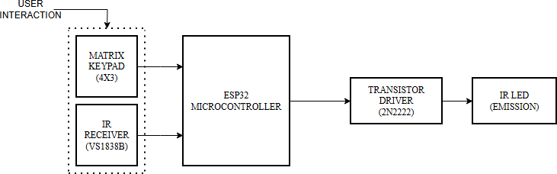

Fig. 1. Block diagram of ESP32-based Universal IR Remote Control System

- Hardware design
The proposed universal infrared (IR) remote control system has a number of components, but five main components:
  - ESP32 microcontroller.
  - VS1838B IR receiver module.
  - IR LED.
  - 2N2222 NPN transistor driver circuit.
  - 4×3 matrix keypad. Each of these components is con- nected to the other and powered using a supplied voltage of 3.3 V from the onboard voltage regulator of the ESP32, eliminating the need for any external power supply.
The ESP32 microcontroller acts as the central processing unit and manages all GPIO-based interactions (including but not limited to) key scanning, IR signal reception and retrieval, memory storage, and retransmitting IR signals. The microcon- troller was chosen for this application because it had adequate GPIOs for checking user’s input through the keyboard, fast and efficient processing speed to maintain real-time performance, and enough memory to hold several raw IR waveform arrays simultaneously.
The VS1838B IR receiver module provides signal input to the remote controlling system. Its VCC pin is connected to the
3.3V supply from the ESP32, it’s GND pin up ground refer- ence from the system, and its OUT pin is connected to GPIO 14 of the microcontroller; it receives and transmits infrared signals at a carrier frequency of 38 kHz. This frequency is standard for nearly all consumer electronic devices that utilize IR remote controls.
The VS1838B infrared receiver demodulates the incoming infrared (IR) signal during the Learning Phase and provides raw pulse width(representing on/off pattern of the IR signal)

information through the ESP32 for subsequent capture and storage.
The IR transmit subsystem has an IR LED that is energized by means of a 2N2222 NPN transistor. The LED anode is connected to a +3.3V power rail through a 100 ohm current limiting resistor and the LED cathode is connected to the collector of the 2N2222 transistor. The base of the 2N2222 transistor is connected to the GPIO27 pin of the ESP32 via a 1K resistor. The emitter pin of the transistor is connected to the common ground of the system. When the GPIO27 pin is driven high by the ESP32, the transistor goes into saturation mode allowing the current to flow through the IR LED; thus enabling transmission of the IR signal. In order to provide the necessary current to drive the IR LED for an effective IR transmission range, a transistor driver circuit is required because the GPIO pin of the ESP32 does not provide enough output capability to drive the IR LED directly.
The user interface for this system is provided by a 4×3 matrix keypad consisting of 12 push buttons arranged in 4 rows and 3 columns.The ESP32 has four Row I/O pins for the keypad (R1/R2), each connected to a particular GPIO pin on the ESP32 (GPIO32, GPIO33, GPIO25, GPIO26). Similarly,
three Column I/O Pins (C1/C2/C3) are tied into GPIO18, GPIO19 and GPIO23 respectively. The Keypad has a total of 12 programmable channels that correspond to the keys 1-9 (12 Channels). The complete list of I/O pins associated with the Keypad is presented in Table I.
There is a common ground reference connection for the ESP32, VS1838B IR decoder unit, 2N2222 NPN transistor emitter and the Keypad; therefore, all signal levels are stable and referenced against one another.
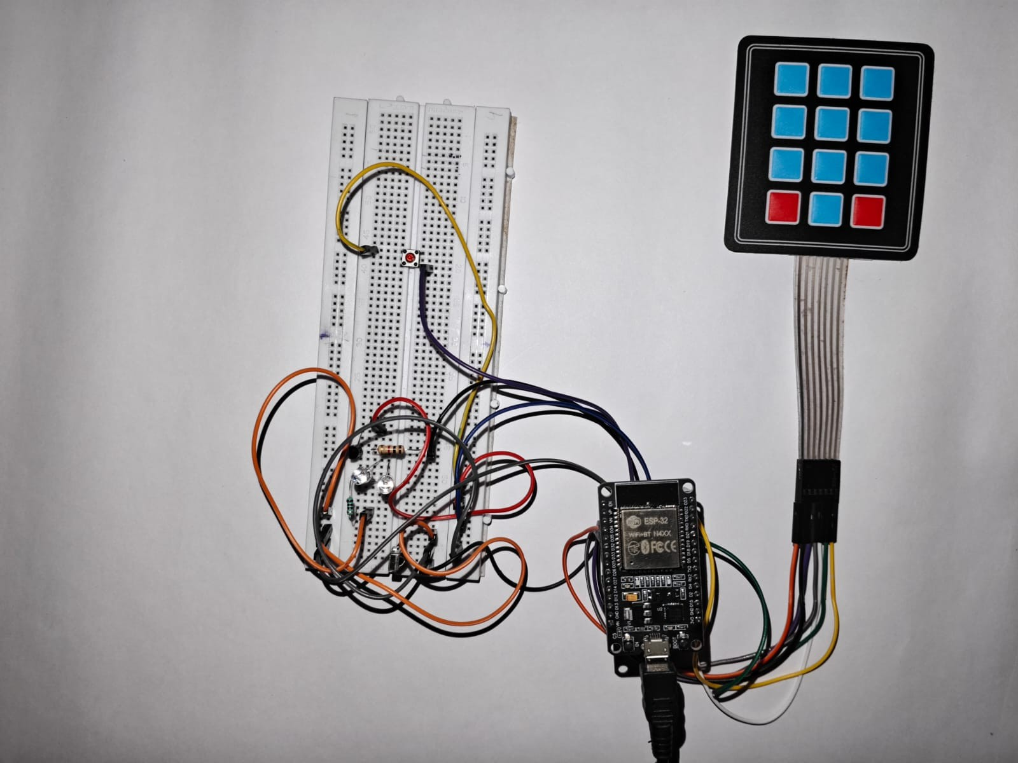
Fig. 2. Prototype of the ESP32-based Universal IR Remote Control System

- Software Implementation
The firmware for the proposed universal infra-red (IR) remote control system was created using the Arduino Inte- grated Development Environment (IDE). There are two main libraries of software included in this project; the first is the IRremoteESP8266 library. This library is used to capture and
resend infrared signals. The second library is the Keypad Library, which interfaces with the matrix keypad that will be included in this project.
- Library and Pin Configuration
The Pin assignments for the hardware will be defined before any of the library objects are created. For example, the GPIO14 pin will be the infrared signal receiver pin, while the GPIO27 pin will be the infrared light-emitting diode (LED) signal transmitter pin. An IRrecv object will be created to receive the infrared signals from an external remote control from the GPIO14 pin, as well as an IRsend object will be created to transmit infrared signals through the LED from the GPIO27 pin. The IR transmission frequency will be set to 38 KHz, which is the same frequency used by most remote controls for consumer electronic devices.
- Structure of Data Storage
A custom data structure called IRCode has been created to store the raw IR waveform data for each programmable key. Each IRCode contains a malloc’d uint16t* (pointing to the raw pulse-width array), a uint16t to hold the length of the array, and a boolean flag to indicate that a valid signal has been stored for that key. An array of 12 IRCode’s (storedCodes) is declared to provide independent storage for each of the 12 keys on the keypad. The use of malloc() and free() allows the programmer to dynamically allocate a memory area to store the raw IR arrays in the ESP32’s internal RAM so that the memory can be used efficiently by multiple stored signals.
- Keypad Event Detection
The getKeys method from the Keypad library constantly polls the keypad in its main loop each time through. The Keypad library’s configuration parameters include a hold-time of 2 seconds and a debounce-time of 50 ms. There are two keypad event types that the system looks for and processes: short press (the key is released) and long press (the key is held down). To convert the character values for each key pressed to an array index (i.e., to storeCodes), the method will use the getKeyIndex() helper function to map 1-9 to index locations 0- 8, to index 9, index 0 to index 10, and to index 11, respectively.
- Learn Mode
The system will go into learn mode for the detected key once a HOLD event is received on that key. The function irrecv.decode() from the IRremoteESP8266 is executed in a polling loop, with a timeout window of eight seconds, to wait for a valid IR signal to be received by the VS1838B module. After receiving a valid IR signal, the function resultToRawAr- ray() will convert the received result into a raw array of pulse- width timing, while the function getCorrectedRawLength() will provide the length of the raw array. If information related to that key already exists, any old information will be freed using the function free() before the new information can be stored. The new raw array is stored in flash memory with the functions malloc() and memcpy(), and the stored Codes flag will be set to true, for that key. After each successful capture, the function irrecv.resume() is called so that the IR receiver is prepared for the next capture attempt.

- Replay Mode
When the system detects a released event on any key, it will check the stored flag for that IRCode entry. If there was a valid signal that has already been stored, the function irsend.sendRaw() will be executed using the stored raw pulse- width array for the number of raw pulses and a carrier frequency of 38 kHz as arguments. The result will be a captured IR waveform that is transmitted back out through the IR LED at the correct carrier frequency and will produce a signal that will be identical to the original output of the remote control. If the key did not have a previously stored signal, a warning will be output through the serial monitor, with no transmission taking place.
- Results and Discussion
- Learning Phase Testing
The learning phase testing was performed by pressing each of the 12 keys on the keypad for a minimum of 2 seconds while aiming the original remote control for the corresponding device at the VS1838B IR Receiver module to learn, capture, and save the raw IR waveform of each device. During all of the learning phases of every device tested, the IRremoteESP8266 library successfully decoded the IR signals received during the 8 seconds allowed to learn each of the IR protocols used by each of the original remote controls used in all tests, and there were no failures to capture any of the learning signals.
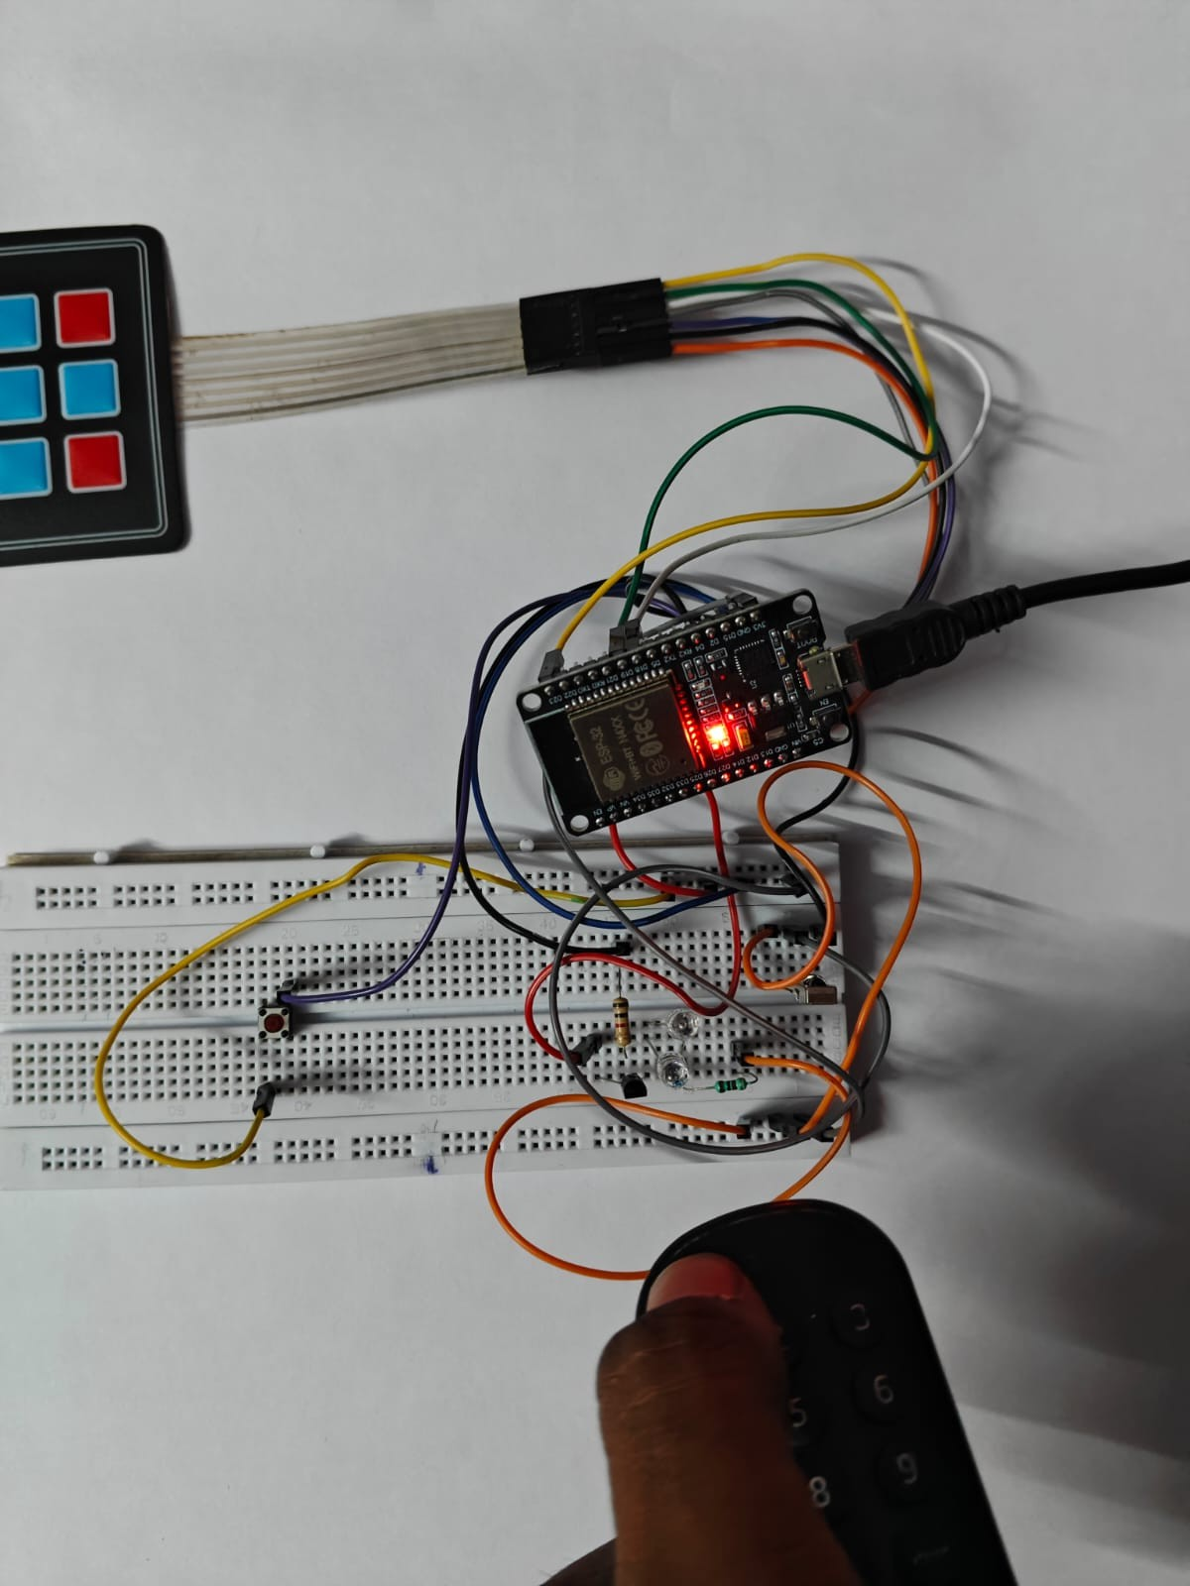
Fig. 3. Prototype of the ESP32-based Universal IR Remote Control System during IR signal learning phase, with the original remote control pointed toward the VS1838B IR receiver module
- Replay Phase Performance
Evaluation of performance in the Replay Phase of this phase consisted of activating each programmed key by performing a short press and observing the resulting response of the target device while verifying that the stored IR signals were success- fully retransmitted; thereby triggering the proper action from
the target device being tested for each attempted activation. Response times from key press to target device activation were also recorded. All response times were found to be less than one second, which is comparable to response times using original manufacturer’s remote controls. No missed or incorrect commands were noted during Replay Testing. Fig 4,5 shows using of Universal IR Remote Control System to control the electric ceiling fan and set-up box
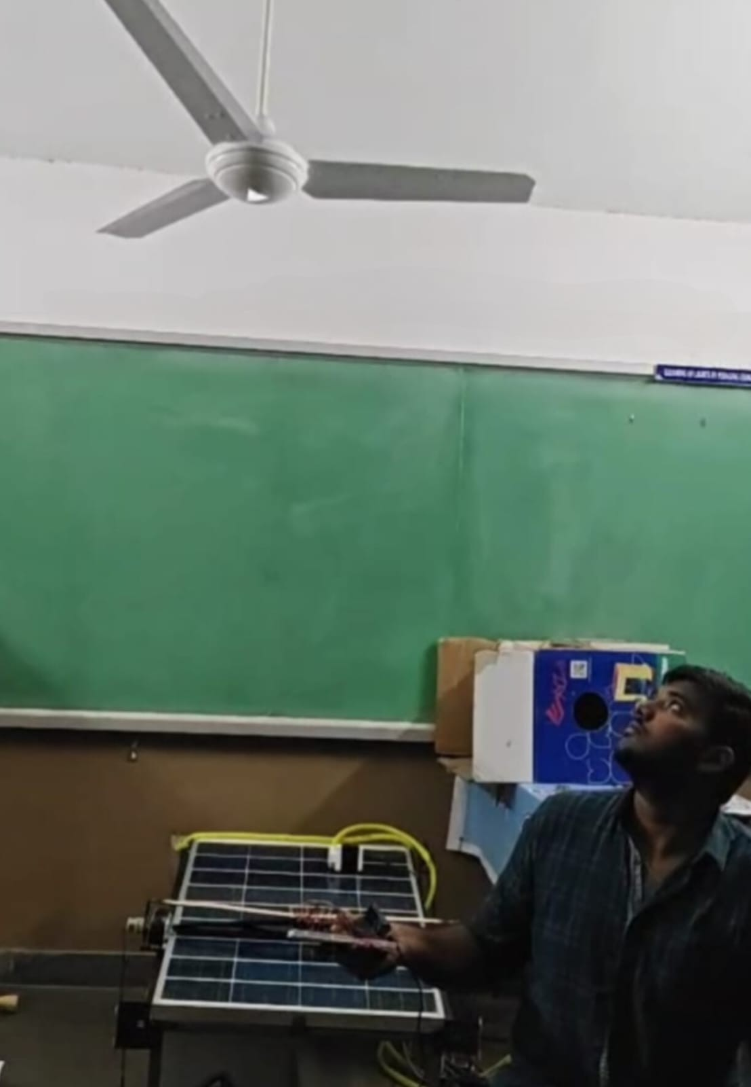

Fig. 4. Demonstration of the proposed system successfully controlling a ceiling fan using the ESP32-based Universal IR Remote Control prototype.

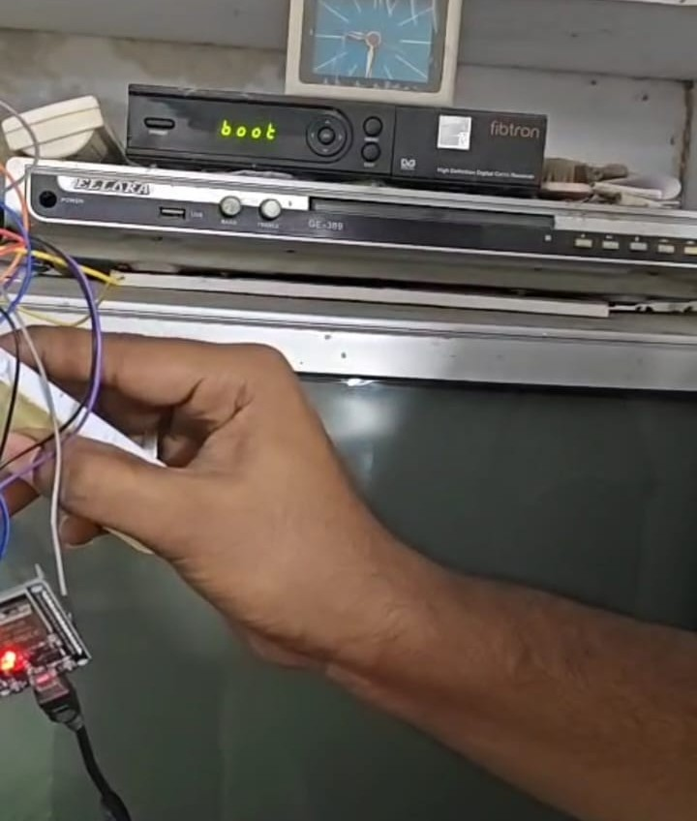
Fig. 5. The Demonstration shows that the proposed system successfully controlling a set-up box using the ESP32-based Universal IR Remote and effectively performing functions.

- Multi-Brand Compatibility
Compatibility of this system with retail consumer electronic devices from a minimum of five different manufacturers was demonstrated through testing. The system was able to learn and retransmit successfully IR signals measured by learn- ing the respective original remote controls without altering, modifying, or changing the physical hardware or firmware in any manner. Therefore, it can be concluded that the proposed system’s use of raw waveform capture and retransmission will be appropriate for any type of IR-based consumer electronic device manufactured by any manufacturer regardless of the manufacturer or IR Protocol used.
- CONCLUSION
This paper presented the design and implementation of an all-in-one remote control that works using an ESP32 micro- controller as both a prototype and the real-world product. The universal remote control can learn, store, and output infrared signals from consumer electronics and provide a compact and inexpensive way to eliminate the hassle of using many different dedicated remote controls. By successfully capturing the raw infrared signal from televisions, satellite receivers, and fans from five different manufacturers, the system has demonstrated an ability to re-transmit signals using a pro- grammable 12 key interface successfully with no more than one second delay when receiving a remote control command and an approximate range of 8 metres from the IR receiver. Since the method of capturing raw infrared2 signal requires no predefined IR Protocol Database nor is dependent on protocols, this system is truly universal. That is, the system is compatible with all IR-based devices and will work regardless of manu- facturer or protocol. Furthermore, since this system will need no network connections or cloud services to function, it will operate independently of the Internet. Future improvements on this product may include: adding non-volatile memory to retain learned infrared signals after being powered down; enhancing the infrared functionality to provide an extended range of transmission; and integrating the ESP32’s existing embedded Wi-Fi radio to allow for controlling appliances connected to the Internet.
References
- Z. Ling, C. Gao, C. Sano, C. Toe, Z. Li and X. Fu, ”STIR: A Smart and Trustworthy IoT System Interconnecting Legacy IR Devices,” in IEEE Internet of Things Journal, vol. 7, no. 5, pp. 3958-3967, May 2020
- M. Muthiah and A. V. Natesh, ”Low cost smart glove for universal con- trol of IR devices,” 2016 IEEE International Symposium on Technology and Society (ISTAS), Kollam, India, 2016, pp. 1-5,
- C. -H. Wu, L. -S. Ma, Y. -J. Cai and T. -F. Yeh, ”A multi-purpose remote controller based on Bluetooth mobile phone,” 2010 11th International Conference on Control Automation Robotics and Vision, Singapore, 2010, pp. 358-363.
- A. L. H. P S, M. Shafiulla, S. Mohammed Naveed, S. Ahmed, S. Mohammed Nawaz and U. Kumar, ”Home Automation Using Wi-Fi: ESP32-Based System for Remote Control and Environmental Monitor- ing,” 2024 Third International Conference on Distributed Computing and Electrical Circuits and Electronics (ICDCECE), Ballari, India, 2024, pp. 1-7.
- X. Han, ”Infrared remote control design based on single chip mi- crocomputer,” 2015 IEEE International Conference on Computer and Communications (ICCC), Chengdu, China, 2015, pp. 245-249.
- A. A. Rasheed and M. Khidrjarjes, ”Detection and study of various IR handheld remote control signals and using them for home applications,” International Conference on Education and e-Learning Innovations, Sousse, Tunisia, 2012, pp. 1-7.
- Junghak Kim, Seungchul Kim, Sangtaick Park and Jinwoo Hong, ”Home appliances controlling through Smart TV set-top box with screen- mirroring remote controller,” 2013 International Conference on ICT Convergence (ICTC), Jeju, Korea (South), 2013, pp. 1009-1012.
- G. S. R. Satyanarayana, B. G. Praveen, N. V. Kumar, N. N. Naidu and
S. S. Rao, ”Time Driven and IoT Enabled Remote Controller for IR- Based Legacy Electronic Appliances,” 2025 IEEE 6th India Council International Subsections Conference (INDISCON), Rourkela, India, 2025, pp. 1-6.
- Yu-Chung Yang and Fan-Tien Cheng, ”Autonomous and universal remote control scheme,” IEEE 2002 28th Annual Conference of the Industrial Electronics Society. IECON 02, Seville, Spain, 2002, pp. 2266-2271 vol.3.
- A. Shinde, S. Kanade, N. Jugale, A. Gurav, R. A. Vatti and M. M. Patwardhan, ”Smart Home automation system using IR, bluetooth, GSM and android,” 2017 Fourth International Conference on Image Information Processing (ICIIP), Shimla, India, 2017, pp. 1-6.
- Y. Takahashi et al., ”DeepRemote: A smart remote controller for intuitive control through home appliances recognition by deep learning,” 2017 Tenth International Conference on Mobile Computing and Ubiquitous Network (ICMU), Toyama, Japan, 2017, pp. 1-6.
- C. G. C. Carducci, A. Monti, M. H. Schraven, M. Schumacher and D. Mueller, ”Enabling ESP32-based IoT Applications in Building Automa- tion Systems,” 2019 II Workshop on Metrology for Industry 4.0 and IoT (MetroInd4.IoT), Naples, Italy, 2019, pp. 306-311.

