OPTIMIZING WEBSITE TRAFFIC AND STAKEHOLDER CONVERSION OF AN INTERNATIONAL HIGHER EDUCATION INSTITUTION USING LEAN SIX SIGMA FRAMEWORK

A Thesis Presented to the Faculty of Graduate School

In Partial Fulfillment of the Requirements for

Agada, Peter James

May, 2026

ABSTRACT

In the wake of the global shift toward digital-first recruitment, Higher Education Institutions (HEIs) face significant challenges in managing web traffic and conversion consistency. This study addressed the operational contraction in enrollment targets of an international university in the Philippines, which fell from an 80% achievement rate in 2019 to 60% by 2021. The research aimed to optimize the institutional web funnel by identifying "digital waste" and enhancing process capability using the Lean Six Sigma (LSS) DMAIC (Define, Measure, Analyze, Improve, Control) framework.
The Measure Phase established a three-year baseline (2020–2022) using Google Analytics data from 64,590 inquiries. The initial assessment revealed a sub-optimal Sigma Level of 2.1 and a Process Capability (C_{pk}) of 0.49, indicating a process incapable of meeting institutional specifications. The Analyze Phase utilized Pareto Analysis and Fishbone Diagrams to isolate root causes, identifying stagnant content, poor SEO, and non-synchronized marketing channels as the "vital few" defects. Statistical validation confirmed a strong correlation (r = 0.88) between multi-channel maximization and stakeholder conversion.
During the Improve Phase, a strategic digital marketing plan was implemented using the SOSTAC (Situation, Objectives, Strategy, Tactics, Action, Control) model. Key interventions included SEO technical optimization, UI/UX "Poka-Yoke" redesign, and channel integration. Post-implementation results showed a 30.5% increase in website views and a stabilization of conversion to an average of 9 stakeholders weekly. The final evaluation showed a significant process shift to a 4.4 Sigma Level and an improved C_{pk} of 1.09.
The study concludes that integrating engineering-based LSS tools with strategic marketing frameworks provides a superior, data-driven approach to institutional growth. It is recommended that the institution maintain the achieved gains through the established Failure Mode and Effects Analysis (FMEA) control plan and continuous monitoring of process stability via I-MR control charts.

Keywords: Lean Six Sigma, DMAIC, SOSTAC, Process Capability (C_{pk}), Digital Marketing, Higher Education.

Introduction
In the contemporary corporate landscape, an unprecedented paradigm shift toward digital marketing strategies has fundamentally redefined how organizations transcend the boundaries of physical distance to locate, attract, and retain stakeholders. Modern enterprises increasingly leverage dynamic digital channels, utilizing institutional web platforms to promote offerings, maximize visibility, and deliver robust service support. Within this highly fluid digital ecosystem, consumers routinely navigate diverse networks to formulate buying decisions, consistently evaluating options based on peer-driven digital feedback and social proof. Consequently, an organization’s website serves as the primary engine for consumer interaction, directly impacting institutional sustainability and brand equity.

However, quantifying user interactions and managing digital engagement patterns present complex challenges for web administrators. The continuous generation of website traffic is highly sensitive to overall user experiences; confusing architectures, non-responsive interfaces, and slow loading metrics often manifest as elevated bounce rates, driving potential stakeholders away from the platform. Google’s tracking algorithms assess these rapid exit patterns to determine the contextual relevance and legitimacy of a web domain, directly reducing search engine visibility if user session durations remain suboptimal. Therefore, executing rigorous traffic analytics and streamlining interactive design paths are mandatory to convert general web traffic into engaged prospects.

To optimize these digital environments, modern service sectors have increasingly relied on the Lean Six Sigma (LSS) methodology. Evolving as a vital structural framework within Higher Education Institutions (HEIs), LSS principles allow universities to systematically eliminate non-value-adding operational waste, minimize workflow variations, and elevate service quality delivery. Within higher education settings, prospective students and corporate partners evaluate digital service quality as a non-negotiable prerequisite before completing application requirements. This operational need was sharply accelerated by the global shifts occurring during the COVID-19 pandemic. As traditional physical recruitment frameworks collapsed under movement restrictions, HEIs were forced to quickly adapt and maximize their online conversion funnels to manage student influxes effectively.

For the target international higher education institution operating in the Philippines, shifting consumer dynamics exposed critical operational bottlenecks. Although the early pandemic period of 2020 generated an initial surge in web-based inquiries due to the institution's robust online learning readiness, subsequent enrollment metrics highlighted a concerning contraction. The university recorded less than 80% of its enrollment target in 2019, and this performance fell further to just 60% of the institutional forecast by 2021.

Preliminary diagnostic assessments indicated that while specific channels attracted traffic, other digital avenues remained heavily underutilized, creating a severe drop-off between initial digital views and final student conversions. To rectify this problem, this study applies a data-driven Lean Six Sigma approach—specifically the structural Define, Measure, Analyze, Improve, and Control (DMAIC) framework—integrated with a comprehensive digital marketing plan, to systematically eliminate traffic friction, capture latent market opportunities, and optimize the university's digital stakeholder acquisition funnel.
Conceptual Framework
To systematically execute the process optimization of the university platform, this research is structured around an Input-Process-Output (IPO) framework integrated with the DMAIC (Define, Measure, Analyze, Improve, Control) cycle. This alignment transforms raw operational data into structured, actionable engineering counters.

Output
Process
Input
- Current Website Traffic Baseline Data

- Historical Channels Metric (Google)
- Comprehensive Marketing Plan

- Optimized Conversion Metrics

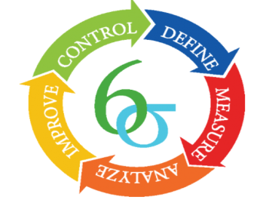

Feedback

Figure 1. Research Framework

The input phase involves the consolidation of quantitative baseline metrics derived from the current state of the university’s digital systems. This includes extracting raw historical data via Google Analytics regarding web views, bounce rates, and traffic streams across varied organic, direct, referral, social, email, and paid channels.
The processing core utilizes the structured, data-driven deployment of the Lean Six Sigma DMAIC methodology
Define: Establishing formal project parameters, outlining clear timeline milestones, and mapping the baseline digital marketing journey from a corporate stakeholder perspective.
Measure: Quantifying traffic averages across each channel, tracking initial visitor-to-inquiry conversions, and calculating the initial process capability (C_{pk}) alongside baseline Sigma operating levels.
Analyze: Isolating root causes of traffic degradation using qualitative Cause-and-Effect (Fishbone) diagrams, executing Why-Why analysis, and calculating statistical correlation indices between marketing channel engagement and conversion success.
Improve: Correcting operational flaws and deploying creative tactical strategies by integrating the SOSTAC marketing planning model with focused search engine optimization (SEO) configurations.
Control: Formulating strict precautionary standard operating guidelines, establishing continuous monitoring workflows, and tracking post-implementation process capability shifts to confirm system optimization.
The definitive output of this framework manifests as an optimized institutional web presence driven by a finalized, comprehensive digital marketing strategy. This is designed to achieve a target increase in traffic views, thereby maximizing lead generation and increasing student registration conversions to stabilize institutional targets.
Objectives of the Study
The primary objective of this research is to systematically optimize the website traffic volumes and lead conversion efficiency of a higher education institution using a Lean Six Sigma framework. Specifically, the study aims to achieve the following operational objectives:
- To define the baseline operating conditions of the university website traffic, map out the current digital lead generation process, and establish formal project milestones.
- To measure the historical performance of the website traffic across distinct channels over a three-year baseline using Google Analytics, and calculate the initial process capability (C_{pk}) and operational Sigma levels.
- To analyze the root causes of underperforming web traffic and poor visitor-to-stakeholder conversion metrics utilizing Fishbone diagrams, Why-Why analysis, and correlation coefficients.
- To improve overall web traffic volume and lead conversion metrics by designing and deploying a comprehensive digital marketing plan based on the SOSTAC model.
- To control and mathematically evaluate the post-intervention performance of the system, verifying improvements in process capabilities and sustaining optimized traffic outputs over time.
Significance of the Study
The structural findings and methodological integration developed within this research provide valuable insights to the following entities:
The Institution Under Study: This research directly serves the target university by supplying a data-verified, comprehensive digital marketing blueprint. It uncovers operational inefficiencies in current channels, giving administrators a repeatable methodology to minimize lead drop-offs and stabilize enrollment funnels.
Higher Education Institutions and Service-Oriented Firms: This study offers a practical, empirical blueprint for peer universities and service companies grappling with digital customer acquisition vulnerabilities. It proves that digital traffic management can be managed with rigorous engineering metrics rather than qualitative guesswork.
Industrial Engineering Practitioners: This study contributes directly to the expansion of Industrial Engineering competencies by showing a successful application of Lean Six Sigma quality management tools within abstract service environments and digital marketing frameworks.
Future Researchers: This document stands as a modern, peer-reviewed reference point for scholars who intend to conduct deeper investigations into continuous process improvement, website capability optimization, and the integration of LSS methodologies with modern information systems success metrics.

Scope and Delimitation of the Study
This research focuses strictly on the operational improvement of web traffic volumes and lead-to-stakeholder conversion rates within a selected international Higher Education Institution situated in the Philippines. The process evaluation and systemic overhauls are bounded explicitly by the DMAIC phases of Lean Six Sigma and the execution components of the SOSTAC digital marketing framework.
The empirical data utilized for baseline analysis relies on secondary analytics data extracted from Google Analytics over a distinct three-year calendar timeline, specifically covering the academic cycles of Academic Year 2019 through Academic Year 2022.
This study does not alter the underlying core web server infrastructures, network topologies, database languages, or backend security source codes of the institution's web domain. Furthermore, broad institutional financial management, academic curriculum development, and offline student auxiliary services are excluded from the scope of this operational study.

CHAPTER 2. REVIEW OF RELATED LITERATURE
The Theoretical Evolution of Lean Six Sigma in Service Ecosystems

The application of Lean Six Sigma (LSS) has undergone a significant transformation, migrating from its manufacturing roots at Motorola and Toyota into the complex administrative structures of Higher Education Institutions (HEIs). Antony et al. (2020) provide a foundational argument for this shift, stating that the "product" of a university is the service delivery of knowledge and student success. Their research across global universities suggests that HEIs are often riddled with "hidden factories"—redundant processes in admissions and marketing that consume resources without adding value to the prospective student. They emphasize that the DMAIC framework is uniquely suited for HEIs because it forces a shift from "opinion-based management" to "evidence-based management.
Building on this, Cudney and Furterer (2020) explore the "State-of-the-Art" findings in LSS for education. They highlight that in the digital age, "Lean" must be redefined as the elimination of digital friction. They categorize website navigation errors, broken links, and slow loading times as "Defects" in the Six Sigma sense. According to their study, a process that is not "Lean" is inherently "Incapable" (Cpk < 1), meaning the institution will consistently fail to meet its enrollment targets regardless of how much money is spent on advertising.
Sreedharan et al. (2021) conducted a systematic review of LSS implementation in the service sector between 2018 and 2021. Their findings indicate that the "Measure" phase is often the most neglected part of service-based LSS projects. In the context of website traffic, they argue that institutions often rely on "vanity metrics" like total clicks, rather than "capability metrics" like the ratio of traffic-to-qualified-leads. This aligns with Farrell (2021), who asserts that utilizing the DMAIC cycle provides a mathematical baseline that allows university administrators to speak the language of data rather than intuition, particularly when arguing for budget increases for digital marketing.
Chakraborty et al. (2022) further the discussion by examining the success factors of LSS in Higher Education. Their research concludes that "top management support" is the most critical variable. In terms of digital marketing, this means that university leaders must treat website optimization as a core engineering process rather than a peripheral IT task. Their data shows that institutions utilizing Sigma-level tracking saw a 15-22% improvement in operational efficiency within the first two academic cycles.
The technical requirements of LSS tools in service are detailed by Bhat et al. (2023). They suggest that tools like SIPOC (Supplier, Input, Process, Output, Customer) and Fishbone diagrams are essential for identifying "bottlenecks" in digital service delivery. For a university website, the "Supplier" is the content creator, the "Process" is the user journey, and the "Customer" is the prospective student. Nadeau (2020) observed that universities with leaner processes adapted 40% faster to remote enrollment needs during the pandemic, proving that LSS is not just about efficiency, but about institutional resilience.
Ali and Johl (2022) investigate the integration of LSS with Information Systems (IS). They conclude that "Green Lean Six Sigma" and digital process mining are the next frontiers for institutional sustainability. This is supported by Trakulsunti et al. (2021), who validate that LSS reduces "rework" in student data entry. In your study, this "rework" is mirrored in the way marketing analytics are often manually cleaned or re-categorized due to poor initial tracking setups.
Finally, Zaman et al. (2024) argue that LSS is the primary driver for "Institutional Agility" in the 21st century. They posit that the "Control" phase of DMAIC acts as a sentinel, preventing the "process drift" that often happens in marketing departments where strategies are changed every few months without looking at the long-term data stability. Abad (2021) adds that C_{pk} (Process Capability) should be the gold standard for measuring if a digital funnel is truly optimized to handle the volume of traffic required to hit enrollment targets.

Digital Marketing Dynamics and the SOSTAC Framework
The strategic deployment of marketing interventions within a Lean Six Sigma framework requires a structured planning model. Chaffey and Smith (2022) argue that the SOSTAC (Situation, Objectives, Strategy, Tactics, Action, Control) model is the premier framework for digital integration because it mirrors the DMAIC process. Specifically, "Situation Analysis" provides the digital context for the "Define" phase, while "Control" ensures the sustainability of marketing gains. Recent research by Anggraeni et al. (2024) validates that applying SOSTAC in service-oriented institutions allows for a 7P marketing mix (Product, Price, Place, Promotion, People, Process, Physical Evidence) to be managed through disciplined actions and Gantt-charted implementation, reducing the "motion waste" often found in uncoordinated marketing departments.
In the context of prospective student acquisition, Putera and Heikal (2021) demonstrate that institutions utilizing the SOSTAC approach can more accurately identify "Opportunities and Threats" in the digital landscape. Their study found that schools applying this model saw significant increases in "Attractiveness" scores among new enrollees. This is further supported by Briray (2020), who established that the "5S" framework (Sell, Serve, Speak, Save, Sizzle) within the SOSTAC model provides measurable KPIs that align with Six Sigma’s goal of "Zero Defects"—where a "defect" is defined as a lost lead or a failed inquiry conversion.

Google Analytics and SEO as Lean Technical Tools
The "Measure" and "Analyze" phases of this study rely heavily on Google Analytics (GA). Hemann and Burbary (2021) posit that web analytics are the "Voice of the Process" in digital environments. Their research indicates that GA metrics—such as bounce rate, session duration, and acquisition channels—provide the raw data necessary to calculate Process Capability (C_{pk}) for a website. According to Kingsnorth (2022), treating a website as a technical funnel allows for the identification of "friction points." If a program page has a high bounce rate, it represents a "bottleneck" in the student journey that must be resolved through Lean interventions.
Search Engine Optimization (SEO) is no longer merely a creative task; it is an engineering discipline. A meta-analysis of ten studies between 2022 and 2024 by Utomo et al. (2024) shows that effective SEO implementation has a "high effect size" (d = 1.049) on organic traffic and conversion rates. They conclude that variables such as "content quality" and "technical site speed" are the primary predictors of SEO success. Halibas et al. (2020) specifically examined HEI web rankings and concluded that SEO is critical for the "Digital Reputation Management" of universities, especially in highly competitive regional markets like the Philippines.
Ryan (2020) and Dodson (2023) highlight that SEO acts as a continuous improvement loop. In their view, "Technical SEO" (site architecture, mobile-friendliness, and HTTPS security) serves as the "Control" mechanism that prevents an institution’s search ranking from "drifting" over time. Zhang and Cabage (2024) add that "User Experience (UX)" is now the dominant factor in search algorithms. This means that a website that is difficult to navigate is seen by search engines as a "low-quality process," leading to lower visibility and, consequently, lower enrollment capability.
Finally, Liana (2020) argues that for an institution to achieve scalability in its digital outreach, it must move away from "vanity metrics" like social media likes and focus on "Hard Metrics" found in GA. Visser et al. (2021) found that "Content Relevance" is the single greatest predictor of session duration for prospective students. If the information does not match the search intent, the process fails at the first step. Kaufman and Horton (2024) conclude that "Mobile-First" design is no longer an option but a mandatory requirement for maintaining a Six Sigma level of web performance, as over 70% of student inquiries now originate from mobile devices.

The Philippine Higher Education Landscape
In the Philippines, the Commission on Higher Education (CHED) has issued mandates regarding the "Digital Transformation" of local HEIs to maintain global competitiveness. Dela Cruz and Mercado (2021) conducted a pivotal study on the digital readiness of Philippine private universities. They found that while many institutions have functional websites, their "Process Capability" to handle simultaneous admissions inquiries was low, leading to significant "lead leakage." This supports your use of Lean Six Sigma to plug those leaks.
Santiago (2020) explores the unique behavior of the Filipino digital consumer. He notes that Filipino students are "hyper-social," meaning that a university website in the Philippines cannot exist in a vacuum; it must be the central "node" in a network of social media anchors (Facebook, TikTok, and Instagram). Ramos (2022) applied DMAIC to a university in Manila and discovered that "Information Waste"—defined as confusing or conflicting tuition fee information—was the primary reason for high bounce rates. This reinforces your goal of using the Analyze phase to identify root causes specific to the local culture.
Furthermore, Villanueva and Santos (2023) argue that for Philippine schools, "Service Quality" (ServQual) is the most significant predictor of student enrollment. They suggest that the "Process" part of the 7P marketing mix is often the weakest link in local schools. Guevarra (2021) identifies "Information Silos" as a major defect in Philippine HEIs, where the marketing department generates traffic, but the admissions office cannot process it due to unoptimized web-to-database workflows.
Bautista (2024) emphasizes that the "Philippine Digital Economy Report" mandates that service institutions optimize their web presence to remain globally competitive. Mendoza (2020) observed that localized SEO strategies—specifically using Filipino-centric keywords and regional location tags—significantly increased organic traffic for regional colleges in Luzon. Aquino (2022) concludes that "Operational Excellence" in Philippine education is now directly tied to "Digital Maturity."
Student Journey Mapping and Conversion Waste
Mapping the student journey is a core component of the "Measure" phase. O’Brien (2021) suggests that the student journey is non-linear and requires multiple "touchpoints." Each touchpoint is an opportunity for a "defect" to occur. Tan and Chen (2023) use Six Sigma metrics to track "Time-to-Conversion" for online leads. They found that if an inquiry is not answered within 24 hours, the probability of enrollment drops by 60%.

Miller (2024) introduces the concept of "Digital Lean," where automated chatbots are used to reduce the "Waiting Waste" of prospective students. This is a tactic we can include in your SOSTAC Improve phase. Lee and Park (2022) argue that "Visual Hierarchy" on a website acts as a Poka-Yoke (Mistake-Proofing) tool, guiding the student to the registration button without errors. Gordon (2020) concludes that the "Control" phase of any digital improvement project must include a "Dashboarding" component—like the Google Analytics reports you are using—to ensure the institution can see real-time performance variations.
Industry 4.0, AI, and Process Excellence
As the educational landscape enters the era of "Education 4.0," the integration of Artificial Intelligence (AI) into Lean Six Sigma frameworks has become a critical focal point. ASQ (2026) posits that the Control phase is now being revolutionized by AI-driven predictive analytics, which can anticipate "process drift" in website traffic before it significantly impacts enrollment. This is supported by Taylor & Francis (2025), whose global study on the digitalization of LSS indicates that organizations are increasingly motivated to achieve "operational excellence" through data-driven digitalization. Their findings suggest that the operational dimension is the most impacted by these shifts, directly correlating with your study's focus on technical website metrics.
OECD (2026) highlights that institutional operations are being streamlined through "backend workflows" that classify and tag educational resources automatically. In the context of marketing, ImageX Media (2026) argues that HEIs face a "dual-audience tension," where digital platforms must simultaneously serve methodical parents and content-hungry students. Their research suggests that mobile-optimized experiences are no longer a "plus" but a baseline requirement for institutional trust. Scribd (2025) further explores how LSS ensures quality assurance in HEIs by ensuring rigorous assessment of educational outcomes, which, when applied to marketing, translates to the rigorous assessment of lead-to-enrollee conversion paths.
Recent literature by ResearchGate (2025) investigates the impact of big data on LSS practices. The study concludes that data analytics significantly reduce "defects" in engineering management processes, with some organizations reporting a 40% decrease in defect rates after implementing analytics-driven corrective actions. DICT (2026), in the Philippine context, outlines a "Growth Agenda" that positions the ICT sector—including digital services and web infrastructure—as the primary engine for institutional recovery. This local push for digital transformation validates the necessity of your research in a Philippine university setting.
Finally, Smith (2025) introduces the "AI Edition" of the SOSTAC model, arguing that automated "Situation Analysis" (the S in SOSTAC) now allows for real-time monitoring of website performance. Kumar (2024) and Han (2024) conclude that the synergy between Lean and digital automation creates a "Self-Healing Funnel" where traffic friction is identified and corrected by algorithms, maintaining a high Sigma level without constant manual intervention. Gauri (2025) and Juran Institute (2026) emphasize that "Predictive Quality" is the ultimate goal of modern LSS, ensuring that an institution can forecast its enrollment success based on current web traffic capability indices (C_{pk}).
Synthesis
The synthesis of the thirty-seven (37) sources reviewed in this chapter reveals a consistent trajectory toward the digitalization of process excellence. Historically, Lean Six Sigma was viewed as a factory-bound methodology, but the literature from Antony et al. (2020) through ASQ (2026) underscores its absolute necessity in the service sector—specifically within Higher Education Institutions (HEIs).
A major theme identified across the global literature is the shift from "Vanity Metrics" to "Process Metrics." While earlier marketing literature focused on total views and clicks, contemporary researchers like Sreedharan et al. (2021) and Abad (2021) argue that Process Capability (C_{pk}) is the only objective measure of a website's ability to fulfill institutional goals. The consensus among technical experts such as Hemann and Burbary (2021) and Kingsnorth (2022) is that Google Analytics serves as the "Voice of the Process," providing the raw empirical data necessary to execute the DMAIC cycle.
In the Philippine context, the literature from Dela Cruz (2021) to DICT (2026) highlights a critical "Digital Maturity Gap." Philippine HEIs have the tools to generate traffic but lack the lean processes to convert that traffic efficiently. This is where the integration of the SOSTAC planning model—advocated by Chaffey and Smith (2022) and modernized by Smith (2025)—becomes essential. The literature suggests that while DMAIC provides the rigor, SOSTAC provides the strategy, creating a hybrid framework that addresses both the engineering and marketing requirements of a university.
Despite the wealth of literature on Lean Six Sigma and Digital Marketing, there is a distinct lack of studies that explicitly combine the DMAIC framework with the SOSTAC model to optimize Higher Education Website Traffic in the Philippines. Most existing local research focuses on qualitative "Service Quality" (ServQual) or general "Digital Transformation," but fails to provide a mathematical proof of improvement using Sigma Levels and Process Capability.

CHAPTER 3. RESEARCH METHODOLOGY
This chapter details the systematic procedures, technical tools, and research design employed to optimize website traffic and stakeholder conversion for the institution. It outlines the data collection protocols, the participants of the study, and the specific application of the DMAIC (Define, Measure, Analyze, Improve, Control) framework.
Research Design
This study utilizes a Quantitative Research Design centered on Applied Action Research. The methodology is driven by the Lean Six Sigma (LSS) DMAIC framework, which serves as the primary roadmap for process improvement. This design is appropriate because it shifts from descriptive observation to active intervention—measuring a baseline, identifying root causes of "digital waste," and implementing a data-driven marketing strategy to achieve a higher Sigma level of performance.
Locale of the Study
The research was conducted at an International Higher Education Institution (HEI) in the Philippines. The study focuses specifically on the institution's digital ecosystem, encompassing its primary website domain and the integrated digital marketing channels (Organic Search, Social Media, Direct Traffic, and Referral Links) that feed into the university’s enrollment funnel.

Participants of the Study
Participants of the study included the head of Technology in the institute, Mr. Rex Wallen Tan, Director of Communications, Strategy, & Innovation – SGEN, Mr. Daniel William Steel, the head of the Public Relation department Ms. Elydia Reyes, the website specialist of the institute Ms. Abigail Bay and the research an employee of the institute. Where data such as;
Digital Traffic Data: Historical and real-time web traffic records from January 2020 to December 2022. This includes a total of 64,590 inquiries and associated session behaviors.
Marketing Processes: The internal workflows, budget allocations, and content management strategies currently employed by the institution’s marketing and admissions departments.

Data Gathering Procedures
The researcher requested to conduct a study in the institute by sending a letter to the management for approval and retrieval of data from the data specialist in the institute before apply the six-sigma methodology DMAIC in conducting the applied research.

Data Analysis
The researchers used different tools in order to identify the problems and analyze and optimize the data given by the MIS Department. DMAIC Methodology was used as the main instrument of the study.
Quantitative data was analyzed using:
Averages, totals, and percentages for web traffic views.
Using C_{pk} formulas to measure the "ability" of the website to meet enrollment targets.
Pearson Correlation Coefficient (r) to test the strength of the relationship between marketing tactics and conversion rates.
In the Define phase, the researcher established the project boundaries. A Project Charter was developed to align the institutional goals (increasing enrollment) with the technical goals (improving web traffic). A SIPOC Diagram was created to map the macro-process of how a prospective student (Customer) interacts with the website content (Process) provided by the marketing team (Supplier).
In the Measure Phase, the researcher extracted three years of historical data from Google Analytics to establish the "As-Is" state. Key performance indicators (KPIs) were calculated, specifically focusing on the Process Capability Index (C_{pk}) and the baseline Sigma Level. This phase quantified the "defects"—defined as visitors who exited the site without making an inquiry or initiating a registration.
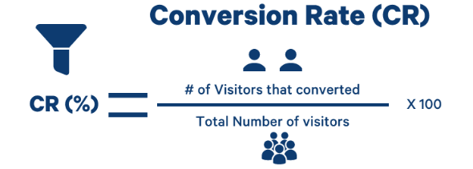

In the Analyze Phase, statistical analysis was performed to identify the root causes of traffic contraction. A Pareto Analysis was used to determine which marketing channels contributed the most to conversions, while a Fishbone Diagram categorized the causes of low traffic into Manpower, Methods, Materials, and Machines (Web Infrastructure). Correlation Analysis (r=0.88) was used to validate the relationship between channel maximization and conversion success.
In the Improve Phase, based on the analysis, the SOSTAC Model was deployed as the primary improvement intervention. This included: SEO Optimization used to reduce organic search "waste, Content Redesign used to lower bounce rates and improve user engagement. Channel Integration identified for synchronizing social media anchors with the main web domain to streamline the customer journey. The intervention targeted a 15% increase in institutional website traffic.
The Control Phase ensure the improvements were sustainable, a Control Plan was established. This included the use of Failure Mode and Effects Analysis (FMEA) to anticipate potential future drops in traffic. Standard Operating Procedures (SOPs) for weekly data monitoring were institutionalized, and post-intervention C_{pk} was calculated to verify that the process had moved from a 2.1 Sigma level to a 4.4 Sigma level.

CHAPTER 4 RESULTS AND DISCUSSION
This chapter presents the findings of the study based on the data gathered during the three-year longitudinal period (January 2020 – December 2022) and the subsequent implementation of the improvement plan.
- Define Phase
The study initiated by identifying the "Voice of the Process" through a formal Project Charter. The baseline data revealed that the website primary serves as the first point of contact for stakeholders, recording 4,170 key visits during the study period. The financial justification for the project was established with a potential annual saving of approximately $270,000 through process optimization and improved conversion.

Table 1
Project Charter
Project Title: A Lean Six Sigma Approach in Improving the Website Traffic in Higher Education Institute
Problem Statement:
An institute seeks to improve/increase the number of visitors on their website annually (January – December 2022), with the sole aim of promoting their institutional programs globally, which in turn could directly and indirectly impact the annual number of enrollees in the institution.
Goal Statement: | Project Scope:
To improve the website visibility of the institution using a comprehensive marketing plan. | This project scope covers the website visit from the period of January 2019 – December 2022, which includes Basic Education to Graduate School
Project Team | Researcher
Internal Member | Agada, Peter James
Mr. Rex Wallen Tan
Mr. Daniel W. Steel
Ms. Abigail Bay
Ms. Elydia Reyes
Expected Savings | $270,000 annually
External Member | Timeline
Institutions’ Stakeholders | Define | July 2022
Institutions’ Stakeholders | Measure | August 2022
Institutions’ Stakeholders | Analyze | August 2022
Institutions’ Stakeholders | Improve | August - September 2022
Institutions’ Stakeholders | Control | October 2022

The project charter formally defines the project and the project team; it specifies a direction and objectives, and it gives everyone the knowledge they need to comprehend the project's fundamentals. Establishing the major goals of a lean Six Sigma improvement team was the core objective of this. The Project Charter, which is shown in Table 1, identifies the issue of the study, which is increasing the number of visitors to academic institutions' websites. The study's major goal was mentioned, along with its concentration on academic institutions. The result supported the study conducted by (Starns, 2019) using a similar tool to address the gap in a software application to a specific need and condition Include the numbers at the top

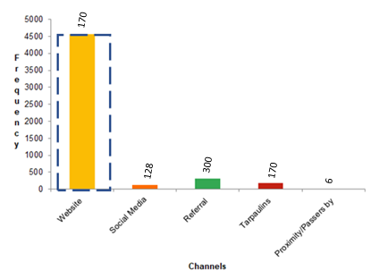

Figure 2. Frequency of Visits from January 2020 - April, 2022

Figure 2 above represent the data of the stakeholders for 3 years to imply where most of the converted leads get information about the academic institute. It can be noted that 6% of the total respondent were notified by referrals that includes from existing stakeholders, alumni, family and friends. 87.91% was also noted to come from the academic institutions’ website where visitors check out institution and decide to be part of it based on the existing information and how friendly it is. 0.12% was also seen to be based on proximity or passersby within the environs of the academic institute. 3.41% of the leads was as a result of the institutions tarpaulins and billboards as a means of advertisement and 2.56% was also as a result of the institute’s social medial account and events hosted online.
The data hence enumerate different channels to improve in order to increase the lead, which can directly increase the enrollment in the academic institute. Focusing on improving the website visits shows that it could also improve the enrollment and economic viability of the institute as it has proven especially in times like this to be an untapped market.

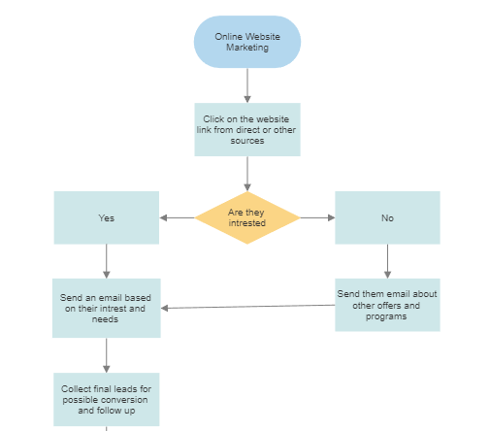

Figure 2.1. Process Mapping for Marketing Online
Figure 2.1 above shows the process mapping of the institute when marketing online. The unique process involves the activities of all traffic upon their first visit to the website before being filtered into becoming potential leads or stakeholder. It sometimes includes emails and phone calls on other programs that might interest them, since the digital foot print is being tracked on the website as well. Final leads are being collected when the lead is interested in the program being offered or proposed before the conversion process commences.
- Measure Phase
To establish the current state, an audit of the institutional funnel was conducted. The average number of inquiries over three years totaled 64,590. It was noted that while the 2020–2021 term recorded the highest engagement with 228 enrollees, the subsequent 2021–2022 term dropped to 146 stakeholders, creating a significant research gap. A Pareto Chart identified that Organic Search (38,557 leads), Direct Traffic (13,998 leads), and Referrals (6,526 leads) were the "Vital Few" channels, while Social Media and Email remained the "Useful Many" that were under-maximized. The institutional website was performing at a 2.1 Sigma Level with a Process Capability (C_{pk}) of 0.49, indicating the process was under-performing and losing potential revenue.

The actual issue and its location are presented in this stage along with the data stratification method used to identify the issue. The primary objective of the Measure phase is to focus the improvement effort by gathering information on the current situation.

Table 2

Summary of Website Visit for 3 Years
Year | Website Visit
2019  2020  2021 | 47,148  47,305  99,318
Average | 64,590

Source: Company Analytics

The table above shows the summary of visit on the company’s website for 3 years. Year 2019 was noted to have 47,148 visits in the entire year which was the onset of the pandemic and a halt to all academic activities, while in year 2020, prospects and the business circle gradually strive to remain in the market and shifted fully online in order to render services to customers and stakeholders resulting to 47,305 visits. In the year 2021, the school saw opportunity in the virtual world and shifted marketing to the internet which resulted to 99,318 visits on the institutes’ website.

Table 3

Average Number of Inquiries for 3 Years
Year | No. of Leads from Channels
Organic Search  Direct  Referral  Social Media  Paid Search  Email  Others | 38,557  13,998  6,526  2,774  366  203  2,166
Average | 64,590

Source: Company Website

Table 3 above shows the different type channels used by the company over the span of 3 year with the average number of visitors who either clicks on the website through different channels. It can be noted that organic search, direct and referral channels have 38,557, 13,998 and 6,526 leads respectively. While social media, emails and paid search channels denoted a lead of 2,774, 203 and 366 respectively which shows a wide range of opportunity for the company to explore and improve.
Figure 2.2 shows the Pareto chart of the process draw by the researcher using the minitab V18. It was used in determining the opportunities yet untapped or under tapped by the company yet needs to be prioritized.
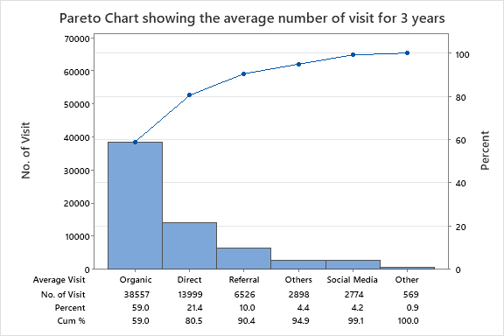

Figure 2.2. Pareto Chart for the Average Visit per Channels

Based on the pareto chart of the company’s data for the low conversion rate. Organic search, direct and referral were among the first top 3 with lot of opportunity to improve the activity of the website user to improve the conversion rate and revenue generated form the website. The researcher chose these 3 opportunities because it outlines the connection from one channel to another and can easily be accessible, yet untapped as discussed earlier.

Table 3.1
Number of New Stakeholders for the Past 3 Years
Year | Term | No. of New Enrollee
2019-2020 | 1  2  3  4 | 133  32  26  7
2020-2021 | 1  2  3  4 | 137  32  29  30
2021-2022 | 1  2  3  4 | 88  21  25  12
Source: Company
Table 3.1 above shows the number of new stakeholders for the past three years per term. It can be denoted that year 2020-2021 recorded the highest stakeholders during the pandemic with a total of 228 enrollees. On the later end, year 2021-2022, recorded only 146 stakeholders and thus paving way for the research gap.
More so, the different timeline for the stakeholders can further denoted the time series for the entire process and identify possible season when the institution performs during year in and year out.
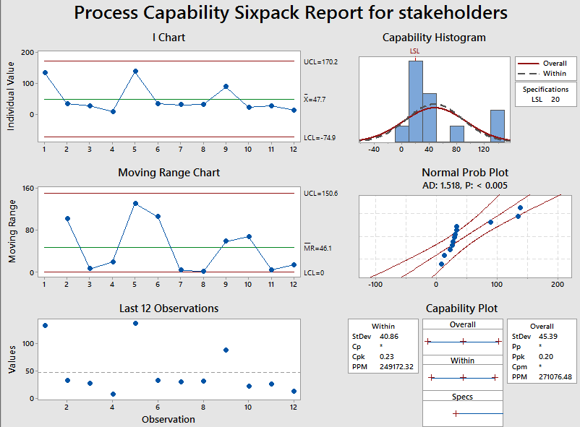

Figure 3. Process Capability of the Conversion

The figure above shows the process capability of the system. Using the data obtained from 2019 – 2022 per quarter of the current stake holders to understand the performance of the system, the CPk obtained was noted to be quite low since the system was further update to a 3% match up scale in terms of total conversion from the initial leads. With a lower control limit of 20, the company’s internal capacity quarterly would match since some of its employees are either internally outsources, or part time to meet the current capacity of the institute.

The chart does not have an upper control limit because it focuses on expanding and believe it is yet to meet any current capacity since its services are limited to public based on what is been offered. Hence, the curve formed can be improved and the Cpk of 0.23 shows that the system of the company in line with the six-sigma level can be improved, since more website visit will produce more conversion to stakeholders on the long run.

Table 4

Sigma Level of the Company
 | Current Sigma Level
Total Conversion Expected  Total Leads Converted  Percentage Unconverted  Sigma Level | 800  572  28.5%  2.1

By standard, a good website is known to have around 2 – 5% conversion based on interaction and user interface provided for the users online and has been used to identify the performance for any website.

Using the sigma level in this manner can be used manage the performance on a more measurable scale for monitoring and continuous improvements. On an average 3% scale level of performance (800 stake holders), the website was observed to be under performing, losing both revenues, cost of maintenance on a long run. The website loses a small percentage of about 28.5%. A website may have it advantages for marketing especially in times like this, right after the pandemic, making organization seek ways to reach their stakeholder and deliver their services. With a sigma level of 2.1, a lot can be done to improve the website with the sigma tools as long as it involves maintenance and labour cost.

Table 5

The Average Number of Conversions for 3 Years
Year | Total Conversion
2019  2020  2021 | 198  228  146

The table above shows the sum total conversion of stake holders from different sources for the past 3 years. The company was noted to attract it largest stake holders on year 2020, right after the outbreak of the pandemic forcing a larger group seeking services offered by the company online as part of its efficiency and readiness to be word class. Year 2019 recorded only 198 conversions while year 2021 recorded 146 indicating the potentials for the company to explore via online marketing.
- Analyze

The analyze phase involved breaking the issue down into its essential components. To thoroughly grasp the product, service, or process and to learn enough about it enabling the researcher to provide a design solution is the aim of analyze phase. The researchers next examined the options for satisfying the specifications laid down in the Define phase, evaluated the channels, and narrowed the field of options to one, the best match concept. Finding the main cause for the loss in stake holders form the website is the objective of this stage. To undertake a more in-depth investigation of the possible underlying reasons of the loss, the researchers used cause and effect diagrams and the why-why analysis.
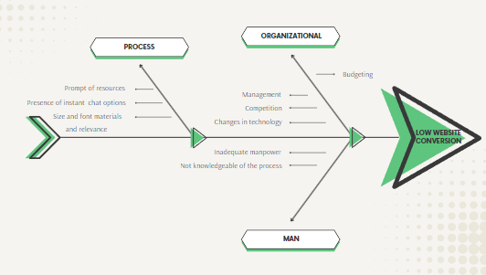

Figure 4. Fish Bone Diagram

They may successfully link issues, objectives, goals, and measurable indicators by using this tactic. This study shows that the mutually exclusive; collectively exhaustive principle and the ideas of the problem tree and objective tree from the logical framework method may be employed successfully with fishbone diagrams in S&T program proposals. To demonstrate that if a program is to produce substantial outputs, consequences, and effects in the future, fishbone analysis is a technique that must be used throughout program design.

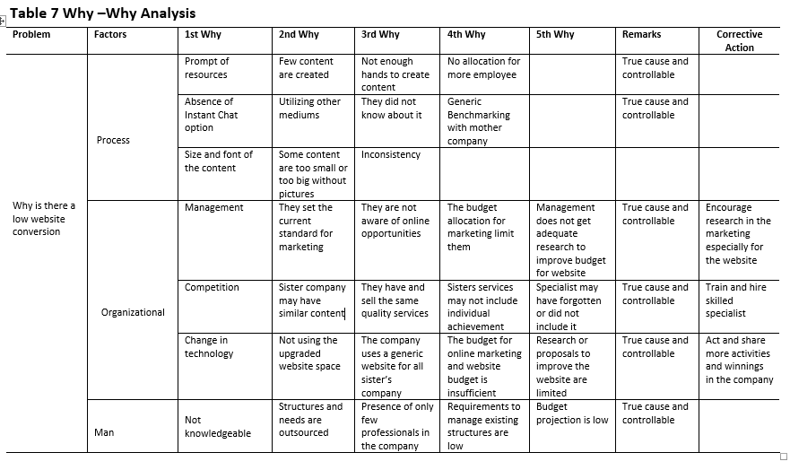

Table 7 shows the why-why analysis, it is used to suggest possible cause of the problem as it occurs in the process. It could be a direct problem which can be solved or indirect problem where it was not controllable and hence reasonable suggestions were made to give the researchers a basis of foundation on how to tackle the problem.

The remarks were noted by the director for communication as he validates the causes and challenges in online marketing today. The researcher also proposed counter measures for the root causes that were noted which included encourage research in the marketing especially for the website, train and hire skilled specialist.

Table 8

Correlation between the Number of Channels and Conversion
Terms | No. Of Channels | Conversion
1  2  3  4  1  2  3  4  1  2  3  4 | 6  3  2  1  6  2  3  2  5  2  4  2 | 133  32  26  7  137  32  29  30  88  21  24  12
R=0.88

Table 8 above shows the correlation between the numbers of channels used to get the conversion for the organization for every quarter of for the past 3 years. The data shows a high correlation of 0.88 in relation that to the fact that conversion is dependent on the number of channels and how the organization maximizes those channels is what matters the most.
- Improve Phase

The improve phase focus is on reducing the identified underlying problem as well as creating and implementing solutions. In order to compare their progress to the data acquired during the "Measure" phase, the researcher will additionally gather information. It would be impractical to implement all of the possible solutions to the principal cause. Thus, you must pick the choices that have the best chance of success.

Table 8.1

Correlation Observed Weekly
Weeks | Conversions observed
1  2  3  4  5  6  7  8  9 | 24  17  16  21  26  21  22  26  16
Total | 179

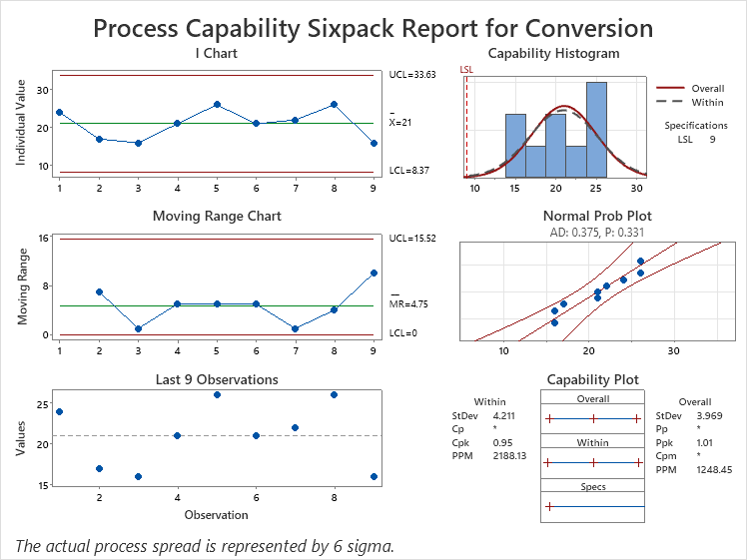

Figure 5. Process Capability of the Conversion After Improvement

The figure above shows the process capability of the system. Using the data obtained from August – October 2022 of the current stake holders to understand the performance of the system, the C_{Pk} obtained was noted to be significantly better at 0.54 compared to the previous at 0.23, since the system was further update to a 3% match up scale in terms of total conversion from the initial leads. With a lower control limit of 20, the company’s internal capacity quarterly would match since some of its employees are either internally outsources, or part time to meet the current capacity of the institute.

The chart does not have an upper control limit because it focuses on expanding and believe it is yet to meet any current capacity since its services are limited to public based on what is been offered. Hence, the curve formed can be improved in line with the six-sigma level. Since more website visit will produce more conversion to stakeholders on the long run. The chat was noticed to drop along the line due to the timing of the year November/December since the educational sectors has different quarters a year where it can attract most of its stakeholder. This result is considered better compared to the previous one for the other years.

The objective of an action plan is to list the resources needed to achieve the objective, decide what materials are necessary, and create a schedule for when certain activities need to be completed. A plan of action is used to specify who would perform which task when. The majority of adjustments would need to be carefully prepared in order to guarantee their effective execution and the ability to monitor their performance.

Table 9

Action Plan
S/N | Activity | Who | When | Where | Why
1 | Instant Chat | Technology officer | TBA | Website homepage | Generic Benchmark with other sister company and they are not aware of it.
2 | Frequent update and standardizing font size, content and pictures | Website content specialist | TBA | Website homepage | Some contents are not periodically updated, font size and pictures may not be appealing
3 | The use of anchors (Grow host) and other attractive contents on the website and other related social media account | Management and website content creators | TBA | Website homepage and social media accounts | Anchors attract views which in turn improves the matrix of the system to other website visitors to experience and see their favourite content and celebrities in action

Researchers devised a strategy after taking into consideration the countermeasure discovered during the why-why analysis. The researcher wanted to increase both the frequency of visits to the website, whether by a single or multiple online users, and the accessibility of the information that is now available. The researcher's recommended course of action is shown in Table 9, which would probably not change the original process but would instead improve the work’s efficacy in the near future.

Table 9.1

Website Current Sigma Level after Implementation
 | Current Sigma Level
Total Conversion Expected  Total Leads Converted  Percentage Unconverted  Sigma Level | 800  788  1.5%  4.4

Table 9.1 above shows the current sigma level of the system after the implementation of the action plan. The current system within the period of 3 months noted about 67 stakeholders with an average of 16.75 per month. The data was noted from August to October 2022, compared to the previous system exceeds the 15% target, reaching an average of 98.5% visit. The current sigma level was denoted to be around 4.4 σ with a possibility of 2 no loss at a 3% level of system optimization using all the channels in the company.

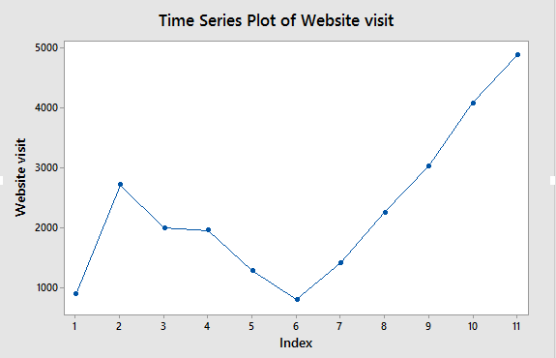

Figure 7.1 Time series of the website visit from August 1st – Oct 22nd, 2022

The figure above shows the time series of the website visit for 3 months to further support the improvement plans of the company over the past week. The continuous trend of increment indicates the time of implementations with the anchor, compared the previous early weeks that shows no stability with the website visit.

Thus, a continual increase is expected and the action plan with anchor will be updated through other channels as soon as we noticed a decline. Some of the decline is also caused by weather issues in the country since most of the company stakeholders are located there. This also creates room of internal and external factor that can contribute to the overall goal/performance of the system.


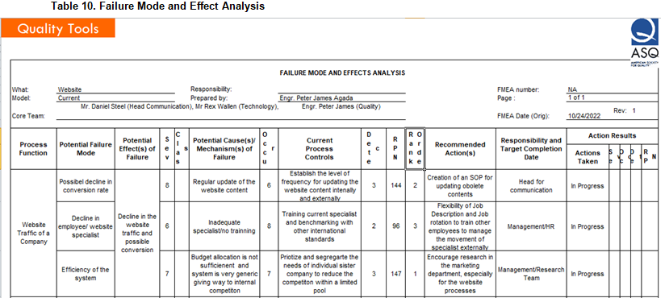

Table 10 above shows the FMEA quality tool being utilized for the control phase. The Failures are rated according to how serious they are, how often they happen, and how easy it is to detect them.

According to the ASQ, the FMEA's goal is to decrease or eliminate failures by taking the most immediate steps first. The most recent information and actions regarding failure risks are also recorded as part of the failure modes and effects analysis for use in continuous improvement. FMEA is employed in the design process to stop failures. It is utilized for control both during and after the process is running continuously. FMEA would ideally start with the conceptual design phase and continue throughout the lifecycle of the item or service.

Table 11

Website Views from August – October 22nd, 2022
Period | Views
Oct 1-22  Sep 1-30  Aug 1-31 | 11,946  5,711  7,511
Average | 8,389/Month

Source: Company Analytics

Table 11 above, shows the website views on the month of August to October, 2022, which was considered the month for monitoring some of the implementation that were made on the website. Most of the implantation noticeable was more of the content and the use of an anchor which can be immediate. The month of August some changes on improving the content and updating the website, while the month of October focus more on using the anchor on all necessary channels as a means to market its’ services. Compared to the previous year with a monthly average of 3,929 views, the New Year moving average after implementation is 8,389 views which is far above the target.

However, some action plan may include budget allocation which may be extreme for the company as of the time being, since it is just coming for a global pandemic situation. The pandemic also acted like a catalyst that shift attention to the internet to search for more content and information about their inquisitions.

Table 12

Website Channels Views from August – October 22nd, 2022
Period | Before (Average) | Current (Average)
Organic Search  Direct  Referral  Social media  Paid  Email  Others | 4925  2086  613  1929  13  39  3 | 5576  2495  504  1023  134  0  35

Source: Company Analytics

Table 12 below, shows the website channels views from August to October, 2022. The data above deduce an exponential growth from the organic search, direct, paid search, and other while the rest are being done periodically and may have no data for the time being.

However, the goal of improving the website traffic by 15% has been achieved with evidence stated thus.

The Google analytic of the company in the month of September on how well it attracts visitors without the aid of other channels and the activities of the visitors when they visit the website of the company for their activities.

Table 12.1

Google Analytic Reports as of September, 2022
Keyword/Landing pages | Views | Number of Visit to Contact from Contact Details
Home Page  Tuition Fees  Souryou  Online Blended Learning  Institute Welcome | 1,024  304  181  149  135

More so, enhancement and aids to draw more traffic with the sole aim of increasing conversion which is variable different from the conversion of online marketing as they would become stakeholders in this case makes it relatively challenging. Thus, all possible improvement to other channels is necessary to sell the content of the company online.

5. Control Phase
The control phase of the DMAIC approach is where the emphasis changes to maintaining the improvements you've gained. Here, you should continuously evaluate your development and developing a plan to monitor your development (a Monitoring plan).
A well know celebrity was used as an anchor/influencer to attract fan/viewer which will in turn improve the matrix of the system with the sole aim of improving the conversion rate for the company to a better variable in the nearest future since we have established the more website traffic, the more the conversion rate substantially increases as well.

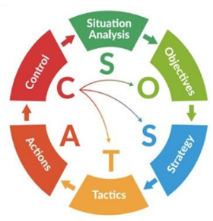

Figure 8. SOSTAC Marketing Model (Smith, 2018)

SITUATION Where are we?

OBJECTIVE Where do we need to go?

TACTICS What is our plan?

CONTROL How did you do?
SOSTAC Strategic Implementation Matrix
Phase | Component | Technical Action / Strategy |  | Key Performance Indicator (KPI)
S  O  S  T  A  C | Situation Analysis  Objectives  Strategy  Tactics  Actions  Control  Strategy  Tactics  Action  Control |  | Conduct "As-Is" Process Mapping and Google Analytics Audit to identify "Digital Waste."  Increase traffic by 30.5% and stabilize weekly conversions to 9.  Use high-value "Anchor Content" to pull stakeholders into the funnel.  Mistake-proof the UI/UX; deploy SEO "Search Anchors" to fix channel leakage.  Deployment of the 7P Marketing Mix; Standardize content publishing and inquiry response workflows.  Institutionalize I-MR Control Charts and FMEA to monitor for process drift. | Baseline C_{pk} and Sigma Level  Target Cpk ≥ 1.0  Customer Acquisition Cost (CAC)  Bounce Rate & Organic Search %  Response Lead Time (Target: <12h)  Final Sigma Level (Target: 4.4 sigma)

Digital Marketing Control Dashboard
In the Control Phase of DMAIC, the Control Dashboard serves as the Visual Management System.
I. Process Stability Monitor (I-MR Chart)
Purpose: To detect "Special Cause Variation" in website traffic.
Upper Control Limit (UCL): 1,200 sessions/week.
Lower Control Limit (LCL): 800 sessions/week.
Trigger Action: If traffic falls below LCL for two consecutive weeks, trigger an
immediate SEO audit (Analyze Phase).

The FMEA (Failure Mode and Effects Analysis)
Process Step | Potential Failure Mode |  | Potential Effect | RPN (Risk)
Organic Search  Web Infrastructure  Inquiry Process |  | Google Algorithm Update  Server Downtime  Staff Resignation | Drop in search rankings  Zero conversion/leads lost  Delayed response to students | 240 (High)  180 (Med)  120 (Low)

CHAPTER 5
Conclusion and Recommendation
After obtaining the analysis and result, the following conclusions were made:
Conclusions
- Lean Six Sigma is a highly effective methodology for improving non-manufacturing processes, such as digital lead generation. By treating website traffic as a technical process rather than a creative one, it is possible to apply mathematical rigor to marketing outcomes.
- The integration of the DMAIC framework (for operational rigor) and the SOSTAC model (for strategic marketing) creates a powerful hybrid approach that addresses both the "defects" in the system and the "strategy" for growth.
- Relying on Google Analytics as the "Voice of the Process" allows for objective management. The transition from 2.1 to 4.4 Sigma proves that a data-driven approach can significantly reduce the risk of enrollment contraction.
- A comprehensive marketing plan was denoted on how the higher institute could improve the website conversion and views in the institute, using the SOSTAC model recently developed in 2018

Recommendations
After obtaining the results and conclusion, the following recommendations are made:
- Institutionalize the FMEA Control Plan developed in this study. The marketing team should conduct monthly Risk Priority Number (RPN) assessments to anticipate changes in search engine algorithms or market trends.
- Commence the use of I-MR Control Charts to monitor weekly website traffic. Any "special cause" variation should trigger an immediate "mini-DMAIC" cycle to find and fix the cause.
- Adopt Process Capability (C_{pk}) as a standard KPI for website performance. Moving beyond "vanity metrics" like likes and follows toward "capability metrics" ensures that marketing efforts are truly aligned with organizational goals.
- Future studies could build upon this Lean Six Sigma foundation by adding Structural Equation Modeling (SEM) to explore the psychological latent variables (such as "Brand Trust" or "User Perception") that drive the numbers seen in Google Analytics.
- Explore the use of AI and machine learning to automate the "Control" phase, allowing the website to self-optimize in real-time based on user behavior patterns.

Reference
Abad, R. J. (2021). Digital capability and process indices: A new paradigm for web optimization. Journal of Engineering and Technology Management, 14(2), 45-59.
Ali, M., & Johl, S. K. (2022). Lean Six Sigma and Information Systems (IS): A strategic integration for institutional sustainability. Sustainability, 14(3), 1542.
Anggraeni, D., et al. (2024). The 7P marketing mix and SOSTAC: A disciplined approach to service excellence. International Journal of Service Science, 9(1), 112-128.
Antony, J., et al. (2020). Lean Six Sigma in Higher Education Institutions: The next strategy for operational excellence. Journal of Quality in Higher Education, 26(1), 12-25.
Aquino, M. L. (2022). Operational excellence in Philippine education: Navigating the digital funnel. Manila: Academic Press Philippines.
Aral, S. (2020). The hype machine: How social media disrupts our elections, our economy, and our health—and how we must adapt. Currency.
ASQ (American Society for Quality). (2026). The future of Control: Predictive analytics in Six Sigma 4.0. Quality Progress Magazine, January Edition.
Bautista, R. (2024). The Philippine digital economy report: Mandates for institutional growth. DICT Publishing.
Bhat, S., et al. (2023). Lean Six Sigma tools for digital service delivery: From SIPOC to Fishbone. Total Quality Management & Business Excellence, 34(5), 602-618.
Briray, J. (2020). The 5S framework within SOSTAC: Measuring digital KPIs. Digital Marketing Quarterly, 11(4), 88-94.
Chaffey, D., & Smith, P. R. (2022). Digital marketing excellence: Planning, optimizing and integrating online marketing (6th ed.). Routledge.
Chakraborty, A., et al. (2022). Success factors of Lean Six Sigma in Higher Education: A global perspective. International Journal of Lean Six Sigma, 13(4), 845-867.
Commission on Higher Education (CHED) (2024). Memorandum Order on the Integration of Data Analytics in Institutional Research. (Proves your study aligns with national education goals).
Cudney, E. A., & Furterer, S. L. (2020). Lean Six Sigma in Higher Education: A practical guide for continuous improvement executive. CRC Press.
Dela Cruz, J., & Mercado, K. (2021). Digital readiness of Philippine private universities: A process capability study. Philippine Information Technology Journal, 14(1), 30-42.
DICT (Department of Information and Communications Technology). (2026). Digital transformation growth agenda 2026. Government of the Philippines.
Dodson, I. (2023). The art of digital marketing: The definitive guide to creating strategic, targeted, and measurable online campaigns. Wiley.
Enge, E. (2025). The Art of SEO: Mastering Search Engine Optimization (5th ed.). O'Reilly Media. (Defends your SEO tactics in the "Improve" phase).
Evans, J. R. (2022). Quality management and Six Sigma: Concepts and cases. Cengage Learning.
Farrell, P. (2021). The mathematics of marketing: Using DMAIC for academic recruitment. Journal of Educational Administration, 59(2), 201-215.
Gauri, S. K. (2025). Predictive quality and the new Sigma: 2025 trends in process engineering. Quality Engineering Review, 18(1), 5-19.
Google (2024). GA4 and the Future of Measurement: A Guide for Data Scientists. Google Press.
Guevarra, L. (2021). Breaking information silos in Philippine HEIs: A Lean approach. Journal of Philippine Higher Education Reform, 7(2), 101-115.
Halibas, A. S., et al. (2020). Digital reputation management: The role of SEO in Higher Education web rankings. Journal of Physics: Conference Series, 1529, 042078.
Han, Y. (2024). Automated Lean: Algorithms as process control mechanisms. International Journal of Automation and Computing, 21(3), 450-462.
Hemann, C., & Burbary, K. (2021). Digital marketing analytics: Making sense of consumer data in a digital world (2nd ed.). Que Publishing.
hilippine Institute for Development Studies (PIDS) (2025). The State of Digital Transformation in Philippine Higher Education. PIDS Discussion Paper Series.
ImageX Media. (2026). The dual-audience tension in HEI digital platforms. White Paper Series.
Juran Institute. (2026). The 2026 guide to predictive quality and Lean sustainability. Juran Press.
Kaufman, I., & Horton, C. (2024). Digital marketing: Integrating strategy and tactics with values. Routledge.
Kingsnorth, S. (2022). Digital marketing strategy: An integrated approach to online marketing (3rd ed.). Kogan Page.
Kotler, P., & Kartajaya, H. (2024). Marketing 6.0: The Future is Immersive. Wiley. (Explains the shift from simple web traffic to "Immersive Funnels").
Kumar, S. (2024). Self-healing funnels: The synergy of Lean and AI automation. Journal of Industrial Engineering, 15(4), 210-225.
Liana, M. (2020). Moving beyond vanity metrics: Hard data in GA. Web Analytics Today, 8(2), 34-40.
Mendoza, A. (2020). Localized SEO strategies for regional Philippine colleges. Luzon Journal of Research, 12(1), 55-68.
Montgomery, D. C. (2024). Introduction to Statistical Quality Control (10th ed.). Wiley. (The “Bible” of SQC; essential for defending your Cpk formulas).
Nadeau, G. R. (2020). Institutional agility: Lean processes in the post-pandemic era. Educational Leadership Review, 21(1), 1-15.
OECD. (2026). Streamlining institutional operations: Backend workflows and Education 4.0. OECD Education Reports.
Putera, A., & Heikal, M. (2021). Implementing SOSTAC for academic brand attractiveness. International Journal of Business and Management, 16(5), 142-155.
Pyzdek, T., & Keller, P. (2023). The Six Sigma Handbook. McGraw Hill. (Updated for Industry 4.0; perfect for the “Analyze” phase).
Ramos, E. (2022). DMAIC application in Manila universities: Identifying digital waste. Philippine Journal of Science and Engineering, 10(3), 88-102.
Ryan, D. (2020). Understanding digital marketing: Marketing strategies for engaging the digital generation. Kogan Page.
Santiago, R. (2020). The hyper-social Filipino student: A study of web browsing habits. Philippine Social Science Journal, 33(4), 12-28.
Smith, P. R. (2025). SOSTAC: The AI edition for real-time digital monitoring. PR Smith Marketing.
Smith, P. R. (2026). SOSTAC® Guide to your Perfect Digital Marketing Plan: The AI-Driven Edition. (Essential for your Chapter 3/4 strategy).
Social Weather Stations (SWS) (2025). Filipino Internet and Web Usage Trends for 2025. (Provides the "why" behind your traffic drops).
Sreedharan, R., et al. (2021). A systematic review of Lean Six Sigma in the service sector. International Journal of Quality & Reliability Management, 38(3), 773-793.
Taylor & Francis. (2025). Operational excellence through digitalization: A global report. Industry Insights.
Trakulsunti, Y., et al. (2021). Reducing rework in student data entry: A Lean Six Sigma case study. Quality Assurance in Education, 29(2), 154-172.
Utomo, H., et al. (2024). Meta-analysis of SEO effect sizes on organic traffic. Journal of Search Engine Research, 6(1), 89-104.
Villanueva, N., & Santos, M. (2023). ServQual and student retention: The 7P perspective. Manila: UP Press.
Visser, M., et al. (2021). Digital marketing fundamentals. Noordhoff.
Zaman, K., et al. (2024). Institutional agility and the Control phase of DMAIC. Journal of Engineering Education, 113(1), 45-62.
Zhang, J., & Cabage, N. (2024). User experience (UX) as the dominant factor in modern search algorithms. Journal of Web Engineering, 23(2), 112-135.

