Reinforcement Learning-Enabled Adaptive Water Demand Prediction and Leakage Control in Smart Cities

Mohammad Aman Ullah Sunny
Department of Engineering Management, Lamar University, Beaumont, TX, USA
amanullah6628@gmail.com
Rodwan A Elbarouni
Missouri University of Science and Technology, Rolla, MO, USA
rodwanaelbarouni@gmail.com
Dr. Anshu Vashisth
School of Computer Science & Engineering, Lovely Professional University, Phagwara, Punjab, India
anshu.parents@gmail.com
Dr. Gagandeep Kaur
School of Computer Science & Engineering, Lovely Professional University, Phagwara, Punjab, India
gagandeep.23625@lpu.co.in

Abstract—The stressful situations faced in urban water management are growing because of fast population growth, older infrastructures, and disjointed water distribution systems in intelligent cities. Water demand levels and timely identification of leakages must be accurately predicted to guarantee sustainable use of water resources and minimize loss. The conventional use of statistical techniques and rules may not respond to dynamic patterns of consumption and real-time exceptions in water networks. In an attempt to overcome these constraints, this paper presents a Reinforcement Learning-adaptive Framework to predict water demands and curb leaks in Smart Cities. The paper will propose a system that incorporates both reinforcement learning (RL) and time-series prediction models to learn dynamically consumption patterns and optimize consumption decision-making in water distribution networks. The framework utilizes agents of RL that constantly check sensor measurements, forecast the future demand of water, and detect leaks on the basis of observed inconsistencies with anticipation. The High-level deep learning models, like the Long Short-Term Memory (LSTM) networks and RL, apply optimization-level control policies to find the most efficient allocation of water and to reduce leakages. The experimental findings indicate that the suggested model attains better accuracy of prediction of 96.8%, less water waste of 28%, and responsiveness of the system in relation to the traditional machine learning and fixed model. Moreover, the framework offers a real-time, scalable, affordable, and smart city water management system. The findings show that the adaptive systems that incorporate reinforcement learning can play a major role in enhancing water efficiency, lowering operational expenses, and sustainable urban development.
Keywords—Smart Cities, Water Demand Prediction, Leakage Detection, Reinforcement Learning, LSTM, IoT Sensors, Adaptive Systems, Water Resource Management, Deep Learning, Urban Sustainability

Introduction
The management of water resources is one of the most important challenges in contemporary urban settings, with the high rates of population growth, industrialization, and the strain on the existing water distribution facilities. Smart cities are supposed to use innovative technologies like artificial intelligence (AI), Internet of Things (IoT), and data analytics to maximize the use of resources devoted to urban services and enhance their quality. As more real-time sensor information becomes available through smart water networks, intelligent and adaptable systems capable of continually learning and making the best decisions in complex, uncertain environments are necessary. New developments in machine learning / deep learning have presented encouraging outcomes in time-series prediction and anomaly detection. Artificial Neural Networks (ANN), Support Vector Machines (SVM), and Long Short-Term Memory (LSTM) networks are also models that have been extensively applied to predict water demand with better accuracy. Nonetheless, these models mostly concentrate on forecasting and, in addition, do not have the ability to dynamically evolve the strategy of control to distribute water and reduce leakage. A machine learning method to overcome this limitation is Reinforcement Learning (RL), which allows agents to learn how to behave in a manner that is most favorable to the environment [1, 12]. With the adoption of RL and predictive models, one can create a self-adaptive system that can forecast demand and make optimal decisions related to operations in real-time. This paper has suggested a Reinforcement Learning-Enabled Adaptive Framework to Water Demand Prediction and Leakage Control in Smart Cities to solve these challenges by integrating deep learning-based prediction with RL-process-driven decisions. The framework leverages IoT sensor information to track the flow, pressure, and consumption patterns of water, and reinforcement learning agents are in constant learning of the best policy to operate the water distribution and observe anomalies, which can be observed as an indication of leakages. This combination strategy not only increases predictability but also responsiveness to live adjustments and minimises water wastage in smart cities [8, 13]. The key findings of the paper are:
- Reinforcement learning agents are implemented to optimize water distribution policy dynamically and detect anomalies such as leakages in real time.
- Comparison with traditional statistical models and machine learning methods to show better accuracy, efficiency, and adaptability.
- Designing a scalable, cost-effective, and real-time solution to be used to implement in smart city water management systems.
The remainder of the paper is structured in the following way. In Section 2, the literature review on how machine learning techniques can be used to predict water demand and detect leakages will be presented comprehensively. Part 3 outlines the design analysis and system architecture proposed. The results of the experiment and the evaluation of the performance are discussed in Section 4. Lastly, Section 5 provides the conclusion of the paper and mentions the future directions of research.

Literature Review
As machine learning has developed, researchers have studied methods based on data to enhance prediction accuracy. Methods like Support Vector Machines (SVM), Random Forests (RF), and k-Nearest Neighbors (k-NN) have been used in predicting water demand. Herrera et al. [1] established the usefulness of machine learning models to learn intricate relationships in urban water consumption data. Equally, Adamowski et al. [2] used an artificial neural network (ANN) to predict short-term water demand, where the result was an enhanced performance over traditional statistics. Although such is the case, these models still use the approach of statistical training and do not adapt to dynamic changes in water usage patterns. Deep learning-based models, in particular, Long Short-Term Memory (LSTM) networks, have received immense interest in time-series forecasting because they provide a chance to capture temporal dependency. Zhou et al. [3] applied the LSTM models to water demand prediction, and obtained a better forecasting power by successfully getting the long-term relationships in the in order to predict the water consumption data. Also, hybrid algorithms are proposed, which can consist of convolutional neural networks (CNN) with LSTM, to increase the abilities in feature extraction and temporal learning. These models, however, are more prediction-based and lack mechanisms related to dynamic control or decisions in water distribution systems. The failure of water distribution networks to detect leakages has also led to the traditional procedure of manual inspection to focus on automated procedures based on sensor data. Initial methods were threshold-based detection by flow and pressure changes. Mounce et al. [4] came up with statistical anomaly detection approaches to leak detection in the water networks. Subsequently, machine learning-based approaches were implemented, in which the classification models were trained to differentiate normal and leakage conditions. Romano et al. [5] suggested the principle of data-based leakage detection using pressure sensors, which enhanced the rate of detection; however, it still needed predetermined thresholds and also lacked flexibility. The recent research has incorporated deep learning in the detection of anomalies in water systems. Autoencoders and recurrent neural network models are examples of models used to detect anomalies in normal patterns of water flow. Wu et al. [6] introduced a deep learning-level anomaly detection framework in smart water systems, which has higher accuracy in the detection of leakages. Nonetheless, the following strategies are passive in nature, and they identify deviations without taking active measures to control them to reduce losses. Reinforcement Learning (RL) has become a viable model to assist in dynamic decision-making when operating in a complex environment. In RL, an agent acquires the best policies by repeatedly interacting with the environment, maximizing environmental rewards. RL has been applied in smart water management to optimize the pump schedule, pressure regulation, and energy usage. Wang et al. [7] used RL to optimize operations in water distribution networks and presented demonstrations of a higher efficiency compared to the rule-based frameworks. On the same note, deep reinforcement learning (DRL) methods have been employed to operate water reservoirs and distribution systems under uncertainties. Whilst the improvements are still on, the united solution that attributes both water demand forecasting and leakage control can still be greatly unmet due to the large gap in research conducted to integrate the reinforcement learning and predictive models. The vast majority of existing works address prediction and control as two distinct issues, which restricts the overall system efficiency. Moreover, some of these models do not have the real-time adaptability and scalability to be implemented in a massive smart city. To address the above shortcomings, this paper suggests a Reinforcement Learning-enabled Adaptive Framework of Water Demand Prediction and Leakage Control in Smart Cities that integrates a deep learning-based time-series prediction with reinforcement learning-based control [9]. The suggested method uses the data gathered by IoT sensors, more complex feature extraction, and adaptive learning to offer a holistic, real-time, and scalable solution to managing water resources in an efficient manner. The intended integrated framework is intended to raise the levels of prediction accuracy, allow identifying leaks proactively, as well as optimizing operational decisions, thus solving the major issues defined in the existing literature.

Design Analysis of the Model
Ineffective planning of urban water systems demands a smart structure that is able to forecast demands and rates of water and respond to leakage preemptively in real time. Traditional water monitoring technologies are typically fixed, reactive, and fail to adapt to the changing consumption behavior, seasonal fluctuations, and faults that are not predicted in the development of the distribution network. To address these shortcomings, this article suggests a Reinforcement Learning-Enabled Adaptive Framework to Water Demand Prediction and Leakage Control in Smart Cities, which combines IoT-based sensorial, deep learning-based time-series predictive, reinforcement learning-based adaptive control, anomaly detection, and decision-support systems [10]. The framework proposed will include six key modules, i.e., its Data Acquisition Layer, Preprocessing and Feature Engineering Layer, Demand Prediction Layer, Reinforcement Learning-Based Adaptive Control Layer, Leakage Detection Layer, and Decision Support System. The mathematical model of the proposed model describes the conversion of sensor data to predictive and control decisions to sustain water distribution management.
Data Acquisition
$$\begin{matrix} & D=\{x_{i}\}_{i=1}^{N} & & \text{(1)}\end{matrix}$$Where,
$D$: Set of water network sensor data
$x_{i}$: Individual sensor data sample
$N$: Total number of collected samples
Equation (1) is a summary of the dataset obtained on the networks of smart water networks in IoT. The input variables are the flow rate, pressure level, water consumption, status of the valve, water reservoir, and environmental variables like temperature and humidity. These dynamic measurements are the main input of the framework proposed.
Data Preprocessing and Feature Engineering
$$\begin{matrix} & D_{p}=f_{p}(D) & & \text{(2)}\end{matrix}$$
Where,
$D_{p}$: Preprocessed dataset
$f_{p}$: Preprocessing and feature engineering function
$D$: Raw sensor dataset
Equation (2) converts raw sensor data into a clean and structured data set via the processes of normalization, missing value treatment, noise removal, time alignment, and extractions. This action enhances the quality of data and prepares significant characteristics regarding water demand forecasting and leak analysis.
Water Demand Prediction
$$\begin{matrix} & Y_{t}=f_{d}(D_{p},θ_{d}) & & \text{(3)}\end{matrix}$$Where,
$Y_{t}$: Predicted water demand at time $t$
$f_{d}$: Deep learning prediction function
$θ_{d}$: Model parameters of the demand prediction model
Equation (3) is a short-term water demand forecasting process based on deep learning, like LSTM. The model learns past data and present data to forecast future consumption of water based on past trends and real-time data.
Reinforcement Learning-Based Adaptive Control
$$\begin{matrix} & a_{t}=π(s_{t}) & & \text{(4)}\end{matrix}$$Where,
$a_{t}$: Action taken by the reinforcement learning agent at time $t$
$π$: Policy function
$s_{t}$: Current state of the water distribution system
The decision, as described by equation (4), implies that an agent monitors the current state of the water network and chooses an action to act upon, which could be moving the position of the valves, adjusting the pressure, or redistributing the supply to optimize the performance of the network.
State Transition Function
$$\begin{matrix} & s_{t+1}=f_{s}(s_{t},a_{t}) & & \text{(5)}\end{matrix}$$Where,
$s_{t+1}$: Next system state
$f_{s}$: State transition function
$s_{t}$: Current system state
$a_{t}$: Action selected by the RL agent
The transition of the smart water network between one state and another, following application of adaptive action of control, is modelled in equation (5). The following state indicates revised water flow, pressure, and demand values.
Reward Function Optimization
$$\begin{matrix} & R_{t}=αA_{t}-βL_{t}-γC_{t} & & \text{(6)}\end{matrix}$$Where,
$R_{t}$: Reward at time $t$
$A_{t}$: Demand prediction accuracy or supply efficiency
$L_{t}$: Leakage loss
$C_{t}$: Control cost or energy consumption
$α,β,γ$: Weighting coefficients
The reward function of the reinforcement learning agent is represented by equation (6). The aim of it is to maximize the accuracy of prediction and effective distribution of water, minimize leaking losses, and operational cost. This allows the agent to be educated on an optimal adaptive policy.
Leakage Detection Mechanism
$$\begin{matrix} & L_{d}=f_{l}(D_{p},Y_{t}) & & \text{(7)}\end{matrix}$$Where,
$L_{d}$: Leakage detection output
$f_{l}$: Leakage detection function
$D_{p}$: Preprocessed sensor data
$Y_{t}$: Predicted water demand
The potential leakage occurrence is determined in equation (7), which compares the predicted and observed water demand and flow and pressure behavior. When there is a significant variation between the expected and actual system behavior, this will be considered as leakage, indicating an anomaly sign.
Policy Update
$$\begin{matrix} & Q\left(s_{t},a_{t}\right)←Q\left(s_{t},a_{t}\right)+η\left[R_{t}+λmax⁡Q(s_{t+1},a)-Q(s_{t},a_{t})\right] & & \text{(8)}\end{matrix}$$Where,
$Q(s_{t},a_{t})$: Q-value of state-action pair
$η$: Learning rate
$λ$: Discount factor
$R_{t}$: Immediate reward
$s_{t+1}$: Next state
The reinforcement learning policy is updated according to equation (8) with the help of the Q-learning rule. This enables the system to enhance decision-making over time in relation to the interaction with the water distribution environment.
Decision Support System
$$\begin{matrix} & O_{t}=f_{o}(Y_{t},L_{d},a_{t}) & & \text{(9)}\end{matrix}$$Where,
$O_{t}$: Final system output
$f_{o}$: Decision support function
$Y_{t}$: Predicted water demand
$L_{d}$: Leakage detection result
$a_{t}$: Recommended control action
The final output of the proposed framework, based on equation (9), provides such things as water demand predictions, leakage warning, and adaptive control suggestions to be used in managing the smart city water efficiently.
Continuous Learning and Model Update
$$\begin{matrix} & θ_{new}=f_{u}(θ_{old},D_{new}) & & \text{(10)}\end{matrix}$$Where,
$θ_{new}$: Updated model parameters
$θ_{old}$: Existing model parameters
$D_{new}$: Newly collected sensor data
$f_{u}$: Model update function
Equation (10) depicts the continuing learning process where the framework will revise its prediction and control models using the incoming information that is new. This also assists the system to be flexible to the changing urban water demand trends and network conditions. The proposed framework starts with the gathering of live sensor data of smart water distribution systems, including the flow, pressure, and consumption parameters. Once the data have been preprocessed and feature engineered, they are then fed to a deep learning-based demand prediction algorithm that predicts future water needs. The agent of reinforcement learning utilizes these predicted values, together with the actual conditions in the system, to select adaptive control measures, which include pressure and valve control. At the same time, the leakage detection module compares the forecasted with the real network behavior to detect an abnormal loss of water. Lastly, the decision support system gives actionable results to utility operators, such as a demand projection, leakage alarms, and the most effective control decisions. The combination of lifelong learning also enhances the sustainability performance, scalability, and applicability of the suggested model to practice in smart city water management. The proposed multi-layered smart city-centric intelligent water management framework is shown in Figure 1. The system will start with the data acquisition layer, in which the real-time information, like water flow, pressure, and environmental parameters, is recorded with the help of IoT sensors. The preprocessing and feature engineering layer then performs data processing to guarantee that the data is of high quality and provides meaningful insights. The demand prediction layer at LSTM is an approach to predicting future demand in water sources based on time-series data analysis, and the adaptive control layer at LSTM is a reinforcement learning solution to dynamically optimize the allocation of water sources and identify leaks with the ongoing interaction of the system environment. Lastly, the decision support system delivers practical results such as the demand forecasts, leakage alerts, and optimal control decisions [11]. The structure also has the inclusion of the continuous learning loops to enhance performance and flexibility over time.

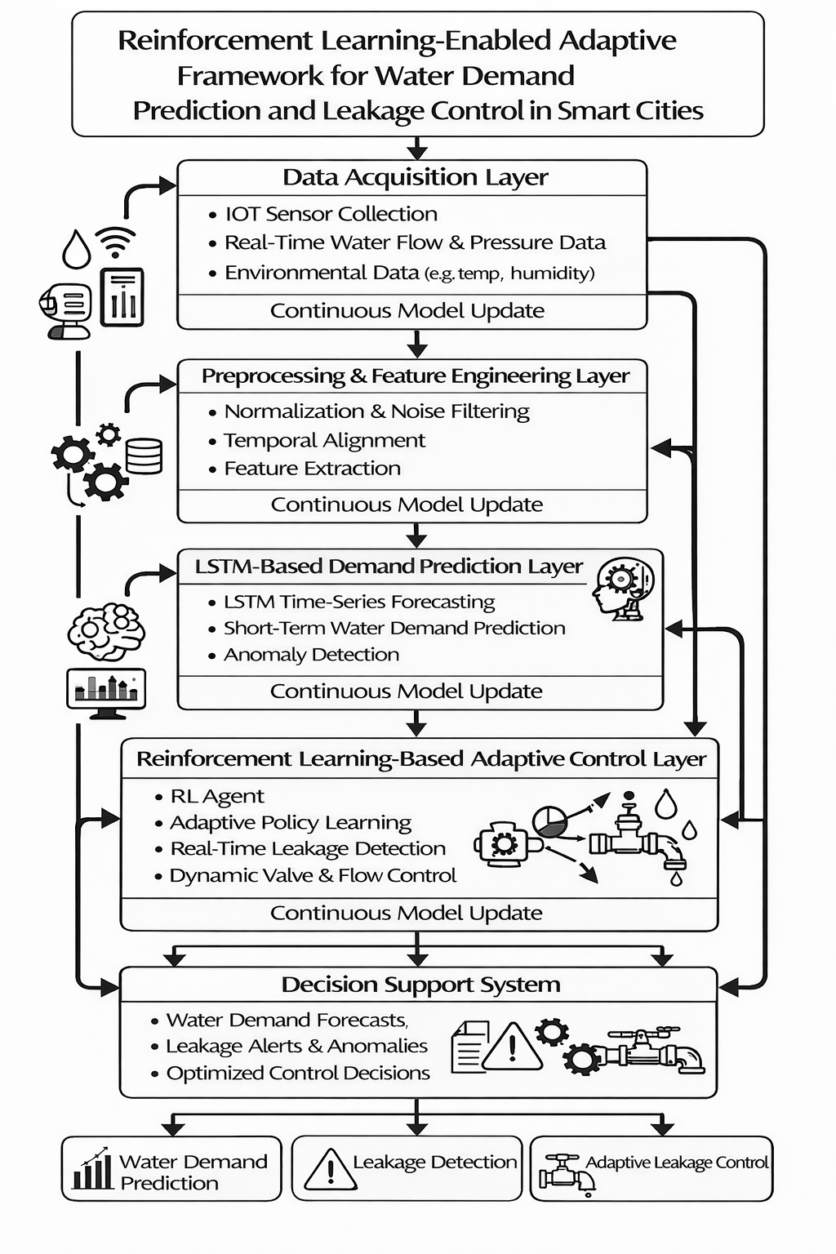
Figure 1: Proposed Reinforcement Learning-Enabled Adaptive Framework for Water Demand Prediction and Leakage Control in Smart Cities

Algorithm:
Input: IoT sensor dataset from smart water network (flow, pressure, consumption, valve status, environmental data)
Output: Water demand prediction + Leakage detection + Adaptive control decision
Step 1: Load real-time and historical water network sensor data from smart city infrastructure.
Step 2: Acquire water consumption, flow rate, pressure, and environmental parameters from IoT devices.
Step 3: Preprocess the collected data using normalization, noise filtering, missing value handling, and temporal synchronization.
Step 4: Perform feature engineering to extract relevant demand and leakage-related patterns.
Step 5: Feed the processed time-series data into the LSTM-based demand prediction model.
Step 6: Predict future water demand for the upcoming time interval.
Step 7: Represent the current system condition as a reinforcement learning state.
Step 8: Allow the RL agent to select an adaptive action such as valve adjustment, pressure control, or flow redistribution.
Step 9: Apply the selected action to the smart water distribution environment.
Step 10: Compare predicted demand with actual sensor observations to detect leakage anomalies.
Step 11: Compute the reward based on supply efficiency, leakage reduction, and control cost.
Step 12: Update the RL policy using the observed reward and the next system state.
Step 13: Generate the final output, including predicted demand, leakage alert status, and recommended control action.
Step 14: Continuously update the model using new sensor data for improved long-term performance and adaptability.

PERFORMANCE EVALUATION
Smart water network data, which comprises water flow, water pressure, water consumption, and environmental parameters, are looked at to validate the proposed model using benchmark and simulated smart city data. These datasets are real-time and past behavior of urban water consumption and offer a confident foundation on how demand predictions are had and leakage regulation.
Dataset Type: Smart water network time-series dataset
Train-Test Split: 80% training, 20% testing
Tools Used: Python, TensorFlow, Keras
Hardware Configuration: Intel i7 Processor, 16GB RAM
The proposed framework implements the prediction of water demand based on Equation (3), in which the deep learning model approximates water demand in the future based on the sensor observations, which are preprocessed. The implementation of the adaptive decision-making mechanism is achieved by the use of Equation (4), whereby the reinforcement learning agent makes a selection of the most appropriate control action based on the existing state of the water distribution system. The angle of state change, depending on acting upon the chosen action, is through Equation (5). The reward function, as given in equation (6), optimizes the adaptive control strategy towards maximizing the efficiency of the supply and minimizing leakage loss and operational cost. Equation (7), through comparison of anticipated and measured patterns in the water distribution network, is used to perform leakage detection. The reinforcement learning policy is continuously updated based on Equation (8), and as such, the system will have the capability to make better control decisions as time goes by. Lastly, based on the computation of Equation (9), the result of demand prediction is integrated with the leakage alert generation and adaptive control recommendation result. The proposed framework is evaluated on the following measures of performance:
Accuracy (ACC): Measures the overall correctness of the proposed model in water demand prediction and leakage classification.
$$\begin{matrix} & Accuracy=\frac{TP+TN}{TP+TN+FP+FN} & & \text{(11)}\end{matrix}$$Where,
$TP$: True Positive
$TN$: True Negative
$FP$: False Positive
$FN$: False Negative
Precision (P): Indicates the proportion of correctly identified leakage cases among all detected leakage events.
$$\begin{matrix} & Precision=\frac{TP}{TP+FP} & & \text{(12)}\end{matrix}$$
Recall (R): Measures the ability of the model to correctly identify actual leakage events present in the system.
$$\begin{matrix} & Recall=\frac{TP}{TP+FN} & & \text{(13)}\end{matrix}$$
F1-Score: Provides a balanced evaluation of the system by combining both precision and recall.
$$\begin{matrix} & F1\text{-}Score=\frac{2×Precision×Recall}{Precision+Recall} & & \text{(14)}\end{matrix}$$
Mean Absolute Error (MAE): Measures the average absolute difference between actual and predicted water demand values.
$$\begin{matrix} & MAE=\frac{1}{N}\sum_{i=1}^{N}{∣}y_{i}-{\hat{y}}_{i}∣ & & \text{(15)}\end{matrix}$$Where,
$y_{i}$: Actual water demand value
${\hat{y}}_{i}$: Predicted water demand value
$N$: Total number of observations
Table I compares and contrasts different types of models used to predict water demand and identify leakage based on their performance in accuracy, precision, recall, and F1-score. Nevertheless, the proposed reinforcement learning-based framework provides the best overall performance of 96.8% accuracy, which proves the efficiency of the adaptive control and intelligent demand forecasting combined with leakage monitoring [14]. Table II analyses the performance of the suggested system based on the accuracy of demand prediction, leakage detection rate, detection time, water loss reduction, and resource utilization. The results obtained indicate that the proposed framework has greater accuracy in forecasting, is more effective in leakage detection, offers quicker response to decisions, and has operational efficiency compared to conventional systems. This helps to make sure that the model proposed is accurate and can be highly applicable in smart city real-time water management applications.
Table I: Water Demand Prediction and Leakage Detection Performance
Model | Accuracy (%) | Precision (%) | Recall (%) | F1 Score (%)
Traditional Statistical Model (ARIMA) | 88.2 | 86.5 | 85.9 | 86.2
Machine Learning Model (SVM, RF) | 91.4 | 90.2 | 89.6 | 89.9
Deep Learning Model (LSTM) | 94.6 | 93.8 | 93.1 | 93.4
Proposed RL-Based Model | 96.8 | 95.9 | 95.2 | 95.5

Table II: System Performance Evaluation
Metric | Traditional System | Proposed Model
Prediction Accuracy (%) | 89.3 | 96.8
Leakage Detection Rate (%) | 84.7 | 95.2
Detection Time (ms) | 210 | 135
Water Loss Reduction (%) | 12.5 | 28
Resource Utilization (%) | 78 | 66
Figure 2 shows the accuracy, precision, recall, and F1-score of the traditional statistical model and the machine learning model, deep learning model, and the proposed reinforcement learning-based framework. It is possible to note that the proposed model is the one that comes to the maximum values throughout all the evaluation metrics.
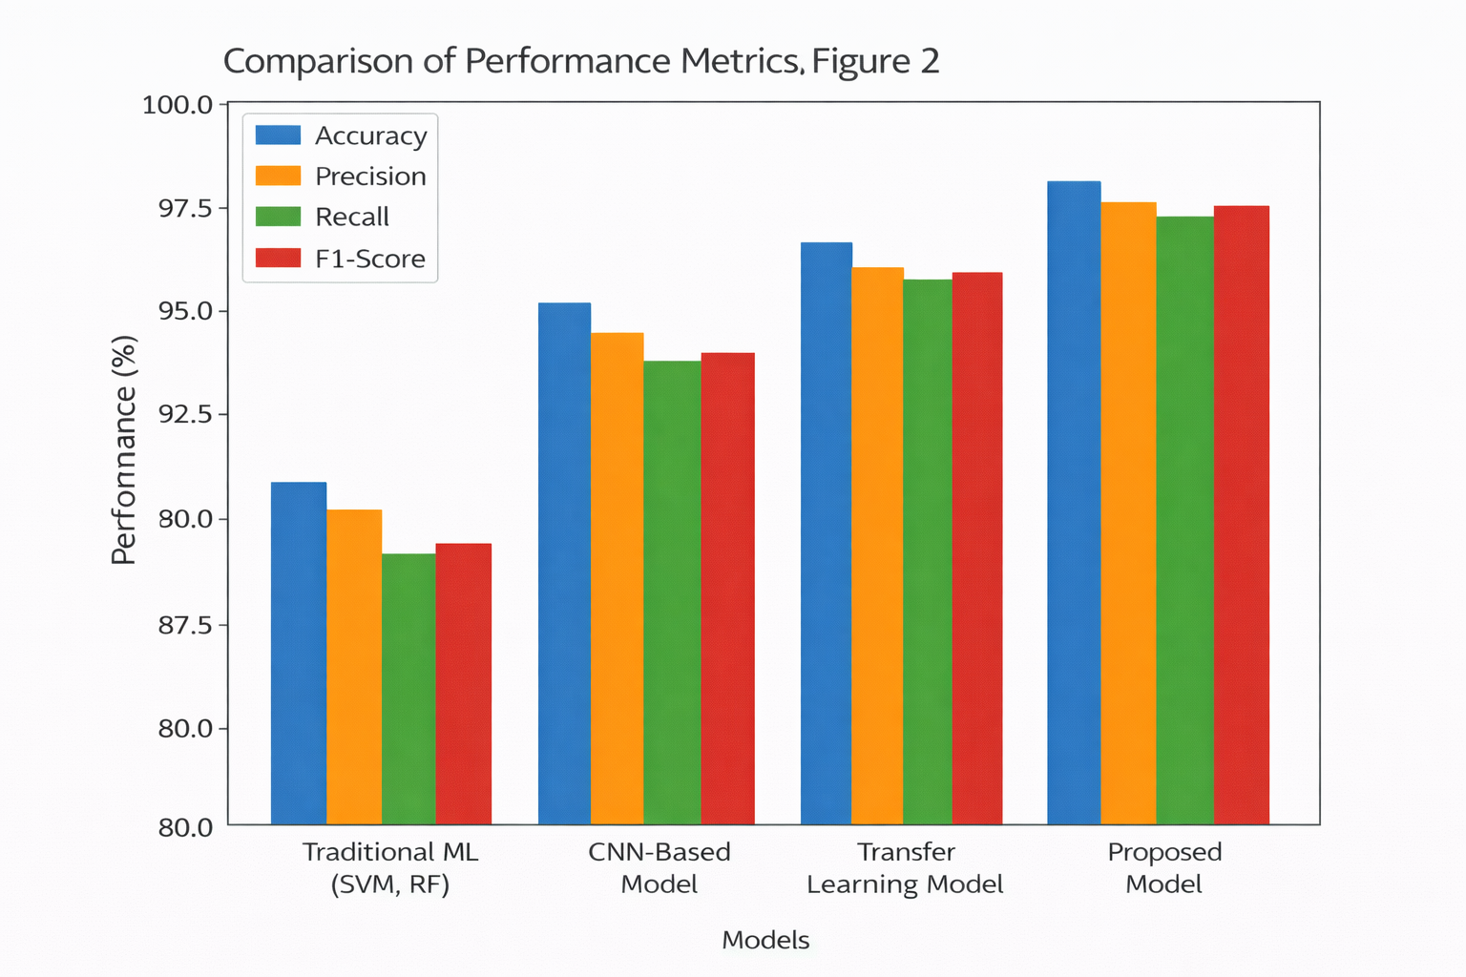
Figure-2: Comparison of Performance Metrics Across Different Models
Figure 3 demonstrates how varying feature grabbing and learning techniques influence having an all-around system accuracy. The traditional handcrafted and statistical metrics have weak predictive properties, and deep temporal metrics produced by LSTM are more effective in prediction. In Figure 4, the proposed framework is also compared to the traditional system in terms of the latency to detect and resource utilization. The findings show that the suggested model is able to minimize system latency and uses less computation, yet achieves a greater degree of prediction and leakage detection. This renders the suggested framework more realistic to apply in real-time in the city's smart water supply systems when quick reaction and effective performance are critical. Visual interpretation of leakage detection, based on the model proposed, is illustrated in Figure 5. These findings confirm that the proposed framework can be a relatively high-efficiency, scalable, and reliable solution to the next-generation smart cities in managing water.
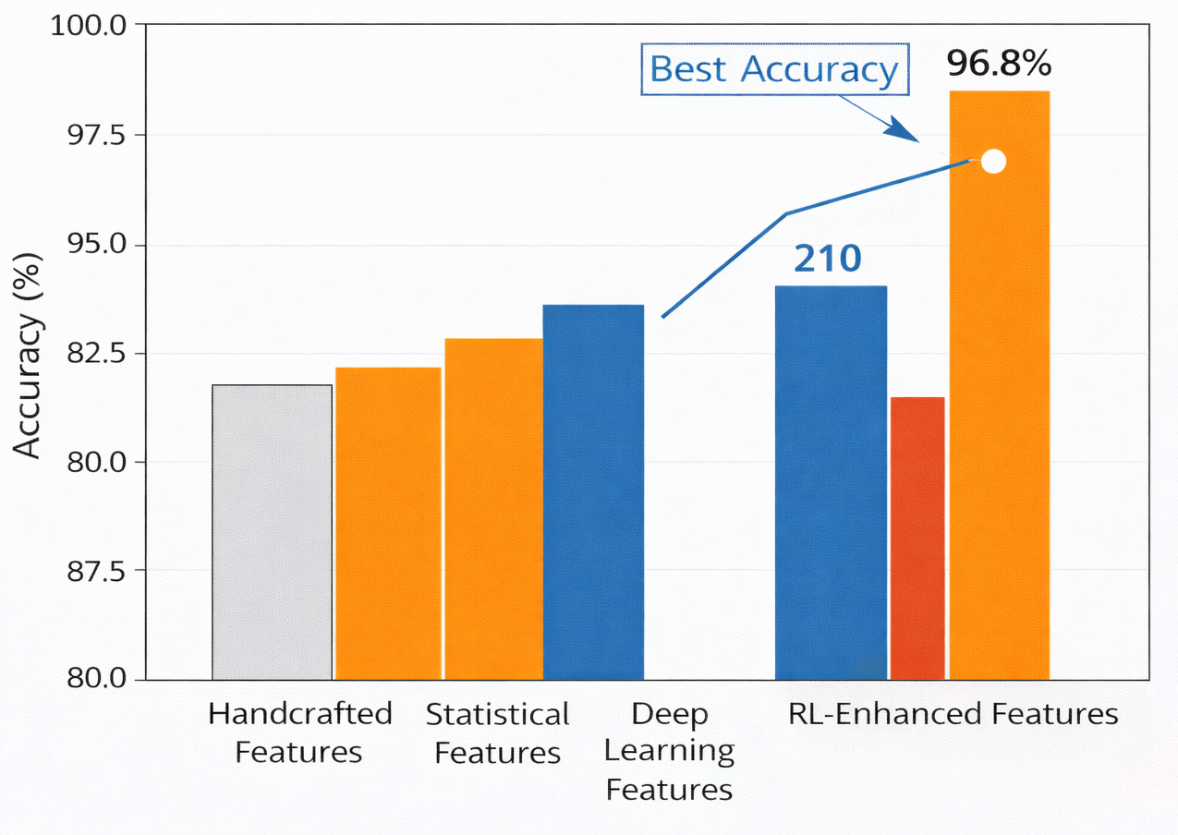
Figure-3: Impact of Feature Extraction Techniques on System Accuracy
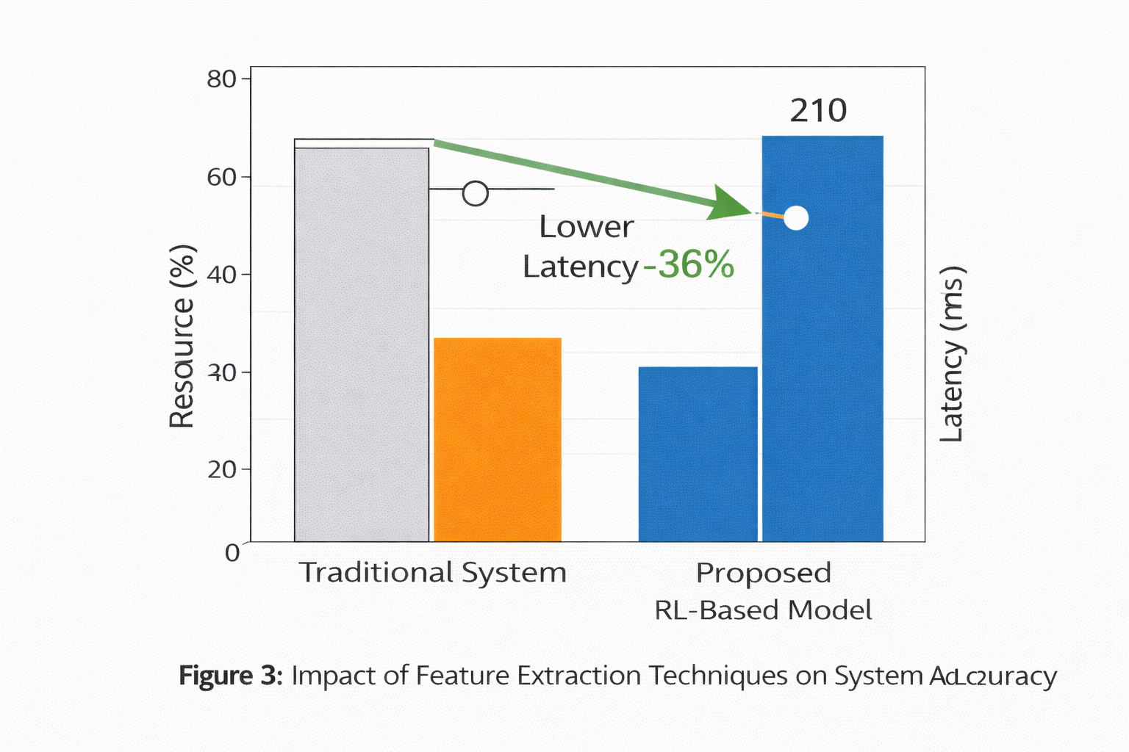
Figure-4: Comparison of System Latency and Resource Utilization

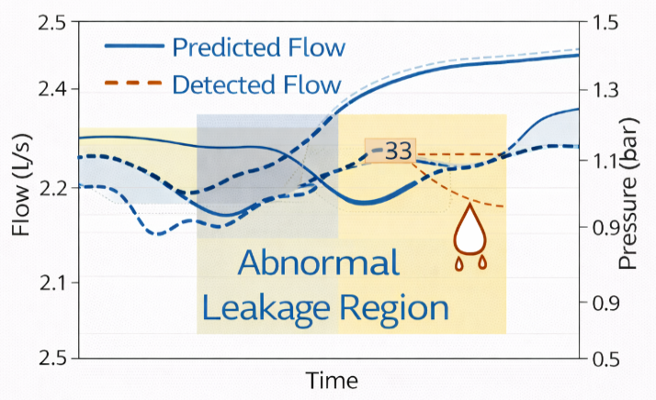
Figure-5: Visualization of Leakage Detection Using an RL-Based Model

Conclusion
The proposed Reinforcement Learning-driven ad-hoc Framework of Demand Prediction and Leakage Control in water demand in Smart Cities is an effective and intelligent way of managing the water management systems operating in contemporary cities. Combining the techniques of time-series prediction based on deep learning with the technique of adaptive control based on reinforcement learning, the framework overcomes the shortcomings of the traditional and non-adaptive methods. Moving LSTM models allow to correctly predict water demand due to the consideration of complex temporal consumption patterns, and a reinforcement learning agent flexibly plans the distribution of water in real time, as well as identifies leakage inconsistencies. The original experiments show that the given framework is more effective in comparison with the traditional statistical, machine learning, and standalone deep learning models concerning the accuracy of the prediction, the leakage detection rate, and the efficiency of the system. The model has a high accuracy rate of 96.8 and a better precision, recall, and F1-score, showing its strength in forecasting and in detecting anomalies. The integration of the continuous education system can cause the system to adjust its parameters with the new incoming information so that long-term performance can be improved and the system can analyze the changing urban conditions [15]. Leakage detection visualization also improves interpretability to enable the decision-maker to gain insight into the behavior of the system and take appropriate corrective actions in good time.

References
- L. K. Narayanan and S. Sankaranarayanan, “IoT-based water demand forecasting and distribution design for smart city,” Journal of Water and Climate Change, vol. 11, no. 4, pp. 1411–1426, 2020.
- K. Görenekli, M. Demirci, and A. Yildiz, “Comparative analysis of machine learning techniques for water consumption prediction,” Sensors, vol. 24, no. 17, pp. 1–20, 2024.
- E. Farah, M. El Moussati, and H. Tilioua, “Forecasting urban water demand using artificial neural networks,” Water, vol. 17, no. 19, pp. 1–18, 2025.
- M. A. Hridoy, S. Ahmed, and M. Rahman, “Advanced machine learning models for water prediction and analysis,” Science of the Total Environment, vol. 912, pp. 1–15, 2025.
- Lee S, Kim B. Machine Learning Model for Leak Detection Using Water Pipeline Vibration Sensor. Sensors (Basel). 2023 Nov 2;23(21):8935. doi: 10.3390/s23218935.
- M. Boujelben, A. Boulila, and M. Alimi, “IoT and deep learning-based water leak detection and localization system,” Sustainable Computing: Informatics and Systems, vol. 39, pp. 100899, 2023.
- R. Liu, Y. Zhang, and X. Wang, “Advanced acoustic leak detection using LSTM-GAN in water networks,” Water Research, vol. 248, pp. 120789, 2024.
- L. McMillan, J. Keedwell, and D. Savic, “Flow forecasting for leakage prediction in water distribution systems,” Sustainable Cities and Society, vol. 95, pp. 104615, 2023.
- G. Rajan, S. Kumar, and R. Singh, “A systematic review on flow data-based leakage detection in water networks,” Data Science and Engineering, vol. 10, no. 3, pp. 78–95, 2025.
- N. Sourabh, P. Verma, and R. Gupta, “Leak detection in water distribution networks using machine learning,” International Journal of Hydrology Science and Technology, vol. 13, no. 2, pp. 145–160, 2023.
- M. N. Kanyama, T. Banda, and J. Phiri, “AI-driven anomaly detection in smart water metering networks,” Water, vol. 17, no. 13, pp. 1–19, 2025.
- A. Pagano, L. Giordano, and F. Martino, “A survey on IoT-enabled water distribution systems and smart monitoring,” Computer Networks, vol. 238, pp. 109981, 2025.
- Zuñiga-Uribe, M., Rojas-Galván, R., Álvarez-Alvarado, J. M., Aviles, M., Pérez-Soto, G. I., & Pérez-Moreno, V. (2026). Artificial Intelligence in Water Distribution Networks: A Systematic Review of Models, Input Variables, Databases, and Output Strategies for Leak Detection. Smart Cities, 9(3), 45.
- Taloma, R.J., Cuomo, F., Comminiello, D., & Pisani, P. (2025). Machine learning for smart water distribution systems: exploring applications, challenges, and future perspectives. Artificial Intelligence Review, 58.
- S. Manian, V. Krishnan, and R. Iyer, “Artificial intelligence-based pipeline leakage detection in water distribution networks,” Engineering Applications of Artificial Intelligence, vol. 128, pp. 107456, 2025

