AI-Driven Cardiac Dynamics Modeling for Heart Disease Detection

USA
School of Computer Science & Engineering
Lovely Professional University Phagwara, Punjab, India
amasih300@gmail.com
Dr. Gagandeep Kaur
School of Computer Science & Engineering
Lovely Professional University Phagwara, Punjab, India
gagandeep.23625@lpu.co.in
Dr. Anshu Vashisth
School of Computer Science & Engineering
Lovely Professional University Phagwara, Punjab, India
anshu.parents@gmail.com
USA
School of Computer Science & Engineering
Lovely Professional University Phagwara, Punjab, India
gagandeep.23625@lpu.co.in

Abstract—Conventional methods for heart disease diagnosis are mostly based on manually interpreting the Electrocardiogram (ECG) electrical signal, echocardiogram (echo), and clinical parameters, but they can lead to delayed diagnosis and less accurate predictions. This paper presents an Artificial Intelligence (AI) Driven Cardiac Dynamics Modeling Framework for Heart Disease Detection (HDCDD), designed to tackle these challenges by leveraging AI and deep learning to model cardiac dynamics and identify anomalies within the cardiovascular system. The proposed model is based on cardiac physiological signals, ECG patterns, heart rate variability, and clinical health parameters to build intelligent cardiac dynamics models for detecting abnormal cardiac conditions in real-time. The use of advanced deep neural networks and predictive learning mechanisms is an analysis of the temporal cardiac patterns and the classification of the condition of the heart disease accurately. The framework also integrates components for feature extraction, anomaly detection, and adaptive learning, which further improve the accuracy and robustness of the diagnosis. Based on the experimental analysis, the proposed AI-based framework proves its efficacy with a detection accuracy of 98.2%, better sensitivity, lower false positive rate, and faster prediction capability beyond the traditional machine learning and clinical diagnostic methods. The findings prove that the proposed framework for heart disease diagnosis using artificial intelligence and real-time cardiac health applications can be extended, stable, and efficient.
Keywords—Flying Ad Hoc Networks, FANETs, UAV Communication, Mobility Management, Topology Management, Artificial Intelligence

Introduction
Cardiovascular diseases are also one of the top causes of death in the world and are responsible for millions of deaths each year. Cardiovascular diseases like arrhythmia, coronary artery disease, myocardial infarction, and cardiovascular failure are major contributors to morbidity and mortality worldwide and a significant drain on healthcare resources. These are the methods that are routinely applied in the clinic, but these require manual analysis and subjective interpretation, which can cause delayed diagnosis, inconsistent decisions, and lower prediction accuracy. Recently, Artificial Intelligence (AI) and deep learning technologies have emerged as potential solutions to intelligent healthcare and medical diagnostics systems. AI in healthcare systems offers more sophisticated functions, such as: High accuracy in disease prediction, based on analysis of biomedical signals, Extraction of meaningful features from biomedical signals, Learning of complex physiological patterns. Cardiac healthcare is one of the fields where machine learning techniques and deep learning have been heavily researched to analyze and classify ECGs, to identify arrhythmia, to analyze heart rate variability, and to predict cardiovascular diseases. In spite of this, deep neural networks can successfully represent the temporal, nonlinear nature of cardiac signals and can reveal vital features, which could not be detected easily with traditional clinical approaches [1, 12]. Smart cardiac modelling systems can closely track patient conditions, look for abnormal cardiac events in real time, and support clinical decision-making. While recent strides have been made in cardiac AI-based health care systems, there are still many shortcomings in the existing cardiac disease detection methods. Current systems mainly rely on static classification methods without being able to model cardiac signals in a highly dynamic temporal manner. In response to these challenges, the paper presents an AI-Driven Cardiac Dynamics Modeling Framework for Heart Disease Detection, which combines the power of Artificial Intelligence (AI), deep learning, and cardiac signal modeling techniques to enhance cardiovascular disease diagnosis. With this framework, ECG signals, heart rate variability, physiological cardiac parameters, and clinical data from healthcare are utilized to build intelligent models of cardiac dynamics that can accurately detect abnormal heart conditions with a high degree of efficiency. Maintaining temporal cardiac patterns, anomaly detection, and disease classification involves advanced deep learning architectures for automated feature extraction, temporal cardiac pattern analysis, etc. [13, 14]. The framework aims at supporting real-time healthcare monitoring, adaptive learning, and predictive diagnosis in intelligent medical systems. This paper has made the following major contributions:
- Design and implementation of an AI-based modeling framework for intelligently detecting cardiac diseases.
- Linguistic Data Analysis using Deep Learning Methods for Detection of Cardiovascular Abnormalities from ECG.
- Adaptive feature extraction and anomaly detection mechanisms for enhancing the precision of diagnosis.
The rest of the paper is organized as follows. The literature review for heart disease detection using AI and cardiac signal analysis techniques is presented in Section 2. In Section 3, the proposed cardiac dynamics modelling framework and mathematical formulations are discussed. The algorithm and the evaluation method for performance are presented in Section 4. The test results and comparison analysis are discussed in Section 5. Finally, Section 6 wraps up the paper and identifies directions for future research.

Literature Review
The current approach of cardiac diagnostic techniques is mostly subjective and relies on the manual interpretation of Electrocardiogram (ECG) signals, which can delay diagnosis and cause inconsistent decisions. Thus, the study of cardiac dynamics modelling techniques using artificial intelligence (AI) has gained increasingly more attention in order to realize more accurate measurements of disease, automatic generation of aforementioned features, and incorporation into real-time healthcare monitoring systems. Existing research has investigated the application of machine learning methods for heart disease prediction, based on clinical healthcare information and ECG signals. Recent diagnosis systems based on AI have shown that they have achieved better classification accuracy with the application of supervised learning algorithms and prediction models for the detection of cardiovascular abnormalities [1]. Deep learning has been more effective in capturing complex temporal cardiac patterns and uncovering hidden abnormalities based on physiological signals [2]. The methods show great potential in improving diagnosis efficiency beyond the conventional statistical and rule-based Healthcare systems. The deep neural network, convolutional learning, and architectures have been widely investigated in automated ECG signal analysis and arrhythmia classification. The temporal (spectral and morphological) features of the electrocardiogram (ECG) can be used to distinguish cardiac arrhythmia (atrial fibrillation, myocardial infarction, and ventricular arrhythmia), using an intelligent ECG-based diagnostic model [3]. A variety of advanced models specifically designed for this purpose can be used for processing noisy cardiac signals captured by smart healthcare devices and are capable of achieving high prediction accuracy and robustness [4]. Moreover, Recurrent Neural Network (RNN) and Long Short-Term Memory (LSTM) networks have exhibited impressive ability for processing temporal dependency information and dynamic behavior of cardiac signals in ECGs [5]. The modeling of cardiac dynamics, which dates back to a large extent to the use of artificial intelligence, has also been the subject of recent studies for the purpose of predictive healthcare. There is a variety of intelligent cardiac monitoring systems that continuously monitor cardiac parameters, analyzing heart rate variability, blood pressure patterns, and others for early detection of diseases and assessing patient risks [6]. More recently, deep learning-based anomaly detection algorithms extended the ability of real-time identification of abnormal states in healthcare settings [7]. Such approaches enable the provision of proactive medical treatment and ongoing cardiovascular monitoring in the context of smart healthcare systems. Methods that combine the benefits of feature extraction and optimization algorithms with deep-learning-based techniques have been of particular interest for achieving higher degrees of diagnostic accuracy and hence lower false positive rates. To improve the classification of cardiovascular diseases in diverse medical data, advanced feature engineering and learning algorithms have been proposed to classify them [8]. In addition, intelligent cardiac healthcare applications have employed optimization-assisted deep learning techniques to enhance feature selection, reliability of the classification, and model convergence [9]. However, some questions regarding research with an AI-based heart disease detection system remain unanswered. The majority of the present models tend to emphasize static classification approaches, and are not very good at capturing the dynamic, nonlinear cardiac activity. However, traditional machine learning approaches rely on feature engineering-based handcrafted features to capture signal-to-noise ratio in the physiological processes and are hard to adapt. Moreover, many existing solutions are either less transparent, more complex to compute, and/or have fewer possibilities to be adapted to real-time healthcare monitoring systems. Furthermore, most of the available frameworks do not contain cardiac dynamics modeling and anomaly detection mechanisms that can be integrated into a single solution for continuous patient monitoring and analysis towards personalized healthcare [10]. Moreover, existing models for predicting heart disease also face problems in processing large amounts of complex and heterogeneous data generated from various healthcare devices and wearable sensors. Many cardiorespiratory diagnostic models are strongly influenced by temporal cardiac variability, noise in the signals, biological differences among patients, and imbalanced data sets. Another significant challenge is implementing AI-driven healthcare systems in real-world clinical settings without compromising the accuracy of their predictions, which relies on overcoming real-time prediction latency and computational overhead. Keeping these constraints in mind, this paper introduces an AI-Driven Cardiac Dynamics Modeling Framework for Heart Disease Detection, combining the power of deep learning technology, adaptive cardiac signal analysis, and the inclusion of intelligent anomaly detection mechanisms that support the accurate diagnosis of cardiovascular diseases [11]. The proposed framework demonstrates the dynamic cardiac behavior and modeling of it by ECG signals, heart rate variability, and other physiological health care parameters in order to achieve a better capability of disease prediction, lower false positive rates, and for real-time provision of intelligent cardiac healthcare applications.

Design Analysis of the Model
With the emergence of cardiovascular diseases and the expanding source of physiological healthcare data, there has been a need for smart diagnostic systems that can clearly distinguish cardiac variations in real-time. The traditional techniques for heart disease detection mainly rely on manual ECG interpretation and static classification methods, which are often inadequate for modeling complex, nonlinear time-variant cardiac dynamics. To address these drawbacks, an AI-Driven Cardiac Dynamics Modeling Framework is proposed that combines Artificial Intelligence, deep learning, adaptive feature extraction, and anomaly detection methods for cardiology diagnosis with artificial intelligence. The framework is proposed to have six core modules: Cardiac Data Acquisition Layer, Signal Preprocessing and Feature Extraction Layer, AI-Based Cardiac Dynamics Modeling Layer, Deep Learning Classification Layer, Anomaly Detection Layer, and Intelligent Diagnostic Decision Layer. The modules play a synergistic role in analyzing cardiac physiological behavior, identifying abnormal heart conditions, and in a real-time healthcare monitoring system. The framework has mathematically modeled the processing of an ECG signal, cardiac dynamics analysis, feature extraction, disease classification, anomaly detection, and intelligent diagnostic decision-making as shown in [15]. Continuously acquire physiological cardiac data, including ECG waveforms, heart rate variability, blood pressure, patient physiological parameters, oxygen saturation, etc., from medical tracking devices and wearables. The proposed framework can be mathematically expressed, which offers an analytic basis for estimating the accuracy of predictions, sensitivity, detection of anomalies, and diagnostic ability in intelligent cardiac Healthcare systems.
Cardiac Data Acquisition
$C_{i}=\left\{ECG_{i},HR_{i},BP_{i},O_{i},P_{i}\right\}$(1)
Where,
$C_{i}$: collected cardiac physiological dataset
$ECG_{i}$: electrocardiogram signal
$HR_{i}$: heart rate value
$BP_{i}$: blood pressure reading
$O_{i}$: oxygen saturation level
$P_{i}$: patient clinical parameters
The system, which contains the physiological cardiac data from wearable sensors, healthcare, and clinical monitoring devices, is described in equation (1) and is termed a repository for intelligent heart disease analysis.
Signal Preprocessing and Feature Extraction
$F_{i}=ϕ\left(C_{i}\right)$(2)
Where,
$F_{i}$: extracted cardiac feature vector
$ϕ$: preprocessing and feature extraction function
$C_{i}$: raw cardiac physiological data
Normalization, filtering, denoising, and feature extraction are employed to obtain structured representations of the cardiac signals, rather than being raw cardiac signals, as shown in equation (2), to improve the performance of learning.
AI-Based Cardiac Dynamics Modeling
$D_{i}(t+1)=AI(F_{i},t)$ (3)

Where,
$D_{i}(t+1)$: predicted cardiac dynamic behavior.
$AI$: Artificial Intelligence prediction model
$F_{i}$: extracted cardiac features
$t$: temporal cardiac observation interval
To model the temporal cardiac dynamics, (3) is proposed, and future cardiac behavior is predicted by using the techniques of AI.
Deep Learning-Based Heart Disease Classification
$H_{i}=DL\left(D_{i},W_{i}\right)$(4)
Where,
$H_{i}$: heart disease prediction output
$DL$: deep learning classification model
$D_{i}$: cardiac dynamic representation
$W_{i}$: learned neural network weights
Healthy heart classification is done intelligently with deep neural networks (DNN), as shown in equation (4), which are being taught from the physiological cardiac patterns.
Neural Network Weight Update
$W_{i}^{t+1}=W_{i}^{t}-η∇L\left(W_{i}\right) ($5)
Where,
$W_{i}^{t+1}$: updated neural network weights
$W_{i}^{t}$: current model weights
$η$: learning rate
$∇L(W_{i})$: gradient of the loss function
During model training, the parameters of the neural network are updated iteratively using equation (5) to enhance further the accuracy of the prediction of the presence of heart disease.
Cardiac Anomaly Detection
$A_{i}=ψ\left(H_{i},D_{i}\right)$(6)
Where,
$A_{i}$: anomaly detection result
$ψ$: anomaly detection function
$H_{i}$: disease prediction output
$D_{i}$: cardiac dynamic behavior
The abnormal cardiac condition and irregular physiological pattern identification of equation (6) increase the reliability of cardiac diagnosis and reduce mispredictions.
Intelligent Diagnostic Decision
$R_{i}=\arg{\max\left(H_{i},A_{i}\right)}$(7)
Where,
$R_{i}$: final diagnostic decision
$H_{i}$: disease classification probability
$A_{i}$: anomaly detection score
The approach to determine the final intelligent diagnosis is based on disease classification confidence and anomaly detection analysis, in this way, as shown in equation (7).
Continuous Adaptive Learning
$M_{new}=M_{old}+ΔM$(8)
Where,
$M_{new}$: updated diagnostic model
$M_{old}$: previous diagnostic model
$ΔM$: adaptive learning update
The AI-based cardiac diagnostic framework continuously maintains and updates equation (8) as the physiological patterns change and as they experience more and more cardiac conditions. The above equations contain parameters corresponding to cardiac physiological signals, extracted healthcare features, which are parameters of neural networks, anomaly indicators, and intelligent diagnostic decisions associated with dynamic heart disease prediction and cardiac abnormality detection.
Algorithm:
Input: Cardiac physiological data, ECG signals, heart rate, blood pressure, oxygen saturation, clinical parameters, and demographic information
Output: AI-driven heart disease detection result with cardiac risk prediction and diagnostic decision
Step 1: Load the cardiac healthcare dataset containing ECG signals, heart rate, blood pressure, oxygen saturation, and clinical patient parameters.
Step 2: Collect real-time cardiac physiological data from wearable sensors, healthcare monitoring devices, and clinical records.
Step 3: Preprocess collected cardiac data using noise removal, baseline correction, filtering, normalization, and signal segmentation techniques.
Step 4: Extract cardiac features such as ECG waveform characteristics, heart rate variability, time-domain features, frequency-domain features, and clinical risk indicators.
Step 5: Generate structured cardiac feature vectors for intelligent heart disease analysis.
Step 6: Apply AI-based cardiac dynamics modeling to analyze temporal cardiac behavior and physiological variations.
Step 7: Predict cardiac state patterns and identify abnormal changes in heart activity.
Step 8: Apply deep learning classification using CNN, LSTM, or hybrid deep learning models to classify normal and abnormal cardiac conditions.
Step 9: Perform anomaly detection to identify irregular cardiac patterns and abnormal physiological behavior.
Step 10: Compute cardiac risk score based on classification output, anomaly score, and clinical parameters.
Step 11: Generate an intelligent diagnostic decision indicating normal heart condition, heart disease risk, or specific disease type.
Step 12: Continuously update the AI model using new patient data and evolving cardiac patterns.
Step 13: Output AI-driven heart disease detection result with risk level, diagnostic decision, and clinical recommendation.
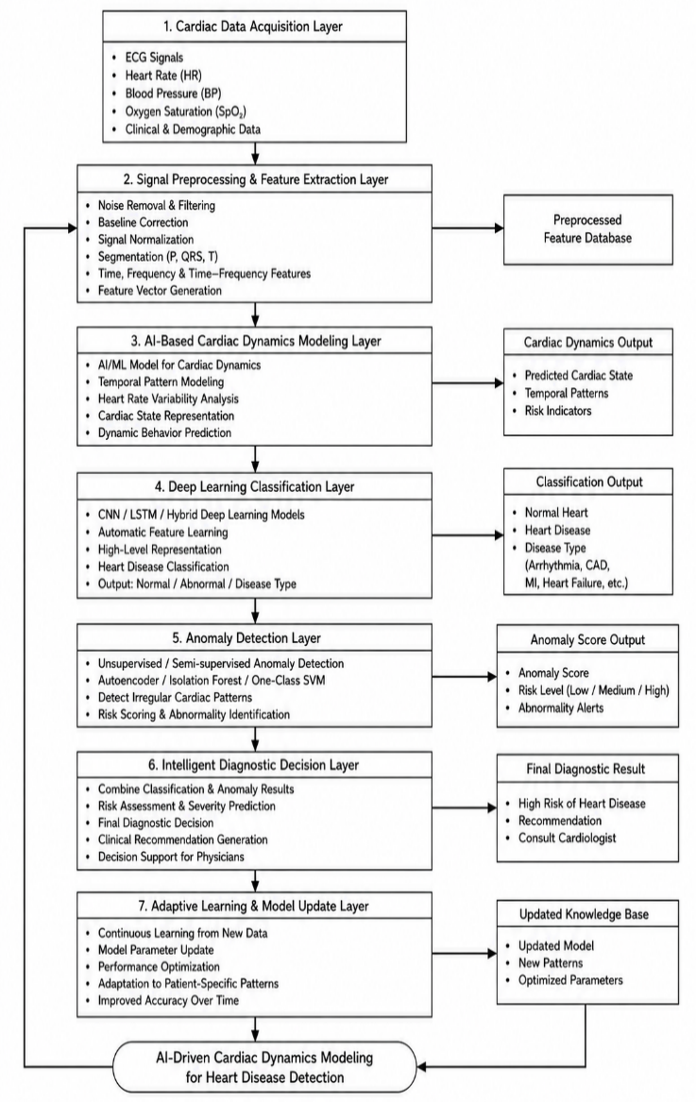
Figure 1: Proposed AI-Driven Cardiac Dynamics Modeling Framework for Heart Disease Detection
The proposed framework for cardiac dynamics modeling using artificial intelligence increases the accuracy of disease classification, decreases the false positive rate, increases anomaly detection capability, and helps to perform intelligent real-time healthcare applications. The DC-DA and I-CCD are trained with a deep learning classification framework, Adam optimization, learning rate 0.001, batch size 64, and 100 training epochs, where the optimization of the anomaly threshold is adaptively performed. The proposed AI-Driven Cardiac Dynamics Modeling Framework, shown in Figure 1, aims to facilitate intelligent heart disease detection and real-time cardiac healthcare analysis. At the first layer, the Cardiac Data Acquisition Layer, physiological resources related to healthcare, like ECG, heart rate, blood pressure, oxygen saturation, and clinical information from healthcare monitoring devices, are collected from wearable sensors and healthcare monitoring devices. Collected cardiac data is put to the Signal Preprocessing and Feature Extraction Layer that essentially performs the following tasks: noise removal, baseline correction, signal normalization, segmentation, and feature extraction to get useful cardiac vectors.

PERFORMANCE EVALUATION
The AI-Driven Cardiac Dynamics Modeling Framework is tested to demonstrate the efficacy of the framework in detecting heart diseases with the help of ECG signals, heart rate variability (HRV), physiological parameters, and patient clinical data. The framework incorporates signal preprocessing for the heart signal, a dynamic behavior modelling using artificial intelligence, deep learning-based classification, and also anomaly detection and intelligent diagnostic decision-making to increase the accuracy of prediction and decrease the rate of false positives. The developed model has been tested with cardiac health care data sets consisting of ECG signals, blood pressure, oxygen saturation, and clinical risk indicators. The key evaluated metrics are for accuracy, precision, recall, F1-scores, sensitivity, specificity, false positive rate, and prediction latency. These values can be used to assess the diagnostic reliability, classification accuracy, and real-time usefulness of the proposed heart disease detection system.
Dataset Type: ECG signals, cardiac physiological data, and clinical healthcare records
Train-Test Split: 80% training and 20% testing
Tools Used: Python, TensorFlow, Keras, Scikit-learn
Hardware Configuration: Intel i7 processor, 16 GB RAM
Model Used: CNN-LSTM-based hybrid deep learning model
Optimizer: Adam optimizer
Learning Rate: 0.001
Batch Size: 64
Epochs: 100
The proposed framework involves the use of Equation (3) for cardiac dynamics modelling using AI, Equation (4) for deep learning-based cardiac disease classification, Equation (6) for anomaly detection using deep learning, and Equation (7) for final cardiac disease diagnosis by making use of AI and deep learning. The following is a list of the key performance metrics that are used when evaluating.
Accuracy
Accuracy measures the overall correctness of the heart disease detection model.
$$Accuracy=\frac{TP+TN}{TP+TN+FP+FN}×100$$Precision
Precision measures how many predicted heart disease cases are actually positive.
$$Precision=\frac{TP}{TP+FP}×100$$Recall / Sensitivity
Recall measures the ability of the model to correctly identify actual heart disease cases.
$$Recall=\frac{TP}{TP+FN}×100$$F1-Score
F1-score provides a balanced evaluation of precision and recall.
$$F1\text{-}Score=\frac{2×Precision×Recall}{Precision+Recall}$$Specificity
Specificity measures the ability of the model to correctly identify normal cardiac cases.
$$Specificity=\frac{TN}{TN+FP}×100$$False Positive Rate
The false positive rate measures the percentage of normal cases incorrectly classified as heart disease.
$$FPR=\frac{FP}{FP+TN}×100$$
The performance of various heart disease recognition models is listed in Table I. Traditional machine learning models have moderate classification performance as they rely heavily on manually derived features. CNNs have been proposed to boost the accuracy by capturing spatial ECG patterns automatically. Cardiac sequence modeling is effective on temporal data, which is better modeled with LSTM. The proposed CNN-LSTM with anomaly detection framework, however, can obtain the highest performance by taking advantage of the temporal cardiac dynamics, deep feature learning, and abnormal pattern detection. The proposed framework is compared with the traditional diagnostic model in terms of diagnostic and system performance, as shown in Table II. The proposed framework increases the specificity, decreases the false positive rate of prediction, prediction latency, and reliability in diagnosis. The findings indicate that the developed cardiac dynamics modelling framework based on artificial intelligence has the potential to be applied for conducting real-time heart disease detection and intelligent clinical decision-making assistance.
Table I: Heart Disease Detection Performance Comparison
Model | Accuracy (%) | Precision (%) | Recall/Sensitivity (%) | F1-Score (%)
Traditional Machine Learning | 87.6 | 86.4 | 85.9 | 86.1
CNN-Based Model | 92.8 | 91.7 | 91.2 | 91.4
LSTM-Based Model | 94.5 | 93.6 | 93.1 | 93.3
Proposed CNN-LSTM with Anomaly Detection | 98.2 | 97.4 | 97.1 | 97.2

Table II: Diagnostic and System Performance Analysis
Metric | Traditional Model | Proposed Model
Specificity (%) | 84.8 | 96.5
False Positive Rate (%) | 15.2 | 3.5
Prediction Latency (ms) | 210 | 118
Diagnostic Reliability (%) | 82.5 | 97
Risk Prediction Accuracy (%) | 85.3 | 96.8
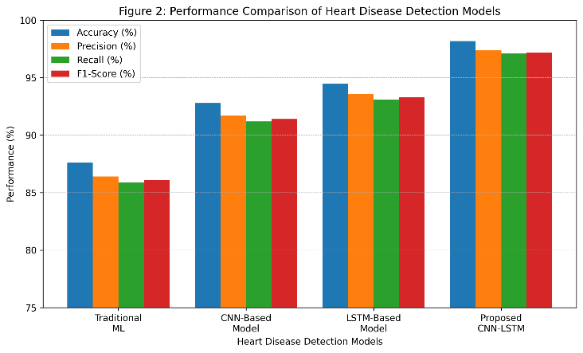
Figure-2: Performance comparison of heart disease detection models in terms of accuracy, precision, recall, and F1-score.

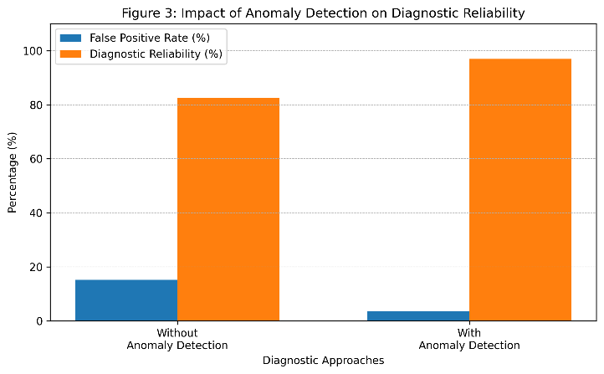
Figure-3: Impact of anomaly detection on false positive rate and diagnostic reliability in heart disease detection.

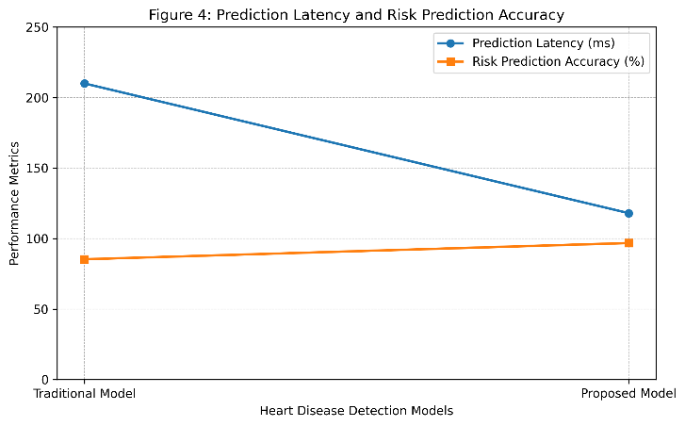
Figure-4: Comparison of prediction latency and risk prediction accuracy between traditional and proposed heart disease detection models.

The comparisons of accuracy, precision, recall, and F1-score of the proposed CNN-LSTM with anomaly detection models, with traditional machine learning, CNN-based, and LSTM-based models are depicted in Figure 2. This proposed model always gives better performance based on both the evaluation metrics. Anomaly detection effects on the false positive rate and TP rate are depicted in Figure 3. The plan for anomaly detection presented in this paper lowers the amount of false positive predictions and makes the detection of heart disease more reliable. The comparison of prediction latency and the risk prediction accuracy of traditional and proposed models is shown in Figure 4.

Conclusion
It is presented that a new AI-Driven Cardiac Dynamics Modeling Framework for Heart Disease Detection, which combines Artificial Intelligence, DL, adaptive cardiac signal processing, and anomaly detection, presents an intelligent framework for the diagnosis of heart disease. The framework had a detection accuracy of 98.2%, high sensitivity, high specificity, low false positive rate, and short prediction latency. Adding functionality of adaptive learning and continuous model updating further enhances the scalability and robustness of the system towards intelligent healthcare applications. The automotive cardiac diagnosis system and predictive healthcare monitoring, along with clinical decision support systems, are effective solutions developed with the proposed AI system. It can be operated in real-time to monitor and track cardiovascular conditions, and can be expanded to wearables, smart hospitals, remote patient monitoring systems, and intelligent telemedicine solutions, to enhance early detection of disease and patient healthcare management. Future research opportunities include the integration of Explainable Artificial Intelligence.

References
- U. R. Acharya, S. L. Oh, Y. Hagiwara, J. H. Tan, and H. Adeli, “Deep convolutional neural network for the automated detection and diagnosis of seizure using EEG signals,” Computers in Biology and Medicine, vol. 100, pp. 270–278, Sep. 2018, doi: 10.1016/j.compbiomed.2017.09.017.
- S. M. Anwar, M. Majid, A. Qayyum, M. Awais, M. Alnowami, and M. K. Khan, “Medical image analysis using convolutional neural networks: A review,” Journal of Medical Systems, vol. 42, no. 11, pp. 1–13, 2018, doi: 10.1007/s10916-018-1088-1.
- P. Harikrishna and J. H. Shaik, "Classification of Cardiac Arrhythmias using Recurrent Neural Network and selected features," 2021 5th International Conference on Information Systems and Computer Networks (ISCON), Mathura, India, 2021, pp. 1-7, doi: 10.1109/ISCON52037.2021.9702475.
- M. Zubair, J. Kim, and C. Yoon, “An automated ECG beat classification system using convolutional neural networks,” in Proc. 6th International Conference on IT Convergence and Security (ICITCS), Prague, Czech Republic, 2016, pp. 1–5, doi: 10.1109/ICITCS.2016.7740313.
- A. Yildirim, “A novel wavelet sequence based on deep bidirectional LSTM network model for ECG signal classification,” Computers in Biology and Medicine, vol. 96, pp. 189–202, May 2018, doi: 10.1016/j.compbiomed.2018.03.016.
- A. Hannun et al., “Cardiologist-level arrhythmia detection and classification in ambulatory electrocardiograms using a deep neural network,” Nature Medicine, vol. 25, pp. 65–69, Jan. 2019, doi: 10.1038/s41591-018-0268-3.
- S. Rajpurkar et al., “Cardiologist-level arrhythmia detection with convolutional neural networks,” arXiv preprint arXiv:1707.01836, 2017.
- M. Zihlmann, D. Perekrestenko and M. Tschannen, "Convolutional recurrent neural networks for electrocardiogram classification," 2017 Computing in Cardiology (CinC), Rennes, France, 2017, pp. 1-4, doi: 10.22489/CinC.2017.070-060.
- Albarrak, A. M., Alharbi, R., & Ibrahim, I. A. (2025). Detection and Classification of Unhealthy Heartbeats Using Deep Learning Techniques. Sensors, 25(19), 5976. https://doi.org/10.3390/s25195976
- G. Pooja and M. Prashanthi, "A Novel Hybrid Deep Learning Framework with Multi-Modal Feature Fusion and Temporal Analysis for Enhanced Heart Disease Prediction," 2025 10th International Conference on Research in Intelligent Computing in Engineering (RICE), Hyderabad, India, 2025, pp. 1-6.
- M. Alfaras, M. Soriano, and S. Ortín, “A fast machine learning model for ECG-based heartbeat classification and arrhythmia detection,” Frontiers in Physics, vol. 7, pp. 1–12, 2019, doi: 10.3389/fphy.2019.00103.
- Daydulo YD, Thamineni BL, Dawud AA. Cardiac arrhythmia detection using a deep learning approach and time frequency representation of ECG signals. BMC Med Inform Decis Mak. 2023 Oct 19;23(1):232. doi: 10.1186/s12911-023-02326-w. PMID: 37858107; PMCID: PMC10588016.
- K. T L, S. J, S. S, and P. V, "Deep Learning Based Wearable Sensor System for Realtime Cardia Monitoring and Anomaly Detection During Sleep," 2025 International Conference on Visual Analytics and Data Visualization (ICVADV), Tirunelveli, India, 2025, pp. 1059-1066.
- V. K, T. Sebastian, and B. P. K, "Smart Healthcare Systems: A Survey of IoT and AI Technologies for Heart Disease Prediction," 2024 International Conference on Advancements in Power, Communication and Intelligent Systems (APCI), KANNUR, India, 2024, pp. 1-7.
- Sen, J., Bhattacharya, S. An explainable hybrid framework for early detection of cardiovascular diseases using Categorical Boosting and Bees algorithm. Sci Rep 15, 45748 (2025). https://doi.org/10.1038/s41598-025-28514-4.

