Product Authenticity Detection Using Block Chain

P.Subba Rao  Dept. of Computer Science & Engineering  Santhiram Engineering College (Autonomous)  Nandyal, Andhra Pradesh, India  subbarao.cse@srecnandyal.edu.in | S.Sameera  Dept. of Computer Science & Engineering  Santhiram Engineering College (Autonomous)  Nandyal, Andhra Pradesh, India  23X51A05L2@srecnandyal.edu.in | S.Fariha  Dept. of Computer Science & Engineering  Santhiram Engineering College (Autonomous)  Nandyal, Andhra Pradesh, India  23X51A05J6@srecnandyal.edu.in
V.Renuka  Dept. of Computer Science & Engineering  Santhiram Engineering College (Autonomous)  Nandyal, Andhra Pradesh, India  23X51A05M6@srecnandyal.edu.in | S.Akhila  Dept. of Computer Science & Engineering  Santhiram Engineering College (Autonomous)  Nandyal, Andhra Pradesh, India  23X51A0514@srecnandyal.edu.in

Abstract: Each year, counterfeit products invade the marketplace and cause losses for both consumers and manufacturers. A significant aspect of this problem is that most existing tracking methods rely on a central database that can be altered or compromised (hacked). The solution presented in this paper is a product verification method that uses permissioned blockchains. Every product has a uniquely assigned digital identifier (ID) at the time of factory manufacture, which is either an encoded QR code or an NFC tag. As the product moves through the supply chain, each transfer of custody along the supply path (from factory to warehouse, warehouse to truck, truck to store floor, and from store to customer) is permanently documented on a blockchain and validated by an automatic smart contract. A customer can use a smartphone app to scan (read) the tag and determine if the product is original and its historical movement through the supply chain. Testing of 5,000 simulated product records resulted in a total accuracy rate of 97.3% for determination of authenticity and a total average time for verification of 2.1 seconds.
Keywords—Blockchain; smart contracts; product authentication; supply chain security; QR code; NFC; counterfeit detection; traceability.

I. Introduction
Counterfeiting is more than an economic problem – it's also a health and safety threat[2] (e.g., a counterfeit brake pad or a counterfeit antimalarial drug could result in serious injury or death). In the last major study done by the OECD, it was estimated that 2.5% of total global trade was due to counterfeiting and still climbing .[5] The greatest impact for counterfeit goods occurs in the pharmaceutical, electronic, high-end luxury and food sectors.[7], [8]
The common means of addressing this issue have been to use holographic labels, serialized databases, and telephone verification of products but all of these methods have a fundamental weakness: all of these methods use a central entity to maintain the record of the product. If the central entity is compromised, then it is possible for a sophisticated counterfeiter to issue a seemingly legitimate document of authenticity for an entirely counterfeit product by bribing a single employee or hacking a single server.[7], [9]
Rather than having one 'master database', a blockchain stores the transaction ledger separately by all of the organisations that have access to the information on the transaction ledger. When all organisations agree that a transaction is valid, the transaction can be added to the blockchain (the Ledger); once a transaction has been added to a block, it would be impossible to change (because you would have to rewrite all copies of the entire block simultaneously, a calculation that is prohibitively excessive).[4], [6]
In addition to the definition of the transaction process, Smart Contracts create another layer of safety/security[2]; Smart Contracts are automatically executed programs that will verify the conditions of the transaction against an established set of criteria before allowing the transaction to be added to the database. No one can change or override the execution of a Smart Contract once it has begun to be executed.[13], [16]
This paper describes how the characteristics of a blockchain can be leveraged to enable product authentication. The specific contributions of this paper are: (i) a four-tier architecture to connect physical tags to a permissioned blockchain, (ii) a five-tier product life cycle completely enforced by Smart Contracts, (iii) a Weighted Authenticity Score that combines the elements of a product's chain of custody into a single number that indicates the level of trust of that chain of custody, and (iv) performance measurements across 5,000 test records.
Section II provides an overview of related research, and identifies the gap. Section III describes the architecture of the proposed system. Section IV describes the implementation of the system. Section V describes the Authenticated Model. Section VI presents the performance results from the implementation of the architecture. Section VII provides a conclusion to the results presented.

II. Related Work

Food traceability was an initial application that was tested. Researchers discovered that blockchain technology could help reduce the time it takes to investigate product recalls from days to seconds by allowing inspectors to have a non-modifiable record of all places the product has been found during its processing .[10] The idea proved to work, however, the proposed solution was limited to providing batch-level tracking of products, not individual identification of products in serial situations.

Pharmaceutical serialisation was the next major application to receive attention. RFID tags were affixed to drug shipments, and the tag numbers were entered onto a consortium blockchain, allowing pharmacies to confirm that each shipment matched an assigned batch of drugs produced by a specific manufacturer .[11], [18] The only real barrier was cost, due to the fact that public blockchain networks (utilised for these types of transactions) require a fee for each transaction, thus resulting in a very high cost for registering thousands of different items.
Hyperledger Fabric has solved the problem of transaction fees by making sure that only approved organisations may transact with each other.[13] The network can also use a simpler consensus architecture as well. Because all transactions are backed by approved organisations in the Fabric network, gas costs are minimal. Several supply chain related pilots have run on Fabric and indicated that it was fast enough to support fast commercial transactions. However, none of the Project Pilots demonstrated a method of verification on the customer side, which is the last mile of the supply chain where customers are trying to confirm the authenticity of a product, nor have any of the Project Pilots demonstrated how to resolve QR code duplication, where a counterfeiter takes a picture of a valid tag and reproduces it.
Table I indicates the major limitations of the various solutions discussed and what this new work contributes to their resolution.

TABLE I. Literature Gap Analysis
Author | Year | Method | Limitation | This Work Adds
Tian [10] | 2017 | Blockchain+ IoT | Batch-level only, no item auth | Item-level QR/NFC binding
Rodrigues [11] | 2017 | RFID+ blockchain | High gas cost, public chain | Permissioned chain, no gas fee
Androulaki [13] | 2018 | Hyperledger Fabric | No consumer verification | Mobile consumer app + score
Westerkamp [12] | 2020 | Token composition | No anti-cloning defence | Cryptographic tag binding

III. System Architecture
A. Overall Design
Four layers make up the entire system. The base will be referred to as a ledger system, known to include both the blockchain network and the various peer nodes. A logical layer will translate incidents occurring in real life (e.g., when a product ships) into blockchain transaction entries, using application logic (layer two) as the means of processing these. The third layer is the connection between physical tags and digital record keeping by providing a hardware integration layer. Finally the fourth layer—what the ultimate users will interface with and/ or access—will either be via a mobile app (for consumers) or a web-based dashboard (for supply chain operators). [7],[9], [14]
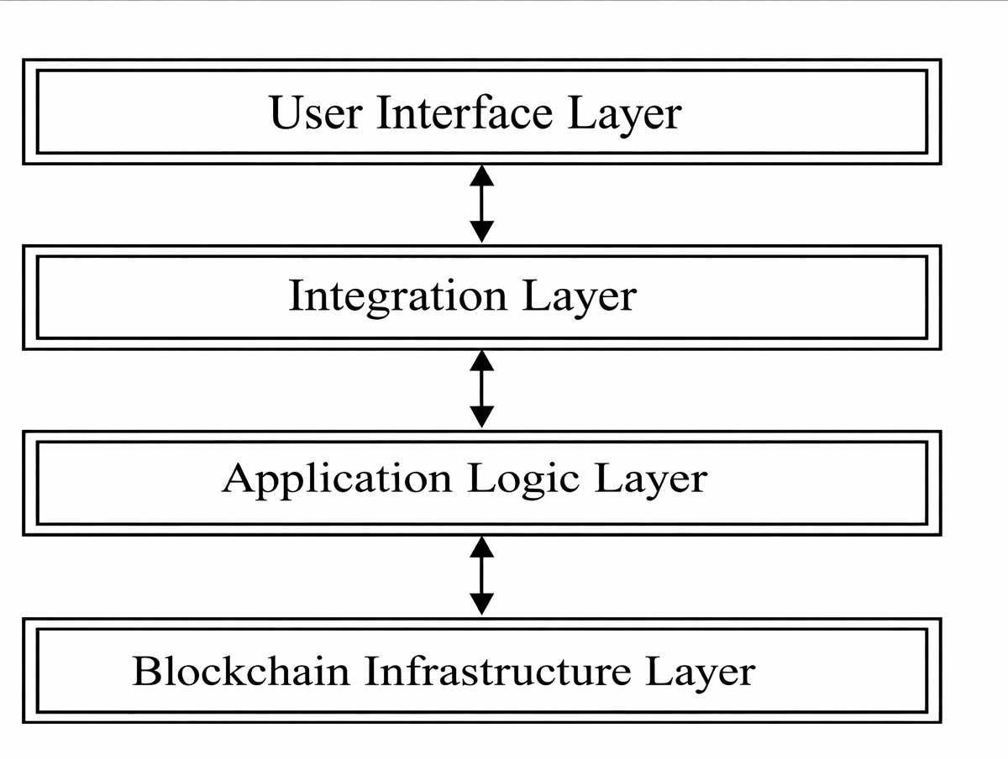
Fig 1: System Architecture of Proposed Model
B. Blockchain Network Setup
The network operates on Hyperledger Fabric 2.4, which is a permissioned framework where only vetted organisations that have a certificate are allowed to participate.[10] The network consists of three node types: endorser peers (managed by manufacturers), committer peers (managed by logistics partners), and an ordering service that contains three Raft nodes to sequence transactions into blocks. Each participant has an identity associated with an X.509 certificate provided by the certificate authority for the network.
Before any transaction can be recorded in the ledger, it must be endorsed (signed) by at least two different organisations[3]. The two-endorsement rule protects against a single entity inserting false records in the ledger.For example, a manufacturer cannot create false records of deliveries and a logistics company cannot create false records of transfers that were not made.
C. Product Digital Identity
When an item leaves the factory floor, the system creates a Unique Product Identifier (UPID). A UPID consists of three parts - the manufacturer’s organization ID, the current Unix Timestamp expressed in milliseconds, and 128 bits of random data - which are combined into a single string and hashed using SHA-256; this produces a long fixed-length string safe for printing as a QR Code.[4]
The hash alone cannot prevent counterfeiters from photographing QR codes and copying the image. Therefore, at the time of product registration, the manufacturer's private key will cryptographically sign the UPID, which information is recorded on-chain with the product record. Later, when someone scans the QR Code, the smart contract will validate the signature against the manufacturer's public key. A copied image of a QR code will show the proper design but it will lack a valid cryptographic signature; thus, it cannot be validated as authentic.[16]
D. Product State Machine
Throughout its lifecycle, a product passes through five different states: manufactured, in warehouse, in transit, at retail, and sold. The smart contract strictly enforces the fact and/or order of these states as well. For example, if a scan was performed that attempted to skip directly from manufactured to retail, that scan would be rejected (because the smart contract would reject it). This process ensures that if an improper product is substituted anywhere in the supply chain, it would be detected.[15], [16]
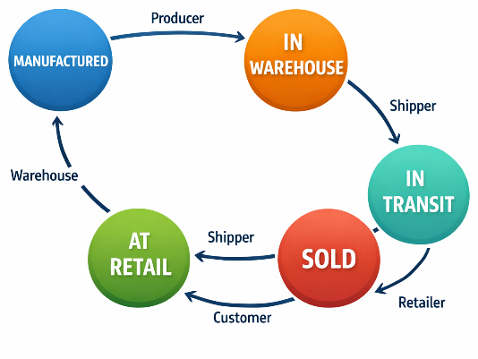
Fig 2: Product State Machine Diagram
IV. Implementation
A. Technology Stack
Because of the ability of Go to compile into very efficient native code as well as its ability to execute transactions in a very fast manner, chain code (aka smart contracts) is written using Go. The consumer-facing mobile application is written using React Native allowing it to be deployed on both Android and iOS using the same code base.

In addition, there is a Node.JS gateway between the mobile application and the blockchain network which performs wallet management, certificate storage and manages the submission of transactions from the mobile application without direct interaction with Fabric.[13]
Error Correction Level H is used in QR Codes in order for users to still be able to read 30% of the QR Code damaged or uncleaned. NDEF formatted NFC Tags can be read by all Android and iOS devices[1] without requiring any additional applications. Each tag stores only the UPID and the signature is validated through the smart contract as opposed to through the tag.[15]
B. Smart Contract Functions
Four functions are exposed through the chain code. The Register Product function is called by nodes entitled to put a manufacturer's product record onto the ledger; only those nodes have access to this function. The Record Event function is responsible for creating an event in the supply chain and ensures that a) the caller's role is verified and b) the state transition can be confirmed as valid before allowing it to add an event into the ledger database. The Verify Product function checks whether the product has been verified by running a signature check and an ordered sequence check and returns a structured answer that contains a score of the product's authenticity. The Query History function allows for all ordered events associated with any product ID to be queried from the ledger.[16]
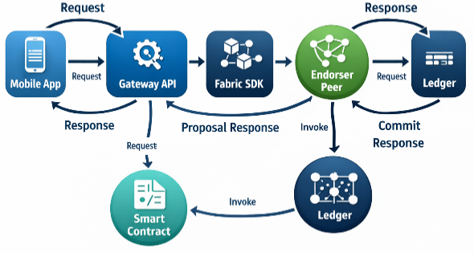
Fig 3 : Smart Contract Interaction Sequence Diagram
C. Consumer Verification Steps
When a customer selects a product inside a retail facility and needs confirmation regarding its authenticity; they utilize their mobile device to scan the QR code of the package label or the NFC tag near it. Upon scanning the product's QR code or tapping the NFC tag, the app sends the UPID to the gateway, which executes Verify Product on the blockchain. The smart contract verifies that the manufacturer signed the product, confirms that the item has progressed through all expected stages of supply chain activity (and in the proper sequence), and returns a numeric value representing the product's level of authenticity. The mobile app displays either a green checkmark or red X to let the user know whether or not the product was authentic; in addition, if the product was in fact authentic, the mobile app lists all of the locations the product has traveled through its supply chain to help give the user a better understanding of where the item has previously been located.[17]
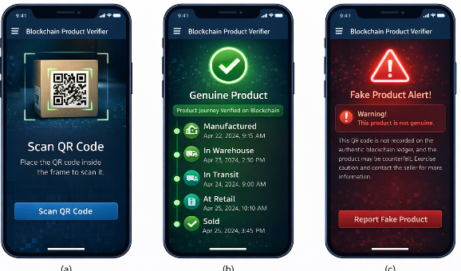
Fig 4 : Mobile Application Verification Interface
D. Security Analysis
Three attacks were specifically designed against during
The project's features were specifically developed to protect against three specific attacks.
The first is QR code cloning. A counterfeiter can take a picture of a legitimate QR code and print and apply that code to a fraudulent product. The QR code will not work, because the unique private key signature is not present; this is verified by the smart contract.[16]
The second attack is ledger alteration and is accomplished by altering the historical record of the database. Since each block has the hash from the previous block, changing any prior block's records results in breaking the hash chain for every subsequent block; therefore, all the nodes will reject the altered block immediately.[4]
The third attack is insider tampering. An employee of a legitimate company may attempt to falsely record a handover. To do so, the employee must obtain a second independent endorsement from another verifiable source; a rogue insider may not submit an order for a handover without meeting this requirement.[13]
V. Authenticity Confidence Model
Sometimes an appropriate answer cannot be obtained with just a pass/fail result. For instance, although a product’s signature may validate the product, including the product history may not be complete, or even if it contains all of the transactions, the timestamps associated with the transaction may be old. Composite Authenticity Score (A) captures the multiple levels of confidence associated with historical transactions.
A = w₁ · V + w₂ · C + w₃ · T
V indicates the signature verification status, which will be 1 (for acceptable signature) or 0 (for unacceptable signature). Chain confidence is calculated as the ratio of the total number of valid chain transitions to the total number of legitimate chain transitions on a history of that event; thus, an incomplete chain will be low in value.
Temporal Trust (T) is calculated as an exponentially decaying function over the time elapsed from the last recorded event; hence a high score for an event chain is given where there is a reliable number of events recorded in a timely manner. Conversely, high scores are assigned as a result of the absence of sequentially recorded events.
The values assigned to the weightings (w1 =0.50, w2 =0.30, w3=0.20) signify that the most conclusive indication of invalidity is a failed signature; secondly, broken chain of custody from a legitimate source; and thirdly, a stale record is an indication of possible invalidity, but not as much as the previous two factors. Validity A is measured on a scale from 0-1, where scores of 0.85 and higher are ranked as authentic, scores between 0.60-0.84 will trigger caution for manual inspection, and scores under 0.60 will be flagged as not authentic.[7], [8]
Algorithm 1 summarizes the sequential steps used by the Smart Contract.
Algorithm 1: Product Verification Procedure
Input: productID
Output: class, confidence
1: record ← fetch(productID)
2: if record = NULL then
3: return ("Not Found")
4: V ← verify_conditions(record)
5: C ← min(observed / expected, 1.0)
6: T ← compute_time_score(record)
7: A ← 0.50 × V + 0.30 × C + 0.20 × T
8: if A ≥ 0.85 then
9: class ← "Authentic"
10: else if A ≥ 0.60 then
11: class ← "Caution"
12: else
13: class ← "Not Authentic"
14: return (class, confidence)

Vi. Results and Discussion
A. Test Setup
The ordering service contained three orderer nodes that were each operating according to the Raft consensus algorithm. The test network is made up of four peer nodes that are spread out amongst three different organizations (the manufacturer, the logistics company, and the retailer). Virtual machines in the test network were based on vCPUs with 4 vCPUs and 8 GB of RAM with SSD storage. Throughout the experiment, a total of 5,000 product records were generated with five different product types. A total of 15% of those product records contained injected faults in the form of broken signatures, incorrect order of state sequence, and missing events to simulate counterfeit products.
B. Transaction Speed
The average verification time for a product was 2.1 seconds, with a mean standard deviation of 0.38 seconds, from the time an app sends a request until that request was completed with a return of completed results. The 95th percentile time for verifying product was 2.9 seconds. Both register product and record event requests took an average of 3.4 seconds to complete as they require the endorsement of two organizations to complete. No request during the entire test run exceeded 4.2 seconds..
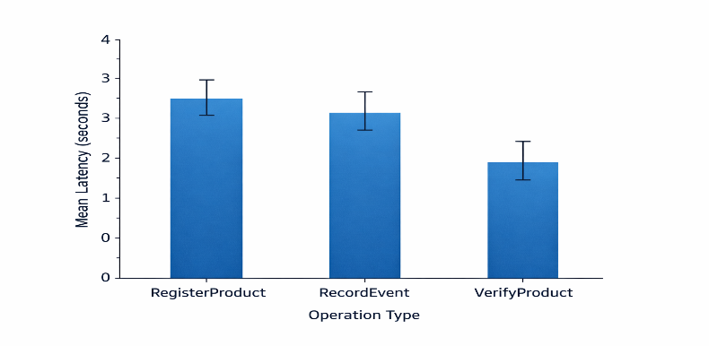
Fig 5 : Transaction Latency Comparison

C. Detection Accuracy
When compared with the ground truth labels, the accuracy of the system was 97.3%. The precision of the system for genuine products was 98.1% and the recall for genuine products was 98.6%. The F1 score for counterfeiting was 96.2%. A small number of false negatives were measured because there were long time delays between supply chain events on some genuine products, which caused the T in the temporal trust component to be lowered enough that the A score would move to the Caution band, instead of remaining in Authentic.
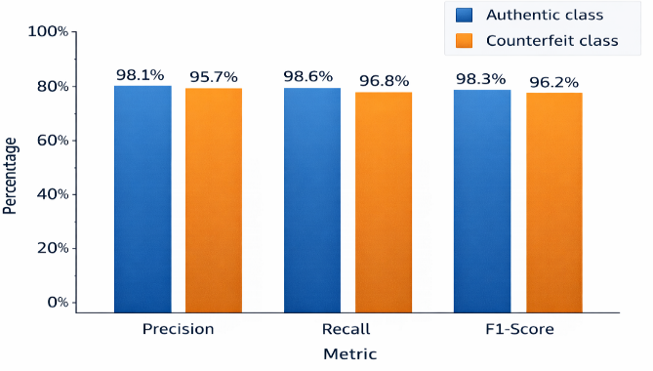
Fig 6 : Detection Performance Metrics (Precision, Recall, F1-Score)

D. Throughput
During simultaneous use of the network, it was able to process 180 VerifyProduct calls per second until the response times rose to over 3 seconds. Each call had an average chain code execution time of 42 milliseconds. Because Hyperledger Fabric does not have any gas fees, the only ongoing operating expense is the cost of the physical infrastructure required to run the peer nodes.

E. Comparison with Existing Approaches
Table II puts the proposed system alongside a standard centralised database and a public Ethereum deployment across five dimensions.

TABLE II. System Comparison
Criterion | Central DB | Ethereum | Proposed
Tamper Resistance | Low | High | High
Decentralisation | None | Full | Partial*
Verify Latency | < 0.5 s | > 15 s | ~2.1 s
Transaction Cost | Negligible | High (gas) | Low (fixed)
QR Clone Defence | None | None | Cryptographic
*Permissioned network; federated but not fully open.
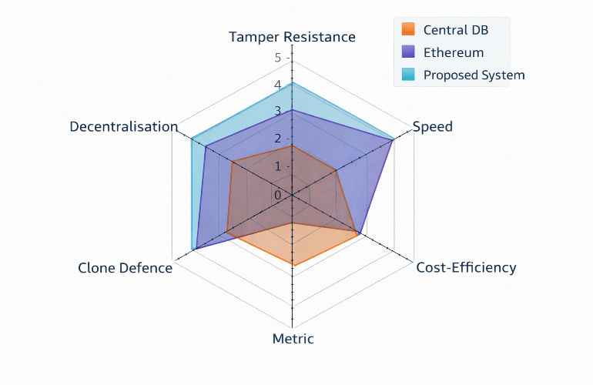
Fig 7 : Comparative Analysis of Systems (Radar Chart)

F. Discussion
Results demonstrate the practicality of a highly secure Blockchain system as a permissionless solution to transact securely as an electronic transaction. The speed; however, is still not sufficient to compete against traditional (central) databases. Nevertheless, the permissionless approach significantly reduces the 15-second time it takes for any public blockchain to confirm a retail point-of-sale (POS) transaction, thus making it practical for POS verification.

The cryptographic binding of tagged transactions (i.e., a cryptographic mechanism) is the method that neither previous approaches provide, as well as the method that mitigates the risk of sending counterfeit goods by QR Code (e.g., QR Code cloning).
A primary limitation of this system lies in that it relies on the first registration of the product (the initial registration event) being bona fide. If a counterfeiting organisation has access to the manufacturing organisation’s infrastructure at the factory level, it could authorise counterfeit products to be registered to the first registration on a QR code that was wrongly registered in the DB.
Physical controls to mitigate the risk of counterfeit registrations must be implemented within the factory, including: HSM (hardware security modules) for key storage; CCTV (closed-circuit television) recording of tagged transactions at each manufacturing tagging station; all of which, are outside the scope of this electronic system described herein.
ViI. Conclusion
The Development of a Product Authentication Application on a Permissioned Blockchain has enabled the ability to track the entire supply chain for products digitally; through this technology, consumers are able to scan a physical product using a mobile phone or other innovative devices to substantiate its authenticity. Several design elements combine to produce a system where it is extremely difficult to insert a fake record into the network and/or create a replica of an authentic tag: Smart Contracts enforce state machine rules; Unique Cryptographic Signatures are associated with each physical tag; and two endorsements must be attached to each transaction.
The results of the testing indicated that the suggested system, 97.3% detection accuracy, and 2.1 seconds verification time, would be practical within an actual retail environment. When compared to a centralised database, there would be a very minor inconvenience in terms of speed (to achieve tamper proof records and lack of a central point of weakness). When compared to a public blockchain, the centralised solution offers customers low costs with significantly quicker verification than the public option.
Putting together IoT temperature sensors to facilitate the cold-chain maintaining of cold-chain pharmaceuticals so that the RecordEvent function can be executed, exploring zero-knowledge proofs in order to allow manufacturers to validate the authenticity of their products without having to disclose proprietary batch information, and establishing cross-chain bridges between networks so that products on one member consortium can be verified by those on another member consortium are follow-up activities planned upon project completion.

VIiI. References
- S. Adigopula and M. V. Subramanyam, "DCNN-RFF-NFC: A novel design of NFC security using deep convolution neural network-based RF fingerprinting," Neural Computing and Applications, vol. 37, no. 6, pp. 4439–4453, 2025.
- K. S. Nirmala Bai and M. V. Subramanyam, "Integrated intrusion detection design with discretion of leading agent using machine learning for efficient MANET system," Scientific Reports, vol. 15, no. 1, p. 30849, 2025.
- K. S. Nirmala Bai and M. V. Subramanyam, "ETPA: Energy, Throughput, Privacy Aware Multipath Routing with Intrusion Avoidance for Reliable MANET System," SSRG International Journal of Electrical and Electronics Engineering, vol. 12, no. 7, pp. 18–33, 2025.
- S. Nakamoto, "Bitcoin: A peer-to-peer electronic cash system," Cryptography Mailing List, 2008.
- OECD and EUIPO, "Trade in counterfeit and pirated goods: Mapping the economic impact," OECD Publishing, Paris, Tech. Rep. 2016.
- Y. Lu, "Blockchain and the related issues: A review of current research topics," Journal of Management Analytics, vol. 5, no. 4, pp. 231–255, 2018.
- N. Kshetri, "Blockchain's roles in meeting key supply chain management objectives," International Journal of Information Management, vol. 39, pp. 80–89, Apr. 2018.
- M. Saberi, M. Kouhizadeh, J. Sarkis, and L. Shen, "Blockchain technology and its relationships to sustainable supply chain management," International Journal of Production Research, vol. 57, no. 7, pp. 2117–2135, 2019.
- K. Korpela, J. Hallikas, and T. Dahlberg, "Digital supply chain transformation toward blockchain integration," in Proc. 50th Hawaii International Conference on System Sciences (HICSS), 2017.
- F. Tian, "Supply chain quality management based on blockchain and IoT," in Proc. 14th International Conference on Service Systems and Service Management (ICSSSM), Dalian, China, 2017, pp. 1–6.
- B. Rodrigues, T. Bocek, and B. Stiller, "The use of blockchain for anti-counterfeiting in the fashion industry," in Proc. IEEE IFIP Networking Workshops, 2017.
- M. Westerkamp, F. Victor, and A. Kupper, "Tracing manufacturing processes using blockchain-based token compositions," Digital Communications and Networks, vol. 6, no. 2, pp. 167–176, May 2020.
- E. Androulaki et al., "Hyperledger Fabric: A distributed operating system for permissioned blockchains," in Proc. 13th European Conference on Computer Systems (EuroSys), Porto, Portugal, 2018, Art. no. 30.
- S. Abeyratne and R. Monfared, "Blockchain ready manufacturing supply chain using distributed ledger," International Journal of Research in Engineering and Technology, vol. 5, no. 9, pp. 1–10, 2016.
- H. Lin, W. He, and X. Chen, "Blockchain-based data sharing system for IoT devices," IEEE Access, vol. 6, pp. 78640–78649, 2018.
- K. Christidis and M. Devetsikiotis, "Blockchains and smart contracts for the Internet of Things," IEEE Access, vol. 4, pp. 2292–2303, 2016.
- M. Caro, M. Ali, M. Vecchio, and R. Giaffreda, "Blockchain-based traceability in agri-food supply chain management," in Proc. IoT Vertical and Topical Summit on Agriculture (IoT Tuscany), Italy, 2018, pp. 1–4.
- A. Bocek, B. Rodrigues, T. Strasser, and B. Stiller, "Blockchains everywhere – A use-case of blockchains in the pharma supply-chain," in Proc. IFIP/IEEE International Symposium on Integrated Network Management (IM), 2017.

