Analyzing AI-Driven Digital Transformation and Faculty Engagement Through PLS-SEM

Athira M K
Department of Commerce and Management, Amrita Vishwa Vidyapeetham, Amritapuri, India
athiramk943@gmail.com
Dayana Da,
Department of Commerce and Management, Amrita Vishwa Vidyapeetham, Amritapuri, India

Akshada Nair
V K Krishna Menon College of Commerce and Economics,Mumbai, India

Abstract— The post-COVID-19 digital transformation of higher education has significantly reshaped teaching practices and institutional operations, making faculty engagement critical for institutional success. However, many institutions struggle to sustain faculty engagement due to uneven digital readiness, increased workload, and techno-stress, creating a gap between technology adoption and effective utilization. This study examines the impact of digital transformation factors on faculty engagement and organizational commitment in higher education institutions. An integrated framework combining the Job Demands–Resources (JD-R) model, Social Exchange Theory (SET), Self-Determination Theory (SDT), and the Technology Acceptance Model (TAM) is used to explain these relationships. A mixed-methods approach was adopted, using structured questionnaires and interviews with 224 faculty members. Correlation, multiple regression, and Partial Least Squares Structural Equation Modelling (PLS-SEM) were used for quantitative analysis. The results show that institutional support (β = 0.41), digital infrastructure (β = 0.34), and professional development (β = 0.29) significantly increase faculty engagement, while techno-stress significantly decreases it (β = −0.22), and that about 63% of the variance in faculty engagement can be accounted for by the combination of these variables. Faculty engagement partially mediates the relationship between digital transformation and institutional outcomes. The findings emphasize the need for faculty-centered digital strategies that balance technological investment with strong institutional support.
Keywords— Digital Transformation; Faculty Engagement; Organizational Commitment; Higher Education; Post-Pandemic Education

Introduction
COVID-19 accelerated digital transformation in higher education, forcing universities to rapidly shift from in-person to online and hybrid modes of instruction. This transition helped to maintain continuity of academic activities, but also highlighted some structural and human issues for the adoption of technology, instructional effectiveness and faculty adaptability. The growing use of digital systems in core university operations has brought faculty engagement as an important enabler of good quality education and successful institutions.
Despite significant investments in digital infrastructure and learning technologies, many institutions struggle to achieve consistent faculty adoption for teaching and learning. This indicates a gap between technology availability and its effective pedagogical use. Often, teachers have to deal with higher workload, role confusion and techno-stress resulting in lowered motivation and participation. Demands for institutional support and professional development also vary and have an impact on faculty reactions to digital transformation efforts.
However, in the Indian higher education landscape, the issue becomes all the more challenging due to the digital divide, the preparedness of institutions and the implementation of policies. Thus, it is important to have a more holistic understanding of the interactions between digital transformation factors and organizational and psychological factors affecting engagement. This study fills this void by investigating the combined influence of digital transformation, faculty engagement and organization commitment on an integrated theory. The research will establish a connection between the empirical approach and already available behavioral models to come up with recommendations on how to create a digitally designed educational system, driven by humans with the objective of achieving higher engagement and effectiveness of the institutions in the new normal of the post-Covid educational environment.

Major Contributions
- Propose a single multi-theory framework that combines JD-R, SET, SDT and TAM to describe faculty engagement in the context of digitally transformed higher education environments.
- Measures the relative effect of the digital transformation factors and reveals that institutional support is the main factor influencing faculty engagement, rather than technology or training.
- Defines faculty engagement as a key intervening variable between the digital transformation efforts and institutional effectiveness and organizational commitment.
- Formulates and tests a mixed-method analytical model of regression analysis and PLS-SEM for studying the relationship between digital factors and faculty engagement in higher education.

Literature Review
Digital transformation in the Higher Education sector has been heavily researched in the post-pandemic world, focusing initially on the impact of the digital environment on the learning system as a whole. They emphasize the way digital transformation changes institutional structures and learning spaces [1] and how technology can support pedagogies that improve teaching [2] Brodie et al. [3] goes further to state that the pandemic had the opportunity to evaluate and reshape the conventional teaching models; in this regard, Dolenc et al. [4] have points to make: the development of the lasting hybrid teaching-learning models. However, incorporation of technology and pedagogy is still problematic. Rapanta et al. [5] emphasize the importance of putting technology together with design aspects of teaching and learning, while Rof et al. [6] demonstrate that digitally mature institutions have been more successful in adapting to technology. Some of the drawbacks mentioned earlier are lack of digital readiness and training, as cited by Sahni et al. [7] and adapting the approach in teaching is on-going, as stated by Subiyantoro [8].
The aspects of competence and capacity, extended to sustainability and long-term change in University systems were discussed by Munir [9] and governance and policy issues concerning the digital adoption were discussed by Sangwa et al. [10] respectively. Empirical evidence by Leal Filho et al. [11] supports that the implementation of digital transformation has positive impact on engagement as well, but needs to be supported by the institutions. According to Ahmed et al. [12] faculty worries regarding student interaction is one of the main challenges. Deroncele-Acosta et al. [13] conclude that innovation and collaboration will play a vital role in the success of post-pandemic action and adaptation, whereas Nguyen et al. [14] highlight the need for policy adaptation and institutional resilience. González [15] states that there was better improvement in faculty's digital competencies, meaning that there is better technological preparedness. Adaptability and resilience are seen as the key attributes in maintaining ‘industry success’ by Qureshi et al. [16] and Luvalo [17] who emphasizes the concept of interdisciplinarity as a strong reason for innovation.
Vallo Hult et al. [18] provide empirical evidence that when implemented properly, digital tools can be empowering for engagement, and when implemented improperly, they can be limiting. As Karim et al. [19] demonstrate, having a digital platform was essential for keeping teaching and learning flowing, and Ashour et al. [20] correctly conclude that the pandemic has furthered an ongoing transition towards hybrid learning and flexible pedagogies. Although these contributions have been made, very little research has been conducted considering faculty engagement as a key mechanism between digital transformation and organizational outcomes. Despite these contributions, research that looks at faculty engagement as a key mechanism connecting digital transformation with organizational outcomes remains limited.

Conceptual Framework
The current study combines the Job Demands–Resources (JD-R) model, Social Exchange Theory (SET), Self-Determination Theory (SDT) and the Technology Acceptance Model (TAM) to construct a conceptual framework that outlines faculty engagement in the process of making higher education digitally transformed. According to the JD-R framework, job resources like digital infrastructure, institutional support, and job development opportunities promote engagement and job demands like techno-stress decrease engagement. SET proposes that as the institution's support is increased, so will faculty's engagement and commitment. Both SDT and TAM highlight relatedness, autonomy and competence as the foundation of intrinsic motivation while ease of use of digital tools as a driver for engagement.
From a theoretical perspective, digital transformation factors are posited to impact faculty engagement, which will lead to increased organizational commitment and effective institutional results. The relationships among digital transformation factors, faculty engagement and institutional outcomes are shown in Figure 1 provides a conceptual framework for this study. The approach will be structured enough to develop the hypotheses and test them empirically so that the theory concepts and analytical techniques go hand-in-hand.
- H1: Digital infrastructure positively influences faculty engagement
- H2: Institutional support positively influences faculty engagement
- H3: Professional development positively influences faculty engagement
- H4: Techno-stress negatively influences faculty engagement
- H5: Faculty engagement positively influences organizational commitment
- H6: Organizational commitment positively influences institutional effectiveness
- H7: Faculty engagement mediates the relationship between digital transformation and institutional effectiveness.
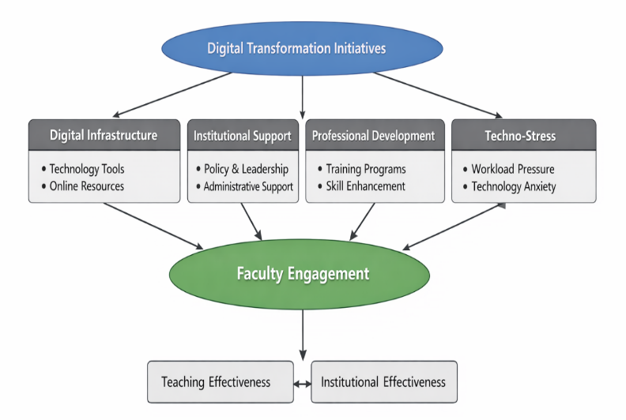
- Conceptual Framework of Digital Transformation and Faculty Engagement in Higher Education

Research Methodology
This paper applies a structured combination of qualitative and quantitative methods to address the issue of faculty engagement in the context of digital transformation in the post-pandemic world of higher education. The methodology aims to reflect quantitative relationships between the main constructs, as well as qualitative insight into the experiences of the faculty.
It uses a sequential explanatory design with quantitative data analysis preceded by qualitative data interpretation to enhance researches result and increase validity. The topic's variables include digital infrastructure, institutional support, professional development, techno-stress, faculty engagement and organizational commitment. Diversity and representativeness of data is achieved by having it gathered from faculty members at various higher education institutions. In order to guarantee analytical rigor, statistical and structural modeling methods are combined in the study: correlation analysis, multiple regression, and Partial Least Squares Structural Equation Modelling (PLS-SEM). It allows for the analysis of measurement reliability, structural relationships, and mediation effects, thereby offering a holistic perspective on the relationship between digital transformation and various institutional outcomes and faculty engagement.
The overall framework of the research methodology is shown in figure 2, which highlights the process of data collection, sampling and analysis. This overall framework renders the methodological approaches transparent, and emphasizes the use of qualitative and quantitative methods. Triangulation enhances the validity and reliability of the findings through the combination of the two strategies.
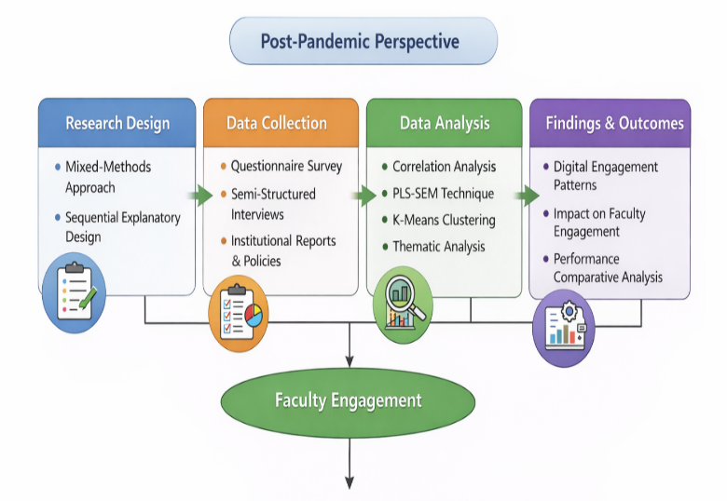
- Research Methodology Framework for Analysing Digital Transformation and Faculty Engagement

Research Design
This study was categorized as mixed method research design with sequential explanatory method, which applied quantitative method and through qualitative interpretation. With this design, statistical relationships between the various digital transformation factors and faculty engagement can be identified as well as contextual factors derived from faculty experiences.
The structure of the research is empirical testing the proposed hypotheses based on the conceptual framework. The quantitative inputs are used to analyze the strength and significance of relations between variables, with supporting explanations being done using qualitative inputs.
The design features an enabling factor (digital infrastructure, institutional support, and professional development) as well as an inhibiting factor (techno-stress) to capture its impact on faculty engagement and organizational outcomes together. The research design blends statistical modelling with interpretative analysis, fostering analytical rigor while also hosting practical relevance, and thus provides a comprehensive understanding of faculty engagement in the context of new digitally transformed HE contexts.

Data Collection and Sample
Structured questionnaires were used to gather primary data for this work that was distributed to faculty members in several higher education institutions. Stratified random sampling was used to get enough and a fair representation from various academic disciplines, various types of institution and various types of faculty. This way the findings are less biased as they include the entire range of the population, and more applicable to the community. In the end 224 respondents were included, which was suitable for researchers to complete structural equation modelling.
The questionnaire scale items aimed to assess items related to the different constructs, such as digital infrastructure, institutional support, professional development, techno-stress, faculty engagement and organizational commitment on the five-point Likert scale. Semi-structured interviews were then used with a subset of participants to gain deeper insights into faculty experiences and problems in digitally transformed environments. The use of quantitative and qualitative data makes the study reliable and valid by applying the method of triangulation and can provide a comprehensive picture of the research problem.

Variables and Measurement
The study investigates the role and power of digital transformation factors to impact faculty engagement on various measures. The independent variable factors are professional development, institutions support and digital infrastructure, whereas the factor of techno-stress is negative one of the influencing factors. Facility engagement is defined as a dependent variable and organizational commitment is defined as outcome variable. Items on the measurement were modified from the literature and rated on a 5-point Likert scale. Cronbach's alpha, composite reliability (CR) and average variance extracted (AVE) were used to assess reliability and validity, with acceptable levels. Multiple regression models and structural equation modelling are used to model the relationship between variables. The relationship between digital transformation factors and faculty engagement is expressed in (1), where $FE$denotes faculty engagement, $DI$represents digital infrastructure, $IS$indicates institutional support, $PD$refers to professional development, and $TS$denotes techno-stress. The term $β_{0}$represents the intercept, $β_{1}$to $β_{4}$are the regression coefficients corresponding to each predictor variable, and $ϵ$denotes the error term.
The structural relationships among latent constructs are represented in (2), where $η$denotes endogenous latent variables such as faculty engagement and organizational outcomes, and $ξ$represents exogenous latent variables corresponding to digital transformation factors. The matrix $B$defines the relationships among endogenous variables, $Γ$captures the effects of exogenous variables on endogenous constructs, and $ζ$represents the structural error term.
${FE}_{i}= β_{0}+{ β}_{1}{DI}_{i} + β_{2}{Is}_{i} +{ β}_{3}{PD}_{i} + β_{4}{TS}_{i} +{ ϵ}_{i}$ (1)
$η = Bη + Γξ + ζ$ (2)
The relationship between the factors of digital transformation and the faculty engagement is represented by a structural equation model in Figure 3. This model allows for assessments of the measurement and structural elements of the proposed model.
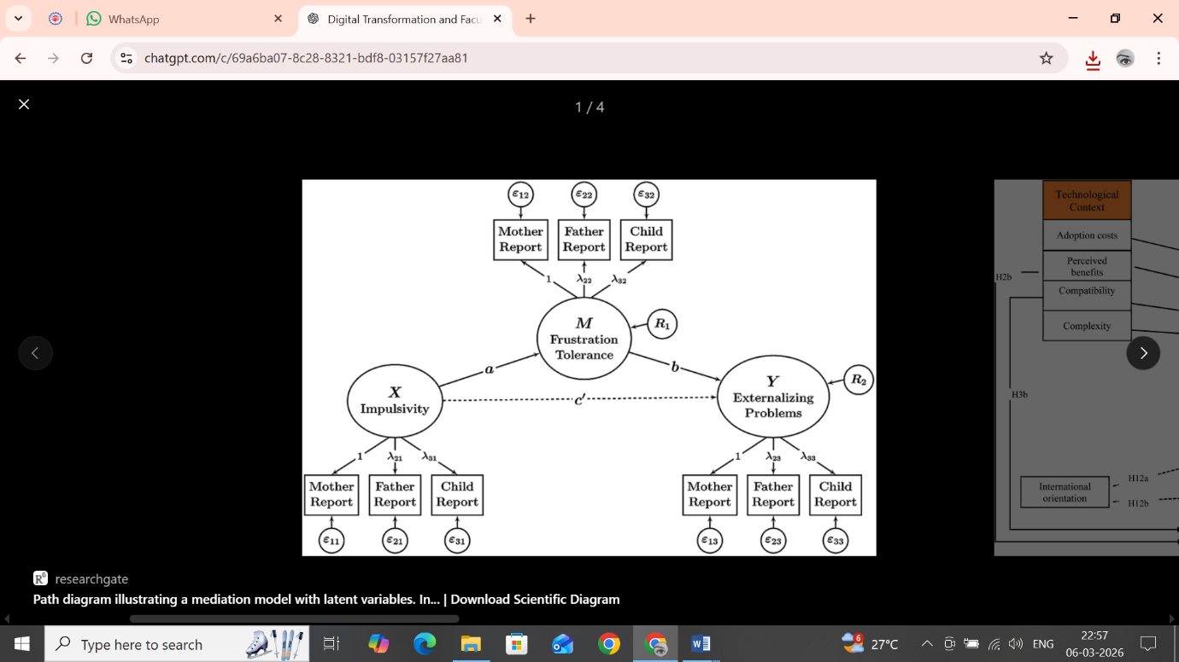
- Structural Equation Model (SEM) Showing the Relationship between Digital Transformation Factors and Faculty Engagement

Data Analysis Techniques
Data analysis was carried out using a combination of statistical and structural modelling techniques to evaluate the proposed relationships. Descriptive statistics were used at first to summarize the content of the dataset and its overview on major variables in the data. This was followed by correlation analysis to assess the strength and direction of relationships between the digital transformation factors and faculty engagement. A multiple regression analysis was then undertaken to evaluate the effect of the independent variables (digital infrastructure, institutional support, professional development, and techno-stress) on the faculty engagement. This step allowed the most important predictors and their contribution to be identified.
Partial Least Squares Structural Equation Modelling (PLS-SEM) was then used to further validate the proposed model. This method can be applied to the analysis of complicated relationships among multiple latent constructs and intervening variables. The reliability and validity indicator Cronbach's alpha, composite reliability, and average variance extracted were used to test the measurement model. Structural model was evaluated by using path coefficients (β), t-values, p-values and coefficient of determination (R²).
The overall methodology outlined is a methodical and trustworthy way to explore the link between digital transformation and faculty engagement. The use of a 'mixed methods' design with adequate statistical and structural modelling methodology, adds to the precision in the analysis and a contextual depth to the study. Use of instrumental stratification and validated measurement structures increases the credence and generalization of the results. Moreover, through applying the PLS-SEM it was possible to evaluate complex relationships, such as mediating effects in the model. This methodological approach guarantees the quality of the outcomes, in terms of being both empirically valid and practically relevant to an understanding of faculty engagement in digitally transformed higher education environments.

Result and Discussion
The study incorporates descriptive statistics and testing through multiple regression model, correlation analysis and PLS-SEM, in attempt to validate the proposed model based on the data gathered from 224 faculty members. The second phase involves regression analysis and structural modeling of the hypotheses to be tested and to assess the strength of the relationships that were identified.
Tables and figures are used clearly to present statistical results and/or model structures. The discussion synthesizes the findings and relates them to the prevailing theories to explain the importance of digital transformation for faculty engagement, and how this engagement affects organizational commitment and institutional effectiveness in a world emerging from the pandemic and the current educational landscape.

Descriptive Analysis
On a 5-point Likert scale, mean values above 3.5 indicate a high level. Faculty engagement (Mean = 3.89) and digital infrastructure (Mean = 3.84) are high, while techno-stress (Mean = 2.91) is moderate. The distribution of all key variables is described in Table I, with the mean value of each being close to the median in acceptable ranges, representing consistency of the responses.
- Descriptive Statistics of Key Variables
Variable | Mean | Standard Deviation | Minimum | Maximum
Digital Infrastructure (DI) | 3.84 | 0.72 | 2.10 | 4.90
Institutional Support (IS) | 3.67 | 0.81 | 2.00 | 4.85
Professional Development (PD) | 3.52 | 0.76 | 1.95 | 4.75
Techno-Stress (TS) | 2.91 | 0.69 | 1.80 | 4.20
Faculty Engagement (FE) | 3.89 | 0.70 | 2.25 | 4.95

Correlation and Regression Analysis
A significant positive correlation between faculty engagement and digital infrastructure (r = 0.68), institutional support (r = 0.72), and professional development (r = 0.65) is found, and a significant negative correlation is found between faculty engagement and techno-stress (r = −0.47). The correlation matrix of the variables is presented in table II and the results indicate the expected relationships among the variables. All correlations are statistically significant and in the expected direction, supporting preliminary relationships among variables and justifying further regression analysis.
The regression results also show that institutional support (β = 0.41) is the strongest predictor of faculty engagement, followed by digital infrastructure (β = 0.34), professional development (β = 0.29), and finally a negative impact of techno-stress (β = −0.22). The model explains 63% of the variance (R² = 0.63). Table III summarizes the results of the regressions that were used to confirm the hypotheses of the study (H1 – H4). Multicollinearity was assessed using Variance Inflation Factor (VIF), and all values were below 5, indicating no multicollinearity issues.
- Correlation Matrix
Variables | DI | IS | PD | TS | FE
DI | 1.00 | 0.61** | 0.54** | -0.32** | 0.68**
IS | 0.61** | 1.00 | 0.59** | -0.28** | 0.72**
PD | 0.54** | 0.59** | 1.00 | -0.21* | 0.65**
TS | -0.32** | -0.28** | -0.21* | 1.00 | -0.47**
FE | 0.68** | 0.72** | 0.65** | -0.47** | 1.00
**Note: *p < 0.05, p < 0.01
- MULTIPLE REGRESSION RESULTS (DEPENDENT VARIABLE: FACULTY ENGAGEMENT)
Predictor Variable | Coefficient (β) | Standard Error | t-value | Significance (p)
Digital Infrastructure (DI) | 0.34 | 0.05 | 6.82 | 0.001
Institutional Support (IS) | 0.41 | 0.06 | 7.21 | 0.001
Professional Development (PD) | 0.29 | 0.05 | 5.94 | 0.002
Techno-Stress (TS) | -0.22 | 0.04 | -4.88 | 0.003
Model Statistics | R² = 0.63 |  | F = 42.5 | p < 0.001

Structural Model Analysis (PLS-SEM)
The results of PLS-SEM indicate the internal consistency and validity of the measurement model due to the indicators that meet the recommended threshold (CR > 0.85, AVE > 0.60). Bootstrapping with 5000 resamples was performed to assess the significance of path coefficients. The findings suggest that faculty engagement significantly influences organizational commitment (β = 0.58, p < 0.01) and institutional effectiveness (β = 0.49, p < 0.01). All measurement model indicators satisfied recommended thresholds, confirming convergent validity and reliability.
Path model results are presented in Figure 4, which depict the structural model. The results confirmed the mediating effect of faculty engagement between digital transformation and institutional outcomes, and consequently, this supports H5–H7.
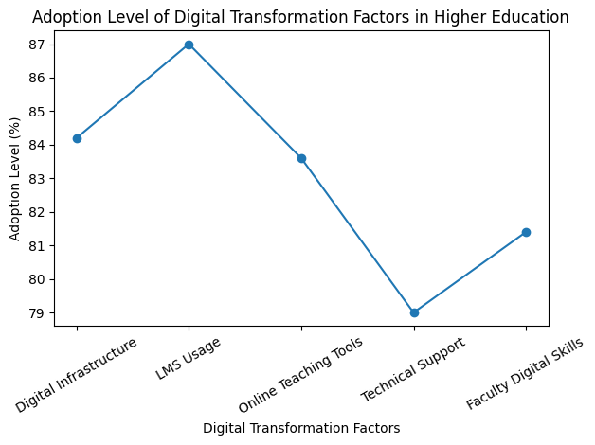
- Structural Model Results of Digital Transformation and Faculty Engagement

Digital Transformation and Engagement Levels
A high level of digital transformation adoption is reflected in the extensive use of learning management systems and online teaching tools, along with moderately high institutional support. As shown in Figure 5, digital transformation factors demonstrate strong adoption levels, with some variation in support mechanisms.
Similarly, faculty engagement is highest in instructional activities, followed by digital innovation and collaborative learning. Figure 6 presents the distribution of faculty engagement dimensions, indicating higher engagement in core academic responsibilities compared to participation in institutional activities.
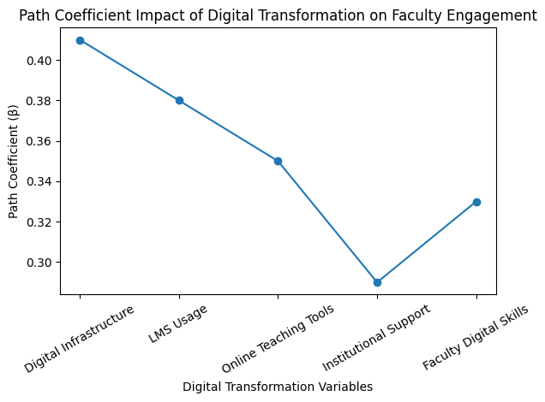
- Digital Transformation Levels in Higher Education
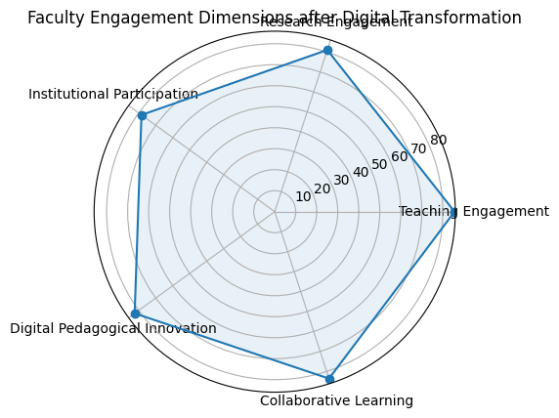
- Faculty Engagement Dimensions after Digital Transformation
The results indicate that institutional support is the primary driver of faculty engagement and does not depend on technology. Institutional policies and support systems are significant in enabling the positive impacts of digital infrastructure and professional development to contribute to engagement.
Excessive digital demands and techno-stress negatively impact engagement, which aligns with the Job Demands–Resources (JD-R) model, where increased job demands reduce engagement. Results also follow the trends of the perceived ease of use, perceived usefulness and perceived intrinsic motivation in faculty behaviors as described in the TAM and SDT.
In general, the study shows that engaging faculty is a significant mediating variable between digital transformation and organizational commitment and institutional effectiveness, highlighting the importance of developing human-centered digital strategies in higher education institutions.
The findings highlight that institutional support is a stronger determinant of faculty engagement than technological factors, suggesting that organizational policies and leadership play a critical role in digital transformation success. This aligns with prior studies [11], [14], which emphasize institutional readiness over technological availability. The negative impact of techno-stress reinforces the need for balanced digital adoption strategies. These results provide practical implications for higher education institutions to prioritize faculty-centric policies alongside technological investments.

Conclusion
The study examined the role of digital transformation in enhancing teacher engagement and organizational outcomes in higher education post-Covid-19, based on the theory-integrated approach. The results support statements that digital infrastructure and institutional support positively influence faculty engagement, and that technostress has a negative impact on faculty engagement. Institutional support was the most powerful predictor with organizational mechanisms taking a more important role than technology. The outcomes further confirm that the role of the faculty engagement is a significant intermediary relationship between digital transformation and organizational commitment and institutional effectiveness. It's a reminder to institutions to look beyond the technology itself and develop an environment that would allow effective use. The study design was cross-sectional and used self-reported data, which have limitations in making causal inferences or introducing response bias. Also, the sample is limited to a specific type of higher education, preventing generalizations. Longitudinal studies are suggested in future to investigate engagement over time and include cross-institutional or international study settings. Other factors, like leadership styles, faculty well-being, and digital competencies can also be included in further studies, offering a more complete picture of the engagement dynamics.

References

- J. A. García Camargo, J. D. Niño Torres, J. A. López-Castiblanco, L. K. Herrera-Quintero, and J. I. Bula Escobar, “Digital Transformation: Perspectives and Post-Pandemic Adaptation in the Education Sector – A Case Study,” Ingeniería e Investigación, vol. 44, no. 3, p. e112661, Jan. 2025, doi: https://doi.org/10.15446/ing.investig.112661.
- ‌C. Tuffnell, “Digital transformation of post-pandemic learning and teaching: Utilising TPACK to support educator development in a flipped learning pilot,” vol. 3, no. 2, Jun. 2023, doi: https://doi.org/10.21428/8c225f6e.6f043b79.
- ‌K. Brodie, A. Joffe, S. Dukhan, S. Godsell, D. de Klerk, and K. Padayachee, “From pandemic disruption to post-pandemic transformation: New possibilities for teaching in South African higher education,” South African Journal of Higher Education, vol. 36, no. 4, pp. 66–84, 2022, doi: https://doi.org/10.20853/36-4-5180.
- ‌ K. Dolenc, A. Šorgo, and M. Ploj, “Perspectives on Lessons From the COVID-19 Outbreak for Post-pandemic Higher Education: Continuance Intention Model of Forced Online Distance Teaching,” European Journal of Educational Research, vol. 11, no. 1, pp. 163–177, Jan. 2022, doi: https://doi.org/10.12973/eu-jer.11.1.163.
- ‌C. Rapanta, L. Botturi, P. Goodyear, L. Guàrdia, and M. Koole, “Balancing technology, pedagogy and the new normal: Post-pandemic challenges for higher education,” Postdigital Science and Education, vol. 3, no. 3, pp. 715–742, Aug. 2021, doi: https://doi.org/10.1007/s42438-021-00249-1.
- ‌A. Rof, A. Bikfalvi, and P. Marques, “Pandemic-accelerated Digital Transformation of a Born Digital Higher Education Institution: Towards a Customized Multimode Learning Strategy,” Educational Technology & Society, vol. 25, no. 1, pp. 124–141, Jan. 2022.
- ‌S. Sahni, S. Verma, and R. Pratap, “Understanding digital transformation challenges for online learning and teaching in higher education institutions: a review and research framework,” Benchmarking, May 2024, doi: https://doi.org/10.1108/bij-04-2022-0245.
- ‌S. Subiyantoro, “Transformative online learning post-pandemic: challenges, opportunities, and future trends,” Jurnal Pekommas, vol. 9, no. 1, pp. 29–39, Jun. 2024, doi: https://doi.org/10.56873/jpkm.v9i1.5233.
- ‌H. Munir, “Reshaping Sustainable University Education in Post-Pandemic World: Lessons Learned from an Empirical Study,” Education Sciences, vol. 12, no. 8, p. 524, Aug. 2022, doi: https://doi.org/10.3390/educsci12080524.
- ‌S. Sangwa, A. Butera, and P. Mutabazi, “Digital Transformation of Higher Education: A Post-COVID Review of Adoption, Quality Assurance, and Governance Challenges,” SSRN Electronic Journal, 2025, doi: https://doi.org/10.2139/ssrn.5368756.
- ‌Walter Leal Filho et al., “Digital transformation and sustainable development in higher education in a post-pandemic world,” International Journal of Sustainable Development and World Ecology, pp. 1–16, Jul. 2023, doi: https://doi.org/10.1080/13504509.2023.2237933.
- ‌V. Ahmed, C. Anane, Ayman Alzaatreh, and S. Saboor, “Faculty perception of online education: considerations for the post-pandemic world,” Frontiers in education, vol. 8, Nov. 2023, doi: https://doi.org/10.3389/feduc.2023.1258980.
- ‌A. Deroncele-Acosta, M. L. Palacios-Núñez, and A. Toribio-López, “Digital Transformation and Technological Innovation on Higher Education Post-COVID-19,” Sustainability, vol. 15, no. 3, p. 2466, Jan. 2023, doi: https://doi.org/10.3390/su15032466.
- ‌A. Nguyen, Lý Thị Trần, and B.-H. Duong, “Higher education policy and management in the post-pandemic era,” Policy Futures in Education, vol. 21, no. 4, pp. 330–334, Mar. 2023, doi: https://doi.org/10.1177/14782103231158171.
- ‌K. Gonzalez, “Digital Transformation and Teacher Competencies in Higher Education: A Post-pandemic Analysis,” ISSN: 2435-9467 – The Barcelona Conference on Education 2024: Official Conference Proceedings, pp. 811–824, Feb. 2025, Accessed: May 06, 2026.
- ‌F. Qureshi, S. Khawaja, Mirjana Pejić Bach, and Maja Meško, “Slovenian Higher Education in a Post-Pandemic World: Trends and Transformations,” Systems, vol. 12, no. 4, pp. 132–132, Apr. 2024, doi: https://doi.org/10.3390/systems12040132.
- ‌LM Luvalo, “post-pandemic higher education: systematic review of implications and approaches on teaching and learning,” Zenodo, Jul. 2024, doi: https://doi.org/10.5281/zenodo.15258199.
- ‌Helena Vallo Hult, Christian Master Östlund, P. Pålsson, and Katarina Jood, “Designing for digital transformation of residency education – a post-pandemic pedagogical response,” BMC Medical Education, vol. 23, no. 1, Jun. 2023, doi: https://doi.org/10.1186/s12909-023-04390-2.
- ‌Karim, A. M., Chowdhury, T. I., & Karim, A. M. (2024). Study on comparative adaption of educational tools in the institute of higher education: Post pandemic perspective. International Journal of Academic Research in Business and Social Sciences.[online], 14(1), 325-338.
- Ashour, S., El-Refae, G. A., & Zaitoun, E. A. (2021). Post-pandemic higher education: Perspectives from university leaders and educational experts in the United Arab Emirates. Higher Education for the Future, 8(2), 219-238.

