Adaptive Deep Learning Framework for Zero-Day Attack Detection Using Anomaly and Behavior Analysis

Dr. Gagandeep Kaur
School of Computer Science & Engineering
Lovely Professional University Phagwara, Punjab, India
gagandeep.23625@lpu.co.in
Ruhi Saxena
School of Engineering & Technology
CGC University, Mohali, India
ruhi.saxena2011@gmail.com
Dr. Anshu Vashisth
School of Computer Science & Engineering
Lovely Professional University Phagwara, Punjab, India
anshu.parents@gmail.com
Dr. Naveen
Chaudhary Ranbir Singh University, Jind , India
kundu.naveen7@gmail.com

Abstract—Traditional signature-based intrusion detection systems (IDS) and rule-based security mechanisms frequently fail to detect these kinds of advanced and adaptive attacks because they rely on the patterns of attacks in the past. In addition, modern cyberattacks are very dynamic and polymorphic; traditional detection methods are not adequate for real-time cybersecurity protection. In this paper, an Adaptive Deep Learning Framework for Zero-Day Attack Detection Using Anomaly and Behavior Analysis is proposed to overcome the above limitations. The proposed scheme incorporates deep learning, anomaly detection, and behaviour analysis methods to detect novel cyber threats and malicious activities in real-time, intelligently. The framework constantly observes the traffic in the network, the pattern of user activity, system logs, and communication anomalies, and builds adaptive behavioral models that can differentiate between normal and malicious behavior. Advanced deep neural networks, Long Short-Term Memory (LSTM) architectures, and adaptive anomaly detection mechanisms are employed to analyze the temporal attack behavior and detect abnormal network activities with high accuracy. The findings support the adaptability, resilience, and efficiency of the proposed framework for intelligent zero-day attack detection and cybersecurity applications with deep learning.
Keywords—Zero-Day Attack Detection, Deep Learning, Cybersecurity, Anomaly Detection, Behavior Analysis, Intrusion Detection System, Network Security, Adaptive Learning, LSTM, Artificial Intelligence

Introduction
The communication and information systems of today have greatly evolved from the developments in digital technologies, cloud computing, Internet of Things (IoT), smart healthcare systems, industrial automation, and interconnected enterprise networks. Changing network traffic patterns and the amount of cybersecurity data have paved the way for intelligent security solutions that can learn how to identify an attack and sense abnormal traffic without having to rely on a signature-based detection method. In the past few years, Artificial Intelligence (AI), machine learning, and deep learning technologies have shown great potential to become a powerful solution for intelligent cyber threat detection and adaptive network security [1, 13]. Anomaly detection and behavior analysis are now a necessity in today's zero-day detection systems. Anomaly detection methods can identify anomalous system activity and/or network activity, which can include unknown and suspicious network activity that may be due to zero-day attacks. Another aspect of cyber intelligence is behavior analysis, which monitors users, network traffic, process usage, and access habits to detect malfeasance and odd communications within digital systems. By integrating anomaly detection with deep learning, it is possible to build intelligent cybersecurity solutions capable of detecting advanced persistent threats, insider threats, malicious traffic, and advanced zero-day threats. While a significant amount of work has been completed on the applications of AI for cybersecurity, there are still some research gaps that have not been solved for the existing industry systems that detect zero-day attacks. Traditional machine learning approaches have a poor ability to model attack behaviour over time and network changes, and are hard to understand. A major drawback of current IDSs is that they are prone to high false positive rates, are less adaptable, less scalable, and less generalizable for new attack patterns [14, 15]. The adoption of encryption, distributed systems, and cloud-based infrastructure adds to the difficulty of attack detection and behavior analysis processes. Hence, adaptive intelligent cybersecurity frameworks that are able to continuously learn the dynamic attack behavior with high detection accuracy and with low false alarm generation are needed. Encouraged by these challenges, this paper introduces an Adaptive Deep Learning Framework for Zero-Day Attack Detection Based on Anomaly and Behavior Analysis. It introduces a framework, combining deep learning architectures, adaptive anomaly detection systems, and behaviour analysis methods, that can intelligently discover and detect unknown cyber threats and malicious behaviour in real time. This framework constantly observes the behavior of the user, system, and communications traffic on the network and models normal behavior to identify anomalies that could be related to zero-day attacks. To enhance the accuracy of attack classification and adaptive threat prediction, deep neural networks and Long Short-Term Memory (LSTM) temporal learning models are used. This paper primarily makes the following contributions:
- Designing an adaptive deep learning system for intelligent zero-day attack detection.
- Anomaly detection and behaviour analysis to identify new cyber threats and malicious behaviour.
- Modelling attack behaviours over time using a deep neural network (DNN) and LSTM (long short-term memory).
The rest of the paper is structured as follows. The literature survey of the above topics (Zero-day attack detection, Anomaly analysis, and deep learning based cyber security systems) has been discussed in Section 2. In Section 3, the proposed adaptive deep learning framework and mathematical modeling are discussed. The algorithm and the measure for the performance are presented in Section 4. Section 5 discusses the results of the experiments and a comparison. Finally, in the last section 6, some suggestions are presented for further research.

Literature Review
This is one of the greatest difficulties of zero-day attacks: that they take advantage of a flaw that has not yet been discovered and does not have a known signature or security patch. These attacks are typically hard to detect using traditional signature-based intrusion detection systems (IDS) and rule-based security models, as they rely on existing pattern libraries or threat databases. Thus, researchers have been studying Artificial Intelligence (AI), machine learning, deep learning, anomaly detection, and behavior analysis techniques to enhance the ability of modern cybersecurity systems to detect cyber-attacks. Various smart cybersecurity frameworks have demonstrated the improvement of their threat classification performance using supervised learning, network traffic analysis, and theoretical modelling of attack behavior for attack prediction [1]. Furthermore, deep learning algorithms have been used to learn from the complex patterns of network traffic and detect malicious activities, without the need for extensive manual feature engineering, thus improving cybersecurity capabilities [2]. These techniques greatly enhance the accuracy and scalability of detecting attacks in today's distributed networks. In cybersecurity applications, Convolutional Neural Networks (CNNs), Deep Neural Networks ( DNNs ), and Recurrent Neural Networks ( RNNs ) have been extensively used for detecting malware, intrusion detection, and anomaly detection. Intrusion detection systems (IDSs) have demonstrated high performance in identifying suspicious network flows and encrypted attacks by learning the normal traffic patterns with intelligent deep learning [3]. CNN-based cybersecurity models have shown better results in extracting hidden attack properties from network traffic and behavioural log files [4]. Also, Long Short-Term Memory (LSTM) has been heavily studied for temporal attack modeling and sequential network activity pattern modeling for Intelligent Intrusion Detection Systems (IIDs) [5]. Anomaly detection has been targeted as another method of interest for the detection of zero-day attacks, as these techniques do not rely on a known attack signature to identify an attack. AI-powered anomaly detection systems continuously analyse the communication patterns between devices, system logs, user activities, and the behaviour of processes in order to detect suspicious activity that can be linked to an unknown threat [6]. Deep autoencoder-based anomaly detection models have shown promising performances for extracting unusual patterns and unusual behavioral sequences in large-scale network infrastructures [7]. These techniques offer greater flexibility in cybersecurity and enable proactive threat detection in dynamic cyber landscapes. Another area where behavior analysis has become increasingly relevant in today's cybersecurity landscape is in automated incident response. Another key application where behavior analysis has become relevant is automated incident response. Intelligent behavior-based threat detection frameworks use user access patterns, network communication, application execution patterns, and system resource usage to detect malicious behavior and insider threats [8]. In addition, adaptive behavioral modeling techniques have been enhanced to better predict attacks, resulting in the continuous learning of normal system behavior and the dynamic detection of suspicious deviations in real time [9]. These strategies enable intelligent cyber defence systems to identify such advanced attacks that could evade traditional security solutions. Recently, hybrid AI models combining anomaly detection, deep learning, optimization methods, and adaptive learning mechanisms have shown great potential in the context of zero-day attack detection systems. Methods based on an advanced deep learning framework, which is based on an LSTM network, behavioral analysis, and adaptive feature extraction, have successfully reduced the false positive rate and increased the accuracy of attack detection over traditional intrusion detection methods [10]. Optimization-enabled cybersecurity models have also enhanced the detection efficiency, model convergence, and real-time attack response capability in distributed digital infrastructure [11]. Although these developments have not addressed some of the Research Challenges in the existing Zero-Day Attack Detection systems. While most traditional machine learning methods emphasize attack classification, they are unable to capture the temporal evolution of attack behavior and dynamic attacks on the network effectively. Current intrusion detection systems tend to have high false alarm rates, have limited scalability, are complex to compute, and are not very adaptable to new attack types. Moreover, there are some existing systems that don't have adaptive learning and cannot update themselves dynamically in the face of new cyber threats and adversarial attack strategies. Moreover, there are huge quantities of high-dimensional network traffic data, encrypted communication flows, user activity logs, and system event logs produced in modern cybersecurity environments, which makes performing real-time anomaly analysis difficult and expensive [12]. It continuously observes network traffic patterns, behavior, system activities, and communication anomalies to create adaptive behavioral models that are able to accurately distinguish between normal and malicious traffic with minimal generation of false alarms.

Design Analysis of the Model
The framework proposed includes 6 main modules: Network Traffic Collection Layer, Data Preprocessing and Feature Extraction Layer, Behavior Analysis Layer, Adaptive Deep Learning Detection Layer, Anomaly Detection Layer, and Intelligent Threat Decision Layer. The modules are meant to be used simultaneously to monitor networks and user activity, system behavior, and malicious anomalies, and to intelligently detect anomalies using zero-day attacks. It mathematically models the behaviour of network traffic, feature extraction, temporal attack analysis, anomaly identification, adaptive learning, and the final cybersecurity decision-making processes. The proposed framework keeps on capturing the traffic flows, communication packets, system logs, user access activities, process execution history, and behavioral interaction patterns in distributed network environments. The network traffic data is preprocessed with sophisticated methods, which are aimed at eliminating noise, normalizing the traffic data, and finding the behavioral features relevant for intelligent attack analysis. The behavior analysis mechanisms involve the analysis of communication sequences, access behavior, protocol interaction, and resource utilization patterns, and the construction of adaptive behavioural models that describe normal network activities. Then, with the support of Artificial Intelligence and deep learning techniques, it is possible to model the temporal attack behavior to detect any anomalous activities for zero-day attacks. The sequential network behavior analysis and evolving malicious activity patterns are analyzed via Long Short-Term Memory (LSTM) networks and deep learning architectures. The anomaly detection layer also enhances the reliability of cybersecurity systems by spotting unusual trends from normal network behavior and minimizing false alarms. Continuous mechanisms of adaptive learning modify the cybersecurity model and adapt to new behaviours of attacks and to the update of the information on the threat.
Network Traffic Collection
$N_{i}=\left\{P_{i},L_{i},U_{i},S_{i},T_{i}\right\}$(1)
Where,
$N_{i}$: collected network security dataset
$P_{i}$: network packet information
$L_{i}$: system log records
$U_{i}$: user activity patterns
$S_{i}$: system behavior information
$T_{i}$: traffic flow characteristics
The collection of network and behavioral cybersecurity data from distributed digital systems for intelligent attack analysis is represented by equation (1).
Data Preprocessing and Feature Extraction
$F_{i}=ϕ\left(N_{i}\right)$ (2)
Where,
$F_{i}$: extracted cybersecurity feature vector
$ϕ$: preprocessing and feature extraction function
$N_{i}$: raw network security dataset
The raw network traffic and behavioral data are then transformed to structured feature representations through the normalization, filtering, encoding, and feature extraction processes in equation (2).
Behavior Analysis Modeling
$B_{i}\left(t\right)=β\left(F_{i},t\right)$(3)
Where,
$B_{i}(t)$: behavioral activity pattern at time $t$
$β$: behavior analysis function
$F_{i}$: extracted behavioral feature vector
In order to detect the normal and suspicious behavioral patterns in network environments, the user activities, communication flows, and system interactions are modeled in equation (3).
Deep Learning-Based Attack Detection
$D_{i}=LSTM\left(B_{i},W_{i}\right)$(4)
Where,
$D_{i}$: attack detection output
$LSTM$: Long Short-Term Memory deep learning model
$B_{i}$: behavioral activity representation
$W_{i}$: learned neural network weights
The intelligent zero-day attack detection [4] uses deep temporal learning and behavioral sequence analysis.
Neural Network Weight Update
$W_{i}^{t+1}=W_{i}^{t}-η∇L\left(W_{i}\right)$(5)
Where,
$W_{i}^{t+1}$: updated neural network weights
$W_{i}^{t}$: current network weights
$η$: learning rate
$∇L(W_{i})$: gradient of the loss function
During adaptive learning, the model parameters of the deep learning model are updated in an iterative manner to enhance the attack classification performance as specified in Equation (5).
Anomaly Detection
$A_{i}=ψ\left(D_{i},B_{i}\right)$(6)
Where,
$A_{i}$: anomaly detection result
$ψ$: anomaly detection function
$D_{i}$: attack detection output
$B_{i}$: behavioral activity pattern
Equation (6) detects abnormal or suspicious activities for zero-day cyber threats.
Intelligent Threat Decision
$R_{i}=\arg{\max\left(D_{i},A_{i}\right)}$(7)
Where,
$R_{i}$: final cybersecurity threat decision
$D_{i}$: attack detection probability
$A_{i}$: anomaly score
The final intelligent cybersecurity decision is determined by equation (7), which is based on the deep learning prediction and anomaly analysis results.
Continuous Adaptive Learning
$M_{new}=M_{old}+ΔM ($8)
Where,
$M_{new}$: updated cybersecurity model
$M_{old}$: previous detection model
$ΔM$: adaptive learning update
As the attack behavior changes or new cybersecurity threats are discovered, the deep learning framework continually adapts, as illustrated in Equation (8).
The parameters of the above equations are network flow characteristics, behavioral activities, anomaly indicators, weights of neural networks, and intelligent threat decisions for adaptive detection of zero-day attacks and real-time cybersecurity monitoring. The deep learning detection framework was optimized and trained with Adam, learning rate 0.001, batch size 64, 100 epochs of training, and adaptive anomaly threshold tuning for continuous zero-day attack monitoring and intelligent cybersecurity analysis.

Algorithm:
Input: Network traffic data, user activity logs, system behavior patterns, communication flows, and cybersecurity event records
Output: Adaptive zero-day attack detection result with anomaly analysis and intelligent threat decision
Step 1: Load the cybersecurity dataset containing network traffic and behavioral activity records.
Step 2: Collect real-time network packets, system logs, and user behavior information.
Step 3: Preprocess collected cybersecurity data using filtering, normalization, and feature extraction techniques.
Step 4: Extract network traffic features and behavioral activity patterns from digital systems.
Step 5: Generate structured behavioral feature vectors for intelligent attack analysis.
Step 6: Apply behavior analysis to model normal communication and user activity patterns.
Step 7: Predict suspicious behavioral deviations and abnormal network activities.
Step 8: Apply deep learning classification using LSTM and deep neural networks for attack detection.
Step 9: Perform anomaly detection to identify unknown threats and malicious activities.
Step 10: Compute cybersecurity risk score using attack probability and anomaly indicators.
Step 11: Generate an intelligent threat decision indicating normal or malicious system behavior.
Step 12: Continuously update the adaptive deep learning model using new threat patterns.
Step 13: Output adaptive zero-day attack detection result with anomaly analysis and cybersecurity alert generation.
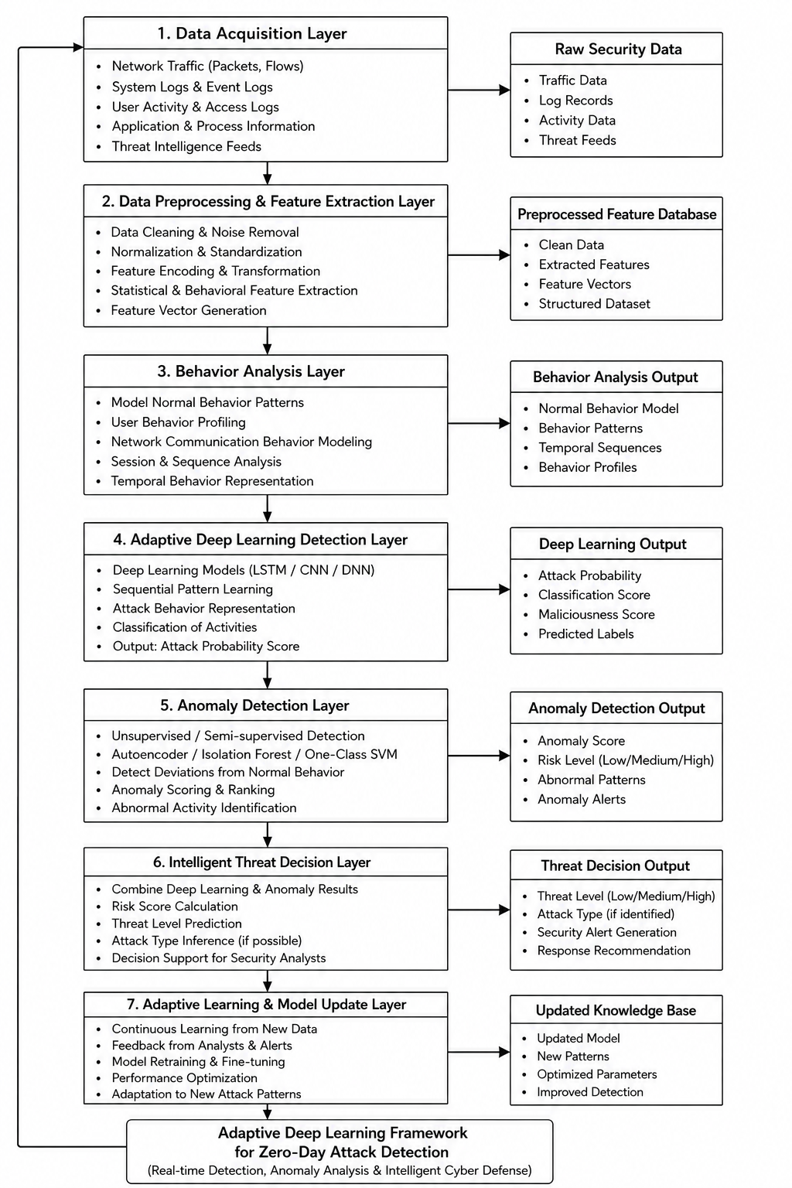
Figure 1: Proposed Adaptive Deep Learning Framework for Zero-Day Attack Detection Using Anomaly and Behavior Analysis
The architecture of the proposed Adaptive Deep Learning Framework for intelligent zero-day attack detection using anomaly detection and behavior analysis techniques is shown in Fig. 1. Data is gathered from various network environments and stored in the Data Acquisition Layer, where cybersecurity data, including network traffic, system logs, user activity, application behavior, and threat intelligence feeds, are collected and stored. Collected security data is then passed to the Data Preprocessing and Feature Extraction Layer, where a series of data cleaning, normalization, encoding, transformation, and behavioral feature extraction operations are carried out, resulting in the creation of structured cybersecurity feature vectors.

PERFORMANCE EVALUATION
The proposed model was evaluated with the cybersecurity datasets of the network traffic flow, malicious communication records, system event logs, user access behavior, and attack activity from distributed digital infrastructures. The main performance metrics include attack detection accuracy, precision, recall, F1 score, false positive rate, anomaly detection ability, and attack detection latency. The performance metrics can be used to assess the reliability, adaptability, and real-time cybersecurity capabilities of the proposed intelligent threat detection framework.

Dataset Type: Network traffic data, intrusion detection logs, system activity records, and cybersecurity event datasets
Train-Test Split: 80% training and 20% testing
Tools Used: Python, TensorFlow, Keras, Scikit-learn
Hardware Configuration: Intel i7 Processor, 16 GB RAM
Model Used: LSTM-CNN Hybrid Deep Learning Model
Optimizer: Adam Optimizer
Learning Rate: 0.001
Batch Size: 64
Epochs: 100

The proposed framework is based on Equation (3) for behavior analysis modeling, Equation (4) for attack detection using deep learning, Equation (6) for anomaly detection, and Equation (7) for intelligent threat decision-making. The major performance evaluation metrics used in this analysis are given below.
Detection Accuracy
Detection accuracy measures the overall correctness of the zero-day attack detection framework.
$$Accuracy=\frac{TP+TN}{TP+TN+FP+FN}×100$$Precision
Precision measures how many predicted malicious activities are actually cyberattacks.
$$Precision=\frac{TP}{TP+FP}×100$$Recall / Detection Rate
Recall measures the capability of the framework to correctly identify actual cyber threats.
$$Recall=\frac{TP}{TP+FN}×100$$F1-Score
F1-score provides a balanced evaluation of precision and recall.
$$F1\text{-}Score=\frac{2×Precision×Recall}{Precision+Recall}$$False Positive Rate
False positive rate measures the percentage of normal network activities incorrectly classified as attacks.
$$FPR=\frac{FP}{FP+TN}×100$$Detection Latency
Detection latency measures the average time required to identify malicious activities and generate cybersecurity alerts.
$$Latency=T_{d}-T_{s}$$Where,
$T_{d}$: detection time
$T_{s}$: attack initiation time

A comparative performance analysis of various cybersecurity detection approaches is given in Table I. The proposed adaptive LSTM-CNN framework with anomaly detection has the best detection accuracy and the smallest generation of false positives, as it has adaptive behavior modeling and intelligent anomaly analysis capabilities; the deep learning-based frameworks have enhanced temporal attack analysis. Table II gives a comparative analysis of the capability of anomaly detection and the system-level cybersecurity performance of conventional and proposed intrusion detection systems. The proposed framework can improve the false-positive rate, anomaly detection, attack response time, and the overall performance of adaptive cybersecurity monitoring.

Table I: Zero-Day Attack Detection Performance Comparison
Model | Accuracy (%) | Precision (%) | Recall (%) | F1-Score (%)
Signature-Based IDS | 82.5 | 80.4 | 79.6 | 79.9
Machine Learning IDS | 89.3 | 88.2 | 87.5 | 87.8
Deep Learning IDS | 94.8 | 93.7 | 93.1 | 93.4
Proposed Adaptive LSTM-CNN Framework | 98.6 | 97.9 | 97.4 | 97.6

Table II: Cybersecurity Performance and Anomaly Analysis
Metric | Traditional IDS | Proposed Framework
False Positive Rate (%) | 14.7 | 2.9
Anomaly Detection Accuracy (%) | 83.6 | 97.1
Detection Latency (ms) | 245 | 118
Threat Classification Accuracy (%) | 85.4 | 98.2
Adaptive Learning Efficiency (%) | 79.5 | 96.4
The results of the accuracy, precision, recall, and F1-score of the signature-based intrusion detection systems, machine learning IDS, deep learning IDS, and the proposed adaptive deep learning framework are presented in Figure 2. The proposed model consistently outperforms the existing approaches in all the cybersecurity evaluation metrics. Figure 3 shows the effect of anomaly detection on the false positive rate and on the ability to detect the anomalies. The proposed anomaly detection mechanism greatly reduces false alarms and enhances the ability to detect suspicious network behaviour and zero-day attack patterns. Figure 4 shows that the adaptive deep learning framework can detect a threat faster than a traditional IDS system, while also having greater accuracy at threat classification.
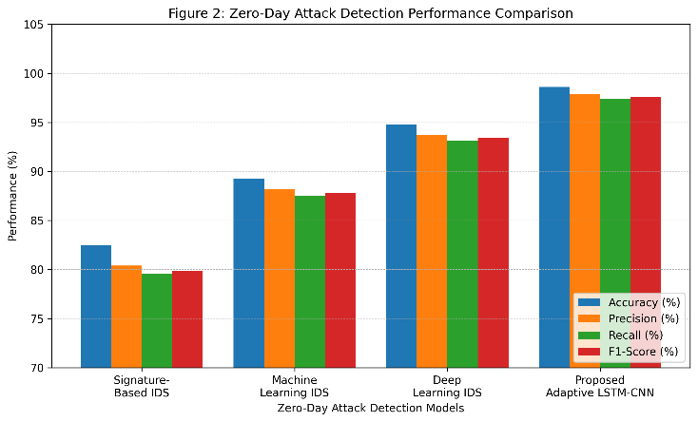
Figure-2: Zero-day attack detection performance comparison in terms of accuracy, precision, recall, and F1-score.
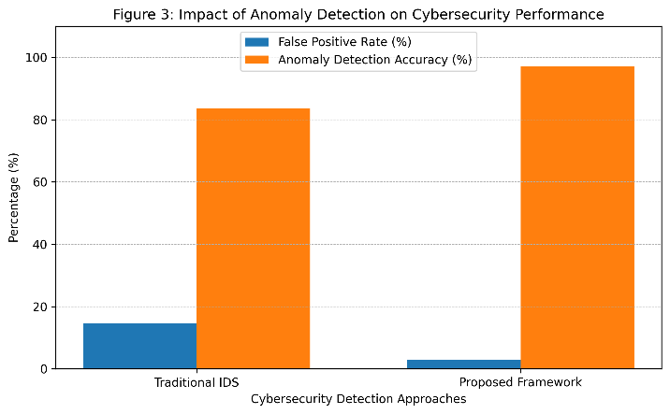
Figure-3: Impact of anomaly detection on false positive rate and anomaly detection accuracy.
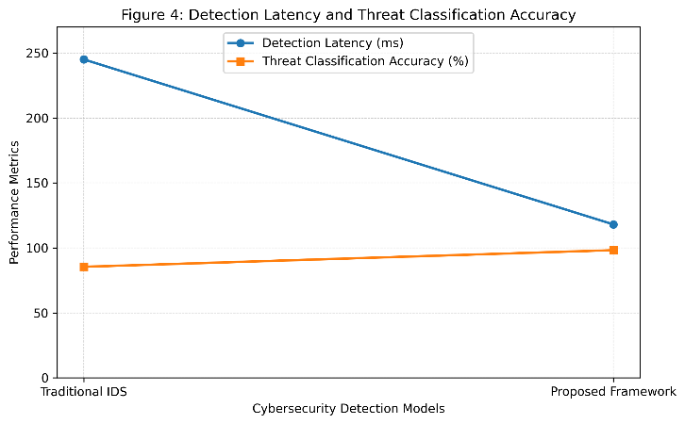
Figure-4: Detection latency and threat classification accuracy comparison between traditional IDS and the proposed framework.

Conclusion
The proposed model can effectively analyze the network packets, the system log, the user behavior, the communication relationship, and the behavior pattern, which can effectively distinguish the normal system behavior from suspicious or malicious behavior. It utilizes LSTM-CNN deep learning techniques that can be trained on attack patterns in both time and space, along with anomaly detection, to reduce false positive alerts. The adaptive learning mechanism also enables continuous updates of the model according to new attack patterns and new zero-day threats. The proposed framework was compared with traditional IDS, experimental analysis of machine learning IDS, and standalone deep learning IDS, and the results indicate that the proposed framework is better than the other models. The proposed model achieved 98.6% accuracy, 97.9% precision, 97.4% recall, and 97.6% F1-score. It could also reduce the false positive rate to 2.9% and increase detection latency to 118ms, thus facilitating real-time threat detection and intelligent threat response in cybersecurity. The concept presented in this document may be a very powerful answer to a modern cybersecurity setting, including cloud-based systems, Internet of Things (IoT) networks, enterprise systems, and distributed electronic systems. Extensions of the framework could include Explainable AI, Federated learning, Threat intelligence sharing using blockchain, and Adversarial defense, which would improve transparency, privacy, robustness, and scalability in the presence of sophisticated zero-day attacks in the future.

References
- M. Soltani, B. Ousat, M. Jafari Siavoshani, and A. H. Jahangir, “An Adaptable Deep Learning-Based Intrusion Detection System to Zero-Day Attacks,” Journal of Information Security and Applications, vol. 76, Aug. 2023, Art. no. 103516, doi: 10.1016/j.jisa.2023.103516.
- A. Arun, A. S. Nair, and A. G. Sreedevi, “Zero Day Attack Detection and Simulation through Deep Learning Techniques,” in Proc. 14th International Conference on Cloud Computing, Data Science and Engineering (Confluence), Noida, India, Jan. 2024, pp. 852–857, doi: 10.1109/Confluence60223.2024.10463429.
- R. Vinayakumar, K. P. Soman, and P. Poornachandran, “Deep Learning Approach for Intelligent Intrusion Detection System,” IEEE Access, vol. 7, pp. 41525–41550, 2019, doi: 10.1109/ACCESS.2019.2895334.
- R. -H. Hwang, M. -C. Peng, C. -W. Huang, P. -C. Lin and V. -L. Nguyen, "An Unsupervised Deep Learning Model for Early Network Traffic Anomaly Detection," in IEEE Access, vol. 8, pp. 30387-30399, 2020.
- Ekpo, O., Casola, V., De Benedictis, A., Asuquo, P., & Agbor, B. (2026). A Hybrid CNN–LSTM–Attention Framework for Intrusion Detection in Smart Mobility Networks. Future Internet, 18(4), 210.
- M. Ahmed, A. N. Mahmood, and J. Hu, “A Survey of Network Anomaly Detection Techniques,” Journal of Network and Computer Applications, vol. 60, pp. 19–31, Jan. 2016, doi: 10.1016/j.jnca.2015.11.016.
- S. Tossou, M. Qorib, and T. Kacem, "Anomaly-Based Intrusion Detection System: A Deep Learning Approach," 2023 International Symposium on Networks, Computers and Communications (ISNCC), Doha, Qatar, 2023, pp. 1-6.
- Wang, Y.-C., Houng, Y.-C., Chen, H.-X., & Tseng, S.-M. (2023). Network Anomaly Intrusion Detection Based on a Deep Learning Approach. Sensors, 23(4), 2171. https://doi.org/10.3390/s23042171
- C. Yin, Y. Zhu, J. Fei, and X. He, “A Deep Learning Approach for Intrusion Detection Using Recurrent Neural Networks,” IEEE Access, vol. 5, pp. 21954–21961, 2017, doi: 10.1109/ACCESS.2017.2762418.
- K. Ammar, “Detecting Zero-Day Attacks Using Deep Learning with Metaheuristic Optimization,” Engineering, Technology & Applied Science Research, vol. 16, no. 1, pp. 1–10, 2026.
- A. Alsirhani, M. M. Alshahrani, A. M. Hassan, and A. I. Taloba, “Implementation of African Vulture Optimization Algorithm Based on Deep Learning for Cybersecurity Intrusion Detection,” Alexandria Engineering Journal, vol. 79, pp. 105–115, Sept. 2023, doi: 10.1016/j.aej.2023.07.077.
- P. Manickam et al., “Billiard-Based Optimization With Deep Learning Driven Anomaly Detection in Internet of Things Assisted Sustainable Smart Cities,” Alexandria Engineering Journal, vol. 83, pp. 102–112, Nov. 2023, doi: 10.1016/j.aej.2023.10.039.
- A. Dahal, P. Bajgai, and N. Rahimi, “Analysis of Zero Day Attack Detection Using MLP and XAI,” arXiv preprint arXiv:2501.16638, 2025.
- C. Redino et al., "Zero Day Threat Detection Using Graph and Flow Based Security Telemetry," 2022 International Conference on Computing, Communication, and Intelligent Systems (ICCCIS), Greater Noida, India, 2022, pp. 655-662.
- P. Moriano, S. C. Hespeler, M. Li, and M. Mahbub, “Adaptive Anomaly Detection for Identifying Attacks in Cyber-Physical Systems: A Systematic Literature Review,” arXiv preprint arXiv:2411.14278, 2024.

