AI-Based Mobility and Topology Management in Flying Ad Hoc Networks Using Hybrid Bio-Inspired Optimization

Dr. Anshu Vashisth
School of Computer Science & Engineering
Lovely Professional University Phagwara, Punjab, India
anshu.parents@gmail.com
Swarnima Gupta
Uttaranchal Institute of Technology, Uttaranchal university, Dehradun Uttarakhand, India
erswarnimagupta@gmail.com
Dr. Gagandeep Kaur
School of Computer Science & Engineering
Lovely Professional University Phagwara, Punjab, India
gagan.dhoofer@gmail.com
Ruhi Saxena
School of Engineering & Technology
CGC University, Mohali, India
ruhi.saxena2011@gmail.com

Abstract—The adoption of a new communication paradigm is getting attention in the research world, where Flying Ad Hoc Networks (FANETs) have been deemed a viable approach for supporting coordinated operations of multiple Unmanned Aerial Vehicles (UAVs) in situations characterized by dynamic environments and the absence of infrastructure. Taking into consideration these drawbacks, in this paper, a novel and up-to-date AI-Based Mobility and Topology Management Framework for Flying Ad Hoc Networks via Hybrid Bio-Inspired Optimization is proposed. The proposed systems combine a Particle Swarm Optimization (PSO) and Ant Colony Optimization (ACO) inspired model, introducing a novel hybrid model, with Artificial Intelligence techniques to provide a dynamic framework for optimizing UAV mobility patterns, topology formation, and communication paths within the proposed framework. Predictive mobility analysis using AI to make networks more adaptable and minimise topology changes. In addition, the hybrid optimization method will optimize the routing efficiency, reduce the communication overhead, and increase the packet delivery efficiency between nodes in the highly dynamic FANET environment. Results of experimental analysis prove that the proposed scheme has a better PDR of 96.4%, lower EED or end-to-end delay of 31%, and better topology stability that performs better than the traditional mobility management approaches with respect to reducing energy consumption.
Keywords—Flying Ad Hoc Networks, FANETs, UAV Communication, Mobility Management, Topology Management, Artificial Intelligence

Introduction
Flying Ad Hoc Networks (FANETs) are high-level mobile ad hoc networks with the capability to utilize multiple Unmanned Aerial Vehicles (UAVs) without relying on any stationary communication infrastructures for ad hoc communication. The applications of FANETs in disaster management, military surveillance, environmental monitoring, smart agriculture, traffic monitoring, border security, intelligent transportation systems, etc., have attracted much attention. Quickly establishing a self-organized communication network is a key capability of UAVs, allowing them to share information with each other in real-time and work together on tasks. The mobility of UAVs, the frequently changing communication topology, intermittent connectivity, limited energy, and unpredictable environment terrain, however, are significant challenges in ensuring reliable communication and network stability. The topography of FANETs varies too much because of the high mobility of the nodes and their three-dimensional movement, different from conventional MANETs and Vehicular Ad Hoc Networks (VANETs). Standard routing and topology management protocols don't cope well with such dynamic conditions. Route breakages, communication overhead, packet losses, network congestion, and energy inefficiency greatly impact the Quality of Service (QoS) in the UAV communication system [1, 11]. Furthermore, the centralized methods of mobility management are impractical for large-scale distributed UAV systems due to the high complexity of mobility management and scalability issues. In view of these challenges, there has recently been more emphasis on developing Artificial Intelligence (AI) and bio-inspired optimization methods for managing networks intelligently in FANETs. An adaptive learning capability is a vital characteristic developed by AI-based approaches that allows for intelligent predictions of movement, route planning, topology control, and resource allocation for UAVs. Machine learning and swarm intelligence methods are used to boost the reliability of communications, helping to predict network behavior and optimise the UAV coordination dynamically. In the context of routing, clustering, and topology management optimization problems in UAV networks, optimization algorithms have exhibited good effectiveness in solving these problems by mimicking the natural behaviors of swarms of known animals. Optimization algorithms have demonstrated excellent performance on UAV networks' routing, clustering, and topology management problems through their resemblance to the swarm behavior of some types of known animals. Of these techniques, hybrid bio-inspired optimization techniques have gained a lot of interest recently since they integrate the best properties of several optimization techniques for improved convergence rate, exploration capacity, and routing efficiency [12]. Although some progress has been made, some problems in today's FANET mobility and topology management systems have not been solved yet. Current systems cannot simultaneously optimize the UAV mobility, topology control, and communication routing under highly dynamic conditions. Too much overhead or too many messages are passed in excessive amounts; scalability becomes an issue, topology is unstable, and energy is not efficient. In addition, most of the current routing schemes are inefficient in terms of predicting routes in time-varying and failure-prone aerial communication applications. In response to the above challenges, an Artificial Intelligence-based Mobility and Topology Management Framework for Flying Ad Hoc Networks (FAHN) employing Hybrid Bio-Inspired Optimization (HBI) is proposed in this paper. The proposed framework is applied to dynamically manage UAV mobility and network topology, which involves integration of different forms of AI techniques with a hybrid optimization model based on Ant Colony Optimization and Particle Swarm Optimization [13, 14]. Major contributions of the present paper are summarised below:
- Development of an AI-based mobility & topology management for Flying Ad Hoc Networks.
- Simplification of communication overhead and stability of the network in cases where high mobility is present in a FANET.
The rest of the paper is organized as follows. The literature review on the related topics of FANET mobility management, topology control, and bio-inspired optimization methods is presented in Section 2. In Section 3, an AI-based hybrid optimization framework and mathematical modelling are discussed. The algorithm and evaluation measure of the performance are given in Section 4. Experimental results and comparison are discussed in Section 5. Finally, the paper is closed, and directions for the future of the research are outlined in Section 6.

Literature Review
One of the primary research challenges facing FANET environments is to keep communication links stable and the routes efficient, since the aerial network configurations evolve continuously and UAV mobility is very high. The dynamic movement of nodes, short transmission range, availability of multiple link failures, and varying network densities are the key challenges that hinder the efficient performance of traditional MANETs and VANETs routing and topology management protocols from working efficiently in FANETs. Therefore, AI, machine learning, and bio-inspired optimization techniques have been investigated for enhancing the reliability of the communications, topology stability, and the efficiency of the routing algorithms in UAV networks. The researchers have studied some mobility-aware routing protocols for FANET communication systems. One of the first thorough investigations of FANWs and a detailed analysis of the distinctive communication requirements of dynamically changing and mobile UAV topologies was presented by the authors [1]. They showed that traditional ad hoc routing protocols are not suitable for highly dynamic aerial applications. Likewise, Authors of [2] studied UAV communication architectures and paid more attention to the role of adaptive topology management mechanisms to keep the aerials connected. There has been increased interest in the field of UAV communication optimization using techniques of Artificial Intelligence and machine learning. A viable way to empower UAVs to adaptively route adjustment under changing network conditions has been proposed as reinforcement learning (RL)-based routing approaches. In $[3]$, a deep reinforcement learning model-based routing algorithm has been developed to optimize the packet delivery with reduced communication delay in a dynamic environment for the routing of UAVs. Similarly, [4] used machine learning techniques in UAV networks for predictive mobility analysis in order to achieve link breakage reduction and a stable routing. The highlighted methods showcased the potential of AI techniques to dynamically adjust network behavior, a testament to their ability to adapt in intelligent responses to real-time environmental conditions. The complex routing and topology management issues have also enabled the application of bio-inspired optimization algorithms with promising results in FANETs. Some widely used methods based on the socialization behavior of the bird flock, such as Particle Swarm Optimization (PSO), have been used in the optimal route discovery and UAV trajectory optimization. Keeping this in mind, [5] presented a PSO algorithm for routing in a UAV communication network, which enhances the network throughput and reduces the routing overhead. Likewise, by taking inspiration from the foraging behavior of ants, Ant Colony Optimization (ACO) has been used to determine efficient communication paths and dynamic topology structures in distributed UAV environments. In a highly mobile FANET environment, [6] presented an adaptable routing topology control scheme based on ACO (Adaptive control) to reduce packet loss and increase routing adaptability. Optimization techniques that utilize multiple optimization techniques have been studied to further enhance the optimization performance, including the hybrid bio-inspired methods. In comparison with the traditional standalone optimization approaches, hybrid PSO-ACO approaches have shown better convergence rate, routing efficiency, and adaptability to the network. [7] suggested a hybrid swarm intelligence algorithm combining PSO with ACO for use in optimizing the path of a UAV and showed improved communication stability and energy efficiency. Likewise, [8] proposed a hybrid optimization-based topology control mechanism for UAV networks that demonstrated that it outperforms the classical TC algorithm in terms of PDR and network congestion in a dynamic mobility environment. Even though such progress is achieved in FANETs, there are still some limitations in the existing mobility and topology management systems. Most of the current routing protocols are essentially geared towards static optimization and are incapable of dynamically changing the network aerial conditions efficiently. Most of the available AI-based approaches don't have a topology predictor built in and are not capable of optimizing mobility management, routing efficiency, and topology stability simultaneously. In addition, the current optimization models are very complex, hard to communicate, and not scalable in large-scale distributed UAV systems. One of the key issues in FANETs is a dynamic topology, such as a network topology changing rapidly. UAVs are moved frequently, thus the links become unstable, and route breakages become common, affecting the Quality of Service (QoS) [9] considerably. Prior research also discusses the intelligence prediction of the mobility behaviour of UAVs and proactive topology adaptation to a limited degree. Furthermore, in real-time aerial communication scenarios, most optimization-based research does not optimize on all three aspects: energy efficiency, reliability, and stability of routes. The decision, based on a hybrid Particle Swarm Optimization (PSO) and Ant Colony Optimization (ACO) model, has been adapted. It has been enhanced with AI-oriented Mobility Prediction, optimizing the adaptability of the network and anticipation of the topology [10]. The main objective of the proposed system is to improve the stability of the topology, communication reliability, packet delivery performance, and energy efficiency, and minimize the communication overhead and routing delay in a highly dynamic FANET environment.

Design Analysis of the Model
The emergence of Flying Ad Hoc Networks (FANETs) and distributed communication systems for distributed UAVs (dUAVs) has brought serious issues in topology maintenance and stable communications when mobility is high and dynamic. Due to the nodes' mobility, which takes place in three dimensions, the UAV network frequently suffers topology changes, route changes, additional delay in communication, and loss of packets. To overcome these obstacles, the proposed Artificial Intelligence-based Mobility and Topology Management Framework merges Artificial Intelligence and Hybrid Bio-Inspired Optimization to control the movement of UAVs, topology formation, and communication routing in a smart way in real-time. The proposed architecture is composed of 6 main layers: UAV Mobility Monitoring Layer, Data Collection and Feature Extraction Layer, AI-Based Mobility Prediction Layer, Hybrid Bio-Inspired Optimization Layer, Dynamic Topology Management Layer, and Intelligent Routing Decision Layer. The hybrid optimization process is used to choose stable neighbouring UAV nodes, according to the predicted mobility behaviour, the communication quality, and energy availability.
UAV Mobility Data Collection
$M_{i}=\{x_{i},y_{i},z_{i},v_{i},d_{i},e_{i}\}$ (1)
Where,
$M_{i}$: mobility information of UAV node $i$
$x_{i},y_{i},z_{i}$: three-dimensional coordinates of the UAV node
$v_{i}$: velocity of UAV node
$d_{i}$: movement direction of the UAV node
$e_{i}$: residual energy of the UAV node
Equation (1) describes the mobility of dekstrosan in a FANET environment. This information is gathered and then used for mobility prediction, topology building, and routing optimization.
Feature Extraction and Mobility Analysis
$F_{i}=ϕ(M_{i}$(2)
Where,
$F_{i}$: extracted feature vector
$ϕ$: preprocessing and feature extraction function
$M_{i}$: mobility dataset collected from UAV nodes
The integrated preprocessing, normalization, and feature extraction are employed in equation (2) to transform raw data from a UAV mobility system into structured representations or features. Implementing these features for AI-based mobility prediction and optimization analysis.
AI-Based Mobility Prediction
$P_{i}(t+1)=AI(F_{i}$(3)
Where,
$P_{i}(t+1)$: predicted future position of UAV node
$AI$: artificial intelligence prediction model
$F_{i}$: extracted mobility feature vector
The future movement position of the UAV nodes is predicted according to the Artificial Intelligence technique in Equation (3). Predictive mobility analysis enables the prevention of an unstable network communication link and enhances the stability of the network topology.
Particle Swarm Optimization-Based Mobility Update
$$V_{i}^{t+1}=wV_{i}^{t}+c_{1}r_{1}\left(Pbest_{i}-X_{i}^{t}\right)+c_{2}r_{2}\left(Gbest-X_{i}^{t}\right) (4)$$
Where,
$V_{i}^{t+1}$: updated velocity of UAV node
$w$: inertia weight
$c_{1},c_{2}$: acceleration coefficients
$r_{1},r_{2}$: random variables
$Pbest_{i}$: personal best position
$Gbest$: global best position
$X_{i}^{t}$: current UAV position
The Particle Swarm Optimization method (PSO) is employed to improve the top con in Equation (4) to optimize mobility behavior of the UAVs to improve the stability of the topology.
Ant Colony Optimization-Based Route Selection
$$P_{ij}=\frac{{\left(τ_{ij})^{α}(η_{ij}\right)}^{β}}{\sum_{k∈N_{i}}{(}τ_{ik})^{α}(η_{ik})^{β}} (5)$$
Where,
$P_{ij}$: probability of selecting a communication path
$τ_{ij}$: pheromone value between UAV nodes
$η_{ij}$: heuristic communication quality
$α,β$: weighting coefficients
$N_{i}$: neighboring UAV nodes
In dynamic FANET environments, Equation (5) is a proposed approach to select optimal communication routes via pheromone learning and evaluation of communication quality.
Dynamic Topology Stability Evaluation
$T_{s}=\frac{L_{q}+E_{r}}{D_{m}+C_{o}}$ (6)
Where,
$T_{s}$: topology stability score
$L_{q}$: link quality
$E_{r}$: residual energy
$D_{m}$: mobility variation
$C_{o}$: communication overhead
In Equation(6), topology is assessed with respect to the quality of communication, energy availability, mobility scenario, and network overhead.
Intelligent Routing Decision
$R_{d}=arg⁡max⁡(T_{s},P_{ij}$(7)
Where,
$R_{d}$: optimal routing decision
$T_{s}$: topology stability score
$P_{ij}$: communication path probability
According to the results of topology stability and the hybrid optimization, Equation (7) is used to decide the optimum communication path.
Continuous Topology Update
$T_{new}=T_{old}+ΔT$ (8)
Where,
$T_{new}$: updated topology structure
$T_{old}$: previous topology structure
$ΔT$: topology update variation
The proposed framework adopts AI predictive mobility analysis and an optimization method incorporating hybrid PSO-ACO to enhance the stability of routing, reduce communication overhead, decrease delay, and increase the stability of the networking topology in a highly dynamic UAV communication environment. To implement the hybrid optimization framework, adaptive PSO inertia weight, acceleration coefficients, and pheromone evaporation rate were set as 0.7, 1.5, and 0.4, respectively, and the interval for communication update was set as 5 s for continuous topology adaptation in distributed UAV networks. Figure 1 shows the proposed AIBMF for FANETs based on Hybrid Bio-Inspired Optimization. The framework starts with the UAV Mobility Data Collection Layer, in which transmission data in real time, like UAV position, velocity, battery remaining data, etc., Loss of Link (LOS), neighboring node data, etc., are collected in a distributed manner from different UAV nodes.
Algorithm:
Input: UAV mobility data, topology information, residual energy, link quality, signal strength, neighboring node information
Output: AI-based optimized mobility and topology management with a stable routing path in FANETs
Step 1: Load the FANET mobility and topology dataset.
Step 2: Collect real-time UAV mobility data such as position, velocity, direction, residual energy, and link quality.
Step 3: Preprocess collected data using cleaning, filtering, normalization, and feature extraction techniques.
Step 4: Extract mobility features and topology-related features from UAV nodes.
Step 5: Apply AI-based mobility prediction to estimate future UAV positions and movement behavior.
Step 6: Predict possible topology variations and detect potential link breakages.
Step 7: Apply Particle Swarm Optimization to update UAV mobility patterns and identify stable node positions.
Step 8: Apply Ant Colony Optimization to discover reliable communication routes based on pheromone and heuristic values.
Step 9: Perform hybrid PSO-ACO fitness evaluation using link quality, residual energy, delay, and communication overhead.
Step 10: Generate optimized topology structure for stable FANET communication.
Step 11: Select the best routing path using intelligent routing decision based on topology stability and route probability.
Step 12: Continuously update topology and routing decisions according to real-time UAV movement.
Step 13: Output AI-based mobility and topology management results with optimized routing and enhanced FANET stability.
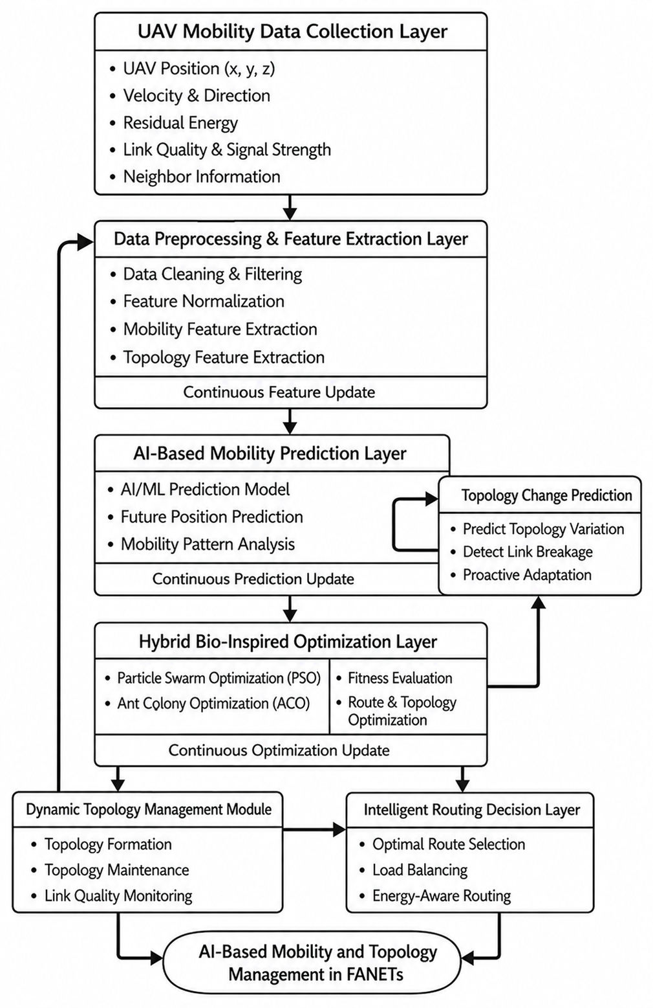
Figure 1: Proposed AI-Based Mobility and Topology Management Framework Using Hybrid Bio-Inspired Optimization for FANETs

PERFORMANCE EVALUATION
The framework combines Artificial Intelligence-based mobility prediction and Hybrid PSO (PS, Particle Swarm Optimization) and ACO (AC, Ant Colony Optimization) to optimize UAV movement, topology formation, and communication routing. The system is able to actively adjust topology structures and routing paths on the fly according to the mobility information of the UAVs, the quality of the communication channels, the energy level of the neighboring nodes, and their actions. A number of experiments were conducted to address the system robustness in realistic FANET environments, considering the varying speeds of the UAVs, the number of UAVs in the network, the communication ranges, and topology variations. The performance evaluation was done under the following simulation parameters:
Network Type: Flying Ad Hoc Network (FANET)
Simulation Area: 1500 m × 1500 m
Number of UAV Nodes: 25–100 UAVs
Mobility Model: Random Waypoint Mobility Model
Communication Range: 250 meters
Simulation Tools: Python, NS-3, MATLAB
Hardware Configuration: Intel i7 Processor, 16GB RAM
Optimization Techniques: Particle Swarm Optimization (PSO) and Ant Colony Optimization (ACO)

The proposed framework is based on the following equations: Equation (3) used for AI-based mobility prediction, Equation (4) used for Particle Swarm Optimization-based mobility updates, Equation (5) used for Ant Colony Optimization-based route selection, and Equation (6) used for topology stability analysis. The most important performance indexes considered in the analysis are the following:

Packet Delivery Ratio (PDR)
Measures the successful delivery of data packets between UAV nodes.
$PDR=\frac{P_{r}}{P_{s}}×100$ (9)
Where,
$P_{r}$: number of packets received
$P_{s}$: number of packets sent
End-to-End Delay (EED)
Measures the average communication delay between source and destination UAV nodes.
$EED=\frac{∑(D_{r}-D_{s})}{N}$ (10)
Where,
$D_{r}$: packet receiving time
$D_{s}$: packet sending time
$N$: total number of transmitted packets
Topology Stability Ratio (TSR)
Measures the stability of communication links and topology structure.
$TSR=\frac{L_{s}}{L_{t}}×100$ (11)
Where,
$L_{s}$: stable communication links
$L_{t}$: total communication links
Communication Overhead (CO)
Measures the additional routing and control communication generated in the network.
$CO=\frac{C_{p}}{D_{p}}×100$ (12)
Where,
$C_{p}$: control packets transmitted
$D_{p}$: data packets transmitted
Energy Consumption (EC)
Measures the average energy consumed during communication and topology management.
$$EC=∑(E_{t}+E_{r})$$
Where,
$E_{t}$: transmission energy
$E_{r}$: reception energy
Comparative analysis of different mobility and topology management strategies is shown in terms of packet delivery ratio, topology stability, communication overhead, and end-to-end delay in Table I. Along with frequent topology changes and unstable communication links, traditional routing protocols lose in communication reliability. While AI-based methods increase the flexibility of routing, they are still subject to communication overhead in the case of high dynamism. The proposed hybrid PSO-ACO optimization framework is well-suited to deliver the highest PHDR, topology stability for the lowest routing overhead, and communication delay.
Table I: Performance Comparison of Mobility and Topology Management Models
Model | Packet Delivery Ratio (%) | Topology Stability (%) | Communication Overhead (%) | End-to-End Delay (ms)
Traditional FANET Routing | 82.4 | 74.1 | 100 | 245
AI-Based Routing | 89.6 | 85.7 | 81 | 198
PSO-Based Optimization | 92.3 | 88.2 | 74 | 176
Proposed Hybrid PSO-ACO Model | 96.4 | 94.8 | 61 | 142

In this section, energy utilization and routing efficiency of the conventional method and the proposed method are compared as shown in Table II. The comparison between the FANET management models for PDR, Topology stability, and Conv. Overhead and Routing delay are shown in Figure 2. Proposed intelligent mobility prediction and adaptive topology optimization algorithms provide better performance in all the evaluation metrics. Figure 3 shows the efficiency and stability of communication links and the maintenance performance of routes with the use of AI for topology prediction. The suggested mechanism is effective in significantly decreasing route breakage and achieving continuous communication when UAVs are mobile. Figure 4 compares the communication overhead (CO) and energy consumption between traditional routing approaches and the proposed hybrid optimization framework.
Table II: Energy and Routing Performance Analysis
Metric | Traditional Model | Proposed Model
Energy Consumption (%) | 84 | 63
Routing Efficiency (%) | 78 | 95
Link Failure Rate (%) | 29 | 11
Network Lifetime (%) | 71 | 92

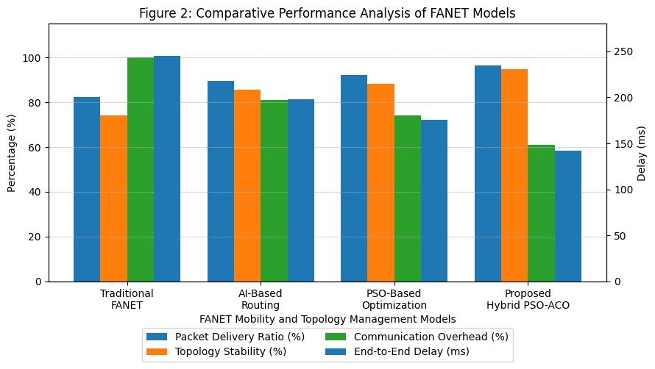
Figure-2: Comparative performance analysis of FANET mobility and topology management models.
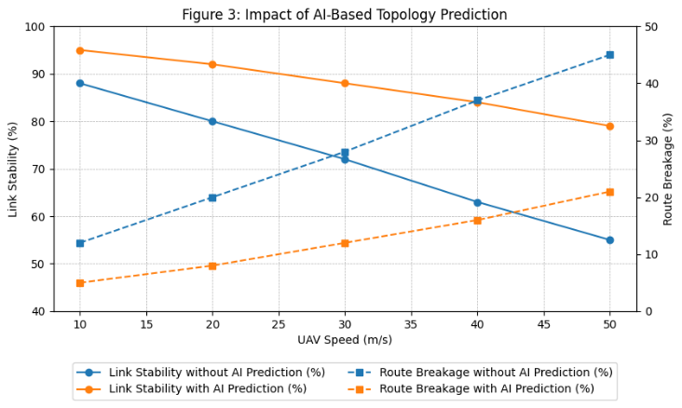
Figure-3: Impact of AI-based topology prediction on link stability and route breakage.
The impact of anomaly detection on the false positive rate and detection rate is illustrated in Figure 3. The rate of detection in the proposed model is significantly improved compared to the traditional models, while the number of false positives is also reduced. This indicates robustness to the malicious/poisoned updates in federated learning. The model is more secure and reliable regarding malware detection. For this, Figure 4 addresses the latency and communication overhead of the system. This proposed scheme reduces the delay and reduces the communication overhead much more than the rest of the traditional schemes [15]. This illustrates how federated learning is efficient in ensuring that small amounts of data are passed on in order to enhance performance.
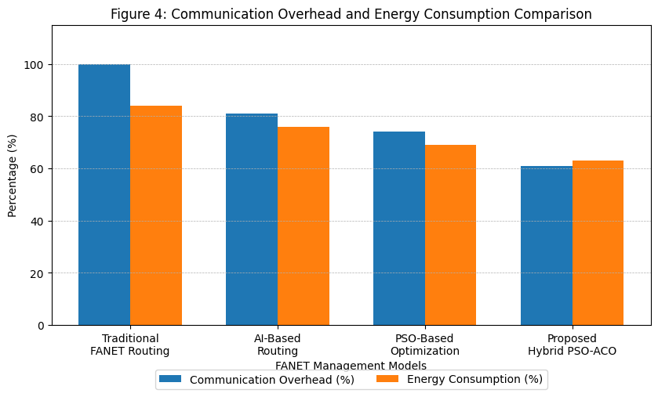
Figure-4: Communication overhead and energy consumption comparison among FANET management models.

Conclusion
In this paper, an AI-Based Mobility and Topology Management Framework for Flying Ad Hoc Networks (FANETs) using Hybrid Bio-Inspired Optimization to overcome the main issues in a highly dynamic UAV communication environment has been introduced. The proposed framework combines AI-based mobility prediction, Hybrid Particle Swarm Optimization (PSO), and Ant Colony Optimization (ACO) to optimize the mobility behavior of UAVs, the stability of their network topology, and their routing efficiency in real time. Therefore, the proposed model showed a higher packet delivery ratio of 96.4%, and it reduced the end-to-end delay, minimized the overhead in communication, and utilized the energy optimally with intelligent topology adaptation and optimized routing strategies. The framework also showed to be highly scalable and flexible with different levels of UAV mobility and network density. Artificial Intelligence technology for topology management in a Distributed UAV Communication System using Hybrid Bio-Inspired Optimization is an effective solution. The proposed framework is used for real-time adaptive decision-making and provides better reliability in providing communication services for applications like disaster monitoring, military surveillance, environmental sensing, intelligent transportation systems, and smart city operations. The proposed framework can be expanded by incorporating blockchain-based secure communication, Explainable Artificial Intelligence (XAI), and energy-efficient swarm coordination techniques in future work to enhance security, scalability, and autonomous decision-making of next-generation UAV communication networks.

References
- I. Bekmezci, O. K. Sahingoz, and Ş. Temel, “Flying Ad-Hoc Networks (FANETs): A survey,” Ad Hoc Networks, vol. 11, no. 3, pp. 1254–1270, 2013.
- L. Gupta, R. Jain, and G. Vaszkun, “Survey of important issues in UAV communication networks,” IEEE Communications Surveys & Tutorials, vol. 18, no. 2, pp. 1123–1152, 2016.
- Lansky, J., Ali, S., Rahmani, A. M., Yousefpoor, M. S., Yousefpoor, E., Khan, F., & Hosseinzadeh, M. (2022). Reinforcement Learning-Based Routing Protocols in Flying Ad Hoc Networks (FANET): A Review. Mathematics, 10(16), 3017.
- Y. Bai, Z. Chang, and R. Jäntti, "Deep Reinforcement Learning-enabled Dynamic UAV Deployment and Power Control in Multi-UAV Wireless Networks," ICC 2024 - IEEE International Conference on Communications, Denver, CO, USA, 2024, pp. 1286-1290.
- F. Z. Rabahi, S. Boudjit, N. E. H. Bahloul, S. Djahel, and C. Bemmoussat, "PSO-OLSR: A Particle Swarm Optimization-based Proactive Routing Protocol for UAV Networks," 2022 IEEE 96th Vehicular Technology Conference (VTC2022-Fall), London, United Kingdom, 2022, pp. 1-7.
- Bijalwan, A., Hussain, I., Purohit, K. C., & Kumar, M. A. (2023). Enhanced Ant Colony Optimization for Vehicular Ad Hoc Networks Using Fittest Node Clustering. Sustainability, 15(22), 15903.
- Ji, Y., Liu, Q., Zhou, C., Han, Z., & Wu, W. (2025). Hybrid Swarm Intelligence and Human-Inspired Optimization for Urban Drone Path Planning. Biomimetics, 10(3), 180.
- Ulaş, M., Sezgin, A., & Boyacı, A. (2025). A Hybrid Optimization Framework for Dynamic Drone Networks: Integrating Genetic Algorithms with Reinforcement Learning. Applied Sciences, 15(9), 5176.
- J. Kennedy and R. Eberhart, "Particle swarm optimization," Proceedings of ICNN'95 - International Conference on Neural Networks, Perth, WA, Australia, 1995, pp. 1942-1948 vol.4.
- Zheng, Y., Liang, Y., Liu, B., Yu, H., Tian, F., Xia, J., & Zhang, X. (2025). Ant Colony Optimization for Accelerated Pathway Identification in Connection Element Method Reservoir Models: A Fast-Track Solution for Large-Scale Simulations. Processes, 13(2), 404.
- Sayal, A., Jha, J., N., C., Gupta, V., Gupta, A., Gupta, O., & Memoria, M. (2023). Neural Networks And Machine Learning. 2023 IEEE 5th International Conference on Cybernetics, Cognition and Machine Learning Applications (ICCCMLA), 58-63.
- A. O. Hashesh, S. Hashima, R. M. Zaki, M. M. Fouda, K. Hatano, and A. S. T. Eldien, "AI-Enabled UAV Communications: Challenges and Future Directions," in IEEE Access, vol. 10, pp. 92048-92066, 2022
- Y. Zeng, R. Zhang, and T. J. Lim, “Wireless communications with unmanned aerial vehicles: Opportunities and challenges,” IEEE Communications Magazine, vol. 54, no. 5, pp. 36–42, 2016.
- F. Aftab, Z. Zhang, and A. Ahmad, “Self-organization based clustering in MANETs and wireless sensor networks: A survey,” IEEE Communications Surveys & Tutorials, vol. 21, no. 4, pp. 3366–3397, 2019.
- E. Kuiper and S. Nadjm-Tehrani, "Mobility Models for UAV Group Reconnaissance Applications," 2006 International Conference on Wireless and Mobile Communications (ICWMC'06), Bucharest, Romania, 2006, pp. 33-33.

