Web-Based Diabetes Risk Prediction Using Interpretable Machine Learning

Sandeep Sebastian
Department of Computer Science
Amal Jyothi College of Engineering
Kottayam, India-686518
georgesebu202@gmail.com

Honey Joseph
Department of Computer Science
Amal Jyothi College of Engineering
Kottayam, India-686518
honeyjoseph@amaljyothi.ac.in

Abstract— Diabetes is a chronic disease affecting millions of people worldwide. For preventing and treating it properly, early detection is very important. Diagnosis of diabetes depends on medical tests and clinical examinations, but these may not always be available for early detection. In this work, a web-based system is developed to predict the risk of diabetes using a machine learning approach. Using the PIMA Indians Diabetes Dataset, a Logistic Regression model is built and trained. Before training the model, the data is processed using techniques like filling missing values and standardizing the features. The system also includes a grey zone to deal with ambiguous predictions. If the probability is between 0.3 and 0.7, it indicates that the result is unclear and advises the user to consult a doctor for additional testing. The model showed an accuracy of 75.3% and an ROC-AUC score of 0.84. It shows that it performs well in predicting diabetes risk. The results become more accurate by showing how each feature affects the prediction, along with an analysis of odds ratios. This helps the system be useful for basic clinical support. The model is connected to a web interface using Flask. Users can easily enter data and get their diagnosis. This approach balances reliability, ease of understanding, and practical use with good accuracy.
Keywords—Diabetes Prediction, Grey Zone, Machine Learning, Clinical Decision Support, Logistic Regression, Interpretability, Random Forest, Uncertainty Handling, Decision Tree, Healthcare Analytics

Introduction
Diabetes is a metabolic condition affecting a large number of people, leading to serious health issues that require early detection. The early detection of risk is very important because it can help to avoid serious health issues that can be caused by diabetes. It helps to perform timely treatment. But the diagnostic methods commonly used depend on lab tests and medical evaluations. This can take time and may not be available for proactive diagnosis.
As medical data is available, the prediction of disease can be performed by a machine learning approach by analyzing patient information. The risk can be estimated by finding patterns and relationships in the data. It supports doctors in decision-making. A significant number of existing models prioritize maximizing accuracy. They give less attention to understanding how the results are produced or handling uncertain predictions. In the medical field, it is important to deal with ambiguous cases properly to avoid confusion and wrong outcomes. It is also important to know which different factors affect the result and how they affect it.
In this work, a web-based system is developed to predict diabetes risk. It focuses on clarity and reliability. A Logistic Regression model is built, and a Grey Zone is introduced to handle unclear prediction cases. The model also explains how different factors affect the result using odds ratio analysis. It acts as a basic clinical decision support.

LITERATURE REVIEW

Comparative Analysis of Machine Learning Models in Diabetes Prediction
Over the years, various machine learning models have been used for diabetes prediction. The most commonly used model is Naïve Bayes, due to its simplicity and effectiveness. It works well with smaller datasets. But it assumes that all features are independent. When dealing with large, complex medical data, the efficiency of the model might become low. [3].The Decision Tree algorithm is easy to understand and provides clear results. However, they can overfit easily and depend on data quality [4]. Similarly, K-Nearest Neighbor (KNN) can be used simply, but it requires more computation. It is sensitive to data scaling [5].
Support Vector Machines and Random Forest are more advanced methods. It can give better prediction accuracy. These models are like magic black boxes. It's hard to know how they make decisions, which is a problem for healthcare [7,8]. The accuracy of Artificial Neural Networks (ANN) can be improved by learning complex patterns. But they are not easy to interpret and need more computational power [9]. K-Means clustering is an unsupervised method. But direct disease prediction cannot be performed well by using it. They also need extra steps or tuning to give useful results [10]. Some models give high accuracy, but they reduce interpretability, and more computational effort is needed. In order to overcome this issue, a balanced approach that can provide reliable predictions is needed so that it can be easily understood and can be used in clinical settings.

Research Gap and Problem Identification
The existing models for diabetes prediction have several limitations. Most of them focus mainly on accuracy and place too little importance on recall, which can result in missing actual diabetic cases. Also, most methods assume that the dataset is clean, but in real situations, medical data often has missing or incorrect values. Another problem is that models like Random Forest and SVM are more complex. They do not clearly show how different inputs affect the result, which is essential in medical decisions.
In addition, many existing systems do not properly handle uncertainty. In real-world cases, some predictions may not be clearly positive or negative, and forcing a definite result can be misleading.
To overcome these problems, this work proposes a system that:
- Uses a Logistic Regression model that is easy to understand.
- Introduces a Grey Zone to handle uncertain predictions.
- Shows how each feature contributes to the risk.
- Works efficiently for real-time measurements.

METHODOLOGY
The system is built using a simple machine learning process to predict diabetes risk. It involves preparing the data, creating the model, checking how well it works, and then using it in a web application to make it more user-friendly.

Dataset Description
The PIMA Indians Diabetes Dataset is used to train the model. The dataset consists of 768 records with 8 input features and one output value. The output, called Outcome, shows whether a person is diabetic (1) or not (0). It includes other relevant medical data like number of pregnancies, blood pressure, glucose level, body mass index (BMI), insulin level, diabetes pedigree function, skin thickness and age. The target value shows whether a person has diabetes or not [10](PIMA)

Data Preprocessing
Data preprocessing is important for improving the model's performance and making it more reliable. The data undergo the following processes:
- Handling Missing Values: Zero values are present in some features, which represent missing data. In order to handle outliers and keep the data more reliable, these zero values are replaced by the median values.
- Feature Scaling: All input features are scaled to a common range using z-score normalization.
$Z=\frac{X-μ​}{σ}$ ,
In this equation, the standardized value is represented by Z. The original feature value is represented by X, and the mean of the feature is represented by μ. The standard deviation is represented by σ. This transformation ensures that all features are scaled to a common range, improving model convergence and performance.
- Feature Selection: Important medical features are selected based on medical knowledge and findings from prior studies.
- Train–Test Split: The dataset is split into training and testing sets in a 70:30 ratio, used to check how well the model performs on new data.

Model Development
A Logistic Regression model is built, so that the working of the model can be better understood and controlled. The model uses a sigmoid function to convert the input values into a probability between 0 and 1.
$σ\left(z\right)=\frac{1}{1+e^{-z}}$ ,
Where $σ\left(z\right)$ represents the predicted probability, and z is the linear combination of input features and model parameters. The sigmoid function maps any real-valued input into a range between 0 and 1, which makes it suitable for binary classification problems. The model is trained using gradient descent, and L2 regularization is added to lower overfitting.

Medical Grey Zone
One of the important parts of this work is the use of Grey Zone to handle uncertain predictions. Instead of giving only yes or no results, the system divides the output into three categories:1) Low Risk (Probability ≤ 0.3), 2) Grey Zone (0.3 < Probability < 0.7), 3) High Risk (Probability ≥ 0.7). This approach avoids forcing unclear results into fixed categories. It helps to provide safer suggestions by advising the users to consult a doctor[12].

Model Interpretability
The model is made simple using odds ratio analysis, which makes it more understandable. It shows how each factor affects the risk.
$$Odd ratio=e^{w}$$
This helps the system understand how much each factor adds to the risk of diabetes. It also calculates the contribution of each feature to find which medical factors contribute the most impact[13].

System Integration
The model is connected to a web application using Flask. The system has three main parts:
- Frontend: A simple interface built with HTML and CSS. Here, users can enter their details.
- Backend: A Flask server that handles the requests and runs the prediction
- Model Layer: The trained Logistic Regression model, along with the preprocessing steps
The application takes input from the user. It processes the data using the model. Then it shows the result along with the probability and a simple explanation of the prediction.

Comparative Models
To check the performance of the model, it's compared with two machine learning models, Decision Tree and Random Forest. These models are chosen because they are commonly used for classification. They have different strengths in terms of performance and ease of understanding. The Decision Tree model is simple and easy to understand. A set of decision rules arranged in a tree-like structure is used for prediction. Clear results and easy explanations are achieved in this model, and makes it useful in medical cases. The model is set with a limited depth to reduce overfitting. It helps the model perform well on data it has not seen before. The Random Forest model is a combination of multiple decision trees, in which the combination of the results from many trees is used to improve the performance of the model. It helps to reduce errors and make the predictions more stable. It usually gives better accuracy compared to a single Decision Tree.
The same dataset and the same preprocessing steps used in the Logistic Regression model are used in both models for training and testing. They include handling missing values and preparing the features. This maintains the integrity of the results by ensuring all subjects are evaluated under the same conditions. The performance of these models is evaluated by using standard measures like accuracy, confusion matrix, and ROC-AUC score.

SYSTEM ARCHITECTURE
The system is designed in multiple layers to keep it organized and easy to expand. It works in a simple flow. First, the user enters their medical details through the web page, and then this data is sent to the Flask backend, which is prepared using a saved scaler so it matches the format used during training. After that, the data is given to the trained Logistic Regression model, and it calculates the chance of diabetes. Based on this value, the result is shown as Low Risk, Grey Zone, or High Risk. To make the result easy to understand, it is displayed to the user along with the probability and simple explanations.
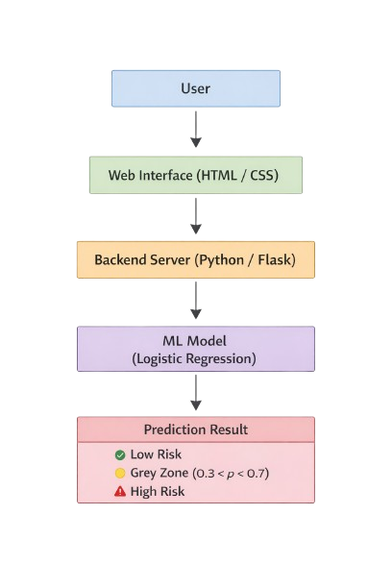
Fig. 1. Architecture Diagram
This setup helps the system give the results quickly. It also allows a smooth connection between the machine learning model and the web application.

IMPLEMENTATION DETAILS
The system is built using Python Programming and other machine learning tools. The Logistic Regression model is created using NumPy. It helps in understanding and controlling how the model works. Gradient descent with 5000 iterations and a learning rate of 0.01 is used to train the model. L2 regularization is also used to reduce overfitting. It improves how well the model works on the new data. After training, the model and the scaler are saved. Later, it is loaded into the Flask application to make real-time predictions. The frontend is designed using HTML and CSS, where users can enter the details. The predictions are generated after processing the input by the backend. It uses the trained model to give the prediction.

RESULTS AND DISCUSSION
Multiple metrics are used to evaluate the performance of the diabetes prediction system. They include accuracy, confusion matrix, ROC-AUC curve, and interpretability analysis. The effectiveness of the model in both prediction and clinical usability is demonstrated in the results.

Model Performance
The model achieved an accuracy of 75.3% on the test data. It also obtained an ROC-AUC score of 0.84. It shows that it can clearly distinguish between diabetic and non-diabetic cases. These results show that the model gives reliable performance.

Confusion Matrix Analysis
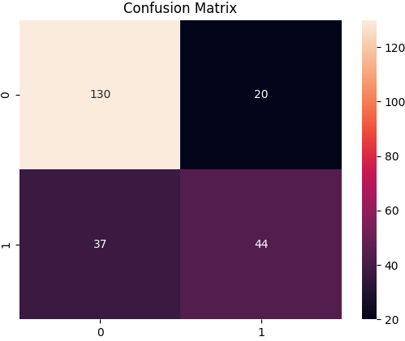
Fig. 2. Confusion Matrix of the Model

Figure 2 shows the confusion matrix, which interprets the performance of the model. Among the test samples, the model correctly predicted 44 instances as diabetic cases and 130 instances as non-diabetic cases. It shows some diabetic cases are misclassified as non-diabetic, resulting in false negatives (37). Also, a total of 20 non-diabetic individuals were incorrectly identified as diabetic, leading to false positives. This shows a problem with sensitivity. It is important in medical use. Missing a positive case can be serious.

ROC-AUC Curve
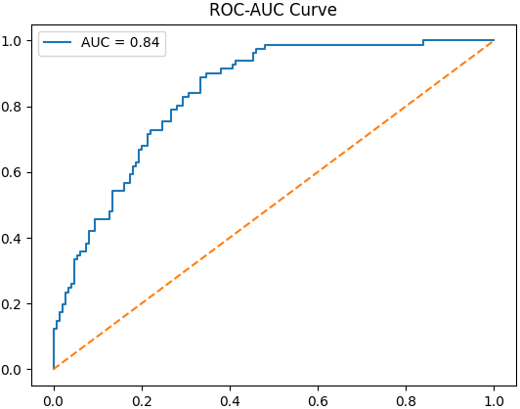
Fig. 3. ROC Curve of the Model

The ROC curve balances between correctly identifying positive cases and wrongly predicting negatives as positives. The model gets an AUC score of 0.84. This score shows that it has a good ability to separate diabetic and non-diabetic cases.

Medical Grey Zone Analysis
One of the main parts of this work is the use of a Grey Zone to handle uncertain cases. The prediction results are divided into three groups. They are Low Risk, Grey Zone, and High Risk.
The results show that:
- 55.4% of cases fall under Low Risk
- 28.6% fall under the Grey Zone
- 16.0% fall under High Risk
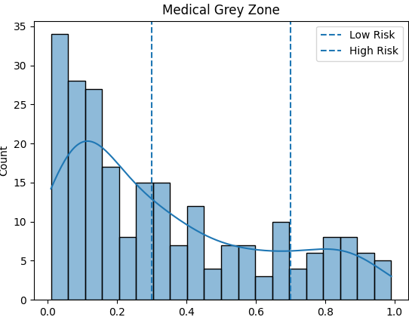
Fig. 4. Probability Distribution with Medical Grey Zone
This shows that many cases fall into the uncertain range. So, it is not always good to force them into just yes or no results. The Grey Zone helps in making safer decisions by suggesting a doctor’s consultation for such cases.

Feature Importance Analysis
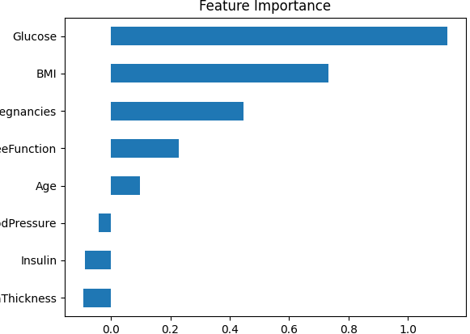
Fig. 5. Feature Importance Based on Model Weights
The feature analysis shows that glucose level has the biggest impact on predicting diabetes, followed by body mass index (BMI) and the number of pregnancies. Glucose level is one of the main indicators of diabetes. Features like blood pressure, insulin, and skin thickness have less impact.

Interpretability and Clinical Insight
One of the main advantages of this system is that it is easy to understand. The model uses the odds ratio to explain the results. It helps in identifying the main risk factors for diabetes. For example, glucose level has a strong effect on increasing the risk, followed by BMI and pregnancy. The system can be useful not only for predictions but also for basic clinical support.

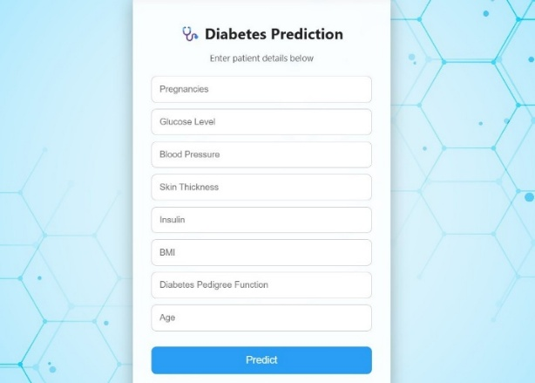
Web Application Interface
Fig. 6. User Input Interface of the Web Application
The web-based interface allows users to input medical parameters such as glucose level, BMI, and age. It can be entered through a simple and user-friendly form.
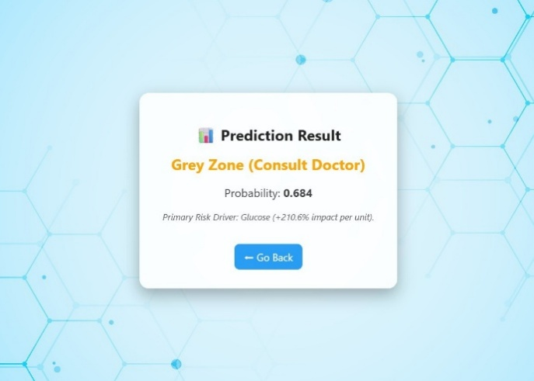
Fig. 7. Prediction Result Interface
The system shows the predicted risk level along with the probability and a simple explanation. It also includes the main factor affecting the result. This makes the system user-friendly. It also helps in understanding the prediction better. This is useful in a clinical setting.

Comparative Analysis

Random Forest Performance
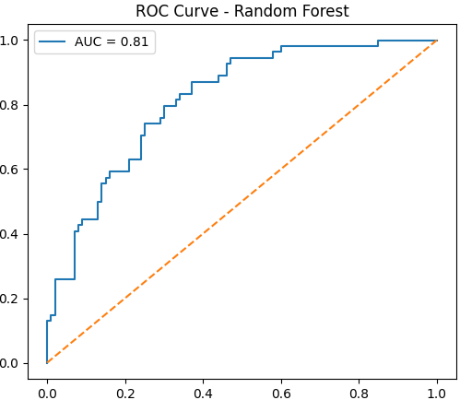
Fig. 8. ROC Curve of Random Forest Model
The Random Forest model achieved an ROC-AUC score of 0.81, indicating that the model has good performance in classification. It is able to separate diabetic and non-diabetic cases well. Its performance is slightly lower compared to the Logistic Regression model.
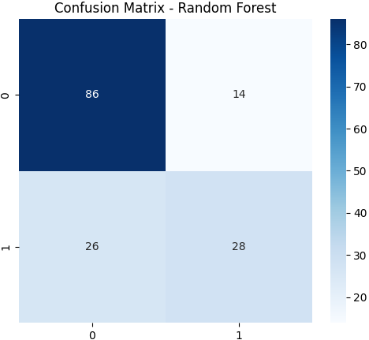
Fig. 9. Confusion Matrix of Random Forest Model
The confusion matrix shows how the Random Forest model is performing. It correctly identifies many non-diabetic cases (86 true negatives). However, some diabetic cases are predicted as non-diabetic (26 false negatives), which shows a limitation in recall for positive cases. The Random Forest model gives good performance with an AUC of 0.81. However, the Logistic Regression model gives a higher AUC of 0.84, which is also easier to understand, making it more useful in a clinical setting.

Decision Tree Performance
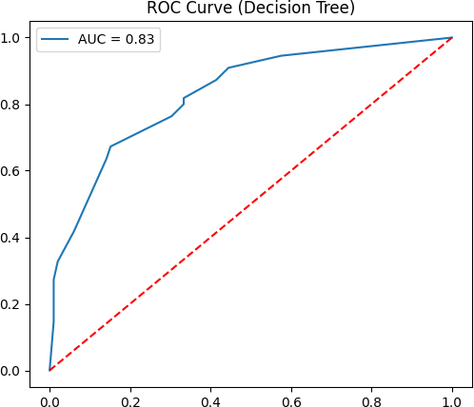
Fig. 10. ROC Curve of Decision Tree Model
The Decision Tree model achieved an ROC-AUC score of 0.83. This shows good performance in classification. The model is able to separate diabetic and non-diabetic cases effectively.
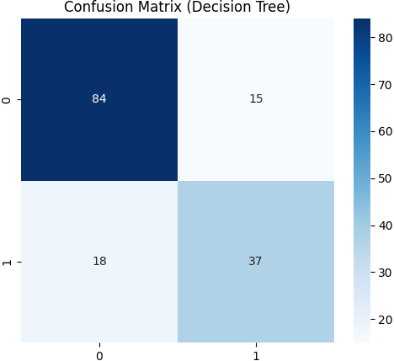
Fig. 11. Confusion Matrix of Decision Tree Model
Figure 11 shows the confusion matrix of the Decision tree model. It shows how the model is performing. It correctly identifies many diabetic cases (37 true positives). This improves recall compared to the other models. However, there are still a few wrong predictions.
Table 1 shows the comparison between the models. It shows that the Decision Tree model gives the highest accuracy. The Logistic Regression model has the best ROC-AUC score. Random Forest and Decision Tree also perform well. But they are harder to understand than Logistic Regression. In medical use, the model must be easy to understand and reliable for decision-making. The Logistic Regression model gives good prediction results. It also shows how each feature affects the result. It handles uncertain cases using the Grey Zone approach. So, it is more suitable for use in clinical decision support than the other models.
Table I. Model Comparison
Model | Accuracy | AUC | Key Strength
Logistic Regression | 75.3% | 0.84 | Interpretability and Stability
Random Forest | 74% | 0.81 | Ensemble Learning
Decision Tree | 78.6% | 0.83 | Simplicity and Higher Accuracy

CONCLUSION
A web-based system is built using a machine learning approach for predicting diabetes risk. The system uses a model that is built using logistic regression. The model is trained on the PIMA Indians Diabetes Dataset. The data is prepared using techniques like filling missing values with the median and standardizing the features. The system achieved an accuracy of 75.3% and an ROC-AUC score of 0.84. This shows that it performs well in predicting diabetes risk. The system gives importance to making the results easy to understand and useful in a clinical setting.
In order to handle uncertain predictions, the concept of the Grey Zone was introduced. The results are divided into three categories: Low Risk, Grey Zone, and High Risk. The forcing of uncertain cases into fixed categories can be avoided by introducing the Grey Zone. It provides safer guidance by recommending a doctor’s consultation when required. The model provides clear insights using odds ratio analysis. It shows how each feature contributes to the overall risk. This helps in understanding how different medical factors affect diabetes prediction. The system is connected to a web application, which allows users to get predictions in real time. Overall, the proposed system shows that it is important to keep a balance between precision, clarity, and practical use when developing machine learning solutions for healthcare.

References
- A. S. Abdalrada, A. F. Neamah, and H. Murad, “Predicting diabetes disease occurrence using logistic regression: An early detection approach,” Iraqi Journal for Computer Science and Mathematics, vol. 5, no. 1, Art. no. 6, 2024, doi: 10.30880/ijcsm.2024.05.01.011.
- H. El Massari, Z. Sabouri, S. Mhammedi, and N. Gherabi, "Diabetes Prediction Using Machine Learning Algorithms and Ontology," Journal of ICT Standardization, vol. 10, no. 2, pp. 319–338, May 2022, doi: 10.13052/jicts2245-800X.10212.
- L. N. Salsabila, M. R. D. Pangga, S. M. Yasser, N. A. Riyani, S. Aminah, and Wahyunengsih, “Application of naïve Bayes algorithm for diabetes prediction,” Jurnal UJMC, vol. 10, no. 1, pp. 56–68, 2024.
- T. Dudkina, I. Meniailov, K. Bazilevych, S. Krivtsov, and A. Tkachenko, “Classification and prediction of diabetes disease using decision tree method,” in Proc. Int. Conf. on Information Technologies, Kharkiv, Ukraine, 2021, pp. 1–6.
- S. Suriya and J. Joanish Muthu,“Type 2 diabetes prediction using K-nearest neighbor algorithm,” Journal of Trends in Computer Science and Smart Technology, vol. 5, no. 2, pp. 190–205, Jun. 2023, doi: 10.36548/jtcsst.2023.2.007.
- H. P. Wibowo, M. Anshori, and M. S. Haris, “The discriminant analysis function was implemented to predict the presence of diabetes,” Journal of Applied Data Analytics, vol. 4, no. 2, pp. 45–52, 2024.
- R. R. Asaad, “Support vector machine classification learning algorithm for diabetes prediction,” International Research Journal of Science, Technology, Engineering and Mathematics, vol. 2, no. 2, pp. 26–32, Jul. 2022.
- S. Wang,“Diabetes prediction using random forest in healthcare,” Highlights in Science, Engineering and Technology, vol. 92, pp. 210–216, 2024.
- E. P. Prakash, K. Srihari, S. Karthik, M. V. Kamal, P. Dileep, S. Bharath Reddy, M. A. Mukunthan, K. Somasundaram, R. Jaikumar, N. Gayathri, and K. Sahile, “Implementation of artificial neural network to predict diabetes with high-quality health system,” Computational Intelligence and Neuroscience, vol. 2022, Article ID 1174173, pp. 1–7, May 2022, doi: 10.1155/2022/1174173.
- https://www.kaggle.com/datasets/uciml/pima-indians-diabetes-database
- S. Anam, Z. Fitriah, N. Hidayat, and M. H. A. A. Maulana, “Classification model for diabetes mellitus diagnosis based on K-means clustering algorithm optimized with bat algorithm,” International Journal of Advanced Computer Science and Applications (IJACSA), vol. 14, no. 1, pp. 653–660, 2023
- J. Coste and J. Pouchot, "A grey zone for quantitative diagnostic and screening tests," International Journal of Epidemiology, vol. 32, no. 2, pp. 304–313, Apr. 2003, doi: 10.1093/ije/dyg054.
- S. M. Hailpern and P. F. Visintainer, "Odds ratios and logistic regression: further examples of their use and interpretation," The Stata Journal, vol. 3, no. 3, pp. 213–225, 2003.

